JavaScript is a bit confusing for developers experienced in class-based languages (like Java or C++), as it is dynamic and does not provide a class implementation per se (the class keyword is introduced in ES2015, but is syntactical sugar, JavaScript remains prototype-based).

When it comes to inheritance, JavaScript only has one construct: objects. Each object has a private property (referred to as [[Prototype]] ) which holds a link to another object called its prototype. That prototype object has a prototype of its own, and so on until an object is reached with null as its prototype. By definition, null has no prototype, and acts as the final link in this prototype chain.

Nearly all objects in JavaScript are instances of Object which sits on the top of a prototype chain.

While this is often considered to be one of JavaScript's weaknesses, the prototypal inheritance model is in fact more powerful than the classic model. It is, for example, fairly trivial to build a classic model on top of a prototypal model.

Inheritance with the prototype chain

Inheriting properties
JavaScript objects are dynamic "bags" of properties (referred to as own properties). JavaScript objects have a link to a prototype object. When trying to access a property of an object, the property will not only be sought on the object but on the prototype of the object, the prototype of the prototype, and so on until either a property with a matching name is found or the end of the prototype chain is reached.

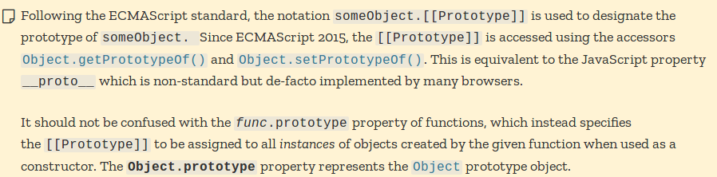

Here is what happens when trying to access a property:

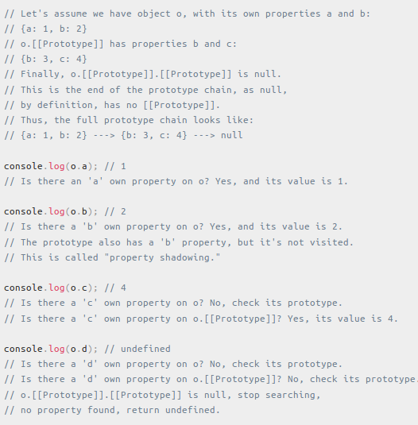

Setting a property to an object creates an own property. The only exception to the getting and setting behavior rules is when there is an inherited property with a getter or a setter.

Inheriting "methods"

JavaScript does not have "methods" in the form that class-based languages define them. In JavaScript, any function can be added to an object in the form of a property. An inherited function acts just as any other property, including property shadowing as shown above (in this case, a form of method overriding).

When an inherited function is executed, the value of this points to the inheriting object, not to the prototype object where the function is an own property.

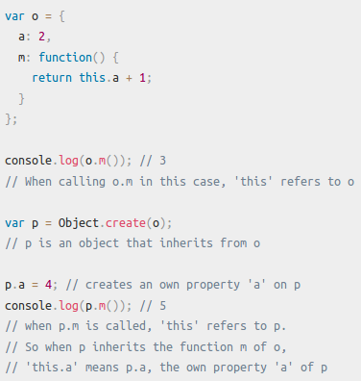

Different ways to create objects and the resulting prototype chain

Objects created with syntax constructs

Example 1:

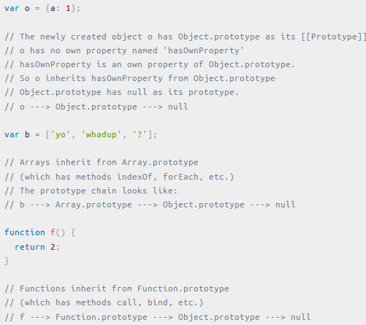

Example 2:

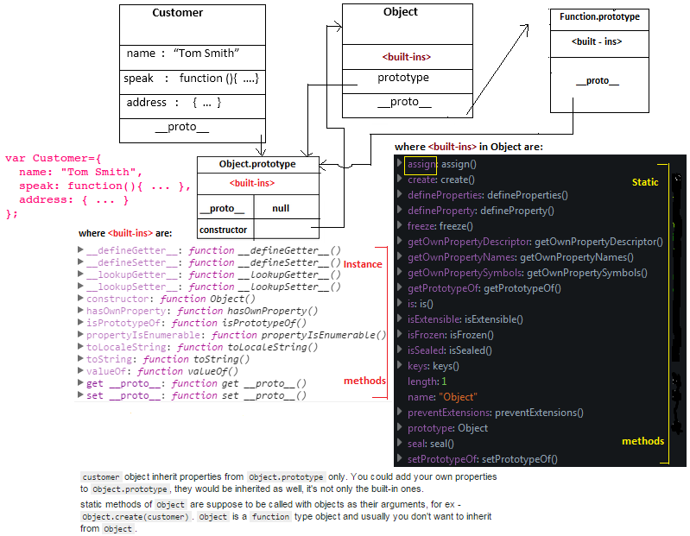

With a constructor

A "constructor" in JavaScript is "just" a function that happens to be called with the new operator.

Example 1:

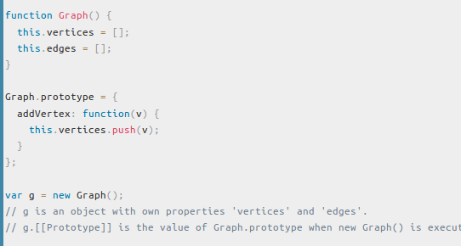

Example 2:

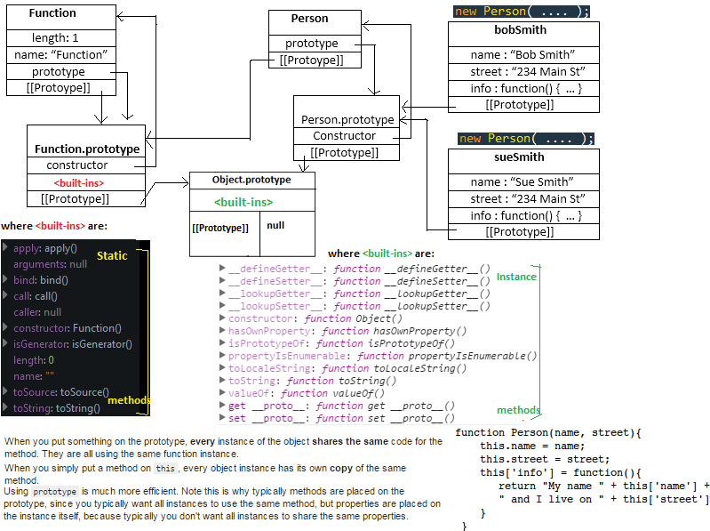

With Object.create

ECMAScript 5 introduced a new method: Object.create(). Calling this method creates a new object. The prototype of this object is the first argument of the function:

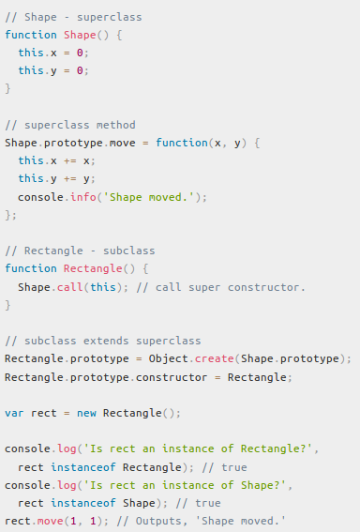

Rectangle.prototype = Object.create(Shape.prototype) does following:
1) Rectangle.prototype.__proto__ = Shape.prototype
2) Rectangle.prototype.constructor = Shape

With the class keyword

ECMAScript 2015 introduced a new set of keywords implementing classes. Although these constructs look like those familiar to developers of class-based languages, they are not the same. JavaScript remains prototype-based. The new keywords include class, constructor, static, extends, and super.

'use strict';

class Polygon {
constructor(height, width) {
this.height = height;
this.width = width;
}
}

class Square extends Polygon {
constructor(sideLength) {
super(sideLength, sideLength);
}
get area() {
return this.height * this.width;
}
set sideLength(newLength) {
this.height = newLength;
this.width = newLength;
}
}

var square = new Square(2);

class keyword
Syntax:
class name [extends] {
// class body
}

Description
Just like with class expressions, the class body of a class declaration is executed in strict mode. The constructor property is optional.

Class declarations are not hoisted (unlike function declarations).

Examples
A simple class declaration
In the following example, we first define a class named Polygon, then extend it to create a class named Square. Note that super(), used in the constructor, can only be used in constructors and must be called before the this keyword can be used.

class Polygon {
constructor(height, width) {
this.name = 'Polygon';
this.height = height;
this.width = width;
}
}

class Square extends Polygon {
constructor(length) {
super(length, length);
this.name = 'Square';
}
}

constructor keyword
Syntax
constructor([arguments]) { ... }

Description
There can be only one special method with the name "constructor" in a class. Having more than one occurrence of a constructor method in a class will throw a SyntaxError error.

A constructor can use the super keyword to call the constructor of a parent class.

If you do not specify a constructor method, a default constructor is used.
Examples
Using the constructor method

This code snippet is taken from the classes sample (live demo).

class Square extends Polygon {
constructor(length) {
// Here, it calls the parent class' constructor with lengths
// provided for the Polygon's width and height
super(length, length);
// Note: In derived classes, super() must be called before you
// can use 'this'. Leaving this out will cause a reference error.
this.name = 'Square';
}

get area() {
return this.height * this.width;
}

set area(value) {
this.area = value;
}
}

Another example

Take a look at this code snippet

class Polygon {
constructor() {
this.name = "Polygon";
}
}

class Square extends Polygon {
constructor() {
super();
}
}

class Rectangle {}

Object.setPrototypeOf(Square.prototype, Rectangle.prototype);

console.log(Object.getPrototypeOf(Square.prototype) === Polygon.prototype); //false
console.log(Object.getPrototypeOf(Square.prototype) === Rectangle.prototype); //true

let newInstance = new Square();
console.log(newInstance.name); //Polygon

Here the prototype of Square class is changed but still the constructor of the previous base class Polygon is called when a new instance of a square is being created.
Default constructors

As stated, if you do not specify a constructor method a default constructor is used. For base classes the default constructor is:

constructor() {}

For derived classes, the default constructor is:

constructor(...args) {
super(...args);
}

static keyword
The static keyword defines a static method for a class.
Syntax
static methodName() { ... }

Description
Static method calls are made directly on the class and are not callable on instances of the class. Static methods are often used to create utility functions.

Calling static methods
From another static method
In order to call a static method within another static method of the same class, you can use the this keyword.

class StaticMethodCall {
static staticMethod() {
return 'Static method has been called';
}
static anotherStaticMethod() {
return this.staticMethod() + ' from another static method';
}
}
StaticMethodCall.staticMethod();
// 'Static method has been called'

StaticMethodCall.anotherStaticMethod();
// 'Static method has been called from another static method'

From class constructor and other methods
Static methods are not directly accessible using the this keyword from non-static methods. You need to call them using the class name: CLASSNAME.STATIC_METHOD_NAME() or by calling the method as a property of the constructor: this.constructor.STATIC_METHOD_NAME().

class StaticMethodCall {
constructor() {
console.log(StaticMethodCall.staticMethod());
// 'static method has been called.'

console.log(this.constructor.staticMethod());
// 'static method has been called.'
}

static staticMethod() {
return 'static method has been called.';
}
}

Examples
The following example demonstrates several things:

- How a static method is implemented on a class.
- That a class with a static member can be sub-classed.
- How a static method can and cannot be called.

class Triple {
static triple(n) {
if (n === undefined) {
n = 1;
}
return n * 3;
}
}

class BiggerTriple extends Triple {
static triple(n) {
return super.triple(n) * super.triple(n);
}
}

console.log(Triple.triple()); // 3
console.log(Triple.triple(6)); // 18

var tp = new Triple();

console.log(BiggerTriple.triple(3));
// 81 (not affected by parent's instantiation)

console.log(tp.triple());
// 'tp.triple is not a function'.

extends keyword
The extends keyword is used in class declarations or class expressions to create a class which is a child of another class.
Syntax
class ChildClass extends ParentClass { ... }

Description
The extends keyword can be used to subclass custom classes as well as built-in objects.
The .prototype of the extension must be an Object or null.

Examples
Using extends

The first example creates a class called Square from a class called Polygon.

class Square extends Polygon {
constructor(length) {
// Here, it calls the parent class' constructor with lengths
// provided for the Polygon's width and height
super(length, length);
// Note: In derived classes, super() must be called before you
// can use 'this'. Leaving this out will cause a reference error.
this.name = 'Square';
}

get area() {
return this.height * this.width;
}
}

Using extends with built-in objects

This example extends the built-in Date object.

class myDate extends Date {
constructor() {
super();
}

getFormattedDate() {
var months = ['Jan', 'Feb', 'Mar', 'Apr', 'May', 'Jun', 'Jul', 'Aug', 'Sep', 'Oct', 'Nov', 'Dec'];
return this.getDate() + '-' + months[this.getMonth()] + '-' + this.getFullYear();
}
}

Extending null

Extending from null works like with a normal class, except that the prototype object does not inherit from Object.prototype.

class nullExtends extends null {
constructor() {}
}

Object.getPrototypeOf(nullExtends); // Function.prototype
Object.getPrototypeOf(nullExtends.prototype) // null

new nullExtends(); //ReferenceError: this is not defined

super keyword
The super keyword is used to access and call functions on an object's parent.

The super.prop and super[expr] expressions are valid in any method definition in both classes and object literals.

Syntax

super([arguments]); // calls the parent constructor.
super.functionOnParent([arguments]);

Description

When used in a constructor, the super keyword appears alone and must be used before the this keyword is used. The super keyword can also be used to call functions on a parent object.

Example

Using super in classes
class Polygon {
constructor(height, width) {
this.name = 'Polygon';
this.height = height;
this.width = width;
}
sayName() {
console.log('Hi, I am a ', this.name + '.');
}
}

class Square extends Polygon {
constructor(length) {
this.height; // ReferenceError, super needs to be called first!

// Here, it calls the parent class' constructor with lengths
// provided for the Polygon's width and height
super(length, length);

// Note: In derived classes, super() must be called before you
// can use 'this'. Leaving this out will cause a reference error.
this.name = 'Square';
}

get area() {
return this.height * this.width;
}

set area(value) {
this.height = this.width = Math.sqrt(value);
}
}

Super-calling static methods

You are also able to call super on static methods.

class Human {
constructor() {}
static ping() {
return 'ping';
}
}

class Computer extends Human {
constructor() {}
static pingpong() {
return super.ping() + ' pong';
}
}
Computer.pingpong(); // 'ping pong'

Deleting super properties will throw an error

You can not use the delete operator and super.prop or super[expr] to delete a parent class' property, it will throw a ReferenceError.

class Base {
constructor() {}
foo() {}
}
class Derived extends Base {
constructor() {}
delete() {
delete super.foo;
}
}

new Derived().delete(); // ReferenceError: invalid delete involving 'super'.

super.prop can not overwrite non-writable properties

When defining non-writable properties with e.g. Object.defineProperty, super can not overwrite the value of the property.

class X {
constructor() {
Object.defineProperty(this, 'prop', {
configurable: true,
writable: false,
value: 1
});
}
f() {
super.prop = 2;
}
}

var x = new X();
x.f(); // TypeError: "prop" is read-only
console.log(x.prop); // 1

Using super.prop in object literals

Super can also be used in the object initializer / literal notation. In this example, two objects define a method. In the second object, super calls the first object's method. This works with the help of Object.setPrototypeOf() with which we are able to set the prototype of obj2 to obj1, so that super is able to find method1 on obj1.

var obj1 = {
method1() {
console.log('method 1');
}
}

var obj2 = {
method2() {
super.method1();
}
}

Object.setPrototypeOf(obj2, obj1);
obj2.method2(); // logs "method 1"

Performance

The lookup time for properties that are high up on the prototype chain can have a negative impact on performance, and this may be significant in code where performance is critical. Additionally, trying to access nonexistent properties will always traverse the full prototype chain.

Also, when iterating over the properties of an object, every enumerable property that is on the prototype chain will be enumerated. To check whether an object has a property defined on itself and not somewhere on its prototype chain, it is necessary to use the hasOwnProperty method which all objects inherit from Object.prototype. To give you a concrete example, let's take the above graph example code to illustrate it:

console.log(g.hasOwnProperty('vertices'));
// true

console.log(g.hasOwnProperty('nope'));
// false

console.log(g.hasOwnProperty('addVertex'));
// false

console.log(g.__proto__.hasOwnProperty('addVertex'));
// true

hasOwnProperty is the only thing in JavaScript which deals with properties and does not traverse the prototype chain.

Note: It is not enough to check whether a property is undefined. The property might very well exist, but its value just happens to be set to undefined.

