The let statement declares a block scope local variable, optionally initializing it to a value.

In ES5,
when you declare a variable using the var keyword, the scope of the variable is
global-scoped, if you declare it outside of a function
or
function-scoped in case you declare it inside a function.

ES6 provides a new way of declaring a variable by using the let keyword.
The let keyword works similar to the var keyword,
except that the variables it declares are block-scoped.

let var1 [= value1] [, var2 [= value2]] [, ..., varN [= valueN]];
Parameters
var1, var2, …, varN
Variable name. It can be any legal identifier.
value1, value2, …, valueN
Initial value of the variable. It can be any legal expression.

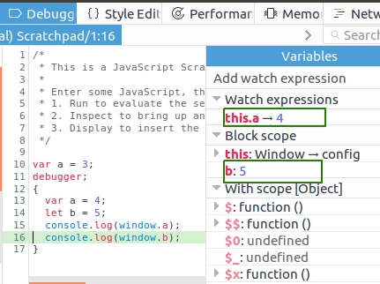

Based on above (debugging),
A global environment consists of two parts:
1) A declarative environment record, which is basically an internal data structure that is not accessible from user land code. That's where const, let, class and others live. It's the same kind of environment used in functions.
2) An object environment record which, as the name implies, stores all bindings as properties of an object. That object is accessible in user land code (it's the global object). You can learn more about this in the spec.

