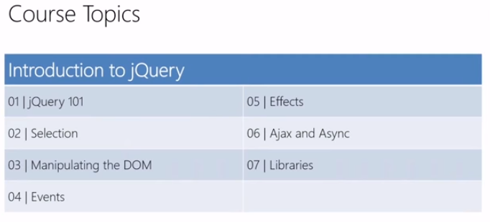

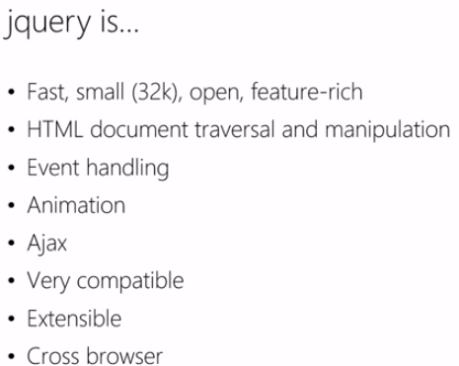

When to use it?
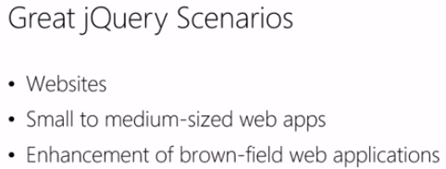
When not to use?
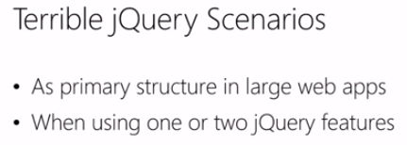

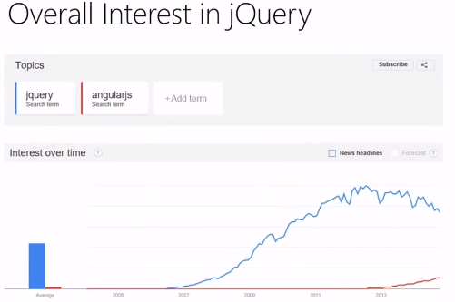

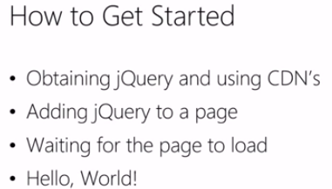

http://codepen.io/sham-ibmgs/pen/wMYrgV/

Waiting for the page to load:
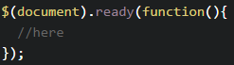
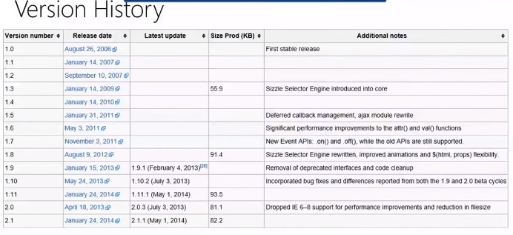

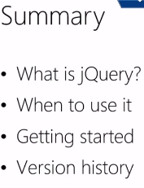

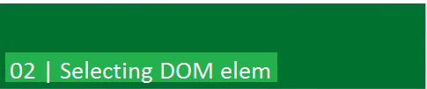

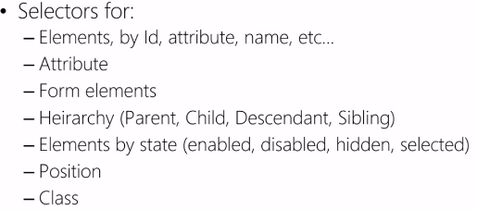

Syntax:
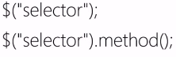

jQuery Selectors Specificity helps… a little.
According to this JSPerf test, adding specificity to the selector in the posted examples consistently improves performance in repeated tests, but the gains could conceivably be considered negligible at the user interaction level where events are occurring sporadically in relatively small iterations.
In some tests, the difference was small enough and within the margin of error to be considered statistically equivalent.

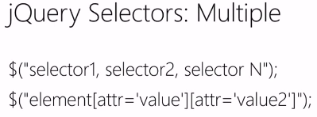
Examples:
$(“h1, h2”)

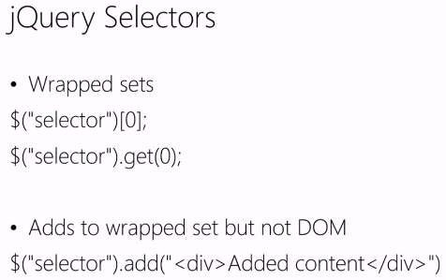

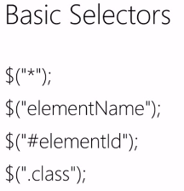
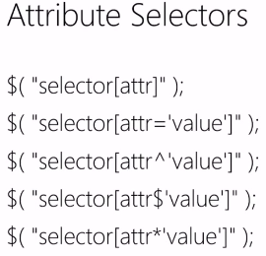

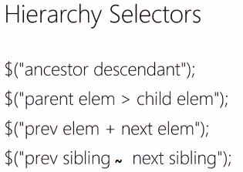

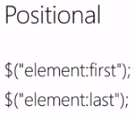

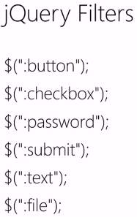

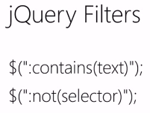

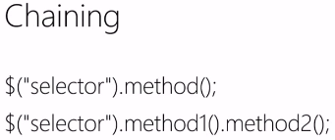

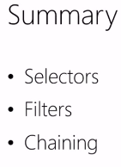

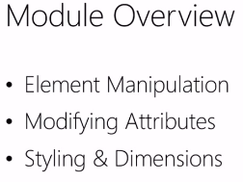
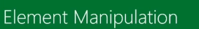
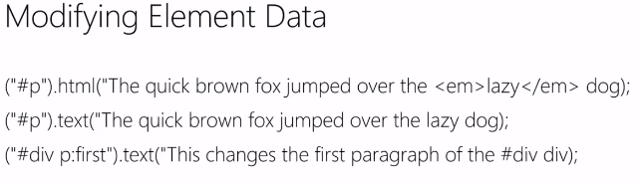
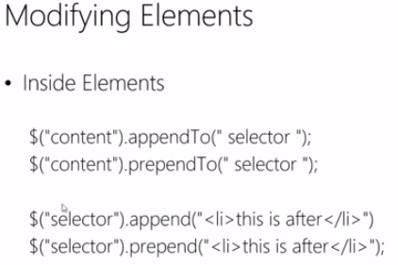

.append() puts data inside an element at last index and
.prepend() puts the prepending elem at first index

suppose:
<div class='a'> //<---you want div c to append in this
<div class='b'>b</div>
</div>

when .append() executes it will look like this:
$('.a').append($('.c'));
after execution:
<div class='a'> //<---you want div c to append in this
<div class='b'>b</div>
<div class='c'>c</div>
</div>

http://jsfiddle.net/hB2E4/4/ - append example

when .prepend() executes it will look like this:
$('.a').prepend($('.c'));
after execution:
<div class='a'> //<---you want div c to append in this
<div class='c'>c</div>
<div class='b'>b</div>
</div>

http://jsfiddle.net/hB2E4/5/ - prepend example
.after() puts the element after the element
.before() puts the element before the element

using after:
$('.a').after($('.c'));
after execution:
<div class='a'>
<div class='b'>b</div>
</div>
<div class='c'>c</div> //<----this will be placed here

http://jsfiddle.net/hB2E4/2/ - after example

using before:
$('.a').before($('.c'));
after execution:
<div class='c'>c</div> //<----this will be placed here
<div class='a'>
<div class='b'>b</div>
</div>

http://jsfiddle.net/hB2E4/3/ - before example

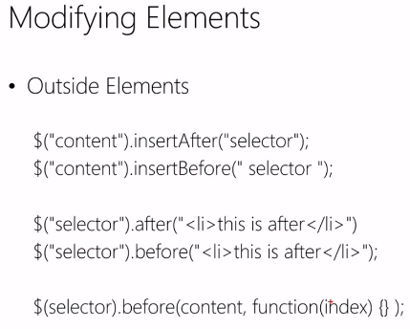

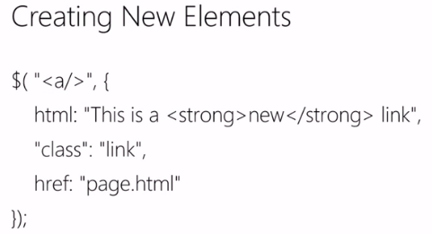
var $div = $("<div>", {id: "foo", class: "a"});
$div.click(function(){ /* ... */ });
$("#box").append($div);

Another example:
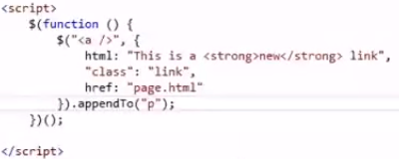

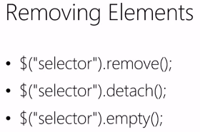

.empty()
Remove all child nodes of the set of matched elements from the DOM.
This method removes not only child (and other descendant) elements, but also any text within the set of matched elements. This is because, according to the DOM specification, any string of text within an element is considered a child node of that element. Consider the following HTML:
<div class="container">
<div class="hello">Hello</div>
<div class="goodbye">Goodbye</div>
</div>
We can target any element for removal:
$( ".hello" ).empty();
This will result in a DOM structure with the Hello text deleted:
<div class="container">
<div class="hello"></div>
<div class="goodbye">Goodbye</div>
</div>
If we had any number of nested elements inside <div class="hello">, they would be removed, too.
To avoid memory leaks, jQuery removes other constructs such as data and event handlers from the child elements before removing the elements themselves.
If you want to remove elements without destroying their data or event handlers (so they can be re-added later), use .detach()instead.

.detach()
Remove the set of matched elements from the DOM.
The .detach() method is the same as .remove(), except that .detach() keeps all jQuery data associated with the removed elements. This method is useful when removed elements are to be reinserted into the DOM at a later time.
<!doctype html>
<html lang="en">
<head>
<meta charset="utf-8">
<title>detach demo</title>
<style>
p {
background: yellow;
margin: 6px 0;
}
p.off {
background: black;
}
</style>
<script src="https://code.jquery.com/jquery-1.10.2.js"></script>
</head>
<body>

<p>Hello</p>
how are
<p>you?</p>
<button>Attach/detach paragraphs</button>

<script>
$( "p" ).click(function() {
$( this ).toggleClass( "off" );
});
var p;
$( "button" ).click(function() {
if ( p ) {
p.appendTo( "body" );
p = null;
} else {
p = $( "p" ).detach();
}
});
</script>

</body>
</html>
.remove()
Remove the set of matched elements from the DOM.
Similar to .empty(), the .remove() method takes elements out of the DOM. Use .remove() when you want to remove the element itself, as well as everything inside it. In addition to the elements themselves, all bound events and jQuery data associated with the elements are removed. To remove the elements without removing data and events, use .detach()instead.
Consider the following HTML:
<div class="container">
<div class="hello">Hello</div>
<div class="goodbye">Goodbye</div>
</div>

We can target any element for removal:
$(".hello").remove();
This will result in a DOM structure with the <div> element deleted:
<div class="container">
<div class="goodbye">Goodbye</div>
</div>
If we had any number of nested elements inside <div class="hello">, they would be removed, too. Other jQuery constructs such as data or event handlers are erased as well.
We can also include a selector as an optional parameter. For example, we could rewrite the previous DOM removal code as follows:
$( "div" ).remove( ".hello" );
This would result in the same DOM structure:
<div class="container">
<div class="goodbye">Goodbye</div>
</div>

Removes all paragraphs from the DOM
<!doctype html>
<html lang="en">
<head>
<meta charset="utf-8">
<title>remove demo</title>
<style>
p {
background: yellow;
margin: 6px 0;
}
</style>
<script src="https://code.jquery.com/jquery-1.10.2.js"></script>
</head>
<body>

<p>Hello</p>
how are
<p>you?</p>
<button>Call remove() on paragraphs</button>

<script>
$( "button" ).click(function() {
$( "p" ).remove();
});
</script>

</body>
</html>
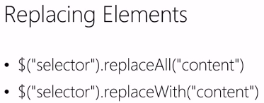
.replaceAll( target )
Where target is a selector string, jQuery object, DOM element, or array of elements indicating which element(s) to replace.
Replace each target element with the set of matched elements.

The .replaceAll() method is similar to .replaceWith(), but with the source and target reversed. Consider this DOM structure:
<div class="container">
<div class="inner first">Hello</div>
<div class="inner second">And</div>
<div class="inner third">Goodbye</div>
</div>
We can create an element, then replace other elements with it:
$( "<h2>New heading</h2>" ).replaceAll( ".inner" );
This causes all of them to be replaced:
<div class="container">
<h2>New heading</h2>
<h2>New heading</h2>
<h2>New heading</h2>
</div>

Or, we could select an element to use as the replacement:
$( ".first" ).replaceAll( ".third" );
This results in the DOM structure:
<div class="container">
<div class="inner second">And</div>
<div class="inner first">Hello</div>
</div>

From this example, we can see that the selected element replaces the target by being moved from its old location, not by being cloned.
- The .replaceAll() method removes all data and event handlers associated with the removed nodes.
Example:
Replace all the paragraphs with bold words.
<!doctype html>
<html lang="en">
<head>
<meta charset="utf-8">
<title>replaceAll demo</title>
<script src="https://code.jquery.com/jquery-1.10.2.js"></script>
</head>
<body>

<p>Hello</p>
<p>cruel</p>
<p>World</p>

<script>
$( "<b>Paragraph. </b>" ).replaceAll( "p" );
</script>

</body>
</html>

.replaceWith(newContent)
Replace each element in the set of matched elements with the provided new content and return the set of elements that was removed.
1) .replaceWith(newContent) - The content to insert. May be an HTML string, DOM element, array of DOM elements, or jQuery object.
2) .replaceWith(function) - A function that returns content with which to replace the set of matched elements.
The .replaceWith() method removes content from the DOM and inserts new content in its place with a single call. Consider this DOM structure:
<div class="container">
<div class="inner first">Hello</div>
<div class="inner second">And</div>
<div class="inner third">Goodbye</div>
</div>

The second inner <div> could be replaced with the specified HTML:
$( "div.second" ).replaceWith( "<h2>New heading</h2>" );
This results in the structure:
<div class="container">
<div class="inner first">Hello</div>
<h2>New heading</h2>
<div class="inner third">Goodbye</div>
</div>
All inner <div> elements could be targeted at once:
$( "div.inner" ).replaceWith( "<h2>New heading</h2>" );
This causes all of them to be replaced:
<div class="container">
<h2>New heading</h2>
<h2>New heading</h2>
<h2>New heading</h2>
</div>

An element could also be selected as the replacement:
$( "div.third" ).replaceWith( $( ".first" ) );
This results in the DOM structure:
<div class="container">
<div class="inner second">And</div>
<div class="inner first">Hello</div>
</div>
This example demonstrates that the selected element replaces the target by being moved from its old location, not by being cloned.
The .replaceWith() method, like most jQuery methods, returns the jQuery object so that other methods can be chained onto it. However, it must be noted that the original jQuery object is returned. This object refers to the element that has been removed from the DOM, not the new element that has replaced it.
- The .replaceWith() method removes all data and event handlers associated with the removed nodes.
<!doctype html>
<html lang="en">
<head>
<meta charset="utf-8">
<title>replaceWith demo</title>
<style>
button {
display: block;
margin: 3px;
color: red;
width: 200px;
}
div {
color: red;
border: 2px solid blue;
width: 200px;
margin: 3px;
text-align: center;
}
</style>
<script src="https://code.jquery.com/jquery-1.10.2.js"></script>
</head>
<body>

<button>First</button>
<button>Second</button>
<button>Third</button>

<script>
$( "button" ).click(function() {
$( this ).replaceWith( "<div>" + $( this ).text() + "</div>" );
});
</script>

</body>
</html>

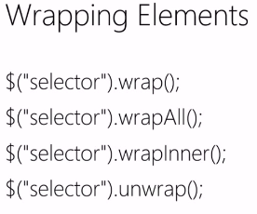

.wrap()
Wrap an HTML structure around each element in the set of matched elements.
.wrap( wrappingElement ) – where wrappingElement is A selector, element, HTML string, or jQuery object specifying the structure to wrap around the matched elements. When you pass a jQuery collection containing more than one element, or a selector matching more than one element, the first element will be used.

The .wrap() function can take any string or object that could be passed to the $() factory function to specify a DOM structure. This structure may be nested several levels deep, but should contain only one inmost element. A copy of this structure will be wrapped around each of the elements in the set of matched elements. This method returns the original set of elements for chaining purposes.

Consider the following HTML:
<div class="container">
<div class="inner">Hello</div>
<div class="inner">Goodbye</div>
</div>

Using .wrap(), we can insert an HTML structure around the inner <div> elements like so:
$( ".inner" ).wrap( "<div class='new'></div>" );
The new <div> element is created on the fly and added to the DOM. The result is a new <div> wrapped around each matched element:
<div class="container">
<div class="new">
<div class="inner">Hello</div>
</div>
<div class="new">
<div class="inner">Goodbye</div>
</div>
</div>

The second version of this method allows us to instead specify a callback function. This callback function will be called once for every matched element; it should return a DOM element, jQuery object, or HTML snippet in which to wrap the corresponding element. For example:
$( ".inner" ).wrap(function() {
return "<div class='" + $( this ).text() + "'></div>";
});

This will cause each <div> to have a class corresponding to the text it wraps:
<div class="container">
<div class="Hello">
<div class="inner">Hello</div>
</div>
<div class="Goodbye">
<div class="inner">Goodbye</div>
</div>
</div>

Examples:
Wrap a new div around all of the paragraphs.

<!doctype html>
<html lang="en">
<head>
<meta charset="utf-8">
<title>wrap demo</title>
<style>
div {
border: 2px solid blue;
}
p {
background: yellow;
margin: 4px;
}
</style>
<script src="https://code.jquery.com/jquery-1.10.2.js"></script>
</head>
<body>

<p>Hello</p>
<p>cruel</p>
<p>World</p>

<script>
$( "p" ).wrap( "<div></div>" );
</script>

</body>
</html>

Wraps a newly created tree of objects around the spans. Notice anything in between the spans gets left out like the <strong> (red text) in this example. Even the white space between spans is left out. Click View Source to see the original html.>
<!doctype html>
<html lang="en">
<head>
<meta charset="utf-8">
<title>wrap demo</title>
<style>
div {
border: 2px blue solid;
margin: 2px;
padding: 2px;
}
p {
background: yellow;
margin: 2px;
padding: 2px;
}
strong {
color: red;
}
</style>
<script src="https://code.jquery.com/jquery-1.10.2.js"></script>
</head>
<body>

<span>Span Text</span>
<strong>What about me?</strong>
<span>Another One</span>

<script>
$( "span" ).wrap( "<div><div><p><em><b></b></em></p></div></div>" );
</script>

</body>
</html>

Wrap a new div around all of the paragraphs.
<!doctype html>
<html lang="en">
<head>
<meta charset="utf-8">
<title>wrap demo</title>
<style>
div {
border: 2px solid blue;
}
p {
background: yellow;
margin: 4px;
}
</style>
<script src="https://code.jquery.com/jquery-1.10.2.js"></script>
</head>
<body>

<p>Hello</p>
<p>cruel</p>
<p>World</p>

<script>
$( "p" ).wrap( document.createElement( "div" ) );
</script>

</body>
</html>

Wrap a jQuery object double depth div around all of the paragraphs. Notice it doesn't move the object but just clones it to wrap around its target.
<!doctype html>
<html lang="en">
<head>
<meta charset="utf-8">
<title>wrap demo</title>
<style>
div {
border: 2px solid blue;
margin: 2px;
padding: 2px;
}
.doublediv {
border-color: red;
}
p {
background: yellow;
margin: 4px;
font-size: 14px;
}
</style>
<script src="https://code.jquery.com/jquery-1.10.2.js"></script>
</head>
<body>

<p>Hello</p>
<p>cruel</p>
<p>World</p>
<div class="doublediv"><div></div></div>

<script>
$( "p" ).wrap( $( ".doublediv" ) );
</script>

</body>
</html>

.wrapAll()
Wrap an HTML structure around all elements in the set of matched elements.

.wrapAll( wrappingElement ) – where wrappingElement is A selector, element, HTML string, or jQuery object specifying the structure to wrap around the matched elements.
.wrapAll( function ) – where function is A callback function returning the HTML content or jQuery object to wrap around the matched elements. Receives the index position of the element in the set as an argument. Within the function, this refers to the current element in the set.

The .wrapAll() function can take any string or object that could be passed to the $() function to specify a DOM structure. This structure may be nested several levels deep, but should contain only one inmost element. The structure will be wrapped around all of the elements in the set of matched elements, as a single group.

Consider the following HTML:

<div class="container">
<div class="inner">Hello</div>
<div class="inner">Goodbye</div>
</div>

Using .wrapAll(), we can insert an HTML structure around the inner <div> elements like so:

$( ".inner" ).wrapAll( "<div class='new' />");

The new <div> element is created on the fly and added to the DOM. The result is a new <div> wrapped around all matched elements:
<div class="container">
<div class="new">
<div class="inner">Hello</div>
<div class="inner">Goodbye</div>
</div>
</div>

Examples:
Wrap a new div around all of the paragraphs.
<!doctype html>
<html lang="en">
<head>
<meta charset="utf-8">
<title>wrapAll demo</title>
<style>
div {
border: 2px solid blue;
}
p {
background: yellow;
margin: 4px;
}
</style>
<script src="https://code.jquery.com/jquery-1.10.2.js"></script>
</head>
<body>

<p>Hello</p>
<p>cruel</p>
<p>World</p>

<script>
$( "p" ).wrapAll( "<div></div>" );
</script>

</body>
</html>

Wraps a newly created tree of objects around the spans. Notice anything in between the spans gets left out like the <strong> (red text) in this example. Even the white space between spans is left out. Click View Source to see the original html.
<!doctype html>
<html lang="en">
<head>
<meta charset="utf-8">
<title>wrapAll demo</title>
<style>
div {
border: 2px blue solid;
margin: 2px;
padding: 2px;
}
p {
background: yellow;
margin: 2px;
padding: 2px;
}
strong {
color: red;
}
</style>
<script src="https://code.jquery.com/jquery-1.10.2.js"></script>
</head>
<body>

<span>Span Text</span>
<strong>What about me?</strong>
<span>Another One</span>

<script>
$( "span").wrapAll( "<div><div><p><em><b></b></em></p></div></div>" );
</script>

</body>
</html>

Wrap a new div around all of the paragraphs.
<!doctype html>
<html lang="en">
<head>
<meta charset="utf-8">
<title>wrapAll demo</title>
<style>
div {
border: 2px solid blue;
}
p {
background: yellow;
margin: 4px;
}
</style>
<script src="https://code.jquery.com/jquery-1.10.2.js"></script>
</head>
<body>

<p>Hello</p>
<p>cruel</p>
<p>World</p>

<script>
$( "p" ).wrapAll( document.createElement( "div" ) );
</script>

</body>
</html>

Wrap a jQuery object double depth div around all of the paragraphs. Notice it doesn't move the object but just clones it to wrap around its target.
<!doctype html>
<html lang="en">
<head>
<meta charset="utf-8">
<title>wrapAll demo</title>
<style>
div {
border: 2px solid blue;
margin: 2px;
padding: 2px;
}
.doublediv {
border-color: red;
}
p {
background: yellow;
margin: 4px;
font-size: 14px;
}
</style>
<script src="https://code.jquery.com/jquery-1.10.2.js"></script>
</head>
<body>

<p>Hello</p>
<p>cruel</p>
<p>World</p>
<div class="doublediv"><div></div></div>

<script>
$( "p" ).wrapAll( $( ".doublediv" ) );
</script>

</body>
</html>

http://jsfiddle.net/Hw7KM/174/ - wrap(), wrapAll(), wrapInner()

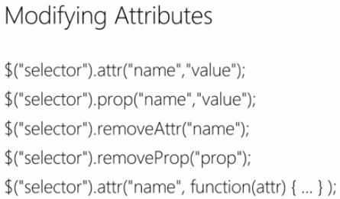

.attr() Vs .prop()
https://www.youtube.com/watch?v=Yo0G26SsocE

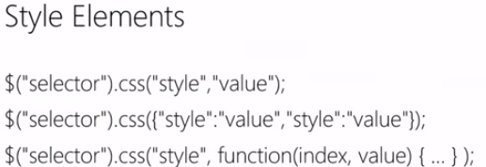

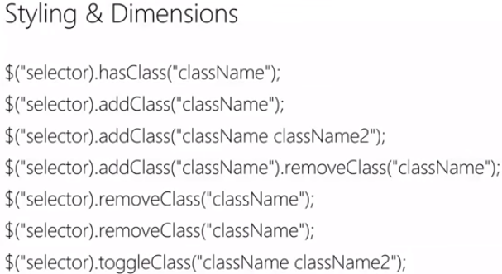

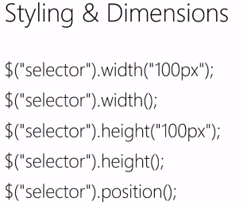

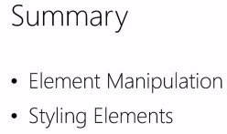



Event Object
jQuery's event system normalizes the event object according to W3C standards. The event object is guaranteed to be passed to the event handler. Most properties from the original event are copied over and normalized to the new event object.

jQuery.Event Constructor
The jQuery.Event constructor is exposed and can be used when calling trigger. The new operator is optional.
Check trigger's documentation to see how to combine it with your own event object.
Example:
//Create a new jQuery.Event object without the "new" operator.
var e = jQuery.Event( "click" );

// trigger an artificial click event
jQuery( "body" ).trigger( e );

As of jQuery 1.6, you can also pass an object to jQuery.Event() and its properties will be set on the newly created Event object.
Example:
// Create a new jQuery.Event object with specified event properties.
var e = jQuery.Event( "keydown", { keyCode: 64 } );

// trigger an artificial keydown event with keyCode 64
jQuery( "body" ).trigger( e );

Event Properties

jQuery normalizes the following properties for cross-browser consistency:
- target
- relatedTarget
- pageX
- pageY
- which
- metaKey
The following properties are also copied to the event object, though some of their values may be undefined depending on the event:
altKey, bubbles, button, buttons, cancelable, char, charCode, clientX, clientY, ctrlKey, currentTarget, data, detail, eventPhase, key, keyCode, metaKey, offsetX, offsetY, originalTarget, pageX, pageY, relatedTarget, screenX, screenY, shiftKey, target, toElement, view, which

OtherProperties
Certain events may have properties specific to them. Those can be accessed as properties of the event.originalEvent object.
Example:
// add the dataTransfer property for use with the native `drop` event
// to capture information about files dropped into the browser window
jQuery.event.props.push( "dataTransfer" );

event.currentTarget
The current DOM element within the event bubbling phase.

event.data
An optional object of data passed to an event method when the current executing handler is bound.
Also in: Events

event.delegateTarget
The element where the currently-called jQuery event handler was attached.

event.isDefaultPrevented()
Returns whether event.preventDefault() was ever called on this event object.

event.isImmediatePropagationStopped()
Returns whether event.stopImmediatePropagation() was ever called on this event object.

event.isPropagationStopped()
Returns whether event.stopPropagation() was ever called on this event object.

event.metaKey
Indicates whether the META key was pressed when the event fired.

event.namespace
The namespace specified when the event was triggered.

event.pageX
The mouse position relative to the left edge of the document.

event.pageY
The mouse position relative to the top edge of the document.

event.preventDefault()
If this method is called, the default action of the event will not be triggered.

event.relatedTarget
The other DOM element involved in the event, if any.

event.result
The last value returned by an event handler that was triggered by this event, unless the value was undefined.

event.stopImmediatePropagation()
Keeps the rest of the handlers from being executed and prevents the event from bubbling up the DOM tree.

event.stopPropagation()
Prevents the event from bubbling up the DOM tree, preventing any parent handlers from being notified of the event.

event.target
The DOM element that initiated the event.

event.timeStamp
The difference in milliseconds between the time the browser created the event and January 1, 1970.

event.type
Describes the nature of the event.

event.which
For key or mouse events, this property indicates the specific key or button that was pressed.

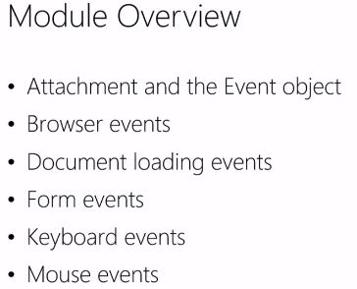

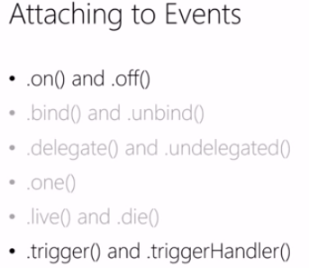

Event attachment - http://codepen.io/codefoster/pen/jaIDb

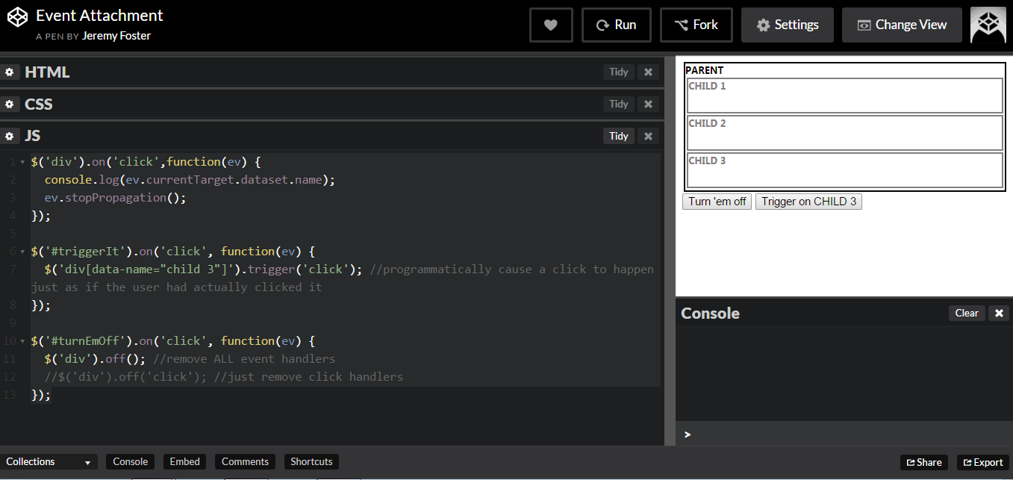

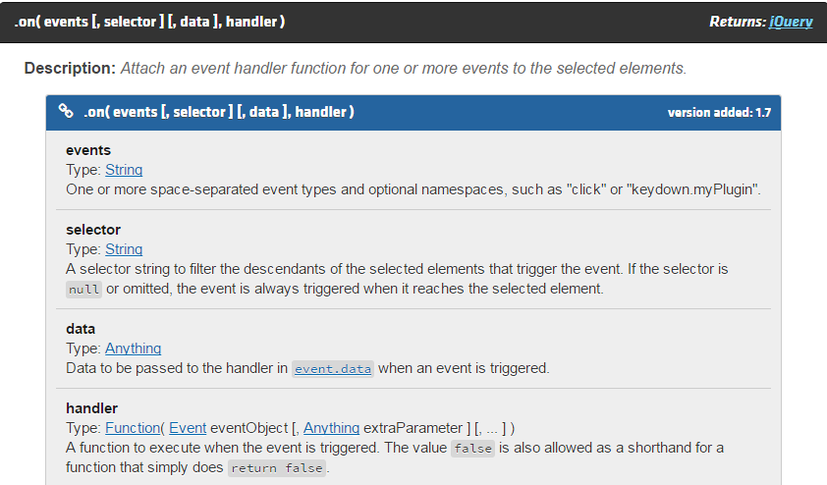

Some examples:
1)
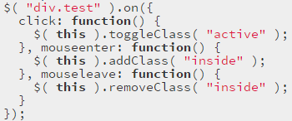

2)
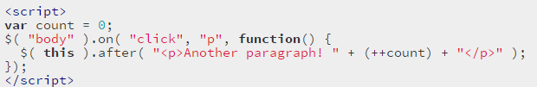

3)
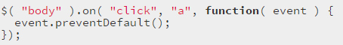

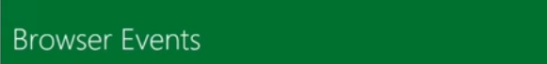

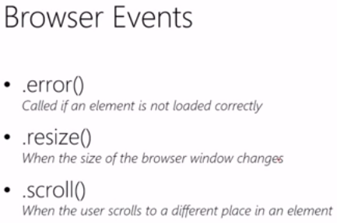

$document.ready(fn) will be loaded at the beginning of interactive face when the Dom has "completed" loading

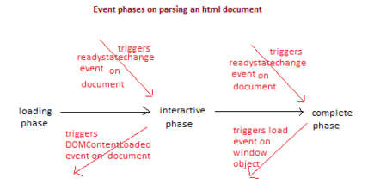

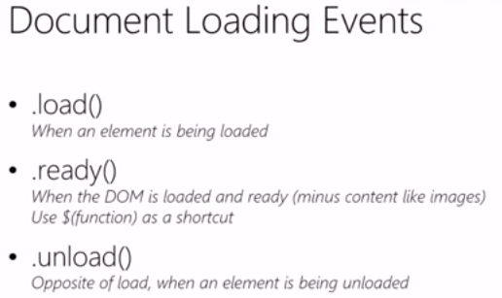

Example - http://codepen.io/codefoster/pen/aoweb

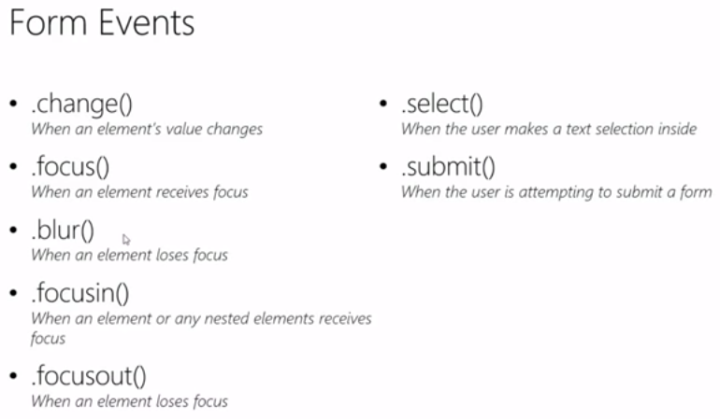

https://www.youtube.com/watch?v=cxl05ijABYk&list=PL9C661D1672621FAB
