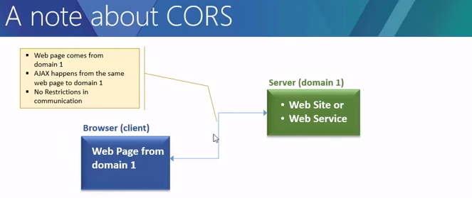

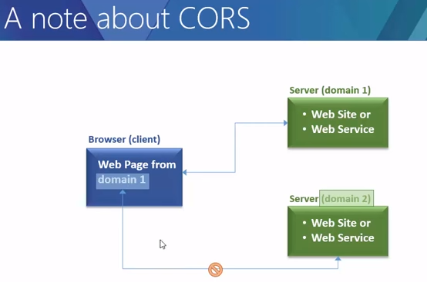

Here domain is port+host+protocol

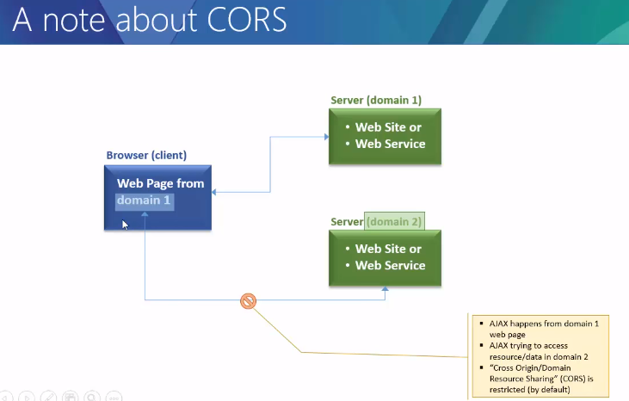
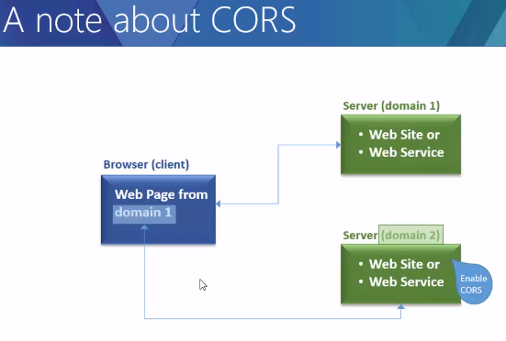

This article is a general discussion of Cross-Origin Resource Sharing, and includes a discussion of the HTTP headers as implemented in Firefox 3.5.

Overview
The Cross-Origin Resource Sharing standard works by adding new HTTP headers that allow servers to describe the set of origins that are permitted to read that information using a web browser. Additionally, for HTTP request methods that can cause side-effects on user data (in particular, for HTTP methods other than GET, or for POST usage with certain MIME types), the specification mandates that browsers "preflight" the request, soliciting supported methods from the server with an HTTP OPTIONS request method, and then, upon "approval" from the server, sending the actual request with the actual HTTP request method. Servers can also notify clients whether "credentials" (including Cookies and HTTP Authentication data) should be sent with requests.
Subsequent sections discuss scenarios, as well as a breakdown of the HTTP headers used.

Cross-origin-resource-sharing

Examples of access control scenarios
Here, we present three scenarios that illustrate how Cross-Origin Resource Sharing works. All of these examples use the XMLHttpRequest object, which can be used to make cross-site invocations in any supporting browser.
The JavaScript snippets included in these sections (and running instances of the server-code that correctly handles these cross-site requests) can be found "in action" here, and will work in browsers that support cross-site XMLHttpRequest. A discussion of Cross-Origin Resource Sharing from a server perspective (including PHP code snippets) can be found here.

Simple requests
A simple cross-site request is one that meets all the following conditions:
1) The only allowed methods are:
- GET
- HEAD
- POST
2) Apart from the headers set automatically by the user agent (e.g. Connection, User-Agent, etc.), the only headers which are allowed to be manually set are:
- Accept
- Accept-Language
- Content-Language
- Content-Type
3) The only allowed values for the Content-Type header are:
- application/x-www-form-urlencoded
- multipart/form-data
- text/plain

Note: These are the same kinds of cross-site requests that web content can already issue, and no response data is released to the requester unless the server sends an appropriate header. Therefore, sites that prevent cross-site request forgery have nothing new to fear from HTTP access control.
For example, suppose web content on domain http://foo.example wishes to invoke content on domain http://bar.other. Code of this sort might be used within JavaScript deployed on foo.example:
var invocation = new XMLHttpRequest();
var url = 'http://bar.other/resources/public-data/';

function callOtherDomain() {
if(invocation) {
invocation.open('GET', url, true);
invocation.onreadystatechange = handler;
invocation.send();
}
}
Let us look at what the browser will send the server in this case, and let's see how the server responds:
GET /resources/public-data/ HTTP/1.1
Host: bar.other
User-Agent: Mozilla/5.0 (Macintosh; U; Intel Mac OS X 10.5; en-US; rv:1.9.1b3pre) Gecko/20081130 Minefield/3.1b3pre
Accept: text/html,application/xhtml+xml,application/xml;q=0.9,*/*;q=0.8
Accept-Language: en-us,en;q=0.5
Accept-Encoding: gzip,deflate
Accept-Charset: ISO-8859-1,utf-8;q=0.7,*;q=0.7
Connection: keep-alive
Referer: http://foo.example/examples/access-control/simpleXSInvocation.html
Origin: http://foo.example

HTTP/1.1 200 OK
Date: Mon, 01 Dec 2008 00:23:53 GMT
Server: Apache/2.0.61
Access-Control-Allow-Origin: *
Keep-Alive: timeout=2, max=100
Connection: Keep-Alive
Transfer-Encoding: chunked
Content-Type: application/xml

[XML Data]
Lines 1 - 10 are headers sent by Firefox 3.5. Note that the main HTTP request header of note here is the Origin: header on line 10 above, which shows that the invocation is coming from content on the the domain http://foo.example.
Lines 13 - 22 show the HTTP response from the server on domain http://bar.other. In response, the server sends back an Access-Control-Allow-Origin: header, shown above in line 16. The use of the Origin: header and of Access-Control-Allow-Origin: show the access control protocol in its simplest use. In this case, the server responds with a Access-Control-Allow-Origin: * which means that the resource can be accessed by any domain in a cross-site manner. If the resource owners at http://bar.other wished to restrict access to the resource to be only from http://foo.example, they would send back:
Access-Control-Allow-Origin: http://foo.example
Note that now, no domain other than http://foo.example (identified by the ORIGIN: header in the request, as in line 10 above) can access the resource in a cross-site manner. The Access-Control-Allow-Origin header should contain the value that was sent in the request's Originheader.

Preflighted requests
Unlike simple requests (discussed above), "preflighted" requests first send an HTTP request by the OPTIONS method to the resource on the other domain, in order to determine whether the actual request is safe to send. Cross-site requests are preflighted like this since they may have implications to user data. In particular, a request is preflighted if:
- It uses methods other than GET, HEAD or POST. Also, if POST is used to send request data with a Content-Type other than application/x-www-form-urlencoded, multipart/form-data, or text/plain, e.g. if the POST request sends an XML payload to the server usingapplication/xml or text/xml, then the request is preflighted.
- It sets custom headers in the request (e.g. the request uses a header such as X-PINGOTHER)
Note: Starting in Gecko 2.0, the text/plain, application/x-www-form-urlencoded, andmultipart/form-data data encodings can all be sent cross-site without preflighting. Previously, onlytext/plain could be sent without preflighting.
An example of this kind of invocation might be:
var invocation = new XMLHttpRequest();
var url = 'http://bar.other/resources/post-here/';
var body = '<?xml version="1.0"?><person><name>Arun</name></person>';

function callOtherDomain(){
if(invocation)
{
invocation.open('POST', url, true);
invocation.setRequestHeader('X-PINGOTHER', 'pingpong');
invocation.setRequestHeader('Content-Type', 'application/xml');
invocation.onreadystatechange = handler;
invocation.send(body);
}
}

......
In the example above, line 3 creates an XML body to send with the POST request in line 8. Also, on line 9, a "customized" (non-standard) HTTP request header is set (X-PINGOTHER: pingpong). Such headers are not part of the HTTP/1.1 protocol, but are generally useful to web applications. Since the request (POST) uses a Content-Type of application/xml, and since a custom header is set, this request is preflighted.
Let's take a look at the full exchange between client and server:
OPTIONS /resources/post-here/ HTTP/1.1
Host: bar.other
User-Agent: Mozilla/5.0 (Macintosh; U; Intel Mac OS X 10.5; en-US; rv:1.9.1b3pre) Gecko/20081130 Minefield/3.1b3pre
Accept: text/html,application/xhtml+xml,application/xml;q=0.9,*/*;q=0.8
Accept-Language: en-us,en;q=0.5
Accept-Encoding: gzip,deflate
Accept-Charset: ISO-8859-1,utf-8;q=0.7,*;q=0.7
Connection: keep-alive
Origin: http://foo.example
Access-Control-Request-Method: POST
Access-Control-Request-Headers: X-PINGOTHER

HTTP/1.1 200 OK
Date: Mon, 01 Dec 2008 01:15:39 GMT
Server: Apache/2.0.61 (Unix)
Access-Control-Allow-Origin: http://foo.example
Access-Control-Allow-Methods: POST, GET, OPTIONS
Access-Control-Allow-Headers: X-PINGOTHER
Access-Control-Max-Age: 1728000
Vary: Accept-Encoding, Origin
Content-Encoding: gzip
Content-Length: 0
Keep-Alive: timeout=2, max=100
Connection: Keep-Alive
Content-Type: text/plain

POST /resources/post-here/ HTTP/1.1
Host: bar.other
User-Agent: Mozilla/5.0 (Macintosh; U; Intel Mac OS X 10.5; en-US; rv:1.9.1b3pre) Gecko/20081130 Minefield/3.1b3pre
Accept: text/html,application/xhtml+xml,application/xml;q=0.9,*/*;q=0.8
Accept-Language: en-us,en;q=0.5
Accept-Encoding: gzip,deflate
Accept-Charset: ISO-8859-1,utf-8;q=0.7,*;q=0.7
Connection: keep-alive
X-PINGOTHER: pingpong
Content-Type: text/xml; charset=UTF-8
Referer: http://foo.example/examples/preflightInvocation.html
Content-Length: 55
Origin: http://foo.example
Pragma: no-cache
Cache-Control: no-cache

<?xml version="1.0"?><person><name>Arun</name></person>

HTTP/1.1 200 OK
Date: Mon, 01 Dec 2008 01:15:40 GMT
Server: Apache/2.0.61 (Unix)
Access-Control-Allow-Origin: http://foo.example
Vary: Accept-Encoding, Origin
Content-Encoding: gzip
Content-Length: 235
Keep-Alive: timeout=2, max=99
Connection: Keep-Alive
Content-Type: text/plain

[Some GZIP'd payload]
Lines 1 - 12 above represent the preflight request with the OPTIONS method. Firefox 3.1 determines that it needs to send this based on the request parameters that the JavaScript code snippet above was using, so that the server can respond whether it is acceptable to send the request with the actual request parameters. OPTIONS is an HTTP/1.1 method that is used to determine further information from servers, and is an idempotent method, meaning that it can't be used to change the resource. Note that along with the OPTIONS request, two other request headers are sent (lines 10 and 11 respectively):
Access-Control-Request-Method: POST
Access-Control-Request-Headers: X-PINGOTHER
The Access-Control-Request-Method header notifies the server as part of a preflight request that when the actual request is sent, it will be sent with a POST request method. The Access-Control-Request-Headers header notifies the server that when the actual request is sent, it will be sent with an X-PINGOTHER custom header. The server now has an opportunity to determine whether it wishes to accept a request under these circumstances.
Lines 14 - 26 above are the response that the server sends back indicating that the request method (POST) and request headers (X-PINGOTHER) are acceptable. In particular, let's look at lines 17-20:
Access-Control-Allow-Origin: http://foo.example
Access-Control-Allow-Methods: POST, GET, OPTIONS
Access-Control-Allow-Headers: X-PINGOTHER
Access-Control-Max-Age: 1728000
The server responds with Access-Control-Allow-Methods and says that POST, GET, and OPTIONSare viable methods to query the resource in question. Note that this header is similar to the HTTP/1.1 Allow: response header, but used strictly within the context of access control. The server also sends Access-Control-Allow-Headers with a value of X-PINGOTHER, confirming that this is a permitted header to be used with the actual request. Like Access-Control-Allow-Methods, Access-Control-Allow-Headers is a comma separated list of acceptable headers. Finally, Access-Control-Max-Age gives the value in seconds for how long the response to the preflight request can be cached for without sending another preflight request. In this case, 1728000 seconds is 20 days.

Requests with credentials
The most interesting capability exposed by both XMLHttpRequest and Access Control is the ability to make "credentialed" requests that are aware of HTTP Cookies and HTTP Authentication information. By default, in cross-site XMLHttpRequest invocations, browsers will not send credentials. A specific flag has to be set on the XMLHttpRequest object when it is invoked.
In this example, content originally loaded from http://foo.example makes a simple GET request to a resource on http://bar.other which sets Cookies. Content on foo.example might contain JavaScript like this:
var invocation = new XMLHttpRequest();
var url = 'http://bar.other/resources/credentialed-content/';

function callOtherDomain(){
if(invocation) {
invocation.open('GET', url, true);
invocation.withCredentials = true;
invocation.onreadystatechange = handler;
invocation.send();
}
}

Line 7 shows the flag on XMLHttpRequest that has to be set in order to make the invocation with Cookies, namely the withCredentials boolean value. By default, the invocation is made without Cookies. Since this is a simple GET request, it is not preflighted, but the browser will reject any response that does not have the Access-Control-Allow-Credentials: true header, and notmake the response available to the invoking web content.
Here is a sample exchange between client and server:
GET /resources/access-control-with-credentials/ HTTP/1.1
Host: bar.other
User-Agent: Mozilla/5.0 (Macintosh; U; Intel Mac OS X 10.5; en-US; rv:1.9.1b3pre) Gecko/20081130 Minefield/3.1b3pre
Accept: text/html,application/xhtml+xml,application/xml;q=0.9,*/*;q=0.8
Accept-Language: en-us,en;q=0.5
Accept-Encoding: gzip,deflate
Accept-Charset: ISO-8859-1,utf-8;q=0.7,*;q=0.7
Connection: keep-alive
Referer: http://foo.example/examples/credential.html
Origin: http://foo.example
Cookie: pageAccess=2

HTTP/1.1 200 OK
Date: Mon, 01 Dec 2008 01:34:52 GMT
Server: Apache/2.0.61 (Unix) PHP/4.4.7 mod_ssl/2.0.61 OpenSSL/0.9.7e mod_fastcgi/2.4.2 DAV/2 SVN/1.4.2
X-Powered-By: PHP/5.2.6
Access-Control-Allow-Origin: http://foo.example
Access-Control-Allow-Credentials: true
Cache-Control: no-cache
Pragma: no-cache
Set-Cookie: pageAccess=3; expires=Wed, 31-Dec-2008 01:34:53 GMT
Vary: Accept-Encoding, Origin
Content-Encoding: gzip
Content-Length: 106
Keep-Alive: timeout=2, max=100
Connection: Keep-Alive
Content-Type: text/plain

[text/plain payload]
Although line 11 contains the Cookie destined for the content on http://bar.other, if bar.other did not respond with an Access-Control-Allow-Credentials: true (line 19) the response would be ignored and not made available to web content. Important note: when responding to a credentialed request, server must specify a domain, and cannot use wild carding. The above example would fail if the header was wildcarded as: Access-Control-Allow-Origin: *. Since the Access-Control-Allow-Origin explicitly mentions http://foo.example, the credential-cognizant content is returned to the invoking web content. Note that in line 22, a further cookie is set.
All of these examples can be seen working here. The next section deals with the actual HTTP headers.

The HTTP response headers
This section lists the HTTP response headers that servers send back for access control requests as defined by the Cross-Origin Resource Sharing specification. The previous section gives an overview of these in action.

Access-Control-Allow-Origin
A returned resource may have one Access-Control-Allow-Origin header, with the following syntax:
Access-Control-Allow-Origin: <origin> | *
The origin parameter specifies a URI that may access the resource. The browser must enforce this. For requests without credentials, the server may specify "*" as a wildcard, thereby allowing any origin to access the resource.
For example, to allow http://mozilla.com to access the resource, you can specify:
Access-Control-Allow-Origin: http://mozilla.com
If the server specifies an origin host rather than "*", then it must also include Origin in the Vary response header to indicate to clients that server responses will differ based on the value of the Origin request header.

Access-Control-Expose-Headers
(Firefox 4 / Thunderbird 3.3 / SeaMonkey 2.1)
This header lets a server whitelist headers that browsers are allowed to access. For example:
Access-Control-Expose-Headers: X-My-Custom-Header, X-Another-Custom-Header
This allows the X-My-Custom-Header and X-Another-Custom-Header headers to be exposed to the browser.

Access-Control-Max-Age
This header indicates how long the results of a preflight request can be cached. For an example of a preflight request, see the above examples.
Access-Control-Max-Age: <delta-seconds>
The delta-seconds parameter indicates the number of seconds the results can be cached.

Access-Control-Allow-Credentials
Indicates whether or not the response to the request can be exposed when the credentialsflag is true. When used as part of a response to a preflight request, this indicates whether or not the actual request can be made using credentials. Note that simple GET requests are not preflighted, and so if a request is made for a resource with credentials, if this header is not returned with the resource, the response is ignored by the browser and not returned to web content.
Access-Control-Allow-Credentials: true | false
Credentialed requests are discussed above.

Access-Control-Allow-Methods
Specifies the method or methods allowed when accessing the resource. This is used in response to a preflight request. The conditions under which a request is preflighted are discussed above.
Access-Control-Allow-Methods: <method>[, <method>]*
An example of a preflight request is given above, including an example which sends this header to the browser.

Access-Control-Allow-Headers
Used in response to a preflight request to indicate which HTTP headers can be used when making the actual request.
Access-Control-Allow-Headers: <field-name>[, <field-name>]*

The HTTP request headers
This section lists headers that clients may use when issuing HTTP requests in order to make use of the cross-origin sharing feature. Note that these headers are set for you when making invocations to servers. Developers using cross-site XMLHttpRequest capability do not have to set any cross-origing sharing request headers programmatically.

Origin
Indicates the origin of the cross-site access request or preflight request.
Origin: <origin>
The origin is a URI indicating the server from which the request initiated. It does not include any path information, but only the server name.
Note: The origin can be the empty string; this is useful, for example, if the source is a data URL.
Note that in any access control request, the ORIGIN header is always sent.

Access-Control-Request-Method
Used when issuing a preflight request to let the server know what HTTP method will be used when the actual request is made.
Access-Control-Request-Method: <method>
Examples of this usage can be found above.

Access-Control-Request-Headers
Used when issuing a preflight request to let the server know what HTTP headers will be used when the actual request is made.
Access-Control-Request-Headers: <field-name>[, <field-name>]*

How to block cross-origin access
- To prevent cross-origin writes, check for an unguessable token in the request, known as a Cross-Site Request Forgery (CSRF) token. You must prevent cross-origin reads of pages that know this token.
- To prevent cross-origin reads of a resource, ensure that it is not embeddable. It is often necessary to prevent embedding, because embedding a resource always leaks some information about it.
- To prevent cross-origin embedding, ensure that your resource can not be interpreted as one of the embeddable formats listed above. The browser does not respect the Content-Type in most cases. For example if you point a <script> tag at an HTML document, the browser will try to parse the HTML as JavaScript. When your resource is not an entry point to your site, you can also use a CSRF token to prevent embedding.

Cross-origin script API access
JavaScript APIs such as iframe.contentWindow, window.parent, window.open and window.opener allow documents to directly reference each other. When the two documents do not have the same origin, these references provide very limited access to Window and Location objects, as described in the next two sections.
To communicate further between documents from different origins, use window.postMessage.

Window
Specification: http://www.whatwg.org/specs/web-apps/current-work/multipage/browsers.html#security-window.
The following cross-origin access to Window properties is allowed:
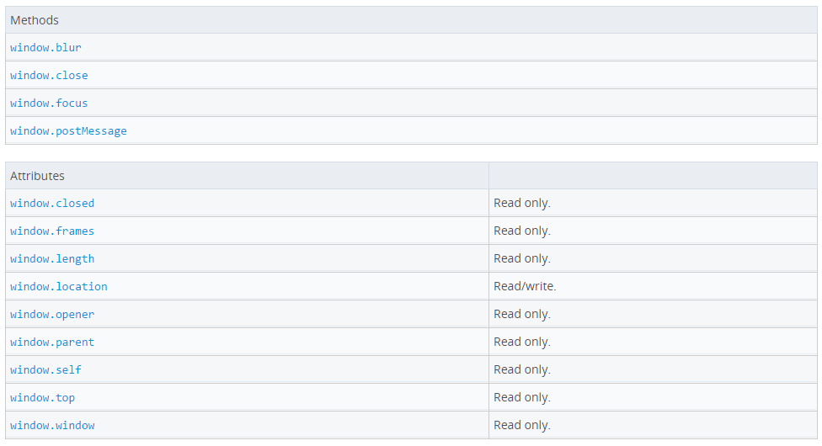

https://developer.mozilla.org/en-US/docs/Web/Security/Same-origin_policy
https://developer.mozilla.org/en-US/docs/Web/HTTP/Access_control_CORS
The same-origin policy restricts how a document or script loaded from one origin can interact with a resource from another origin. It is a critical security mechanism for isolating potentially malicious documents.

Definition of an origin
Two pages have the same origin if the protocol, port (if one is specified), and host are the same for both pages. The following table gives examples of origin comparisons to the URL http://store.company.com/dir/page.html:

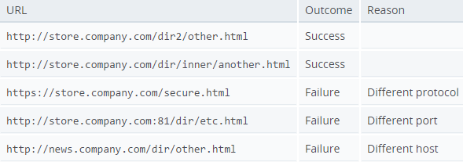

Same-origin policy for file: URIs
In Gecko 1.8 or earlier, any two file: URIs are considered to be same-origin. In other words, any HTML file on your local disk can read any other file on your local disk.
Starting in Gecko 1.9, files are allowed to read only certain other files. Specifically, a file can read another file only if the parent directory of the originating file is an ancestor directory of the target file. Directories cannot be loaded this way, however.
For example, if you have a file foo.html which accesses another file bar.html and you have navigated to it from the file index.html, the load will succeed only if bar.html is either in the same directory as index.html or in a directory contained within the same directory as index.html.
This policy affects anything that does same-origin checks, including XMLHttpRequest, XSLT, and XBL.
For cross-window DOM access, each file is treated as a separate origin, with one exception: if a file is loaded from another file that would otherwise be able to load it following this same-origin policy, they are considered to have the same origin. This load can occur through a subframe, link, location set, call to window.open(), or the like.
For example, if the file /home/user/foo.html is a frameset and one of the frames is /home/user/subdir/bar.html, the frame and frameset are considered to share the same origin. On the other hand, if the file /home/user/subdir/foo.html is a frameset and the frame is/home/user/bar.html, the frame and frameset are considered to have different origins.
The new security.fileuri.strict_origin_policy preference, which defaults to true, can be set to false if the user doesn't want to strictly enforce the same origin policy on file: URIs.

Inherited origins
Content from about:blank and javascript: URLs inherits the origin from the document that loaded the URL, since the URL itself does not give any information about the origin. data: URLs get a new, empty, security context.
Note: Prior to Gecko 6.0, data URLs inherited the security context of the page currently in the browser window if the user enters a data URL into the location bar.

IE Exceptions
Internet Explorer has two major exceptions when it comes to same origin policy
- Trust Zones: if both domains are in highly trusted zone e.g, corporate domains, then the same origin limitations are not applied
- Port: IE doesn't include port into Same Origin components, therefore http://company.com:81/index.html and http://company.com/index.html are considered from same origin and no restrictions are applied.
These exceptions are non-standard and not supported in any other browser but would be helpful if developing an app for Windows RT (or) IE based web application.

Changing origin
A page may change its own origin with some limitations. A script can set the value of document.domain to its current domain or a superdomain of its current domain. If it sets it to a superdomain of its current domain, the shorter domain is used for subsequent origin checks. For example, assume a script in the document at http://store.company.com/dir/other.html executes the following statement:
document.domain = "company.com";
After that statement executes, the page can pass the origin check with http://company.com/dir/page.html (assuminghttp://company.com/dir/page.html sets its document.domain to "company.com" to indicate that it wishes to allow that - see document.domain for more). However, company.com could not set document.domain to othercompany.com since that is not a superdomain of company.com.
The port number is kept separately by the browser. Any call to the setter, including document.domain = document.domain causes the port number to be overwritten with null. Therefore one cannot make company.com:8080 talk to company.com by only setting document.domain = "company.com" in the first. It has to be set in both so that port numbers are both null.

Note: When using document.domain to allow a subdomain to access its parent securely, you need to set document.domain to the same value in both the parent domain and the subdomain. This is necessary even if doing so is simply setting the parent domain back to its original value. Failure to do this may result in permission errors.

Cross-origin network access
The same-origin policy controls interactions between two different origins, such as when you use XMLHttpRequest or an <img> element. These interactions are typically placed in three categories:
- Cross-origin writes are typically allowed. Examples are links, redirects and form submissions. Certain rarely used HTTP requests requirepreflight.
- Cross-origin embedding is typically allowed. Examples are listed below.
- Cross-origin reads are typically not allowed, but read access is often leaked by embedding. For example you can read the width and height of an embedded image, the actions of an embedded script, or the availability of an embedded resource.
Here are some examples of resources which may be embedded cross-origin:
- JavaScript with <script src="..."></script>. Error messages for syntax errors are only available for same-origin scripts.
- CSS with <link rel="stylesheet" href="...">. Due to the relaxed syntax rules of CSS, cross-origin CSS requires a correct Content-Typeheader. Restrictions vary by browser: IE, Firefox, Chrome, Safari (scroll down to CVE-2010-0051) and Opera.
- Images with <img>. Supported image formats include PNG, JPEG, GIF, BMP, SVG, ...
- Media files with <video> and <audio>.
- Plug-ins with <object>, <embed> and <applet>.
- Fonts with @font-face. Some browsers allow cross-origin fonts, others require same-origin fonts.
- Anything with <frame> and <iframe>. A site can use the X-Frame-Options header to prevent this form of cross-origin interaction.

How to allow cross-origin access
A resource makes a cross-origin HTTP request when it requests a resource from a different domain than the one which the first resource itself serves. For example, an HTML page served from http://domain-a.com makes an <img> src request for http://domain-b.com/image.jpg. Many pages on the web today load resources like CSS stylesheets, images and scripts from separate domains.
For security reasons, browsers restrict cross-origin HTTP requests initiated from within scripts. For example, XMLHttpRequest follows the same-origin policy. So, a web application usingXMLHttpRequest could only make HTTP requests to its own domain. To improve web applications, developers asked browser vendors to allow XMLHttpRequest to make cross-domain requests.
The W3C Web Applications Working Group recommends the new Cross-Origin Resource Sharing (CORS) mechanism. CORS gives web servers cross-domain access controls, which enable secure cross-domain data transfers. Modern browsers use CORS in an API container - such asXMLHttpRequest - to mitigate risks of cross-origin HTTP requests.
This article is for web administrators, server developers and front-end developers. Modern browsers handle the client-side components of cross-origin sharing, including headers and policy enforcement. But this new standard means servers have to handle new request and response headers. Another article for server developers discussing cross-origin sharing from a server perspective (with PHP code snippets) is supplementary reading.
This cross-origin sharing standard is used to enable cross-site HTTP requests for:
- Invocations of the XMLHttpRequest API in a cross-site manner, as discussed above.
- Web Fonts (for cross-domain font usage in @font-face within CSS), so that servers can deploy TrueType fonts that can only be cross-site loaded and used by web sites that are permitted to do so.
- WebGL textures.
- Images/video frames drawn to a canvas using drawImage.
- Stylesheets (for CSSOM access).
- Scripts (for unmuted exceptions).

