Q) What is AngularJS?
A) AngularJS is the browser extension for designing single page web applications

Q) What are the building blocks of AngularJS app?
A) Building blocks are:
- Custom attributes called as angular directives in angular world. A directive is an instruction to AngularJS to manipulate a piece of the DOM.
- Work in a module name space Ex – ngMessages, ngResource
- Use dependency injection: Pass the object to the function instead of creating the object inside the function. Ex-
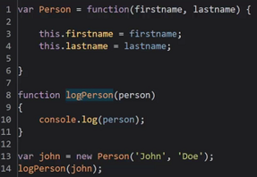
Idea is, logPerson is not dependent on john object. john object can be from a DB or from a network.
- Written AngularJS code is testable. AngularJS built-in services helps on that.
----------------------------------------------------------------------------------------------------------------------------------
Q) What does Browser do?
A)
  - Parse HTML
  - Construct the DOM
  - Combine DOM with CSS
  - Render the DOM
  - Process events(hardware/non-hardware) and invokes event handlers
  - Execute JavaScript on page which can:
- Change the DOM or CSS dynamically
- Rendering engine will render modified DOM
--------------------------------------------------------------------------------------------------------------------------------------
Browsers are event processing machines
Browsers have single execution thread (per tab) performing asynchronous operation
Browser converts hardware events to browser events. For ex- blur event happens after mouse is moved
Event processing follows observer pattern
http://latentflip.com/loupe

Q) How AngularJS extends the browser? Where does the AngularJS get control?
A)
Extends by intercepting the browser’s event-processing loop
Enhancing the browser’s HTML parsing
------------------------------------------------------------------------------------------------------------------------------------

Angular context for event loop
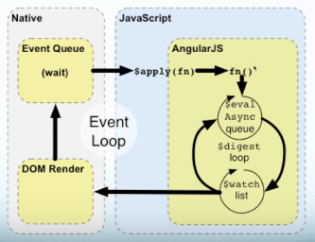

Angular scopes
>The browser has one global scope
>Angular uses multiple scopes created by directives:
Ex- ng-controller, ng-repeat, ng-include, ng-switch etc..
>$digest loop runs against ‘current’ scope
>Setting new angular controller changes the scope
- You can think of a controller as a scope
- It contains methods and variables for a scope
- Angular models are variables within the scope

Browser parser extension by Angularjs
Angular parser parses Angular directives
- Ng-directives (eg. ng-click, ng-class etc..)
- Homegrown directives
Angular parser sets watches
- On page elements(input, checkbox etc..)
- On interpolations {{..}}

-------------------------------------------------------------------------------------------------------------------------------------

The Angular parser and compiler

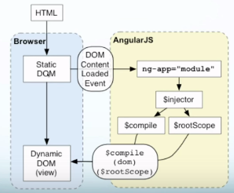

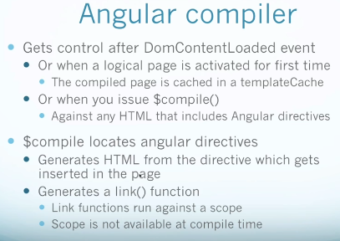

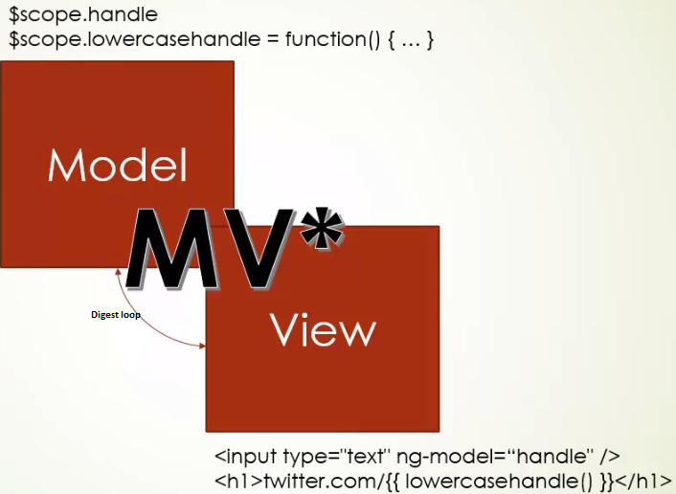

Q) Why $scope.getList() function gets invoked not only on a state change, but on every digest cycle?
In the below code,
<label>
<input type="checkbox" ng-model="showList">
Show unordered list
</label>

<ng-include src="getList()"></ng-include>
$scope.getList() gets invoked on change of $scope.showList by check or uncheck, where $scope.showList is used as,

app3.controller('gListCtrl', function($scope){
$scope.getList = function(){
return $scope.showList ? "ulgrocerylist.html" : "grocerylist.html";
};
});

A)
Because the framework has absolutelly no clue what code is in the getList function. It does not statically analize your code, since it would be both very hard and very inneficient. Due to the nature of how you can use AngularJS, you could be changing the output of getList according to a variable in a completely different controller, service, scope, etc. Thus, this output might need to be re-rendered upon every digest cycle. AngularJS recognizes this, because you have the function call in your template and calls it on every digest to check whether it needs to swap out the template.
Consider this application structure:

<div ng-app="testTest">
<script type="text/ng-template" id="template.html">
<div>Hello world!</div>
</script>
<div ng-controller="templateViewer">
<div>
<div ng-include="content()"></div>
</div>
</div>
<div ng-controller="templateChanger">
<button ng-click="handleClick()">Show / hide content</button>
</div>
</div>
and this code to wire it:
var app = angular.module('testTest', []);
app.factory('template', function() {
return {
show: false
};
});
app.controller('templateChanger', function($scope, template) {
$scope.handleClick = function() {
// toggle showing of template
template.show = !template.show;
};
});
app.controller('templateViewer', function($scope, template) {
// if the result of this function is not re-evaluated on every digest cycle,
// Angular has no idea whether to show or hide the template.
$scope.content = function() {
return template.show ? 'template.html' : '';
};
});
So, the framework needs to rely on this constant re-evaluation of properties and functions that are binded to the templates in the HTML. Since all the data structures that you use are plain javascript objects, and you don't explicitly tell the framework that something in your viewmodel has changed (as you would do by invoking set() methods on your models in other frameworks, such as Backbone or Ember) – angular has to check all variables and re-run all the functions that could possibly change the look of your view, and ng-include is one of these cases.

