jQuery vs ReactJS
List of items. Each item has details which are hidden by default. Whenever user clicks on an item, item will expand and show it’s details. Other items will turn to grey. If we click same item again, it will collapse and items will be in their initial state, collapsed and black. We can also just switch from one expanded item to another, collapsing previous one, expanding new one.

jQuery (JSBin)
$(function() {
$('li').on('click', function(e) {
var $clickedItemDetails = $(e.currentTarget).find('.details');
var $allDetails = $('li .details');

if ($clickedItemDetails.is(':hidden')) {
$allDetails.hide().parent().removeClass('collapsed');
$clickedItemDetails.show();
} else {
$clickedItemDetails.hide();
}

$allDetails.each(function(index, el) {
if ($(el).is(':hidden')) {
$(el).parent().addClass('collapsed');
}
});

if ($('li.collapsed').length === $('li').length) {
$('li').removeClass('collapsed');
}
});
});
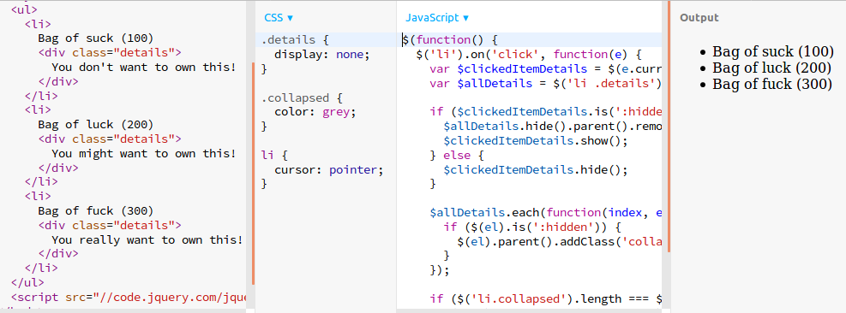
Our data and it’s state are not structured and are spread inside the DOM. Separation between data, state and presentation is vague.
We’re querying the data from the DOM with jQuery’s selectors (like is(':hidden') and .find('.details'). Then we’re changing state directly on the DOM with s, show(), addClass() and removeClass() functions.

React (JSBin)
/** @jsx React.DOM */
var PRODUCTS = [
{
"id": 1, "name": "Bag of suck", "price": 100,
"details": "You don't want to own this!"
},
{
"id": 2, "name": "Bag of luck", "price": 200,
"details": "You might want to own this!"
},
{
"id": 3, "name": "Bag of fuck", "price": 300,
"details": "You really want to own this!"
}
];

var ItemsList = React.createClass({
getInitialState: function() {
return {
expandedProductId: null
};
},

handleProductClick: function(product) {
var newSelectedProductId = product.id;

if (this.state.expandedProductId === product.id) {
newSelectedProductId = null;
}

this.setState({expandedProductId: newSelectedProductId});
},

render: function() {
var self = this, noneSelected = this.state.expandedProductId === null;

var products = PRODUCTS.map(function(product) {
var details, isExpanded = self.state.expandedProductId === product.id;

if (isExpanded) {
details = <div>{product.details}</div>;
}

return (
<li key={product.id}
onClick={self.handleProductClick.bind(self, product)}
className={isExpanded || noneSelected ? '' : 'collapsed'}>
{product.name} ({product.price})
{details}
</li>
);
});

return (
<ul>
{products}
</ul>
);
}
});

React.render(<ItemsList />, document.body);
My first reaction was “wow, more code, this can’t be better”. But it is. Why?
- data is nicely separated in PRODUCTS array
- all the state we have is stored in expandedProductId
- all presentation logic is written in render method
- we can read code top to bottom
- I could easily understand everything it does after quick review (you might not know React yet, but it is fairly easy to learn)

https://facebook.github.io/react/docs/installation.html

