Consider below page:

<html>
<head>
<script src="jquery.js" type="text/javascript"></script>
<script src="abc.js" type="text/javascript">
</script>
<link rel="stylesheets" type="text/css" href="abc.css"></link>
<style>h2{font-wight:bold;}</style>
<script>
$(document).ready(function(){
$("#img").attr("src", "kkk.png");
});
</script>
</head>
<body>
<img id="img" src="abc.jpg" style="width:400px;height:300px;"/>
<script src="kkk.js" type="text/javascript"></script>
</body>
</html>

How does this page load?
What is the sequence of the loading?
When is the JS code executed? (inline and external)
When is the CSS executed (applied)?
When does $(document).ready get executed?
Will abc.jpg be downloaded? Or does it just download kkk.png?

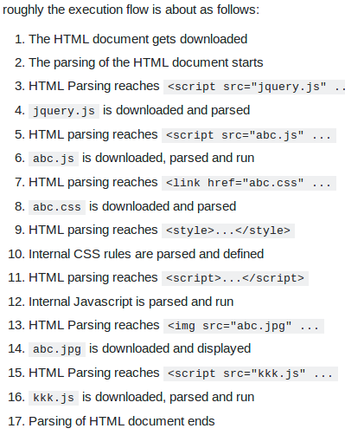

Note that the download may be asynchronous and non-blocking due to behaviours of the browser. For example, in Firefox there is this setting which limits the number of simultaneous requests per domain(host). Read more on this.

Also depending on whether the component has already been cached or not, the component may not be requested again in a near-future request. If the component has been cached, the component will be loaded from the cache instead of the actual URL.

After step 17, document is ready and loaded. Read more.
Now, event onload is fired. Thus when onload is fired, the $("#img").attr("src","kkk.png"); is run. So:
- Document is ready, onload event is fired.
- Javascript execution hits $("#img").attr("src", "kkk.png");
- kkk.png is downloaded and loads into $(“img) of DOM
The $(document).ready() event is actually the event fired when DOM is complete and the page is loaded and ready. Read more.

By default, and from my current understanding, browser usually runs each page on 3 ways: HTML parser, Javascript/DOM, and CSS.

The HTML parser is responsible for parsing and interpreting the markup language and thus must be able to make calls to the other 2 components.

For example when the parser comes across this line:
<a href="#" onclick="alert('test');return false;" style="font-weight:bold">a hypertext link</a>
The parser will make 3 calls, two to Javascript and one to CSS. Firstly, the parser will create this element and register it in the DOM namespace, together with all the attributes related to this element. Secondly, the parser will call to bind the onclick event to this particular element. Lastly, it will make another call to the CSS thread to apply the CSS style to this particular element.

The execution is top down and single threaded. Javascript may look multi-threaded, but the fact is that Javascript is single threaded. This is why when loading external javascript file, the parsing of the main HTML page is suspended.

However, the CSS files can be download simultaneously because CSS rules are always being applied - meaning to say elements are always repainted with the freshest CSS rules defined - thus making it unblocking.

An element will only be available in the DOM after it has been parsed. Thus when working with a specific element, the script is always placed after, or within the window onload event.

Script like this will cause error (on jQuery):
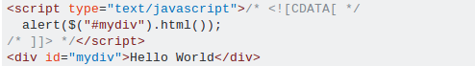

Because when the script is parsed, #mydiv element is still not defined. Instead this would work:
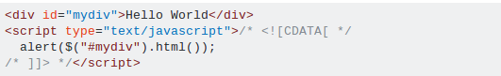

OR
