Mini Emulator-Translator Framework
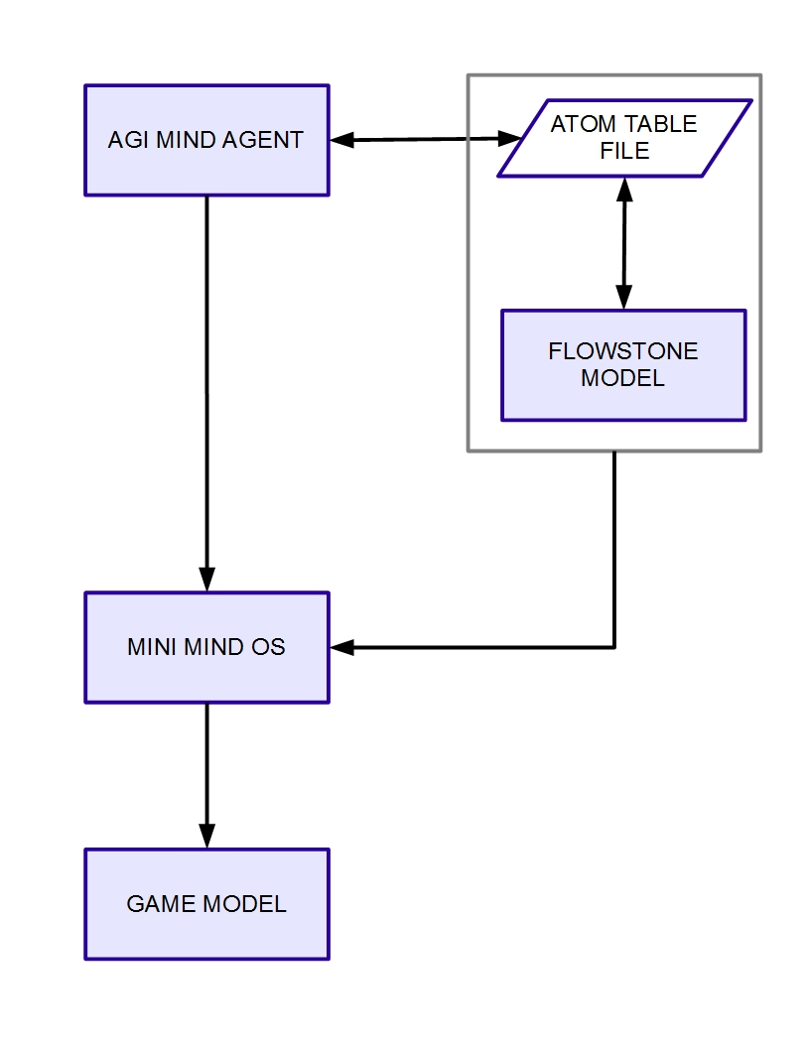
Figure 1. Mini Emulator-Translator Framework illustrated.

The Mini Emulator-Translator (E-T) Framework is a design-science research involving a cross-platform project. The Mini E-T Framework and its components are illustrated by Figure 1. The AGI Mind Agent is derived from the Novamente approach to Artificial General Intelligence (AGI) being pursued by OpenCog. ( http://opencog.org ). The AGI Mind Agent will be developed as part of the Java platform using the NetBeans IDE. ( https://netbeans.org ) The Flowstone Model will be a stand-alone application emulating a Novamente AGI atom space. This model will be developed using DSP Robotics' Flowstone platform. ( http://www.dsprobotics.com ) The Atom Table File is a simple text file that will act as a translator between the two platforms. Together, the AGI Mind Agent and the Flowstone Model with the Atom Table File make up the Mini Mind Operating System (OS). The Mini Mind OS will be one of the components in the Game Model that will also be part of the Java NetBeans platform. Figure 1 also illustrates the outline for this document that will discuss each of the illustrated components in detail.

AGI MIND AGENT
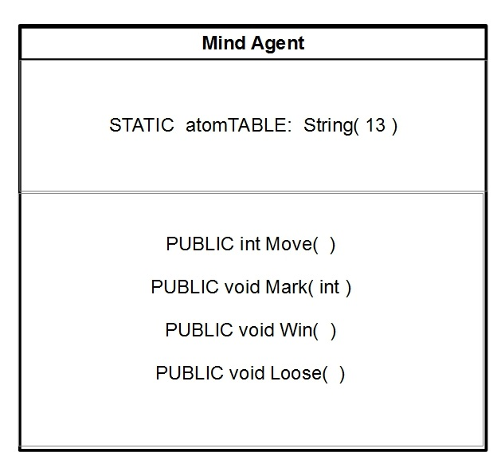
Figure 2. Abbreviated UML class diagram for the AGI Mind Agent.

Figure 2 illustrates an abbreviated UML class diagram for the AGI Mind Agent. The Mind Agent encapsulates a static array of thirteen Stings called the atomTABLE that contains all the data read from the Atom Table File of Figure 1. This makes the Atom Table File data randomly accessible. The Mind Agent also encapsulates four cognitive processes that will operate on the data contained in the atomTable. These four cognitive processes will be described in more detail in a later section.

ATOM TABLE FILE
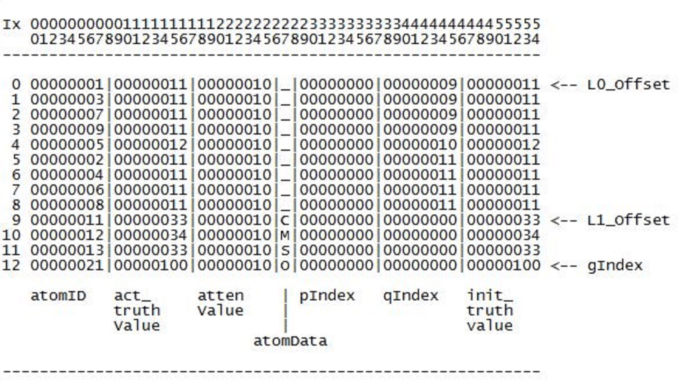
Figure 3a. Physical layout for Atom Table File.

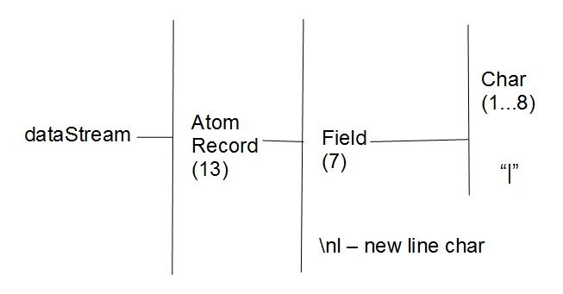
Figure 3b. Warn-Orr diagram illustrating dataStream structure.

Figure 3a shows the physical layout for the Atom Table File. The Atom Table File contains thirteen records of equal length. The horizontal index across the top indicates the column position for each of the fields indicated blow columns. These fields will be discussed in detail in the next section. There is a vertical index in the far left column indicating the index for each record. Both indexes are zero based. To the far right of Figure 3a are the following pointers (top - down):

- L0_Offset is the pointer to the beginning of records for Square Nodes,
- L1_Offset is the pointer to the beginning of records for the Square Type Nodes, and
- The gIndex points to the single record for the Goal Node.

The Square Nodes, Square Type Nodes, and Goal Node will be described later in the section for the Mini Mind OS. While the AGI Mind Agent of the first section will read the Atom Table File record by record, the Mini Mind OS in a latter section will read the file as a continuous string called the dataStream illustrated in Figure 3b. Each field, except the one character atomData field, will be formatted to an eight character, zero packed field. Fields will be separated via the '|' character and each record will be terminated by the new line character '\nl'.

FLOWSTONE MODEL
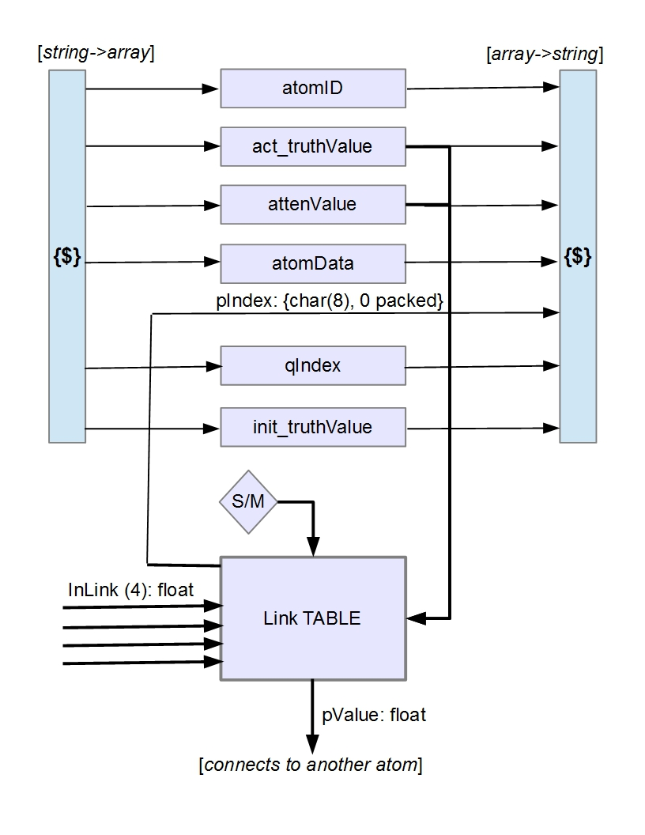
Figure 4. Simple Atom architecture.

Figure 4 illustrates the Simple Atom architecture that is the elemental component of the Flowstone Model. The Simple Atom architecture has two converters, designated “{$}” on the left and the right. The converter on the left takes the dataStream Atom Record of Figure 3b and converts it into an array of atom attributes. The converter on the right takes the array of atom attributes and coverts it back into a dataStream Atom Record . Therefore, the Simple Atom architecture both reads and writes the Atom Table File of Figure 3a. Between the two converters are the following sets of atom attributes:

Basic Data Fields : The following attributes make up the basic data fields. All these fields, except for atomData, are strings representing integers formatted as eight characters with zero packing as shown for the pIndex in Figure 4.
- atomID – is a unique key for each atom and designates the node type for the atom. Ids for Square Nodes are 01,...,09, the Ids for the Square Type Nodes are 11, 12, and 13, and the ID for the Goal Node is 21.
- attenValue – serves as part of the activation mechanism by containing the accumulated times the atom is accessed in a series of tic-tac-toe games.
- atomData – contains a one character data for each atom to be described in the next section.
- qIndex – contains the index to be added to the L0_Offset or L1_Offset which is used for forward chaining Cognitive Processes.

Truth Values: The next set of attributes are the truth values that also serve as part of the activation mechanism.
- act_truthValue – contains either a probability value between 1 and 100 or 0.
- init_truthValue – preserves the initial truth value for the act_truthValue.

Link TABLE, Inputs and Outputs : Figure 4 also shows the Link TABLE with inputs and outputs that server a large role in the activation mechanism.
- Sensory Motor (S/M) – is an immutable Boolean field that is True for Sensory Motor atoms and otherwise False.
- pIndex – contains the index for the maximum of four floating-point values going into the Link TABLE via the physically connected InLinks. This field is formatted as eight characters with zero packing.
- pvalue – is a floating-point value computed according to the S/M input and from the four floating-point values, the act_truthValue, and attenValue going into the Link TABLE according to the following formulas:
  - S/M = false: pValue = ΣInLink(1...4).
  - S/M = true: pValue = act_truthValue(attenValue).

MINI MIND OS
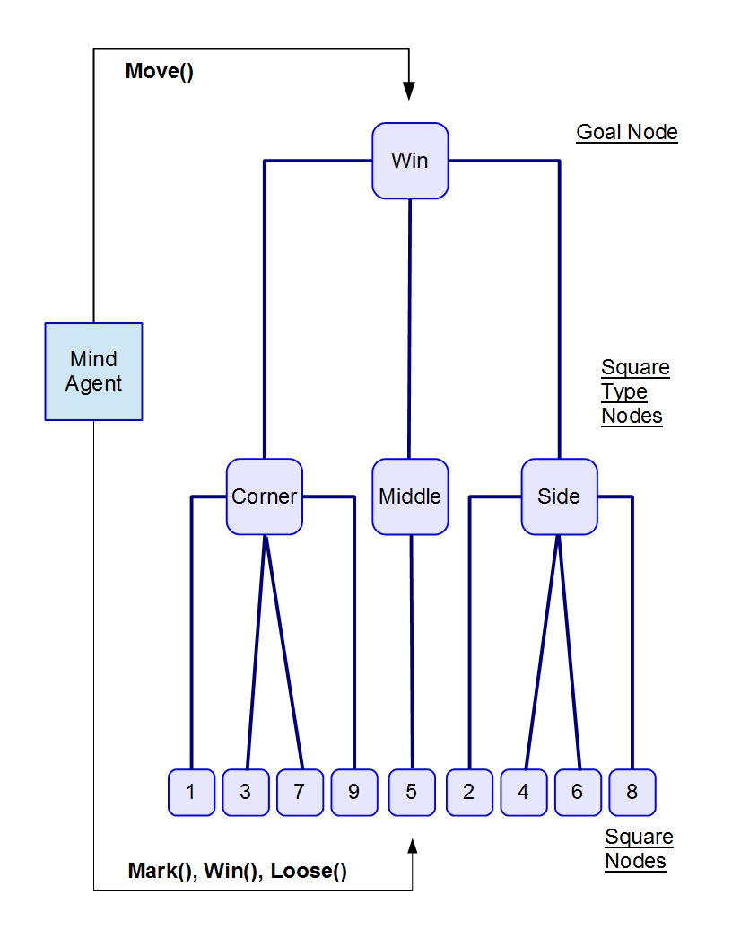
Figure 5. Mini Mind Operating System (OS) architecture.

Figure 5 shows a diagram of the Mini Mind OS architecture. The Mini Mind OS is a composite of the AGI Mind Agent of Figure 2 and the Atom Space of the Flowstone Model.

AGI Mind Agent: The Mini Mind OS architecture has only one Mind Agent that performs the following cognitive processes on the data contained in the Atom Space (see Figure 2).
- Move() - Will do backward processing [from Win Node down to Square Nodes] to find the path having greatest pValues to a terminal square number derived from the Square Node atomID.
- Mark() - will do forward processing [from Square Nodes up to Win Node] to adjust act_truthValues according to the availability of a Square Node and propagate pValues up the atom space hierarchy. Thereby, each Square Type Node will have a pValue equal to the sum of the pValues for the Square Nodes connected to it. Likewise, the Win Node will have a pValue equal to the pValues of the Square Type Nodes connected to it.
- Win() - will do forward processing to increment the attenValues for those nodes participating in a win for 'X' and initialize act_truthValues with corresponding init_truthValues, and set Square Node atomData to the empty character, '_'.
- Loose() - will do forward processing to increment the attenValues for those nodes participating in a tie or a win for 'O' and initialize act_truthValues with corresponding init_truthValues, and set Square Node atomData to the empty character, '_'.

Flowstone Model – Atom Space: Each node in the Atom Space hierarchy represents a Simple Atom of Figure 4. The Atom Space hierarchy is comprised of the following node types;
- Goal Node – where atomData is set to the mark of the winner, 'X' or 'O'.
- Square Type Nodes – where atomData is set accordingly:
  - 'C' for Corner Square Type,
  - 'M' for Middle Square Type, and
  - 'S' for Side Square Type.
- Square Nodes – where atomData will be set accordingly:
  - '_' for empty and available Square Node,
  - 'O' for Square Node marked by the opponent, and
  - 'X' for Square Node marked by the Mini Mind OS.

GAME MODEL
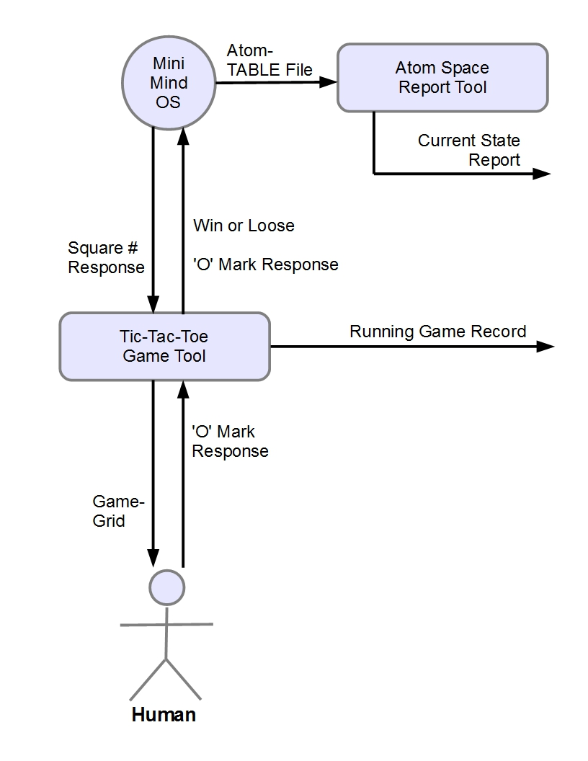
Figure 6a. Game Model illustrated.

Figure 6a Illustrates the Game Model The Game Model has the following four actors with their corresponding roles:
- Human - A human participant will play a series of Tic-Tac-Toe games against the Mini Mind OS. The Mini Mind OS will always play first with an 'X' and the human will play next with an 'O'. The human will communicate their 'O' mark response to the Mini Mind OS via the Tic-Tac-Toe Game Tool.
- Tic-Tac-Toe Game Tool - The game tool will carry out the following functions:
  - Display the current state of the Game Grid with placement of 'X's and 'O's and available empty square numbers. (See Figure 6b)
  - Enable controls for the Human to start a new game or exit the project application.
  - Communicate human moves as an 'O' in a square number to the Mini Mind OS.
  - Communicate to the Mini Mind OS when a win or a loose occurs.
  - Keep and print a running record of who wins {'X' or 'O'} in how many moves. (See Figure 6c)
- Mini Mind OS - The Mini Mind OS will respond to human moves by communicating a square number to the Tic-Tac-Toe Game Tool which will in turn update the square number on the game Grid with an 'X'. The Mini Mind OS will also update the Atom TABLE File which provides the atom data for the Atom Space Report Tool.
- Atom Space Report – Reads the Atom TABLE File and prints a Current State Report as illustrated in Figure 6d.

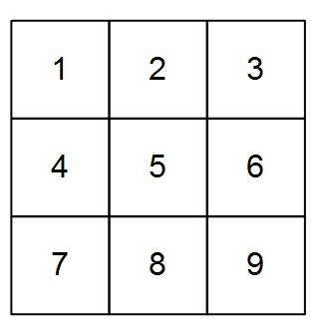
Figure 6b. Tic-Tac-Toe Game Grid illustrated.

Game Grid: Figure 6b illustrates the Tic-Tac-Toe Game Grid. The Game Grid is a composite of nine squares identified by square number 1,...,9. When the Human enters a square number selection, the corresponding square number will be replaced by an 'O'. Likewise, when the Mini Mind OS selects a square number, the corresponding square number will be replaced by an 'X'. A win or a loose occurs when there is a series of the same mark in a row horizontally, vertically, or diagonally.

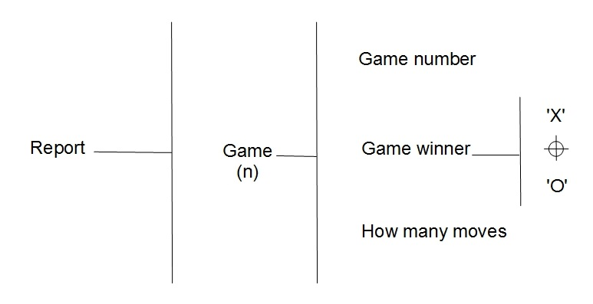
Figure 6c. Warn-Orr diagram for Running Game Record.

Running Game Record: Figure 6c illustrates a Warn-Orr diagram for the Running Game Record produced by the Game Tool actor. As shown by the Warn-Orr structure, each Game will be identified by an unique sequential Game number. Also, each Game line will indicate the Game winner with one character, 'X' or 'O'. Finally each Game will indicate how many moves occurred for a win or a loose.

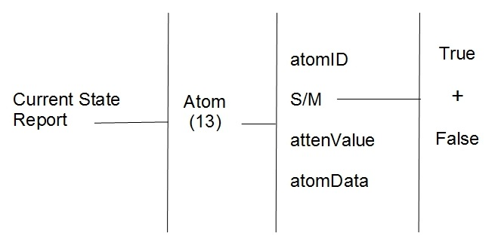
Figure 6d. Warn-Orr diagram for Current State Report.

Current State Report: Figure 6d illustrates a Warn-Orr diagram for the Current State Report produced by the Atom Space Report Tool actor. As illustrated by the Warn-Orr structure, a line for each of thirteen atoms will give the atomID, the S/M state [“True” or “False”], the attenValue, and the atomData for that Atom.

SUMMATION AND DISCUSSION

The Mini E-T Framework is a cross-platform design-science research. The objective of the research is to use a Flowstone Model to emulate the learning function of a hardwired atom space based on the Novamente approach to AGI according to OpenCog.

Hypotheses: The Atom Space of the Flowstone Model is an experiment to prove, or maybe disprove, the following hypotheses.

Hypothesis 1. The Mini Mind OS will loose many of the first games while learning and then start winning games until it becomes unbeatable.

Hypothesis 2. The attention values for Square Type Nodes and Square Nodes will be highest for those nodes involved in winning games.

Results: {…}

Hypothesis 1. {...}

Hypothesis 2. {...}

Further Research and Development: {…}

