ALIGNED PRINT & SCAN
OPERATOR
HANDBOOK
Release 10 Certified Operations Edition
BATCH 3 | PART IX | CHAPTERS 29–40

Contents
Part, Chapter, and numbered subsection entries link to the controlled publication headings.
PART IX — LOAN SIGNING
Chapter 29 — Loan Signing Foundations & Workflow
29.1 Loan Signing Versus Mobile Notary
29.2 Ordering Party Versus Signer
29.3 Role and Signing-Agent Boundaries
29.4 Signing Types
29.5 Signing Methods
29.6 Property and Signing Addresses
29.7 Company, Order, and Escrow Identifiers
29.8 Structured Signers
29.9 Eight Broad APS Stages
29.10 Sensitive Information
29.11 Loan Signing Workflow Map
Chapter 30 — Loan Package Types
30.1 Buyer / Purchase
30.2 Seller
30.3 Refinance
30.4 HELOC
30.5 Loan Modification
30.6 Reverse Mortgage
30.7 Commercial / Custom
Chapter 31 — Common Loan Document Reference
Chapter 32 — Loan Signing Intake & Assignment Review
32.1–32.4 Order, Parties, Identifiers, and Addresses
32.5–32.8 Scope and Instructions
32.9 Assignment Review Procedure
Chapter 33 — Preparing the Loan Signing Quote
33.1–33.5 Quote Inputs
33.6–33.9 Review, Approval, Payment, Revision
Chapter 34 — Loan Signing Status, Operator Action & Customer Communication Sequence
Chapter 35 — Loan Signing Fulfillment Gates
35.1 Ten-Gate Framework
35.2 Gate Rule
Chapter 36 — Package Preparation & Printing
36.1 Package Version Decision Tree
36.2 Authoritative Page Count and Print Volume
36.3 Print and QC Procedure
Chapter 37 — Conducting the Loan Signing
37.1–37.3 Before Leaving, What to Bring, Arrival
37.4–37.9 Identity Through Common Document Presentation
37.10–37.13 Signer Questions and Ordering-Party Contact
37.14–37.16 Stipulations, Table Check, Departure
Chapter 38 — Scanbacks, Approval & Return
38.1–38.4 Requirements, Selection, Upload, Rescan
38.5–38.7 Approval Before Return
38.8–38.10 Physical Return and Completion Readiness
38.11 Scanback → Approval → Return Decision Tree
38.12 Non-Negotiable Hold
Chapter 39 — Loan Signing Exceptions & Financial Resolution
39.1–39.5 Cancellation, No-Sign, Partial, Resign, Cause
39.6 Excessive Wait
39.7–39.11 Stops, Review, Supplemental Invoice, Refund, Resolution
39.12 Loan Signing Exception Decision Tree
39.13 Resign Rule
Chapter 40 — Loan Signing Closeout & Completion
40.1–40.5 Completion Evidence
40.6–40.9 Communication, Timeline, Gate, History
40.10 Closeout Checklist

PART IX — LOAN SIGNING

Chapter 29 — Loan Signing Foundations & Workflow
Purpose: perform this workflow from verified APS and assignment evidence while preserving legal, notarial, financial, privacy, and ordering-party boundaries.
YOU WILL LEARN TO
- Review the authoritative assignment, act within role, stop at blockers, communicate accurately, and leave a complete audit trail.
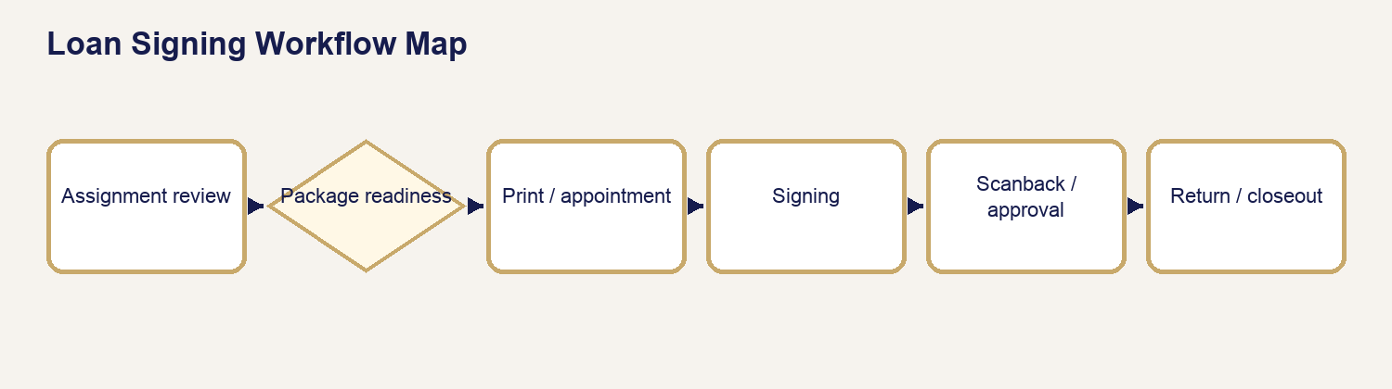
Loan Signing Workflow Map

29.1 Loan Signing Versus Mobile Notary
A Mobile Notary request centers on one or more notarial acts at a location. A Loan Signing assignment centers on a controlled closing package, ordering-party instructions, presentation/signature requirements, possible notarizations, printing, scanbacks, approval, and physical return. The signing agent remains a notary only for actual notarial acts.

29.2 Ordering Party Versus Signer
The ordering party controls assignment scope and operational instructions. The signer controls their own decisions and signatures. Neither relationship authorizes APS to give legal, lending, title, escrow, tax, or financial advice.

29.3 Role and Signing-Agent Boundaries
Present documents neutrally, identify printed information, obtain signatures/initials/dates as instructed, perform authorized notarial acts, preserve package integrity, and report exceptions. Refer interpretation, discrepancies, term questions, and decisions to the designated contact.

29.4 Signing Types
APS recognizes Buyer/Purchase, Seller, Refinance, HELOC, Loan Modification, Reverse Mortgage, Commercial/Complex, and Other/Custom. The actual order and package determine scope.

29.5 Signing Methods
In-person/mobile is the default physical package workflow. RON is used only when the assignment, document, receiving party, platform, law, and APS readiness permit it. “Either/TBD” is a blocker until the authorized method is confirmed.

29.6 Property and Signing Addresses
Keep property address and signing location separate. Verify the actual appointment location, route, access, safety, timezone, and property reference without assuming they are the same.

29.7 Company, Order, and Escrow Identifiers
Record the ordering company, company file/order number, escrow/transaction number, and other authorized identifiers exactly. Do not place unnecessary account or taxpayer data in ordinary notes.

29.8 Structured Signers
Maintain each signer’s full legal name, role/capacity, contact path, confirmation requirement, and relationship to documents. Do not collapse multiple signers into a note.

29.9 Eight Broad APS Stages
Assignment review → package readiness → printing/QC → appointment readiness → signing → scanbacks/approval → return → completion. The ten-gate framework in Chapter 35 adds financial and exception resolution controls.

29.10 Sensitive Information
Protect loan numbers, taxpayer data, bank details, IDs, nonpublic personal information, and package contents. Use approved storage/communication, not ordinary email or screenshots.

29.11 Loan Signing Workflow Map
Order received → assignment/instructions reviewed → quote/authorization → package/version received → print/QC → appointment/signer confirmation → table signing/notarization → table check → scanback/approval when required → physical return/tracking when required → exception/financial resolution → closeout.

Chapter 30 — Loan Package Types
Purpose: perform this workflow from verified APS and assignment evidence while preserving legal, notarial, financial, privacy, and ordering-party boundaries.
YOU WILL LEARN TO
- Review the authoritative assignment, act within role, stop at blockers, communicate accurately, and leave a complete audit trail.

30.1 Buyer / Purchase
Purpose: transfer/acquire property while funding a new loan and completing settlement. Expect borrower loan documents, title/settlement documents, possible deed-side documents, disclosures, affidavits, and property/product riders.
Document | What it is / why it appears | Signer usually does | Commonly notarized? | Operator focus / referral
Closing Disclosure | final disclosed loan/cost summary | reviews and signs/acknowledges | usually no | signatures only; refer figures
Note | promise to repay | signs | usually no | names, dates, package version
Security Instrument | secures debt with property | owners/borrowers sign | commonly; inspect certificate | capacities, riders, certificate
Title/Settlement forms | closing/disbursement/title requirements | signs assigned forms | varies | preserve order; refer title questions
Occupancy/Name affidavits | transaction representations | reviews and signs | often varies | no coaching; actual certificate controls

30.2 Seller
Seller packages center on conveyance, title/settlement, payoff, proceeds, identity, and seller representations. They may be shorter than borrower packages but can contain high-consequence deeds and affidavits.
Document | Why it appears | Signer usually does | Commonly notarized? | Operator focus / caution
Deed | conveyance | grantor signs | commonly | exact capacity/certificate; no deed advice
Seller affidavits | title/transaction facts | reads, supplies facts, signs | frequently varies | no factual coaching
Settlement statement | proceeds/cost accounting | reviews/signs | usually no | refer financial discrepancies
Payoff authorization | permits payoff information/action | signs | varies | protect account information
Closing instructions | controls execution/return | follows assigned acknowledgments | varies | orderer controls

30.3 Refinance
Refinance replaces or changes financing on existing property. Packages commonly include Closing Disclosure, note, security instrument, rescission notice when applicable, escrow/payment information, affidavits, riders, and title documents.
Document | Why it appears | Signer usually does | Commonly notarized? | Operator focus / caution
Closing Disclosure | final terms/costs | reviews/signs | usually no | do not interpret figures
Note | repayment obligation | signs | usually no | version/signature
Security Instrument | collateral | signs | commonly | actual certificate
Right to Cancel | covered rescission notice | dates/acknowledges receipt | no | do not calculate disputed deadline
Affidavits/Compliance | representations/corrections | signs | varies | refer legal questions

30.4 HELOC
HELOC packages concern a revolving line secured by property. Actual Texas home-equity and lender instructions are critical; never generalize product or legal requirements.
Document | Why it appears | Signer usually does | Commonly notarized? | Operator focus / caution
HELOC Agreement/Note | line terms/repayment | signs/initials | usually no | no rate/draw advice
HELOC Security Instrument | secures line | owners sign | commonly | actual certificate/capacity
Disclosures | product/cost information | acknowledges | usually no | refer lender questions
Right to Cancel when applicable | rescission notice | acknowledges/dates | no | printed instructions control

30.5 Loan Modification
Modification packages document lender/servicer-approved changes to an existing obligation. Do not imply that signing guarantees a particular servicing outcome.
Document | Why it appears | Signer usually does | Commonly notarized? | Operator focus / caution
Modification Agreement | states approved changes | signs | may be | correct loan/borrower/version
Affidavits/Certifications | supports eligibility/facts | reads/signs | varies | no coaching
Payment Instructions | operational next step | reviews/retains | no | do not accept payment unless authorized
Security-related instrument | records/continues collateral change | signs | often varies | actual certificate controls

30.6 Reverse Mortgage
Reverse Mortgage packages may contain multiple notes/security instruments, a loan agreement, payment-plan disclosures, certifications, riders, and non-borrowing-spouse documents. Provide time and neutral organization; refer counseling/product questions.
Document | Why it appears | Signer usually does | Commonly notarized? | Operator focus / caution
Note(s) | evidence debt structure | borrowers sign | usually no | paired documents/version
Mortgage(s)/Security Instruments | secure obligations | required parties sign | commonly | paired certificates/riders
Loan Agreement/Disclosures | program terms/responsibilities | reviews/signs | varies | no product advice
NBS documents | defined spouse capacity | named spouse signs | varies | never determine eligibility/rights

30.7 Commercial / Custom
Commercial/custom packages vary by entity, authority, counsel, property, and negotiated terms. Require explicit instructions and capacity evidence; source-note unfamiliar instruments.
Document | Why it appears | Signer usually does | Commonly notarized? | Operator focus / caution
Note/Security documents | debt/collateral | authorized representative signs | varies | entity/capacity and certificate
Resolutions/Authority | proves signing authority | signs/certifies if directed | varies | do not decide sufficiency
Guarantees | supports obligation | guarantor signs | varies | no legal explanation
Custom closing documents | negotiated requirements | signs as assigned | varies | ordering party/counsel controls

Chapter 31 — Common Loan Document Reference
Purpose: perform this workflow from verified APS and assignment evidence while preserving legal, notarial, financial, privacy, and ordering-party boundaries.
YOU WILL LEARN TO
- Review the authoritative assignment, act within role, stop at blockers, communicate accurately, and leave a complete audit trail.

31.1 Critical Notarization Rule
COMMONLY NOTARIZED DOES NOT MEAN ALWAYS NOTARIZE. Actual authority comes from the actual document, its actual certificate, applicable law, and authorized assignment instructions. Never add a certificate merely because a similar document is often notarized.

31.2 Closing Disclosure
Reference field | Maintained training guidance
Common package(s) | Buyer/Purchase; Refinance; some HELOC
What it is | CFPB-mandated disclosure summarizing final loan terms, projected payments, and closing costs.
Why it appears | Allows the borrower to review the transaction’s final disclosed financial terms.
Signer interaction | Signer reviews and signs or acknowledges receipt where the package directs.
Operator focus | Locate signatures/dates and follow presentation instructions without interpreting figures.
Commonly notarized? | Usually no; verify the actual form.
Presentation guidance | Identify the title and direct the signer to the disclosed sections without characterizing the deal.
Do not | Do not explain whether APR, cash to close, fees, or terms are correct or favorable.
If signer has a question | Refer financial, lender, settlement, and discrepancy questions to the named lender/title contact.
Source | Consumer Financial Protection Bureau — Closing Disclosure and closing-document guidance.

31.3 Promissory Note
Reference field | Maintained training guidance
Common package(s) | Buyer/Purchase; Refinance; HELOC or product-specific note; Reverse Mortgage note(s)
What it is | The borrower’s written promise to repay under stated terms.
Why it appears | Evidence of the debt and repayment obligation.
Signer interaction | Borrower signs exactly as directed; initials may appear where specified.
Operator focus | Names, signature capacity, required dates, and package-version integrity.
Commonly notarized? | Usually no; verify actual document/certificate.
Presentation guidance | State that it is the note and point to the lender-provided payment/term sections if instructed.
Do not | Do not interpret interest, default, prepayment, or enforceability.
If signer has a question | Refer term/payment/legal questions to lender or ordering party.
Source | CFPB closing guidance; Fannie Mae/Freddie Mac Uniform Notes; HUD HECM model notes.

31.4 Deed of Trust / Mortgage / Security Instrument
Reference field | Maintained training guidance
Common package(s) | Buyer/Purchase; Refinance; HELOC; Reverse Mortgage security instruments
What it is | Instrument securing the debt with an interest in the described property.
Why it appears | Creates the collateral/security relationship and is generally recorded.
Signer interaction | Required property owners/borrowers sign in stated capacities.
Operator focus | Correct version, property/address context, names/capacities, riders, signatures, certificate.
Commonly notarized? | Commonly, but not automatically; inspect the actual certificate and instructions.
Presentation guidance | Identify the document and signature/certificate locations only.
Do not | Do not explain foreclosure, lien priority, homestead effect, or legal consequences.
If signer has a question | Refer legal/property/title questions to lender/title/attorney.
Source | CFPB closing guidance; Fannie Mae/Freddie Mac Uniform Security Instruments; HUD model mortgages.

31.5 Notice of Right to Cancel
Reference field | Maintained training guidance
Common package(s) | Certain refinance/home-secured credit transactions; not ordinary purchase closings
What it is | Notice of a statutory rescission period when applicable.
Why it appears | Provides required cancellation timing and method for covered transactions.
Signer interaction | Signer acknowledges receipt and dates/copies as directed.
Operator focus | Correct transaction/date/copy count and ordering-party instructions.
Commonly notarized? | Usually no.
Presentation guidance | Point to the printed deadline/method without calculating or advising.
Do not | Do not tell a signer whether a transaction is rescindable or calculate a disputed deadline.
If signer has a question | Refer coverage/deadline questions to lender/title or legal counsel.
Source | Consumer Financial Protection Bureau — right of rescission guidance.

31.6 Initial Escrow Account Disclosure
Reference field | Maintained training guidance
Common package(s) | Purchase; Refinance when escrow applies
What it is | Estimate of escrow deposits and projected disbursements.
Why it appears | Explains how taxes/insurance may be collected and paid from escrow.
Signer interaction | Signer reviews and signs/acknowledges if directed.
Operator focus | Signature/acknowledgment placement and package completeness.
Commonly notarized? | Usually no.
Presentation guidance | Identify the escrow disclosure and let the signer review figures.
Do not | Do not predict shortages, tax changes, or future payments.
If signer has a question | Refer calculation questions to lender/servicer.
Source | CFPB mortgage-closing guidance and actual lender disclosure.

31.7 First Payment Letter / Payment Coupon
Reference field | Maintained training guidance
Common package(s) | Purchase; Refinance; some modifications
What it is | Operational payment instructions showing initial due date, amount, and destination.
Why it appears | Helps the borrower make the first scheduled payment.
Signer interaction | Signer reviews and retains the appropriate copy.
Operator focus | Do not separate borrower-retained pages from the package incorrectly.
Commonly notarized? | No, absent an unusual actual certificate.
Presentation guidance | Point to the printed instructions.
Do not | Do not change payment instructions or accept payment unless expressly authorized.
If signer has a question | Refer servicing/payment questions to lender/servicer.
Source | Actual lender/servicer document and assignment instructions.

31.8 Occupancy Affidavit
Reference field | Maintained training guidance
Common package(s) | Purchase; Refinance; some investment/second-home loans
What it is | Statement concerning intended or actual occupancy.
Why it appears | Supports underwriting and loan-program representations.
Signer interaction | Signer reads, completes only permitted factual blanks, and signs as directed.
Operator focus | Names, property, permitted completion, signature, and actual certificate.
Commonly notarized? | Often contains a certificate; verify actual document.
Presentation guidance | Invite the signer to read the statement and answer only for themselves.
Do not | Do not advise which occupancy status to select.
If signer has a question | Refer classification/legal questions to lender/title.
Source | Actual package; Fannie Mae special-purpose forms where applicable.

31.9 Signature / Name Affidavit
Reference field | Maintained training guidance
Common package(s) | Purchase; Refinance; Seller; HELOC; other packages
What it is | Statement connecting name variations or signatures to the signer.
Why it appears | Supports identity/name consistency across transaction records.
Signer interaction | Signer reviews listed variations, reports inaccuracies, and signs as directed.
Operator focus | Never force acceptance of an incorrect name; inspect actual certificate.
Commonly notarized? | Commonly, but verify actual certificate.
Presentation guidance | Ask the signer to review each variation and refer corrections.
Do not | Do not invent aliases or tell the signer to claim a name they dispute.
If signer has a question | Pause and contact ordering party for inaccurate/missing variations.
Source | Actual title/lender package and authorized instructions.

31.10 Compliance Agreement / Errors & Omissions Agreement
Reference field | Maintained training guidance
Common package(s) | Purchase; Refinance; HELOC; some seller packages
What it is | Agreement to cooperate with permitted post-closing corrections or omitted administrative items.
Why it appears | Supports correction of defined clerical/compliance issues.
Signer interaction | Signer reads and signs as directed.
Operator focus | Document title, signature and actual certificate; distinguish from E&O insurance.
Commonly notarized? | May be; verify the actual certificate.
Presentation guidance | Identify the document without describing the scope beyond its text.
Do not | Do not promise what corrections may be demanded or interpret legal limits.
If signer has a question | Refer scope/legal-effect questions to lender/title.
Source | Actual lender/title document; package instructions.

31.11 IRS / Tax Forms (for example W-9, 4506-C where present)
Reference field | Maintained training guidance
Common package(s) | Varies by lender/product
What it is | Taxpayer identification or transcript authorization forms included for the transaction.
Why it appears | Supports lender verification/reporting requirements.
Signer interaction | Signer verifies taxpayer information and signs as directed.
Operator focus | Correct form/version, signature/date, no copying sensitive data into APS notes.
Commonly notarized? | Usually no.
Presentation guidance | Identify the form and signature area only.
Do not | Do not provide tax advice or complete taxpayer elections.
If signer has a question | Refer tax/content questions to lender or tax professional.
Source | Actual IRS/lender form and package instructions.

31.12 Insurance Documents
Reference field | Maintained training guidance
Common package(s) | Purchase; Refinance; Reverse Mortgage; some HELOC
What it is | Evidence, authorization, or acknowledgment concerning required property insurance.
Why it appears | Supports collateral protection and closing conditions.
Signer interaction | Signer reviews and signs/acknowledges where directed.
Operator focus | Keep policy/data pages in order and protect personal information.
Commonly notarized? | Usually no unless actual certificate says otherwise.
Presentation guidance | Identify as insurance-related package material.
Do not | Do not advise coverage sufficiency or policy selection.
If signer has a question | Refer to insurer/lender/title.
Source | Actual insurer/lender/title documents.

31.13 Title and Settlement Documents
Reference field | Maintained training guidance
Common package(s) | Purchase; Seller; Refinance; HELOC; Commercial/Custom
What it is | Title, settlement, closing, disbursement, and ownership-related documents prepared for the transaction.
Why it appears | Coordinate conveyance, settlement, payoff, fees, and title requirements.
Signer interaction | Parties review and sign the forms assigned to them.
Operator focus | Ordering-party instructions, capacity, signature lines, notarization certificate, copy/return requirements.
Commonly notarized? | Varies; inspect each actual document.
Presentation guidance | Present by exact title and keep the package order.
Do not | Do not interpret title condition, ownership, prorations, or legal effect.
If signer has a question | Refer to title/escrow/attorney.
Source | Actual title/settlement package; CFPB closing guidance where applicable.

31.14 Deed
Reference field | Maintained training guidance
Common package(s) | Seller; Purchase; some estate/entity/custom closings
What it is | Instrument conveying an interest in real property.
Why it appears | Transfers the described property interest when validly executed/delivered/recorded.
Signer interaction | Authorized grantor(s) sign in stated capacity.
Operator focus | Exact names/capacities, property reference, signature, witnesses if required, actual certificate.
Commonly notarized? | Commonly, but actual deed/certificate/law controls.
Presentation guidance | Identify the deed and signature/certificate areas.
Do not | Do not choose deed type, advise ownership effect, or alter legal description.
If signer has a question | Refer to title/attorney/orderer.
Source | Actual deed and jurisdiction/ordering-party authority.

31.15 Seller Affidavits
Reference field | Maintained training guidance
Common package(s) | Seller
What it is | Seller statements about ownership, liens, occupancy, repairs, identity, or transaction facts.
Why it appears | Supports title/settlement review and risk allocation.
Signer interaction | Seller reads, supplies only their facts, and signs as directed.
Operator focus | No coaching; verify actual certificate and completeness.
Commonly notarized? | Frequently but variably; inspect actual form.
Presentation guidance | Ask the seller to review the statement and refer uncertainty.
Do not | Do not answer factual/legal questions for the seller.
If signer has a question | Refer to title/attorney/orderer.
Source | Actual title/settlement package.

31.16 Payoff Authorization
Reference field | Maintained training guidance
Common package(s) | Seller; Refinance; some modifications
What it is | Authorization to obtain, confirm, or transmit payoff information.
Why it appears | Supports satisfaction of existing obligations at closing.
Signer interaction | Authorized party reviews account/property information and signs.
Operator focus | Correct account/party, privacy, signature, and transmission path.
Commonly notarized? | Varies; verify actual document.
Presentation guidance | Identify the authorization and protect account information.
Do not | Do not calculate payoff or promise disbursement timing.
If signer has a question | Refer to title/lender/servicer.
Source | Actual title/lender/servicer form.

31.17 HELOC Agreement / Note
Reference field | Maintained training guidance
Common package(s) | HELOC
What it is | Product-specific agreement or note governing a revolving home-equity line.
Why it appears | States borrowing, repayment, advance, rate, and account terms.
Signer interaction | Borrower signs/initials as directed.
Operator focus | Correct product/version, signatures, and package instructions.
Commonly notarized? | Usually no; verify actual document.
Presentation guidance | Identify it as the HELOC agreement/note.
Do not | Do not explain draws, rates, tax effects, or suitability.
If signer has a question | Refer to lender.
Source | Actual lender document; Fannie Mae special-purpose guidance where applicable.

31.18 HELOC Security Instrument
Reference field | Maintained training guidance
Common package(s) | HELOC
What it is | Instrument securing the HELOC with the property.
Why it appears | Creates the product’s collateral relationship and may be recorded.
Signer interaction | Required owners/borrowers sign in stated capacities.
Operator focus | Names, property, riders, signatures, and actual certificate.
Commonly notarized? | Commonly; actual certificate controls.
Presentation guidance | Identify title/signature/certificate locations.
Do not | Do not explain lien priority or Texas home-equity law.
If signer has a question | Refer to lender/title/attorney.
Source | Actual lender/title instrument and applicable authoritative instructions.

31.19 Loan Modification Agreement
Reference field | Maintained training guidance
Common package(s) | Loan Modification
What it is | Agreement changing specified terms of an existing loan.
Why it appears | Documents the servicer/lender-approved modification.
Signer interaction | Borrower reviews and signs as directed.
Operator focus | Correct borrower/loan/version, signature/date, and actual certificate.
Commonly notarized? | May be; verify actual document.
Presentation guidance | Identify the agreement and let the signer read the stated changes.
Do not | Do not explain eligibility, affordability, or legal consequences.
If signer has a question | Refer to servicer/lender/housing counselor or attorney.
Source | Actual servicer/lender agreement; HUD model modification documents where applicable.

31.20 Reverse Mortgage Note(s)
Reference field | Maintained training guidance
Common package(s) | Reverse Mortgage
What it is | HECM or proprietary reverse-mortgage debt instrument(s); HUD HECM packages may contain multiple notes.
Why it appears | Evidence obligations under the reverse-mortgage structure.
Signer interaction | Borrower(s) sign as directed; package may distinguish first/second instruments.
Operator focus | Do not omit paired documents; verify names, capacities, versions, signatures.
Commonly notarized? | Usually no; verify actual document.
Presentation guidance | Identify each note by its exact title and sequence.
Do not | Do not explain loan economics, benefits, or estate consequences.
If signer has a question | Refer to lender/counselor/title/attorney.
Source | HUD HECM model documents; actual proprietary package.

31.21 Reverse Mortgage Security Instrument(s)
Reference field | Maintained training guidance
Common package(s) | Reverse Mortgage
What it is | HECM/proprietary mortgage or deed-of-trust instruments; HUD HECM may include first and second instruments.
Why it appears | Secures obligations under the reverse-mortgage structure.
Signer interaction | Required borrowers/owners sign in stated capacities.
Operator focus | Paired instruments, riders, property, signatures, certificates, package order.
Commonly notarized? | Commonly; actual certificate controls.
Presentation guidance | Present each instrument by exact title.
Do not | Do not interpret lien structure, foreclosure, occupancy, or succession rights.
If signer has a question | Refer to lender/title/counselor/attorney.
Source | HUD HECM model mortgages; actual package.

31.22 Reverse Mortgage Disclosures / Loan Agreement
Reference field | Maintained training guidance
Common package(s) | Reverse Mortgage
What it is | Program/product disclosures and agreement describing advances, charges, payment plan, and borrower responsibilities.
Why it appears | Documents program terms and required acknowledgments.
Signer interaction | Borrower reviews and signs/acknowledges as directed.
Operator focus | Correct versions, all required signatures, retain copies, no interpretation.
Commonly notarized? | Varies; inspect actual document.
Presentation guidance | Identify exact document names and allow appropriate review time.
Do not | Do not recommend payment options or explain financial suitability.
If signer has a question | Refer to lender/HECM counselor/attorney.
Source | HUD HECM model documents and actual lender package.

31.23 Non-Borrowing Spouse Documents
Reference field | Maintained training guidance
Common package(s) | Reverse Mortgage; jurisdiction/product dependent
What it is | Certifications, acknowledgments, or property-right documents for an eligible or other non-borrowing spouse.
Why it appears | Addresses program and property-right requirements defined by the actual transaction.
Signer interaction | Named spouse reviews and signs only documents assigned to that capacity.
Operator focus | Identity/capacity, correct document set, signatures, actual certificates.
Commonly notarized? | Varies; inspect every actual form.
Presentation guidance | Use the package’s exact capacity language.
Do not | Do not determine eligibility, property rights, or future occupancy protections.
If signer has a question | Refer to lender/title/HECM counselor/attorney.
Source | HUD Borrower and Non-Borrowing Spouse Certifications; actual package.

Chapter 32 — Loan Signing Intake & Assignment Review
Purpose: perform this workflow from verified APS and assignment evidence while preserving legal, notarial, financial, privacy, and ordering-party boundaries.
YOU WILL LEARN TO
- Review the authoritative assignment, act within role, stop at blockers, communicate accurately, and leave a complete audit trail.

32.1–32.4 Order, Parties, Identifiers, and Addresses
Verify orderer/customer, all structured signers/capacities, company/order/escrow identifiers, property address, signing address, date/time/timezone, access, and contact path.

32.5–32.8 Scope and Instructions
Confirm signing type/method, package status, print requirements/copies, signer confirmation, scanbacks, approval-before-return, physical return, shipping label, stipulations, and source of every instruction.

32.9 Assignment Review Procedure
1. Open the exact request and Loan Signing assignment.
2. Compare order, signers, identifiers, addresses, and appointment.
3. Read all authoritative instructions; enter each requirement with source and applicability.
4. Identify missing/conflicting facts and stop advancement.
5. Record review completion only after scope is coherent.

Chapter 33 — Preparing the Loan Signing Quote
Purpose: perform this workflow from verified APS and assignment evidence while preserving legal, notarial, financial, privacy, and ordering-party boundaries.
YOU WILL LEARN TO
- Review the authoritative assignment, act within role, stop at blockers, communicate accurately, and leave a complete audit trail.

33.1–33.5 Quote Inputs
Verify package type/complexity, page count/version, print sets and borrower copies, appointment/travel, scanbacks, approval hold, return method, after-hours/rush, and authorized custom items. Do not price from an unreceived package when print volume materially controls price unless the uncertainty is explicit and authorized.

33.6–33.9 Review, Approval, Payment, Revision
Review the customer/orderer-facing scope, send the current version, record authorized approval, and satisfy prepaid or authorized Business terms. Revise for package, appointment, printing, scanback, return, wait/resign, or other scope change without rewriting paid history.

Chapter 34 — Loan Signing Status, Operator Action & Customer Communication Sequence
Purpose: perform this workflow from verified APS and assignment evidence while preserving legal, notarial, financial, privacy, and ordering-party boundaries.
YOU WILL LEARN TO
- Review the authoritative assignment, act within role, stop at blockers, communicate accurately, and leave a complete audit trail.
Stage | Operator action | Ordering-party/signer communication | Do not advance until
Assignment received | review order and instructions | acknowledgment where maintained | scoped assignment
Information/package needed | request exact missing item | orderer-directed message | blocker resolved
Quote/authorization | send reviewed quote | current quote/authorization | approved version
Package received/replaced | identify active version | package receipt/change notice if needed | version authority clear
Print/QC | print active version and inspect | readiness/issue message | print gate passes
Appointment | confirm signer/time/location | confirmation/reminder | signer/appointment ready
Signing | conduct within boundaries | orderer contact for questions/stops | table check complete
Scanback | scan/QC/upload | scanback status | required pages accepted
Approval hold | wait for approval | concise orderer follow-up | approval received or instruction changes
Return | package/label/drop-off/tracking | tracking/return notice | return evidence complete
Exception/financial | record cause and decision | approved exception message | operational/financial resolution
Completion | verify all gates | closeout communication | ten gates pass

Chapter 35 — Loan Signing Fulfillment Gates
Purpose: perform this workflow from verified APS and assignment evidence while preserving legal, notarial, financial, privacy, and ordering-party boundaries.
YOU WILL LEARN TO
- Review the authoritative assignment, act within role, stop at blockers, communicate accurately, and leave a complete audit trail.
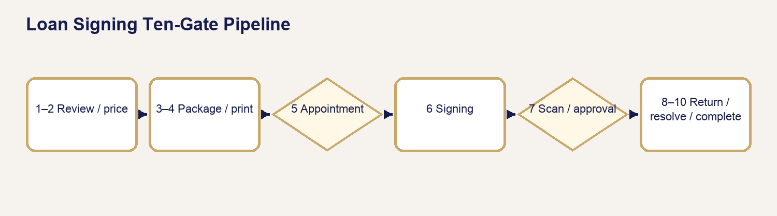
Loan Signing Ten-Gate Pipeline

35.1 Ten-Gate Framework
1. Assignment Review.
2. Pricing / Financial Readiness.
3. Package Readiness.
4. Printing / QC.
5. Appointment Readiness.
6. Signing Completion.
7. Scanback / Approval.
8. Physical Return.
9. Exception / Financial Resolution.
10. Final Completion.

35.2 Gate Rule
Each gate records purpose, required conditions, operator location, APS display, blocker, communication, authorized override if any, prohibited bypass, and next stage. “Not applicable” must be supported by assignment facts—not selected to make completion easier.

Chapter 36 — Package Preparation & Printing
Purpose: perform this workflow from verified APS and assignment evidence while preserving legal, notarial, financial, privacy, and ordering-party boundaries.
YOU WILL LEARN TO
- Review the authoritative assignment, act within role, stop at blockers, communicate accurately, and leave a complete audit trail.
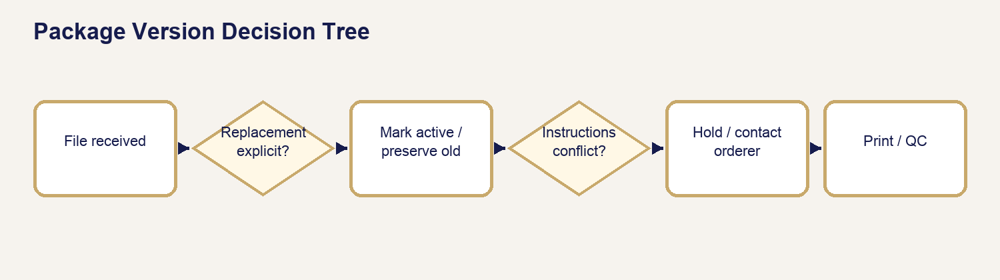
Package Version Decision Tree

36.1 Package Version Decision Tree
New file received? Compare source/order/timestamp/instructions. Explicit replacement? Preserve prior version, mark new active version, recalculate page/print facts, and repeat QC. Ambiguous? Hold and contact orderer. Never combine pages across versions without written authority.

36.2 Authoritative Page Count and Print Volume
Source pages × signing sets/borrower/additional copies determines expected printed pages; sidedness informs expected sheets. Use verified source count and record the package version.

36.3 Print and QC Procedure
1. Confirm active version and instructions.
2. Verify page size, mixed letter/legal needs, scale, sidedness, color, sets, and borrower copies.
3. Print one controlled set; compare count/order/quality.
4. Print remaining authorized sets.
5. Conduct final count/order/legibility/orientation check.
6. Keep copies separated and protected.

Chapter 37 — Conducting the Loan Signing
Purpose: perform this workflow from verified APS and assignment evidence while preserving legal, notarial, financial, privacy, and ordering-party boundaries.
YOU WILL LEARN TO
- Review the authoritative assignment, act within role, stop at blockers, communicate accurately, and leave a complete audit trail.
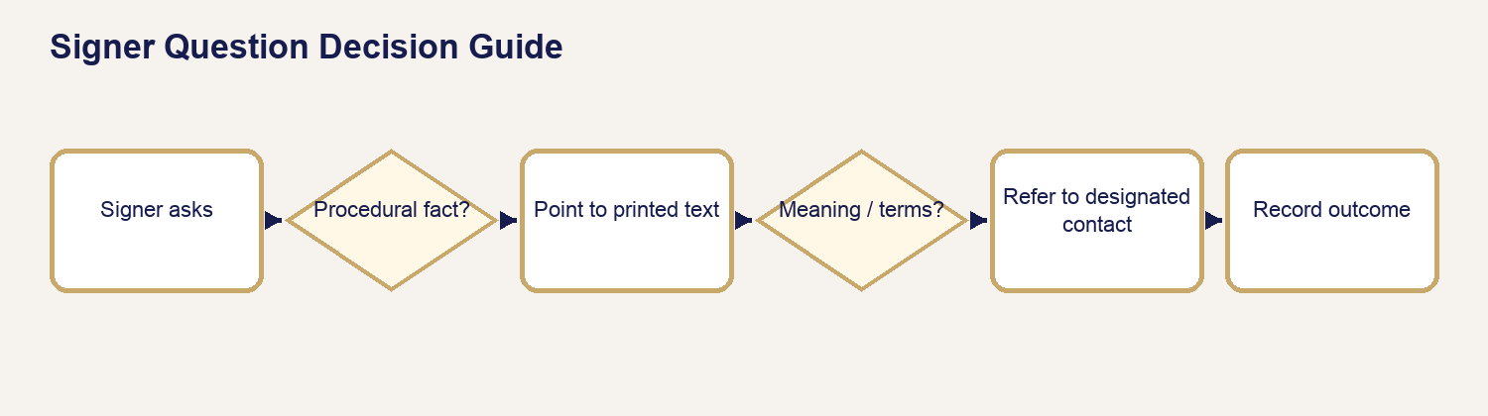
Signer Question Decision Guide

37.1–37.3 Before Leaving, What to Bring, Arrival
Verify gates, active package, copies, journal/seal, IDs/tools, contact/escalation path, route, return materials, phone power, and safety. At arrival confirm signer/location before exposing documents.

37.4–37.9 Identity Through Common Document Presentation
Establish satisfactory identity for notarial acts, confirm signer willingness and capacity without legal conclusions, present package in required order, obtain exact signatures/initials/dates, complete only actual certificates, and preserve document order.

37.10–37.13 Signer Questions and Ordering-Party Contact
You may identify a document, point to printed information, repeat authorized instructions, and explain notarial procedure. Refer meaning, correctness, loan terms, settlement figures, title, tax, legal effect, or whether to sign. Pause and contact the designated orderer; record the outcome.

37.14–37.16 Stipulations, Table Check, Departure
Complete authorized stipulations exactly. Before departure, inspect every required signature/initial/date/certificate, page order, loose items, copies, journal, scanback set, and return package. Do not leave with a correctable omission unnoticed.

Chapter 38 — Scanbacks, Approval & Return
Purpose: perform this workflow from verified APS and assignment evidence while preserving legal, notarial, financial, privacy, and ordering-party boundaries.
YOU WILL LEARN TO
- Review the authoritative assignment, act within role, stop at blockers, communicate accurately, and leave a complete audit trail.
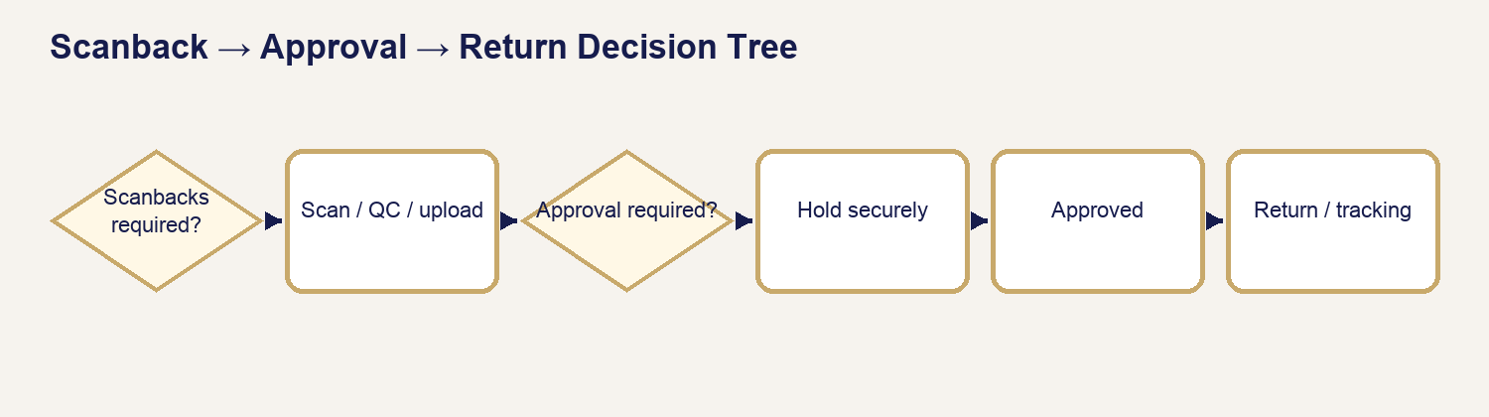
Scanback → Approval → Return Decision Tree

38.1–38.4 Requirements, Selection, Upload, Rescan
Identify whether scanbacks are required and which pages/set. Scan in order, legibly, at the required resolution; open/QC the final file. If rejected or incomplete, rescan from the signed originals and preserve the correction trail.

38.5–38.7 Approval Before Return
When approval-before-return applies, hold the physical package securely. Follow up through the approved channel and wait. Never return while the gate is unresolved.

38.8–38.10 Physical Return and Completion Readiness
Use the authorized label/carrier/drop-off method. Verify package, address/label, cutoff, receipt, tracking, and proof. Completion requires return evidence where applicable.

38.11 Scanback → Approval → Return Decision Tree
Scanbacks required? If NO, follow return instruction. If YES, scan/QC/upload. Approval required? If YES, hold securely until explicit approval. Rescan requested? Correct and re-upload. Once approved, return using the authorized label, retain receipt/tracking, and record evidence.

38.12 Non-Negotiable Hold
STOP — Never return while an applicable approval-before-return gate is unresolved.

Chapter 39 — Loan Signing Exceptions & Financial Resolution
Purpose: perform this workflow from verified APS and assignment evidence while preserving legal, notarial, financial, privacy, and ordering-party boundaries.
YOU WILL LEARN TO
- Review the authoritative assignment, act within role, stop at blockers, communicate accurately, and leave a complete audit trail.
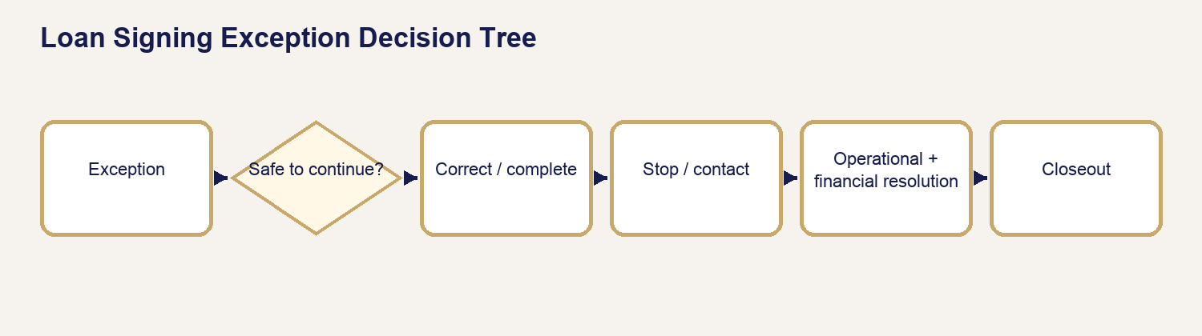
Loan Signing Exception Decision Tree

39.1–39.5 Cancellation, No-Sign, Partial, Resign, Cause
Record what occurred, when, who directed the stop, documents affected, package custody, and communication. Distinguish APS-caused correction from signer/orderer/document/other causes without making blame statements.

39.6 Excessive Wait
The maintained suggestion includes the first 30 minutes, then $25 per started additional 30-minute increment. APS-caused delay is excluded by default. An administrator authorizes any charge, waiver, or custom result; the operator does not collect automatically onsite.

39.7–39.11 Stops, Review, Supplemental Invoice, Refund, Resolution
Identity, package, signer, instruction, safety, or legal-boundary stops take priority. Additional amounts use the authorized supplemental-invoice workflow; refunds remain tied to original payment and provider evidence.

39.12 Loan Signing Exception Decision Tree
Can the signing safely and lawfully continue under current instructions? If YES, correct/continue and record. If NO, stop and contact orderer. Is same-visit correction authorized? If NO, secure package and follow no-sign/partial/resign direction. Determine cause and financial review separately. Resume or close only after both operational and financial resolution.

39.13 Resign Rule
APS-caused resign suggestion is zero. Other causes require administrator review. Link every additional visit and package version to the original assignment.

Chapter 40 — Loan Signing Closeout & Completion
Purpose: perform this workflow from verified APS and assignment evidence while preserving legal, notarial, financial, privacy, and ordering-party boundaries.
YOU WILL LEARN TO
- Review the authoritative assignment, act within role, stop at blockers, communicate accurately, and leave a complete audit trail.

40.1–40.5 Completion Evidence
Operational work, scanback/approval, return/tracking, exceptions, and financial resolution each require evidence when applicable.

40.6–40.9 Communication, Timeline, Gate, History
Send only the approved closeout communication for the correct audience. Review Timeline for assignment, package, print, appointment, signing, scans, approval, return, exceptions, money, and final completion. Preserve all versions and history.

40.10 Closeout Checklist
- Active package and all instructions reconciled.
- Signatures/initials/dates/certificates and table check complete.
- Scanbacks/QC/approval complete when applicable.
- Package returned with receipt/tracking when applicable.
- Exceptions and supplemental/refund decisions resolved.
- Required payment or authorized terms correctly recorded.
- Ordering-party/signer communication and Timeline verified.
- Final completion gate passed without override abuse.

Loan Document Source Register

Authoritative external sources
1. Consumer Financial Protection Bureau — Closing Disclosure and official closing-document consumer guidance.
2. Fannie Mae/Freddie Mac Uniform Instruments — current notes, riders/addenda, security instruments, and special-purpose documents.
3. HUD Single Family Housing Model Documents — current HECM/reverse-mortgage notes, mortgages, agreements, disclosures, and borrower/non-borrowing-spouse certifications.
4. Texas Secretary of State — traditional and online notary educational information; Texas Government Code Chapter 406; applicable Texas Administrative Code.

APS sources
- Release 10 Loan Signing intake, assignment, fulfillment, exception, wait-time, scanback, return, and completion behavior.
- `assets/js/admin.js`, `assets/js/admin-v3.js`, `assets/js/operator-reference-catalog.mjs`.
- Loan Signing migrations, Edge Function logic, and Release 6–8 regression/certification tests.

Qualification rule
The catalog describes common operational purpose and presentation. It does not determine whether a document belongs in a package, whether it is legally sufficient, or whether it must be notarized.
COMMONLY NOTARIZED DOES NOT MEAN ALWAYS NOTARIZE. Actual authority comes from the document in front of the operator, its actual certificate, applicable law, and authorized assignment instructions.
Commercial/custom instruments, lender-specific affidavits, title/escrow forms, tax forms, insurance documents, and nonstandard modification documents vary materially. Their actual package and ordering-party instructions remain authoritative. These entries are source-qualified rather than generalized into legal conclusions.

