ALIGNED PRINT & SCAN
OPERATOR
HANDBOOK
Release 10 Certified Operations Edition
Remote Online Notary · Mobile Notary
Print & Scan · Loan Signing
BATCH 1 PREVIEW | PARTS I–IV | CHAPTERS 1–14

Contents
This visible Batch 1 contents list links to the true chapter headings. The Word master also preserves the heading hierarchy used for PDF bookmarks and later full-edition assembly.
Part I — Aligned Print & Scan
Chapter 1 — APS Mission, Services & Operating Model
Chapter 2 — Roles, Authority & Professional Boundaries
Part II — Customer & Portal Operations
Chapter 3 — The Customer Journey
Chapter 4 — Customer Portal Operations
Part III — Admin Operations
Chapter 5 — Admin Navigation & Daily Triage
Chapter 6 — The Request Workspace
Chapter 7 — Understanding Status, Next Action & Gates
Part IV — Customers, Participants, Documents & Records
Chapter 8 — Customers, Signers, Witnesses & Participants
Chapter 9 — Document Mental Model, Customer Uploads & Review
Chapter 10 — Document Classification & Safe Handling
Chapter 11 — Completed & Proof-Produced Documents
Chapter 12 — Document Release, Delivery & Audit
Chapter 13 — Document Replacement, Mistakes & Recovery
Chapter 14 — Service-Specific Document Lifecycles

Lists and navigation

Figures
- Figure 01 — APS System Map
- Figure 02 — Universal Request Lifecycle
- Figure 03 — Portal / System Relationship
- Figure 04 — State Mental Map
- Figure 05 — Customer vs Signer vs Ordering Party
- Figure 06 — Participant Decision
- Figure 07 — Document Lifecycle
- Figure 08 — Internal vs Customer-Visible
- Figure 09 — Document Release Decision
- Figure 10 — RON / Proof Document Lifecycle
- Figure 11 — Mobile Original vs APS Scan
- Figure 12 — Print & Scan Source-to-Output
- Figure 13 — Loan Package / Scanback / Return
- Figure 14 — Service-Specific Document Lifecycles

Tables
- Service relationship
- Role comparison
- Customer stages
- Portal troubleshooting
- Admin navigation
- Request workspace tabs
- Participant roles
- Document classifications
- Recovery and communication sequence

Procedures
- Procedure 1.1 Orient a new request
- Procedure 2.1 Decide whether you may act
- Procedure 3.1 Identify customer stage
- Procedure 4.1 Investigate portal question
- Procedure 5.1 Daily opening triage
- Procedure 5.2 Daily closeout
- Procedure 6.1 Work a Next Action
- Procedure 7.1 Evaluate a gate
- Procedure 8.1 Add/correct participant
- Procedure 9.1 Review upload
- Procedure 10.1 Handle safely
- Procedure 11.1 Missing Proof output
- Procedure 12.1 Release document
- Procedure 13.1 Wrong release
- Procedure 14.1 Identify document lane

Checklists
- Completed-document review
- Document Review
- Document Release
- Document Mistake Recovery

Front Matter

Document control
Title: Aligned Print & Scan Operator Handbook — Release 10 Certified Operations Edition. Batch: 1, Parts I–IV, Chapters 1–14. Status: owner/editorial review preview. Certified source baseline: Release 10 source continuation `570460680b6262bb1e418cf66a00d61e72ebf2e2`; certified runtime `6788efbfc321a0f3ec6e92b27696ed63b1769641`. Locked handbook architecture approved 2026-08-20 and merged through specification PR #107.
This preview teaches current operation; it does not authorize application, pricing, policy, legal, or provider changes. Production behavior controls if the preview and application differ. Report drift before relying on stale instructions.

Revision history
Edition | Date | Scope | Status
Batch 1 Preview | 2026-08-20 | Front matter and Parts I–IV, Chapters 1–14 | Owner/editorial review
Full Edition | Future controlled assembly | Locked Parts I–XIII | Not produced

How to use this handbook
Learn reads the explanation, visual, and example. Operate follows the numbered procedure and gate. Quick Reference uses an independently printable checklist after training. Quick References summarize; the chapter procedure controls when detail matters.
Callouts have fixed meanings. OPERATOR RULE states a control that always applies. STOP identifies a condition that blocks safe advancement. DECISION shows a fork and next stage. CUSTOMER COMMUNICATION states what an authorized recipient should receive. QUICK TIP offers a practical reminder without changing policy.

Evidence and professional boundaries
CONFIRMED IN PRODUCTION is directly verified in certified production. CONFIRMED IN CODE is supported by maintained source/tests. CONFIRMED IN DOCUMENTATION is an approved operating rule not independently proven by code. SOURCE VERIFICATION REQUIRED marks a locked subject whose exact content still needs authoritative confirmation.
Operators explain APS process, identify visible facts, and follow approved procedures. They do not provide legal or financial advice, decide what legal form a person needs, select a notarial act outside their authorized role, promise provider outcomes, or bypass security and money controls.

Reading workflow diagrams
Navy rounded rectangles are APS stages/actions. Gold diamonds are decisions. Grey shapes are customer, provider, or external events. A gate/lock means “do not advance until satisfied.” STOP means hold and escalate. A check means the condition is satisfied. Labels accompany color so diagrams remain understandable without color.

Navigation framework
The Word master uses true Heading 1–3 styles. The visible TOC lists Parts, chapters, and useful major sections. Lists of figures, tables, procedures, checklists, and decision trees are maintained as controlled indexes. Cross-references use heading names rather than guessed final page numbers.

Part I — Aligned Print & Scan

Chapter 1 — APS Mission, Services & Operating Model
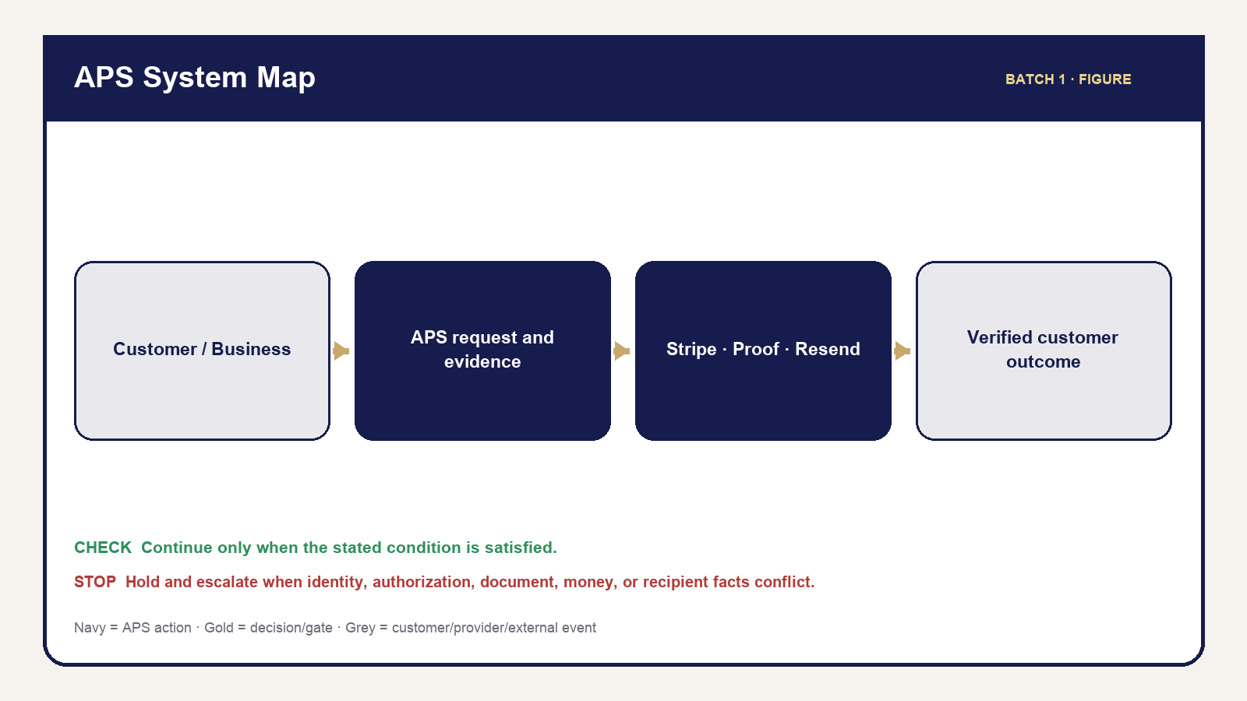
Figure 01 — Aps System Map
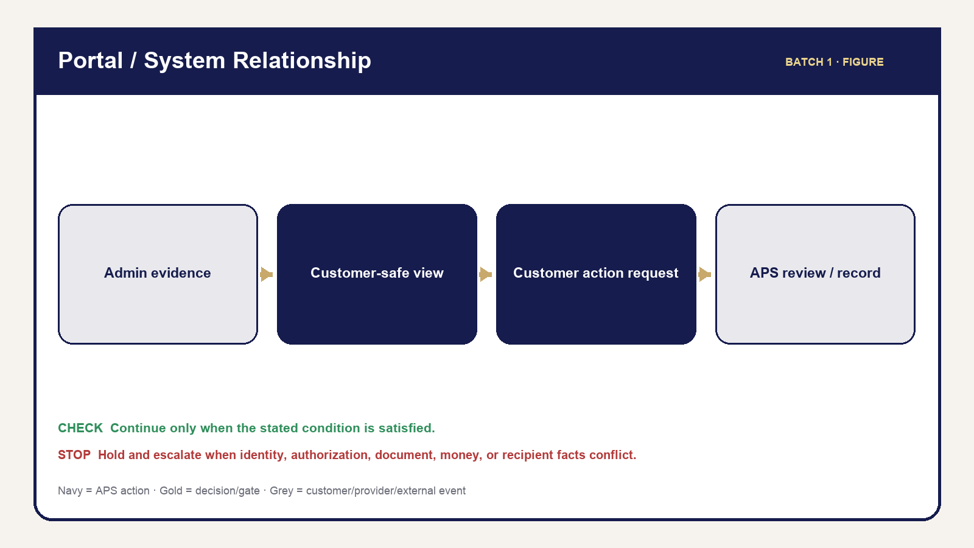
Figure 03 — Portal System Relationship
Aligned Print & Scan coordinates service work from request through verified closeout. The operator’s job is to preserve the right customer, request, facts, money, documents, communications, and history while moving work only when the next gate is satisfied. A polished customer experience depends on quiet discipline: confirm before changing, use the maintained action, and verify what the customer can actually see.
APS supports four service families. Remote Online Notary uses APS for request, quote, payment, preparation, post-session document review, customer release, and completion while Proof handles provider-native identity, meeting, signing, certificate, and seal activity. Mobile Notary sends an operator to a confirmed physical location. Print & Scan converts an authorized source into checked output. Loan Signing manages an ordering-party assignment, package, signing appointment, scanbacks, return, exceptions, and financial resolution.
Retail work is scoped to a request/reference and verified customer relationship. Business work adds an authenticated organization, membership, role, locations, service eligibility, and assigned billing terms. Neither relationship changes the central rule: the operator acts within the exact request and the person or organization permitted to receive its information.

What APS knows, what the operator verifies, and what comes from providers
APS stores the request, customer/organization relationship, service facts, quote and invoice history, messages, document metadata, fulfillment facts, and Timeline. The operator verifies that these facts match the work in front of them. Stripe supplies authoritative card/ACH results; Proof supplies provider-native RON states and completed assets; routing supplies distance evidence when available; Resend supplies email acceptance/failure evidence. A provider response is evidence, not permission to skip APS review.
OPERATOR RULE — Use the right source.** Read APS for APS facts, inspect the actual document for document facts, and use the provider record for provider outcomes. If sources disagree, hold the action, preserve both facts, and escalate. Do not choose the most convenient value.

Procedure 1.1 — Orient a new request
- Open the request from Requests, Review Queue, search, Calendar, or the applicable service module.
- Match the APS reference, service, customer/organization, and current status.
- Read Next Action and inspect the tab that contains its supporting evidence.
- Check for Review Queue blockers, pending customer actions, and unresolved money/document requirements.
- Identify which facts APS controls and which require customer, ordering-party, or provider confirmation.
- Take only the action supported by current evidence.
- Verify the resulting screen, customer visibility when applicable, and Timeline/message record.
STOP — If the request, recipient, document, amount, or provider result is ambiguous, do not advance. Correct or escalate the ambiguity first.

Service relationship table
Service | APS coordinates | External/customer responsibility | Completion focus
RON | Intake, money, preparation, Proof handoff, returned-document review/release | Signer readiness; Proof-native identity/session actions | Correct completed asset reviewed/released plus gates
Mobile | Address/travel, appointment, acts, optional scan, final charges | Signer, ID, documents, witnesses, safe location | Performed facts, certificate/document check, delivery, money
Print & Scan | Source review, page/specs, production/QC, delivery | Correct source/specification approval | Output QC and authorized delivery
Loan Signing | Assignment, package/version, appointment, signing, scanback/return, exception/money | Ordering-party instructions and signer participation | Ten applicable fulfillment gates

Figures: APS System Map and Portal/System Relationship Map. See Part V — Quotes, Invoices & Money for detailed financial operation and Parts VI–IX for service execution.

Chapter 2 — Roles, Authority & Professional Boundaries
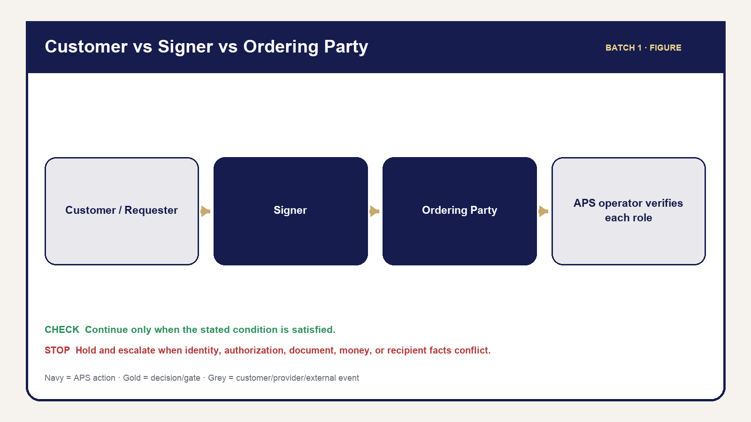
Figure 05 — Customer Signer Orderer
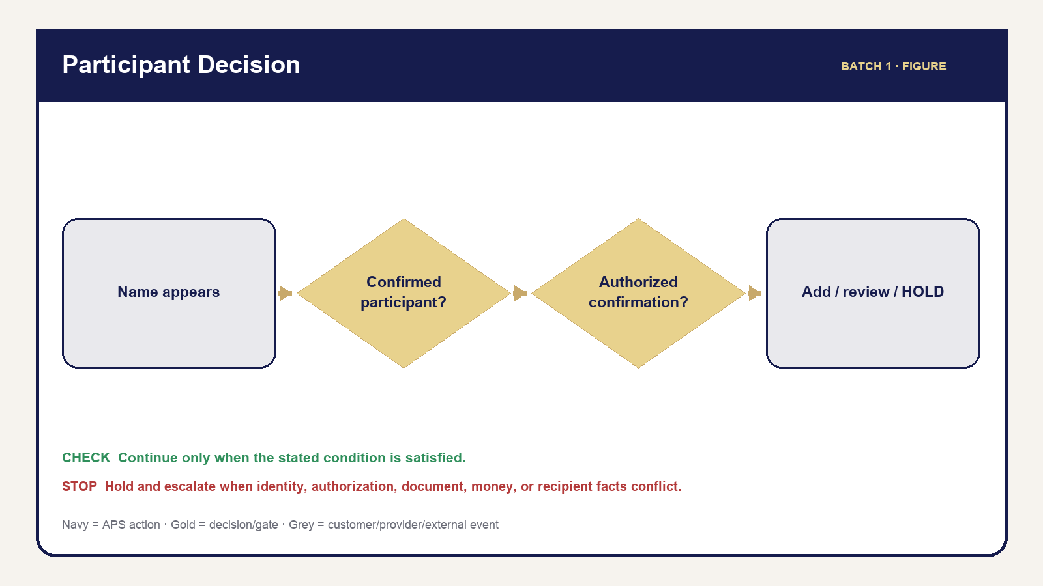
Figure 06 — Participant Role Relationship
Roles answer two questions: who is acting, and what are they allowed to do? A familiar person or visible record does not expand permission. APS owner/admin/staff authority remains separate from Business organization roles, retail request access, signer participation, and provider authority.
The APS owner/admin controls APS-wide decisions within maintained permissions. Staff may perform only the functions assigned to their active role. A Business admin manages authorized organization context without becoming an APS admin. A Business member acts only for memberships and capabilities currently granted. A retail customer has scoped access to the applicable request, not a general customer database.
The requester initiates or coordinates work. The signer is the person whose signature/notarial participation is required. The ordering party supplies authoritative Loan Signing scope and instructions. A document witness observes signing when required. A credible witness is an identity method used only when legally available and must never be confused with a document witness.

Operator judgment and boundaries
Operators may explain APS steps, identify document titles and visible signing areas within approved role boundaries, request missing operational facts, and stop unsafe or unauthorized work. Operators must not interpret legal effect, advise whether to sign, choose legal forms, change document wording, promise a refund, bypass identity requirements, or describe a payment/provider action as complete before evidence exists.

Procedure 2.1 — Decide whether you may act
- Identify your active APS role and the action you intend to take.
- Identify the request, organization, participant, document, and recipient affected.
- Confirm the action appears in the maintained interface for your role and current context.
- Verify the facts required by the action; visibility alone is not proof the facts are ready.
- If the question requests legal/financial interpretation, pause and refer it to the appropriate authorized professional.
- If identity, willingness, awareness, safety, legality, or authorization is uncertain, hold or refuse the affected action.
- Record neutral facts and the referral/escalation; avoid conclusions you are not qualified to make.

Role comparison
Role | May do | Must not do | Record that remains
APS operator | Perform assigned APS actions and verify results | Exceed role, improvise policy, expose internal data | Timeline, message, fulfillment, or audit evidence
Customer/requester | Supply facts, approve quote, pay, request action | Access internal or unrelated-request data | Customer action/request history
Signer | Participate and make personal signing decisions | Be inferred solely from document text | Participant/readiness and service facts
Ordering party | Supply authoritative assignment facts/instructions | Convert instructions into legal advice by APS | Assignment and communication history
Witness | Perform the applicable witness role | Be treated as signer/credible witness without authority | Participant role/readiness
Provider | Return provider-native result | Decide APS release/completion | Provider-to-APS evidence

STOP — Refuse or escalate:** identity cannot be established; willingness or awareness is absent; coercion, illegality, or safety concern exists; the document is incomplete for the requested operation; required authority/instructions are missing; or the requested action exceeds the operator’s role. Record facts, not accusations.
Figures: Customer vs Signer vs Ordering Party and Customer/Participant Role Relationship.

Part II — Customer & Portal Operations

Chapter 3 — The Customer Journey
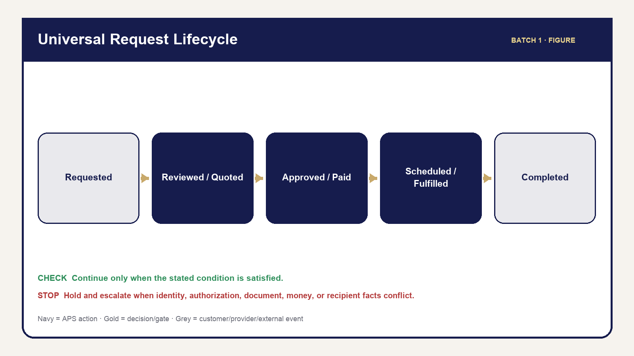
Figure 02 — Universal Request Lifecycle
The customer journey is a series of controlled promises. A submitted request means APS received information; it does not mean the appointment is confirmed or service is guaranteed. An estimate is an early calculation; a reviewed quote is the current APS offer. Approval authorizes the quoted scope; payment resolves an invoice only when authoritative evidence says so. Scheduling, fulfillment, document release, and completion remain separate.

The journey in operator language
Discover and submit. The customer selects a service, supplies contact and service facts, acknowledges boundaries, and submits. APS creates the request/reference and attempts the maintained acknowledgment. The operator checks the actual saved record rather than relying on an email alone.
Review and quote. APS verifies scope, participants, documents, page/distance/package facts, and pricing inputs. Missing facts create an information step. The quote is built, reviewed, and intentionally sent. Customer or ordering-party approval is recorded before the applicable invoice/payment stage.
Schedule and fulfill. Requested dates are preferences until APS confirms current appointment facts. Each service has its own readiness and performance requirements. A completed appointment or provider session is not necessarily APS completion; documents, delivery, return, exceptions, and money may remain.
Close and support. APS verifies applicable gates, sends the maintained customer-safe outcome, and preserves history. Cancellation and reschedule submissions are review requests, not automatic decisions. Support must remain scoped to the right request and customer.

Procedure 3.1 — Identify the customer’s current stage
- Open the correct request and match the reference/customer or organization.
- Read the request status and Next Action.
- Check the Quote, Payments, Fulfillment, Documents, Messages, and Timeline tabs for supporting facts.
- Identify the last stage with complete evidence—not merely the most advanced-looking label.
- Identify the current blocker and who can resolve it: APS, customer, ordering party, or provider.
- Use the maintained message/action for that stage if communication is needed.
- Verify what the customer portal now shows and what record was added.
Customer stage | Operator verifies | Customer should see/receive | Do not imply
Request received | Saved request/reference | Acknowledgment and secure request path | Appointment or acceptance confirmed
Quote ready | Reviewed current quote/version | Quote and response action | Payment already due without invoice path
Approved/payment | Approval plus invoice-specific state | Accurate amount/status/payment action | Pending/partial is paid in full
Appointment | Confirmed date/time/method/location | Current confirmed facts | Requested time is confirmed
Fulfillment | Service-specific evidence | Safe progress/next action | Service label alone proves completion
Documents | Correct eligible released file | Scoped view/download | Upload or provider source is released output
Completed | All applicable gates clear | Settled summary and eligible final actions | Completion while blockers remain

CUSTOMER COMMUNICATION — Say what has happened, what happens next, and what the customer needs to do. Do not promise a decision that is still under review.
Figure: Universal Request Lifecycle.

Chapter 4 — Customer Portal Operations

Figure 03 — Portal System Relationship
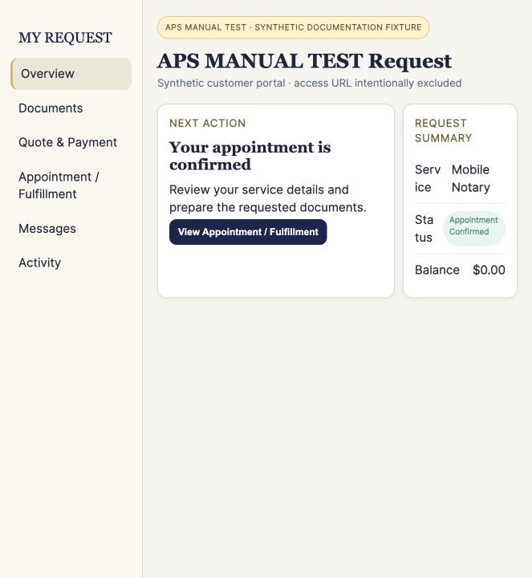
APS governed synthetic screenshot — ss 100 portal overview
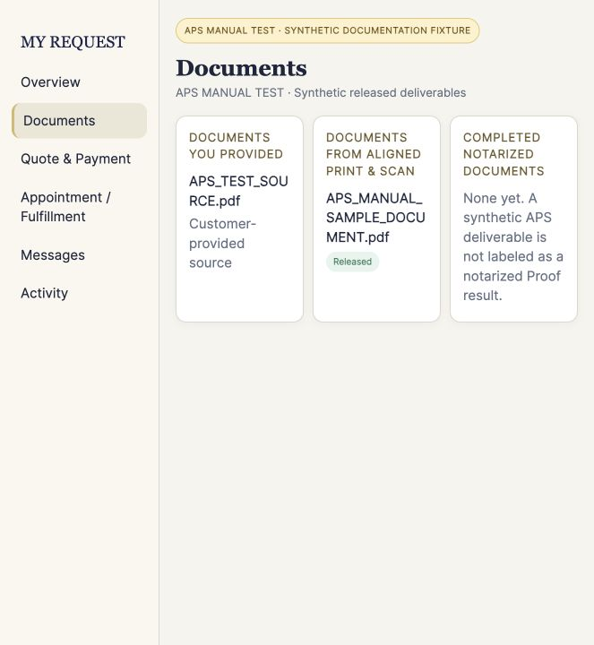
APS governed synthetic screenshot — ss 101 portal documents
The Customer Portal is a customer-safe view of one verified request. It is not the Admin workspace and it does not expose internal notes, policy calculations, provider errors, raw identifiers, audit files, or unreleased documents. Operators should compare portal behavior with APS facts whenever a customer reports a mismatch.
The maintained sections are Overview, Documents, Quote & Payment, Appointment/Fulfillment, Messages, and Activity. Overview summarizes current status and Next Action. Documents separates source and released customer files. Quote & Payment shows current customer-safe quote/invoice/payment/refund facts. Appointment/Fulfillment shows confirmed, service-appropriate information. Messages shows customer-facing communications. Activity is a filtered history, not the complete Admin Timeline.

What customers can and cannot do
Customers can review current safe facts, approve/request quote changes where eligible, pay an eligible invoice, upload additional files through the maintained verification path, request cancellation/rescheduling, contact support, and access intentionally released files. They cannot view or edit internal APS records, authorize their own refund, mark service complete, release documents, see other requests, or turn a request into a confirmed appointment.

Procedure 4.1 — Investigate a portal question
- Obtain and verify the APS reference and customer relationship using the maintained support process.
- Open the exact Admin request; never search by name alone and assume the result.
- Identify the portal section involved.
- Compare the portal-safe value with the authoritative Admin tab and Timeline.
- For documents, verify classification, current version, review, release, and intended recipient.
- For money, verify the exact invoice and authoritative payment/refund state.
- For appointment/fulfillment, distinguish requested from confirmed and performed from completed.
- Correct only through the maintained workflow. Do not send internal screenshots or raw protected links.
- Confirm the customer-visible result and record the support outcome.

Documents language
The heading is DOCUMENTS FROM ALIGNED PRINT & SCAN. The explanatory text is: “Files provided to you by Aligned Print & Scan will appear here.” The empty state is: “No documents have been provided yet.” This customer language does not weaken the internal rule that only an eligible, intentionally released file crosses into customer visibility.

Portal troubleshooting
Symptom | Check | Safe response | Escalate when
Customer cannot access request | Reference/email verification and correct URL | Re-establish only the maintained scoped path | Identity or authorization remains uncertain
Customer cannot open file | Release state, signed access, file integrity | Regenerate only authorized access; verify file | Wrong file, corruption, or access boundary suspected
Status seems wrong | Admin evidence and Timeline | Explain current verified stage; use maintained correction | Conflicting facts or impossible state
Payment not reflected | Invoice/provider result | Wait/reconcile through maintained path | Provider mismatch or duplicate-risk state
Missing message | Message Log and delivery evidence | Retry only when safe and idempotent | Recipient/delivery ambiguity

STOP — Never ask the customer to provide a password, payment credential, full ID image, KBA answer, or protected token through ordinary support communication.
Screenshots: Portal Overview, Documents, Quote & Payment, Appointment/Fulfillment, Messages, and Activity. Figure: Portal/System Relationship Map.

Part III — Admin Operations

Chapter 5 — Admin Navigation & Daily Triage
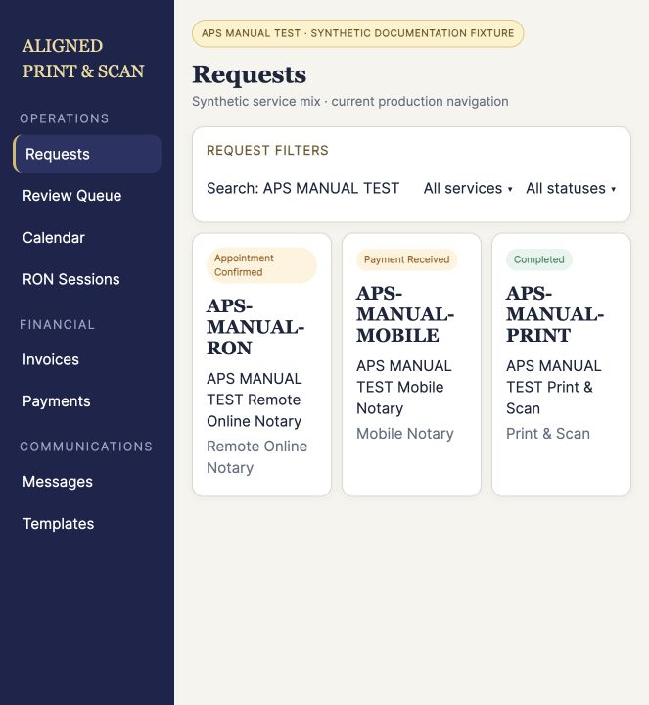
APS governed synthetic screenshot — ss 001 requests
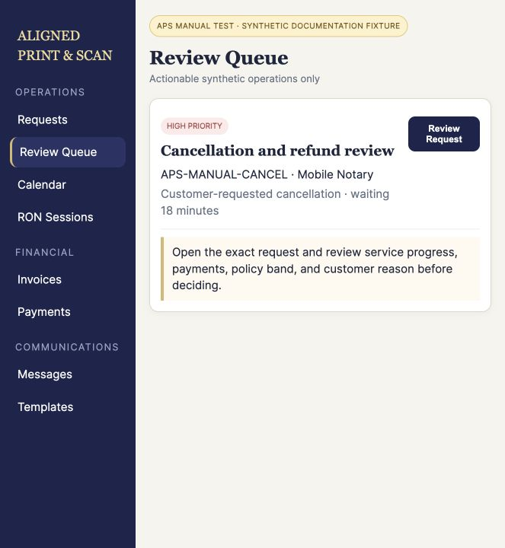
APS governed synthetic screenshot — ss 010 review queue
Admin is the operator’s working environment. Start with the module that answers the operational question, then open the exact request for consequential work. The Dashboard summarizes; Requests is the working queue; Review Queue identifies actionable blockers; Calendar organizes requested/confirmed dates. Service, finance, customer, organization, communication, resource, settings, and access modules provide focused views without replacing the request record.

Where to go
Need | Start here | Verify before acting
Find/process request | Requests or global search | Reference, service, customer/organization
Resolve blocker | Review Queue | Reason, waiting age, supporting tab/evidence
Review schedule | Calendar | Requested versus confirmed date/time
RON work | RON Sessions then request Fulfillment/Documents | APS stage, Proof facts, returned asset
Loan Signing | Loan Signings then request Fulfillment | Assignment/package/gates
Money question | Invoices/Payments then exact request | Invoice identity and ledger
Customer/Business | Customers, Organizations, Applications | Correct relationship/membership
Communication | Messages/Templates plus request Messages | Recipient, trigger, delivery history
Guidance | Scripts or Resource Center | Reference only; no workflow change
Access | Staff & Access | Active role/permission and self-lockout safety

Procedure 5.1 — Daily opening triage
- Sign in through the maintained Admin login and verify your active authorized role.
- Review Dashboard counts for new, waiting, scheduled, and financially unresolved work.
- Open Review Queue; start with safety, authorization, document, money, and time-sensitive blockers.
- Review Calendar for today and the next operating window. Confirm whether each time is requested or confirmed.
- Review RON Sessions and Loan Signings that require provider/package action.
- Review failed or pending communications and payments without blind retries.
- Use global search and filters to locate exact references; clear stale filters when counts appear inconsistent.
- Open the request before any consequential action and verify its evidence.

Loading, empty, and error
Loading means APS has not finished retrieving the view. Empty means the completed view contains no matching items. Error means APS could not complete the load. Do not treat prolonged loading as empty, and do not treat an error as proof there is no work. Refresh once safely, confirm session/network context, try the authoritative module, and escalate repeated errors with the time, module, visible message, and non-sensitive context.
OPERATOR RULE — A summary card is a pointer, not the record. Open the exact request/invoice/document before changing anything.

Procedure 5.2 — Daily closeout
- Revisit Review Queue and today’s Calendar items.
- Confirm completed actions have Timeline/message/financial/document evidence.
- Identify work intentionally left on hold and the named blocker/owner.
- Verify failed messages or provider operations have a safe next step rather than duplicate retries.
- Secure documents, close private screens, and follow clear-desk/device controls.
Quick Reference: Where Do I Go in Admin? Screenshots: Dashboard, Requests, Review Queue, Calendar, global search/filters, and loading/empty/error.

Chapter 6 — The Request Workspace
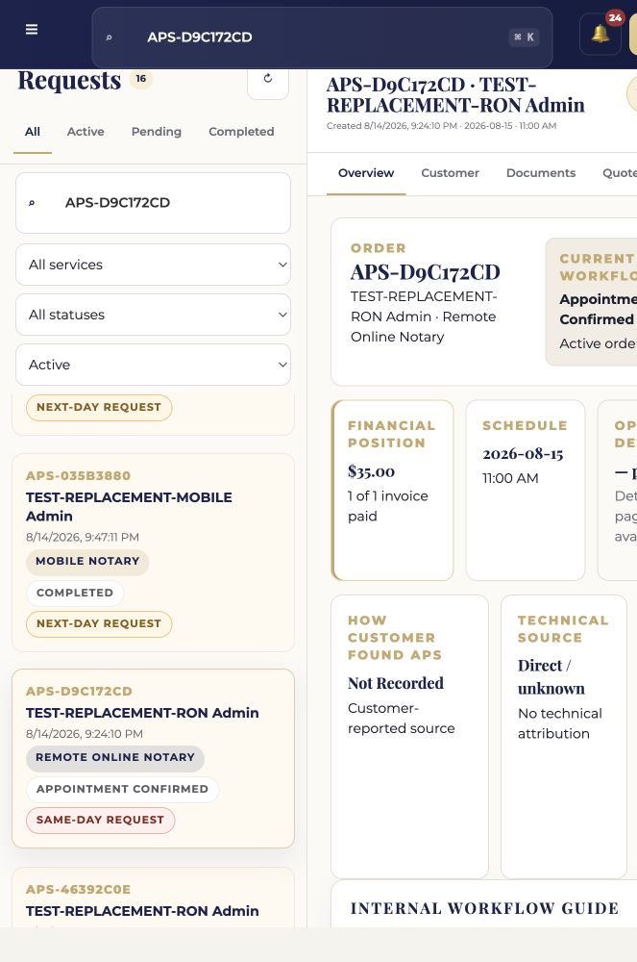
APS governed synthetic screenshot — ss 020 request overview
The request workspace holds the evidence needed to operate one request. Verify the request before reading individual fields: reference, service, customer/organization, and current status. Similar names, repeated customers, replacement documents, and related visits create wrong-record risk.
The eight maintained tabs are Overview, Customer, Documents, Quote, Payments, Messages, Fulfillment, and Timeline. Overview explains current state and Next Action. Customer identifies the relationship and contact context. Documents controls files and release. Quote controls current prepared scope. Payments preserves invoices/payments/refunds. Messages records customer-facing communication. Fulfillment holds service facts and gates. Timeline preserves event history.

Procedure 6.1 — Work an Admin next action
- Match the APS reference, service, customer/organization, and status in the selected-request header.
- Read Next Action as guidance, then open the supporting tab.
- Verify prerequisites and blockers in the underlying record.
- Review related documents, money, participant, appointment, and provider facts as applicable.
- Perform the smallest maintained action that advances the verified condition.
- Re-open or refresh the affected tab and confirm the visible result.
- Check Timeline and Messages if the action should create history or communication.
- Check the Customer Portal view when the customer should see a change.

Tab operating guide
Tab | Primary question | Common risk
Overview | Where is this request and what is next? | Treating summary/status as proof
Customer | Who is connected and how may APS contact them? | Wrong identity/recipient
Documents | What file is this, and who may see it? | Wrong version/customer/release
Quote | What reviewed scope is currently offered? | Sending stale/unreviewed quote
Payments | Which invoice/payment/refund is authoritative? | Combining invoices or treating pending as paid
Messages | What was prepared/sent/accepted/failed? | Blind duplicate send
Fulfillment | What service facts and gates remain? | Completing from status alone
Timeline | What occurred and when? | Editing history instead of correcting forward

Archive removes a request from active work without deleting history. Restore returns it to active operation. Before either action, verify it is the correct request and that the action will not conceal unresolved work.
STOP — Do not act if the header and supporting tab describe different customers, organizations, services, versions, or financial relationships. Preserve evidence and escalate the mismatch.
Figure: Request Workspace Evidence Flow. Screenshot plan: one annotated workspace overview plus focused crops for each tab and Next Action.

Chapter 7 — Understanding Status, Next Action & Gates
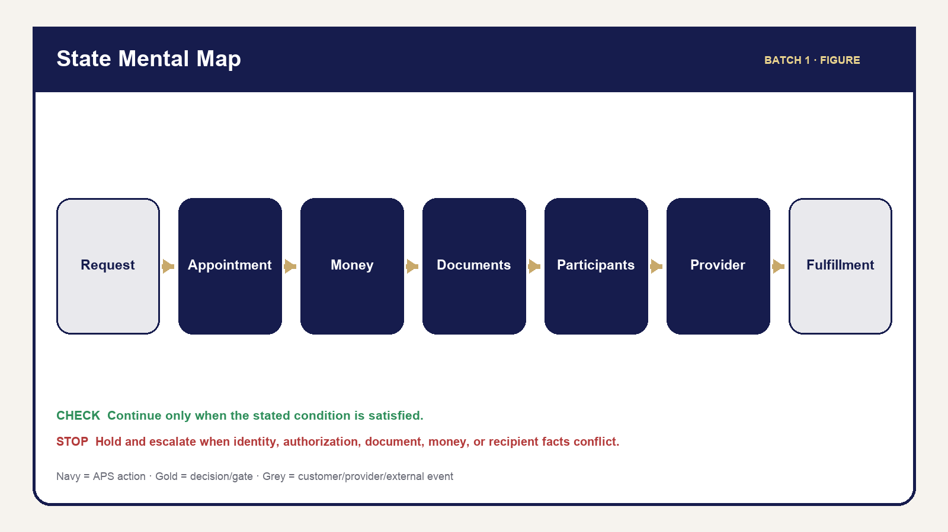
Figure 04 — State Mental Map
APS work moves across parallel dimensions. Request/service status summarizes the overall stage. Appointment facts distinguish requested, confirmed, rescheduled, and performed. Financial facts belong to individual invoices/payments/refunds. Documents have source, review, completion, eligibility, and release states. Participants have role/readiness. Providers have their own progress. Fulfillment records what was actually done. Loan Signing and exceptions add further controlled dimensions.
OPERATOR RULE — STATUS IS NOT PROOF.** Payment status does not prove service completion. Appointment status does not prove fulfillment. A Review Queue blocker is not the request status. A file upload does not prove review or release. A provider meeting ending does not prove APS completion.
Next Action is the recommended operational step derived from current facts. It helps the operator navigate, but the underlying tab remains the evidence. A gate is a required condition before advancement. A blocker explains what is missing. An authorized override exists only when the maintained workflow provides it; a manually convenient status change is not an override.

Procedure 7.1 — Evaluate an advancement gate
- Name the intended next stage.
- List the required conditions for that stage.
- Open the APS tabs that hold each condition; do not rely on one summary.
- Classify every condition as satisfied, not applicable, missing, conflicting, or requiring authorized review.
- If any applicable condition is missing/conflicting, hold advancement and create/use the maintained next action or communication.
- If an override is permitted, verify the authorized person, reason, and record before using it.
- Advance only through the maintained action.
- Verify resulting status, blocker clearance, customer visibility, and Timeline evidence.

Decision guide
- YES — evidence satisfies every applicable condition: continue through the maintained action.
- NO — required evidence is absent: hold and obtain the missing fact.
- CONFLICT: stop and reconcile; never choose one value silently.
- REVIEW/AUTHORIZED OVERRIDE: route to the authorized reviewer; preserve the reason and outcome.
- TERMINAL WORK: do not resurrect a completed/cancelled/archived item merely to clear a cosmetic blocker.
The State Mental Map shows these dimensions as parallel lanes converging only at applicable advancement and completion gates. The Review Queue Decision Guide explains whether to act, wait, communicate, or escalate.

Part IV — Customers, Participants, Documents & Records

Chapter 8 — Customers, Signers, Witnesses & Participants

Figure 05 — Customer Signer Orderer

Figure 06 — Participant Role Relationship
A customer or requester may coordinate service without being the signer. A Business member may submit for an organization without participating in the notarial act. A Loan Signing ordering party directs the assignment while the signer decides whether to sign. Keep these roles explicit because identity, communication, readiness, and document access depend on them.
Witness roles are not interchangeable. A document witness observes a signature when applicable. A credible witness is a legally controlled identity method and is used only where applicable requirements are satisfied. Never relabel one as the other for convenience.

Procedure 8.1 — Add or correct a participant
- Open the correct request and Customer/participant area.
- Determine who supplied the participant information: customer, signer, or authorized ordering party.
- Confirm the person’s role and whether participation is required; do not infer this from document text.
- Search/review existing participants to prevent a duplicate.
- Use Add Participant or Edit Participant with customer/orderer-confirmed facts only.
- Record readiness facts separately from identity facts.
- If a name appears but participation is unclear, use Flag Additional Participant Review.
- Use Additional Participant Information Needed only through the maintained communication workflow when confirmation is needed.
- Verify the participant list, readiness blocker, and Timeline/history.

Decision tree — another person appears
If the person is already confirmed, review the existing record and role. If not, ask whether the customer or authorized ordering party confirmed participation. When confirmed, add the person and update readiness. When unclear, do not infer: flag review, request information, and hold the affected advancement. Separately identify signer, document witness, credible witness, ordering party, or non-signing named person.
Role | Confirm from | Readiness focus | Do not infer
Requester/customer | Intake and verified relationship | Contact and requested service facts | That requester is signer
Signer | Customer/orderer confirmation and service record | Identity, willingness, appointment/document readiness | From a printed name alone
Ordering party | Assignment/business authority | Instructions, package, authorized contacts | That ordering party may sign
Document witness | Customer/orderer requirement | Availability and role | Credible-witness authority
Credible witness | Applicable lawful identity procedure | Eligibility, identity, declaration | From ordinary witness status

STOP — Conflicting names, roles, or recipient instructions require review before documents, communication, appointment, or service advances.
Figures: Customer vs Signer vs Ordering Party and Customer/Participant Role Relationship. Quick Reference: Participant Decision Guide.

Chapter 9 — Document Mental Model, Customer Uploads & Review
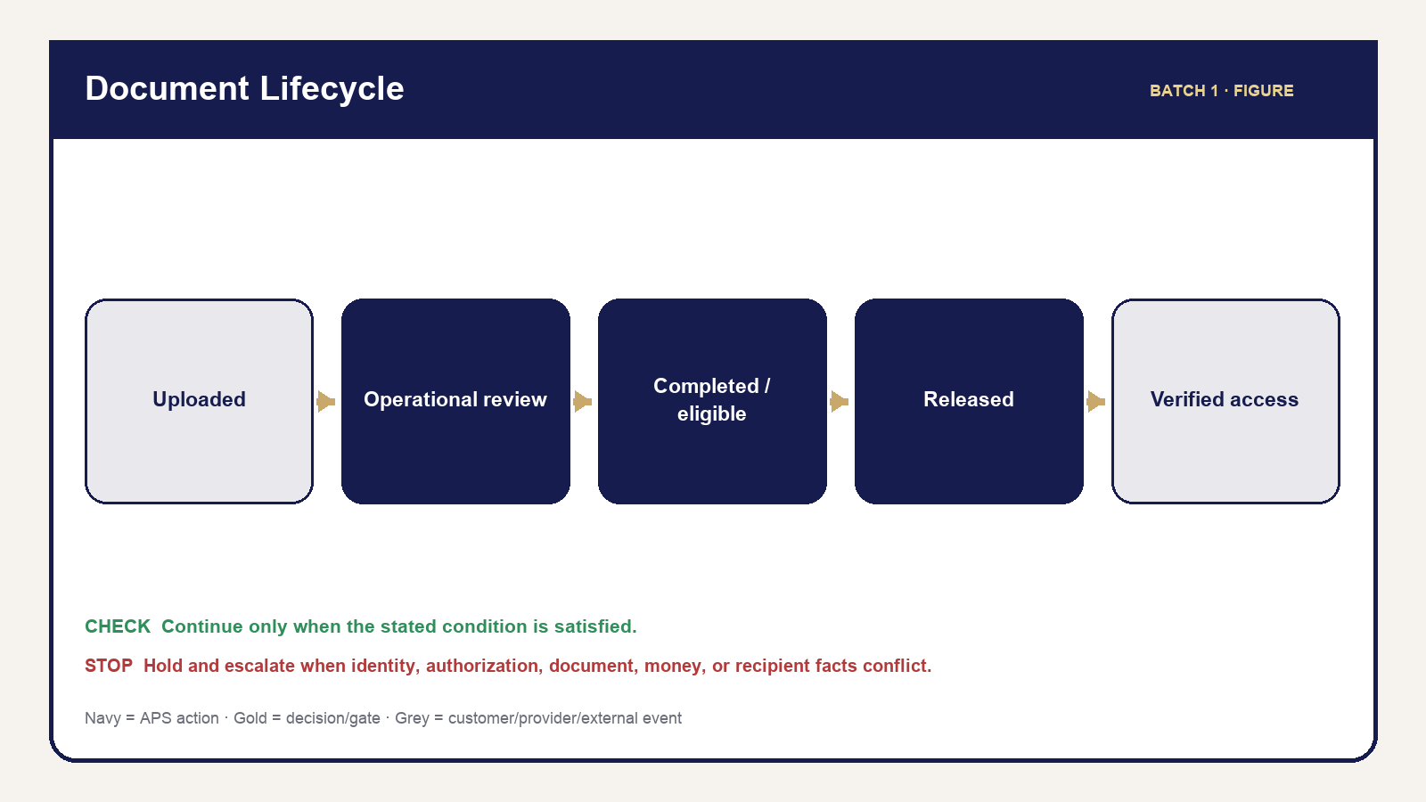
Figure 07 — Document Lifecycle
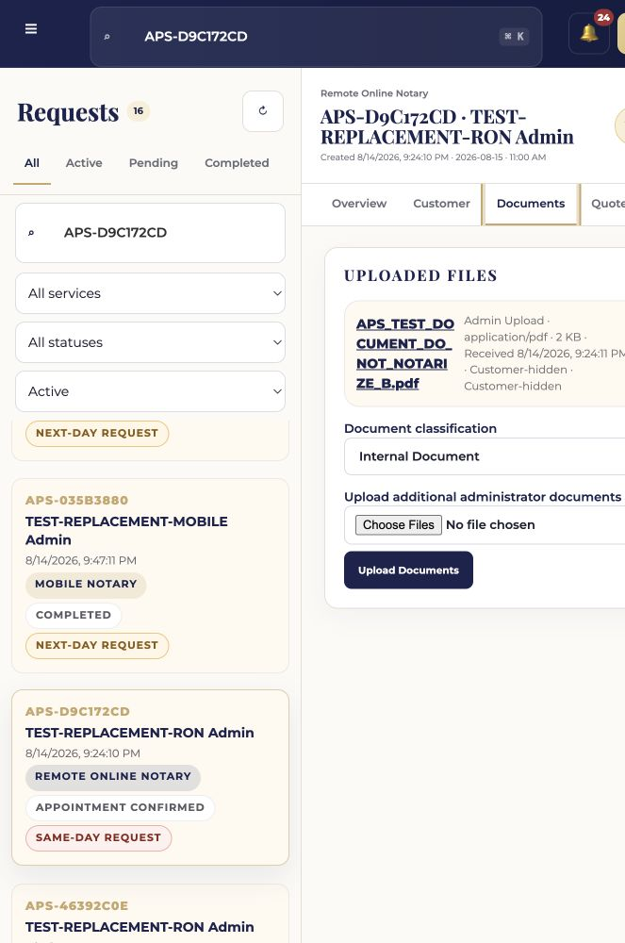
APS governed synthetic screenshot — ss 030 document lifecycle
Every document is controlled by five questions: Who provided it? What is it for? Who may see it? Is it ready to be released? What happens next? Answer them before opening, attaching, producing, sending, or releasing a file.
OPERATOR RULE — UPLOAD ≠ REVIEW ≠ COMPLETION ≠ RELEASE.** A present file may be corrupt, incomplete, the wrong version, internal, or associated with the wrong request. Presence does not make service complete or the file customer-visible.
Operational review asks whether APS can safely perform the requested workflow: correct request/file association, file opens, obvious corruption, page count where applicable, current version, operational completeness, participant/service information, and next step. Legal review asks whether a document is legally valid, sufficient, effective, or appropriate. APS operators do not perform legal review or recommend document wording/forms outside authorized professional scope.

Procedure 9.1 — Review a customer upload
- Open the exact request and Documents tab.
- Match the filename, uploader/provenance, request, service, and intended purpose.
- Open through the maintained protected access path.
- Confirm the file opens and is not obviously corrupt.
- Verify authoritative page count where the service uses page authority; a parser failure is not zero pages.
- Confirm the version/source and identify missing/replacement pages.
- Compare participant information with confirmed request participants without interpreting legal effect.
- Check service-specific operational readiness.
- Classify the file using the maintained control or hold for clarification.
- Request exact missing information/replacement when required.
- Verify document state and Timeline evidence.

Document received decision
The decision tree checks, in order: file opens; correct request; correct/current version; page count available when required; participant information sufficient; service information sufficient. A failure routes to Request Information, Hold, or Escalate. Only a fully satisfied operational review routes to Ready for Operational Use.
WHAT NOT TO DO: Do not decide legal sufficiency, select a notarial act for the customer, change legal language, treat a blank/failed page count as authoritative, or advance because a deadline is close.
Quick References: Five Questions for Every Document and Document Review Checklist.

Chapter 10 — Document Classification & Safe Handling
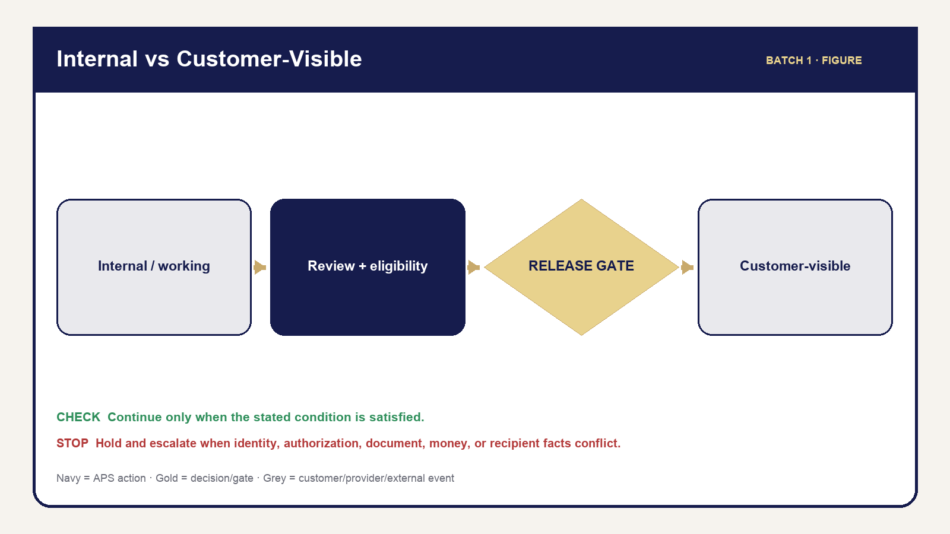
Figure 08 — Document Security Boundary
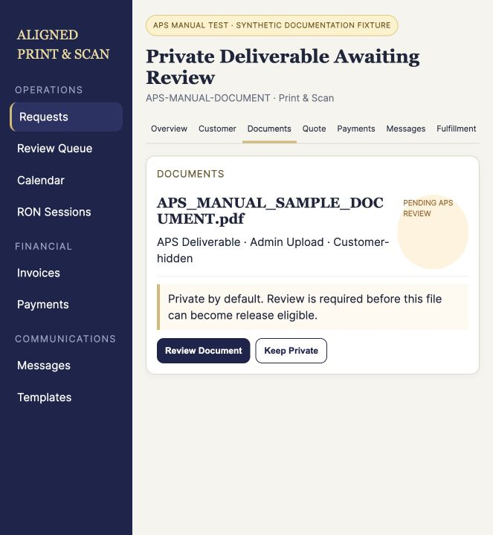
APS governed synthetic screenshot — ss 031 private output review
Classification states the document’s operational role and visibility boundary. Use the current production control when available. Handbook-friendly labels explain the concept; where an exact UI label differs, the UI label controls and the source register records the mapping.
Teaching class | Purpose | Customer visibility | Key control
Customer Upload | Customer-provided source | Own source where maintained | Verify request/provenance/readiness
Internal APS Document | Notes, audit, administration | No | INTERNAL MEANS INTERNAL
Working Document | Production/QC/intermediate file | No | Never release merely because attached
Completed/Notarized | Service output requiring review | Not automatically | Verify correct completed version
Completed/Customer-Eligible | Reviewed candidate for delivery | Only after release | Explicit release authorization
Customer-Released | Intentionally released file | Yes, scoped | Verify recipient and audit
Proof Completed | Provider-returned RON output | Only after APS review/release | Never substitute source/raw URL
Loan Package | Current/superseded assignment package | Usually controlled/internal | Version and custody
Borrower Copy | Required signer copy | Physical/authorized path | Copy count and QC
Scanback | Post-signing electronic return | Ordering-party workflow | QC/approval hold
Return Proof | Tracking/drop-off/custody evidence | As authorized | Preserve, do not fabricate
Invoice/Receipt | Financial artifact | Maintained financial path | Exact invoice/payment authority

OPERATOR RULE — INTERNAL MEANS INTERNAL.** Storing or attaching a file on a request does not make it appropriate for the Customer or Business Portal. Release authorization is the controlled crossing from the Admin/internal side to the customer-visible side.

Procedure 10.1 — Handle a file safely
- Confirm the exact request/organization before opening or downloading.
- Use protected APS links; understand that access may expire.
- Keep downloads off shared/personal devices unless the authorized workflow requires local handling and security controls are satisfied.
- Do not attach documents to email unless the maintained template/action permits the exact eligible file.
- Recheck the recipient and request before any external delivery.
- Remove temporary local exposure according to maintained security practice without deleting APS history.
- Record and escalate suspected wrong-customer access or distribution.
Figure: Internal vs Customer-Visible Document Security Boundary. Quick Reference: Document Classification.

Chapter 11 — Completed & Proof-Produced Documents
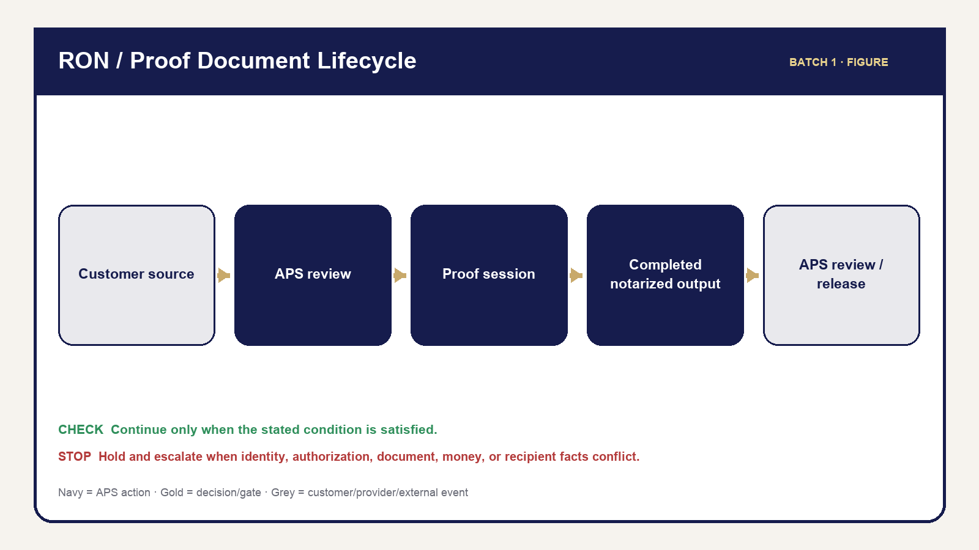
Figure 10 — Ron Proof Document
A source document enters the service. A working document may support preparation. A completed document reflects performed work. A completed/notarized electronic document returned by Proof is a provider output that still requires APS review. A customer-released file is the exact eligible completed version intentionally crossed into customer visibility.
The RON document path is: Customer Source → APS Review → Proof/RON Session → Completed Notarized Electronic Document → Post-Session Review → Correct Completed Version → Release Readiness → Customer Release. Each arrow is a control point, not an automatic promise.
STOP — DO NOT release the pre-notarization source document as though it were the completed notarized document.** The source may share a filename or appearance with the final output. Verify provenance, provider-completed state, correct version, and file content before release.

Checklist 11.1 — Completed-document review
- Correct request and intended recipient/organization.
- Correct signer and service.
- Expected completed document is present.
- File opens and is not obviously corrupt.
- Correct completed/notarized version is selected.
- Classification is appropriate; no internal-only file is selected.
- Applicable fulfillment and financial release gates are satisfied.
- Filename/provenance distinguish it from the source and superseded versions.
- Release readiness is explicit.

Procedure 11.1 — Missing Proof completed output
- Keep document release and APS completion on hold.
- Review the APS RON stage and provider transaction/asset evidence available to the operator.
- Confirm the session/result belongs to the exact request and environment.
- Use only the maintained sync/retry path when its preconditions are met.
- Do not upload or release the source as a substitute.
- Record the missing-output condition and retry/result.
- Escalate persistent, ambiguous, wrong-version, or integrity failure.
- Use customer-safe communication only when needed; do not expose raw provider errors or promise timing.
SOURCE VERIFICATION REQUIRED: Final wording for every operator-visible Proof failure/retry label must be reconciled during the Part VI drafting pass. The Batch 1 control—hold, do not substitute, use maintained retry, preserve evidence—remains valid.
Figure: RON/Proof Document Lifecycle. Quick Reference: Completed Document Review Checklist.

Chapter 12 — Document Release, Delivery & Audit
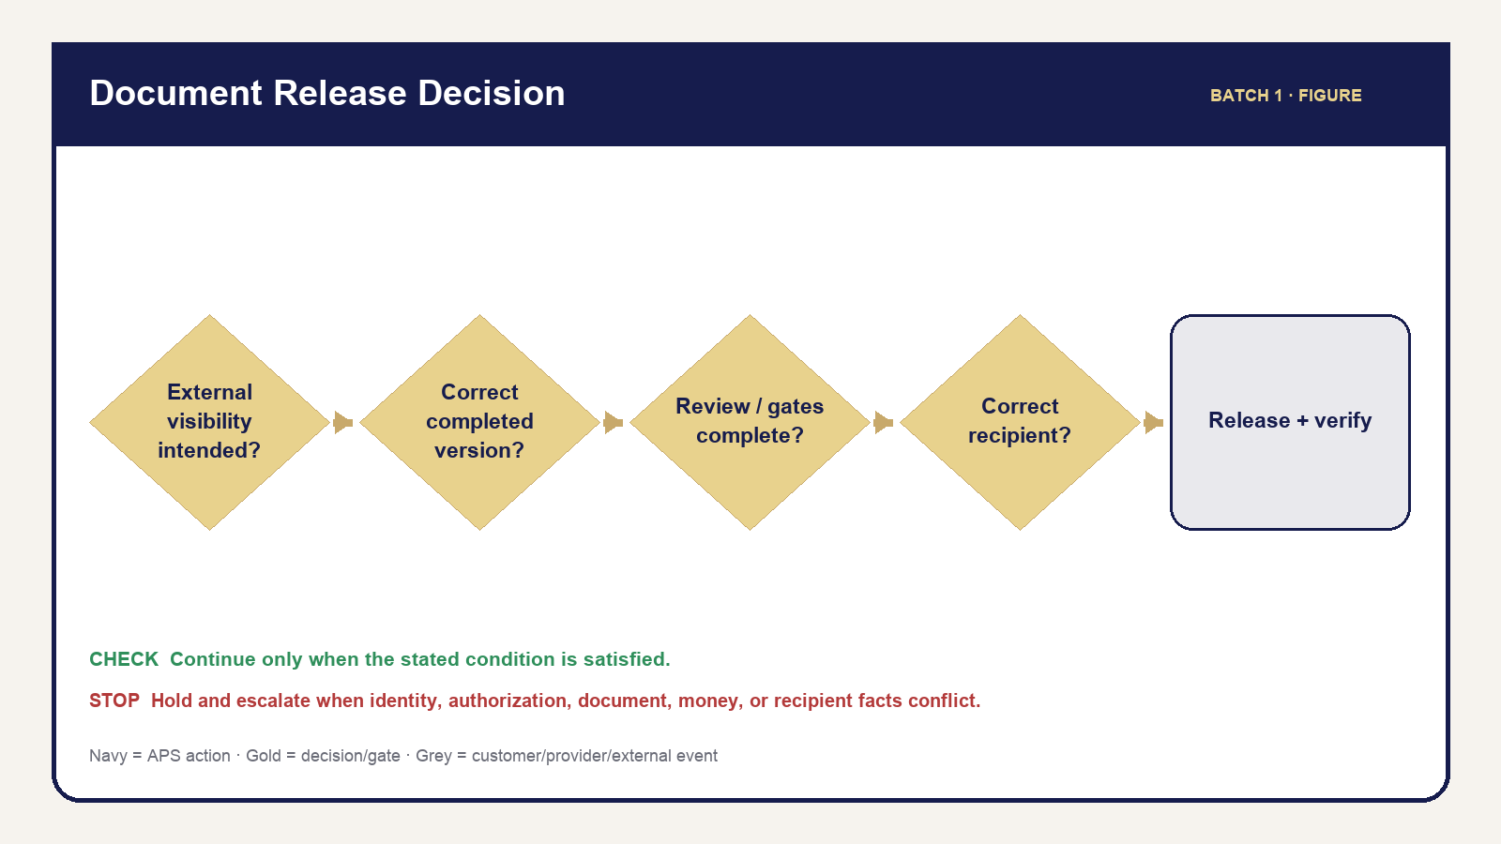
Figure 09 — Document Release Decision
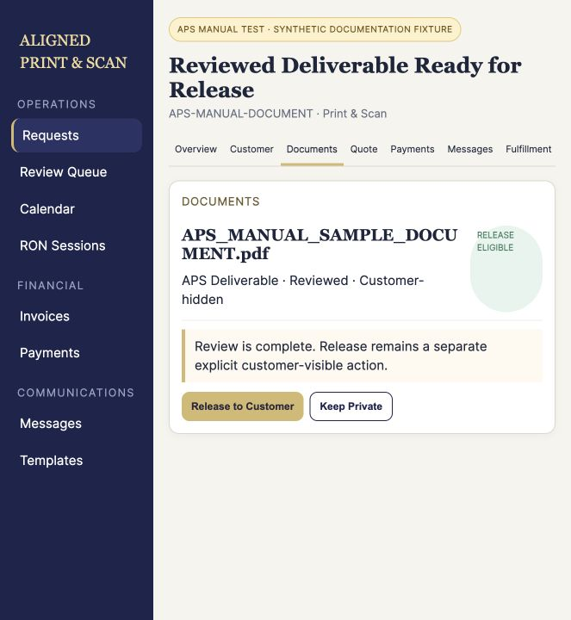
APS governed synthetic screenshot — ss 032 release to customer
Release is deliberate authorization, not a side effect of upload, review, provider completion, or message preparation. The operator must prove the file is the correct current customer-eligible output, the intended recipient is correct, and applicable service/financial/fulfillment conditions allow release.

Procedure 12.1 — Release a document to the customer
- Open the correct request and verify reference, customer/organization, and service.
- Open Documents.
- Identify the intended completed/customer-eligible file.
- Verify the correct request, customer, and organization again.
- Verify provenance, classification, and current version; open the file.
- Confirm operational review is complete.
- Confirm applicable service, financial, fulfillment, and release gates.
- Confirm the file is eligible for the intended customer—not internal, working, audit, source-only, or superseded.
- Perform the maintained Release to Customer action and confirmation.
- Verify the release state and correct portal group/view/download.
- Verify Timeline/audit evidence.
- Send or verify associated communication only when the maintained workflow requires it; do not resend blindly.

Decision tree — release or hold
If the document is not intended for external visibility, keep it internal. If it is external, ask whether it is the correct completed/current version. If no, hold and resolve. If yes, ask whether review and service-specific gates are complete. If no, hold. If yes, verify the intended recipient. A recipient mismatch is STOP. Only the fully satisfied path releases, then verifies visibility and audit/communication evidence.

Internal versus customer document
Question | Internal APS/working file | Customer-released file
Exists on request | May | Yes
Admin access | Authorized staff | Authorized staff
Automatic customer visibility | No | No—requires maintained release
May contain working/QC content | Yes | No
Suitable final output | Not assumed | Verified
Portal visibility | Prohibited | Scoped after release

The portal heading is DOCUMENTS FROM ALIGNED PRINT & SCAN. It says: “Files provided to you by Aligned Print & Scan will appear here.” The empty state says: “No documents have been provided yet.” Internal terminology remains more precise because it controls classification, review, and authorization.
After release, the operator must be able to answer: which file; which version; when; which request/account; what customer communication occurred; and what Timeline/audit evidence remains.
Figure: Document Release Decision Tree. Quick References: Document Release Checklist and Internal vs Customer Document Comparison.

Chapter 13 — Document Replacement, Mistakes & Recovery
Recovery protects the customer and the historical record. Correct forward; do not delete or overwrite history to make a mistake disappear. Each troubleshooting entry uses the same pattern: symptom, checks, likely cause, action, prohibited action, communication, escalation, and record.

Recovery table
Symptom | Check/action | Do not do | Record/escalation
Wrong upload/request | Provenance, request, access; quarantine from use | Move/release casually | Preserve event; escalate privacy risk
Wrong/superseded version | Version source, replacement, page count | Silently overwrite history | Mark current/superseded through maintained path
Corrupt/incomplete file | Open, page count, missing pages | Treat failure as ready | Request replacement; record blocker
Missing Proof output | Provider/APS asset state | Substitute source | Hold, maintained retry, escalate
Internal file misclassified | Purpose/visibility/release | Release to “fix” classification | Correct safely and verify portal
Wrong file selected for release | Release state, recipient, access | Delete evidence or send more | STOP distribution; incident review
Customer cannot open | Release/access/file integrity | Email an internal copy | Restore authorized access or escalate
Incomplete scanback/return proof | Package/QC/approval/custody | Complete assignment cosmetically | Hold service gate; follow Part IX later

Procedure 13.1 — Respond to a wrong-document release
- Stop additional distribution and do not send replacement material impulsively.
- Verify exactly what file/version was released, to which request/account, when, and through what access path.
- Preserve Timeline, message, release, and access evidence; do not delete history to hide the mistake.
- Protect unrelated customer/tenant data and restrict further access through the maintained authorized path when available.
- Escalate immediately to the owner/authorized incident reviewer.
- Use only authorized customer communication; do not invent legal breach-notification language.
- Perform the approved corrective action and verify it.
- Record facts, decisions, communication, and final state.
ESCALATE — OWNER / AUTHORIZED INCIDENT REVIEW: Formal incident or legal-response requirements are not defined by this handbook. The operator preserves evidence and follows the authorized decision.

Document status/action/communication sequence
Stage | Operator action | Communication | Hold until | Record
Received/review needed | Open, verify, review | Optional receipt only when maintained | Operational facts known | Document state/Timeline
Information/replacement needed | Identify exact deficiency | Maintained information request | Replacement/answer verified | Message plus blocker
Completed artifact ready | Review current output | Do not announce release yet | Eligibility/gates satisfied | Review evidence
Released | Verify portal/access | Maintained delivery message when required | Visibility/audit verified | Release, Message, Timeline
Post-release problem | Stop, investigate, escalate | Authorized response only | Incident/correction authorized | Complete incident facts
Loan package/scanback/return | Preserve version/QC/custody | Ordering-party path | Applicable Part IX gate | Package/fulfillment history

Quick Reference: Document Mistake Recovery.

Chapter 14 — Service-Specific Document Lifecycles
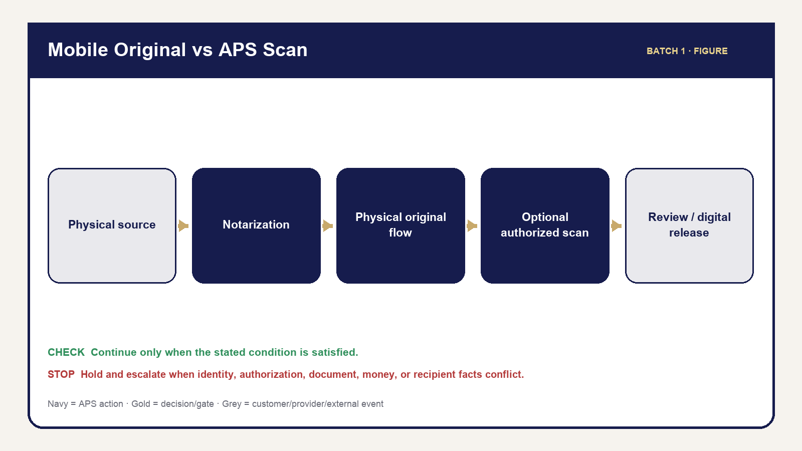
Figure 11 — Mobile Original Scan
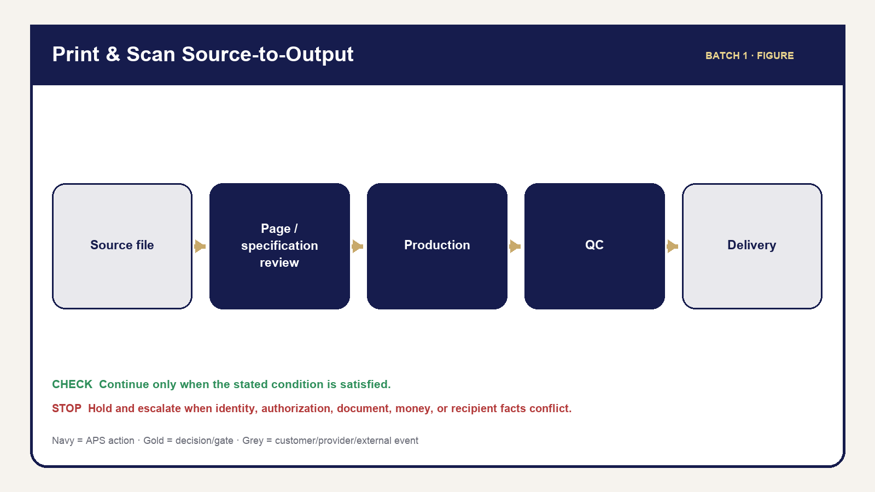
Figure 12 — Print Source Output
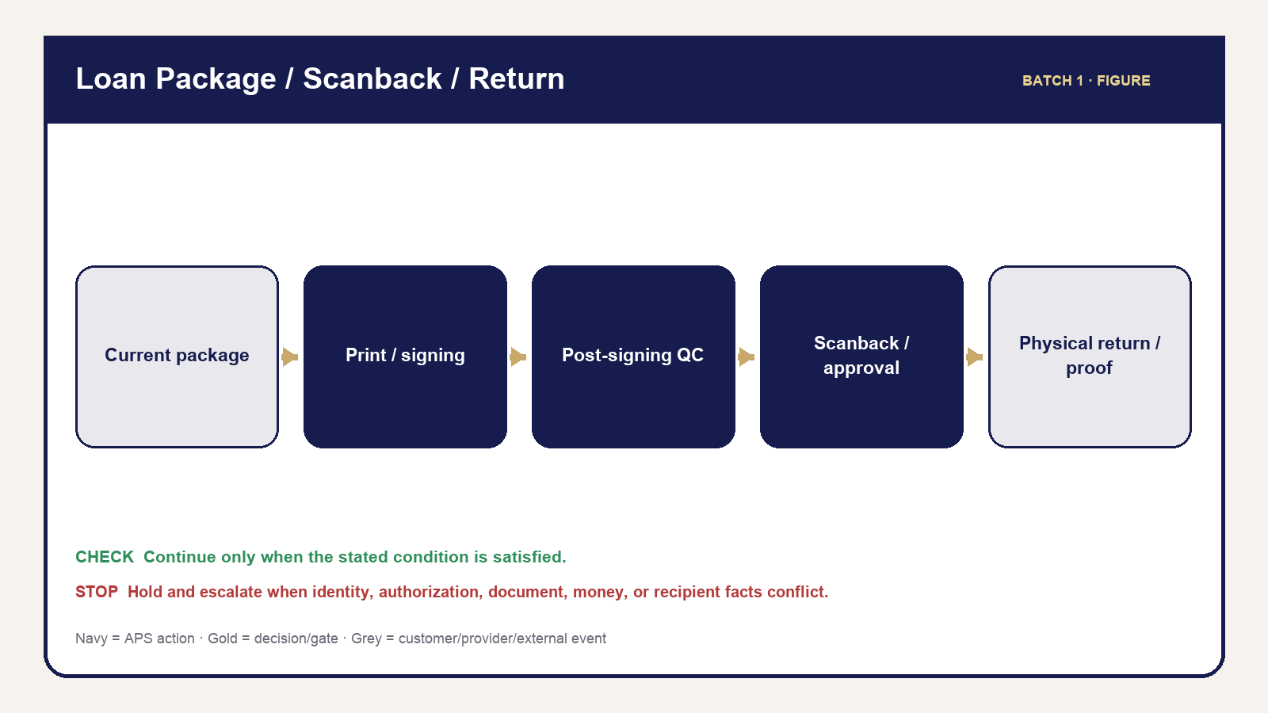
Figure 13 — Loan Package Return
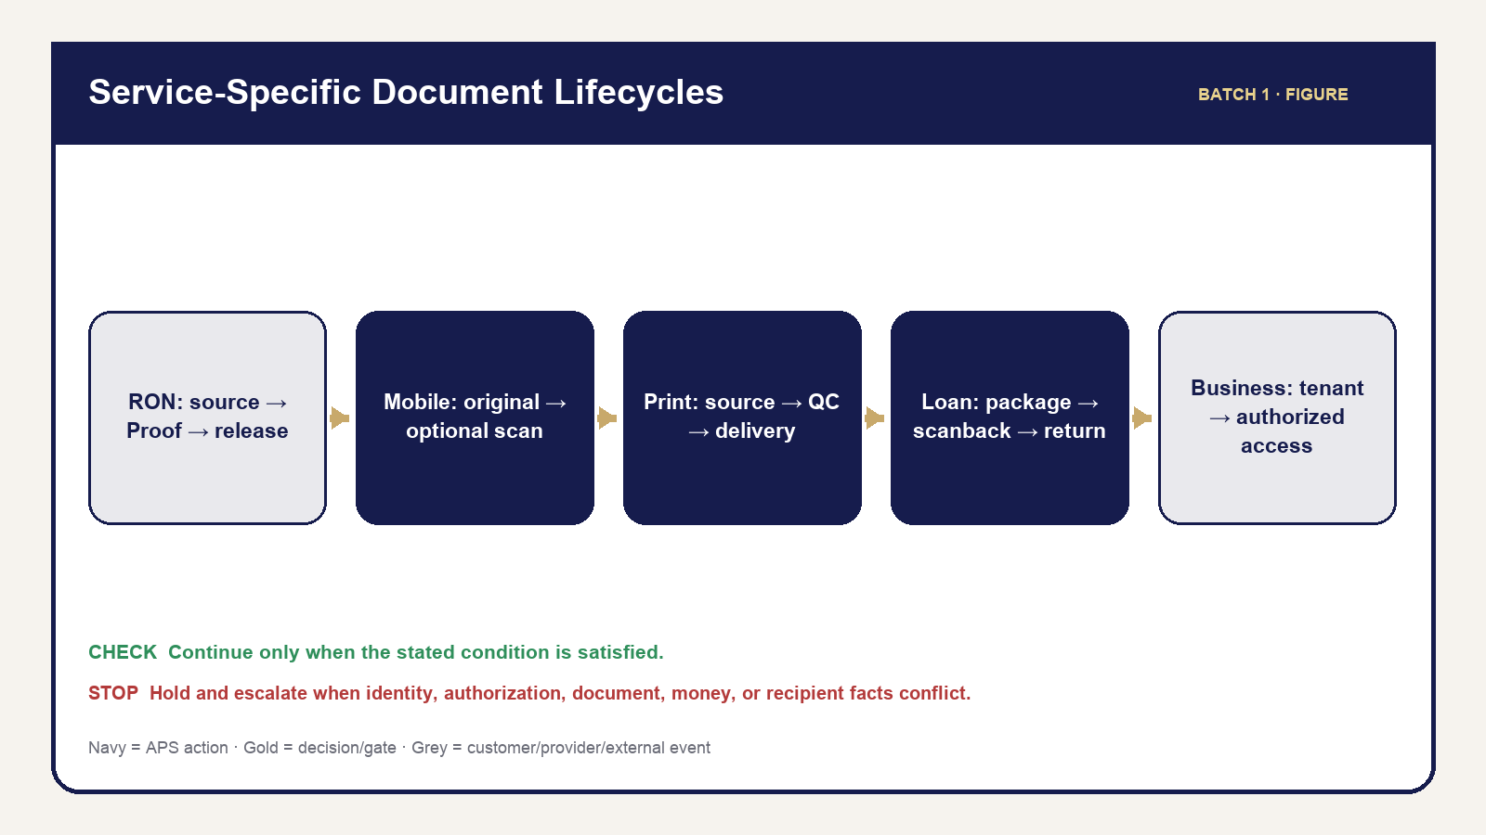
Figure 14 — Service Document Comparison
The document controls taught in Chapters 9–13 apply differently by service. This chapter gives the high-level lanes operators need before detailed service training. It does not draft later service procedures.

RON
Source → APS operational review → Proof/RON session → completed notarized electronic document → post-session review → correct-version release → customer access. APS release remains separate from provider completion. Apply Chapter 12; see Part VI for detailed RON operation.

Mobile
Physical/source document → in-person notarization → physical original remains in the authorized physical flow → optional APS scan when requested/authorized → scan QC/review → digital release where applicable. An optional scan does not replace returning/accounting for the physical original. See Part VII.

Print & Scan
Source file → file/page/specification review → production → first-copy/final QC → scan/output integrity → pickup/courier/portal delivery. Production start and delivery are meaningful controlled facts. See Part VIII.

Loan Signing — high level only
Loan package → current version → print/borrower copies → signing → post-signing table QC → scanback when required → approval when required → physical return → tracking/proof. Do not return during an applicable approval hold and do not overwrite superseded package history. Detailed procedures belong in Part IX.

Business
Organization-linked request → tenant-scoped document → role/capability check → classification/review → release/access → historical visibility. A Business role never grants cross-organization access or APS admin authority. Detailed Business operation belongs in Part X.

Procedure 14.1 — Identify the applicable document lane
- Verify the request’s service and customer/organization context.
- Identify the current document type and provenance.
- Locate the current point in the applicable service lane.
- Apply the universal classification, review, security, and release controls from Chapters 9–13.
- Apply only the service-specific gate already established by current source; use the later Part for detailed operation.
- If service and document lane conflict, hold and escalate rather than improvising a hybrid path.
Figure: Service-Specific Document Lifecycle Comparison, supported by Mobile Physical Original vs APS Scan, Print & Scan Source-to-Output, and Loan Package/Scanback/Return high-level visuals.

Batch 1 Quick References
Each item is designed for independent printing in the final edition. Chapter procedures control if a summary and detailed instruction differ.

QR-01 — Where Do I Go in Admin?
Request work → Requests. Blocker → Review Queue. Schedule → Calendar. Exact customer/order/invoice → Search, then open request. RON/Loan Signing overview → service module, then request. Money → Invoices/Payments, then exact ledger. Communication → Messages plus request Messages. Guidance → Scripts/Resources. Access → Staff & Access.
STOP — IF: reference/customer/organization does not match.

QR-02 — Request Workspace Tabs
Overview: stage/Next Action. Customer: relationship/contact. Documents: file/review/release. Quote: current offer. Payments: invoices/payments/refunds. Messages: communication evidence. Fulfillment: service facts/gates. Timeline: history.

QR-03 — State Mental Map
Check request, appointment, money, document, participant, provider, fulfillment, Loan Signing stage, and exception state separately. STATUS IS NOT PROOF. Advance only when the specific gate’s evidence is satisfied.

QR-04 — Customer vs Signer vs Ordering Party
Customer/requester coordinates. Signer participates and decides whether to sign. Ordering party supplies authoritative Loan Signing scope/instructions. Never infer one role from another or from document text.

QR-05 — Participant Decision Guide
Existing confirmed participant? Review role/readiness. New but confirmed by customer/authorized orderer? Add through maintained workflow. Unclear? Flag Additional Participant Review, request information, and HOLD. Separate signer, witness, credible witness, ordering party, and non-signing named person.

QR-06 — Five Questions for Every Document
- Who provided it? 2. What is it for? 3. Who may see it? 4. Is it ready for release? 5. What happens next?
UPLOAD ≠ REVIEW ≠ COMPLETION ≠ RELEASE.

QR-07 — Document Review Checklist
Correct request/file; provenance; file opens; no obvious corruption; page count when applicable; current version; operational completeness; participant/service facts; classification; next action; Timeline evidence.

QR-08 — Completed Document Review
Correct request/recipient/service; expected completed output; file opens; correct completed/notarized version; no internal/source/superseded file; applicable gates; release readiness.
STOP — Never release the pre-notarization RON source as the completed notarized document.

QR-09 — Document Release Checklist
Correct request/customer/org → correct completed current file → file opens → review complete → service/money/fulfillment gates clear → eligible classification → Release to Customer → verify portal/access → verify Timeline/message.

QR-10 — Document Release Decision Guide
External visibility intended? NO: internal. YES: current completed version? NO: hold. Review/gates complete? NO: hold. Correct recipient? NO: STOP. YES: release, verify visibility and audit.

QR-11 — Document Mistake Recovery
Stop distribution; verify exact file/version/recipient/time; preserve evidence; protect unrelated data; escalate; communicate only as authorized; correct forward; verify and record. Never delete history to hide an error.

QR-12 — Internal vs Customer Document
Internal/working means Admin-only unless a maintained release workflow authorizes external visibility. Existence on a request never creates portal visibility. Customer-released means the exact eligible file crossed the controlled release boundary and was verified.

Batch 1 Source Register
Subject | Authority | Batch 1 use
Certified baseline | `docs/audits/RELEASE_10_PRODUCTION_CERTIFICATION.md` | production status, maintained modules, counts, safety boundaries
Admin/workspace | `admin-dashboard.html`, `assets/js/admin.js`, `assets/js/admin-v3.js`, Admin tests | modules, tabs, Next Action, search/filter, review behavior
Customer journey/portal | `customer-status.html`, `assets/js/script.js`, customer-view/action functions/tests | six sections, actions, customer-safe visibility
People/participants | participant UI/domain/migrations/tests; maintained template/script catalogs | roles, Add/Edit/Review, no inference
Documents | upload/release/customer-view/storage functions/tests; `docs/manual-source/WORKFLOW_CATALOGS.md` | classification, review, release, access, recovery
RON completed assets | Proof document/completed-asset lifecycle modules/tests | source/completed distinction, retry/hold/release boundaries
State/gates | completion helpers, fulfillment tests, workflow catalogs | parallel dimensions and gate behavior
Money cross-references | invoice/payment/refund code/tests; `docs/BUSINESS_RULES.md` | high-level distinctions only; detailed operation deferred to Part V
Brand/layout | `assets/css/styles.css`, `docs/BRAND_AND_UI_GUIDELINES.md`, locked specification | palette, typography, logo, callouts, tables
Existing screenshots | `docs/manual-source/SCREENSHOT_MANIFEST.md`, `docs/assets/manual/` | governed synthetic visual evidence

Source verification required
- Exact operator-visible Proof failure/retry labels will be reconciled in Part VI; Batch 1 teaches hold/do-not-substitute/maintained-retry/escalation.
- Exact production classification labels will be mapped to the handbook-friendly teaching classes during final editorial reconciliation; current controls remain authoritative.
- Formal incident/legal response for wrong-document release is not defined here; operators escalate to owner/authorized incident review and do not invent notification policy.
- Future-Part procedures and final page-number cross-references remain intentionally unpopulated.

