ALIGNED PRINT & SCAN
OPERATOR
HANDBOOK
Release 10 Certified Operations Edition
CERTIFIED OPERATIONS EDITION | PARTS I–XIII | CHAPTERS 1–53

Document Control
Certified baseline: APS Release 10. Edition: Certified Operations Edition. Publication authority: OWNER APPROVED — LOCKED specification, PR #107. This editable master is assembled from controlled chapter source, not from unrelated application code or live production data.

How to Use This Handbook
LEARN in Parts I–IV; OPERATE in Parts V–XII; use Part XIII for QUICK REFERENCE. The detailed governing chapter controls whenever a Quick Reference is abbreviated. Stop and source-verify any material drift.

Scope and Professional Boundaries
Operators coordinate verified APS work within assigned authority. They do not give legal or financial advice, choose legal documents or notarial acts for customers, interpret loan terms, bypass fulfillment gates, expose protected information, or manufacture provider, payment, delivery, or audit outcomes.

How to Read Workflow Diagrams
Rectangles show controlled stages or actions; diamonds show decisions; arrows show permitted sequence. A branch is not permission to bypass the governing conditions. Text explanations remain the accessible authority.

Contents
Part, Chapter, and numbered subsection entries link to the controlled publication headings.
PART I — Aligned Print & Scan
Chapter 1 — APS Mission, Services & Operating Model
What APS knows, what the operator verifies, and what comes from providers
Procedure 1.1 — Orient a new request
Service relationship table
Chapter 2 — Roles, Authority & Professional Boundaries
Operator judgment and boundaries
Procedure 2.1 — Decide whether you may act
Role comparison
PART II — Customer & Portal Operations
Chapter 3 — The Customer Journey
The journey in operator language
Procedure 3.1 — Identify the customer’s current stage
Chapter 4 — Customer Portal Operations
What customers can and cannot do
Procedure 4.1 — Investigate a portal question
Documents language
Portal troubleshooting
PART III — Admin Operations
Chapter 5 — Admin Navigation & Daily Triage
Where to go
Procedure 5.1 — Daily opening triage
Loading, empty, and error
Procedure 5.2 — Daily closeout
Chapter 6 — The Request Workspace
Procedure 6.1 — Work an Admin next action
Tab operating guide
Chapter 7 — Understanding Status, Next Action & Gates
Procedure 7.1 — Evaluate an advancement gate
Decision guide
PART IV — Customers, Participants, Documents & Records
Chapter 8 — Customers, Signers, Witnesses & Participants
Procedure 8.1 — Add or correct a participant
Decision tree — another person appears
Chapter 9 — Document Mental Model, Customer Uploads & Review
Procedure 9.1 — Review a customer upload
Document received decision
Chapter 10 — Document Classification & Safe Handling
Procedure 10.1 — Handle a file safely
Chapter 11 — Completed & Proof-Produced Documents
Checklist 11.1 — Completed-document review
Procedure 11.1 — Missing Proof completed output
Chapter 12 — Document Release, Delivery & Audit
Procedure 12.1 — Release a document to the customer
Decision tree — release or hold
Internal versus customer document
Chapter 13 — Document Replacement, Mistakes & Recovery
Recovery table
Procedure 13.1 — Respond to a wrong-document release
Document status/action/communication sequence
Chapter 14 — Service-Specific Document Lifecycles
RON
Mobile
Print & Scan
Loan Signing — high level only
Business
Procedure 14.1 — Identify the applicable document lane
PART V — QUOTES, INVOICES & MONEY
Chapter 15 — From Estimate to Approved Quote
15.1 Estimate Versus Quote
15.2 Facts Required Before Quoting
15.3 Service-Specific Quote Worksheets
15.4 Build and Review in Admin
15.5 Quote Version and Revision
15.6 Sending and Customer/Orderer Approval
15.7 What Blocks a Quote
15.8 Quote Audit and History
Chapter 16 — Invoice, Payment & Receipt
16.1 Quote → Invoice → Payment → Receipt
16.2 Invoice #1
16.3 Supplemental/Final Invoice #2
16.4 Card and ACH
16.5 Pending Versus Paid
16.6 Partial Payment
16.7 Authorized Offline and TEST Payment
16.8 Receipt
16.9 Reconciliation and Duplicate Prevention
16.10 Never Rewrite a Paid Invoice
Chapter 17 — Refunds, Business Terms & Financial Gates
17.1 Refund Review Versus Completed Refund
17.2 Partial/Full and Retained Amount
17.3 Original Payment Relationship
17.4 Failed or Ambiguous Provider State
17.5 Prepaid, Due on Receipt, Net 15, and Net 30
17.6 Who Assigns Terms
17.7 Credit Hold
17.8 Postpaid Completion and Open Receivable
17.9 Prohibited Shortcuts
17.10 Financial Decision Table and Escalation
PART VI — REMOTE ONLINE NOTARIZATION
Chapter 18 — Remote Online Notary Foundations & Workflow
18.1 APS-Originated RON Powered by Proof
18.2 Texas Operator Boundaries
18.3 Readiness Domains
18.4 What APS Controls and What Proof Controls
18.5 KBA, Identity, Meeting, and Privacy Boundaries
18.6 Remote Online Notary Workflow Map
18.7 Thirteen APS RON Stages
Chapter 19 — Preparing the Remote Online Notary Quote
19.1 When RON Is Ready to Quote
19.2 Notarial Act Information
19.3 Participants and Witnesses
19.4 Documents and Service Requirements
19.5 Build, Review, and Send Quote
19.6 Customer Approval
19.7 Prepaid Payment Gate
19.8 When to Revise
19.9 RON Quote Readiness Checklist
Chapter 20 — RON Status, Operator Action & Customer Communication Sequence
20.1–20.13 Operating Rule
Chapter 21 — RON Fulfillment Gates & Closeout
21.1–21.8 Readiness Gates
21.9 Session Completion
21.10 Completed Proof Document
21.11 Document Release
21.12 Final Completion
21.13 Post-Session Review and Release Procedure
21.14 Failed or Incomplete Processing
21.15 RON Failure / Alternative Path Decision Tree
21.16 RON Quick References
PART VII — MOBILE NOTARY
Chapter 22 — Mobile Notary Workflow, Travel & Readiness
22.1 Mobile Notary Workflow Map
22.2 Intake and Service Address
22.3 Travel Origin
22.4 ORS and Manual Distance Fallback
22.5 Fee Inputs
22.6 Mobile Travel / Quote Decision Flow
22.7 Requested Versus Confirmed Appointment
22.8 Participant and Document Readiness
22.9 Safety, Reschedule, and Dispatch
Chapter 23 — Preparing the Mobile Notary Quote
23.1–23.3 Readiness and Fee Inputs
23.4 Build, Review, and Send
23.5 Approval and Payment
23.6 Revision
23.7 Mobile Quote Readiness Checklist
Chapter 24 — Mobile Status, Operator Action & Customer Communication Sequence
24.12 Timeline Evidence
Chapter 25 — Mobile Fulfillment Gates, Appointment & Closeout
25.1 Readiness Gates
25.2 Before You Leave
25.3 Travel and Arrival
25.4 At the Table
25.5 Identity, Willingness, Act, and Certificate
25.6 Journal Completion
25.7 Optional Scan
25.8 Final Charges
25.9 Delivery
25.10 Before You Drive Away
25.11 Final Money and Completion Gates
25.12 Exceptions, Safety, and Quick References
PART VIII — PRINT & SCAN
Chapter 26 — Print & Scan Workflow & Quote Preparation
26.1 Print & Scan Workflow Map
26.2 When Ready to Quote
26.3 File Opens and Authoritative Page Count
26.4 Production Requirements
26.5 Scanning, PDF Support, and Delivery
26.6 Build Through Revision
26.7 Quote Readiness Checklist
Chapter 27 — Print & Scan Status, Operator Action & Customer Communication Sequence
27.10 Timeline Evidence
Chapter 28 — Print & Scan Fulfillment Gates, Production & Closeout
28.1–28.7 Preproduction Gates
28.8 Production-Start Boundary
28.9 First-Copy and Final QC
28.10 Scan QC, Naming, and Integrity
28.11 Delivery
28.12 Completion
28.13 Exceptions and Recovery
28.14 Quick References
PART IX — LOAN SIGNING
Chapter 29 — Loan Signing Foundations & Workflow
29.1 Loan Signing Versus Mobile Notary
29.2 Ordering Party Versus Signer
29.3 Role and Signing-Agent Boundaries
29.4 Signing Types
29.5 Signing Methods
29.6 Property and Signing Addresses
29.7 Company, Order, and Escrow Identifiers
29.8 Structured Signers
29.9 Eight Broad APS Stages
29.10 Sensitive Information
29.11 Loan Signing Workflow Map
Chapter 30 — Loan Package Types
30.1 Buyer / Purchase
30.2 Seller
30.3 Refinance
30.4 HELOC
30.5 Loan Modification
30.6 Reverse Mortgage
30.7 Commercial / Custom
Chapter 31 — Common Loan Document Reference
Chapter 32 — Loan Signing Intake & Assignment Review
32.1–32.4 Order, Parties, Identifiers, and Addresses
32.5–32.8 Scope and Instructions
32.9 Assignment Review Procedure
Chapter 33 — Preparing the Loan Signing Quote
33.1–33.5 Quote Inputs
33.6–33.9 Review, Approval, Payment, Revision
Chapter 34 — Loan Signing Status, Operator Action & Customer Communication Sequence
Chapter 35 — Loan Signing Fulfillment Gates
35.1 Ten-Gate Framework
35.2 Gate Rule
Chapter 36 — Package Preparation & Printing
36.1 Package Version Decision Tree
36.2 Authoritative Page Count and Print Volume
36.3 Print and QC Procedure
Chapter 37 — Conducting the Loan Signing
37.1–37.3 Before Leaving, What to Bring, Arrival
37.4–37.9 Identity Through Common Document Presentation
37.10–37.13 Signer Questions and Ordering-Party Contact
37.14–37.16 Stipulations, Table Check, Departure
Chapter 38 — Scanbacks, Approval & Return
38.1–38.4 Requirements, Selection, Upload, Rescan
38.5–38.7 Approval Before Return
38.8–38.10 Physical Return and Completion Readiness
38.11 Scanback → Approval → Return Decision Tree
38.12 Non-Negotiable Hold
Chapter 39 — Loan Signing Exceptions & Financial Resolution
39.1–39.5 Cancellation, No-Sign, Partial, Resign, Cause
39.6 Excessive Wait
39.7–39.11 Stops, Review, Supplemental Invoice, Refund, Resolution
39.12 Loan Signing Exception Decision Tree
39.13 Resign Rule
Chapter 40 — Loan Signing Closeout & Completion
40.1–40.5 Completion Evidence
40.6–40.9 Communication, Timeline, Gate, History
40.10 Closeout Checklist
PART X — BUSINESS ACCOUNTS & BUSINESS PORTAL
Chapter 41 — Business Account Lifecycle & Roles
41.1 Lifecycle Mental Model
41.2 Application, Review, and Approval
41.3 Organization and Invitation
41.4 Activation, Authentication, and Recovery
41.5 Roles and Membership
41.6 Organization Switching
41.7 Locations and Service Eligibility
41.8 Business Account Lifecycle Map
Chapter 42 — Business Portal Operations, Requests & Documents
42.1 Portal Orientation
42.2 Creating and Reviewing Requests
42.3 Requests and Organization Ownership
42.4 Documents
42.5 Messages and Communication History
42.6 Locations
42.7 Member Administration
42.8 Recovery and Escalation
Chapter 43 — Business Account Status, Admin Action & Applicant Communication Sequence
43.1 Application Received, Review, Information Needed, Approved
43.2 Organization, Invitation, and Activation
43.3 Service Eligibility and Business Requests
43.4 Billing, Reminders, and Payment
43.5 Credit Hold
43.6 Recovery, Suspension, and Closure
43.7 Business Lifecycle Decision Guide
Chapter 44 — Business Billing & Completion
44.1 Billing Models
44.2 Due on Receipt, Net 15, and Net 30
44.3 Invoice Issue and Partial Payment
44.4 Due Soon, Due Today, Past Due, and Failed Payment
44.5 Credit Hold Procedure
44.6 Completion and Closure
PART XI — COMMUNICATIONS, TEMPLATES & SCRIPTS
Chapter 45 — Communication Control & Delivery Truth
45.1 Templates, Scripts, and Operator Messages
45.2 AUTO, OPERATOR, and IF NEEDED
45.3 Before Sending
45.4 Send Message Versus Send & Update Status
45.5 Attachments and Released Deliverables
45.6 Delivery Evidence and Retry
45.7 Customer-Safe Language
45.8 Communication Decision Tree
Chapter 46 — Maintained Template Master Directory — All 54
46.1 Production Count and Reconciliation
46.2 Indexes
46.3 Preview Alias Reconciliation
46.4 Template Entry Standard
Chapter 47 — Maintained Scripts & Reference Cards — All 48
47.1 Reference-Only Safety Rule
47.2 Eight Maintained Categories
47.3 Use and Do-Not-Use Guidance
47.4 Classification
PART XII — EXCEPTIONS, SECURITY & OPERATIONAL ASSURANCE
Chapter 48 — Troubleshooting, Exceptions & Recovery
48.1 Required Recovery Pattern
48.2 Missing Information
48.3 Wrong, Replacement, or Released Document
48.4 Page Count
48.5 Quote
48.6 Payment and Refund Ambiguity
48.7 Appointment, No-Show, and Safety
48.8 RON, Proof, KBA, and Identity
48.9 ORS and PDF Parser
48.10 Email and Delivery
48.11 Loan Package, Scanback, and Return
48.12 Cancellation, No-Sign, Partial, Resign, and Wait
48.13 Complaint, Chargeback, or Misconduct
48.14 Admin Loading, Empty, and Error States
Chapter 49 — Security & Privacy for Operators
49.1 Customer Privacy
49.2 Business Tenant Separation
49.3 Document Security and Protected Links
49.4 Passwords and Recovery
49.5 Payment Information
49.6 IDs and KBA
49.7 Internal Notes
49.8 Admin, Business, and Customer Access
49.9 Downloads and Emailing Documents
49.10 Personal Devices
49.11 Screenshots and Training Data
49.12 Secrets
49.13 Incident Escalation
Chapter 50 — Operational Assurance & Handbook Control
50.1 Pre-Action Checks
50.2 Post-Action Verification
50.3 Timeline and Audit Integrity
50.4 Duplicate Prevention
50.5 End-of-Day Review
50.6 Source Drift
50.7 Handbook Maintenance
50.8 Legal and Provider Source Revalidation
50.9 Controlled Revision and Owner Approval
PART XIII — QUICK REFERENCES & APPENDICES
Chapter 51 — Admin, State, People, Documents & Money Quick References
51.1 APS System Map
51.2 Universal Request Lifecycle
51.3 Where Do I Go in Admin?
51.4 Request Workspace Tabs
51.5 Review Queue Decision Guide
51.6 State Mental Map
51.7 Loading vs Empty vs Error
51.8 Customer vs Signer vs Ordering Party
51.9 Document Classification
51.10 Document Release Checklist
51.11 Document Mistake Recovery
51.12 Quote vs Invoice vs Payment vs Receipt
51.13 Send vs Send & Update Status
Chapter 52 — Service Quick References
52.1 Remote Online Notarization Quick References
52.2 Mobile Notary Quick References
52.3 Print & Scan Quick References
52.4 Loan Signing Quick References
52.5 Business Account Quick References
Chapter 53 — Communication, Safety & Reference Indexes
53.1 Which Message Do I Send Now?
53.2 Template Quick Index
53.3 Script and Card Quick Index
53.4 Security Checklist
53.5 Stop, Hold, and Escalate Guide
53.6 Daily Opening and End-of-Day
53.7 Independent Print and Lamination Controls
APPENDICES
Appendix A — Glossary and Acronyms
Appendix B — Status and State Catalog
Appendix C — Template Index and Production Reconciliation
Appendix D — Script and Card Index
Appendix E — Package Comparison
Appendix F — Loan Document Source Register
Appendix G — Figure, Table, Procedure, Checklist, and Decision Tree Index
Appendix H — Source Authority and Traceability
Appendix I — Revision History and Owner Approval

PART I — Aligned Print & Scan

Chapter 1 — APS Mission, Services & Operating Model
Purpose: perform this workflow from verified APS and assignment evidence while preserving legal, notarial, financial, privacy, and ordering-party boundaries.
YOU WILL LEARN TO
- Review the authoritative assignment, act within role, stop at blockers, communicate accurately, and leave a complete audit trail.
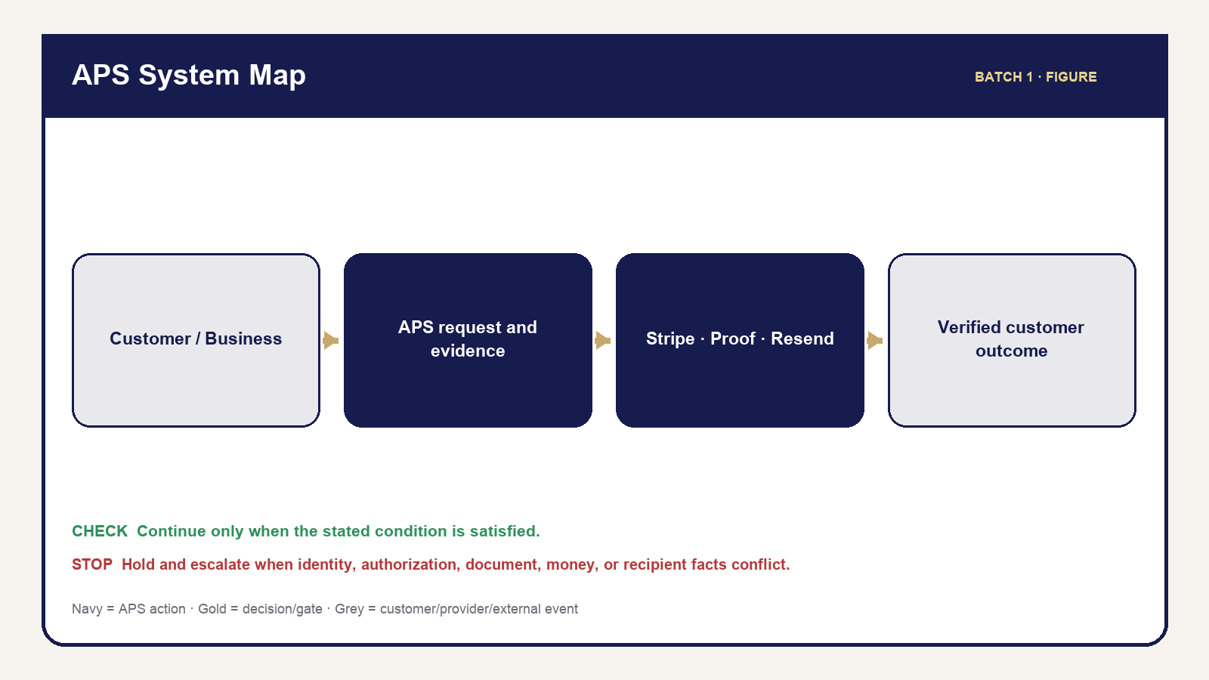
01 Aps System Map
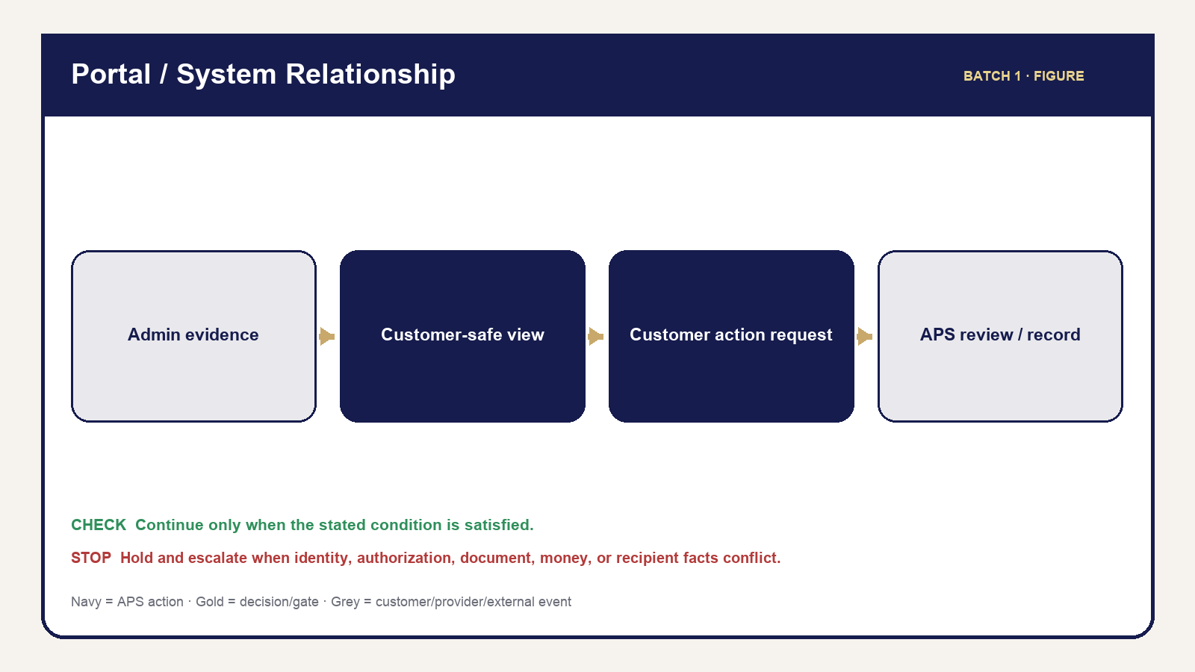
03 Portal System Relationship
Aligned Print & Scan coordinates service work from request through verified closeout. The operator’s job is to preserve the right customer, request, facts, money, documents, communications, and history while moving work only when the next gate is satisfied. A polished customer experience depends on quiet discipline: confirm before changing, use the maintained action, and verify what the customer can actually see.
APS supports four service families. Remote Online Notary uses APS for request, quote, payment, preparation, post-session document review, customer release, and completion while Proof handles provider-native identity, meeting, signing, certificate, and seal activity. Mobile Notary sends an operator to a confirmed physical location. Print & Scan converts an authorized source into checked output. Loan Signing manages an ordering-party assignment, package, signing appointment, scanbacks, return, exceptions, and financial resolution.
Retail work is scoped to a request/reference and verified customer relationship. Business work adds an authenticated organization, membership, role, locations, service eligibility, and assigned billing terms. Neither relationship changes the central rule: the operator acts within the exact request and the person or organization permitted to receive its information.

What APS knows, what the operator verifies, and what comes from providers
APS stores the request, customer/organization relationship, service facts, quote and invoice history, messages, document metadata, fulfillment facts, and Timeline. The operator verifies that these facts match the work in front of them. Stripe supplies authoritative card/ACH results; Proof supplies provider-native RON states and completed assets; routing supplies distance evidence when available; Resend supplies email acceptance/failure evidence. A provider response is evidence, not permission to skip APS review.
OPERATOR RULE — Use the right source. Read APS for APS facts, inspect the actual document for document facts, and use the provider record for provider outcomes. If sources disagree, hold the action, preserve both facts, and escalate. Do not choose the most convenient value.

Procedure 1.1 — Orient a new request
1. Open the request from Requests, Review Queue, search, Calendar, or the applicable service module.
2. Match the APS reference, service, customer/organization, and current status.
3. Read Next Action and inspect the tab that contains its supporting evidence.
4. Check for Review Queue blockers, pending customer actions, and unresolved money/document requirements.
5. Identify which facts APS controls and which require customer, ordering-party, or provider confirmation.
6. Take only the action supported by current evidence.
7. Verify the resulting screen, customer visibility when applicable, and Timeline/message record.
STOP: If the request, recipient, document, amount, or provider result is ambiguous, do not advance. Correct or escalate the ambiguity first.

Service relationship table
Service | APS coordinates | External/customer responsibility | Completion focus
RON | Intake, money, preparation, Proof handoff, returned-document review/release | Signer readiness; Proof-native identity/session actions | Correct completed asset reviewed/released plus gates
Mobile | Address/travel, appointment, acts, optional scan, final charges | Signer, ID, documents, witnesses, safe location | Performed facts, certificate/document check, delivery, money
Print & Scan | Source review, page/specs, production/QC, delivery | Correct source/specification approval | Output QC and authorized delivery
Loan Signing | Assignment, package/version, appointment, signing, scanback/return, exception/money | Ordering-party instructions and signer participation | Ten applicable fulfillment gates

Figures: APS System Map and Portal/System Relationship Map. See Part V — Quotes, Invoices & Money for detailed financial operation and Parts VI–IX for service execution.

Chapter 2 — Roles, Authority & Professional Boundaries
Purpose: perform this workflow from verified APS and assignment evidence while preserving legal, notarial, financial, privacy, and ordering-party boundaries.
YOU WILL LEARN TO
- Review the authoritative assignment, act within role, stop at blockers, communicate accurately, and leave a complete audit trail.
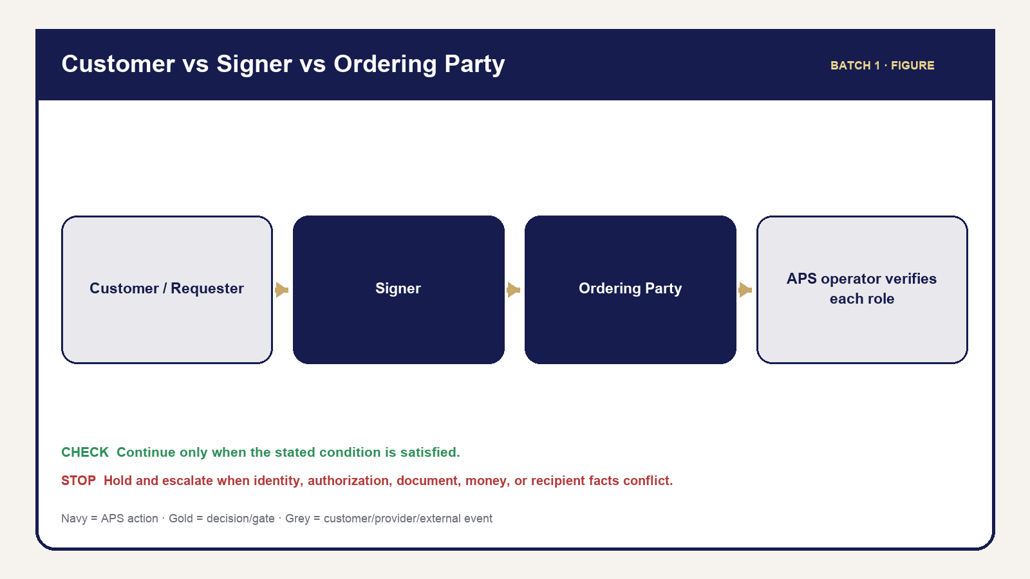
05 Customer Signer Orderer
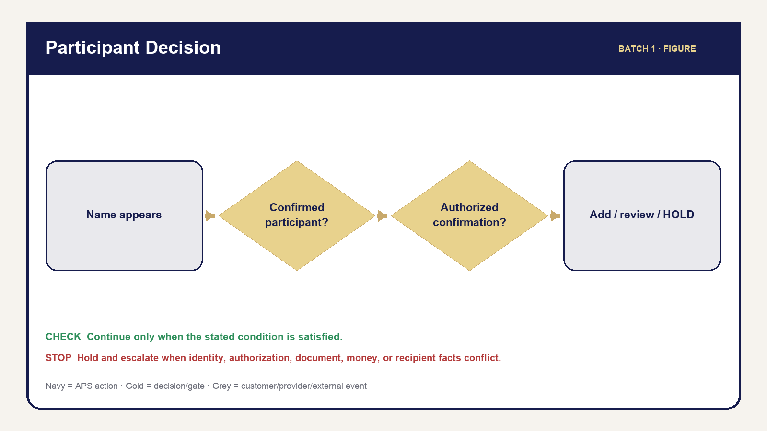
06 Participant Role Relationship
Roles answer two questions: who is acting, and what are they allowed to do? A familiar person or visible record does not expand permission. APS owner/admin/staff authority remains separate from Business organization roles, retail request access, signer participation, and provider authority.
The APS owner/admin controls APS-wide decisions within maintained permissions. Staff may perform only the functions assigned to their active role. A Business admin manages authorized organization context without becoming an APS admin. A Business member acts only for memberships and capabilities currently granted. A retail customer has scoped access to the applicable request, not a general customer database.
The requester initiates or coordinates work. The signer is the person whose signature/notarial participation is required. The ordering party supplies authoritative Loan Signing scope and instructions. A document witness observes signing when required. A credible witness is an identity method used only when legally available and must never be confused with a document witness.

Operator judgment and boundaries
Operators may explain APS steps, identify document titles and visible signing areas within approved role boundaries, request missing operational facts, and stop unsafe or unauthorized work. Operators must not interpret legal effect, advise whether to sign, choose legal forms, change document wording, promise a refund, bypass identity requirements, or describe a payment/provider action as complete before evidence exists.

Procedure 2.1 — Decide whether you may act
1. Identify your active APS role and the action you intend to take.
2. Identify the request, organization, participant, document, and recipient affected.
3. Confirm the action appears in the maintained interface for your role and current context.
4. Verify the facts required by the action; visibility alone is not proof the facts are ready.
5. If the question requests legal/financial interpretation, pause and refer it to the appropriate authorized professional.
6. If identity, willingness, awareness, safety, legality, or authorization is uncertain, hold or refuse the affected action.
7. Record neutral facts and the referral/escalation; avoid conclusions you are not qualified to make.

Role comparison
Role | May do | Must not do | Record that remains
APS operator | Perform assigned APS actions and verify results | Exceed role, improvise policy, expose internal data | Timeline, message, fulfillment, or audit evidence
Customer/requester | Supply facts, approve quote, pay, request action | Access internal or unrelated-request data | Customer action/request history
Signer | Participate and make personal signing decisions | Be inferred solely from document text | Participant/readiness and service facts
Ordering party | Supply authoritative assignment facts/instructions | Convert instructions into legal advice by APS | Assignment and communication history
Witness | Perform the applicable witness role | Be treated as signer/credible witness without authority | Participant role/readiness
Provider | Return provider-native result | Decide APS release/completion | Provider-to-APS evidence

STOP — Refuse or escalate: identity cannot be established; willingness or awareness is absent; coercion, illegality, or safety concern exists; the document is incomplete for the requested operation; required authority/instructions are missing; or the requested action exceeds the operator’s role. Record facts, not accusations.
Figures: Customer vs Signer vs Ordering Party and Customer/Participant Role Relationship.

PART II — Customer & Portal Operations

Chapter 3 — The Customer Journey
Purpose: perform this workflow from verified APS and assignment evidence while preserving legal, notarial, financial, privacy, and ordering-party boundaries.
YOU WILL LEARN TO
- Review the authoritative assignment, act within role, stop at blockers, communicate accurately, and leave a complete audit trail.
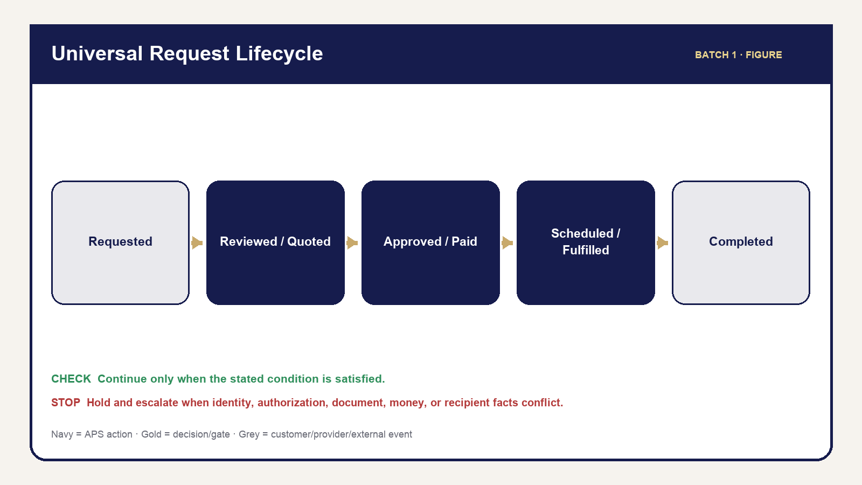
02 Universal Request Lifecycle
The customer journey is a series of controlled promises. A submitted request means APS received information; it does not mean the appointment is confirmed or service is guaranteed. An estimate is an early calculation; a reviewed quote is the current APS offer. Approval authorizes the quoted scope; payment resolves an invoice only when authoritative evidence says so. Scheduling, fulfillment, document release, and completion remain separate.

The journey in operator language
Discover and submit. The customer selects a service, supplies contact and service facts, acknowledges boundaries, and submits. APS creates the request/reference and attempts the maintained acknowledgment. The operator checks the actual saved record rather than relying on an email alone.
Review and quote. APS verifies scope, participants, documents, page/distance/package facts, and pricing inputs. Missing facts create an information step. The quote is built, reviewed, and intentionally sent. Customer or ordering-party approval is recorded before the applicable invoice/payment stage.
Schedule and fulfill. Requested dates are preferences until APS confirms current appointment facts. Each service has its own readiness and performance requirements. A completed appointment or provider session is not necessarily APS completion; documents, delivery, return, exceptions, and money may remain.
Close and support. APS verifies applicable gates, sends the maintained customer-safe outcome, and preserves history. Cancellation and reschedule submissions are review requests, not automatic decisions. Support must remain scoped to the right request and customer.

Procedure 3.1 — Identify the customer’s current stage
1. Open the correct request and match the reference/customer or organization.
2. Read the request status and Next Action.
3. Check the Quote, Payments, Fulfillment, Documents, Messages, and Timeline tabs for supporting facts.
4. Identify the last stage with complete evidence—not merely the most advanced-looking label.
5. Identify the current blocker and who can resolve it: APS, customer, ordering party, or provider.
6. Use the maintained message/action for that stage if communication is needed.
7. Verify what the customer portal now shows and what record was added.
Customer stage | Operator verifies | Customer should see/receive | Do not imply
Request received | Saved request/reference | Acknowledgment and secure request path | Appointment or acceptance confirmed
Quote ready | Reviewed current quote/version | Quote and response action | Payment already due without invoice path
Approved/payment | Approval plus invoice-specific state | Accurate amount/status/payment action | Pending/partial is paid in full
Appointment | Confirmed date/time/method/location | Current confirmed facts | Requested time is confirmed
Fulfillment | Service-specific evidence | Safe progress/next action | Service label alone proves completion
Documents | Correct eligible released file | Scoped view/download | Upload or provider source is released output
Completed | All applicable gates clear | Settled summary and eligible final actions | Completion while blockers remain

CUSTOMER COMMUNICATION: Say what has happened, what happens next, and what the customer needs to do. Do not promise a decision that is still under review.
Figure: Universal Request Lifecycle.

Chapter 4 — Customer Portal Operations
Purpose: perform this workflow from verified APS and assignment evidence while preserving legal, notarial, financial, privacy, and ordering-party boundaries.
YOU WILL LEARN TO
- Review the authoritative assignment, act within role, stop at blockers, communicate accurately, and leave a complete audit trail.

03 Portal System Relationship
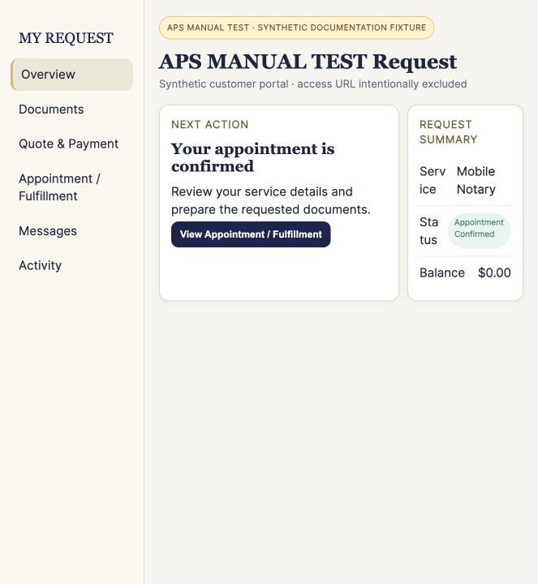
Governed synthetic APS interface — ss 100 portal overview
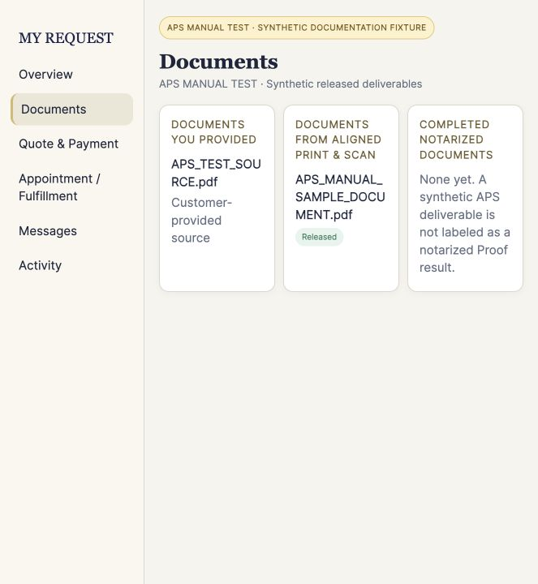
Governed synthetic APS interface — ss 101 portal documents
The Customer Portal is a customer-safe view of one verified request. It is not the Admin workspace and it does not expose internal notes, policy calculations, provider errors, raw identifiers, audit files, or unreleased documents. Operators should compare portal behavior with APS facts whenever a customer reports a mismatch.
The maintained sections are Overview, Documents, Quote & Payment, Appointment/Fulfillment, Messages, and Activity. Overview summarizes current status and Next Action. Documents separates source and released customer files. Quote & Payment shows current customer-safe quote/invoice/payment/refund facts. Appointment/Fulfillment shows confirmed, service-appropriate information. Messages shows customer-facing communications. Activity is a filtered history, not the complete Admin Timeline.

What customers can and cannot do
Customers can review current safe facts, approve/request quote changes where eligible, pay an eligible invoice, upload additional files through the maintained verification path, request cancellation/rescheduling, contact support, and access intentionally released files. They cannot view or edit internal APS records, authorize their own refund, mark service complete, release documents, see other requests, or turn a request into a confirmed appointment.

Procedure 4.1 — Investigate a portal question
1. Obtain and verify the APS reference and customer relationship using the maintained support process.
2. Open the exact Admin request; never search by name alone and assume the result.
3. Identify the portal section involved.
4. Compare the portal-safe value with the authoritative Admin tab and Timeline.
5. For documents, verify classification, current version, review, release, and intended recipient.
6. For money, verify the exact invoice and authoritative payment/refund state.
7. For appointment/fulfillment, distinguish requested from confirmed and performed from completed.
8. Correct only through the maintained workflow. Do not send internal screenshots or raw protected links.
9. Confirm the customer-visible result and record the support outcome.

Documents language
The heading is DOCUMENTS FROM ALIGNED PRINT & SCAN. The explanatory text is: “Files provided to you by Aligned Print & Scan will appear here.” The empty state is: “No documents have been provided yet.” This customer language does not weaken the internal rule that only an eligible, intentionally released file crosses into customer visibility.

Portal troubleshooting
Symptom | Check | Safe response | Escalate when
Customer cannot access request | Reference/email verification and correct URL | Re-establish only the maintained scoped path | Identity or authorization remains uncertain
Customer cannot open file | Release state, signed access, file integrity | Regenerate only authorized access; verify file | Wrong file, corruption, or access boundary suspected
Status seems wrong | Admin evidence and Timeline | Explain current verified stage; use maintained correction | Conflicting facts or impossible state
Payment not reflected | Invoice/provider result | Wait/reconcile through maintained path | Provider mismatch or duplicate-risk state
Missing message | Message Log and delivery evidence | Retry only when safe and idempotent | Recipient/delivery ambiguity

STOP: Never ask the customer to provide a password, payment credential, full ID image, KBA answer, or protected token through ordinary support communication.
Screenshots: Portal Overview, Documents, Quote & Payment, Appointment/Fulfillment, Messages, and Activity. Figure: Portal/System Relationship Map.

PART III — Admin Operations

Chapter 5 — Admin Navigation & Daily Triage
Purpose: perform this workflow from verified APS and assignment evidence while preserving legal, notarial, financial, privacy, and ordering-party boundaries.
YOU WILL LEARN TO
- Review the authoritative assignment, act within role, stop at blockers, communicate accurately, and leave a complete audit trail.
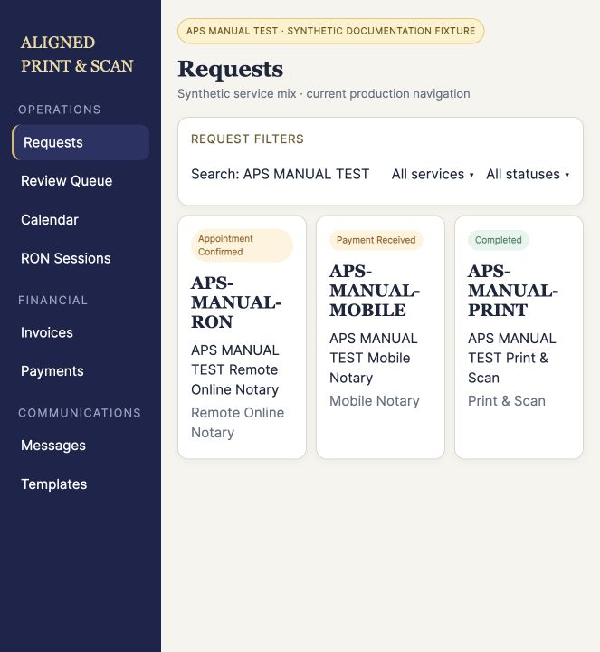
Governed synthetic APS interface — ss 001 requests
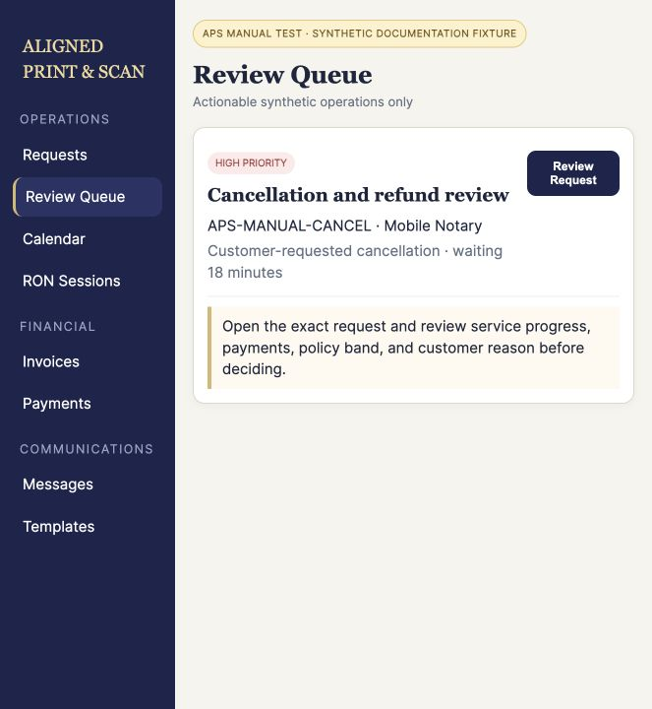
Governed synthetic APS interface — ss 010 review queue
Admin is the operator’s working environment. Start with the module that answers the operational question, then open the exact request for consequential work. The Dashboard summarizes; Requests is the working queue; Review Queue identifies actionable blockers; Calendar organizes requested/confirmed dates. Service, finance, customer, organization, communication, resource, settings, and access modules provide focused views without replacing the request record.

Where to go
Need | Start here | Verify before acting
Find/process request | Requests or global search | Reference, service, customer/organization
Resolve blocker | Review Queue | Reason, waiting age, supporting tab/evidence
Review schedule | Calendar | Requested versus confirmed date/time
RON work | RON Sessions then request Fulfillment/Documents | APS stage, Proof facts, returned asset
Loan Signing | Loan Signings then request Fulfillment | Assignment/package/gates
Money question | Invoices/Payments then exact request | Invoice identity and ledger
Customer/Business | Customers, Organizations, Applications | Correct relationship/membership
Communication | Messages/Templates plus request Messages | Recipient, trigger, delivery history
Guidance | Scripts or Resource Center | Reference only; no workflow change
Access | Staff & Access | Active role/permission and self-lockout safety

Procedure 5.1 — Daily opening triage
1. Sign in through the maintained Admin login and verify your active authorized role.
2. Review Dashboard counts for new, waiting, scheduled, and financially unresolved work.
3. Open Review Queue; start with safety, authorization, document, money, and time-sensitive blockers.
4. Review Calendar for today and the next operating window. Confirm whether each time is requested or confirmed.
5. Review RON Sessions and Loan Signings that require provider/package action.
6. Review failed or pending communications and payments without blind retries.
7. Use global search and filters to locate exact references; clear stale filters when counts appear inconsistent.
8. Open the request before any consequential action and verify its evidence.

Loading, empty, and error
Loading means APS has not finished retrieving the view. Empty means the completed view contains no matching items. Error means APS could not complete the load. Do not treat prolonged loading as empty, and do not treat an error as proof there is no work. Refresh once safely, confirm session/network context, try the authoritative module, and escalate repeated errors with the time, module, visible message, and non-sensitive context.
OPERATOR RULE: A summary card is a pointer, not the record. Open the exact request/invoice/document before changing anything.

Procedure 5.2 — Daily closeout
1. Revisit Review Queue and today’s Calendar items.
2. Confirm completed actions have Timeline/message/financial/document evidence.
3. Identify work intentionally left on hold and the named blocker/owner.
4. Verify failed messages or provider operations have a safe next step rather than duplicate retries.
5. Secure documents, close private screens, and follow clear-desk/device controls.
Quick Reference: Where Do I Go in Admin? Screenshots: Dashboard, Requests, Review Queue, Calendar, global search/filters, and loading/empty/error.

Chapter 6 — The Request Workspace
Purpose: perform this workflow from verified APS and assignment evidence while preserving legal, notarial, financial, privacy, and ordering-party boundaries.
YOU WILL LEARN TO
- Review the authoritative assignment, act within role, stop at blockers, communicate accurately, and leave a complete audit trail.
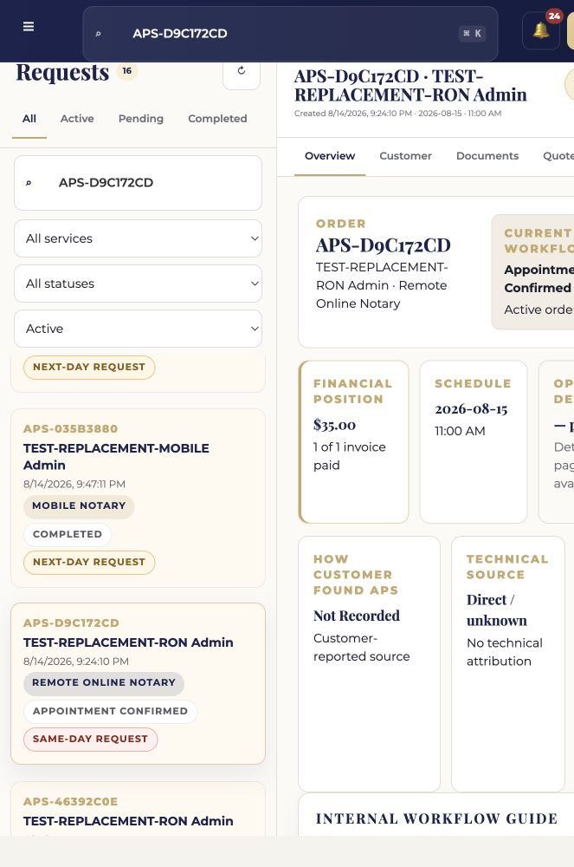
Governed synthetic APS interface — ss 020 request overview
The request workspace holds the evidence needed to operate one request. Verify the request before reading individual fields: reference, service, customer/organization, and current status. Similar names, repeated customers, replacement documents, and related visits create wrong-record risk.
The eight maintained tabs are Overview, Customer, Documents, Quote, Payments, Messages, Fulfillment, and Timeline. Overview explains current state and Next Action. Customer identifies the relationship and contact context. Documents controls files and release. Quote controls current prepared scope. Payments preserves invoices/payments/refunds. Messages records customer-facing communication. Fulfillment holds service facts and gates. Timeline preserves event history.

Procedure 6.1 — Work an Admin next action
1. Match the APS reference, service, customer/organization, and status in the selected-request header.
2. Read Next Action as guidance, then open the supporting tab.
3. Verify prerequisites and blockers in the underlying record.
4. Review related documents, money, participant, appointment, and provider facts as applicable.
5. Perform the smallest maintained action that advances the verified condition.
6. Re-open or refresh the affected tab and confirm the visible result.
7. Check Timeline and Messages if the action should create history or communication.
8. Check the Customer Portal view when the customer should see a change.

Tab operating guide
Tab | Primary question | Common risk
Overview | Where is this request and what is next? | Treating summary/status as proof
Customer | Who is connected and how may APS contact them? | Wrong identity/recipient
Documents | What file is this, and who may see it? | Wrong version/customer/release
Quote | What reviewed scope is currently offered? | Sending stale/unreviewed quote
Payments | Which invoice/payment/refund is authoritative? | Combining invoices or treating pending as paid
Messages | What was prepared/sent/accepted/failed? | Blind duplicate send
Fulfillment | What service facts and gates remain? | Completing from status alone
Timeline | What occurred and when? | Editing history instead of correcting forward

Archive removes a request from active work without deleting history. Restore returns it to active operation. Before either action, verify it is the correct request and that the action will not conceal unresolved work.
STOP: Do not act if the header and supporting tab describe different customers, organizations, services, versions, or financial relationships. Preserve evidence and escalate the mismatch.
Figure: Request Workspace Evidence Flow. Screenshot plan: one annotated workspace overview plus focused crops for each tab and Next Action.

Chapter 7 — Understanding Status, Next Action & Gates
Purpose: perform this workflow from verified APS and assignment evidence while preserving legal, notarial, financial, privacy, and ordering-party boundaries.
YOU WILL LEARN TO
- Review the authoritative assignment, act within role, stop at blockers, communicate accurately, and leave a complete audit trail.
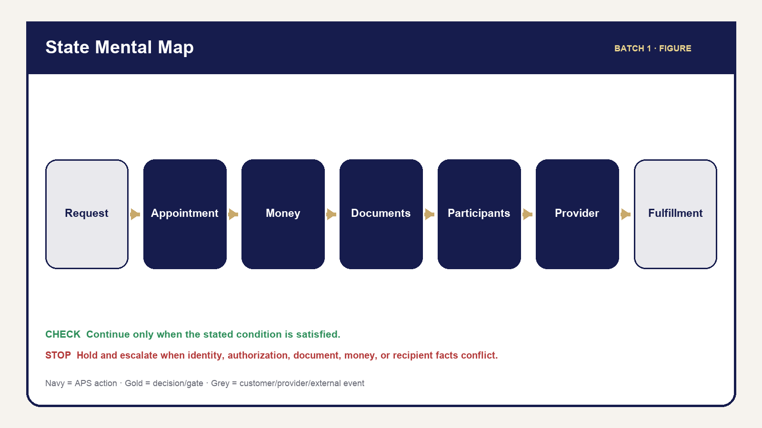
04 State Mental Map
APS work moves across parallel dimensions. Request/service status summarizes the overall stage. Appointment facts distinguish requested, confirmed, rescheduled, and performed. Financial facts belong to individual invoices/payments/refunds. Documents have source, review, completion, eligibility, and release states. Participants have role/readiness. Providers have their own progress. Fulfillment records what was actually done. Loan Signing and exceptions add further controlled dimensions.
OPERATOR RULE — STATUS IS NOT PROOF. Payment status does not prove service completion. Appointment status does not prove fulfillment. A Review Queue blocker is not the request status. A file upload does not prove review or release. A provider meeting ending does not prove APS completion.
Next Action is the recommended operational step derived from current facts. It helps the operator navigate, but the underlying tab remains the evidence. A gate is a required condition before advancement. A blocker explains what is missing. An authorized override exists only when the maintained workflow provides it; a manually convenient status change is not an override.

Procedure 7.1 — Evaluate an advancement gate
1. Name the intended next stage.
2. List the required conditions for that stage.
3. Open the APS tabs that hold each condition; do not rely on one summary.
4. Classify every condition as satisfied, not applicable, missing, conflicting, or requiring authorized review.
5. If any applicable condition is missing/conflicting, hold advancement and create/use the maintained next action or communication.
6. If an override is permitted, verify the authorized person, reason, and record before using it.
7. Advance only through the maintained action.
8. Verify resulting status, blocker clearance, customer visibility, and Timeline evidence.

Decision guide
- YES — evidence satisfies every applicable condition: continue through the maintained action.
- NO — required evidence is absent: hold and obtain the missing fact.
- CONFLICT: stop and reconcile; never choose one value silently.
- REVIEW/AUTHORIZED OVERRIDE: route to the authorized reviewer; preserve the reason and outcome.
- TERMINAL WORK: do not resurrect a completed/cancelled/archived item merely to clear a cosmetic blocker.
The State Mental Map shows these dimensions as parallel lanes converging only at applicable advancement and completion gates. The Review Queue Decision Guide explains whether to act, wait, communicate, or escalate.

PART IV — Customers, Participants, Documents & Records

Chapter 8 — Customers, Signers, Witnesses & Participants
Purpose: perform this workflow from verified APS and assignment evidence while preserving legal, notarial, financial, privacy, and ordering-party boundaries.
YOU WILL LEARN TO
- Review the authoritative assignment, act within role, stop at blockers, communicate accurately, and leave a complete audit trail.

05 Customer Signer Orderer
A customer or requester may coordinate service without being the signer. A Business member may submit for an organization without participating in the notarial act. A Loan Signing ordering party directs the assignment while the signer decides whether to sign. Keep these roles explicit because identity, communication, readiness, and document access depend on them.
Witness roles are not interchangeable. A document witness observes a signature when applicable. A credible witness is a legally controlled identity method and is used only where applicable requirements are satisfied. Never relabel one as the other for convenience.

Procedure 8.1 — Add or correct a participant
1. Open the correct request and Customer/participant area.
2. Determine who supplied the participant information: customer, signer, or authorized ordering party.
3. Confirm the person’s role and whether participation is required; do not infer this from document text.
4. Search/review existing participants to prevent a duplicate.
5. Use Add Participant or Edit Participant with customer/orderer-confirmed facts only.
6. Record readiness facts separately from identity facts.
7. If a name appears but participation is unclear, use Flag Additional Participant Review.
8. Use Additional Participant Information Needed only through the maintained communication workflow when confirmation is needed.
9. Verify the participant list, readiness blocker, and Timeline/history.

Decision tree — another person appears
If the person is already confirmed, review the existing record and role. If not, ask whether the customer or authorized ordering party confirmed participation. When confirmed, add the person and update readiness. When unclear, do not infer: flag review, request information, and hold the affected advancement. Separately identify signer, document witness, credible witness, ordering party, or non-signing named person.
Role | Confirm from | Readiness focus | Do not infer
Requester/customer | Intake and verified relationship | Contact and requested service facts | That requester is signer
Signer | Customer/orderer confirmation and service record | Identity, willingness, appointment/document readiness | From a printed name alone
Ordering party | Assignment/business authority | Instructions, package, authorized contacts | That ordering party may sign
Document witness | Customer/orderer requirement | Availability and role | Credible-witness authority
Credible witness | Applicable lawful identity procedure | Eligibility, identity, declaration | From ordinary witness status

STOP: Conflicting names, roles, or recipient instructions require review before documents, communication, appointment, or service advances.
Figures: Customer vs Signer vs Ordering Party and Customer/Participant Role Relationship. Quick Reference: Participant Decision Guide.

Chapter 9 — Document Mental Model, Customer Uploads & Review
Purpose: perform this workflow from verified APS and assignment evidence while preserving legal, notarial, financial, privacy, and ordering-party boundaries.
YOU WILL LEARN TO
- Review the authoritative assignment, act within role, stop at blockers, communicate accurately, and leave a complete audit trail.
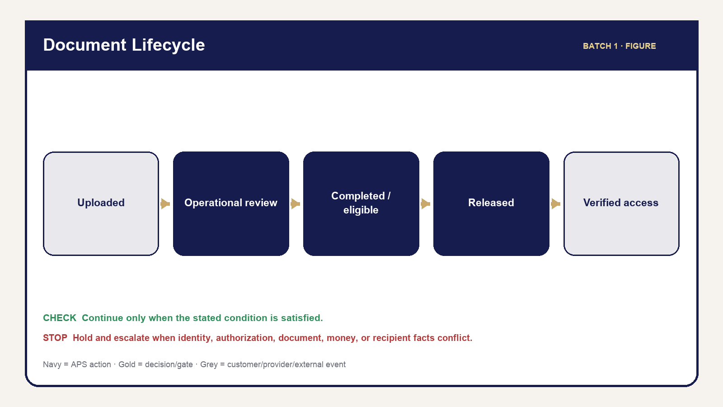
07 Document Lifecycle
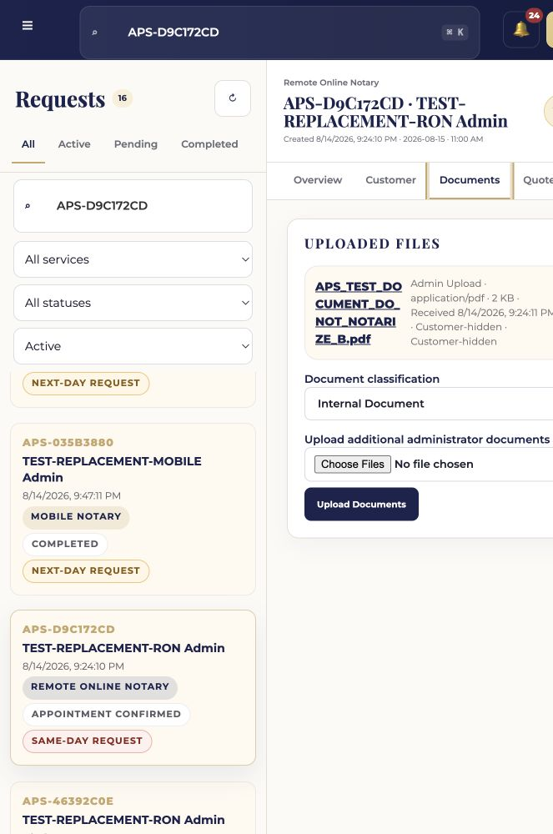
Governed synthetic APS interface — ss 030 document lifecycle
Every document is controlled by five questions: Who provided it? What is it for? Who may see it? Is it ready to be released? What happens next? Answer them before opening, attaching, producing, sending, or releasing a file.
OPERATOR RULE — UPLOAD ≠ REVIEW ≠ COMPLETION ≠ RELEASE. A present file may be corrupt, incomplete, the wrong version, internal, or associated with the wrong request. Presence does not make service complete or the file customer-visible.
Operational review asks whether APS can safely perform the requested workflow: correct request/file association, file opens, obvious corruption, page count where applicable, current version, operational completeness, participant/service information, and next step. Legal review asks whether a document is legally valid, sufficient, effective, or appropriate. APS operators do not perform legal review or recommend document wording/forms outside authorized professional scope.

Procedure 9.1 — Review a customer upload
1. Open the exact request and Documents tab.
2. Match the filename, uploader/provenance, request, service, and intended purpose.
3. Open through the maintained protected access path.
4. Confirm the file opens and is not obviously corrupt.
5. Verify authoritative page count where the service uses page authority; a parser failure is not zero pages.
6. Confirm the version/source and identify missing/replacement pages.
7. Compare participant information with confirmed request participants without interpreting legal effect.
8. Check service-specific operational readiness.
9. Classify the file using the maintained control or hold for clarification.
10. Request exact missing information/replacement when required.
11. Verify document state and Timeline evidence.

Document received decision
The decision tree checks, in order: file opens; correct request; correct/current version; page count available when required; participant information sufficient; service information sufficient. A failure routes to Request Information, Hold, or Escalate. Only a fully satisfied operational review routes to Ready for Operational Use.
WHAT NOT TO DO: Do not decide legal sufficiency, select a notarial act for the customer, change legal language, treat a blank/failed page count as authoritative, or advance because a deadline is close.
Quick References: Five Questions for Every Document and Document Review Checklist.

Chapter 10 — Document Classification & Safe Handling
Purpose: perform this workflow from verified APS and assignment evidence while preserving legal, notarial, financial, privacy, and ordering-party boundaries.
YOU WILL LEARN TO
- Review the authoritative assignment, act within role, stop at blockers, communicate accurately, and leave a complete audit trail.
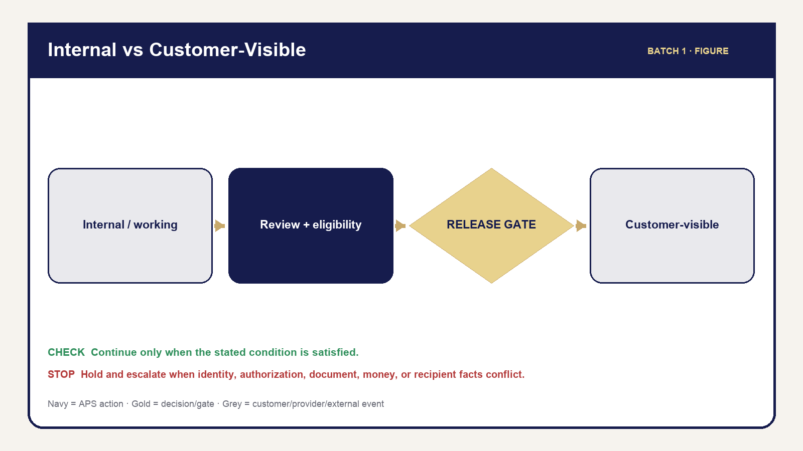
08 Document Security Boundary
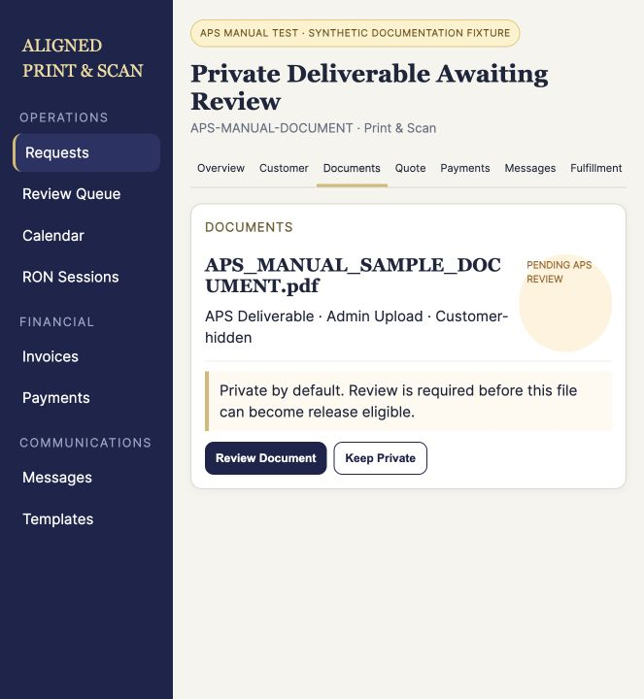
Governed synthetic APS interface — ss 031 private output review
Classification states the document’s operational role and visibility boundary. Use the current production control when available. Handbook-friendly labels explain the concept; where an exact UI label differs, the UI label controls and the source register records the mapping.
Teaching class | Purpose | Customer visibility | Key control
Customer Upload | Customer-provided source | Own source where maintained | Verify request/provenance/readiness
Internal APS Document | Notes, audit, administration | No | INTERNAL MEANS INTERNAL
Working Document | Production/QC/intermediate file | No | Never release merely because attached
Completed/Notarized | Service output requiring review | Not automatically | Verify correct completed version
Completed/Customer-Eligible | Reviewed candidate for delivery | Only after release | Explicit release authorization
Customer-Released | Intentionally released file | Yes, scoped | Verify recipient and audit
Proof Completed | Provider-returned RON output | Only after APS review/release | Never substitute source/raw URL
Loan Package | Current/superseded assignment package | Usually controlled/internal | Version and custody
Borrower Copy | Required signer copy | Physical/authorized path | Copy count and QC
Scanback | Post-signing electronic return | Ordering-party workflow | QC/approval hold
Return Proof | Tracking/drop-off/custody evidence | As authorized | Preserve, do not fabricate
Invoice/Receipt | Financial artifact | Maintained financial path | Exact invoice/payment authority

OPERATOR RULE — INTERNAL MEANS INTERNAL. Storing or attaching a file on a request does not make it appropriate for the Customer or Business Portal. Release authorization is the controlled crossing from the Admin/internal side to the customer-visible side.

Procedure 10.1 — Handle a file safely
1. Confirm the exact request/organization before opening or downloading.
2. Use protected APS links; understand that access may expire.
3. Keep downloads off shared/personal devices unless the authorized workflow requires local handling and security controls are satisfied.
4. Do not attach documents to email unless the maintained template/action permits the exact eligible file.
5. Recheck the recipient and request before any external delivery.
6. Remove temporary local exposure according to maintained security practice without deleting APS history.
7. Record and escalate suspected wrong-customer access or distribution.
Figure: Internal vs Customer-Visible Document Security Boundary. Quick Reference: Document Classification.

Chapter 11 — Completed & Proof-Produced Documents
Purpose: perform this workflow from verified APS and assignment evidence while preserving legal, notarial, financial, privacy, and ordering-party boundaries.
YOU WILL LEARN TO
- Review the authoritative assignment, act within role, stop at blockers, communicate accurately, and leave a complete audit trail.
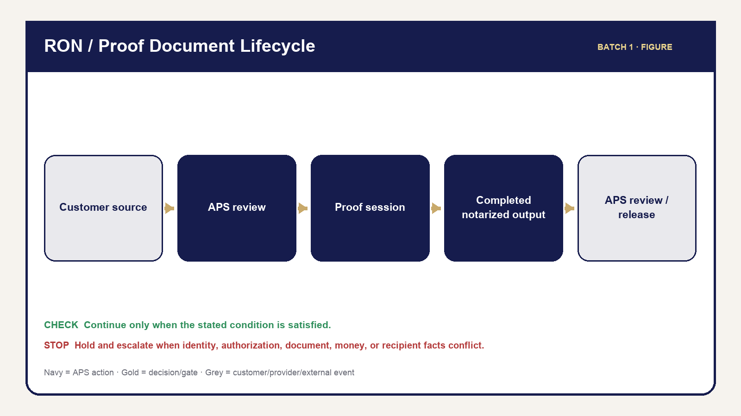
10 Ron Proof Document
A source document enters the service. A working document may support preparation. A completed document reflects performed work. A completed/notarized electronic document returned by Proof is a provider output that still requires APS review. A customer-released file is the exact eligible completed version intentionally crossed into customer visibility.
The RON document path is: Customer Source → APS Review → Proof/RON Session → Completed Notarized Electronic Document → Post-Session Review → Correct Completed Version → Release Readiness → Customer Release. Each arrow is a control point, not an automatic promise.
STOP — DO NOT release the pre-notarization source document as though it were the completed notarized document. The source may share a filename or appearance with the final output. Verify provenance, provider-completed state, correct version, and file content before release.

Checklist 11.1 — Completed-document review
- Correct request and intended recipient/organization.
- Correct signer and service.
- Expected completed document is present.
- File opens and is not obviously corrupt.
- Correct completed/notarized version is selected.
- Classification is appropriate; no internal-only file is selected.
- Applicable fulfillment and financial release gates are satisfied.
- Filename/provenance distinguish it from the source and superseded versions.
- Release readiness is explicit.

Procedure 11.1 — Missing Proof completed output
1. Keep document release and APS completion on hold.
2. Review the APS RON stage and provider transaction/asset evidence available to the operator.
3. Confirm the session/result belongs to the exact request and environment.
4. Use only the maintained sync/retry path when its preconditions are met.
5. Do not upload or release the source as a substitute.
6. Record the missing-output condition and retry/result.
7. Escalate persistent, ambiguous, wrong-version, or integrity failure.
8. Use customer-safe communication only when needed; do not expose raw provider errors or promise timing.
SOURCE VERIFICATION REQUIRED: Final wording for every operator-visible Proof failure/retry label must be reconciled during the Part VI drafting pass. The Batch 1 control—hold, do not substitute, use maintained retry, preserve evidence—remains valid.
Figure: RON/Proof Document Lifecycle. Quick Reference: Completed Document Review Checklist.

Chapter 12 — Document Release, Delivery & Audit
Purpose: perform this workflow from verified APS and assignment evidence while preserving legal, notarial, financial, privacy, and ordering-party boundaries.
YOU WILL LEARN TO
- Review the authoritative assignment, act within role, stop at blockers, communicate accurately, and leave a complete audit trail.
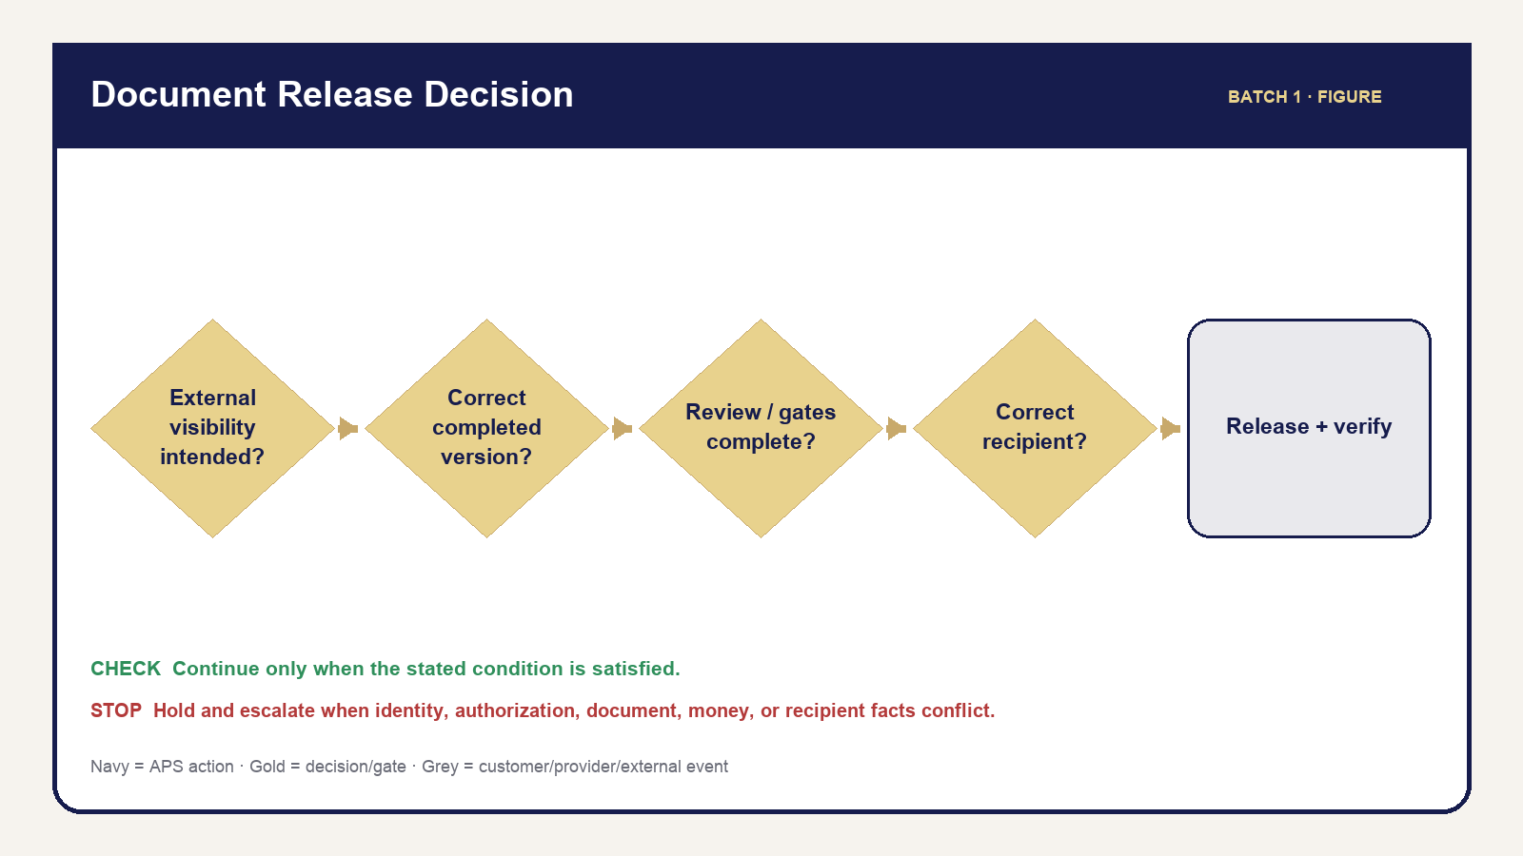
09 Document Release Decision
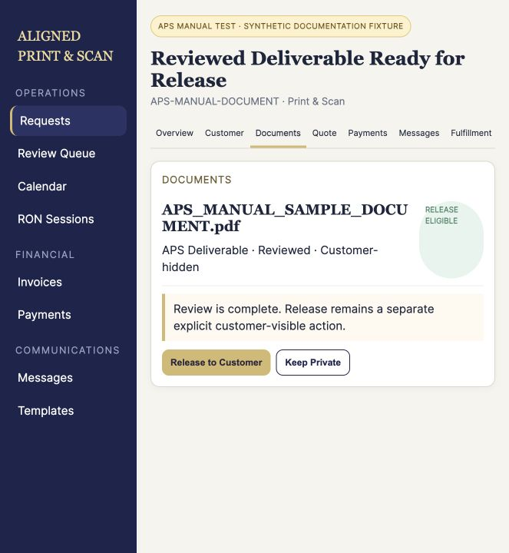
Governed synthetic APS interface — ss 032 release to customer
Release is deliberate authorization, not a side effect of upload, review, provider completion, or message preparation. The operator must prove the file is the correct current customer-eligible output, the intended recipient is correct, and applicable service/financial/fulfillment conditions allow release.

Procedure 12.1 — Release a document to the customer
1. Open the correct request and verify reference, customer/organization, and service.
2. Open Documents.
3. Identify the intended completed/customer-eligible file.
4. Verify the correct request, customer, and organization again.
5. Verify provenance, classification, and current version; open the file.
6. Confirm operational review is complete.
7. Confirm applicable service, financial, fulfillment, and release gates.
8. Confirm the file is eligible for the intended customer—not internal, working, audit, source-only, or superseded.
9. Perform the maintained Release to Customer action and confirmation.
10. Verify the release state and correct portal group/view/download.
11. Verify Timeline/audit evidence.
12. Send or verify associated communication only when the maintained workflow requires it; do not resend blindly.

Decision tree — release or hold
If the document is not intended for external visibility, keep it internal. If it is external, ask whether it is the correct completed/current version. If no, hold and resolve. If yes, ask whether review and service-specific gates are complete. If no, hold. If yes, verify the intended recipient. A recipient mismatch is STOP. Only the fully satisfied path releases, then verifies visibility and audit/communication evidence.

Internal versus customer document
Question | Internal APS/working file | Customer-released file
Exists on request | May | Yes
Admin access | Authorized staff | Authorized staff
Automatic customer visibility | No | No—requires maintained release
May contain working/QC content | Yes | No
Suitable final output | Not assumed | Verified
Portal visibility | Prohibited | Scoped after release

The portal heading is DOCUMENTS FROM ALIGNED PRINT & SCAN. It says: “Files provided to you by Aligned Print & Scan will appear here.” The empty state says: “No documents have been provided yet.” Internal terminology remains more precise because it controls classification, review, and authorization.
After release, the operator must be able to answer: which file; which version; when; which request/account; what customer communication occurred; and what Timeline/audit evidence remains.
Figure: Document Release Decision Tree. Quick References: Document Release Checklist and Internal vs Customer Document Comparison.

Chapter 13 — Document Replacement, Mistakes & Recovery
Purpose: perform this workflow from verified APS and assignment evidence while preserving legal, notarial, financial, privacy, and ordering-party boundaries.
YOU WILL LEARN TO
- Review the authoritative assignment, act within role, stop at blockers, communicate accurately, and leave a complete audit trail.
Recovery protects the customer and the historical record. Correct forward; do not delete or overwrite history to make a mistake disappear. Each troubleshooting entry uses the same pattern: symptom, checks, likely cause, action, prohibited action, communication, escalation, and record.

Recovery table
Symptom | Check/action | Do not do | Record/escalation
Wrong upload/request | Provenance, request, access; quarantine from use | Move/release casually | Preserve event; escalate privacy risk
Wrong/superseded version | Version source, replacement, page count | Silently overwrite history | Mark current/superseded through maintained path
Corrupt/incomplete file | Open, page count, missing pages | Treat failure as ready | Request replacement; record blocker
Missing Proof output | Provider/APS asset state | Substitute source | Hold, maintained retry, escalate
Internal file misclassified | Purpose/visibility/release | Release to “fix” classification | Correct safely and verify portal
Wrong file selected for release | Release state, recipient, access | Delete evidence or send more | STOP distribution; incident review
Customer cannot open | Release/access/file integrity | Email an internal copy | Restore authorized access or escalate
Incomplete scanback/return proof | Package/QC/approval/custody | Complete assignment cosmetically | Hold service gate; follow Part IX later

Procedure 13.1 — Respond to a wrong-document release
1. Stop additional distribution and do not send replacement material impulsively.
2. Verify exactly what file/version was released, to which request/account, when, and through what access path.
3. Preserve Timeline, message, release, and access evidence; do not delete history to hide the mistake.
4. Protect unrelated customer/tenant data and restrict further access through the maintained authorized path when available.
5. Escalate immediately to the owner/authorized incident reviewer.
6. Use only authorized customer communication; do not invent legal breach-notification language.
7. Perform the approved corrective action and verify it.
8. Record facts, decisions, communication, and final state.
ESCALATE — OWNER / AUTHORIZED INCIDENT REVIEW: Formal incident or legal-response requirements are not defined by this handbook. The operator preserves evidence and follows the authorized decision.

Document status/action/communication sequence
Stage | Operator action | Communication | Hold until | Record
Received/review needed | Open, verify, review | Optional receipt only when maintained | Operational facts known | Document state/Timeline
Information/replacement needed | Identify exact deficiency | Maintained information request | Replacement/answer verified | Message plus blocker
Completed artifact ready | Review current output | Do not announce release yet | Eligibility/gates satisfied | Review evidence
Released | Verify portal/access | Maintained delivery message when required | Visibility/audit verified | Release, Message, Timeline
Post-release problem | Stop, investigate, escalate | Authorized response only | Incident/correction authorized | Complete incident facts
Loan package/scanback/return | Preserve version/QC/custody | Ordering-party path | Applicable Part IX gate | Package/fulfillment history

Quick Reference: Document Mistake Recovery.

Chapter 14 — Service-Specific Document Lifecycles
Purpose: perform this workflow from verified APS and assignment evidence while preserving legal, notarial, financial, privacy, and ordering-party boundaries.
YOU WILL LEARN TO
- Review the authoritative assignment, act within role, stop at blockers, communicate accurately, and leave a complete audit trail.
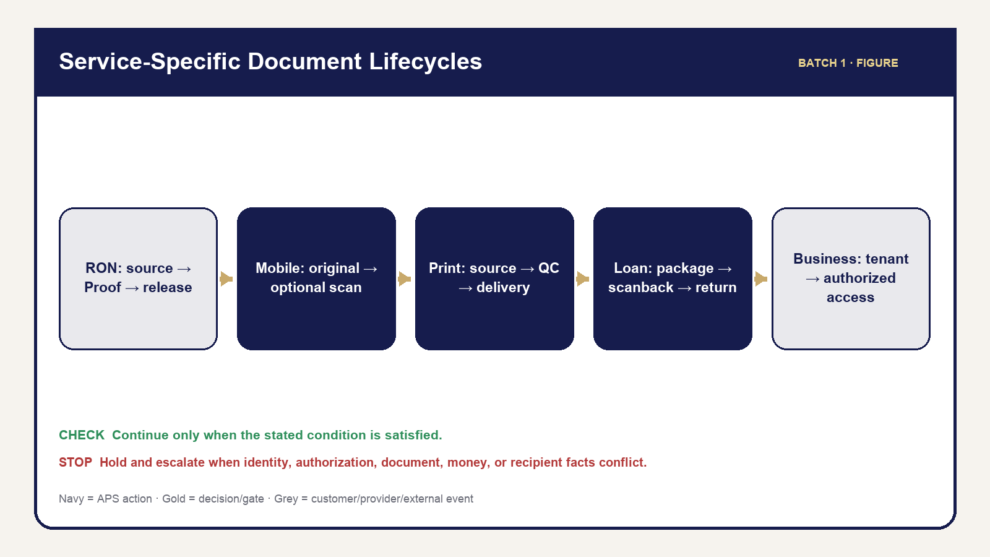
14 Service Document Comparison
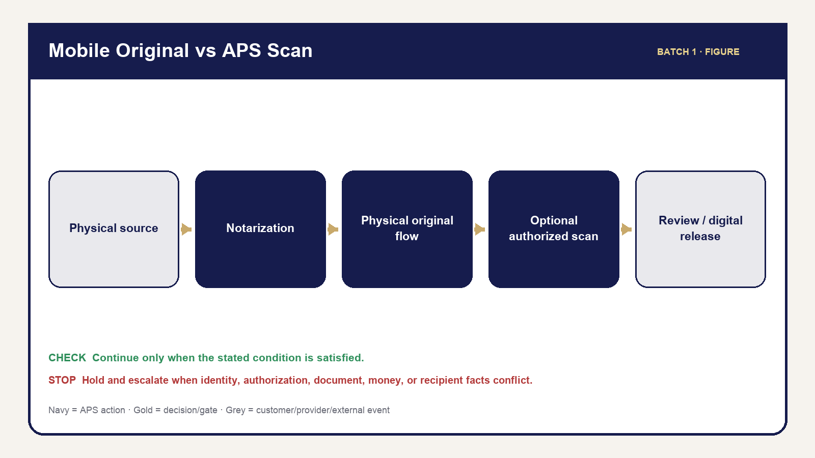
11 Mobile Original Scan
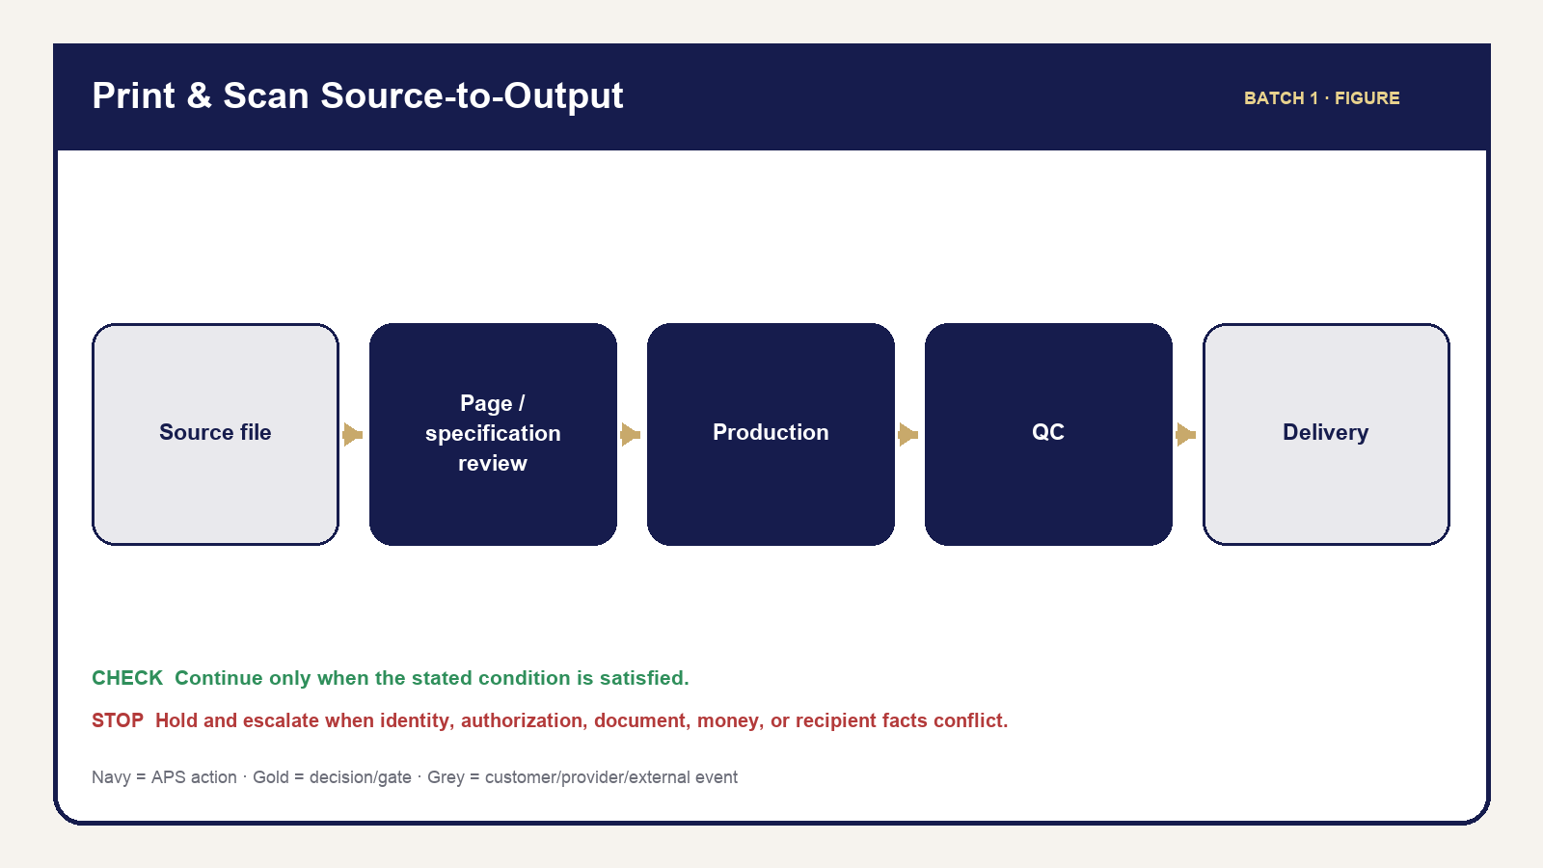
12 Print Source Output
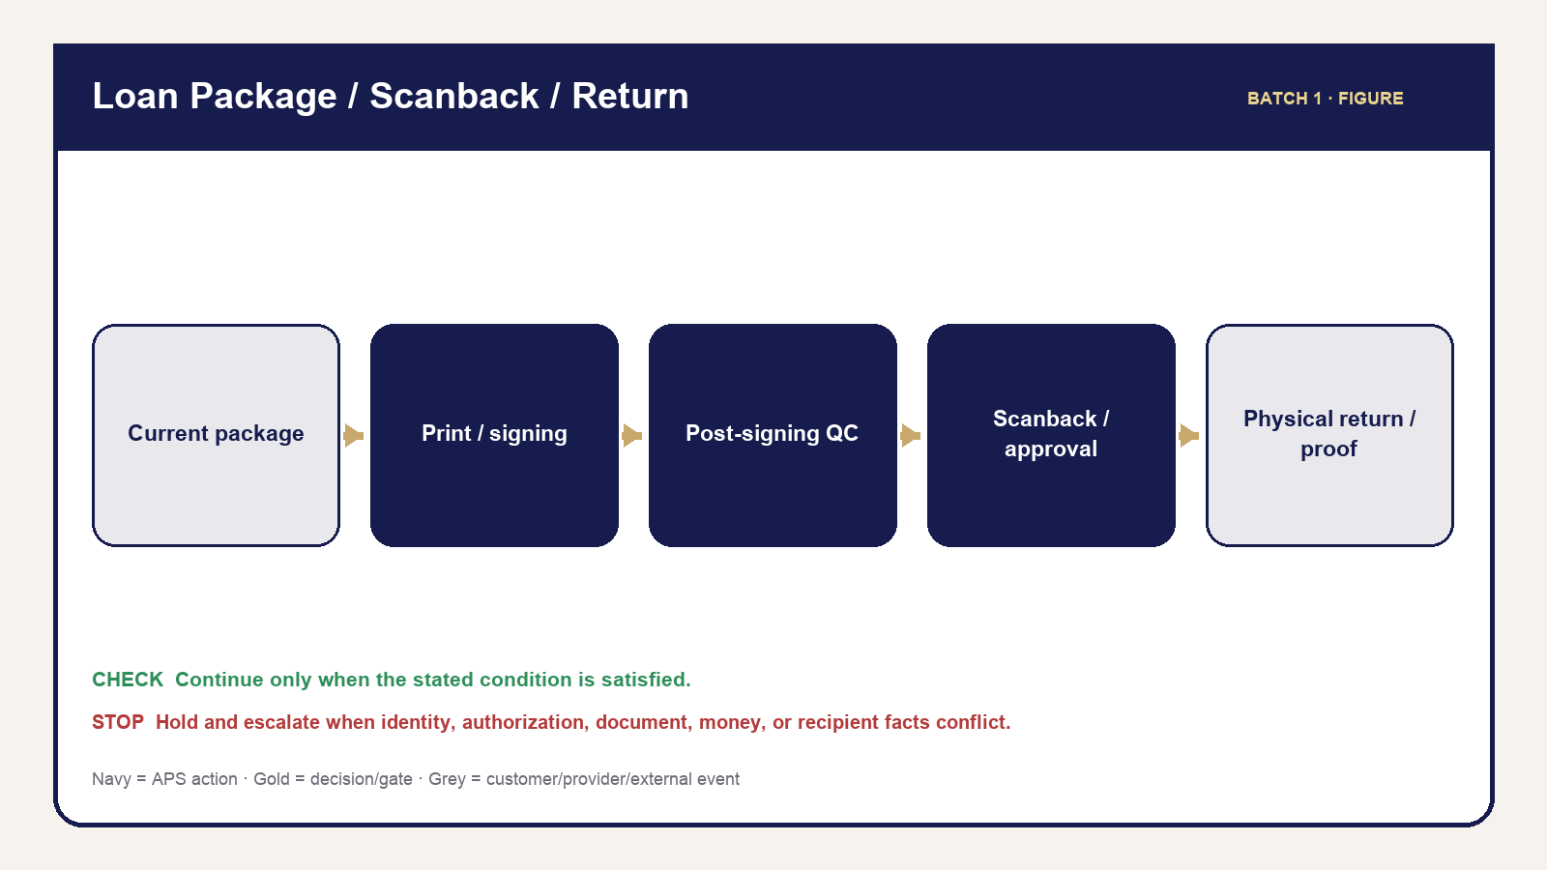
13 Loan Package Return
The document controls taught in Chapters 9–13 apply differently by service. This chapter gives the high-level lanes operators need before detailed service training. It does not draft later service procedures.

RON
Source → APS operational review → Proof/RON session → completed notarized electronic document → post-session review → correct-version release → customer access. APS release remains separate from provider completion. Apply Chapter 12; see Part VI for detailed RON operation.

Mobile
Physical/source document → in-person notarization → physical original remains in the authorized physical flow → optional APS scan when requested/authorized → scan QC/review → digital release where applicable. An optional scan does not replace returning/accounting for the physical original. See Part VII.

Print & Scan
Source file → file/page/specification review → production → first-copy/final QC → scan/output integrity → pickup/courier/portal delivery. Production start and delivery are meaningful controlled facts. See Part VIII.

Loan Signing — high level only
Loan package → current version → print/borrower copies → signing → post-signing table QC → scanback when required → approval when required → physical return → tracking/proof. Do not return during an applicable approval hold and do not overwrite superseded package history. Detailed procedures belong in Part IX.

Business
Organization-linked request → tenant-scoped document → role/capability check → classification/review → release/access → historical visibility. A Business role never grants cross-organization access or APS admin authority. Detailed Business operation belongs in Part X.

Procedure 14.1 — Identify the applicable document lane
1. Verify the request’s service and customer/organization context.
2. Identify the current document type and provenance.
3. Locate the current point in the applicable service lane.
4. Apply the universal classification, review, security, and release controls from Chapters 9–13.
5. Apply only the service-specific gate already established by current source; use the later Part for detailed operation.
6. If service and document lane conflict, hold and escalate rather than improvising a hybrid path.
Figure: Service-Specific Document Lifecycle Comparison, supported by Mobile Physical Original vs APS Scan, Print & Scan Source-to-Output, and Loan Package/Scanback/Return high-level visuals.

PART V — QUOTES, INVOICES & MONEY

Chapter 15 — From Estimate to Approved Quote
Purpose: perform this workflow from verified APS and assignment evidence while preserving legal, notarial, financial, privacy, and ordering-party boundaries.
YOU WILL LEARN TO
- Review the authoritative assignment, act within role, stop at blockers, communicate accurately, and leave a complete audit trail.
APS treats pricing as a controlled progression: intake facts support an estimate; verified scope supports a quote; customer or ordering-party approval authorizes the quoted scope. A quote never proves payment, appointment readiness, or fulfillment completion.

15.1 Estimate Versus Quote
An estimate is provisional guidance based on incomplete or customer-entered facts. An approved quote is the current APS price proposal after the operator verifies service, participants, documents, location, timing, delivery, and applicable additions. Label uncertainty honestly and do not present an intake estimate as a final promise.

15.2 Facts Required Before Quoting
Verify the customer/orderer, service type, participant count, document scope, requested date/time, delivery method, and any service-specific facts. Missing page count, address, witnesses, platform eligibility, package version, or delivery instructions can block an accurate quote.

15.3 Service-Specific Quote Worksheets
Service | Minimum verified inputs | Typical blocker
RON | participants, document, requested act supplied by signer/recipient, appointment and eligibility facts | uncertain act, missing document, participant/platform issue
Mobile | service address, round-trip travel evidence, acts/signers, witnesses, timing, optional print/scan | unresolved route, location, witness, or document fact
Print & Scan | authoritative page count, B&W/color, copies, paper, sides, scan/delivery | file does not open or specifications conflict
Loan Signing | orderer, package type/version, appointment, printing, scanback/return instructions | incomplete assignment or superseded package

15.4 Build and Review in Admin
Open the exact request, confirm the service-detail record, then review each line item against authoritative evidence. Recalculate from current facts, review the customer-safe description, and verify that required taxes, travel, production, delivery, or approved custom items are represented once.

15.5 Quote Version and Revision
Preserve quote history. A revised quote becomes a new/current version; it does not erase the version a customer previously reviewed. Revise when material scope, page count, travel, timing, delivery, package, or approved exception changes.

15.6 Sending and Customer/Orderer Approval
Send only the current reviewed quote through the maintained communication workflow. Approval must be tied to that version. If an orderer rather than the signer controls the assignment, record the authorized orderer approval without implying signer financial authority.

15.7 What Blocks a Quote
STOP — Do not finalize a quote when required scope is missing, the source file cannot be verified, the travel route is unresolved, the requested act is unknown, an assignment instruction conflicts, or the price depends on an unauthorized decision.

15.8 Quote Audit and History
The record should show the quote version, amount, scope, operator action, delivery attempt/result, approval, and any later revision. Use Messages and Timeline to distinguish “prepared,” “sent,” “approved,” and “superseded.”

Chapter 16 — Invoice, Payment & Receipt
Purpose: perform this workflow from verified APS and assignment evidence while preserving legal, notarial, financial, privacy, and ordering-party boundaries.
YOU WILL LEARN TO
- Review the authoritative assignment, act within role, stop at blockers, communicate accurately, and leave a complete audit trail.

16.1 Quote → Invoice → Payment → Receipt
The quote describes approved scope. The invoice requests payment for that scope. A payment records funds applied to a particular invoice. A receipt confirms a recorded payment. These are separate records and none should be inferred from another.

16.2 Invoice #1
Create the first invoice only from an approved quote or other authorized billing basis. Verify customer/orderer, amount, due timing, payment terms, and description before delivery.

16.3 Supplemental/Final Invoice #2
Use a supplemental invoice for authorized additions such as verified extra pages, travel, optional scans, wait-time review, additional visits, or other approved scope. Preserve Invoice #1 and its payments; do not replace history with one rewritten total.

16.4 Card and ACH
Treat the provider result and APS ledger as authority. A customer-reported screenshot or bank statement may prompt review but does not by itself authorize a paid state.

16.5 Pending Versus Paid
Pending means the payment is not yet confirmed as settled/accepted by the maintained workflow. Paid requires the provider or authorized manual-payment workflow to record a successful payment against the intended invoice.

16.6 Partial Payment
Apply the amount to the correct invoice and retain the remaining balance. Do not mark an invoice or request fully paid merely because some money was received.

16.7 Authorized Offline and TEST Payment
Only administrators may use the maintained manual/offline recorder, with the real payment method, amount, date, and unique reference. TEST records are training fixtures only and must never be used on a legitimate request.

16.8 Receipt
A receipt follows successful payment recording. Verify amount, invoice relationship, date, and customer-safe destination. A generated receipt does not cure a missing or ambiguous payment record.

16.9 Reconciliation and Duplicate Prevention
Before retrying, compare invoice balance, existing payments, provider reference, communication history, and Timeline. Reuse the maintained idempotent path; never create another payment merely because a screen response was slow.

16.10 Never Rewrite a Paid Invoice
OPERATOR RULE — Preserve the paid invoice. Bill legitimate later scope through a supplemental invoice or follow the authorized refund/correction workflow.

Chapter 17 — Refunds, Business Terms & Financial Gates
Purpose: perform this workflow from verified APS and assignment evidence while preserving legal, notarial, financial, privacy, and ordering-party boundaries.
YOU WILL LEARN TO
- Review the authoritative assignment, act within role, stop at blockers, communicate accurately, and leave a complete audit trail.

17.1 Refund Review Versus Completed Refund
A request for review, an approved decision, a provider request, and a completed refund are different states. Tell the customer only what the authoritative record supports.

17.2 Partial/Full and Retained Amount
Document the original charge, amount proposed for refund, amount retained, reason, and authorization. Never calculate or promise a discretionary result without administrator approval.

17.3 Original Payment Relationship
Link the refund to the original payment and invoice. This preserves the remaining paid amount, invoice history, provider reference, and customer receipt trail.

17.4 Failed or Ambiguous Provider State
Pause when the provider response is missing or contradictory. Reconcile before retrying. Do not represent money as returned until the maintained provider/ledger evidence supports completion.

17.5 Prepaid, Due on Receipt, Net 15, and Net 30
Prepaid work requires payment before the applicable fulfillment gate. Due on Receipt creates an immediate receivable. Net 15 and Net 30 create approved postpaid due dates. Terms affect timing, not the need for accurate invoices, payment records, or credit controls.

17.6 Who Assigns Terms
Only authorized APS administrators assign or change Business Account terms. Applicants and members cannot self-grant credit.

17.7 Credit Hold
A credit hold blocks new work or advancement according to maintained Business rules. Do not bypass it because the requester is familiar, urgent, or promises later payment.

17.8 Postpaid Completion and Open Receivable
Authorized postpaid work may be operationally complete while an invoice remains open. Record completion evidence and preserve the receivable; do not falsify paid status.

17.9 Prohibited Shortcuts
- Do not fabricate payment, refund, waiver, or credit evidence.
- Do not delete paid invoices or prior balances.
- Do not use a status change to simulate money movement.
- Do not disclose internal provider errors to the customer.

17.10 Financial Decision Table and Escalation
Condition | Operator action | Do not advance until
Prepaid balance due | send/confirm maintained invoice | paid evidence exists
Partial payment | preserve applied amount and balance | required balance gate is satisfied
Refund under review | record facts and escalate | decision and provider result are known
Postpaid in good standing | perform authorized work | nonfinancial gates pass
Credit hold | notify through approved channel | administrator clears hold

PART VI — REMOTE ONLINE NOTARIZATION

Chapter 18 — Remote Online Notary Foundations & Workflow
Purpose: perform this workflow from verified APS and assignment evidence while preserving legal, notarial, financial, privacy, and ordering-party boundaries.
YOU WILL LEARN TO
- Review the authoritative assignment, act within role, stop at blockers, communicate accurately, and leave a complete audit trail.
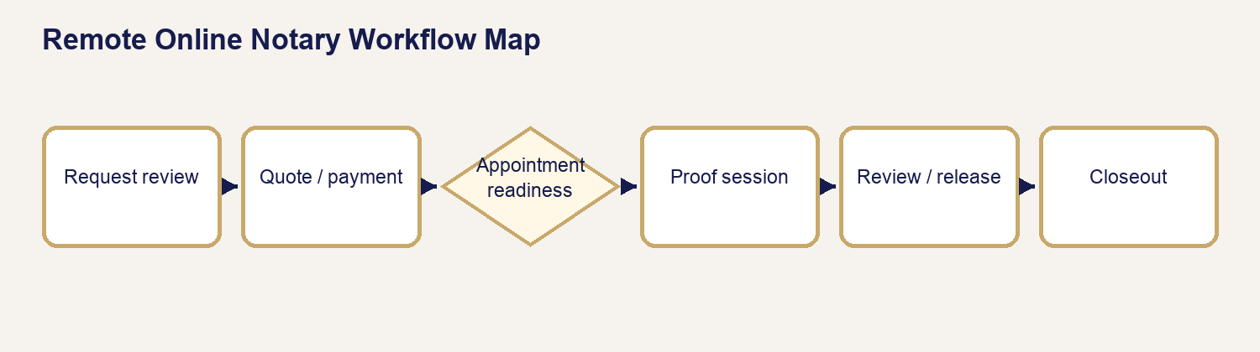
15 Ron Workflow

18.1 APS-Originated RON Powered by Proof
APS owns the customer request, quote, payment, appointment, operator review, customer-safe communication, document review, release, and closeout. Proof supplies the controlled identity, audio-video, transaction, and provider-completed-document functions.

18.2 Texas Operator Boundaries
The online notary must follow Texas authority and be physically located as required. The operator does not give legal advice, select a notarial act for the signer, determine a document’s legal effect, or promise acceptance by a receiving party.

18.3 Readiness Domains
Confirm participant, document, identity-process, technology, appointment, financial, and delivery readiness separately. “Appointment scheduled” does not mean all other domains are ready.

18.4 What APS Controls and What Proof Controls
APS controls | Proof controls
request, scope, quote, payment, appointment | provider transaction and signer access
participant mapping and readiness review | credential analysis/KBA result and platform flow
operator return review and customer release | audio-video session and provider-completed asset

18.5 KBA, Identity, Meeting, and Privacy Boundaries
Never ask for, coach, store, or repeat KBA answers. Do not copy credential numbers into ordinary notes. Use the provider result and approved session. Stop when identity, willingness, awareness, location, technology, or continuous audio-video cannot be established.

18.6 Remote Online Notary Workflow Map
Request review → information readiness → quote/approval → prepaid payment → appointment → signer/document readiness → Proof preparation → review/activation → signer access → live session → provider completion → APS document review/release → closeout.

18.7 Thirteen APS RON Stages
The maintained stages are operational checkpoints, not decorative labels. Advance only from evidence owned by the current stage; failed provider work, incomplete documents, unreleased output, or outstanding required balance remains a blocker.

Chapter 19 — Preparing the Remote Online Notary Quote
Purpose: perform this workflow from verified APS and assignment evidence while preserving legal, notarial, financial, privacy, and ordering-party boundaries.
YOU WILL LEARN TO
- Review the authoritative assignment, act within role, stop at blockers, communicate accurately, and leave a complete audit trail.

19.1 When RON Is Ready to Quote
The request has identifiable participants, readable documents, supplied act/recipient instructions, proposed timing, eligibility facts, and a delivery expectation. Unknown legal/notarial choices remain with the signer or receiving party.

19.2 Notarial Act Information
Record what the signer or authorized receiving party requests. If the certificate or instruction is absent or ambiguous, pause and refer; do not choose the act.

19.3 Participants and Witnesses
Verify each signer’s full legal name and contact path. Distinguish document witnesses from credible witnesses and confirm who supplies them.

19.4 Documents and Service Requirements
Confirm the active file opens, appears complete for operational processing, supports the intended electronic workflow, and is not superseded. APS does not decide legal sufficiency.

19.5 Build, Review, and Send Quote
Use the verified service facts, current pricing authority, participant count, acts, timing, and approved additions. Review the customer-safe scope before sending.

19.6 Customer Approval
Approval must identify the current quote version. A verbal expectation or appointment request is not approval of an unseen revision.

19.7 Prepaid Payment Gate
RON is prepaid unless an authorized Business term applies. Do not activate or conduct the session while the applicable payment gate remains unresolved.

19.8 When to Revise
Revise for changed participants, acts, documents, timing, service method, or approved additions. Preserve the superseded quote.

19.9 RON Quote Readiness Checklist
- Current request and participant records verified.
- Act/instructions supplied by an authorized source.
- Active document opens and is mapped to the request.
- Eligibility, appointment, and provider readiness risks identified.
- Current quote reviewed, delivered, and approved before invoicing.

Chapter 20 — RON Status, Operator Action & Customer Communication Sequence
Purpose: perform this workflow from verified APS and assignment evidence while preserving legal, notarial, financial, privacy, and ordering-party boundaries.
YOU WILL LEARN TO
- Review the authoritative assignment, act within role, stop at blockers, communicate accurately, and leave a complete audit trail.
Stage | APS condition | Operator action | Customer communication | Gate / record
Request Received | scoped request exists | review participants/documents | acknowledgment is automatic where maintained | Timeline intake
Information Needed | required fact missing | request the exact missing item | approved information-needed template | remain Under Review
Quote Ready/Approved | reviewed version exists | send, then record approval | quote-ready communication | approved version
Payment Required/Received | invoice open/paid | reconcile provider and ledger | invoice/payment confirmation | applicable prepaid balance
Appointment | confirmed facts saved | send confirmation/reminder | appointment template/channel | date/time/platform ready
Preparation | Proof draft/readiness reviewed | prepare once, verify mapping | only approved preparation instructions | no duplicate transaction
Identity issue | provider check unsuccessful | follow neutral retry/alternative path | do not expose or coach answers | provider result recorded
Session | activated and ready | conduct authorized act | controlled session language | continuous compliant session
Completed document | provider asset exists | return to APS, review/QC | no release promise yet | APS review pending
Release/completion | approved customer deliverable released | send customer-safe completion | document/completion template | release + final gates
Cancellation/reschedule | authorized change requested | use maintained decision workflow | approved change message | history preserved
Failure/alternative | retry not safe/eligible | pause, escalate, offer eligible alternative | neutral next step | no false completion

20.1–20.13 Operating Rule
For every row, verify the stage, condition, template/channel, successful delivery evidence, and Timeline entry. “Send Message” communicates without inventing status. “Send & Update Status” changes status only after successful delivery through its maintained workflow.

Chapter 21 — RON Fulfillment Gates & Closeout
Purpose: perform this workflow from verified APS and assignment evidence while preserving legal, notarial, financial, privacy, and ordering-party boundaries.
YOU WILL LEARN TO
- Review the authoritative assignment, act within role, stop at blockers, communicate accurately, and leave a complete audit trail.
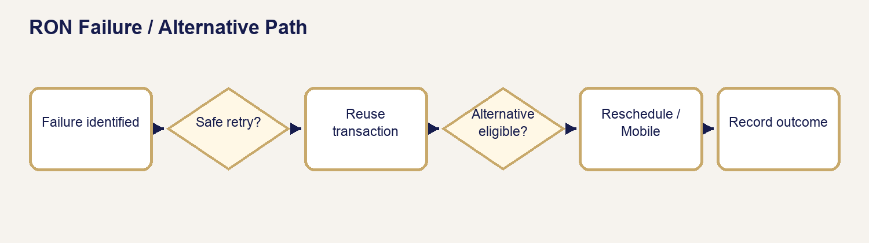
16 Ron Failure Decision

21.1–21.8 Readiness Gates
Request review, participants, documents, quote, approval, payment, appointment, and identity/platform readiness are independent. Each requires its own evidence. The operator checks the request workspace, document classification, current quote/invoice, appointment facts, and Proof readiness panel.

21.9 Session Completion
Confirm the authorized live session ended with the intended act completed or a clearly recorded stop. Provider “session ended” alone does not prove a valid completed document.

21.10 Completed Proof Document
Return to APS through the maintained provider synchronization. Confirm the provider asset belongs to the correct transaction, signer, document, and version; then conduct completed-document review.

21.11 Document Release
Release is an explicit APS action after classification and review. A provider-completed document is not automatically customer-visible.

21.12 Final Completion
Verify service components, applicable balance, appointment/session evidence, completed asset, release/delivery, and unresolved exceptions. Only then mark complete through the maintained path.

21.13 Post-Session Review and Release Procedure
1. Open the exact request and Proof transaction.
2. Confirm provider completion and download/synchronize through the maintained action.
3. Compare signer, file, act/certificate, page integrity, and transaction relationship.
4. Classify the output as an internal completed document until approved.
5. Resolve defects or record the permitted exception.
6. Release only the intended customer deliverable.
7. Verify portal visibility, communication evidence, and Timeline.

21.14 Failed or Incomplete Processing
Do not create a replacement transaction reflexively. Determine whether the existing transaction supports a safe retry, whether a new appointment or service method is required, and whether financial review applies.

21.15 RON Failure / Alternative Path Decision Tree
Identity/platform/session passes? If YES, continue to completed-asset review. If NO, is a provider-supported retry authorized and safe? If YES, reuse the maintained transaction. If NO, hold the request, communicate neutrally, and evaluate reschedule or Mobile conversion. Never bypass identity or represent incomplete work as complete.

21.16 RON Quick References
Use RON Quote Readiness, Appointment Readiness, Identity/KBA Boundaries, Session Checklist, Proof Completed Document Check, Document Release, Closeout, and Failure/Alternative Path cards.

PART VII — MOBILE NOTARY

Chapter 22 — Mobile Notary Workflow, Travel & Readiness
Purpose: perform this workflow from verified APS and assignment evidence while preserving legal, notarial, financial, privacy, and ordering-party boundaries.
YOU WILL LEARN TO
- Review the authoritative assignment, act within role, stop at blockers, communicate accurately, and leave a complete audit trail.
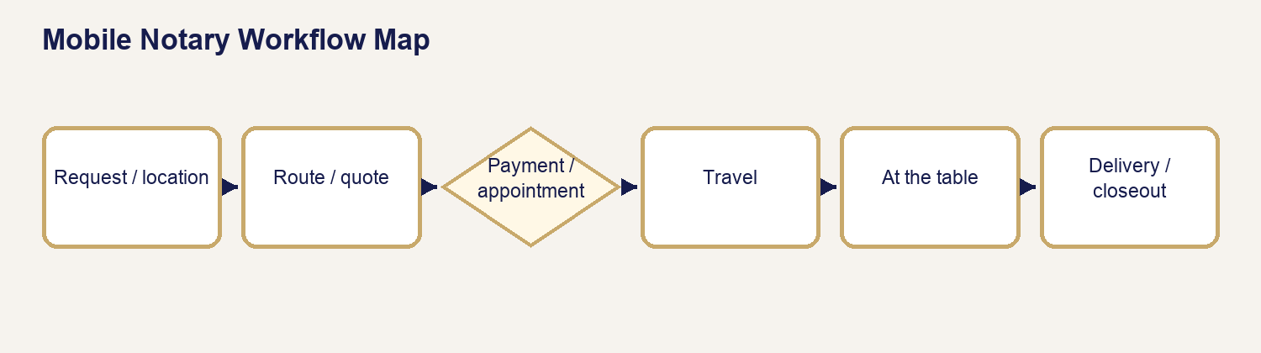
17 Mobile Workflow

22.1 Mobile Notary Workflow Map
Request → service/location review → route/travel facts → quote/approval → payment → appointment → before-leaving checks → travel/arrival → table work/journal → optional scan/final charges → delivery → closeout.

22.2 Intake and Service Address
Confirm a structured street, city, state, ZIP, unit/access instruction, safe meeting context, and who will be present. Never calculate travel from an informal description when the maintained address is incomplete.

22.3 Travel Origin
Use the saved authorized APS origin or approved one-time origin. The origin must represent the actual dispatch basis; do not choose a location merely to manipulate price.

22.4 ORS and Manual Distance Fallback
Use OpenRouteService when available. When routing is unavailable, enter verified round-trip miles and the authorized fee with the required reason. Manual fallback records an honest limitation; it does not fabricate a route.

22.5 Fee Inputs
Review round-trip mileage, maintained travel tier, after-hours timing, notarial acts, signers, witnesses, optional print/scan, parking/tolls when authorized, and other approved additions. Customer-entered mileage is not authority.

22.6 Mobile Travel / Quote Decision Flow
Address complete? If NO, request information. If YES, route available? If YES, save route evidence and tier. If NO, obtain verified manual miles/reason. Then apply current pricing authority, review additions, and send the quote. Escalate unusual or unsafe travel.

22.7 Requested Versus Confirmed Appointment
A preferred date/window is a request. A confirmed appointment has explicit date, time, timezone, location, contact, access, and readiness facts saved and communicated.

22.8 Participant and Document Readiness
Verify signer identity path, willingness, document presence, supplied act, witnesses, and any print/scan expectation before dispatch.

22.9 Safety, Reschedule, and Dispatch
Operators may stop or reschedule for unsafe location, threats, coercion, inability to communicate, identity failure, unwillingness, improper document/act demands, or material readiness failure. Record facts without inflammatory or sensitive detail.

Chapter 23 — Preparing the Mobile Notary Quote
Purpose: perform this workflow from verified APS and assignment evidence while preserving legal, notarial, financial, privacy, and ordering-party boundaries.
YOU WILL LEARN TO
- Review the authoritative assignment, act within role, stop at blockers, communicate accurately, and leave a complete audit trail.

23.1–23.3 Readiness and Fee Inputs
Confirm the exact address and route evidence, appointment timing, signer/act count, witnesses, travel tier, after-hours status, optional print/scan, and authorized additions. Do not quote from a one-way distance when the pricing rule uses round trip.

23.4 Build, Review, and Send
Build from current facts, verify each line once, review the customer-safe scope, and use the maintained quote communication.

23.5 Approval and Payment
Tie approval to the current quote. Apply the prepaid dispatch gate unless authorized Business terms govern.

23.6 Revision
Revise for a changed address, time, route, participants, witnesses, documents, service components, or authorized exception.

23.7 Mobile Quote Readiness Checklist
- Complete service address and authorized origin.
- Round-trip route evidence or reasoned manual fallback.
- Appointment timing, acts, signers, witnesses, and optional services.
- Reviewed current quote and approval.
- Required dispatch payment or authorized terms.

Chapter 24 — Mobile Status, Operator Action & Customer Communication Sequence
Purpose: perform this workflow from verified APS and assignment evidence while preserving legal, notarial, financial, privacy, and ordering-party boundaries.
YOU WILL LEARN TO
- Review the authoritative assignment, act within role, stop at blockers, communicate accurately, and leave a complete audit trail.
Stage | Operator action | Communication | Do not advance until
Request Received | review request, location, participants, documents | maintained acknowledgment | scoped request exists
Information Needed | request exact missing facts | information-needed template | blockers resolved
Quote Ready/Approval | review/send current quote | quote-ready communication | current version approved
Payment Required/Received | reconcile invoice/payment | payment communication | dispatch gate satisfied
Appointment | save confirmed facts | Mobile confirmation/reminder | time/location/contact ready
Travel/Arrival | follow maintained operational contact | concise arrival/delay message if needed | safety and access remain acceptable
Service Completed | finish act/certificate/journal review | no premature completion promise | table work verified
Supplemental Invoice | record authorized additions | approved invoice/payment message | required final balance resolved
Scan Delivery | review/classify/release optional scan | released-document message | scan QC and release complete
Completion | verify all components | completion communication | final gates pass
Cancellation/Reschedule | use maintained decision path | approved change message | financial/appointment history preserved

24.12 Timeline Evidence
For every communication, confirm recipient, channel, delivery state, related status/action, and Timeline evidence. Do not duplicate a successful message because the operator revisits the stage.

Chapter 25 — Mobile Fulfillment Gates, Appointment & Closeout
Purpose: perform this workflow from verified APS and assignment evidence while preserving legal, notarial, financial, privacy, and ordering-party boundaries.
YOU WILL LEARN TO
- Review the authoritative assignment, act within role, stop at blockers, communicate accurately, and leave a complete audit trail.

25.1 Readiness Gates
Request, location, travel price, participants, documents, quote, approval, payment, appointment, and travel/service readiness must all be supported before departure.

25.2 Before You Leave
Verify address/access, contact, schedule, route, payment, documents, supplied act, credentials/tools, journal, seal, witnesses, print sets, scan plan, phone power, and safety plan.

25.3 Travel and Arrival
Use the actual route safely. Record meaningful delay through the approved channel. At arrival, verify location and participant before exposing documents or beginning the act.

25.4 At the Table
Confirm identity, willingness, awareness, document completeness for notarial handling, requested act, signatures, and witness roles. Keep explanations procedural and refer legal/document questions.

25.5 Identity, Willingness, Act, and Certificate
Stop when satisfactory identification or willingness is absent. Complete only the authorized act and certificate; do not choose or rewrite legal content.

25.6 Journal Completion
Complete the required journal record contemporaneously and protect it. Do not place unnecessary sensitive credential data in APS notes.

25.7 Optional Scan
Scan only when included/authorized. Preserve page order, legibility, orientation, and file integrity; upload as internal until reviewed and released.

25.8 Final Charges
Record only verified, authorized additions. Do not collect an improvised onsite fee. Use supplemental invoicing and administrator review where required.

25.9 Delivery
Follow the agreed physical/digital delivery path and record evidence. Customer portal visibility requires explicit release of eligible digital output.

25.10 Before You Drive Away
Recheck signatures, initials, dates, certificate, seal, journal, page order, witnesses, originals/copies, scan expectation, and return/delivery instructions while correction may still be possible.

25.11 Final Money and Completion Gates
Verify required balance, appointment/service evidence, optional scan release, physical delivery, and exceptions. Do not let a zero balance substitute for fulfillment evidence.

25.12 Exceptions, Safety, and Quick References
Use the maintained Mobile Before You Leave, At the Table, Journal Reminder, Before You Drive Away, Optional Scan, Closeout, and Safety/Stop cards. Escalate threats, coercion, identity failure, prohibited advice requests, document irregularity, or unapproved financial demands.

PART VIII — PRINT & SCAN

Chapter 26 — Print & Scan Workflow & Quote Preparation
Purpose: perform this workflow from verified APS and assignment evidence while preserving legal, notarial, financial, privacy, and ordering-party boundaries.
YOU WILL LEARN TO
- Review the authoritative assignment, act within role, stop at blockers, communicate accurately, and leave a complete audit trail.
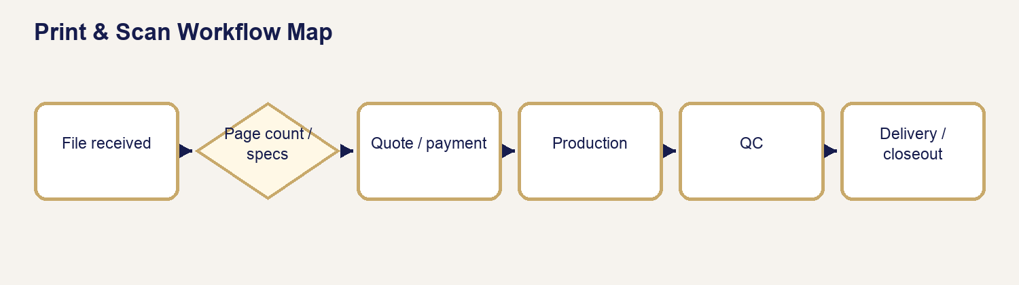
18 Print Scan Workflow

26.1 Print & Scan Workflow Map
Request/file intake → source review → authoritative page count/specifications → quote/approval → payment → production → first-copy/final QC → scan/file integrity when applicable → pickup/courier/portal delivery → completion.

26.2 When Ready to Quote
The active source opens, page count is verified, specifications are complete, delivery is known, and special handling is authorized.

26.3 File Opens and Authoritative Page Count
Use the maintained parser result when reliable. If manual review is required, count the active source and record the verified whole-number count. A changed source after quote triggers pricing review.

26.4 Production Requirements
Confirm B&W/color, copies, paper size/type, sides, scaling, orientation, finishing if supported, and any mixed instructions. Do not assume printer defaults are the customer specification.

26.5 Scanning, PDF Support, and Delivery
Confirm pages to scan, source order, PDF merge/split expectation, filename, resolution/legibility, and pickup/courier/mobile/digital delivery path.

26.6 Build Through Revision
Build from verified page volume and specifications; review, send, obtain approval, satisfy payment, and revise when the source/specification/delivery changes.

26.7 Quote Readiness Checklist
- Active file opens and authoritative page count is recorded.
- Color, copies, paper, sides, scaling, scan, and delivery are explicit.
- Changed-file and pricing-review flags are cleared legitimately.
- Current quote is reviewed, sent, approved, and paid/term-authorized.

Chapter 27 — Print & Scan Status, Operator Action & Customer Communication Sequence
Purpose: perform this workflow from verified APS and assignment evidence while preserving legal, notarial, financial, privacy, and ordering-party boundaries.
YOU WILL LEARN TO
- Review the authoritative assignment, act within role, stop at blockers, communicate accurately, and leave a complete audit trail.
Stage | Operator action | Communication | Gate / evidence
File/Request Received | inspect source and service details | acknowledgment where maintained | active file mapped
Information Needed | request exact file/specification | information-needed message | source/spec complete
Quote Ready/Approval | review/send quote | quote-ready message | approved current version
Payment Required/Received | reconcile invoice/payment | payment message | production payment gate
Production | schedule and produce from active source | status only when useful/approved | no unapproved source change
Completed Output | first-copy and final QC | no release promise before review | QC evidence
Delivery | pickup/courier/portal path | delivery-ready/released message | physical proof or digital release
Completion | verify all purchased components | completion message | final gate passes
Cancellation/Problem | stop production safely, preserve facts | approved exception message | financial/material review

27.10 Timeline Evidence
Record source version, page count review, quote/payment, production/QC, delivery/release, communications, and completion. Failed delivery is not “sent,” and uploaded output is not automatically released.

Chapter 28 — Print & Scan Fulfillment Gates, Production & Closeout
Purpose: perform this workflow from verified APS and assignment evidence while preserving legal, notarial, financial, privacy, and ordering-party boundaries.
YOU WILL LEARN TO
- Review the authoritative assignment, act within role, stop at blockers, communicate accurately, and leave a complete audit trail.

28.1–28.7 Preproduction Gates
File received, file opens, page count, specifications, quote, approval, and payment/terms each require evidence. A failure at any one prevents production start.

28.8 Production-Start Boundary
Confirm the active source/version and approved specifications immediately before starting. Preserve superseded files; do not silently substitute a newer attachment.

28.9 First-Copy and Final QC
Inspect first/last and problem-prone pages for count, order, orientation, scale, margins, clipping, color, readability, paper, and sides. Then verify the entire final set and copy count.

28.10 Scan QC, Naming, and Integrity
Compare source pages to scanned pages, check order/orientation/legibility, open the final PDF, verify merge/split behavior and filename, and retain provenance. Do not release a file merely because upload succeeded.

28.11 Delivery
For pickup, record readiness/handoff. For courier/mobile delivery, record destination and proof. For digital output, classify, review, and explicitly release only the intended customer deliverable.

28.12 Completion
Confirm every purchased component: print/copy, scan, courier/mobile delivery, payment/terms, and customer release when APS owes a digital deliverable.

28.13 Exceptions and Recovery
Stop for wrong source, changed page count, clipping, unreadable output, missing pages, wrong order, damaged source, failed delivery, or privacy risk. Preserve the bad output internally, correct from authoritative source, repeat QC, and communicate through the approved workflow.

28.14 Quick References
Use Print & Scan Workflow, Quote Readiness, Production Specifications, First-Copy QC, Scan QC, File Naming/Integrity, Delivery, and Closeout cards.

PART IX — LOAN SIGNING

Chapter 29 — Loan Signing Foundations & Workflow
Purpose: perform this workflow from verified APS and assignment evidence while preserving legal, notarial, financial, privacy, and ordering-party boundaries.
YOU WILL LEARN TO
- Review the authoritative assignment, act within role, stop at blockers, communicate accurately, and leave a complete audit trail.
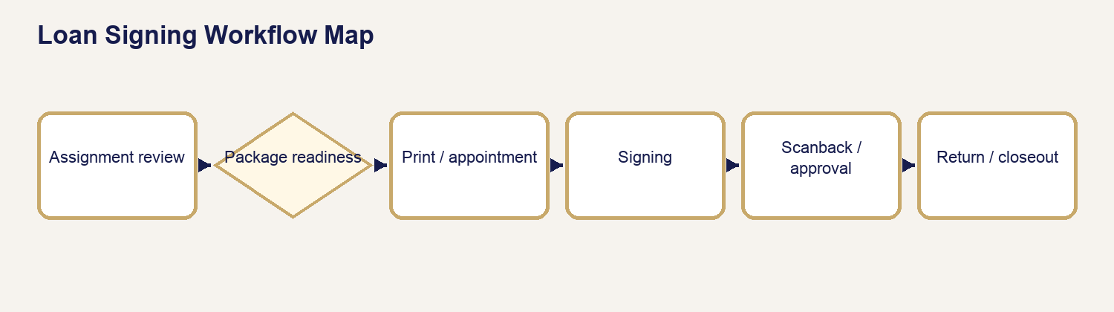
19 Loan Signing Workflow

29.1 Loan Signing Versus Mobile Notary
A Mobile Notary request centers on one or more notarial acts at a location. A Loan Signing assignment centers on a controlled closing package, ordering-party instructions, presentation/signature requirements, possible notarizations, printing, scanbacks, approval, and physical return. The signing agent remains a notary only for actual notarial acts.

29.2 Ordering Party Versus Signer
The ordering party controls assignment scope and operational instructions. The signer controls their own decisions and signatures. Neither relationship authorizes APS to give legal, lending, title, escrow, tax, or financial advice.

29.3 Role and Signing-Agent Boundaries
Present documents neutrally, identify printed information, obtain signatures/initials/dates as instructed, perform authorized notarial acts, preserve package integrity, and report exceptions. Refer interpretation, discrepancies, term questions, and decisions to the designated contact.

29.4 Signing Types
APS recognizes Buyer/Purchase, Seller, Refinance, HELOC, Loan Modification, Reverse Mortgage, Commercial/Complex, and Other/Custom. The actual order and package determine scope.

29.5 Signing Methods
In-person/mobile is the default physical package workflow. RON is used only when the assignment, document, receiving party, platform, law, and APS readiness permit it. “Either/TBD” is a blocker until the authorized method is confirmed.

29.6 Property and Signing Addresses
Keep property address and signing location separate. Verify the actual appointment location, route, access, safety, timezone, and property reference without assuming they are the same.

29.7 Company, Order, and Escrow Identifiers
Record the ordering company, company file/order number, escrow/transaction number, and other authorized identifiers exactly. Do not place unnecessary account or taxpayer data in ordinary notes.

29.8 Structured Signers
Maintain each signer’s full legal name, role/capacity, contact path, confirmation requirement, and relationship to documents. Do not collapse multiple signers into a note.

29.9 Eight Broad APS Stages
Assignment review → package readiness → printing/QC → appointment readiness → signing → scanbacks/approval → return → completion. The ten-gate framework in Chapter 35 adds financial and exception resolution controls.

29.10 Sensitive Information
Protect loan numbers, taxpayer data, bank details, IDs, nonpublic personal information, and package contents. Use approved storage/communication, not ordinary email or screenshots.

29.11 Loan Signing Workflow Map
Order received → assignment/instructions reviewed → quote/authorization → package/version received → print/QC → appointment/signer confirmation → table signing/notarization → table check → scanback/approval when required → physical return/tracking when required → exception/financial resolution → closeout.

Chapter 30 — Loan Package Types
Purpose: perform this workflow from verified APS and assignment evidence while preserving legal, notarial, financial, privacy, and ordering-party boundaries.
YOU WILL LEARN TO
- Review the authoritative assignment, act within role, stop at blockers, communicate accurately, and leave a complete audit trail.

30.1 Buyer / Purchase
Purpose: transfer/acquire property while funding a new loan and completing settlement. Expect borrower loan documents, title/settlement documents, possible deed-side documents, disclosures, affidavits, and property/product riders.
Document | What it is / why it appears | Signer usually does | Commonly notarized? | Operator focus / referral
Closing Disclosure | final disclosed loan/cost summary | reviews and signs/acknowledges | usually no | signatures only; refer figures
Note | promise to repay | signs | usually no | names, dates, package version
Security Instrument | secures debt with property | owners/borrowers sign | commonly; inspect certificate | capacities, riders, certificate
Title/Settlement forms | closing/disbursement/title requirements | signs assigned forms | varies | preserve order; refer title questions
Occupancy/Name affidavits | transaction representations | reviews and signs | often varies | no coaching; actual certificate controls

30.2 Seller
Seller packages center on conveyance, title/settlement, payoff, proceeds, identity, and seller representations. They may be shorter than borrower packages but can contain high-consequence deeds and affidavits.
Document | Why it appears | Signer usually does | Commonly notarized? | Operator focus / caution
Deed | conveyance | grantor signs | commonly | exact capacity/certificate; no deed advice
Seller affidavits | title/transaction facts | reads, supplies facts, signs | frequently varies | no factual coaching
Settlement statement | proceeds/cost accounting | reviews/signs | usually no | refer financial discrepancies
Payoff authorization | permits payoff information/action | signs | varies | protect account information
Closing instructions | controls execution/return | follows assigned acknowledgments | varies | orderer controls

30.3 Refinance
Refinance replaces or changes financing on existing property. Packages commonly include Closing Disclosure, note, security instrument, rescission notice when applicable, escrow/payment information, affidavits, riders, and title documents.
Document | Why it appears | Signer usually does | Commonly notarized? | Operator focus / caution
Closing Disclosure | final terms/costs | reviews/signs | usually no | do not interpret figures
Note | repayment obligation | signs | usually no | version/signature
Security Instrument | collateral | signs | commonly | actual certificate
Right to Cancel | covered rescission notice | dates/acknowledges receipt | no | do not calculate disputed deadline
Affidavits/Compliance | representations/corrections | signs | varies | refer legal questions

30.4 HELOC
HELOC packages concern a revolving line secured by property. Actual Texas home-equity and lender instructions are critical; never generalize product or legal requirements.
Document | Why it appears | Signer usually does | Commonly notarized? | Operator focus / caution
HELOC Agreement/Note | line terms/repayment | signs/initials | usually no | no rate/draw advice
HELOC Security Instrument | secures line | owners sign | commonly | actual certificate/capacity
Disclosures | product/cost information | acknowledges | usually no | refer lender questions
Right to Cancel when applicable | rescission notice | acknowledges/dates | no | printed instructions control

30.5 Loan Modification
Modification packages document lender/servicer-approved changes to an existing obligation. Do not imply that signing guarantees a particular servicing outcome.
Document | Why it appears | Signer usually does | Commonly notarized? | Operator focus / caution
Modification Agreement | states approved changes | signs | may be | correct loan/borrower/version
Affidavits/Certifications | supports eligibility/facts | reads/signs | varies | no coaching
Payment Instructions | operational next step | reviews/retains | no | do not accept payment unless authorized
Security-related instrument | records/continues collateral change | signs | often varies | actual certificate controls

30.6 Reverse Mortgage
Reverse Mortgage packages may contain multiple notes/security instruments, a loan agreement, payment-plan disclosures, certifications, riders, and non-borrowing-spouse documents. Provide time and neutral organization; refer counseling/product questions.
Document | Why it appears | Signer usually does | Commonly notarized? | Operator focus / caution
Note(s) | evidence debt structure | borrowers sign | usually no | paired documents/version
Mortgage(s)/Security Instruments | secure obligations | required parties sign | commonly | paired certificates/riders
Loan Agreement/Disclosures | program terms/responsibilities | reviews/signs | varies | no product advice
NBS documents | defined spouse capacity | named spouse signs | varies | never determine eligibility/rights

30.7 Commercial / Custom
Commercial/custom packages vary by entity, authority, counsel, property, and negotiated terms. Require explicit instructions and capacity evidence; source-note unfamiliar instruments.
Document | Why it appears | Signer usually does | Commonly notarized? | Operator focus / caution
Note/Security documents | debt/collateral | authorized representative signs | varies | entity/capacity and certificate
Resolutions/Authority | proves signing authority | signs/certifies if directed | varies | do not decide sufficiency
Guarantees | supports obligation | guarantor signs | varies | no legal explanation
Custom closing documents | negotiated requirements | signs as assigned | varies | ordering party/counsel controls

Chapter 31 — Common Loan Document Reference
Purpose: perform this workflow from verified APS and assignment evidence while preserving legal, notarial, financial, privacy, and ordering-party boundaries.
YOU WILL LEARN TO
- Review the authoritative assignment, act within role, stop at blockers, communicate accurately, and leave a complete audit trail.

31.1 Critical Notarization Rule
COMMONLY NOTARIZED DOES NOT MEAN ALWAYS NOTARIZE. Actual authority comes from the actual document, its actual certificate, applicable law, and authorized assignment instructions. Never add a certificate merely because a similar document is often notarized.

31.2 Closing Disclosure
Reference field | Maintained training guidance
Common package(s) | Buyer/Purchase; Refinance; some HELOC
What it is | CFPB-mandated disclosure summarizing final loan terms, projected payments, and closing costs.
Why it appears | Allows the borrower to review the transaction’s final disclosed financial terms.
Signer interaction | Signer reviews and signs or acknowledges receipt where the package directs.
Operator focus | Locate signatures/dates and follow presentation instructions without interpreting figures.
Commonly notarized? | Usually no; verify the actual form.
Presentation guidance | Identify the title and direct the signer to the disclosed sections without characterizing the deal.
Do not | Do not explain whether APR, cash to close, fees, or terms are correct or favorable.
If signer has a question | Refer financial, lender, settlement, and discrepancy questions to the named lender/title contact.
Source | Consumer Financial Protection Bureau — Closing Disclosure and closing-document guidance.

31.3 Promissory Note
Reference field | Maintained training guidance
Common package(s) | Buyer/Purchase; Refinance; HELOC or product-specific note; Reverse Mortgage note(s)
What it is | The borrower’s written promise to repay under stated terms.
Why it appears | Evidence of the debt and repayment obligation.
Signer interaction | Borrower signs exactly as directed; initials may appear where specified.
Operator focus | Names, signature capacity, required dates, and package-version integrity.
Commonly notarized? | Usually no; verify actual document/certificate.
Presentation guidance | State that it is the note and point to the lender-provided payment/term sections if instructed.
Do not | Do not interpret interest, default, prepayment, or enforceability.
If signer has a question | Refer term/payment/legal questions to lender or ordering party.
Source | CFPB closing guidance; Fannie Mae/Freddie Mac Uniform Notes; HUD HECM model notes.

31.4 Deed of Trust / Mortgage / Security Instrument
Reference field | Maintained training guidance
Common package(s) | Buyer/Purchase; Refinance; HELOC; Reverse Mortgage security instruments
What it is | Instrument securing the debt with an interest in the described property.
Why it appears | Creates the collateral/security relationship and is generally recorded.
Signer interaction | Required property owners/borrowers sign in stated capacities.
Operator focus | Correct version, property/address context, names/capacities, riders, signatures, certificate.
Commonly notarized? | Commonly, but not automatically; inspect the actual certificate and instructions.
Presentation guidance | Identify the document and signature/certificate locations only.
Do not | Do not explain foreclosure, lien priority, homestead effect, or legal consequences.
If signer has a question | Refer legal/property/title questions to lender/title/attorney.
Source | CFPB closing guidance; Fannie Mae/Freddie Mac Uniform Security Instruments; HUD model mortgages.

31.5 Notice of Right to Cancel
Reference field | Maintained training guidance
Common package(s) | Certain refinance/home-secured credit transactions; not ordinary purchase closings
What it is | Notice of a statutory rescission period when applicable.
Why it appears | Provides required cancellation timing and method for covered transactions.
Signer interaction | Signer acknowledges receipt and dates/copies as directed.
Operator focus | Correct transaction/date/copy count and ordering-party instructions.
Commonly notarized? | Usually no.
Presentation guidance | Point to the printed deadline/method without calculating or advising.
Do not | Do not tell a signer whether a transaction is rescindable or calculate a disputed deadline.
If signer has a question | Refer coverage/deadline questions to lender/title or legal counsel.
Source | Consumer Financial Protection Bureau — right of rescission guidance.

31.6 Initial Escrow Account Disclosure
Reference field | Maintained training guidance
Common package(s) | Purchase; Refinance when escrow applies
What it is | Estimate of escrow deposits and projected disbursements.
Why it appears | Explains how taxes/insurance may be collected and paid from escrow.
Signer interaction | Signer reviews and signs/acknowledges if directed.
Operator focus | Signature/acknowledgment placement and package completeness.
Commonly notarized? | Usually no.
Presentation guidance | Identify the escrow disclosure and let the signer review figures.
Do not | Do not predict shortages, tax changes, or future payments.
If signer has a question | Refer calculation questions to lender/servicer.
Source | CFPB mortgage-closing guidance and actual lender disclosure.

31.7 First Payment Letter / Payment Coupon
Reference field | Maintained training guidance
Common package(s) | Purchase; Refinance; some modifications
What it is | Operational payment instructions showing initial due date, amount, and destination.
Why it appears | Helps the borrower make the first scheduled payment.
Signer interaction | Signer reviews and retains the appropriate copy.
Operator focus | Do not separate borrower-retained pages from the package incorrectly.
Commonly notarized? | No, absent an unusual actual certificate.
Presentation guidance | Point to the printed instructions.
Do not | Do not change payment instructions or accept payment unless expressly authorized.
If signer has a question | Refer servicing/payment questions to lender/servicer.
Source | Actual lender/servicer document and assignment instructions.

31.8 Occupancy Affidavit
Reference field | Maintained training guidance
Common package(s) | Purchase; Refinance; some investment/second-home loans
What it is | Statement concerning intended or actual occupancy.
Why it appears | Supports underwriting and loan-program representations.
Signer interaction | Signer reads, completes only permitted factual blanks, and signs as directed.
Operator focus | Names, property, permitted completion, signature, and actual certificate.
Commonly notarized? | Often contains a certificate; verify actual document.
Presentation guidance | Invite the signer to read the statement and answer only for themselves.
Do not | Do not advise which occupancy status to select.
If signer has a question | Refer classification/legal questions to lender/title.
Source | Actual package; Fannie Mae special-purpose forms where applicable.

31.9 Signature / Name Affidavit
Reference field | Maintained training guidance
Common package(s) | Purchase; Refinance; Seller; HELOC; other packages
What it is | Statement connecting name variations or signatures to the signer.
Why it appears | Supports identity/name consistency across transaction records.
Signer interaction | Signer reviews listed variations, reports inaccuracies, and signs as directed.
Operator focus | Never force acceptance of an incorrect name; inspect actual certificate.
Commonly notarized? | Commonly, but verify actual certificate.
Presentation guidance | Ask the signer to review each variation and refer corrections.
Do not | Do not invent aliases or tell the signer to claim a name they dispute.
If signer has a question | Pause and contact ordering party for inaccurate/missing variations.
Source | Actual title/lender package and authorized instructions.

31.10 Compliance Agreement / Errors & Omissions Agreement
Reference field | Maintained training guidance
Common package(s) | Purchase; Refinance; HELOC; some seller packages
What it is | Agreement to cooperate with permitted post-closing corrections or omitted administrative items.
Why it appears | Supports correction of defined clerical/compliance issues.
Signer interaction | Signer reads and signs as directed.
Operator focus | Document title, signature and actual certificate; distinguish from E&O insurance.
Commonly notarized? | May be; verify the actual certificate.
Presentation guidance | Identify the document without describing the scope beyond its text.
Do not | Do not promise what corrections may be demanded or interpret legal limits.
If signer has a question | Refer scope/legal-effect questions to lender/title.
Source | Actual lender/title document; package instructions.

31.11 IRS / Tax Forms (for example W-9, 4506-C where present)
Reference field | Maintained training guidance
Common package(s) | Varies by lender/product
What it is | Taxpayer identification or transcript authorization forms included for the transaction.
Why it appears | Supports lender verification/reporting requirements.
Signer interaction | Signer verifies taxpayer information and signs as directed.
Operator focus | Correct form/version, signature/date, no copying sensitive data into APS notes.
Commonly notarized? | Usually no.
Presentation guidance | Identify the form and signature area only.
Do not | Do not provide tax advice or complete taxpayer elections.
If signer has a question | Refer tax/content questions to lender or tax professional.
Source | Actual IRS/lender form and package instructions.

31.12 Insurance Documents
Reference field | Maintained training guidance
Common package(s) | Purchase; Refinance; Reverse Mortgage; some HELOC
What it is | Evidence, authorization, or acknowledgment concerning required property insurance.
Why it appears | Supports collateral protection and closing conditions.
Signer interaction | Signer reviews and signs/acknowledges where directed.
Operator focus | Keep policy/data pages in order and protect personal information.
Commonly notarized? | Usually no unless actual certificate says otherwise.
Presentation guidance | Identify as insurance-related package material.
Do not | Do not advise coverage sufficiency or policy selection.
If signer has a question | Refer to insurer/lender/title.
Source | Actual insurer/lender/title documents.

31.13 Title and Settlement Documents
Reference field | Maintained training guidance
Common package(s) | Purchase; Seller; Refinance; HELOC; Commercial/Custom
What it is | Title, settlement, closing, disbursement, and ownership-related documents prepared for the transaction.
Why it appears | Coordinate conveyance, settlement, payoff, fees, and title requirements.
Signer interaction | Parties review and sign the forms assigned to them.
Operator focus | Ordering-party instructions, capacity, signature lines, notarization certificate, copy/return requirements.
Commonly notarized? | Varies; inspect each actual document.
Presentation guidance | Present by exact title and keep the package order.
Do not | Do not interpret title condition, ownership, prorations, or legal effect.
If signer has a question | Refer to title/escrow/attorney.
Source | Actual title/settlement package; CFPB closing guidance where applicable.

31.14 Deed
Reference field | Maintained training guidance
Common package(s) | Seller; Purchase; some estate/entity/custom closings
What it is | Instrument conveying an interest in real property.
Why it appears | Transfers the described property interest when validly executed/delivered/recorded.
Signer interaction | Authorized grantor(s) sign in stated capacity.
Operator focus | Exact names/capacities, property reference, signature, witnesses if required, actual certificate.
Commonly notarized? | Commonly, but actual deed/certificate/law controls.
Presentation guidance | Identify the deed and signature/certificate areas.
Do not | Do not choose deed type, advise ownership effect, or alter legal description.
If signer has a question | Refer to title/attorney/orderer.
Source | Actual deed and jurisdiction/ordering-party authority.

31.15 Seller Affidavits
Reference field | Maintained training guidance
Common package(s) | Seller
What it is | Seller statements about ownership, liens, occupancy, repairs, identity, or transaction facts.
Why it appears | Supports title/settlement review and risk allocation.
Signer interaction | Seller reads, supplies only their facts, and signs as directed.
Operator focus | No coaching; verify actual certificate and completeness.
Commonly notarized? | Frequently but variably; inspect actual form.
Presentation guidance | Ask the seller to review the statement and refer uncertainty.
Do not | Do not answer factual/legal questions for the seller.
If signer has a question | Refer to title/attorney/orderer.
Source | Actual title/settlement package.

31.16 Payoff Authorization
Reference field | Maintained training guidance
Common package(s) | Seller; Refinance; some modifications
What it is | Authorization to obtain, confirm, or transmit payoff information.
Why it appears | Supports satisfaction of existing obligations at closing.
Signer interaction | Authorized party reviews account/property information and signs.
Operator focus | Correct account/party, privacy, signature, and transmission path.
Commonly notarized? | Varies; verify actual document.
Presentation guidance | Identify the authorization and protect account information.
Do not | Do not calculate payoff or promise disbursement timing.
If signer has a question | Refer to title/lender/servicer.
Source | Actual title/lender/servicer form.

31.17 HELOC Agreement / Note
Reference field | Maintained training guidance
Common package(s) | HELOC
What it is | Product-specific agreement or note governing a revolving home-equity line.
Why it appears | States borrowing, repayment, advance, rate, and account terms.
Signer interaction | Borrower signs/initials as directed.
Operator focus | Correct product/version, signatures, and package instructions.
Commonly notarized? | Usually no; verify actual document.
Presentation guidance | Identify it as the HELOC agreement/note.
Do not | Do not explain draws, rates, tax effects, or suitability.
If signer has a question | Refer to lender.
Source | Actual lender document; Fannie Mae special-purpose guidance where applicable.

31.18 HELOC Security Instrument
Reference field | Maintained training guidance
Common package(s) | HELOC
What it is | Instrument securing the HELOC with the property.
Why it appears | Creates the product’s collateral relationship and may be recorded.
Signer interaction | Required owners/borrowers sign in stated capacities.
Operator focus | Names, property, riders, signatures, and actual certificate.
Commonly notarized? | Commonly; actual certificate controls.
Presentation guidance | Identify title/signature/certificate locations.
Do not | Do not explain lien priority or Texas home-equity law.
If signer has a question | Refer to lender/title/attorney.
Source | Actual lender/title instrument and applicable authoritative instructions.

31.19 Loan Modification Agreement
Reference field | Maintained training guidance
Common package(s) | Loan Modification
What it is | Agreement changing specified terms of an existing loan.
Why it appears | Documents the servicer/lender-approved modification.
Signer interaction | Borrower reviews and signs as directed.
Operator focus | Correct borrower/loan/version, signature/date, and actual certificate.
Commonly notarized? | May be; verify actual document.
Presentation guidance | Identify the agreement and let the signer read the stated changes.
Do not | Do not explain eligibility, affordability, or legal consequences.
If signer has a question | Refer to servicer/lender/housing counselor or attorney.
Source | Actual servicer/lender agreement; HUD model modification documents where applicable.

31.20 Reverse Mortgage Note(s)
Reference field | Maintained training guidance
Common package(s) | Reverse Mortgage
What it is | HECM or proprietary reverse-mortgage debt instrument(s); HUD HECM packages may contain multiple notes.
Why it appears | Evidence obligations under the reverse-mortgage structure.
Signer interaction | Borrower(s) sign as directed; package may distinguish first/second instruments.
Operator focus | Do not omit paired documents; verify names, capacities, versions, signatures.
Commonly notarized? | Usually no; verify actual document.
Presentation guidance | Identify each note by its exact title and sequence.
Do not | Do not explain loan economics, benefits, or estate consequences.
If signer has a question | Refer to lender/counselor/title/attorney.
Source | HUD HECM model documents; actual proprietary package.

31.21 Reverse Mortgage Security Instrument(s)
Reference field | Maintained training guidance
Common package(s) | Reverse Mortgage
What it is | HECM/proprietary mortgage or deed-of-trust instruments; HUD HECM may include first and second instruments.
Why it appears | Secures obligations under the reverse-mortgage structure.
Signer interaction | Required borrowers/owners sign in stated capacities.
Operator focus | Paired instruments, riders, property, signatures, certificates, package order.
Commonly notarized? | Commonly; actual certificate controls.
Presentation guidance | Present each instrument by exact title.
Do not | Do not interpret lien structure, foreclosure, occupancy, or succession rights.
If signer has a question | Refer to lender/title/counselor/attorney.
Source | HUD HECM model mortgages; actual package.

31.22 Reverse Mortgage Disclosures / Loan Agreement
Reference field | Maintained training guidance
Common package(s) | Reverse Mortgage
What it is | Program/product disclosures and agreement describing advances, charges, payment plan, and borrower responsibilities.
Why it appears | Documents program terms and required acknowledgments.
Signer interaction | Borrower reviews and signs/acknowledges as directed.
Operator focus | Correct versions, all required signatures, retain copies, no interpretation.
Commonly notarized? | Varies; inspect actual document.
Presentation guidance | Identify exact document names and allow appropriate review time.
Do not | Do not recommend payment options or explain financial suitability.
If signer has a question | Refer to lender/HECM counselor/attorney.
Source | HUD HECM model documents and actual lender package.

31.23 Non-Borrowing Spouse Documents
Reference field | Maintained training guidance
Common package(s) | Reverse Mortgage; jurisdiction/product dependent
What it is | Certifications, acknowledgments, or property-right documents for an eligible or other non-borrowing spouse.
Why it appears | Addresses program and property-right requirements defined by the actual transaction.
Signer interaction | Named spouse reviews and signs only documents assigned to that capacity.
Operator focus | Identity/capacity, correct document set, signatures, actual certificates.
Commonly notarized? | Varies; inspect every actual form.
Presentation guidance | Use the package’s exact capacity language.
Do not | Do not determine eligibility, property rights, or future occupancy protections.
If signer has a question | Refer to lender/title/HECM counselor/attorney.
Source | HUD Borrower and Non-Borrowing Spouse Certifications; actual package.

Chapter 32 — Loan Signing Intake & Assignment Review
Purpose: perform this workflow from verified APS and assignment evidence while preserving legal, notarial, financial, privacy, and ordering-party boundaries.
YOU WILL LEARN TO
- Review the authoritative assignment, act within role, stop at blockers, communicate accurately, and leave a complete audit trail.

32.1–32.4 Order, Parties, Identifiers, and Addresses
Verify orderer/customer, all structured signers/capacities, company/order/escrow identifiers, property address, signing address, date/time/timezone, access, and contact path.

32.5–32.8 Scope and Instructions
Confirm signing type/method, package status, print requirements/copies, signer confirmation, scanbacks, approval-before-return, physical return, shipping label, stipulations, and source of every instruction.

32.9 Assignment Review Procedure
1. Open the exact request and Loan Signing assignment.
2. Compare order, signers, identifiers, addresses, and appointment.
3. Read all authoritative instructions; enter each requirement with source and applicability.
4. Identify missing/conflicting facts and stop advancement.
5. Record review completion only after scope is coherent.

Chapter 33 — Preparing the Loan Signing Quote
Purpose: perform this workflow from verified APS and assignment evidence while preserving legal, notarial, financial, privacy, and ordering-party boundaries.
YOU WILL LEARN TO
- Review the authoritative assignment, act within role, stop at blockers, communicate accurately, and leave a complete audit trail.

33.1–33.5 Quote Inputs
Verify package type/complexity, page count/version, print sets and borrower copies, appointment/travel, scanbacks, approval hold, return method, after-hours/rush, and authorized custom items. Do not price from an unreceived package when print volume materially controls price unless the uncertainty is explicit and authorized.

33.6–33.9 Review, Approval, Payment, Revision
Review the customer/orderer-facing scope, send the current version, record authorized approval, and satisfy prepaid or authorized Business terms. Revise for package, appointment, printing, scanback, return, wait/resign, or other scope change without rewriting paid history.

Chapter 34 — Loan Signing Status, Operator Action & Customer Communication Sequence
Purpose: perform this workflow from verified APS and assignment evidence while preserving legal, notarial, financial, privacy, and ordering-party boundaries.
YOU WILL LEARN TO
- Review the authoritative assignment, act within role, stop at blockers, communicate accurately, and leave a complete audit trail.
Stage | Operator action | Ordering-party/signer communication | Do not advance until
Assignment received | review order and instructions | acknowledgment where maintained | scoped assignment
Information/package needed | request exact missing item | orderer-directed message | blocker resolved
Quote/authorization | send reviewed quote | current quote/authorization | approved version
Package received/replaced | identify active version | package receipt/change notice if needed | version authority clear
Print/QC | print active version and inspect | readiness/issue message | print gate passes
Appointment | confirm signer/time/location | confirmation/reminder | signer/appointment ready
Signing | conduct within boundaries | orderer contact for questions/stops | table check complete
Scanback | scan/QC/upload | scanback status | required pages accepted
Approval hold | wait for approval | concise orderer follow-up | approval received or instruction changes
Return | package/label/drop-off/tracking | tracking/return notice | return evidence complete
Exception/financial | record cause and decision | approved exception message | operational/financial resolution
Completion | verify all gates | closeout communication | ten gates pass

Chapter 35 — Loan Signing Fulfillment Gates
Purpose: perform this workflow from verified APS and assignment evidence while preserving legal, notarial, financial, privacy, and ordering-party boundaries.
YOU WILL LEARN TO
- Review the authoritative assignment, act within role, stop at blockers, communicate accurately, and leave a complete audit trail.
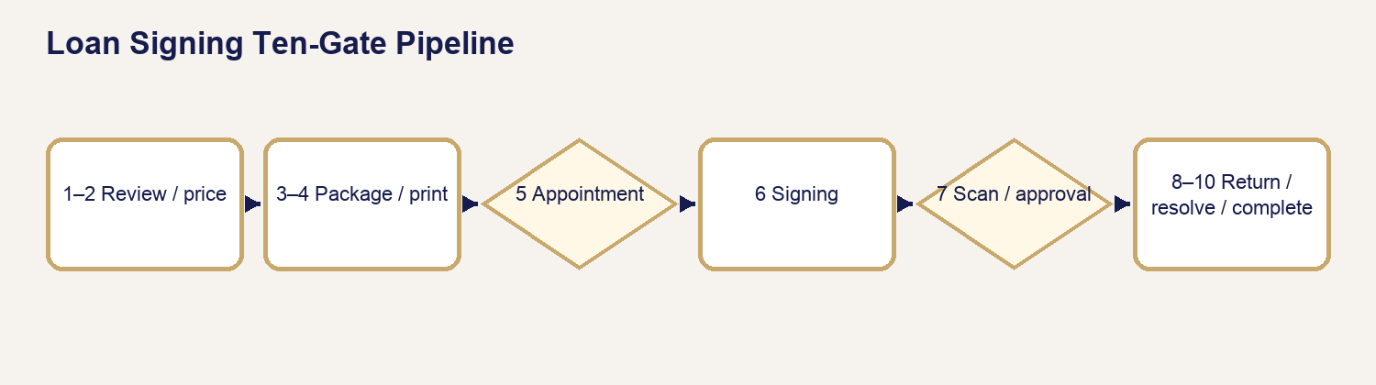
20 Loan Signing Ten Gates

35.1 Ten-Gate Framework
1. Assignment Review.
2. Pricing / Financial Readiness.
3. Package Readiness.
4. Printing / QC.
5. Appointment Readiness.
6. Signing Completion.
7. Scanback / Approval.
8. Physical Return.
9. Exception / Financial Resolution.
10. Final Completion.

35.2 Gate Rule
Each gate records purpose, required conditions, operator location, APS display, blocker, communication, authorized override if any, prohibited bypass, and next stage. “Not applicable” must be supported by assignment facts—not selected to make completion easier.

Chapter 36 — Package Preparation & Printing
Purpose: perform this workflow from verified APS and assignment evidence while preserving legal, notarial, financial, privacy, and ordering-party boundaries.
YOU WILL LEARN TO
- Review the authoritative assignment, act within role, stop at blockers, communicate accurately, and leave a complete audit trail.
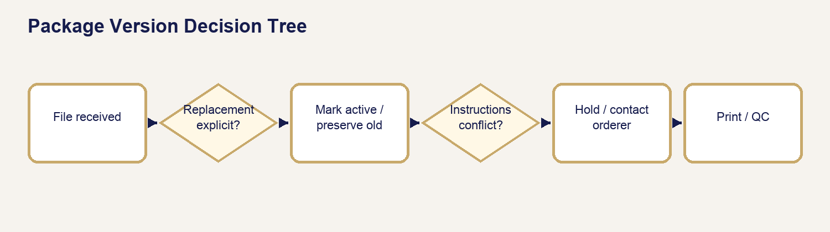
21 Package Version Decision

36.1 Package Version Decision Tree
New file received? Compare source/order/timestamp/instructions. Explicit replacement? Preserve prior version, mark new active version, recalculate page/print facts, and repeat QC. Ambiguous? Hold and contact orderer. Never combine pages across versions without written authority.

36.2 Authoritative Page Count and Print Volume
Source pages × signing sets/borrower/additional copies determines expected printed pages; sidedness informs expected sheets. Use verified source count and record the package version.

36.3 Print and QC Procedure
1. Confirm active version and instructions.
2. Verify page size, mixed letter/legal needs, scale, sidedness, color, sets, and borrower copies.
3. Print one controlled set; compare count/order/quality.
4. Print remaining authorized sets.
5. Conduct final count/order/legibility/orientation check.
6. Keep copies separated and protected.

Chapter 37 — Conducting the Loan Signing
Purpose: perform this workflow from verified APS and assignment evidence while preserving legal, notarial, financial, privacy, and ordering-party boundaries.
YOU WILL LEARN TO
- Review the authoritative assignment, act within role, stop at blockers, communicate accurately, and leave a complete audit trail.
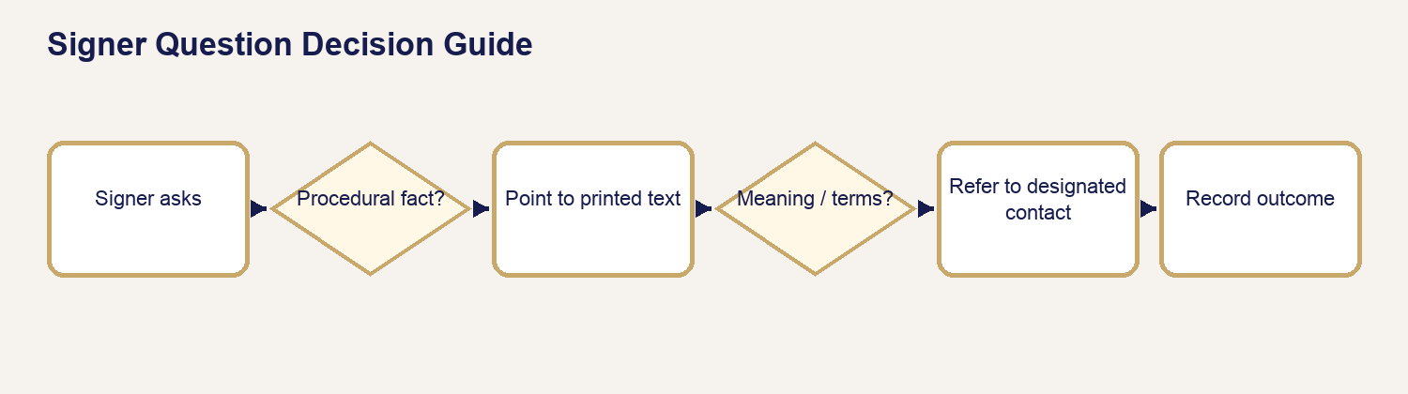
22 Signer Question Guide

37.1–37.3 Before Leaving, What to Bring, Arrival
Verify gates, active package, copies, journal/seal, IDs/tools, contact/escalation path, route, return materials, phone power, and safety. At arrival confirm signer/location before exposing documents.

37.4–37.9 Identity Through Common Document Presentation
Establish satisfactory identity for notarial acts, confirm signer willingness and capacity without legal conclusions, present package in required order, obtain exact signatures/initials/dates, complete only actual certificates, and preserve document order.

37.10–37.13 Signer Questions and Ordering-Party Contact
You may identify a document, point to printed information, repeat authorized instructions, and explain notarial procedure. Refer meaning, correctness, loan terms, settlement figures, title, tax, legal effect, or whether to sign. Pause and contact the designated orderer; record the outcome.

37.14–37.16 Stipulations, Table Check, Departure
Complete authorized stipulations exactly. Before departure, inspect every required signature/initial/date/certificate, page order, loose items, copies, journal, scanback set, and return package. Do not leave with a correctable omission unnoticed.

Chapter 38 — Scanbacks, Approval & Return
Purpose: perform this workflow from verified APS and assignment evidence while preserving legal, notarial, financial, privacy, and ordering-party boundaries.
YOU WILL LEARN TO
- Review the authoritative assignment, act within role, stop at blockers, communicate accurately, and leave a complete audit trail.
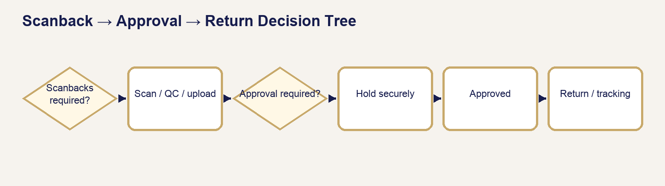
23 Scanback Approval Return

38.1–38.4 Requirements, Selection, Upload, Rescan
Identify whether scanbacks are required and which pages/set. Scan in order, legibly, at the required resolution; open/QC the final file. If rejected or incomplete, rescan from the signed originals and preserve the correction trail.

38.5–38.7 Approval Before Return
When approval-before-return applies, hold the physical package securely. Follow up through the approved channel and wait. Never return while the gate is unresolved.

38.8–38.10 Physical Return and Completion Readiness
Use the authorized label/carrier/drop-off method. Verify package, address/label, cutoff, receipt, tracking, and proof. Completion requires return evidence where applicable.

38.11 Scanback → Approval → Return Decision Tree
Scanbacks required? If NO, follow return instruction. If YES, scan/QC/upload. Approval required? If YES, hold securely until explicit approval. Rescan requested? Correct and re-upload. Once approved, return using the authorized label, retain receipt/tracking, and record evidence.

38.12 Non-Negotiable Hold
STOP — Never return while an applicable approval-before-return gate is unresolved.

Chapter 39 — Loan Signing Exceptions & Financial Resolution
Purpose: perform this workflow from verified APS and assignment evidence while preserving legal, notarial, financial, privacy, and ordering-party boundaries.
YOU WILL LEARN TO
- Review the authoritative assignment, act within role, stop at blockers, communicate accurately, and leave a complete audit trail.
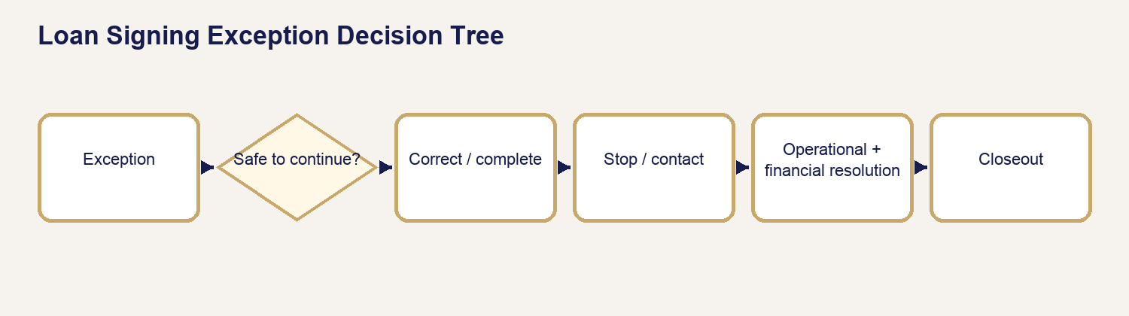
24 Loan Signing Exception

39.1–39.5 Cancellation, No-Sign, Partial, Resign, Cause
Record what occurred, when, who directed the stop, documents affected, package custody, and communication. Distinguish APS-caused correction from signer/orderer/document/other causes without making blame statements.

39.6 Excessive Wait
The maintained suggestion includes the first 30 minutes, then $25 per started additional 30-minute increment. APS-caused delay is excluded by default. An administrator authorizes any charge, waiver, or custom result; the operator does not collect automatically onsite.

39.7–39.11 Stops, Review, Supplemental Invoice, Refund, Resolution
Identity, package, signer, instruction, safety, or legal-boundary stops take priority. Additional amounts use the authorized supplemental-invoice workflow; refunds remain tied to original payment and provider evidence.

39.12 Loan Signing Exception Decision Tree
Can the signing safely and lawfully continue under current instructions? If YES, correct/continue and record. If NO, stop and contact orderer. Is same-visit correction authorized? If NO, secure package and follow no-sign/partial/resign direction. Determine cause and financial review separately. Resume or close only after both operational and financial resolution.

39.13 Resign Rule
APS-caused resign suggestion is zero. Other causes require administrator review. Link every additional visit and package version to the original assignment.

Chapter 40 — Loan Signing Closeout & Completion
Purpose: perform this workflow from verified APS and assignment evidence while preserving legal, notarial, financial, privacy, and ordering-party boundaries.
YOU WILL LEARN TO
- Review the authoritative assignment, act within role, stop at blockers, communicate accurately, and leave a complete audit trail.

40.1–40.5 Completion Evidence
Operational work, scanback/approval, return/tracking, exceptions, and financial resolution each require evidence when applicable.

40.6–40.9 Communication, Timeline, Gate, History
Send only the approved closeout communication for the correct audience. Review Timeline for assignment, package, print, appointment, signing, scans, approval, return, exceptions, money, and final completion. Preserve all versions and history.

40.10 Closeout Checklist
- Active package and all instructions reconciled.
- Signatures/initials/dates/certificates and table check complete.
- Scanbacks/QC/approval complete when applicable.
- Package returned with receipt/tracking when applicable.
- Exceptions and supplemental/refund decisions resolved.
- Required payment or authorized terms correctly recorded.
- Ordering-party/signer communication and Timeline verified.
- Final completion gate passed without override abuse.

PART X — BUSINESS ACCOUNTS & BUSINESS PORTAL

Chapter 41 — Business Account Lifecycle & Roles
Purpose: perform this workflow from verified APS and assignment evidence while preserving legal, notarial, financial, privacy, and ordering-party boundaries.
YOU WILL LEARN TO
- Review the authoritative assignment, act within role, stop at blockers, communicate accurately, and leave a complete audit trail.
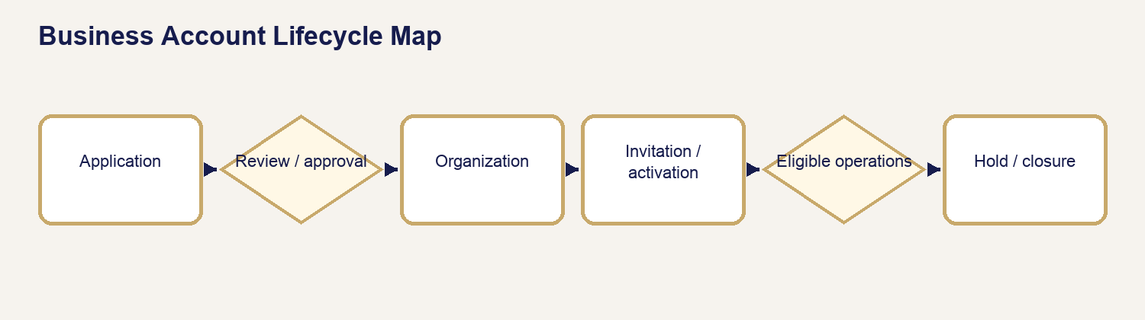
25 Business Lifecycle

41.1 Lifecycle Mental Model
A Business Account moves through application, review, approval, organization setup, invitation, activation, authenticated use, billing eligibility, ongoing service, and controlled closure. Keep application, organization, membership, request, and billing states separate. A change in one does not silently change the others.

41.2 Application, Review, and Approval
Confirm legal/display name, authorized contact, requested services, billing preference, and submitted evidence. Review missing or conflicting facts before approval. Approval authorizes organization setup; it does not create a service request, charge, or payment.

41.3 Organization and Invitation
Create or confirm the organization only from the approved application. Invite the authorized member to the correct organization and role. An invitation is pending until accepted; never describe an invited person as active before activation succeeds.

41.4 Activation, Authentication, and Recovery
Activation establishes the member’s authenticated access. Password recovery uses the maintained recovery path and verified destination. Operators do not learn, set, or retain customer passwords. Failed recovery, wrong organization, or unverified identity is a hold condition.

41.5 Roles and Membership
Use the least authority required. Organization administrators manage authorized organization-level activity; members work only within their assigned organization and role. Suspension removes current access without erasing historical ownership or audit records.

41.6 Organization Switching
Before switching organizations, confirm the selected organization in the Business Portal header/context. Requests, documents, messages, locations, and billing must remain scoped to the selected organization. Stop if the displayed organization does not match the intended work.

41.7 Locations and Service Eligibility
Maintain approved business locations separately from one-time service addresses. Location availability does not itself authorize a service, price, credit term, or assignment. Each request still passes its service-specific gates.

41.8 Business Account Lifecycle Map
Application → review → approval → organization → invitation → activation → authenticated membership → eligible requests and billing → hold/suspension if required → controlled closure with history preserved.

Chapter 42 — Business Portal Operations, Requests & Documents
Purpose: perform this workflow from verified APS and assignment evidence while preserving legal, notarial, financial, privacy, and ordering-party boundaries.
YOU WILL LEARN TO
- Review the authoritative assignment, act within role, stop at blockers, communicate accurately, and leave a complete audit trail.

42.1 Portal Orientation
The Business Portal presents organization-scoped requests, locations, members where authorized, documents, messages, invoices, payments, and account status. Verify the organization context before acting.

42.2 Creating and Reviewing Requests
An authenticated member submits a request for an eligible service. APS reviews service facts, participants, documents, timing, location, pricing, and billing readiness. Submission does not guarantee acceptance or bypass quote, payment, appointment, or fulfillment controls.

42.3 Requests and Organization Ownership
Keep the requesting member, customer/contact, signer/participant, ordering organization, and service recipient distinct. Historical requests remain linked to the organization even if a member later leaves.

42.4 Documents
Apply the Chapter 8–14 document lifecycle. Organization access is not document-release authority. Customer-visible files must still be classified, reviewed, intentionally released, and scoped to the correct request and organization.

42.5 Messages and Communication History
Send only to an authorized eligible recipient. Successful delivery evidence belongs in the Communication Log and Timeline. A read-only script never sends a message. Inspect prior attempts before retrying.

42.6 Locations
Select or enter the actual service location without overwriting a maintained organization address. Validate access, travel, safety, and service-area requirements for the individual request.

42.7 Member Administration
Invite, change, suspend, or remove a member only with organization authority. Confirm the target identity, organization, and role. Preserve completed activity and do not transfer historical actions to another person.

42.8 Recovery and Escalation
For access failure, first identify whether the issue is invitation, activation, authentication, role, organization selection, or account status. Use recovery only for authentication problems; do not bypass a hold or suspension by creating a duplicate member.

Chapter 43 — Business Account Status, Admin Action & Applicant Communication Sequence
Purpose: perform this workflow from verified APS and assignment evidence while preserving legal, notarial, financial, privacy, and ordering-party boundaries.
YOU WILL LEARN TO
- Review the authoritative assignment, act within role, stop at blockers, communicate accurately, and leave a complete audit trail.
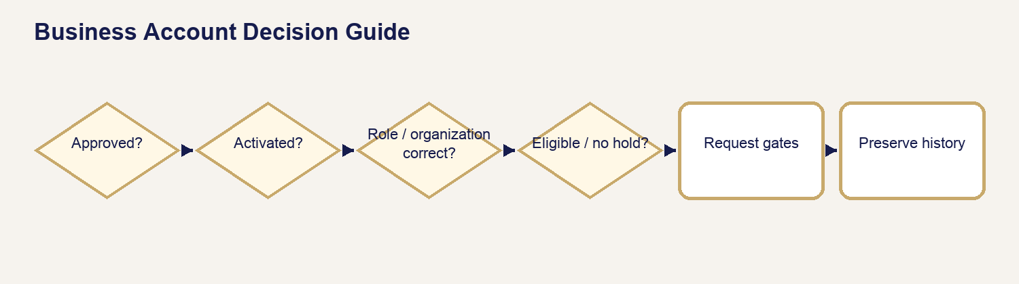
26 Business Decision

43.1 Application Received, Review, Information Needed, Approved
Stage | APS status / condition | Admin action | Applicant communication | Template / channel | Gate / do not advance until | Timeline / audit record
Received | application submitted | inspect organization/contact facts | acknowledge receipt when maintained | approved application channel | application exists | receipt and source
Review | under review | validate facts and terms | only factual review update | operator channel if needed | conflicts resolved | reviewer and outcome
Information needed | blocker identified | request exact missing item | applicant-safe request | approved operator message | item received and reviewed | request and response
Approved | approval authorized | create/confirm organization | approval and activation next step | maintained channel | decision recorded | approver and timestamp

43.2 Organization, Invitation, and Activation
Create the organization from approved facts, send the invitation to the authorized address, and verify acceptance before describing access as active. Record invitation, delivery result, activation, role, and organization membership.

43.3 Service Eligibility and Business Requests
Eligibility permits request submission under the organization; it does not auto-approve service. Apply the relevant quote, payment, appointment, document, and fulfillment gates to each request.

43.4 Billing, Reminders, and Payment
Issue the authorized invoice under the organization’s terms. Communicate due date, current balance, and payment state without turning a scheduled reminder into a collection threat. Record successful delivery and payment evidence.

43.5 Credit Hold
A credit hold blocks new credit-dependent advancement according to maintained terms. It does not erase open work, rewrite invoices, or remove portal history. Communicate the exact condition and authorized resolution path.

43.6 Recovery, Suspension, and Closure
Use password recovery for authentication only. Suspension/removal changes access; closure ends future organization activity after open operational and financial matters are resolved. Preserve all lawful historical records.

43.7 Business Lifecycle Decision Guide
Is the organization approved? If NO, remain in application review. If YES, is the member invited and activated? If NO, resolve invitation/activation. If YES, is the role and selected organization correct? If NO, stop and correct access. If YES, is the account eligible and free of an applicable hold? If NO, follow the authorized hold path. If YES, proceed to request-specific gates.

Chapter 44 — Business Billing & Completion
Purpose: perform this workflow from verified APS and assignment evidence while preserving legal, notarial, financial, privacy, and ordering-party boundaries.
YOU WILL LEARN TO
- Review the authoritative assignment, act within role, stop at blockers, communicate accurately, and leave a complete audit trail.

44.1 Billing Models
Prepaid work requires the applicable payment gate before service. Postpaid work uses only approved organization terms. A Business Account relationship does not by itself authorize credit.

44.2 Due on Receipt, Net 15, and Net 30
Apply the organization’s recorded term to the invoice date and due date. Do not switch terms to accelerate or delay collection. A due date is a recorded contractual/authorized fact, not an operator estimate.

44.3 Invoice Issue and Partial Payment
Issue an invoice only from authorized service and price facts. Partial payment reduces the legitimate balance but does not mark the invoice paid. Preserve Invoice #1 and add authorized supplemental invoices instead of rewriting history.

44.4 Due Soon, Due Today, Past Due, and Failed Payment
Use the maintained business billing template matching the actual state. Do not send multiple contradictory notices or call a failed attempt a completed payment. Inspect delivery and payment records before retrying.

44.5 Credit Hold Procedure
1. Confirm the organization, invoice, due date, current balance, payment attempts, and terms.
2. Confirm an authorized hold decision and scope.
3. Record the hold without altering invoice history.
4. Send the maintained hold notice to an eligible recipient.
5. Verify delivery and Timeline evidence.
6. Release the hold only after the authorized condition is satisfied and recorded.

44.6 Completion and Closure
Request completion and organization closure are different. Complete each service only when its operational, document, communication, and financial gates pass. Close an organization only after open requests, invoices, documents, memberships, and retention obligations are reconciled.

PART XI — COMMUNICATIONS, TEMPLATES & SCRIPTS

Chapter 45 — Communication Control & Delivery Truth
Purpose: perform this workflow from verified APS and assignment evidence while preserving legal, notarial, financial, privacy, and ordering-party boundaries.
YOU WILL LEARN TO
- Review the authoritative assignment, act within role, stop at blockers, communicate accurately, and leave a complete audit trail.
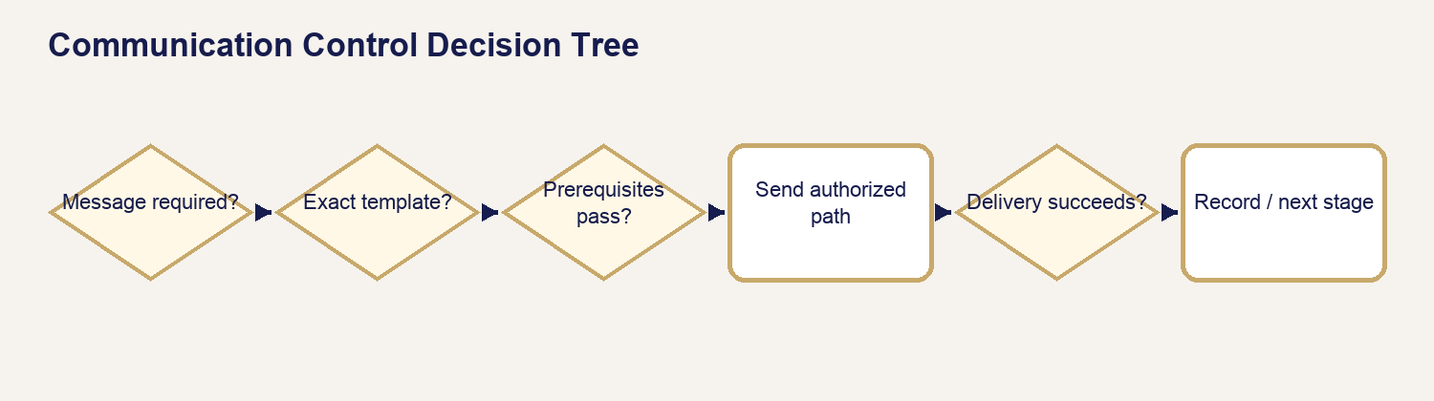
27 Communication Decision

45.1 Templates, Scripts, and Operator Messages
A template is maintained communication content that may be rendered, sent, logged, and sometimes associated with a status. A script/card is read-only operator guidance. An operator-composed message is allowed only within the current authorized communication path.

45.2 AUTO, OPERATOR, and IF NEEDED
AUTO means the current system initiates delivery from a verified event. OPERATOR means an authorized operator selects and sends it. IF NEEDED means use only when the stated condition exists. Template existence is never proof of automation.

45.3 Before Sending
Confirm request/organization, recipient eligibility, current stage, exact condition, template, variables, attachments, release authority, and prior attempts. Stop for wrong recipient, wrong request, stale status, unresolved attachment, or inconsistent financial facts.

45.4 Send Message Versus Send & Update Status
Send Message records communication without changing authoritative workflow status. Send & Update Status is appropriate only for a maintained transition and only after successful delivery. Never use messaging to manufacture readiness.

45.5 Attachments and Released Deliverables
Attach only the exact eligible quote, invoice, or intentionally released customer deliverable. Internal, audit, source, wrong-request, wrong-customer, superseded, and unreleased files are prohibited.

45.6 Delivery Evidence and Retry
Successful delivery, failure, provider evidence, rendered content, recipient, template key, channel, and time belong in Communication Log/Timeline. Before retrying, inspect existing attempts and use the maintained idempotency boundary.

45.7 Customer-Safe Language
State what happened, what is needed, what the customer should do, and what happens next. Do not expose internal queue names, provider internals, technical error text, or unapproved legal/financial conclusions.

45.8 Communication Decision Tree
Is communication required now? If NO, do not send. If YES, is there an exact maintained template for the actual condition? If YES, verify prerequisites and recipient. If NO, is an authorized operator-composed message allowed? If NO, escalate. If YES, compose narrowly. In every path, verify delivery and record the result.

Chapter 46 — Maintained Template Master Directory — All 54
Purpose: perform this workflow from verified APS and assignment evidence while preserving legal, notarial, financial, privacy, and ordering-party boundaries.
YOU WILL LEARN TO
- Review the authoritative assignment, act within role, stop at blockers, communicate accurately, and leave a complete audit trail.

46.1 Production Count and Reconciliation
The locked production inventory contains 54 active system-maintained keys. The 44-key preview catalog supplies rich metadata for most common workflows. Ten production keys require metadata completed from maintained migrations/functions or a source note; no missing metadata is guessed.

46.2 Indexes
The generated directory is ordered by production category and key. The master table supplies service, trigger/stage, audience, and category fields, supporting service, trigger, audience, category, and alphabetical lookup.

46.3 Preview Alias Reconciliation
`aps_unable_to_fulfill` maps to production `aps_cancellation_service_unavailable`; `late_retained_amount_explanation` maps to `late_cancellation_explanation`; `refund_due` maps to `cancellation_confirmed_refund_due`. Preview aliases are not claimed as separate active templates.

46.4 Template Entry Standard
Every generated entry includes the locked operational fields. A `SOURCE-NOTED` trigger/classification means the key is verified but automatic initiation was not established from code; use remains operator-controlled until verified.

46.5 Compact Master Index
Key | Name | Category | Service
appointment_confirmed | Appointment Confirmed | Appointment, intake, quote, payment, completion, and general | All applicable services
appointment_reminder | Appointment Reminder | Appointment, intake, quote, payment, completion, and general | All applicable services
appointment_rescheduled | Appointment Rescheduled | Appointment, intake, quote, payment, completion, and general | All applicable services
awaiting_payment_reminder | Awaiting Payment Reminder | Appointment, intake, quote, payment, completion, and general | All applicable services
final_invoice | Invoice / Final Invoice (invoice attachment) | Appointment, intake, quote, payment, completion, and general | All applicable services
general_customer_message | General Customer Message | Appointment, intake, quote, payment, completion, and general | All applicable services
mobile_appointment_confirmation | Mobile Appointment Confirmation | Appointment, intake, quote, payment, completion, and general | Mobile Notary
order_completed | Order Completed | Appointment, intake, quote, payment, completion, and general | All applicable services
payment_received | Payment Received | Appointment, intake, quote, payment, completion, and general | All applicable services
quote_ready | Quote Ready (quote attachment) | Appointment, intake, quote, payment, completion, and general | All applicable services
request_received | Request Received | Appointment, intake, quote, payment, completion, and general | All applicable services
review_request | Customer Experience Review | Appointment, intake, quote, payment, completion, and general | All applicable services
ron_session_ready | RON Session Ready | Appointment, intake, quote, payment, completion, and general | Remote Online Notary
service_changed_appointment_conversion | Service Changed / Appointment Conversion | Appointment, intake, quote, payment, completion, and general | All applicable services
completed_scan_delivery | Completed Scan Delivery (released deliverable only) | Documents and participant information | Print & Scan
document_delivery | Document Delivery (released deliverable only) | Documents and participant information | All applicable services
document_needed_for_quote | Document Needed to Complete Quote | Documents and participant information | All applicable services
document_received_under_review | Document Received / Under Review | Documents and participant information | All applicable services
participant_information_needed | Additional Participant Information Needed | Documents and participant information | All applicable services
aps_cancellation_service_unavailable | APS Cancellation / Service Unable to Fulfill | Cancellation and refund | All applicable services
cancellation | Cancellation | Cancellation and refund | All applicable services
cancellation_confirmed_no_payment | Cancellation Confirmed — No Payment | Cancellation and refund | All applicable services
cancellation_confirmed_refund_due | Cancellation Confirmed — Refund Due | Cancellation and refund | All applicable services
cancellation_request_received | Cancellation Request Received | Cancellation and refund | All applicable services
late_cancellation_explanation | Late Cancellation / Retained Earned Amount Explanation | Cancellation and refund | All applicable services
refund_processed | Refund Processed | Cancellation and refund | All applicable services
business_credit_hold_notice | Business Credit Hold Notice | Business, security, and resources | Business Accounts
business_invoice_issued | Business Invoice Issued | Business, security, and resources | Business Accounts
business_partial_payment | Business Partial Payment Received | Business, security, and resources | Business Accounts
business_password_reset | Business Account Password Reset | Business, security, and resources | Business Accounts
business_payment_due_receipt | Business Payment Due — Due on Receipt | Business, security, and resources | Business Accounts
business_payment_due_soon | Business Payment Due Soon | Business, security, and resources | Business Accounts
business_payment_due_today | Business Payment Due Today | Business, security, and resources | Business Accounts
business_payment_failed | Business Payment Failed | Business, security, and resources | Business Accounts
business_payment_past_due | Business Payment Past Due | Business, security, and resources | Business Accounts
business_payment_received | Business Payment Received | Business, security, and resources | Business Accounts
resource_center_response | Resource Center Response | Business, security, and resources | Resource Center
lsa_request_received | Loan Signing Request Received | Loan Signing | Loan Signing
lsa_information_needed | Loan Signing Assignment Information Needed | Loan Signing | Loan Signing
lsa_assignment_confirmed | Loan Signing Assignment Confirmed | Loan Signing | Loan Signing
lsa_signer_confirmation | Loan Signing Signer Confirmation | Loan Signing | Loan Signing
lsa_cancellation_under_review | Loan Signing Cancellation Under Review | Loan Signing | Loan Signing
lsa_signing_not_completed | Loan Signing Could Not Be Completed | Loan Signing | Loan Signing
lsa_additional_appointment_needed | Loan Signing Additional Appointment Needed | Loan Signing | Loan Signing
lsa_exception_resolved | Loan Signing Exception Resolved | Loan Signing | Loan Signing
lsa_package_documents_needed | Loan Signing Package or Documents Needed | Loan Signing | Loan Signing
lsa_replacement_package_received | Loan Signing Replacement Package Received | Loan Signing | Loan Signing
lsa_signing_follow_up | Loan Signing Requires Follow-Up | Loan Signing | Loan Signing
lsa_cancellation_requested | Loan Signing Cancellation Requested | Loan Signing | Loan Signing
lsa_cancellation_resolution | Loan Signing Cancellation Resolution | Loan Signing | Loan Signing
lsa_additional_charge_review | Loan Signing Additional Charge Authorization Needed | Loan Signing | Loan Signing
lsa_additional_charge_issued | Loan Signing Additional Charge Issued | Loan Signing | Loan Signing
lsa_scanback_return_follow_up | Loan Signing Scanback or Return Follow-Up | Loan Signing | Loan Signing
lsa_completed | Loan Signing Completed | Loan Signing | Loan Signing

46.6 Appointment Confirmed
Template field | Controlled operator guidance
Template name / key | Appointment Confirmed / appointment_confirmed
Category / service | Appointment, intake, quote, payment, completion, and general / All applicable services
Purpose | Communicate the verified appointment confirmed condition without changing facts or policy.
Audience / recipient | Eligible customer/recipient for the current request
WHEN TO USE | Only when the current authoritative record supports appointment confirmed.
WHEN NOT TO USE | Wrong recipient/request/organization; stale or unverified condition; prerequisite, attachment, release, or financial conflict.
WHAT MUST BE TRUE BEFORE SENDING | Recipient eligibility, current stage/condition, variables, attachments, and prior delivery attempts are verified.
AUTO / OPERATOR / IF NEEDED | IF NEEDED — operator verifies actual condition and current send path
Trigger / channel | Verified workflow condition; maintained email/operator communication path. Template existence alone is not automation evidence.
Recipient outcome | Recipient receives the customer-safe appointment confirmed message and its authorized next step.
Related status / next action / gate | Use the actual associated status where maintained; do not update status unless successful delivery and the maintained transition both apply.
What happens next | Follow the service-specific procedure after the recipient receives appointment confirmed.
What APS records | Template key, recipient, channel, rendered content, delivery result, time, source event, and Timeline/Communication Log evidence.
Important variables | Customer/organization identity, request reference, service, current dates/amounts/links, and eligible attachment where applicable.
Operator cautions | Do not expose internal terms, promise provider timing, send unreleased files, duplicate delivery, or manufacture status.
Alias / source note | Production key verified in the locked 54-key directory; exact automation remains governed by current implementation.

46.7 Appointment Reminder
Template field | Controlled operator guidance
Template name / key | Appointment Reminder / appointment_reminder
Category / service | Appointment, intake, quote, payment, completion, and general / All applicable services
Purpose | Communicate the verified appointment reminder condition without changing facts or policy.
Audience / recipient | Eligible customer/recipient for the current request
WHEN TO USE | Only when the current authoritative record supports appointment reminder.
WHEN NOT TO USE | Wrong recipient/request/organization; stale or unverified condition; prerequisite, attachment, release, or financial conflict.
WHAT MUST BE TRUE BEFORE SENDING | Recipient eligibility, current stage/condition, variables, attachments, and prior delivery attempts are verified.
AUTO / OPERATOR / IF NEEDED | SOURCE-NOTED — event timing must be verified before AUTO use
Trigger / channel | Verified workflow condition; maintained email/operator communication path. Template existence alone is not automation evidence.
Recipient outcome | Recipient receives the customer-safe appointment reminder message and its authorized next step.
Related status / next action / gate | Use the actual associated status where maintained; do not update status unless successful delivery and the maintained transition both apply.
What happens next | Follow the service-specific procedure after the recipient receives appointment reminder.
What APS records | Template key, recipient, channel, rendered content, delivery result, time, source event, and Timeline/Communication Log evidence.
Important variables | Customer/organization identity, request reference, service, current dates/amounts/links, and eligible attachment where applicable.
Operator cautions | Do not expose internal terms, promise provider timing, send unreleased files, duplicate delivery, or manufacture status.
Alias / source note | Production key verified in the locked 54-key directory; exact automation remains governed by current implementation.

46.8 Appointment Rescheduled
Template field | Controlled operator guidance
Template name / key | Appointment Rescheduled / appointment_rescheduled
Category / service | Appointment, intake, quote, payment, completion, and general / All applicable services
Purpose | Communicate the verified appointment rescheduled condition without changing facts or policy.
Audience / recipient | Eligible customer/recipient for the current request
WHEN TO USE | Only when the current authoritative record supports appointment rescheduled.
WHEN NOT TO USE | Wrong recipient/request/organization; stale or unverified condition; prerequisite, attachment, release, or financial conflict.
WHAT MUST BE TRUE BEFORE SENDING | Recipient eligibility, current stage/condition, variables, attachments, and prior delivery attempts are verified.
AUTO / OPERATOR / IF NEEDED | IF NEEDED — operator verifies actual condition and current send path
Trigger / channel | Verified workflow condition; maintained email/operator communication path. Template existence alone is not automation evidence.
Recipient outcome | Recipient receives the customer-safe appointment rescheduled message and its authorized next step.
Related status / next action / gate | Use the actual associated status where maintained; do not update status unless successful delivery and the maintained transition both apply.
What happens next | Follow the service-specific procedure after the recipient receives appointment rescheduled.
What APS records | Template key, recipient, channel, rendered content, delivery result, time, source event, and Timeline/Communication Log evidence.
Important variables | Customer/organization identity, request reference, service, current dates/amounts/links, and eligible attachment where applicable.
Operator cautions | Do not expose internal terms, promise provider timing, send unreleased files, duplicate delivery, or manufacture status.
Alias / source note | Production key verified in the locked 54-key directory; exact automation remains governed by current implementation.

46.9 Awaiting Payment Reminder
Template field | Controlled operator guidance
Template name / key | Awaiting Payment Reminder / awaiting_payment_reminder
Category / service | Appointment, intake, quote, payment, completion, and general / All applicable services
Purpose | Communicate the verified awaiting payment reminder condition without changing facts or policy.
Audience / recipient | Eligible customer/recipient for the current request
WHEN TO USE | Only when the current authoritative record supports awaiting payment reminder.
WHEN NOT TO USE | Wrong recipient/request/organization; stale or unverified condition; prerequisite, attachment, release, or financial conflict.
WHAT MUST BE TRUE BEFORE SENDING | Recipient eligibility, current stage/condition, variables, attachments, and prior delivery attempts are verified.
AUTO / OPERATOR / IF NEEDED | IF NEEDED — operator verifies actual condition and current send path
Trigger / channel | Verified workflow condition; maintained email/operator communication path. Template existence alone is not automation evidence.
Recipient outcome | Recipient receives the customer-safe awaiting payment reminder message and its authorized next step.
Related status / next action / gate | Use the actual associated status where maintained; do not update status unless successful delivery and the maintained transition both apply.
What happens next | Follow the service-specific procedure after the recipient receives awaiting payment reminder.
What APS records | Template key, recipient, channel, rendered content, delivery result, time, source event, and Timeline/Communication Log evidence.
Important variables | Customer/organization identity, request reference, service, current dates/amounts/links, and eligible attachment where applicable.
Operator cautions | Do not expose internal terms, promise provider timing, send unreleased files, duplicate delivery, or manufacture status.
Alias / source note | Production key verified in the locked 54-key directory; exact automation remains governed by current implementation.

46.10 Invoice / Final Invoice (invoice attachment)
Template field | Controlled operator guidance
Template name / key | Invoice / Final Invoice (invoice attachment) / final_invoice
Category / service | Appointment, intake, quote, payment, completion, and general / All applicable services
Purpose | Communicate the verified invoice / final invoice (invoice attachment) condition without changing facts or policy.
Audience / recipient | Eligible customer/recipient for the current request
WHEN TO USE | Only when the current authoritative record supports invoice / final invoice (invoice attachment).
WHEN NOT TO USE | Wrong recipient/request/organization; stale or unverified condition; prerequisite, attachment, release, or financial conflict.
WHAT MUST BE TRUE BEFORE SENDING | Recipient eligibility, current stage/condition, variables, attachments, and prior delivery attempts are verified.
AUTO / OPERATOR / IF NEEDED | IF NEEDED — operator verifies actual condition and current send path
Trigger / channel | Verified workflow condition; maintained email/operator communication path. Template existence alone is not automation evidence.
Recipient outcome | Recipient receives the customer-safe invoice / final invoice (invoice attachment) message and its authorized next step.
Related status / next action / gate | Use the actual associated status where maintained; do not update status unless successful delivery and the maintained transition both apply.
What happens next | Follow the service-specific procedure after the recipient receives invoice / final invoice (invoice attachment).
What APS records | Template key, recipient, channel, rendered content, delivery result, time, source event, and Timeline/Communication Log evidence.
Important variables | Customer/organization identity, request reference, service, current dates/amounts/links, and eligible attachment where applicable.
Operator cautions | Do not expose internal terms, promise provider timing, send unreleased files, duplicate delivery, or manufacture status.
Alias / source note | Production key verified in the locked 54-key directory; exact automation remains governed by current implementation.

46.11 General Customer Message
Template field | Controlled operator guidance
Template name / key | General Customer Message / general_customer_message
Category / service | Appointment, intake, quote, payment, completion, and general / All applicable services
Purpose | Communicate the verified general customer message condition without changing facts or policy.
Audience / recipient | Eligible customer/recipient for the current request
WHEN TO USE | Only when the current authoritative record supports general customer message.
WHEN NOT TO USE | Wrong recipient/request/organization; stale or unverified condition; prerequisite, attachment, release, or financial conflict.
WHAT MUST BE TRUE BEFORE SENDING | Recipient eligibility, current stage/condition, variables, attachments, and prior delivery attempts are verified.
AUTO / OPERATOR / IF NEEDED | OPERATOR
Trigger / channel | Verified workflow condition; maintained email/operator communication path. Template existence alone is not automation evidence.
Recipient outcome | Recipient receives the customer-safe general customer message message and its authorized next step.
Related status / next action / gate | Use the actual associated status where maintained; do not update status unless successful delivery and the maintained transition both apply.
What happens next | Follow the service-specific procedure after the recipient receives general customer message.
What APS records | Template key, recipient, channel, rendered content, delivery result, time, source event, and Timeline/Communication Log evidence.
Important variables | Customer/organization identity, request reference, service, current dates/amounts/links, and eligible attachment where applicable.
Operator cautions | Do not expose internal terms, promise provider timing, send unreleased files, duplicate delivery, or manufacture status.
Alias / source note | Production key verified in the locked 54-key directory; exact automation remains governed by current implementation.

46.12 Mobile Appointment Confirmation
Template field | Controlled operator guidance
Template name / key | Mobile Appointment Confirmation / mobile_appointment_confirmation
Category / service | Appointment, intake, quote, payment, completion, and general / Mobile Notary
Purpose | Communicate the verified mobile appointment confirmation condition without changing facts or policy.
Audience / recipient | Eligible customer/recipient for the current request
WHEN TO USE | Only when the current authoritative record supports mobile appointment confirmation.
WHEN NOT TO USE | Wrong recipient/request/organization; stale or unverified condition; prerequisite, attachment, release, or financial conflict.
WHAT MUST BE TRUE BEFORE SENDING | Recipient eligibility, current stage/condition, variables, attachments, and prior delivery attempts are verified.
AUTO / OPERATOR / IF NEEDED | IF NEEDED — operator verifies actual condition and current send path
Trigger / channel | Verified workflow condition; maintained email/operator communication path. Template existence alone is not automation evidence.
Recipient outcome | Recipient receives the customer-safe mobile appointment confirmation message and its authorized next step.
Related status / next action / gate | Use the actual associated status where maintained; do not update status unless successful delivery and the maintained transition both apply.
What happens next | Follow the service-specific procedure after the recipient receives mobile appointment confirmation.
What APS records | Template key, recipient, channel, rendered content, delivery result, time, source event, and Timeline/Communication Log evidence.
Important variables | Customer/organization identity, request reference, service, current dates/amounts/links, and eligible attachment where applicable.
Operator cautions | Do not expose internal terms, promise provider timing, send unreleased files, duplicate delivery, or manufacture status.
Alias / source note | Production key verified in the locked 54-key directory; exact automation remains governed by current implementation.

46.13 Order Completed
Template field | Controlled operator guidance
Template name / key | Order Completed / order_completed
Category / service | Appointment, intake, quote, payment, completion, and general / All applicable services
Purpose | Communicate the verified order completed condition without changing facts or policy.
Audience / recipient | Eligible customer/recipient for the current request
WHEN TO USE | Only when the current authoritative record supports order completed.
WHEN NOT TO USE | Wrong recipient/request/organization; stale or unverified condition; prerequisite, attachment, release, or financial conflict.
WHAT MUST BE TRUE BEFORE SENDING | Recipient eligibility, current stage/condition, variables, attachments, and prior delivery attempts are verified.
AUTO / OPERATOR / IF NEEDED | IF NEEDED — operator verifies actual condition and current send path
Trigger / channel | Verified workflow condition; maintained email/operator communication path. Template existence alone is not automation evidence.
Recipient outcome | Recipient receives the customer-safe order completed message and its authorized next step.
Related status / next action / gate | Use the actual associated status where maintained; do not update status unless successful delivery and the maintained transition both apply.
What happens next | Follow the service-specific procedure after the recipient receives order completed.
What APS records | Template key, recipient, channel, rendered content, delivery result, time, source event, and Timeline/Communication Log evidence.
Important variables | Customer/organization identity, request reference, service, current dates/amounts/links, and eligible attachment where applicable.
Operator cautions | Do not expose internal terms, promise provider timing, send unreleased files, duplicate delivery, or manufacture status.
Alias / source note | Production key verified in the locked 54-key directory; exact automation remains governed by current implementation.

46.14 Payment Received
Template field | Controlled operator guidance
Template name / key | Payment Received / payment_received
Category / service | Appointment, intake, quote, payment, completion, and general / All applicable services
Purpose | Communicate the verified payment received condition without changing facts or policy.
Audience / recipient | Eligible customer/recipient for the current request
WHEN TO USE | Only when the current authoritative record supports payment received.
WHEN NOT TO USE | Wrong recipient/request/organization; stale or unverified condition; prerequisite, attachment, release, or financial conflict.
WHAT MUST BE TRUE BEFORE SENDING | Recipient eligibility, current stage/condition, variables, attachments, and prior delivery attempts are verified.
AUTO / OPERATOR / IF NEEDED | IF NEEDED — operator verifies actual condition and current send path
Trigger / channel | Verified workflow condition; maintained email/operator communication path. Template existence alone is not automation evidence.
Recipient outcome | Recipient receives the customer-safe payment received message and its authorized next step.
Related status / next action / gate | Use the actual associated status where maintained; do not update status unless successful delivery and the maintained transition both apply.
What happens next | Follow the service-specific procedure after the recipient receives payment received.
What APS records | Template key, recipient, channel, rendered content, delivery result, time, source event, and Timeline/Communication Log evidence.
Important variables | Customer/organization identity, request reference, service, current dates/amounts/links, and eligible attachment where applicable.
Operator cautions | Do not expose internal terms, promise provider timing, send unreleased files, duplicate delivery, or manufacture status.
Alias / source note | Production key verified in the locked 54-key directory; exact automation remains governed by current implementation.

46.15 Quote Ready (quote attachment)
Template field | Controlled operator guidance
Template name / key | Quote Ready (quote attachment) / quote_ready
Category / service | Appointment, intake, quote, payment, completion, and general / All applicable services
Purpose | Communicate the verified quote ready (quote attachment) condition without changing facts or policy.
Audience / recipient | Eligible customer/recipient for the current request
WHEN TO USE | Only when the current authoritative record supports quote ready (quote attachment).
WHEN NOT TO USE | Wrong recipient/request/organization; stale or unverified condition; prerequisite, attachment, release, or financial conflict.
WHAT MUST BE TRUE BEFORE SENDING | Recipient eligibility, current stage/condition, variables, attachments, and prior delivery attempts are verified.
AUTO / OPERATOR / IF NEEDED | IF NEEDED — operator verifies actual condition and current send path
Trigger / channel | Verified workflow condition; maintained email/operator communication path. Template existence alone is not automation evidence.
Recipient outcome | Recipient receives the customer-safe quote ready (quote attachment) message and its authorized next step.
Related status / next action / gate | Use the actual associated status where maintained; do not update status unless successful delivery and the maintained transition both apply.
What happens next | Follow the service-specific procedure after the recipient receives quote ready (quote attachment).
What APS records | Template key, recipient, channel, rendered content, delivery result, time, source event, and Timeline/Communication Log evidence.
Important variables | Customer/organization identity, request reference, service, current dates/amounts/links, and eligible attachment where applicable.
Operator cautions | Do not expose internal terms, promise provider timing, send unreleased files, duplicate delivery, or manufacture status.
Alias / source note | Production key verified in the locked 54-key directory; exact automation remains governed by current implementation.

46.16 Request Received
Template field | Controlled operator guidance
Template name / key | Request Received / request_received
Category / service | Appointment, intake, quote, payment, completion, and general / All applicable services
Purpose | Communicate the verified request received condition without changing facts or policy.
Audience / recipient | Eligible customer/recipient for the current request
WHEN TO USE | Only when the current authoritative record supports request received.
WHEN NOT TO USE | Wrong recipient/request/organization; stale or unverified condition; prerequisite, attachment, release, or financial conflict.
WHAT MUST BE TRUE BEFORE SENDING | Recipient eligibility, current stage/condition, variables, attachments, and prior delivery attempts are verified.
AUTO / OPERATOR / IF NEEDED | IF NEEDED — operator verifies actual condition and current send path
Trigger / channel | Verified workflow condition; maintained email/operator communication path. Template existence alone is not automation evidence.
Recipient outcome | Recipient receives the customer-safe request received message and its authorized next step.
Related status / next action / gate | Use the actual associated status where maintained; do not update status unless successful delivery and the maintained transition both apply.
What happens next | Follow the service-specific procedure after the recipient receives request received.
What APS records | Template key, recipient, channel, rendered content, delivery result, time, source event, and Timeline/Communication Log evidence.
Important variables | Customer/organization identity, request reference, service, current dates/amounts/links, and eligible attachment where applicable.
Operator cautions | Do not expose internal terms, promise provider timing, send unreleased files, duplicate delivery, or manufacture status.
Alias / source note | Production key verified in the locked 54-key directory; exact automation remains governed by current implementation.

46.17 Customer Experience Review
Template field | Controlled operator guidance
Template name / key | Customer Experience Review / review_request
Category / service | Appointment, intake, quote, payment, completion, and general / All applicable services
Purpose | Communicate the verified customer experience review condition without changing facts or policy.
Audience / recipient | Eligible customer/recipient for the current request
WHEN TO USE | Only when the current authoritative record supports customer experience review.
WHEN NOT TO USE | Wrong recipient/request/organization; stale or unverified condition; prerequisite, attachment, release, or financial conflict.
WHAT MUST BE TRUE BEFORE SENDING | Recipient eligibility, current stage/condition, variables, attachments, and prior delivery attempts are verified.
AUTO / OPERATOR / IF NEEDED | SOURCE-NOTED — event timing must be verified before AUTO use
Trigger / channel | Verified workflow condition; maintained email/operator communication path. Template existence alone is not automation evidence.
Recipient outcome | Recipient receives the customer-safe customer experience review message and its authorized next step.
Related status / next action / gate | Use the actual associated status where maintained; do not update status unless successful delivery and the maintained transition both apply.
What happens next | Follow the service-specific procedure after the recipient receives customer experience review.
What APS records | Template key, recipient, channel, rendered content, delivery result, time, source event, and Timeline/Communication Log evidence.
Important variables | Customer/organization identity, request reference, service, current dates/amounts/links, and eligible attachment where applicable.
Operator cautions | Do not expose internal terms, promise provider timing, send unreleased files, duplicate delivery, or manufacture status.
Alias / source note | Production key verified in the locked 54-key directory; exact automation remains governed by current implementation.

46.18 RON Session Ready
Template field | Controlled operator guidance
Template name / key | RON Session Ready / ron_session_ready
Category / service | Appointment, intake, quote, payment, completion, and general / Remote Online Notary
Purpose | Communicate the verified ron session ready condition without changing facts or policy.
Audience / recipient | Eligible customer/recipient for the current request
WHEN TO USE | Only when the current authoritative record supports ron session ready.
WHEN NOT TO USE | Wrong recipient/request/organization; stale or unverified condition; prerequisite, attachment, release, or financial conflict.
WHAT MUST BE TRUE BEFORE SENDING | Recipient eligibility, current stage/condition, variables, attachments, and prior delivery attempts are verified.
AUTO / OPERATOR / IF NEEDED | IF NEEDED — operator verifies actual condition and current send path
Trigger / channel | Verified workflow condition; maintained email/operator communication path. Template existence alone is not automation evidence.
Recipient outcome | Recipient receives the customer-safe ron session ready message and its authorized next step.
Related status / next action / gate | Use the actual associated status where maintained; do not update status unless successful delivery and the maintained transition both apply.
What happens next | Follow the service-specific procedure after the recipient receives ron session ready.
What APS records | Template key, recipient, channel, rendered content, delivery result, time, source event, and Timeline/Communication Log evidence.
Important variables | Customer/organization identity, request reference, service, current dates/amounts/links, and eligible attachment where applicable.
Operator cautions | Do not expose internal terms, promise provider timing, send unreleased files, duplicate delivery, or manufacture status.
Alias / source note | Production key verified in the locked 54-key directory; exact automation remains governed by current implementation.

46.19 Service Changed / Appointment Conversion
Template field | Controlled operator guidance
Template name / key | Service Changed / Appointment Conversion / service_changed_appointment_conversion
Category / service | Appointment, intake, quote, payment, completion, and general / All applicable services
Purpose | Communicate the verified service changed / appointment conversion condition without changing facts or policy.
Audience / recipient | Eligible customer/recipient for the current request
WHEN TO USE | Only when the current authoritative record supports service changed / appointment conversion.
WHEN NOT TO USE | Wrong recipient/request/organization; stale or unverified condition; prerequisite, attachment, release, or financial conflict.
WHAT MUST BE TRUE BEFORE SENDING | Recipient eligibility, current stage/condition, variables, attachments, and prior delivery attempts are verified.
AUTO / OPERATOR / IF NEEDED | IF NEEDED — operator verifies actual condition and current send path
Trigger / channel | Verified workflow condition; maintained email/operator communication path. Template existence alone is not automation evidence.
Recipient outcome | Recipient receives the customer-safe service changed / appointment conversion message and its authorized next step.
Related status / next action / gate | Use the actual associated status where maintained; do not update status unless successful delivery and the maintained transition both apply.
What happens next | Follow the service-specific procedure after the recipient receives service changed / appointment conversion.
What APS records | Template key, recipient, channel, rendered content, delivery result, time, source event, and Timeline/Communication Log evidence.
Important variables | Customer/organization identity, request reference, service, current dates/amounts/links, and eligible attachment where applicable.
Operator cautions | Do not expose internal terms, promise provider timing, send unreleased files, duplicate delivery, or manufacture status.
Alias / source note | Production key verified in the locked 54-key directory; exact automation remains governed by current implementation.

46.20 Completed Scan Delivery (released deliverable only)
Template field | Controlled operator guidance
Template name / key | Completed Scan Delivery (released deliverable only) / completed_scan_delivery
Category / service | Documents and participant information / Print & Scan
Purpose | Communicate the verified completed scan delivery (released deliverable only) condition without changing facts or policy.
Audience / recipient | Eligible customer/recipient for the current request
WHEN TO USE | Only when the current authoritative record supports completed scan delivery (released deliverable only).
WHEN NOT TO USE | Wrong recipient/request/organization; stale or unverified condition; prerequisite, attachment, release, or financial conflict.
WHAT MUST BE TRUE BEFORE SENDING | Recipient eligibility, current stage/condition, variables, attachments, and prior delivery attempts are verified.
AUTO / OPERATOR / IF NEEDED | IF NEEDED — operator verifies actual condition and current send path
Trigger / channel | Verified workflow condition; maintained email/operator communication path. Template existence alone is not automation evidence.
Recipient outcome | Recipient receives the customer-safe completed scan delivery (released deliverable only) message and its authorized next step.
Related status / next action / gate | Use the actual associated status where maintained; do not update status unless successful delivery and the maintained transition both apply.
What happens next | Follow the service-specific procedure after the recipient receives completed scan delivery (released deliverable only).
What APS records | Template key, recipient, channel, rendered content, delivery result, time, source event, and Timeline/Communication Log evidence.
Important variables | Customer/organization identity, request reference, service, current dates/amounts/links, and eligible attachment where applicable.
Operator cautions | Do not expose internal terms, promise provider timing, send unreleased files, duplicate delivery, or manufacture status.
Alias / source note | Production key verified in the locked 54-key directory; exact automation remains governed by current implementation.

46.21 Document Delivery (released deliverable only)
Template field | Controlled operator guidance
Template name / key | Document Delivery (released deliverable only) / document_delivery
Category / service | Documents and participant information / All applicable services
Purpose | Communicate the verified document delivery (released deliverable only) condition without changing facts or policy.
Audience / recipient | Eligible customer/recipient for the current request
WHEN TO USE | Only when the current authoritative record supports document delivery (released deliverable only).
WHEN NOT TO USE | Wrong recipient/request/organization; stale or unverified condition; prerequisite, attachment, release, or financial conflict.
WHAT MUST BE TRUE BEFORE SENDING | Recipient eligibility, current stage/condition, variables, attachments, and prior delivery attempts are verified.
AUTO / OPERATOR / IF NEEDED | IF NEEDED — operator verifies actual condition and current send path
Trigger / channel | Verified workflow condition; maintained email/operator communication path. Template existence alone is not automation evidence.
Recipient outcome | Recipient receives the customer-safe document delivery (released deliverable only) message and its authorized next step.
Related status / next action / gate | Use the actual associated status where maintained; do not update status unless successful delivery and the maintained transition both apply.
What happens next | Follow the service-specific procedure after the recipient receives document delivery (released deliverable only).
What APS records | Template key, recipient, channel, rendered content, delivery result, time, source event, and Timeline/Communication Log evidence.
Important variables | Customer/organization identity, request reference, service, current dates/amounts/links, and eligible attachment where applicable.
Operator cautions | Do not expose internal terms, promise provider timing, send unreleased files, duplicate delivery, or manufacture status.
Alias / source note | Production key verified in the locked 54-key directory; exact automation remains governed by current implementation.

46.22 Document Needed to Complete Quote
Template field | Controlled operator guidance
Template name / key | Document Needed to Complete Quote / document_needed_for_quote
Category / service | Documents and participant information / All applicable services
Purpose | Communicate the verified document needed to complete quote condition without changing facts or policy.
Audience / recipient | Eligible customer/recipient for the current request
WHEN TO USE | Only when the current authoritative record supports document needed to complete quote.
WHEN NOT TO USE | Wrong recipient/request/organization; stale or unverified condition; prerequisite, attachment, release, or financial conflict.
WHAT MUST BE TRUE BEFORE SENDING | Recipient eligibility, current stage/condition, variables, attachments, and prior delivery attempts are verified.
AUTO / OPERATOR / IF NEEDED | IF NEEDED — operator verifies actual condition and current send path
Trigger / channel | Verified workflow condition; maintained email/operator communication path. Template existence alone is not automation evidence.
Recipient outcome | Recipient receives the customer-safe document needed to complete quote message and its authorized next step.
Related status / next action / gate | Use the actual associated status where maintained; do not update status unless successful delivery and the maintained transition both apply.
What happens next | Follow the service-specific procedure after the recipient receives document needed to complete quote.
What APS records | Template key, recipient, channel, rendered content, delivery result, time, source event, and Timeline/Communication Log evidence.
Important variables | Customer/organization identity, request reference, service, current dates/amounts/links, and eligible attachment where applicable.
Operator cautions | Do not expose internal terms, promise provider timing, send unreleased files, duplicate delivery, or manufacture status.
Alias / source note | Production key verified in the locked 54-key directory; exact automation remains governed by current implementation.

46.23 Document Received / Under Review
Template field | Controlled operator guidance
Template name / key | Document Received / Under Review / document_received_under_review
Category / service | Documents and participant information / All applicable services
Purpose | Communicate the verified document received / under review condition without changing facts or policy.
Audience / recipient | Eligible customer/recipient for the current request
WHEN TO USE | Only when the current authoritative record supports document received / under review.
WHEN NOT TO USE | Wrong recipient/request/organization; stale or unverified condition; prerequisite, attachment, release, or financial conflict.
WHAT MUST BE TRUE BEFORE SENDING | Recipient eligibility, current stage/condition, variables, attachments, and prior delivery attempts are verified.
AUTO / OPERATOR / IF NEEDED | IF NEEDED — operator verifies actual condition and current send path
Trigger / channel | Verified workflow condition; maintained email/operator communication path. Template existence alone is not automation evidence.
Recipient outcome | Recipient receives the customer-safe document received / under review message and its authorized next step.
Related status / next action / gate | Use the actual associated status where maintained; do not update status unless successful delivery and the maintained transition both apply.
What happens next | Follow the service-specific procedure after the recipient receives document received / under review.
What APS records | Template key, recipient, channel, rendered content, delivery result, time, source event, and Timeline/Communication Log evidence.
Important variables | Customer/organization identity, request reference, service, current dates/amounts/links, and eligible attachment where applicable.
Operator cautions | Do not expose internal terms, promise provider timing, send unreleased files, duplicate delivery, or manufacture status.
Alias / source note | Production key verified in the locked 54-key directory; exact automation remains governed by current implementation.

46.24 Additional Participant Information Needed
Template field | Controlled operator guidance
Template name / key | Additional Participant Information Needed / participant_information_needed
Category / service | Documents and participant information / All applicable services
Purpose | Communicate the verified additional participant information needed condition without changing facts or policy.
Audience / recipient | Eligible customer/recipient for the current request
WHEN TO USE | Only when the current authoritative record supports additional participant information needed.
WHEN NOT TO USE | Wrong recipient/request/organization; stale or unverified condition; prerequisite, attachment, release, or financial conflict.
WHAT MUST BE TRUE BEFORE SENDING | Recipient eligibility, current stage/condition, variables, attachments, and prior delivery attempts are verified.
AUTO / OPERATOR / IF NEEDED | IF NEEDED — operator verifies actual condition and current send path
Trigger / channel | Verified workflow condition; maintained email/operator communication path. Template existence alone is not automation evidence.
Recipient outcome | Recipient receives the customer-safe additional participant information needed message and its authorized next step.
Related status / next action / gate | Use the actual associated status where maintained; do not update status unless successful delivery and the maintained transition both apply.
What happens next | Follow the service-specific procedure after the recipient receives additional participant information needed.
What APS records | Template key, recipient, channel, rendered content, delivery result, time, source event, and Timeline/Communication Log evidence.
Important variables | Customer/organization identity, request reference, service, current dates/amounts/links, and eligible attachment where applicable.
Operator cautions | Do not expose internal terms, promise provider timing, send unreleased files, duplicate delivery, or manufacture status.
Alias / source note | Production key verified in the locked 54-key directory; exact automation remains governed by current implementation.

46.25 APS Cancellation / Service Unable to Fulfill
Template field | Controlled operator guidance
Template name / key | APS Cancellation / Service Unable to Fulfill / aps_cancellation_service_unavailable
Category / service | Cancellation and refund / All applicable services
Purpose | Communicate the verified aps cancellation / service unable to fulfill condition without changing facts or policy.
Audience / recipient | Eligible customer/recipient for the current request
WHEN TO USE | Only when the current authoritative record supports aps cancellation / service unable to fulfill.
WHEN NOT TO USE | Wrong recipient/request/organization; stale or unverified condition; prerequisite, attachment, release, or financial conflict.
WHAT MUST BE TRUE BEFORE SENDING | Recipient eligibility, current stage/condition, variables, attachments, and prior delivery attempts are verified.
AUTO / OPERATOR / IF NEEDED | IF NEEDED — operator verifies actual condition and current send path
Trigger / channel | Verified workflow condition; maintained email/operator communication path. Template existence alone is not automation evidence.
Recipient outcome | Recipient receives the customer-safe aps cancellation / service unable to fulfill message and its authorized next step.
Related status / next action / gate | Use the actual associated status where maintained; do not update status unless successful delivery and the maintained transition both apply.
What happens next | Follow the service-specific procedure after the recipient receives aps cancellation / service unable to fulfill.
What APS records | Template key, recipient, channel, rendered content, delivery result, time, source event, and Timeline/Communication Log evidence.
Important variables | Customer/organization identity, request reference, service, current dates/amounts/links, and eligible attachment where applicable.
Operator cautions | Do not expose internal terms, promise provider timing, send unreleased files, duplicate delivery, or manufacture status.
Alias / source note | preview alias: aps_unable_to_fulfill

46.26 Cancellation
Template field | Controlled operator guidance
Template name / key | Cancellation / cancellation
Category / service | Cancellation and refund / All applicable services
Purpose | Communicate the verified cancellation condition without changing facts or policy.
Audience / recipient | Eligible customer/recipient for the current request
WHEN TO USE | Only when the current authoritative record supports cancellation.
WHEN NOT TO USE | Wrong recipient/request/organization; stale or unverified condition; prerequisite, attachment, release, or financial conflict.
WHAT MUST BE TRUE BEFORE SENDING | Recipient eligibility, current stage/condition, variables, attachments, and prior delivery attempts are verified.
AUTO / OPERATOR / IF NEEDED | IF NEEDED — operator verifies actual condition and current send path
Trigger / channel | Verified workflow condition; maintained email/operator communication path. Template existence alone is not automation evidence.
Recipient outcome | Recipient receives the customer-safe cancellation message and its authorized next step.
Related status / next action / gate | Use the actual associated status where maintained; do not update status unless successful delivery and the maintained transition both apply.
What happens next | Follow the service-specific procedure after the recipient receives cancellation.
What APS records | Template key, recipient, channel, rendered content, delivery result, time, source event, and Timeline/Communication Log evidence.
Important variables | Customer/organization identity, request reference, service, current dates/amounts/links, and eligible attachment where applicable.
Operator cautions | Do not expose internal terms, promise provider timing, send unreleased files, duplicate delivery, or manufacture status.
Alias / source note | Production key verified in the locked 54-key directory; exact automation remains governed by current implementation.

46.27 Cancellation Confirmed — No Payment
Template field | Controlled operator guidance
Template name / key | Cancellation Confirmed — No Payment / cancellation_confirmed_no_payment
Category / service | Cancellation and refund / All applicable services
Purpose | Communicate the verified cancellation confirmed — no payment condition without changing facts or policy.
Audience / recipient | Eligible customer/recipient for the current request
WHEN TO USE | Only when the current authoritative record supports cancellation confirmed — no payment.
WHEN NOT TO USE | Wrong recipient/request/organization; stale or unverified condition; prerequisite, attachment, release, or financial conflict.
WHAT MUST BE TRUE BEFORE SENDING | Recipient eligibility, current stage/condition, variables, attachments, and prior delivery attempts are verified.
AUTO / OPERATOR / IF NEEDED | IF NEEDED — operator verifies actual condition and current send path
Trigger / channel | Verified workflow condition; maintained email/operator communication path. Template existence alone is not automation evidence.
Recipient outcome | Recipient receives the customer-safe cancellation confirmed — no payment message and its authorized next step.
Related status / next action / gate | Use the actual associated status where maintained; do not update status unless successful delivery and the maintained transition both apply.
What happens next | Follow the service-specific procedure after the recipient receives cancellation confirmed — no payment.
What APS records | Template key, recipient, channel, rendered content, delivery result, time, source event, and Timeline/Communication Log evidence.
Important variables | Customer/organization identity, request reference, service, current dates/amounts/links, and eligible attachment where applicable.
Operator cautions | Do not expose internal terms, promise provider timing, send unreleased files, duplicate delivery, or manufacture status.
Alias / source note | Production key verified in the locked 54-key directory; exact automation remains governed by current implementation.

46.28 Cancellation Confirmed — Refund Due
Template field | Controlled operator guidance
Template name / key | Cancellation Confirmed — Refund Due / cancellation_confirmed_refund_due
Category / service | Cancellation and refund / All applicable services
Purpose | Communicate the verified cancellation confirmed — refund due condition without changing facts or policy.
Audience / recipient | Eligible customer/recipient for the current request
WHEN TO USE | Only when the current authoritative record supports cancellation confirmed — refund due.
WHEN NOT TO USE | Wrong recipient/request/organization; stale or unverified condition; prerequisite, attachment, release, or financial conflict.
WHAT MUST BE TRUE BEFORE SENDING | Recipient eligibility, current stage/condition, variables, attachments, and prior delivery attempts are verified.
AUTO / OPERATOR / IF NEEDED | IF NEEDED — operator verifies actual condition and current send path
Trigger / channel | Verified workflow condition; maintained email/operator communication path. Template existence alone is not automation evidence.
Recipient outcome | Recipient receives the customer-safe cancellation confirmed — refund due message and its authorized next step.
Related status / next action / gate | Use the actual associated status where maintained; do not update status unless successful delivery and the maintained transition both apply.
What happens next | Follow the service-specific procedure after the recipient receives cancellation confirmed — refund due.
What APS records | Template key, recipient, channel, rendered content, delivery result, time, source event, and Timeline/Communication Log evidence.
Important variables | Customer/organization identity, request reference, service, current dates/amounts/links, and eligible attachment where applicable.
Operator cautions | Do not expose internal terms, promise provider timing, send unreleased files, duplicate delivery, or manufacture status.
Alias / source note | preview alias: refund_due

46.29 Cancellation Request Received
Template field | Controlled operator guidance
Template name / key | Cancellation Request Received / cancellation_request_received
Category / service | Cancellation and refund / All applicable services
Purpose | Communicate the verified cancellation request received condition without changing facts or policy.
Audience / recipient | Eligible customer/recipient for the current request
WHEN TO USE | Only when the current authoritative record supports cancellation request received.
WHEN NOT TO USE | Wrong recipient/request/organization; stale or unverified condition; prerequisite, attachment, release, or financial conflict.
WHAT MUST BE TRUE BEFORE SENDING | Recipient eligibility, current stage/condition, variables, attachments, and prior delivery attempts are verified.
AUTO / OPERATOR / IF NEEDED | IF NEEDED — operator verifies actual condition and current send path
Trigger / channel | Verified workflow condition; maintained email/operator communication path. Template existence alone is not automation evidence.
Recipient outcome | Recipient receives the customer-safe cancellation request received message and its authorized next step.
Related status / next action / gate | Use the actual associated status where maintained; do not update status unless successful delivery and the maintained transition both apply.
What happens next | Follow the service-specific procedure after the recipient receives cancellation request received.
What APS records | Template key, recipient, channel, rendered content, delivery result, time, source event, and Timeline/Communication Log evidence.
Important variables | Customer/organization identity, request reference, service, current dates/amounts/links, and eligible attachment where applicable.
Operator cautions | Do not expose internal terms, promise provider timing, send unreleased files, duplicate delivery, or manufacture status.
Alias / source note | Production key verified in the locked 54-key directory; exact automation remains governed by current implementation.

46.30 Late Cancellation / Retained Earned Amount Explanation
Template field | Controlled operator guidance
Template name / key | Late Cancellation / Retained Earned Amount Explanation / late_cancellation_explanation
Category / service | Cancellation and refund / All applicable services
Purpose | Communicate the verified late cancellation / retained earned amount explanation condition without changing facts or policy.
Audience / recipient | Eligible customer/recipient for the current request
WHEN TO USE | Only when the current authoritative record supports late cancellation / retained earned amount explanation.
WHEN NOT TO USE | Wrong recipient/request/organization; stale or unverified condition; prerequisite, attachment, release, or financial conflict.
WHAT MUST BE TRUE BEFORE SENDING | Recipient eligibility, current stage/condition, variables, attachments, and prior delivery attempts are verified.
AUTO / OPERATOR / IF NEEDED | IF NEEDED — operator verifies actual condition and current send path
Trigger / channel | Verified workflow condition; maintained email/operator communication path. Template existence alone is not automation evidence.
Recipient outcome | Recipient receives the customer-safe late cancellation / retained earned amount explanation message and its authorized next step.
Related status / next action / gate | Use the actual associated status where maintained; do not update status unless successful delivery and the maintained transition both apply.
What happens next | Follow the service-specific procedure after the recipient receives late cancellation / retained earned amount explanation.
What APS records | Template key, recipient, channel, rendered content, delivery result, time, source event, and Timeline/Communication Log evidence.
Important variables | Customer/organization identity, request reference, service, current dates/amounts/links, and eligible attachment where applicable.
Operator cautions | Do not expose internal terms, promise provider timing, send unreleased files, duplicate delivery, or manufacture status.
Alias / source note | preview alias: late_retained_amount_explanation

46.31 Refund Processed
Template field | Controlled operator guidance
Template name / key | Refund Processed / refund_processed
Category / service | Cancellation and refund / All applicable services
Purpose | Communicate the verified refund processed condition without changing facts or policy.
Audience / recipient | Eligible customer/recipient for the current request
WHEN TO USE | Only when the current authoritative record supports refund processed.
WHEN NOT TO USE | Wrong recipient/request/organization; stale or unverified condition; prerequisite, attachment, release, or financial conflict.
WHAT MUST BE TRUE BEFORE SENDING | Recipient eligibility, current stage/condition, variables, attachments, and prior delivery attempts are verified.
AUTO / OPERATOR / IF NEEDED | IF NEEDED — operator verifies actual condition and current send path
Trigger / channel | Verified workflow condition; maintained email/operator communication path. Template existence alone is not automation evidence.
Recipient outcome | Recipient receives the customer-safe refund processed message and its authorized next step.
Related status / next action / gate | Use the actual associated status where maintained; do not update status unless successful delivery and the maintained transition both apply.
What happens next | Follow the service-specific procedure after the recipient receives refund processed.
What APS records | Template key, recipient, channel, rendered content, delivery result, time, source event, and Timeline/Communication Log evidence.
Important variables | Customer/organization identity, request reference, service, current dates/amounts/links, and eligible attachment where applicable.
Operator cautions | Do not expose internal terms, promise provider timing, send unreleased files, duplicate delivery, or manufacture status.
Alias / source note | Production key verified in the locked 54-key directory; exact automation remains governed by current implementation.

46.32 Business Credit Hold Notice
Template field | Controlled operator guidance
Template name / key | Business Credit Hold Notice / business_credit_hold_notice
Category / service | Business, security, and resources / Business Accounts
Purpose | Communicate the verified business credit hold notice condition without changing facts or policy.
Audience / recipient | Authorized Business Account contact/member
WHEN TO USE | Only when the current authoritative record supports business credit hold notice.
WHEN NOT TO USE | Wrong recipient/request/organization; stale or unverified condition; prerequisite, attachment, release, or financial conflict.
WHAT MUST BE TRUE BEFORE SENDING | Recipient eligibility, current stage/condition, variables, attachments, and prior delivery attempts are verified.
AUTO / OPERATOR / IF NEEDED | IF NEEDED — operator verifies actual condition and current send path
Trigger / channel | Verified workflow condition; maintained email/operator communication path. Template existence alone is not automation evidence.
Recipient outcome | Recipient receives the customer-safe business credit hold notice message and its authorized next step.
Related status / next action / gate | Use the actual associated status where maintained; do not update status unless successful delivery and the maintained transition both apply.
What happens next | Follow the service-specific procedure after the recipient receives business credit hold notice.
What APS records | Template key, recipient, channel, rendered content, delivery result, time, source event, and Timeline/Communication Log evidence.
Important variables | Customer/organization identity, request reference, service, current dates/amounts/links, and eligible attachment where applicable.
Operator cautions | Do not expose internal terms, promise provider timing, send unreleased files, duplicate delivery, or manufacture status.
Alias / source note | Production key verified in the locked 54-key directory; exact automation remains governed by current implementation.

46.33 Business Invoice Issued
Template field | Controlled operator guidance
Template name / key | Business Invoice Issued / business_invoice_issued
Category / service | Business, security, and resources / Business Accounts
Purpose | Communicate the verified business invoice issued condition without changing facts or policy.
Audience / recipient | Authorized Business Account contact/member
WHEN TO USE | Only when the current authoritative record supports business invoice issued.
WHEN NOT TO USE | Wrong recipient/request/organization; stale or unverified condition; prerequisite, attachment, release, or financial conflict.
WHAT MUST BE TRUE BEFORE SENDING | Recipient eligibility, current stage/condition, variables, attachments, and prior delivery attempts are verified.
AUTO / OPERATOR / IF NEEDED | IF NEEDED — operator verifies actual condition and current send path
Trigger / channel | Verified workflow condition; maintained email/operator communication path. Template existence alone is not automation evidence.
Recipient outcome | Recipient receives the customer-safe business invoice issued message and its authorized next step.
Related status / next action / gate | Use the actual associated status where maintained; do not update status unless successful delivery and the maintained transition both apply.
What happens next | Follow the service-specific procedure after the recipient receives business invoice issued.
What APS records | Template key, recipient, channel, rendered content, delivery result, time, source event, and Timeline/Communication Log evidence.
Important variables | Customer/organization identity, request reference, service, current dates/amounts/links, and eligible attachment where applicable.
Operator cautions | Do not expose internal terms, promise provider timing, send unreleased files, duplicate delivery, or manufacture status.
Alias / source note | Production key verified in the locked 54-key directory; exact automation remains governed by current implementation.

46.34 Business Partial Payment Received
Template field | Controlled operator guidance
Template name / key | Business Partial Payment Received / business_partial_payment
Category / service | Business, security, and resources / Business Accounts
Purpose | Communicate the verified business partial payment received condition without changing facts or policy.
Audience / recipient | Authorized Business Account contact/member
WHEN TO USE | Only when the current authoritative record supports business partial payment received.
WHEN NOT TO USE | Wrong recipient/request/organization; stale or unverified condition; prerequisite, attachment, release, or financial conflict.
WHAT MUST BE TRUE BEFORE SENDING | Recipient eligibility, current stage/condition, variables, attachments, and prior delivery attempts are verified.
AUTO / OPERATOR / IF NEEDED | IF NEEDED — operator verifies actual condition and current send path
Trigger / channel | Verified workflow condition; maintained email/operator communication path. Template existence alone is not automation evidence.
Recipient outcome | Recipient receives the customer-safe business partial payment received message and its authorized next step.
Related status / next action / gate | Use the actual associated status where maintained; do not update status unless successful delivery and the maintained transition both apply.
What happens next | Follow the service-specific procedure after the recipient receives business partial payment received.
What APS records | Template key, recipient, channel, rendered content, delivery result, time, source event, and Timeline/Communication Log evidence.
Important variables | Customer/organization identity, request reference, service, current dates/amounts/links, and eligible attachment where applicable.
Operator cautions | Do not expose internal terms, promise provider timing, send unreleased files, duplicate delivery, or manufacture status.
Alias / source note | Production key verified in the locked 54-key directory; exact automation remains governed by current implementation.

46.35 Business Account Password Reset
Template field | Controlled operator guidance
Template name / key | Business Account Password Reset / business_password_reset
Category / service | Business, security, and resources / Business Accounts
Purpose | Communicate the verified business account password reset condition without changing facts or policy.
Audience / recipient | Authorized Business Account contact/member
WHEN TO USE | Only when the current authoritative record supports business account password reset.
WHEN NOT TO USE | Wrong recipient/request/organization; stale or unverified condition; prerequisite, attachment, release, or financial conflict.
WHAT MUST BE TRUE BEFORE SENDING | Recipient eligibility, current stage/condition, variables, attachments, and prior delivery attempts are verified.
AUTO / OPERATOR / IF NEEDED | IF NEEDED — operator verifies actual condition and current send path
Trigger / channel | Verified workflow condition; maintained email/operator communication path. Template existence alone is not automation evidence.
Recipient outcome | Recipient receives the customer-safe business account password reset message and its authorized next step.
Related status / next action / gate | Use the actual associated status where maintained; do not update status unless successful delivery and the maintained transition both apply.
What happens next | Follow the service-specific procedure after the recipient receives business account password reset.
What APS records | Template key, recipient, channel, rendered content, delivery result, time, source event, and Timeline/Communication Log evidence.
Important variables | Customer/organization identity, request reference, service, current dates/amounts/links, and eligible attachment where applicable.
Operator cautions | Do not expose internal terms, promise provider timing, send unreleased files, duplicate delivery, or manufacture status.
Alias / source note | Production key verified in the locked 54-key directory; exact automation remains governed by current implementation.

46.36 Business Payment Due — Due on Receipt
Template field | Controlled operator guidance
Template name / key | Business Payment Due — Due on Receipt / business_payment_due_receipt
Category / service | Business, security, and resources / Business Accounts
Purpose | Communicate the verified business payment due — due on receipt condition without changing facts or policy.
Audience / recipient | Authorized Business Account contact/member
WHEN TO USE | Only when the current authoritative record supports business payment due — due on receipt.
WHEN NOT TO USE | Wrong recipient/request/organization; stale or unverified condition; prerequisite, attachment, release, or financial conflict.
WHAT MUST BE TRUE BEFORE SENDING | Recipient eligibility, current stage/condition, variables, attachments, and prior delivery attempts are verified.
AUTO / OPERATOR / IF NEEDED | IF NEEDED — operator verifies actual condition and current send path
Trigger / channel | Verified workflow condition; maintained email/operator communication path. Template existence alone is not automation evidence.
Recipient outcome | Recipient receives the customer-safe business payment due — due on receipt message and its authorized next step.
Related status / next action / gate | Use the actual associated status where maintained; do not update status unless successful delivery and the maintained transition both apply.
What happens next | Follow the service-specific procedure after the recipient receives business payment due — due on receipt.
What APS records | Template key, recipient, channel, rendered content, delivery result, time, source event, and Timeline/Communication Log evidence.
Important variables | Customer/organization identity, request reference, service, current dates/amounts/links, and eligible attachment where applicable.
Operator cautions | Do not expose internal terms, promise provider timing, send unreleased files, duplicate delivery, or manufacture status.
Alias / source note | Production key verified in the locked 54-key directory; exact automation remains governed by current implementation.

46.37 Business Payment Due Soon
Template field | Controlled operator guidance
Template name / key | Business Payment Due Soon / business_payment_due_soon
Category / service | Business, security, and resources / Business Accounts
Purpose | Communicate the verified business payment due soon condition without changing facts or policy.
Audience / recipient | Authorized Business Account contact/member
WHEN TO USE | Only when the current authoritative record supports business payment due soon.
WHEN NOT TO USE | Wrong recipient/request/organization; stale or unverified condition; prerequisite, attachment, release, or financial conflict.
WHAT MUST BE TRUE BEFORE SENDING | Recipient eligibility, current stage/condition, variables, attachments, and prior delivery attempts are verified.
AUTO / OPERATOR / IF NEEDED | SOURCE-NOTED — event timing must be verified before AUTO use
Trigger / channel | Verified workflow condition; maintained email/operator communication path. Template existence alone is not automation evidence.
Recipient outcome | Recipient receives the customer-safe business payment due soon message and its authorized next step.
Related status / next action / gate | Use the actual associated status where maintained; do not update status unless successful delivery and the maintained transition both apply.
What happens next | Follow the service-specific procedure after the recipient receives business payment due soon.
What APS records | Template key, recipient, channel, rendered content, delivery result, time, source event, and Timeline/Communication Log evidence.
Important variables | Customer/organization identity, request reference, service, current dates/amounts/links, and eligible attachment where applicable.
Operator cautions | Do not expose internal terms, promise provider timing, send unreleased files, duplicate delivery, or manufacture status.
Alias / source note | Production key verified in the locked 54-key directory; exact automation remains governed by current implementation.

46.38 Business Payment Due Today
Template field | Controlled operator guidance
Template name / key | Business Payment Due Today / business_payment_due_today
Category / service | Business, security, and resources / Business Accounts
Purpose | Communicate the verified business payment due today condition without changing facts or policy.
Audience / recipient | Authorized Business Account contact/member
WHEN TO USE | Only when the current authoritative record supports business payment due today.
WHEN NOT TO USE | Wrong recipient/request/organization; stale or unverified condition; prerequisite, attachment, release, or financial conflict.
WHAT MUST BE TRUE BEFORE SENDING | Recipient eligibility, current stage/condition, variables, attachments, and prior delivery attempts are verified.
AUTO / OPERATOR / IF NEEDED | SOURCE-NOTED — event timing must be verified before AUTO use
Trigger / channel | Verified workflow condition; maintained email/operator communication path. Template existence alone is not automation evidence.
Recipient outcome | Recipient receives the customer-safe business payment due today message and its authorized next step.
Related status / next action / gate | Use the actual associated status where maintained; do not update status unless successful delivery and the maintained transition both apply.
What happens next | Follow the service-specific procedure after the recipient receives business payment due today.
What APS records | Template key, recipient, channel, rendered content, delivery result, time, source event, and Timeline/Communication Log evidence.
Important variables | Customer/organization identity, request reference, service, current dates/amounts/links, and eligible attachment where applicable.
Operator cautions | Do not expose internal terms, promise provider timing, send unreleased files, duplicate delivery, or manufacture status.
Alias / source note | Production key verified in the locked 54-key directory; exact automation remains governed by current implementation.

46.39 Business Payment Failed
Template field | Controlled operator guidance
Template name / key | Business Payment Failed / business_payment_failed
Category / service | Business, security, and resources / Business Accounts
Purpose | Communicate the verified business payment failed condition without changing facts or policy.
Audience / recipient | Authorized Business Account contact/member
WHEN TO USE | Only when the current authoritative record supports business payment failed.
WHEN NOT TO USE | Wrong recipient/request/organization; stale or unverified condition; prerequisite, attachment, release, or financial conflict.
WHAT MUST BE TRUE BEFORE SENDING | Recipient eligibility, current stage/condition, variables, attachments, and prior delivery attempts are verified.
AUTO / OPERATOR / IF NEEDED | IF NEEDED — operator verifies actual condition and current send path
Trigger / channel | Verified workflow condition; maintained email/operator communication path. Template existence alone is not automation evidence.
Recipient outcome | Recipient receives the customer-safe business payment failed message and its authorized next step.
Related status / next action / gate | Use the actual associated status where maintained; do not update status unless successful delivery and the maintained transition both apply.
What happens next | Follow the service-specific procedure after the recipient receives business payment failed.
What APS records | Template key, recipient, channel, rendered content, delivery result, time, source event, and Timeline/Communication Log evidence.
Important variables | Customer/organization identity, request reference, service, current dates/amounts/links, and eligible attachment where applicable.
Operator cautions | Do not expose internal terms, promise provider timing, send unreleased files, duplicate delivery, or manufacture status.
Alias / source note | Production key verified in the locked 54-key directory; exact automation remains governed by current implementation.

46.40 Business Payment Past Due
Template field | Controlled operator guidance
Template name / key | Business Payment Past Due / business_payment_past_due
Category / service | Business, security, and resources / Business Accounts
Purpose | Communicate the verified business payment past due condition without changing facts or policy.
Audience / recipient | Authorized Business Account contact/member
WHEN TO USE | Only when the current authoritative record supports business payment past due.
WHEN NOT TO USE | Wrong recipient/request/organization; stale or unverified condition; prerequisite, attachment, release, or financial conflict.
WHAT MUST BE TRUE BEFORE SENDING | Recipient eligibility, current stage/condition, variables, attachments, and prior delivery attempts are verified.
AUTO / OPERATOR / IF NEEDED | SOURCE-NOTED — event timing must be verified before AUTO use
Trigger / channel | Verified workflow condition; maintained email/operator communication path. Template existence alone is not automation evidence.
Recipient outcome | Recipient receives the customer-safe business payment past due message and its authorized next step.
Related status / next action / gate | Use the actual associated status where maintained; do not update status unless successful delivery and the maintained transition both apply.
What happens next | Follow the service-specific procedure after the recipient receives business payment past due.
What APS records | Template key, recipient, channel, rendered content, delivery result, time, source event, and Timeline/Communication Log evidence.
Important variables | Customer/organization identity, request reference, service, current dates/amounts/links, and eligible attachment where applicable.
Operator cautions | Do not expose internal terms, promise provider timing, send unreleased files, duplicate delivery, or manufacture status.
Alias / source note | Production key verified in the locked 54-key directory; exact automation remains governed by current implementation.

46.41 Business Payment Received
Template field | Controlled operator guidance
Template name / key | Business Payment Received / business_payment_received
Category / service | Business, security, and resources / Business Accounts
Purpose | Communicate the verified business payment received condition without changing facts or policy.
Audience / recipient | Authorized Business Account contact/member
WHEN TO USE | Only when the current authoritative record supports business payment received.
WHEN NOT TO USE | Wrong recipient/request/organization; stale or unverified condition; prerequisite, attachment, release, or financial conflict.
WHAT MUST BE TRUE BEFORE SENDING | Recipient eligibility, current stage/condition, variables, attachments, and prior delivery attempts are verified.
AUTO / OPERATOR / IF NEEDED | IF NEEDED — operator verifies actual condition and current send path
Trigger / channel | Verified workflow condition; maintained email/operator communication path. Template existence alone is not automation evidence.
Recipient outcome | Recipient receives the customer-safe business payment received message and its authorized next step.
Related status / next action / gate | Use the actual associated status where maintained; do not update status unless successful delivery and the maintained transition both apply.
What happens next | Follow the service-specific procedure after the recipient receives business payment received.
What APS records | Template key, recipient, channel, rendered content, delivery result, time, source event, and Timeline/Communication Log evidence.
Important variables | Customer/organization identity, request reference, service, current dates/amounts/links, and eligible attachment where applicable.
Operator cautions | Do not expose internal terms, promise provider timing, send unreleased files, duplicate delivery, or manufacture status.
Alias / source note | Production key verified in the locked 54-key directory; exact automation remains governed by current implementation.

46.42 Resource Center Response
Template field | Controlled operator guidance
Template name / key | Resource Center Response / resource_center_response
Category / service | Business, security, and resources / Resource Center
Purpose | Communicate the verified resource center response condition without changing facts or policy.
Audience / recipient | Eligible customer/recipient for the current request
WHEN TO USE | Only when the current authoritative record supports resource center response.
WHEN NOT TO USE | Wrong recipient/request/organization; stale or unverified condition; prerequisite, attachment, release, or financial conflict.
WHAT MUST BE TRUE BEFORE SENDING | Recipient eligibility, current stage/condition, variables, attachments, and prior delivery attempts are verified.
AUTO / OPERATOR / IF NEEDED | IF NEEDED — operator verifies actual condition and current send path
Trigger / channel | Verified workflow condition; maintained email/operator communication path. Template existence alone is not automation evidence.
Recipient outcome | Recipient receives the customer-safe resource center response message and its authorized next step.
Related status / next action / gate | Use the actual associated status where maintained; do not update status unless successful delivery and the maintained transition both apply.
What happens next | Follow the service-specific procedure after the recipient receives resource center response.
What APS records | Template key, recipient, channel, rendered content, delivery result, time, source event, and Timeline/Communication Log evidence.
Important variables | Customer/organization identity, request reference, service, current dates/amounts/links, and eligible attachment where applicable.
Operator cautions | Do not expose internal terms, promise provider timing, send unreleased files, duplicate delivery, or manufacture status.
Alias / source note | Production key verified in the locked 54-key directory; exact automation remains governed by current implementation.

46.43 Loan Signing Request Received
Template field | Controlled operator guidance
Template name / key | Loan Signing Request Received / lsa_request_received
Category / service | Loan Signing / Loan Signing
Purpose | Communicate the verified loan signing request received condition without changing facts or policy.
Audience / recipient | Authorized ordering-party or signer recipient, as the maintained event requires
WHEN TO USE | Only when the current authoritative record supports loan signing request received.
WHEN NOT TO USE | Wrong recipient/request/organization; stale or unverified condition; prerequisite, attachment, release, or financial conflict.
WHAT MUST BE TRUE BEFORE SENDING | Recipient eligibility, current stage/condition, variables, attachments, and prior delivery attempts are verified.
AUTO / OPERATOR / IF NEEDED | IF NEEDED — operator verifies actual condition and current send path
Trigger / channel | Verified workflow condition; maintained email/operator communication path. Template existence alone is not automation evidence.
Recipient outcome | Recipient receives the customer-safe loan signing request received message and its authorized next step.
Related status / next action / gate | Use the actual associated status where maintained; do not update status unless successful delivery and the maintained transition both apply.
What happens next | Follow the service-specific procedure after the recipient receives loan signing request received.
What APS records | Template key, recipient, channel, rendered content, delivery result, time, source event, and Timeline/Communication Log evidence.
Important variables | Customer/organization identity, request reference, service, current dates/amounts/links, and eligible attachment where applicable.
Operator cautions | Do not expose internal terms, promise provider timing, send unreleased files, duplicate delivery, or manufacture status.
Alias / source note | Production key verified in the locked 54-key directory; exact automation remains governed by current implementation.

46.44 Loan Signing Assignment Information Needed
Template field | Controlled operator guidance
Template name / key | Loan Signing Assignment Information Needed / lsa_information_needed
Category / service | Loan Signing / Loan Signing
Purpose | Communicate the verified loan signing assignment information needed condition without changing facts or policy.
Audience / recipient | Authorized ordering-party or signer recipient, as the maintained event requires
WHEN TO USE | Only when the current authoritative record supports loan signing assignment information needed.
WHEN NOT TO USE | Wrong recipient/request/organization; stale or unverified condition; prerequisite, attachment, release, or financial conflict.
WHAT MUST BE TRUE BEFORE SENDING | Recipient eligibility, current stage/condition, variables, attachments, and prior delivery attempts are verified.
AUTO / OPERATOR / IF NEEDED | IF NEEDED — operator verifies actual condition and current send path
Trigger / channel | Verified workflow condition; maintained email/operator communication path. Template existence alone is not automation evidence.
Recipient outcome | Recipient receives the customer-safe loan signing assignment information needed message and its authorized next step.
Related status / next action / gate | Use the actual associated status where maintained; do not update status unless successful delivery and the maintained transition both apply.
What happens next | Follow the service-specific procedure after the recipient receives loan signing assignment information needed.
What APS records | Template key, recipient, channel, rendered content, delivery result, time, source event, and Timeline/Communication Log evidence.
Important variables | Customer/organization identity, request reference, service, current dates/amounts/links, and eligible attachment where applicable.
Operator cautions | Do not expose internal terms, promise provider timing, send unreleased files, duplicate delivery, or manufacture status.
Alias / source note | Production key verified in the locked 54-key directory; exact automation remains governed by current implementation.

46.45 Loan Signing Assignment Confirmed
Template field | Controlled operator guidance
Template name / key | Loan Signing Assignment Confirmed / lsa_assignment_confirmed
Category / service | Loan Signing / Loan Signing
Purpose | Communicate the verified loan signing assignment confirmed condition without changing facts or policy.
Audience / recipient | Authorized ordering-party or signer recipient, as the maintained event requires
WHEN TO USE | Only when the current authoritative record supports loan signing assignment confirmed.
WHEN NOT TO USE | Wrong recipient/request/organization; stale or unverified condition; prerequisite, attachment, release, or financial conflict.
WHAT MUST BE TRUE BEFORE SENDING | Recipient eligibility, current stage/condition, variables, attachments, and prior delivery attempts are verified.
AUTO / OPERATOR / IF NEEDED | IF NEEDED — operator verifies actual condition and current send path
Trigger / channel | Verified workflow condition; maintained email/operator communication path. Template existence alone is not automation evidence.
Recipient outcome | Recipient receives the customer-safe loan signing assignment confirmed message and its authorized next step.
Related status / next action / gate | Use the actual associated status where maintained; do not update status unless successful delivery and the maintained transition both apply.
What happens next | Follow the service-specific procedure after the recipient receives loan signing assignment confirmed.
What APS records | Template key, recipient, channel, rendered content, delivery result, time, source event, and Timeline/Communication Log evidence.
Important variables | Customer/organization identity, request reference, service, current dates/amounts/links, and eligible attachment where applicable.
Operator cautions | Do not expose internal terms, promise provider timing, send unreleased files, duplicate delivery, or manufacture status.
Alias / source note | Production key verified in the locked 54-key directory; exact automation remains governed by current implementation.

46.46 Loan Signing Signer Confirmation
Template field | Controlled operator guidance
Template name / key | Loan Signing Signer Confirmation / lsa_signer_confirmation
Category / service | Loan Signing / Loan Signing
Purpose | Communicate the verified loan signing signer confirmation condition without changing facts or policy.
Audience / recipient | Authorized ordering-party or signer recipient, as the maintained event requires
WHEN TO USE | Only when the current authoritative record supports loan signing signer confirmation.
WHEN NOT TO USE | Wrong recipient/request/organization; stale or unverified condition; prerequisite, attachment, release, or financial conflict.
WHAT MUST BE TRUE BEFORE SENDING | Recipient eligibility, current stage/condition, variables, attachments, and prior delivery attempts are verified.
AUTO / OPERATOR / IF NEEDED | IF NEEDED — operator verifies actual condition and current send path
Trigger / channel | Verified workflow condition; maintained email/operator communication path. Template existence alone is not automation evidence.
Recipient outcome | Recipient receives the customer-safe loan signing signer confirmation message and its authorized next step.
Related status / next action / gate | Use the actual associated status where maintained; do not update status unless successful delivery and the maintained transition both apply.
What happens next | Follow the service-specific procedure after the recipient receives loan signing signer confirmation.
What APS records | Template key, recipient, channel, rendered content, delivery result, time, source event, and Timeline/Communication Log evidence.
Important variables | Customer/organization identity, request reference, service, current dates/amounts/links, and eligible attachment where applicable.
Operator cautions | Do not expose internal terms, promise provider timing, send unreleased files, duplicate delivery, or manufacture status.
Alias / source note | Production key verified in the locked 54-key directory; exact automation remains governed by current implementation.

46.47 Loan Signing Cancellation Under Review
Template field | Controlled operator guidance
Template name / key | Loan Signing Cancellation Under Review / lsa_cancellation_under_review
Category / service | Loan Signing / Loan Signing
Purpose | Communicate the verified loan signing cancellation under review condition without changing facts or policy.
Audience / recipient | Authorized ordering-party or signer recipient, as the maintained event requires
WHEN TO USE | Only when the current authoritative record supports loan signing cancellation under review.
WHEN NOT TO USE | Wrong recipient/request/organization; stale or unverified condition; prerequisite, attachment, release, or financial conflict.
WHAT MUST BE TRUE BEFORE SENDING | Recipient eligibility, current stage/condition, variables, attachments, and prior delivery attempts are verified.
AUTO / OPERATOR / IF NEEDED | IF NEEDED — operator verifies actual condition and current send path
Trigger / channel | Verified workflow condition; maintained email/operator communication path. Template existence alone is not automation evidence.
Recipient outcome | Recipient receives the customer-safe loan signing cancellation under review message and its authorized next step.
Related status / next action / gate | Use the actual associated status where maintained; do not update status unless successful delivery and the maintained transition both apply.
What happens next | Follow the service-specific procedure after the recipient receives loan signing cancellation under review.
What APS records | Template key, recipient, channel, rendered content, delivery result, time, source event, and Timeline/Communication Log evidence.
Important variables | Customer/organization identity, request reference, service, current dates/amounts/links, and eligible attachment where applicable.
Operator cautions | Do not expose internal terms, promise provider timing, send unreleased files, duplicate delivery, or manufacture status.
Alias / source note | Production key verified in the locked 54-key directory; exact automation remains governed by current implementation.

46.48 Loan Signing Could Not Be Completed
Template field | Controlled operator guidance
Template name / key | Loan Signing Could Not Be Completed / lsa_signing_not_completed
Category / service | Loan Signing / Loan Signing
Purpose | Communicate the verified loan signing could not be completed condition without changing facts or policy.
Audience / recipient | Authorized ordering-party or signer recipient, as the maintained event requires
WHEN TO USE | Only when the current authoritative record supports loan signing could not be completed.
WHEN NOT TO USE | Wrong recipient/request/organization; stale or unverified condition; prerequisite, attachment, release, or financial conflict.
WHAT MUST BE TRUE BEFORE SENDING | Recipient eligibility, current stage/condition, variables, attachments, and prior delivery attempts are verified.
AUTO / OPERATOR / IF NEEDED | IF NEEDED — operator verifies actual condition and current send path
Trigger / channel | Verified workflow condition; maintained email/operator communication path. Template existence alone is not automation evidence.
Recipient outcome | Recipient receives the customer-safe loan signing could not be completed message and its authorized next step.
Related status / next action / gate | Use the actual associated status where maintained; do not update status unless successful delivery and the maintained transition both apply.
What happens next | Follow the service-specific procedure after the recipient receives loan signing could not be completed.
What APS records | Template key, recipient, channel, rendered content, delivery result, time, source event, and Timeline/Communication Log evidence.
Important variables | Customer/organization identity, request reference, service, current dates/amounts/links, and eligible attachment where applicable.
Operator cautions | Do not expose internal terms, promise provider timing, send unreleased files, duplicate delivery, or manufacture status.
Alias / source note | Production key verified in the locked 54-key directory; exact automation remains governed by current implementation.

46.49 Loan Signing Additional Appointment Needed
Template field | Controlled operator guidance
Template name / key | Loan Signing Additional Appointment Needed / lsa_additional_appointment_needed
Category / service | Loan Signing / Loan Signing
Purpose | Communicate the verified loan signing additional appointment needed condition without changing facts or policy.
Audience / recipient | Authorized ordering-party or signer recipient, as the maintained event requires
WHEN TO USE | Only when the current authoritative record supports loan signing additional appointment needed.
WHEN NOT TO USE | Wrong recipient/request/organization; stale or unverified condition; prerequisite, attachment, release, or financial conflict.
WHAT MUST BE TRUE BEFORE SENDING | Recipient eligibility, current stage/condition, variables, attachments, and prior delivery attempts are verified.
AUTO / OPERATOR / IF NEEDED | IF NEEDED — operator verifies actual condition and current send path
Trigger / channel | Verified workflow condition; maintained email/operator communication path. Template existence alone is not automation evidence.
Recipient outcome | Recipient receives the customer-safe loan signing additional appointment needed message and its authorized next step.
Related status / next action / gate | Use the actual associated status where maintained; do not update status unless successful delivery and the maintained transition both apply.
What happens next | Follow the service-specific procedure after the recipient receives loan signing additional appointment needed.
What APS records | Template key, recipient, channel, rendered content, delivery result, time, source event, and Timeline/Communication Log evidence.
Important variables | Customer/organization identity, request reference, service, current dates/amounts/links, and eligible attachment where applicable.
Operator cautions | Do not expose internal terms, promise provider timing, send unreleased files, duplicate delivery, or manufacture status.
Alias / source note | Production key verified in the locked 54-key directory; exact automation remains governed by current implementation.

46.50 Loan Signing Exception Resolved
Template field | Controlled operator guidance
Template name / key | Loan Signing Exception Resolved / lsa_exception_resolved
Category / service | Loan Signing / Loan Signing
Purpose | Communicate the verified loan signing exception resolved condition without changing facts or policy.
Audience / recipient | Authorized ordering-party or signer recipient, as the maintained event requires
WHEN TO USE | Only when the current authoritative record supports loan signing exception resolved.
WHEN NOT TO USE | Wrong recipient/request/organization; stale or unverified condition; prerequisite, attachment, release, or financial conflict.
WHAT MUST BE TRUE BEFORE SENDING | Recipient eligibility, current stage/condition, variables, attachments, and prior delivery attempts are verified.
AUTO / OPERATOR / IF NEEDED | IF NEEDED — operator verifies actual condition and current send path
Trigger / channel | Verified workflow condition; maintained email/operator communication path. Template existence alone is not automation evidence.
Recipient outcome | Recipient receives the customer-safe loan signing exception resolved message and its authorized next step.
Related status / next action / gate | Use the actual associated status where maintained; do not update status unless successful delivery and the maintained transition both apply.
What happens next | Follow the service-specific procedure after the recipient receives loan signing exception resolved.
What APS records | Template key, recipient, channel, rendered content, delivery result, time, source event, and Timeline/Communication Log evidence.
Important variables | Customer/organization identity, request reference, service, current dates/amounts/links, and eligible attachment where applicable.
Operator cautions | Do not expose internal terms, promise provider timing, send unreleased files, duplicate delivery, or manufacture status.
Alias / source note | Production key verified in the locked 54-key directory; exact automation remains governed by current implementation.

46.51 Loan Signing Package or Documents Needed
Template field | Controlled operator guidance
Template name / key | Loan Signing Package or Documents Needed / lsa_package_documents_needed
Category / service | Loan Signing / Loan Signing
Purpose | Communicate the verified loan signing package or documents needed condition without changing facts or policy.
Audience / recipient | Authorized ordering-party or signer recipient, as the maintained event requires
WHEN TO USE | Only when the current authoritative record supports loan signing package or documents needed.
WHEN NOT TO USE | Wrong recipient/request/organization; stale or unverified condition; prerequisite, attachment, release, or financial conflict.
WHAT MUST BE TRUE BEFORE SENDING | Recipient eligibility, current stage/condition, variables, attachments, and prior delivery attempts are verified.
AUTO / OPERATOR / IF NEEDED | IF NEEDED — operator verifies actual condition and current send path
Trigger / channel | Verified workflow condition; maintained email/operator communication path. Template existence alone is not automation evidence.
Recipient outcome | Recipient receives the customer-safe loan signing package or documents needed message and its authorized next step.
Related status / next action / gate | Use the actual associated status where maintained; do not update status unless successful delivery and the maintained transition both apply.
What happens next | Follow the service-specific procedure after the recipient receives loan signing package or documents needed.
What APS records | Template key, recipient, channel, rendered content, delivery result, time, source event, and Timeline/Communication Log evidence.
Important variables | Customer/organization identity, request reference, service, current dates/amounts/links, and eligible attachment where applicable.
Operator cautions | Do not expose internal terms, promise provider timing, send unreleased files, duplicate delivery, or manufacture status.
Alias / source note | Production key verified in the locked 54-key directory; exact automation remains governed by current implementation.

46.52 Loan Signing Replacement Package Received
Template field | Controlled operator guidance
Template name / key | Loan Signing Replacement Package Received / lsa_replacement_package_received
Category / service | Loan Signing / Loan Signing
Purpose | Communicate the verified loan signing replacement package received condition without changing facts or policy.
Audience / recipient | Authorized ordering-party or signer recipient, as the maintained event requires
WHEN TO USE | Only when the current authoritative record supports loan signing replacement package received.
WHEN NOT TO USE | Wrong recipient/request/organization; stale or unverified condition; prerequisite, attachment, release, or financial conflict.
WHAT MUST BE TRUE BEFORE SENDING | Recipient eligibility, current stage/condition, variables, attachments, and prior delivery attempts are verified.
AUTO / OPERATOR / IF NEEDED | IF NEEDED — operator verifies actual condition and current send path
Trigger / channel | Verified workflow condition; maintained email/operator communication path. Template existence alone is not automation evidence.
Recipient outcome | Recipient receives the customer-safe loan signing replacement package received message and its authorized next step.
Related status / next action / gate | Use the actual associated status where maintained; do not update status unless successful delivery and the maintained transition both apply.
What happens next | Follow the service-specific procedure after the recipient receives loan signing replacement package received.
What APS records | Template key, recipient, channel, rendered content, delivery result, time, source event, and Timeline/Communication Log evidence.
Important variables | Customer/organization identity, request reference, service, current dates/amounts/links, and eligible attachment where applicable.
Operator cautions | Do not expose internal terms, promise provider timing, send unreleased files, duplicate delivery, or manufacture status.
Alias / source note | Production key verified in the locked 54-key directory; exact automation remains governed by current implementation.

46.53 Loan Signing Requires Follow-Up
Template field | Controlled operator guidance
Template name / key | Loan Signing Requires Follow-Up / lsa_signing_follow_up
Category / service | Loan Signing / Loan Signing
Purpose | Communicate the verified loan signing requires follow-up condition without changing facts or policy.
Audience / recipient | Authorized ordering-party or signer recipient, as the maintained event requires
WHEN TO USE | Only when the current authoritative record supports loan signing requires follow-up.
WHEN NOT TO USE | Wrong recipient/request/organization; stale or unverified condition; prerequisite, attachment, release, or financial conflict.
WHAT MUST BE TRUE BEFORE SENDING | Recipient eligibility, current stage/condition, variables, attachments, and prior delivery attempts are verified.
AUTO / OPERATOR / IF NEEDED | IF NEEDED — operator verifies actual condition and current send path
Trigger / channel | Verified workflow condition; maintained email/operator communication path. Template existence alone is not automation evidence.
Recipient outcome | Recipient receives the customer-safe loan signing requires follow-up message and its authorized next step.
Related status / next action / gate | Use the actual associated status where maintained; do not update status unless successful delivery and the maintained transition both apply.
What happens next | Follow the service-specific procedure after the recipient receives loan signing requires follow-up.
What APS records | Template key, recipient, channel, rendered content, delivery result, time, source event, and Timeline/Communication Log evidence.
Important variables | Customer/organization identity, request reference, service, current dates/amounts/links, and eligible attachment where applicable.
Operator cautions | Do not expose internal terms, promise provider timing, send unreleased files, duplicate delivery, or manufacture status.
Alias / source note | Production key verified in the locked 54-key directory; exact automation remains governed by current implementation.

46.54 Loan Signing Cancellation Requested
Template field | Controlled operator guidance
Template name / key | Loan Signing Cancellation Requested / lsa_cancellation_requested
Category / service | Loan Signing / Loan Signing
Purpose | Communicate the verified loan signing cancellation requested condition without changing facts or policy.
Audience / recipient | Authorized ordering-party or signer recipient, as the maintained event requires
WHEN TO USE | Only when the current authoritative record supports loan signing cancellation requested.
WHEN NOT TO USE | Wrong recipient/request/organization; stale or unverified condition; prerequisite, attachment, release, or financial conflict.
WHAT MUST BE TRUE BEFORE SENDING | Recipient eligibility, current stage/condition, variables, attachments, and prior delivery attempts are verified.
AUTO / OPERATOR / IF NEEDED | IF NEEDED — operator verifies actual condition and current send path
Trigger / channel | Verified workflow condition; maintained email/operator communication path. Template existence alone is not automation evidence.
Recipient outcome | Recipient receives the customer-safe loan signing cancellation requested message and its authorized next step.
Related status / next action / gate | Use the actual associated status where maintained; do not update status unless successful delivery and the maintained transition both apply.
What happens next | Follow the service-specific procedure after the recipient receives loan signing cancellation requested.
What APS records | Template key, recipient, channel, rendered content, delivery result, time, source event, and Timeline/Communication Log evidence.
Important variables | Customer/organization identity, request reference, service, current dates/amounts/links, and eligible attachment where applicable.
Operator cautions | Do not expose internal terms, promise provider timing, send unreleased files, duplicate delivery, or manufacture status.
Alias / source note | Production key verified in the locked 54-key directory; exact automation remains governed by current implementation.

46.55 Loan Signing Cancellation Resolution
Template field | Controlled operator guidance
Template name / key | Loan Signing Cancellation Resolution / lsa_cancellation_resolution
Category / service | Loan Signing / Loan Signing
Purpose | Communicate the verified loan signing cancellation resolution condition without changing facts or policy.
Audience / recipient | Authorized ordering-party or signer recipient, as the maintained event requires
WHEN TO USE | Only when the current authoritative record supports loan signing cancellation resolution.
WHEN NOT TO USE | Wrong recipient/request/organization; stale or unverified condition; prerequisite, attachment, release, or financial conflict.
WHAT MUST BE TRUE BEFORE SENDING | Recipient eligibility, current stage/condition, variables, attachments, and prior delivery attempts are verified.
AUTO / OPERATOR / IF NEEDED | IF NEEDED — operator verifies actual condition and current send path
Trigger / channel | Verified workflow condition; maintained email/operator communication path. Template existence alone is not automation evidence.
Recipient outcome | Recipient receives the customer-safe loan signing cancellation resolution message and its authorized next step.
Related status / next action / gate | Use the actual associated status where maintained; do not update status unless successful delivery and the maintained transition both apply.
What happens next | Follow the service-specific procedure after the recipient receives loan signing cancellation resolution.
What APS records | Template key, recipient, channel, rendered content, delivery result, time, source event, and Timeline/Communication Log evidence.
Important variables | Customer/organization identity, request reference, service, current dates/amounts/links, and eligible attachment where applicable.
Operator cautions | Do not expose internal terms, promise provider timing, send unreleased files, duplicate delivery, or manufacture status.
Alias / source note | Production key verified in the locked 54-key directory; exact automation remains governed by current implementation.

46.56 Loan Signing Additional Charge Authorization Needed
Template field | Controlled operator guidance
Template name / key | Loan Signing Additional Charge Authorization Needed / lsa_additional_charge_review
Category / service | Loan Signing / Loan Signing
Purpose | Communicate the verified loan signing additional charge authorization needed condition without changing facts or policy.
Audience / recipient | Authorized ordering-party or signer recipient, as the maintained event requires
WHEN TO USE | Only when the current authoritative record supports loan signing additional charge authorization needed.
WHEN NOT TO USE | Wrong recipient/request/organization; stale or unverified condition; prerequisite, attachment, release, or financial conflict.
WHAT MUST BE TRUE BEFORE SENDING | Recipient eligibility, current stage/condition, variables, attachments, and prior delivery attempts are verified.
AUTO / OPERATOR / IF NEEDED | IF NEEDED — operator verifies actual condition and current send path
Trigger / channel | Verified workflow condition; maintained email/operator communication path. Template existence alone is not automation evidence.
Recipient outcome | Recipient receives the customer-safe loan signing additional charge authorization needed message and its authorized next step.
Related status / next action / gate | Use the actual associated status where maintained; do not update status unless successful delivery and the maintained transition both apply.
What happens next | Follow the service-specific procedure after the recipient receives loan signing additional charge authorization needed.
What APS records | Template key, recipient, channel, rendered content, delivery result, time, source event, and Timeline/Communication Log evidence.
Important variables | Customer/organization identity, request reference, service, current dates/amounts/links, and eligible attachment where applicable.
Operator cautions | Do not expose internal terms, promise provider timing, send unreleased files, duplicate delivery, or manufacture status.
Alias / source note | Production key verified in the locked 54-key directory; exact automation remains governed by current implementation.

46.57 Loan Signing Additional Charge Issued
Template field | Controlled operator guidance
Template name / key | Loan Signing Additional Charge Issued / lsa_additional_charge_issued
Category / service | Loan Signing / Loan Signing
Purpose | Communicate the verified loan signing additional charge issued condition without changing facts or policy.
Audience / recipient | Authorized ordering-party or signer recipient, as the maintained event requires
WHEN TO USE | Only when the current authoritative record supports loan signing additional charge issued.
WHEN NOT TO USE | Wrong recipient/request/organization; stale or unverified condition; prerequisite, attachment, release, or financial conflict.
WHAT MUST BE TRUE BEFORE SENDING | Recipient eligibility, current stage/condition, variables, attachments, and prior delivery attempts are verified.
AUTO / OPERATOR / IF NEEDED | IF NEEDED — operator verifies actual condition and current send path
Trigger / channel | Verified workflow condition; maintained email/operator communication path. Template existence alone is not automation evidence.
Recipient outcome | Recipient receives the customer-safe loan signing additional charge issued message and its authorized next step.
Related status / next action / gate | Use the actual associated status where maintained; do not update status unless successful delivery and the maintained transition both apply.
What happens next | Follow the service-specific procedure after the recipient receives loan signing additional charge issued.
What APS records | Template key, recipient, channel, rendered content, delivery result, time, source event, and Timeline/Communication Log evidence.
Important variables | Customer/organization identity, request reference, service, current dates/amounts/links, and eligible attachment where applicable.
Operator cautions | Do not expose internal terms, promise provider timing, send unreleased files, duplicate delivery, or manufacture status.
Alias / source note | Production key verified in the locked 54-key directory; exact automation remains governed by current implementation.

46.58 Loan Signing Scanback or Return Follow-Up
Template field | Controlled operator guidance
Template name / key | Loan Signing Scanback or Return Follow-Up / lsa_scanback_return_follow_up
Category / service | Loan Signing / Loan Signing
Purpose | Communicate the verified loan signing scanback or return follow-up condition without changing facts or policy.
Audience / recipient | Authorized ordering-party or signer recipient, as the maintained event requires
WHEN TO USE | Only when the current authoritative record supports loan signing scanback or return follow-up.
WHEN NOT TO USE | Wrong recipient/request/organization; stale or unverified condition; prerequisite, attachment, release, or financial conflict.
WHAT MUST BE TRUE BEFORE SENDING | Recipient eligibility, current stage/condition, variables, attachments, and prior delivery attempts are verified.
AUTO / OPERATOR / IF NEEDED | IF NEEDED — operator verifies actual condition and current send path
Trigger / channel | Verified workflow condition; maintained email/operator communication path. Template existence alone is not automation evidence.
Recipient outcome | Recipient receives the customer-safe loan signing scanback or return follow-up message and its authorized next step.
Related status / next action / gate | Use the actual associated status where maintained; do not update status unless successful delivery and the maintained transition both apply.
What happens next | Follow the service-specific procedure after the recipient receives loan signing scanback or return follow-up.
What APS records | Template key, recipient, channel, rendered content, delivery result, time, source event, and Timeline/Communication Log evidence.
Important variables | Customer/organization identity, request reference, service, current dates/amounts/links, and eligible attachment where applicable.
Operator cautions | Do not expose internal terms, promise provider timing, send unreleased files, duplicate delivery, or manufacture status.
Alias / source note | Production key verified in the locked 54-key directory; exact automation remains governed by current implementation.

46.59 Loan Signing Completed
Template field | Controlled operator guidance
Template name / key | Loan Signing Completed / lsa_completed
Category / service | Loan Signing / Loan Signing
Purpose | Communicate the verified loan signing completed condition without changing facts or policy.
Audience / recipient | Authorized ordering-party or signer recipient, as the maintained event requires
WHEN TO USE | Only when the current authoritative record supports loan signing completed.
WHEN NOT TO USE | Wrong recipient/request/organization; stale or unverified condition; prerequisite, attachment, release, or financial conflict.
WHAT MUST BE TRUE BEFORE SENDING | Recipient eligibility, current stage/condition, variables, attachments, and prior delivery attempts are verified.
AUTO / OPERATOR / IF NEEDED | IF NEEDED — operator verifies actual condition and current send path
Trigger / channel | Verified workflow condition; maintained email/operator communication path. Template existence alone is not automation evidence.
Recipient outcome | Recipient receives the customer-safe loan signing completed message and its authorized next step.
Related status / next action / gate | Use the actual associated status where maintained; do not update status unless successful delivery and the maintained transition both apply.
What happens next | Follow the service-specific procedure after the recipient receives loan signing completed.
What APS records | Template key, recipient, channel, rendered content, delivery result, time, source event, and Timeline/Communication Log evidence.
Important variables | Customer/organization identity, request reference, service, current dates/amounts/links, and eligible attachment where applicable.
Operator cautions | Do not expose internal terms, promise provider timing, send unreleased files, duplicate delivery, or manufacture status.
Alias / source note | Production key verified in the locked 54-key directory; exact automation remains governed by current implementation.

Chapter 47 — Maintained Scripts & Reference Cards — All 48
Purpose: perform this workflow from verified APS and assignment evidence while preserving legal, notarial, financial, privacy, and ordering-party boundaries.
YOU WILL LEARN TO
- Review the authoritative assignment, act within role, stop at blockers, communicate accurately, and leave a complete audit trail.

47.1 Reference-Only Safety Rule
SCRIPTS GUIDE THE OPERATOR. THEY DO NOT CHANGE THE REQUEST. Reading or using a script does not send communication, change status, move money, modify customer data, release a document, or create Proof activity.

47.2 Eight Maintained Categories
The generated catalog imports all 48 frozen entries from `assets/js/operator-reference-catalog.mjs` across RON Session, Notarial Acts, Mobile Notary, Print & Scan, Loan Signing, Problem / Stop / Refusal, Quick-Flip, and Checklists.

47.3 Use and Do-Not-Use Guidance
Use the maintained situation and boundaries. Do not use any card outside its service/stage, to bypass a stop, or as a substitute for the full procedure. Related-template mapping is stated only where supported.

47.4 Classification
Full Script contains maintained spoken wording; Quick-Flip/Quick Reference condenses a controlled workflow; Checklist verifies required facts; Decision/Stop Card protects a boundary. Classification never grants operational authority.

47.5 Compact Script Index
Key | Name | Category | Type
ron-opening | RON Opening and Location Confirmation | RON Session | FULL SCRIPT
ron-closing | RON Closing and APS Return | RON Session | FULL SCRIPT
acknowledgment | Acknowledgment | Notarial Acts | FULL SCRIPT
jurat | Jurat / Verification on Oath or Affirmation | Notarial Acts | FULL SCRIPT
oath-affirmation | Oath or Affirmation | Notarial Acts | FULL SCRIPT
signature-witnessing | Signature Witnessing | Notarial Acts | FULL SCRIPT
certified-copy | Certified Copy Procedure | Notarial Acts | FULL SCRIPT
credible-witness | Credible Witness Identification | Notarial Acts | FULL SCRIPT
representative-capacity | Representative Capacity / POA | Notarial Acts | FULL SCRIPT
multiple-parties | Multiple Signers, Documents, and Acts | Notarial Acts | FULL SCRIPT
mobile-arrival | Mobile Arrival and Introduction | Mobile Notary | FULL SCRIPT
mobile-closing | Mobile Closing and Document Return | Mobile Notary | FULL SCRIPT
print-production | Print & Scan Production Start | Print & Scan | FULL SCRIPT
print-qc | Print and Scan Quality Control | Print & Scan | FULL SCRIPT
lsa-assignment-review | Loan Signing Assignment Acceptance / Review | Loan Signing | FULL SCRIPT
lsa-signer-confirmation | Loan Signing Signer Confirmation | Loan Signing | FULL SCRIPT
lsa-arrival-introduction | Loan Signing Arrival / Introduction | Loan Signing | FULL SCRIPT
lsa-advice-boundary | Loan Signing Legal / Financial Advice Boundary | Loan Signing | FULL SCRIPT
lsa-signer-hesitation | Loan Signing Signer Hesitation / Refusal | Loan Signing | FULL SCRIPT
lsa-id-stop | Loan Signing ID / Notarization Stop | Loan Signing | DECISION / STOP CARD
lsa-no-show | Loan Signing Signer Unavailable / No Show | Loan Signing | FULL SCRIPT
lsa-partial-signing | Loan Signing Partial / Incomplete Signing | Loan Signing | FULL SCRIPT
lsa-scanback-hold | Loan Signing Scanback Approval Hold | Loan Signing | FULL SCRIPT
lsa-return-tracking | Loan Signing Return / Tracking | Loan Signing | FULL SCRIPT
lsa-financial-question | Loan Signing Financial Question | Loan Signing | FULL SCRIPT
lsa-refund-question | Loan Signing Refund Question | Loan Signing | FULL SCRIPT
lsa-cancellation-review | Loan Signing Cancellation Review | Loan Signing | FULL SCRIPT
lsa-no-sign | Loan Signing No-Sign / Incomplete | Loan Signing | FULL SCRIPT
lsa-resign | Loan Signing Resign / Return Visit | Loan Signing | FULL SCRIPT
lsa-wait-review | Loan Signing Excessive Wait Review | Loan Signing | FULL SCRIPT
lsa-exception-checklist | Loan Signing Exception & Financial Checklist | Checklists | CHECKLIST
lsa-card-intake | LSA Assignment Intake Card | Checklists | CHECKLIST
lsa-card-printing | LSA Printing / Package Card | Checklists | CHECKLIST
lsa-card-table-qc | LSA Signing Table QC Card | Checklists | CHECKLIST
lsa-card-return | LSA Scanback / Return Card | Checklists | CHECKLIST
lsa-card-cancellation | LSA Cancellation Decision Card | Checklists | CHECKLIST
lsa-card-no-sign | LSA No-Sign Card | Checklists | CHECKLIST
lsa-card-resign | LSA Resign Card | Checklists | CHECKLIST
lsa-card-wait | LSA Wait-Time Card | Checklists | CHECKLIST
lsa-card-completion | LSA Completion Card | Checklists | CHECKLIST
no-legal-advice | No Legal Advice | Problem / Stop / Refusal | DECISION / STOP CARD
identity-mismatch | Identity or Name Discrepancy | Problem / Stop / Refusal | DECISION / STOP CARD
technology-stop | RON Technology or Proof Failure | Problem / Stop / Refusal | DECISION / STOP CARD
refusal | Stop or Refuse Service | Problem / Stop / Refusal | DECISION / STOP CARD
ron-quick-flip | RON Quick-Flip | Quick-Flip | QUICK-FLIP / QUICK REFERENCE
ron-checklist | RON - Must Do Every Session | Checklists | CHECKLIST
mobile-checklist | Mobile - Must Do Every Appointment | Checklists | CHECKLIST
print-checklist | Print & Scan - Must Do Every Job | Checklists | CHECKLIST

47.6 RON Opening and Location Confirmation
Script/card field | Maintained guidance
Name / key | RON Opening and Location Confirmation / ron-opening
Category / service / classification | RON Session / RON / FULL SCRIPT
Purpose | Open the controlled session, confirm identities and locations, and set neutral expectations.
WHEN TO USE | At the start of every RON session, before the notarial act begins.
WHEN NOT TO USE | Do not use outside the stated situation, to bypass this stop condition, or as authority to send/change data: Stop if identity, willingness, awareness, location, technology, or document readiness cannot be established.
Situation / audience | Operator reference for the maintained service situation; speak only to the authorized participant/recipient.
Maintained wording | Welcome to Aligned Print & Scan. Before we begin, please state your full name and the physical location where you are joining today. I am physically located in Texas. I will confirm your identity and willingness before we proceed.
Operator boundary | Do not choose a notarial act for the signer.; Do not coach KBA or credential answers.; Do not proceed outside the approved audio-video session.
Must do | Confirm the signer is the intended participant.; Confirm the signer and Texas online notary locations as required by the approved platform process.; Use the Proof session and recording workflow; keep APS administrative data out of the conversation.
Stop / decision condition | Stop if identity, willingness, awareness, location, technology, or document readiness cannot be established.
Related workflow stage / gate | Complete the applicable act script, then use the RON closing and APS return checklists.
Related template | None verified; use the service’s maintained communication sequence
Related source/procedure | RON SOP; Proof boundary; Acknowledgment; Jurat
Reference-only safety | Using this item does not send, change status, move money, modify records, release documents, or create provider activity.

47.7 RON Closing and APS Return
Script/card field | Maintained guidance
Name / key | RON Closing and APS Return / ron-closing
Category / service / classification | RON Session / RON / FULL SCRIPT
Purpose | Close the signer interaction accurately and return control to APS without promising release before review.
WHEN TO USE | After the platform signing/notarial work is complete.
WHEN NOT TO USE | Do not use outside the stated situation, to bypass this stop condition, or as authority to send/change data: Stop release if the completed asset, certificate, audit trail, or APS completion gate is incomplete.
Situation / audience | Operator reference for the maintained service situation; speak only to the authorized participant/recipient.
Maintained wording | The session work is complete. APS must receive and review the completed document before any customer release. Please use your secure request portal for the current status.
Operator boundary | Do not mark APS Completed solely because the call ended.; Do not release an unreviewed provider document.
Must do | Confirm the provider session state.; Return to APS and synchronize status.; Review the returned document and audit materials before release.
Stop / decision condition | Stop release if the completed asset, certificate, audit trail, or APS completion gate is incomplete.
Related workflow stage / gate | Sync Proof status, review returned assets, release only an eligible document, then evaluate completion.
Related template | None verified; use the service’s maintained communication sequence
Related source/procedure | RON return; Document review; Completion gate
Reference-only safety | Using this item does not send, change status, move money, modify records, release documents, or create provider activity.

47.8 Acknowledgment
Script/card field | Maintained guidance
Name / key | Acknowledgment / acknowledgment
Category / service / classification | Notarial Acts / All applicable notarial/services / FULL SCRIPT
Purpose | Record the signer's acknowledgment that the signature was made for the purposes stated in the document.
WHEN TO USE | Only when the signer has selected or the receiving party has provided an acknowledgment certificate.
WHEN NOT TO USE | Do not use outside the stated situation, to bypass this stop condition, or as authority to send/change data: Stop for identity doubt, unwillingness, lack of awareness, incomplete document, or an absent/insufficient certificate the signer cannot resolve.
Situation / audience | Operator reference for the maintained service situation; speak only to the authorized participant/recipient.
Maintained wording | Do you acknowledge that you signed this document for the purposes and consideration expressed in it?
Operator boundary | Do not require the signer to sign in front of you solely because the signature was made earlier.; Do not advise the signer which certificate to use.
Must do | Identify the signer through an authorized method.; Confirm willingness and awareness.; Complete the supplied or legally appropriate certificate without altering the document's legal meaning.
Stop / decision condition | Stop for identity doubt, unwillingness, lack of awareness, incomplete document, or an absent/insufficient certificate the signer cannot resolve.
Related workflow stage / gate | Complete the certificate and service-specific final inspection.
Related template | None verified; use the service’s maintained communication sequence
Related source/procedure | Texas Government Code Chapter 406; RON/Mobile SOP
Reference-only safety | Using this item does not send, change status, move money, modify records, release documents, or create provider activity.

47.9 Jurat / Verification on Oath or Affirmation
Script/card field | Maintained guidance
Name / key | Jurat / Verification on Oath or Affirmation / jurat
Category / service / classification | Notarial Acts / All applicable notarial/services / FULL SCRIPT
Purpose | Administer an oath or affirmation and witness the signature for a sworn statement.
WHEN TO USE | When the selected certificate requires a verification on oath or affirmation.
WHEN NOT TO USE | Do not use outside the stated situation, to bypass this stop condition, or as authority to send/change data: Stop if the signer will not swear or affirm, cannot sign in the required presence, or the document/certificate is incomplete.
Situation / audience | Operator reference for the maintained service situation; speak only to the authorized participant/recipient.
Maintained wording | Do you solemnly swear or affirm that the statements in this document are true and correct? Please sign while I observe.
Operator boundary | Do not treat a jurat as an acknowledgment.; Do not omit the spoken oath or affirmation.
Must do | Administer an audible oath or affirmation.; Require the signer to sign in the notary's presence.; Complete the jurat certificate only after the oath/affirmation and witnessed signature.
Stop / decision condition | Stop if the signer will not swear or affirm, cannot sign in the required presence, or the document/certificate is incomplete.
Related workflow stage / gate | Complete certificate and final inspection.
Related template | None verified; use the service’s maintained communication sequence
Related source/procedure | Oath/Affirmation; RON/Mobile SOP
Reference-only safety | Using this item does not send, change status, move money, modify records, release documents, or create provider activity.

47.10 Oath or Affirmation
Script/card field | Maintained guidance
Name / key | Oath or Affirmation / oath-affirmation
Category / service / classification | Notarial Acts / All applicable notarial/services / FULL SCRIPT
Purpose | Administer a verbal oath or affirmation for a lawful purpose.
WHEN TO USE | When an oath/affirmation is requested independently or as part of a jurat.
WHEN NOT TO USE | Do not use outside the stated situation, to bypass this stop condition, or as authority to send/change data: Stop if the participant does not understand or will not make the declaration.
Situation / audience | Operator reference for the maintained service situation; speak only to the authorized participant/recipient.
Maintained wording | Do you solemnly swear or affirm that the statement you are about to make is true and correct?
Operator boundary | Do not force religious wording.; Do not accept silence or an ambiguous response.
Must do | Offer oath or affirmation neutrally.; Obtain a clear affirmative response.; Record the act according to the approved journal/platform process.
Stop / decision condition | Stop if the participant does not understand or will not make the declaration.
Related workflow stage / gate | Record the act and continue only with the requested lawful procedure.
Related template | None verified; use the service’s maintained communication sequence
Related source/procedure | Jurat; Texas notary guidance
Reference-only safety | Using this item does not send, change status, move money, modify records, release documents, or create provider activity.

47.11 Signature Witnessing
Script/card field | Maintained guidance
Name / key | Signature Witnessing / signature-witnessing
Category / service / classification | Notarial Acts / All applicable notarial/services / FULL SCRIPT
Purpose | Witness a signature only where the requested act and certificate are legally supported.
WHEN TO USE | When the requester has supplied an appropriate supported certificate and the signer will sign in the notary's presence.
WHEN NOT TO USE | Do not use outside the stated situation, to bypass this stop condition, or as authority to send/change data: Stop if no legally supported act/certificate is identified.
Situation / audience | Operator reference for the maintained service situation; speak only to the authorized participant/recipient.
Maintained wording | Please confirm that you are signing willingly, then sign while I observe.
Operator boundary | Do not substitute signature witnessing for an acknowledgment or jurat.; Do not create unsupported certificate wording.
Must do | Verify identity.; Observe the signature.; Use the supplied supported certificate.
Stop / decision condition | Stop if no legally supported act/certificate is identified.
Related workflow stage / gate | Complete the certificate and inspection.
Related template | None verified; use the service’s maintained communication sequence
Related source/procedure | Acknowledgment; Jurat; Stop/Refuse
Reference-only safety | Using this item does not send, change status, move money, modify records, release documents, or create provider activity.

47.12 Certified Copy Procedure
Script/card field | Maintained guidance
Name / key | Certified Copy Procedure / certified-copy
Category / service / classification | Notarial Acts / All applicable notarial/services / FULL SCRIPT
Purpose | Handle copy certification only within Texas notarial authority.
WHEN TO USE | When asked to certify a copy and the record is not a publicly recordable document whose certified copy must come from a public custodian.
WHEN NOT TO USE | Do not use outside the stated situation, to bypass this stop condition, or as authority to send/change data: Stop when authority is unclear or the record must come from an official custodian.
Situation / audience | Operator reference for the maintained service situation; speak only to the authorized participant/recipient.
Maintained wording | I can explain the notarial process, but I cannot certify a copy when Texas law requires the official custodian to issue it.
Operator boundary | Do not certify copies of publicly recordable documents that must be obtained from the custodian.; Do not certify a copy without comparing it to the original.
Must do | Inspect the original and copy when the act is permitted.; Confirm the record is within Texas copy-certification authority.; Use the correct certificate.
Stop / decision condition | Stop when authority is unclear or the record must come from an official custodian.
Related workflow stage / gate | Complete the supported certificate or refer the customer to the record custodian.
Related template | None verified; use the service’s maintained communication sequence
Related source/procedure | Texas Secretary of State notary guidance
Reference-only safety | Using this item does not send, change status, move money, modify records, release documents, or create provider activity.

47.13 Credible Witness Identification
Script/card field | Maintained guidance
Name / key | Credible Witness Identification / credible-witness
Category / service / classification | Notarial Acts / All applicable notarial/services / FULL SCRIPT
Purpose | Use a credible witness only under the applicable Texas identity rules and approved record process.
WHEN TO USE | When the signer lacks acceptable identification and a lawful credible-witness method is available.
WHEN NOT TO USE | Do not use outside the stated situation, to bypass this stop condition, or as authority to send/change data: Stop when the witness is not credible, cannot be identified, has a disqualifying interest, or the required facts cannot be established.
Situation / audience | Operator reference for the maintained service situation; speak only to the authorized participant/recipient.
Maintained wording | I must identify both the signer and the credible witness under the applicable procedure. The witness must truthfully establish the signer's identity.
Operator boundary | Do not use a document witness as an identity witness without satisfying the credible-witness rule.; Do not coach testimony.
Must do | Distinguish a credible witness from a document witness.; Identify and administer the required declaration to the credible witness.; Record the method and participants.
Stop / decision condition | Stop when the witness is not credible, cannot be identified, has a disqualifying interest, or the required facts cannot be established.
Related workflow stage / gate | Complete the identity record and then the selected notarial act.
Related template | None verified; use the service’s maintained communication sequence
Related source/procedure | Identity; Witness distinction; Journal
Reference-only safety | Using this item does not send, change status, move money, modify records, release documents, or create provider activity.

47.14 Representative Capacity / POA
Script/card field | Maintained guidance
Name / key | Representative Capacity / POA / representative-capacity
Category / service / classification | Notarial Acts / All applicable notarial/services / FULL SCRIPT
Purpose | Notarize the identified signer's act without deciding legal authority or document effect.
WHEN TO USE | When a signer signs in a representative capacity or under a power of attorney.
WHEN NOT TO USE | Do not use outside the stated situation, to bypass this stop condition, or as authority to send/change data: Stop if identity, willingness, awareness, certificate, or document completeness is insufficient.
Situation / audience | Operator reference for the maintained service situation; speak only to the authorized participant/recipient.
Maintained wording | I can notarize your signature and stated capacity, but I cannot determine whether the authority or document is legally sufficient.
Operator boundary | Do not give an opinion on POA validity.; Do not rewrite capacity language or select the act.
Must do | Identify the individual signer.; Use the capacity described in the document/certificate.; Confirm willingness and awareness.
Stop / decision condition | Stop if identity, willingness, awareness, certificate, or document completeness is insufficient.
Related workflow stage / gate | Complete the selected act and record the stated capacity.
Related template | None verified; use the service’s maintained communication sequence
Related source/procedure | No Legal Advice; Acknowledgment/Jurat
Reference-only safety | Using this item does not send, change status, move money, modify records, release documents, or create provider activity.

47.15 Multiple Signers, Documents, and Acts
Script/card field | Maintained guidance
Name / key | Multiple Signers, Documents, and Acts / multiple-parties
Category / service / classification | Notarial Acts / All applicable notarial/services / FULL SCRIPT
Purpose | Keep every signer, document, and certificate separately accountable.
WHEN TO USE | Whenever a service includes more than one participant, document, or act.
WHEN NOT TO USE | Do not use outside the stated situation, to bypass this stop condition, or as authority to send/change data: Stop when mappings, documents, or certificates are ambiguous.
Situation / audience | Operator reference for the maintained service situation; speak only to the authorized participant/recipient.
Maintained wording | We will handle each signer, document, and notarial act separately so the certificates and APS record remain accurate.
Operator boundary | Do not assume one oath, acknowledgment, or certificate covers unrelated acts.; Do not merge participant identities.
Must do | Map each signer to each document and act.; Repeat identity, willingness, and act-specific procedure as required.; Inspect every certificate before closing.
Stop / decision condition | Stop when mappings, documents, or certificates are ambiguous.
Related workflow stage / gate | Reconcile counts and complete the service-specific final check.
Related template | None verified; use the service’s maintained communication sequence
Related source/procedure | Participant mapping; Final inspection
Reference-only safety | Using this item does not send, change status, move money, modify records, release documents, or create provider activity.

47.16 Mobile Arrival and Introduction
Script/card field | Maintained guidance
Name / key | Mobile Arrival and Introduction / mobile-arrival
Category / service / classification | Mobile Notary / Mobile Notary / FULL SCRIPT
Purpose | Start the appointment professionally and confirm the order before handling documents.
WHEN TO USE | On arrival at every mobile appointment.
WHEN NOT TO USE | Do not use outside the stated situation, to bypass this stop condition, or as authority to send/change data: Stop for safety, identity, coercion, incomplete documents, or unresolved act/certificate issues.
Situation / audience | Operator reference for the maintained service situation; speak only to the authorized participant/recipient.
Maintained wording | Hello, I am the notary from Aligned Print & Scan. Before we begin, I will confirm the signer, requested service, identification, documents, and any witnesses.
Operator boundary | Do not begin certificate work until identity and document readiness are established.; Do not leave original identification or documents unattended.
Must do | Confirm the safe meeting location and intended signer.; Match APS service facts to the documents present.; Explain that legal advice and act selection are outside the notary's role.
Stop / decision condition | Stop for safety, identity, coercion, incomplete documents, or unresolved act/certificate issues.
Related workflow stage / gate | Perform the selected act, certificate inspection, document return, and APS completion check.
Related template | None verified; use the service’s maintained communication sequence
Related source/procedure | Mobile SOP; Notarial Acts
Reference-only safety | Using this item does not send, change status, move money, modify records, release documents, or create provider activity.

47.17 Mobile Closing and Document Return
Script/card field | Maintained guidance
Name / key | Mobile Closing and Document Return / mobile-closing
Category / service / classification | Mobile Notary / Mobile Notary / FULL SCRIPT
Purpose | Account for every document and charge before leaving the appointment.
WHEN TO USE | At the end of each mobile appointment.
WHEN NOT TO USE | Do not use outside the stated situation, to bypass this stop condition, or as authority to send/change data: Stop departure until certificates, documents, additional services, and delivery expectations reconcile.
Situation / audience | Operator reference for the maintained service situation; speak only to the authorized participant/recipient.
Maintained wording | Before I leave, I am checking each notarial certificate and accounting for every document. I will also confirm any agreed scan or delivery service.
Operator boundary | Do not leave with an incomplete certificate.; Do not promise a portal document before APS review/release.
Must do | Inspect signature, seal, date, venue, and certificate wording.; Account for all customer documents.; Record additional acts/services and agreed delivery.
Stop / decision condition | Stop departure until certificates, documents, additional services, and delivery expectations reconcile.
Related workflow stage / gate | Return to APS, record fulfillment, invoice additions if needed, upload/review deliverables, and evaluate completion.
Related template | None verified; use the service’s maintained communication sequence
Related source/procedure | Mobile final check; Completion gate
Reference-only safety | Using this item does not send, change status, move money, modify records, release documents, or create provider activity.

47.18 Print & Scan Production Start
Script/card field | Maintained guidance
Name / key | Print & Scan Production Start / print-production
Category / service / classification | Print & Scan / Print & Scan / FULL SCRIPT
Purpose | Establish the meaningful production-start boundary and run controlled output.
WHEN TO USE | After source verification, specifications, and required payment checks are complete.
WHEN NOT TO USE | Do not use outside the stated situation, to bypass this stop condition, or as authority to send/change data: Stop for corrupt files, unclear specifications, payment blockers, or source mismatch.
Situation / audience | Operator reference for the maintained service situation; speak only to the authorized participant/recipient.
Maintained wording | Internal operator checkpoint: source verified, specifications confirmed, payment state checked, and production is now starting.
Operator boundary | Do not mark production started merely to change cancellation treatment.; Do not print an unreviewed or wrong-version source.
Must do | Verify the exact source file and requested specifications.; Record Production Started only when physical/digital production actually begins.; Inspect the first copy before the full run.
Stop / decision condition | Stop for corrupt files, unclear specifications, payment blockers, or source mismatch.
Related workflow stage / gate | Complete print/scan QC, name the final file, upload as the correct classification, review, and release if eligible.
Related template | None verified; use the service’s maintained communication sequence
Related source/procedure | Print & Scan SOP; Cancellation policy
Reference-only safety | Using this item does not send, change status, move money, modify records, release documents, or create provider activity.

47.19 Print and Scan Quality Control
Script/card field | Maintained guidance
Name / key | Print and Scan Quality Control / print-qc
Category / service / classification | Print & Scan / Print & Scan / FULL SCRIPT
Purpose | Verify output completeness, readability, orientation, and file integrity.
WHEN TO USE | For the first copy, final print set, and every completed scan.
WHEN NOT TO USE | Do not use outside the stated situation, to bypass this stop condition, or as authority to send/change data: Stop for missing pages, clipping, skew, unreadability, wrong order, or filename/provenance mismatch.
Situation / audience | Operator reference for the maintained service situation; speak only to the authorized participant/recipient.
Maintained wording | Internal operator checkpoint: page count, order, orientation, legibility, color, margins, and file opening are verified.
Operator boundary | Do not release a file based only on successful upload.; Do not overwrite the source document classification.
Must do | Compare page count to source.; Inspect first and last pages plus problem-prone pages.; Open the final PDF and verify merge/split order and filename.
Stop / decision condition | Stop for missing pages, clipping, skew, unreadability, wrong order, or filename/provenance mismatch.
Related workflow stage / gate | Upload Completed Scan, review, release intentionally, and evaluate completion.
Related template | None verified; use the service’s maintained communication sequence
Related source/procedure | Document lifecycle; Release protection
Reference-only safety | Using this item does not send, change status, move money, modify records, release documents, or create provider activity.

47.20 Loan Signing Assignment Acceptance / Review
Script/card field | Maintained guidance
Name / key | Loan Signing Assignment Acceptance / Review / lsa-assignment-review
Category / service / classification | Loan Signing / Loan Signing / FULL SCRIPT
Purpose | Review authoritative assignment facts before acceptance.
WHEN TO USE | When a new Loan Signing enters review.
WHEN NOT TO USE | Do not use outside the stated situation, to bypass this stop condition, or as authority to send/change data: Stop when scope, package, signer, timing, return, or pricing facts are incomplete.
Situation / audience | Operator reference for the maintained service situation; speak only to the authorized participant/recipient.
Maintained wording | Internal checkpoint: ordering party, company reference, signing type and method, appointment, signers, package, printing, scanbacks, return, stipulations, fee, and payment terms are confirmed.
Operator boundary | Do not infer instructions from package text.; Do not accept an assignment with unresolved readiness blockers.
Must do | Confirm every requirement from an authoritative source.; Keep property, signing, and return locations separate.; Record accepted pricing and payment terms.
Stop / decision condition | Stop when scope, package, signer, timing, return, or pricing facts are incomplete.
Related workflow stage / gate | Accept only after review, then use the maintained confirmation template.
Related template | None verified; use the service’s maintained communication sequence
Related source/procedure | LSA Assignment Intake Card; Assignment Requirements
Reference-only safety | Using this item does not send, change status, move money, modify records, release documents, or create provider activity.

47.21 Loan Signing Signer Confirmation
Script/card field | Maintained guidance
Name / key | Loan Signing Signer Confirmation / lsa-signer-confirmation
Category / service / classification | Loan Signing / Loan Signing / FULL SCRIPT
Purpose | Confirm logistics without requesting unnecessary sensitive information.
WHEN TO USE | Before an appointment when signer confirmation is required.
WHEN NOT TO USE | Do not use outside the stated situation, to bypass this stop condition, or as authority to send/change data: Stop and route to review if the signer, location, or appointment cannot be confirmed.
Situation / audience | Operator reference for the maintained service situation; speak only to the authorized participant/recipient.
Maintained wording | Hello, this is Aligned Print & Scan confirming your scheduled signing date, time, and location. Please have acceptable identification and follow any preparation instructions provided by the ordering party.
Operator boundary | Do not discuss loan terms or document effect.; Do not request credential numbers by phone.
Must do | Confirm availability, time, and location.; Use only orderer-approved preparation instructions.; Record the contact result neutrally.
Stop / decision condition | Stop and route to review if the signer, location, or appointment cannot be confirmed.
Related workflow stage / gate | Update signer-confirmation facts and notify the ordering party when needed.
Related template | Signer Confirmation Needed template; Appointment
Related source/procedure | Signer Confirmation Needed template; Appointment
Reference-only safety | Using this item does not send, change status, move money, modify records, release documents, or create provider activity.

47.22 Loan Signing Arrival / Introduction
Script/card field | Maintained guidance
Name / key | Loan Signing Arrival / Introduction / lsa-arrival-introduction
Category / service / classification | Loan Signing / Loan Signing / FULL SCRIPT
Purpose | Open the signing professionally and state the neutral signing-agent role.
WHEN TO USE | At the signing location before documents are handled.
WHEN NOT TO USE | Do not use outside the stated situation, to bypass this stop condition, or as authority to send/change data: Stop for identity, willingness, safety, package, or instruction blockers.
Situation / audience | Operator reference for the maintained service situation; speak only to the authorized participant/recipient.
Maintained wording | Hello, I am the signing agent from Aligned Print & Scan. I will verify identity, present the documents, and witness or notarize signatures as authorized. I cannot explain legal or financial effects or advise whether to sign.
Operator boundary | Do not imply you represent the lender or title company unless accurate.; Do not overstate authority.
Must do | Confirm the intended signers and package.; Confirm willingness and acceptable identification.; Follow the assignment instructions.
Stop / decision condition | Stop for identity, willingness, safety, package, or instruction blockers.
Related workflow stage / gate | Proceed document by document and preserve the orderer contact path.
Related template | None verified; use the service’s maintained communication sequence
Related source/procedure | LSA Signing Table QC Card; Notarial boundaries
Reference-only safety | Using this item does not send, change status, move money, modify records, release documents, or create provider activity.

47.23 Loan Signing Legal / Financial Advice Boundary
Script/card field | Maintained guidance
Name / key | Loan Signing Legal / Financial Advice Boundary / lsa-advice-boundary
Category / service / classification | Loan Signing / Loan Signing / FULL SCRIPT
Purpose | Respond consistently when asked what a document means or whether to sign.
WHEN TO USE | Whenever a signer requests interpretation or advice.
WHEN NOT TO USE | Do not use outside the stated situation, to bypass this stop condition, or as authority to send/change data: Stop until the authorized representative resolves the question.
Situation / audience | Operator reference for the maintained service situation; speak only to the authorized participant/recipient.
Maintained wording | I can identify the document and direct you to the places requiring attention, but I cannot explain its legal or financial effect or advise whether to sign. We can contact the appropriate title, lender, or closing representative.
Operator boundary | Do not interpret loan terms.; Do not advise the signer to sign.; Do not choose a notarial certificate for the customer.
Must do | Pause and allow authorized clarification.; Remain neutral.; Record only the operational outcome.
Stop / decision condition | Stop until the authorized representative resolves the question.
Related workflow stage / gate | Resume only with clear authorized direction or record the appropriate exception.
Related template | None verified; use the service’s maintained communication sequence
Related source/procedure | Financial Question; No Legal Advice
Reference-only safety | Using this item does not send, change status, move money, modify records, release documents, or create provider activity.

47.24 Loan Signing Signer Hesitation / Refusal
Script/card field | Maintained guidance
Name / key | Loan Signing Signer Hesitation / Refusal / lsa-signer-hesitation
Category / service / classification | Loan Signing / Loan Signing / FULL SCRIPT
Purpose | Pause without pressure when a signer hesitates.
WHEN TO USE | When a signer questions or declines a document.
WHEN NOT TO USE | Do not use outside the stated situation, to bypass this stop condition, or as authority to send/change data: Stop if the signer will not proceed or cannot obtain clarification.
Situation / audience | Operator reference for the maintained service situation; speak only to the authorized participant/recipient.
Maintained wording | That’s okay. I cannot advise you to sign or not sign. We can pause while you contact the appropriate representative for clarification.
Operator boundary | Do not pressure the signer.; Do not characterize uncertainty as misconduct.
Must do | Distinguish hesitation from a clear refusal.; Offer the authorized contact path.; Record facts neutrally.
Stop / decision condition | Stop if the signer will not proceed or cannot obtain clarification.
Related workflow stage / gate | Record no-sign or partial status according to the facts and secure the package.
Related template | Signing Could Not Be Completed template; No-Sign Card
Related source/procedure | Signing Could Not Be Completed template; No-Sign Card
Reference-only safety | Using this item does not send, change status, move money, modify records, release documents, or create provider activity.

47.25 Loan Signing ID / Notarization Stop
Script/card field | Maintained guidance
Name / key | Loan Signing ID / Notarization Stop / lsa-id-stop
Category / service / classification | Loan Signing / Loan Signing / DECISION / STOP CARD
Purpose | Explain a required notarial stop without accusation.
WHEN TO USE | When identity or a lawful notarial requirement cannot be satisfied.
WHEN NOT TO USE | Do not use outside the stated situation, to bypass this stop condition, or as authority to send/change data: Stop the affected notarial act.
Situation / audience | Operator reference for the maintained service situation; speak only to the authorized participant/recipient.
Maintained wording | The required notarial step cannot be completed under the current circumstances. The assignment will need follow-up before we can proceed.
Operator boundary | Do not label the signer fraudulent.; Do not retain unnecessary credential details.; Do not bypass requirements.
Must do | State the process limitation neutrally.; Protect identity information.; Secure the package and follow return instructions.
Stop / decision condition | Stop the affected notarial act.
Related workflow stage / gate | Record an identity/notarization-stop exception and route it to review.
Related template | None verified; use the service’s maintained communication sequence
Related source/procedure | ID/Notarization Stop; Exception Review
Reference-only safety | Using this item does not send, change status, move money, modify records, release documents, or create provider activity.

47.26 Loan Signing Signer Unavailable / No Show
Script/card field | Maintained guidance
Name / key | Loan Signing Signer Unavailable / No Show / lsa-no-show
Category / service / classification | Loan Signing / Loan Signing / FULL SCRIPT
Purpose | Handle an unavailable signer professionally without threatening fees.
WHEN TO USE | When the signer is unavailable at the scheduled appointment.
WHEN NOT TO USE | Do not use outside the stated situation, to bypass this stop condition, or as authority to send/change data: Stop when the authorized wait/contact path is exhausted.
Situation / audience | Operator reference for the maintained service situation; speak only to the authorized participant/recipient.
Maintained wording | This is Aligned Print & Scan at the scheduled signing location. I am documenting the appointment status and our team will review the appropriate next step with the ordering party.
Operator boundary | Do not state that a fee is automatic.; Do not disclose business billing terms to an unrelated signer.
Must do | Record arrival and contact attempts.; Follow authorized waiting instructions.; Secure the package.
Stop / decision condition | Stop when the authorized wait/contact path is exhausted.
Related workflow stage / gate | Record a signer-unavailable/no-sign review and preserve return requirements.
Related template | None verified; use the service’s maintained communication sequence
Related source/procedure | No-Sign Card; Wait-Time Card
Reference-only safety | Using this item does not send, change status, move money, modify records, release documents, or create provider activity.

47.27 Loan Signing Partial / Incomplete Signing
Script/card field | Maintained guidance
Name / key | Loan Signing Partial / Incomplete Signing / lsa-partial-signing
Category / service / classification | Loan Signing / Loan Signing / FULL SCRIPT
Purpose | Close or pause a partially completed package without falsely completing it.
WHEN TO USE | When some signers or documents complete and others do not.
WHEN NOT TO USE | Do not use outside the stated situation, to bypass this stop condition, or as authority to send/change data: Stop normal completion until the partial-signing review is resolved.
Situation / audience | Operator reference for the maintained service situation; speak only to the authorized participant/recipient.
Maintained wording | The signing was not fully completed. I will secure the package and our team will review the appropriate next steps with the ordering party.
Operator boundary | Do not mark Completed.; Do not automatically classify the entire attempt as No Sign.
Must do | Record what occurred without interpreting documents.; Preserve package and stipulation disposition.; Keep return instructions active.
Stop / decision condition | Stop normal completion until the partial-signing review is resolved.
Related workflow stage / gate | Create the structured partial exception and customer-safe follow-up.
Related template | Signing Requires Follow-Up template; Partial Signing Card
Related source/procedure | Signing Requires Follow-Up template; Partial Signing Card
Reference-only safety | Using this item does not send, change status, move money, modify records, release documents, or create provider activity.

47.28 Loan Signing Scanback Approval Hold
Script/card field | Maintained guidance
Name / key | Loan Signing Scanback Approval Hold / lsa-scanback-hold
Category / service / classification | Loan Signing / Loan Signing / FULL SCRIPT
Purpose | Prevent return before required scanback approval.
WHEN TO USE | When instructions require scanback approval before return.
WHEN NOT TO USE | Do not use outside the stated situation, to bypass this stop condition, or as authority to send/change data: Stop return until approval or authoritative revised instructions are received.
Situation / audience | Operator reference for the maintained service situation; speak only to the authorized participant/recipient.
Maintained wording | The package is being held for the required scanback review. Return or drop-off will proceed only after authorized approval or updated instructions.
Operator boundary | Do not drop the package before required approval.; Do not treat submission as approval.
Must do | Complete scanback QC.; Submit through the authorized channel.; Record approval or correction facts.
Stop / decision condition | Stop return until approval or authoritative revised instructions are received.
Related workflow stage / gate | Record approval, then continue the existing return workflow.
Related template | None verified; use the service’s maintained communication sequence
Related source/procedure | Scanback / Return Card; Return requirements
Reference-only safety | Using this item does not send, change status, move money, modify records, release documents, or create provider activity.

47.29 Loan Signing Return / Tracking
Script/card field | Maintained guidance
Name / key | Loan Signing Return / Tracking / lsa-return-tracking
Category / service / classification | Loan Signing / Loan Signing / FULL SCRIPT
Purpose | Account for authorized package return without becoming a general courier service.
WHEN TO USE | After signing or an exception when physical return is required.
WHEN NOT TO USE | Do not use outside the stated situation, to bypass this stop condition, or as authority to send/change data: Stop if return instructions, label, or destination are unclear.
Situation / audience | Operator reference for the maintained service situation; speak only to the authorized participant/recipient.
Maintained wording | Internal checkpoint: label, carrier or direct destination, drop-off, tracking, receipt, and proof are recorded against this assignment.
Operator boundary | Do not invent a destination.; Do not broaden APS into unrelated courier work.
Must do | Use the authorized label and destination.; Retain customer-safe tracking proof.; Link return to the correct visit and package.
Stop / decision condition | Stop if return instructions, label, or destination are unclear.
Related workflow stage / gate | Complete authorized return, record proof, and evaluate exception closeout.
Related template | None verified; use the service’s maintained communication sequence
Related source/procedure | Scanback / Return Card; Release 7 return engine
Reference-only safety | Using this item does not send, change status, move money, modify records, release documents, or create provider activity.

47.30 Loan Signing Financial Question
Script/card field | Maintained guidance
Name / key | Loan Signing Financial Question / lsa-financial-question
Category / service / classification | Loan Signing / Loan Signing / FULL SCRIPT
Purpose | Explain an authorized factual charge without improvising policy.
WHEN TO USE | When an orderer asks why an authorized amount appears.
WHEN NOT TO USE | Do not use outside the stated situation, to bypass this stop condition, or as authority to send/change data: Stop if the persisted decision and invoice do not agree.
Situation / audience | Operator reference for the maintained service situation; speak only to the authorized participant/recipient.
Maintained wording | The amount reflects the authorized assignment review shown in your account. I can explain the recorded service facts and applicable terms, but I cannot provide legal or financial advice or change the decision outside the review process.
Operator boundary | Do not expose internal rationale or policy ceilings.; Do not negotiate an unapproved amount.
Must do | Use the authorized customer-safe explanation.; Refer to the maintained terms and invoice.; Escalate disputed facts.
Stop / decision condition | Stop if the persisted decision and invoice do not agree.
Related workflow stage / gate | Route corrections through Exception & Financial Review.
Related template | Additional Charge template; Loan Signing Terms
Related source/procedure | Additional Charge template; Loan Signing Terms
Reference-only safety | Using this item does not send, change status, move money, modify records, release documents, or create provider activity.

47.31 Loan Signing Refund Question
Script/card field | Maintained guidance
Name / key | Loan Signing Refund Question / lsa-refund-question
Category / service / classification | Loan Signing / Loan Signing / FULL SCRIPT
Purpose | Describe the authoritative refund state without promising provider timing.
WHEN TO USE | When an authorized contact asks about a refund.
WHEN NOT TO USE | Do not use outside the stated situation, to bypass this stop condition, or as authority to send/change data: Stop if the refund amount or state is inconsistent.
Situation / audience | Operator reference for the maintained service situation; speak only to the authorized participant/recipient.
Maintained wording | The approved refund amount and current processing state are shown in your account. Posting time depends on the original payment method and provider, so I will not describe it as completed until the authoritative record confirms completion.
Operator boundary | Do not promise settlement timing.; Do not call an approved refund completed before evidence.
Must do | Confirm the authorized recipient.; Use the persisted refund status.; Preserve the original payment history.
Stop / decision condition | Stop if the refund amount or state is inconsistent.
Related workflow stage / gate | Escalate through the existing APS refund workflow.
Related template | Refund Processed template; Refund SOP
Related source/procedure | Refund Processed template; Refund SOP
Reference-only safety | Using this item does not send, change status, move money, modify records, release documents, or create provider activity.

47.32 Loan Signing Cancellation Review
Script/card field | Maintained guidance
Name / key | Loan Signing Cancellation Review / lsa-cancellation-review
Category / service / classification | Loan Signing / Loan Signing / FULL SCRIPT
Purpose | Separate cancellation facts, policy guidance, financial authorization, and communication.
WHEN TO USE | Whenever cancellation is requested before the assignment is closed.
WHEN NOT TO USE | Do not use outside the stated situation, to bypass this stop condition, or as authority to send/change data: Stop financial execution until an authorized resolution is recorded.
Situation / audience | Operator reference for the maintained service situation; speak only to the authorized participant/recipient.
Maintained wording | We received the cancellation request. APS will review the work actually performed and the applicable assignment terms before confirming any financial result.
Operator boundary | Do not promise a refund.; Do not charge the suggested ceiling automatically.
Must do | Record who requested cancellation and the authoritative stage facts.; Snapshot the applicable policy or organization terms.; Require an administrator decision before any charge or refund.
Stop / decision condition | Stop financial execution until an authorized resolution is recorded.
Related workflow stage / gate | Use the existing supplemental-invoice or refund workflow only after authorization.
Related template | None verified; use the service’s maintained communication sequence
Related source/procedure | Loan Signing Exception & Financial Review
Reference-only safety | Using this item does not send, change status, move money, modify records, release documents, or create provider activity.

47.33 Loan Signing No-Sign / Incomplete
Script/card field | Maintained guidance
Name / key | Loan Signing No-Sign / Incomplete / lsa-no-sign
Category / service / classification | Loan Signing / Loan Signing / FULL SCRIPT
Purpose | Record a neutral outcome without assigning blame or falsely completing the assignment.
WHEN TO USE | When no documents or only part of a package can be completed.
WHEN NOT TO USE | Do not use outside the stated situation, to bypass this stop condition, or as authority to send/change data: Stop if lawful notarial requirements, identity, willingness, or safety are not satisfied.
Situation / audience | Operator reference for the maintained service situation; speak only to the authorized participant/recipient.
Maintained wording | The signing could not be completed as planned. APS will review the assignment and provide the appropriate next step.
Operator boundary | Do not mark Completed.; Do not call a partial signing a no-sign.; Do not record unnecessary identity details.
Must do | Record arrival/start facts and the neutral reason.; Preserve package, scanback, and return instructions.; Route financial consequences to Admin review.
Stop / decision condition | Stop if lawful notarial requirements, identity, willingness, or safety are not satisfied.
Related workflow stage / gate | Record the structured exception and notify the orderer only with customer-safe wording.
Related template | None verified; use the service’s maintained communication sequence
Related source/procedure | Loan Signing; Compliance Stop
Reference-only safety | Using this item does not send, change status, move money, modify records, release documents, or create provider activity.

47.34 Loan Signing Resign / Return Visit
Script/card field | Maintained guidance
Name / key | Loan Signing Resign / Return Visit / lsa-resign
Category / service / classification | Loan Signing / Loan Signing / FULL SCRIPT
Purpose | Create a linked visit under the same assignment and keep cause review separate from pricing.
WHEN TO USE | When an authorized correction or additional appointment is needed.
WHEN NOT TO USE | Do not use outside the stated situation, to bypass this stop condition, or as authority to send/change data: Stop until the corrected package and appointment instructions are authoritative.
Situation / audience | Operator reference for the maintained service situation; speak only to the authorized participant/recipient.
Maintained wording | An additional signing appointment is needed. APS will confirm scheduling and any authorized financial update separately.
Operator boundary | Do not create an unrelated duplicate request.; Do not infer blame.
Must do | Record the authorized source and cause category.; Create Visit 2 or the next visit number under the same assignment.; Waive APS/notary-caused correction fees by default unless legitimately reviewed.
Stop / decision condition | Stop until the corrected package and appointment instructions are authoritative.
Related workflow stage / gate | Schedule the linked visit and separately review any fee.
Related template | None verified; use the service’s maintained communication sequence
Related source/procedure | Loan Signing Visits; Package Versioning
Reference-only safety | Using this item does not send, change status, move money, modify records, release documents, or create provider activity.

47.35 Loan Signing Excessive Wait Review
Script/card field | Maintained guidance
Name / key | Loan Signing Excessive Wait Review / lsa-wait-review
Category / service / classification | Loan Signing / Loan Signing / FULL SCRIPT
Purpose | Calculate a policy suggestion from authoritative timestamps without automatically billing it.
WHEN TO USE | When waiting exceeds the included 30 minutes.
WHEN NOT TO USE | Do not use outside the stated situation, to bypass this stop condition, or as authority to send/change data: Stop if timestamps or cause are incomplete.
Situation / audience | Operator reference for the maintained service situation; speak only to the authorized participant/recipient.
Maintained wording | APS is reviewing the recorded appointment timing. Any authorized billing update will be communicated separately.
Operator boundary | Do not use the current clock as a substitute for facts.; Do not show suggested fees as customer debt.
Must do | Use arrival and signing-start/departure timestamps.; Exclude APS-caused delay from the suggestion.; Require Admin authorization before invoicing.
Stop / decision condition | Stop if timestamps or cause are incomplete.
Related workflow stage / gate | Waive, accept the suggestion, or enter a reasoned custom amount.
Related template | None verified; use the service’s maintained communication sequence
Related source/procedure | Loan Signing Policy v1; Supplemental Invoice
Reference-only safety | Using this item does not send, change status, move money, modify records, release documents, or create provider activity.

47.36 Loan Signing Exception & Financial Checklist
Script/card field | Maintained guidance
Name / key | Loan Signing Exception & Financial Checklist / lsa-exception-checklist
Category / service / classification | Checklists / All applicable notarial/services / CHECKLIST
Purpose | Provide the required sequence for every LSA exception.
WHEN TO USE | For cancellation, no-sign, incomplete signing, resign, return visit, wait, or added-charge review.
WHEN NOT TO USE | Do not use outside the stated situation, to bypass this stop condition, or as authority to send/change data: Stop closure while service, financial, or communication review remains unresolved.
Situation / audience | Operator reference for the maintained service situation; speak only to the authorized participant/recipient.
Maintained wording | Checklist: facts recorded; policy snapshot identified; organization terms reviewed; Admin financial decision recorded; invoice/refund action completed through the existing ledger; customer-safe communication sent; review closed.
Operator boundary | Do not rewrite Invoice #1.; Do not mark refunds processed before provider/offline evidence.
Must do | Keep business, service, financial, and exception states separate.; Preserve original pricing and payment history.; Record Timeline and resolve the Review Queue item.
Stop / decision condition | Stop closure while service, financial, or communication review remains unresolved.
Related workflow stage / gate | Close only after all applicable records agree.
Related template | None verified; use the service’s maintained communication sequence
Related source/procedure | Loan Signing Release 8; Refund SOP; Completion gate
Reference-only safety | Using this item does not send, change status, move money, modify records, release documents, or create provider activity.

47.37 LSA Assignment Intake Card
Script/card field | Maintained guidance
Name / key | LSA Assignment Intake Card / lsa-card-intake
Category / service / classification | Checklists / All applicable notarial/services / CHECKLIST
Purpose | Concise intake reference.
WHEN TO USE | Before accepting an assignment.
WHEN NOT TO USE | Do not use outside the stated situation, to bypass this stop condition, or as authority to send/change data: STOP for any unresolved scope or readiness fact.
Situation / audience | Operator reference for the maintained service situation; speak only to the authorized participant/recipient.
Maintained wording | VERIFY: orderer, reference, type, method, appointment, signers, package, printing, scanbacks, return, stipulations, fee, and terms.
Operator boundary | Do not infer missing requirements.
Must do | Use authoritative sources.; Keep locations distinct.
Stop / decision condition | STOP for any unresolved scope or readiness fact.
Related workflow stage / gate | NEXT: accept and confirm only after review.
Related template | None verified; use the service’s maintained communication sequence
Related source/procedure | Assignment Review script
Reference-only safety | Using this item does not send, change status, move money, modify records, release documents, or create provider activity.

47.38 LSA Printing / Package Card
Script/card field | Maintained guidance
Name / key | LSA Printing / Package Card / lsa-card-printing
Category / service / classification | Checklists / All applicable notarial/services / CHECKLIST
Purpose | Protect package version and print accuracy.
WHEN TO USE | Before and after every package print.
WHEN NOT TO USE | Do not use outside the stated situation, to bypass this stop condition, or as authority to send/change data: STOP for version, count, or quality mismatch.
Situation / audience | Operator reference for the maintained service situation; speak only to the authorized participant/recipient.
Maintained wording | VERIFY: active version, page count, paper, sidedness, scaling, sets, borrower copies, and QC.
Operator boundary | Do not overwrite the original package.
Must do | Use the authoritative counted source.; Preserve superseded versions.
Stop / decision condition | STOP for version, count, or quality mismatch.
Related workflow stage / gate | NEXT: record QC and readiness.
Related template | None verified; use the service’s maintained communication sequence
Related source/procedure | Package Versioning
Reference-only safety | Using this item does not send, change status, move money, modify records, release documents, or create provider activity.

47.39 LSA Signing Table QC Card
Script/card field | Maintained guidance
Name / key | LSA Signing Table QC Card / lsa-card-table-qc
Category / service / classification | Checklists / All applicable notarial/services / CHECKLIST
Purpose | Concise signing-table quality check.
WHEN TO USE | During and immediately after signing.
WHEN NOT TO USE | Do not use outside the stated situation, to bypass this stop condition, or as authority to send/change data: STOP for identity, willingness, document, or certificate blockers.
Situation / audience | Operator reference for the maintained service situation; speak only to the authorized participant/recipient.
Maintained wording | DO: remain neutral. VERIFY: signer, signatures, initials, dates, certificates, and package order.
Operator boundary | Do not interpret terms or pressure signing.
Must do | Check every required execution point.; Protect signer choice.
Stop / decision condition | STOP for identity, willingness, document, or certificate blockers.
Related workflow stage / gate | NEXT: record outcome and post-signing QC.
Related template | None verified; use the service’s maintained communication sequence
Related source/procedure | Arrival; Advice Boundary
Reference-only safety | Using this item does not send, change status, move money, modify records, release documents, or create provider activity.

47.40 LSA Scanback / Return Card
Script/card field | Maintained guidance
Name / key | LSA Scanback / Return Card / lsa-card-return
Category / service / classification | Checklists / All applicable notarial/services / CHECKLIST
Purpose | Control scanbacks and authorized return.
WHEN TO USE | After signing or exception.
WHEN NOT TO USE | Do not use outside the stated situation, to bypass this stop condition, or as authority to send/change data: STOP for unclear destination or missing authorization.
Situation / audience | Operator reference for the maintained service situation; speak only to the authorized participant/recipient.
Maintained wording | VERIFY: scanback scope and QC, approval-before-return, label, destination, tracking, receipt, and proof.
Operator boundary | Do not drop before required approval.
Must do | Hold when approval is required.; Record authoritative return facts.
Stop / decision condition | STOP for unclear destination or missing authorization.
Related workflow stage / gate | NEXT: complete return and close blockers.
Related template | None verified; use the service’s maintained communication sequence
Related source/procedure | Scanback Hold; Return / Tracking
Reference-only safety | Using this item does not send, change status, move money, modify records, release documents, or create provider activity.

47.41 LSA Cancellation Decision Card
Script/card field | Maintained guidance
Name / key | LSA Cancellation Decision Card / lsa-card-cancellation
Category / service / classification | Checklists / All applicable notarial/services / CHECKLIST
Purpose | Keep facts, policy, decision, and communication separate.
WHEN TO USE | When cancellation is requested.
WHEN NOT TO USE | Do not use outside the stated situation, to bypass this stop condition, or as authority to send/change data: STOP before financial action without authority.
Situation / audience | Operator reference for the maintained service situation; speak only to the authorized participant/recipient.
Maintained wording | REVIEW: preparation, printing, travel, arrival, signing, terms, payment, and cause. Admin authorizes the result.
Operator boundary | Do not auto-charge the policy ceiling.
Must do | Snapshot policy and financial facts.; Use the existing invoice/refund ledger.
Stop / decision condition | STOP before financial action without authority.
Related workflow stage / gate | NEXT: communicate and close only after all actions resolve.
Related template | None verified; use the service’s maintained communication sequence
Related source/procedure | Cancellation Review
Reference-only safety | Using this item does not send, change status, move money, modify records, release documents, or create provider activity.

47.42 LSA No-Sign Card
Script/card field | Maintained guidance
Name / key | LSA No-Sign Card / lsa-card-no-sign
Category / service / classification | Checklists / All applicable notarial/services / CHECKLIST
Purpose | Concise neutral no-sign response.
WHEN TO USE | When signing cannot proceed.
WHEN NOT TO USE | Do not use outside the stated situation, to bypass this stop condition, or as authority to send/change data: STOP normal completion.
Situation / audience | Operator reference for the maintained service situation; speak only to the authorized participant/recipient.
Maintained wording | DO: record facts, secure the package, follow return instructions, and open review.
Operator boundary | Do not pressure or promise a charge/refund.
Must do | Preserve arrival and outcome facts.; Keep financial review separate.
Stop / decision condition | STOP normal completion.
Related workflow stage / gate | NEXT: Admin review and customer-safe communication.
Related template | None verified; use the service’s maintained communication sequence
Related source/procedure | No-Sign script
Reference-only safety | Using this item does not send, change status, move money, modify records, release documents, or create provider activity.

47.43 LSA Resign Card
Script/card field | Maintained guidance
Name / key | LSA Resign Card / lsa-card-resign
Category / service / classification | Checklists / All applicable notarial/services / CHECKLIST
Purpose | Preserve the original attempt and link the next visit.
WHEN TO USE | When another appointment is required.
WHEN NOT TO USE | Do not use outside the stated situation, to bypass this stop condition, or as authority to send/change data: STOP until corrected facts are authoritative.
Situation / audience | Operator reference for the maintained service situation; speak only to the authorized participant/recipient.
Maintained wording | VERIFY: cause, new documents/version, appointment, signers, location, instructions, and fee review.
Operator boundary | Do not overwrite Visit 1.
Must do | Create the next visit on the same assignment.; Default APS-caused correction suggestion to zero.
Stop / decision condition | STOP until corrected facts are authoritative.
Related workflow stage / gate | NEXT: schedule linked visit and separately authorize any fee.
Related template | None verified; use the service’s maintained communication sequence
Related source/procedure | Resign script
Reference-only safety | Using this item does not send, change status, move money, modify records, release documents, or create provider activity.

47.44 LSA Wait-Time Card
Script/card field | Maintained guidance
Name / key | LSA Wait-Time Card / lsa-card-wait
Category / service / classification | Checklists / All applicable notarial/services / CHECKLIST
Purpose | Apply the maintained wait rule as a suggestion only.
WHEN TO USE | When authoritative wait exceeds the included period.
WHEN NOT TO USE | Do not use outside the stated situation, to bypass this stop condition, or as authority to send/change data: STOP if timing or cause is incomplete.
Situation / audience | Operator reference for the maintained service situation; speak only to the authorized participant/recipient.
Maintained wording | VERIFY: first 30 minutes included; then $25 per additional 30 minutes or portion. Admin authorizes.
Operator boundary | Do not collect automatically onsite.
Must do | Use arrival and signing-start/departure facts.; Exclude APS-caused delay by default.
Stop / decision condition | STOP if timing or cause is incomplete.
Related workflow stage / gate | NEXT: waive, accept, or authorize a reasoned custom result.
Related template | None verified; use the service’s maintained communication sequence
Related source/procedure | Wait Review script
Reference-only safety | Using this item does not send, change status, move money, modify records, release documents, or create provider activity.

47.45 LSA Completion Card
Script/card field | Maintained guidance
Name / key | LSA Completion Card / lsa-card-completion
Category / service / classification | Checklists / All applicable notarial/services / CHECKLIST
Purpose | Protect normal and exception closeout paths.
WHEN TO USE | Before closing a Loan Signing.
WHEN NOT TO USE | Do not use outside the stated situation, to bypass this stop condition, or as authority to send/change data: STOP for any unresolved operational, financial, return, or communication item.
Situation / audience | Operator reference for the maintained service situation; speak only to the authorized participant/recipient.
Maintained wording | VERIFY: outcome, package/stipulation disposition, scanbacks, return/tracking, financial resolution, communication, Timeline, and Review Queue.
Operator boundary | Do not mark a cancelled or no-sign assignment normally Completed.
Must do | Use the Release 7 completion gate for normal completion.; Preserve exception history.
Stop / decision condition | STOP for any unresolved operational, financial, return, or communication item.
Related workflow stage / gate | NEXT: close with the accurate final outcome.
Related template | None verified; use the service’s maintained communication sequence
Related source/procedure | Completion Gate; Exception Checklist
Reference-only safety | Using this item does not send, change status, move money, modify records, release documents, or create provider activity.

47.46 No Legal Advice
Script/card field | Maintained guidance
Name / key | No Legal Advice / no-legal-advice
Category / service / classification | Problem / Stop / Refusal / All applicable notarial/services / DECISION / STOP CARD
Purpose | Maintain the notary's neutral role when a customer asks what to sign or which act to select.
WHEN TO USE | Whenever the signer asks for legal interpretation, document drafting, or act selection.
WHEN NOT TO USE | Do not use outside the stated situation, to bypass this stop condition, or as authority to send/change data: Stop until the customer or receiving party supplies a lawful direction/certificate.
Situation / audience | Operator reference for the maintained service situation; speak only to the authorized participant/recipient.
Maintained wording | I can explain the notarial process, but I cannot advise you which notarial act to choose or what the document means. You may contact the document recipient or a qualified attorney.
Operator boundary | Do not recommend acknowledgment versus jurat.; Do not interpret legal effect or draft certificate language for the customer.
Must do | Explain process neutrally.; Allow the signer/recipient to resolve the choice.; Document a stopped or rescheduled service accurately if unresolved.
Stop / decision condition | Stop until the customer or receiving party supplies a lawful direction/certificate.
Related workflow stage / gate | Resume only after the issue is resolved; otherwise record the accurate outcome.
Related template | None verified; use the service’s maintained communication sequence
Related source/procedure | All notarial acts; Refusal
Reference-only safety | Using this item does not send, change status, move money, modify records, release documents, or create provider activity.

47.47 Identity or Name Discrepancy
Script/card field | Maintained guidance
Name / key | Identity or Name Discrepancy / identity-mismatch
Category / service / classification | Problem / Stop / Refusal / All applicable notarial/services / DECISION / STOP CARD
Purpose | Handle mismatched names or identity evidence without guessing.
WHEN TO USE | When the document, APS participant record, credential, or signer presentation does not reconcile.
WHEN NOT TO USE | Do not use outside the stated situation, to bypass this stop condition, or as authority to send/change data: Stop if identity cannot be satisfactorily established.
Situation / audience | Operator reference for the maintained service situation; speak only to the authorized participant/recipient.
Maintained wording | I cannot change or guess identity information. We need acceptable evidence and a document/certificate that accurately identifies the signer before proceeding.
Operator boundary | Do not alter names to force a match.; Do not enter or retain KBA answers in APS.
Must do | Compare the presented evidence to the person and document.; Use only authorized identification methods.; Record the unresolved blocker without sensitive credential data.
Stop / decision condition | Stop if identity cannot be satisfactorily established.
Related workflow stage / gate | Correct permitted APS administrative data or reschedule; do not falsely complete.
Related template | None verified; use the service’s maintained communication sequence
Related source/procedure | Identity; Proof boundary
Reference-only safety | Using this item does not send, change status, move money, modify records, release documents, or create provider activity.

47.48 RON Technology or Proof Failure
Script/card field | Maintained guidance
Name / key | RON Technology or Proof Failure / technology-stop
Category / service / classification | Problem / Stop / Refusal / All applicable notarial/services / DECISION / STOP CARD
Purpose | Pause safely when audio, video, identity, credential, or provider processing is unreliable.
WHEN TO USE | During KBA, credential analysis, audio-video, document processing, or provider synchronization failures.
WHEN NOT TO USE | Do not use outside the stated situation, to bypass this stop condition, or as authority to send/change data: Stop when identity or continuous audio-video cannot be maintained.
Situation / audience | Operator reference for the maintained service situation; speak only to the authorized participant/recipient.
Maintained wording | We need a reliable connection and successful identity process to continue. I will pause rather than bypass the required step.
Operator boundary | Do not coach KBA answers.; Do not create a replacement Proof transaction without authorization.; Do not mark a failed step complete.
Must do | Use provider-supported retry/reconnect paths.; Sync APS after provider recovery.; Preserve idempotency; reuse the existing transaction.
Stop / decision condition | Stop when identity or continuous audio-video cannot be maintained.
Related workflow stage / gate | Retry safely, reschedule if necessary, and record the actual provider/APS state.
Related template | None verified; use the service’s maintained communication sequence
Related source/procedure | Proof operations; Idempotency
Reference-only safety | Using this item does not send, change status, move money, modify records, release documents, or create provider activity.

47.49 Stop or Refuse Service
Script/card field | Maintained guidance
Name / key | Stop or Refuse Service / refusal
Category / service / classification | Problem / Stop / Refusal / All applicable notarial/services / DECISION / STOP CARD
Purpose | Protect the signer, notary, APS record, and public trust when the act cannot lawfully or safely proceed.
WHEN TO USE | For identity doubt, coercion, unwillingness, lack of awareness, incomplete documents, unsupported acts, fraud indicators, or unsafe conditions.
WHEN NOT TO USE | Do not use outside the stated situation, to bypass this stop condition, or as authority to send/change data: Stop immediately for suspected coercion, fraud, incapacity, identity failure, or safety risk.
Situation / audience | Operator reference for the maintained service situation; speak only to the authorized participant/recipient.
Maintained wording | I am unable to complete this notarial service because the required conditions are not satisfied. I can explain the process limitation, but I cannot bypass it.
Operator boundary | Do not fabricate completion.; Do not threaten, diagnose, or make legal conclusions.
Must do | State the process reason neutrally.; Preserve documents and privacy.; Record the actual outcome without accusatory speculation.
Stop / decision condition | Stop immediately for suspected coercion, fraud, incapacity, identity failure, or safety risk.
Related workflow stage / gate | Record stopped/refused status and next safe action; escalate when required.
Related template | None verified; use the service’s maintained communication sequence
Related source/procedure | Troubleshooting; Security
Reference-only safety | Using this item does not send, change status, move money, modify records, release documents, or create provider activity.

47.50 RON Quick-Flip
Script/card field | Maintained guidance
Name / key | RON Quick-Flip / ron-quick-flip
Category / service / classification | Quick-Flip / All applicable notarial/services / QUICK-FLIP / QUICK REFERENCE
Purpose | Provide a concise live-session prompt without replacing the full SOP.
WHEN TO USE | During a controlled RON session after the full checklist has been reviewed.
WHEN NOT TO USE | Do not use outside the stated situation, to bypass this stop condition, or as authority to send/change data: Stop on any identity, willingness, awareness, document, certificate, or technology blocker.
Situation / audience | Operator reference for the maintained service situation; speak only to the authorized participant/recipient.
Maintained wording | OPEN: name + locations. CHECK: identity, willingness, awareness, document, act. PERFORM: exact act script. CLOSE: provider state, APS sync, review before release.
Operator boundary | Do not use this card to skip identity, recording, certificate, or review requirements.
Must do | Keep the full SOP available.; Use the exact act-specific script.; Return to APS after the provider session.
Stop / decision condition | Stop on any identity, willingness, awareness, document, certificate, or technology blocker.
Related workflow stage / gate | Use RON Closing and APS Return.
Related template | None verified; use the service’s maintained communication sequence
Related source/procedure | RON Opening; Act scripts; RON Closing
Reference-only safety | Using this item does not send, change status, move money, modify records, release documents, or create provider activity.

47.51 RON - Must Do Every Session
Script/card field | Maintained guidance
Name / key | RON - Must Do Every Session / ron-checklist
Category / service / classification | Checklists / All applicable notarial/services / CHECKLIST
Purpose | Provide the mandatory pre-session through return checklist.
WHEN TO USE | Before, during, and immediately after every RON session.
WHEN NOT TO USE | Do not use outside the stated situation, to bypass this stop condition, or as authority to send/change data: Stop at the first unmet readiness or legal requirement.
Situation / audience | Operator reference for the maintained service situation; speak only to the authorized participant/recipient.
Maintained wording | Checklist: paid/readiness checked; appointment confirmed; signers/documents mapped; identity and locations confirmed; act performed; provider state synced; completed asset reviewed before release.
Operator boundary | Do not activate, invite, release, or complete early.
Must do | Confirm payment/readiness and appointment.; Map signers, documents, witnesses, and acts.; Preserve one Proof transaction and sync lifecycle events.; Review completed document and audit material before release.
Stop / decision condition | Stop at the first unmet readiness or legal requirement.
Related workflow stage / gate | Advance only to the next legitimately supported APS stage.
Related template | None verified; use the service’s maintained communication sequence
Related source/procedure | RON SOP; Proof boundary; Completion gate
Reference-only safety | Using this item does not send, change status, move money, modify records, release documents, or create provider activity.

47.52 Mobile - Must Do Every Appointment
Script/card field | Maintained guidance
Name / key | Mobile - Must Do Every Appointment / mobile-checklist
Category / service / classification | Checklists / All applicable notarial/services / CHECKLIST
Purpose | Provide the mandatory travel, appointment, certificate, and APS return checklist.
WHEN TO USE | For every mobile appointment.
WHEN NOT TO USE | Do not use outside the stated situation, to bypass this stop condition, or as authority to send/change data: Stop departure until the final check is complete.
Situation / audience | Operator reference for the maintained service situation; speak only to the authorized participant/recipient.
Maintained wording | Checklist: order/address confirmed; ID and documents ready; act and witnesses resolved; every certificate inspected; documents accounted for; added services recorded; APS fulfillment and financial state reconciled.
Operator boundary | Do not leave with a known certificate defect or unaccounted document.
Must do | Confirm safe logistics before leaving.; Inspect every certificate before departure.; Account for documents and delivery promises.; Record fulfillment facts and charges accurately.
Stop / decision condition | Stop departure until the final check is complete.
Related workflow stage / gate | Update APS, deliver/release safely, and evaluate completion.
Related template | None verified; use the service’s maintained communication sequence
Related source/procedure | Mobile SOP; Mobile closing
Reference-only safety | Using this item does not send, change status, move money, modify records, release documents, or create provider activity.

47.53 Print & Scan - Must Do Every Job
Script/card field | Maintained guidance
Name / key | Print & Scan - Must Do Every Job / print-checklist
Category / service / classification | Checklists / All applicable notarial/services / CHECKLIST
Purpose | Provide the mandatory source, production, QC, delivery, and completion checklist.
WHEN TO USE | For every Print & Scan job.
WHEN NOT TO USE | Do not use outside the stated situation, to bypass this stop condition, or as authority to send/change data: Stop for source, quality, payment, classification, or release blockers.
Situation / audience | Operator reference for the maintained service situation; speak only to the authorized participant/recipient.
Maintained wording | Checklist: source/version/specifications confirmed; payment checked; production start recorded truthfully; first copy and final output inspected; file opened; classification/provenance correct; release intentional; completion gate satisfied.
Operator boundary | Do not release an internal, source, audit, or unreviewed file.
Must do | Protect the source document.; Verify counts, order, orientation, legibility, and filename.; Release only the exact eligible deliverable.
Stop / decision condition | Stop for source, quality, payment, classification, or release blockers.
Related workflow stage / gate | Complete delivery/pickup facts, Timeline, portal verification, and completion.
Related template | None verified; use the service’s maintained communication sequence
Related source/procedure | Print & Scan SOP; Document release
Reference-only safety | Using this item does not send, change status, move money, modify records, release documents, or create provider activity.

PART XII — EXCEPTIONS, SECURITY & OPERATIONAL ASSURANCE

Chapter 48 — Troubleshooting, Exceptions & Recovery
Purpose: perform this workflow from verified APS and assignment evidence while preserving legal, notarial, financial, privacy, and ordering-party boundaries.
YOU WILL LEARN TO
- Review the authoritative assignment, act within role, stop at blockers, communicate accurately, and leave a complete audit trail.
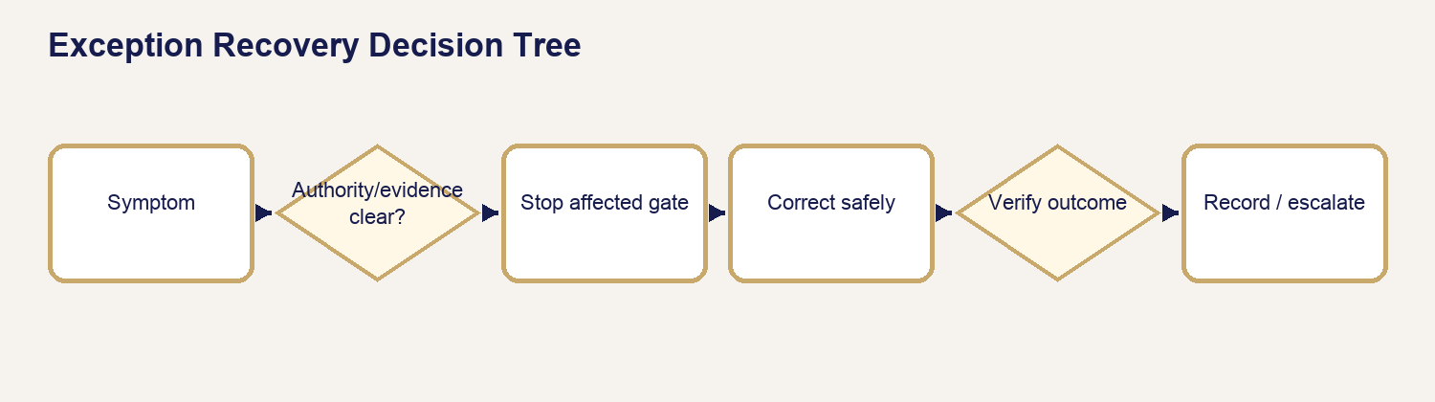
28 Exception Recovery

48.1 Required Recovery Pattern
Every exception record answers: SYMPTOM; WHAT TO CHECK; LIKELY CAUSE; WHAT TO DO; WHAT NOT TO DO; CUSTOMER COMMUNICATION; WHEN TO ESCALATE; WHAT GETS RECORDED. Begin from the exact request and authoritative evidence. Never manufacture a status, bypass a gate, duplicate a charge/send, or conceal an unresolved condition.
Symptom | What to check / likely cause | What to do | What not to do / escalation / record
Missing information | current request, participants, documents, instructions, prior asks | request the exact missing fact through the maintained path; hold the affected gate | do not guess; escalate conflicting authority; record item, request, recipient, delivery, resolution
Wrong or replacement document | request, classification, version, source, release state | quarantine wrong/superseded item, identify active version, repeat review | do not delete history or release an unreviewed replacement; record lineage and decision
Page-count mismatch | authoritative source, parser output, manual count, color/copies | reconcile with the source; use governed manual count when parser cannot establish authority | do not price/produce from an unexplained count; record count method and evidence
Quote conflict | current scope, version, approval, invoice, service facts | revise prospectively and obtain authorization | do not overwrite approval or invoice history; escalate unauthorized concessions
Payment/refund ambiguity | ledger, provider evidence, invoice, authorization, prior attempts | hold fulfillment/financial closure and route authorized review | do not retry blindly, promise settlement time, or mark processed early

48.2 Missing Information
Name the missing item, why it blocks advancement, who may supply it, and the safe next step. Recheck after receipt; a reply is not proof the blocker is resolved.

48.3 Wrong, Replacement, or Released Document
Keep source, internal, customer-visible, released, superseded, and replacement states distinct. If an incorrect file was released, stop further release, preserve audit evidence, identify recipients and scope, escalate privacy/security review, and use only approved correction communication.

48.4 Page Count
Compare the exact source file with authoritative page-count evidence. For parsing failure, password protection, unsupported format, mixed originals, or manual physical pages, record the governed fallback. Reconfirm after replacement.

48.5 Quote
Compare service, scope, rates, travel, pages/copies, timing, add-ons, approval, and invoice. Correct with a new version; do not retroactively rewrite the accepted quote.

48.6 Payment and Refund Ambiguity
Separate attempted, failed, pending, paid, partially paid, refund due, and refund processed. Provider evidence and the APS ledger must agree before customer-facing finality.

48.7 Appointment, No-Show, and Safety
Verify location, time/timezone, contact attempts, arrival/departure evidence, wait rule, access, and safety facts. Personal safety overrides schedule pressure. Record neutral facts and return instructions.

48.8 RON, Proof, KBA, and Identity
Do not coach KBA, store answers, create substitute identities, or describe a provider attempt as successful. Preserve the existing transaction where authorized, use provider-supported recovery, and route alternative service only after eligibility review.

48.9 ORS and PDF Parser
Treat ORS or parser output as an aid, not authority. If routing, mileage, file type, encryption, corruption, or page extraction prevents a dependable result, use the maintained manual path and document the basis.

48.10 Email and Delivery
Check recipient eligibility, address, template, rendered content, attachment/release authority, delivery result, and prior attempts. Never treat “send clicked” as delivery or resend blindly.

48.11 Loan Package, Scanback, and Return
Confirm active version, print count, completed signatures/initials/dates/certificates, scanback scope/QC, approval requirement, label/destination, drop-off, and tracking. Never return before required approval.

48.12 Cancellation, No-Sign, Partial, Resign, and Wait
Keep service outcome, operational cause, financial decision, communication, and any linked return visit separate. Policy suggestions do not authorize charges, waivers, or refunds.

48.13 Complaint, Chargeback, or Misconduct
Preserve records; use neutral language; restrict access; do not retaliate, diagnose, admit unsupported fault, alter history, or contact parties outside authority. Escalate promptly to the owner/authorized reviewer.

48.14 Admin Loading, Empty, and Error States
Loading means wait; empty means no matching visible records; error means retrieval failed. Recheck filters, organization, request, connectivity, and permissions. Do not act from stale or incomplete content.

Chapter 49 — Security & Privacy for Operators
Purpose: perform this workflow from verified APS and assignment evidence while preserving legal, notarial, financial, privacy, and ordering-party boundaries.
YOU WILL LEARN TO
- Review the authoritative assignment, act within role, stop at blockers, communicate accurately, and leave a complete audit trail.
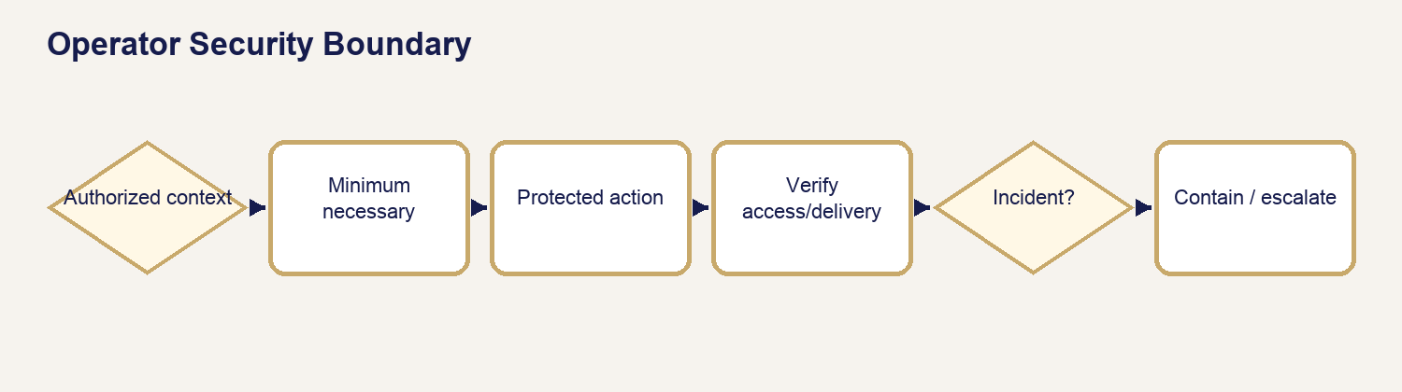
29 Security Boundary

49.1 Customer Privacy
Access only the minimum information needed for the assigned task. Verify recipient, request, purpose, channel, and release authority before viewing, downloading, discussing, or sending protected information.

49.2 Business Tenant Separation
Confirm the selected organization before every Business action. Membership in one organization never grants access to another; do not copy records between organizations to solve an access problem.

49.3 Document Security and Protected Links
Keep internal/source/unreleased files out of customer-visible storage and ordinary email. Use approved protected links, verify expiration/access behavior, and record release/delivery evidence.

49.4 Passwords and Recovery
Never ask for, learn, store, or set a customer password. Use the maintained recovery path and verified destination. Recovery does not bypass suspension, role, organization, or eligibility controls.

49.5 Payment Information
Use approved payment interfaces. Do not place full card/bank data in notes, messages, screenshots, or documents. Record provider-safe references and outcomes only.

49.6 IDs and KBA
Use identity evidence only for the authorized process. Do not retain unnecessary images/details, coach KBA, record answers, or copy identity data into general notes.

49.7 Internal Notes
Write factual, necessary, professional notes suitable for audit. Exclude speculation, diagnoses, unnecessary sensitive data, passwords, secrets, and customer-inappropriate internal shorthand.

49.8 Admin, Business, and Customer Access
Use your own authorized account, least privilege, and the correct portal/context. Never share sessions, impersonate a user, or use access from one role to satisfy another role’s task.

49.9 Downloads and Emailing Documents
Download only when required; protect the device and local file; remove temporary copies under policy. Email only an intentionally released eligible deliverable to an eligible recipient.

49.10 Personal Devices
Use approved, updated, locked devices and networks. Avoid shared/public devices and untrusted networks. Do not sync protected files into personal photo, cloud, messaging, or backup services.

49.11 Screenshots and Training Data
Use synthetic fixtures or complete redaction. Do not capture legitimate PII, IDs, documents, tokens, financial data, or private messages for training.

49.12 Secrets
Passwords, recovery links, API keys, tokens, signing secrets, and private configuration never belong in the handbook, screenshots, messages, tickets, or ordinary notes.

49.13 Incident Escalation
Stop the affected action, preserve evidence, limit further exposure, notify the authorized owner/security contact, and record factual scope and time. Do not independently investigate beyond authority or erase evidence.

Chapter 50 — Operational Assurance & Handbook Control
Purpose: perform this workflow from verified APS and assignment evidence while preserving legal, notarial, financial, privacy, and ordering-party boundaries.
YOU WILL LEARN TO
- Review the authoritative assignment, act within role, stop at blockers, communicate accurately, and leave a complete audit trail.
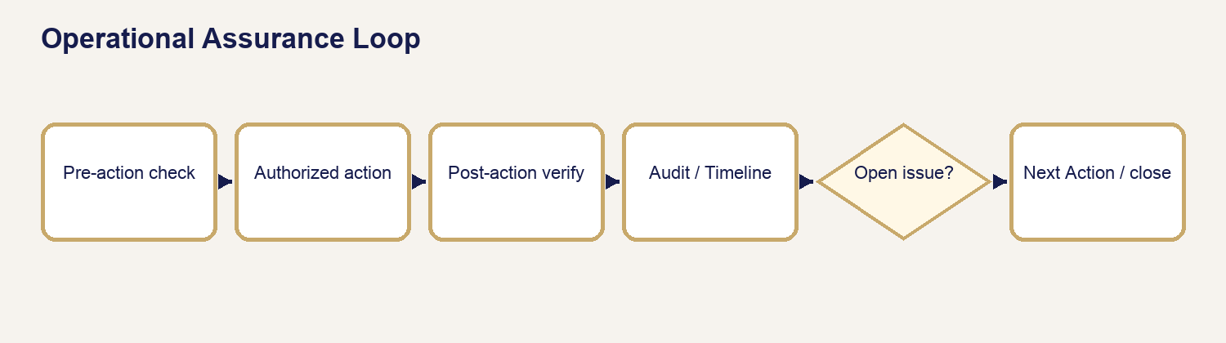
30 Assurance Loop

50.1 Pre-Action Checks
Verify identity/context, exact request, organization, current state, authority, source/version, recipient, variables, attachments, gate readiness, prior attempts, and expected audit result before consequential action.

50.2 Post-Action Verification
Confirm actual outcome rather than button click: persisted state, delivery/provider evidence, Timeline/Communication Log, document visibility, financial record, Next Action, and absence of duplicate/unintended effects.

50.3 Timeline and Audit Integrity
Preserve truthful sequence, actor, source, time, decision, delivery result, and exception. Never rewrite history to make an outcome appear cleaner.

50.4 Duplicate Prevention
Search for prior request, message, invoice, payment attempt, refund, provider transaction, upload, or assignment. When uncertainty remains, stop and reconcile before creating another.

50.5 End-of-Day Review
Review open holds, failed deliveries, pending payments/refunds, unreleased documents, upcoming appointments, scanback/return obligations, Business credit issues, and exceptions. Assign a truthful Next Action and owner.

50.6 Source Drift
If APS behavior, labels, templates, scripts, provider rules, law, or maintained policy differ from this handbook, stop relying on the affected instruction, mark the discrepancy, and escalate source verification.

50.7 Handbook Maintenance
Change controlled source, not compiled artifacts alone. Preserve chapter, figure, screenshot, photograph, template/script inventory, source-register, build, QA, and revision-history materials.

50.8 Legal and Provider Source Revalidation
Revalidate time-sensitive legal/notarial, lender/title, payment, identity, and provider facts against authoritative current sources before controlled revision. Do not fill gaps with general knowledge.

50.9 Controlled Revision and Owner Approval
Record proposed change, authority, affected sections/assets, reviewer, tests, date, edition, and owner decision. Publish only approved, reproducible artifacts; preserve superseded history.

PART XIII — QUICK REFERENCES & APPENDICES

Chapter 51 — Admin, State, People, Documents & Money Quick References
Purpose: perform this workflow from verified APS and assignment evidence while preserving legal, notarial, financial, privacy, and ordering-party boundaries.
YOU WILL LEARN TO
- Review the authoritative assignment, act within role, stop at blockers, communicate accurately, and leave a complete audit trail.

51.1 APS System Map
Public site → request/intake → Admin review/workspace → Customer or Business Portal visibility → provider/payment channels where authorized → Timeline/audit. Confirm system, actor, organization, request, and permitted action before work.

51.2 Universal Request Lifecycle
Received → review → information/quote → approval/payment → appointment/production → fulfillment/QC → eligible release/delivery → completion. STOP at the first unmet gate.

51.3 Where Do I Go in Admin?
Review Queue for new/blocked review; request workspace for service work; Customers/Participants for identity/roles; Documents for classification/release; Communications for delivery truth; financial views for quote/invoice/payment/refund; Business areas for organization/member/billing controls.

51.4 Request Workspace Tabs
Overview: scope/state/Next Action. Participants: roles and contact eligibility. Documents: source/classification/review/release. Communications: rendered message/delivery. Timeline: audit sequence. Service/financial areas: only when the request and role authorize them.

51.5 Review Queue Decision Guide
Correct request and service? Required facts present? Participants/roles clear? Documents safe and classified? Quote/payment/appointment gates known? If NO, request/record the exact blocker. If YES, assign the truthful Next Action.

51.6 State Mental Map
Keep request status, Next Action, document state, communication delivery, financial state, appointment/fulfillment state, and provider state separate. One does not silently prove another.

51.7 Loading vs Empty vs Error
Loading: wait. Empty: verify filters/context. Error: do not infer; retry safely and escalate persistent failure. Never act from partial/stale data.

51.8 Customer vs Signer vs Ordering Party
Customer requests/pays or owns the relationship; signer/participant performs an act; ordering party controls an assignment. Verify who may receive which information and who may authorize change.

51.9 Document Classification
Identify request → source/creator → purpose → class → review state → release eligibility → recipient/scope. Five questions: what is it, whose is it, why retained, may customer see it, what proves release?

51.10 Document Release Checklist
Correct request and recipient; intended final file; classification permits release; review complete; no sensitive/internal/superseded content; exact filename; authorized release action; portal/email visibility checked; Timeline/delivery evidence recorded.

51.11 Document Mistake Recovery
Stop release → preserve evidence → identify file/request/recipients/scope → restrict further access where authorized → notify owner/security → prepare verified correction → record recovery. Never delete history or conceal exposure.

51.12 Quote vs Invoice vs Payment vs Receipt
Quote proposes scope/price. Invoice states amount due. Payment is provider/ledger outcome. Receipt confirms an actual payment. Never use one as proof of another.

51.13 Send vs Send & Update Status
Send records communication only. Send & Update Status is used only for a maintained authorized transition after successful delivery. Verify rendered message, recipient, attachments, delivery, transition, and audit result.

Chapter 52 — Service Quick References
Purpose: perform this workflow from verified APS and assignment evidence while preserving legal, notarial, financial, privacy, and ordering-party boundaries.
YOU WILL LEARN TO
- Review the authoritative assignment, act within role, stop at blockers, communicate accurately, and leave a complete audit trail.

52.1 Remote Online Notarization Quick References
Quote readiness: service/document/jurisdiction, signers, timing, platform, copies, price/payment. Appointment: signer/contact, technology, ID/readiness, document, Proof path. Session: identity/willingness/awareness, act/certificate, recording/provider controls. Closeout: completed Proof/notarized asset reviewed, correct request/classification, intentionally released, delivery verified. Failure: preserve transaction, no KBA coaching, retry only supported path, assess lawful alternative.

52.2 Mobile Notary Quick References
Quote readiness: acts/signers/documents, location, round-trip mileage/tier, timing/after-hours, witnesses, scan/delivery. Before leaving: payment/appointment, route/safety, supplies, journal, instructions. At table: identity/willingness/awareness, act/certificate, signatures, journal, counts. Before driving away: every certificate/document/accounting item checked. Optional scan: authority, completeness, legibility, naming, upload/release. Closeout: delivery, final charges, Timeline. Stop for safety, identity, coercion, incomplete documents, or unsupported act.

52.3 Print & Scan Quick References
Quote readiness: authoritative page count, B&W/color, copies, paper, sidedness, finishing, scan/PDF support, timing/delivery. Production: active source/version and payment gate. First-copy QC: count/order/orientation/color/legibility/crop/scale. Scan QC: every page, order, orientation, readability, completeness. Naming/integrity: request-safe name, final format, open/check file. Delivery: exact eligible output and recipient. Closeout: production/delivery evidence and completion gates.

52.4 Loan Signing Quick References
Mental map: assignment/orderer/signer/package/version/appointment/scanback/approval/return/financial closeout. Packages: Buyer, Seller, Refinance, HELOC, Modification, Reverse Mortgage, Commercial/Custom. COMMONLY NOTARIZED DOES NOT MEAN ALWAYS NOTARIZE; actual document, certificate, law, and authorized instructions control. Ten gates: Assignment Review; Pricing/Financial; Package; Print/QC; Appointment; Signing; Scanback/Approval; Return; Exception/Financial; Final Completion. Print/prep and before leaving: active version, sets/copies, page count, instructions, signers, route, label. Table: neutral presentation, signatures/initials/dates, certificates, referral boundaries. Post-table/scanback: complete count/QC. Return only after required approval with label/destination/tracking. Preserve package and escalate exceptions; close only when all gates agree.

52.5 Business Account Quick References
Lifecycle: application → review → approval → organization → invitation/activation → authenticated role → eligible requests/billing → hold/suspension/closure with history preserved. Verify organization switch before every action. Roles never transfer across tenants. Billing: prepaid or authorized Due on Receipt/Net 15/Net 30. Credit hold blocks credit-dependent work; it does not erase records or silently cancel work. Closure requires open operational/financial matters resolved and history preserved.

Chapter 53 — Communication, Safety & Reference Indexes
Purpose: perform this workflow from verified APS and assignment evidence while preserving legal, notarial, financial, privacy, and ordering-party boundaries.
YOU WILL LEARN TO
- Review the authoritative assignment, act within role, stop at blockers, communicate accurately, and leave a complete audit trail.

53.1 Which Message Do I Send Now?
Service/stage | Condition | Maintained message family | Classification | Do not send if
Any / intake-review | received or exact information missing | Request Received / information-needed template | IF NEEDED | wrong recipient, stale request, missing variables
Any / quote-payment | quote ready, invoice, payment outcome | Quote Ready / Invoice / Payment template | IF NEEDED or verified event | scope/version/payment evidence conflicts
RON/Mobile/Print | readiness, appointment, delivery, completion | service-specific maintained template | IF NEEDED | gate not satisfied or file unreleased
Loan Signing | assignment, package, signer, scanback, return, exception | `lsa_` maintained family | IF NEEDED | orderer/signer audience or authoritative stage unclear
Business | billing, password recovery, credit hold | `business_` maintained family | IF NEEDED or source-noted event | organization/recipient/terms not verified
Any / reminder-review | maintained timed event | reminder/review family | SOURCE-NOTED | current automation/event timing not verified

53.2 Template Quick Index
Use Chapter 46’s 54-key directory by service, category, stage/trigger, audience, and alphabet. Template existence is not proof of automation. Verify actual condition, recipient, variables, attachment/release, channel, prior attempts, delivery evidence, and status effect.

53.3 Script and Card Quick Index
Use Chapter 47’s 48-entry catalog by service, category, stage, and classification. Scripts guide the operator; they do not change the request, send communication, move money, release documents, or create provider activity.

53.4 Security Checklist
Correct account/portal/organization/request; least access; protected device/network; recipient and release authority; no secrets/passwords/KBA answers; approved channel; minimum necessary data; safe local handling; post-action access/delivery verified; incident escalated.

53.5 Stop, Hold, and Escalate Guide
STOP the action for identity, willingness, awareness, safety, suspected fraud/coercion, unlawful/unsupported act, wrong recipient/request, unreleased document, uncertain money movement, duplicate risk, or missing authority. HOLD the affected gate while facts can be resolved. ESCALATE persistent conflict, exposure, misconduct, provider/legal uncertainty, or any action beyond role.

53.6 Daily Opening and End-of-Day
Opening: secure session/device; correct date/time; review appointments, queues, holds, failed deliveries, provider/financial exceptions; confirm supplies and assigned priorities. End-of-day: reconcile open requests, documents, messages, payments/refunds, appointments, scanbacks/returns, Business holds, exceptions, Timeline, Next Action, and responsible owner; secure materials and sign out.

53.7 Independent Print and Lamination Controls
Every Quick Reference carries its title, governing chapter, edition/baseline, scope, stop rule, and reminder that the detailed chapter controls. Reprint after controlled revision; remove superseded copies.

APPENDICES

Appendix A — Glossary and Acronyms
APS: Aligned Print & Scan. Gate: required conditions before advancement. Next Action: truthful controlled work item. Ordering party: assignment authority distinct from signer. Released deliverable: customer-eligible file intentionally authorized for visibility. RON: Remote Online Notarization. KBA: knowledge-based authentication controlled by the provider. Scanback: governed electronic copy submitted for review. SOURCE VERIFICATION REQUIRED: material statement withheld from authority until verified.

Appendix B — Status and State Catalog
Request, Next Action, document, communication, financial, appointment, fulfillment, Business organization/member, and provider states are independent controlled dimensions. Use the current APS label and governing chapter; never infer one state from another.

Appendix C — Template Index and Production Reconciliation
Authoritative inventory: 54 unique maintained production keys documented in Chapter 46. Three preview aliases are reconciled and not double-counted. Timing-sensitive automation claims remain source-noted until current implementation proves the event.

Appendix D — Script and Card Index
Authoritative inventory: 48 maintained entries across eight categories documented in Chapter 47. Each is reference-only and classified as Full Script, Quick-Flip/Quick Reference, Checklist, or Decision/Stop Card.

Appendix E — Package Comparison
Buyer/Purchase, Seller, Refinance, HELOC, Loan Modification, Reverse Mortgage, and Commercial/Custom are compared in Chapter 30. Actual package and instructions control; package label never substitutes for document/version review.

Appendix F — Loan Document Source Register
Chapter 31 and `batch-3/LOAN_DOCUMENT_SOURCE_REGISTER.md` govern the common-document entries and unresolved source notes. Commonly notarized never means always notarize.

Appendix G — Figure, Table, Procedure, Checklist, and Decision Tree Index
The final assembly generates controlled lists from captions and headings. Batch figures retain stable numbers and descriptive captions; procedures, checklists, and decision trees link to their governing chapters.

Appendix H — Source Authority and Traceability
Authority order: certified Release 10 behavior; current repository source/configuration/schema; Release 10 certification; maintained APS documentation/training; authoritative Texas sources; legally available maintained signing-agent training; authoritative provider and lender/title/agency material. A lower source never silently overrides a higher current authority.

Appendix I — Revision History and Owner Approval
Specification: OWNER APPROVED — LOCKED, PR #107. Batch 1: PRs #108–109. Batches 2–5 and final assembly retain branch, commit, PR, merge, QA, source notes, and owner-authorized publication evidence. Release 11 is outside this edition.

List of Figures
- Figure 01 — 01 Aps System Map
- Figure 02 — 02 Universal Request Lifecycle
- Figure 03 — 03 Portal System Relationship
- Figure 04 — 04 State Mental Map
- Figure 05 — 05 Customer Signer Orderer
- Figure 06 — 06 Participant Role Relationship
- Figure 07 — 07 Document Lifecycle
- Figure 08 — 08 Document Security Boundary
- Figure 09 — 09 Document Release Decision
- Figure 10 — 10 Ron Proof Document
- Figure 11 — 11 Mobile Original Scan
- Figure 12 — 12 Print Source Output
- Figure 13 — 13 Loan Package Return
- Figure 14 — 14 Service Document Comparison
- Figure 15 — 15 Ron Workflow
- Figure 16 — 16 Ron Failure Decision
- Figure 17 — 17 Mobile Workflow
- Figure 18 — 18 Print Scan Workflow
- Figure 19 — 19 Loan Signing Workflow
- Figure 20 — 20 Loan Signing Ten Gates
- Figure 21 — 21 Package Version Decision
- Figure 22 — 22 Signer Question Guide
- Figure 23 — 23 Scanback Approval Return
- Figure 24 — 24 Loan Signing Exception
- Figure 25 — 25 Business Lifecycle
- Figure 26 — 26 Business Decision
- Figure 27 — 27 Communication Decision
- Figure 28 — 28 Exception Recovery
- Figure 29 — 29 Security Boundary
- Figure 30 — 30 Assurance Loop

List of Tables
Controlled entries are indexed through the numbered chapter/subsection headings and captions in this edition. Use the expanded Contents and PDF bookmark tree for direct navigation.

List of Procedures
Controlled entries are indexed through the numbered chapter/subsection headings and captions in this edition. Use the expanded Contents and PDF bookmark tree for direct navigation.

List of Checklists
Controlled entries are indexed through the numbered chapter/subsection headings and captions in this edition. Use the expanded Contents and PDF bookmark tree for direct navigation.

List of Decision Trees
Controlled entries are indexed through the numbered chapter/subsection headings and captions in this edition. Use the expanded Contents and PDF bookmark tree for direct navigation.

Source Authority and Traceability
Certified Release 10 behavior and current maintained repository authority control. Batch source registers preserve Texas notary, provider, lender/title/agency, template, script, financial, and loan-document qualification. SOURCE VERIFICATION REQUIRED items are never promoted to established facts.

Revision History and Owner Approval Record
Specification PR #107; Batch 1 PRs #108–109; Batch 2 PR #114; Batch 3 PR #115; Batch 4 PR #116; Batch 5 PR #117. Final assembly is published only after structural, accessibility, visual, navigation, inventory, source, and safety certification.

