**Data Trees**

*See the lesson notes at*: [dmaccarthy.github.io/sci/#cs_new/web1/tree](https://dmaccarthy.github.io/sci/#cs_new/web1/tree).

*You may need to use a search engine for some of these questions.*

1. Briefly explain what we mean by “hierarchical data”.

Answer

2. Define each of these terms as they relate to data trees: (a) node, (b) parent, (c) child, (d) sibling, (e) root.

Answer

3. Here is a portion of a data tree representing the organization of the National Hockey League.

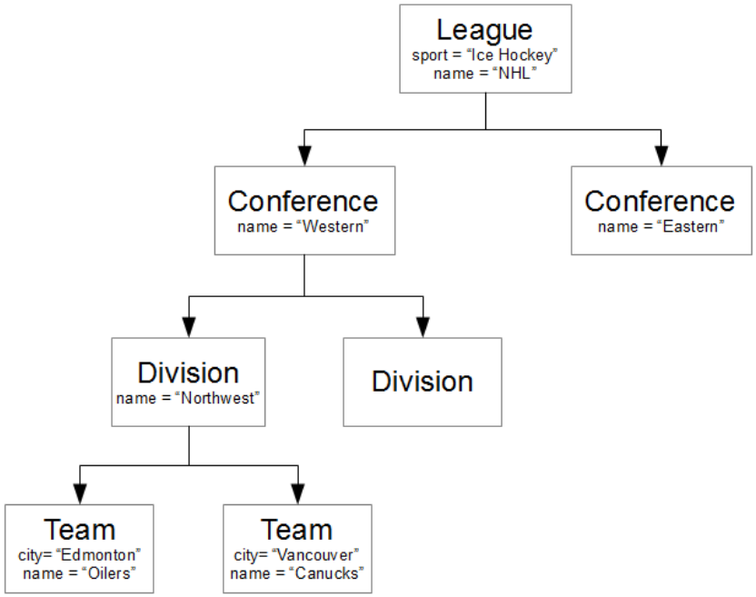

a) Which node is the parent of the node that represents the Edmonton Oilers?

Answer

b) Which node is the sibling of the node that represents the Edmonton Oilers?

Answer

c) Which node is the root node of the data tree?

Answer

d) Which nodes are the child nodes of the node representing the Western Conference?

Answer

4. Below is a student’s school schedule. Draw a data tree to represent all the information contained in the schedule. You can do this using a chart tool in your word processing program or using a paint program; or you can do the drawing on paper and insert a photo of your work.

**Student**: Chris Jones

**Student ID**: 999999999

**School**: Salisbury Composite High School

**School Year**: 2024-2025

**Semester 1**

|  |  |  |
| --- | --- | --- |
| **Period** | **Course** | **Room** |
| 1 | Science 10 | 188 |
| 2 | Physical Education 10 | Small Gym |
| 3 | English 10-1 | 268 |
| 4 | Drama 10 | Theatre |

**Semester 2**

|  |  |  |
| --- | --- | --- |
| **Period** | **Course** | **Room** |
| 1 | Computing Science 10 | 140 |
| 2 | Math 10C | 146 |
| 3 | Social Studies 10-1 | 222 |
| 4 | French 10 | 201 |

Answer

5. [Mary Had a Little Lamb](https://www.poetryfoundation.org/poems/46954/mary-had-a-little-lamb) is a well-known nursery rhyme. Devise a tree that represents the structure of the rhyme.

Answer