JiT Summary

The following chunk of code reads in and merges the sheets from the workbook, then removes rows where the “Date Coded” field was left blank:

library(readxl)

## Warning: package 'readxl' was built under R version 3.6.3

library(dplyr)

## Warning: package 'dplyr' was built under R version 3.6.3

##   
## Attaching package: 'dplyr'

## The following objects are masked from 'package:stats':  
##   
## filter, lag

## The following objects are masked from 'package:base':  
##   
## intersect, setdiff, setequal, union

library(ggplot2)

## Warning: package 'ggplot2' was built under R version 3.6.3

library(tidyr)

## Warning: package 'tidyr' was built under R version 3.6.3

state <- c("Kansas","Nebraska","Wyoming ", "North Dakota")  
  
df <- data.frame()  
  
for (states in state){  
   
 df <- rbind(df,read_excel("C:/Users/DavidMcCullough/Marzano Research/MZR - Share/10_REL/Task 6-Research/CE6.6_JiT/Data Entry/CE6.6.1 Data Entry_FINAL.xlsx",   
 sheet = states)[,1:26])  
}

## New names:  
## * `` -> ...31  
## * `` -> ...32  
## * `` -> ...33

df_coded <- df[!is.na(df$`Date Coded`),]  
  
vars <- names(df)

The following code chunk generates barplots for each of the TBD variables in the datasets.

ggplot(data = temp, aes(x=factor(get(vars[variable])),y=percent,fill=factor(get(vars[variable])))) +   
 geom_bar(stat = "identity", position = position_dodge2(preserve = "single")) +   
 facet_grid(cols = vars(State)) +   
 theme(axis.text.x = element_blank(),axis.title = element_blank(),plot.title = element_text(hjust = 0.5)) +  
 labs(fill="Response") +   
 ggtitle(tools::toTitleCase(vars[variable]))

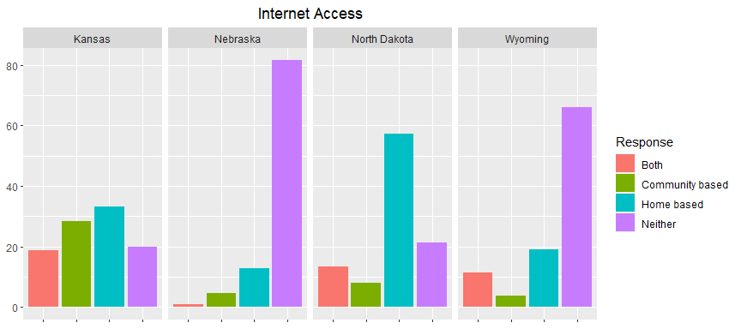

knitr::kable(spread(data = temp[,-4],key = get(vars[variable]),value = n))

|  |  |  |  |  |
| --- | --- | --- | --- | --- |
| State | Both | Community based | Home based | Neither |
| Kansas | 64 | 97 | 114 | 68 |
| Nebraska | 2 | 9 | 25 | 160 |
| North Dakota | 12 | 7 | 51 | 19 |
| Wyoming | 6 | 2 | 10 | 35 |

knitr::kable(spread(data = temp[,-3],key = get(vars[variable]),value = percent))

|  |  |  |  |  |
| --- | --- | --- | --- | --- |
| State | Both | Community based | Home based | Neither |
| Kansas | 18.7 | 28.3 | 33.2 | 19.8 |
| Nebraska | 1.0 | 4.6 | 12.8 | 81.6 |
| North Dakota | 13.5 | 7.9 | 57.3 | 21.3 |
| Wyoming | 11.3 | 3.8 | 18.9 | 66.0 |