Requirements

In order to avoid incorrect integration with MS SSMS, the working environment must meet the following conditions:

* The data source must be a configured system DSN. Refer to the [Driver Configuration](https://www.devart.com/odbc/sqlite/docs/driver_configuration_and_conne.htm) article to learn how to configure a System DSN
* The driver, studio, and SQL Server must be of the same bitness. For example, if you are using 64-bit SQL Server Management Studio on 64-bit Windows platform, then configure the 64-bit version of the driver using ODBC Administrator launched from %windir%\system32\odbcad32.exe. Otherwise, configure the driver using the 32-bit version of ODBC Administrator - launch it from %windir%\SysWOW64\odbcad32.exe.
* ODBC Driver for SQLite and SQL Server must be installed on the same computer.
* .NET Framework 4.5 must be installed on the computer.

Connecting to SQLite from SQL Server Management Studio using ODBC Driver for SQLite

You can use the Microsoft SQL Server Management Studio to connect your SQLite data to an SQL Server instance. Linked Server is a tool of MS SQL Server that allows to execute distributed queries to refer tables stored on non-SQL Server datbase in a single query. With linked servers, you can execute commands against different data sources such as SQLite and merge them with your SQL Server database. You can create a linked server with one of these methods: by using the options in the Object Explorer or by executing stored procedures.

Below are major advantages of using SQL Server Linked Servers to connect to SQLite:

1. The ability to connect other database instances on the same or remote server.
2. The ability to run distributed queries on heterogeneous data sources across the organization.
3. The ability to work with diverse data sources in the same way.

How to configure a SQL Server Linked Server to connect to SQLite

You can follow the steps to create a linked server for SQLite in SQL Server Management Studio by using Object Explorer:

1. Start your Management Studio and choose your SQL Server instance.
2. In the **Object Explorer pane**, expand the **Server Objects**, right-click on **Linked Servers** and then click on **New Linked Server**.
3. Configure your linked server in the dialog box:
   * Give a name for your server in the **Linked server** field.
   * Under **Server type**, select **Other data source** .
   * Choose **Microsoft OLE DB Provider for ODBC Drivers** in the **Provider** drop-down list.
   * In the **Data source** field, enter the name of your DSN, e.g. Devart ODBC Driver for SQLite . Alternatively, you can input the ODBC Driver connection string in the **Provider** field.

The linked server will appear under the Linked Servers in the Object Explorer Pane. You can now issue distributed queries and access SQLite databases through SQL Server.

Retrieving Data From SQLite

Disable the **Allow inprocess option** of MSDASQL OLE DB Provider for ODBC Drivers. For this, find the **MSDASQL** provider in the list of Linked Servers and double-click on it

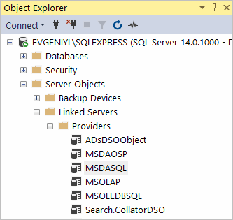

In the appeared **Provider Options** window, clear the **Allow inprocess** checkbox:

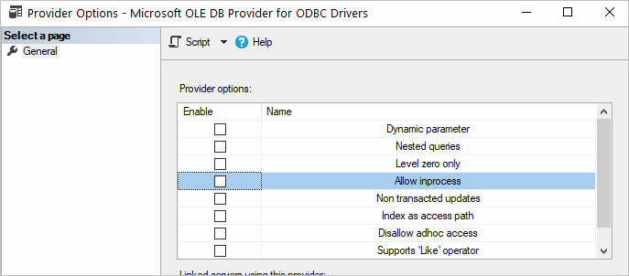

Create a new **Linked Server**

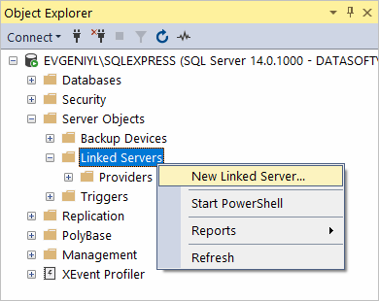

Make sure to select **Microsoft OLE DB Provider for ODBC Drivers** and specify the following parameters:

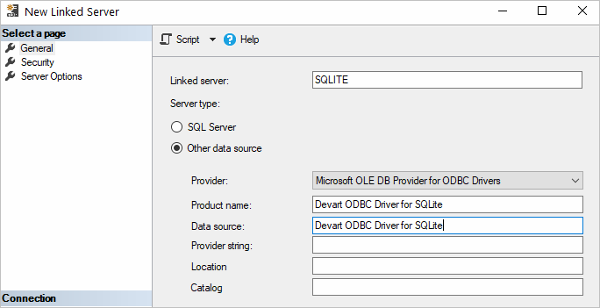

The SQLite tables are already available to be fetched. To query the linked server, click **New Query** in the toolbar:

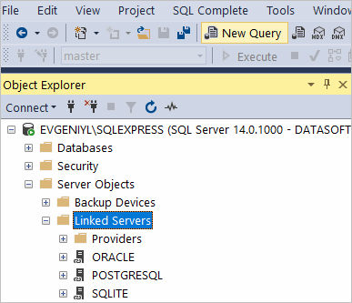

Enter your SQL query in the editor window and click **Execute** to run the query:

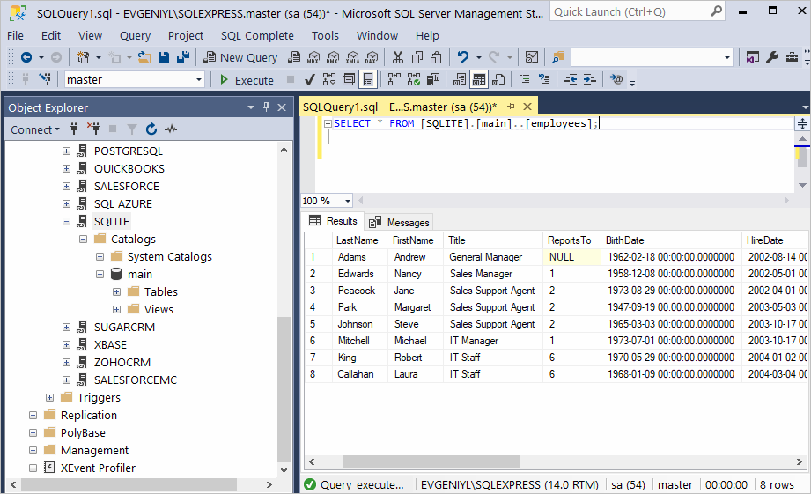

As a result, you can see the contents of the selected table retrieved directly from the SQLite account you are connected to.

Attention

If the Linked Server was created with the Allow inprocess option enabled, then you should delete this Linked Server and create it again with the Allow inprocess option disabled.