# Introduction:

Similar to web searches, ECM Library can be used for the simplest of searches like “ECM Library Chicago”, but when it’s critical to find that one document, users can use ECM library to do ***much*** more. Learning to use various types of search queries will lead to more specific and exact results. Most of the search query options are available through ECM Library menu checkboxes. In addition, there is a search language, or “query syntax”, that gives you quick search access by directly entering in keywords. This document introduces some of the more common and useful tips to use in ECM Library. Many of these search syntaxes are modeled after Google’s search language, so those who are familiar with Google’s search will quickly learn ECM Library.

You can search on the full text of 65 identified file types immediately after the set-up of ECM Library, giving you the confidence that if it’s in your database, you can find it!

Contents

Introduction: 1

ECM Library Text Search Syntax Quick Tips 1

Search Option Details 2

Spelling 2

How to Use “Show Weights” 3

How Weights are Assigned 3

Text Searches Are Not Case Sensitive 4

Exact Search Match 4

Inflection Search 4

Thesaurus Search 5

Searching on Financials or Numbers: 7

When to use Business Meaning 7

When Your Company is using Microsoft Thesaurus 8

|  |  |
| --- | --- |
| ECM Library Text Search Syntax Quick Tips for main text search query command line  ***For further help, in the search command line click F10 Function or right-click on your mouse***  ***to see the Search Assistant screen.*** | |
| **Exact Word or Phrase**  “Maggie Smith”  Maggie  Searches are case insensitive | **Results**  Maggie smith, maggie smith, MAGGIE SMITH,  maggie, Maggie, MAGGIE |
| **Inflectional searches**  ^Run  Searches on one word and not a phrase | **Results**  run, runs, running and ran  See search assistant to view list of inflections for a word |
| **OR**  peace OR treaty  peace treaty | **Results**  Peace, treaty, Peace (and) treaty, Peace (and) TREATY etc  Search results will bring back any combination of any search keywords. |
| **Wildcards**  tree*  *tree  “John Sch*” | **Results**  treed, treen, treetop, trees  no results – wildcard works for the end of words only  John Schmidt, John Schulz, John Schultz |
| **AND**  Bill AND Dave  bill +Dave  Bill + Dave | **Results**  Bill (with) Dave  Bill (*with*) dave  BILL (with) DAVE etc. |
| **AND NOT - Exclude Operator**  Bill AND NOT Dave  Bill AND NOT Dave  Bill –dave  AND NOT statement must follow another keyword statement in the query | Results bill (but never one mention of) dave  BILL *(but never one mention of)* Dave etc |
| **Near or Proximity Search**  “Dave Smith” NEAR “Thomas Bartlett” | **Results**  “Dave Smith” ‘s name will be in the same document as “Thomas Bartlett”  Weightings must be turned on to identify how near and how often these two words appear. |
| **Microsoft Thesaurus**  ~claim  ~competitivesearch | **Example customized results**  Customer Record 565A, Company XYZ Standard Claims Form  Transact Data Corp, Maztra Development Inc., Seabuild Corp.  Contact your administrator for details. Your company needs to populate the Microsoft Thesaurus in order for this function to bring back something other than an exact match. |
| **ECM Library Thesauri**  record  Must be placed in the “Thesaurus command line”, which can be found on any search screen. | **Results**  Record, conduct, evidence, indication, security, superiority |

# Search Option Details

## Spelling

Search words need to be spelled correctly. By clicking on the right mouse, a menu will come up giving you an option to spell check your search. This will automatically open up Word spelling and will automatically close that Word window when you are completed.

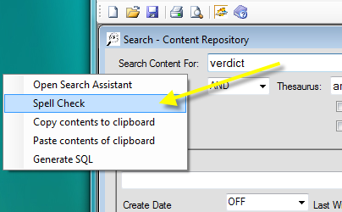

## 

## How to Use “Show Weights”

Every search can have weighting turned on or turned off. User weighting with caution: a weighted search takes longer than a non-weighted serach. But identifying your search results with weights can help to searches more quickly identify the documents that have a better probability in meeting your search criteria. “Show Weights” are available all on search screens.

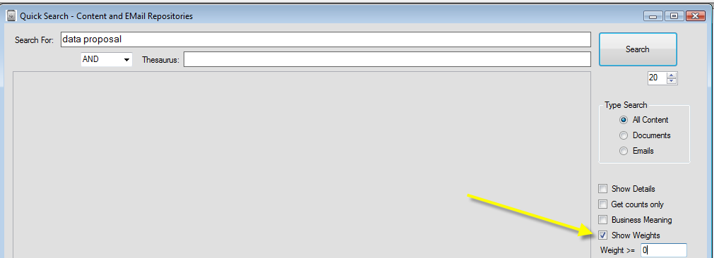

ECM Library’s default weight number is 0. If there are no weight numbers entered, you will receive back all content that has a weighting greater than 0. Suggestion: start with a weighting of 100 or more if you expect high number of search results.

## How Weights are Assigned

Weights allow you to have a better indication of which documents may match your criteria.  For example, a document with a weighting of 500 has a high likelihood of having multiple matches for more than one keyword in your search.  A weighting of 5 may have just a single use of one word in your search.    The search engine assigns its own “guess” value, so be aware that weighted searches will leave out documents that are assigned a “negligible weighting”.  In other words, if you really need to find every document that contains every use of a specific word, we recommend you search without weights.  If you are trying to find a concentration of concepts, words or phrases, then weighting will be very helpful.

The search engine will assign a weighted number or value for every matched document.  The assigned value is produced by combining the number of occurrences on words (or phrases), the nearness of words, and by comparing word matches to the relative size of a document.    When you combine multiple search ideas together, the search engine cannot “guess” what emphasis you personally want to place on certain keywords or search operators.    So if you need to put emphasis on a critical word, use only that word in your search and take the highest weighted search matches for that word or phrase.

You can limit your search results by selecting a minimum threshold weight number.  But use threshold numbers with caution.  Although the same consistent methods are deployed by ECM Library for every weighted search, weighting numbers can appear arbitrary.  One time you may find that all you need are the search results with a weighting over “100”,  but another time it’s helpful to use a weighting of “20”.   Experience in using the search capabilities will allow you to best learn when to assign what threshold number, or when to let everything come back with no weight threshold by just assigning a “0”.

When you select emails as part of your search**, all emails with attachments will come back regardless of any minimum threshold weight assigned.**  This is because the weighting assignment given to documents when compared to the weighting assignment give to emails ***with*** attachments is mathematically like comparing “apples to oranges”.     Such numbers would be inconsistent and therefore are not valid for comparative weightings.  The ECM Library architecture therefore is designed to bring back all emails with attachments regardless of its weight.    This ensures that you will see and bring back everything that may be relevant to your search.

## Text Searches Are Not Case Sensitive

ECM Library search queries are not case sensitive. However, when you find a document you want to review, and you open that document, that software application (e.g. Adobe Reader) may have a search engine that is case sensitive for viewing that document.

## Exact Search Match

For an exact word search just enter in a word or words without quotations. For example:

Maggie

Will bring back all documents that contain maggie, Maggie, MAGGIE, but no other words. Adding another word right after Maggie will default to an OR statement. For example:

Maggie Smith

Will look for documents with Maggie in a document, or Smith in a document, or Maggie and Smith somewhere within a document.

Phrases should be enclosed in double quotation marks (""). For example:

**

In this search, ECM Library will look for files/documents that contain specifically Maggie Smith as an exact phrase. All searches are case insensitive, which means it doesn’t matter how you capitalize the letters – or not. For example, typing "*maggie smith”* will return all content containing the words like "Maggie Smith, maggie smith," or "MAGGIE SMITH" or “meggie smith”

## Inflection Search

Inflectional searches handle grammatical relations to a word such as tense, number, gender etc. More specifically, the plural and singular, as well as the gender and neutral forms of nouns, verbs, and adjectives will be matched.

If a word is searched with *^Run :*

**

The search query is asking “find any words that are similar to *run* in one document”. The search engine will look for inflectional use of the word *run*, such *as run, runs, runnin*g and *ran*. Without a weighted search on, all documents will be presented in order of what is retrieved by the search engine, and not in order of best search matches. Using a weighted search with inflectional use is often the best combination.

If Business Meaning is checked the searches automatically include all the inflections of a word as well as near proximity of words. The search with Free Text use alone can broaden the search significantly. Therefore, Free Text searches are often combined with other uses of a search, such as AND or NOT. It’s also a good idea with an inflectional search to limit your search parameters with AND or NOT.

If you want to see what words were “run” under the inflection search, then go into the Search Assistant (via right mouse click or by F10 key), click EXP (for expand) and you will see the words generated.

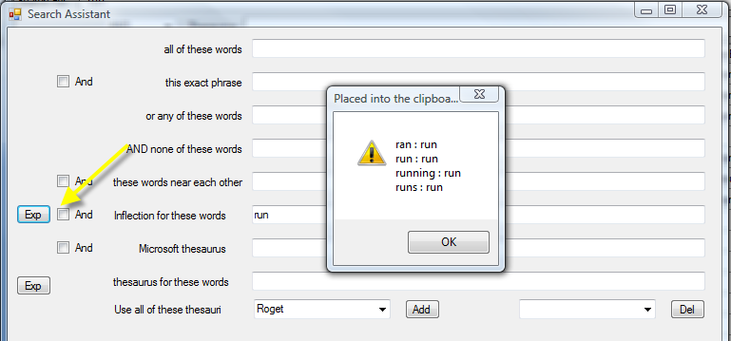

## 

## Thesaurus Search

The thesaurus is made up of mostly words, but has some phrases in it. For two words try a search like:

**

This search query means “find any of these words or words that are exactly court and like claims. Because of the AND statement the search will come back with documents that just find something that are like *court* with variations on claims*.*

Note that a thesaurus search must be preceded by another word entry. If by chance you only want to do a thesaurus search, enter in the exact word in the first line followed by the second line:

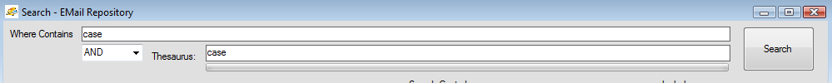

In the main search screens, the search will select the default thesaurus set up by your administrator. If you wish to use another thesaurus or multiple thesauri, that thesaurus search needs to be done in search assistant.

If you want to know what thesaurus words are being used in a particular thesaurus, first select the thesaurus from the drop down list in the Search Assistant. Next click on EXP (for expansion). You will see the words that are being used to search. Here below in the second screenshot, the list is long. Number of expanded words is all based on the word you select. Common words will tend to have more expansions than exacting/descriptive-type words. If you don’t want to use all the words, copy the expansion into your search line and delete the non-relevant words to limit your search! Notice how the expansion words from the Search Assistant (second screenshot below) have been pasted (by a right mouse) into the search line (below), and certain words have been taken out. This search line now says “Search on case or business or information or lawsuit or reasoning”.



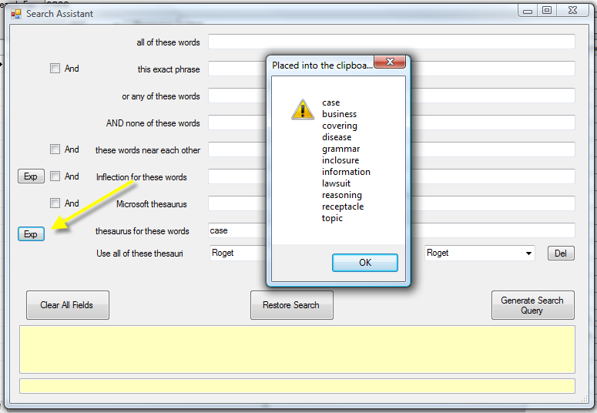

## Searching on Financials or Numbers:

If you are searching on financials or numbers you need to have it written out exactly for the search to come back.

The $ sign needs to be placed inside double quotations.

You do not need to have use commas as the search treats commas as “noise” lettering and disregards them. It will search for numbers with and without the comma. However, once you open up a document or file, that document type may be search sensitive to commas so exactness may be needed within any particular document.

If you are not sure if the number has a comma or not, or if it has a $ or not you could write out your query as:

“$40000” “40000”

A wildcard can work at the end of a number but not at the beginning of a number. A wildcard will need double quotations around it: “400*” will bring back 400, 4000, 40000, 4,000, 40,000 etc. It will not bring back anything with a dollar sign infront of it.

## When to use Business Meaning

Business meaning is also called FREETEXT in SQL Search queries. It is very powerful to use when you have a “concept” of what you are looking for, but not sure of specific words or catch phrases. Business meaning includes:

1. inflectional searches on all words you enter.
2. It will look for density or proximity of terms in each document based on the list that is generated in your search.
3. If your business has populated the Microsoft Thesaurus, those expansion or substitution words will be automatically used in Business Meaning. See your administrator for details.

Checking business for a phrase means “ take my set of keywords and match up meanings of these keywords. Then search everywhere for concepts that are around these terms.” Clicking on business meaning will be far less precise than a non-business meaning search, but it is verypowerful because it looks for concepts around keywords. For example, “business proposal customer” will look for these words and any similar like words that are grouped close together.

With a Business Meaning search, the AND search operator will be disregarded and the NEAR search operator will be disregarded. . It just looks for the “listing” of words that you have entered.

With business meaning, you are creating a list of phrases (with double quotations) or words that will all be searched. Thesaurus is disabled with Business Meaning due to the too-extensive query that is most often created, slowing down the search geometrically.

Business Meaning searches are best combined with a weighted search. But please be aware that your search will be slower than usual with the combination of these two searches combined.

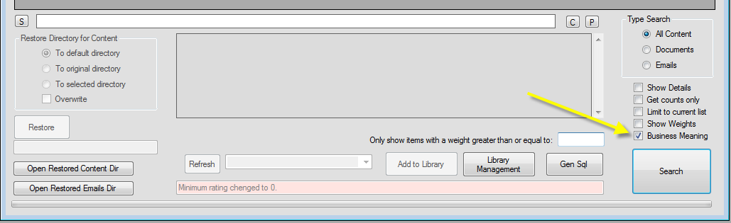

## When Your Company is using Microsoft Thesaurus

Your company has the ability to create its own “Classonomy” of language that is specific to the needs of ECM Library searchers.

A Microsoft Thesaurus search is either noted with a “~” in front of each word in a search command line: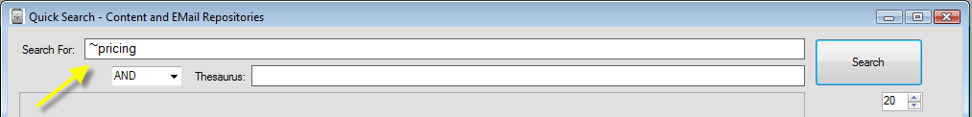

or by entering word(s) in the Microsoft Thesaurus line in the Search Assistant:

## 

Your ECM Library database administrator is responsible for training you on the type of classonomy used. Within the same classonomy, you could have either a “substitution” listing or a “expansion” listing. For example, if you enter in the acronynom “ECM”, the classonomy may automatically substituteso “ECM” to only search on “Enterprise Content Management”. Or if you enter in ECM, the classonomy may expand ECM into searching on many similar words for your search, such as “content management” “archive” “search and retrieval” “e-Discovery” etc.