# ECM Library Virtual Database Search Capability

Displaying millions of rows of data on a form consumes lots of memory and can easily make the UI unresponsive. It can take from minutes to hours to bring back more than 10,000 rows of data. If the query is submitted over the Internet, multiply that time by 100.

In order for the UI to display large amounts of data and remain responsive, the UI should only load and display data that it needs to show. Paging data makes use of memory more efficiently since additional data is only loaded when needed. However, in a Client environment this is almost impossible. The key word here is “almost”. ECM Library can do it!

ECM Library now supports four new parameters, two at the user level and two at the system level. Setting these two parameters properly should allow ECM Library to retrieve millions of rows over the Internet in just a few seconds – for a few thousand rows a five second response time may be possible.

## The USER Parameters

The parameters are two sets of two. There are two sets so that a systems administrator can override user’s settings. Basically, there are two parameters – 1) Turn Virtual Paging on and 2) Set how many rows to return per pagination. It is that simple. When virtual paging is enabled, a couple of buttons are added to the search screens. They will be described later. The quick explanation is that one button allows the user to page forward and, you guessed it, the other allows backward paging.

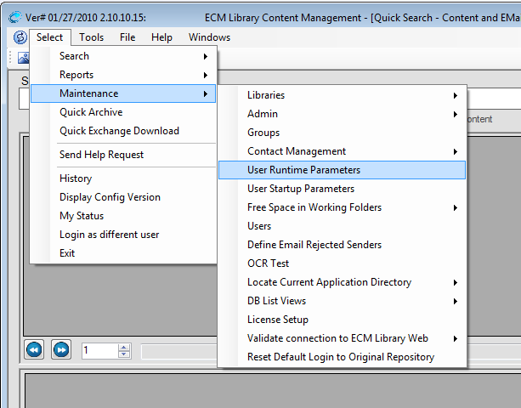

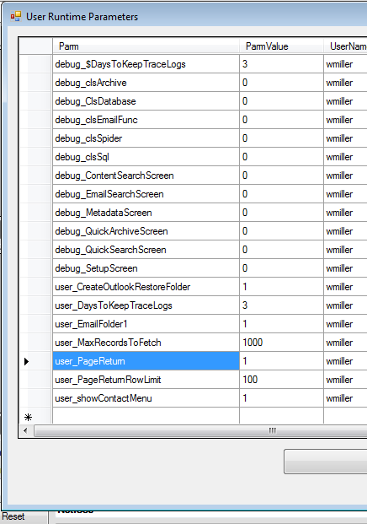

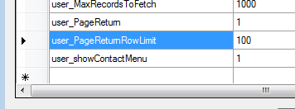

# Systems Override

