In order to capture email before it goes to the user or just to capture it in an automated fashion so no email is left behind, the ability to capture directly from an exchange server mailbox is provided here. This method provides a journaling concept without the overhead of journaling. The exchange administrator can direct emails from anyone’s email folder at either reception or transmission time. ECM Library can download from one master exchange folder or if desired, every individual email folder on the server.

For a master folder or for individual folders:

1. Enter the exchange host’s name or IP address.
2. Enter the login ID
3. Enter the password and verify correctness
4. If it is an SSL connection, check the SSL box
5. If it is an IMAP connection, check the IMAP box
6. If you wish to delete the email out of the folder as soon as it is successfully received, check the Delete After Download
7. If the port number is not the standard default, enter the port number
8. Select the retention code
9. If the execution requires a specific user ID to run successfully, enter it
10. Press Insert or Update accordingly

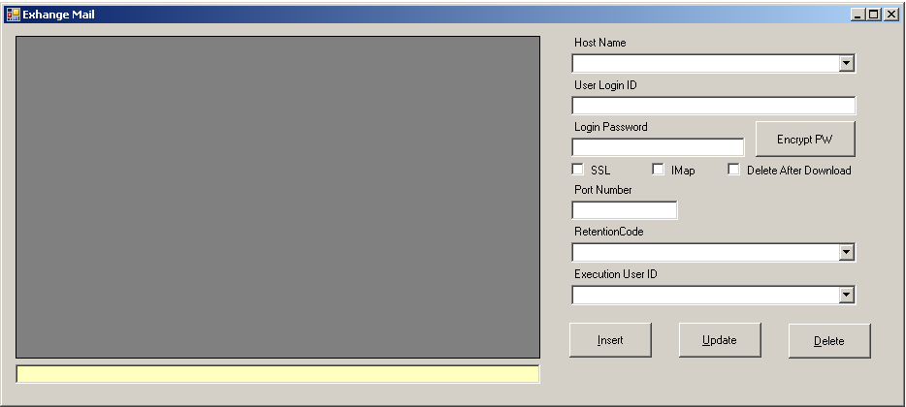

To remove a mailbox, select the desired mailbox in the grid and press delete