ECM Library Content Management System
Developer: Dale Miller
Reviewer: Liz Garnand
Table of Contents

The Product ECM Library
Purpose
ECM Library archives, manages, and provides easy access to your company’s intellectual and critical asset: all the electronic data. It creates one easy repository for your content, while maintaining control on who has access to what information. Using features that were formerly only affordable by Fortune 100 companies, ECM Library is affordable and intuitive for even the smallest business. Its architecture is based on decades of software design experience developing and deploying content enterprise solutions for the most complex and demanding organizations. This design team experience is combined with today’s leading-edge technologies and methodologies.
Search and retrievals are lightening fast, thorough and intelligent. The power and complexity are under-the-hood: users will experience an easy and intuitive Windows-based graphic user interface that integrates into Windows Office and Windows Explorer using familiar drag-and-drops and mouse-clicks.
  - What it provides
  - What it saves
  - E-Discovery
  - Graphic/Picture Recognition
  - Multimedia
    - Music
    - Voice Recordings (analog/digital)
    - Video

Licensing
Licenses are issued on a “per machine basis”. Any machine can be defined to the system up to the assigned number of licenses purchased. Then, an equal or less number of users can be assigned to the repository – up to one per machine.
Then the users can login and use any machine that is defined to the repository under their ID if it too is assigned to the repository. This allows for a user to go to a remote site and use the application provided he/she is defined to the repository and the machine he/she wishes to use is also defined to the repository. A machine is automatically entered into the repository when the application is installed and executed for the first time if the maximum number of seats (machines allowed) is not exceeded. If that number is exceeded, this machine cannot log into the system until a seat is freed up or more seats are purchased.

Archiving
  - Emails
  - Content
  - Contacts

Search

  - Methods
    - Contains
    - Free Text (Business Meaning, synonyms
      - When FREETEXT is used, the search engine internally performs the following actions on the freetext string, assigns each term a weight, and then finds the matches.
        - Separates the string into individual words based on word boundaries (word-breaking).
        - Generates inflectional forms of the words (stemming).
        - Identifies a list of expansions or replacements for the terms based on matches in the thesaurus.
    - Weighted Results
      - Can be used either in Contains or FREETEXT searches
      - A minimum return weight can be specified
      - Sorts the results in the most likely first and the least likely last
  - )Syntax
    - The syntax of the search, or the way in which one enters words and phrases for which to search, is based on a common and accepted format. It will be best and most easily explained through example. For example, if a search were needed that looked for the single word “automobile” then all that would have to be entered into the search line would be the single word “automobile” and the search key pressed or the enter key pressed. Then the search engine would examine every document, email and piece of metadata for the exact word “automobile”. It goes without too much explanation that the single word search is simple and will return, at times, unmanageable amounts of content.
    - To begin to limit the amount of returned data, let’s expand the search to include more key words to allow the search engine to reduce (be more selective) on what content is considered. So for this search, the terms “automobile accident” will be entered as separate words on the search command line. This instructs the search engine to look for content containing the word “accident” or “automobile”. This will most likely result in even more content being returned. There are times during searches when this is a desired effect, so remember, words separated with blanks are considered to be using the “OR” operation. Therefore, if I looked for the phrase “Albert Einstein”, I would bring back all the content containing the name “Albert’ or the name “Einstein”.
    - It is a very easy process to change this search, either of the above searches to be much more specific. For example, entering automobile +accident in the search command line or Albert + Einstein would now instruct the search engine to bring back only content that contained both of the search words. I s indeed, very easy to begin to limit the amount of data being returned.
    - A good example is when one of the larger insurance companies searched for robbins +fatal +car +accident +Kansas. This allowed the search engine to immediately reduce the set of returned content to just a few documents. The research analyst thought that this was too few understanding the magnitude of the case she was researching. She restructured the search criteria to read like this (and we will explain fully in a moment). The search she entered was robbins NEAR Collins +^fatal +^car +accident +Kansas +"Fort Riley". This returned less than 50 emails, documents, pictures, and filings out of some 1,000,000 documents. What this researcher had told the search engine to do was to find all content that contained the word “robbins” in close proximity to the word “Collins” (as it was Robbins vs. Collins in the filings), to search for words that had the meaning of fatal (such as death, casualty, fatality, etc.), include content that used the word auto, automobile, vehicle, etc., and contained the word accident within the document as well as the word Kansas (no consideration to capitalization) and contained the exact phrase “Fort Riley”. Once the search was initiated, the documents were returned for her to review in a couple of seconds. She reviewed these documents, selected the ones she determined to be pertinent and loaded them into a library she created for this case. She then added the other search team members to the library and passed the library link to the legal department.
    - Wild card searches can be easily performed in case one is not sure of the full spelling of a word or wants to include all the words that may begin with, end with, or contain a phrase. For example if the spelling of Fort Robbins was not certain, the researcher could look for “Fort Robb*” finding all occurances of any phrases that contained the starting letters “fort robb” and then had anything or nothing following them. The reverse is true also. In case you were unsure if it was Fort or Ft. a search cound be performed on +*F* +Robbins or “F* Robbins” or “F* Robb*”. The power and flexibility of the ECM Library search engine is fully under the users’ control.
    - The Last example deals with a phrase that you which to search considering its business meaning. NOW THIS IS WHERE I HAVE TO THINK OF HOW BEST TO EXPLAIN THIS CONCEPT AS IT IS THE MOST ESOTERIC.
  - Email
  - Content Search
- One or more specific words or phrases (simple term)
- A word or a phrase where the words begin with specified text (prefix term)
- Inflectional forms of a specific word (generation term)
- A word or phrase close to another word or phrase (proximity term)
- Synonymous forms of a specific word (thesaurus)
- Words or phrases using weighted values (weighted term)
  - Global
  - Screens
  - Search History Table

Unique Data Requirements
  - Library Names
  - Group Names

Components
Secure Access
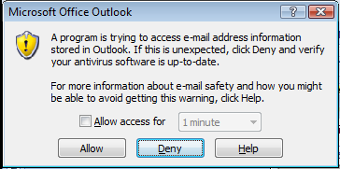
- Purpose:
- Components:
  - Allow Access for
  - Allow
  - Deny
  - Help

The Control Screen
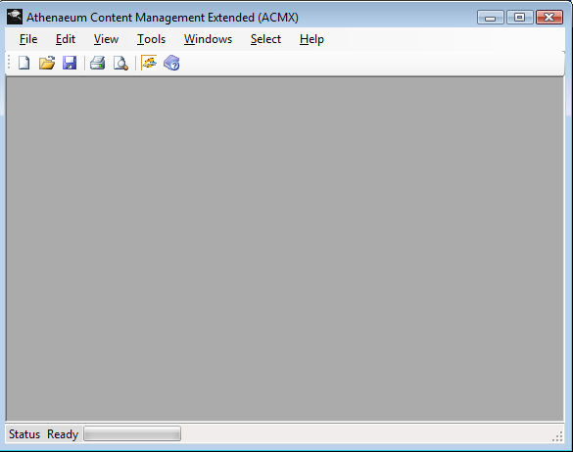
    - File
    - Edit
    - View
    - Tools
    - Windows
    - Select
    - Help
The Setup and Archive Management Screen
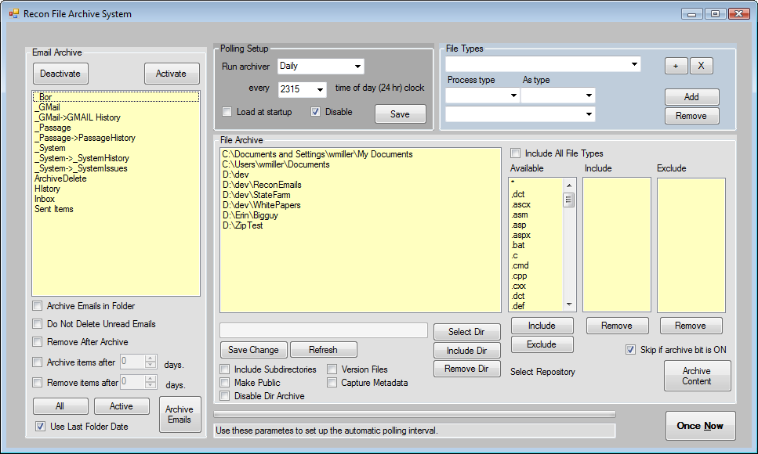
- Purpose:
- Compoments:
  - Email Archive Group:
    - The displayed list
    - Archive Emails in Folder
    - Do not delete unread emails
    - Remove after archive
    - Archive items after
    - Remove items after
    - ALL Button
    - Active Button
    - Archive Button
    - Use last folder date
  - Polling Setup Group
    - Run Archiver
    - Every
    - Load at startup
    - Disable
    - Save
  - File Types Group
    - Drop down list of file types
    - The “*” Button
    - The “X” button
    - Process Type
    - As Type
    - The List of assigned types
    - Add Button
    - Remove Button
  - File Archive Group
    - List of Active Directories
    - Include all file types
    - Available
    - Include
    - Exclude
    - Select Dir
    - Include Dir
    - Remove Dir
    - Save Change
    - Refresh
    - Include Sub-directories
    - Make Public
    - Disable Dir Archive
    - Version Files
    - Capture Metadata
    - Include Button
    - Exclude Button
    - Remove under Include List
    - Remove under exclude List
    - Skip if Archive bit is on
    - Archive Content Button
  - Progress Bar
  - Status Bar
  - Once Now Button

E-Mail Search Screen
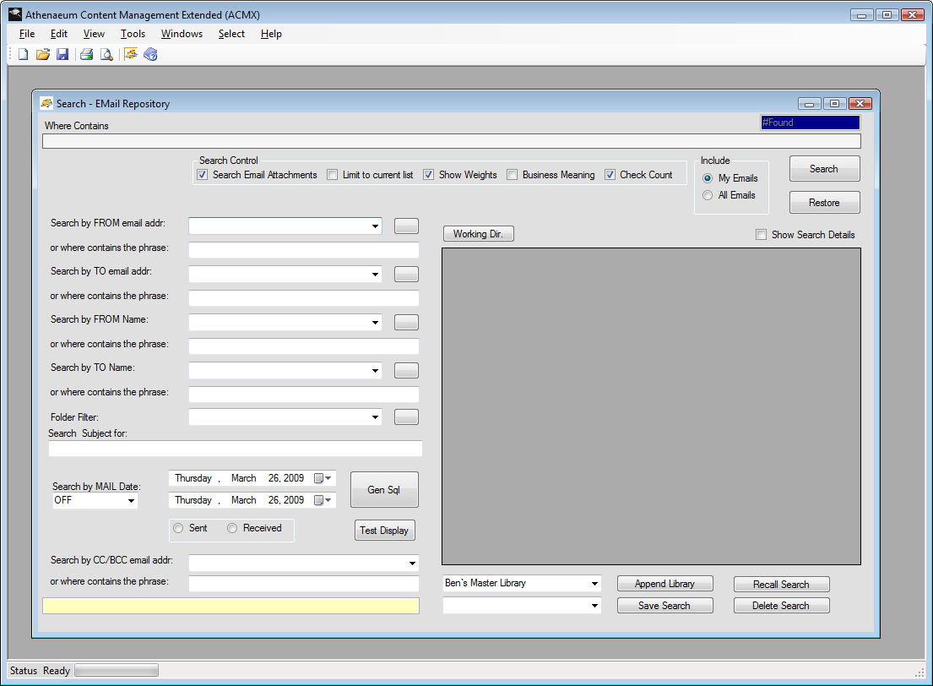

Content Search Screen
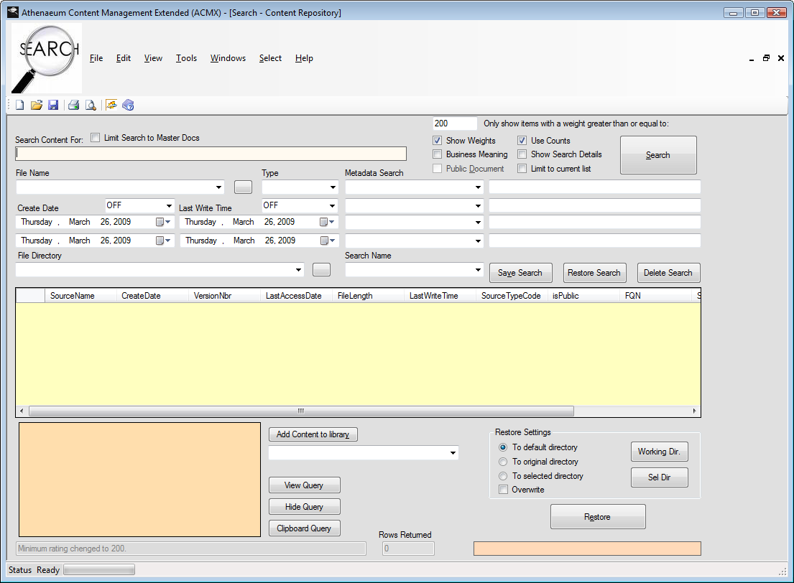
Search Content For
Limit Search to Master Docs

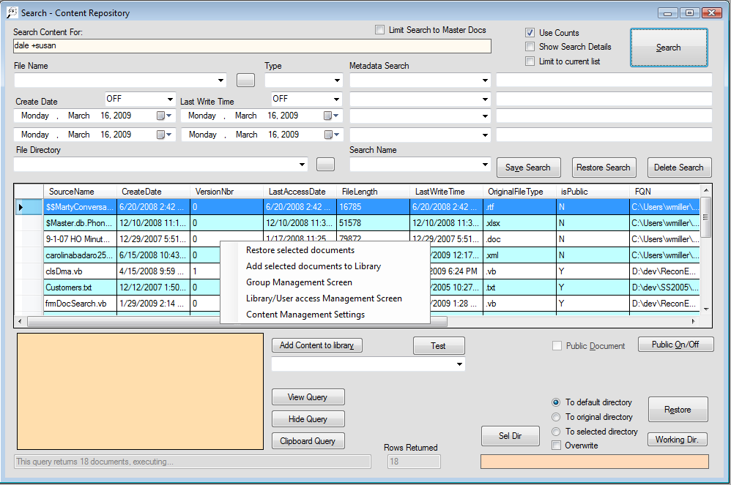

The Right Mouse Menu
      - Restore Selected Documents
      - Add selected documents to library
      - Group Management Screen
      - Library/User management
      - Content Management Settings

Callable from All Search Screens
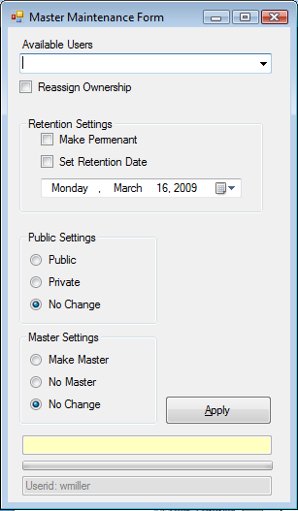
      - User Notifications: User Reassignment

Search All of the Repository
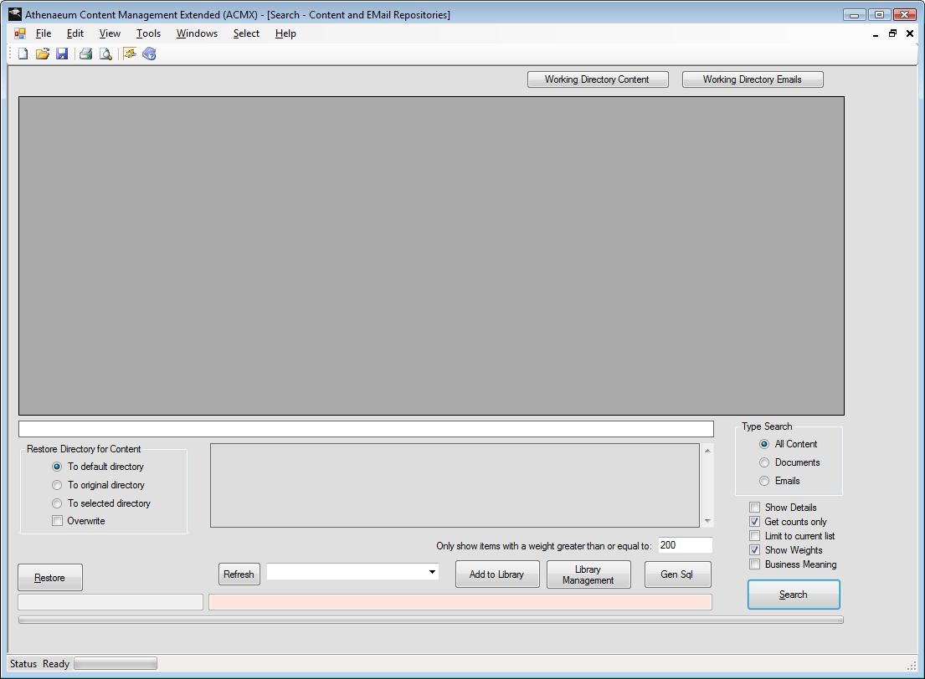
Purpose:
Screen Components:
- MIDI Parent:
- Working Directory Content
- Working Directory Emails
- Grid Display
- Search Bar

Library Creation and Management Screen
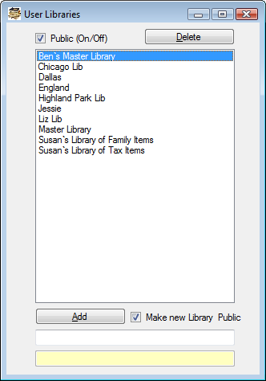

User Groups
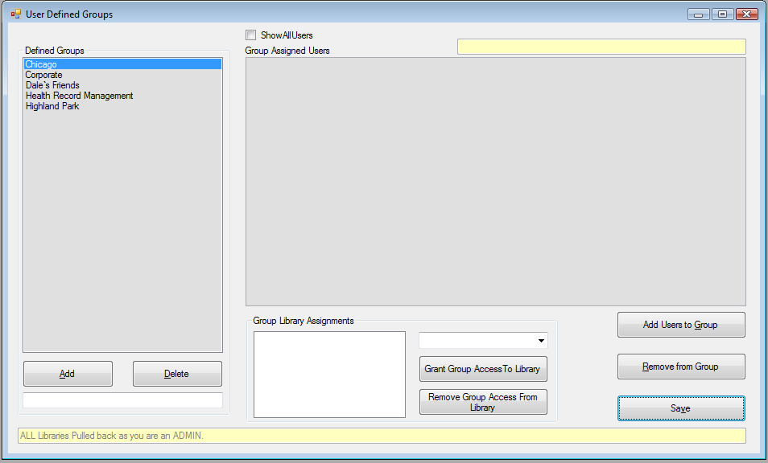

How groups work:

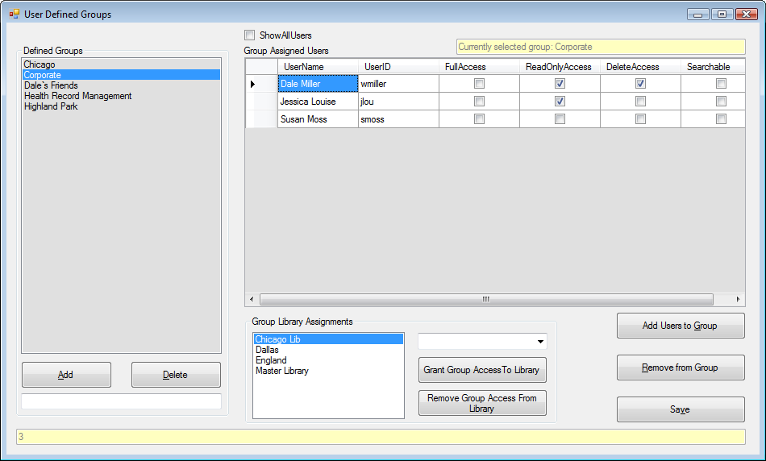

User Notifications:
        - Add to a group
        - Removed from a group

Library Items Management Screen
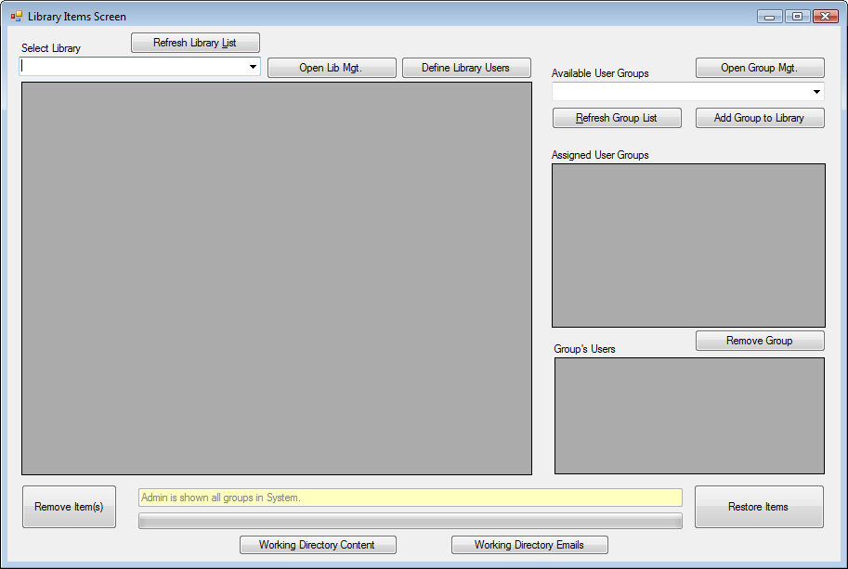

User Notifications:
      - Added to a library
      - Removed from a library

User Startup Parameters
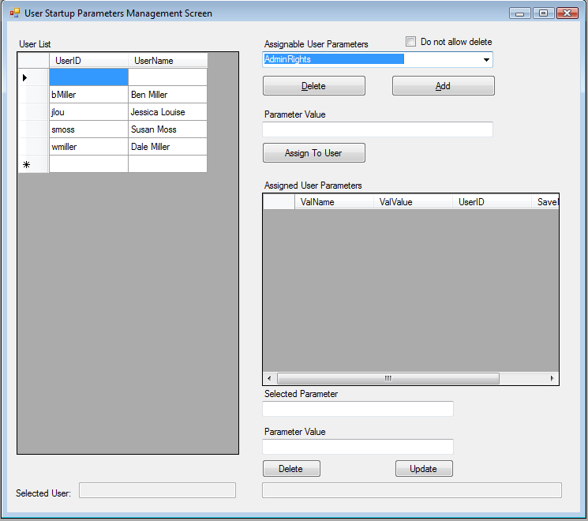

Working Folders
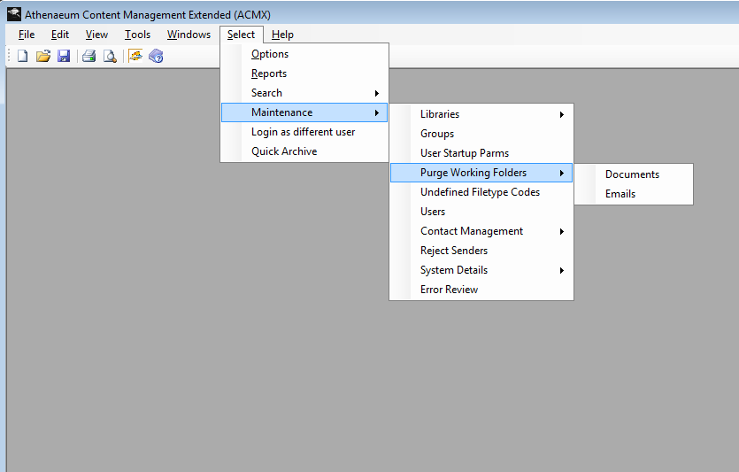
    - Purpose
    - Setup
    - Purging

File Types
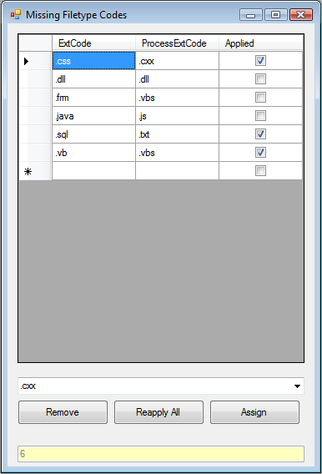
    - Purpose
    - Default Types
    - New Types

The Users Setup
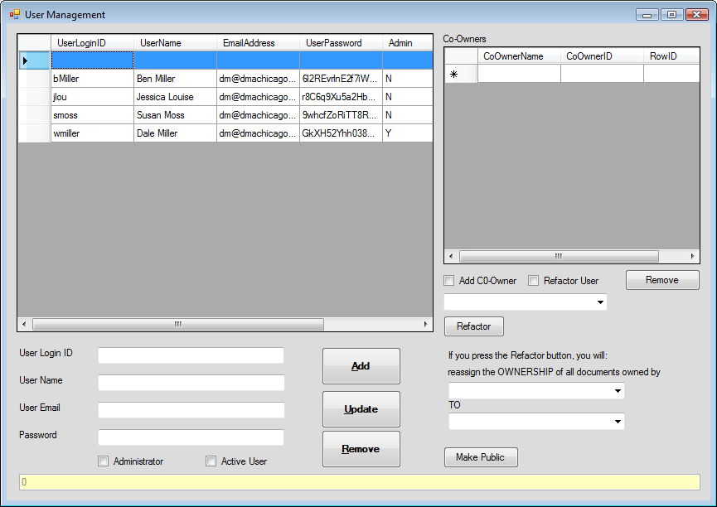

Contact Management Screens Navigation

Archive Contacts

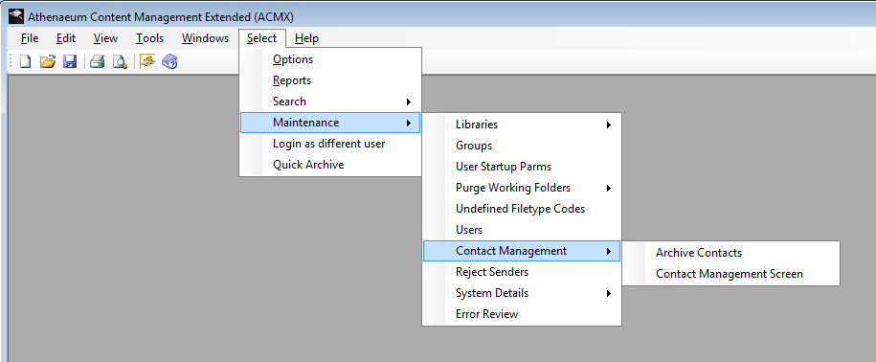
    - Archive Contacts:
There is no screen for this action. It initiates a process.

Contact Management Screen
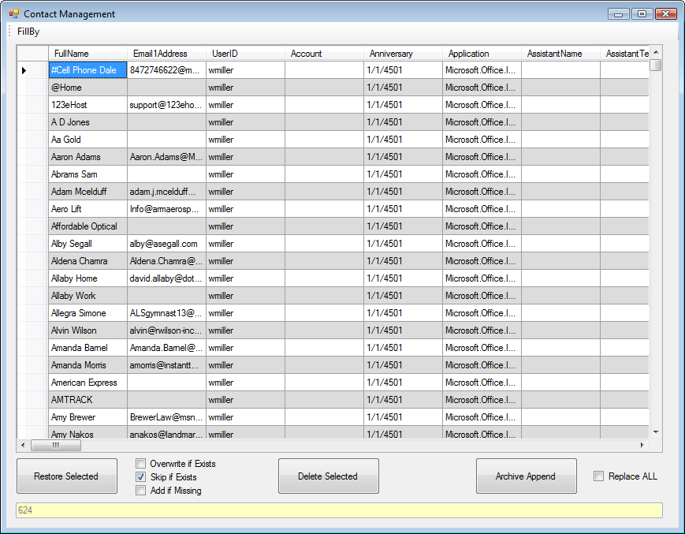
- Restore Selected
  - Overwrite if exists
  - Skip if exists
  - Add if missing
- Delete Selected
- Archive Append
- Replace All

Reject Senders Screen
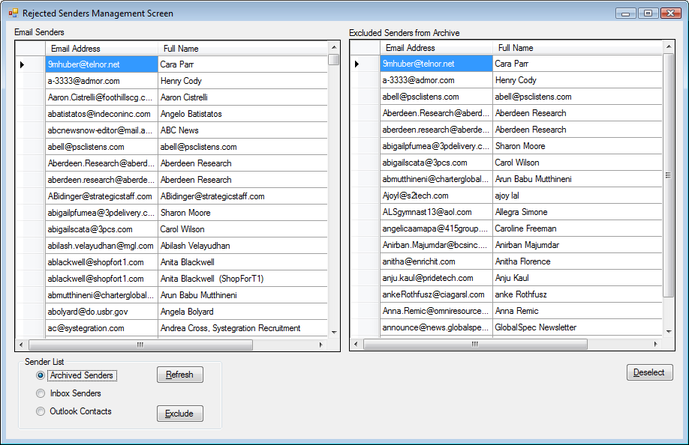
Email Senders
Error Tracking and Reporting
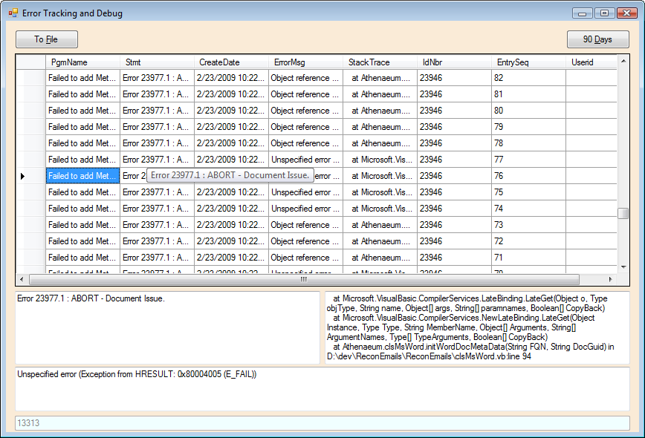
Quick Archive
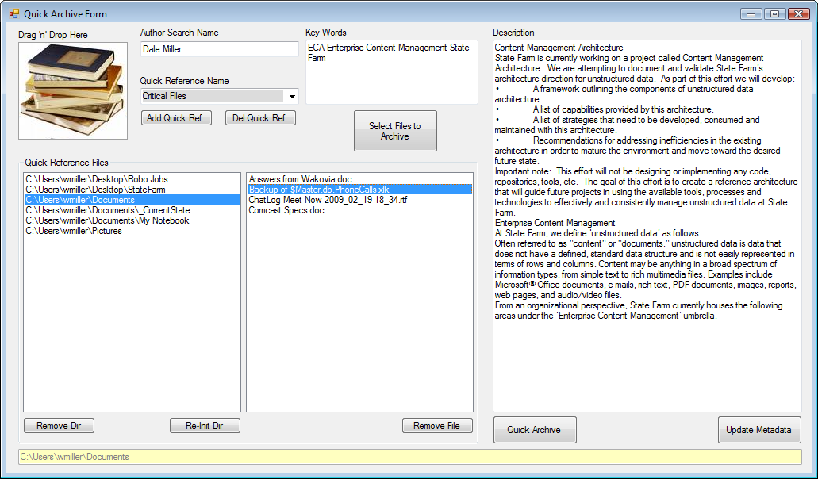

Login as a Different User
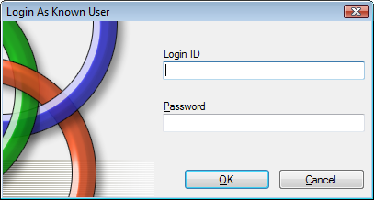
    - Purpose
    - Limitations
    - Login ID
    - Components
      - Password
      - OK
      - Cancel

Profile Maintenance
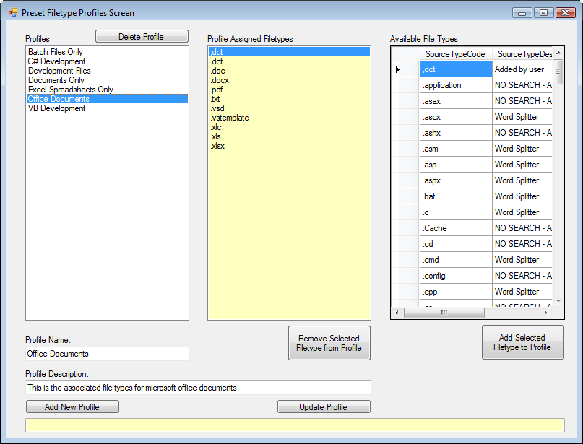
      - Purpose
      - Limitations
      - Components
        - Profiles
        - Profile Assigned Types
        - Available Filet ype
        - Profile Name
        - Profile Description
        - Add New Profile
        - Update Profile
        - Remove Selected Filetype from Profile
        - Add Selected Filetype to Profile
        - Status Bar

Retention Management
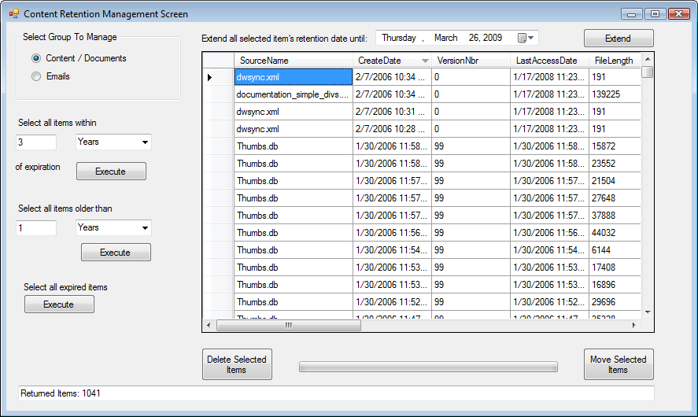

Setup
  - The database
    - Initial User
    - Initial Settings

APP.Config File
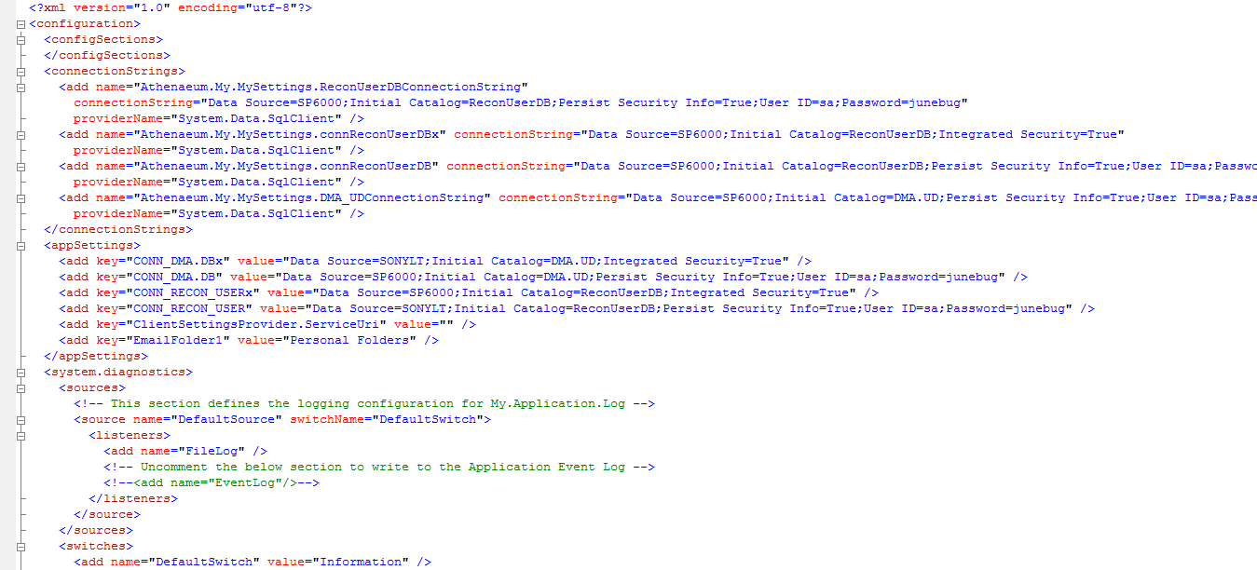

Web Install
    - How to setup the Web Install
    - How to execute the Web Install
    - What the install adds to your system

Minimum System Requirements
    - Operating Systems
    - Processor
    - Memory
    - Databases
      - SQL Server 2005
      - SQL Server 2008
      - SQL Server 2005 Desktop
      - SQL Server 2008 Desktop

Product Utilization
    - Enterprise Wide
    - Single User
      - Synchronization
      - Limited Search When not Connected to Net

Reference Software

- SQL Server 2005 or greater
- SQL Express Edition
- SQL Server Management Studio
- SQL Server Management Studio Express
- The ECM Library repository

Image XMP Tagging
XMP information is rapidly becoming the standard, working in conjunction with XML, for embedding metadata into images. ECM Library provides users with the capability to embedded needed metadata within their digital pictures. ECM Library will also scan, extract and archive for search any embedded XMP data within digital pictures.
The Adobe Extensible Metadata Platform (XMP) is a standard for processing and storing standardized and proprietary metadata, created by Adobe Systems Inc.
XMP standardizes the definition, creation, and processing of extensible metadata. Serialized XMP can be embedded into a significant number of popular file formats, without breaking their readability by non-XMP-aware applications. Embedding metadata ("the truth is in the file") avoids many problems that occur when metadata is stored separately. XMP is used in PDF, photography and photo editing applications.

XMP Data Model
XMP defines a metadata model that can be used with any defined set of metadata items. XMP also defines particular schemas for basic properties useful for recording the history of a resource as it passes through multiple processing steps, from being photographed, scanned, or authored as text, through photo editing steps (such as cropping or color adjustment), to assembly into a final image. XMP allows each software program or device along the way to add its own information to a digital resource, which can then be retained in the final digital file.
XMP is most commonly serialized and stored using a subset of the W3C Resource Description Framework (RDF), which is in turn expressed in XML.

Appendix I: The Search Engine Syntax

CONTAINS
( { column_name | ( column_list ) | * }
, '< contains_search_condition >'
[ , LANGUAGE language_term ]
)
< contains_search_condition > ::=
{ < simple_term >
| < prefix_term >
| < generation_term >
| < proximity_term >
| < weighted_term >
}
| { ( < contains_search_condition > )
[ { < AND > | < AND NOT > | < OR > } ]
< contains_search_condition > [ ...n ]
}
< simple_term > ::=
word | " phrase "
< prefix term > ::=
{ "word * " | "phrase *" }
< generation_term > ::=
FORMSOF ( { INFLECTIONAL | THESAURUS } , < simple_term > [ ,...n ] )
< proximity_term > ::=
{ < simple_term > | < prefix_term > }
{ { NEAR | ~ }
{ < simple_term > | < prefix_term > }
} [ ...n ]
< weighted_term > ::=
ISABOUT
( { {
< simple_term >
| < prefix_term >
| < generation_term >
| < proximity_term >
}
[ WEIGHT ( weight_value ) ]
} [ ,...n ]
)
< AND > ::=
{ AND | & }
< AND NOT > ::=
{ AND NOT | & !}
< OR > ::=
{ OR | | }

Arguments
column_name
Is the name of a full-text indexed column of the table specified in the FROM clause. The columns can be of type char, varchar, nchar, nvarchar, text, ntext, image, xml, varbinary, or varbinary(max).
column_list
Specifies two or more columns, separated by commas. column_list must be enclosed in parentheses. Unless language_term is specified, the language of all columns of column_list must be the same.
*
Specifies that the query will search all full-text indexed columns in the table specified in the FROM clause for the given search condition. The columns in the CONTAINS clause must come from a single table that has a full-text index. Unless language_term is specified, the language of all columns of the table must be the same.
LANGUAGE language_term
Is the language to use for word breaking, stemming, thesaurus expansions and replacements, and noise-word (or) removal as part of the query. This parameter is optional.
If documents of different languages are stored together as binary large objects (BLOBs) in a single column, the locale identifier (LCID) of a given document determines what language to use to index its content. When querying such a column, specifying LANGUAGE language_term can increase the probability of a good match.
language_term can be specified as a string, integer, or hexadecimal value corresponding to the LCID of a language. If language_term is specified, the language it represents will be applied to all elements of the search condition. If no value is specified, the column full-text language is used.
When specified as a string, language_term corresponds to the alias column value in he compatibility view. The string must be enclosed in single quotation marks, as in 'language_term'. When specified as an integer, language_term is the actual LCID that identifies the language. When specified as a hexadecimal value, language_term is 0x followed by the hexadecimal value of the LCID. The hexadecimal value must not exceed eight digits, including leading zeros.
If the value is in double-byte character set (DBCS) format, SQL Server will convert it to Unicode.
If the language specified is not valid or there are no resources installed that correspond to that language, SQL Server returns an error. To use the neutral language resources, specify 0x0 as language_term.
<contains_search_condition>
Specifies the text to search for in column_name and the conditions for a match.
<contains_search_condition> is nvarchar. An implicit conversion occurs when another character data type is used as input. In the following example, the @SearchWord variable, which is defined as varchar(30), causes an implicit conversion in the CONTAINS predicate.

USE AdventureWorks;
GO
DECLARE @SearchWord varchar(30)
SET @SearchWord ='performance'
SELECT Description
FROM Production.ProductDescription
WHERE CONTAINS(Description, @SearchWord);
Because "parameter sniffing" does not work across conversion, use nvarchar for better performance. In the example, declare @SearchWord as nvarchar(30).

USE AdventureWorks;
GO
DECLARE @SearchWord nvarchar(30)
SET @SearchWord = N'performance'
SELECT Description
FROM Production.ProductDescription
WHERE CONTAINS(Description, @SearchWord);
You can also use the OPTIMIZE FOR query hint for cases in which a non optimal plan is generated.
word
Is a string of characters without spaces or punctuation.
phrase
Is one or more words with spaces between each word.
Note:
Some languages, such as those written in some parts of Asia, can have phrases that consist of one or more words without spaces between them.
<simple_term>
Specifies a match for an exact word or a phrase. Examples of valid simple terms are "blue berry", blueberry, and "Microsoft SQL Server". Phrases should be enclosed in double quotation marks (""). Words in a phrase must appear in the same order as specified in <contains_search_condition> as they appear in the database column. The search for characters in the word or phrase is not case-sensitive. Noise words (such as a, and, or the) in full-text indexed columns are not stored in the full-text index. If a noise word is used in a single word search, SQL Server returns an error message indicating that the query contains only noise words. SQL Server includes a standard list of noise words in the directory \Mssql\Binn\FTERef of each instance of SQL Server.
Punctuation is ignored. Therefore, CONTAINS(testing, "computer failure") matches a row with the value, "Where is my computer? Failure to find it would be expensive." For more information on word-breaker behavior, see.
<prefix_term>
Specifies a match of words or phrases beginning with the specified text. Enclose a prefix term in double quotation marks ("") and add an asterisk (*) before the ending quotation mark, so that all text starting with the simple term specified before the asterisk is matched. The clause should be specified this way: CONTAINS (column, '"text*"'). The asterisk matches zero, one, or more characters (of the root word or words in the word or phrase). If the text and asterisk are not delimited by double quotation marks, so the predicate reads CONTAINS (column, 'text*'), full-text search considers the asterisk as a character and searches for exact matches to text*. The full-text engine will not find words with the asterisk (*) character because word breakers typically ignore such characters.
When <prefix_term> is a phrase, each word contained in the phrase is considered to be a separate prefix. Therefore, a query specifying a prefix term of "local wine*" matches any rows with the text of "local winery", "locally wined and dined", and so on.
<generation_term>
Specifies a match of words when the included simple terms include variants of the original word for which to search.
INFLECTIONAL
Specifies that the language-dependent stemmer is to be used on the specified simple term. Stemmer behavior is defined based on stemming rules of each specific language. The neutral language does not have an associated stemmer. The column language of the columns being queried is used to refer to the desired stemmer. If language_term is specified, the stemmer corresponding to that language is used.
A given <simple_term> within a <generation_term> will not match both nouns and verbs.
THESAURUS
Specifies that the thesaurus corresponding to the column full-text language, or the language specified in the query is used. The longest pattern or patterns from the <simple_term> are matched against the thesaurus and additional terms are generated to expand or replace the original pattern. If a match is not found for all or part of the <simple_term>, the non-matching portion is treated as a simple_term. For more information on the full-text search thesaurus, see.
<proximity_term>
Specifies a match of words or phrases that must be in the document that is being searched. Like the AND operator, <proximity_term> requires both the search terms to exist in the document being searched.
NEAR | ~
Indicates that the word or phrase on each side of the NEAR or ~ operator must occur in a document for a match to be returned. Several proximity terms can be chained, as in a NEAR b NEAR c or a ~ b ~ c. Chained proximity terms must all be in the document for a match to be returned.
When used in the CONTAINSTABLE function, the proximity of the search terms affects the ranking of each document. The nearer the matched search terms are in a document, the higher the ranking of the document. If matched search terms are >50 terms apart, the rank returned on the document is 0.
For example, CONTAINS (column_name, 'fox NEAR chicken') and CONTAINSTABLE (table_name, column_name, 'fox ~ chicken') would both return any documents in the specified column that contain both "fox" and "chicken". In addition, CONTAINSTABLE returns a rank for each document based on the proximity of "fox" and "chicken". For example, if a document contains the sentence, "The fox ate the chicken," its ranking would be high.
NEAR indicates the logical distance between terms, rather than the absolute distance between them. For example, terms within different phrases or sentences within a paragraph are treated as farther apart than terms in the same phrase or sentence, regardless of their actual proximity, on the assumption that they are less related. Likewise, terms in different paragraphs are treated as being even farther apart.
<weighted_term>
Specifies that the matching rows (returned by the query) match a list of words and phrases, each optionally given a weighting value.
ISABOUT
Specifies the <weighted_term> keyword.
WEIGHT(weight_value)
Specifies a weight value, which is a number from 0.0 through 1.0. Each component in <weighted_term> may include a weight_value. weight_value is a way to change how various portions of a query affect the rank value assigned to each row matching the query. WEIGHT does not affect the results of CONTAINS queries, but WEIGHT impacts rank in queries.
Note:
The decimal separator is always a period, regardless of the operating system locale.
{ AND | & } | { AND NOT | &! } | { OR | | }
Specifies a logical operation between two contains search conditions.
AND | &
Indicates that the two contains search conditions must be met for a match. The ampersand symbol (&) may be used instead of the AND keyword to represent the AND operator.
AND NOT | &!
Indicates that the second search condition must not be present for a match. The ampersand followed by the exclamation mark symbol (&!) may be used instead of the AND NOT keyword to represent the AND NOT operator.
OR | |
Indicates that either of the two contains search conditions must be met for a match. The bar symbol (|) may be used instead of the OR keyword to represent the OR operator.
When <contains_search_condition> contains parenthesized groups, these parenthesized groups are evaluated first. After evaluating parenthesized groups, these rules apply when using these logical operators with contains search conditions:
- NOT is applied before AND.
- NOT can only occur after AND, as in AND NOT. The OR NOT operator is not allowed. NOT cannot be specified before the first term. For example, CONTAINS (mycolumn, 'NOT "phrase_to_search_for" ' ) is not valid.
- AND is applied before OR.
- Boolean operators of the same type (AND, OR) are associative and can therefore be applied in any order.
n
Is a placeholder indicating that multiple CONTAINS search conditions and terms within them can be specified.
Remarks
Full-text predicates and functions work on a single table, which is implied in the FROM predicate. To search on multiple tables, use a joined table in your FROM clause to search on a result set that is the product of two or more tables.
CONTAINS is not recognized as a keyword if the compatibility level is less than 70. For more information, see.
Full-text predicates are not allowed in the when the database compatibility level is set to 100.

Comparison of LIKE to Full-Text Search
In contrast to full-text search, the Transact-SQL predicate works on character patterns only. Also, you cannot use the LIKE predicate to query formatted binary data. Furthermore, a LIKE query against a large amount of unstructured text data is much slower than an equivalent full-text query against the same data. A LIKE query against millions of rows of text data can take minutes to return; whereas a full-text query can take only seconds or less against the same data, depending on the number of rows that are returned.
Examples

A. Using CONTAINS with <simple_term>
The following example finds all products with a price of $80.99 that contain the word "Mountain".

USE AdventureWorks;
GO
SELECT Name, ListPrice
FROM Production.Product
WHERE ListPrice = 80.99
AND CONTAINS(Name, 'Mountain');
GO

B. Using CONTAINS and phrase in <simple_term>
The following example returns all products that contain either the phrase "Mountain" or "Road".

USE AdventureWorks;
GO
SELECT Name
FROM Production.Product
WHERE CONTAINS(Name, ' "Mountain" OR "Road" ')
GO

C. Using CONTAINS with <prefix_term>
The following example returns all product names with at least one word starting with the prefix chain in the Name column.

USE AdventureWorks;
GO
SELECT Name
FROM Production.Product
WHERE CONTAINS(Name, ' "Chain*" ');
GO

D. Using CONTAINS and OR with <prefix_term>
The following example returns all category descriptions containing strings with prefixes of either "chain" or "full".

USE AdventureWorks;
GO
SELECT Name
FROM Production.Product
WHERE CONTAINS(Name, '"chain*" OR "full*"');
GO

E. Using CONTAINS with <proximity_term>
The following example returns all product names that have the word bike near the word performance.

USE AdventureWorks;
GO
SELECT Description
FROM Production.ProductDescription
WHERE CONTAINS(Description, 'bike NEAR performance');
GO

F. Using CONTAINS with <generation_term>
The following example searches for all products with words of the form ride: riding, ridden, and so on.

USE AdventureWorks;
GO
SELECT Description
FROM Production.ProductDescription
WHERE CONTAINS(Description, ' FORMSOF (INFLECTIONAL, ride) ');
GO

G. Using CONTAINS with <weighted_term>
The following example searches for all product names containing the words performance, comfortable, or smooth, and different weightings are given to each word.

USE AdventureWorks;
GO
SELECT Description
FROM Production.ProductDescription
WHERE CONTAINS(Description, 'ISABOUT (performance weight (.8),
comfortable weight (.4), smooth weight (.2) )' );
GO

H. Using CONTAINS with variables
The following example uses a variable instead of a specific search term.

USE AdventureWorks;
GO
DECLARE @SearchWord nvarchar(30)
SET @SearchWord = N'Performance'
SELECT Description
FROM Production.ProductDescription
WHERE CONTAINS(Description, @SearchWord);
GO

I. Using CONTAINS with A Logical Operator (AND)
The following example uses the ProductDescription table of the AdventureWorks database. The query uses the CONTAINS predicate to search for descriptions in which the description ID is not equal to 5 and the description contains both the word "Aluminum" and the word "spindle." The search condition uses the AND Boolean operator.

USE AdventureWorks;
GO
SELECT Description
FROM Production.ProductDescription
WHERE ProductDescriptionID <> 5 AND
CONTAINS(Description, ' Aluminum AND spindle');
GO

J. Using CONTAINS to Verify a Row Insertion
The following example uses CONTAINS within a SELECT subquery. Using the AdventureWorks database, the query obtains the comment value of all the comments in the ProductReview table for a particular cycle. The search condition uses the AND Boolean operator.

USE AdventureWorks;
GO
INSERT INTO Production.ProductReview
(ProductID, ReviewerName, EmailAddress, Rating, Comments)
VALUES
(780, 'John Smith', 'john@fourthcoffee.com', 5,
'The Mountain-200 Silver from AdventureWorks Cycles meets and exceeds expectations. I enjoyed the smooth ride down the roads of Redmond')

-- Given the full-text catalog for these tables is Adv_ft_ctlg,
-- with change_tracking on so that the full-text indexes are updated automatically.
WAITFOR DELAY '00:00:30'
-- Wait 30 seconds to make sure that the full-text index gets updated.

SELECT r.Comments, p.Name
FROM Production.ProductReview r
JOIN Production.Product p
ON
r.ProductID = p.ProductID

AND r.ProductID = (SELECT ProductID
FROM Production.ProductReview
WHERE CONTAINS (Comments,
' AdventureWorks AND
Redmond AND
"Mountain-200 Silver" '))

GO

A. Using FREETEXT to search for words containing specified character values
The following example searches for all documents containing the words related to vital, safety, components.
USE AdventureWorks;
GO
SELECT Title
FROM Production.Document
WHERE FREETEXT (Document, 'vital safety components' );
GO

Appendix II: Introduction to Full-Text Searching
The full-text search feature of ECM Library as provided through utilizing Microsoft SQL Server 2005 delivers enterprise search functionality integrated into the database. Significant enhancements in the areas of performance, manageability, and functionality deliver best-of-breed search capabilities for applications of any size.
This paper is for database administrators and developers alike. An introduction to full-text search and its architecture is followed by details about important enhancements and new features.

What Full-Text Search Does for Liz and Dale besides make them smile?
Full-text search allows fast and flexible indexing for keyword-based query of text data stored in a SQL Server database. Unlike the LIKE predicate, which only works on character patterns, full-text queries perform a linguistic search against this data, operating on words and phrases based on rules of a particular language.
The performance benefit of using full-text search can be best realized when querying against a large amount of unstructured text data. A LIKE query (for example, '%cencini%') against millions of rows of text data can take minutes to return; whereas a full-text query (for 'cencini') can take only seconds or less against the same data, depending on the number of rows that are returned.
Full-text indexes may be built not just on columns that contain text data, but also against formatted binary data, such as Microsoft® Word documents, stored in a BLOB-type column; in these cases, it is not possible to use the LIKE predicate for keyword queries.
With the growing popularity of storing and managing textual data in a database, demand has risen for full-text search capabilities in a wide variety of applications. Common uses of full-text search include Web-based applications (searching websites, product catalogs, news items, and other data), document management systems, and custom applications that need to provide text search capabilities over data stored in a SQL Server database.
SQL Server 2005 full-text search can scale from small mobile or personal deployments with relatively few and simple queries, up to complex mission-critical applications with high query volume over huge amounts of textual data. Full-text search provides integrated management capabilities and easy-to-use Transact-SQL query syntax; building applications that expose search capabilities is quick and easy.
Full-text search is also highly extensible. The full-text engine can support additional languages for index and query (by adding additional word breakers or stemmers from a third-party vendor), as well as filtering of additional document formats (there are a number of third-party filters to choose from). A set of well-known, published interfaces provide the framework for full-text engine extensibility For more information, see the MSDN topics.
In short, if there is an application that manages textual data stored in SQL Server, chances are that full-text search will add great value by providing fast, robust, enterprise-class search functionality integrated into the database platform.

Full-Text Search Architecture
The Microsoft Full-Text Engine for SQL Server (MSFTESQL) powers full-text search in SQL Server. This engine is in turn built on Microsoft Search (MSSearch) technology and is integrated into the SQL Server 2005 Database Engine more tightly than ever. One major architectural improvement made in the SQL Server 2005 release has been the implementation of side-by-side installs of the full-text engine. This means that for each instance of SQL Server 2005, there is a dedicated instance of MSFTESQL, including dedicated components (such as word breakers and filters), resources (such as memory), and configuration (such as service-level settings like resource_usage) at the instance level.
(The full-text search engine in previous versions of SQL Server was shared by all instances of SQL Server, as well as the operating system and other Microsoft server products such as Exchange and SharePoint™ Portal Server. A side effect of this approach was that updates to the operating system or other products that used MSSearch had wide and sometimes undesired effects on all other products that used MSSearch.)
Let's take a closer look at SQL Server 2005 full-text search.

Indexing
Full-text indexes are a special type of token-based functional index that is built and maintained by the full-text engine. The process of building a full-text index is quite different from building other types of indexes. Rather than construct a B-tree structure based on a value stored in a particular row, MSFTESQL builds an inverted, stacked, compressed index structure based on individual tokens from the text being indexed.

Index Structure
A good understanding of the structure of a full-text index helps one appreciate how the full-text engine works. Let's take a look at a basic example of a full-text index rendered in tabular form:
Note Actual full-text indexes contain information in addition to what is presented in this table. The table below is provided for explanatory purposes.
Keyword | ColId | DocId | Occ
token1 | 1 | 1 | 1
token1 | 1 | 1 | 5
token1 | 1 | 2 | 2
token1 | 2 | 1 | 1
token2 | 1 | 1 | 5
token2 | 2 | 4 | 11
(etc.) ... | (etc.) ... | (etc.) ... | (etc.) ...
The Keyword column corresponds to some representation of a single token extracted at indexing time. What makes up a token is determined by a component of the full-text engine called a "word breaker." Each language supported by full-text search has a word breaker component that breaks a text stream into individual tokens based on the rules for word boundaries of that particular language.
The ColId column is a numeric value that corresponds to a particular table and column that is full-text indexed. Since multiple tables and columns may be stored in a single full-text catalog, the ColId value is used to narrow queries down to only occurrences of a keyword that come from the table and column specified in a full-text query.
Each DocId value for a Keyword/ColId pair maps to a particular full-text key value in a full-text indexed table. DocId values that satisfy a search condition are passed from the full-text engine to the database engine, where they are mapped to full-text key values from the base table being queried.
Note DocId is represented internally as a compressible 4-byte integer value, which therefore may be different from the data type of the full-text key. As such, the upper limit to the number of full-text indexed rows in a full-text catalog in SQL Server 2005 is roughly 2,000,000,000.
The Occ column is actually a list of lists—for each DocId value, there is a list of occurrence values that correspond to relative offsets of the particular keyword within that DocId. Occurrence values are useful in determining phrase or proximity matches (for example, phrases have numerically adjacent occurrence values), as well as in computing relevance score (for example, the number of occurrences in a DocId as well as in a particular full-text index may be used in scoring).
As indicated before, the DocId and Occ values are compressed, primarily to save space and I/O costs at query time. During the indexing process, index fragments of a certain size are generated and periodically merged together into a larger master index; otherwise, the cost of inserting into this specially keyed compressed structure, potentially thousands of times per row, would be very expensive.
Now that you have a basic idea of the full-text index structure, let's look at how SQL Server 2005 full-text search can take massive amounts of text data stored in the database and build a full-text index on it.

Indexing Process
The indexing process consists of two conceptual pieces: gathering data and constructing the full-text index structure. The architecture of the full-text gathering mechanism was improved in SQL Server 2005 in order to make the full-text indexing process more efficient, leading to significant performance improvements.
When a full-text population (also known as a "crawl") is initiated, the Database Engine pushes large batches of data into memory and tells the full-text engine to begin indexing. (The values from a column or columns of a table are full-text indexed.) Using a protocol handler component, the full-text engine pulls the data from memory through its indexing pipeline to be further processed, resulting in a full-text index.
In past releases, the gathering process was akin to a Web crawl, based on a row-by-row pulling mechanism as opposed to the batching semantics described above. SQL Server Yukon's batching mechanism, by contrast, makes more aggressive and efficient use of resources, and in turn yielding a massive full-text indexing performance improvement.
Note When indexing data stored in a BLOB column, a special component that implements the IFilter interface is used to extract text based on the specified file format for that data (e.g., Microsoft Word). In some cases, the filter components require the BLOB data to be written out to disk (as opposed to pushed into memory), so the indexing process can be slightly different for that type of data.
As part of processing, the gathered text data is passed through a word breaker to separate the text into individual tokens (keywords). The language to be used for tokenization is specified on a per-column level, or may be identified within BLOB or XML data by the filter component.
Additional processing may be performed to remove "noise" words (that is, words with little value as search criteria), and to normalize tokens before they are stored in the full-text index or an index fragment.
Figure 1 shows an overview of the components of the full-text engine in SQL Server 2005.
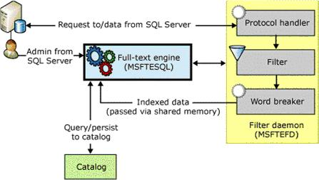
Figure 1. Full-text engine components in SQL Server 2005
When a population has completed, a final 'master' merge process is triggered. By merging the index fragments together, query performance is improved (because only the master index needs to be queried rather than a number of index fragments), and better scoring statistics may be used for relevance ranking. Because large amounts of data must be written and read when index fragments are merged, the master merge can be I/O intensive, but it will not block incoming queries.

Query
Querying a full-text index is extremely fast and flexible. Because of the specialized index structure described above, it is very quick and easy to locate matches for particular search criteria.
Below is an example of a full-text query in SQL Server 2005:
SELECT ProductModelId, ProductName
FROM ProductModel
WHERE CONTAINS(CatalogDescription, ' " aluminum alloy " ')
This query will project out ProductModelId and ProductName from the ProductModel table for each row that contains the phrase "aluminum alloy" anywhere in its CatalogDescription field.
The full-text portion of the query is parsed and sent to the full-text engine to be evaluated against the full-text index for the ProductModel table. The query terms in the search condition (in this case, "aluminum alloy") are tokenized by the word breaker for the column- or query-specified language, any noise words are removed, and a list of matching DocId values is returned from the full-text engine. Within the Database Engine, the list of DocId values is looked up against an internal structure that maps DocId values to full-text key values, and the resulting full-text key values are joined to the ProductModel table in order to project out the ProductModelId and ProductName values for the matching rows.
Note In past releases, the mapping of DocIds to full-text key values was performed in the full-text engine. In SQL Server 2005, this process has migrated into the database engine where more efficient and consistent caching strategies may be utilized. This migration (plus deeper enhancements made to the query engine) should also speed up full-text queries over previous releases. The full-text query performance improvements range from modest to orders of magnitude better for some queries.
The above query example represents a simple full-text query. Full-text queries have a robust yet simple syntax that allows for the evaluation of extremely powerful query expressions. This paper will not go into much more detail on the specific elements of full-text search expressions; for more information, see SQL Server 2005 Books Online.

Ranking – The Liz and Dale show

Liz and I try very hard not to talk about this concept and set of theories at bars too often as the patrons, once hearing our discussions, just will not leave us alone. Women throw themselves at me knowing that this kind of technology is ours. It is almost embarrassing.

Ranking of ISABOUT
ISABOUT is a vector-space query in traditional information retrieval terminology. The default ranking algorithm used is Jaccard, a widely known formula. The ranking is computed for each term in the query and then combined as described below.
ContainsRank = same formula used for CONTAINSTABLE ranking of a single term (above).
Weight = the weight specified in the query for each term. MaxQueryRank is the default weight.
WeightedSum = Σ[key=1 to n] ContainsRankKey * WeightKey
Rank = ( MaxQueryRank * WeightedSum ) / ( ( Σ[key=1 to n] ContainsRankKey2 )
+ ( Σ[key=1 to n] WeightKey2 ) - ( WeightedSum ) )
The sums are computed using unsigned 4-byte integers. For this reason, no more than 4294 keys can be in any given vector query because the integer may overflow (this condition is checked and such queries are failed). The other math is done in 8-byte integers.

Ranking of FREETEXT
Freetext ranking is based on the OKAPI BM25 ranking formula. Each term in the query is ranked, and the values are summed. Freetext queries will add words to the query via inflectional generation (stemmed forms of the original query terms); these words are treated as separate terms with no special weighting or relationship with the words from which they were generated. Synonyms generated from the Thesaurus feature are treated as separate, equally weighted terms.
Rank = Σ[Terms in Query] w (((k1 + 1) tf) / (K + tf)) * ((k3 + 1) qtf / (k3 + qtf)))
Where:
- w is the Robertson-Sparck Jones weight.
- Originally, w is defined as:
w = log10 ( ( ( r + 0.5 ) * ( N – n – R + r + 0.5 ) ) / ( ( R – r + 0.5 ) * ( n – r + 0.5 ) ) )
This was simplified to:
w = log10 ( ( ( r + 0.5 ) * ( N – R + r + 0.5 ) ) / ( ( R – r + 0.5 ) * ( n – r + 0.5 ) ) )
- R is the number of documents marked relevant by a user. This is not implemented in SQL Server 2005 full-text search, and thus is ignored.
- r is the number of documents marked relevant by a user containing the term. This is not implemented.
- N is the number of documents with values for the property in the query.
- n is the number of documents containing the term.
- K is ( k1 * ( ( 1 – b ) + ( b * dl / avdl ) ) ).
- dl is the document length, in word occurrences.
- avdl is the average document length of the property over which the query spans, in word occurrences.
- k1, b, and k3 are the constants 1.2, 0.75, and 8.0, respectively.
- tf is the frequency of the term in a specific document.
- qtf is the frequency of the term in the query.

Full-text search in SQL Server can generate a score (or rank value) about the relevance of the data being returned; this per-row rank value can be an ordering semantic, so that data that is more relevant is presented ahead of data that is considered less relevant.
Rank values for full-text queries may be returned from CONTAINSTABLE and FREETEXTTABLE full-text query clauses. CONTAINSTABLE and FREETEXTTABLE behave like table-valued functions that return two columns: a key column (which can be used to join to the full-text indexed base table), and a rank column (which can be used to order results by rank). The CONTAINS and FREETEXT clauses do not expose a score value, because they are predicates in the Transact-SQL language.
Three types of ranking are used in full-text queries including CONTAINSTABLE, CONTAINSTABLE using ISABOUT (weighting), and FREETEXTTABLE. All are based on the distribution of words in the query and the indexed data, but each works differently. Further, none of the ranking methods is absolute; for performance reasons, many values are rounded and normalized. Ranks of query results are only useful in relation to the ranks of other results from the same query. They are not comparable to the ranks of results from other queries, either from the same catalog or from other catalogs.
The science of ranking is far from mature, and as the field evolves, Microsoft may change how ranking works. Therefore, applications built on MSSearch must not rely on any particular ranking implementation, or they may break when a new version of MSSearch is released. In fact, ranking in MSSearch of 2005 differs in several ways from ranking in products such as Sharepoint Portal Server, Indexing Service, SQL Server 2000, and others.
Ranking over Boolean clauses is handled by taking the minimum rank from nodes under an AND clause and the maximum rank from nodes under an OR clause. Because ranks aren't directly comparable, this is at best an incorrect approximation of the ideal. For this reason, queries like FREETEXTTABLE(col1, 'foo') and CONTAINSTABLE(col1, 'bar') are certainly not recommended. Given the combination heuristics above, there would be no telling for each result which clause the rank came from—the FREETEXTTABLE or the CONTAINSTABLE clause.

Statistics for Ranking
When an index is built, statistics are collected for use in ranking. To minimize the size of the index and computational complexity, the statistics are often rounded.
When a catalog is being built, the algorithm creates small indexes as data is indexed, then merges the indexes into a large index. This process is repeated many times. A final merging of indexes into one large master index is called a "master merge". Some statistics are taken from individual indexes that contain query results, and some from the master index; others are computed only when a master merge takes place. As a result, the ranking statistics can vary greatly in accuracy and timeliness. This also explains why the same query can return different rank results over time as indexes are merged. Further, as full-text indexed data is added, modified, and deleted, those changes also will impact statistics and rank computation.
The list below includes some commonly used statistics that are important in calculating rank:
- Property: An attribute of a document. This corresponds to a column in SQL Server.
- Document: The entity that is returned in queries. In SQL Server this corresponds to a row. A document can have multiple properties, just as a row can have multiple full-text indexed columns.
- Index: A single inverted index of one or more documents. This may be entirely in memory or on disk. Many query statistics are relative to the individual index where the match occurred.
- Catalog: A collection of indexes treated as one entity for queries. Catalogs are the unit of organization visible to the SQL Server administrator.
- Word: The unit of matching in the full-text engine. Streams of text from documents are tokenized into words by language-specific word breakers.
- Occurrence: The word offset in a document property as determined by the word breaker. The first word is at occurrence 1, the next at 2, and so on. In order to avoid false positives in phrase and proximity queries, end-of-sentence skips 8 occurrences. End-of-paragraph skips 128 occurrences.
- Key: Combination of a property and a word.
- HitCount: The number of times the key occurs in the result.
- Log2: The highest-order bit set in a 4-byte value. Log base 2 was chosen over any other type of logarithmic computation for performance reasons. It is much faster than computing log base 10 or log base e.
unsigned Log2 ( unsigned long s )
{
for ( unsigned iLog2 = 0; s != 0; iLog2++ )
s >>= 1;
return iLog2;
}
- IndexDocumentCount: Total number of documents in the index.
- KeyDocumentCount: Number of documents in the index containing the key.
- MaxOccurrence: The largest occurrence stored in an index for a given property in a document.
- MaxQueryRank: The maximum rank returned by the engine (1000).

Ranking of CONTAINSTABLE

StatisticalWeight = Log2( ( 2 + IndexDocumentCount ) / KeyDocumentCount )
Rank = min( MaxQueryRank, HitCount * 16 * StatisticalWeight / MaxOccurrence )
Phrase matches are ranked just like individual keys except that KeyDocumentCount (the number of documents containing the phrase) is assumed to be 1. This can be wrong in many cases, and leads to phrases having relatively higher weights than individual keys.

Ranking of ISABOUT
ISABOUT is a vector-space query in traditional information retrieval terminology. The default ranking algorithm used is Jaccard, a widely known formula. The ranking is computed for each term in the query and then combined as described below.
ContainsRank = same formula used for CONTAINSTABLE ranking of a single term (above).
Weight = the weight specified in the query for each term. MaxQueryRank is the default weight.
WeightedSum = Σ_{[key=1 to n]} ContainsRank_{Key} * Weight_{Key}
Rank = ( MaxQueryRank * WeightedSum ) / ( ( Σ_{[key=1 to n]} ContainsRankKey2 )
+ ( Σ_{[key=1 to n]} WeightKey2 ) - ( WeightedSum ) )
The sums are computed using unsigned 4-byte integers. For this reason, no more than 4294 keys can be in any given vector query because the integer may overflow (this condition is checked and such queries are failed). The other math is done in 8-byte integers.

Ranking of FREETEXT
Freetext ranking is based on the OKAPI BM25 ranking formula. Each term in the query is ranked, and the values are summed. Freetext queries will add words to the query via inflectional generation (stemmed forms of the original query terms); these words are treated as separate terms with no special weighting or relationship with the words from which they were generated. Synonyms generated from the Thesaurus feature are treated as separate, equally weighted terms.
Rank = Σ_{[Terms in Query]} w ( ( ( k₁ + 1 ) tf ) / ( K + tf ) ) * ( ( k3 + 1 ) qtf / ( k3 + qtf ) ) )
Where:
- w is the Robertson-Sparck Jones weight.
- Originally, w is defined as:
w = log₁₀ ( ( ( r + 0.5 ) * ( N – n – R + r + 0.5 ) ) / ( ( R – r + 0.5 ) * ( n – r + 0.5 ) ) )
This was simplified to:
w = log₁₀ ( ( ( r + 0.5 ) * ( N – R + r + 0.5 ) ) / ( ( R – r + 0.5 ) * ( n – r + 0.5 ) ) )
- R is the number of documents marked relevant by a user. This is not implemented in SQL Server 2005 full-text search, and thus is ignored.
- r is the number of documents marked relevant by a user containing the term. This is not implemented.
- N is the number of documents with values for the property in the query.
- n is the number of documents containing the term.
- K is ( k1 * ( ( 1 – b ) + ( b * dl / avdl ) ) ).
- dl is the document length, in word occurrences.
- avdl is the average document length of the property over which the query spans, in word occurrences.
- k1, b, and k3 are the constants 1.2, 0.75, and 8.0, respectively.
- tf is the frequency of the term in a specific document.
- qtf is the frequency of the term in the query.

Rank Computation Issues
The process of computing rank, as described above, depends on a number of factors:
- Different word breakers tokenize text differently. For example, the string "dog-house" will be broken into "dog" "house" by one word breaker, and into "dog-house" by another. This means that matching and ranking will vary based on the language specified, because not only are the words different, but also the document length is different. The document length difference can affect ranking for queries not involving any of the words in the string.
- Statistics such as IndexDocumentCount can vary widely. For example, if a catalog has 2 billion rows in the master index, then one new document is indexed into an in-memory index, and ranks for that document based on the number of documents in the in-memory index will be skewed compared with ranks for documents from the master index. For this reason, it is recommended that the indexes be merged into a master index (using the ALTER FULLTEXT CATALOG ... REORGANIZE DDL statement) once all indexing is complete.
- Word breakers and filters together detect sentences and paragraphs. Occurrences skip by 8 at end of sentence and by 128 at end of paragraph. So MaxOccurrence can vary widely depending on how many sentences and paragraphs are detected in a property value.
- MaxOccurrence values are normalized into 1 of 32 ranges. This means, for example, that a document 50 words long is treated the same as a document 100 words long. Below is the table used for normalization. Because the document lengths are in the range between adjacent table values 32 and 128, they are effectively treated as having the same length, 128 (32 < docLength <= 128).
{ 16, 32, 128, 256, 512, 725, 1024, 1450, 2048, 2896, 4096, 5792, 8192, 11585,
16384, 23170, 28000, 32768, 39554, 46340, 55938, 65536, 92681, 131072, 185363,
262144, 370727, 524288, 741455, 1048576, 2097152, 4194304 };
- In cases where TOP_N_BY_RANK is used with the new precomputed rank option (discussed later), some additional rounding may be done while computing rank, so there may be some difference in those values based on whether or not the precomputed rank option is enabled.
Now that you have a good understanding of full-text search, let's move on to the new features in SQL Server 2005.

New Features for the Database Administrator – Liz and Dale are watching out for you too!

Side-by-Side Full-Text Engine Install
The section mentioned side-by-side full-text engine install, but did not spell out its meaning for database administrators.
First of all, side-by-side install of the full-text engine simplifies the process of managing and updating your servers. In the past, updating operating system service packs, or other instances or server products on the system, could affect SQL Server full-text search through the shared Microsoft Search (MSSearch) service. Furthermore, installing products like SharePoint Portal Server could introduce a newer version of MSSearch, which could change the behavior of full-text search. In contrast, isolating the full-text engine to the instance level prevents such unwanted side effects.
Side-by-side install means that the following components now exist at the per-instance level in SQL Server 2005:
- MSFTESQL. The full-text engine service manages the filter daemon component, performs administrative operations, and executes full-text queries. It appears as MSFTESQL$<instance_name> for a named instance.
- MSFTEFD. The full-text filter daemon safely loads and drives third-party extensible components used for index and query, such as word breakers, stemmers, and filters, without compromising the integrity of the full-text engine service itself.
- Word breakers, stemmers, and filters. Each instance now uses its own set of word breakers, stemmers, and filters, rather than relying on the operating system version of these components. These components are also easier to register and configure at a per-instance level. For more information, see SQL Server 2005 Books Online.

Security Enhancements
Improved security is a benefit of the side-by-side install capabilities of full-text search in SQL Server 2005. Past releases required the shared MSSearch service to run as LocalSystem; however, many organizations' security policies require services to run in a low-privileged security context. In SQL Server 2005, the full-text engine is synchronized to use the same account as the Database Engine (as opposed to LocalSystem), making it is easier to deploy full-text search functionality in a locked-down environment, yet the side-by-side approach ensures there is no risk of the side effects that can be introduced in a shared-service setting.
SQL Server 2005 full-text search can also prevent unsigned binaries from loading into the full-text engine process. Full-text search exposes an extensible architecture for filters, stemmers, and word breakers, so you can install third-party components as well. To prevent the execution of dangerous or untrusted code, full-text search exposes a configurable setting that by default prohibits loading components that are not Authenticode-signed by a trusted source.

Indexing Performance and Scale Enhancements
Perhaps the most dramatic improvement in SQL Server 2005 full-text search over previous releases has been made in the area of full-text indexing performance. Re-architecture of the full-text gathering mechanism (discussed briefly in "Indexing" above), as well as improvements in index merge strategy, have improved indexing performance by more than an order of magnitude in internal tests. For example, on the same hardware, with the same data set, building a full-text index on 20 million rows of character-based text data took roughly 14 days in SQL Server 2000, while in SQL Server 2005, the same index required less than 10 hours.
An additional benefit of the indexing re-architecture in SQL Server 2005 is improved resource utilization. Building a full-text index on a server with a large amount of available memory achieves optimal performance, as that memory will be used for pushing larger batches of data to be indexed.
Full-text indexes in SQL Server 2005 also can scale up to large quantities of data. Previous releases scaled to tens- or low-hundreds of thousands of rows of data; SQL Server 2005 full-text catalogs, by contrast, have been tested with and can support up to 2,000,000,000 rows of data (based on the 4-byte internal DocId). Further, the indexing process also scales up to that amount of data on a larger number of CPUs. Scalability of the text engine at indexing time over multiple CPUs has also improved significantly over previous releases (the full-text engine scales well up to roughly 16 CPUs on a 32-bit platform).

Full-Text Data Definition Language
Not only is it faster than ever to create full-text indexes in SQL Server 2005, the process has also become easier. SQL Server 2005 introduces Data Definition Language (DDL) statements for creating, altering, and dropping full-text indexes and catalogs. (Formerly, these indexes and catalogs were created using system stored procedures, which are deprecated but continue to work.)
An example of basic full-text DDL statements is provided below:
USE AdventureWorks
GO
-- creates full-text catalog - note accent sensitivity may now be
-- specified note also that this catalog is created as default so any
-- index I create that does not specify catalog will use this catalog
CREATE FULLTEXT CATALOG AwCat WITH ACCENT_SENSITIVITY=OFF AS DEFAULT
GO

-- creates index in AwCat (default) on ProductModel table
-- note we are using ProductModelId (unique single-column non-nullable)
-- as our FT key we also set change tracking to be manual so we can
-- periodically sync changes
CREATE FULLTEXT INDEX ON ProductModel(CatalogDescription)
KEY INDEX PK_ProductModel_ProductModelId WITH CHANGE_TRACKING MANUAL
GO

-- start a manual change tracking update on ProductModel
-- see Books Online for more information on full-text population options
ALTER FULLTEXT INDEX ON ProductModel START MANUAL POPULATION
GO

-- trigger a master merge on AwCat - can help with query performance
-- and improves ranking. This is done automatically after full and
-- manual populations, but can help periodically in auto change
-- tracking with a good amount of updates
ALTER FULLTEXT CATALOG AwCat REORGANIZE
GO
Using full-text DDL in SQL Server 2005 provides access to an easier-to-use syntax, as well as the many new features of full-text search.

Backup, Restore, and Recovery
One of the most significant full-text integration features of the SQL Server 2005 release has been the capability to back up, restore, and recover full-text catalogs using the same facilities as regular database and transaction log files. Full-text catalogs are managed by the full-text engine, and are stored in the file system. In previous releases, full-text catalogs needed to be backed up separately from SQL Server data files, which could cause difficulty in ensuring a smooth disaster recovery.
In contrast, SQL Server 2005 full-text catalogs are included in database, log, file, and filegroup backups. When a backup is taken, any indexing activity is temporarily suppressed to ensure consistent state between the full-text catalog and database, at which point the full-text catalog is backed up. For regular log backups, the full-text change-tracking log is included as part of the backup, and only data that has changed between the last full or differential backup needs to be re-indexed. (To speed recovery, take a full or differential backup after making schema changes or significant data loading to a full-text catalog.)
Using the AdventureWorks database example above, which includes the AwCat full-text catalog, you could execute the following command to back up the database, including its full-text catalog:
BACKUP DATABASE AdventureWorks TO DISK='C:\backups\aw.dmp'
GO
After backing up the database, you could simulate a disaster by executing:
USE master
GO
DROP DATABASE AdventureWorks
GO
Likewise, to restore the database, including its full-text catalog, you can execute the command:
RESTORE DATABASE AdventureWorks FROM DISK='C:\backups\aw.dmp'
GO
Therefore, the following query should work just as it did before the disaster:
USE AdventureWorks
SELECT ProductName
FROM ProductModel
WHERE CONTAINS(CatalogDescription, ' " aluminum alloy " ')

Transportability via sp_detach_db, sp_attach_db
SQL Server 2005 full-text search provides the ability to easily detach and move full-text catalogs in the same way that SQL Server database files may be detached, moved, and re-attached. Full-text catalogs are included with sp_detach_db and sp_attach_db. After detaching a database, you may move the full-text catalog and/or database data files, and then re-attach the database. Full-text catalog metadata is updated to reflect the change of location. This capability simplifies building, testing, moving, and deploying databases across multiple servers.

Rich Status Reporting
To provide the best possible manageability and supportability experience for full-text users, SQL Server 2005 full-text search provides easy ways for database administrators to diagnose and repair errors.
The crawl logging mechanism of SQL Server 2005 full-text maintains verbose, plain-text logs under the \LOG directory for each full-text catalog; these logs provide informational messages about full-text populations, as well as useful error messages and, if necessary, suggested resolutions to those problems.
Further, improved granularity of status reporting for processes such as full-text populations allows for easier tracking of various processes that are under way on the server. Additionally, more granular properties for status reporting were added to a number of built-in functions like OBJECTPROPERTY, and all full-text metadata is exposed through the new catalog views (such as sys.fulltext_catalogs, sys.fulltext_indexes, and sys.fulltext_index_columns).

Profiler Support for Full-Text Queries
Database administration and profiling are now easier with the addition of the full-text query event to the SQL Server 2005 Profiler tool. Adding the full-text query event helps isolate performance bottlenecks by providing detailed information on full-text query execution. Using the full-text query Profiler trace, you can see how expensive the full-text query is overall relative to other portions of your Transact-SQL query, and determine whether index lookup or some other part of the query could be optimized.

New Features for the Developer

Thesaurus Functionality
The new thesaurus functionality of SQL Server 2005 full-text search allows developers to reliably refine incoming full-text queries programmatically by expanding or replacing the incoming search term(s) with more appropriate or useful search terms. The full-text thesaurus eliminates the need for custom scripts to parse and expand or replace incoming query strings; the thesaurus is also easy to use through standard full-text query syntax. An example CONTAINS query that uses the thesaurus functionality follows:
SELECT ProductId, ProductName
FROM ProductModel
WHERE CONTAINS(CatalogDescription, ' FORMSOF(THESAURUS, metal) ')
Further, with FREETEXT queries, the thesaurus is invoked automatically as part of FREETEXT query processing, for example:
SELECT ProductId, ProductName
FROM ProductModel
WHERE FREETEXT(CatalogDescription, ' metal ')
The FREETEXT query invokes the thesaurus similarly to what was done in the CONTAINS query before it. The full-text thesaurus feature allows expansions and replacements to be configured for each language.

Configurable Accent Sensitivity
In previous releases, full-text catalogs and queries were accent sensitive by default. In SQL Server 2005, accent sensitivity is now a catalog-level setting that may be configured using the new full-text catalog DDL (mentioned above). For example, an accent-insensitive full-text catalog that is queried for "cafe" will match rows that have the keywords "café" and "cafe" stored in them. On the other hand, an accent-sensitive full-text catalog that is queried for the word "café" will only match rows that contain the word "café".
This accent sensitivity may be configured at CREATE FULLTEXT CATALOG time:
CREATE FULLTEXT CATALOG AwCat WITH ACCENT_SENSITIVITY=OFF
GO
Or by using ALTER FULLTEXT CATALOG:
ALTER FULLTEXT CATALOG AwCat REBUILD WITH ACCENT_SENSITIVITY=ON
GO
In some cases, applications would filter for certain query terms, and would expand a word like "café" to ' "café" OR "cafe" ' to find the both accented and unaccented forms of the word. With the configurable accent sensitivity in SQL Server 2005, this application-level processing is no longer necessary.

Query-Time Transformation of Noise Words
Application developers have long desired to be able to change the noise-word handling behavior of full-text search in contexts where users can input arbitrary full-text query expressions. The main area of pain has been CONTAINS-style queries, where a search expression such as ' "search" NEAR "the" ' ("the" is a noise word) would fail with the error, "Your query contained only noise words." The desired behavior in these cases is to ignore the noise word, and process the query to simply look for the word "search".
In SQL Server 2005, a new sp_configure setting is introduced to allow developers and database administrators to relax some parts of full-text noise-word handling. By executing the following Transact-SQL statement, you can take advantage of the new transformation of noise words in CONTAINS queries:
EXEC sp_configure 'show advanced options', 1
GO
RECONFIGURE
GO
EXEC sp_configure 'transform noise words', 1
GO
RECONFIGURE
GO
A full description of the transform noise words feature is provided in SQL Server 2005 Books Online; however, with SQL Server 2005 full-text search, developers will no longer need to maintain a copy of the noise list in their applications and programmatically pre-parse query strings to remove noise words from user input.

Multi-Column Query
Full-text queries traditionally have been executed against a single column (by using the name as column specifier) or all columns of a particular table (by using an asterisk). Unfortunately, this one-or-all approach required developers to use multiple full-text query clauses for queries against only some, but not all full-text indexed columns of a table, which resulted in a separate query to the full-text engine for each clause. In SQL Server 2005, a column list can now be specified instead, allowing developers to query one, some, or all full-text indexed columns of a table using a single query.
Let's look at an example:
USE MyDb
GO

CREATE TABLE myFt_Table(pk INT NOT NULL, txtCol1 VARCHAR(1024), txtCol2 VARCHAR(1024), txtCol3 VARCHAR(1024) )
GO

-- populate table with values

CREATE UNIQUE CLUSTERED INDEX idx1 ON myFt_Table(pk)
GO

CREATE FULLTEXT CATALOG myFtCat WITH ACCENT_SENSITIVITY=OFF AS DEFAULT
GO

CREATE FULLTEXT INDEX ON myFt_Table(txtCol1, txtCol2, txtCol3)
KEY INDEX idx1
GO
Above we've created a simple four-column table in some database. The pk column becomes the unique non-nullable single-column full-text key column, and we have three varchar columns that we have decided to full-text index. Now that the table and full-text index have been created and populated, let's look at some queries:

SELECT pk, txtCol1
FROM myFt_Table
WHERE CONTAINS(txtCol1, ' "foo" AND "bar" ')

SELECT *
FROM myFt_Table
WHERE CONTAINS(*, ' "foo" AND "bar" ')

SELECT pk, txtCol2, txtCol3
FROM myFt_Table
WHERE CONTAINS( ( txtCol2, txtCol3 ) , ' "foo" AND "bar" ')
Notice that in the third query above, the multiple columns are specified as a parenthesized, comma-separated list. That query is equivalent to the following query:

SELECT pk, txtCol2, txtCol3
FROM myFt_Table
WHERE CONTAINS(txtCol2, ' "foo" AND "bar" ')
OR CONTAINS(txtCol3, ' "foo" AND "bar" ')
Note that the above query uses multiple clauses to express the search condition (we are not searching against txtCol1). As mentioned previously, using multiple clauses requires the full-text engine to evaluate multiple full-text queries; in contrast, providing the column list as part of a single full-text query clause requires it to evaluate only a single query expression. Using this technique where possible will improve query performance and efficiency.

Query-Level Language Specification
SQL Server 2005 full-text search honors document-specified language settings in BLOB and XML documents at indexing time. For example, consider the following XML document:

<myXmlDoc>
<docTitle>
<docENUTitle xml:lang="en-us">
Yukon full-text search
</docENUTitle>
<docDEUTitle xml:lang="de">
Yukon full-text search (german equivalent)
</docDEUTitle>
</docTitle>
…
</myXmlDoc>
The docENUTitle element is specified to use the US English language as its language, whereas the docDEUTitle specifies German. At indexing time, the content of docENUTitle is tokenized by the US English word breaker, and the content of docDEUTitle is parsed by the German word breaker.
So what to do at query time? SQL Server 2005 full-text query syntax for the CONTAINS, CONTAINSTABLE, FREETEXT, and FREETEXTTABLE clauses all support a new LANGUAGE <lcid> parameter (specified as a numeric value or as a string) which may be used to override the column-default full-text language with the clause-level language. This clause-level language dictates which word breaker, stemmer, thesaurus, and noise word list to use for all terms of the full-text query. For example, if my column's default full-text language was set to 0 (Neutral), I could execute the following queries:

-- use neutral language (column default)
SELECT *
FROM ft_Table
WHERE CONTAINS(xmlFtCol, ' "Full-Text Search" ')

-- use English language
SELECT *
FROM ft_Table
WHERE CONTAINS(xmlFtCol, ' "Full-Text Search" ', LANGUAGE 'English')

-- use German language
SELECT *
FROM ft_Table
WHERE CONTAINS(xmlFtCol, ' "Full-Text Search" ', LANGUAGE 'German')
Because the neutral, English, and German word breakers tokenize text differently, it is desirable to use the correct word-breaking semantics for a query in English or German. Since keywords are indexed from the XML data using the English and German word breakers where specified, the language specification in the above queries becomes quite useful.
The LANGUAGE <lcid> parameter's value may be specified as a Transact-SQL variable if it is used in a full-text query clause in a stored procedure. For example:

CREATE PROCEDURE SearchDocuments
@srchString nvarchar(1024),
@language int,
@topN int,
@searchType smallint
AS
IF @searchType = 0
SELECT [KEY], [RANK]
FROM FREETEXTTABLE(Document, Document, @srchString,
LANGUAGE @language, @topN)
ORDER BY [RANK] DESC
ELSE
SELECT [KEY], [RANK]
FROM CONTAINSTABLE(Document, Document, @srchString,
LANGUAGE @language, @topN)
ORDER BY [RANK] DESC
GO
The above example searches against a Document table and passes in, as a parameter to the stored procedure, the search string, query-level language value (int), TOP_N_BY_RANK value, and the conditions under which to use CONTAINSTABLE or FREETEXTTABLE.
The above stored procedure makes the process of hooking this search up to a user interface much easier. The search string can be pulled from a text input field, query-level language can become a drop-down list of supported languages (this list may now be selected from the system catalog view sys.fulltext_languages), and the search type and TOP_N_ BY_RANK values can be easily set from drop-down boxes or radio buttons in the application.

Precomputed Rank
Developers using SQL Server 2005 full-text search can take advantage of a new optimization for FREETEXTTABLE queries that use the TOP_N_BY_RANK parameter (an example is shown above). As described earlier, there is a significant difference in the type of rank computation used for FREETEXTTABLE queries and the rank computation used for CONTAINSTABLE queries. The precomputed rank optimization in SQL Server 2005 allows FREETEXTTABLE queries to use rank values in a full-text catalog as opposed to having to calculate those values on the fly. As a result, these queries should increase to near CONTAINSTABLE speed the FREETEXTTABLE queries that use the TOP_N_BY_RANK parameter.
Precomputed rank is an sp_configure option that may be enabled as follows:

EXEC sp_configure 'show advanced options', 1
GO
RECONFIGURE
GO
EXEC sp_configure 'precompute rank', 1
GO
RECONFIGURE
GO

Enhanced Query Performance and Ranking Improvements
As mentioned in previous sections, the performance and scale of full-text search in SQL Server 2005 have been improved. Database developers and users of their full-text enabled applications should see an improvement over previous releases on the lines of 30-50 percent for straight full-text queries. The development team has focused on query performance improvements in the full-text engine itself, as well as the migration into the database engine of DocId-to-key-mapping facilities. Users should find that SQL Server 2005 delivers good improvement in query performance over previous releases.
Relevance scores returned from FREETEXTTABLE queries are higher quality than in previous releases. Refinements to scoring formulas used by full-text search, as well as improvements to the implementation of the Okapi BM-25 scoring algorithm, improve scoring over large and small data sets, as well as over multiple columns in a single table.

Conclusion
The SQL Server 2005 release signifies a significant step forward for the full-text search feature. Users of full-text search in SQL Server 2005 will find an enterprise-class, best-of-breed text-search facility that is easy to use and manage.

Appendix III: DBA Stored Procedures
There are stored procedures in each database that can assist you in gathering information you need to document or work with full-text catalogs already present in your environment. As with other stored procedures that provide information on objects in SQL Server, these stored procedures start with "sp_help". The following table shows those stored procedures, their purpose, and information provided by the stored procedure:

sp_help_fulltext_catalogs
Must be run in the database in which it resides
USE adventureworks2000
GO
exec sp_help_fulltext_catalogs @fulltext_catalog_name = 'ctgDocumentSummary'
ftcatid | The ID of the full-text catalog
Name | The name of the full-text catalog
Path | The physical location of the Gatherer Project folder
Status | The current status of the catalog:  0 = Idle  1 = Full population in progress  2 = Paused  3 = Throttled  4 = Recovering  5 = Shutdown  6 = Incremental population in progress  7 = Building index  8 = Disk is full. Paused  9 = Change tracking
Number_FullText_Tables | The number of tables associated with the catalog

sp_help_fulltext_catalogs_cursor
Must be run in the database in which it resides
USE adventureworks2000
GO
DECLARE @mycursor CURSOR
EXEC sp_help_fulltext_catalogs_cursor @mycursor OUTPUT, 'ctgDocumentSummary'
FETCH NEXT FROM @mycursor
WHILE (@@FETCH_STATUS <> -1)
BEGIN
FETCH NEXT FROM @mycursor
END
CLOSE @mycursor
DEALLOCATE @mycursor
GO
ftcatid | The ID of the full-text catalog
Name | The name of the full-text catalog
Path | The physical location of the Gatherer Project folder
Status | The current status of the catalog:  0 = Idle  1 = Full population in progress  2 = Paused  3 = Throttled  4 = Recovering  5 = Shutdown  6 = Incremental population in progress  7 = Building index  8 = Disk is full. Paused  9 = Change tracking
Number_FullText_Tables | The number of tables associated with the catalog

sp_help_fulltext_columns
Must be run in the database in which it resides
USE adventureworks2000
GO
exec sp_help_fulltext_columns @table_name = 'Document' (optional: @column_name = 'column_name')
Leaving @column_name NULL returns all columns and associated information
TABLE_OWNER | The owner of the table
TABLE_ID | ID of the table
TABLE_NAME | The name of the table
FULLTEXT_COLID | The ID of the column (from the table itself)
FULLTEXT_COLUMN_NAME | Column of the table that specifies the document type (applicable only when data type is image)
FULLTEXT_BLOBTP_COLNAME | The name of the column specifying the document type
FULLTEXT_BLOBTP_COLID | The ID of the document type column (from the table itself)
FULLTEXT_LANGUAGE | The language used for the full-text search of the column (expressed as a local identifier)

sp_help_fulltext_columns_cursor
Must be run in the database in which it resides
USE adventureworks2000
GO
DECLARE @mycursor CURSOR
EXEC sp_help_fulltext_columns_cursor @mycursor OUTPUT
FETCH NEXT FROM @mycursor
WHILE (@@FETCH_STATUS <> -1)
BEGIN
FETCH NEXT FROM @mycursor
END
CLOSE @mycursor
DEALLOCATE @mycursor
GO
TABLE_OWNER | The owner of the table
TABLE_ID | ID of the table
TABLE_NAME | The name of the table
FULLTEXT_COLID | The ID of the column (from the table itself)
FULLTEXT_COLUMN_NAME | Column of the table that specifies the document type (applicable only when data type is image)
FULLTEXT_BLOBTP_COLNAME | The name of the column specifying the document type
FULLTEXT_BLOBTP_COLID | The ID of the document type column (from the table itself)
FULLTEXT_LANGUAGE | The language used for the full-text search of the column (expressed as a local identifier)

sp_help_fulltext_tables
Must be run in the database in which it resides
USE adventureworks2000
GO
exec sp_help_fulltext_tables @fulltext_catalog_name = 'ctgDocumentSummary'
TABLE_OWNER | The owner of the table
TABLE_NAME | The name of the table associated with the full-text catalog
FULLTEXT_KEY_INDEX_NAME | The name of the unique index in the table
FULLTEXT_KEY_COLID | The ID of the column associated with the unique index
FULLTEXT_INDEX_ACTIVE | Specifies whether the columns associated with the full-text index are eligible for queries
FULLTEXT_CATALOG_NAME | The name of the full-text catalog

sp_help_fulltext_tables_cursor
Must be run in the database in which it resides
USE AdventureWorks2000
GO
DECLARE @mycursor CURSOR
EXEC sp_help_fulltext_tables_cursor @mycursor OUTPUT, 'ctgDocumentSummary'
FETCH NEXT FROM @mycursor
WHILE (@@FETCH_STATUS <> -1)
BEGIN
FETCH NEXT FROM @mycursor
END
CLOSE @mycursor
DEALLOCATE @mycursor
GO
TABLE_OWNER | The owner of the table
TABLE_NAME | The name of the table associated with the full-text catalog
FULLTEXT_KEY_INDEX_NAME | The name of the unique index in the table
FULLTEXT_KEY_COLID | The ID of the column associated with the unique index
FULLTEXT_INDEX_ACTIVE | Specifies whether the columns associated with the full-text index are eligible for queries
FULLTEXT_CATALOG_NAME | The name of the full-text catalog

