
Root Document
Communication, Collaboration, and Content:
Compelling Convergence
Version: 1.0, May 15, 2006
AUTHOR(S): Peter O'Kelly
(pokelly@burtongroup.com)
Additional Input:
Mike Gotta, Guy Creese, Karen Hobert
TECHNOLOGY THREAD:
VantagePoint Conclusion
Communication/collaboration/content offerings are in the midst of sweeping transformation. Previously constrained by proprietary, costly, and complex products and services, and recently impacted by severe spam and security problems, the offerings are now moving to a model that will be much more productive for organizations and individuals.The model is built on a foundation of channels for communication, workspaces for collaboration, and virtually unified content management. It has important potential for addressing increasingly broad and stringent regulatory requirements. It also has unprecedented potential to improve productivity and responsiveness by keeping users focused on business tasks instead of technology and tool concepts.
104609
104609 | 

Page: 1
Collaboration and Content Strategies
In-Depth Research Overview
104609


Publishing Information
Burton Group is a research and consulting firm specializing in network and applications infrastructure technologies. Burton works to catalyze change and progress in the network computing industry through interaction with leading vendors and users. Publication headquarters, marketing, and sales offices are located at:
Burton Group
7090 Union Park Center, Suite 200
Midvale, Utah USA 84047-4169
Phone: +1.801.566.2880
Fax: +1.801.566.3611
Toll free in the USA: 800.824.9924
Internet: info@burtongroup.com; www.burtongroup.com
Copyright 2007 Burton Group. ISSN 1048-4620. All rights reserved. All product, technology and service names are trademarks or service marks of their respective owners.
Terms of Use: Burton customers can freely copy and print this document for their internal use. Customers can also excerpt material from this document provided that they label the document as Proprietary and Confidential and add the following notice in the document: Copyright © 2007 Burton Group. Used with the permission of the copyright holder. Contains previously developed intellectual property and methodologies to which Burton Group retains rights. For internal customer use only.
Requests from non-clients of Burton for permission to reprint or distribute should be addressed to the Client Services Department at +1.801.304.8174.
Burton Group's Collaboration and Content Strategies service provides objective analysis of networking technology, market trends, vendor strategies, and related products. The information in Burton Group's Collaboration and Content Strategies service is gathered from reliable sources and is prepared by experienced analysts, but it cannot be considered infallible. The opinions expressed are based on judgments made at the time, and are subject to change. Burton offers no warranty, either expressed or implied, on the information in Burton Group's Collaboration and Content Strategies service, and accepts no responsibility for errors resulting from its use.
If you do not have a license to Burton Group's Collaboration and Content Strategies service and are interested in receiving information about becoming a subscriber, please contact Burton Group.
Table Of Contents
Synopsis 5
Analysis 6
Communication, Collaboration, and Content in Context 6
Communication 6
Collaboration 7
Content 8
Context 8
Communication, Collaboration, and Content Are Complementary 9
Current Communication / Collaboration / Content Chaos 9
Trends: The Potential for Compelling Convergence 1 0
“The Future Is Already Here. It's Just Unevenly Distributed.” 1 0
Substantive Standards 1 1
Improving Economics 1 1
Emerging Requirements and Challenges: Carrot and Stick 1 1
Virtually Unified Content 1 2
SOA and Superplatform Alignment 1 2
Growing Need for Autonomous Operation 1 3
Rapidly Evolving User Skills, Etiquette, and Incentive Systems 1 3
Proj ections 1 3
Prevailing Patterns 1 3
Consolidated Clients and a Reduced Role for E-mail 1 4
Metamodels Matter More 1 5
Communication/Collaboration/Content Market Dynamics: Category Consolidation and Collisions 15
Specialized Market Opportunities 1 6
Selectively Fertile Ground for Free and Open Source Software/Services 1 6
Recommendations 1 7
Collaborate to Create a Comprehensive Strategy 1 7
Build a Product/Service Portfolio 1 7
Proactively Prepare Policy 1 8
Plan for Change and Heterogeneity 1 8
Play and Learn in Order to Understand the Future of Work 1 9
The Details 20
Causes of Communication / Collaboration / Content Complexity and Chaos 20
Costly, Complex, and Closed Enterprise-Oriented Infrastructure Products 20
Artificial, Arbitrary, and Counterproductive Boundaries 20
“Good Enough” Alternatives 2 1
Explosive Growth in Channels and Workspaces 22
Divisive Devices and Networks 22
Incumbent Vendor Strategy Shifts and Stability Concerns 23
Ineffective Etiquette and Incentive Systems 23
Communication: Channels and Items 24
Blogs for Communication 24
Multi-Channel Clients 24
Collaboration: Workspaces and Artifacts 25
Workspaces for Collaboration 26
Wikis for Collaboration 29
Content: Virtually Unified Containers 3 0
Conclusion 3 2
AuthorBio 3 3
4
Synopsis

Communication, collaboration, and content management are increasingly mission-critical in both organizational and personal contexts. Unfortunately, related software offerings have often had limited success. Collaboration software has achieved only moderate acceptance, and the effectiveness of e-mail—today's primary communication software channel—has been severely impaired by spam, viruses, and other security challenges. Content management has been deployed primarily to support document-centric processes, resulting in a myriad of product categories (e.g., document management, imaging management, e-mail content management, forms, search, and records management).
A new model is emerging, with a focus on channels for communication, workspaces for collaboration, and virtually unified content management. The new model also seeks to maximize the extent to which users and developers can communicate and collaborate in context, thereby staying focused on real-world activities instead of technologies and tools.
Improved communication, collaboration, and content management are also facilitated by emerging hardware, software, and networking offerings that buffer users from underlying technology boundaries and offer opportunities to comprehensively and consistently enforce policies. Effective and timely exploitation of the emerging opportunities is mandatory for basic business benefits and to comply with increasingly broad and stringent security and regulatory requirements.
Organizations and individuals who successfully leverage the new communication, collaboration, and content management opportunities are likely to be more productive, responsive, and competitive. They will also be more able to manage individuals' time and attention, by providing less disruptive and intrusive work environments. With most people currently spending inordinate amounts of (generally unpleasant) time on working through their e-mail inboxes (or searching for files across network file servers), and with the risk of inadvertent policy complacency that leaves organizations exposed to security and regulatory challenges, effective execution is imperative.
In order to develop a strategy and a set of policies for emerging communication, collaboration, and content opportunities, organizations must understand historical challenges as well as emerging trends. Failure to learn from history, along with the need to address subtle etiquette and incentive system dimensions, will only exacerbate existing challenges.

5

Analysis
Information technology (IT) has great potential to advance communication, collaboration, and content management. But, to date, the results have been uneven at best. The IT industry has come up with a long list of terms to describe products and services designed to facilitate communication and collaboration, including “groupware,” “teamware,” “workflow,” and many others (with myriad variations such as “human workflow” and “enterprise collaboration portal”). There's a similar situation in content management, with specialized market segments for content, database, document, e-mail, file, record, and web content management. The vendors espousing the ambiguously defined categories don't seem to communicate or collaborate much, however, and the result, for both organizations and individuals, is a grab bag of products and services that usually don't work well together.
Communication, Collaboration, and Content in Context
In order to establish a framework for exploring emerging trends that will help to bring order to the current chaos, it's useful to start with a review of fundamental concepts and goals. It all starts with four basic definitions (quoting from the MSN Encarta dictionary):
- Communication: “The exchange of information between people, e.g., by means of speaking, writing, or using a common system of signs or behavior” (for the context of this document, it's useful to generalize to include groups and applications as well as individuals)
- Collaboration: “The act of working together with one or more people in order to achieve something”
- Content: “The amount of something contained in something else”
- Context: “The circumstances or events that form the environment within which something exists or takes place”
Communication and collaboration are how people work together (and with information resources) to collectively get things done. Content, for our purposes, includes all of the artifacts created (and captured and contained in a storage system) as a byproduct of human or application interaction. IT can help organizations and individuals become more productive and responsive by helping them to communicate and collaborate more efficiently and effectively, and by making content readily, appropriately, and securely available. The next few sections accentuate the positive in describing how IT can benefit communication, collaboration, and content management. Subsequent sections will return to the current, often chaotic, realities of enterprise communication/collaboration/content management.
Communication
In software systems, communication is focused on the transmission of items through channels, and item types may include messages or documents (Hypertext Markup Language [HTML] and other formats). There are many types of channels, with asynchronous channels examples including e-mail, Usenet's Network News Transfer Protocol (NNTP), and RSS resources such as blogs and news feeds. RSS is an abbreviation for an Extensible Markup Language (XML) content syndication format that's variously defined as “Rich Site Summary,” “RDF (Resource Description Framework) Site Summary,” and “Really Simple Syndication.” Blogs, also known as “weblogs,” are typically simple, reverse-chronologically sequenced e-mail journals.
Synchronous channel types include instant messaging (IM), telephony, and forms of audio and video conferencing. Telephony is increasingly virtualized, with the telephone service decoupled from any telephony device/wired-place dependencies. Skype is currently the most prominent example of telephony virtualization services that can transform your PC into a telephony device that can be used wherever you have Internet access. (See the Collaboration and Content Strategies report, “Revolution in Real-Time Communication and Collaboration: For Real This Time,” for more on real-time trends.)
A variety of supplemental services can usefully augment communication channels:
6
- Unread (new activity) indicators/marks
- Filing that captures and stores items in folders, often with additional categorization or labeling options, such as marking a filed item “urgent”
- Indexing and searching within an item (content) repository
- Filtering (e.g., automatically filing items based on search criteria)
- Subscriptions that create alerts for people (or applications) when specified events transpire or specific channels or items are updated
Routine channel usage patterns including reading/deleting items, filing items in a file folder/item repository for future reference, and creating and communicating new items (for example, forwarding an e-mail or annotating and posting an item you wish to share with your blog readers). In other words, channel/item processing usually results in information value-add actions that include content management (putting items into a repository of some type) and/or communicating new items via one or more channels.
As a preview of the broader communication/collaboration/content chaos, it's important to note that, for many people, channel-oriented communication is currently a combination of phone, e-mail, fax, and IM, with supplemental services that leave a lot to be desired. Many e-mail products have limited filing features, and IM services generally default to ephemeral (not persistent) mode. As another example, Windows Explorer, the file management tool included with Windows, can be used to communicate files (right-click on a file name and select the “Send to” menu item), but many people are unaware of this capability.
It's also important to note that there's little new in the scenarios described thus far. People have been communicating via channels and items for centuries, albeit usually through physical media such as paper, and often with administrative personnel providing the supplemental filtering, searching, alerting, and filing services. Software products and services simply haven't yet been ideal for improving communication patterns.
Collaboration
Collaboration is goal-focused and commonly centered on documents (for example, completing a customer request for proposal [RFP]), processes, and projects. In software systems, collaboration involves the use of shareable, virtual workspaces that contain artifacts such as documents, images, and tools for activities such as shared discussions, file folders, or project calendars. Workspaces are often defined with membership and role privileges; you might be a manager in one workspace and an observer in another.
Workspace-oriented products and services often include or integrate with additional services such as presence awareness—ideally, both globally and locally (such as with someone who's currently online and working in the same workspace or tool in which you're also working). Synchronization services are often included in workspace-oriented offerings, in order to facilitate offline work and flexible workspace distribution. Workspace products and services also often support flexible subscription and notification services, in order to alert workspace members of changes to pertinent content or specific events, such as changes in project schedules or status, or an update to a specific document.
The combination of alert subscriptions and presence awareness is very useful in workspaces. If, after receiving an alert and entering the workspace, members can determine the presence and status of others similarly involved, it's often conducive to collaborative “swarming”—serendipitously engaging in joint work.
Examples of asynchronous, workspace-oriented collaboration offerings include EMC Documentum eRoom , IBM Lotus Notes/Domino, Microsoft's Groove Virtual Office, Microsoft SharePoint , Socialtext , and Traction. Some of today's leading synchronous collaboration offerings include Citrix Systems GoToMeeting , IBM Lotus Sametime , Macromedia Breeze from Adobe, Microsoft Office Live Meeting, and WebEx .
7

Workspaces have many advantages for collaboration. Consider one that is focused on competitive product offerings. Such a workspace is likely to include tools for discussion, documents, and perhaps a calendar of anticipated competitor events. The discussion would track competitive news events, and would likely include threaded discussions (posts and responses) among people who are analyzing and comparing notes on the significance of competitive events. The documents tool would likely be populated with competitive press releases, product overviews, and other types of information.
Workspaces have several advantages over channels for this type of collaborative endeavor. If, for example, e-mail were used instead of a workspace, then the discussion threads and documents would be scattered throughout several (often already overflowing) e-mail inboxes and folders, and there would be no central repository of information and tools that people new to the context could explore to become familiar with earlier collaborative activities and analysis.
Workspace-based collaboration, as with channel-oriented communication, is nothing new; people have been collaborating in shared workspaces such as physical meeting rooms for eons. Of course, many people either don't routinely use workspace-oriented tools today, or are forced to work with collections of partially workspace-oriented tools that preclude flexible collaboration and content sharing. Therefore, the promise of IT for collaboration lies in the virtualization that can alleviate place, time, and physical media constraints. For many people, however, this promise has yet to be fulfilled.
Content
“Content” has a relatively vague definition, compared to communication and collaboration, and that vagueness is reflected in today's often-difficult-to-differentiate software product categories, which include content, database, document, file, record, and web content management. Despite the plethora of products in these categories, most organizations still maintain more than 70% of their content outside the control of content management systems (e.g., in basic file systems rather than document or database management systems [DBMSs]).
This situation has long been suboptimal, in terms of fully exploiting the value of content, and it's now increasingly untenable for organizations that are subject to expanding record-keeping regulatory requirements. Many industries are now required to keep records of all forms of communication, including e-mail as well as other types of digital document discourse. Fortunately, a trend toward virtually unified content (explained later in this document) will make it possible for organizations to both establish requisite content control and make content more accessible (with appropriate security policy enforcement) to content consumers and application developers.
Context
Communication, collaboration, and content in context means working at a level of abstraction that consistently keeps users' focus on real-world concepts and activities, rather than technology-related details. Users should work in terms of customer meetings and RFPs, for instance, not in terms of software applications, tools, and files.
A related goal is to maximize the extent to which metadata is unobtrusively exploited and captured in context. (Metadata is data about data, such as capturing the fact that “Acme Widgets” is a customer name, and “5/15/2006” is the date of the last meeting with Acme, rather than just maintaining the text with no structure.) Ideally, users should work with consistent goals, models (data/schema and process), and classification schemes (also known as taxonomies). By fully exploiting metadata, users can also minimize the amount of redundant and error-prone content-capture activities.
Another goal of communication, collaboration, and content in context is to flexibly enable both users and developers to work in their preferred tools and operating environments, rather than forcing them to switch among tools for their communication, collaboration, and content management needs. This approach helps to make other resources—both information and people—accessible in context. Some examples include “knowledge repositories” and “expertise locators,” along with the tools required to connect in context.
8

Communication, Collaboration, and Content Are Complementary
Communication is often conducive to collaboration. An item describing a relevant event in a communication channel can trigger collaboration. For example, an alert about a new customer RFP, competitive update, regulatory change, or other event with potential business impact can result in the creation of a new workspace for collaborative projects that address the events.
Collaboration, in turn, often results in communication for both successful and unsuccessful collaborative endeavors. A competitive-response brainstorming activity can result, for example, in a sales force update, and a collaborative review of revised regulatory requirements might result in an overview document that is sent through communication channels to employees and business partners who are likely to be impacted by the new requirements.
Communication and collaboration are not interchangeable, however. Attempts to facilitate collaboration in communication channels are far from optimal, as anyone who has attempted to manage a complex, multiperson project using an e-mail inbox (or paper-based memos) has experienced. While it's possible to facilitate collaboration using communication channel-oriented tools, it's far from ideal because users are required to manage and maintain shared contexts outside the channels. This rapidly becomes unwieldy for collaboration endeavors involving complex joint activities among multiple people.
Similarly, communication in workspaces is also limiting, and often constrained by the membership and contextual focus of the workspace. Many workspace-oriented offerings support subscription-based channel- and item-oriented update mechanisms (such as the option of sending daily workspace activity updates via e-mail or RSS), but workspaces are not appropriate substitutes for communication channels.
Content management is highly complementary to both communication and collaboration. People often talk around, or work together on, content as represented by documents, spreadsheets, presentations, and other media formats. Most artifacts in collaborative workspaces are documents, which often have version-control requirements. Most e-mail conferencing is centered on content such as PowerPoint presentation reviews.
Current Communication / Collaboration / Content Chaos
The concepts described thus far in this document are reasonable and intuitive. They describe how people have long been working together, with, for example, memos and meeting rooms used to facilitate communication, collaboration, and content management. If, however, related patterns are well established and IT has great potential to advance them, then why has progress to date been so uneven, and why are so many people conducting their lives from their e-mail inboxes? The causes of this chaos are described in “The Details” section of this document. To summarize, the key causes include:
- Costly, complex, and closed enterprise-oriented infrastructure products that are generally proprietary and inappropriate for departmental or ad hoc team needs
- Artificial, arbitrary, and counterproductive boundaries, such as distinct and often incompatible offerings for communication, collaboration, and content management needs
- “Good enough,” often Internet-based, alternatives, which emerged by default to address the otherwise underserved market requirements, and resulted in even more islands of communication, collaboration, and content
- Explosive growth of channels and workspaces, coinciding with several challenges (spam, viruses, and other security challenges) that made e-mail, the primary communication channel, far less effective
- Divisive devices that extended communication channels but weren't broadly useful for collaboration
- Expensive and cumbersome wireless networking that created additional strain on communication/collaboration tools
- Incumbent-vendor strategy shifts and stability concerns, along with growing commoditization, consolidation,
and standardization that have created strategic challenges for many smaller and/or more focused competitors
9
•Ineffective etiquette and incentive systems, long-standing challenges in communication/collaboration/content contexts, that often result in people resorting to least-common-denominator tools (typically, e-mail, phone, IM, and fax) that are not well suited for collaboration and tend to exacerbate information dissipation problems
Trends: The Potential for Compelling Convergence
Today's common enterprise environment—with an installed base of incompatible products, divisive devices, incentive systems conducive to inadvertent complacency, and other challenges—is certainly daunting. Fortunately, several market trends are combining to present new opportunities for improved communication/collaboration/content practices.
“The Future Is Already Here. It's Just Unevenly Distributed. ”
This quote, from science fiction author William Gibson, is an apt description of today's communication/collaboration/content state of the art. Many organizations are already more productive and responsive due to deft deployments of related technologies. Some examples include:
- Enterprises fully exploiting the capabilities of IBM Lotus Notes/Domino and Sametime to support intracompany, synchronous, and asynchronous communication/collaboration needs in both channels and workspaces
- Microsoft's “dogfooding” (the company's term for internal, early deployment of its own products) of its future communication and collaboration offerings, including a suite of channel and workspace tools that also accommodate PC/telephony integration
- Organizations deploying Google Enterprise and Google Desktop search solutions to establish consistent search services encompassing intranet content as well as Google's Internet search capabilities
- Adobe leveraging its Macromedia Breeze product as a communication and collaboration utility for internal and external contexts that used to be less-effectively handled via conference calls, or more expensively and disruptively handled by people who are required to travel to meet in person rather than in virtual workspaces
- Multinational organizations using Groove Virtual Office (acquired by Microsoft in early 2005) in order to coordinate and collaborate on virtual team-driven initiatives such as the recovery efforts in disaster areas
- Traction Software and Socialtext, two web-centric collaboration software vendors, using their own products to sustain interaction with customers in order to define future product releases
- Burton Group analysts routinely participating in vendor briefings (including presentations and interactive demonstrations) using e-mail conferencing services from vendors such as Citrix, Microsoft, Raindance, and WebEx
- People using digital video recorders to capture items (programs) broadcast on television channels and make them available for on-demand viewing; similar capabilities are now also being used in organizations to record and later replay meetings and presentations
Many individuals are already routinely communicating and collaborating in ways that most people might consider to be futuristic—for example, using tools such as AOL Instant Messenger (AIM), Apple iChat, MSN Messenger, or Yahoo! Instant Messenger for text and video communication over the Internet. The rapidly expanding and global use of such tools highlights an important communication/collaboration/content trend, with consumer-oriented offerings introducing capabilities before they become available from offerings focused on organizations.
Internet-based multiplayer games may be the most telling leading indicator of future, mainstream communication and collaboration opportunities, with services such as Microsoft Xbox Live and Sony Playstation online gaming offering low-cost, Internet-based, immersive, multimedia workspaces that have a variety of seamless communication and collaboration tools.
1 0
All of the examples in this section highlight people and organizations using recent communication/collaboration/content management tools to successfully address specific, albeit sometimes limited (intraorganizational), needs. The trends outlined in the next few sections will help to make the successful patterns more the norm than the exception.
Substantive Standards
Real and de facto standards are one important enabler of improved communication/collaboration/content management. Proprietary content formats have been largely displaced by HTML and XML, and proprietary interfaces have been supplanted by interfaces including Structured Query Language (SQL), Web-based Distributed Authoring and Versioning (WebDAV), and, in the near future, XML Query (XQuery). The pain of dealing with proprietary repositories has been ameliorated by Java Specification Request (JSR) 170 (the “Content Repository for Java technology API”), which enables applications to access different content repositories via a standardized Java platform application programming interface (API). The universal adoption of e-mail services standards for interapplication communication is another important standards-related trend.
The use of RSS for XML-based content syndication is also an important development that has significant potential for improving communication, collaboration, and content management. Popular XML syndication clients such as FeedDemon can now work with an amazingly broad variety of RSS- and Atom-based information sources.
Communication-enabling standards such as Session Initiation Protocol (SIP) and SIP for Instant Messaging and Presence Leveraging Extensions (SIMPLE) are facilitating improved interoperability for rendezvous and shared-tool usage. Vendors such as IBM and Microsoft are also finally working with consumer service providers such as AOL, Google, and Yahoo! in order to establish seamless IM interoperability (using IBM Sametime and Microsoft Live Communications Server) for enterprise customers.
Improving Economics
Significant improvements in hardware, networking, and software economics are presenting new communication/collaboration/content management opportunities. Nearly all PCs and mobile devices now have a range of built-in communication capabilities, often including digital cameras, and a basic webcam (for audio-video conferencing) that can be added to a PC for approximately $50. Webcams (and related software tools) are also built-in with some recent PC offerings such as Apple's iMac desktop and MacBook Pro laptop.
Networking has also made significant strides, with cost-effective home broadband resulting in greater than 60% home broadband penetration in many major cities worldwide. With wireless broadband routers costing as little as $50, rapid growth in wireless networking will also continue for the foreseeable future. Wide-area wireless data services are also broadly available, with some service providers offering unlimited, high-speed data services for less than $100 per month.
These and other hardware and software economic trends are accelerating mainstream adoption of communication/collaboration/content management tools. Audio-videoconferencing and personal web journal publishing are now readily and inexpensively accessible to anyone who has high-speed Internet access.
Emerging Requirements and Challenges: Carrot and Stick
Most organizations and individuals are now aware of communication/ collaboration/content constraints, and most also realize that failure to exploit IT in this context is not an option. Improved capabilities are required for two fundamental reasons. First, it's simply good business. Second, it's increasingly a legal mandate, due to expanding regulatory compliance requirements.
1 1
In terms of business fundamentals, effective communication, collaboration, and content management are key to organizational productivity and responsiveness. This certainly isn't a new development, but as more organizations successfully exploit related tools, those that don't do so are at a growing competitive disadvantage.
The Security and Risk Management Strategies report, “Secure Collaboration: Regulatory Compliance Drives the Market,” provides details on regulatory compliance trends. Although the requirements vary considerably by country and business domain, the scope and depth of interactions that organizations are required to track have increased dramatically during recent years, and the trend is not likely to abate anytime soon.
Virtually Unified Content
Digital artifacts have historically been scattered across containers representing product categories, including content database, document, e-mail, file, record, and web content management. One consequence of the deployment of myriad, specialized container types (and affiliated applications) is the fact that most people find it exceptionally difficult to find, access, and exploit information they know is managed somewhere within their organization (or on the Internet).
Within the past several years, the plethora of separate applications to manage these different content types has shrunk somewhat as vendors have embraced the umbrella term of enterprise content management to denote combining previously separate content applications into suites. However, while this is an improvement over the past, in many cases it is only an incremental improvement.
Several market trends are producing dramatic improvements in this context, contributing to a shift to virtually unified content management. With this model, content consumers and application developers have virtualized access to content, with consistent access models and APIs that transcend lower-level storage system differences.
Virtualization facilitates a unified view of content, making it possible to present consolidated customer information, for example, even if the underlying data is managed in a mix of DBMSs, document management systems, and file systems. Google's Enterprise and Desktop search offerings are illustrative in this context, as is Oracle Collaboration Suite (which stores almost all content inside Oracle Database but offers a variety of user and developer tool/interface options).
SOA and Superplatform Alignment
Industry trends focused on service-oriented architecture (SOA) and superplatforms are also accelerating communication/collaboration/content developments.
SOA can, in many usage scenarios, vastly simplify access to many types of containers. Building on the underlying technologies that enable virtually unified content, SOA provides a consistent, standards-based, and technology-independent framework for inter-application content integration.
The superplatform concept refers to the market trend—exemplified by IBM, Microsoft, and Oracle—to provide comprehensive and integrated application platforms, addressing DBMS, application servers, message-oriented middleware, and other product/service categories.
Communication, collaboration, and content concerns are now important parts of the superplatform model. Windows Server 2003, for example, includes Windows SharePoint Services, Microsoft's server-side foundation for collaborative content management and applications. Presence awareness and contextualized communication/collaboration tools are also increasingly pervasive in the superplatform offerings from IBM, Microsoft, and Oracle.
The three leading vendors also share a common vision for virtually unified content. Oracle Collaboration Suite is already primarily DBMS-based, for example, and future IBM Workplace and Microsoft Windows Server System will also be more DBMS-based.
Overall, superplatform alignment for communication, collaboration, and content management are accelerating market uptake because it means organizations have fewer specialized products to purchase and manage.
1 2
Growing Need for Autonomous Operation
We now have reasonably high-speed and cost-effective wide-area digital wireless services, Wireless Fidelity (WiFi) hot spots (in many airports, hotels, coffee shops, Internet cafes, and so on), very low-cost equipment for wireless home networking, and even in-flight wireless Internet access services (from companies such as Boeing's Connexion) that are all expanding the range of contexts in which people can choose to be online. Somewhat paradoxically, however, there is also a widespread and growing need for autonomous operation—the ability to leverage communication and collaboration tools while working offline.
Reasons autonomous operation will continue to be important include:
1Lack of global wireless coverage: Even with services such as Connexion, there will be many regions and usage contexts that don't offer wireless networking for the foreseeable future, or that offer wireless but only at a very high cost (satellite-based transmission on ships, for example).
2Inconsistent security and quality of service: Some wireless services are inappropriate for communication and collaboration tools that don't offer deep security. For example, anyone in the local Starbucks with a simple network sniffer tool can capture unencrypted network traffic, including your identity and password, if your tools don't use encryption.
3Exploitation of local device capabilities: With large amounts of storage, fast processors, and robustly useful input/output capabilities on mobile devices, it's often more effective to do work locally and then transmit only updates.
The need for autonomous operation, in turn, entails a need for data and application synchronization to ensure that people always work with up-to-date application and content versions.
Rapidly Evolving User Skills, Etiquette, and Incentive Systems
Changes in user skills, etiquette, and incentive systems are also important trends for communication, collaboration, and content management planning. Historically, for instance, user training was a big part of any communication/collaboration/content project budget. More recently, however, as most people now entering the workforce have extensive experience with e-mail, IM, other channels such as Short Message Service (SMS), and a variety of workspace-oriented offerings, the incremental training costs have dropped. People working with communication and collaboration tools in both work and personal contexts are also more likely to use “do unto others” judgment in their interaction models, respecting others' time and attention in hopes that others will do the same.
Projections
As the transition from chaos to compelling convergence continues, communication/collaboration/content trends have broad implications.
Prevailing Patterns
One important pattern is a shift in user and developer conceptual models toward more seamlessly integrated sets of tools and services. Figure 1 projects several advances:
- Communication expands from an e-mail-dominated user experience to a multi-channel model with unified user experience for channels including e-mail, telephony, IM, RSS, and others (such as audio and video).
- Collaboration expands beyond simple discussion forums to encompass project and meeting workspaces, conferencing, and a variety of shared tools for collaborative activities (such as discussion forums and group calendars).
- Content evolves from the historical text-centric model to accommodate images, videos, audio files, and other multimedia content types.
1 3
•Communication, collaboration, and content offerings are now much more integrated than earlier alternatives.
Figure 1: Emerging Communication, Collaboration, and Content Product Categories
Consolidated Clients and a Reduced Role for E-mail
Today's e-mail clients are focused on e-mail, calendaring/scheduling, and a limited set of personal information (such as contacts and to-do/task lists) management needs. Leading e-mail products are already virtualized to an extent, supporting the traditional client application model and, optionally, both web-based and mobile device access.
The next wave of communication clients will be further generalized and virtualized, with a common model including:
1A consistent user experience for multiple channel types, including e-mail, telephony, and RSS feeds. Third-party products such as NewsGator already extend Outlook with RSS capabilities; future releases of Outlook and other e-mail clients will eventually have RSS support built in (Microsoft, for example, has announced plans for pervasive RSS support in Outlook 2007, expected to be released to Microsoft enterprise customers during late 2006).
2A unified item repository, extending the model incorporated by unified messaging (typically email/phone/fax) clients to include RSS and other channel types such as IM. The item repositories will ultimately be decoupled from channel clients in platform services such as the Windows Future Storage (WinFS) system planned for Microsoft Longhorn (planned to be released after the initial release of Windows Vista). For example, Microsoft's platform, Internet Explorer 7 (IE7), and Outlook 2007, will share a common RSS item management service.
1 4
BURTON GROUP 7090 Union Park Center Suite 200 Midvale · Utah 84047 · P 801.566.2880 · F 801.566.3611 · www.burtongroup.com
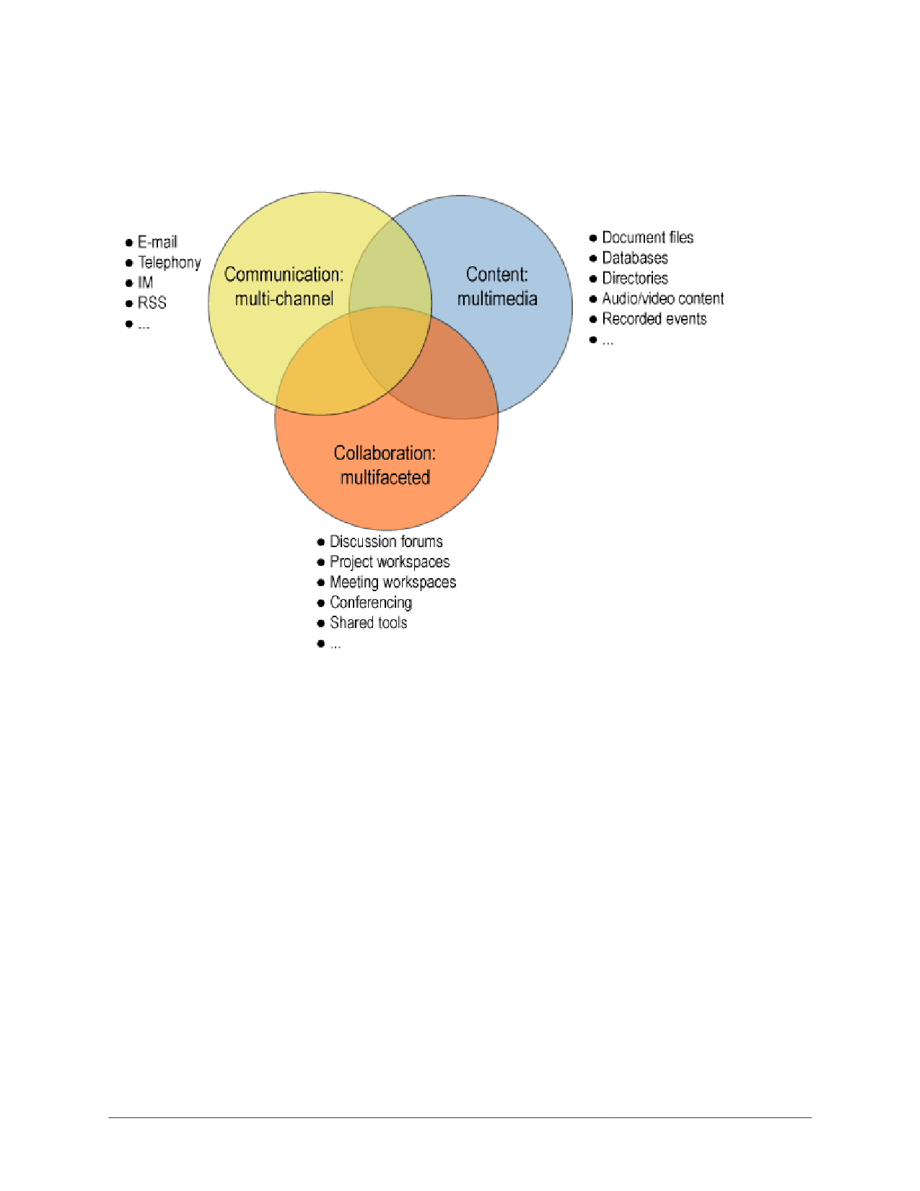
3Client-wide services for filtering, search, archival, and other needs. Users will be able to create filters, for instance, that work across all channel types.
4Collaboration-conducive services (e.g., to create a new meeting or document-oriented workspace from an e-mail item or meeting invitation). Microsoft Office 2003 already offers this capability when used in conjunction with Windows SharePoint Services, and products such as Groove Virtual Office also extend Microsoft Office applications with similar capabilities.
5Further decoupling of devices and services, with seamless synchronization of profiles and preferences across device types and access methods.
E-mail will serve in a reduced role as other communication, collaboration, and content management capabilities are more widely deployed, in part because e-mail won't be routinely misused for collaborative activities.
Metamodels Matter More
A metamodel is a model of a model. Metamodels determine the range of applications that can be addressed with software products. Blogs, for example, are useful for relatively simple, HTML-based, reverse-chronologically sequenced e-mail journals. Other currently popular e-mail client product metamodels typically include an inbox, folders, a calendar, a contact list (address book), and simple to-do/task lists.
Comprehensive and seamless communication and collaboration support requires a broad and deep metamodel. The metamodels incorporated in products such as IBM Lotus Notes/Domino and Groove Virtual Office, for example, are so deep (especially in terms of security and synchronization) that, in some respects, the products have more in common with platforms than with other communication/collaboration products.
Content-related metamodels are also increasingly important. The metamodel embodied in Traction Software's Enterprise Blog software, for example, builds on decades of hypermedia research by Douglas Engelbart (Stanford Research Institute), Andries van Dam (Brown University), and other leading thinkers who pioneered and first implemented hypertext starting in the 1960's. Traction is as simple as a wiki (defined and described in the “Wikis for Collaboration” section of this document) in terms of getting started with a new workspace, but the depth of its metamodel makes Traction more robust for a wider range of collaboration needs as workspaces evolve. This type of metamodel depth and scope will be increasingly important as organizations expand the complexity and volume of interaction managed in workspace offerings.
Communication/Collaboration/Content Market Dynamics: Category Consolidation and Collisions
Communication, collaboration, and content management vendors are exhibiting a pattern also seen at the platform, DBMS, and application server layers of the software stack. First, market momentum is consolidating, with IBM, Microsoft, and Oracle poised to gain market share. The three leaders are the only companies that can, at this point, afford to continue making the investments required to compete across the entire communication/collaboration/content continuum, and they also have strategic advantages, relative to other vendors, in their platform and/or application businesses.
A second market dynamic that is fostering consolidation is the growth of free, open source, and low-cost (often hosted) alternatives for subsets of the communication/collaboration/content continuum. Blog and wiki software, for example, now have considerable market momentum for domains that aren't a good match for platform-oriented enterprise-vendor offerings.
1 5

The expanding scope of communication/collaboration/content architecture is also producing some product category collisions. The leading content management, document management, and portal vendors, for example, now all offer collaboration-focused tools. It's unlikely, however, that these vendors will be able to round out their offerings with collaboration features more rapidly than the communication and collaboration leaders can add content/document management and portal-oriented capabilities. EMC may prove to be an exception to this pattern, as its Documentum and eRoom acquisitions have large installed bases and strong product-line-level synergy.
Specialized Market Opportunities
Communication/collaboration/content market transitions have created several opportunities for vendors that are focused on specialized, often tactical market opportunities. In the IM market, for example, vendors such as Akonix Systems, FaceTime Communications, and IMlogic offer products to expand the scope of secure, auditable IM to include public IM services. Merger and acquisition activity is a natural development in such specialized market segments, with, for example, Symantec acquiring IMlogic during January 2006 in order to augment Symantec's messaging security and archiving product family.
Several vendors have also focused on the need to integrate disparate systems. CASAHL Technology, for example, specializes in integrating, extending, and migrating collaborative content and applications among products from Groove Networks, IBM, Microsoft, Oracle, and other vendors. Percussion Software is another integration specialist, providing tools to integrate IBM Lotus Notes/Domino content with content management and workflow applications.
Groove is an example of a collaboration vendor with both stand-alone and complementary market opportunities. Groove Virtual Office is a powerful collaboration platform on its own, but it offers integration with Microsoft products including Office, SharePoint, and Visual Studio, so Groove is also used by many Microsoft customers seeking to take SharePoint content securely offline. In another example of market consolidation, Microsoft acquired Groove in March 2005 and plans to both continue offering Groove as a stand-alone product and to integrate Groove-related technologies into the Office 2007 product family.
Selectively Fertile Ground for Free and Open Source Software/Services
In another recurring IT pattern, the combination of standards and commoditization has resulted in opportunities for free and open source initiatives and vendors. There are now several free and/or open source enterprise messaging initiatives, for example, as well as open source initiatives focused on collaboration, such as OpenGroupware.org.
In an open source document management example, one of the original co-founders of Documentum has contributed to Alfresco , a commercial open source alternative for enterprise content management. Alfresco is not freely available for commercial deployments, but it is offered at a considerably lower price than traditional document management product alternatives. Plone is another popular open source content management system.
The wiki community has been a particularly prolific open source collaboration context, with a variety of free and commercial wiki alternatives now available. Socialtext has been an especially visible commercial wiki software vendor, with its wiki-based workspace offering.
Burton Group does not expect free or open source communication/collaboration initiatives to become a significant, direct threat to commercial vendors such as IBM, Microsoft, and Oracle, however, because competition in the enterprise infrastructure market is now focused more on integration on a platform and product family basis than any specific communication/collaboration market segment. The free and open source alternatives are important options for a range of organizational and personal communication and collaboration needs; they're just not likely to expand to address the full spectrum addressed by commercial, enterprise-oriented vendors.
1 6

Recommendations
Organizations and individuals seeking to optimize communication, collaboration, and content management endeavors need to account for several technology- and policy-related issues.
Collaborate to Create a Comprehensive Strategy
The first step toward developing a comprehensive communication/collaboration/content strategy is to bring all related domain/subject matter experts together, and to ensure they are all communicating, collaborating, and sharing content. In a practice-what-you-preach sense, this multidisciplinary and often distributed planning context is an excellent opportunity to employ software tools such as wikis in order to facilitate the work.
Domain areas that should be part of the analysis and planning include e-mail/messaging, IM, conferencing, portals, workflow, business process automation, telephony, digital rights management, security, and privacy. Content, document, file, records, and web content management domains should also be included.
It's critically important to build organizational consensus about the future of communication/collaboration/content management, and to resist simply extrapolating from historical, often over-specialized experience. All participants should understand the expanding communication/collaboration/content-related ramifications of regulatory compliance requirements, for example, and the team should also work to develop a shared set of expectations about the opportunities and risks associated with next-generation mobile devices and services. The planning must also account for tactical constraints and considerations, such as the lack of native offline support in Microsoft SharePoint (prior to the release of Microsoft's Office 2007 family of products) and the need to integrate deployed communication/collaboration/content tools and applications.
The strategic planning process should avoid historical patterns of distinguishing among
synchronous/asynchronous, ephemeral/persistent, intranet/Internet, and other blurring boundaries. It should also assume a work lifecycle perspective, and account for patterns flowing across communication and collaboration contexts, such as the common scenario of an item in a communication channel resulting in the creation of a project workspace, which in turn ultimately produces more communication-channel-based activity (all of which produces more content that must be appropriately managed).
The planning process should be immediate and high-priority, as many organizations are already exhibiting symptoms of inadvertent complacency, and the next wave of mobile devices will usher in new types of opportunities and challenges. It's also extremely unlikely that government organizations are going to slow or reverse the recent trend toward more stringent regulatory compliance requirements.
To maximize the probability of success, it's also useful to start with a small number of projects, and to clearly communicate the business value of successful communication/collaboration/content tool usage. Business domains that have been recently impacted by expanding regulatory compliance requirements are strong candidates.
Build a Product/Service Portfolio
Most organizations and individuals currently have large and diverse collections of communication/collaboration/content management tools. As market consolidation continues and as standards improve interoperability, it's important to build a portfolio of communication/collaboration/content offerings, and to ensure they are used effectively.
Steps toward building the portfolio include:
1Taking inventory of existing communication/collaboration/content products and services 2Projecting tactical and strategic communication/collaboration/content goals and requirements 3Reviewing the operational, competitive, and strategic status of your primary
communication/collaboration/content suppliers, and mapping their strengths and weaknesses to your
organization's emerging requirements
1 7
4Reducing dependencies on suppliers that are unlikely to thrive in the next round of competition
The steering committee should also track market trends and periodically reconvene to ensure that the group sustains a consistent level of consensus, because the criteria for what constitutes “good enough” and overkill in different communication/collaboration/content contexts will remain dynamic. While a wiki might be the best short-term form-follows-function fit for a planning context today, for example, expanding regulatory compliance requirements may necessitate moving the workspace to a more enterprise infrastructure-integrated alternative tomorrow.
Decision criteria for the use of DBMS-based communication, collaboration, and content management offerings are a second example of a context that warrants regular review. As DBMS pervasiveness continues to expand and DBMSs become more cost-effective for a wider range of application types, what today might seem like architectural (or economic) overkill will often be the ideal choice in the future.
Proactively Prepare Policy
Organizations that fail to address perennial etiquette and incentive system challenges will incur all of the communication/collaboration/content costs and achieve few of the benefits. Policies must be formulated and established to:
1Minimize the potential for inadvertent complacency as well as deliberate, counterproductive work patterns (e.g., knowingly depriving coworkers of beneficial information for personal or political reasons).
2Maximize secure information structuring and sharing, and minimize the potential for information dissipation.
3Make it easy and convenient for people to select and use the right tool for a given need, by providing tool selection guidance, templates, and examples. Highlighting and rewarding exemplary communication/collaboration/content behavior is often useful for building broader awareness of this need.
Policies should also encourage people to remain cognizant of communication and collaboration contexts. In collaborative endeavors, for instance, it's critically important to establish purpose before action—to clearly formulate, articulate, and build consensus about project goals and roles. Participants working in (real or virtual) collaborative workspace endeavors, as a second example, should also turn off (or tune out) channel-based alert mechanisms that aren't urgent or pertinent for the task at hand. It's also good policy to set an expectation that all communication and collaboration endeavors, over time, will be recorded and analyzed, in part to capture organizational knowledge, and in part for regulatory compliance.
Plan for Change and Heterogeneity
Communication, collaboration, and content management needs are definitely not a “one size fits all” issue. Different communication/collaboration/content patterns and personal preferences must be addressed, as must the large, installed base of deployed products and services.
Pragmatically, of course, no organization is able to dictate product/service choices to its entire community of customers, suppliers, and partners. In addition, the growing use of interorganizational communication and collaboration means that the range of products/services that organizations must be able to work with will continue to grow, even as organizations consolidate internal options.
The ongoing changes in the product/service offerings of major suppliers, especially IBM, Microsoft, and Oracle, will also continue to result in changes for their customers. Fortunately, expanding standards such as SIP,
SIMPLE, and WS–* (the myriad web services initiatives related to e-mail services standards) will help to alleviate historical multivendor integration and interoperability challenges.
1 8
Play and Learn in Order to Understand the Future of Work
Beyond all of the planning and policies, it's also important to develop a vision of the future of communication, collaboration, and content management tools. Internet-based multiplayer games are a good place to start. Game services such as Xbox Live include task-focused, immersive, multimedia workspaces with a variety of seamless communication and collaboration tools. They're also very useful leading indicators of more mainstream-oriented trends. While the more risqué and violent games obviously aren't useful case studies for future work trends, the overall experience is a hopeful leading indicator that communication and collaboration tools will continue to make work more productive, responsive, and enjoyable.

1 9

The Details
This section elaborates on the historical developments that led to today's communication/collaboration/content challenges, and includes examples of channel- and workspace-oriented offerings.
Causes of Communication / Collaboration / Content Complexity and Chaos
Several challenges have constrained communication, collaboration, and content management deployments in the past, ranging from cost and complexity to etiquette and incentive systems.
Costly, Complex, and Closed Enterprise-Oriented Infrastructure Products
The cost, complexity, and market focus of historical communication/collaboration/content products and services have been long-standing and significant problems. Early offerings required extensive vendor infrastructure investments. For example, the developers of pioneering products such as Lotus Notes were forced to compensate for the lack of adequate, cross-platform services for security, compound document storage, and data distribution. The scope and depth of products such as Notes meant they were inherently enterprise-oriented and required extensive administration and management resources. Early products were also priced and licensed in traditional enterprise models, making it difficult for small- to medium-size organizations to justify their cost.
Early communication and collaboration products were also foreign to both users and application developers, thus necessitating investments in training. The user model was often counterproductive because users were forced to work in terms of applications, artifacts, and actions, instead of the other way around (working in context and focused on real-world actions and artifacts). In order to complete an expense report, for example, a user might have to launch IBM Lotus Notes, navigate to an expense reporting database, create a new Notes document, and launch an Excel file attachment, taking several application- and artifact-related steps that don't directly help in the real-world activity of completing a request for reimbursement of expenses.
A lack of industry standards for communication and collaboration domains resulted in proprietary formats, protocols, and APIs—the information technology (IT) investments made in one product weren't readily transferable, and integration across systems was challenging. The proprietary architectures also meant the products were very difficult to use across organizational boundaries. Interorganizational collaboration could be done with products such as Notes, but it required cross-certification and server-to-server replication procedures that weren't easy to establish.
Artificial, Arbitrary, and Counterproductive Boundaries
Early communication and collaboration products generally followed the model in Figure 2, with e-mail for communication, discussion forums for collaboration, and basic content management in folders and files. This was a pragmatic approach during the 1980's and early 1990's, when hardware and networking were still very expensive and the commercial Internet had yet to go mainstream. However, it resulted in some counterproductive compromises due to constraints that now seem artificial and arbitrary. The product architectures were more a function of hardware and networking constraints at the time of their design than they were reflections of the way people naturally communicated and collaborated.
20
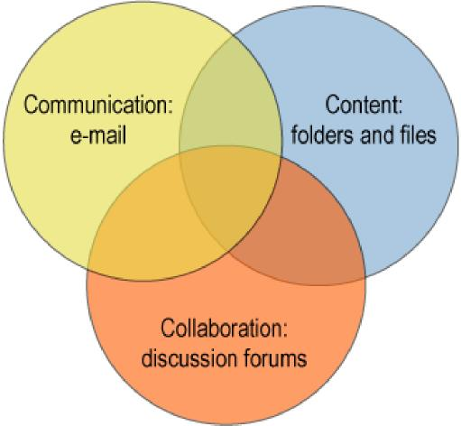
Figure 2: Early Communication, Collaboration, and Content Product Categories
For many people, the model depicted in Figure 2 would seem a bit generous, as in most cases the communication/collaboration/content-oriented tools had little overlap. More integrated products, such as IBM Lotus Notes/Domino, followed an integrated approach. But that was, until recently, the exception rather than the norm.
Historically, the leading communication/collaboration/content products were conducive to specialized and somewhat vocational organizational models, with IT departments establishing distinct operational support groups for e-mail/messaging, collaboration, and content management (in addition, of course, to the telecom and network infrastructure groups that were already in place). This pattern exacerbated later adoption of new communication/collaboration/content products and services. Instant messaging (IM), for example, is a communication channel, but it's not architecturally similar to e-mail, so in many cases yet another new group was established to shepherd its usage. Web conferencing is another example; it's a synchronous collaboration tool that doesn't neatly fit into organizational structures focused on supporting e-mail, asynchronous collaboration tools such as discussion forms, and content management.
“Good Enough” Alternatives
In a familiar industry pattern, the cost and complexity of enterprise-oriented products resulted in new opportunities for vendors addressing otherwise under-served markets, and/or focused on delivering products that were good enough for a subset of the overall problem space. As product category calcification continued in enterprise communication, collaboration, and content management markets through the mid-1990's, a new set of alternatives emerged. Many of the alternative offerings were service-oriented and available as hosted offerings that required little or no direct IT administrative support. Hosted offerings were particularly attractive for collaborative endeavors crossing organizational boundaries.
Architecturally, many of the communication/collaboration/content offerings of the last decade have been based on a web application architecture, with relatively simple, browser-based user experiences and a centrally managed, web application server back end. Many of the more recent offerings have been “teamware” that offer simple, shared virtual spaces on the Internet for teams to share documents, participate in collaborative discussions, and use a common
set of tools for project calendars, task lists, and so on.
2 1
Examples of teamware that facilitate document sharing, discussion forums, and tool sharing range from enterprise product offerings such as eRoom (part of EMC/Documentum) to free, consumer-oriented, hosted offerings such as MSN Groups and Yahoo! Groups. In comparison with previously established products such as IBM Lotus Notes/Domino (which was also web-ified starting in the mid-1990's), the web-centric offerings had broad reach, requiring only browser clients, and offered centralized application administration. They also entailed trade-offs in terms of user experience (browser client versus rich client) and offline support (no autonomous operation). However, these offerings were still attractive for many requirements, especially when enterprise-oriented alternatives weren't practical or economically feasible.
To give credit where due, it's important to note that e-mail, chat, and discussion forums had been around for decades by the time of the Internet bubble. Pioneering protocols and services such as Internet Relay Chat (IRC) and Usenet's NNTP (Usenet started in 1979) had long served the Internet community, but they weren't routinely used in business or by individuals because of limited Internet access and often because of sometimes cryptic user experiences. Now Usenet, for instance, is more readily accessible as Google Groups, which has been building on a complete archive of Usenet discussion groups since 1981 (sometimes to the chagrin of individuals who posted content during the early days of the Internet, when it was a relatively limited community, and now find their decades-old posts accessible to anyone with Internet access).
More recently, blogs and wikis are two important examples of Internet-centric communication/collaboration/content tools that are challenging more traditional, enterprise-oriented products. Blogs are useful for web journals, and wikis are powerful, lightweight workspaces for collaborative authoring.
Explosive Growth in Channels and Workspaces
The availability of a wide variety of communication/collaboration/content offerings, along with relentless drives to “do more with less” (which often meant “do more with fewer,” as in fewer people) during the last several years, have resulted in significant growth in the use of channels and workspaces. For most people, the pattern applies to both work and personal interaction and information management endeavors. It has been a distinctly mixed blessing, not only affording new opportunities, but also bringing new challenges, in part due to information overload and in part due to deteriorating signal-to-noise ratios in primary channels such as e-mail.
E-mail's growing problems include overwhelming volume, spam (including “occupational spam,” a phrase used to describe counterproductive intraorganizational e-mail patterns), and viruses, along with other types of security challenges. E-mail has also been complicated by the tendency of people to use it as a tool of the least common denominator when other, more appropriate tools are not readily available. For most people, the overall result is a set of generally inconsistent, disconnected, and redundant tools for communication, collaboration, and content management.
Divisive Devices and Networks
The evolution of mobile devices and networks has also been problematic— especially in North America. The Application Platform Strategies report, “Mobility and Innovation: Trends in Enterprise Collaboration,” for example, outlined a vision for ideal collaboration environments, but the vision has yet to be completely realized.
Divisive devices are a key part of the problem, as most mobile devices in broad deployment today involve compromises in terms of scope, capability, and integration. As a result, many mobile professionals could benefit from using something like a Batman utility belt to manage their diverse and multifaceted devices, and some now travel with power strips to simplify using the power adapters required for their multitudinous devices.
Networking has also been a challenge for mobile devices. Despite the widespread publicity for Wi-Fi hot spots and Bluetooth, for example, device-oriented wireless networking (for services other than telephony) has remained too complex and costly for most people. Research In Motion (RIM)'s BlackBerry is an important counterexample and leading indicator, but it has thus far been used primarily by enterprises for wireless/mobile access to e-mail.
22

Multidevice synchronization is another major problem. Most people currently have a difficult time keeping their contact lists synchronized across their device collections, so more general-purpose communication and collaboration resources remain tantalizingly out of reach of their devices.
Today's mobile, wireless devices are well suited to a wide range of communication, collaboration, and content management needs. Because of current constraints, however, they are instead relegated to roles primarily focused on a small set of communication channels (phone, e-mail, SMS, and perhaps IM) and rudimentary personal information management (contacts, calendar, to-do lists). Although capable of much more—with expansive storage space, powerful processors, and flexible input/output capabilities—the devices are, today, generally dumbed-down by software and network limitations.
Incumbent Vendor Strategy Shifts and Stability Concerns
Significant and disruptive product family transitions among the largest communication and collaboration vendors (IBM and Microsoft) have created challenges during the last few years. For example, IBM Lotus Notes/Domino is the most widely deployed enterprise collaboration product today (in terms of supporting workspaces, not just enterprise e-mail). But for several years, IBM focused on migrating Notes/Domino customers to its WebSpherebased Workplace product family (IBM has since more successfully harmonized the product lines).
Microsoft has made major communication and collaboration product strategy changes during recent years. Exchange Server 2000, for example, included capabilities for IM and conferencing, but those features have since been displaced by Microsoft's newer Live Communications Server and Live Meeting service. Microsoft SharePoint is now at the center of Microsoft's workspace architecture, but SharePoint was re-architected for its 2003 release and has several prerequisites, including Office 2003 and Windows Server 2003, in order to use its full feature set. SharePoint will also be extended in a release expected during the second half of 2006 to address some facets of enterprise content management.
Oracle is emerging as another strong competitor in the enterprise communication/collaboration/content management market. Oracle Collaboration Suite offers a wide variety of communication and collaboration capabilities, all in a consistent product framework built on Oracle's relational DBMS. Oracle has been very effective in positioning its Collaboration Suite, promoting, for example, the fact that Oracle's DBMS-based architecture offers today what IBM and Microsoft are planning for future releases.
The relentless competition among IBM, Microsoft, and Oracle, along with the growing variety of free and low- cost tools such as blogs and wikis, have combined to produce a destabilizing wave for many smaller competitors in the communication/collaboration/content management market. As a result, many enterprises are now contending not only with disruptive changes among their primary suppliers, but also serious viability questions for their secondary suppliers.
For more on the communication/collaboration/content competition among IBM, Microsoft, and Oracle, see the Collaboration and Content Strategies report, “IBM, Microsoft, and Oracle: Competing to Lead the Next Wave of Enterprise Communication/Collaboration.”
Ineffective Etiquette and Incentive Systems
Communication, collaboration, and content management have been perennially challenged by etiquette and incentive systems. Historically, communication/collaboration/content tools often entailed redundant work with no clear return on personal time investment, such as a pattern that discouraged information structuring and sharing.
The widespread and often addictive nature of e-mail and instant messaging (IM) has also caused problems for individuals who spend an inordinate amount of time using the tools instead of focusing on their other responsibilities. Group contexts have also been complicated by tools such as e-mail and IM, with many meeting participants paying more attention to the e-mail and IM channels than the group activities.
23

In many organizations, the lack of well-designed and articulated best practices in communication/collaboration/content contexts results in people reverting to least-common-denominator alternatives, usually a mix of e-mail, phone, IM, and faxes. This pattern causes further information dissipation (spread across inboxes, local file systems, etc.) and is also conducive to inadvertent complacency—people unknowingly violating organizational policies for information distribution and retention.
Communication: Channels and Items
In order to understand the significance of communication and collaboration product metamodels, it's useful to review them in popular channel- and workspace-oriented offerings. This and the following sections include examples with FeedDemon and Groove, although their use in examples should not be interpreted as a recommendation of either product, relative to their respective competitors.
Blogs for Communication
Blogs, also known as weblogs, are typically simple web-based journals, authored by an individual person, and used to share information with colleagues, friends, family, or anyone else who cares to read the blog. Most blogs present (post) items in reverse chronological sequence, and many blog readers use RSS aggregator clients (such as FeedDemon) in order to efficiently skim blogs and other news sources for new activity.
Blogs have become very popular, in part because they are easy to get started, relative to other web-publishing alternatives. Popular blogging products/services include Blogger (acquired by Google in early 2003), Radio UserLand, and Six Apart's Movable Type software and TypePad service. The explosive popularity of blogging has led to the creation of blog aggregator and searching services such as Technorati . Several books on blogging (both technology and the “blogosphere” culture) have also been published.
From a communication perspective, most blogs have very simple metamodels, representing web-based channels with basic Hypertext Markup Language (HTML) posts. As such, blogs are useful both for stand-alone purposes and as viewing or alerting mechanisms used in conjunction with other contexts, including workspaces.
Some blog offerings have evolved to become relatively elaborate e-mail publishing systems, supporting comments (nested discussions associated with posts), multiuser authoring, staging, versioning, and other traditional content-publishing features. Blogger's comment feature, for example, also offers e-mail notification when comments have been posted, making Blogger something of a hybrid communication tool that fosters collaborative discussions and also supports RSS and e-mail channel models. Traction Software is another important hybrid tool example. It can be not only easily deployed for enterprise blogs, but also robustly scaled to address more elaborate needs because of its advanced hypertext metamodel.
Multi-Channel Clients
FeedDemon is a popular Extensible Markup Language (XML) syndication aggregator client. The FeedDemon client model shown in Figure 3 has three panes. The left pane is called the channel bar, and it lists RSS channels that have been selected and grouped by the user (the channel group name in the example is “1 Burton Group”). In this example, the channel for Burton Group's Application Platform Strategies service has been selected.
24
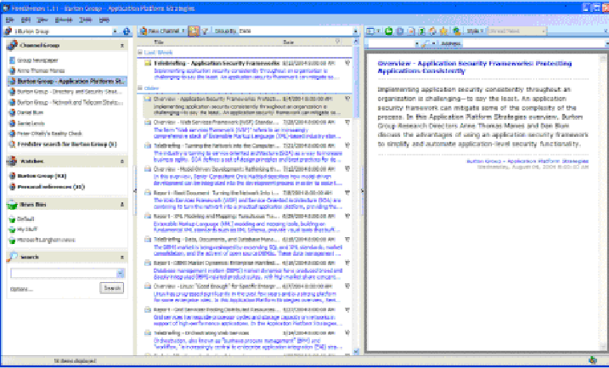
Figure 3: FeedDemon Client
The channel bar also lists FeedDemon watches, which are item filters; in this example, any items that include the words “Burton Group” will appear in the Burton Group watch. The channel bar's news bins are folders into which users can drag and drop items to keep and organize them. Since items in channels are essentially point-in-time snapshots, with retention limits, any items users want to save permanently must be copied into news bins.
The center pane is the news item list, and it uses bold-faced text to identify unread items (in the example, the “TeleBriefing—Application Security Frameworks” item is unread). FeedDemon includes several item-level tools; for example, there are menu options for e-mailing an item or opening a blogging client to annotate and post the selected item in a blog.
The right pane is FeedDemon's newspaper view, and it displays item contents. In this example, a single item was selected in the news item list; if no item has been selected, the newspaper view includes multiple item summaries. The newspaper view may also have multiple (tabbed) open content windows, and uses a browser client to display full webpages when a Uniform Resource Locator (URL) has been clicked.
FeedDemon is modeled on Outlook 2003's user experience. The corresponding panes in Outlook 2003 are for folder lists, items (that may be messages or other item types if unified messages services such as a fax or voicemail message are being used), and an item viewer pane.
Many IM clients have similar channel-oriented interfaces for persistent communication items. Yahoo! Messenger, for instance, has an optional (turned off by default) message archive feature that presents a list of channels including messages, alerts, conferences, and mobile messages. In a familiar user model, selecting a channel populates an index of items, and a third window pane presents selected item content.
Google's Gmail service, as a second example, offers the option of capturing Google Talk IM chat histories within a Gmail folder. This also makes Google Talk chat histories searchable, along with e-mail messages.
Collaboration: Workspaces and Artifacts
25
The Collaboration and Content Strategies overview, “Virtual Workspaces: Hubs for Activity-Centric Collaboration,” provides an extensive overview of workspace-based collaboration offerings. The rest of this section provides an example of key workspace-related capabilities through an introduction to Microsoft's Groove Virtual Office product and a summary of wiki capabilities.
Workspaces for Collaboration
Though Groove Virtual Office (hereafter simply referred to as “Groove”) is a product that has not yet achieved widespread market success, it serves as a useful leading indicator of features that are likely to eventually appear in other collaboration products/services. The product will be reintroduced as Microsoft Office Groove 2007 during the second half of 2006, and appears to have a strategic role in Microsoft's overall communication/collaboration/content management product strategy.
Groove's metamodel includes:
1Workspaces: Shared, virtual spaces governed by membership and roles
2Tools: Components that combine forms, views, and data models for specific tasks such as discussion forums, file folders, group calendars, contact managers, and business activities such as collaborative document reviews; Groove also includes a workspace type for file sharing that extends Microsoft Windows Explorer with Groove services
3Artifacts or tool content items: These vary depending on tool type
4Presence awareness and tracking: These apply both globally and in specific workspaces and tools 5Subscriptions: Groove users can create subscriptions to be alerted about activity involving workspaces, tools, shared folders, or specific files
6Very deep, always-on security: Groove security includes systemwide encryption and an advanced,
federated identity and trust model that can be integrated with organizational directory systems 7Seamless synchronization: Groove's metamodel assumes local operations on shared workspaces, and the
product includes services that unobtrusively keep workspace instances synchronized; Groove's
synchronization model is built on a peer-to-peer architecture that doesn't require a centralized server for
workspace management or distribution
Figure 4 includes two views of the Groove Launchbar, Groove's systemwide workspace and contact-tracking tool. The workspace Launchbar pane appears when the “Workspaces” tab is clicked. In this example, workspaces are listed in a status-categorized view. Two workspaces are active, none have unread content, six workspaces are present on the PC but have no unread content, and a total of 15 workspaces are associated with the user account but not loaded on the computer.

26

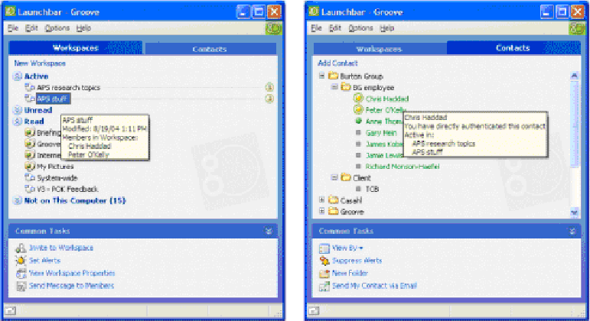
Figure 4: Groove Virtual Office Launchbar
The textbox showing the status of the “APS stuff” workspace appears when the mouse pointer (not shown in Figure 4) hovers over a workspace name. Groove's workspace-level presence awareness is evident in this example; at the time of the screen shot, Chris Haddad and Peter O'Kelly were active in the “APS stuff” workspace.
The screen shot on the right side of Figure 4 is an example of contact tracking in Groove's Launchbar (visible when the “Contacts” tab is selected). In this example, contacts are viewed by folder (contact group); they can also be viewed in alphabetical and other ordering such as current status. The mouse pointer was hovering over Chris Haddad's contact name in this example, so Groove displayed a textbox with supplemental information about Chris Haddad, including the list of workspaces in which he was currently active.
Figure 5 is a screen shot of a Groove workspace.

27

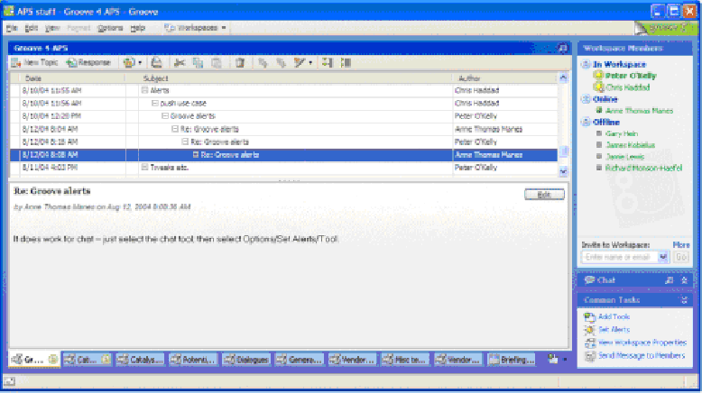
Figure 5: Groove Workspace Example
The workspace window has several panes. The left pane shows a tool view; in this case, a simple discussion tool used for a collaborative discussion of Groove features and their applicability for a pilot test within Burton Group's Application Platform Strategies service. In this example, a discussion item is selected in the top pane, and the item's content is displayed below the item list.
The workspace also includes several other discussion tools and a group calendar tool. The tabs below the discussion tool view are used to navigate among tools, and they include presence awareness. The circled number “1” (next to the tool tabs on the left) indicates that one workspace member was active; hovering over the circled “1” would display a textbox listing the active member's name.
Other panes in the workspace window include a workspace-level member list (in the upper right), showing the current status of workspace members. In this example, Chris Haddad and Peter O'Kelly were online and active in the workspace, Anne Thomas Manes was online but not active in the workspace, and several other workspace members were offline.
A chat tool is also available in the workspace; in this example it was minimized (clicking on the double up-arrow icon in the chat frame would expand the chat tool and display any chat history). The pane on the lower right side makes common tasks (for the current context/selection) available.
Figure 6 is an example of Groove's file-sharing workspace feature.

28

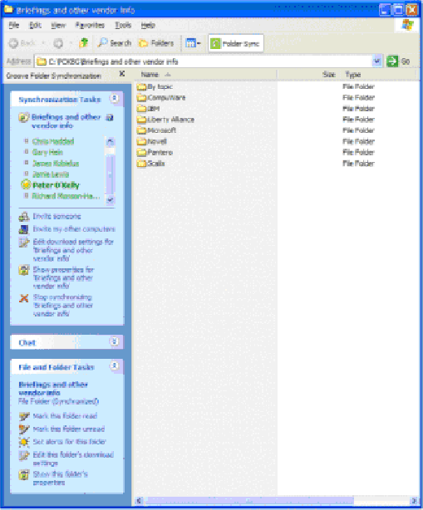
Figure 6: Groove File-Sharing Workspace Example
Windows Explorer is extended with Groove-specific capabilities in the left-side task pane. Groove automatically synchronizes the file-sharing workspace among workspace members, so any files created or updated in the workspace appear on all workspace members' computers. This capability is also useful for personal information management, and, for example, Groove can be used to synchronize Internet Explorer Favorites and other system-level folders across multiple PCs.
Synchronization-related tasks are listed at the top of the pane, showing membership and presence status and offering actions such as inviting additional members. A chat tool is also available (but is minimized in the example). The lower task list includes other context-sensitive file- and folder-related tasks. In this example, since folders were displayed, folder-level tasks were presented; if a file or collection of files had instead been selected, Groove would have presented file-level tasks.
Wikis for Collaboration
In contrast to client-focused products such as Groove, wikis are web-centric, lightweight alternatives for collaborative content management. The Collaboration and Content Strategies reports, “Blogs, Wikis, and Beyond: New Alternatives for Communication and Collaboration” and “Wikis in the Enterprise: Democratizing and Directing Collaboration and Content Management,” provide detailed introductions to wiki-related content management and collaborative application development. This section introduces high-level wiki concepts.
Quoting from Answers.com's definition:
29
Wiki-wiki is the Hawaiian word for quick. Wiki Wiki Web sites are sites designed for users to be able to make additions or edit any page of the site. They often have a common vocabulary, and consider themselves a “Wiki” community.
Another definition can be found in Wikipedia , a free, web-based, collaboratively authored encyclopedia (which also happens to be an example of a wiki):
Here a wiki . . . is a type of website that allows users to easily add, remove, or otherwise edit all content, very quickly and easily, sometimes without the need for registration. This ease of interaction and operation makes a wiki an effective tool for collaborative writing. The term Wiki can also refer to the collaborative software itself (wiki engine) that facilitates the operation of such a website.
The Wikipedia definition continues with a detailed wiki introduction and history.
The first wiki was created by Ward Cunningham in 1995 in order to facilitate collaborative software engineering. From a metamodel perspective, wikis consist of pages, links (page references), and views. Changes to pages are also captured, providing a means of version control (that often comes in handy due to “the wiki way” cultural norm of allowing anyone to edit any page at any time).
As with blogs, wikis have become very popular, in part because they are very simple alternatives to more traditional e-mail content authoring and communication/collaboration/content management tools. Ward Cunningham used an elegantly simple model for hypertext authoring. For example, to create a new page in a wiki tool, users simply create a link to the new page and then follow the link to edit the new page. The alternative—creating the target of the link first, capturing its URL, and then returning to the original writing context—is much more disruptive.
Content: Virtually Unified Containers
Figure 7 is a depiction of key architectural developments in virtually unified content containers. Where previously enterprises had to deal with multiple product categories and content formats, there is now a trend toward consistent data services that present a consistent level of abstraction (for both content-consuming end users and application developers) that isolates underlying storage system differences.

3 0

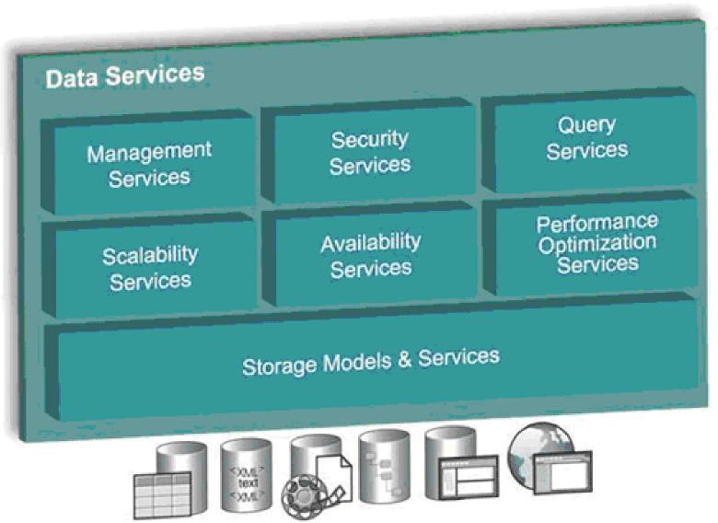
Figure 7: IBM Data Services Architecture (Source: IBM)
Several developments have made this type of approach feasible. First is an industry-wide shift to XML and XML Schema. Many content domains that used to entail working with unstructured or semi-structured, often proprietary formats are now shifting to technology- and vendor-independent XML formats, generally with richer metadata (often through a cleaner distinction between metadata managed by a storage system versus application-managed metadata).
A second important development is the advent of database management systems (DBMSs) that robustly support non-relational data types, such as compound XML documents and other media types. As DBMSs evolve to handle XML-structured data, and as communication/collaboration usage patterns expand to more multiuser scenarios (keeping in mind that even a single user working with multiple devices constitutes, in many respects, a multiuser scenario), a DBMS foundation is ideally suited for an expanding range of communication/collaboration needs.
Standards are a third key development. In addition to XML-related standards, the WS-* suite of web services standards, along with other content-oriented standards initiatives such as JSR 170 (the Java Community Process content repository API initiative) have made it possible for developers to adopt driver/adapter-based architectural models such as the IBM Data Services model in Figure 7.
Several vendors failed to achieve widespread success with similar models using proprietary approaches in the past, such as Microsoft's Object Linking and Embedding Database (OLE DB), which is built on Microsoft's Component Object Model (COM) technology. The combination of DBMSs extended with robust XML support and several recent industry standards, however, has established new opportunities for virtually unified content.
3 1
Conclusion

Communication/collaboration/content offerings are in the midst of sweeping transformation. Previously constrained by proprietary, costly, and complex products and services, and recently impacted by severe spam and security problems, the offerings are now moving to a model that will be much more productive for organizations and individuals.
The model is built on a foundation of channels for communication, workspaces for collaboration, and virtually unified content management. It has important potential for addressing increasingly broad and stringent regulatory requirements. It also has unprecedented potential to improve productivity and responsiveness by keeping users focused on business tasks instead of technology and tool concepts.

3 2

Author Bio
Peter O'Kelly
Research Director Emphasis: XML
Background: Peter O’Kelly is the research director for Burton Group’s Collaboration and Content Strategies service. He covers communication/collaboration workspaces, applications, and tools; XML and document/database management system convergence, and extensive experience with IBM and Microsoft communication/collaboration products. Prior to joining Burton Group, Peter led IBM Lotus Notes product management during the pivotal Notes R4 release, and established product management and competitive strategy for collaborative application pioneer Groove Networks. With 25 years of experience in application architectures, XML and database topics, collaborative applications, enterprise application development, and business development, Peter is frequently quoted and looked to for insight regarding major movements in collaboration and communication fields, and is a frequent speaker at Enterprise 2.0 and IBM Lotusphere. Peter blogs at http://pbokelly.blogspot.com.

3 3

