A Practical Guide
to

Federal Enterprise Architecture
Chief Information Officer Council
Version 1.0
Preface
iii
An enterprise architecture (EA) establishes the Agency-wide roadmap to achieve an Agency's mission through optimal performance of its core business processes within an efficient information technology (IT) environment. Simply stated, enterprise architectures are "blueprints" for systematically and completely defining an organization's current (baseline) or desired (target) environment. Enterprise architectures are essential for evolving information systems and developing new systems that optimize their mission value. This is accomplished in logical or business terms (e.g., mission, business functions, information flows, and systems environments) and technical terms (e.g., software, hardware, communications), and includes a Sequencing Plan for transitioning from the baseline environment to the target environment.
If defined, maintained, and implemented effectively, these institutional blueprints assist in optimizing the interdependencies and interrelationships among an organization's business operations and the underlying IT that support operations. The experience of the Office of Management and Budget (OMB) and General Accounting Office (GAO) has shown that without a complete and enforced EA, federal agencies run the risk of buying and building systems that are duplicative, incompatible, and unnecessarily costly to maintain and integrate.
For EAs to be useful and provide business value, their development, maintenance, and implementation should be managed effectively. This step-by-step process guide is intended to assist agencies in defining, maintaining, and implementing EAs by providing a disciplined and rigorous approach to EA life cycle management. It describes major EA program management areas, beginning with suggested organizational structure and management controls, a process for development of a baseline and target architecture, and development of a sequencing plan. The guide also describes EA maintenance and implementation, as well as oversight and control. Collectively, these areas provide a recommended model for effective EA management.
Background
Reflecting the general consensus in industry that large, complex systems development and acquisition efforts should be guided by explicit EAs, Congress required Federal Agency Chief Information Officers
to develop, maintain, and facilitate integrated systems architectures with the passage of the Clinger-Cohen Act¹in 1996. Additionally, OMB has issued guidance that requires agency information systems investments to be consistent with Federal, Agency, and bureau architectures. Other OMB guidance provides for the content of Agency enterprise architectures.² Similarly, the Chief Information Officer Council, the Department of the Treasury, the National Institute of Standards Technology (NIST), and GAO, have developed architecture frameworks or models that define the content of enterprise architectures.³
¹ Public Law 104-106, section 5125, 110 Stat. 684 (1996).
² OMB Circular A-130, Management of Federal Information Resources, November 30, 2000.
³ Federal Enterprise Architecture Framework, Version 1.1, Federal Chief Information Officers Council, September 1999; Treasury Enterprise Architecture Framework, Version 1, the Department of the Treasury, July 3, 2000; the National Institute of Standards and Technology's Enterprise Architectural Model, referenced in NIST Special Publication 500-167, Information Management Directions: the Integration Challenge; and Strategic Information Planning: Framework for Designing and Developing System Architectures (GAO/IMTEC-92-51, June 1992).
This guide builds upon, complements, and is directly linked to the GAO Information Technology Investment Management (ITIM) framework⁴ that was developed to provide a common structure for discussing and assessing IT capital planning and investment control (CPIC) practices at Federal Agencies. ITIM enhances earlier Federal IT investment management guidance by extending the Select/Control/Evaluate approach, mandated by the Clinger-Cohen Act, into a growth and maturity framework.⁵ It is also directly linked to the Federal Enterprise Architecture Framework.
The Need for this Guide
While these frameworks and models provide valuable guidance on the content of enterprise architectures, there is literally no federal guidance how to successfully manage the process of creating, changing, and using the enterprise architecture. This guidance is crucially important. Without it, it is highly unlikely that an organization can successfully produce a complete and enforceable EA for optimizing its systems' business value and mission performance. For example, effective development of a complete EA needs a corporate commitment with senior management sponsorship. The enterprise architecture development should be managed as a formal project by an organizational entity that is held accountable for success. Since the EA facilitates change based upon the changing business environment of the organization, the architect is the organization's primary change agent. Effective implementation requires establishment of system compliance with the architecture, as well as continuous assessment and enforcement of compliance. Waiver of these requirements may occur only after careful, thorough, and documented analysis. Without these commitments, responsibilities, and tools, the risk is great that new systems will not meet business needs, will be incompatible, will perform poorly, and will cost more to develop, integrate, and maintain than is warranted.
Conclusion
The processes described in this guide represent fundamental principles of good EA management. Since the guide is not a one-size-fits-all proposition, Agencies or organizations should adapt its recommendations and steps to fit their individual needs. We encourage you to consider these EA processes and best practices carefully before pursuing other approaches.
An electronic version of this guide is available at the following Internet address: http://www.cio.gov.
If you have questions or comments about this guide, please contact Rob C. Thomas II at (703) 921-6425, by email at rob.c.thomas(&,customs.treas.gov, or by mail at:
U.S. Customs Service 7681 Boston Boulevard Springfield, VA 22153
⁴ Information Technology Investment Management: A Framework for Assessing and Improving Process Maturity (GAO/AIMD-10.1.23, Exposure Draft, 2000).
⁵ In the Select Phase, the costs and benefits of all available projects are assessed and the optimal portfolio of projects is selected. During the Control Phase, the portfolio is monitored and corrective action is applied where needed. In the Evaluate Phase, implemented projects are reviewed to ensure that they are producing the benefits expected and adjustments are made where appropriate.
Credits
This document was produced by the Federal Architecture Working Group (FAWG) under the strategic direction of the Enterprise Interoperability and Emerging Information Technology Committee (EIEITC) of the Federal Chief Information Officer Council.
The following persons contributed to accomplishing this Guide.
Name | Title | Agency
Rob C. Thomas, II | Dir., Tech. & Arch. Group, Chief Architect | U.S. Customs Service
Randolph C. Hite | Dir., Information Technology Systems Issues | General Accounting Office
Ray Beamer | Senior Principal Scientist | The MITRE Corporation
William H. McVay | Senior Policy Analyst | Office of Management and Budget
Elaine Ward | Principal Engineer | The MITRE Corporation
Keith Rhodes | Chief Technologist | General Accounting Office
Mary Lou Collins | Lead Engineer | The MITRE Corporation
George Brundage | Chief Architect | U.S. Department of the Treasury
Scott Bernard | Management Consultant | Booz-Allen & Hamilton, Inc.
Lester Diamond | Assistant Director | General Accounting Office
Michael A. Tiemann | Dir., Arch. & Stnds. Div., Chief Architect | U.S. Department of Energy
Thomas P. Cullen | Policy Analyst | U.S. Customs Service
William Lew | Technical Assistant Director | General Accounting Office
John Anderson | Principal Engineer | The MITRE Corporation
Daryl Knuth | Information Architect | U.S. Customs Service
Barbara Scott | Management Analyst | U.S. Department of Education
Paul J. Paradis | Management Analyst | U.S. Department of Energy
Naba Barkakati | Technical Assistant Director | General Accounting Office
Kathy Sowell | Lead Engineer | The MITRE Corporation
Wayne Shiveley | Senior Computer Scientist | Federal Bureau of Investigation

Table of Contents
Prefaceiii
1. | Introduction |  | 1
 | 1.1. | Purpose | 1
 | 1.2. | Scope | 1
 | 1.3. | Audience | 1
 | 1.4. | Document Organization | 2
 | 1.5. | How to Use this Guide | 3
 | 1.6. | Related Documents | 4
2. | Definitions, Drivers, and Principles |  | 5
 | 2.1. | Enterprise Architecture Defined | 5
 | 2.2. | The Uses and Benefits of Enterprise Architecture | 5
 | 2.3. | Legislation and other Guidance | 6
 | 2.4. | Architecture Principles | 7
 | 2.5. | The Enterprise Life Cycle | 8
 | 2.6. | The Enterprise Architecture Process | 9
3. | Initiate Enterprise Architecture Program |  | 11
 | 3.1. | Obtain Executive Buy-in and Support | 11
 |  | 3.1.1. Ensure Agency Head Buy-in and Support | 11
 |  | 3.1.2. Issue an Executive Enterprise Architecture Policy | 11
 |  | 3.1.3. Obtain Support from Senior Executives and Business Units | 12
 | 3.2. | Establish Management Structure and Control | 13
 |  | 3.2.1. Establish a Technical Review Committee | 14
 |  | 3.2.2. Establish a Capital Investment Council | 14
 |  | 3.2.3. Establish an EA Executive Steering Committee | 14
 |  | 3.2.4. Appoint Chief Architect | 14
 |  | 3.2.5. Establish an Enterprise Architecture Program Management Office | 15
 | 3.3. | Enterprise Architecture Program Activities and Products | 17
 |  | 3.3.1. Develop an EA Marketing Strategy and Communications Plan | 17
 |  | 3.3.2. Develop an EA Program Management Plan | 18
 |  | 3.3.3. Initiate Development of the Enterprise Architecture | 18
4. | Define an Architecture Process and Approach |  | 21
 | 4.1. | Define the Intended Use of the Architecture | 22
 | 4.2. | Define the Scope of the Architecture | 22
 | 4.3. | Determine the Depth of the Architecture | 22
 | 4.4. | Select Appropriate EA Products | 23
 |  | 4.4.1. Select Products that Represent the Business of the Enterprise | 23
 |  | 4.4.2. Select Products that Represent Agency Technical Assets | 24
 | 4.5. | Evaluate and Select a Framework | 24
 |  | 4.5.1. Federal Enterprise Architecture Framework | 25

4.5.2. DoD C4ISR Architecture Framework 27
4.5.3. Treasury Enterprise Architecture Framework 28
4.6. Select an EA Toolset 30
- Develop the Enterprise Architecture 33
5.1. Collect Information 34
5.2. Generate Products and Populate EA Repository 35
5.2.1. Essentials in Building the Baseline Architecture 36
5.2.2. Essentials in Building the Target Architecture 36
5.2.3. Review, Validate, and Refine Models 38
5.3. Develop the Sequencing Plan 38
5.3.1. Identify Gaps 39
5.3.2. Define and Differentiate Legacy, Migration, and New Systems 39
5.3.3. Planning the Migration 40
5.4. Approve, Publish, and Disseminate the EA Products 41
- Use the Enterprise Architecture 43
6.1. Integrate the EA with CPIC and SLC Processes 43
6.1.1. Train Personnel 45
6.1.2. Establish Enforcement Processes and Procedures 45
6.2. Execute the Integrated Process 47
6.2.1. Initiate New and Follow-on Projects 47
6.2.2. Execute the Projects 51
6.2.3. Complete the Project 52
6.3. Other Uses of the EA 54
- Maintain the Enterprise Architecture 55
Maintain the Enterprise Architecture as the Enterprise Evolves 55
7.1.1. Reassess the Enterprise Architecture Periodically 55
7.1.2. Manage Products to Reflect Reality 56
7.2. Continue to Consider Proposals for EA Modifications 57
- Continuously Control and Oversee the Enterprise Architecture Program 59
8.1. Ensure Necessary EA Program Management Controls Are In Place and Functioning 59
8.2. Identify Where EA Program Expectations Are Not Being Met 59
8.3. Take Appropriate Actions to Address Deviations 60
8.4. Ensure Continuous Improvement 60
- Summary 63
Appendix A: EA Roles and Responsibilities 65
Appendix B: Glossary 67
Appendix C: Acronyms 71
Appendix D: Example Architecture Products 73
D.1. Mission and Vision Statements 73
- Information Dictionary 73
- Concept of Operations (CONOPS) Graphic 74
- Activity Models and Trees 76
- Business Use Case Model 78
- Class Model 81
- State Model 82
- Node Connectivity Diagrams 83
- Information Exchange Matrix 86
- Organization Chart 87
- Systems Interface Description and Connectivity Diagram 88
- Standards Profile 89
- Technical Reference Model 90
Appendix E: Sample Architectural Principles 93
Appendix F: Bibliography 97
Appendix G: The Zachman Framework 101
List of Figures
Figure 1. Role of Architecture Principles 7
Figure 2. The Enterprise Life Cycle 8
Figure 3. The Enterprise Architecture Process 9
Figure 4. Notional EA Organization 13
Figure 5. Depth and Detail of the Architecture 21
Figure 6. Structure of the FEAF Components 26
Figure 7. FEAF Architecture Matrix 26
Figure 8. DoD C4ISR Framework 27
Figure 9. DoD C4ISR Products 28
Figure 10. The Treasury Enterprise Architecture Framework 29
Figure 11. TEAF Products 30
Figure 12. Example Approach for EA Development 33
Figure 13. Systems Migration Chart 40
Figure 14. IMP/Architecture Project Assessment Framework 44
Figure 15. Architecture Management 45
Figure 16. Define New and Follow-on Programs/Projects 48
Figure 17. Execute Programs/Projects 51
Figure 18. Evaluate Programs/Projects 53
Figure 19. Enterprise Architecture Transition 56
Figure 20. Key Success Factors 61
Figure 21. DoD Battlespace Concept of Operations Graphic 74
Figure 22. U.S. Customs Service Trade Compliance Concept of Operations Graphic 75
Figure 23. Generic IDEF Activity Model 77
Figure 24. U.S. Customs, ACS, Activity Tree 77
Figure 25. U.S. Customs, Trade Compliance, UML Activity Model 78
Figure 26. U.S. Customs, Trade Compliance-External, UML Use Case Diagram 79
Figure 27. U.S. Customs, Trade Compliance-Internal, UML Use Case Diagram 79
Figure 28. U.S. Customs, Trade Compliance, Declare Goods, UML Use Case Specification 80
Figure 29. U.S. Customs, Trade Compliance, Commercial View, UML Class Diagram 81
Figure 30. U.S. Customs, Trade Compliance, Carrier, UML State Diagram 82
Figure 31. U.S. Customs, ACS, Customs Systems, Node Connectivity Diagram 84
Figure 32. U.S. Customs, ACS, N² Chart 85
Figure 33. U.S. Air Force Node Connectivity Diagram 86
Figure 34. Generic Organization Chart 88
Figure 35. Generic System Interface Description Connectivity Diagram 89
Figure 36. Standards Profile Table 90
Figure 37. U.S. Customs Technical Reference Model 90
Figure 38. Generic TRM Domain and Sub-domain Definitions and Components 91
Figure 39. The Zachman Framework Matrix 102
List of Tables
Table 1. EAPMO Roles and Responsibilities 17
Table 2. Framework Selection Criteria 25
Table 3. Tool Selection Criteria 31
Table 4. Baseline and Target Architecture Differentiators 35
Table 5. EA Review Goals 50
Table 6. Example Logical Information Exchange Matrix 87
1. Introduction
1.1. Purpose
The purpose of this document is to provide guidance to Federal Agencies in initiating, developing, using, and maintaining an enterprise architecture (EA). This guide offers an end-toend process to initiate, implement, and sustain an EA program, and describes the necessary roles and associated responsibilities for a successful EA program.
An EA establishes the Agency-wide roadmap to achieve an Agency's mission through optimal
performance of its core business processes within an efficient information technology (IT) environment. Simply stated, enterprise architectures are "blueprints" for systematically and completely defining an organization's current (baseline) or desired (target) environment. Enterprise architectures are essential for evolving information systems, developing new systems, and inserting emerging technologies that optimize their mission value. While some agencies have enterprise architectures in place, others do not. For agencies that already have an EA in place, this guide should be tailored to fit these Agencies' needs. For smaller agencies, a streamlined version of the guide should be created to support the needs of the Agency.
1.2. Scope
This guide focuses on EA processes, products, and roles and responsibilities. While this guide addresses the enterprise life cycle, it describes in detail how the EA processes relate to enterprise engineering, program management, and capital planning and investment control (CPIC) processes.
The breadth and depth of information presented here should be tailored to your organization. Some examples are presented in the appendices, and references to supplementary material are included in the text or bibliography. Feel free to individualize these examples as needed.
1.3. Audience
This guide is intended primarily for Federal Agency architects tasked with the generation and institutionalization of EAs. This document provides guidance to Agencies that currently do not have EAs and those that can benefit from improvements in their EA methods for development and maintenance. For Agencies without an EA, this document provides useful guidance to the Agency Head and the Chief Information Officer (CIO) for educating and obtaining key stakeholder commitment in establishing an effective EA.
This guide is also aimed at CPIC process participants [e.g., investment review boards, and the
Office of Management and Budget (OMB)], as well as enterprise engineering and program management process participants (e.g., program/project managers, systems engineers, application architects, systems developers, configuration managers, risk managers, and security engineers).
Although the guide specifically addresses the roles and responsibilities of major players in the architecture development process, it is also a handbook for anyone who needs to know more about the EA process. Regardless of your role or responsibility—whether you have sole responsibility for EA development or are a member of an architecture team—if you are involved in the enterprise life cycle, this guide is for you.
1.4. Document Organization
The document is organized as follows:
Section 1: Introduction Defines the purpose, scope, audience, and
organization of the document.
Section 2: Definitions, Drivers, Presents the context for the EA process, i.e.,
and Principles principles and legislative drivers, and defines the
architecture development, implementation, and maintenance process.
Section 3: Initiate Enterprise Defines EA program procedural steps to initiate the
Architecture program, typical EA organization, and products of
Program the EA.
Section 4: Define an Defines a process for building an enterprise
Architecture Process architecture and describes federally developed and Approach frameworks.
Section 5: Develop the Provides the procedural steps for developing baseline
Enterprise and target architectures and a sequencing plan.
Architecture
Section 6: Use the Enterprise Demonstrates how the EA process interacts with
Architecture capital planning and investment control and with the
Systems Life Cycle.
Section 7: Maintain the Discusses processes and procedures to maintain EA
Enterprise products throughout the life-cycle process.
Architecture
Section 8: Continuously Provides guidelines to ensure EA processes and
Control and Oversee practices are being followed and remedies and the EA Program corrective actions applied when warranted.
Section 9: Summary Presents highlights of the EA guide and provides
final recommendations for the initiation and
implementation of a successful EA program.
Appendix A: EA Roles and Provides a concise description of key personnel roles
Responsibilities and responsibilities for EA development,
implementation, and maintenance.
Appendix B: Glossary Provides a definition of terms used within this
document.
Appendix C: Acronyms Provides a list of all acronyms used within this
document.
Appendix D: Example Provides sample EA essential and supporting
Architecture products.
Products

Appendix E: Sample Describes samples of the essential architectural
Architectural principles that are a starting point in the architecture
Principles process.
Appendix F: Bibliography Provides a list of key documents used during the
development of this guide and other informative source documentation.
Appendix G: The Zachman Presents a brief background and description of the
Framework Zachman Framework and its application to enterprise
architecture.
1.5. How to Use this Guide
This guide is a "how-to" manual for Federal Agency architects and stakeholders in the initiation, development, use, and maintenance of EAs. To find an answer to your specific need or question, please consult the following table for frequently asked questions. These and many other questions are answered throughout the guide.

 | Question | Section
 | Why develop an EA? | 2.0
 | What are the primary benefits of using an EA? | 2.0
 | What are the legislative drivers and mandates for using an EA? | 2.0
 | What is the Enterprise Life Cycle? | 2.0
 | What is a baseline architecture? | 2.0
 | What is a target architecture? | 2.0
 | What is a sequencing plan? | 2.0
 | How does the EA process relate to the CPIC process? | 3.0
 | Who is responsible for architecture policies? | 3.0
 | Who is responsible for the EA? | 3.0
 | How does one market the selected approach to senior executives? | 3.0
 | What are frameworks and how do I select one? | 4.0
 | How do I create a baseline or target architecture? | 5.0
 | How do I transition from the baseline to the target? | 5.0
 | How is the EA used within the CPIC process to justify information technology investments? | 6.0
 | How do architecture processes relate to other enterprise engineering activities? | 6.0
 | How does a project manager or application architect ensure alignment to the EA when proposing a new project? | 6.0
 | How do I maintain the EA in the midst of evolving systems and new business requirements? | 7.0
 | What are the organizational roles and responsibilities when | Appendix A

 | Question | Section
 | developing and maintaining an EA?
 | What do architectural products look like? | Appendix D
 | What are EA architectural principles? | 2.0 and Appendix E
 | Where can I find more EA information? | Appendix F and G

1.6. Related Documents
- Federal Enterprise Architecture Framework (FEAF), issued by the Federal CIO Council, dated September 1999.
The FEAF provides guidance for developing, maintaining, and facilitating enterprise architectures in the Federal government.
- Architecture Alignment and Assessment Guide, produced for the Federal CIO Council by the Federal Architecture Working Group (FAWG), dated October 2000.
- Smart Practices in Capital Planning, produced by the FAWG and the Capital Planning and IT Management Committee, dated October 2000.
Together with GAO and OMB guidance, these documents provide guidance on the interaction and integration of the CPIC and EA processes. Collectively, these documents describe the CPIC
and EA processes working as a governance mechanism to ensure successful organizational change and information technology (IT) investments to support that change.
See Appendix F for a complete listing of reference documentation.
2. Definitions, Drivers, and Principles

2.1. Enterprise Architecture Defined
EA terminology carries many variations within

Enterprise Architecture—a strategic
information asset base, which defines the
mission, the information necessary to perform the mission and the technologies necessary to perform the mission, and the transitional
processes for implementing new technologies in response to the changing mission needs. An enterprise architecture includes a baseline architecture, target architecture, and a sequencing plan.
Key Definitions
Architecture—the structure of components, their interrelationships, and the principles and
guidelines governing their design and evolution over time.
Enterprise—an organization (or cross-organizational entity) supporting a defined business scope and mission. An enterprise includes interdependent resources (people, organizations, and technology) who must coordinate their functions and share information in support of a common mission (or set of related missions).
Baseline architecture—the set of products that portray the existing enterprise, the current business practices, and technical infrastructure. Commonly referred to as the "As-Is"
architecture.
Target architecture—the set of products that portray the future or end-state enterprise, generally captured in the organization's strategic thinking and plans. Commonly referred to as the "To-Be" architecture.
Sequencing Plan—a document that defines the strategy for changing the enterprise from the current baseline to the target architecture. It schedules multiple, concurrent, interdependent activities, and incremental builds that will evolve the enterprise.
Enterprise Architecture Products—the graphics, models, and/or narrative that depicts the enterprise environment and design.
each organization and in the vast array of literature. Therefore, the authors have settled on one consistent set of definitions for key terms
used within this guide. The definition for Enterprise Architecture is the endorsed definition from the Federal CIO Council and appears in the September 1999 version of the FEAF. Although the term enterprise is defined in terms of an organization, it must be understood that in many cases, the enterprise
may transcend established organizational boundaries (e.g., trade, grant management, financial management, logistics).
Appendix B contains a listing of additional terms, their definitions, and the source authority.
2.2. The Uses and Benefits of Enterprise Architecture
In general, the essential reasons for developing an EA include:
- Alignment—ensuring the reality of the implemented enterprise is aligned with management's intent
- Integration—realizing that the business rules are consistent across the organization, that the data and its use are immutable, interfaces and information flow are standardized, and the connectivity and interoperability are managed across the enterprise
- Change—facilitating and managing change to any aspect of the enterprise
- Time-to-market—reducing systems development, applications generation, modernization timeframes, and resource requirements
- Convergence—striving toward a standard IT product portfolio as contained in the Technical Reference Model (TRM).

An EA offers tangible benefits to the enterprise and those responsible for evolving the enterprise. The EA can:
- Capture facts about the mission, functions, and business foundation in an understandable manner to promote better planning and decision making
- Improve communication among the business organizations and IT organizations within the enterprise through a standardized vocabulary
- Provide architectural views that help communicate the complexity of large systems and facilitate management of extensive, complex environments
- Focus on the strategic use of emerging technologies to better manage the enterprise's information and consistently insert those technologies into the enterprise
- Improve consistency, accuracy, timeliness, integrity, quality, availability, access, and sharing of IT-managed information across the enterprise
- Support the CPIC processes by providing a tool for assessment of benefits, impacts, and capital investment measurements and supporting analyses of alternatives, risks, and tradeoffs
- Highlight opportunities for building greater quality and flexibility into applications without increasing cost
- Achieve economies of scale by providing mechanisms for sharing services across the enterprise
- Expedite integration of legacy, migration, and new systems
- Ensure legal and regulatory compliance.
The primary purpose of an EA is to inform, guide, and constrain the decisions for the enterprise, especially those related to IT investments. The true challenge of enterprise engineering is to maintain the architecture as a primary authoritative resource for enterprise IT planning. This goal is not met via enforced policy, but by the value and utility of the information provided by the EA.
2.3. Legislation and other Guidance
Within the Federal government, numerous rules and regulations govern the development and execution of IT policy. These guidelines have been established to better manage strategic plans, enhance IT acquisition practices, justify IT expenditures, measure IT performance, report results to Congress, integrate new technologies, and manage information resources.
The Clinger-Cohen Act holds each Agency CIO responsible for developing, maintaining, and facilitating the implementation of an information technical architecture. Executive Order 13011, Federal Information Technology, established the Federal CIO Council as the principal interagency forum for improving practices in the design, modernization, employment, sharing, and performance of Agency information resources. Sections 1 through 3 of the Federal CIO Council's Architecture Alignment and Assessment Guide describe IT reform and its evolution.
The guide highlights OMB guidance directed to the Federal community, which extended IT reform beyond the Clinger-Cohen Act. The Federal CIO Council began developing the Federal Enterprise Architecture Framework in April 1998 in accordance with the priorities enunciated in Clinger-Cohen and issued it in 1999.
Additional sources of mandates and drivers for EA include:
- Government Paperwork Elimination Act (GPEA)
- Freedom of Information Act (FOIA) and Amendments
- Government Performance Results Act of 1993 (GPRA)
- OMB Circulars A-130 and A—11
- GAO Guidance, Findings, and Recommendations
- Federal CIO Council documents.
2.4. Architecture Principles
Principles establish the basis for a set of rules and behaviors for an organization. There are principles that govern the EA process and principles that govern the implementation of the architecture. Architectural principles for the EA process affect development, maintenance, and
use of the EA. Architectural principles for EA implementation establish the first tenets and related decision-making guidance for designing and developing information systems.
The Chief Architect, in conjunction with the CIO and select Agency business managers, defines the architectural principles that map to the organization's IT vision and strategic plans. As shown in Figure 1, architectural principles should represent fundamental requirements and practices believed to be good for the organization. These principles should be refined to meet Agency business needs. It should be possible to map specific actions, such as EA development, systems acquisitions, and implementation, to the architectural principles. Deliberate and explicit
standards-oriented policies and guidelines for the EA development and implementation are generated in compliance with the principles. Each and every phase of the Systems Life Cycle is supported by the actions necessitated by the architecture principles. CPIC actions are governed by the implications within the principles.
Figure 1. Role of Architecture Principles
Systems Life Cycle
- Systems Migration
- Technology Insertion
- Dual Operations
- Deployment Plans
Capital Planning and
Investment Control
- Project Selection
- Project Control
- Project Evaluation
- Return on Investment
EA
Policies and Guidelines
- EA Development
- EA Use
- EA Maintenance
- EA Compliance
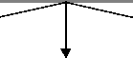

Strategic Plans
Implications
,
IT Vision,
,
Requirements,
and Practices
Principles
- EA
- Enterprise
Business Needs
Actions
Appendix E provides sample EA principles for consideration as a starting point, as well as the rationale for and the impact of implementing each principle. Each Agency should apply, add to,
or modify these sample principles. Formulating these supporting statements should be an essential part of an Agency's effort to define its principles.
2.5. The Enterprise Life Cycle
The enterprise life cycle is the dynamic, iterative process of changing the enterprise over time by incorporating new business processes, new technology, and new capabilities, as well as maintenance and disposition of existing elements of the enterprise.
Although the EA process is the primary topic of this guide, it cannot be discussed without consideration of other closely related processes. These include the enterprise engineering and program management cycle (more commonly known as the system development/acquisition life cycle) that aids in the implementation of an EA, and the CPIC process that selects, controls, and evaluates investments. Overlying these processes are human capital management and information security management. When these processes work together effectively, the enterprise can effectively manage IT as a strategic resource and business process enabler. When these processes are properly synchronized, systems migrate efficiently from legacy technology environments through evolutionary and incremental developments, and the Agency is able to demonstrate its return on investment. Figure 2 illustrates the interaction of the dynamic and interactive cycles as they would occur over time.
Figure 2. The Enterprise Life Cycle
EA
Process
Enterprise
Engineering
and
Program
Management
CPIC
Process
Operations & Maintenance
Systems Migration
Modernization
The
Enterprise
Life Cycle

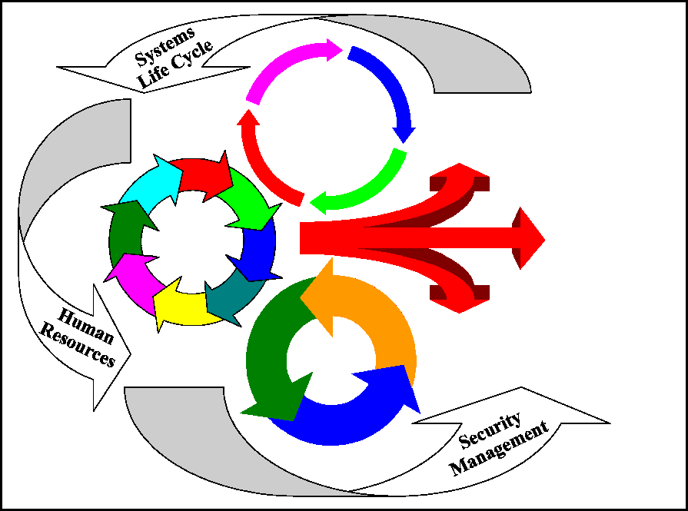
2.6. The Enterprise Architecture Process
As a prerequisite to the development of every enterprise architecture, each Agency should establish the need to develop an EA and formulate a strategy that includes the definition of a vision, objectives, and principles. Figure 3 shows a representation of the EA process. Executive buy-in and support should be established and an architectural team created within the organization. The team defines an approach and process tailored to Agency needs. The architecture team implements the process to build both the baseline and target EAs. The architecture team also generates a sequencing plan for the transition of systems, applications, and
associated business practices predicated upon a detailed gap analysis. The architecture is employed in the CPIC and the enterprise engineering and program management processes via prioritized, incremental projects and the insertion of emerging new technologies. Lastly, the architectures are maintained through a continuous modification to reflect the Agency's current baseline and target business practices, organizational goals, visions, technology, and infrastructure.
Figure 3. The Enterprise Architecture Process
Section 3.1
Section 7
Maintain the Enterprise Architecture
Obtain
Executive
Buy-In and
Support
Establish
Management
Structure
and Control
Section 3.2
Section 6
Use
the
Enterprise
Architecture
Control
Contro
and
and
Oversight
Oversight
Define an
Architecture
Process
and Approach
Section 4
Section 5.3
Develop the
Sequencing Plan
Develop
Target
Enterprise
Architecture
Develop
Baseline Enterprise Architecture
Section 5.2
Section 5.2

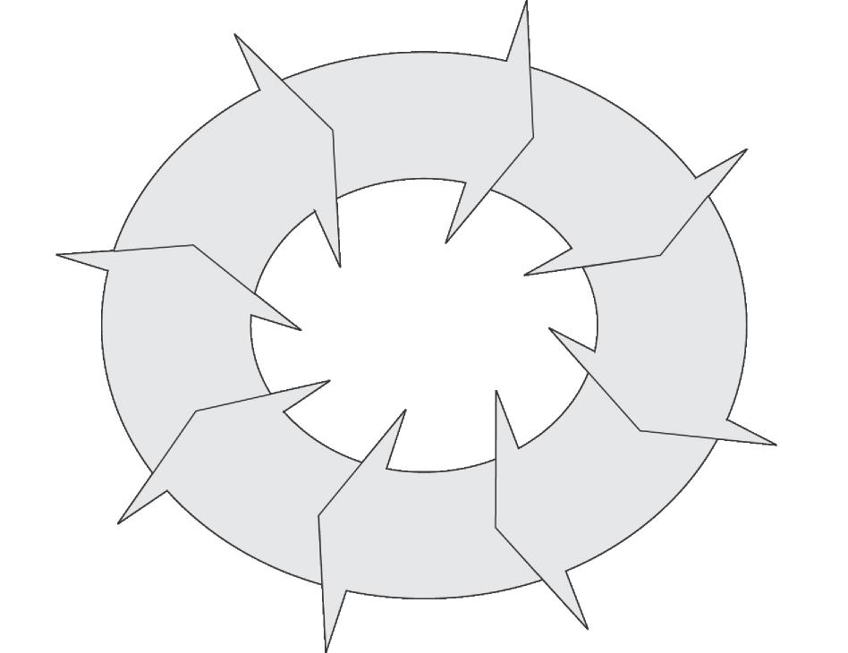

3. Initiate Enterprise Architecture Program
The enterprise architecture is a corporate asset that should be managed as a formal program. Successful execution of the EA process is an Agency-wide endeavor requiring management, allocation of resources, continuity, and coordination. Agency business line executives should
work closely with the Agency architecture team to produce a description of the Agency's operations, a vision of the future, and an investment and technology strategy for accomplishing defined goals.
Experience shows that obtaining the needed cooperation among Agency executives is not an easy task. Creating an EA program calls for sustained leadership and strong commitment. This degree of sponsorship and commitment needs the buy-in of the Agency Head, leadership by the CIO, and early designation of a Chief Architect.
3.1. Obtain Executive Buy-in and Support
Gaining executive commitment to any new initiative requires the development of a strong business case and a communications approach to effectively convey that business case. Since the concept of an EA is not intuitively understood outside the CIO organization, the CIO should create a marketing strategy to communicate the strategic and tactical value for EA development to the Agency Head, other senior Agency executives, and business units.
3.1.1. Ensure Agency Head Buy-in and Support
Without buy-in from the Agency Head, the CIO will find it hard to maintain the necessary sponsorship desired to fund and implement improved systems and processes. The CIO takes the lead to provide understanding and gain the Agency Head's buy-in. This can be accomplished by:
- Leveraging success stories from other Agency and private sector organizations as well as the experience and knowledge of EA experts
- Using examples to demonstrate how an EA can provide a blueprint and roadmap for desired changes or improvements in mission performance and accountability
- Emphasizing the legislative requirements for developing, maintaining, and implementing an EA within the Federal sector.
Once the CIO is assured the Agency Head understands the need for an EA, it is important to secure the Agency Head's commitment to pursue the architecture effort. The CIO accomplishes this by mobilizing the Agency Head's appreciation into the expression of clear, Agency-wide support. This will establish a mandate to business and CIO executives to support the effort by allocating the needed time and resources. The CIO should coordinate with the Agency Head on
the selection of an Agency executive to be designated as the Chief Architect. Experience demonstrates that the CIO's authority alone is insufficient to make the endeavor a success. A clear mandate from the Agency Head is a prerequisite to success.
3.1.2. Issue an Executive Enterprise Architecture Policy
The CIO, in collaboration with the Agency Head, develops a policy based on the Agency's architecture principles that governs the development, implementation, and maintenance of the EA. The EA policy should be approved by the Agency Head and, at a minimum, should include:
- Description of the purpose and value of an EA
- Description of the relationship of the EA to the Agency's strategic vision and plans
- Description of the relationship of the EA to capital planning, enterprise engineering, and
program management
- Translation of business strategies into EA goals, objectives, and strategies
- Commitment to develop, implement, and maintain an EA
- Identification of EA compliance as one criterion for new and ongoing investments
- Overview of an enforcement policy
- Security practices to include certification and accreditation
- Appointment of the Chief Architect and establishment of an EA core team
- Establishment of the EA Program Management Office (EAPMO)
- Establishment of the EA Executive Steering Committee (EAESC).
3.1.3. Obtain Support from Senior Executives and Business Units
Commitment and participation of the Agency's senior executive and business teams are vitally important. The CIO should initiate a marketing program to emphasize the value of the architecture and the Agency Head's support and commitment. The senior executive team and its
organizational units are both stakeholders and users of the architecture. Therefore, the CIO invests time and effort in familiarizing the staff with what an EA is and how it can help achieve organizational goals and commitments. Even though the target audience varies among Agencies, the audience for Departments should include the Deputy and Under Secretaries and the Assistant
Secretaries and their key staffs. For Agencies, the audience should include the Deputy and Assistant Administrators, Commissioners, or Bureau Chiefs.
The primary goal of educating the Department and Agency senior executives is to obtain their concurrence and commitment to having their organizations as active participants. Participation
can involve the executives (or their designees) in attending planning sessions, committing resources (people and funding) for specific tasks, or becoming a champion or spokesperson for the effort. Maintaining the participation and support of key executives is crucial to sustaining a successful effort.
The Chief Architect should create a plan to obtain the support of the enterprise's business units.
It is recommended that the business units establish an "inner circle" of domain owners and subject matter experts (SMEs). This leadership group should consist of business unit managers who "own" specific lines of business. This leadership group should be able to understand and
communicate enterprise goals and objectives, and to think creatively, with consideration of budgets and other constraints. This group of managers is responsible for ensuring that the business layers of the architecture are properly documented, and that the sequencing plan makes
sense from the perspective of the business strategy, considering both automated and non-automated processes.
Once the EA policy has been disseminated, the CIO and Chief Architect should organize and conduct a program kickoff meeting to explain the EA goals, objectives, processes, products, and interrelationships with activities of the systems development life cycle, capital planning and investment process, and other related activities. The goal of the program kickoff meeting is to
promote buy-in by program participants at middle and lower levels of the organization. After several of the first EA products are developed and analyzed, the products and analysis should be disseminated throughout the Agency and its communities of interest to demonstrate the value of these early results and achieve maximum exposure for the benefits of the EA development effort.

3.2. Establish Management Structure and Control
Figure 4 illustrates a notional program organization to manage, control, and monitor EA activity and progress. The organization shows the desired functional roles, interrelationships, and lines of communication. The organization structure should facilitate and advance the performance of EA roles and responsibilities. The roles of the EAESC, Technical Review Committee (TRC), and the
Establish Management
Structure and Control

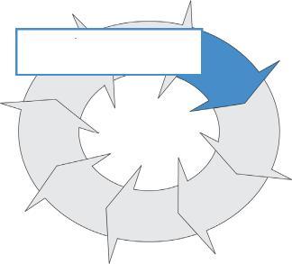
EA Program Management Office are unique to the introduction of the EA process. Other roles, such as Quality Assurance (QA), Configuration Management (CM), Risk Management (RM), Security, and Evaluation are customary IT support roles. These roles are expanded to explicitly include EA-related responsibilities.

EA roles should be evaluated based on the size of the organization, the complexity of the business and architecture, and other factors to effectively determine the correlation of roles assigned to personnel. In a large organization with complex business processes, an individual may be responsible for one specific role. In smaller Agencies or organizations, an individual may be assigned several roles and responsibilities.
Business Line Organization
Domain
Owners

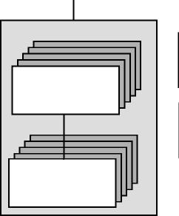
Agency Head

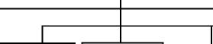

EA Executive  Steering  Committee | Chief  Information  Officer |  | Capital  Investment  Council |  | Staff  Organization
Quality  Assurance |  |  | Technical  Review  Committee

EA Program
Management Office
Architecture Core Team
Chief Architect
Evaluation
Configuration
Management
Risk Management
Subject
Matter
Experts
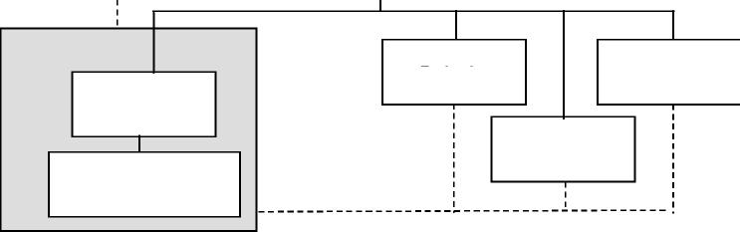

Figure 4. Notional EA Organization

3.2.1. Establish a Technical Review Committee
The CIO should charter and appoint a Technical Review Committee to manage the review of candidate projects and assess project alignment with the EA. Once the EA has been developed and approved, the TRC assesses each proposed investment for compliance with the architecture.
The TRC reports their conclusions and provides recommendations to a Capital Investment Council (CIC).
In all cases, the TRC determines and documents the results and the accompanying rationale for its actions. The TRC reviews a project and assesses if:
- The project completely aligns with the EA
- The project does not align with the EA and an alternate course of action is needed
- The project does not align with the EA and a waiver is approved.
The TRC approves a waiver only if the impacts of the lack of alignment are understood and acceptable. By approving a waiver, the TRC conveys to the CIC that it does not object to the proposed project.
3.2.2. Establish a Capital Investment Council
The Agency Head establishes a CIC to achieve informed decision making regarding costs, benefits, risks of alternative investment options and architectural alignment. The goal of the CIC
is to ensure enterprise and application architecture projects are feasible from a cost-benefit standpoint. The CIC reviews proposed IT investments and makes the final investment funding decision. It accepts program and project proposals that have been assessed by the TRC and determines whether these programs/projects fit within the overall budgetary and funding goals for
the enterprise. While a project may be technically aligned with the EA, the CIC may reject funding for a project because of other external constraints or budgetary reasons. CIC decisions may necessitate updates to the sequencing plan.
3.2.3. Establish an EA Executive Steering Committee
The Agency Head establishes an EA Executive Steering Committee to direct, oversee, and approve the EA and EA program. The EAESC is responsible for approving the initial EA, approving significant changes to the EA, and approving the EA Program Plan.
The EAESC should be formally chartered, with a designated chair or co-chairs, and empowered to ensure Agency-wide strategic direction, oversight, and decision-making authority for the EA.
The EAESC charter should authorize the chair or co-chairs to appoint the membership. By charter, the EAESC membership should consist of active participants that represent and include all major Agency business and technology areas. To perform effectively as a decision-making body, it is crucial that the EAESC members are senior leaders, with the authority to commit resources and make and enforce decisions within their respective organizations.
3.2.4. Appoint Chief Architect
The CIO should appoint, with the Agency Head's approval, an Agency executive to serve as Chief Architect and EA Program Manager. The Chief Architect is responsible for leading the development of the EA work products and support environment. The Chief Architect serves as the technology and business leader for the development organization, ensuring the integrity of the
architectural development processes and the content of the EA products. The Chief Architect should be friend and liaison to the business line units and ensure that business unit processes are emphasized in the EA. Likewise, the Chief Architect is responsible for ensuring that the EA provides the best possible information and guidance to IT projects and stakeholders, and that systems development efforts are properly aligned with business unit requirements.
In the role of EA Program Manager, the Chief Architect has management responsibility for the EA program, with the authority, responsibility, and accountability for the overall architectural effort. The Program Manager is responsible for the planning, staffing, and ultimate success of the program, including acquisition of sustaining funding, negotiating schedules, timely and accurate delivery of the EA products, and the establishment of an appropriate support environment that ensures proper application of these assets.
The core competencies of the Chief Architect include expertise in strategic and technical planning, policy development, capital planning and investment control, change management, systems engineering and architectural design, business process reengineering, and large-scale program management. In addition, the Chief Architect becomes completely conversant with the Agency's business and IT environments. As the primary technical leader of this effort, the Chief Architect should be a good communicator who can bridge the cultural differences that often exist
between the business and systems organizations, and facilitate interaction and cooperation between these two cultures.
3.2.5. Establish an Enterprise Architecture Program Management Office
The EA effort should be treated as a formal program with full sponsorship through the Agency's CPIC process. An EA Program Management Office should be established to manage, monitor, and control the development and maintenance of the EA. The EAPMO staff includes
experienced architects. The EAPMO identifies and performs cost analyses of alternative approaches for developing the EA, and manages in-house or outside contractor EA development work. The EAPMO is also charged with determining needed resources and securing funding and resource commitments.
A primary goal of the EAPMO and the EAESC is to ensure success of the EA program. Each phase of the program (i.e., EA development, use, and maintenance) is subject to the CIC policies and procedures for investment decisions.
3.2.5.1. Appoint Key Personnel
The CIO should make the EA an explicit responsibility for those individuals designated as the
organization's Evaluators, Risk Manager, and Configuration Manager. The Risk Manager identifies, monitors, controls, and mitigates EA program risks in light of environmental factors
(e.g., external business constraints, and technical constraints). The Configuration Manager assumes responsibility for configuration management of the EA products in the same way that configuration management is imposed on any other engineering baseline.
The CIO should establish an independent QA organization to perform evaluation of the EA. This team should report to the EAESC and ensure all established program and project standards and processes are met. Potential sources for review include external reference groups, impartial or uninvolved external entities, or by hiring a neutral third party specializing in assessments or validations. Within the Federal government, Agencies can request their Inspector Generals to
conduct an IV&V review or enlist the services of a non-profit entity such as a Federally Funded Research and Development Center (FFRDC).
3.2.5.2. Establish Enterprise Architecture Core Team
At the same time the Agency Head and CIO achieve business line ownership of the effort, a core team of IT experts, business line experts, and technologists should be assigned to develop the desired process and procedures used throughout the development effort. Participants should have an understanding of the current business and technical environment and the strategic business objectives envisioned in the EA. The team includes the Chief Architect; senior business, systems, data, infrastructure and security systems architects. This team should be well grounded in the existing environment and prepared to document and develop the EA that will support evolving business needs.
The architecture core team should include IT representatives from the Agency's applications,
data, and infrastructure organizations. The specific core teamwork groups should include business analysts, data analysts, systems designers, security specialists, and systems programmers. As the program gets underway, more resources/team members are typically added
to the architecture core team. The architecture core team will include program managers proficient in managing Agency-wide programs as well as interagency initiatives.
The EA core team is responsible for all activities involving the development, implementation, maintenance, and management of the architecture. This includes:
- Developing EA processes, procedures, and standards
- Developing baseline and target architectures
- Developing and maintaining an EA repository
- Performing quality assurance, risk management, and configuration management
- Guiding systems development and acquisition efforts
- Defining EA performance measures.
Table 1 provides a listing of functional roles and the associated responsibilities assigned to EA core team members. In smaller agencies, some of these roles and responsibilities may be shared, doubled up, or contracted out.
Table 1. EAPMO Roles and Responsibilities
Role | Responsibilities
Chief Architect | Heads the EAPMO, organizes and manages the EA core team; directs development of the baseline and target architecture.
Senior Architecture Consultant | Provides architecture strategy and planning consultation to the Chief Architect.
Business Architect | Analyzes and documents business processes, scenarios, and information flow.
Applications Architect | Analyzes and documents systems, internal and external interfaces, control, and data flow.
Information Architect | Analyzes and documents business information (logical and physical) and associated relationships.
Infrastructure Architect | Analyzes and documents system environments, including network communications, nodes, operating systems, applications, application servers, web and portal servers, and middleware.
Security Systems Architect | Oversees, coordinates, and documents IT security aspects of the EA, including design, operations, encryption, vulnerability, access, and the use of authentication processes.
Technical Writer | Ensures that policies, guidebooks, and other documentation within the EA repository are clear, concise, usable, and conform to configuration management standards.
Quality Assurance | Ensures that all established program and project standards, processes, and practices are met.
Risk Management | Identifies, monitors, and controls risks in light of environmental factors and constraints.
Configuration Control | Assures that all changes are identified, tracked, monitored, and appropriately documented.

3.3. Enterprise Architecture Program Activities and Products 3.3.1. Develop an EA Marketing Strategy and Communications Plan
The purpose of the marketing strategy and communications plan is (1) to keep senior executives and business units continually informed, and (2) to disseminate EA information to management teams. The CIO's staff, in cooperation with the Chief Architect and support staff, defines a marketing and communications plan consisting of (a) constituencies, (b) level of detail, (c) means of communication, (d) participant feedback, (e) schedule for marketing efforts, and (f) method of evaluating progress and buy-in. It is the CIO's role to interpret the Agency Head's vision and to
recognize innovative ideas (e.g., the creation of a digital government) that can become key drivers within the EA strategy and plan. If resources permit, the Chief Architect should use one
or all of the following tools to communicate with the community of interest: seminars and forums, web pages, electronic surveys, and e-mail listservs.
One of the recommended means for marketing the EA is a primer to inform Agency business executives and stakeholders of the EA strategy and plan. The primer can be used to express the Agency Head's vision for the enterprise and the role of EA in accomplishing that vision—for
example, creating the integrated foundation for online government or streamlining business processes and technology.
The primer should describe the tenets of the EA and its many benefits as an agent of change in achieving organizational goals (e.g., integrating business services and initiatives) or as a critical resource to evaluate options for change as business and technology needs evolve. The primer should clearly describe the roles and responsibilities of the senior executives and their organizational units in developing, implementing, and maintaining the EA. It is important that the primer include customized sections that relate directly to specific business line audiences.
The primer should demonstrate the benefits of an EA for the Agency's stakeholders. This is particularly important since many of the stakeholders may be needed to provide skilled resources,
support, and time to the effort. Once completed, the primer should be widely distributed throughout the Agency and made available on the Agency's web site. It should be briefed to all personnel impacted by the introduction of the EA. Introductory materials drawn from the primer should be incorporated into local and Agency-wide training programs.
3.3.2. Develop an EA Program Management Plan
A formal plan is desired for sound program management. The EAPMO creates an EA program management plan (PMP) that includes a roadmap to accomplish the goals set by the EAESC and
implementation plans to achieve those goals. The plan should include goals for the Chief Architect in setting Agency-wide architectural objectives. These goals should help the
architecture team establish and maintain lower-level architectures that comply with the EA.
The PMP delineates plans and a set of actions to develop, use, and maintain the EA, including EA management, control, and oversight. To facilitate the tracking of cost, schedule, and performance
data, oversight and control procedures should be developed, documented, and implemented within the PMP. The PMP should also include:
- Requirements for the EA Program Manager to identify all funding requirements, spending timelines/schedules, and links to performance measures
- A Work Breakdown Structure (WBS) detailing the tasks and subtasks necessary to acquire, develop, and maintain the architecture
- Resource estimates for funding, staffing, training, workspace requirements, and equipment needs
- Roadmap for the initiation of project plans
- Requirements for performing quality assurance, risk management, configuration management, and security management
- Requirements for the establishment and maintenance of an EA information repository. 3.3.3. Initiate Development of the Enterprise Architecture
Once the EAPMO is in place and the PMP is produced, the first of the architecture projects is launched. There are several peripheral activities associated with the start of this development. The EAPMO's initial project will:
- Institute PMP practices
- Establish EA development processes and management practices
- Train EA project participants
- Build baseline EA products
- Build target EA products (as possible)
- Create the sequencing plan
- Populate the EA repository.
Sections 4 and 5 provide discussions on the details of the development of the EA.

4. Define an Architecture Process and Approach

The next step in the EA process is establishing an EA process and approach. The EA will be used as a tool to facilitate and manage change within the Agency organization. The scope and nature of the Agency and the changes to be made will dictate the scope and nature of the architecture to be developed. While the EA is an excellent tool to manage large and complex environments, the depth and detail of the EA needs to be tailored to the individual enterprise. Figure 5 illustrates how the depth and detail in the EA varies not only with the size and complexity of the enterprise,
Define an Architecture
Process and Approach

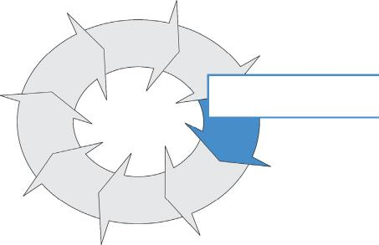
but also the many types of risks associated with change. Regardless, the scope of the enterprise architecture for the strategic planner and business owner views (as defined by the architecture framework selected) needs to encompass the entire enterprise. The agency will understand the relationships and dependencies among its lines-of-business and thus position itself to make
informed decisions on how to approach defining EA depth and detail for these lines-of-business.
The first activity in this process is to determine the intended use of the architecture. It drives the rest of the EA development process. The subsequent activities describe how to scope, characterize, select EA products, build, and use the EA.

Before actually developing the EA, an Agency needs to evaluate and select an architectural framework as guidance. This section describes several candidate frameworks currently used within the Federal community. The selection of a framework is contingent on the purpose of the EA and the products to be developed.
Goals:
- Build a baseline architecture that represents reality
- Build a target architecture that represents the business vision and IT strategies
- Develop a sequencing plan that describes an incremental strategy for transitioning the baseline to the target
- Publish an approved EA and sequencing plan that are accessible by agency employees


Additionally, a toolset or repository for the EA development and use should be employed. The chosen
tool should be commensurate with the products to be generated.

Size
Depth & Detail
Complexity
Risk

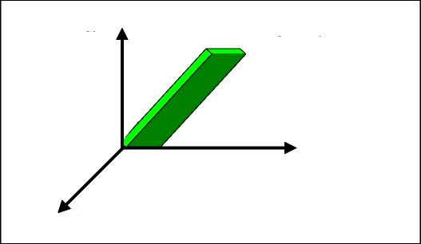

Figure 5. Depth and Detail of the Architecture

4.1. Define the Intended Use of the Architecture
Architectures should be built with a specific purpose in mind. It could be business process reengineering, systems acquisition, system-of-systems migration or integration, user training, interoperability evaluation, or any other intent. The purpose of the architecture is closely tied to the organization's Strategic Plan(s), legislation such as GPRA and Clinger-Cohen, and support of
the capital investment process. Before an architect begins to describe an architecture, the organization determines the changes the architecture is intended to facilitate, the issue(s) the architecture is intended to explore, the questions the architecture is expected to help answer, and the interests and perspectives of the audience and users. One important practical consideration is determining the types of analyses that will be performed; i.e., knowing that the architecture may be used as input to specific models or simulations can affect what to include and how to structure the products.
The purpose of the EA may, and likely will, evolve over time to meet new requirements. The Chief Architect should ensure that any such EA evolution does, in fact, meet the newly determined requirements. This will increase the efficiency of the architecture development and create greater balance in the resulting architecture.
4.2. Define the Scope of the Architecture
It is critically important that EA development be approached in a top-down, incremental manner, consistent with the hierarchical architectural views that are the building blocks of proven EA frameworks, including the ones discussed later in this guide. In doing so, it is equally important that the scope of the higher level business views of the EA span the entire enterprise or agency. By developing this enterprise-wide understanding of business processes and rules, and information needs, flows, and locations, the agency will be positioned to make good decisions about whether the enterprise, and thus the EA, can be appropriately compartmentalized. Without doing so, scoping decisions about the EA run the risk of promoting "stove-piped" operations and systems environments, and ultimately sub-optimizing enterprise performance and accountability. Other considerations relevant to defining the scope of the EA include, but are not limited to:
- Relevance of activities, functions, organizations, timeframes, etc.
- Enterprise scope (intra- and inter-Agency domains)
- Operational scenarios, situations, and geographical areas to be considered
- Projected economic benefits
- Projected business and technical risk areas
- Projected availability and capabilities of specific technologies during the target timeframe (applies to target architecture only).
Defining the scope leads the planners to project management factors that will contribute to these determinations, including the resources available for building the architecture as well as the resources and level of expertise available for analysis and design tasks.
4.3. Determine the Depth of the Architecture
Care should be taken to judge the appropriate level of detail to be captured based on the intended use and scope of the EA and executive decisions to be made using the EA. It is important that a
consistent and equal level of depth be completed in each view and perspective. If pertinent characteristics are omitted, the architecture may not be useful. If unnecessary characteristics are
included, the architecture effort may prove infeasible given the time and resources available, or the architecture may be confusing and/or cluttered with details that are superfluous. EA characteristics are influenced by the focus: whether primarily capturing the baseline vs. the target and vice-versa. It is equally important to predict the future uses of the architecture so that, within resource limitations, the architecture can be structured to accommodate future tailoring,
extension, or reuse. The depth and detail of the EA needs to be sufficient for its purpose.
4.4. Select Appropriate EA Products
Essential products are those required for all architectures, while supporting products may be necessary to fulfill specific informational needs. Only
those supporting products that portray the desired characteristics should be built. The required products should help formulate the selection of a framework and associated toolset.

Essential products—the graphics, models, and/or narratives that every architecture description must include, to support the scope and characteristics of the EA.
Supporting products—the graphics, models, and/or narratives that may be needed to further elaborate on essential products or to address particular domain or scope extensions (e.g., real-time or special performance considerations).
Model—representations of reality: the information, activities, relationships, and constraints.
It is essential that the Chief Architect guide the construction of the technical content to meet the needs of the EA, especially in the desired level of detail needed in the work products. If the content is at too high a level of abstraction, it may not be sufficiently useful to guide projects and reviews. If the content is too detailed, it may be difficult to manage.
4.4.1. Select Products that Represent the Business of the Enterprise
As the first step in identifying and creating the business definition, the Chief Architect determines which products can be used to provide an integrated view of the Agency core business. These include functional, informational, and organizational models. Functional or process models may be represented in several forms, including:
- Use Cases
- Activity Models/Trees
- IDEF [Integrated Computer Aided Manufacturing (ICAM) Definition] business process models
- Concept of Operations (CONOPS)
- State Models.
Information models include class models and conceptual data models. Appropriate combinations of these models should be used to represent internal and external organizational participants, activities, inputs, outputs, flow of information, sequencing, interrelationships between data, and external interfaces. The models span the enterprise and represent the enterprise at the strategic
level. Additional information and examples of these models are provided in Appendix D.
The business definition should be created in the baseline and target architectures and the sequencing plan. In the baseline architecture, it represents the current state of business operations and information exchange within and across the organization. In the sequencing plan, it
represents business changes and maps to planned systems and business improvements. In the target architecture, it represents planned business operations as expressed in business strategies and visions.
4.4.2. Select Products that Represent Agency Technical Assets
The technical content of the EA represents the technical assets of the Agency. It consists of the logical and physical designs of the baseline and target architectures. At a minimum, this content includes designs of data, applications, and infrastructure (including hardware, software, and communications). These products identify information needs, software applications/programs,
middleware, and underlying physical infrastructure supporting the current environment and needed to support the Concept of Operations (CONOPS) for the enterprise in its target state.
EA products created to support business content are often extended to represent the solution space. Thus, many of the models could be reused, extended, and referenced in order to define the technical architecture. The purpose of the technical architecture is to ensure that a conforming
system satisfies a specific set of business needs and requirements. It provides the technical systems implementation guidelines for creating engineering specifications and developing products.
4.5. Evaluate and Select a Framework
As each Federal Agency embarks on this stage of the architecture process, it must select an appropriate architectural framework. A number of well-established frameworks are successfully used throughout the Federal sector. Alternatively, an Agency may choose to develop its own framework,
Framework—a logical structure for classifying and organizing complex information.
although the costs, benefits, and risks of doing so should be weighed against the risks of adopting or tailoring an existing framework. While Federal Agencies vary widely in their approach to architecture development and implementation, established frameworks permit comparisons and analyses across Agencies. Therefore, it is recommended that before an Agency develops a new framework (if an Agency has a mandated framework, it must be employed), it should investigate the use of other existing Federally developed frameworks.
Three Federally sponsored (and commonly accepted) architectural frameworks are used as candidate frameworks and for descriptive purposes within this EA guide. These contain essential and supporting products, and promote development of architectures that are complete, understandable, and integratable. The organizations that developed these frameworks continue to tailor them to ensure parallel precepts, principles, and methodologies. The frameworks are:
- Federal Enterprise Architecture Framework (FEAF)
- Department of Defense (DoD) Command, Control, Communications, Computer, Intelligence, Surveillance and Reconnaissance (C4ISR) Architecture Framework
- Treasury Enterprise Architecture Framework (TEAF).
Other EA frameworks exist and have been used in Government programs (e.g., Department of Agriculture's framework and the National Institute of Standards and Technology [NIST] framework). This guide does not address these other frameworks because most organizations
have standardized on the FEAF, C4ISR, and TEAF for EA development. In addition to EA frameworks, many processes exist that can be used to support framework development, such as
the Department of Energy's corporate systems information architecture roadmap for IT systems implementation. Since a notional process is described in this guide, other Federal Agency EA processes are not discussed.
The use of an EA framework ensures uniformity and standardization when migrating and integrating information systems. The selected framework will depend on the intended use, scope, and characteristics of the architecture to be developed. Table 2 lists major factors to consider.
Table 2. Framework Selection Criteria
Areas |  |  | Factors
 |  | • | Regulatory and legislative direction
Policy |  | • | Agency policy
 |  | • | Compatibility needed with another Agency or joint policy
 |  | • | Context for the enterprise—e.g., subordinate to a larger enterprise, closely related to another enterprise
Enterprise |  | • | Experience with a particular framework
 |  | • | Mandates and drivers—e.g., emphasis on business versus infrastructure or operational versus technical issues
 |  | • | Priorities, intended uses and desired level of detail—e.g., large scale modernization versus stable IT environment
EA products |  | • | Resource and schedule constraints on modeling efforts
 |  | • | Availability of existing architecture products

Frameworks include concepts that drive the types of architecture products being created. The
products, both graphical and textual, capture the information prescribed by the framework. Equivalent products may be substituted if the new product has similar or more extensive
attributes than the original product. This is often done when specific methods (e.g., object-oriented analysis and design) lend themselves to particular modeling techniques.
Using the FEAF, C4ISR, or TEAF frameworks should substantially reduce the development process and will shorten the time to get an EA in place and put an Agency on a path for success. The following sections provide a
Method—a prescribed way of approaching a particular problem.
brief description of the FEAF, C4ISR, and TEAF frameworks.
4.5.1. Federal Enterprise Architecture Framework
In September 1999, the Federal CIO Council published the Federal Enterprise Architecture Framework, Version 1.1 for developing an EA within any Federal Agency or for a system that transcends multiple inter-agency boundaries. It builds on common business practices and designs that cross organizational boundaries. The FEAF provides an enduring standard for developing
and documenting architecture descriptions of high-priority areas. It provides guidance in describing architectures for multi-organizational functional segments of the Federal Government.
These Federal architectural segments collectively constitute the Federal EA. Currently, the FAWG is sponsoring the development of EA products for trade and grant Federal architecture segments.
As shown in Figure 6, the FEAF partitions a given architecture into business, data, applications,
and technology architectures. The FEAF currently includes the first three columns of the Zachman framework and the Spewak EA planning methodology (see Appendix G).
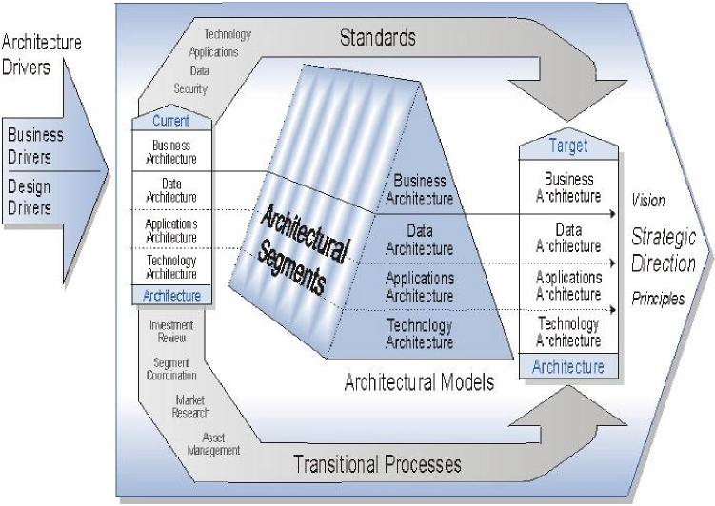
Figure 6. Structure of the FEAF Components
For the Federal Enterprise, the Federal CIO Council seeks to develop, maintain, and facilitate the
implementation of a top-level EA predicated upon the FEAF. This architecture serves as a reference point to facilitate the efficient and effective coordination of common business processes, technology insertion, information flows, systems, and investments among Federal
Agencies. The FEAF provides a structure to develop, maintain, and implement top-level operating environments and support implementation of IT systems. As shown in Figure 7, the FEAF is graphically represented as a 3x5 matrix with architecture types (Data, Application, and Technology) on one axis of the matrix, and perspectives (Planner, Owner, Designer, Builder, and Subcontractor) on the other. The corresponding EA products are listed within the cells of the matrix.
Data  Architecture | Application  Architecture | Technology  Architecture

List of Business Objects | List of Business Processes | List of Business Locations
Semantic Model | Business Process Model | Business Logistics System
Logical Data Model | Application Architecture | System Geographic  Deployment Architecture
Physical Data Model | Systems Design | Technology Architecture
Data Dictionary | Programs | Network Architecture

Planner Perspective
Owner Perspective
Designer Perspective
Builder Perspective
Subcontractor Perspective

Figure 7. FEAF Architecture Matrix

4.5.2. DoD C4ISR Architecture Framework
In December 1997, the DoD published its C4ISR Architecture Framework. This framework applies to all branches of the armed services and includes the numerous major and subordinate commands, field organizations, and task forces within each service.
In the C4ISR Architectural Framework, the operational view describes the tasks and activities, operational elements, and information flows needed to accomplish or to support an operation. It specifies the nature of each needline's information exchange in sufficient
Needline—a requirement that is the logical expression of the need to transfer information among nodes.
detail to determine the desired degree of interoperability. The systems view identifies which systems support the requirement. It translates the desired degree of interoperability into a set of needed system capabilities, and compares current/postulated implementations with the needed
capabilities. The technical view defines the criteria that govern the implementation of each system capability. To be consistent and integrated, an architecture description should provide
explicit linkages among its various views. Figure 8 illustrates these three views and their relationships.
Operational
View
Figure 8. DoD C4ISR Framework
Identifies Warfighter
Relationships and Information Needs
Systems
View
Relates Capabilities and
Characteristics to Operational Requirements
Specific Capabilities Identified to Satisfy Information-Exchange Levels and Other Operational Requirements
Technical Criteria Governing Interoperable Implementation/ Procurement of the Selected System Capabilities
Technical
View
Prescribes Standards
and Conventions

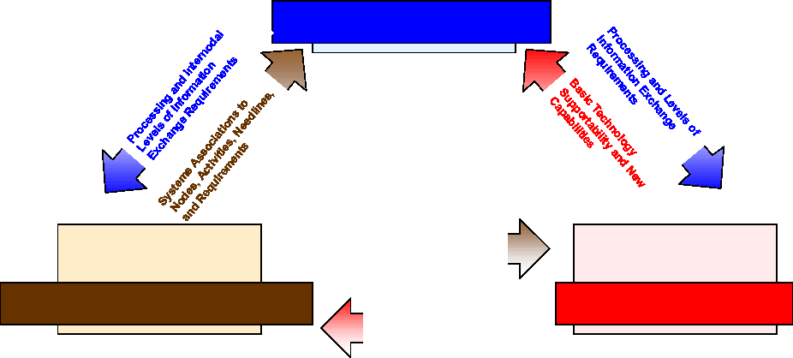
Figure 9 depicts the C4ISR essential and supporting architecture products. Appendix D provides examples of C4ISR essential products.

All  Views |  | Operational  View |  | Systems  View |  | Technical  View
Overview & Summary  Information | High-level  Concept of Operations  Graphic |  | Systems  Interface  Description |  | Technical  Architecture  Profile
Integrated Dictionary | Node  Connectivity  Description
Information
Exchange
Matrix
 | Command Relationship  Chart  Activity Model  Operational Rules  Model  State Transition  Description  Event Trace  Diagrams  Logical Data Model |  | Systems  Communications  Description  Systems Matrix  System  Functionality  Description  Operational Activity  to System Function  Traceability Matrix  Systems Information  Exchange Matrix  System Performance  Parameters Matrix  System Evolution  Description  System Technology  Forecast  Systems Rules  Model  System State  Transition  Systems Event Trace Diagrams  Physical Data Model |  | Standards Technology Forecast

Essential Work Products
Supporting Work Products

Figure 9. DoD C4ISR Products
4.5.3. Treasury Enterprise Architecture Framework
In July 2000, the Department of the Treasury published the Treasury Enterprise Architecture Framework. The TEAF provides (1) guidance to Treasury bureaus concerning the development and evolution of information systems architecture; (2) a unifying concept, common principles, technologies, and standards for information systems; and (3) a template for the development of the EA.
The TEAF describes an architectural framework that supports Treasury's business processes in terms of products. This framework guides the development and redesign of the business processes for various bureaus in order to meet the requirements of recent legislation in a rapidly changing technology environment. The TEAF prescribes architectural views and delineates a set of notional products to portray these views. Figure 10 illustrates the TEAF framework.

Figure 10. The Treasury Enterprise Architecture Framework
What, How Much, and How Frequently
Enabler
Who and Why
How, Where, and When
Organizational
Infrastructure
Information
Functional
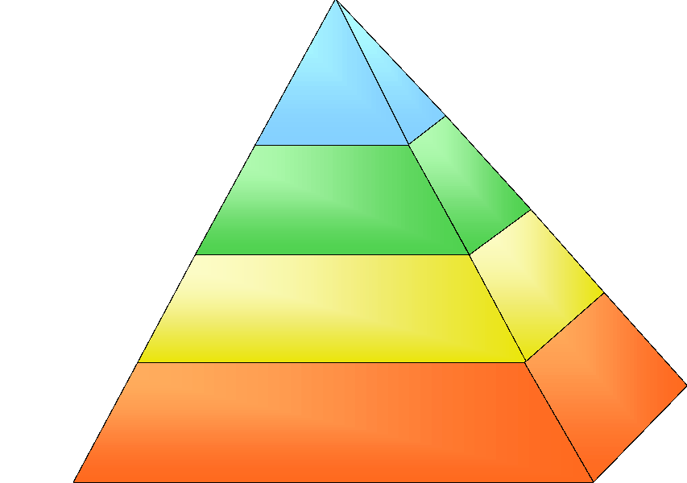
The TEAF's functional, information and organizational architecture views collectively model the organization's processes, procedures, and business operations. By grounding the architecture in the business of the organization, the TEAF defines the core business procedures and enterprise processes. Through its explicit models, a TEAF-based architecture enables the identification and reasoning of enterprise- and system-level concerns and investment decisions.
The TEAF provides a unifying concept, common terminology and principles, common standards and formats, a normalized context for strategic planning and budget formulation, and a universal approach for resolving policy and management issues. It describes the enterprise information systems architecture and its components, including the architecture's purpose, benefits, characteristics, and structure. The TEAF introduces various architectural views and delineates several modeling techniques. Each view is supported with graphics, data repositories, matrices,
or reports (i.e., architectural products). Figure 11 shows a matrix with four views and four perspectives. Essential products are shown across the top two rows of the matrix. It is notable that the TEAF includes an Information Assurance Trust model, the Technical Reference Model,
and standards profiles as essential work products. These are not often addressed as critical framework components.

Functional  View | Information  View | Organizational  View | Infrastructure  View

Planner
Perspective
Owner
Perspective
Designer
Perspective
Builder
Perspective
EA Repository
Listings
High Level
Modeling
Logical Modeling
Physical
Modeling
Mission & Vision  Statements | Information Dictionary | Organization  Charts | Technical  Reference  Model  Standards Profile
Activity  Model  Info Assurance  Trust Model | Information  Exchange Matrix  (Conceptual) | Node Connectivity  Description  (Conceptual) | Info Assurance  Risk Assessment  System Interface  Description  (Level 1)
Business Process/  System Function  Matrix  Event Trace  Diagrams  State Charts | Information  Exchange Matrix  (Logical)  Logical Data Model  Data CRUD Matrices | Node Connectivity  Description  (Logical) | System Interface  Description  (Level 2 & 3)
System  Functionality  Description | Information  Exchange Matrix  (Physical)  Physical Data Model | Node Connectivity  Description  (Physical) | System Interface  Description  (Level 4)  System Performance  Parameters Matrix

Essential Work Products |  | Supporting Work Products

Figure 11. TEAF Products
One of these frameworks should provide a means to logically structure and organize the selected EA products. Now, in order to effectively create and maintain the EA products, a toolset should be selected.
4.6. Select an EA Toolset
To increase the usefulness of any architecture, it is important to maintain the EA within an interactive architectural tool. Fortunately, there are many automated architecture tools available on the market today. The choice of tool should be predicated upon the organization's needs based on the size and complexity of its architecture. The Chief Architect and architecture core team may use the Office suite of tools (e.g., Microsoft's PowerPoint and Word) and/or modeling tools (e.g., Rational Rose by Rational Corporation, Systems Architect by Popkin, or Framework by Ptech).
There are toolsets available from leading vendors that can provide alignment with the chosen framework and recommended products. Tool criteria should be determined based on the intended use of the architecture, scope, levels of integration desired, and other factors. Table 3 lists candidate topics to aid in the selection of tools. The list can be tailored to a specific set of requirements for tool selection. One tool will probably not meet all requirements. Therefore, a tool suite or combination of tools will be needed. The work products should be maintained in
several different types of media such as hardcopy documentation (briefings and reports), electronic files on CD-ROM, HTML documents on the web, and other EA Computer Aided Software Engineering (CASE) tools and development tools that provide a relational database management system.

Table 3. Tool Selection Criteria
Functional Area |  |  | Criteria
 |  | • | Available platforms
 |  | • | Support for chosen framework
 |  | • | Support for modeling methods and techniques—e.g., object-oriented analysis and design, IDEF, activity models, class models, information models
 |  | • | Import/Export capability
 |  | • | Cost (initial and maintenance) and licensing
 |  | • | Vendor support (e.g., time, cost)
 |  | • | Training schedule, cost, length
 |  | • | Ease of use
Development of EA products
 |  | • | Integration of products generated—ability to integrate baseline and target architectures and enterprise engineering products
 |  | • | Capacity, expected size, and complexity of models
 |  | • | Integrated and consolidated repository
 |  | • | Multi-user support
 |  | • | Meta-model support (e.g., ability to configure and tailor model elements)
 |  | • | RM support/issues tracking
 |  | • | CM support
 |  | • | QA support
 |  | • | Ability to interoperate with other enterprise engineering products and development tools/repositories
Maintenance of EA products |  | • | Traceability to requirements and other enterprise engineering artifacts
 |  | • | RM support/issues tracking
 |  | • | CM support
 |  | • | QA support
 |  | • | Accessibility (e.g., software needed, access requirements)
 |  | • | Documentation generation—briefings and reports
Dissemination of EA products |  | • | Media supported (e.g., CD-ROM, HTML)
 |  | • | Levels of Access control (e.g., Read-Only, Read-Write)
 |  | • | Use of hypertext links

Tool standardization is a recommended best practice. It proves cost-effective when determining architecture quality and alignment with the EA policy from an acquisition cost perspective and for consistent interoperability of models.

5. Develop the Enterprise Architecture

The next step is to build the architecture products based on the purpose of the architecture and the chosen framework. This consists of the essential products, supporting products (if needed), and individually defined products (e.g., briefing charts, interview notes) driven by architecture-specific needs and processes. To facilitate integration with other architectures, it is crucial to include all depictions of relationships with applicable external components, that is, entities outside the Agency.
Develop Baseline
Enterprise Architecture
Develop Target
Enterprise Architecture

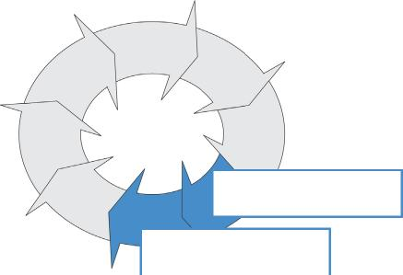

It may be useful, resources permitting, to conduct some proof-of-principle analyses at various stages of architecture development. For example, one could conduct trial runs of the EA development process using carefully selected subsets of the areas to be analyzed. The architecture core team should ensure that the products are consistent and properly interrelated. If the products are not applied and populated uniformly, the Chief Architect and architecture core team will be unable to compare or contrast the products or perform thorough analyses.
Regardless of the scope and complexity of the views to be developed, the architecture core team
should apply a consistent approach to developing the baseline and target architectures. The selected approach should include (1) a data collection phase, (2) preliminary product generation, (3) review and revision stages, and (4) publication and delivery of the architecture products to an appropriate repository. Figure 12 shows a typical process for developing the EA products. Each of these activities is described in more detail in the following subsections.
Figure 12. Example Approach for EA Development
Data Collection
Familiarization
Training
Literature
and
Documentation
Review
Preliminary
Meetings
and
Interviews
Preliminary Product Generation
Generate
Preliminary
Products
Hold
Group
Brainstorming
Sessions
Conduct In-depth Individual Interviews
Review and Revision
Revise
Products
As Needed
Independent and SME Review and Validation
Publication and
Delivery
Publish
Architecture
Products
Populate
Tools and
Repositories
Generate
Briefing
and
Present

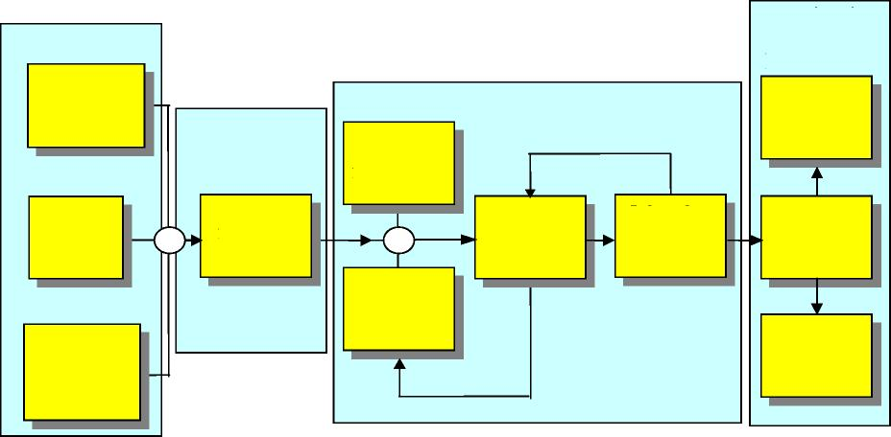

5.1. Collect Information
The first step in the build approach is to identify and collect existing products that describe the enterprise as it exists today and as it is intended to look and operate in the future. Data collection is the crucial, initial effort involving review of documentation, staging of training sessions, and interviewing SMEs and domain owners.
All appropriate collected information and products  should be placed in a centralized electronic EA repository. In the case of the baseline architecture, sample products to be collected include:  - Current business functions and information flows | Repository—an information system used to store and access architectural information, relationships among the information elements, and work  products.

- Data models
- External interface descriptions
- Existing application and systems documentation
- Technical designs, specifications, and equipment inventories. In the case of the target architecture, sample products to be collected include:
- Proposed business processes and information flow
- Strategic plans
- Modernization plans
- Requirements documents.
Many of these products may not exist or may not accurately represent the current baseline or proposed target environments. If documentation is missing, the architecture core team should develop a strategy to create the needed documentation or decide whether to make the investment.
In this case, the interviewers will have to rely on business or system SMEs concerning the purpose and scope of the activity and the expectations for their participation. After collecting a sufficient amount of this data, work can begin on creating the EA products and populating the EA repository.
Ideally, preliminary, draft architectural products can be generated at this time without in-depth SME involvement. With the development of strawman products, the architects can then conduct
a series of stakeholder brainstorming sessions and in-depth SME interviews to solidify the products. The Chief Architect should review and validate the proposed interview list and ensure SME participation via communications with the domain owners. The marketing and buy-in process described in Section 3 should have set the stage for this participation.
It may be useful to record these interviews for future reference. Always follow up to ensure that interview information is interpreted correctly. Once the initial interviews are completed, the architecture core team extracts information from the interviews and then refines the existing products within the EA repository.
5.2. Generate Products and Populate EA Repository
Some products may be created during the first iteration of the EA development process while others may be created during later iterations depending on the framework, process, and chosen methods. In addition, depending on whether the baseline or the target is being created, various factors will affect the approach taken, the focus of the products, and the order in which products are generated. These key differentiators are described in Table 4.
Table 4. Baseline and Target Architecture Differentiators
 | Baseline Architecture | Target Architecture
Process | Process applies the chosen framework. | Process applies the same framework as for Baseline.
 | Process relies extensively on existing documentation, e.g., process and procedure manuals. | Documentation may not exist or is likely to be inconsistent, e.g., various vision and planning documents.
 | Generation of products will begin in IT organization, and eventually extend to business SMEs for validation of products. | Generation of products begins with heavy participation by SMEs from business units.
 | Reverse engineering is likely. Process needs verification that requirement and design documentation reflects reality. | Emphasis is on forward engineering, building on business process reengineering efforts and technology forecasts.
 | Available information is standardized and normalized as a foundation for change. | Material originally produced for different time frames, e.g., 1-year plans, 5-year plans, strategic plans, is integrated to a single vision.
Products | Models are based on reality. | Models are based on assumptions, plans, and recognized needs, political  environment, future technology.
 | Products describe the entire current enterprise at a consistent, high level. Additional analysis, detail based on priority areas, e.g., known problems areas. | Products describe a vision for the entire enterprise. Additional analysis, detail based on priority areas, e.g., anticipated modernization.
 | Describes all significant manual and automated operations. | Explicitly includes legacy, with upgrades if they are planned, or there is an implicit decommission of what exists in the  Baseline. Also includes planned transitional components.
 | Consistency, completeness, correctness can be validated. | Consistency, completeness can be validated.
 | Products are available and controlled in a repository. | Products are available, linked to the  Baseline Architecture, and controlled in the same repository as the Baseline architecture.

The information contained in the EA is usually expressed as a collection of interdependent products. The volume of information, as well as the presentation style of that information is often too great for a user to quickly comprehend. Also, users often focus on their particular area of concern and can easily overlook critical dependencies that their processes or assets may have on other processes and organizations in the enterprise. Therefore, providing electronic links among
the interdependent information can highlight the interdependencies and greatly improve the understandability of the information. Change control is also significantly streamlined—by establishing the links among information at its origin, impact analysis is facilitated and change proposals can be evaluated more readily. Some agencies document and distribute their EAs in the form of web sites and CD-ROMs, thus easing readability, access, and distribution.
The process of getting the enterprise from where it is today to where it wants to be in the future needs formal thought and that focuses on optimizing enterprise-wide performance and
accountability. This thought process is documented with the Agency's strategic plan. This document defines the mission and long-range objectives of the Agency and relates to plans for business reengineering and systems modernization. Together these products should drive the top-down sequence of EA product development.
5.2.1. Essentials in Building the Baseline Architecture
In building the EA, a logical first step is describing the current or "as is" state. This is an important step because it enables future progress to be measured against a baseline. It has been said that if you don't know where you are it's hard to know if you are on the way to where you are going. Establishing a set of architectural products that describe and document the current state of the enterprise from business functions to technology infrastructure sets the stage for establishing a plan for moving towards and measuring progress against a target architecture.
The scope of the baseline analysis and the resultant documentation is critical. The larger the enterprise, the higher the commitment and cost for a comprehensive, explicit, fully detailed and extremely accurate baseline analysis. For larger Departments, there are methods and techniques, as well as models, that facilitate a sampling approach to yield baselines that are useful and less costly. Medium to small enterprises may choose a comprehensive inventory of business processes, applications, and the technology infrastructure in which they operate. In that case, the baseline architecture is a comprehensive inventory of the business functions, software applications and problems, and the technology/hardware infrastructure of the enterprise.
5.2.2. Essentials in Building the Target Architecture
The target architecture should define a vision of future business operations and supporting technology. A long-term blueprint is absolutely necessary. A key consideration is the determination of the date of the target, how far into the future is the projected target. Realization of an organization's mission and vision statements needs:
- A focus on business areas or information needs with the greatest potential payoff for the enterprise
- Development of conceptual models and tools to enable decision makers and staff to better recognize, understand, and discuss information requirements
- An enterprise-wide understanding of the "big picture" and the need for shared information
- A recognition of information as a strategic resource that should be managed using architectures as tools
- Periodic assessments of the enterprise's progress towards its target environment
- Alignment with the enterprise's strategic plan.
The target architecture describes the desired capability and structure of the enterprise business processes, information needs, and IT infrastructure at some point in the future. Therefore, the target architecture is often referred to as the "To-Be" or "As-Planned" architecture. The target
architecture may include alternatives, options, and unknowns—this is acceptable. The EA process is iterative—unknowns are filled in over time.
A target architecture represents enhancements to an existing baseline architecture that add new functionality to support business operations and provide enhanced support for existing business operations. The target architecture must be fiscally and technologically achievable while being grounded in the business needs of the organization. The realities of rapid technological changes necessitate flexibility and capacity for change in the target architectures: they should project no more than 3 to 5 years into the future.
Just as the baseline architecture captures the existing business practices, functionality, and information flows, the target architecture reflects what the organization needs to evolve its information resources. The target architecture provides answers to these basic questions:
- What are the strategic business objectives of the organization?
- What information is needed to support the business?
- What applications are needed to provide information?
- What technology is needed to support the applications?
The answers to these questions are grounded in the Agency's information requirements, and in turn, the information needs are predicated upon the organization's business practices, functionality, and operations. As business roles change, information content and information flow also change. Technology forecasts and information standards profiling can identify the necessary IT to support these changing business processes. These forecasts and standards profiles are necessary prerequisites to developing the target architecture. Within the target architecture, these products can be reflected in the TRM product.
Technology Forecast—a detailed description of emerging technologies and technology standards relevant to the systems and business processes covered in the Agency's EA.
Standards Profile—a specification of documents, technology standards, protocols, and definitions.
Technical Reference Model (TRM)—a taxonomy that provides a consistent set of service areas, interface categories, and relationships to address interoperability and open systems. The TRM integrates the standards

The development of a picture of the organization's future business processes and information needs is central to successful target architecture development. This business view consists of a set of architectural products derived from the agency's strategic plans, business process reengineering results, capital investment plans, and other planning documentation.
The target architecture should:
- Reflect the EA team's judgment about the future uses and characteristics of information within the enterprise
- Reflect the organization's business requirements review for focusing on the opportunities
to automate aspects of work and/or the access to information needed to perform work
- Incorporate technology forecasts
- Specify the needed level of interoperability needed between the data sources and the users of the data
- Identify the IT needed to support the enterprise's technical objective
- Reflect budgetary and territorial concerns.
5.2.3. Review, Validate, and Refine Models
Architecture products are presented for both internal and SME review. After an extensive internal review by the EA core team, the SME and domain owners assess the EA products for accuracy and completeness. This occurs at several points in the process. Prior to SME interviews, senior members of the architecture core team perform a "quick look" review. This review sets the stage for the interviewing process. It helps the interviewers formulate a template to focus the interview sessions. The next review occurs after the team has updated and expanded on the first set of products. There may be additional interview/review cycles before moving on to the SME review.
At the SME review, the review participants (i.e., Chief Architect, architecture core team, QA, Risk Manager, SMEs, domain owners) determine EA product accuracy and completeness. The Risk Manager can provide an early assessment of business, technical, cost, or schedule risks. The products should then be revised as necessary and presented to the TRC and EAESC for validation and final approval. Upon approval, the final architecture (products and models) can be published,
briefings and documentation delivered, and the appropriate databases or architecture tools updated.
IV&V reviews should be considered at key milestones within the EA process depending on major enterprise engineering milestones, the CPIC milestones, and other factors. Once the EA model and resultant products are stabilized and validated, it is important to respond to recommendations from the validation team(s). If necessary, the architecture core team should augment, evolve, or expand the EA models, both in scope and detail, in
accordance with the recommendations.
Develop the Sequencing
Plan

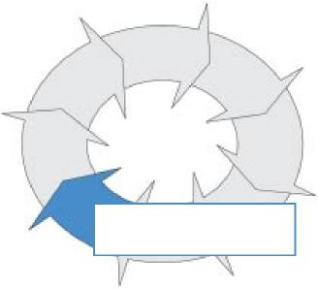
5.3. Develop the Sequencing Plan
The changes needed to transition from the current state of the enterprise to the goals and conditions expressed by the target architecture cannot be achieved in a single quantum step. Evolving the enterprise from its baseline to the
target architecture needs multiple concurrent interdependent activities and incremental builds. The best way to understand and control this complex evolutionary process is by developing and maintaining a systems
migration roadmap or sequencing plan. The sequencing plan should provide a step-by-step process for moving from the baseline architecture to the target architecture.
The sequencing plan may be supported by a set of architecture products, similar to the baseline and target architecture products, generated for several intermediate points in time between the baseline and target environments. The succession from one point in time to the next, and on to the target timeframe, establishes a migration sequence.
Because the sequencing plan represents the current environment, as well as the development programs that are both planned and under way, it becomes a primary tool for program management and investment decisions. To remain current and to support continued coordinated improvements across the enterprise, the sequencing plan should be maintained and updated as time and circumstances dictate.
In addition to specific development requirements for the new components in the target
architecture, development of the sequencing plan should consider a wide variety of inputs, including:
- Sustainment of operations during transition
- Existing technical assets and contractual agreements
- Development programs currently underway
- Anticipated management and organizational changes
- Business goals and operational priorities (including legislation and executive directives)
- Budget priorities and constraints.
5.3.1. Identify Gaps
The first step in transition planning is gap analysis—identifying the differences between the baseline and target architectures in all related architecture products. Critical differences are those that affect the successful accomplishment of the enterprise's mission. Consequently, the gap analysis also develops the user requirements, determines political and technical constraints, and assesses migration risks and feasibility.
Through gap analysis, the architecture core team can determine the components that need to be changed to achieve the desired end-state. The gap between baseline and target architectures is overcome by a series of incremental builds that lead to the target environment. The size of the increments is based upon the overall time between the baseline and target, dependencies among developmental programs and components, critical path analysis for highly dependent activities, business-driven priorities (e.g., legislative mandates and executive directives), limitations in
human capital capacity to manage the incremental projects and builds, expected return-oninvestment from projects and builds, and risks. Overall, the gap analysis assesses the state of the legacy systems, technology maturity, acquisition opportunities, and fiscal reality of the transition.
5.3.2. Define and Differentiate Legacy, Migration, and New Systems
Legacy, migration, and new systems make up the technical components for the transition to the target environment. Legacy systems and their applications are those in current operation and usually are phased out during the deployment of the target architecture. Migration systems and applications may be in current operation, but certainly will be in operation when the transition begins and for some time into the future. Therefore, they may not be specifically represented in the target architecture. Migration systems also include systems, databases, interfaces, or other
components that may be introduced and temporarily used to sustain operations between the current systems (and incremental phase) and the establishment of target architecture components. New systems and applications are those that are being acquired, are under development, or are being deployed. They are expected to be operational as part of the target environment.
The key to prioritizing projects is the sequencing of the termination of systems, the phasing out of functionality, and the timing of systems deployment, technology insertion, and the addition of new functionality into the enterprise. The architecture core team considers dual operation of legacy systems alongside the initial start-up of new systems and account for this potential in the sequencing plan. The uninterrupted flow and management of data, its use by both the legacy and new systems, and its creation and distribution should be outlined in the sequencing plan. The migration should be managed and pursued incrementally so that the impact of unforeseen events
(e.g., technical problems, fiscal delays, etc.) on the efficient operation of the enterprise will be minimized.
Decisions about sequenced investments need to be driven by high-level analyses about respective costs, benefits, and risks, as well as sequential technical and functional dependencies.
A major section of the sequencing plan is the system evolution or migration analysis captured in a set of systems migration tables, diagrams, or charts. Figure 13 illustrates a notional migration chart. This type of chart helps illustrate how systems and applications are expected to evolve between the baseline and target architectures. Generally, a system evolves in one of six ways:
- Current systems continue in operation (System D)
- Existing system functionality is absorbed by another system (System A into System B)
- Legacy system transitions to migration and evolves into a new system (System B into System X)
- Current system is planned for further evolution (System C into System Y)
- A new system developed during transition that becomes the permanent final system (System E)
- A merger of legacy functionality and migration systems (System N into System K and then absorbed into System D).
Figure 13. Systems Migration Chart
System C |  |  |  |  | System Y
 |  | System E
 |  | System E |  | System E

System D |  |  |  |  | 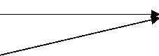 | System D
 |  |  |  | System K
System N |  |  |  | System K

Today Transition Period Target
System A | 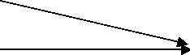
System B |  |  |  |  | System X
System B |  | System B |  |  | System X

A sequenced insertion of functionality and a detailed deployment plan for IT systems is
developed based upon operational priorities, risk management, and return on investment.
5.3.3. Planning the Migration
The rate of modernization—that is, migration to the target architecture—needs to be planned in
convenient, manageable increments to accommodate the organization's capacity to handle change. Understanding the level of effort is necessary to allocate and manage the work according to a scheduled migration with milestones. This will depend on proposed information systems
development or acquisition, priorities, and the availability of resources, such as budget, people, and time constraints.
The implementation of changed business processes might be expressed as program initiatives with one or more projects. A review of the collection of gaps between the baseline and target
architectures determines which enhancements, modifications, and replacements are needed. Dependency analysis determines the alternatives available for sequential and concurrent activities, and helps determine what should be accomplished in which increment or iteration of projects. Projects would then be defined to implement each of the initiatives (or sets thereof). Each project represents a logical division of work that is easier to describe and manage from the overall effort and would be assigned to an individual project manager with clear responsibility for its success.
The next step in the development of the migration path focuses on dependency analysis and consideration for the desired level of effort for each of the projects. The interdependency of systems within the enterprise and the dependencies among projects and initiatives is the primary driving force in determining the sequence for implementing solutions. Estimating the effort and
duration for each initiative provides additional information to the dependency analysis that supports critical path analysis. After considering options offered by tradeoffs from critical vs. non-critical changes, prioritizing key enhancements to meet key management priorities (such as
legislative mandates or executive directives), and providing for sufficient leeway to reduce schedule risk, a draft sequence plan for the portfolio of projects can be created.
Final refinement of the sequencing plan involves review and refinement to meet the short-term needs and potentially volatile priorities of the business units within the financial constraints of the enterprise. The following are some key issues to consider when refining the strategy:
- What is the potential for commitment of funds for the initial phases of the migration?
- What is the potential for the commitment of funds for the entire transition to the target architecture?
- How soon will the business units see the initial benefits (i.e., operational enhancements or return on investment) from the plan?
- Does the sequencing plan provide incremental improvements to system users to help sustain commitment and support to the program?
- What risks are inherent in the current sequencing plan? How will they be mitigated?
- What alternatives are currently available if funding or resources are delayed?
The modification, enhancement, or development of information may include applications, data integration, and interfaces, as well as systems platform acquisition, staffing, training (or
retraining), and systems deployment. Because almost all systems development implies the control and transfer of funds, systems development should be coordinated and integrated with financial management. In addition, interrelationships and interdependencies—whether architectural, organizational, and external—need to be accounted for in the sequencing plan.
5.4. Approve, Publish, and Disseminate the EA Products
Upon verification and validation of the architectural products, the Agency's management should approve the overall architecture. This step includes approval by the EAESC, the CIO, Chief Architect, and Agency executives up to and including the Agency Head (e.g., Secretary,
Commissioner, or Directors). Each Agency incorporates its own approval processes for this cycle.
The Agency executives, managers, and architects should have ready access to the information in the EA. By distributing the information in electronic Read-Only format, executives and managers can use the information directly while the controlled baseline is maintained. Executives and managers should use the information for more than just reference purposes— incorporating it into communications, briefings, and directives. Application architects use the
information to analyze artifacts against their own reality and identifying opportunities for improvements. Enterprise architects use the information to apply "what-if" analysis against the baseline. In addition, Read-Only format versions of the EA limit the number of staff able to make changes and modifications to the products, easing the burden of change management on the enterprise as a whole.
The EA documents extensive information about the Agency. Careful consideration must be made
to the distribution of that information. Although it is possible that an EA may not have any confidential information, the aggregation of the information may comprise a security risk. In the wrong hands, the compilation of enterprise information in the EA could create a vulnerability to
the Agency by providing sufficient information for infiltration and disruption. Some of the information (or combinations thereof) may need to be controlled and accessed on a "need-toknow" basis (e.g., network models, critical performance factors, system interfaces, etc.). The architecture core team considers what classes of EA users will need what information: contractors, management, and Agency staff typically focus on particular areas of the enterprise, and thus may only need particular subsets of the EA. An EA that includes a comprehensive view of the details of the Agency systems and infrastructure could be organized in levels of detail and distributed in a tiered format corresponding to security clearances and the need to know.
Architecting is an ongoing, iterative process requiring regular modification and maintenance.
Whenever the EA changes, it is imperative to update the architecture models. A detailed discussion of architecture maintenance is presented in Section 7.
6. Use the Enterprise Architecture
Using the EA to implement new projects provides a positive impact on the enterprise. If the EA is not successfully used, the entire development effort to this point is for naught. In this section, the emphasis shifts to integrating use of the EA across multiple activities and organizational groups. Success depends on active management, proactive architects, and receptive project personnel. It also depends on integrating the EA process with other enterprise life cycle processes, particularly the CPIC process.
Establishing the EA captures the state of the enterprise and the plan for its future—literally a snapshot of the enterprise and its plans for improvement. For the EA to provide the strategic
information asset base as intended, it should become a crucial tool for decision support and communication in the mainstream of daily business operations. Accepting and applying this asset in the Agency's operational paradigm is a technical and cultural challenge.
The EA is managed as a program that facilitates systematic agency change by continuously aligning technology investments and projects with agency mission needs. The EA is updated continuously to reflect changes in operational and investment priorities that may arise due to legislation, budget constraints, or other business drivers. It is a primary tool for baseline control of complex, interdependent enterprise decisions and communication of those decisions to agency stakeholders. The sequencing plan provides a strong guide for agency decision-makers to use as they consider proposed projects. If a project is not represented in the sequencing plan, it should either be denied funding, since it is not aligned with the agency strategy as embodied in the EA,
or it should be granted a waiver if it is a legitimate deviation driven by valid changes in the agency's environment which have not yet been reflected in the EA. It should be noted that it is crucial that the EA represent the current agency strategies and imperatives as closely as possible, since any lag in the EA may constrain the agency's ability to effectively execute its mission until a waiver is issued or the EA is adapted. In cases where a waiver is granted, the cause of the waiver should be examined and appropriate changes to the EA considered if the cause represents a valid and ongoing gap in the EA.
6.1. Integrate the EA with CPIC and SLC Processes
Investment management and systems development/acquisition are closely linked with the EA processes.⁶ The agency should only make investments that move the agency toward the target architecture and these investment decisions should comply with the sequencing plan. The EA, CPIC, and SLC (systems life cycle) processes are integrated to best suit the agency's particular
organization, culture, and internal management practices. Certain basic relationships exist between these functions and they have a common focus: the effective and efficient management of IT investments. The dialogue across CPIC, SLC, and EA processes is continuous, cooperative,
and facilitated by agency commitment to an integrated process. Details of this relationship between management processes and the capital planning and investment control process are
discussed in the Architecture Alignment and Assessment Guide and the Smart Practices in Capital Planning document. GAO's Information Technology Investment Management
⁶ As discussed as the beginning of this guide, these processes are also linked with information security management processes and human capital management processes. Linkages with these latter two processes, however, are not explicitly addressed in this guide.
Framework provides a structured approach to IT investment management that is consistent and integrated with the principles of good EA and system life cycle practices.
Each agency designs its own CPIC process for structuring budget formulation and execution to ensure that investments consistently support strategic goals. All IT projects should align with the
agency mission and support agency business needs while minimizing risks and maximizing returns throughout the investment's life cycle. The target architecture and the sequencing plan provide information for the three phases of the CPIC process. In the Select Phase, the agency determines if the proposed investment meets business decision criteria. To assess the business
alignment of the proposed investment, decision makers use, for example, the business case, acquisition plan, and the project plan to determine whether the proposed investment aligns with
the sequencing plan and target architecture. In the Control Phase, decision makers monitor business and technical compliance as demonstrated in, for example, the updated business case, system architecture, systems design, and test program. In addition, the investment should be monitored to ensure continuing alignment with the agency's strategic and business goals, which may shift over time. In the Evaluate Phase, the decision makers perform a final assessment to determine technical and strategic compliance with the EA. The results, including findings of noncompliance, should influence strategic planning for new business and IT projects, which could then lead to changes in the EA.
Figures 14 and 15 illustrate one example of a CPIC and architecture management process developed by the U.S. Customs Service (Customs)—the Investment Management Process (IMP). There is a detailed discussion of their IMP in the U.S. Customs Service Enterprise Architecture Blueprint (August 1999). This framework enables compliance with the EA and the necessary governance for application to the Enterprise Life Cycle Management activities.
Projects are managed and executed through the agency's systems development/acquisition life cycle. Each agency may have its own unique approach to the systems development/acquisition cycle, but certain fundamental elements such as requirements, systems and software architecture, design, and test are common.
Figure 14. IMP/Architecture Project Assessment Framework
(CONTROL)
- Define
- Build
- Implement
- Operate
IRB
Report
(EVALUATE)
Evaluation
Evaluate
4 Architecture Compliance
Respond to
Business
Change
Audit Reports
Acceptable
Compliance
Report
3
Assess
Technology
Compliance
Investment Process /Architecture Project
Assessment Framework
Compliance Assessment
Unacceptable
Conformance
Proposed Concept
Unacceptable Alignment
Assess
Business
Alignment
1
Unacceptable Compliance
Alignment
Scorecard
Acceptable Alignment
TRM
Standards
Assess Waiver/
Exception Request
5
(SELECT)
Project
Initialization
(SELECT)
Develop
Business
Case
Aligned per IT Strategy
Disapproved
Architecture Roles Architecture Process
Assess
Business Case
Proposal
Enterprise
Design
Patterns
Target IT App.Port / Infra. Initiatives

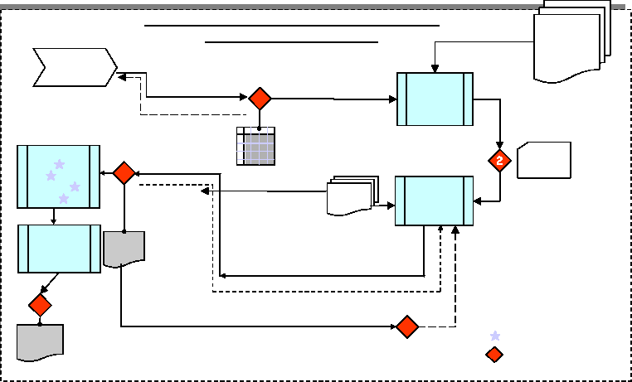
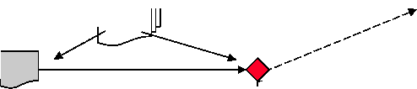

Figure 15. Architecture Management
TRM
Standards
&
Strategies

TRM
Structure
Conduct
Standards
Review

7
Triggers
Enterprise Filter
Perform Technology Insertion and Renewal
TRM Waiver
Containment
Block
Assess
Technology
Compliance
Report
Events
Initiate waiver/exception request per TRC
Unacceptable Conformance
TRM
Standards
Issue Waiver /
Exception
5
Standards Review Required
Approved One-Time Exception
Disapproved
- Respond to user request (EAPMO)
- Respond to market direction (EAPMO)
- Respond to vendor direction (Domain Owner)
- Annual strategic planning event (EAPMO)
- Track emerging technologies (EAPMO/DO/SME)
Architecture Roles Architecture Process

Technology Architecture Management

In order for an agency to successfully deploy an integrated process as described in this document it needs to train its personnel, define and implement compliance criteria, and conduct integrated reviews. Each of these critical aspects is discussed in the subsections that follow.
6.1.1. Train Personnel
It is the responsibility of agency executive management to institutionalize the control structures for the EA process as well as for the agency CPIC and SLC processes. For each decision-making body, all members should be trained, as appropriate, in the EA, the EA process, and the relationship of the EA to the CPIC and SLC. Specific training, at various levels of detail, should be tailored to the architecture role of the personnel.
Anyone who might bring forward a proposal to the Capital Investment Council (CIC)—such as domain managers and project managers—should understand the requirement for EA assessments. To adequately evaluate an investment proposal, the CIC needs specific information. Individuals creating the investment proposals should be trained, as appropriate, in the criteria and submission requirements. Appropriate training will prepare the staff to assess the compliance and correct any deficiencies that exist prior to submission.
6.1.2. Establish Enforcement Processes and Procedures
The processes and procedures that enforce the application of EA guidance and those that ensure its consistency with the "reality" of the enterprise are critical components in EA institutionalization. The EA processes and procedures implement the Executive EA Policy (see Section 3.1.2). The Enforcement Policy defines the standards and process for determining the compliance of systems or projects with the EA and procedures for resolving the issues of noncompliance. A project's technical and schedule compliance is typically assessed in terms of how it conforms to the content, intent, and direction set by the EA.
The processes and procedures should answer the following questions:
- How and when will projects submit project plans to be reviewed for EA compliance?
- Who will be responsible for compliance assessment and/or justification of waivers?
- How will compliance and non-compliance be documented and reported?
- How will outstanding issues of non-compliance be resolved and/or waivers be processed and approved?
- Who will be responsible for processing, authorizing, and reassessing waivers?
- What will be the content and format of waiver submissions?
- If a waiver is granted, how will projects achieve compliance in the future?
- What are the ramifications if a non-compliant project is not granted a waiver (e.g., funding and/or deployment restrictions)?
The processes and procedures should, of necessity, allow exceptions. In many cases, existing systems in the operations and maintenance phase should be granted exceptions or waivers from the technical standards and constraints of the EA. Alignment of some legacy systems with new standards could be unreasonably costly and introduce additional risk to the business users. Also, it is likely that certain initiatives and innovations, such as investigative efforts and proofs-ofconcept, will not comply with the EA.⁷
6.1.2.1. Define Compliance Criteria and Consequences
Requirements for EA assessments include criteria for compliance, waivers, and corresponding submission requirements. In the event of a non-compliant proposal a request for waiver should be prepared and formally submitted to the Technology Review Committee (TRC). The waiver
provides analytical and defendable justification of design changes, budget deviations, and impacts. The waiver request includes identification of the operational, economic, and productivity impacts of any waiver. The corresponding impacts of the waiver not being approved should also be provided to the TRC. The TRC recommends to the CIC approval or denial of requests for waivers. The CIC approves or denies requests for waivers based on this information.
The TRC approves waivers according to the agency's enforcement process. Each waiver that is approved presents an opportunity for feedback on the EA and the EA process. For example, the need for a waiver may indicate that the target architecture, the transition analysis, and/or the
sequencing plan are too constraining or too rigidly defined. In addition, rapidly evolving requirements may necessitate revisiting existing plans outside the normal EA process, since waivers may indicate that the defined target environment does not reflect agency needs. Also the need for reworking proposals may indicate problems in training for compliance.
The CPIC process should respect the integrity of the sequencing plan while considering the strategic and tactical value of all proposals that pass through CPIC checkpoints. Project critical
success factors continue to be met. This double check on project proposals ensures that all funded projects meet the conditions necessary for success. These conditions include, but are not limited to:
- Consistency with the EA
⁷ After a non-compliant investigative or innovative effort is commenced and appropriately controlled during its execution, it may become a candidate project for consideration by the EAESC and TRC. Such a project might well offer proposed changes to the EA.
- Satisfaction of project baseline cost, schedule, capability, and business value commitments
- Compliance with agency-published investment management policies and guidance
- Explicit support by executive management.
6.1.2.2. Set Up Integrated Reviews
The CPIC Select, Control, and Evaluate Phases require reviews of proposals and project performance whenever significant change is contemplated or at logical milestones or key decision points (KDPs) in the systems life cycle. KDPs are points where management should take action regarding project scope, approach, funding, etc. EA enforcement should be applied at KDPs,
when possible, since it is at those points that senior management will convene to consider investment decisions. Reviews may also occur periodically, for example as part of an integrated capital planning/budget cycle. Since the EA is a major management tool for monitoring and guiding change within the agency, the important outcome is to schedule reviews to ensure that planned investments stay on schedule, within budget, and achieve defined goals. In addition, these reviews provide the opportunity for the EA team to communicate changes in the target architecture and sequencing plan to the agency as a whole, as well as to the specific projects that will be affected. Deviations from compliance may be addressed by implementing changes to the project or by a waiver request.
6.2. Execute the Integrated Process
Progress toward the target architecture is accomplished through programs and projects. New and follow-on projects are (1) initiated and selected, (2) executed and controlled, and (3) completed and evaluated. The following sections show the information flow for each of these three CPIC phases with emphasis on how the EA supports the whole process.
6.2.1. Initiate New and Follow-on Projects
Sponsors propose projects under different circumstances:
- New projects are identified and sponsored based on the domain owner's interpretation of the sequencing plan. A project to fill the gap may result in business process reengineering, IT development, and/or change to the infrastructure.
- Planned follow-on projects are anticipated, but still need review by the CPIC and an assessment of the completion of dependencies on previous projects.
- A need for an architectural improvement is identified, e.g., to incorporate a new standard or technology identified by the target architecture, gap and transition analysis, and the sequencing plan.
- A sponsor may initiate a project based on a business or technical need that is not identified in the sequencing plan. In this case, a waiver needs to be approved and the EA team should respond by considering modifications to the EA. This is only possible based upon a formal waiver and approval process including the EAESC, CIC, and other executive-level panels.
Figure 16 depicts the information flow when a project is initiated. It serves as a guide through the cycle of proposal preparation, aligning the proposed project with the EA, and making the decision to fund the effort. The information flow ensures that requirements are being addressed and that a proposed implementation meets expectations and requirements.
Figure 16. Define New and Follow-on Programs/Projects 6.2.1.1. Prepare Proposal
Program Managers Domain Owners Architects
Program/Project Proposal with EA impact assessment & proposed EA changes
Propose
Programs
and
Projects Business Requirements
IT Needs
Technology Updates
Program/Project Proposal
EA Products EA Updates EA Assessment
Approved Waivers Recommendations
Decision to Launch, Conditions
EA
Repository/Tool
Manage EA
Assess/Align
EAESC TRC
Architects
CPIC
Process
Sel
ect
Investment
Council
(CIC)
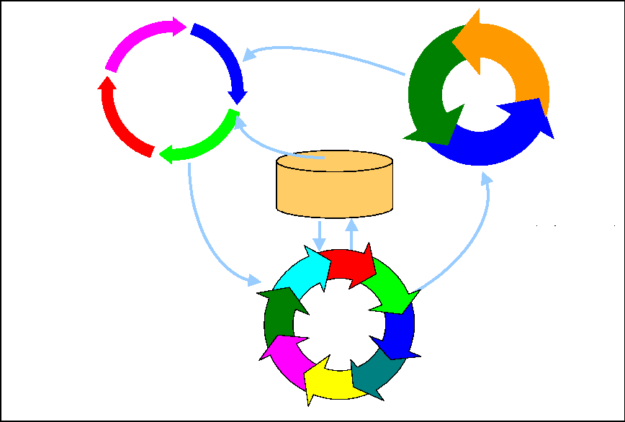
The sponsor of a project prepares a proposal in accordance with predefined agency requirements. The proposal presents the business case for the project and defines a business solution using information from the EA as well as other sources. Business requirements, IT needs, and
technology updates all feed the definition of the effort being planned. Domain owners and program or project leaders prepare the proposal by:
- Mapping objectives to requirements and relationships between high-level requirements to the business objectives
- Documenting a high-level business case
- Providing a cost study
- Defining a business case solution and determining the level of impact introduced into the IT environment
- Ensuring reasonableness of risk, time, and cost
- Ensuring that technical and business implications to the organization are addressed.
The domain owners and program or project leaders should comply with the architecture project reporting requirements and will provide answers to compliance criteria in the proposal documentation. For selection, they will show that the investment supports the agency mission, that the investment meets the business criteria, and that it is consistent with the target architecture and sequencing plan. If an investment deviates from the sequencing plan, the reasoning for the deviation should be documented.
The Chief Architect and the architecture team can advise program/project leaders on business case/solution development. They contribute to the development of investment proposals and
work to facilitate progress through the CPIC. They have a specific interest in ensuring that projects identified in the sequencing plan are funded, and may actually introduce such projects.
For other projects, they will support project leaders in initiating and developing proposals.
6.2.1.2. Align the Project to the EA
The Chief Architect and the architecture group perform proposal assessments. Table 5 describes the types of assessments that occur as projects are subjected to periodic, iterative EA reviews. In the initial phase of defining and selecting a project, the emphasis is on the business alignment, business case solution, sequencing plan, and to a limited degree, technical compliance. As the system concept matures, business and technical compliance are equally addressed. Details of this alignment with business and the CPIC processes are discussed in the Architecture Alignment and Assessment Guide (see Appendix F for a complete reference listing).
Table 5. EA Review Goals
Type of EA Reviews | Review Purpose/Goal
Business alignment | Determine if the proposed project aligns with Agency strategic plans, goals, and objectives. The goal of the review is to ensure that the expected business outcomes of the project are aligned to concept and high-level project requirements.
Business case solution | Examine the proposed solution, at a high level, to determine the impact introduced into the organization's IT environment. The goal of the review is to ensure that the proposed solution supports both the business and technical architecture.
Sequencing plan | Determine whether the proposed investment is consistent with the sequence and priorities in the plan. The goal of the review is to ensure progress toward the target architecture.
Technical compliance | Determine whether the architecture of the proposed solution complies with the enterprise standards, the various architecture levels, and methodologies. The goal of this review is to ensure technical compliance of IT projects.

Upon assessing the project's alignment to the EA, the architects may make recommendations and provide support to bring non-compliant proposals into compliance. In cases where a waiver had
been requested, the architects may respond with an independent assessment of operational, economic, and productivity impacts of the waiver.
6.2.1.3. Make Investment Decision (CPIC Select Phase)
The CIC is responsible for the evaluation of new proposals and for oversight of ongoing investments. Among other criteria, CIC decisions are based on determinations that the proposed projects submitted by the business managers are aligned with agency strategic plans, goals, and objectives. The business proposal and the results of the architecture assessments, including waivers, are reviewed by the investment decision makers. The same conditions and consequences pertain to follow-on projects and incremental funding.
In certain circumstances, it may be necessary to approve a proposal that does not conform to the target architecture and/or the sequencing plan. The conditions under which a waiver is granted
and the operational, economic, and productivity impacts of the waiver are considered in the investment decision. Under most circumstances, any proposal that is not compliant or otherwise does not qualify should be denied a waiver. Non-compliant initiatives may be approved for research, concept development, prototyping, and other purposes. These efforts may challenge assumptions currently accepted in the EA and may lead to breakthroughs that could significantly improve the EA. Nevertheless, the conditions under which a project may proceed should be
unambiguous and clearly stated in the EA policy and should be documented in the CIC's investment decision. Once the project has been acted on, there may be recommended changes to the EA or the requirement for additional detail to enhance the EA. The funding decision will
have an impact on the sequencing plan and potentially the target architecture and transition analysis.
6.2.2. Execute the Projects
Once funding is received, the project can be initiated. Figure 17 depicts the information flow as the project cycles through the integrated EA, SLC, and CPIC processes. A project will pass through this cycle multiple times. There are continuous interactions between the project implementers and the architecture, with more formal reviews at prescribed milestones.
Figure 17. Execute Programs/Projects
Program Managers Domain Owners Architects
Proposed EA Updates Systems Architecture Requirements and Design
EA Products EA Updates Program/Project Progress
Program/Project Progress Systems Architecture
Manage
Programs
and
Projects
Business & IT Priorities Dependencies
Architecture
Design & Constraints
Funding decision to continue, conditions, waivers, redirection
EA
Repository/Tool
Manage EA
Assess/Align
EAESC TRC
Architects
Co ntr ol
Requirements and Design Architecture Assessment Recommendations
CPIC
Process
Investment
Council
(CIC)

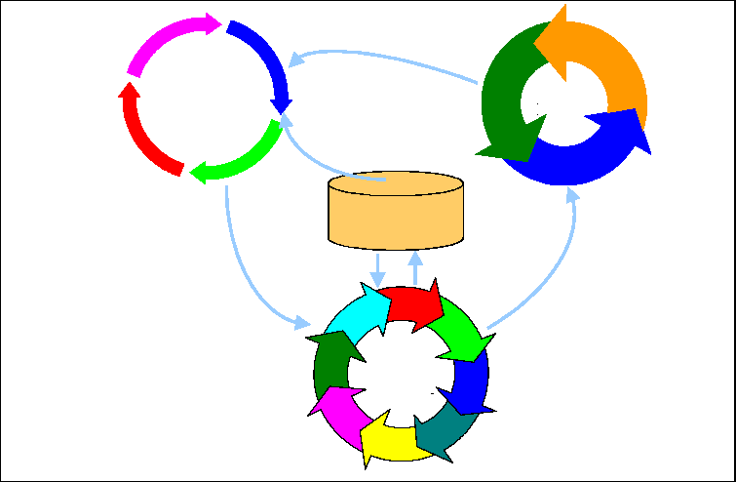
6.2.2.1. Manage and Perform Project Development
Program/Project Leaders use the EA as guidance and constraints on systems architecture and systems design. The project management goal is to ensure that the proposed solution supports the EA. The project's requirements, systems and/or software architecture, design, and test program are developed using concepts, constraints, and recommendations from the EA. Systems migration strategies may be found in the sequencing plan.
The Chief Architect and the architecture group contribute to projects as consulting architects. Their role in the requirements and design phases is to provide guidance to the business unit and its project teams on technical architecture-related issues and emerging trends in the industry.
They make recommendations for relevant parts of the EA (e.g., business, information, data, application, infrastructure, security, and standards).
Initial requirements, systems and/or software architecture, and design rely heavily on existing artifacts from the EA. As the project progresses, products are produced that enhance and expand the level of detail in the EA. These products, generated according to the SLC requirements, are contributed and incorporated into the EA repository.
6.2.2.2. Evolve EA with Program/Project
It is the responsibility of the Chief Architect and the architecture core team, with direction from
the EAESC, to maintain EA alignment with the organization as it evolves. Throughout a project's development/acquisition phase, the requirement is to maintain the alignment of the
evolving solution with the target architecture and sequencing plan. The architecture team reviews the business and technical solution throughout the life cycle and assures compliance with the EA. In incremental reviews, assessments are performed to determine whether the project's products and documentation (the functional analysis, general design, and detailed design) comply with the EA products that have been approved through previous review processes. The projects provide additional information as progress is realized. The goal is to maintain alignment of the project
with the EA throughout development to avoid construction of systems that do not meet the organization's needs.
In addition to systems architecture and design specifics that flesh out the EA at the lower levels of detail, the projects provide new ideas to the EA for changes to the target architecture and transition increments. The EA should be reviewed regularly and synchronized with the enterprise life cycle and investment decisions. The Chief Architect and the architecture team incorporate this feedback into the EA maintenance process. See Chapter 7 for more detailed discussion on EA maintenance.
6.2.2.3. Assess Progress (CPIC Control Phase)
The CPIC Control Phase ensures that the investment is being managed within the planned cost, schedule, and design and that the investment will operate effectively within the technical infrastructure. Systems development and acquisition is inherently risky. Managers and architects provide information according to the reporting requirements for architecture assessments, and this information is used as the basis for decisions about continued funding, imposition of development constraints, and possible redirection of technical efforts. This control is imposed to manage and mitigate risk. Investment decisions rely on analysis of progress reports, compliance assessments, and deviations and waivers to arrive at implications on cost, schedule, and performance.
6.2.3. Complete the Project
Most projects are interdependent on other development projects and legacy systems. Many are followed by additional increments of capability or by additional operations and maintenance (O&M) efforts. Almost all are integrated with other systems when they become operational.
When the project is complete, there is a final assessment of impacts on the agency, the EA, enterprise operations, future systems, and consequently, future investment and funding decisions. Figure 18 depicts the information flow upon completion of a program or project.
Figure 18. Evaluate Programs/Projects
Program Managers Domain Owners Architects
Proposed EA Updates
System Architecture
Requirements
Design
Test Results
Complete
Programs
and
Projects
Sequencing Plan EA Products
Business & IT Priorities Dependencies
Architecture
Design & Constraints
EA
Repository/Tool
Manage EA
Assess/Align
Evaluation
EA Updates
EAESC TRC
Architects
Evaluate
CPIC
Process
Systems Architecture
Requirements & Design Architecture Assessment
Approved Waivers
Design & Recommendations Process Improvements
Investment
Council
(CIC)
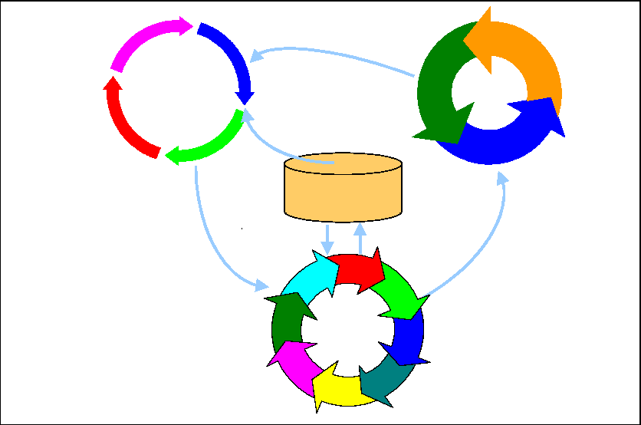
6.2.3.1. Deliver Product
At the end of a program or project, system and updated business processes have been integrated into the environment. An O&M support is defined, training is provided, and a complete set of documentation is communicated to the operations and maintenance staff. Material is provided for the EA repository with the delivered product, to the level of detail appropriate to depict the new baseline architecture. A support and deployment strategy is activated for parallel or turnkey operations. There is a transition from the development/acquisition environment and management to O&M environment and management. At this time opportunities for the reuse of work products from this project to other projects should be considered.
6.2.3.2. Assess Architecture
The EAESC performs an ongoing assessment of the EA. There is much to be learned by evaluating the extent to which a project has complied with the sequencing plan, based upon the target architecture. The experience and lessons learned contribute to the ongoing robustness of the EA processes.
The final assessment of the project with respect to the enterprise architecture involves review of
the original business case, the implementation of the business and technical solutions, the sequencing plan, and final disposition of waivers. The result of the final assessment is the updating of the baseline architecture with changes implemented in business processes, IT products, deployment, technology, and operations. The sequencing plan, target architecture, and gap/transition analyses are also updated to show completion of the program/project. Waivers will either be permanent or may be accompanied by plans for future work. Other results can influence future priorities and dependencies in the sequencing plan. These results provide lessons learned for process improvement and form the basis of business cases for other new programs or projects.
6.2.3.3. Evaluate Results
The EAESC and CIC assess program/project results for impact to the EA and the organization's business processes. The CPIC Evaluate Phase shows that the investment meets the planned performance goals and identifies any reasons for updating the EA. After considering the results of impact to the EA, the conditions that may have necessitated a waiver may prove sufficiently pervasive to justify altering the EA to accommodate future investment proposals with similar requirements.
6.3. Other Uses of the EA
The EA provides guidance and source information for requirements analysts, designers, engineers, and test planners to reference and build upon material executing their responsibilities. The following are examples of uses of the EA outside the normal project cycle:
- Even if an agency is not involved in a major IT upgrade, the EA is a resource for managing inventory, routine maintenance, and queries. Analysis of the baseline architecture can identify opportunities for consolidating network services, floating or site software licenses, and economies of scale for equipment and services.
- The agency can use the EA as a training aid, drawing on its graphics and descriptive material for instruction in the business of the agency or in the technology that is in use or planned.
- Investigative initiatives and proofs-of-concepts should be performed using the EA as a reference. The criteria for EA compliance should be considered, but not mandated, in such efforts. Non-enforcement allows pursuit of innovations that could change the EA, but alignment and impacts of architecture deviations should be included with the results of the experiments.
- Agencies may fund small, low risk projects outside of the CPIC. Program/project managers should still rely on the EA for guidance for the business solution, architectures, requirements, and design of their effort. Compliance with the EA will facilitate integration into the enterprise, and the baseline architecture should be kept current with their products.
- O&M projects rely on the baseline architecture for context. The O&M priorities and decisions may be influenced by the sequencing plan and target architectures. For example, a planner may conclude that soon-to-be-retired IT systems are more economical with minimal O&M support.
7. Maintain the Enterprise Architecture
The EA is, by definition, a set of models that collectively describe the enterprise and its future. Its value to the business operations is more than just IT investment decision management. The
EA is the primary tool to reduce the response time for impact assessment, tradeoff analysis, strategic plan redirection, and tactical reaction. Consequently, the EA must remain current and reflect the reality of the organization's enterprise. In turn, the EA needs regular upkeep and maintenance—a process as important as its original development.
Maintaining the EA should be accomplished within the enforcement structure and configuration control mechanisms of the organization. EA maintenance is the responsibility of the CIO, Chief Architect, and the EAPMO. Using a system of oversight processes and independent verification, the architecture core team periodically assesses and aligns the EA to the ever-changing business
practices, funding profiles, and technology insertion. The EA should remain aligned to the organization's modernization projects and vice versa. The management controls to accomplish EA maintenance are the same ones established to initiate the program and to develop the EA.
7.1. Maintain the Enterprise Architecture as the Enterprise Evolves
If the EA is not kept current, it will quickly
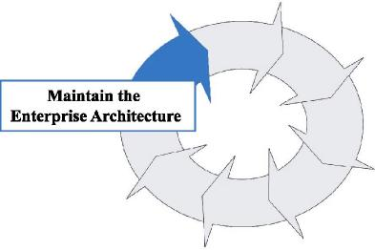
become "shelfware"—yet another well-intentioned plan for improving the enterprise. Perhaps even more damaging, if the EA fails to embody the agency's most current strategy it may limit the organization's ability to meet its
goals and achieve its mission. The EA necessitates a specific organizational and process structure that will ensure the currency of EA content over time. The EA should
reflect the impact of ongoing changes in business function and technology on the enterprise, and in turn, support capital planning
and investment management in keeping up with those changes. Consequently, each component of the EA—baseline architecture, target architecture, sequencing plan, and all the products that constitute them—need to be maintained and kept accurate and current.
7.1.1. Reassess the Enterprise Architecture Periodically
Periodically, it is necessary to revisit the vision that carried the organization to this point and to re-energize that vision within the Agency. Continually, typically in conjunction with the CPIC, the EA should be reviewed to ensure that:
- The current or baseline architecture accurately reflects the current status of the IT infrastructure
- The target architecture accurately reflects the business vision of the enterprise and appropriate technology advances that have occurred since the last release
- The sequencing plan reflects the prevailing priorities of the enterprise and resources that will realistically be available.
The assessment should generate an update to the EA and corresponding changes in dependent projects. The baseline should continue to reflect actions taken to implement the sequencing plan and actions otherwise taken to upgrade the legacy environment as the organization modernizes. The EA assessment and update should be managed and scheduled to in turn update the Agency strategic plan and process for selecting system investments.
7.1.2. Manage Products to Reflect Reality
An Agency is a business entity that remains responsive to business drivers (including new legislation and executive directives), emerging technologies, and opportunities for improvement. The EA reflects the evolution of the Agency, and should continuously reflect the current state
(baseline architecture), the desired state (target architecture), and the long- and short-term strategies for managing the change (the sequencing plan). Figure 19 illustrates the type of continuous changes that should be illustrated by the EA. At no time will a specific target architecture ever be achieved—with each iterative update of the EA, all three components shown in the figure and the timeline are recast. The target architecture is a vision of the future that evolves in advance of it being achieved.
Figure 19. Enterprise Architecture Transition
Implementation Status
Baseline Architecture
Sequencing Plan
Target Architecture
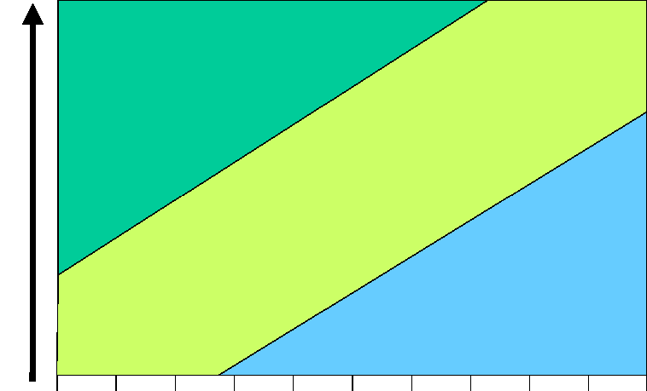

Baseline Transition Target
7.1.2.1. Ensure Business Direction and Processes Reflect Operations
A critical responsibility for the EA program is to monitor the changes in the business operations that affect the organization, the business processes, and the strategic direction of the business.
Changes in business processes that were initiated by process improvement, organizational change, or mandate, may be reflected in the business artifacts of the baseline architecture. Business unit management and their SMEs should report changes in their organizations and initiatives to the Chief Architect and architecture core team. Correspondingly, the Chief Architect ensures that the architecture core team is gaining sufficient insight into the evolution of the operations. Plans and expectations may change as priorities shift over time—these may need
to be reflected in modifications to the target architecture. Priority shifts and the realities of
budget constraints may need to be reflected in the sequencing plan. Thus, EA maintenance will be both reactive and proactive.
7.1.2.2. Ensure Current Architecture Reflects System Evolution
Despite the best operational management and systems maintenance planning, the current architecture and infrastructure may need unanticipated changes. As each new system is deployed and each legacy system reaches a maintenance milestone (e.g., renewal of maintenance contracts), the baseline for the current architecture changes. In addition, system patches should
be introduced frequently or system design changes implemented to respond to high-priority requests. These changes should be reflected in the current architecture artifacts.
7.1.2.3. Evaluate Legacy System Maintenance Requirements Against the Sequencing Plan
As the current architecture evolves to reflect the reality of the legacy systems, new information may emerge that will change the maintenance plans and subsequent organizational and systems transition. For example, system vendors may unexpectedly cease supporting critical components
of the Agency's infrastructure. Alternative actions should be weighed and decisions made regarding replacing the components, paying for additional specialized contractor support, or changing the strategy for phasing in other components in the target architecture. The total cost of
ownership of the system versus alternative systems, as well as outsourcing, may need to be considered. All of these considerations, alternatives, and decisions may dramatically alter the sequencing plan.
7.1.2.4. Maintain the Sequencing Plan as an Integrated Program Plan
The development of the sequencing plan is linked to the acquisition and enterprise engineering
processes. The architect works in partnership with managers who understand the evolving business objectives, as well as the individual program management offices that oversee the acquisition and development of new IT systems. The sequencing plan should be maintained, reviewed and validated, and approved to continually reflect the organization's mission and vision just as any product in the architecture package and plan. The sequencing plan delineates the IT management scheme for systems insertion in support of the organization's long-term business strategies.
7.2. Continue to Consider Proposals for EA Modifications
While the enforcement process helps to ensure that the EA guidance is followed, it is unreasonable to assume that new business priorities and technologies, funding issues, or project challenges will not require modification to the plans, baselines, and products incorporated in the
EA. Emerging technologies continue to necessitate changes to the enterprise. Many of the considerations for changes to the EA are the same considerations that needed to be addressed during its development. Also, the architectural principles need to be continuously addressed.
Proposals for modifying the architecture should address the following questions among others:
- How does the proposed modification support the organization in exploiting IT to increase the effectiveness of its organizational components?
- How does it impact information sharing and interoperability among organizational components?
- What are the security implications? For example, will the modifications need certification of enhanced systems?
- Does the proposed modification use proven technologies and conforming COTS products to satisfy requirements and deliver IT services? Are these technologies and related standards in the industry mainstream, thereby reducing the risk of premature obsolescence?
- Does the acceptance of this proposal position other standards or products for obsolescence? If so, identify them.
- What is the impact on the organization and sub-organizations if the proposal is not accepted? What is the result of the cost-benefit analysis?
- What external organizations or systems will be affected? What action will they have to take?
- What is the estimated overall programmatic cost of the proposed changes including changes to the EA and/or redirection of dependent projects?
- What alternatives have been considered and why were they not recommended?
- What testing, and by whom, should be completed for implementations that will result from acceptance of the proposal?
- What is the recommendation of the enterprise change control board?
Proposals requesting modifications to the EA need to explicitly address these issues. The proposal should be presented to and reviewed by the TRC (for review by architectural team and SMEs) and passed to the EAESC with a recommendation. In cases where the EAESC cannot reach a consensus, a working group may be tasked to investigate and propose recommended actions.
8. Continuously Control and Oversee the Enterprise Architecture Program
The purpose of EA control and oversight is to ensure that the EA development, implementation, and maintenance practices defined in this practical guide and the related EA guidance referenced in this guide (e.g., EA frameworks) are being followed, and to remedy any situations or circumstances where they are not and action is warranted. Control and oversight is a continuous, ongoing function performed throughout the EA life cycle process.
Effective control and oversight is a key to ensuring EA program success. Through it, information
is gathered for accountable decision makers to permit awareness of whether effective EA development, implementation, and maintenance activities are being performed and EA program goals are being met on schedule and within budgets. To do so, the EAESC, the CIO, and the Chief Architect should be vigilant in measuring and validating that the EA process and product standards defined and referenced in this guide are being performed. To do less, diminishes the probability of program success.
8.1. Ensure Necessary EA Program Management Controls Are In Place and Functioning
In Section 3 of this guide, accountability for the EA program was assigned to the EAESC, the CIO, and the Chief Architect. Also, throughout this guide, EA process and product standards or controls that should be used to produce a complete, well-defined, and useful EA have either been defined or referenced. (For example, the guide specified the need for a program management plan to detail what will be done, when, and at what cost, as well as the need to establish management support functions, such as configuration management, risk management, quality assurance, change control, etc. Also, the guide references EA frameworks and tools that help define the content of the EA.)
Knowing the extent to which these controls are being implemented on a continuous basis is crucial to keeping the program on track. To do this, EAESC, the CIO, and the Chief Architect will respectively seek reports (oral and written, routine and ad hoc, formal and informal) and conduct first hand reviews to obtain the appropriate level of visibility into what is occurring on the program vis-à-vis what is expected. It is the responsibility of these accountable entities to define what information they need, when and how often they need it, what the form and content of the information should be, whether it should independently validated or not, etc. Through such
information, the EAESC, the CIO, and the Chief Architect can position themselves to know whether established program management controls are in place and functioning.
8.2. Identify Where EA Program Expectations Are Not Being Met
Through their respective reports and review activities, the EAESC, the CIO, and the Chief Architect will be able to identify what, if any, EA program expectations are not being met. For example, if risk management has been effectively implemented, program risk lists should be regularly generated that assign a risk level based on impact and probability, define risk mitigation strategies, report on progress in implementing these strategies, and whether the progress being made is successfully addressing the risk item. Also, periodic configuration audits should be conducted to ensure that EA configuration items are being defined, controlled, and reported. The EAESC, CIO, and Chief Architect can also rely on independent reviews by the quality assurance function or a verification and validation agent to advise them of deviations from expectations.
These deviations may be program management plan-related, such as omission of work tasks, delays in the completion of work tasks, or additional costs to complete work tasks; or they may be management function-related, such as not following change control procedures, not adhering to
the selected EA framework, or not engaging SMEs and domain owners within business and technical areas.
8.3. Take Appropriate Actions to Address Deviations
Management should take quick and decisive actions to correct problems in light of established priorities. Examples of actions include infusion of additional resources (people, tools, or money), establishment of contingency plans, and redefinition of EA purpose and scope, introduction of missing or strengthening of existing control mechanisms, and increased oversight.
Any changes to the plans, projects, and/or architecture content to address deviations should be
captured in an appropriate documentation trail, and should be justified on the basis of costs, benefits, and risks. Changes should be processed through established change control processes and board authority. The change documentation should characterize the problem, solution, and alternatives chosen and rejected in light of established priorities.
8.4. Ensure Continuous Improvement
Figure 20 is adapted from a traditional representation of the key success factors of Total Quality Management (TQM). This figure represents the same key success factors for enterprise architecting:
- The EA process should be a key support element of the operations of the Agency, and should assist the operations function in performance of its customer-focused mission.
- Successful enterprise architecting is not simply a function of the IT organization, but needs the total enterprise participation.
- Effective enterprise architecting needs "societal networking," that is, internal and external communication and sharing of lessons learned.
The optimum EA process is not a single, one-time event, but is continuous and thus offers the opportunity for continuous improvement. This necessitates ongoing control with monitoring, reassessment, and refinement. As the discipline of enterprise architecting enters the mainstream of Agency operations, lessons can be learned from processes that worked and those that did not work, and from external organizations.
Figure 20. Key Success Factors
Societal Networking
Continuous
Improvement
Enterprise
Architecting
Operations
& Customer
Focus
Total
Participation

Total participation makes continuous improvement everyone's responsibility. The EA's central role in enterprise evolution provides an excellent opportunity to solicit feedback. Lessons learned should be collected from the operational business owners, EA teams, project development teams, and investment management teams. Once the baseline EA has been developed, the architecture team should take stock of the lessons learned and communicate them to their colleagues and participating senior management in order to utilize them in improving the process or the EA
itself. In addition, feedback and lessons learned should be sought from other Agencies, professional organizations, commercial corporations, and consultants.

9. Summary
This Federal Guide to Enterprise Architecture development, maintenance, and use offers a practical "how-to" manual that will assist any Federal Agency in initiating, developing, and maintaining an EA in conjunction with other management processes. Through an illustrative set of "how-to" guidelines and directions, the EA process appears in the context of the Enterprise Life Cycle Management process, which consists of such integrated processes as strategic planning, system development/acquisition, Capital Planning and Investment Control, human capital management, and information security management. While intended primarily for Federal Agency architects, the guide is structured to meet the needs of all Agency staff, from the Agency Head to the CIO and line organization personnel.
The EA is, by definition, a model of the Agency's enterprise and its future direction. Its value to the business operations should be more than simply IT investment decision management. The dynamic changes in technology and business practices impose greater pressure on an Agency to respond more rapidly to these stimuli than ever before. The EA is the main tool to reduce the response time for impact assessment, tradeoff analysis, strategic plan redirection, and tactical reaction.
Although EAs are required by legislative and regulatory direction, they should be developed and used for other reasons, too. Along with their importance in the capital planning and investment management arena, EAs provide a snapshot in time of the Agency's business and technology assets. They are the blueprint to build upon—the roadmap to systems and business migration. They help mitigate risk factors in enterprise modernization, identify opportunities for innovative technology insertion, and aid executives and managers in key decision making at all levels of the organization. And these are but a few of the benefits of maintaining a thorough EA.
The EA process is a long-term, continuous effort. Once developed, the EA is a "living" entity with many parts, whether in the form of a document, database or repository, or web page. To remain current and of optimal value, this "living architecture" needs continual care and maintenance. This, in turn, demands an organizational commitment from top to bottom, since Agency resources in time, money, and people should be dedicated to the architecture's maintenance for the long term.
As an Agency begins its EA efforts, its architecture proponents should secure corporate
commitment and buy-in from senior executives and all levels of the organization. Without engaging the entire Agency from the top down, the architecture effort will face an uphill struggle during much of its existence. Thus, the initial stages of the architecture effort will need extensive work—obtaining commitment and backing, grounding the EA in an approved framework, and establishing a functioning architecture structure within the Agency organization.
As one of the first steps, the Agency's Chief Architect should ground the architecture effort in an established framework, if at all possible, as discussed in Section 4 of this guide. The leading
frameworks offer suitable examples, like the FEAF, TEAF, and DoD C4ISR Architecture Framework discussed in this guide, for frameworks and methodologies. As noted, a number of agencies use variations on these frameworks. If these existing frameworks do not meet your Agency's requirements, develop your own framework; however, consider well the resources and time needed to do so.
It must be emphasized again that you should tailor the contents of this guide to your own organization's needs: "one-size does not fit all" is the rule for EA development and maintenance.
The guidance of this document can be used by all Federal Agencies regardless of size and resources, but this guidance should be tailored appropriately. This guide is not intended as the
"one and only way" all organizations should accomplish EA development, but rather as a synopsis of the "best practices" currently employed in several Federal Agencies and private corporations. For example, in smaller organizations, multiple roles and responsibilities may have to be assumed by one individual, some of the committees and groups will have smaller memberships, and in general, participation will be on a more modest scale. The EA itself, the architecture products, and the associated data repository should be developed as appropriate for that individual organization. Not all Agencies will need the same level of detail, nor the same graphical representations. However, all Agencies will need to ensure that they follow a top-down approach to defining their respective architectures, and that at a minimum the business views of their architectures provide an enterprise-wide understanding of operations.
Lastly, do not suffer alone! Take advantage of the architecture community's available resources.
A vast array of resources is at your disposal. This guide and several of the other references discussed in the document can be found on the Federal CIO Council's web site at http://www.cio.gov. Many architecture frameworks are documented in an extensive body of literature and web sites. Standing working groups meet on a regular basis, and there are numerous annual conferences and seminars on the topic. See Appendix F for a reference list of related documents and web sites.
Appendix A: EA Roles and Responsibilities
The following matrix summarizes the functional roles and responsibilities needed to support EA development, use, and maintenance.
Role | Members  (If composite) | Responsibilities
Agency Head | N/A | Establishes EA as an Agency-wide priority; charters an EA Executive Steering Committee (EAESC); issues policy governing the development, implementation, and maintenance of the EA.
Capital Investment Council (CIC) | - Agency/Department  Heads and their  Deputies  - Division/Business Unit Heads  - Senior Budget Official  - Senior Procurement Official  - Legal Counsel  - CIO  - CFO | Reviews the final proposed major information technology investments and makes the final funding decision, selects projects, monitors progress, and evaluates results for investment decision making.
Chief Architect | N/A | Selects the EA project team; works with CIO to develop EA Primer and architecture policy. Oversees EA product development, use, and refinement. Serves as owner of EA repository and is responsible for architecture sequencing plan. Reports directly to the CIO.
Chief Information Officer (CIO) | N/A | Engages and provides strategic direction to EA Executive Steering Committee (EAESC); enhances the Agency Head's understanding and appreciation for EA; appoints a Chief Architect; markets the benefits of an Agency-wide EA to other Agency executives and stakeholders via collaborative forums; obtains participatory commitment from senior executives; and introduces enforcement measures.
Configuration Control Board (CCB) | - Chief Architect  - Domain Owners | Responsible for monitoring and controlling changes to the EA after initial development.
Configuration Manager | N/A | Responsible for maintenance and configuration control of all EA products.
Domain Owners | - Business Unit Managers | Provides senior-level stakeholder and sponsor participation; works with architecture team on standards insertion and renewal, assigns business line resources (subject matter experts [SMEs]) and oversees review of business architecture products.
Enterprise Architecture Executive Steering Committee | Senior representatives from all organizations and | Decides strategy, planning, and resource allocation related to the development and

Role | Members  (If composite) | Responsibilities
(EAESC) | operational missions within the agency; may include senior executives (e.g.,  CIOs) within the business community | maintenance of the EA products; approves the initial EA; provides strategic direction and ensures corporate support; sponsors, reviews, and approves an overarching architecture management strategy; approves significant changes to the EA.
Enterprise Architecture Program Management Office (EAPMO) | - Chief Architect  - Architecture Core Team | Provides for management and control of EA activities as a formal program; creates and maintains the EA program plan and associated EA project plans; defines tasks, resources, and schedules; provides for program management, monitoring, and control of EA product development and maintenance.
Enterprise Architecture Core Team | - Chief Architect  - Business Architect  - Systems Architect  - Data Architect  - Infrastructure Architect  - Security Architect  - Senior architecture consultants  - Technical writer | Responsible for development and refinement of enterprise and application architectures and for populating the EA repository.  Develops formal standards requirements and manages the architecture processes; provides guidance to other teams.  Provides for administration of the EA processes; influences agency officials so that project resources are obtained/retained, objections are properly handled, progress is maintained, and a high-quality, usable architecture framework is established.  Monitors and measures the architecture's effect on projects via process and product measurements.
Independent Validation and Verification (IV&V) Team | Neutral third party from the Agency, external Agency, or a contractor | Conducts architecture compliance evaluations; provides quality assurance checking on program information (cost, schedule, and performance data), as well as the proper implementation of the architecture methodology.
Quality Assurance Manager | N/A | Ensures quality of all architecture products; participates in architecture product working sessions and reviews. Reports directly to CIO.
Risk Manager | N/A | Identifies, monitors, controls, and takes action to mitigate EA program risks. Reports directly to CIO.
Subject Matter Expert (SME) | Domain experts from within the organization (one from each business unit); may be supplemented with outside consultants | Supports Chief Architect and staff in  documenting the defined mission or business requirements and related objectives; supports definition of policies that impact business goals; reviews EA repository products.
Technical Review Committee (TRC) | - Domain Owners  - Senior Architectural consultants  - Chief Architect  - Agency/Department Business and Technical representatives | Assesses business alignment, solution proposals, and technical compliance; evaluates architecture compliance; assesses waiver/exception requests; and conducts standards review.

Appendix B: Glossary
Term | Source | Definition
"As-Is" Architecture | TEAF | The current state of an enterprise's architecture (see baseline architecture).
"To-Be" Architecture | TEAF | The target state of an enterprise's architecture (see target architecture).
Architectural Artifacts | FEAF | The relevant documentation, models, diagrams, depictions, and analyses, including a baseline repository and standards and security profiles.
Architecture Product | IEEE STD 610.12 | The structure of components, their interrelationships, and the principles and guidelines governing their design and evolution over time.
Architecture | DoD Joint Pub 1-02 | A framework or structure that portrays relationships among all the elements of the subject force, system, or activity.
Architecture | John Zachman | A set of design artifacts, or descriptive representations, that are relevant for describing an object such that it can be produced to requirements (quality) as well as maintained over the period of its useful life (change).
Architecture Repository | TEAF | An information system used to store and access architectural information, relationships among the information elements, and work products.
Artifact | TEAF | An abstract representation of some aspect of an existing or to-be-built system, component, or view. Examples of individual artifacts are a graphical model, structured model, tabular data, and structured or unstructured narrative. Individual artifacts may be aggregated.
Baseline Architecture |  | The set of products that portray the existing enterprise, the current business practices, and technical infrastructure. Commonly referred to as the "As-Is" architecture.
Baseline Architecture | FEAF | Representation of the cumulative "as- built" or baseline of the existing architecture. The current architecture has two parts:  - The current business architecture, which defines the current business needs being met by the current technology  - The current design architecture, which defines the implemented data, applications, and technology used to support the current business needs.
Business Architecture | FEAF | A component of the current and target architectures and relates to the Federal mission and goals. It contains the content of the business models and focuses on the Federal business areas and processes responding to business drivers. The business architecture defines Federal business processes, Federal information flows, and information needed to perform business functions.
Capital Planning and Investment Control (CPIC) Process | OMB | A process to structure budget formulation and execution and to ensure that investments consistently support the strategic goals of the Agency.

Term | Source | Definition
Enterprise | TEAF | An organization supporting a defined business scope and mission. An enterprise is comprised of interdependent resources (people, organizations, and technology) that should coordinate their functions and share information in support of a common mission (or set of related missions).
Enterprise Architecture (EA) | FEAF/TEAF | A strategic information asset base, which defines the business, the information necessary to operate the business, the technologies necessary to support the business operations, and the transitional processes necessary for implementing new technologies in response to the changing business needs. It is a representation or blueprint.
Enterprise Architecture | John Zachman | The set of primitive, descriptive artifacts that constitute the knowledge infrastructure of the enterprise.
Enterprise Architecture Policy |  | A statement governing the development, implementation, and maintenance of the enterprise architecture.
Enterprise Architecture Products |  | The graphics, models, and/or narrative that depict the enterprise environment and design.
Enterprise Engineering |  | A multidisciplinary approach to defining and developing a system design and architecture for the organization.
Enterprise Life Cycle | TEAF | The integration of management, business, and engineering life cycle processes that span the enterprise to align IT with the business.
Federal Enterprise Architecture Framework (FEAF) | FEAF | An organizing mechanism for managing development, maintenance, and facilitated decision making of a Federal EA. The Framework provides a structure for organizing Federal resources and for describing and managing Federal EA activities.
Framework | FEAF | A logical structure for classifying and organizing complex information.
Legacy Systems | TEAF | Those systems in existence and either deployed or under development at the start of a modernization program. All legacy systems will be affected by modernization to a greater or lesser extent. Some systems will become transition systems before they are retired. Other systems will simply be retired as their functions are assumed by modernization systems. Still others will be abandoned when they become obsolete.
Methodology | TEAF | A documented approach for performing activities in a coherent, consistent, accountable, and repeatable manner.
Model | TEAF | Representations of information, activities, relationships, and constraints.
Principle | TEAF | A statement of preferred direction or practice. Principles constitute the rules, constraints, and behaviors that a bureau will abide by in its daily activities over a long period of time.
Principles | FEAF | A component of the strategic direction. In terms of the Federal Enterprise Architecture, the principles are statements that provide strategic direction to support the Federal vision, guide design decisions, serve as a

Term | Source | Definition
 |  | tie breaker in settling disputes, and provide a basis for dispersed, but integrated, decision making.
Repository | TEAF | An information system used to store and access architectural information, relationships among the information elements, and work products.
Sequencing Plan |  | A document that defines the strategy for changing the enterprise from the current baseline to the target architecture. It schedules multiple, concurrent, and interdependent activities and incremental builds that will evolve the enterprise.
Spewak EA Planning Methodology | Enterprise Architecture  Planning, S.H. Spewak | Formal methodology for defining architectures for the use of information in support of the business and the plan for implementing those architectures developed and published by Steven H. Spewak.
Standards | FEAF | A component of the FEAF. Standards are a set of criteria (some of which may be mandatory), voluntary guidelines, and best practices. Examples include:  - Application development  - Project management  - Vendor management  - Production operation  - User support  - Asset management  - Technology evaluation  - Architecture governance  - Configuration management  - Problem resolution.
System | IEEE STD 610.12 | A collection of components organized to accomplish a specific function or set of functions.
Systems Development Life Cycle (SDLC) | TEAF | Guidance, policies, and procedures for developing systems throughout their life cycle, including requirements, design, implementation, testing, deployment, operations, and maintenance.
Target Architecture | FEAF | Representation of a desired future state or "to be built" for the enterprise within the context of the strategic direction. The target architecture is in two parts:  - Target Business Architecture—defines the enterprise future business needs addressed through new or emerging technologies  - Target Design Architecture—defines the future designs used to support future business needs.
Transitional EA Components |  | Representation of a desired state for all or part of the enterprise for an interim milestone between the baseline architecture and the target architecture. A time-sliced set of models that represent the increments in the sequence plan.
Zachman Framework | John Zachman, 1987 IBM Journal Article | Classic work on the concepts of information systems architecture that defined the concept of a framework and provided a 6x6 matrix of architecture views and perspectives with products.

Appendix C: Acronyms
BPR Business Process Reengineering
C4ISR Command, Control, Communications, Computer, Intelligence, Surveillance
and Reconnaissance Architecture Framework
CASE Computer Aided Software Engineering
CBA Cost-Benefit Analysis
CCB Change Control Board and Configuration Control Board
CD-ROM Compact Disk-Read Only Memory
CIC Capital Investment Council
CIO Chief Information Officer
CM Configuration Management
CMM® Capability Maturity Model®
COE Common Operating Environment
CONOPS Concept of Operations
COTS Commercial-off-the-shelf
CPIC Capital Planning and Investment Control
CRUD Create, Read, Update, Delete
DoD Department of Defense
DOT Department of Transportation
EA Enterprise Architecture
EAESC Enterprise Architecture Executive Steering Committee
EAPMO Enterprise Architecture Program Management Office
EIEITC Enterprise Interoperability and Emerging Information Technology Committee
FAWG Federal Architecture Working Group
FEAF Federal Enterprise Architecture Framework
FFRDC Federally Funded Research and Development Center
FOIA Freedom of Information Act
GAO Government Accounting Office
GPEA Government Paperwork Elimination Act
GPRA Government Performance Results Act of 1993
HTML Hypertext Markup Language
ICAM Integrated Computer Aided Manufacturing
ICOM Inputs, Controls, Outputs, and Mechanisms
IDEF Integrated Computer Aided Manufacturing Definition Language
IEM Information Exchange Matrix
IER Information Exchange Requirement
IT Information Technology
IV&V Independent Verification and Validation
KDP Key Decision Point(s)
NIST National Institute of Standards and Technology
O&M Operations and Maintenance
OMB Office of Management and Budget
PMP Program Management Plan
PRA Paperwork Reduction Act
QA Quality Assurance
RM Risk Management
SDLC System Development Life Cycle
SID System Interface Description
SME Subject Matter Expert(s)
TEAF Treasury Enterprise Architecture Framework
TISAF Treasury Information Systems Architecture Framework
TQM Total Quality Management
TRC Technical Review Committee
TRM Technical Reference Model
UML Unified Modeling Language
USAF United States Air Force
WBS Work Breakdown Structure
Appendix D: Example Architecture Products
D.1. Mission and Vision Statements
The Mission Statement describes the charter of the enterprise and the scope of work the enterprise needs to perform. The Vision Statement describes critical success factors for
achieving the enterprise's mission, including the resolution of key issues involving current performance of the mission. Vision Statements cover both business process aspects of the enterprise and IT aspects.
A sample outline for this work product includes:
- Organizational Mission Statement
- Customer Needs
- Business Goals and Objectives
- Business Vision
- Critical Business Issues
- Critical Success Factors.
D.2. Information Dictionary
Many of the architectural products have a graphical representation. However, there is textual information in the form of definitions and metadata (i.e., data about an item) associated with these graphical representations. The Information Dictionary provides a central source for all definitions and metadata, including those that may be provided for convenience within another product as well.
At a minimum, the Information Dictionary is a glossary with definitions of terms used in the given architecture description. The Information Dictionary consists of the attribute table information for all the other work products. The Information Dictionary makes the
set of architecture products stand-alone so that it may be read and understood as a standalone document without reference to other documents.
Each labeled graphical item (e.g., icon, box, or connecting line) in the graphical
representation of an architectural product should have a corresponding entry in the Information Dictionary. The type of metadata included in the Information Dictionary
for each type of item will depend on the type of architectural product from which the item is taken.
D.3. Concept of Operations (CONOPS) Graphic
The high-level Concept of Operations (CONOPS) Graphic is the most general of the
architecture products and the most flexible in format. It is intended to portray the operational activities of the agency (the enterprise) in a single graphic. This work product graphic provides a concise illustration of the business of the enterprise.
The CONOPS Graphic employs generic icons that can be tailored, as needed, and used to represent various classes of players in the architecture. The icons are used to represent nodes (players), missions, activity or tasks, facilities, equipment, etc. The CONOPS Graphic shows the sequencing of activities and illustrates the flow of information. The graphic can also portray the geographic distribution of architectural elements.
Figure 21 illustrates the three-dimensional nature of the military battlespace and the
various players in the ground, sea, air, and space components of the environment. Components include naval ships, ground troops and equipment, airbases, missile batteries, aircraft, satellites; and their respective lines of communications can also be portrayed.
Figure 21. DoD Battlespace Concept of Operations Graphic
S T A T E
V E C T O R

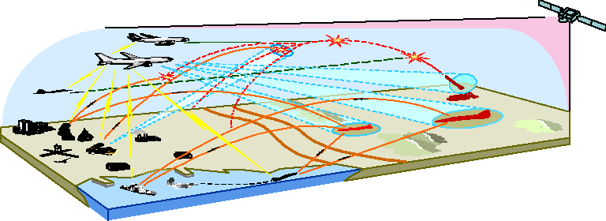
Figure 22 captures the operational environment of the U.S. Customs Service for performance of its Trade Compliance mission. The figure shows the import of goods and merchandise into the U.S. via sea, air, and ground modes of transportation. It also shows
the inspection of those goods and the rejection of invalid or illegal shipments. The graphic portrays the movement of those goods to the eventual consumers. The graphic depicts the collection of duties, fees, and taxes and the flow of those monies into the U.S. Treasury. Customs also captures and collects a large volume of statistical information at its 300-plus ports of entry. The Trade Compliance CONOPS Graphic shows the flow of that information to the Customs Data Center and to over 100 other government agencies.
Figure 22. U.S. Customs Service Trade Compliance Concept of Operations Graphic
Goods at the Port
Warehoused
Destroyed Exam and Inspection
Forfeited
Returned Rejected Goods
Rules and Regulations
Targeting and
Selectivity
Importer/Broker
Cleared Goods
Consignees
USCS
NDC
Consumers
Statistical
Data
Other Government
Agencies
Federal Reserve Bank


D.4. Activity Models and Trees
The Activity Model (also called a Business Process Model) describes the applicable functions associated with the enterprise's business activities, the data and/or information
exchanged between activities (internal exchanges), and the data and/or information exchanged with other activities that are outside the scope of the model (external exchanges). Activity Models are hierarchical in nature. They begin with a single box that represents the overall activity and proceed successively to decompose the activity to the level required for the architecture.
The Activity Model captures the activities performed in a business process or mission and the inputs, controls, outputs, and mechanisms (ICOMs) of those activities.
Mechanisms are the resources that are involved in the performance of an activity. Controls, such as legislation or a business rule, represent constraints on an activity. The ICOMS are called activity constraints because each in some way constrains the business processes being modeled. The Activity Model can be annotated with explicit statements
of business rules, which represent relationships among the ICOMs. For example, a business rule can specify who can do what under specified conditions, the combination of inputs and controls needed, and the resulting outputs.
The Activity Model identifies the mission domain of the model and the viewpoint reflected by the model. Textual descriptions of activity definitions and business flows
should be provided, as needed. Annotations to the model may identify the nodes (business locations) where the activities take place or the costs (actual or estimated) associated with performing each activity.
Certain Activity Models are created using the IDEF (Integrated Computer-Aided Manufacturing (ICAM) Definition) modeling technique. In this technique, activities are chronologically related as information flows through the process. Inputs are shown
entering the activity from the left, while outputs or results of the activity are shown exiting on the right. Figure 23 provides an example of an IDEF Activity Model. The mechanisms (who or what performs the activity) are shown as arrows into the bottom of the activity. These can be people, roles, systems, computer programs, etc. The arrows entering from the top of the activity boxes are controls. Controls are the parameters that direct the activity, such as guidance or regulations from superior organizations, and physical, time, or other resource limitations.
Figure 23. Generic IDEF Activity Model
External Inputs
Mechanisms
(Who or What
performs the activity)
Mechanisms
(Who or What
performs the activity)
Constraints
on the Activity
Collect Data
Input(s)
Process
Data
Output(s)
Disseminate
Data
Use
Data
Decision or Action
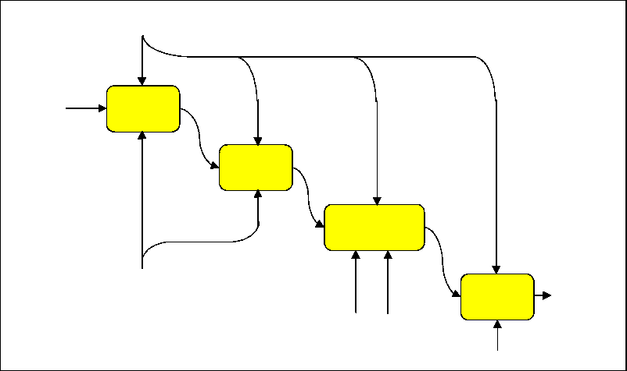
An Activity Model may also be represented in a tree format. As shown in Figure 24, the
highest level activity is represented as the first node in the tree. The lowest level activities called leaves are activities that are not further decomposed.
Figure 24. U.S. Customs, ACS, Activity Tree
1.2.1.1 Entry
Data Processing
1.2.1.2 Border
Release Processing
1.1.1.1 Manage non-Customs
Participation 1.1.1.2 Manage Customs
Participation
1.2.2.1 Entry
Summary Processing
1.2.2.2 Quota
Processing
1.2.1 Making
Entry
1.2.1.3 Cargo
Release Processing
1.1.1 Define User Profiles
1.2.1.4 In-Bond
Processing
1.1 Maintain System Information
1.2.2 File
Entry Summary
1.2 Importation
1.2.2.3 Visa Processing
1.2.2.4 AD/CVD
Processing
1.1.2 Service ACS Reference Information
1.2.4 Statement
Processing
1.1.3 Initiate a
1.2.3 Liquidation
Processing
Bond
1.3.1 Ocean Manifest Processing
1.2.5.1 Manual
Payment Processing
1.2.6 Reconciliation Processing
Processing
1.3.2 Air Manifest
1.2.5 Collections
1.3 Manifest Processing
1.2.5.2 Electronic
Payment Processing
1.3.3 Rail Manifest Processing
1.0 ACS
1.3.4 Passenger Manifest Processing
1.4 Protest Processing
1.5 Drawback Processing
1.6 Surety
Processing
1.8 MEWS
Processing
1.10 Query
1.7 IPR Processing
1.9 Perform Special Projects

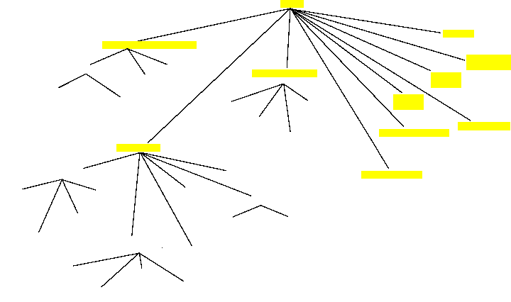
The Activity Model can be annotated with explicit statements of business rules, which represent relationships among the ICOMs. For example, a business rule can specify who can do what under specified conditions, the combination of inputs and controls needed, and the resulting outputs.
Activity Models can be represented in Unified Modeling Language (UML), a standard modeling language adopted by the Object Management Group to support object-oriented analysis, design, and development. Figure 25 depicts an activity diagram represented
in UML.
Figure 25. U.S. Customs, Trade Compliance, UMI Activity Model
Inspector (Office)
Port Inspector
Importer Declares Entry
Review and Validate Entry/Manifest
entry/ Review Entry
event Carrier files Manifest/ Review Manifest
Inspector stamps paper release
entry or manifest rejected
no problems[ entry and manifest OK ]
Import Specialist
accepted
Notice to Importer and Carrier
Apply Selectivity Criteria
2nd Review and Validate
Entry/Manifest
release[ on arrival ]
nspect] on arrival ]
reject
random or selectivity criteria met
Entry Specialist
action required
hold
release[ goods OK ]
Port Inspector
stamps release
Inspects
Goods
seize
Notice to Importer and Carrier

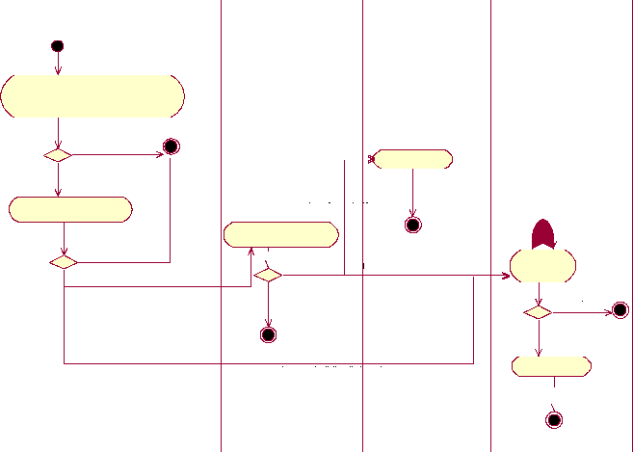
D.5. Business Use Case Model
A Use Case Model can describe either business processes or systems functions depending on the focus of the modeling effort. A Business Use Case Model describes the business processes of an enterprise in terms of business use cases and business actors corresponding to business processes and organizational participants (people, organizations, etc.). The Business Use Case Model is described in Use Case Diagrams and Use Case Specifications. In addition to representing business participation and process, the Use Case Diagram can also depict interrelationships among use cases such as Includes and Extends Relationships. An Includes Relationship represents inclusion or containment of use cases. An Extends Relationship depicts variations or alternative sequences or paths beyond the normal course of action.
The following figures show Use Case Diagrams and Specifications for Customs Trade Compliance Processing. Figure 26 and Figure 27 depict UML Use Case Diagrams and Figure 28 shows a Use Case Specification.

TC_UC_10: File Protest
TC_UC_37: Establish Account
with Customs
Decision to Import
TC_A1: Importer of
Record
TC_UC_8: Declare Goods
TC_UC_2: Estimate/Pay Duties,
Fees, and Taxes
TC_UC_38: Query Customs
TC_UC_11: Make Drawback
Request

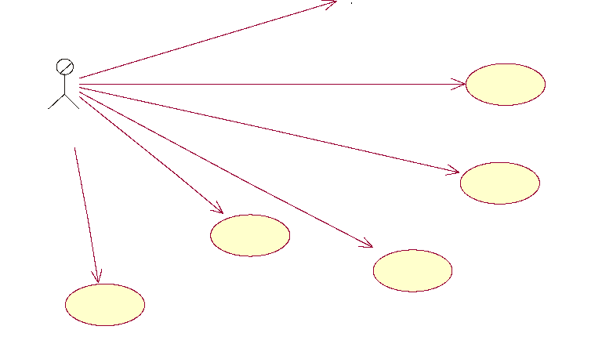
Figure 26. U.S. Customs, Trade Compliance—External, UML Use Case Diagram
TC_UC_67: Process Protest from
Importer
<<extend>>
<<include>>
Goods Declared
TC_A3: US Customs
TC_UC_60: Process Entry
<<extend>>
TC_UC_61: Capture and Review
Importation Information
TC_UC_62: Inspect Goods/Shipment
TC_A13: Entry Clerk
TC_A14: Import
Specialist
TC_A15: Customs
Inpector
TC_A16: OGA
Inspector
TC_UC_63: Collect Duties, Fees,
and Taxes
TC_A14: Import
Specialist
<<include>>
<<extend>>
<<extend>>
TC_UC_66: Liquidate Entry
TC_UC_64: Classify/Value Goods
TC_UC_65: Process Drawback
Request from Importer
<<extend>>

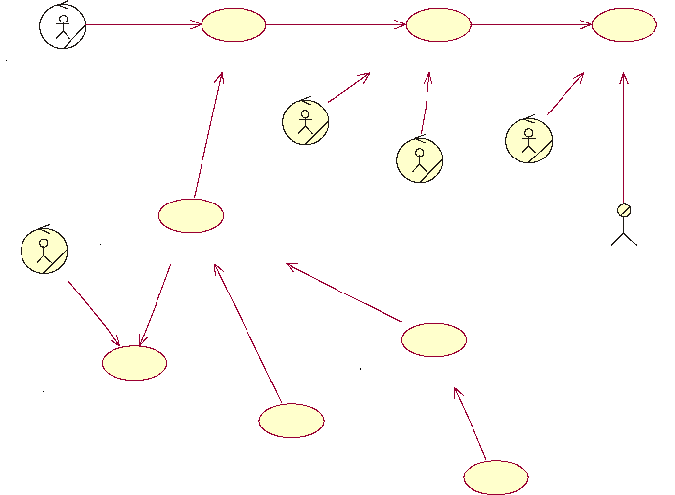
Figure 27. U.S. Customs, Trade Compliance—Internal, UML Use Case Diagram
TC_A_1.0: Declare Goods

1. Overview:
The Importer of Record provides information about an intended importation to Customs. Customs will process the information and respond with notices that determines what the Importer of Record will do next. The Importer of Record corrects or completes the transaction until it is known that the items will or will not be released.
2. Characteristic Information
Use Case Name: Declare Goods
Owner: Mary Lou Collins
Version Creation Date: December 13, 2000
Date Last Updated: December 19, 2000
Scope: Trade compliance
Level: Strategic
Primary Actor: Importer of Record
Secondary Actors: Customs
Focus Classes: Goods, Entry, Entry docs, License, Permit, Visa, Release Notification
Trigger Event: The Importer of Record decides to import goods.
Goal: Receive notification that the goods have been released.
3. Pre-conditions:
1 Importer of Record has made transportation arrangements for the items.
2 Importer of Record is in good standing with Customs, e.g., registered, licensed, bo
4. Main Scenario (Normative Path)
Step Action Description
1 Compile the information required for an entry (CF 3461 or 7501)
2 Collect documentation required by Customs to accompany the entry.
5. Post-conditions:
1 Customs records entry information
2 Importer of Record's payment due or 10-day clock for payment tarts.
3 Goods available for carrier to move them into the U.S.
6. Scenario Exceptions / Variations
Step Variable Possible Variations
1 Information needed Query Customs for tariffs, currency rates, AD/CVD case numbers,
4 Method of filing Broad range of manual to highly automated alternatives
7. Related Information
Priority:
Performance Target:
Frequency: Once for each set of items that can be released at one ti
determined by the Importer or Record
Super Use Case:
Sub Use Case(s):
Dependent Use Cases: Process Entry
8. Target Architecture Differences
Baseline Architecture Target Architecture
Declaration is for a single import transaction Declarations will be associated with an account for pay
duties, fees, and taxes.
9. Open Issues
Issue ID Issue Description
Figure 28. U.S. Customs, Trade Compliance, Declare Goods, UML Use Case Specification
D.6. Class Model
A Class Model is similar to a logical data model. It describes static information and relationships between information. A Class Model also describes informational behaviors. Like many of the other models, it also can be used to model various levels of granularity. Depending on the intent of the model, a Class Model can represent business domain entities or systems implementation classes. A business domain model represents
key business information (domain classes), their characteristics (attributes), their behaviors (methods or operations), and relationships (often referred to as multiplicity, describing how many classes typically participate in the relationship), and cardinality (describes required or optional participation in the relationship). Each class, attribute,
and relationship appearing in the Class Diagram is specified or defined in a class, attribute, or relationship specification. In the case of a relationship, the specification describes how each class participates in the relationship. Specifications further elaborate
and detail information that cannot be represented in the class diagram. Figure 29 illustrates a Customs HML Business Class Diagram.

T_BC_02: TradeAgent
n 1
T_BC_04:
CommercialContract
T_BC_01:
ImporterOfRecord
T_BC_06:
PurchaseOrder
T_BC_05: Invoice
role
licenseNbr registrationNbr
is realized by
T_BC_07:
BlanketPurchaseAgreement
T_BC_08: Consignee
TC_A3: US Customs
(from Owner/Planner
Trade Use Cases)
name
ID address phone
isLicensed() isRegistered()
 | First Draft Complete - 12/14/00
TC_A1: Importer of  Record  (from Owner/Planner  Trade Use Cases) | First Draft Complete - 12/14/00

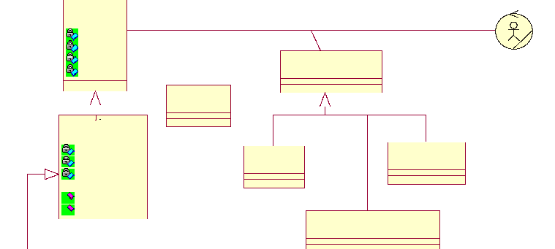

Figure 29. U.S. Customs, Trade Compliance, Commercial View, UML Class Diagram

D.7. State Model
State Models are useful in understanding and representing complicated business or system behaviors over time. A State Model can be used to describe the behavior of a specific business process, systems function, business class, or system class. State
modeling is not a good technique to describe interactions among business processes or classes. Other techniques such as activity modeling or interaction modeling should be used for this purpose.
A UML State Model begins with a start state represented as a solid dot. Middle states are represented as ovals. The ending state is represented as a solid dot within a circle. State transitions are represented as arrows between states. Figure 30 presents a sample Customs UML State Diagram.
Awaiting Transport
[ Bonded, Hired by Importer ] 'Picks up goods
Transporting
Goods
arrived

Awaiting Clearance
Conveyance /Goods Seized
illegal activity I forfeiture determined



cleared

In Transit
Figure 30. U.S. Customs, Trade Compliance, Carrier, UML State Diagram

D.8. Node Connectivity Diagrams
The Node Connectivity Diagram illustrates and describes the business locations (nodes),
the needlines between them, and the characteristics of the information exchanged.
The Node Connectivity Description can be produced at three levels:
- Conceptual Node Connectivity Description—an essential work product that describes the prominent, high-level nodes
- Logical Node Connectivity Description—a supporting work product that describes the design that details all categories and classes of nodes, but does not describe the physical implementation or locations of nodes
- Physical Node Connectivity Description—a supporting work product that describes the physical implementation and locations of nodes.
Each needline is represented by an arrow (indicating the direction of information flow), which is annotated to describe the characteristics of the data or information. Examples of characteristics include its substantive content; media (voice, imagery, text and message
format, etc.); volume requirements; security or classification level; timeliness; and requirements for information system interoperability. Information exchange characteristics are shown selectively, or in summarized form, on this diagram and more comprehensively in the Information Exchange Matrix.
It is important to note that the arrows on the diagram represent needlines only. Each arrow indicates that there is a need for some kind of information transfer between the two connected nodes. There is a one-to-many relationship between needlines and information exchanges; that is, a single needline arrow on the Node Connectivity Description is a
rollup of multiple individual information exchanges. The individual information exchanges are shown on the Information Exchange Matrix.
The diagram should illustrate connectivity with external nodes, i.e., nodes that are not strictly within the scope of the architecture but that act as important sources of
information needed by nodes within the architecture or important destinations for information produced by nodes within the architecture. These external needlines should be labeled to show the external source or destination, as well as the information exchanged.
Functional/Operational views are not required to name real physical facilities as nodes. Functional/Operational views can instead focus on "virtual" nodes, which could be based
on business "roles." These "virtual" nodes will not always be capable of directly integrating with real (physical) nodes from other architectures, but they could provide insight concerning which physical nodes might be able to assume the roles portrayed.
A node can represent a role (e.g., a Bureau Chief Information Officer); an organization (e.g., U.S. Secret Service); a business facility (e.g., a specific IRS Service Center); and so on. The notion of "node" will also vary depending on the level of detail addressed by the architecture effort.
Organizations may choose to represent some nodes in physical terms (i.e., geographic
location) if these nodes are intended to remain "constant" in the architecture analysis, e.g., an effort to determine the most cost-effective communications options between two facilities. On the other hand, organizations may choose to represent nodes much more generically, or notionally, if the entire business practice is being analyzed without constraints imposed by the existing architecture.
To emphasize the focus of the analysis and to ensure comparability and integration across
efforts, it is important that each organization carefully document its use of the "node" concept.
The activities associated with a given information exchange should be noted in some way to provide linkages between each node and the activities performed, and to link the Node Connectivity Diagram with the Activity Model. When more than one Node Connectivity Description is included in an EA description, the architecture team should perform the
appropriate mapping of conceptual to logical and/or logical to physical levels.
Figure 31, Figure 32, and Figure 33 present examples of Node Connectivity Diagrams.
Figure 31. U.S. Customs, ACS, Customs Systems, Node Connectivity Diagram
NCAP
AIMS
MATS ESFAS
SEACATS
ATS
TECS
ACS
TAP
APIS
AES
AAT
NIPS
CAPPS

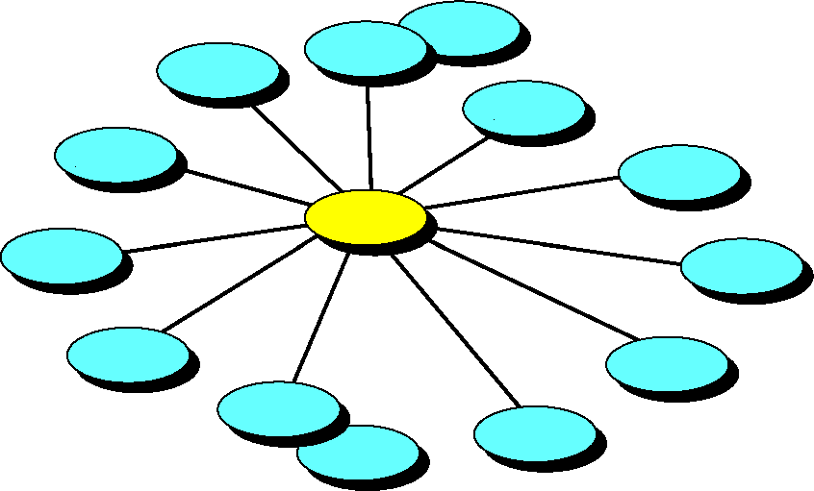
Figure 32. U.S. Customs, ACS, N² Chart
31b
ABI
AMS
36b
33b
35b 9b 25b
2b
3b
7b
1b
4b
6b
28b
Sb
EntSum/
EIP
30b
34b
27b
14b
15b
17b
1a 2a 3a 4a 5a 6a 7a
ACH
Collect
32b
Internal ACS Interfaces
20a
Entry
29b
23b
10a 11a 12a 13a 14a 15a 16a 17a 18a 19a
21a 22a
BRASS
Statement
Quota
ELVIS
Cargo
Select
23a
SumSel
Liquid
Reconcil
BOND
AD/CVD
Drawback
24a
Legend:
Read N2 Chart
in Clockwise Direction
Doc Ret
Protest
In Bond
Sa 9a
Rev 3
as of: 29 June/1500
Manifest
26a
25a
Surety
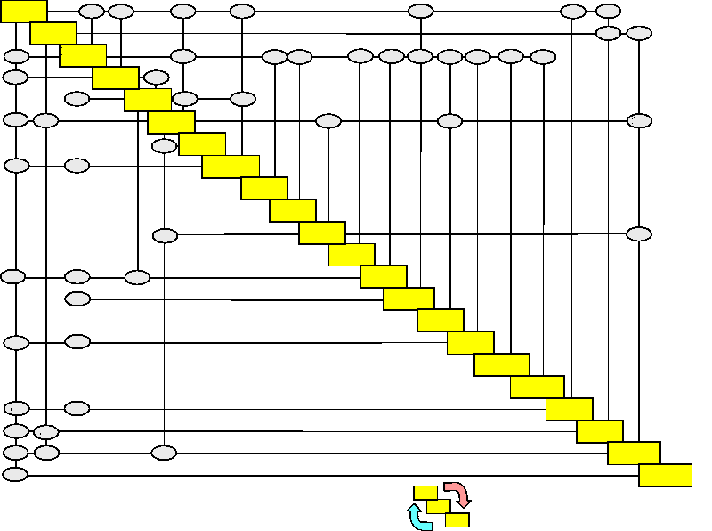
The N² Chart simply represents an alternative method to portray the connectivity between operational nodes of an enterprise. The nodes of the enterprise are shown as boxes on the diagonal of the chart. Information flow between the nodes is captured as numbered
intersections at the vertical and horizontal axes. The chart is read in the clockwise direction. For example, the information flow from the ABI system to the ACH system is annotated at the intersection labeled 2a (above the diagonal). The other side of that
interface—the flow of information from the ACH system to the ABI system—is annotated at the intersection labeled 2b (below the diagonal).
The details or characteristics of each of these information flows are presented in the accompanying Information Exchange Matrix (IEM). Each numbered interface in the Node Connectivity N² Chart becomes a row in the IEM. The information exchange is thoroughly defined and described in the IEM.
The Node Connectivity Diagram depicted in Figure 33 illustrates high-level information exchanges between major operational nodes of the U.S. Air Force (USAF). At this level of detail, only the minimum essential, mission connectivities are illustrated. This graphic is color coded to show the connectivity required for the various USAF mission areas. These mission areas and the color code are presented as a legend in the lower right corner of the chart.

Allied Forces
Oos Ctrs
To: CRC/ FACP
Commercial
Air Carrier
To: AF MAJCOM Ops Ctrs, AIA OSC & USTRANSCOM Cmd Ctrs
Medical Facilities
Service Land & Maritime Forces
To: Multi
Users
JTF
Cmd Ctr
Service Air Defense Units
USTRANSCOM Cmd Ctr
To: Theater Commands & JTFs
FEMA
To: Trans Ctrl Ctrs
To: JTF
Cmd Ctr
To: AFSOC, Deployed AFSOC, USSTRATCOM & JSOTF
To: AFIWC
Theater
Cmd Ctrs
To: Service Air Defense & Service Land & Maritime Forces
To:
Supply
Ctrs
RAMCC
FAA RCCs
To: Multipl
Users JICs
To: AOC & AFSOC Cmd Ctr
To R0CCs/SOCCs & AIA OSC
TACC
To: NMCC
CRE/
FACP
TALCE
Mobility
A/C
Transport
Ops
AOC
WOC/
SOC
To:
TACC
AFSOC
Cmd Ctr
To: AFFOR R/F & ROCC/SOCC
To: 352 & 353 SOG, USSOCOM, TACC
SOC
AFFOR R/F
Allied Gvts
To: AOC
USSTRATCOM Cmd Ctr
JSTARS
To: AIA OSC
To: AFSOC Cmd Ctr
USSOCOM Cmd Ctr
ABCCC
AWACS
To: Deployed SOFs, JTFs,
JICs, & Theater Cmd Ctrs
ROCC/ SOCC
To: FAA RCCs
16th SOW
ICBM LCCs
352 SOG
To: NMCC, FAA RCCs, Unified Cmds, JTFs, JICs, WOC/SOCs,AOC, MAJCOM & Theater Cmd Ctrs
353 SOG
JSOTF
SATELLITE LAUNCH RANGES
Combat
A/C
NMCC
ASOS/
TACP
NCA
To: AOC
AFSPOC
Deployed
AFSOC
Cmd Ctr
To: AOC
Deployed
SOF Forces
ADOC
SOF A/C Units
(USAF/USA)
To NASA
To: Theater Cmd Ctrs & Nat'l Agencies
OSC,^{A:A} OSC, AFSOC
Cmd Ctr, & JTF Cmd Ctrs
AFAC
To: TACC
Trans
Contro
Ctrs
To: JTF Cmd Ctr , & Theater Cmd Ctrs
N/U
CC
Rev 9R, 24 July 95
To:
Transport Ops
l
NAIC AFIWC
AF MAJCOM Ops Ctrs
To:
FMO Ctrs
Maint
Ctrs
Integrated Air Force C4I Systems
To NASA
Mobility Operations Space Operations Special Operations
NDOC
Combat Operations
AIA OSC
MWC
SPADOC
AFSCN
NAVSPOC
Air Force
ARSPOC
Supply
Ctrs
NASA
To: Trans Cont. Ctrs
IWSM Ctrs
Joint or Combined (operated by AF)
Force Mgmt Ops Centers
To: AF MAJCOMs
To: Satellite Launch Ranges, NU/CC, AFSPOC & SPADOC
Sensors
DOD
Wx Sources
Mission Support DOD & External Agencies
Intel Support
Satellite Systems
User Agencies
DMA
DIA
CIO
NSA
Logistics Agencies
Non-DOD
National
Agencies
To: NSA & Other Nat'l Agencies
To: CIA
To: DIA & DMA
To: CIO
CIA
Contractors

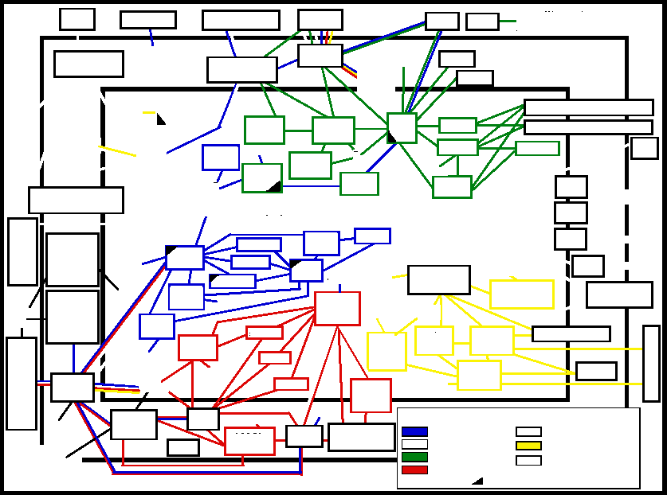

Figure 33. U.S. Air Force Node Connectivity Diagram
D.9. Information Exchange Matrix
The Information Exchange Matrix documents the Information Exchange Requirements (IERs) for an EA. IERs express the relationships across three basic entities (activities, business nodes and their elements, and information flow) and focus on characteristics of the information exchange, such as performance and security. IERs identify who exchanges what information with whom, why the information is necessary, and in what manner. IERs identify the elements of information exchanged between nodes in support
of a particular activity. Relevant attributes of the exchange are noted. The specific attributes included are dependent on the objectives of the specific architecture effort, but may include the type of information media (e.g., data, voice, and video), quality (e.g., frequency, timeliness, and security), and quantity (e.g., volume and speed).
The IEM can be produced at three levels:
• Conceptual Information Exchange Matrix—an essential work product that describes the prominent, high-level information exchanges between prominent nodes

- Logical Information Exchange Matrix—a supporting work product that describes the design that details all categories and classes of information exchanges, but does not describe the physical implementation of them
- Physical Information Exchange Matrix— a supporting work product that describes the physical characteristics of the implementation of information exchanges.
Particular capabilities such as security level of communications may also be captured for each exchange. This work product emphasizes the logical and operational characteristics of the information, namely, what information is needed by whom, from whom, and when. Table 6 illustrates an example of an entry in the Logical IEM of the US Customs Service EA. In the table, AIS is the automated information system at the source and destination that sends and receives the information exchange and LISI is the Level of Information System Interoperability. LISI is scaled from zero for a totally manual interface to five for a fully electronic connection.
Table 6. Example Logical Information Exchange Matrix
No. | Source | Destination | Information | Associated  Activity | Source  AIS | Destination  AIS | Media | LISI | Event  Trigger | Frequency of  Transmission | Interoperability  Issues
208a | Customs | DOT  (NHTSA) | Vehicle  Declaration  (Form HS-7) | Cargo  Release  Processing | ACS | MVII | electronic | 3 | Import of  Vehicle | Daily | Two data fields  missing from  transmission
208b | DOT  (NHTSA) | Customs | Tariff Data  Data Updates | Maintain  Systems  Information | MVII | ACS | electronic | 3 | Data Update Required | As needed | None

The IEM is not intended to be an exhaustive listing of all the details contained in every IER of every node associated with the architecture. That would be too much detail for an
architecture description. Rather, this work product is intended to capture the most important aspects of selected information exchanges. Selecting the important details of
the information exchanges depends on the purpose of the architecture description.
The number of information exchanges associated with an architecture may be quite large, even though the matrix may not contain all details about all IERs. To aid in
understanding the nature of the information exchanges, developers and users of the architecture may want to view the IER data sorted in multiple ways, such as by task, by node, or by attribute. Consequently, using a matrix to present that information is limiting and frequently not practical. A spreadsheet or relational database is well suited to the
highly structured format of the IEM. In practice, hardcopy versions of this product should be limited to high-level summaries or highlighted subsets of particular interest.
D.10. Organization Chart
The Organization Chart illustrates the relationships among organizations or resources. These relationships can include oversight, coordination relationships (influences and
connectivity), and many others, depending on the purpose of the architecture. It is important to show these fundamental roles and management relationships in an architecture. For example, oversight relationships may differ under various circumstances, which will affect the activities that may be performed differently or by different organizations. Different coordination relationships may mean that connectivity requirements are changed. Figure 34 shows a generic example of an Organization Chart.
Figure 34. Generic Organization Chart
Coordination or Other Specified Relationship
Third-Level
Organization
Second-Level
Organization
Third-Level
Organization
Top-Level
Organization
Second-Level
Organization
Hierarchical Relationship
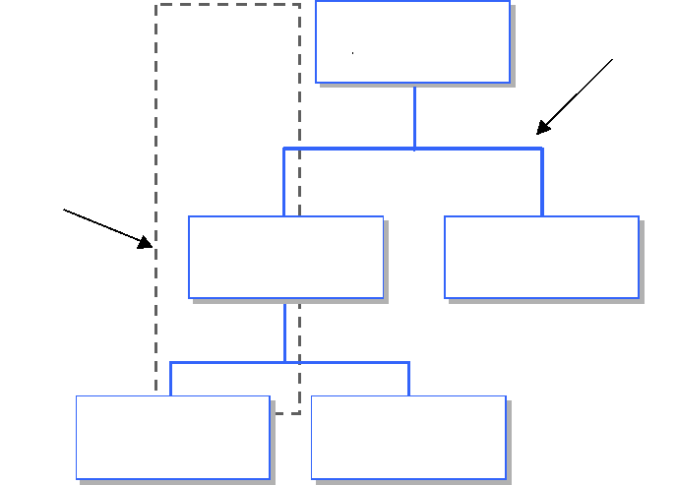
D.11. Systems Interface Description and Connectivity Diagram
The System Interface Description (SID) depicts the assignments of systems and their interfaces to the nodes and needlines described in the Node Connectivity Diagram. The Node Connectivity Description for a given architecture shows nodes (not always defined in physical terms), while the SID depicts the systems corresponding to the system nodes.
The SID identifies the interfaces between nodes, between systems, and between the components of a system, depending on the needs of a particular architecture. A system interface is a simplified or generalized representation of a communications pathway or network, usually depicted graphically as a straight line, with a descriptive label. Pairs of connected systems or system components often have multiple interfaces between them. The SID depicts all interfaces between systems and/or system components that are of interest to the architect.
The graphic descriptions and/or supporting text for the SID should provide details concerning the capabilities of each system. For example, descriptions of information systems should include details concerning the applications present within the system, the infrastructure services that support the applications, and the means by which the system processes, manipulates, stores, and exchanges data. Figure 35 depicts a sample SID Connectivity Diagram.

Intranodal Perspective
SYSTEM 1
Component 1
Component 4
Component 5
Component 2
Component 3
FROM OTHER
NODES
COMMUNICATIONS NETWORK
COMMUNICATIONS
SYSTEM
1
PROCESSING SYSTEM
1
Interface
COMMUNICATIONS
SYSTEM
2
PROCESSING
SYSTEM
2
NODE A
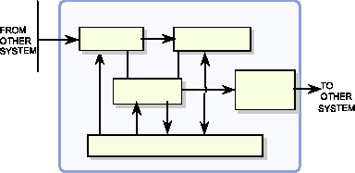
Internodal Perspective System-to-System
NODE A
EXTERNAL
CONNECTION
SYSTEM
2
SYSTEM
1
NODE C
COMMS Interface
SYSTEM
1
SYSTEM
1
SYSTEM
4
SYSTEM
3
SYSTEM
2
NODE B
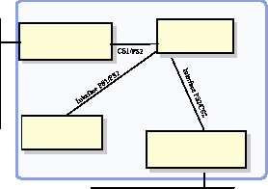

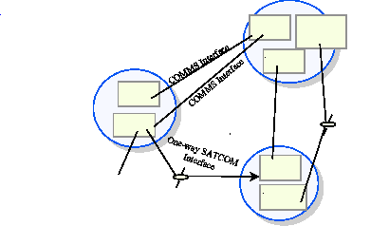
Intrasystem Perspective

COMMUNICATIONS  NETWORK | TO OTHER NODES

Figure 35. Generic System Interface Description Connectivity Diagram
Internodal Perspective Node Edge-to-Node Edge
NODE A
EXTERNAL
CONNECTION
SYSTEM
2
SYSTEM
1
NODE C
COMMS Interface
SYSTEM
1
SYSTEM
1
SYSTEM
4
SYSTEM
3
SYSTEM
2
NODE B

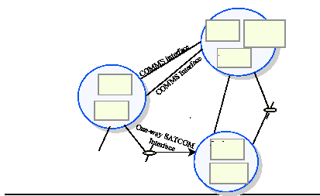
D.12. Standards Profile
An architecture Standards Profile is the set of rules that governs system implementation and operation. In most cases, especially in describing architectures with less than a
department-wide scope, building a Standards Profile will consist of identifying the applicable portions of existing standards guidance documentation, tailoring those portions in accordance within the latitude allowed, and filling in any gaps.
This architecture product references the technical standards that apply to the architecture and how they need to be, or have been, implemented. The profile is time-phased to facilitate a structured, disciplined process of system development and evolution. Time phasing also promotes the consideration of emerging technologies and the likelihood of current technologies and standards becoming obsolete.
A Standards Profile table (see Figure 36) documents the use of the following items within an enterprise:
- Industry standards or technologies
- Federal, department, or bureau standards or technologies
- Commercial products
- Federal, department, or bureau products.

Service Area | Service | Standard
Operating System | Kernel | FIPS Pub 151-1 (POSIX.1)
Operating System | Shell and Utilities | IEEE P1003.2
Software  Engineering Services | Programming Languages | FIPS Pub 119 (ADA)
User Interface | Client Server Operations | FIPS Pub 158 (X-Window System)
User Interface | Object Definition and Management | DoD Human Computer Interface Style Guide
User Interface | Window Management | FIPS Pub 158 (X-Window System)
User Interface | Dialogue Support | Project Standard
Data Management | Data Management | FIPS Pub 127-2 (SQL)
Data Interchange | Data Interchange | FIPS Pub 152 (SGML)
Data Interchange | Electronic Data Interchange | FIPS Pub 161 (EDI)
Graphics | Graphics | FIPS Pub 153 (PHIGS)
. . .

Figure 36. Standards Profile Table
D.13. Technical Reference Model
A Technical Reference Model (TRM) is a taxonomy that provides:
- A consistent set of service areas, interface categories, and relationships used to address interoperability and open-system issues
- Conceptual entities that establish a common vocabulary to better describe, compare, and contrast systems and components
- A basis (an aid) for the identification, comparison, and selection of existing and emerging standards and their relationships.
The TRM organizes the Standards Profile and any standards or technology forecast documents. It can also organize technology infrastructure documentation. Frequently, some combination of the documents organized using the TRM are presented in a single document. Figure 37 depicts the service areas of the U.S. Customs Service TRM.
User Environment
Workstation | Productivity  Tools | Analysis Tools

Application Services | Data Services

App Dev | Web App | Document
Env | Services | Mgmt.

 | Data | Data
Databases | Warehouse | Mgmt.

Integration Services
Figure 37. U.S. Customs Technical Reference Model
Domain
Operating
Systems
Email
Network
Storage
Infrastructure
Mgmt.
Security
Distributed
Computing
Voice
Power Mgmt.
Technologies
Application
Servers
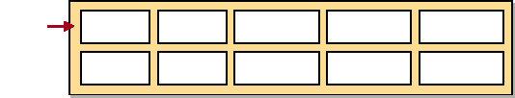

Middleware |  | Workflow |  | Communications |  | Interchange

Service Area |  | Common Services

Technology domains and sub-domains are defined along with key roles and points of contacts. A Technical Architecture Strategy is established for each sub-domain, with specifications and selection criteria, outlining how the products and technologies are going to be utilized. Figure 38 illustrates the domain and sub-domain definition being used in the planning strategy and as building blocks to aid project planning. Components are constructed to represent a set of sub-domains that are used together to build a functional component of the architecture.
Example
Figure 38. Generic TRM Domain and Sub-domain Definitions and Components
Service Area
Sub-Domains
Domain
Sub-Domain Planning Strategy
Common Services
Operating Systems
Desktop/Client OS Mainframe OS
Network OS
App/Data Server OS
App/Data Server OS Planning Strategy
Baseline
Tactical
Strategic
Domain and Sub-domain
- Definitions
- Key Roles & POCs
- Specifications
- Criteria
- Benefits
Example Components
(Functional Collection of Sub-Domains)
App/Data Server OS
Database Mgmt. Tools
Sub-Domain Products
Message Oriented
Middletare
Enterprise DBMS
DBMS Gateways
Components: Database Server
Oracle Toolset...
Oracle APPC...
NT, Solaris...
CA-Datacom,
Oracle...
MO Series...

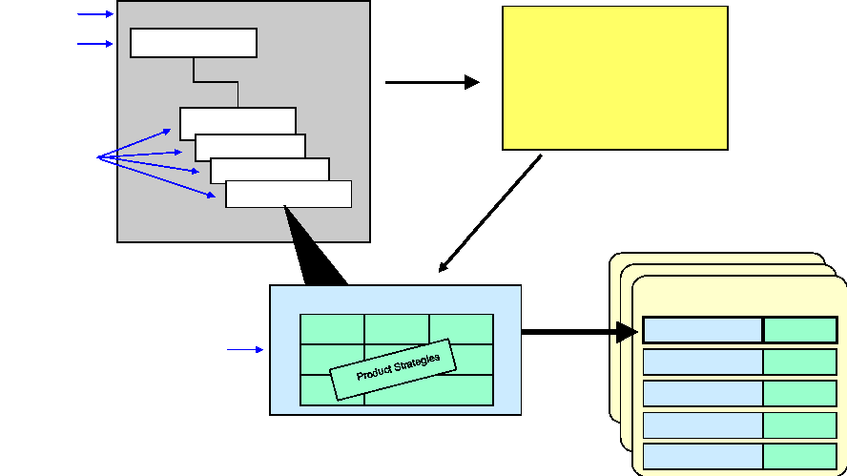

Appendix E: Sample Architectural Principles
The following architecture principles derive from the many architectural principles identified throughout the available architecture literature. They are presented as a starting point in the architecture process. Each individual Agency, with unique needs and requirements, should first consider these, then modify, add to, or replace this list as appropriate to its purposes.
- Architectures must be appropriately scoped, planned, and defined based on the intended use of the architecture.
Rationale: The architecture development effort needs direction and guidance to meet expectations for specific uses of the architecture end products. Detailed models may not be needed for high-level decision making; similarly, simple, descriptive architectures may not provide enough information to support engineering choices.
Implications: The architecture must be generated with a specific purpose and for a specific audience to ensure it meets the expectations of its intended stakeholders.
- Architectures must be compliant with the law as expressed in legislative mandates, executive orders, Federal regulations, and other Federal guidelines.
Rationale: Federal Agencies must abide by laws, policies, and regulations. However, this does not preclude business process improvements that lead to changes in policies and regulations.
Implications: Federal Agencies should be aware of laws, regulations, and external policies regarding the development of architectures and the collection, retention, management, and security of data. Changes in the law (Clinger-Cohen Act) and changes in policy (OMB Circular A—130) may drive changes in architectural processes or applications.
- Architectures facilitate change.
Rationale: In the rapidly changing IT environment, organizations need tools to manage and control their business and technical growth and change. As the technical development life cycle shortens, with new technologies replacing older systems every 18 months, organizations require an overarching architecture to capture their systems design and operating environment.
Implications: The systems developer and the chief architect should ensure the coordination between technology investments and business practices. Architectures must be used in the evaluation function of the Capital Planning and Investment Control process.
- Enterprise architectures must reflect the Agency's strategic plan.
Rationale: The target architecture has maximum value when it is most closely aligned with the organization's strategic plan and other corporate-level direction, concepts, and planning.
Implications: The target architecture must be developed in concert with strategic planners as well as the operational staff. As the strategic plan changes, so do the future environment and the target architecture.
- Architectures continuously change and require transition.
Rationale: The organization is constantly evolving towards its future. As today's architecture transitions to the target architecture, the target becomes the organization's baseline architecture at some point in the future. The baseline architecture continuously moves and transitions toward the target architecture.
Implications: The target architecture is a rolling set of products, continually portraying the out-year environment. As a component of strategic planning and change management, the target architecture captures the future environment including data requirements and systems transitions. The sequencing plan is the organization's roadmap to systems migration.
- Target architectures should project no more than 3 to 5 years into the future.
Rationale: Technology life cycles currently are in the neighborhood of 18 months, and new IT products appear on the market every 18 months. Federal acquisition practices are aligning to these rapid changes, which means that an organization's future information needs and technical infrastructure requirements are changing just as rapidly. Consequently, no one can accurately predict what business practices will prevail 10 to 20 years into the future and what type of IT capabilities and resources will be available.
Implications: Target architectures will need to be revised and updated regularly. The sequencing plan, illustrating intermediate points in time, may become more valuable than the target architectures.
- Architectures provide standardized business processes and common operating environments (COEs).
Rationale: Commonality improves interoperability, cost avoidance, and convergence. For example, the integration of architectural Activity Models and Operational Sequence Diagrams (on the business side) and the Technical Reference Model and technology forecasts (on the technical side) helps establish a COE within the organization's logical and physical infrastructures.
Implications: The systems architect and the chief architect must ensure the coordination between technology investments and business practices. A COE grounded on standard business practices yields improved data structures.
- Architecture products are only as good as the data collected from subject matter experts and domain owners.
Rationale: The architect is not vested with the organizational information. It is incumbent upon the architect to collect the needed architectural information from the members of the
organization who possess the knowledge of the business processes and associated information. These subject matter experts tend to be operational staff, field representatives, systems developers, software designers, etc. The domain owners are the responsible managers of specific business areas.
Implications: The development of the architecture can be a slow process, dependent on the
architect's access to subject matter experts and domain owners. The validity of the architecture can be limited by the accuracy of the collected data. Development of the
architecture is an iterative process of data gathering and interviewing to obtain verification and validity checks of the architectural products.
- Architectures minimize the burden of data collection, streamline data storage, and enhance data access.
Rationale: Data, as a corporate asset, is key to an organization's vision, mission, goals, and daily work routine. The more efficiently an Agency gathers data, stores and retrieves that data, and uses the data, the more productive the Agency. Information is power.
Implications: Business processes are best improved by streamlining the flow and use of data and information. The development of architectural Node Connectivity Descriptions, Information Exchange Matrices, and other information models will aid in the design of improved data management systems.
- Target architectures should be used to control the growth of technical diversity.
Rationale: The rapid adoption of new and innovative IT products can easily lead to introducing a diverse set of IT products that may not always be fully compatible within the existing enterprise infrastructure. This necessitates the selection and implementation of proven market technologies.
Implications: The target architecture must be used in conjunction with the organization's investment review process and technology insertion plans. Relying on the architecture as an integral component of IT decision making helps control the introduction of incompatible products.

Appendix F: Bibliography
Beckner, S. G., & S. T. Norman, Air Force Architecture Development Guide. MITRE Technical Report 98B0000074. Colorado Springs, CO, 1998.
Boar, B. H. Constructing Blueprints for Enterprise IT Architectures. Wiley Computer Press. New York, NY, 1999.
Cook, M. A., Building Enterprise Information Architectures: Reengineering Information Systems. Prentice Hall. Upper Saddle River, NJ, 1996.
Department of Defense, C4ISR Architecture Working Group, DoD C4ISR Architecture Framework, Version 2.0, 18 December 1997.
Department of the Treasury, Chief Information Officer Council, Treasury Enterprise Architecture Framework (TEAF), Version 1.0, 3 July 2000.
Department of the Treasury, Treasury Information Systems Architecture Framework (TISAF), Office of
the Deputy Assistant Secretary for Information Systems and Chief Information Officer, 3 January 1997.
Executive Guide: Measuring Performance and Demonstrating Results of IT Investments. GAO/AIMD98-89. March 1998.
Federal Chief Information Officer (CIO) Council, Federal Architecture Working Group, Architecture Alignment and Assessment Guide, October 2000.
Federal Chief Information Officer (CIO) Council, Federal Enterprise Architecture Framework (FEAF). Version 1.1, September 1999.
Federal Chief Information Officer (CIO) Council, Capital Planning and IT Management Committee, Smart Practices in Capital Planning, October 2000.
Clinger-Cohen Act of 1996 (formerly, Information Technology Management Reform Act [ITMRA]), Public Law 104-106. 10 Feb 1996.
Freedom of Information Act (FOIA). 5 U.S.C. §552, as amended by Public Law 104-231, 110 Stat. 3048 (1996).
Government Paperwork Elimination Act (GPEA) of 1998. Public Law 105-277, Title XVII. 21 Oct 1998.
Government Paperwork Reduction Act (PRA) of 1980, amended 1996. Public Law 104-13, 44 USC Chapter 35.
Government Performance Results Act (GPRA) of 1993. Public Law 103-58. 16 June 1993.
Information Technology Investment Evaluation Guide: Assessing Risks and Returns. A Guide for Evaluating Federal Agencies' IT Investment Decision-making. GAO/AIMD-10.1.13. February 1997.
Information Technology Investment Management: A Framework for Assessing and Improving Maturity. GAO/AIMD-10.1.23. Exposure Draft.
OMB Circular A—11. Preparation and Submission of Budget Estimates. 19 July 2000.
OMB Circular A-130. Management of Federal Information Resources. 30 November 2000. Rechtin, E., & M. W. Maier, The Art of Systems Architecting. CRC Press. New York, NY, 1997.
Sowa, J. F., & J. A. Zachman, Extending and Formalizing the Framework for Information Systems Architecture. IBM Publication G321-5488. IBM Journal, Vol. 31(3). 1992.
Spewak, S. H., Enterprise Architecture Planning. Wiley and Sons, New York, NY, 1992. Systems Development Life Cycle, CIS Handbook 550007, U.S. Customs Service, October 1998.
Thomas, R, II, R. A. Beamer, & P. K. Sowell, Civilian Application of the DoD C4ISR Architecture Framework: A Treasury Department Case Study. Proceedings of 5th International Command and Control Research and Technology Symposium, Canberra, Australia. October 2000.
U.S. Customs Service, Enterprise Architecture Blueprint, August 1999.
Zachman, J. A. A Framework for Information Systems Architecture. IBM Systems Journal. Vol. 26(3). 1987.
Zachman, J. A. The Framework for Enterprise Architecture: Background, Description and Utility. 1996. Internet/WEB Links
Federal Chief Information Officer Council www.cio.gov
Federal Architecture Working Group www.cio.gov/docs/interopeability.html
ArchitecturePlus www.itpolicy.gsa.gov/mke/archplus/archhome.htm
Clinger-Cohen Act www.itpolicy.gsa.gov/mks/regs-leg/s1124 en.htm
The Clinton Administration's Policy on Critical Infrastructure Protection: Presidential Decision Directive 63, May 1998.
www.ciao.gov/CIAO_Document_Library/paper598.html
Department of Defense Technical Reference Model, Version 1.0, November 5, 1999. www-trm.itsi.disa.mil
Department of the Treasury CIO www.treas.gov/cio/
Digital Consulting, Inc (DCI) www.dci.com
Enterprise-wide Information Technology Architectures (EWITA) www.ewita.com
Federal Enterprise Architecture Framework, Version 1, September 1999. www.itpolicy.gsa.gov/mke/archplus/fedarch1.pdf
General Accounting Office, Assessing Risks and Returns: A Guide for Evaluating Federal Agencies' IT Investment Decision-making, Version 1, GAO/AIMD-10.1.13, February 1997. www.gao.gov/policy/itguide/
General Accounting Office, Information Technology Investment Management: A Framework for Assessing and Improving Process Maturity, Exposure Draft, Version 1, GAO/AIMD-10.1.23, May 2000. www.gao.gov/special.pubs/10 1 23.pdf
General Accounting Office, Measuring Performance and Demonstrating Results of Information Technology Investments, AIMD-98-89, March 1998.
www.gao.gov/special.pubs/ai98089.pdf
General Services Administration, Office of Information Technology www.itpolicy.gsa.gov
IEEE 1471, Recommended Practice for Architectural Description, DRAFT Information Assurance Technical Framework Forum
www.iatf.net
Information Technology Investment Portfolio System (I-TIPS) www.itips.gov
International Enterprise Architects Consortium and Architecture Center www.ieac.org
MetaGroup, Inc. Stamford, CT www.metagroup.com
Object Management Group www.omg.org
OMB Circular A—130, Management of Federal Information Resources, Revised, November 30, 2000. www.whitehouse.gov/OMB/circulars/a130/a130.html
OMB Memorandum M-97-16, Information Technology Architectures, June 18, 1997. www.whitehouse.gov/OMB/memoranda/m97-16.html
OMB Memorandum M-00-07, Incorporating and Funding Security in Information Systems Investments, 28 February 2000.
www.whitehouse.gov/OMB/memoranda/m00-07.html
OMB, Proposed revision of OMB Circular No. A-130, in Federal Register, Vol. 65, No. 72, April 13, 2000, pages 19933-19939
www.whitehouse.gov/omb/fedreg/rev-a130.pdf
Software Engineering Institute (SEI) Architecture Technology Page www.sei.cmu.edu
Steven Spewak Enterprise Architecture Planning Home Page www.eap.com
Stanford University, Enterprise Architecture Home Page www.standford.edu/group/APS/arch/index.html
The Open Group Architecture Framework (TOGAF) Technical Reference Model, version 5, 1999. www.opengroup.org/togaf
U. S. Customs Service, Enterprise Architecture Blueprint, October 1999. www.itpolicy.gsa.gov/mke/archplus/eab.pdf
U.S. Customs Service, Technical Reference Model Introductory Guide, August 1999. www.itpolicy.gsa.gov/mke/archplus/trm.pdf
UML - Unified Modeling Language www.omg.org/uml
Zachman Institute for Framework Advancement www.zifa.com
Appendix G: The Zachman Framework
In September 1987, John Zachman published an important article in the IBM Systems Journal identifying what he called "A Framework for Information Systems Architecture," sometimes simply referred to as "The Zachman Framework." This article has grown to become a de facto standard for enterprise architecture development. In fact, the Zachman Framework provides much of the foundation for the FEAF and the frameworks of several Federal Departments and Agencies.
Two key ideas are illustrated in the Zachman Framework:
- There is a set of architectural representations produced over the process of building a complex engineering product representing the different perspectives of the different participants.
- The same product can be described, for different purposes, in different ways, resulting in different types of descriptions.
The Zachman Framework provides the necessary detailed and robust views of the enterprise information architecture. It outlines six increasingly detailed views or levels of abstraction for six architecture descriptions. The levels of abstractions are:
- The Planner or Ballpark View
- The Owner's or Enterprise Model View
- The Designer's or Systems Model View
- The Builder's or Technology Model View
- The Subcontractor's or Detailed Representation View
- The Functioning Enterprise or Actual System View.
And the six architecture descriptions—and the interrogatives that they answer—are:
- The Data Description—What
- The Function Description—How
- The Network Description—Where
- The People Description—Who
- The Time Description—When
- The Motivation Description—Why.
In Zachman's opinion, the single factor that makes his framework unique is that each element on either axis of the matrix is explicitly distinguishable from all other elements on that axis. The representations in each cell of the matrix are not merely successive levels of increasing detail, but
actually are different representations—different in context, meaning, motivation, and use. Because each of the elements on either axis is explicitly different from the others, it is possible to define precisely what belongs in each cell.
Figure 39 illustrates the Zachman Framework in a 6x6 matrix format. The six views or levels of abstraction are the rows of the matrix, while the architectural descriptions—the answers to the
enterprise interrogatives—are the columns. Each of the 36 cells of the matrix represents a descriptive model or architecture product that form the building blocks of the EA.
_crop | DATA What  List ^{rf} Things |  |  | FUNCTIO How  List ^{rf} Processes |  |  | NETWOR Where  List , Locations i. |  |  | PEOPL Who  List .. |  |  | TIME When  List , Events |  |  | MOTIVATIO Why  List .. Business SCCT
(CONTEXTUA  Planne | to the  ENTITY Business |  |  | Business  Function  Business |  |  | the Business  Node = Major Locatio |  |  | Important  People = | to the |  | to the  Time = Major |  |  | Ends/Means=Mgor Critical Success |  | (CONTEXTUA  Bus. Planne  '''
(CONTEXTUA  Planne | to the  ENTITY Business | = Class |  | Business  Function  Business | = Class |  |  |  |  | Important  People = | Major |  | to the  Time = Major | Business |  | Ends/Means=Mgor Critical Success |  | (CONTEXTUA  Bus. Planne  '''
MODE (CONCEPTUA  Owne | e.g. Semantic  Ent = Business  Reln = Business  e.g. Logical Data |  |  | e.g. Business Process  Proc. = Business 1/0 = Business  e.g. Application |  |  | ENTERPRIS  e.g. Business  Node = Business Link = Business  e.g. Distributed |  |  | e.g. Work | Flow |  | e.g. Master  Time = Business Cycle = Business  e.g. Processing |  |  | e.g. Business EN.._ ..  MODE  (CONCEPTUAL  End = Business Owne  Means = Business  e.g., Business Rule  SYSTE
People = Organization Work = Work
e.g. Human
SYSTE  MODE  (LOGICAL  Designe TECHNOLOC | Ent = DataReln = Data  -0 Physical Data |  |  | Proc .= Application ..,. System |  |  | Node - t | Architectur  S  Storage,  gy |  |  | Archtectu |  | Time = System Event ., Control |  |  | MODE (LOGICAL)  End = Structural Designe  Means =Action  -O Rule Trn1-1Alf⁻11 'Int
People = Work =
Presentation
SYSTE  MODE  (LOGICAL  Designe TECHNOLOC |  |  |  |  |  |  | (Processor,  Link = Line  ., Technolo
MODE (PHYSICAL  Builde ncmeI c |  |  |  |  |  |  | Node =  Softwr Link = Line  e.g. Network |  |  | c, |  |  | Time =  nent  e.g. Timing |  |  | MODE (PHYSICAL  Builde  End =  Means =  e.g. Rule DETAILE
MODE (PHYSICAL  Builde ncmeI c |  |  |  | Proc.= Computer e.g. |  |  |  |  |  | People =  Work = Screen  eg Security
MODE (PHYSICAL  Builde ncmeI c | Ent =  Reln = e.g. Data
REPRESEN (OUT-  Sub- Contracto | Ent = Reln = |  |  | Proc.= Language |  |  | Node = Link = |  |  | People = Work = |  |  | Time = |  |  | End = Sub Means = |  | REPRESEN TATIONS (OUT-OF CONTEXT  Sub-  Contracto  F.!!`161104!!`1
REPRESEN (OUT-  Sub- Contracto | Ent = Reln = |  |  | Proc.= Language |  |  | Node = Link = |  |  | People = Work = |  |  | Time = | ne |  | End = Sub Means =
rt.:NCI⁻.:MN  ENTERPRIS  John A Zachman | .9-  Zachman International |  |  | e.g.  ⁽⁸¹⁰⁾ |  |  | e.g.  ²³¹ ⁰⁵³¹ |  |  | e.g. |  |  | e.g. |  |  | e.g. ENTERPRIS

Figure 39. The Zachman Framework Matrix
For further readings and more detailed information on the Zachman Framework, please refer to any of John Zachman's publications, the Zachman Institute for Framework Advancement (ZIFA) web site (http://www.zifa.com), and a number of publications by other authors such as Melissa A. Cook 's text, Building Enterprise Information Architectures: Reengineering Information Systems, Prentice Hall, Upper Saddle River, NJ, 1996. See Appendix F for a listing of related resources.

