TASK: 01

Create directories which would have the following structure by using only mkdir command:

mkdir -p consultadd/{SQL/mysql,bootcamp,java/springboot,javascript/{angular,react},Python/Django/restframework}

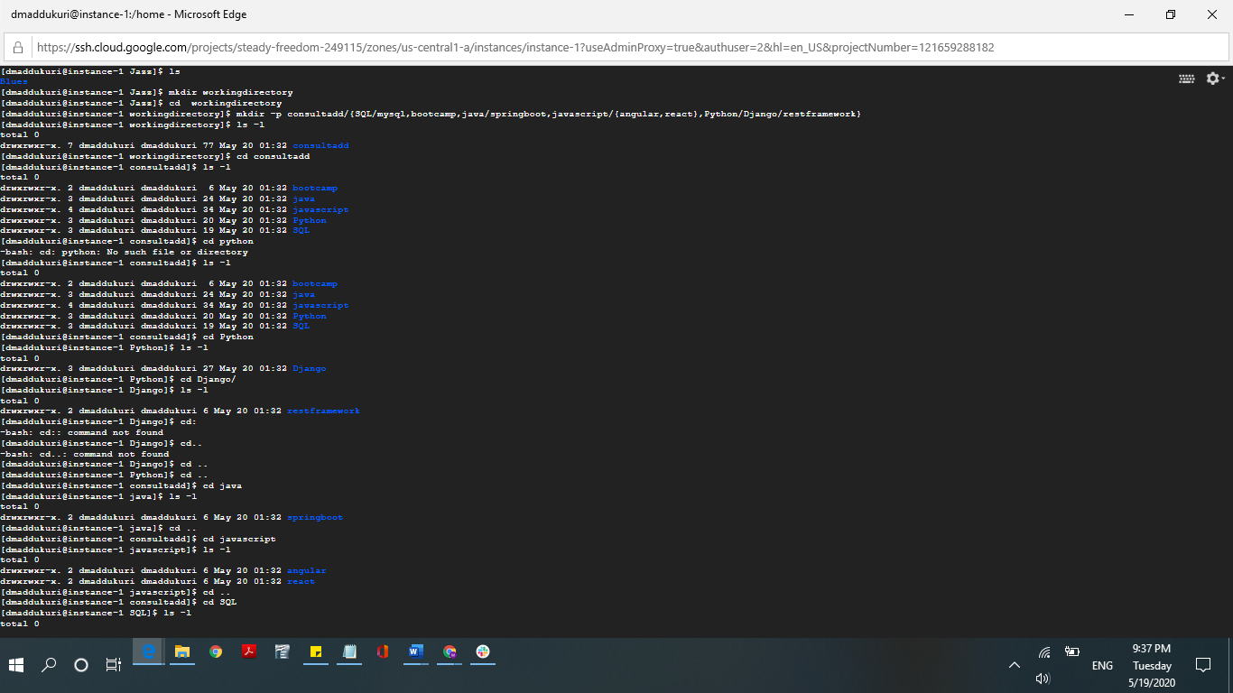

TASK 02:

Create Directory called consultadd

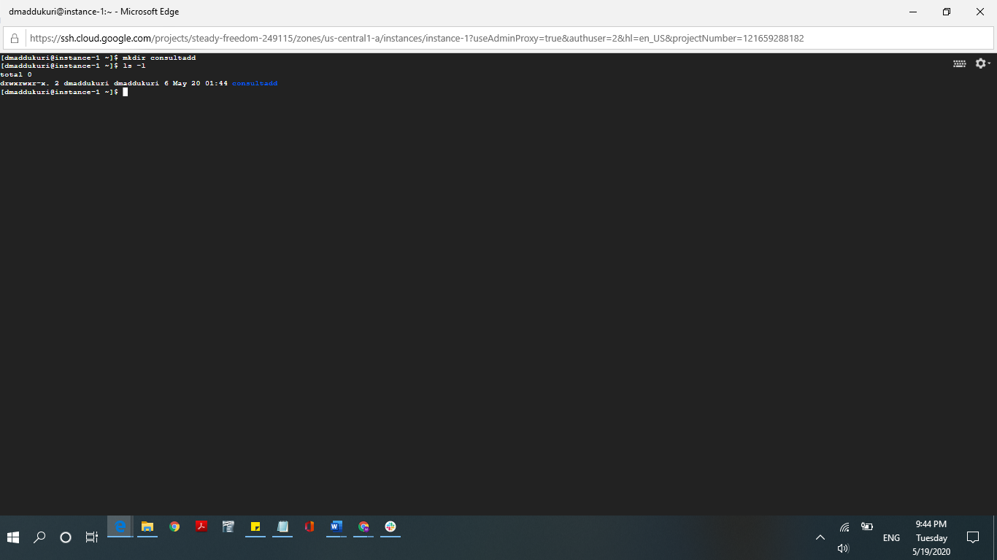

Inside that create 5 more directories named them as dir1, dir2, dir3, dir4 and dir5

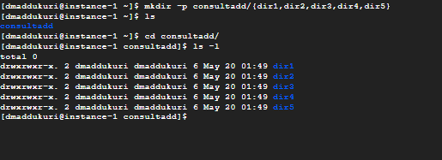

What would be the output of Long Listing after creating these directories?



List all the directories with ls and echo * and see the difference.

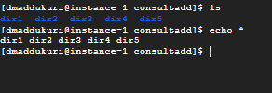

Create a 2 files named them file1.txt and file2.txt inside dir3

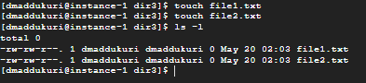

Move  dir5 into the dir3

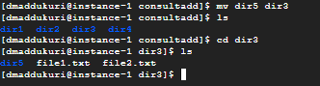

Remove dir 3 after moving all files from dir3 to dir2.

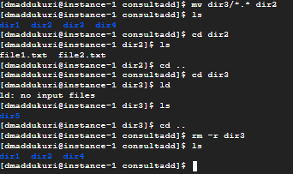

Go to the dir2 and create one more file with name index.html

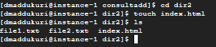

Move to top level directory



Check the permission of all files and directory from current place make sure when you do pwd it should be on consultadd

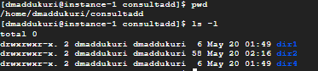

Rename all files of dir2 with extension of .txt to .py

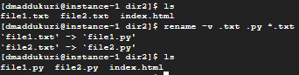

TASK: 03

* What is Nano Editor?

nano is a simple terminal-based text editor. Nano is ideal for making small changes to existing configuration files or for writing short plain text files. Nano can be used in a terminal window or at the system console.

* + How to create a sample file in Nano Editor?

Answer: nano filename

* + How to save file?
  + Answer: ctrl+o
* What is Vi Editor?

Answer:

The default editor that comes with the UNIX operating system is called vi (visual editor). Using vi editor, we can edit an existing file or create a new file from scratch. we can also use this editor to just read a text file.

Operation in Vi Editor

Answer: vi editor is a full screen editor and has two modes of operation:

Command mode commands which cause action to be taken on the file, and Insert mode in which entered text is inserted into the file

In the command mode, every character typed is a command that does something to the text file being edited; a character typed in the command mode may even cause the vi editor to enter the insert mode. In the insert mode, every character typed is added to the text in the file.

TASK: 04

Type finger to see your account and name.



Type cal to see this month’s calendar.

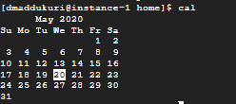

Create a file and give a name random.txt to it with content into it which say “Hello Welcome to the Consultadd Inc Bootcamp”.



Display the same content using cat command.



TASK: 05

* Explain the workflow of the Internet in one paragraph.

The process of transferring information from once device to another relies on packet switching. Each computer connected to the Internet is assigned a unique IP address that allows the device to be recognized. When one device attempts to send a message to another device, the data is sent over the Internet in the form of manageable packets. Each packet is assigned a port number that will connect it to its endpoint.

* How LAN is different from the WAN network?

|  |  |
| --- | --- |
| **LAN** | **WAN** |
| **LAN (Local Area Network) is a computer network covering a small geographic area, like a home, office, school, or group of buildings.** | **WAN (Wide Area Network) is a computer network that covers a broad area network. Communications links cross metropolitan, regional, or national boundaries over a long distance** |
|  |  |
| **High speed** | **Less speed** |
|  |  |
| **LANs have a high data transfer rate.** | **WANs have a lower data transfer rate compared to LANs** |
|  |  |
| **The network in an office building can be a LAN** | [**The Internet is a good example of a WAN**](https://www.diffen.com/difference/Internet_vs_World_Wide_Web) |
|  |  |
| **One LAN can be connected to other LANs over any distance via telephone lines and radio waves.** | **Computers connected to a wide-area network are often connected through public networks, such as the telephone system. They can also be connected through leased lines or satellites.** |
|  |  |
| [**Layer 2 devices like switches and bridges. Layer 1 devices like hubs and repeaters.**](https://www.diffen.com/difference/Hub_vs_Switch) | **Layers 3 devices Routers, Multi-layer Switches and Technology specific devices like ATM or Frame-relay Switches etc.** |
|  |  |
| **Experiences fewer data transmission errors** | **Experiences more data transmission errors as compared to LAN** |
|  |  |
| **High bandwidth is available for transmission.** | **Low bandwidth is available for transmission.** |
|  |  |
| **LAN is easier to maintain at relatively low costs.** | **Maintaining WAN is difficult because of its wider geographical coverage and higher maintenance costs.** |