**DAY -14 & 15 ESTIMATE  (2-3 hours)**

**CONSTRAINT: 01**

-- Give the name of the project as BootProject

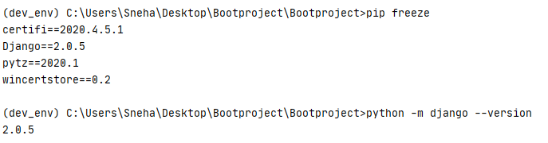

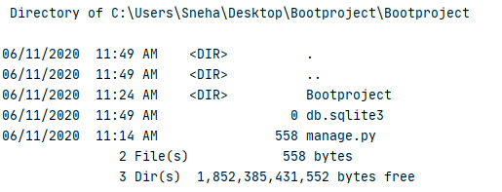

-- Give the name of the application as Bootapp



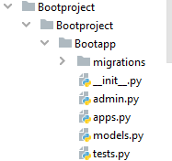

-- Allow views.py to be get properly mapped with urls.py file.

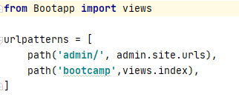

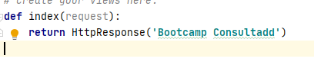

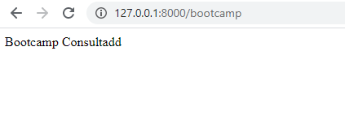

-- Use a template to create a generic HTML file that can display data like- Hi! Welcome to the innovation with Bootcamp training.

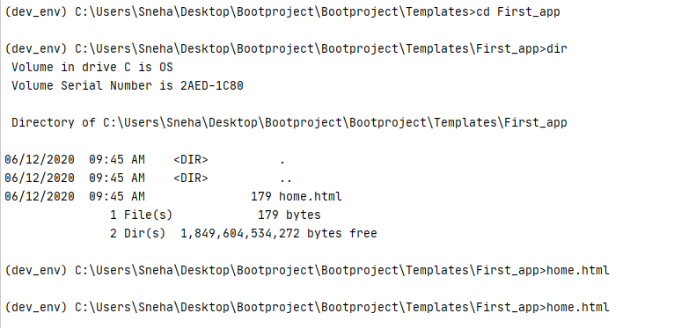

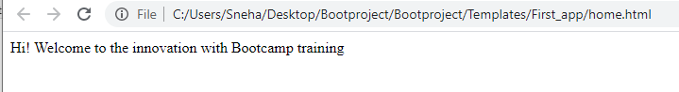

-- While working with the template make sure you give name "TEMPLATE_PATH" to actually connect to the os path.



**CONSTRAINT: 02**

-- Make use of the Static files concept to display jpg file on the web page.

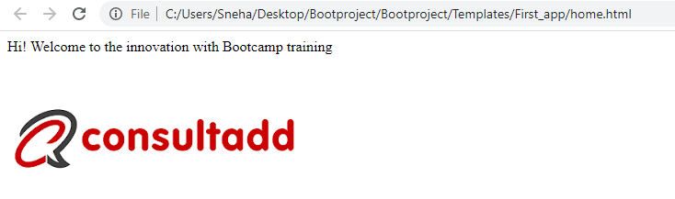

-- Make use of some other static files like CSS or JavaScript to change the font or color of the text.

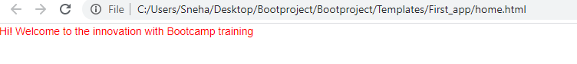

-- Create one models classes as - Name, ID, Contact, Address and migrate them into the database.

-- Make sure to create a super user & Get into the admin console

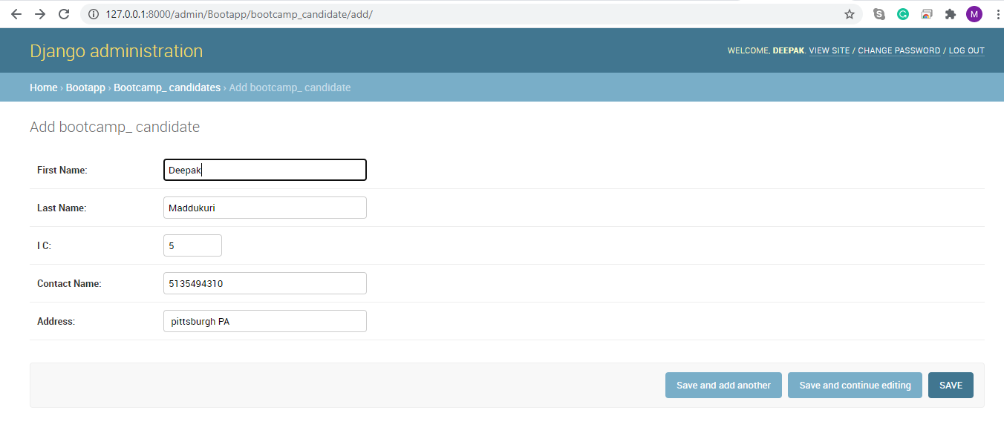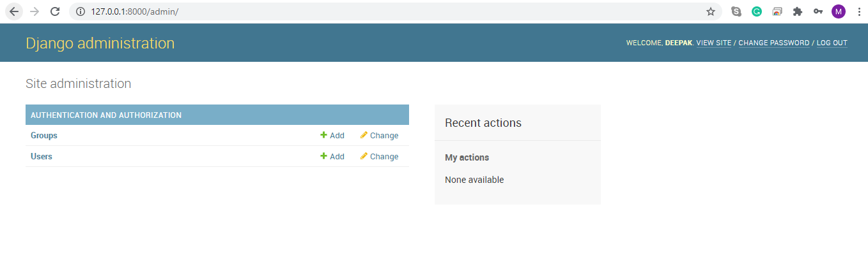

-- Initially migrate them to Django SQLLite

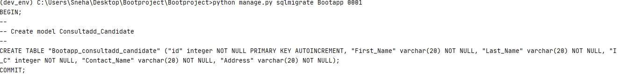

-- Connect with PostgreSQL

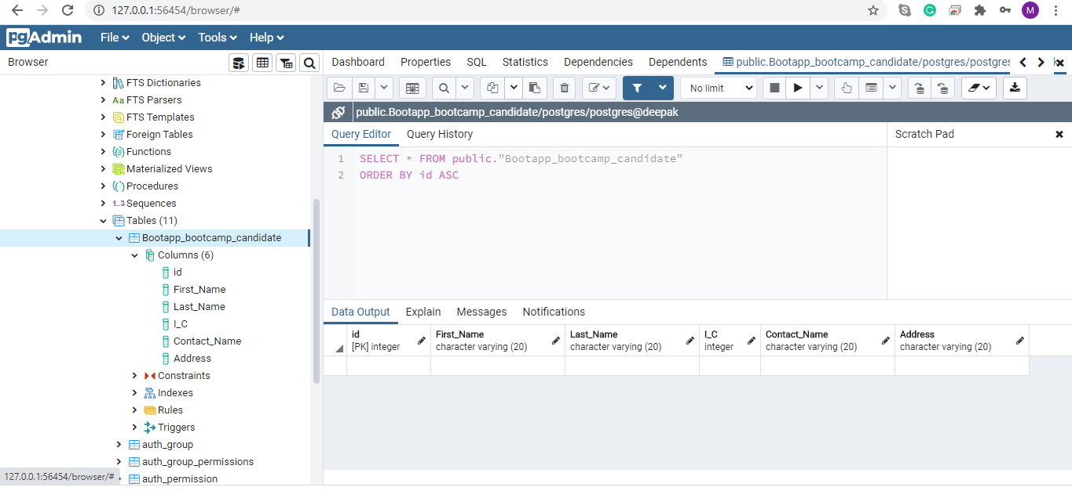

-- I need to install psycopg2-binary

