 | Nexus42 Artificial Intelligence Holding PJSC  Capital Gate, 12th Floor, Al Khaleej Al Arabi Street  Abu Dhabi, United Arab Emirates  people@nexus42.ai · +971 2 555 0042 · nexus42.ai

PRIVATE & CONFIDENTIAL
Ref: NX42/HR/OFR/2026/0418 Date: 16 June 2026
Diego Martín Maeso
Avenida de Asturias 31, 1A
34880 Guardo (Palencia)
España
Dear Diego Martín Maeso,
RE: OFFER OF EMPLOYMENT — AI TECH LEAD
We are delighted to extend to you an offer of employment with Nexus42 Artificial Intelligence Holding PJSC (“Nexus42” or the “Company”). Following our selection process, the Executive Committee has approved your appointment to a senior technical leadership role within our Foundation Models & AI Platform division. This letter sets out the principal terms of our offer.
1. Position and Reporting
You will be employed as AI Tech Lead, reporting to the Vice President, AI Engineering. You will lead a multidisciplinary team responsible for the design, training and large-scale deployment of the Company’s foundation models and applied AI platforms, and will set technical direction, architecture and engineering standards across the division.
2. Nature and Term of Contract
Your employment is offered on a fixed-term basis for an initial period of eighteen (18) months (the “Initial Term”), commencing on the Commencement Date and renewable by mutual written agreement. The contract is governed by UAE Federal Decree-Law No. 33 of 2021 (the UAE Labour Law) and its implementing regulations.
3. Commencement Date and Place of Work
Your Commencement Date is anticipated to be 1 September 2026, or such other date as may be mutually agreed in writing. Your principal place of work will be the Company’s headquarters at Capital Gate, Al Khaleej Al Arabi Street, Abu Dhabi, United Arab Emirates, with hybrid working available in accordance with Company policy.
4. Probationary Period
The first six (6) months of the Initial Term shall constitute a probationary period, during which either party may terminate the employment in accordance with the UAE Labour Law.
5. Remuneration
Your annual base salary will be AED 3,000,000 (three million United Arab Emirates Dirhams), equivalent to approximately EUR 750,000 per annum at an indicative reference rate of EUR 1.00 = AED 4.00. In addition to your base salary, and separately from it, you will receive the cash allowances set out below. All amounts are paid in UAE Dirhams (AED), free of UAE personal income tax.
Component | Annual (AED) | Monthly (AED)
Base salary | 3,000,000 | 250,000
Housing allowance (in addition to salary) | 600,000 | 50,000
Transport allowance (in addition to salary) | 120,000 | 10,000
Total annual cash package | 3,720,000 | 310,000

Your base salary and allowances are payable monthly in arrears by bank transfer to a UAE account nominated by you. The total annual cash package above (AED 3,720,000, approximately EUR 930,000) is exclusive of the benefits set out in clause 7, which are provided in addition.
6. Performance Bonus and Long-Term Incentive
You will be eligible for a discretionary annual performance bonus of up to 30% of your base salary, subject to Company and individual performance, and will be invited to participate in the Company’s Long-Term Incentive Plan, details of which will be provided separately.
7. Benefits
- 30 calendar days of paid annual leave per year, in addition to UAE public holidays;
- comprehensive private medical insurance for you and your eligible dependents;
- annual return air tickets to your home country for you and your eligible dependents;
- a one-time relocation allowance and assistance with relocation to Abu Dhabi;
- UAE residence visa sponsorship for you and your eligible dependents;
- end-of-service gratuity calculated in accordance with the UAE Labour Law.
8. Working Hours
Standard working hours are 40 hours per week, Monday to Friday, exclusive of breaks, together with the flexibility expected of a senior leadership position.
9. Confidentiality, Intellectual Property and Restrictive Covenants
Your employment is conditional upon execution of the Company’s standard Confidentiality and Intellectual Property Assignment Agreement. All intellectual property created in the course of your employment shall vest in the Company. Reasonable post-termination confidentiality and non-solicitation obligations will apply.
10. Conditions Precedent
This offer is conditional upon: (a) satisfactory completion of background, reference and security checks; (b) evidence of your right to be sponsored and to work in the UAE; (c) a satisfactory medical fitness examination; and (d) provision of attested copies of your academic and professional certificates.
11. Validity and Acceptance
This offer is open for acceptance until 30 June 2026. To accept, please sign and return the duplicate of this letter. This letter constitutes the principal terms of our offer and supersedes any prior discussions; a full employment contract will be issued upon acceptance.
We are confident that your expertise will make a significant contribution to Nexus42’s mission to build sovereign, world-class artificial intelligence, and we look forward to welcoming you to the team.
Yours sincerely,
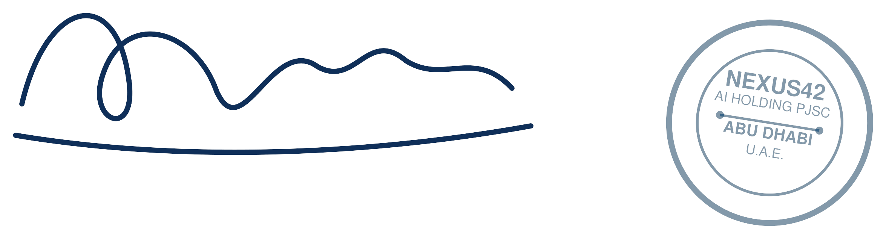
Khalid Al Nuaimi
Group Chief Executive Officer
For and on behalf of Nexus42 Artificial Intelligence Holding PJSC

ACCEPTANCE
I, Diego Martín Maeso, accept the offer of employment on the terms set out in this letter.
Signature: ______________________________ Date: __________________

