

Software Design Document

for

Chess

Version 1.0

|  |  |  |
| --- | --- | --- |
| Daniel Maida | 11441203 | [daniel.maida@wsu.edu](mailto:daniel.maida@wsu.edu) |
| Nazar Stelmakh | 11441299 | [nazar.stelmakh@wsu.edu](mailto:nazar.stelmakh@wsu.edu) |
| Steven Call | 11451145 | [steven.call@wsu.edu](mailto:steven.call@wsu.edu) |

|  |  |
| --- | --- |
|  |  |
|  |  |
|  | Date: October 28, 2016 |
|  |  |
|  |  |

Contents

Use case Diagram 1

Activity diagram 2

Class Diagram 3

Sequence Diagram 4

Group log 5

# USE CASE DIAGRAM

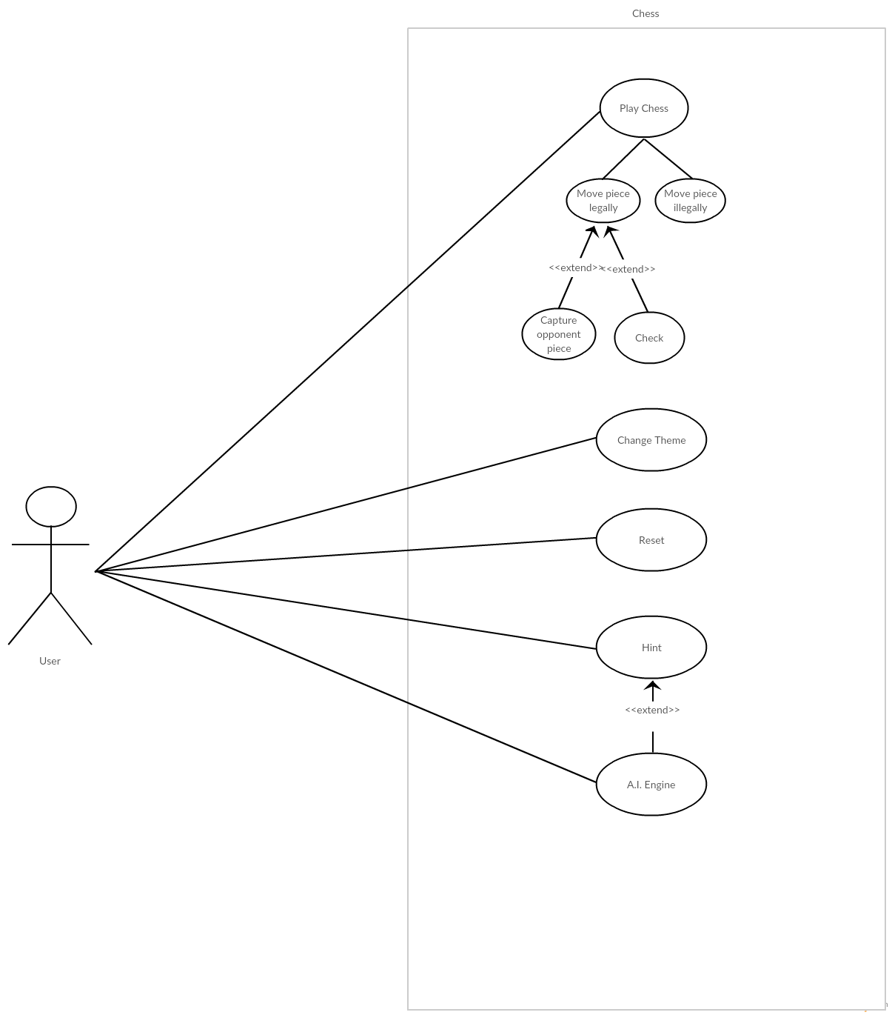

# ACTIVITY DIAGRAM

# CLASS DIAGRAM

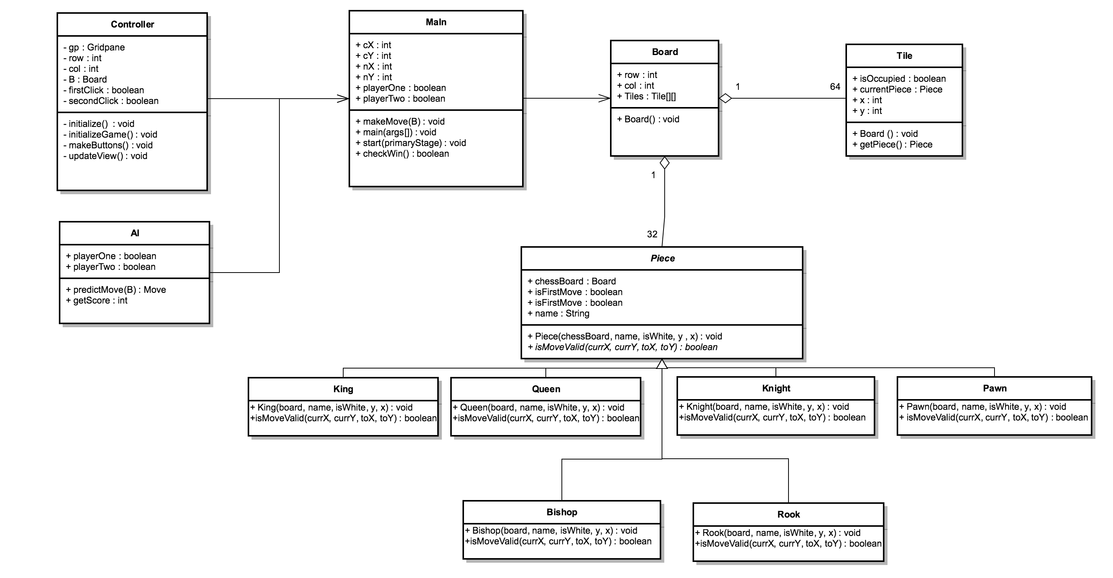

# SEQUENCE DIAGRAM

Appendix B - Group Log

|  |  |  |  |
| --- | --- | --- | --- |
| **Member** | **Meeting/Collaborative**  **Work Time (hrs)** | **Individual Work Time (hrs)** | **Total Time (hrs)** |
| **Daniel Maida** | 2 | 1 | 3 |
| **Nazar Stelamkh** | 2 | 1 | 3 |
| **Steven Call** | 2 | 1 | 3 |