

Software Test Report

for

Chess

Version 1.0

|  |  |  |
| --- | --- | --- |
| Daniel Maida | 11441203 | [daniel.maida@wsu.edu](mailto:daniel.maida@wsu.edu) |
| Nazar Stelmakh | 11441299 | [nazar.stelmakh@wsu.edu](mailto:nazar.stelmakh@wsu.edu) |
| Steven Call | 11451145 | [steven.call@wsu.edu](mailto:steven.call@wsu.edu) |

|  |  |
| --- | --- |
|  |  |
|  |  |
|  | Date: Nov 28, 2016 |
|  |  |
|  |  |

Contents

Software test Plan 1

Tested items and Checklist 2

Inspection Results and Follow-up 3

unit Testing 4

Interface testing 6

System Testing 7

non-functional Requirements Testing 8

# SOFTWARE TEST PLAN

**The Testing Process:** A description of the major phases of the testing process.

**Requirements traceability:** Users are most interested in the system meeting its requirements and testing should be planned so that all requirements are individually tested.

**Tested items:** The products of the software process that are to be tested should be specified.

**Testing schedule:** An overall testing schedule and resource allocation for this schedule. This, obviously, is linked to the more general project development schedule.

**Test recording procedures:** It is not enough simply to run tests. The results of the tests must be systematically recorded. It must be possible to audit the testing process to check that it been carried out correctly.

**Hardware and software requirements:** This section should set out software tools required and estimated hardware utilization.

**Constraints:** Constraints affecting the testing process such as staff shortages should be anticipated in this section

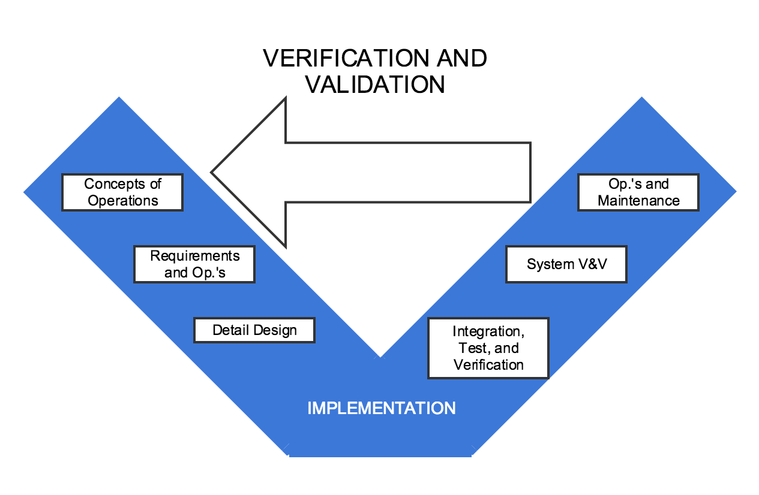

# TESTED ITEMS AND CHECKLIST

# RESULTS AND FOLLOW UP

# UNIT TESTING

# INTERFACE TESTING

Appendix B - Group Log

|  |  |  |  |
| --- | --- | --- | --- |
| **Member** | **Meeting/Collaborative**  **Work Time (hrs)** | **Individual Work Time (hrs)** | **Total Time (hrs)** |
| **Daniel Maida** | 2 | 1 | 3 |
| **Nazar Stelamkh** | 2 | 1 | 3 |
| **Steven Call** | 2 | 1 | 3 |