**CS673 Software Engineering**

**Team 1 Meeting Memos**

**Week 7 part 3 Meeting Notes**

Date and Time: 10/20/2021 4:30 PM - : 5:40PM

Place: Zoom

Participants: Haoyi Zhu, Gunnar Nichols, Kun Mo, Yuwei Wu, Heli Kolambekar, Weiye Xu, Daniel Makover

Memo Taker: Yuwei Wu

**Purpose & Agenda:**

SDD review

SPPP editing

presentation

**Discussions:**

SDD phrasing review

Sppp reviewing & editing

**Action Items:**

Next iteration plan

Retouch some features

Finishing the slides

**Week 7 Meeting Notes**

Date and Time: 10/16/2021 1:00 PM - 2:15 PM

Place: Zoom

Participants: Haoyi Zhu, Gunnar Nichols, Kun Mo, Heli Kolambekar, Weiye Xu, Daniel Makover

Memo Taker: Heli Kolambekar

**Purpose & Agenda:**

Iteration 1 documentation task allotment

Verify task completion on pivotal tracker

**Discussions:**

User stories progress

Delivered:

1. Allow the player to start the trivia game by clicking on the 'Start Game' button
2. Trivia Game has questions for player to play
3. Only one attempt allowed for each question
4. Allow user to keep score
5. Allow user to quit game session by clicking on the 'end game' button
6. Allow the player to view their remaining lives
7. Allow players to know the remaining time of the questions
8. No duplicated questions in each game play

In-Progress:

1. Display Gameplay Element: Lifelines
2. posting score to leaderboard
3. Allow user to see the correct answer after the user clicks on an option or the timer runs out

**Action Items:**

1. Update SPPP (wrt instructor’s comments)
2. SDD
3. Iteration_1 ppt ( Features- Daniel, Architecture- Haoyi, Database Design- Haoyi, UI Design- Daniel, Security-Gunnar, Class Diagram- Heli)

**Week 6 part3 Meeting Notes**

Date and Time: 10/12/2021 4:00 PM - 5:00 PM

Place: Zoom

Participants: Haoyi Zhu, Yuwei Wu, Gunnar Nichols, Kun Mo, Heli Kolambekar, Weiye Xu, Daniel Makover

Memo Taker: Yuwei Wu

**Purpose & Agenda:**

Test current implementation

Divide work for user story in current iteration

**Discussions:**

Self-learning suggestion: bootstrap UI

Current user stories progress:

Delivered:

(Daniel)Trivia Game has questions for player to play

In progress:

(Kun)Allow the player to start the trivia game by clicking on the 'Start Game' button

(Haoyi, Gunnar)Only one attempt allowed for each question

(Heli, Weiye, Yuwei/Abel)Allow user to keep score

(Gunnar, Daniel)Allow user to quit game session by clicking on the 'end game' button

(Heli, Haoyi, Yuwei/Abel)Display Gameplay Element: Lifelines

(Haoyi)Allow the player to view their remaining lives

(Weiye)Allow players to know the remaining time of the questions

(Kun, Haoyi)No repeated questions in each game play

(Daniel)posting score to leaderboard

(Haoyi)Allow user to see the correct answer after the user clicks on an option or the timer runs out

**Key Decisions:**

**Action Items:**

User stories progressing

SDD start working

**Week 6 part2 Meeting Notes**

Date and Time: 10/11/2021 5:00 PM - 6:45 PM

Place: Zoom

Participants: Haoyi Zhu, Yuwei Wu, Gunnar Nichols, Kun Mo, Heli Kolambekar, Weiye Xu, Daniel Makover

Memo Taker: Yuwei Wu

**Purpose & Agenda:**

Setting up new branches/env for iteration 1

Dividing the tasks

**Discussions:**

**Daniel:**

1- to get the nex branch on your local computer you need to run this command in the command line:

$git checkout --track origin/iter_1

2- I just added some more boiler plate code that connected a javascript and CSS file to the game.html page

this should work as the cornerstone for the front end

so just to clarify, if you have the repo clone on your computer just run the command above to add the iter_1 branch to your machine

to get things up and running you need to:

1- set up a virtual environment and activate it

2-download all of the dependencies for the application

3-instantiate the database

4-populate the database (edited)

all of this is in the readme document in the iter_1 branch. let me know if you have problems running this on you local computer

python3 -m venv env

**Key Decisions:**

**Action Items:**

Meeting part 3 Tuesday 4pm

**Week 6 Meeting Notes**

Date and Time: 10/09/2021 1:00 PM - 2:30PM

Place: Zoom

Participants: Haoyi Zhu, Yuwei Wu, Gunnar Nichols, Kun Mo, Heli Kolambekar, Weiye Xu, Daniel Makover

Memo Taker: Yuwei Wu

**Purpose & Agenda:**

Iteration 1 progress

**Discussions:**

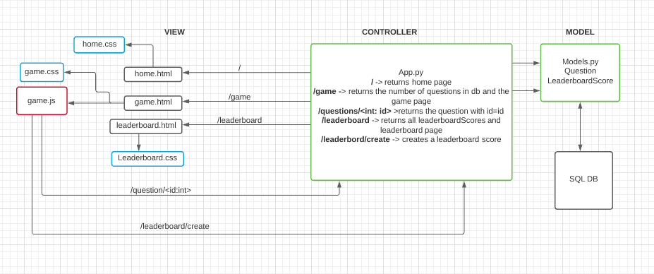

1. Pivotal tracker update

Add user stories to current iteration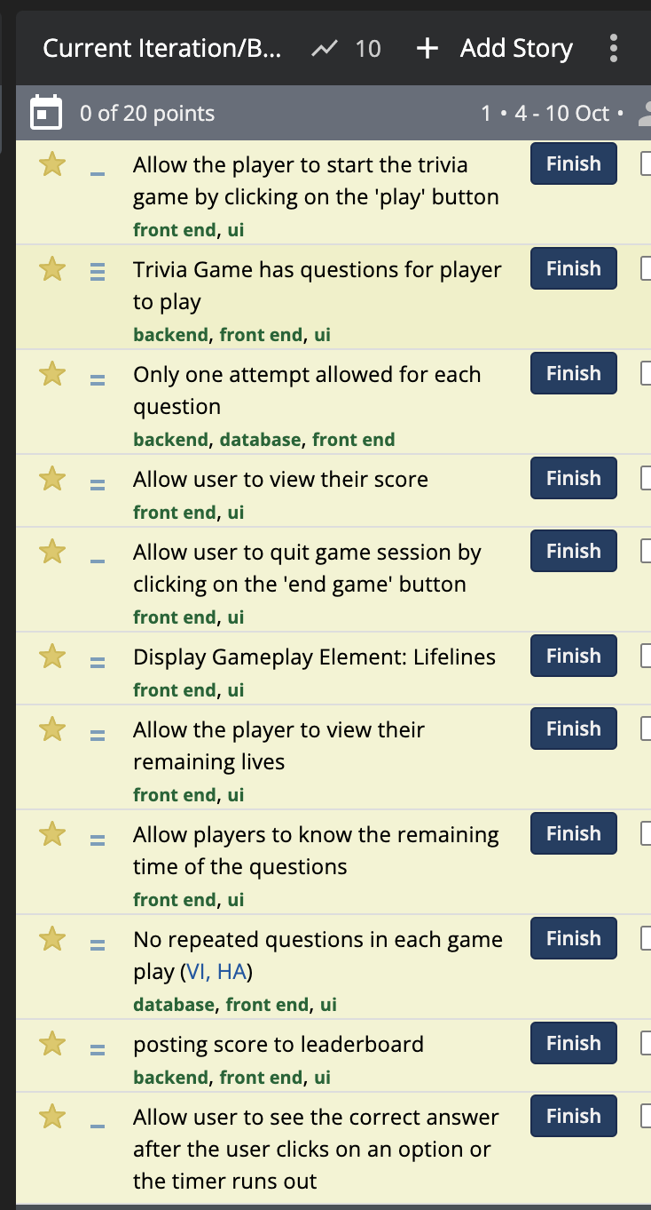

1. Items due for iteration 1:
   1. SDD- software architecture, database design, key algorithms:

Introduction -- Heli

software architecture, database design, key algorithm, classes and methods -- Haoyi

Security design -- Yuwei

Design patterns, ui design -- Daniel

* 1. Going over instructor’s comments in the SPPP after iteration0, and update
  2. User stories and tasks

More stories to be added

* 1. Presentation
  2. Meeting minutes
  3. Progress report

1. Start coding: new branch in pivotal tracker

**Key Decisions:**

Core to work with

**Action Items:**

Monday 5 pm meeting part 2

**Front End Meeting Notes**

Date and Time: 10/07/2021 1:00 PM - 1:40 PM

Place: Zoom

Participants: Haoyi Zhu, Yuwei Wu, Kun Mo, Weiye Xu

Memo Taker: Yuwei Wu

**Purpose & Agenda:**

view html basic page

**Discussion:**

Log in - how to log in & how to create account, flask login library

leaderboard (to view: no need to sign in)

question categories, separate table or mixed table with category column

database problems: json file, api

**Key Decision:**

Keep working on the front end code.

**Action items:**

flask login library page

**Week 5 Meeting Notes**

Date and Time: 10/02/2021 1:00 PM - 2:15 PM

Place: Zoom

Participants: Haoyi Zhu, Yuwei Wu, Gunnar Nichols, Kun Mo, Heli Kolambekar, Weiye Xu

Memo Taker: Heli Kolambekar

**Purpose & Agenda:**

Review instructor’s comments in the SPPP after Iteration 0, work on the SDD

**Discussions:**

1. SDD- software architecture, database design, key algorithms
2. Going over instructor’s comments in the SPPP after iteration0
3. Discussing application prototypes
4. User stories and tasks
5. UI - determining the design and graphics

**Key Decisions:**

1. A single leaderboard for single player and multiplayer games
2. User login page, game play page for Iteration 1

**Action Items:**

1. Every person makes required edits to their section of the SPPP as suggested by the instructor.
2. SDD- Intro (Heli)

Software Architecture, Database Design, Key Algorithms (Haoyi)

Security Design ( Yuwei)

1. UML diagram- Heli
2. Front page UI, play page UI - Kun, Yuwei
3. Reviewing sample SDD - Gunnar
4. Pivotal Tracker User Stories and tasks- Kun, Heli
5. Database design - Haoyi

**Week 4(Part2) Meeting Notes**

Date and Time: 9/27/2021 4:00 PM - 4:50 PM

Place: Zoom

Participants: Haoyi Zhu, Yuwei Wu, Gunnar Nichols, Kun Mo, Daniel Makover, Heli Kolambekar, Weiye Xu

Memo Taker: Haoyi Zhu

**Purpose & Agenda:**

User stories/Lab 2

**Discussions:**

Reward: UI change?

Skip one question or remove one wrong answer?

Hint button: cut done point to get a hint?

UI: counter for each question

User Story: Go through all user stores we have.

Title should be more specific

**Key Decisions:**

**Action Items:**

Keep working on Lab2- tasks and activity

**Week 4 Meeting Notes**

Date and Time: 9/25/2021 1:00 PM - 2: 30PM

Place: Zoom

Participants: Haoyi Zhu, Yuwei Wu, Gunnar Nichols, Kun Mo, Daniel Makover, Heli Kolambekar

Memo Taker: Yuwei Wu

**Purpose & Agenda:**

**File structure**

User stories/Lab 2

**Discussions:**

See the mockup, player profile page, play page that heli setup

For Iteration 1:

* leaderboard table,
* questions table(question id, answer options, etc)
* Timer
* Shuffle
* Question database(create, update, delete)

-> 2 people: Design -> HTML and CSS

-> 2 people: front end Logic -> Javascript and JQUERY

-> 2 people: back end Logic -> Flask and DB

Stories:

STORY 1 -> As a user I can navigate to the home page and see buttons to start the game and a button to see the leaderboard

back end -> route to the home page ‘/‘

front end -> HTML home page displaying two buttons

**Key Decisions:**

Kun -> JS and HTML(frontend)

Haoyi -> Flask and DB(backend)

Gunnar-> JS(backend)

Heli -> JS(backend)

Yuwei -> JS(frontend)

Daniel ->Architecture and HTML

**Action Items:**

-> everyone come up with 2 user stories in pivotal tracker’s **icebox**

Daniel: superuser/administrator for leaderboard and questions

Heli: categories

Gunnar: options

Haoyi: question logic

Kun: timer

Yuwei: player profile

Weiye:

*heli will contact Weiye

-> meeting part2 on Monday 4pm

-> logo design, team name etc

**Week 3(part2) Meeting Notes**

Date and Time: 9/20/2021 4:00 PM - 5:20 PM

Place: Zoom

Participants Haoyi Zhu, Yuwei Wu, Gunnar Nichols, Kun Mo, Daniel Makover, Weiye Xu

Memo Taker: Yuwei Wu

**Purpose & Agenda: Presentation Slides**

**Discussions:**

Go through the SPPP.

Flask Tutorial:

<https://www.youtube.com/watch?v=3mwFC4SHY-Y>

Dued Items:

Readme.md

Doc/ProjX_SPPP

Doc/ProjX_meetingminutes

Doc/ProjX_weeklyreport

Doc/ProjX_presentation_iter0

Timeline

Iteration 1:

Simple, single layer game

Iteration 2:

More features: User profiles/accounts, etc

Iteration 3:

Multiplayer features & refactoring, single page game(better UI etc)

PEP8 example:

<https://www.python.org/dev/peps/pep-0008/>

Go through the slides

**Key Decisions:**

**Action Items: All done by Wednesday 5pm**

* Python/flask unit test framework (eg: PyTest) ---- All involved
* Finalize the slides (contents and format)
* Tuesday 4pm meeting part 3

**Week 3 Meeting Notes**

Date and Time: 9/18/2021 1:00 PM - 2:33 PM

Place: Zoom

Participants Haoyi Zhu, Yuwei Wu, Gunnar Nichols, Kun Mo, Heli Kolambekar, Weiye Xu

Memo Taker: Gunnar Nichols

**Purpose & Agenda:**

Review SPPP

Establish and assign tasks required to be ready to submit and present Iteration 0 on Thursday 9/23/21

Initial Draft of Required Tasks

SPPP - Draft: Configuration Management Plan

Presentation - Established Outline and then populate each section (10-15 min required)

Weekly Report - Most people haven’t submitted a single one as of 3AM 9/19/21

Establish a consensus on the Project Name

Current Ideas: MyTrivia, TriviaMe, Trivial, Knowitall and Trivius

Plan an additional meeting to solidify work to complete presentation on Monday or Tuesday

**Discussions:**

SPPP Review

Overview - Currently Suitable

Related Work - Mention that our app asks questions until you get a certain number wrong, rather than asking a specific number of questions

Proposed High Level Requirements - What level of non-functional requirements should be outlined here

Management Plan - Currently Suitable

Quality Assurance Plan - Edits Drafted in the Document during this meeting, final edits will be completed by Gunnar on Sunday

Configuration Management Plan - Edits Drafted in the Document during this meeting, to be completed by Weiye Xu/Kun Mo

The reference section is being drafted by Heli

Draft Presentation Outline - Done in Presentation Iteration0 Document

**Key Decisions:**

Project Name: Knowitall

The next meeting will be on Monday at 4PM to finalize the work needed to be done to submit Iteration0 and perform the presentation during class Thursday

**Action Items:**

Every individual responsible for updating the remaining work for the SPPP outlined above will complete their work for the meeting on Monday at 4PM

Prepare the PowerPoint slide drafts for next meeting on Monday at 4PM

**Week 2 Sprint Prep Meeting**

Date and Time: 9/13/2021 5:20 PM - 6:40 PM

Place: Slack

Participants: Daniel Makover, Kun Mo

Memo taker: Kun Mo

**Purpose & Agenda:** Doing and discussing the Management Plan in SPPP. Determining the next sprint from the project.

**Discussions:**

1. Process Model. Agile?
2. Objectives and Priorities.
3. Main risks.
4. Our monitoring and controlling tools links.

**Key Decisions:**

1. The process model of our project would be only Agile.
2. App crashes are not important things because the project is not complicated. The main objective is creating a fully functional trivia app.
3. Main risk is a Technical bottleneck.

**Action Items:**

Keep doing the Risk Management Sheet.

Find a sample application video and show it in the next group meeting.

**Week 2 Meeting Notes**

Date and Time: 9/11/2021 1:00 PM - 2:00 PM

Place: Zoom

Participants: Daniel Makover, Haoyi Zhu, Yuwei Wu, Gunnar Nichols, Kun Mo, Heli Kolambekar, Weiye xu

Memo taker: Daniel Makover

**Purpose & Agenda:** Solidify the project idea. Narrow down the project features, and break up tasks for the SPPP

**Discussions:**

The team has chosen a trivia app

Framework: Flask vs Django?

Database: Mongo vs SQL?

**Key Decisions:**

Team chooses to work with Flask, MongoDB

Gunner is buying premium Zoom

Using JSON files Daniel Provided as starting data

**Action Items:**

Due two week: Project descriptions and planning documents

**Week 1 Meeting Notes**

Date and Time: 9/6/2021 5:15 PM - 5:55 PM

Place: Zoom

Participants: Daniel Makover, Haoyi Zhu, Yuwei Wu, Gunnar Nichols, Kun Mo, Heli Kolambekar

Memo taker: Gunnar Nichols

Purpose Template and Established Details:

1. Get to know each other and decide the lead role assignment.
   1. ***Team Leader***: Kun Mo/ Daniel Makover
   2. ***Backup Team leader***: Kun Mo/ Daniel Makover
   3. ***Requirement leader***: Heli Kloambekar
   4. ***Design and Implementation leader***: Haoyi Zhu
   5. ***QA leader***: Gunnar Nichols
   6. ***Configuration leader***:
   7. ***Security leader***: Yuwei Wu
2. Discuss the project ideas.
   1. Project Idea Recording:
   2. Meme Generator
   3. Heli-Homeschooling app
   4. Heli-Hospital management system
   5. Haoyi Zhu - Pokemon Go Project continuation
   6. Yuwei Wu - Biology Project Continuation
   7. Onsite Fundraising Tool

Our objective is to work on an idea that starts with a reasonable scope and can be expanded in future iterations

<https://docs.google.com/document/d/11F5HZai6nUcwk3-Snb99z4WNd0FvQJ9nWnCaMc_kKAI/edit>

1. Decide the meeting time and communication methods.
   1. Saturday
   2. 1:00
   3. zoom meeting
2. Decide the technology stacks and development environment.
   1. Front end
      1. Javascript
      2. Possibly Add REACT + REDUX
   2. Back-end
      1. Programming Language & IDE: Python
      2. Django or Flask?
      3. SQL or NonSQL?