Supplementary Material for
Compound hot–dry drought during co-occurring El Niño and positive Indian Ocean Dipole seasons in Zimbabwe’s agroecological Natural Regions: circulation, maize impacts, and implications for seasonal forecasting
Desmond Manatsa, Terence Mushore, James Ngoma, Isaac Masawana and Rebecca Manzou
Journal of Applied Meteorology and Climatology, manuscript JAMC-D-26-0148 (revised)
Contents. Tables S1–S13 and Figures S1–S4. Season labels are onset years (1951 = October 1951 to March 1952). Unless stated, composites of the four co-occurrence states are relative to the 15 neutral seasons of 1951–2017, individual-mode composites are relative to all other seasons, and p values are from Welch’s t-test. EN = El Niño, LN = La Niña, +IOD and −IOD = positive and negative IOD.

Table S1
Table S1. DJF Oceanic Niño Index and SON Dipole Mode Index for every season, 1951–2024, both from ERSSTv5 with the CPC moving 30-year base (section 2.6), with the revised classification (ONI ±0.5 °C, DMI ±0.4 °C) and the classification in the submitted manuscript (Table 1 of the submitted version, which used a fixed base without detrending). Seasons 2018–2024 are covered by CHIRPS only.
Season | DJF ONI (°C) | SON DMI (°C) | Revised category | Submitted category | Changed
1951/52 | +0.53 | +0.16 | El Niño only | Neutral | yes
1952/53 | +0.41 | −0.18 | Neutral | Neutral
1953/54 | +0.76 | +0.16 | El Niño only | Neutral | yes
1954/55 | −0.68 | −0.41 | La Niña & −IOD | La Niña only | yes
1955/56 | −1.11 | −0.22 | La Niña only | La Niña only
1956/57 | −0.25 | −0.59 | −IOD only | La Niña & −IOD | yes
1957/58 | +1.82 | −0.07 | El Niño only | El Niño only
1958/59 | +0.62 | −0.59 | El Niño & −IOD | −IOD only | yes
1959/60 | −0.09 | −0.29 | Neutral | Neutral
1960/61 | +0.04 | −0.81 | −IOD only | −IOD only
1961/62 | −0.24 | +1.12 | +IOD only | La Niña & +IOD | yes
1962/63 | −0.40 | +0.15 | Neutral | La Niña only | yes
1963/64 | +1.08 | +0.80 | El Niño & +IOD | El Niño & +IOD
1964/65 | −0.59 | −0.16 | La Niña only | La Niña only
1965/66 | +1.38 | +0.33 | El Niño only | El Niño only
1966/67 | −0.41 | +0.03 | Neutral | La Niña only | yes
1967/68 | −0.64 | +0.74 | La Niña & +IOD | La Niña & +IOD
1968/69 | +1.13 | −0.10 | El Niño only | El Niño only
1969/70 | +0.51 | +0.25 | El Niño only | Neutral | yes
1970/71 | −1.36 | −0.23 | La Niña only | La Niña only
1971/72 | −0.71 | −0.23 | La Niña only | La Niña only
1972/73 | +1.85 | +0.96 | El Niño & +IOD | El Niño & +IOD
1973/74 | −1.85 | −0.15 | La Niña only | La Niña only
1974/75 | −0.55 | −0.30 | La Niña only | La Niña only
1975/76 | −1.56 | −0.75 | La Niña & −IOD | La Niña & −IOD
1976/77 | +0.72 | −0.16 | El Niño only | El Niño only
1977/78 | +0.69 | +0.37 | El Niño only | +IOD only | yes
1978/79 | +0.03 | +0.15 | Neutral | Neutral
1979/80 | +0.59 | −0.37 | El Niño only | Neutral | yes
1980/81 | −0.26 | −0.31 | Neutral | Neutral
1981/82 | −0.05 | −0.35 | Neutral | Neutral
1982/83 | +2.19 | +0.58 | El Niño & +IOD | El Niño & +IOD
1983/84 | −0.60 | +0.16 | La Niña only | La Niña only
1984/85 | −1.05 | −0.25 | La Niña only | La Niña only
1985/86 | −0.50 | +0.19 | Neutral | La Niña only | yes
1986/87 | +1.24 | +0.55 | El Niño & +IOD | El Niño & +IOD
1987/88 | +0.81 | +0.31 | El Niño only | El Niño & +IOD | yes
1988/89 | −1.70 | −0.35 | La Niña only | La Niña only
1989/90 | +0.13 | −0.39 | Neutral | Neutral
1990/91 | +0.41 | −0.57 | −IOD only | −IOD only
1991/92 | +1.72 | +0.36 | El Niño only | El Niño & +IOD | yes
1992/93 | +0.09 | −0.30 | Neutral | Neutral
1993/94 | +0.06 | −0.15 | Neutral | Neutral
1994/95 | +0.96 | +0.94 | El Niño & +IOD | El Niño & +IOD
1995/96 | −0.91 | −0.31 | La Niña only | La Niña only
1996/97 | −0.50 | −0.76 | La Niña & −IOD | −IOD only | yes
1997/98 | +2.25 | +1.17 | El Niño & +IOD | El Niño & +IOD
1998/99 | −1.55 | −0.61 | La Niña & −IOD | La Niña & −IOD
1999/00 | −1.67 | −0.07 | La Niña only | La Niña only
2000/01 | −0.68 | +0.04 | La Niña only | La Niña only
2001/02 | −0.15 | −0.38 | Neutral | Neutral
2002/03 | +0.92 | +0.48 | El Niño & +IOD | El Niño & +IOD
2003/04 | +0.36 | −0.09 | Neutral | Neutral
2004/05 | +0.64 | +0.10 | El Niño only | El Niño only
2005/06 | −0.85 | −0.57 | La Niña & −IOD | La Niña & −IOD
2006/07 | +0.65 | +0.78 | El Niño & +IOD | El Niño & +IOD
2007/08 | −1.65 | +0.07 | La Niña only | La Niña only
2008/09 | −0.85 | −0.02 | La Niña only | La Niña only
2009/10 | +1.51 | −0.14 | El Niño only | El Niño only
2010/11 | −1.42 | −1.03 | La Niña & −IOD | La Niña & −IOD
2011/12 | −0.87 | +0.28 | La Niña only | La Niña & +IOD | yes
2012/13 | −0.43 | +0.28 | Neutral | +IOD only | yes
2013/14 | −0.44 | −0.17 | Neutral | Neutral
2014/15 | +0.55 | −0.12 | El Niño only | El Niño only
2015/16 | +2.50 | +0.56 | El Niño & +IOD | El Niño & +IOD
2016/17 | −0.34 | −0.71 | −IOD only | −IOD only
2017/18 | −0.92 | +0.21 | La Niña only | La Niña & +IOD | yes
2018/19 | +0.76 | +0.47 | El Niño & +IOD | El Niño & +IOD
2019/20 | +0.50 | +1.52 | El Niño & +IOD | El Niño & +IOD
2020/21 | −1.05 | −0.09 | La Niña only | La Niña only
2021/22 | −0.97 | −0.31 | La Niña only | La Niña only
2022/23 | −0.68 | −0.74 | La Niña & −IOD | La Niña & −IOD
2023/24 | +1.79 | +1.28 | El Niño & +IOD | El Niño & +IOD
2024/25 | −0.57 | −0.23 | La Niña only | Neutral | yes

Table S2
Table S2. Sensitivity of the national composites (% relative to neutral seasons) to the index convention and to station and dataset choices. "Agree E/I" is the percentage of the 67 seasons of 1951–2017 whose ENSO and IOD phases agree with the primary classification. The linear trend removed from each box and from the DMI give identical classifications, as expected for a linear operation applied over the same period. Station-choice rows use the primary classification. Fig. S3 shows the index series.
Convention or data choice | n | EN & +IOD | p | n | EN only | p | n | LN & −IOD | p | Agree E/I (%)
Moving 30-yr base, ERSSTv5 (primary) | 9 | −24.0 | <0.001 | 14 | −1.0 | 0.90 | 6 | +20.3 | 0.040 | 100/100
Fixed 1981–2010 base, no detrending | 10 | −15.4 | 0.13 | 9 | −5.8 | 0.52 | 7 | +19.7 | 0.031 | 85/94
Fixed 1991–2020 base, no detrending | 8 | −29.9 | 0.001 | 11 | −9.2 | 0.37 | 12 | +8.5 | 0.29 | 85/82
Fixed base, linear trend removed from each box | 10 | −17.7 | 0.086 | 13 | −5.8 | 0.45 | 5 | +17.6 | 0.12 | 96/97
Fixed base, linear trend removed from the DMI | 10 | −17.7 | 0.086 | 13 | −5.8 | 0.45 | 5 | +17.6 | 0.12 | 96/97
HadISST1 DMI, moving base | 7 | −18.2 | 0.053 | 16 | −8.6 | 0.26 | 4 | +7.5 | 0.58 | 100/82
DMI September only | 9 | −21.8 | 0.011 | 13 | −6.6 | 0.47 |  |  |  | 100/85
DMI October only | 12 | −14.3 | 0.12 | 11 | −9.1 | 0.29 |  |  |  | 100/84
DMI November only | 6 | −21.2 | 0.016 | 15 | −7.3 | 0.39 |  |  |  | 100/87
DMI August–October | 8 | −30.4 | <0.001 | 15 | −8.8 | 0.31 |  |  |  | 100/88
MSD station-to-region allocation | 9 | −24.5 | <0.001 | 14 | −1.4 | 0.86 |  | +20.4 | 0.031 | 100/100
No station quality control | 9 | −23.7 | <0.001 | 14 | +0.8 | 0.92 |  | +20.2 | 0.035 | 100/100
Low-coverage region-seasons excluded | 9 | −24.2 | <0.001 | 14 | −1.6 | 0.83 |  | +20.1 | 0.042 | 100/100
Stations, 1983–2017 only | 6 | −13.5 | 0.063 | 5 | −10.4 | 0.35 |  | +20.5 | 0.038 | 100/100
National series from 1959 (NR V present) | 9 | −21.4 | 0.002 | 11 | −2.1 | 0.81 | 5 | +17.0 | 0.027 | 100/100
National series from NR I–IV only | 9 | −22.7 | <0.001 | 14 | −1.9 | 0.80 | 6 | +19.8 | 0.046 | 100/100
CHIRPS v2.0, 1981–2024 | 10 | −14.3 | 0.030 | 5 | −5.7 | 0.63 | 5 | +20.5 | 0.041 | 100/100
Stations 1951–2017 + CHIRPS 2018–2024 | 12 | −23.7 | <0.001 | 14 | −1.0 | 0.90 | 7 | +15.9 | 0.098 | 100/100

Table S3
Table S3. National El Niño & +IOD and El Niño only composites relative to neutral seasons for nine combinations of thresholds, station series 1951–2017 (Fig. 5a). The primary choice is ONI ±0.5 °C and DMI ±0.4 °C.
ONI threshold (°C) | DMI threshold (°C) | n | EN & +IOD (%) | p | n | EN only (%) | p | n neutral
±0.4 | ±0.3 | 13 | −11.7 | 0.25 | 10 | +5.9 | 0.55 | 5
±0.4 | ±0.4 | 9 | −19.4 | 0.013 | 15 | +6.1 | 0.48 | 10
±0.4 | ±0.5 | 8 | −19.5 | 0.016 | 16 | +4.5 | 0.59 | 10
±0.5 | ±0.3 | 13 | −18.3 | 0.048 | 9 | −4.5 | 0.59 | 10
±0.5 | ±0.4 | 9 | −24.0 | <0.001 | 14 | −1.0 | 0.90 | 15
±0.5 | ±0.5 | 8 | −24.1 | 0.002 | 15 | −2.5 | 0.75 | 15
±0.6 | ±0.3 | 13 | −15.0 | 0.096 | 6 | −0.4 | 0.96 | 14
±0.6 | ±0.4 | 9 | −23.6 | <0.001 | 10 | +0.8 | 0.93 | 21
±0.6 | ±0.5 | 8 | −23.7 | 0.001 | 11 | −1.3 | 0.88 | 21

Table S4
Table S4. Tercile classification following Ficchì et al. (2021). Tercile bounds over 1951–2017 are −0.50 and +0.53 °C for the DJF ONI and −0.23 and +0.16 °C for the SON DMI. The mean anomaly is the national rainfall anomaly (% of the 1951–2017 mean). Marginal composites relative to all other seasons: warm ONI −16.0% (n = 22, p = 0.007); cold ONI +13.7% (n = 23, p = 0.018); positive DMI −17.0% (n = 22, p = 0.004); negative DMI +9.5% (n = 23, p = 0.082).
ONI tercile | DMI tercile | n | Mean anomaly (%) | vs middle/middle (p) | Seasons
Cold | Negative | 11 | +15.8 | +7.8 (0.36) | 1954, 1970, 1974, 1975, 1984, 1988, 1995, 1996, 1998, 2005, 2010
Cold | Middle | 9 | +9.3 | +1.2 (0.91) | 1955, 1964, 1971, 1973, 1983, 1999, 2000, 2007, 2008
Cold | Positive | 3 | −13.4 | −21.5 (0.15) | 1967, 2011, 2017
Middle | Negative | 10 | −1.4 | −9.4 (0.30) | 1956, 1959, 1960, 1980, 1981, 1989, 1990, 1992, 2001, 2016
Middle | Middle | 7 | +8.0 | reference | 1952, 1962, 1966, 1978, 1993, 2003, 2013
Middle | Positive | 5 | −0.5 | −8.6 (0.41) | 1951, 1961, 1969, 1985, 2012
Warm | Negative | 2 | −3.6 | −11.7 (0.16) | 1958, 1979
Warm | Middle | 6 | −3.6 | −11.7 (0.27) | 1957, 1968, 1976, 2004, 2009, 2014
Warm | Positive | 14 | −14.2 | −22.2 (0.026) | 1953, 1963, 1965, 1972, 1977, 1982, 1986, 1987, 1991, 1994, 1997, 2002, 2006, 2015

Table S5
Table S5. Station inventory. Station IDs are WMO block indices (67xxx) from the MSD station register. The 9 climatological, agrometeorological and cooperative stations without a WMO index are identified by their MSD national climatological register number (prefixed MSD). The station codes in the archive workbook matched the register for only 4 of these 37 stations and are not used. Longitude and latitude are the positions used in the revised analysis; where they differ from the archive coordinates, the archive values are given. Coordinates are from the MSD station register for the 37 stations it lists; for the other 9 stations the archive coordinates are used, except that the latitude of Chisumbanje was corrected. Archive positions that placed stations at another town include Nyanga (at Mvurwi), Mutoko (at Mutare), Rusape (at Mvuma) and Matopos (at Bulawayo). "NR" is the Natural Region polygon that contains the position used, and "Zone" the sub-zone of the seven-zone shapefile. "Submitted NR" is the allocation used in the submitted manuscript; 14 stations differ.
Station | Station ID | Lon (°E) | Lat (°S) | Archive lon, lat (if changed) | NR | Zone | Submitted NR | Period | Seasons
Chimanimani | MSD 015 | 32.870 | 19.800 |  | I | I | I | 1986–2016 | 31
Chipinge | 67983 | 32.617 | 20.200 | 32.62, 20.12 | I | I | I | 1951–2017 | 67
Nyanga | 67793 | 32.750 | 18.283 | 30.85, 17.03 | I | I | I | 1952–2016 | 64
Banket | MSD 002 | 30.340 | 17.380 |  | II | IIb | II | 1970–2017 | 46
Harare (Belvedere) | 67775 | 31.017 | 17.833 |  | II | IIa | II | 1951–2017 | 67
Chinhoyi | 67665 | 30.200 | 17.367 | 30.22, 17.37 | II | IIb | II | 1962–2017 | 52
Concession | MSD 021 | 30.950 | 17.370 |  | II | IIa | II | 1987–2016 | 27
Guruve | 67673 | 30.700 | 16.650 |  | II | IIb | II | 1963–2017 | 55
Harare Airport | 67774 | 31.100 | 17.933 |  | II | IIa | II | 2013–2017 | 5
Kadoma | 67765 | 29.900 | 18.320 | 29.88, 18.32 | II | IIb | III | 1951–2016 | 66
Karoi | 67663 | 29.615 | 16.831 | 29.62, 16.38 | II | IIb | II | 1951–2016 | 65
Harare (Kutsaga) | 67773 | 31.133 | 17.917 |  | II | IIa | II | 1980–2016 | 37
Marondera (Grasslands) | 67779 | 31.467 | 18.183 |  | II | IIa | II | 1953–2016 | 64
Mutare | 67891 | 32.667 | 18.967 | 32.49, 18.43 | II | IIa | III | 1967–2016 | 50
Mvurwi | 67671 | 30.983 | 17.033 | 31.22, 17.42 | II | IIa | II | 1962–2016 | 54
Rusape | 67785 | 32.134 | 18.538 | 30.43, 19.49 | II | IIb | II | 1962–2016 | 55
Wedza | 67781 | 31.567 | 18.617 |  | II | IIb | II | 1963–2017 | 55
Buhera | 67885 | 31.433 | 19.317 | 31.90, 19.94 | III | III | III | 1962–2017 | 56
Bulawayo (Goetz) | 67963 | 28.613 | 20.144 | 28.51, 20.15 | III | III | IV | 1951–2016 | 66
Chivhu | 67879 | 30.883 | 19.033 |  | III | III | III | 1963–2017 | 53
Gokwe | 67761 | 28.922 | 18.210 | 29.93, 18.22 | III | III | III | 1963–2017 | 55
Gweru | 67861 | 29.850 | 19.450 |  | III | III | III | 1951–2017 | 67
Kwekwe | 67865 | 29.833 | 18.933 |  | III | III | II | 1951–2016 | 66
Masvingo | 67873 | 30.867 | 20.067 |  | III | III | III | 1951–2017 | 67
Mount Darwin | 67675 | 31.583 | 16.783 |  | III | III | II | 1962–2016 | 55
Mutoko | 67693 | 32.217 | 17.417 | 32.67, 18.93 | III | III | II | 1951–2017 | 67
Mvuma | MSD 073 | 30.530 | 19.280 |  | III | III | III | 1987–2016 | 24
Bikita | MSD 005 | 31.720 | 20.110 |  | IV | IV | II | 1988–2016 | 27
Esigodini | MSD 025 | 28.920 | 20.290 |  | IV | IV | IV | 1987–2016 | 22
Lupane | MSD 052 | 27.820 | 18.930 |  | IV | IV | IV | 1983–2017 | 35
Makoholi | 67875 | 30.783 | 19.833 |  | IV | IV | IV | 1962–2016 | 55
Matopos | 67961 | 28.550 | 20.383 | 28.47, 20.04 | IV | IV | IV | 1951–2016 | 65
Nkayi | 67841 | 28.900 | 19.000 |  | IV | IV | IV | 1951–2015 | 64
Plumtree | 67951 | 27.800 | 20.483 | 27.83, 20.48 | IV | IV | IV | 1963–2016 | 54
Tsholotsho | MSD 096 | 27.760 | 19.760 |  | IV | IV | IV | 1951–2016 | 63
Victoria Falls Airport | 67741 | 25.850 | 18.095 | 25.83, 17.93 | IV | IV | IV | 1968–2016 | 49
Zaka | 67883 | 31.467 | 20.333 | 31.27, 20.20 | IV | IV | III | 1962–2016 | 55
Beitbridge | 67964 | 30.000 | 22.217 |  | V | Vb | V | 1959–2017 | 59
Binga | 67755 | 27.333 | 17.617 |  | V | Va | IV | 1961–2017 | 40
Chisumbanje | MSD 019 | 32.230 | 20.800 | 32.14, 20.48 | V | Va | V | 1961–2017 | 55
Hwange National Park | 67743 | 27.000 | 18.633 | 26.48, 18.63 | V | Va | IV | 1962–2017 | 51
Kanyemba | 67571 | 30.417 | 15.633 | 30.37, 15.67 | V | Va | II | 1988–2016 | 28
Kariba | 67651 | 28.883 | 16.517 |  | V | Va | IV | 1990–2016 | 27
Kezi | 67953 | 28.450 | 20.917 |  | V | Va | IV | 1962–2016 | 52
West Nicholson | 67957 | 29.367 | 21.050 |  | V | Va | V | 1991–2016 | 26
Zvishavane | 67869 | 30.067 | 20.317 | 30.05, 20.31 | V | Va | IV | 1962–2016 | 55

Table S6
Table S6. Station density and coverage by Natural Region, 1951–2017. Areas are computed on the Africa Albers equal-area projection. "Reporting" refers to stations with a valid seasonal total in a given season (Fig. S2). Low-coverage seasons have fewer than two reporting stations; in NR V they include the eight seasons of 1951–1958 with no station. Mean ONDJFM totals are for the station series (1951–2017) and CHIRPS (1981–2024).
Region | Area (km²) | Stations | Stations per 10⁴ km² | Median reporting | Range reporting | Low-coverage seasons | Station mean (mm) | CHIRPS mean (mm)
NR I | 5,372 | 3 | 5.58 | 2 | 1–3 | 3 | 1103 | 1214
NR II | 57,818 | 14 | 2.42 | 12 | 3–14 | 0 | 806 | 733
NR III | 64,597 | 10 | 1.55 | 9 | 4–10 | 0 | 684 | 641
NR IV | 115,603 | 10 | 0.87 | 8 | 1–10 | 1 | 673 | 583
NR V | 147,935 | 9 | 0.61 | 6 | 0–9 | 10 | 564 | 490
Zimbabwe | 391,325 | 46 | 1.18 |  |  | 14 |  | 587

Table S7
Table S7. Values removed by quality control. Seasonal totals were flagged when the ratio to the station normal was above 5 or below 0.1, or when that ratio was more than 4 or less than 0.15 times the median ratio of the other stations in the same region and season. Timing values were removed when onset was on or after cessation; the Lupane timing record was removed entirely. One onset value of 365 days (no onset found) was also treated as missing.
Station | Season(s) | Value (mm) | Ratio to station normal | Ratio to regional median ratio | Action
Belvedere | 2014 | 10913.4 | 9.45 | 10.00 | set to missing
Gweru | 1958 | 43.4 | 0.07 | 0.06 | set to missing
Kwekwe | 2014 | 10610.2 | 11.18 | 12.95 | set to missing
Rusape | 1974 | 40.9 | 0.05 | 0.04 | set to missing
Kezi | 1987 | 32.6 | 0.07 | 0.05 | set to missing
Bikita | 2002 | SOS ≥ EOS |  |  | timing set to missing
Lupane | 30 seasons, 1983–2017 | SOS ≥ EOS |  |  | timing set to missing (whole record)
Makoholi | 2003 | SOS ≥ EOS |  |  | timing set to missing
Matopos | 1967 | SOS ≥ EOS |  |  | timing set to missing

Table S8
Table S8. Rainfall composites by Natural Region, station series 1951–2017 (% of the regional mean), with Welch p values, Benjamini–Hochberg q values across the 20 region × co-occurrence tests, and 95% bootstrap confidence intervals (10 000 resamples). ANOVA across the four co-occurrence states: F = 6.65, p = <0.001. Tukey: El Niño only vs El Niño & +IOD −23.0 (p = 0.057); El Niño only vs La Niña only +7.7 (p = 0.73); El Niño only vs La Niña & −IOD +21.3 (p = 0.16); El Niño & +IOD vs La Niña only +30.7 (p = 0.005); El Niño & +IOD vs La Niña & −IOD +44.3 (p = 0.001); La Niña only vs La Niña & −IOD +13.6 (p = 0.52).
Category | NR I | NR II | NR III | NR IV | NR V | National
El Niño (n = 24) vs other | −12.3 (0.052) | −14.3 (0.007) | −16.5 (0.016) | −14.9 (0.017) | −16.7 (0.037) | −14.6 (0.011)
La Niña (n = 23) vs other | +9.6 (0.089) | +13.8 (0.007) | +17.5 (0.012) | +14.3 (0.062) | +14.0 (0.066) | +13.7 (0.018)
Positive IOD (n = 11) vs other | −11.7 (0.091) | −24.6 (<0.001) | −37.7 (<0.001) | −27.7 (<0.001) | −32.9 (<0.001) | −27.3 (<0.001)
Negative IOD (n = 11) vs other | +7.7 (0.25) | +13.0 (0.043) | +19.8 (0.012) | +20.1 (0.075) | +21.6 (0.034) | +16.1 (0.019)
El Niño & +IOD (n = 9) vs neutral | −16.5 (0.055; q 0.14) | −20.7 (0.009; q 0.043) | −30.1 (<0.001; q 0.007) | −23.3 (0.003; q 0.021) | −26.8 (0.003; q 0.021) | −24.0 (<0.001)
95% bootstrap CI | −31.7 to −1.1 | −34.2 to −7.2 | −43.7 to −17.2 | −35.9 to −10.3 | −41.2 to −11.6 | −35.5 to −12.3
El Niño only (n = 14) vs neutral | −7.3 (0.47; q 0.67) | −0.7 (0.92; q 0.93) | +0.9 (0.92; q 0.93) | −0.8 (0.93; q 0.93) | +3.0 (0.79; q 0.93) | −1.0 (0.90)
95% bootstrap CI | −26.1 to +11.6 | −14.5 to +13.2 | −16.7 to +18.5 | −16.3 to +14.6 | −16.9 to +23.9 | −15.6 to +14.0
La Niña only (n = 16) vs neutral | +2.1 (0.80; q 0.93) | +8.9 (0.20; q 0.39) | +9.9 (0.26; q 0.46) | +5.8 (0.51; q 0.69) | +9.2 (0.34; q 0.52) | +6.8 (0.35)
95% bootstrap CI | −12.8 to +17.3 | −4.3 to +21.5 | −6.5 to +26.0 | −11.2 to +22.9 | −8.5 to +27.8 | −6.8 to +19.9
La Niña & −IOD (n = 6) vs neutral | +10.2 (0.27; q 0.46) | +17.7 (0.050; q 0.14) | +25.5 (0.025; q 0.085) | +26.0 (0.18; q 0.39) | +19.6 (0.026; q 0.085) | +20.3 (0.040)
95% bootstrap CI | −6.7 to +25.8 | +2.8 to +32.4 | +8.0 to +43.5 | −1.5 to +59.4 | +5.0 to +33.5 | +4.9 to +36.5
Neutral mean anomaly (n = 15) | +2.3 | −0.6 | −0.2 | −0.3 | −0.7 | +0.6

Table S9
Table S9. CHIRPS v2.0 validation and composites by Natural Region, 1981–2024 (% of the regional mean, Welch p in parentheses; 9 neutral seasons). Driest CHIRPS seasons: 1991/92 (−41.0%), 2023/24 (−29.8%), 1982/83 (−28.4%), 1994/95 (−28.3%), 1981/82 (−28.0%). Fig. S4 shows the monthly evolution by region.
Quantity | NR I | NR II | NR III | NR IV | NR V | National
Station–CHIRPS r, 1981–2017 | 0.66 | 0.89 | 0.89 | 0.76 | 0.86 | 0.89
CHIRPS mean ONDJFM (mm) | 1214 | 733 | 641 | 583 | 490 | 587
El Niño (n = 15) vs other | −31.9 (<0.001) | −24.4 (<0.001) | −27.9 (<0.001) | −23.7 (<0.001) | −26.1 (<0.001) | −25.5 (<0.001)
La Niña (n = 18) vs other | +27.2 (<0.001) | +24.3 (<0.001) | +25.8 (<0.001) | +22.7 (<0.001) | +23.0 (<0.001) | +23.8 (<0.001)
Positive IOD (n = 10) vs other | −27.3 (<0.001) | −23.7 (<0.001) | −28.2 (<0.001) | −25.5 (<0.001) | −25.1 (<0.001) | −25.5 (<0.001)
Negative IOD (n = 7) vs other | +25.1 (0.041) | +19.7 (0.071) | +21.3 (0.086) | +21.2 (0.064) | +21.1 (0.076) | +21.0 (0.064)
El Niño & +IOD (n = 10) vs neutral | −20.0 (0.002) | −13.7 (0.033) | −16.3 (0.016) | −13.1 (0.062) | −14.4 (0.047) | −14.3 (0.030)
El Niño only (n = 5) vs neutral | −19.6 (0.18) | −7.1 (0.49) | −6.2 (0.59) | −1.0 (0.94) | −7.8 (0.55) | −5.7 (0.63)
La Niña only (n = 13) vs neutral | +14.8 (0.080) | +17.4 (0.016) | +20.7 (0.013) | +19.6 (0.018) | +18.8 (0.030) | +19.0 (0.015)
La Niña & −IOD (n = 5) vs neutral | +23.4 (0.002) | +23.0 (0.018) | +20.6 (0.043) | +20.9 (0.059) | +18.2 (0.10) | +20.5 (0.041)
OND rainfall vs neutral, national |  |  |  |  |  | El Niño & +IOD −19.7; El Niño only +2.4

Table S10
Table S10. Partial correlations of rainfall parameters with each index controlling for the other, station series 1951–2017 (n = 67) and daily CHIRPS 1981–2024 (n = 44), with p values. Signs are arranged so that positive values mean drier or later for the station parameters. Station–CHIRPS onset correlation: r = 0.62. Maize correlations use onset years 1960–2017 (station) and 1981–2023 (CHIRPS).
Parameter | Partial r, SON DMI | DJF ONI | Partial r, DJF ONI | SON DMI | r with detrended maize | r with seasonal total
Onset (SOS) | +0.19 (0.11) | +0.33 (0.007)
OND longest dry spell | +0.22 (0.079) | +0.04 (0.75)
December longest dry spell | +0.36 (0.003) | +0.20 (0.10)
Seasonal total (sign reversed) | +0.25 (0.042) | +0.29 (0.018)
Jan–Feb longest dry spell | +0.13 (0.31) | +0.22 (0.070)
February longest dry spell | +0.04 (0.75) | +0.23 (0.059)
Season length (sign reversed) | +0.25 (0.044) | +0.35 (0.004)
CHIRPS onset (1981–2024) | +0.17 (0.26) | +0.04 (0.80) | −0.16 (0.29)
CHIRPS December max dry spell (1981–2024) | +0.25 (0.10) | +0.13 (0.40) | −0.27 (0.077)
CHIRPS February max dry spell (1981–2024) | +0.06 (0.71) | +0.28 (0.063) | −0.50 (<0.001)
Station onset, maize link |  |  | −0.30 (0.022) | −0.37
Station December dry spell, maize link |  |  | −0.22 (0.099) | −0.49
Station February dry spell, maize link |  |  | −0.50 (<0.001) | −0.64
Station seasonal total, maize link |  |  | +0.60 (<0.001) | +1.00

Table S11
Table S11a. Season timing composites relative to neutral seasons by Natural Region (days; Welch p in parentheses), station series 1951–2017. Days are counted from 1 July. For individual modes nationally: El Niño onset +10.1 d (p = 0.011), positive IOD onset +15.7 d (p = 0.037), positive IOD cessation −8.9 d (p = <0.001), positive IOD length −24.4 d (p = 0.003), relative to all other seasons.
Metric | NR I | NR II | NR III | NR IV | NR V | National
SOS, neutral mean (day) | 134 | 151 | 154 | 159 | 153 | 150
SOS, El Niño & +IOD | +26.5 (0.040) | +16.7 (0.047) | +22.3 (0.026) | +9.1 (0.13) | +28.8 (0.034) | +20.6 (0.018)
SOS, El Niño only | +10.6 (0.14) | +2.0 (0.66) | +3.1 (0.51) | −1.4 (0.78) | −1.4 (0.87) | +2.7 (0.49)
EOS, neutral mean (day) | 271 | 265 | 258 | 257 | 257 | 262
EOS, El Niño & +IOD | −2.8 (0.68) | −6.4 (0.24) | −8.4 (0.028) | −2.9 (0.43) | −6.6 (0.050) | −5.7 (0.12)
EOS, El Niño only | −0.1 (0.99) | +1.3 (0.77) | +5.2 (0.29) | +4.1 (0.29) | +1.2 (0.79) | +2.3 (0.59)
LOS, neutral mean (day) | 136 | 114 | 104 | 98 | 106 | 112
LOS, El Niño & +IOD | −29.3 (0.073) | −23.1 (0.005) | −30.7 (0.003) | −12.0 (0.065) | −34.8 (0.014) | −26.2 (0.005)
LOS, El Niño only | −10.6 (0.28) | −0.7 (0.91) | +2.1 (0.75) | +5.6 (0.34) | +1.7 (0.85) | −0.6 (0.92)

Table S11b. Spread of station-level composites relative to neutral seasons (each station compared with its own neutral-season mean). The median of the station standard deviations of onset is 22 days. The earliest recorded EOS is day 245 and the earliest SOS day 93; 28% of station-seasons sit at the EOS bound (El Niño & +IOD 40%, El Niño only 25%, neutral 27%).
Metric | State | Stations | Median (days) | Interquartile range | % later/longer | % earlier/shorter
SOS | El Niño & +IOD | 39 | +18.6 | +10.1 to +24.5 | 87 | 13
SOS | El Niño only | 40 | +1.7 | −2.5 to +8.4 | 60 | 40
SOS | La Niña & −IOD | 41 | −3.5 | −9.6 to +0.3 | 27 | 73
EOS | El Niño & +IOD | 39 | −5.4 | −7.7 to −1.3 | 23 | 77
EOS | El Niño only | 40 | +4.8 | +0.2 to +9.7 | 75 | 25
EOS | La Niña & −IOD | 41 | +5.8 | −1.7 to +10.6 | 73 | 27
LOS | El Niño & +IOD | 39 | −22.1 | −30.2 to −13.1 | 18 | 82
LOS | El Niño only | 40 | +4.1 | −4.3 to +10.8 | 57 | 42
LOS | La Niña & −IOD | 41 | +8.2 | +2.2 to +17.9 | 78 | 22

Table S12
Table S12a. Drought and land-surface composites by Natural Region. SPEI-6 values are March means of each state, 1951–2017. Soil moisture and evaporative stress (PET − ET) are DJF anomalies relative to neutral seasons, 1951–2024, linearly detrended, with Welch p values. SPEI-6 correlates with the station series at r = 0.57, 0.79, 0.83, 0.71, 0.84 for NR I–V and 0.83 nationally.
Quantity | NR I | NR II | NR III | NR IV | NR V | National
SPEI-6, El Niño & +IOD | −0.91 | −0.93 | −1.06 | −0.99 | −0.99 | −0.97
SPEI-6, El Niño only | −0.20 | −0.21 | −0.03 | 0.00 | −0.01 | −0.09
SPEI-6, La Niña only | +0.27 | +0.49 | +0.42 | +0.47 | +0.45 | +0.42
SPEI-6, La Niña & −IOD | +0.89 | +0.98 | +0.83 | +0.84 | +0.83 | +0.87
SPEI-6, Neutral | +0.18 | −0.01 | +0.03 | 0.00 | +0.10 | +0.06
Soil moisture (kg m⁻²), El Niño & +IOD | −3.0 (0.022) | −3.4 (0.026) | −4.5 (0.002) | −3.9 (0.004) | −4.0 (0.002) | −3.9 (0.003)
Soil moisture (kg m⁻²), El Niño only | −1.5 (0.30) | −0.9 (0.62) | −0.8 (0.67) | −0.4 (0.83) | −0.5 (0.77) | −0.6 (0.74)
Soil moisture (kg m⁻²), La Niña only | +0.7 (0.56) | +2.1 (0.14) | +2.3 (0.11) | +2.4 (0.067) | +2.2 (0.10) | +2.2 (0.093)
Soil moisture (kg m⁻²), La Niña & −IOD | +2.9 (0.025) | +5.3 (0.001) | +5.8 (<0.001) | +5.4 (0.001) | +4.8 (0.005) | +5.2 (0.002)
Soil moisture DJF mean (kg m⁻²) | 41.0 | 33.6 | 29.9 | 29.4 | 27.1 | 29.4
PET − ET (mm d⁻¹), El Niño & +IOD | +0.47 (0.097) | +0.53 (0.10) | +0.88 (0.010) | +0.89 (0.014) | +1.12 (0.002) | +0.92 (0.008)
PET − ET (mm d⁻¹), El Niño only | +0.17 (0.58) | +0.05 (0.90) | +0.14 (0.74) | +0.12 (0.80) | +0.34 (0.48) | +0.20 (0.65)
PET − ET (mm d⁻¹), La Niña only | −0.18 (0.50) | −0.42 (0.17) | −0.46 (0.15) | −0.54 (0.11) | −0.39 (0.25) | −0.45 (0.16)
PET − ET (mm d⁻¹), La Niña & −IOD | −0.56 (0.050) | −0.88 (0.006) | −1.05 (0.002) | −1.12 (0.002) | −1.06 (0.007) | −1.04 (0.003)
Cohen's |d|, rainfall / SPEI-6 (El Niño vs other) | 0.54 / 0.80 | 0.74 / 0.84 | 0.64 / 0.73 | 0.58 / 0.71 | 0.62 / 0.77 | 0.70 / 0.80

Table S12b. Detrended DJF maximum temperature over Zimbabwe by state, 1970–2024 (anomaly relative to the 1970–2024 mean), and the difference from neutral seasons with Welch p values. Berkeley Earth trend: 1.76 °C per decade. Berkeley–ERA5 correlation: r = 0.96. Rainfall–Tmax correlation, 1970–2017: r = −0.78 (Berkeley, station rainfall); 1981–2024: r = −0.76 (ERA5, CHIRPS).
State | n | Berkeley Earth (°C) | ERA5 (°C) | Berkeley vs neutral | ERA5 vs neutral
El Niño & +IOD | 11 | +1.25 | +1.47 | +1.37 (<0.001) | +1.67 (<0.001)
El Niño only | 8 | +0.44 | +0.38 | +0.56 (0.13) | +0.58 (0.24)
La Niña only | 17 | −0.62 | −0.58 | −0.50 (0.059) | −0.39 (0.21)
La Niña & −IOD | 6 | −0.97 | −1.21 | −0.85 (0.001) | −1.02 (<0.001)
Neutral | 11 | −0.12 | −0.20

Table S13
Table S13a. Regional circulation indices, 1981–2024. The base regression of national CHIRPS rainfall on the DJF ONI and SON DMI has R² = 0.41. ω500 over Zimbabwe correlates with national station rainfall at r = −0.67 (1951–2017).
Index (DJF, detrended) | r with CHIRPS rainfall | r with DJF ONI | r with SON DMI | Coefficient given ONI and DMI (p) | Added R²
Botswana High index | -0.60 | 0.93 | 0.67 | −0.021 (0.98) | 0.000
Angola Low index | -0.64 | 0.88 | 0.61 | −1.47 (0.16) | 0.029

Table S13b. Detrended national maize production by state, onset years 1960–2023. Variance partition: R² = 0.273; ENSO alone 0.219; IOD alone 0.209; unique ENSO 0.063; unique IOD 0.053; shared 0.156. Standardised coefficients: ONI −0.31 (p = 0.025), DMI −0.28 (p = 0.038). Marginal differences: El Niño minus La Niña −34.4%; positive minus negative IOD −41.5%. Correlation of detrended production with seasonal rainfall: r = 0.60. Lowest harvests since 2000 (thousand tonnes): 2001/02 500, 2015/16 512, 2007/08 525, 2023/24 635.
State | n | Departure from trend (%) | vs neutral (p) | Seasons (onset year)
El Niño & +IOD | 12 | −33.2 | −42.7 (<0.001) | 1963, 1972, 1982, 1986, 1994, 1997, 2002, 2006, 2015, 2018, 2019, 2023
El Niño only | 11 | −8.5 | −18.1 (0.18) | 1965, 1968, 1969, 1976, 1977, 1979, 1987, 1991, 2004, 2009, 2014
La Niña only | 17 | +20.0 | +10.5 (0.43) | 1964, 1970, 1971, 1973, 1974, 1983, 1984, 1988, 1995, 1999, 2000, 2007, 2008, 2011, 2017, 2020, 2021
La Niña & −IOD | 6 | +2.0 | −7.6 (0.50) | 1975, 1996, 1998, 2005, 2010, 2022
Neutral | 13 | +9.6 |  | 1962, 1966, 1978, 1980, 1981, 1985, 1989, 1992, 1993, 2001, 2003, 2012, 2013

Supplementary figures
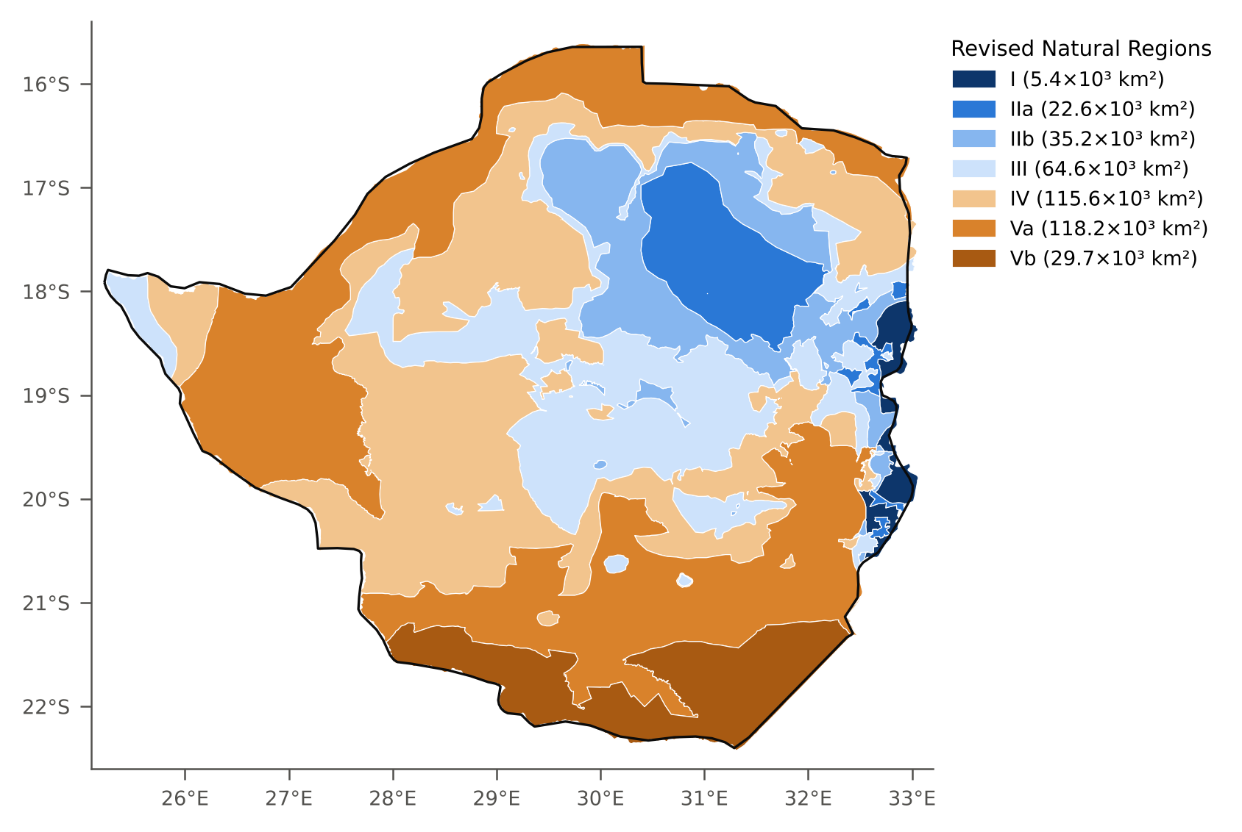
Figure S1. The seven zones of the revised national Natural Region shapefile (I, IIa, IIb, III, IV, Va and Vb) with their areas. The sub-zones IIa/IIb and Va/Vb are dissolved into NR II and NR V for the analysis.
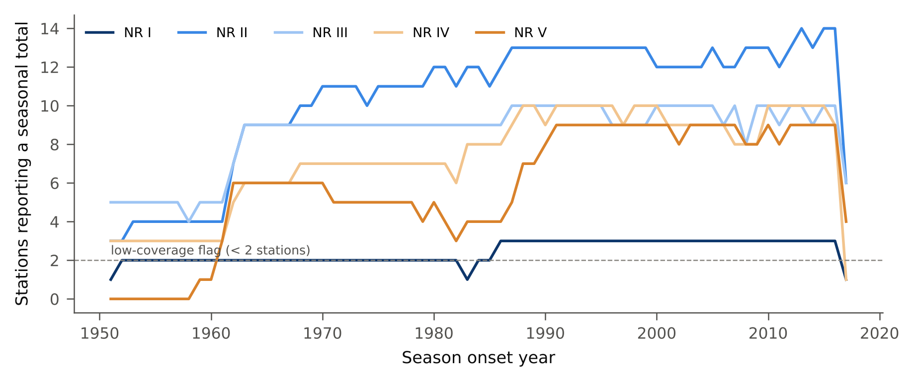
Figure S2. Number of stations reporting a seasonal total in each Natural Region, 1951–2017, after quality control and polygon allocation. The dashed line marks the low-coverage threshold of two stations.
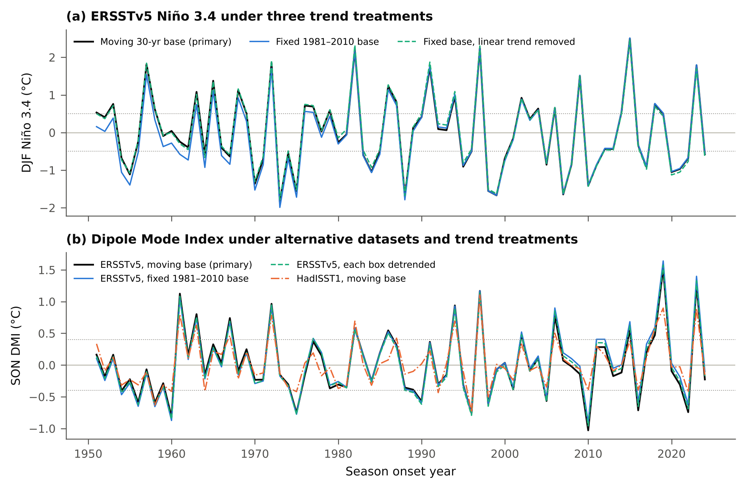
Figure S3. Index series under alternative conventions. (a) DJF Niño 3.4 from ERSSTv5 with the moving 30-year base, a fixed 1981–2010 base, and a fixed base with a linear trend removed. (b) SON DMI from ERSSTv5 with the moving base, fixed 1981–2010 and 1991–2020 bases and a linear trend removed from each box, and from HadISST1 with the moving base. Dashed lines mark the classification thresholds.
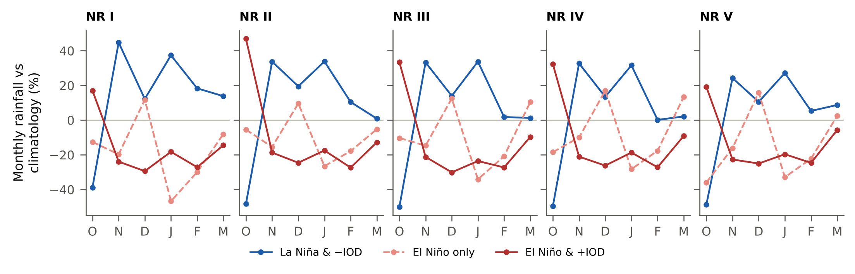
Figure S4. Monthly CHIRPS rainfall anomaly (% of the monthly climatology) from October to March by Natural Region and state, 1981–2024 (La Niña & −IOD 5 seasons, El Niño only 5, El Niño & +IOD 10).

