Supporting Information for “Satellite ozone and lower stratospheric temperature covary in two regions of the central Pacific ENSO dipole”
Desmond Manatsa¹ and Swadhin K. Behera²
¹Faculty of Science and Engineering, Bindura University of Science Education, Bindura, Zimbabwe
²Japan Agency for Marine-Earth Science and Technology, Japan

Contents of this file
Texts S1 to S5; Tables S1 to S16; Figures S1 to S9.

Introduction
This file gives extended data and methods (Text S1), the daily diagnostics and lobe geometry (Text S2), details of the radiative transfer and transport-control calculations (Texts S3 and S4) and the secondary diagnostics (Text S5). Tables S1 to S16 and Figures S1 to S9 give the event list, lobe statistics, full inference for all four region–pressure combinations, the sensitivity, specificity, radiative and transport-control results, the secondary diagnostics and supplementary figures. Tables S6, S7, S8 and S16 were recalculated independently from the archived winter series. Machine-readable series and complete test results are in the reproducibility package.

Text S1. Extended Data and Methods
Domain and winters. The nominal ERA5 study box is 200–230°E and 30°S–30°N. Latitude–pressure sections extend from 1000 to 50 hPa. A winter contains December, January and February (DJF) and is named by its January–February year. The record has 45 winters ending in 1981–2025. March is excluded throughout.
The composites use the six largest and six smallest DJF Niño 3.4 anomalies in this record (Table S1). Warm winters end in 1983, 1992, 1998, 2010, 2016 and 2024. Cold winters end in 1989, 1999, 2000, 2008, 2011 and 2021. These are ranked DJF extremes, not operational event categories. Winter 2000 falls in the ERA5 cold-bias period (Simmons et al., 2020) and is retained. Consecutive cold winters 1999 and 2000 may not be independent ENSO realizations. Two alternative selections are reported as sensitivities. The historical selection replaces 2000 with 1996 (−0.692°C). Ranking by the Relative Oceanic Niño Index (RONI; van Oldenborgh et al., 2021), from a snapshot of 6 October 2026 (NOAA Climate Prediction Center, 2026), replaces warm winter 2024 with 1987 and leaves the cold winters unchanged.
Data. ERA5 provides temperature, winds, pressure vertical velocity (omega), ozone, specific humidity and cloud fields (Hersbach et al., 2020) on a 0.5° working grid. Cloud ice and surface fields with 0.25° native spacing are matched to that grid. Satellite ozone is the three-dimensional SWOOSH combinedo3q product, version 02.73 (Davis et al., 2016). Its file header identifies Aura MLS version 5.0. Native cells span 5° of latitude and 20° of longitude. We use the 68.129 and 100 hPa surfaces and interpolate ERA5 linearly in log pressure to those levels. ERA5 ozone supplies descriptive fields and the background ozone of the radiative columns (Text S3). It is not used as an independent observation, and all analysed ozone anomalies come from SWOOSH.
Anomalies are departures from 1991–2020 calendar-month means. DJF means weight the three months equally, and composites weight winters equally. The Niño 3.4 series (ERSSTv6) keeps its 1981–2010 reference. Zonal wind indices at 30 and 50 hPa represent the quasi-biennial oscillation (QBO). All index snapshots are archived for reproducibility.
Lobes and footprints. Lower stratospheric and upper tropospheric analysis bands are 70–100 and 200–300 hPa. These are operational labels, because the 100 hPa level can lie within the tropical tropopause layer (Fueglistaler et al., 2009). Within each phase, a composite of the other five winters selects cells with at least 2 K in the expected sign, so the evaluated winter never defines its own mask. Lobe means use cosine-latitude area weights, clipped longitude widths and trapezoidal pressure weights. Lobe amplitudes describe temperature-selected features, not the whole domain.
For satellite comparisons, lower stratospheric masks are projected onto horizontal footprints, and native SWOOSH cells receive overlap weights. The contributing cells are centred at 210 and 230°E and together span 200–240°E. Satellite ozone therefore samples a wider longitude band than the ERA5 box and supports only coarse localization.
The 21 winters ending in 2005–2025 use one fixed footprint per hemisphere, trained on the warm winters other than 2016. The footprints span about 25.5–0.5°S, 202–230°E and 0.5–23.5°N, 207.5–230°E. Every contributing satellite cell has complete coverage in this period. Extreme winters require at least 80% weighted ozone coverage in every DJF month at both levels. Under the objective selection, four warm winters (1992, 2010, 2016 and 2024) and three cold winters (2008, 2011 and 2021) qualify.
Regression and inference. The principal model regresses winter-mean temperature on satellite ozone, linear and quadratic Niño 3.4, QBO at 30 and 50 hPa, a linear trend, column ice water path, skin temperature and 70–100 hPa specific humidity, all within the footprint. With the intercept this gives ten parameters and 11 residual degrees of freedom. A transport model adds resolved horizontal advection H′, vertical transport V′ and omega′ (below), leaving 8 degrees of freedom. The partial correlation is the correlation between ozone and temperature after each is regressed on the covariates. Slopes keep units of K ppmv⁻¹.
We use three inference methods. Classical Student t inference is identical to the t test of the partial correlation. Lag-one heteroskedasticity and autocorrelation consistent (HAC) inference includes a finite-sample correction (Newey & West, 1987). Studentized Freedman–Lane permutation inference shuffles reduced-model residuals among winters (Freedman & Lane, 1983), with 99,999 permutations for the principal models and 19,999 for sensitivities. Each method is adjusted for false discovery rate across the four region–pressure combinations (Benjamini & Hochberg, 1995). Conclusions use q_{cons}, the largest of the three adjusted values. A two-winter block permutation checks serial dependence.
Influence, specificity and sensitivity. Influence is assessed by refitting each model with each winter removed in turn. Specificity is examined by pairing temperature in each principal region with ozone from the other three region–pressure combinations, keeping the covariates of the temperature region. A spatially uniform signal left in the residuals would tend to link temperature to ozone elsewhere as well. A significant matched association and a non-significant mismatched one do not test the difference between them, so this comparison is a consistency check rather than a formal test of locality. We also add the mismatched ozone as an extra covariate to the matched model.
Spatial sensitivity repeats the full analysis with 1.5 and 2.5 K thresholds, fixed 0–20° boxes in each hemisphere, masks trained only on winters ending in 1983, 1992 and 1998, and masks that also use a 1991–2004 reference climatology. The last mask contains no evaluation-period data. Sample sensitivity removes winters ending in 2005–2007 (ERA5 cold bias; Simmons et al., 2020), 2016 (QBO disruption; Osprey et al., 2016), 2023–2025 (after the Hunga Tonga–Hunga Haʻapai water vapour injection; Millán et al., 2022), and the last two sets together. An index sensitivity replaces Niño 3.4 with RONI.
Temperature budget, extreme-event and timing diagnostics. Resolved temperature diagnostics use the pressure-coordinate balance
$\frac{∂T}{∂t} = H + V + Q$ (1)
with horizontal advection H and combined vertical transport and compression V given by
$H = −u\frac{∂T}{∂x} − v\frac{∂T}{∂y}, V = ω\left(\frac{κT}{p} − \frac{∂T}{∂p}\right)$ (2)
Here κ = R_{d}/c_{p}, R_{d} is the dry-air gas constant and c_{p} is the specific heat at constant pressure. Positive omega denotes descent, and Q is diabatic heating expressed as a temperature tendency. Diagnostics use monthly mean states before the calendar-month reference is subtracted. The unresolved term R = dT′/dt − H′ − V′ includes omitted transient transport, diabatic heating, analysis increments and numerical error. It is not an observation of ozone heating. A daily DJF 2015–2016 case checks transport signs (Text S2; Table S3).
Extreme-event tests remove each phase mean, pool the centred values and permute ozone within phase, giving 144 assignments for the objective sample. Monthly timing uses adjusted DJF pairs at lags of −2 to +2 months within each winter, with intervals from 4,999 winter-bootstrap resamples. Full-field warm-minus-cold contrasts use all 924 assignments of the twelve selected winters, with false discovery control across 3,451 latitude–pressure cells. This display is conditional on the selected events.

Text S2. Daily Diagnostics and Lobe Geometry
The daily 2015–2016 calculation covers all 91 DJF days, including 29 February. The common pressure set is 50, 70, 100, 125, 200, 225, 250, 300 and 350 hPa, because December and January lack 150 and 175 hPa in the temperature and wind inputs. February permits a vertical-resolution check. Adding those levels changes the maximum lobe vertical tendency by about 0.0047 K day⁻¹. Comparing native 0.25° and working 0.5° February grids changes the maximum vertical and horizontal tendencies by about 0.0012 and 0.0257 K day⁻¹. Signs are unchanged. These checks do not represent omitted subdaily covariance or other ENSO events.
The lower stratospheric and upper tropospheric masks are selected independently within their pressure bands, so their cells need not lie directly above one another. Satellite comparisons use the projected lower stratospheric footprint and the native ozone pressure level, not a vertically integrated ozone column. ERA5 layer ozone is not interpreted as a measurement of vertically conserved ultraviolet transfer.

Text S3. Radiative Transfer Calculation: Details and Robustness
We calculate how much temperature change the observed ozone anomalies can produce with the Rapid Radiative Transfer Model for GCMs (RRTMG; Iacono et al., 2008) in the climlab framework (Rose, 2018). Each footprint is represented by one column built from footprint-weighted ERA5 monthly means for the DJF winters 2005–2025 on 37 pressure levels from 1 to 1000 hPa (0.5° grid over 29.5°S–29.5°N and 200–230°E): temperature, specific humidity, ozone, cloud fraction, cloud liquid and ice water content, skin temperature, surface pressure and albedo. The column is interpolated in log pressure to a grid with spacing of about 0.4–0.5 km between 20 and 300 hPa that contains 68.13 and 100 hPa. Shortwave fluxes use the DJF mean insolation at the footprint centroid (13.9°S and 14.1°N) and its insolation-weighted zenith angle. Carbon dioxide, methane and nitrous oxide are fixed at 400 ppmv, 1,850 ppbv and 330 ppbv, cloud droplets and ice particles have effective radii of 12 and 40 µm, and cloud overlap is random.
The ozone perturbation has the observed vertical shape. SWOOSH anomalies at every level from September to February are averaged over each footprint with the footprint weights of Text S1; this sampling reproduces the regression ozone series exactly. For each target level, the DJF anomaly profile is regressed on the anomaly at the target after adjustment for the principal covariates. This gives the anomaly at each level that accompanies 1 ppmv at the target. Anomalies below 150 hPa are set to zero, and levels with data in fewer than 90% of winters are omitted before the profile is interpolated to the model grid.
At the targets, the background temperature is 199.3 K at southern 68.1 hPa and 196.0 K at northern 100 hPa, background ozone is 0.56 and 0.14 ppmv, and the net all-sky radiative heating is +0.23 and +0.36 K day⁻¹. DJF mean insolation is 464 W m⁻² at the southern centroid and 352 W m⁻² at the northern centroid. The computational grid has 12 levels between 1 and 20 hPa, a log-pressure spacing of 0.07 between 20 and 300 hPa and 16 levels between 300 and 1000 hPa, with the target levels inserted.
Temperature Jacobians use ±0.5 K perturbations and ozone Jacobians ±5% perturbations at each level at or above 150 hPa, with shortwave and longwave heating together. Under fixed dynamical heating, the equilibrium response solves J ΔT = −G ΔO₃ over the adjusted levels, where J and G are the temperature and ozone Jacobians. The transient response integrates dΔT/dt = J ΔT + G ΔO₃(t) with a daily matrix-exponential step from 1 September, holds each month's ozone anomaly fixed through the month and averages ΔT over December–February. For the normalized response of Table S9, the same covariate-adjusted DJF profile is used in all six months, so the calculation is a step response to a constant perturbation imposed on 1 September; only the per-winter experiment uses monthly profiles. At the 125 hPa boundary, the effective balance times of 20–26 days in the principal regions are short compared with the three months before December, and the step and equilibrium responses differ by less than 2%; with the 150 hPa boundary they differ by up to 3%. This agreement concerns the step response and does not show that the evolving monthly anomalies of individual winters are in radiative equilibrium.
Table S10 lists the results for all four regions, both sky conditions and three fixed-heating boundaries. Clear skies raise β by about 30% and, with the 125 hPa boundary, the response ratios by 0.09–0.11 in the principal regions. Moving the boundary changes the southern ratio by at most 0.01. The northern ratio ranges from 0.20 with the boundary at 100 hPa to 0.41 at 150 hPa, because a boundary at the target level holds the temperature just below it fixed (Figure S4).
Both anomaly profiles also contain large ozone anomalies in the middle and upper stratosphere (Figure 3a, d). To test their influence, we rebuilt both columns for clear skies from the background temperature and ozone profiles, with a standard tropical humidity profile and an ocean surface albedo of 0.06. The rebuilt columns reproduce the clear-sky β within 4% in the south and 6% in the north, and the responses within 4% and 7%. In these columns, setting the ozone anomaly to zero above 30 hPa reduces the response by 2.8% in the south and 1.6% in the north, and setting it to zero above 50 hPa reduces it by 6.8% and 7.8%. A thin layer at the target, with a Gaussian width of 0.07 in log pressure, gives 60% and 57% of the response to the observed profile. The truncated response ratios in Table S9 and Figure S4 scale the central all-sky ratios by these factors.
For the per-winter experiment, each winter's monthly September–February footprint anomaly profiles drive the transient calculation directly. After the principal covariates, the predicted radiative temperature correlates with observed temperature at partial r = 0.38 in the south and 0.67 in the north (Figure S5). Table S11 gives the full inference for this regression and for the ozone association after the prediction is subtracted, in all four regions. The regression coefficients have wide intervals that include 1 in both principal regions, so they do not calibrate the radiative amplitude. After subtraction, no region passes q_{cons} < 0.05; northern 100 hPa comes closest (r = 0.66, q_{cons} = 0.060).

Text S4. Transport Controls: Details
Two further diagnostics ask whether measured transport proxies account for the association. The transformed Eulerian mean residual vertical velocity w* (Andrews et al., 1987) is computed in pressure coordinates from 6-hourly ERA5 temperature, meridional wind and omega on a 1.5° grid over 45°S–45°N at 50–150 hPa, with eddy heat fluxes formed from each 6-hourly field. We use its 20°S–20°N mean at 70 hPa for the 68.1 hPa targets and at 100 hPa for the 100 hPa targets and, as a sensitivity, the mean over each footprint's hemisphere from the equator to 25°. The DJF climatology is 0.25 mm s⁻¹ at 70 hPa and 0.47 mm s⁻¹ at 100 hPa, and w* at 70 hPa correlates with Niño 3.4 at r = +0.65, as expected from the ENSO modulation of tropical upwelling (Calvo et al., 2010; Randel et al., 2009).
Nitrous oxide is long lived in the lower stratosphere and decreases with height, whereas ozone increases, so vertical transport moves them in opposite directions. We use Aura MLS Level 2 nitrous oxide, version 6 (Lambert et al., 2026), screened with the thresholds of the version 6 data quality document (Livesey et al., 2026): even status, quality above 0.8, convergence below 2.0 and positive precision. The document gives a useful range of 100–0.46 hPa for this product. Earlier versions of the product were validated against independent measurements (Lambert et al., 2007). Screened values from 1,880 days within 30°S–30°N and 200–240°E are averaged by month in the native SWOOSH cells, converted to anomalies and combined with the ozone footprint weights. Each footprint month at the target levels contains at least 1,215 profiles. Winter 2025 lacks complete coverage, so all transport-control models use the 20 winters ending in 2005–2024. Each control is added to the principal model alone and in combination, leaving 8 to 9 residual degrees of freedom (6 when the transport covariates are also included), and inference follows Text S1. Partial correlations of each control with ozone and with temperature, after the principal covariates, measure its strength (Table S13). The transport tests use the original temperature series, not temperature minus the radiative prediction, so they do not partition the slope into radiative and transport shares.
The residual vertical velocity follows Andrews et al. (1987) in pressure coordinates: ω* = Ω + (a cos φ)⁻¹ ∂(F cos φ)/∂φ and w* = −(H/p) ω*. Here Ω is the zonal-mean omega, F is the zonal-mean eddy heat flux v′θ′ divided by the vertical derivative of zonal-mean potential temperature with respect to pressure, a is the Earth's radius, φ is latitude and H = 7 km. Each of the 63 DJF months from December 2004 to February 2025 uses fields at 00, 06, 12 and 18 UTC. Eddy fluxes and vertical derivatives are formed at each time and averaged over the month. Band means use cosine-latitude weights. The Eulerian mean upwelling has a DJF climatology of 0.21 mm s⁻¹ at 70 hPa and 0.42 mm s⁻¹ at 100 hPa, close to that of w*.
Profile values are assigned to the nearest SWOOSH level when within 3% in pressure, binned into the native 5° × 20° cells and averaged by month when a cell has at least 10 profiles. Anomalies are departures from each cell's calendar-month mean over the record. Footprint anomalies require data in at least 80% of the footprint weight, and winter means require all three months. The data quality document cautions against trend analysis with this product, and every model includes a linear trend. Before adjustment, footprint nitrous oxide correlates only weakly with the SWOOSH ozone series: r = 0.00 at southern 68.1 hPa, −0.12 at northern 100 hPa, −0.13 at northern 68.1 hPa and −0.28 at southern 100 hPa.
Dropping winter 2025 raises the principal-model association from 0.81 to 0.89 at northern 100 hPa and from 0.42 to 0.56 at southern 100 hPa, the upper ends of their leave-one-out ranges in Table S5, and changes the 68.1 hPa associations little. Freedman–Lane inference uses 19,999 permutations, and false discovery adjustment covers the four region–pressure combinations within each model (Table S12). Table S13 gives the strength of each control.

Text S5. Secondary Diagnostics
Extreme winters with complete satellite coverage give the same sign. All 16 pooled within-phase correlations, across four selections and four regions, are positive, from 0.23 to 0.95 (Table S14; Figure S7). In the objective sample of four warm and three cold winters, correlations are 0.90 at southern 68.1 hPa and 0.75 at northern 100 hPa, with pooled slopes of 30 and 24 K ppmv⁻¹. With seven winters and only 144 assignments, no objective test can be expected to pass correction, and none does (q = 0.083 and 0.148). The historical four-per-phase selection passes in three regions (q = 0.037). The extreme sample therefore agrees in sign and magnitude but cannot confirm the association on its own. Monthly ERA5 composites keep opposite upper tropospheric and lower stratospheric anomalies through each winter, with ERA5 ozone following the lower stratospheric phase reversal (Figure S8).
Monthly associations peak at zero lag. Adjusted correlations are 0.61 at southern 68.1 hPa and 0.65 at northern 100 hPa, with winter-bootstrap intervals well above zero (Table S15; Figure S9). One-month lags give 0.27 and 0.17, with intervals that include zero. Shared transport and radiative relaxation on a time scale near one month can both produce a dominant zero-lag correlation in monthly means. The lag structure therefore cannot separate them.
The unresolved budget term R shows no stable ozone association. No full-sample test passes conservative inference, and transport-adjusted partial correlations range from −0.23 to +0.57 (Table S16). Because R combines several noisy processes, this null result neither supports nor excludes ozone heating.
Table S1. Ranked DJF Winters, Relative Index Values and Satellite Coverage
Phase | Winter ending | Niño 3.4 (°C) | RONI (°C) | Ozone coverage | Note
El Niño | 1983 | +1.640 | +2.40 | No | El Chichón
El Niño | 1992 | +1.331 | +2.12 | Yes | Pinatubo
El Niño | 1998 | +1.708 | +2.13 | No
El Niño | 2010 | +1.336 | +1.44 | Yes
El Niño | 2016 | +1.987 | +2.14 | Yes | QBO disruption
El Niño | 2024 | +1.514 | +1.13 | Yes | After Hunga Tonga
La Niña | 1989 | −1.609 | −1.64 | No
La Niña | 1999 | −1.471 | −1.56 | No
La Niña | 2000 | −1.371 | −1.50 | No | ERA5 bias period
La Niña | 2008 | −1.584 | −1.73 | Yes
La Niña | 2011 | −1.340 | −1.42 | Yes
La Niña | 2021 | −1.119 | −1.32 | Yes
Six largest and six smallest DJF Niño 3.4 anomalies over winters ending in 1981–2025. December belongs to the preceding calendar year. Coverage requires at least 80% of the weighted footprint in every DJF month at both satellite levels. RONI values are DJF values from the 6 October 2026 snapshot. Ranking by RONI replaces warm winter 2024 with 1987. The historical selection replaces cold winter 2000 with 1996.
Table S2. Temperature and Vertical Motion in the Active Lobes
Phase | Region | Lower stratospheric T (K) | Upper tropospheric T (K) | Lower stratospheric ω (Pa s⁻¹) | Upper tropospheric ω (Pa s⁻¹)
El Niño | North | −2.17 | +2.54 | −0.0013 | +0.0090
El Niño | South | −2.71 | +2.49 | −0.0010 | −0.021
La Niña | North | +2.63 | −2.40 | +0.0013 | −0.00084
La Niña | South | +3.02 | −2.26 | +0.00076 | +0.011
Means of six winters per phase with leave-one-event-out masks. Lower stratospheric and upper tropospheric bands are 70–100 and 200–300 hPa. Positive omega denotes anomalous descent. Values describe temperature-selected lobes, not the full region.
Table S3. Daily Mean Diagnostics for DJF 2015–2016
Band | Region | T anomaly (K) | Absolute H (K day⁻¹) | Absolute V (K day⁻¹) | Absolute ω (Pa s⁻¹)
Upper troposphere | North | +3.01 | −0.442 | +1.044 | +0.0097
Upper troposphere | South | +2.86 | +0.331 | −0.410 | −0.0102
Lower stratosphere | North | −2.02 | +0.097 | −0.875 | −0.0026
Lower stratosphere | South | −1.80 | −0.449 | −0.694 | −0.0018
Temperature uses the monthly anomaly reference within the held-out 2016 masks. H, V and omega are absolute daily mean diagnostics without a daily climatology. They are not ENSO tendency anomalies or attributed temperature fractions. Daily mean products omit within-day covariance.
Table S4. Event-Selection Sensitivity of Lobe Means
Selection | Phase and region | Lower stratospheric T (K) | Upper tropospheric T (K) | Lower stratospheric ω (Pa s⁻¹) | Upper tropospheric ω (Pa s⁻¹)
Omit 1983, 1992 | El Niño north | −2.51 | +2.61 | −0.00066 | +0.0067
Omit 1983, 1992 | El Niño south | −2.63 | +2.63 | −0.00033 | −0.017
Omit 1983, 1992 | La Niña north | +2.63 | −2.40 | +0.0013 | −0.00084
Omit 1983, 1992 | La Niña south | +3.02 | −2.26 | +0.00076 | +0.011
Historical | El Niño north | −2.17 | +2.54 | −0.0013 | +0.0090
Historical | El Niño south | −2.71 | +2.49 | −0.0010 | −0.021
Historical | La Niña north | +2.24 | −2.21 | +0.0011 | −0.00042
Historical | La Niña south | +2.85 | −2.20 | +0.00073 | +0.0070
RONI-ranked | El Niño north | −2.32 | +2.52 | −0.0012 | +0.012
RONI-ranked | El Niño south | −2.78 | +2.34 | −0.0014 | −0.020
RONI-ranked | La Niña north | +2.63 | −2.40 | +0.0013 | −0.00084
RONI-ranked | La Niña south | +3.02 | −2.26 | +0.00076 | +0.011
Means follow the lobe selection and weighting of Table S2, retrained without the evaluated winter within each selection. Omitting both volcanic warm winters leaves four warm and six cold cases. Historical and RONI-ranked sets each keep six winters per phase. Figures S1 and S2 show full fields, while these values describe the selected active cells.
Table S5. Inference for the Ozone–Temperature Association, 21 Winters Ending in 2005–2025
Region (hPa) | Model | df | Partial r | Leave-one-out range | Classical q | HAC q | Permutation q | q_{cons}
South 68.1 | Expanded | 11 | +0.806 | 0.73–0.86 | 0.0018 | 0.0009 | 0.0019 | 0.0019
North 100.0 | Expanded | 11 | +0.809 | 0.75–0.89 | 0.0018 | 0.0009 | 0.0019 | 0.0019
South 68.1 | + transport | 8 | +0.888 | 0.84–0.94 | 0.0024 | 0.0026 | 0.0024 | 0.0026
North 100.0 | + transport | 8 | +0.775 | 0.67–0.86 | 0.017 | 0.0032 | 0.016 | 0.017
North 68.1 | Expanded | 11 | +0.402 | 0.25–0.58 | 0.173 | 0.027 | 0.175 | 0.175
North 68.1 | + transport | 8 | +0.436 | 0.16–0.68 | 0.277 | 0.051 | 0.277 | 0.277
South 100.0 | Expanded | 11 | +0.424 | 0.15–0.56 | 0.173 | 0.110 | 0.175 | 0.175
South 100.0 | + transport | 8 | +0.246 | 0.01–0.43 | 0.493 | 0.389 | 0.495 | 0.495
The expanded model includes Niño 3.4 and its square, QBO at 30 and 50 hPa, trend, ice water path, skin temperature and lower stratospheric humidity. The transport model adds H′, V′ and omega′. df is the residual degrees of freedom. The leave-one-out range gives partial r with each winter removed in turn. HAC is lag-one heteroskedasticity and autocorrelation consistent inference. Permutation is the studentized Freedman–Lane test with 99,999 permutations. Each q adjusts four regions within one model, and q_{cons} is the largest of the three.
Table S6. Sample, Index and Serial-Dependence Sensitivity of the Two Principal Associations
Sample | Model | n / df | South 68.1: r; q_{cons} | North 100.0: r; q_{cons} | Block q: south / north
Full sample | Expanded | 21/11 | 0.806; 0.0019 | 0.809; 0.0019 | 0.0027 / 0.0027
Full sample | + transport | 21/8 | 0.888; 0.0026 | 0.775; 0.017 | 0.0019 / 0.0075
Omit 2005–2007 | Expanded | 18/8 | 0.823; 0.012 | 0.796; 0.015 | 0.0091 / 0.0091
Omit 2005–2007 | + transport | 18/5 | 0.938; 0.0082 | 0.721; 0.140 | 0.015 / 0.118
Omit 2016 | Expanded | 20/10 | 0.801; 0.0041 | 0.815; 0.0040 | 0.0047 / 0.0026
Omit 2016 | + transport | 20/7 | 0.886; 0.0072 | 0.748; 0.043 | 0.0054 / 0.026
Omit 2023–2025 | Expanded | 18/8 | 0.807; 0.011 | 0.906; 0.0018 | 0.016 / 0.0004
Omit 2023–2025 | + transport | 18/5 | 0.900; 0.015 | 0.891; 0.015 | 0.013 / 0.013
Omit 2016 and 2023–2025 | Expanded | 17/7 | 0.840; 0.011 | 0.910; 0.0040 | 0.024 / 0.0038
Omit 2016 and 2023–2025 | + transport | 17/4 | 0.915; 0.042 | 0.867; 0.055 | 0.071 / 0.071
RONI replaces Niño 3.4 | Expanded | 21/11 | 0.825; 0.0015 | 0.830; 0.0015 | 0.0017 / 0.0017
RONI replaces Niño 3.4 | + transport | 21/8 | 0.904; 0.0017 | 0.828; 0.0062 | 0.0008 / 0.0029
Models and four-region adjustment follow Table S5 and are recomputed within each sample. Early-bias omission keeps winters ending in 2008–2025. The combined omission drops 2016 and 2023–2025. RONI replaces Niño 3.4 and its square. Block q uses studentized reduced-model residual permutations of adjacent two-winter blocks, with a trailing singleton fixed; it is a serial-dependence check with few blocks. Permutations number 99,999 for the full sample and 19,999 otherwise.
Table S7. Footprint Sensitivity: Partial r and q_{cons} for All Four Regions
Mask | Model | South 68.1 | North 100.0 | North 68.1 | South 100.0
Original 2 K | Expanded | 0.806; 0.0019 | 0.809; 0.0019 | 0.402; 0.175 | 0.424; 0.175
Original 2 K | + transport | 0.888; 0.0026 | 0.775; 0.017 | 0.436; 0.277 | 0.246; 0.495
Threshold 1.5 K | Expanded | 0.785; 0.0060 | 0.751; 0.0073 | 0.447; 0.130 | 0.443; 0.130
Threshold 1.5 K | + transport | 0.880; 0.0042 | 0.740; 0.031 | 0.466; 0.233 | 0.298; 0.402
Threshold 2.5 K | Expanded | 0.825; 0.0013 | 0.867; 0.0005 | 0.340; 0.256 | 0.419; 0.205
Threshold 2.5 K | + transport | 0.899; 0.0016 | 0.831; 0.0058 | 0.373; 0.385 | 0.276; 0.443
Fixed 0–20° box | Expanded | 0.697; 0.017 | 0.809; 0.0035 | 0.289; 0.337 | 0.565; 0.059
Fixed 0–20° box | + transport | 0.812; 0.018 | 0.712; 0.042 | 0.294; 0.409 | 0.329; 0.409
Pre-2005 training | Expanded | 0.796; 0.0042 | 0.769; 0.0042 | 0.429; 0.145 | 0.434; 0.145
Pre-2005 training | + transport | 0.872; 0.0041 | 0.761; 0.025 | 0.449; 0.258 | 0.265; 0.459
Pre-2005 training and reference | Expanded | 0.813; 0.0028 | 0.788; 0.0028 | 0.385; 0.193 | 0.402; 0.193
Pre-2005 training and reference | + transport | 0.897; 0.0035 | 0.724; 0.036 | 0.435; 0.279 | 0.212; 0.557
All tests use 21 winters and re-extract temperature, ozone and all covariates within each fixed footprint. Pre-2005 training uses winters ending in 1983, 1992 and 1998. The first pre-2005 mask keeps the 1991–2020 climatology for mask construction. The second uses only the 14 winters ending in 1991–2004 as its reference, so neither its training nor its reference uses evaluation-period data. Fixed boxes span 200–230°E and 0–20° in each hemisphere. Inference uses 19,999 permutations; the original mask repeats the principal result of Table S5.
Table S8. Specificity Test: Temperature Against Matched and Mismatched Ozone
Temperature region (hPa) | Ozone source (hPa) | Model | Partial r | Classical p | Permutation p
South 68.1 | South 68.1 (matched) | Expanded | +0.806 | 0.0009 | 0.0014
South 68.1 | South 68.1 (matched) | + transport | +0.888 | 0.0006 | 0.0004
South 68.1 | North 100.0 | Expanded | +0.064 | 0.837 | 0.838
South 68.1 | North 100.0 | + transport | −0.302 | 0.397 | 0.399
South 68.1 | North 68.1 | Expanded | +0.212 | 0.488 | 0.483
South 68.1 | North 68.1 | + transport | −0.010 | 0.977 | 0.978
South 68.1 | South 100.0 | Expanded | +0.007 | 0.982 | 0.982
South 68.1 | South 100.0 | + transport | −0.072 | 0.842 | 0.838
North 100.0 | South 68.1 | Expanded | −0.148 | 0.629 | 0.628
North 100.0 | South 68.1 | + transport | −0.325 | 0.359 | 0.362
North 100.0 | North 100.0 (matched) | Expanded | +0.809 | 0.0008 | 0.0009
North 100.0 | North 100.0 (matched) | + transport | +0.775 | 0.0084 | 0.0079
North 100.0 | North 68.1 | Expanded | +0.107 | 0.729 | 0.727
North 100.0 | North 68.1 | + transport | +0.025 | 0.946 | 0.946
North 100.0 | South 100.0 | Expanded | +0.278 | 0.358 | 0.357
North 100.0 | South 100.0 | + transport | −0.014 | 0.969 | 0.969
Temperature in each principal region is regressed on ozone from each region–pressure combination, with the covariates of the temperature region. Permutation p uses 19,999 Freedman–Lane permutations. Before adjustment, the four ozone series correlate at r = 0.67–0.94; after adjustment for the principal covariates, at r = −0.26 to 0.41. Adding any mismatched ozone series as an extra covariate leaves the matched partial correlation at 0.81–0.85 (classical p ≤ 0.0014). The test was added after the principal analysis and is a consistency check.
Table S9. Radiative Response to the Observed Ozone Anomaly Profiles Under Fixed Dynamical Heating
Region (hPa) | Observed conditional slope M (K ppmv⁻¹) | β (K day⁻¹ ppmv⁻¹) | Step response (Sep start) / equilibrium (K ppmv⁻¹) | Effective balance time (days) | M/β (days) | Response ratio (range from slope uncertainty alone) | Range across model choices
South 68.1 | 23.6 (12.1 to 35.2) | 0.53 | 10.2 / 10.4 | 20 | 45 | 0.43 (0.29–0.84) | 0.40–0.54
North 100.0 | 45.0 (23.3 to 66.7) | 0.63 | 16.3 / 16.6 | 26 | 71 | 0.36 (0.24–0.70) | 0.20–0.52
All-sky calculation, fixed dynamical heating above 125 hPa, 21 winters. The step response imposes the covariate-adjusted DJF anomaly profile, normalized to 1 ppmv at the target, as a constant perturbation from 1 September and averages temperature over December–February. β is the heating change at the target per ppmv of that profile. The effective balance time is the equilibrium response divided by β; M/β is the balance time the observed slope would need. The response ratio is the step response divided by M. Its range inverts the classical 95% slope interval with the response held fixed and omits uncertainty in the profile, background column, clouds and Jacobians; the ratio is not a causal or variance fraction. The model-choice range spans all-sky and clear-sky calculations with boundaries at 100, 125 and 150 hPa, and ozone profiles set to zero above 30 or 50 hPa (Table S10; Text S3). The inconclusive regions give ratios of 0.27 at southern 100 hPa and 2.02 at northern 68.1 hPa; these are not meaningful because their slopes, 35.0 K ppmv⁻¹ (−14.6 to 84.5) and 5.0 K ppmv⁻¹ (−2.6 to 12.6), are indistinguishable from zero.
Table S10. Radiative Response and Response Ratio for All Four Regions
Region (hPa) | Sky | β, observed profile (K day⁻¹ ppmv⁻¹) | β, thin layer (K day⁻¹ ppmv⁻¹) | Equilibrium response (K ppmv⁻¹) | Effective balance time (days) | Response ratio, boundary 100 hPa | Response ratio, boundary 125 hPa | Response ratio, boundary 150 hPa
South 68.1 | All | 0.53 | 0.54 | 10.4 | 20 | 0.42 | 0.43 | 0.43
South 68.1 | Clear | 0.68 | 0.69 | 13.1 | 19 | 0.54 | 0.54 | 0.54
North 100.0 | All | 0.63 | 0.66 | 16.6 | 26 | 0.20 | 0.36 | 0.41
North 100.0 | Clear | 0.82 | 0.86 | 20.8 | 25 | 0.24 | 0.45 | 0.52
North 68.1 | All | 0.48 | 0.51 | 10.3 | 22 | 1.91 | 2.02 | 2.05
North 68.1 | Clear | 0.60 | 0.64 | 12.6 | 21 | 2.32 | 2.46 | 2.50
South 100.0 | All | 0.66 | 0.68 | 9.4 | 14 | 0.14 | 0.27 | 0.31
South 100.0 | Clear | 0.88 | 0.93 | 13.1 | 15 | 0.18 | 0.38 | 0.44
Equilibrium response and effective balance time use the 125 hPa boundary. Response ratios are step responses (constant DJF profile imposed from 1 September) divided by the observed conditional slopes: 23.6 K ppmv⁻¹ at southern 68.1 hPa, 45.0 at northern 100 hPa, 5.0 at northern 68.1 hPa and 35.0 at southern 100 hPa. The last two slopes are indistinguishable from zero, so their ratios are not meaningful. The thin layer is a Gaussian perturbation of width 0.07 in log pressure at the target.
Table S11. Per-Winter Radiative Experiment: Inference for All Four Regions
Test | Region (hPa) | Partial r | Slope (95% interval) | Classical q | HAC q | Permutation q | q_{cons}
Observed on predicted | South 68.1 | +0.379 | 0.91 (−0.57 to 2.40) | 0.268 | 0.325 | 0.265 | 0.325
Observed on predicted | North 100.0 | +0.674 | 1.89 (0.52 to 3.27) | 0.046 | 0.040 | 0.052 | 0.052
Observed on predicted | North 68.1 | +0.480 | 0.78 (−0.17 to 1.73) | 0.194 | 0.181 | 0.193 | 0.194
Observed on predicted | South 100.0 | −0.128 | −0.58 (−3.55 to 2.39) | 0.678 | 0.711 | 0.678 | 0.711
Ozone after subtraction | South 68.1 | +0.540 | 14.7 (−0.5 to 29.9) | 0.113 | 0.110 | 0.111 | 0.113
Ozone after subtraction | North 100.0 | +0.658 | 29.4 (7.1 to 51.8) | 0.058 | 0.043 | 0.060 | 0.060
Ozone after subtraction | North 68.1 | −0.067 | −0.7 (−8.1 to 6.6) | 0.827 | 0.751 | 0.825 | 0.827
Ozone after subtraction | South 100.0 | +0.307 | 26.6 (−28.1 to 81.4) | 0.410 | 0.350 | 0.404 | 0.410
Twenty-one winters and 11 residual degrees of freedom, with the principal covariates. Observed on predicted regresses observed DJF temperature on the temperature predicted by the per-winter radiative experiment; its slope b is dimensionless, and b = 1 would mean equal observed and predicted amplitudes. Ozone after subtraction regresses observed minus predicted temperature on ozone; its slope is in K ppmv⁻¹, and its partial r compares with the principal values in Table S5. Each q adjusts the four regions within one test (Benjamini–Hochberg), and q_{cons} is the largest of the classical, HAC and Freedman–Lane values, with 19,999 permutations. Predictions at northern 68.1 hPa and southern 100 hPa use the same procedure as the principal regions.
Table S12. Ozone–Temperature Association Under the Transport Controls
Model | df | South 68.1: r; q_{cons} | North 100.0: r; q_{cons} | North 68.1: r; q_{cons} | South 100.0: r; q_{cons}
Principal | 10 | +0.821; 0.0022 | +0.887; 0.0009 | +0.408; 0.188 | +0.563; 0.076
+ N₂O | 9 | +0.849; 0.0022 | +0.885; 0.0018 | +0.261; 0.442 | +0.561; 0.097
+ w*, 20°S–20°N | 9 | +0.730; 0.022 | +0.903; 0.0006 | +0.483; 0.133 | +0.566; 0.093
+ w*, footprint band | 9 | +0.675; 0.048 | +0.870; 0.0020 | +0.395; 0.230 | +0.561; 0.098
+ N₂O and w* | 8 | +0.769; 0.019 | +0.899; 0.0018 | +0.325; 0.360 | +0.579; 0.106
Transport model + N₂O | 6 | +0.957; 0.0008 | +0.841; 0.037 | +0.233; 0.578 | +0.306; 0.578
Twenty winters ending in 2005–2024. Each cell gives the ozone–temperature partial r and q_{cons} after four-region adjustment. The transport model adds resolved H′, V′ and omega′ (Text S1). w* is the transformed Eulerian mean residual vertical velocity at 70 hPa for the 68.1 hPa targets and at 100 hPa for the 100 hPa targets, averaged over 20°S–20°N or over the footprint's hemisphere from the equator to 25°.
Table S13. Strength of the Transport Controls
Diagnostic | South 68.1: r; q_{cons} | North 100.0: r; q_{cons} | North 68.1: r; q_{cons} | South 100.0: r; q_{cons}
N₂O vs ozone | +0.407; 0.378 | −0.189; 0.567 | −0.650; 0.090 | −0.187; 0.567
N₂O vs temperature | +0.126; 0.702 | −0.276; 0.514 | −0.341; 0.514 | −0.551; 0.263
w* vs ozone | −0.558; 0.238 | −0.072; 0.876 | −0.057; 0.876 | +0.130; 0.876
w* vs temperature | −0.613; 0.070 | +0.110; 0.968 | −0.636; 0.070 | +0.016; 0.968
Partial correlation of each control with ozone or temperature after the principal covariates, for 20 winters, with q_{cons} after four-region adjustment. Shared vertical transport predicts negative values in every row. w* is the 20°S–20°N mean. No diagnostic passes q_{cons} < 0.05.
Table S14. Pooled Within-Phase Extreme-Event Tests
Selection | Region (hPa) | Warm / cold n | Assignments | r | Exact p | Adjusted q
Objective | North 68.1 | 4/3 | 144 | +0.935 | 0.0208 | 0.0833
Objective | North 100.0 | 4/3 | 144 | +0.754 | 0.111 | 0.148
Objective | South 68.1 | 4/3 | 144 | +0.898 | 0.0417 | 0.0833
Objective | South 100.0 | 4/3 | 144 | +0.297 | 0.521 | 0.521
Historical | North 68.1 | 4/4 | 576 | +0.878 | 0.0191 | 0.0370
Historical | North 100.0 | 4/4 | 576 | +0.927 | 0.0104 | 0.0370
Historical | South 68.1 | 4/4 | 576 | +0.870 | 0.0278 | 0.0370
Historical | South 100.0 | 4/4 | 576 | +0.230 | 0.519 | 0.519
Omit 1983, 1992 | North 68.1 | 3/3 | 36 | +0.894 | 0.0833 | 0.111
Omit 1983, 1992 | North 100.0 | 3/3 | 36 | +0.843 | 0.0833 | 0.111
Omit 1983, 1992 | South 68.1 | 3/3 | 36 | +0.954 | 0.0278 | 0.111
Omit 1983, 1992 | South 100.0 | 3/3 | 36 | +0.871 | 0.111 | 0.111
RONI-ranked | North 68.1 | 3/3 | 36 | +0.944 | 0.0556 | 0.167
RONI-ranked | North 100.0 | 3/3 | 36 | +0.606 | 0.333 | 0.444
RONI-ranked | South 68.1 | 3/3 | 36 | +0.900 | 0.0833 | 0.167
RONI-ranked | South 100.0 | 3/3 | 36 | +0.311 | 0.500 | 0.500
Each series is centred within phase before pooling, and ozone is permuted only within phase. Exact two-sided p includes ties. Benjamini–Hochberg adjustment covers four regions within each selection. The historical selection replaces 2000 with the adequately sampled 1996 winter. All 16 correlations are positive. These are overlapping, coverage-limited samples, not repeated tests of one cohort. Values were reproduced exactly in the independent recalculation.
Table S15. DJF Monthly Timing Diagnostic
Region (hPa) | Lag (months) | Pairs | Adjusted r | Conditional 95% interval
South 68.1 | −2 | 21 | +0.166 | −0.280 to +0.597
South 68.1 | −1 | 42 | +0.243 | −0.133 to +0.536
South 68.1 | 0 | 63 | +0.608 | +0.467 to +0.752
South 68.1 | +1 | 42 | +0.268 | −0.055 to +0.505
South 68.1 | +2 | 21 | −0.025 | −0.523 to +0.542
North 100.0 | −2 | 21 | −0.189 | −0.616 to +0.253
North 100.0 | −1 | 42 | −0.051 | −0.360 to +0.287
North 100.0 | 0 | 63 | +0.647 | +0.481 to +0.791
North 100.0 | +1 | 42 | +0.166 | −0.115 to +0.415
North 100.0 | +2 | 21 | −0.100 | −0.498 to +0.239
North 68.1 | −2 | 21 | −0.339 | −0.669 to +0.089
North 68.1 | −1 | 42 | +0.088 | −0.164 to +0.366
North 68.1 | 0 | 63 | +0.355 | +0.156 to +0.545
North 68.1 | +1 | 42 | +0.237 | −0.010 to +0.452
North 68.1 | +2 | 21 | −0.189 | −0.627 to +0.363
South 100.0 | −2 | 21 | −0.060 | −0.393 to +0.260
South 100.0 | −1 | 42 | −0.009 | −0.239 to +0.180
South 100.0 | 0 | 63 | +0.530 | +0.396 to +0.659
South 100.0 | +1 | 42 | −0.017 | −0.372 to +0.362
South 100.0 | +2 | 21 | −0.014 | −0.338 to +0.353
All rows use 21 winters. Positive lag pairs earlier ozone with later temperature. Only actual December–February pairs are used: 63 at zero lag, 42 at ±1 and 21 at ±2. Adjustment uses the principal covariates plus calendar-month indicators. Intervals resample whole winters 4,999 times with the fitted adjustment held fixed, so they omit adjustment uncertainty. They are descriptive, not corrected significance or causal-direction tests.
Table S16. Unresolved Tendency Residual Associations
Region (hPa) | Model | df | Partial r | Classical q | HAC q | Permutation q | q_{cons}
South 68.1 | Expanded | 11 | −0.022 | 0.944 | 0.924 | 0.941 | 0.944
North 100.0 | Expanded | 11 | −0.497 | 0.336 | 0.200 | 0.339 | 0.339
South 68.1 | + transport | 8 | +0.357 | 0.622 | 0.380 | 0.626 | 0.626
North 100.0 | + transport | 8 | −0.005 | 0.988 | 0.990 | 0.987 | 0.990
North 68.1 | Expanded | 11 | +0.271 | 0.494 | 0.630 | 0.492 | 0.630
North 68.1 | + transport | 8 | +0.569 | 0.344 | 0.237 | 0.356 | 0.356
South 100.0 | Expanded | 11 | +0.304 | 0.494 | 0.630 | 0.492 | 0.630
South 100.0 | + transport | 8 | −0.227 | 0.705 | 0.599 | 0.708 | 0.708
Full 21-winter sample. The response R = dT′/dt − H′ − V′, in K day⁻¹, contains omitted transient transport, diabatic processes, analysis increments and numerical error. Permutation q uses 19,999 permutations. No conservative q is below 0.05, so the temperature associations in Table S5 cannot be read as detected residual heating.
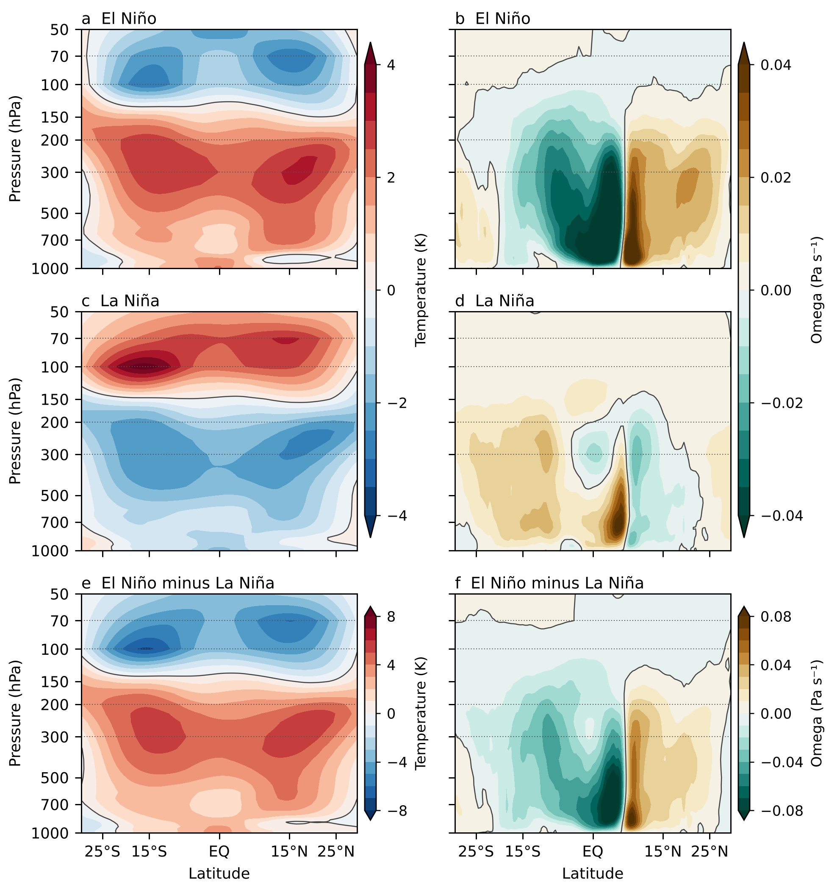
Figure S1. Composites after excluding both volcanic warm winters. As Figure 1, after removing the winters ending in 1983 and 1992 from the warm sample, which leaves four warm and six cold winters. No permutation test is applied to this reduced sample, so panels e and f are not hatched. Active warm lobes remain at about +2.6 K in the upper troposphere and −2.5 to −2.6 K in the lower stratosphere.
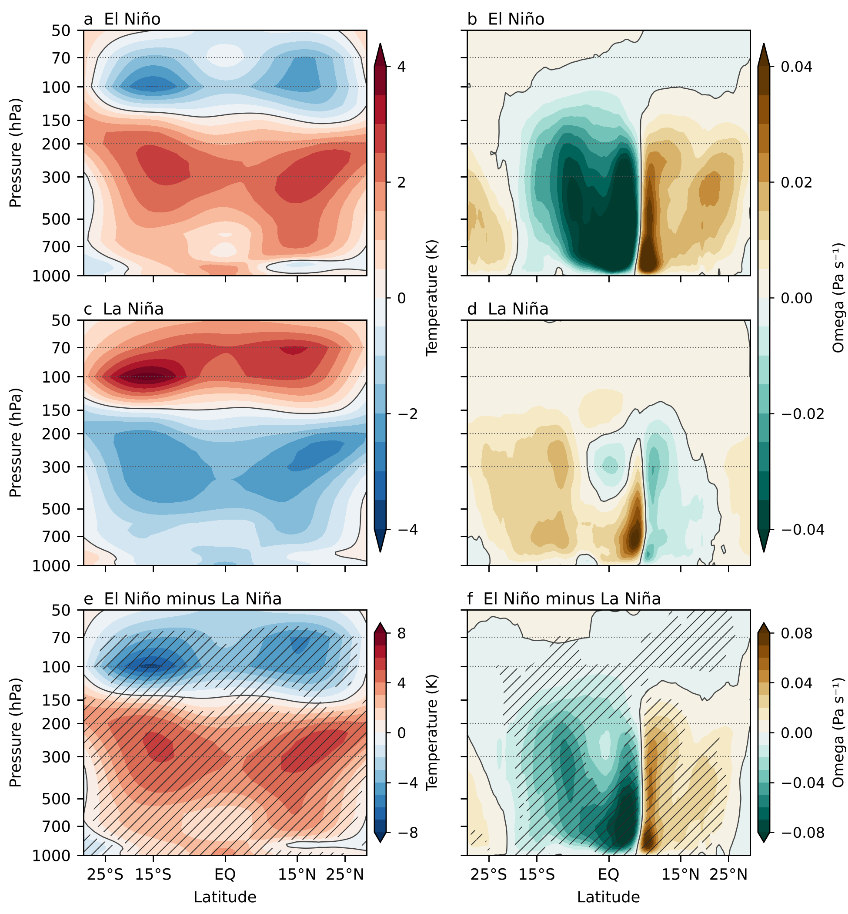
Figure S2. Detrended composites. As Figure 1, after removing each calendar month's linear trend fitted over the 45-winter record about the reference midpoint. The vertical dipole and the contrasting upper tropospheric motion remain. Hatching uses the same conditional 924-assignment test and fieldwise false discovery control. Detrending does not remove volcanic anomalies or dependence between consecutive cold winters.
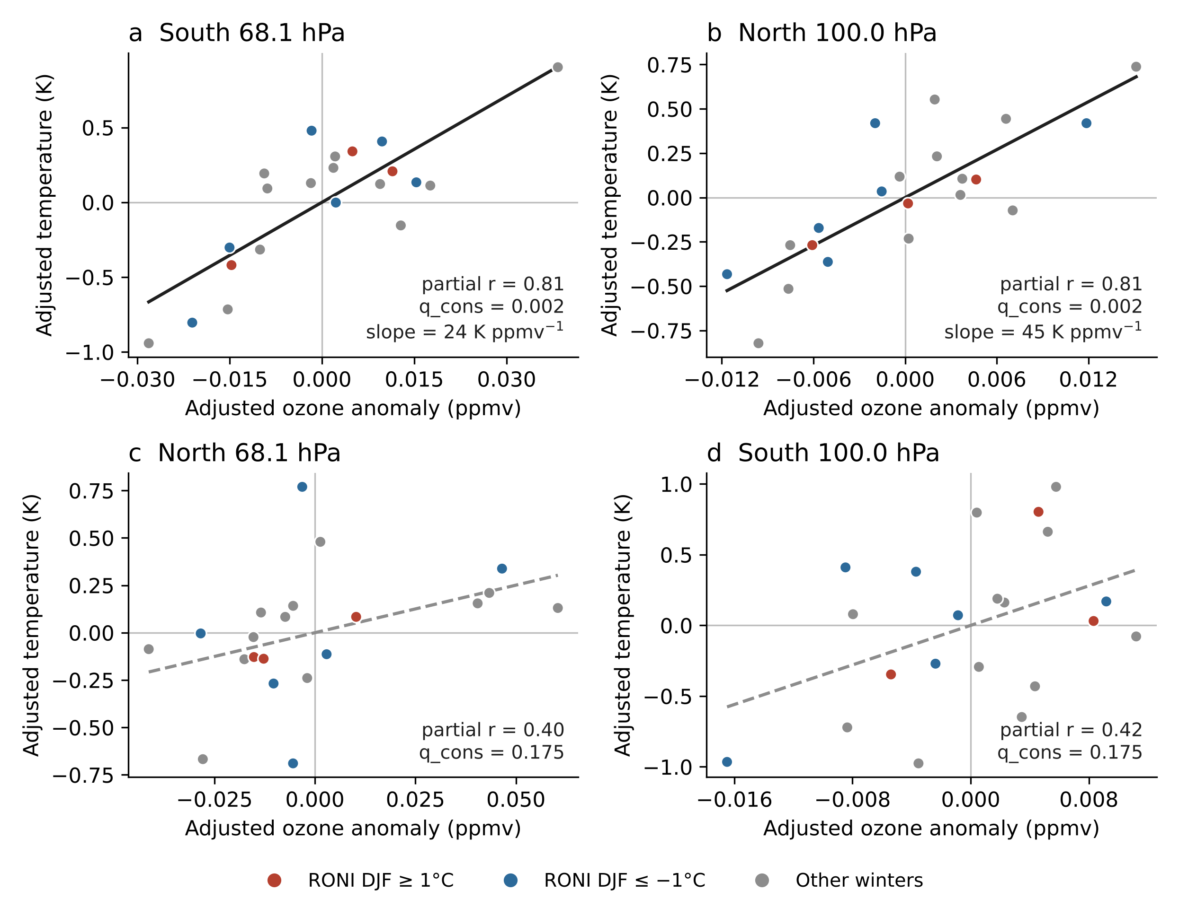
Figure S3. Satellite ozone and pressure-matched temperature after adjustment, for 21 winters ending in 2005–2025. Both variables are residuals from the principal-model covariates: linear and quadratic Niño 3.4, QBO at 30 and 50 hPa, trend, ice water path, skin temperature and lower stratospheric humidity. Panels a and b are the two principal regions; c and d are inconclusive (dashed fits). Annotations give the partial correlation, q_{cons} and, for a and b, the slope. Colours mark winters with DJF RONI of at least 1°C (red) or at most −1°C (blue); these classes illustrate amplitude only.
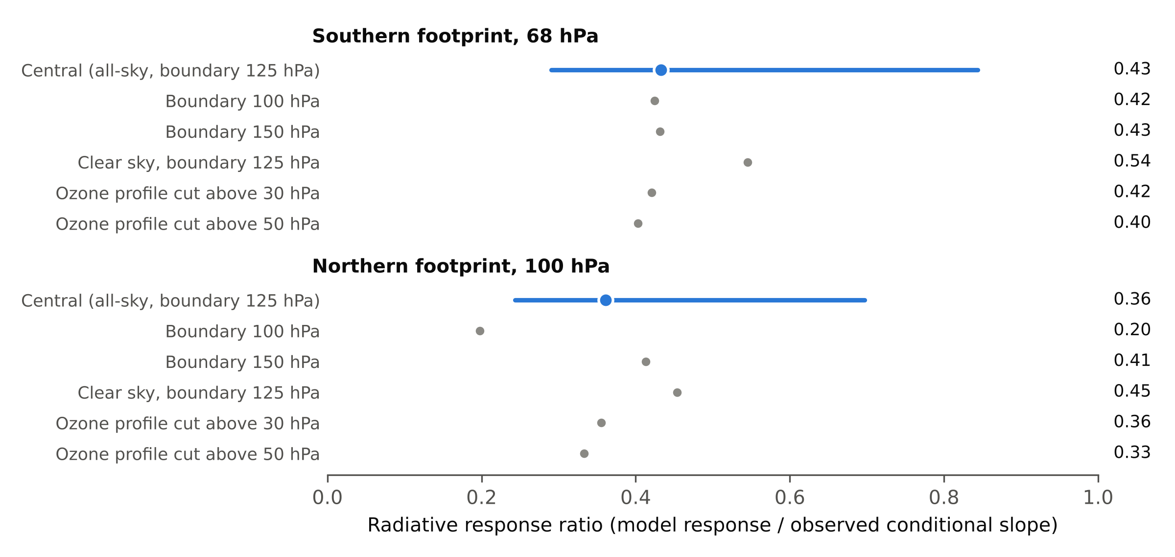
Figure S4. Sensitivity of the radiative response ratio in the two principal regions. Blue: central calculation (all-sky, fixed dynamical heating above 125 hPa, step response from 1 September) with the range from the classical 95% interval of the observed slope alone. Grey: fixed-heating boundaries at 100 and 150 hPa, clear skies with the 125 hPa boundary, and ozone anomaly profiles set to zero above 30 or 50 hPa. Clear skies with the 150 hPa boundary give 0.54 and 0.52 (Table S10). The truncated values scale the central ratio by factors from rebuilt clear-sky columns (Text S3). Ratios are model-conditional and are not causal fractions.
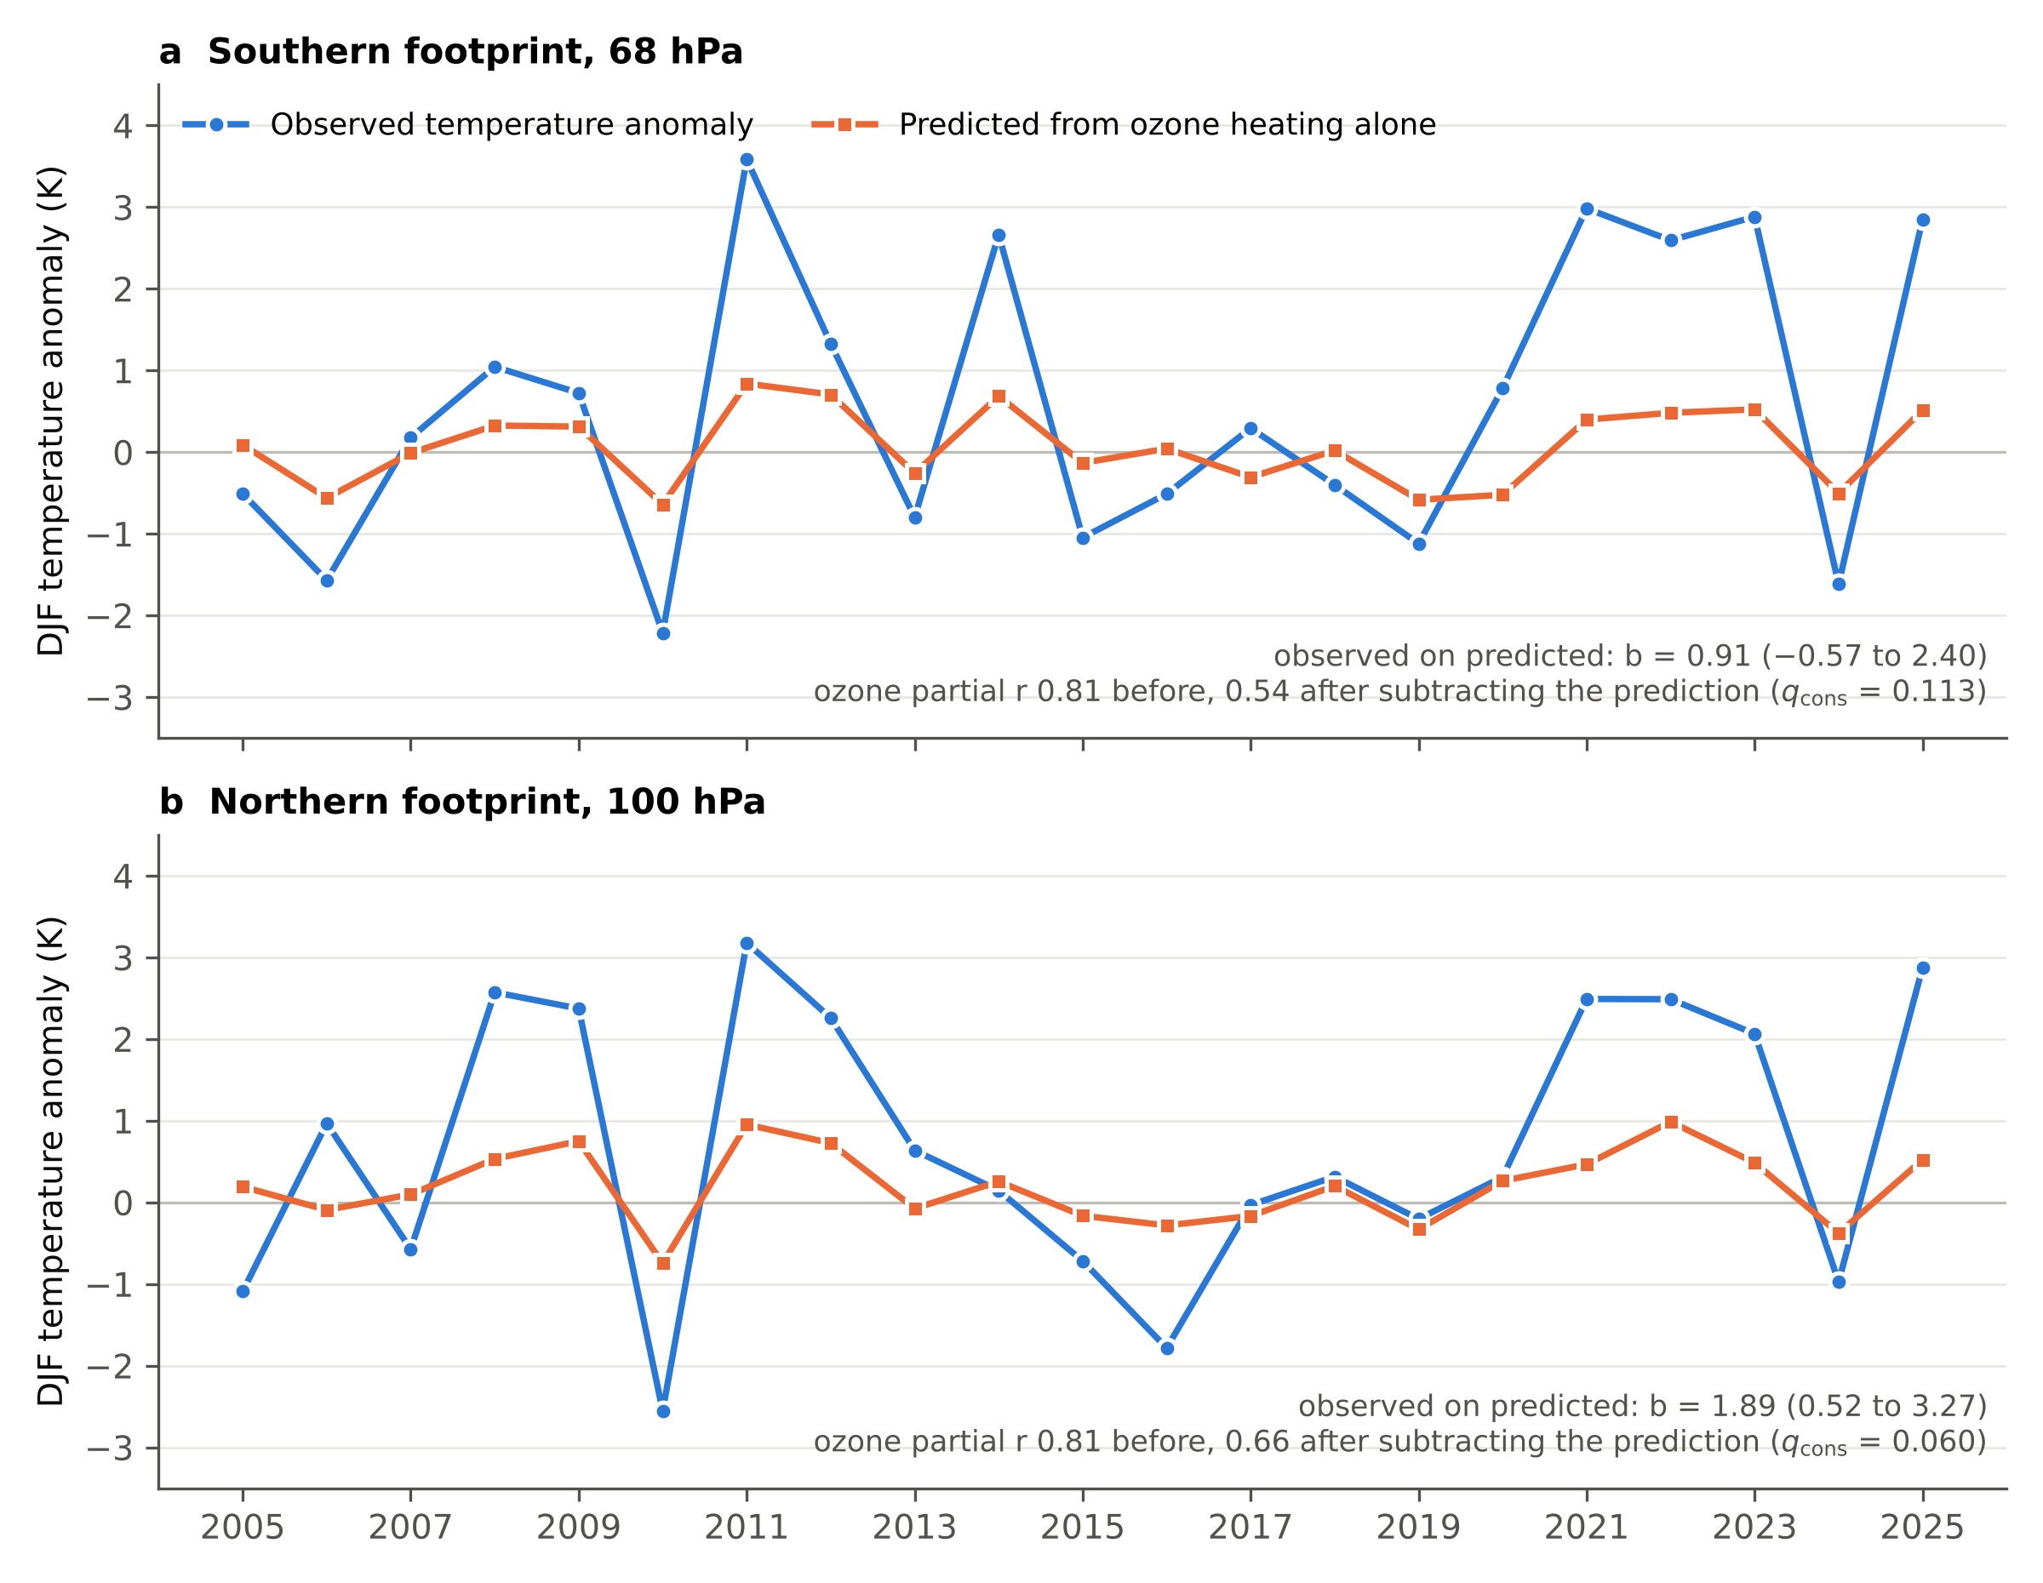
Figure S5. Per-winter radiative experiment in the two principal regions. Observed DJF temperature anomaly (blue) and the temperature predicted from ozone heating alone (orange), from each winter's monthly September–February SWOOSH ozone anomaly profiles under fixed dynamical heating above 125 hPa with all-sky radiation. Annotations give the regression of observed on predicted temperature with the principal covariates, and the ozone partial correlation before and after the prediction is subtracted, with q_{cons} after four-region adjustment (Table S11).
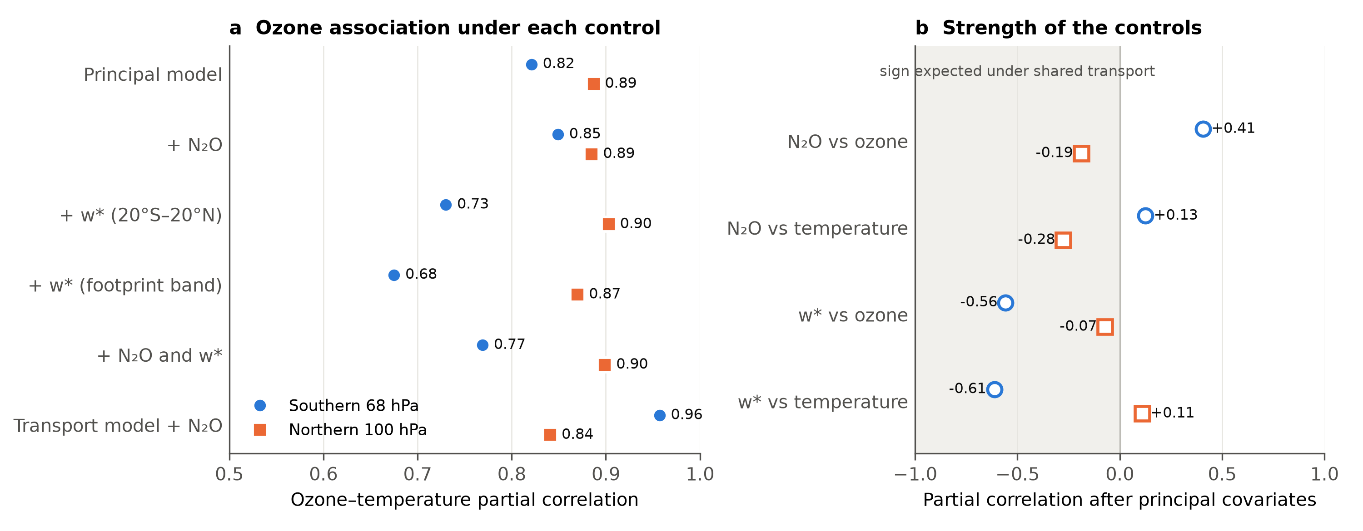
Figure S6. Transport controls in the two principal regions, for the 20 winters ending in 2005–2024 with nitrous oxide data. (a) Ozone–temperature partial correlation in the principal model and with Aura MLS N₂O, ERA5 residual upwelling w* over 20°S–20°N or over the footprint's latitude band, both controls, or the transport model plus N₂O. Filled symbols pass q_{cons} < 0.05 after four-region adjustment. (b) Partial correlation of each control with ozone and with temperature after the principal covariates. Grey shading marks negative values, the sign expected if shared vertical transport drives both ozone and temperature. None passes q_{cons} < 0.05. Values for all four regions are in Tables S12 and S13.
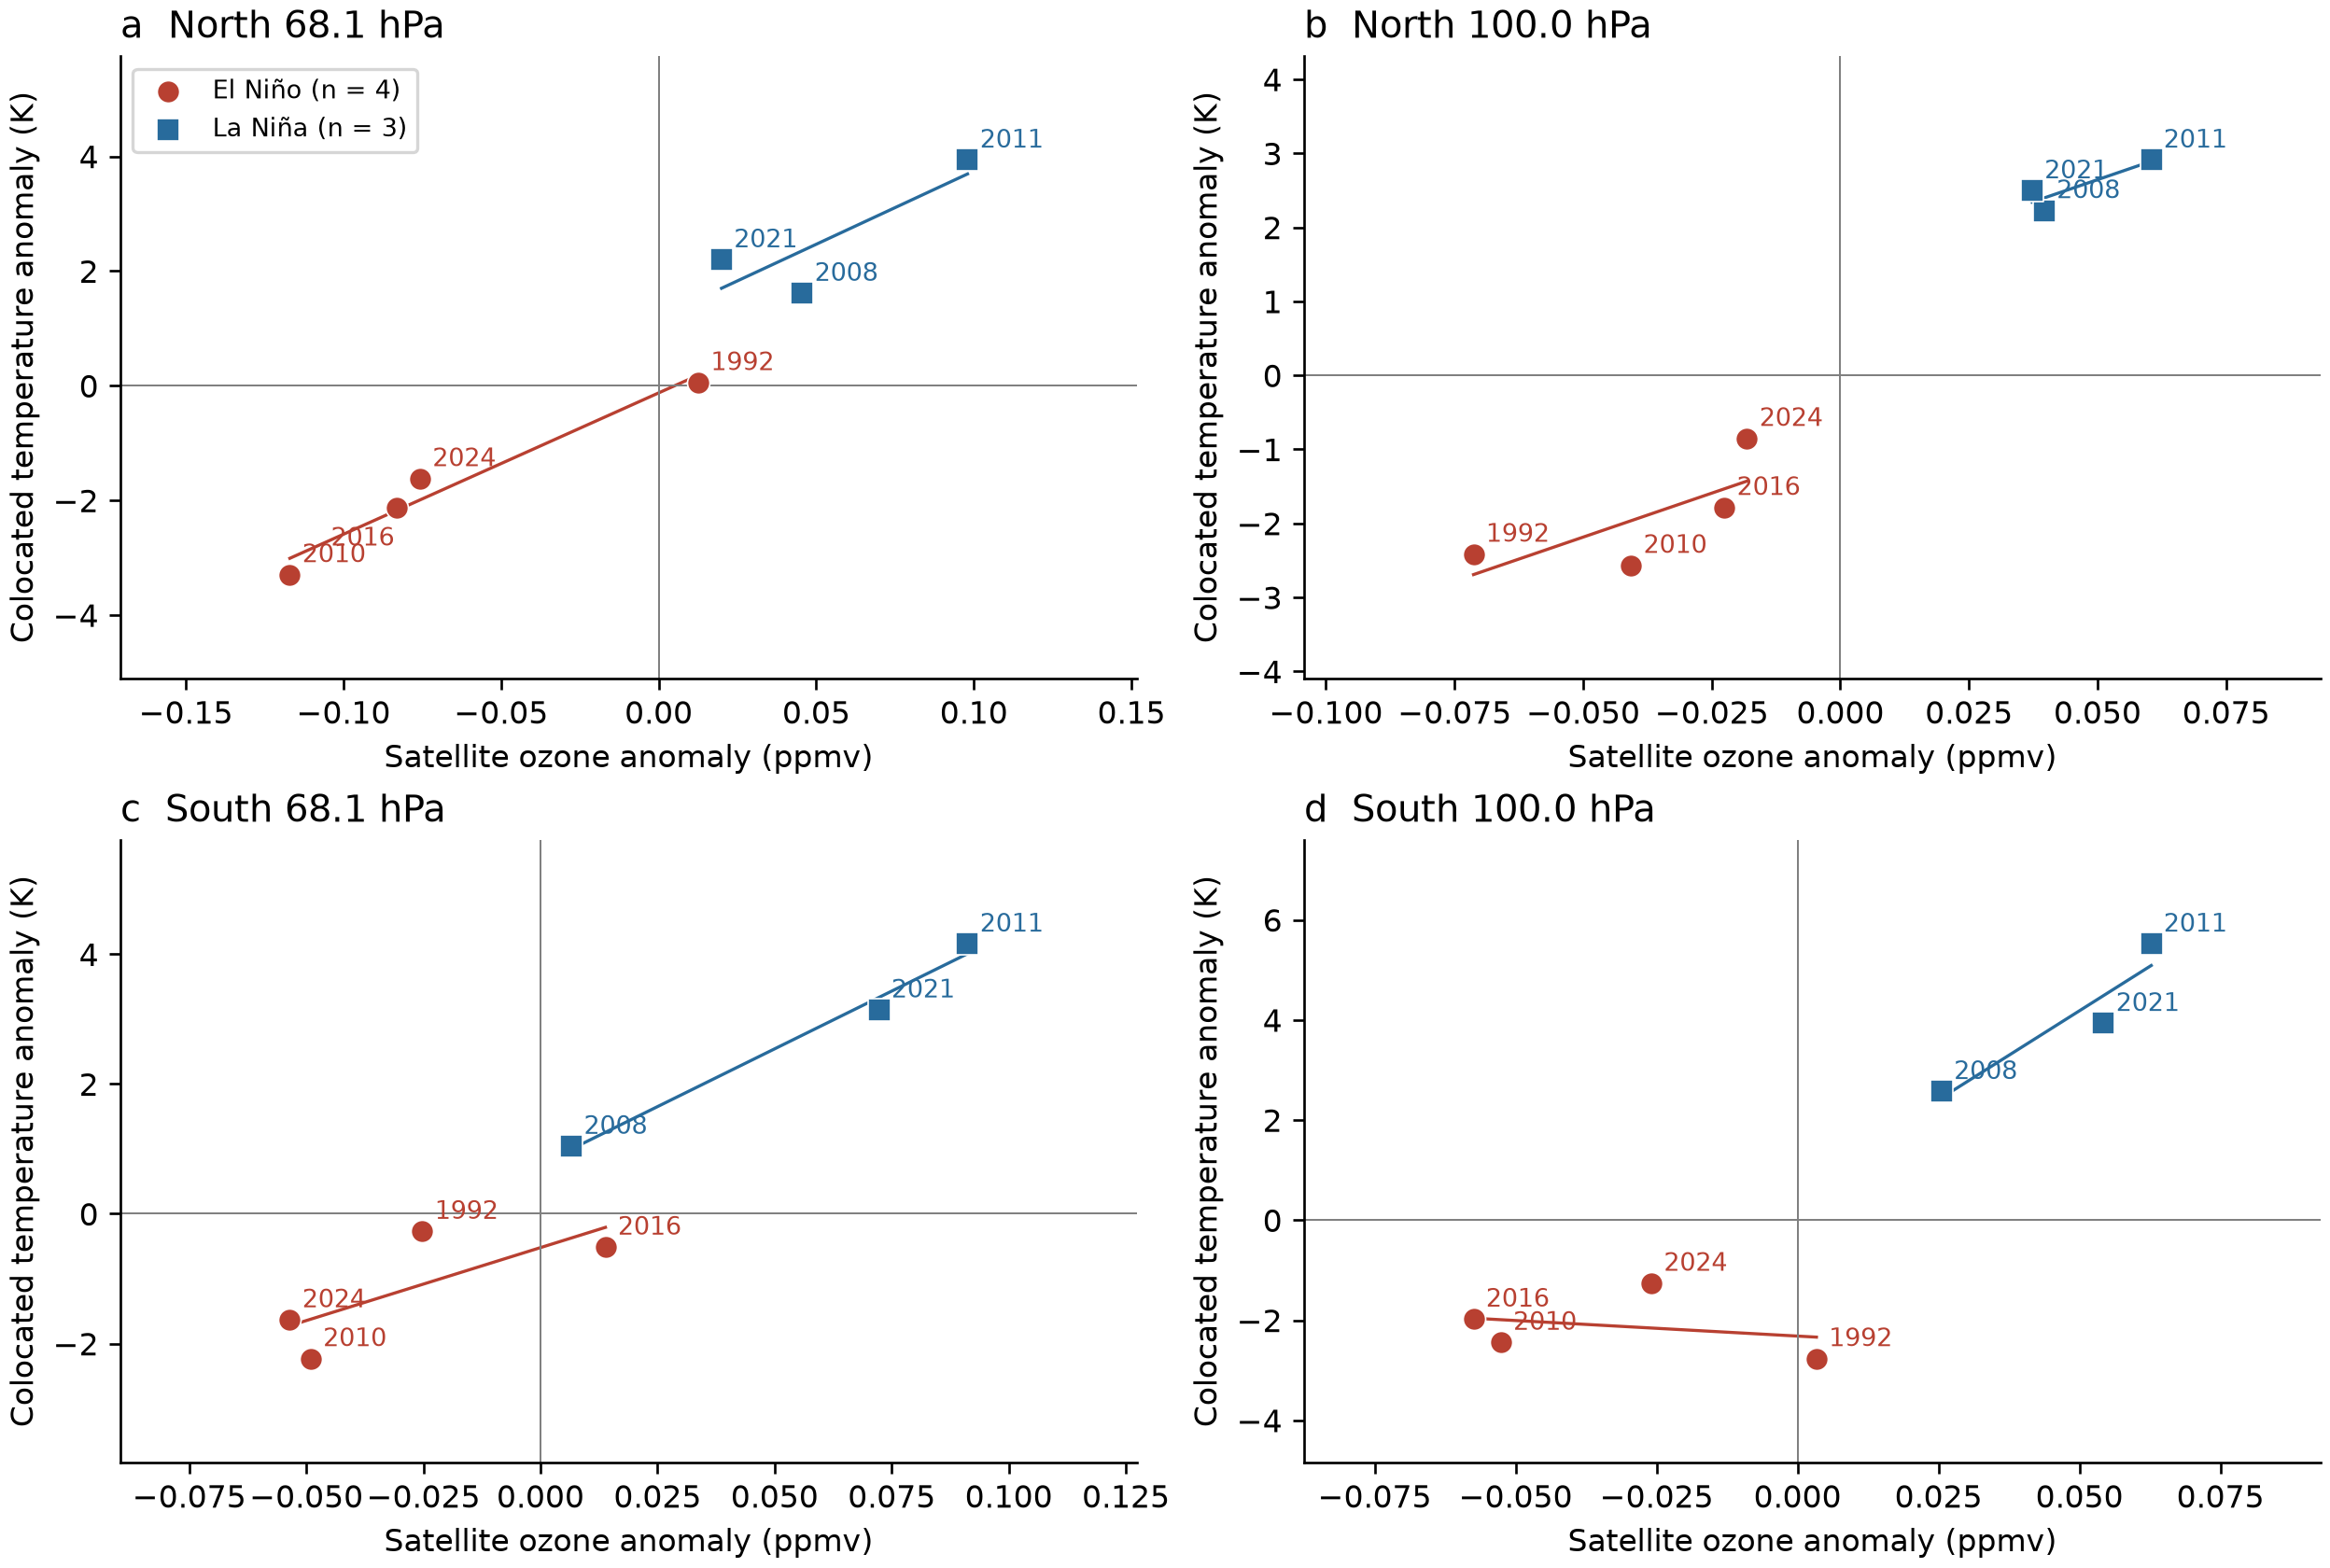
Figure S7. Satellite ozone in the objective extreme sample. SWOOSH ozone and ERA5 temperature at matched 68.1 and 100 hPa levels within the lower stratospheric footprints. Each point is one complete-coverage DJF winter, four warm and three cold, labelled by ending year. Lines are descriptive phase-specific fits. The pooled tests remove phase means and permute ozone within phase; no objective-sample adjusted test passes 0.05 (Table S14). Temperature is matched to the ozone pressure, not averaged over the lobe.
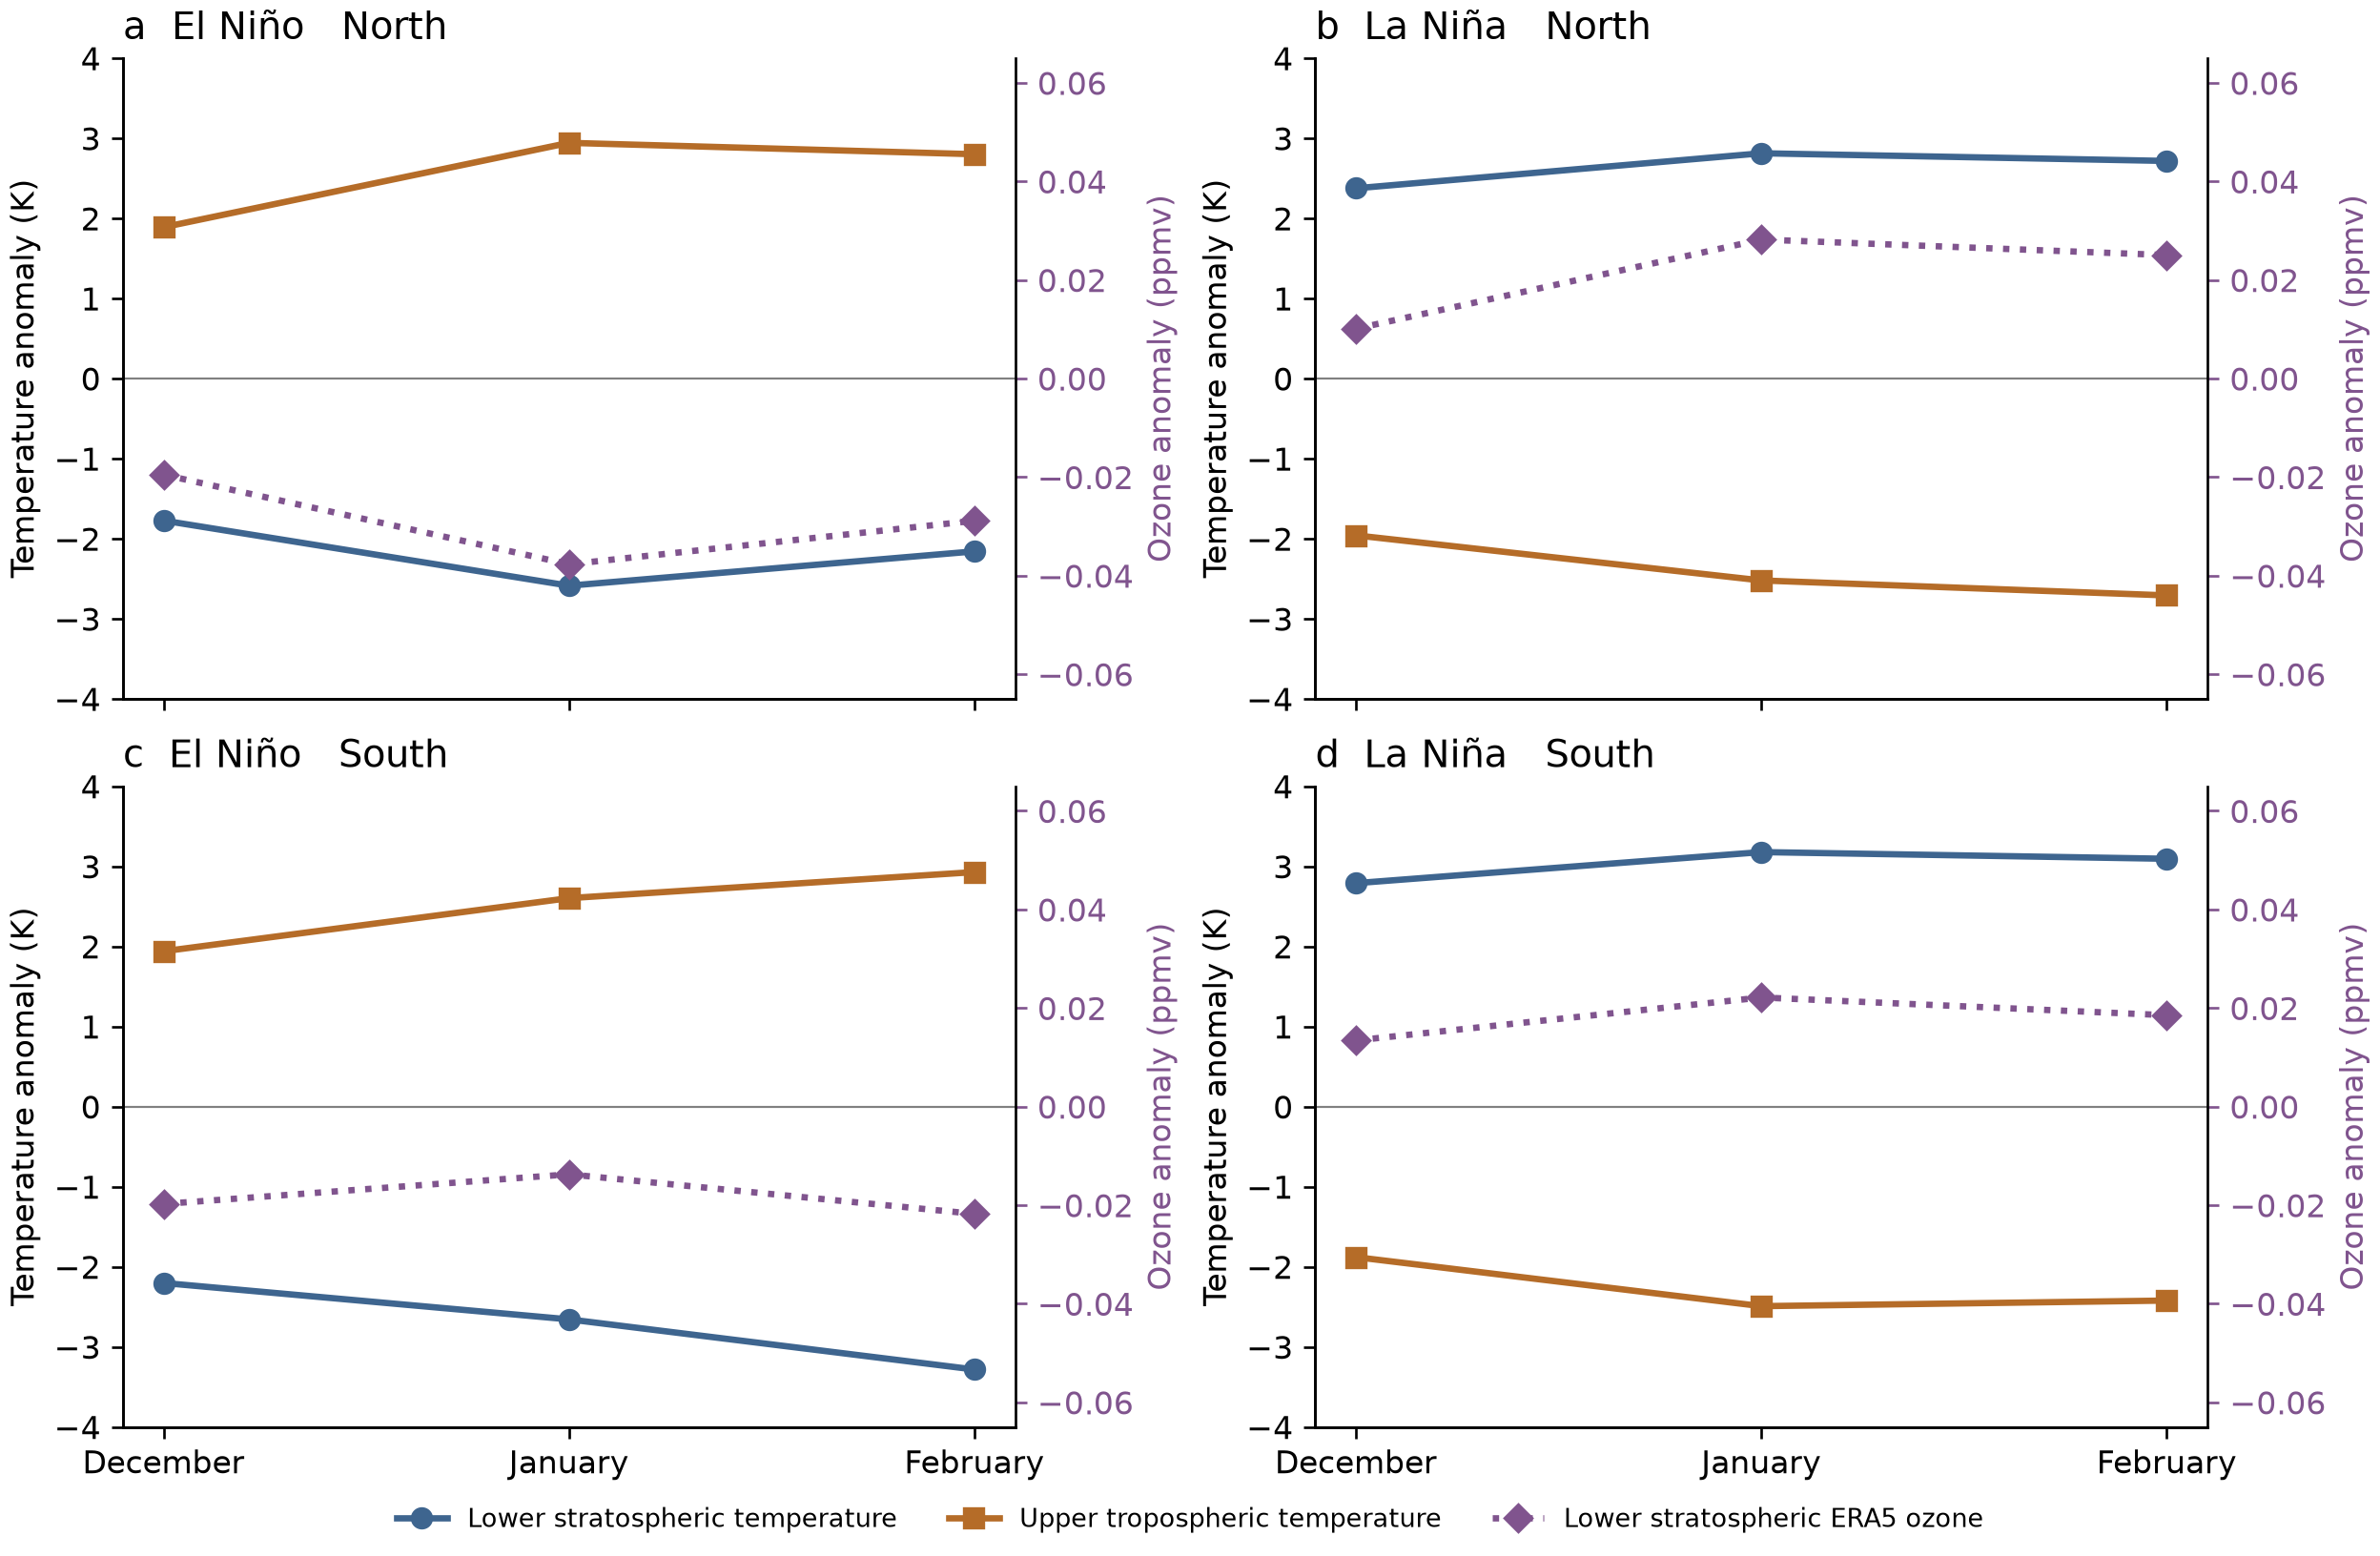
Figure S8. Monthly evolution within the active lobes. Monthly means over six objectively selected winters per phase, with north above south. Blue and orange curves are area- and pressure-weighted temperatures in the separately selected lower stratospheric and upper tropospheric lobes. Purple is ERA5 ozone in the lower stratospheric lobe, read against the right axis. Masks exclude the evaluated winter. Here, reanalysis ozone is descriptive only.
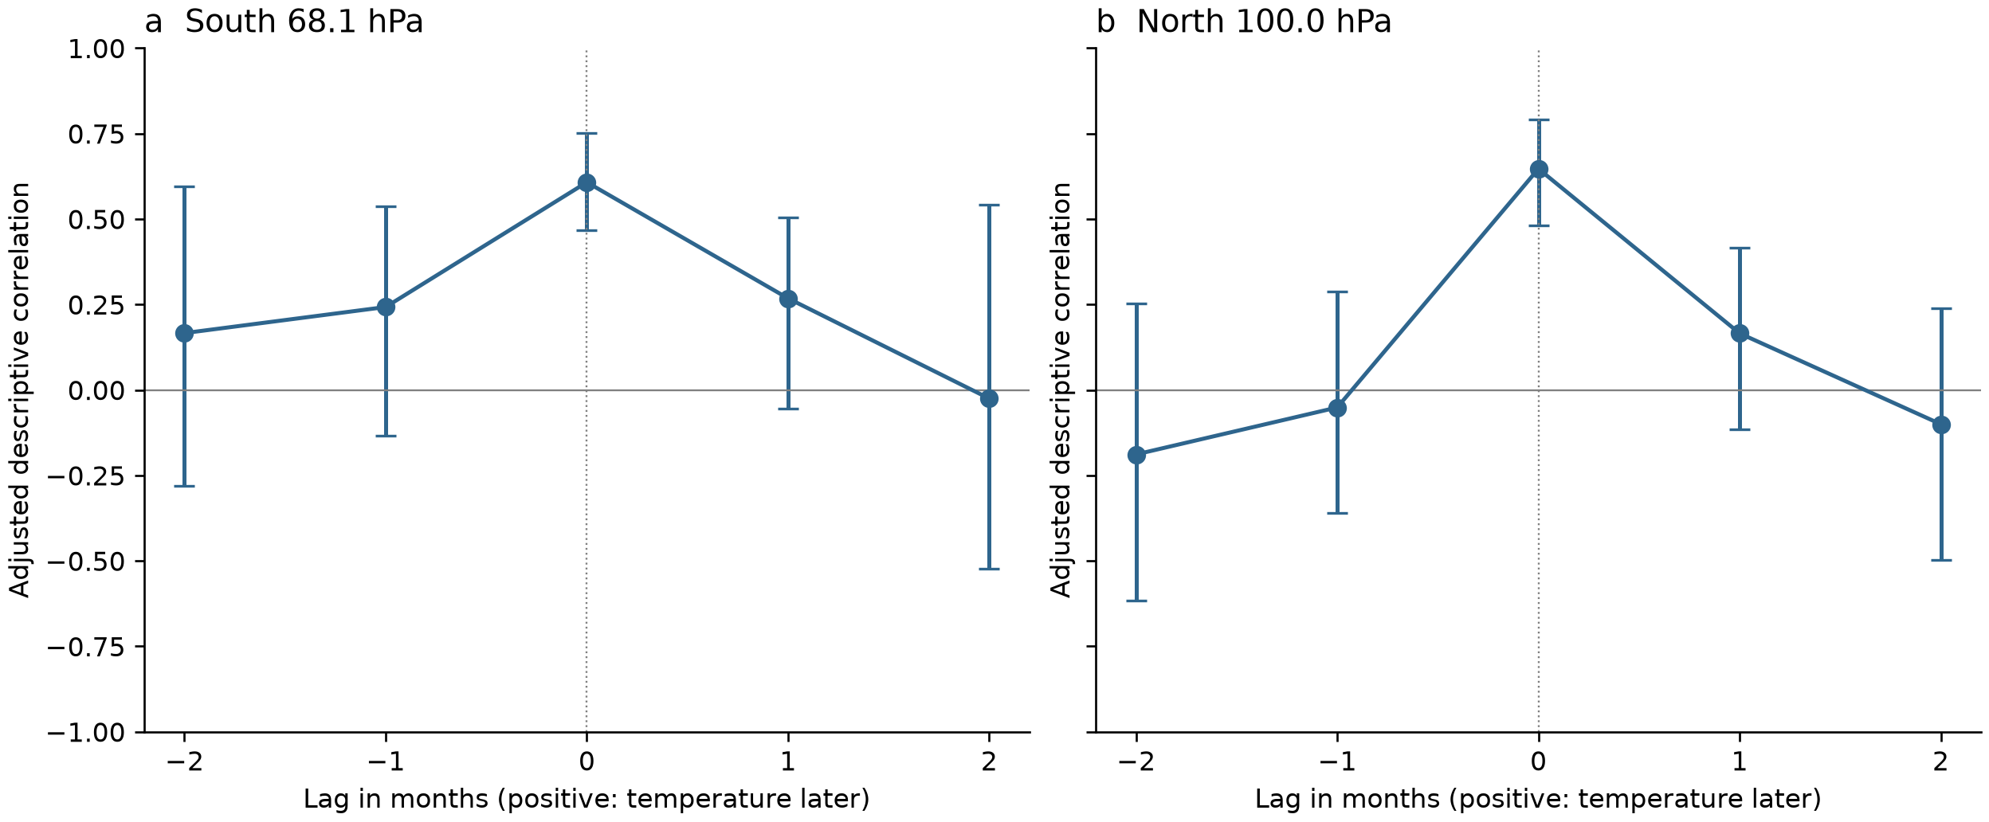
Figure S9. Monthly timing in the principal regions. Adjusted correlations for southern 68.1 hPa and northern 100 hPa, with positive lag meaning temperature follows ozone. Error bars are conditional 95% winter-bootstrap intervals with the adjustment held fixed. The zero-lag correlation is largest, and the one-month intervals include zero. All four regions are tabulated in Table S15.

