School of Computing and Information Technology
CSIT321 - Project

uiabo.

Preliminary Technical Documentation
AI-Based Misinformation Detection for Short-Form Content
Project topic: CSIT-26-S3-30
Group: FYP-26-S3-30
Supervisor: Mr Liaw Chun Huei
Assessor: Mr Terrence Chew
Version 0.6 — 9 September 2026
Student Name | UOW ID | Student E-mail
Ho Sze Wei, Donovan | 8949724 | swdho001@mymail.sim.edu.sg
Wong Yi Da | 1037274 | ydwong003@mymail.sim.edu.sg
Matthew Alexander Peeris | 1052585 | peeris001@mymail.sim.edu.sg
Chu Wai Chung | 8949256 | wcchu001@mymail.sim.edu.sg
Poon Chun Ping | 8865747 | cppoon001@mymail.sim.edu.sg

Implemented Android text-checking prototype

Document Control
Field | Record
Document | Preliminary Technical Documentation
Version | 0.6 — working draft
Evidence cut-off | 9 September 2026
Scope | Completed research, prototype design, implementation and recorded validation.
Missing information | Numbered blank spaces G01–G18 correspond to PTD_MISSING_INFORMATION.md. Blank spaces are editing areas, not completed findings.

  - Record of Revision
Date | Version | Description
7 September 2026 | 0.2 | Consolidated implementation and supporting project material.
8 September 2026 | 0.3 | Reorganised the report to follow the sample technical documentation.
9 September 2026 | 0.4 | Restricted the report to completed work, updated retrieval and evaluation evidence, and added blank editing spaces for missing records.
9 September 2026 | 0.5 | Reworded the report in a direct project voice and removed internal-document citations.
9 September 2026 | 0.6 | Added reusable full-scope PRD, URS and TDM content; restored all role stories/use cases and clearly separated planned functions from implemented evidence.

This report presents our completed research, design, implementation and testing of the Android text-checking prototype. Numbered blank spaces identify information that still needs to be completed.

Table of Contents
Document Control 2
1 Introduction 7
1.1 Problem Statement 7
1.2 Purpose of the Project 7
1.3 Product Vision 7
1.4 Project Objectives and Implemented Prototype 7
1.5 Learning Objectives 8
2 Overview 9
2.1 Competitor and Market Research 9
2.2 Similar Product Comparison 9
2.3 Product Concept and Completed Functions 10
2.4 SWOT Analysis 10
2.5 Product Differentiation 11
2.6 Target Users and Access Model 11
2.7 Business Model and Operating Costs 11
3 Stakeholders 13
3.1 Stakeholder Overview 13
3.2 Team Roles 13
3.3 Component Handoffs and Contributions 13
4 Data Collection 15
4.1 Data Sources 15
4.2 Collected Data Types 15
4.3 Implemented Collection Workflow 15
4.4 Preprocessing and Data Validation 15
4.5 Data Handling 16
4.6 Evaluation Datasets 16
5 Project Timeline 17
5.1 Completed Progress 17
5.2 Actual Gantt Chart 17
5.3 Overall Product Hierarchy / Functionality WBS 19
5.4 Project Charter 19
5.5 Communication and Scope Management 19
5.6 Project Scope Statement 20
6 Requirement Definition 21
6.1 Stakeholder Identification and Analysis 21
6.2 Requirements Gathering 21
6.3 Summary of User and System Needs 21
6.4 Requirements Analysis and Prioritisation 21
6.5 Acceptance Criteria and Traceability 22
6.6 Requirements Tools and Records 22
7 Functional Requirements 23
7.1 Functional Hierarchy 23
7.2 Access Levels 23
7.3 Implemented Text-Checking Functions 23
7.4 Planned Individual-User Functions 23
7.5 Planned Operational Functions 24
7.6 Dependencies, Inputs and Outputs 24
8 Non-Functional Requirements 25
8.1 Reliability and Performance Controls 25
8.2 Security Controls 25
8.3 Interface and Usability 25
8.4 Portability and Device Evidence 25
8.5 Storage and History Behaviour 26
8.6 Documented Non-Functional Targets 26
9 Other Requirements 27
9.1 User and Operating Requirements 27
9.2 Privacy, Data Lifecycle and Legal Records 27
9.3 Assumptions and Dependencies 27
9.4 Operational Recovery 28
10 Risk Management 29
10.1 Observed Risks and Implemented Controls 29
11 Development Methodologies 30
11.1 Methodologies Considered 30
11.2 Selected Methodology 30
11.3 Development Process 30
12 Technical Stack 31
12.1 Frontend and Development Tools 31
12.2 Backend and Persistence 31
12.3 Model and Retrieval Services 31
12.4 Runtime Configuration 31
12.5 Demonstrated Deployment 32
13 User Stories 33
13.1 Free User 33
13.2 Premium User 33
13.3 System Administrator 35
13.4 Data Engineer 35
14 Use Case Descriptions 37
14.1 Shared Across Individual Users 37
14.2 Free User 53
14.3 Premium User 56
14.4 System Administrator 64
14.5 Data Engineer 76
15 Use Case Diagram 85
15.1 Free User 86
15.2 Premium User 89
15.3 System Administrator 91
15.4 Data Engineer 92
16 System Design 93
16.1 Architecture and Data Flow 93
16.2 Pipeline Interfaces 93
16.3 Claim Classification and Extraction 94
16.4 Retrieval and Applicability Decisions 94
16.5 Evidence Assessment and Aggregation 94
16.6 Firestore Data Design 94
16.7 API Interfaces 95
16.8 Submission Sequence and Failure Handling 95
16.9 Application Screens 95
16.10 Full Planned-System Diagrams 99
16.11 Proposed Interface Samples 101
17 Conclusion 110
18 Glossary 111
19 Appendix 112
19.1 Test Results 112
19.1.1 Stance Evaluation — 8 September 112
19.1.2 Retrieval Evaluation — 9 September 112
19.2 Evaluation Review 113
19.3 Meeting Minutes 113
19.4 References 114
19.5 Demonstration / Release Record 115

1 Introduction

1.1 Problem Statement
Short messages and captions can circulate without their original context or supporting evidence. Readers must identify what is being claimed, locate relevant sources and decide whether those sources apply to the statement. These steps are difficult when the message is brief, emotionally framed or missing qualifications such as dates and eligibility conditions.
UIABO is designed for older Singapore users, particularly people aged 65 and above. We focus on a guided checking process with readable explanations and accessible source links.

1.2 Purpose of the Project
This Preliminary Technical Documentation describes UIABO's project rationale, requirements, planning, technical choices and system design. It also records the working Android text-checking prototype, its supporting evidence and the remaining work towards the complete approved system.
The project itself aims to help older Singapore users assess suspicious short-form content through readable explanations, explicit uncertainty and inspectable evidence.

1.3 Product Vision
Our vision is to help users make informed decisions about messages they receive and share. UIABO supports this through an explicit evidence trail and a Not Enough Information result when a decisive assessment is not justified.

1.4 Project Objectives and Implemented Prototype
The approved project scope is broader than the current implementation. The objectives are:
- Provide an elderly-friendly Android application for English short-form text, public webpage links and supported static images.
- Give Free users one successful text or link check per Singapore day and Premium users up to 60 successful checks per month.
- Identify factual claims, retrieve supporting or contradicting evidence, communicate uncertainty and provide citations.
- Provide Premium image upload, OCR correction, caption-image context checking and a separate probabilistic image-manipulation assessment.
- Provide role-restricted System Administrator and Data Engineer functions for account management, feedback investigation and pipeline monitoring.
- Evaluate accuracy, relevance, usability, security and performance without presenting an AI score as proof of truth.
The implemented September prototype currently provides:
- Verified account access, profile editing and server-controlled Free/Premium allowances.
- English text submission through Android to the FastAPI pipeline.
- Claim extraction, evidence retrieval, assessment, citations and explicit Not Enough Information handling.
- Owned Firestore results, history, result reopening and native summary sharing.

1.5 Learning Objectives
G01 — Approved learning objectives

2 Overview

2.1 Competitor and Market Research
We compared Full Fact AI, Factiverse, NewsGuard, Google Fact Check Explorer and InVID-WeVerify to understand their verification workflows, intended users and evidence presentation. The comparison reflects our research as of 31 July 2026.
Full Fact AI supports large-scale monitoring and human fact-checking. It monitors text, audio, video, social media, radio and broadcast content; generates transcripts; extracts and ranks check-worthy statements; and matches new statements with claims that were previously fact-checked. However, the product is intended to help professional fact-checkers identify what requires investigation rather than automatically deciding whether every new claim is true or false (Corney, 2025; Full Fact AI, n.d.; Johnston, 2025).
NewsGuard specialises in source reliability and human-vetted false claims. Its News Reliability Ratings assess publishers using journalistic criteria, while False Claim Fingerprints document known false narratives, evidence, provenance, examples and spread. The source rating and the claim record serve different purposes. A publisher's 0–100 rating must not be presented as the probability that an individual post is false (NewsGuard, n.d.-a, n.d.-b, n.d.-c).
Google Fact Check Explorer is a retrieval service rather than a new-claim verifier. Through the Fact Check Tools API, users and systems can search published ClaimReview records using text or an image. This is valuable when a rumour has already been checked, but it does not extract claims, evaluate a new statement, assess the original publisher or conduct media forensics independently (Google, 2024).
InVID-WeVerify is a human-guided multimedia verification toolkit with automated components. It provides OCR, video keyframe extraction, reverse and cross-network search, fact-check and known-fake search, context aggregation, source-credibility lookup, deepfake detection and image-forensics outputs such as probability scores and heatmaps. A journalist or analyst chooses the relevant tool and interprets the evidence; the plugin does not produce a single automatic truth verdict for an entire post (WeVerify, n.d.-a, n.d.-b, n.d.-c, n.d.-d).
Factiverse provides an automated evidence-backed workflow that detects claims, searches for sources and presents assessments with linked evidence (Factiverse, n.d.-a, n.d.-b, n.d.-c). Its workflow is the closest comparison to UIABO among the products we reviewed.

2.2 Similar Product Comparison
Product | Main function | Comparison with implemented UIABO
Full Fact AI | Monitoring and prioritisation for professional fact-checkers. | UIABO starts with an individual user’s submitted text and presents a saved assessment.
Factiverse | Automated claim detection and evidence-backed assessment. | UIABO combines a comparable text-to-evidence workflow with its own guided Android interface and owned result history.
NewsGuard | Publisher reliability and human-vetted false-claim records. | UIABO assesses a submitted claim against passages; its risk indicator is not a publisher rating.
Google Fact Check Explorer | Search of previously published fact checks. | UIABO uses the Fact Check Tools API as a discovery input and also extracts evidence pages.
InVID-WeVerify | Human-guided multimedia verification tools. | UIABO’s completed workflow is a guided text assessment.

2.3 Product Concept and Completed Functions
The implemented product follows a short sequence: sign in, choose Check text, enter a message, submit, read the result and inspect its sources. Results remain accessible in the signed-in account’s history. Home exposes the account’s current allowance.
Area | Available behaviour
Account | Free registration, email verification, login, password-reset email and logout.
Checking | Typed or pasted English text, up to 5,000 characters.
Assessment | Claim category, extracted claim, concern label, explanation, uncertainty, evidence passages and citations.
Saved results | List and reopen results owned by the signed-in user.
Sharing | Native Android share sheet containing a text summary and source URLs.
Profile and allowance | View account details, save a display name and view remaining checks.

2.4 SWOT Analysis
G02 — Team-reviewed SWOT analysis

2.5 Product Differentiation
UIABO brings claim extraction, source discovery, passage assessment and private result history into one Android journey. Users can see why a result was reached and open its cited sources. When context is missing, the result explains the uncertainty.
We have not yet measured whether older users find this interface easier than competing products, or established that these features are exclusive to UIABO.

2.6 Target Users and Access Model
Unauthenticated access is a pre-login state rather than a separate long-term user role. Registration, login and password recovery lead to one of the approved account roles.
Role | Planned access | Current position
Free User | Text and public-link checking; history, sharing, reporting, review and Premium upgrade; one successful check per day. | Text checking, history, allowance and native summary sharing are implemented.
Premium User | All Free functions; 60 successful checks per month; image, OCR, caption-context and image-authenticity functions. | Premium allowance exists; Premium image and payment functions are planned.
System Administrator | Role-restricted account query, operational-account creation, suspension controls and feedback review. | Planned; no operational portal is implemented.
Data Engineer | Role-restricted incorrect-result dashboard, report investigation and ingestion-pipeline monitoring. | Planned; no operational portal is implemented.

2.7 Business Model and Operating Costs
The PRD defines a social-impact freemium model. Free access supports occasional checking, while Premium access supports more frequent use and the planned image functions. The model remains a proposal until pricing and demand are validated.

2.7.1 Value Proposition and Customer Segments
- Older Android users receive a guided evidence-checking flow with plain-language explanations and uncertainty.
- Free users receive one successful text or webpage-link submission per day.
- Premium users receive up to 60 successful submissions per month and planned image, OCR, context and authenticity functions.
- Future organisational users may access selected verification functions through approved API licensing.

2.7.2 Partners, Activities and Channels
Area | Planned approach from the PRD
Potential partners | Public agencies, fact-checking/news organisations, community and senior-support organisations, universities and research organisations. No formal partnership is asserted.
Key activities | Maintain retrieval sources, evaluate claim/evidence behaviour, validate citations, manage accounts and allowances, test usability and protect user data.
Channels | Android application, community demonstrations, digital-literacy outreach and possible future organisational integration.
Revenue | Free introductory access, monthly Premium access and possible future API licensing. Earlier interface samples show SGD20, but the PRD states that the price requires validation.

2.7.3 Proposed Cost Structure
- Cloud hosting, database, authentication and storage usage.
- AI inference, fact-check search, web search/extraction, OCR and image-analysis services.
- Android development, testing devices and release/distribution costs.
- Dataset preparation, source maintenance, security review and usability evaluation.

2.7.4 Actual Project Expenditure
G03 — Actual project expenditure

3 Stakeholders

3.1 Stakeholder Overview
Stakeholder | Relationship to the completed project work
Intended older users | Provide the audience basis for the interface and plain-language result design.
Family or community helpers | Identified as potential onboarding support in the product context; no separate application role.
Mr Liaw Chun Huei, supervisor | Academic and technical guidance.
Mr Terrence Chew, assessor | Assessment of the project and its deliverables.
Five-person project team | Research, design, implementation, integration, testing and documentation.
External service providers | Supply authentication, storage, model inference and search/extraction services; no partnership is asserted.

3.2 Team Roles
Team member | Assigned roles
Ho Sze Wei, Donovan | Project Leader, Back-End Developer, Database Engineer, Documentation
Matthew Alexander Peeris | Documentation, Database Engineer, Software Analyst, Tester
Chu Wai Chung | Lead Documentation, Database Engineer, Software Tester, Software Analyst
Poon Chun Ping | Database Engineer, Documentation, Software Analyst
Wong Yi Da | Front-End Developer, Back-End Developer, Software Tester, Security Tester

Our role allocation covers project coordination, frontend and backend development, database work, testing and documentation. Individual contributions are recorded separately below.

3.3 Component Handoffs and Contributions
Original component allocation | Interface now integrated
Wong Yi Da — input preparation | PreparedText
Matthew Alexander Peeris — claim analysis | ClaimAnalysis
Chu Wai Chung — evidence retrieval | RetrievalResult
Poon Chun Ping — evidence assessment | AssessmentResult
Ho Sze Wei, Donovan — orchestration and integration | Authenticated API, application and Firestore result path

G04 — Confirmed contribution record

4 Data Collection

4.1 Data Sources
UIABO collects user-submitted text and retrieves public evidence through Google Fact Check Tools and Tavily. Google supplies published fact-check discovery records. Tavily supplies search candidates and extracted page content. The broader retrieval path uses extracted source passages as evidence rather than search snippets or repeated claims.
The preferred catalogue contains gov.sg, mfa.go.th, thaiembassy.org, nasa.gov, snopes.com, fullfact.org, factcheck.org, reuters.com, apnews.com, channelnewsasia.com and nus.edu.sg. The web mode also recognises registration-restricted .gov, .gov.uk and .gov.au hostnames. Source eligibility is a retrieval policy, not a guarantee that a passage is correct or applicable.

4.2 Collected Data Types
Data | Use
Original and normalised text | Retain the submission and prepare it for claim analysis.
Claim category and extracted span | Decide whether factual checking is appropriate.
Source title, URL, publisher, dates and passage | Present inspectable evidence and its provenance.
Relevance, applicability and selected quotations | Record why a passage was accepted and what qualification applies.
Stance, explanation and uncertainty | Explain the evidence assessment.
User ID, timestamps, pipeline version and allowance records | Own saved results, distinguish historical outputs and account for completed checks.

4.3 Implemented Collection Workflow
- Search Google Fact Check and preferred Tavily domains concurrently.
- Extract eligible candidate pages through Tavily and select relevant source sentences.
- When fewer than two origin groups supply direct, applicable evidence, generate up to two alternative queries and search more broadly.
- Treat unfamiliar publishers as leads. A literal link to an eligible original can be followed within the same extraction budget.
- Validate the selected passage and its conditions, then pass accepted evidence to the stance assessor.
The retrieval budget is at most three Tavily searches, one Google request, four extracted URLs and four relevance assessments within 65 seconds. At most six overlapping 1,800-character windows are considered from the first 60,000 characters of a page. These limits can omit relevant evidence.

4.4 Preprocessing and Data Validation
Input preparation validates length, rejects empty or unsupported content, normalises characters and checks English-language suitability. Claim extraction must match a span of the prepared input. Numeric formatting is normalised for retrieval comparison so that forms such as 20,000 and 20000 can match without changing the quantity.
Candidate URLs are checked for malformed hosts, IP literals, credentials, local names, unsupported ports and domain lookalikes. Extraction uses the provider’s fixed API endpoint. The implementation does not independently validate every DNS resolution or redirect inside the extraction provider.
Numbered source sentences allow the backend to copy literal quotations. Missing publication dates remain missing; they are not invented. Duplicate passages and repeated URLs are removed, while same-origin contributions are limited during assessment.

4.5 Data Handling
Provider credentials are loaded on the backend from local configuration and remain outside the Android application. Text and evidence are processed by the configured cloud providers. Firebase Authentication identifies the account; Firestore stores profiles, allowances and owned analysis records.

4.6 Evaluation Datasets
The stance dataset contains 125 provisional claim–passage pairs: 120 fictional cases arranged in 40 groups and five historical regression cases. The retrieval dataset contains 43 provisional cases: 24 development, 16 holdout and three regression cases. Review spreadsheets and evaluation runners have been created.
We prepared the evaluation datasets with Codex. Their labels remain provisional and require independent human review. The current results therefore measure agreement with provisional labels rather than general detection accuracy.

5 Project Timeline

5.1 Completed Progress
Recorded date | Completed work
13 August 2026 | Initial FastAPI endpoint, shared interfaces and Firebase smoke tests reviewed.
7 September 2026 | Android and Firestore text-checking integration and application screenshots.
8 September 2026 | Semantic assessment revision, evaluation runs and Android export validation.
9 September 2026 | Broader retrieval mode, provenance persistence, 400-test backend suite and targeted live evaluations.

These dates identify completed progress checkpoints, rather than individual task start and end dates.

5.2 Actual Gantt Chart
The following Gantt chart is the proposed schedule retained from the PRD. It must not be presented as the actual completion record; the actual task dates are still required below.
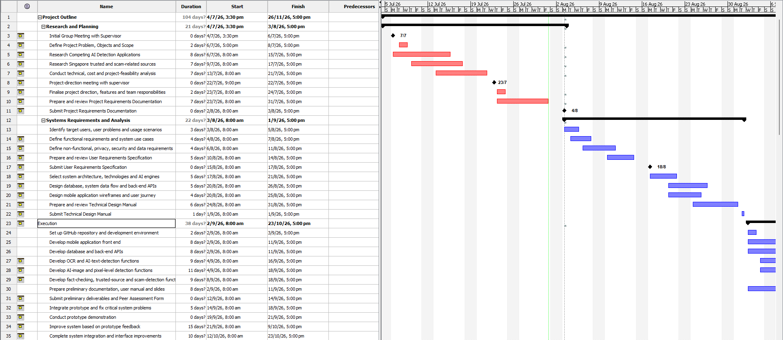
Figure 5.1. Proposed PRD Gantt chart, part 1.
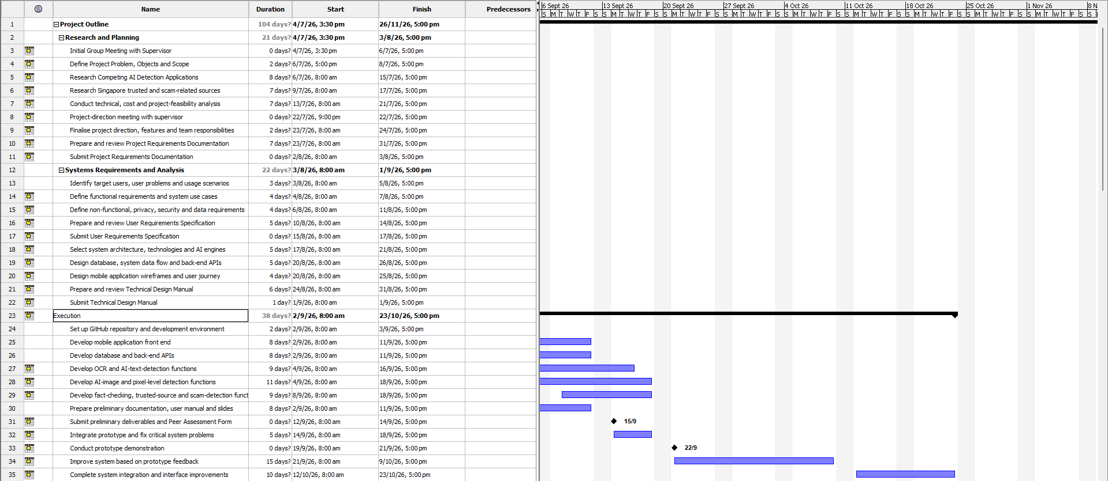
Figure 5.2. Proposed PRD Gantt chart, part 2.
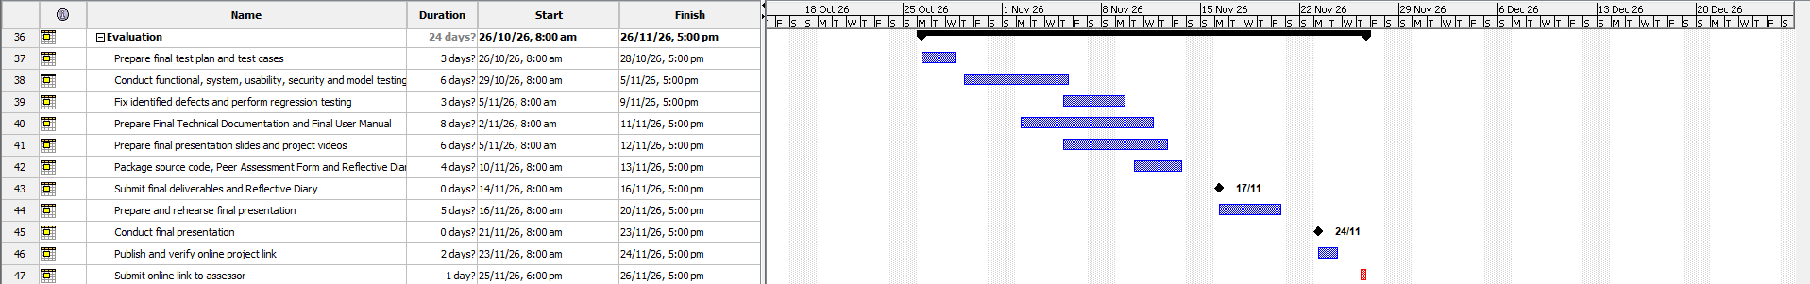
Figure 5.3. Proposed PRD Gantt chart, part 3.
G05 — Actual task timeline

5.3 Overall Product Hierarchy / Functionality WBS
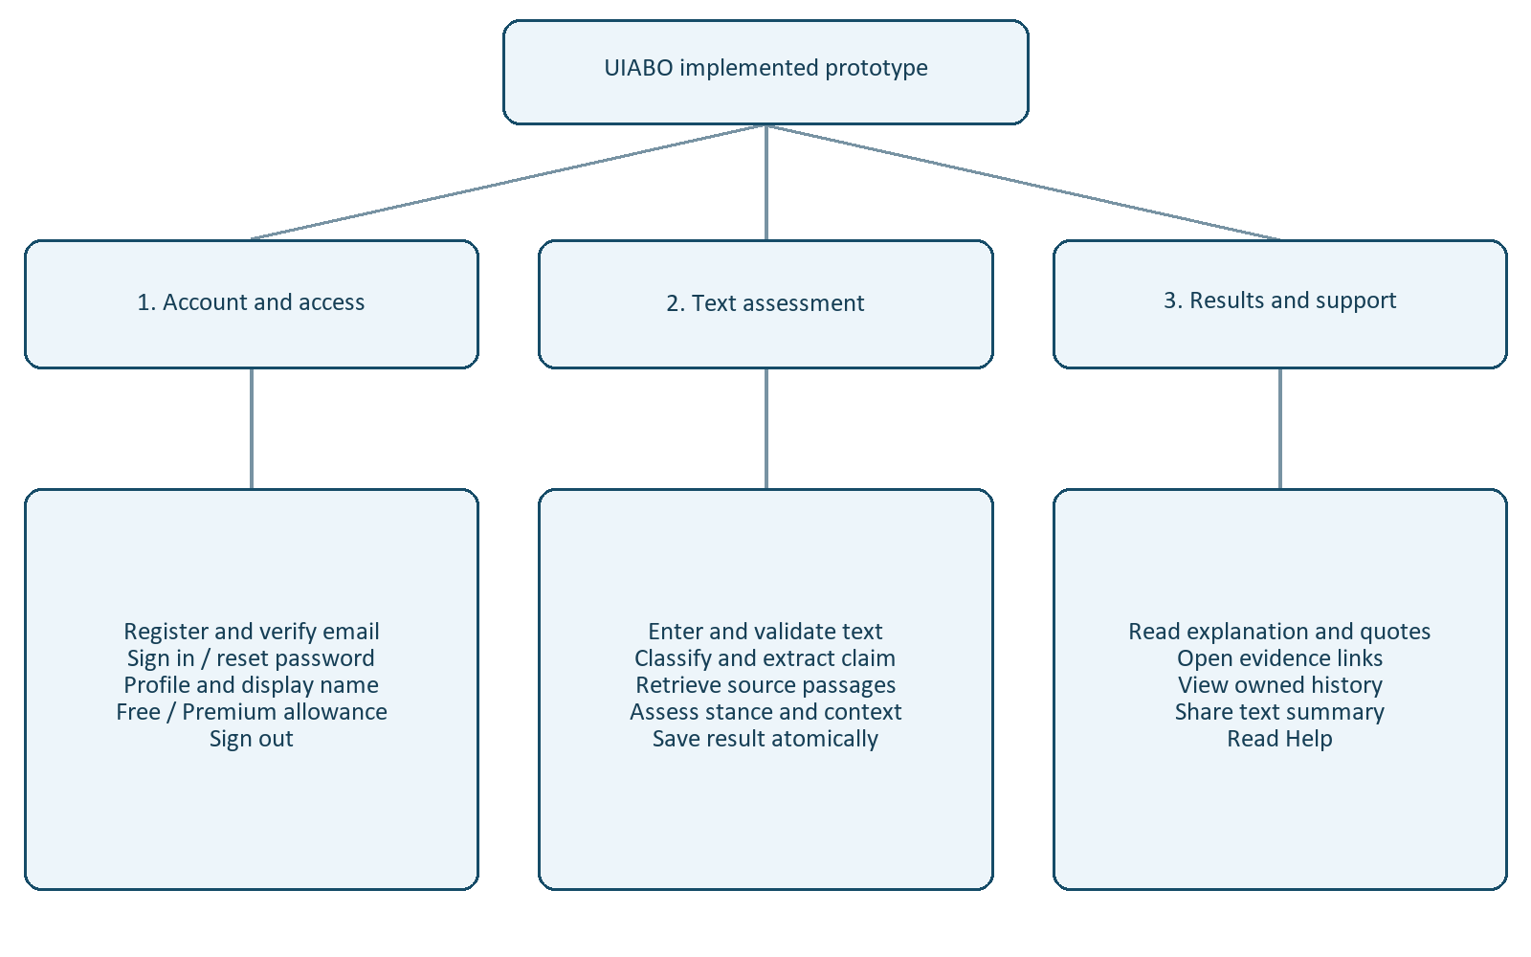
Figure 5.1. Functionality WBS of the implemented prototype.

5.4 Project Charter
G06 — Approved project charter

5.5 Communication and Scope Management
The team uses GitHub for source control and shared implementation. Sprint 1 work was divided around explicit PreparedText, ClaimAnalysis, RetrievalResult and AssessmentResult handoffs so members could develop against common samples. Meeting notes and task records were used to review progress and identify decisions still requiring agreement.
- Scrum provides two-week iteration structure, while a Kanban-style task view tracks work in progress.
- Git branches, commits and pull/fetch workflows provide implementation history and integration control.
- Shared JSON/Pydantic interfaces define component inputs, outputs and controlled failure behaviour.
- The 13 August implementation-planning record identifies the first pipeline goal, component owners and review checklist.
G07 — Formal communication schedule, review decisions and scope approvals

5.6 Project Scope Statement
Scope area | Approved project position
In scope | Android; English short-form text; supported public webpage links; supported static images; evidence-backed results; Free/Premium accounts; System Administrator and Data Engineer functions.
Premium scope | Image upload with caption, OCR review/correction, caption-image context analysis and a separate probabilistic AI-generation/manipulation likelihood assessment.
Operational scope | Account management, feedback/incorrect-result review, data-quality investigation and ingestion-pipeline monitoring.
Out of scope | Video and speech analysis, private/paywalled/inaccessible pages, non-English analysis and any claim that a model score proves truth or manipulation.
Current increment | Authenticated Android English-text checking, evidence retrieval, assessment, Firestore history and server-controlled allowances.

6 Requirement Definition

6.1 Stakeholder Identification and Analysis
Requirements were organised around intended older individual users, family/community helpers, operational users, the project team, supervisor/assessor and external service dependencies. Free and Premium users need a readable checking journey; System Administrators and Data Engineers require separate role-restricted operational workflows.

6.2 Requirements Gathering
- Desk research into misinformation tools, older-user accessibility and comparable products.
- Project scope and feature analysis recorded in the PRD.
- User stories, use cases, operating constraints and dependencies recorded in the URS.
- Architecture, database, activity, sequence and interface design recorded in the TDM.
- Sprint planning, shared interface samples, implementation reviews and automated/live testing.
The available records do not show a completed older-user interview, survey or formal stakeholder acceptance exercise.
G08 — User consultation or requirements-review record

6.3 Summary of User and System Needs
Need | Required response
Simple access | Registration, email verification, login, password recovery and clear role/tier access.
Supported checking | English text and public links for individual users; supported image functions for Premium users.
Understandable result | Concern label, evidence, citations, explanation, uncertainty and a safe next action.
Honest limitation | Not Enough Information where evidence is insufficient; separate factual and image-authenticity assessments.
Private history | Authenticated ownership checks, saved results, deletion controls and protected account data.
Operational oversight | Role-restricted account, feedback, incorrect-result and ingestion-monitoring functions.

6.4 Requirements Analysis and Prioritisation
The team prioritised a vertical text-checking increment because it exercises authentication, input preparation, claim analysis, evidence retrieval, assessment, persistence and Android presentation. Link, image, payment and operational-portal requirements remain in the approved scope but are separate planned increments.

6.5 Acceptance Criteria and Traceability
Area | Documented acceptance condition | Evidence status
Access | Protected functions require a verified, active account and correct role. | Developer tests exist; stakeholder sign-off is missing.
Text input | Accept valid English text up to 5,000 characters and reject invalid input safely. | Implemented and tested.
Allowance | Free: one successful check/day; Premium: 60/month; failed work does not consume allowance. | Implemented baseline and tested.
Result | Return claim, concern, uncertainty, explanation and inspectable evidence; NEI has no fabricated score. | Implemented baseline; general accuracy not established.
Ownership | Users can access only their own saved results. | Implemented and tested.
Full scope | Complete link, image, payment and operational use cases defined in Chapters 7 and 14. | Planned; not accepted as implemented.

G09 — Approved acceptance criteria and stakeholder sign-off

6.6 Requirements Tools and Records
The team uses requirements and design documents, role-based use cases, shared JSON/Pydantic contracts, GitHub history, automated tests, evaluation datasets and meeting records to trace requirements into implementation and testing.

7 Functional Requirements

7.1 Functional Hierarchy
Module | Functions | Status
Account and access | Register, verify, login/logout, reset password, profile, deletion and role/tier checks. | Core access implemented; deletion and operational role flows planned.
Text and link checking | Text submission, public-link retrieval, malicious-link screening and evidence-backed result. | Text implemented; direct link and URL-risk checking planned.
Result management | View evidence, history, deletion, incorrect-result reporting, review and sharing. | View/history/native sharing implemented; other functions planned.
Premium image | Image/caption upload, OCR correction, context analysis and image-authenticity likelihood. | Planned.
Subscription | Upgrade, Premium registration, renewal, cancellation and entitlement confirmation. | Planned; demonstration entitlement is server-controlled.
System administration | Account search/view/create, suspension controls and feedback review. | Planned.
Data engineering | Incorrect-result dashboard/report investigation and ingestion monitoring. | Planned.

7.2 Access Levels
Function | Free | Premium | System Admin | Data Engineer
Text/link assessment | Yes | Yes | No | No
Image/OCR/context/authenticity | Locked | Planned | No | No
Personal result history | Yes | Yes | No | No
Account administration | No | No | Planned | No
Feedback/incorrect-result operations | Submit planned | Submit planned | Review planned | Investigate planned
Ingestion monitoring | No | No | No | Planned

7.3 Implemented Text-Checking Functions
- Register a Free account, verify email, sign in/out, request a password reset, view a profile and update the display name.
- Submit up to 5,000 characters of English text through an authenticated Android session.
- Prepare input, classify/extract a claim, retrieve evidence, assess passages and return a concern result with uncertainty and citations.
- Store owned completed/failed results in Firestore and reopen personal history.
- Apply daily/monthly successful-check allowances, idempotent replay and a per-user processing lock.
- Share a text summary and citation URLs through the device share sheet.

7.4 Planned Individual-User Functions
- Submit supported public article/webpage links and check malicious-link indicators.
- Delete an account or selected result history with confirmation and ownership checks.
- Report an incorrect result, leave a review and share a public result link where approved.
- Upgrade, register for Premium, renew or cancel through a selected payment/subscription mechanism.
- Upload supported static images with captions, review OCR text, analyse context and request an image-authenticity likelihood assessment.

7.5 Planned Operational Functions
- System Administrators authenticate, manage their profiles, query/view accounts, create operational accounts, suspend/unsuspend eligible accounts and review feedback.
- Data Engineers authenticate, manage their profiles, view incorrect-result dashboards and reports, inspect provenance and monitor ingestion runs.

7.6 Dependencies, Inputs and Outputs
Area | Input/dependency | Output
Authentication | Email/password, Firebase availability and verified identity token. | Authenticated role/tier context or controlled denial.
Text analysis | English text, allowance, AI/search credentials and accessible sources. | Owned result containing claim, concern, uncertainty, explanation and evidence.
Link analysis | Supported public URL, safe-fetch rules and webpage access. | Extracted content, URL-risk indicators and assessment; planned.
Image analysis | Supported static image, caption, OCR/authenticity providers and Premium entitlement. | OCR/context/authenticity outputs with limitations; planned.
Subscription | Payment provider confirmation. | Server-controlled Premium entitlement; planned.
Operations | Authorised operational role and stored feedback/pipeline records. | Account actions, investigation records and monitoring status; planned.

8 Non-Functional Requirements

8.1 Reliability and Performance Controls
The implementation uses bounded external requests, structured component errors and schema validation at stage boundaries. Broader retrieval has a 65-second overall budget. Semantic assessment has a separate 65-second budget, a 45-second per-passage limit and a maximum of six passages with concurrency limited to three. The mobile request timeout is 240 seconds.
We measured selected live evaluation requests, with the results presented in Section 19.1. These measurements do not establish production load capacity. Provider throttling affected some requests and remains included in the evaluation totals.
G10 — Measured latency and load-test results

8.2 Security Controls
The backend verifies Firebase identity tokens and takes user identity from the verified token. Protected analysis and history routes require a verified account. Stored account status is checked, and result lookup returns only an owned result. Client-supplied role changes are not accepted by the profile update contract.
User text and retrieved content are treated as untrusted model inputs. Strict structured responses, allowed categories, grounded claim extraction and literal quotation checks constrain the outputs consumed by the pipeline. These controls reduce specific failure modes; they do not establish complete prompt-injection resistance or a security certification.

8.3 Interface and Usability
We designed the app around a guided home screen, visible allowance, labelled actions and result explanations with source links. Chapter 16 shows the implemented interface.
G11 — Completed usability or accessibility study

8.4 Portability and Device Evidence
We developed and tested the app using Windows, an Android Studio emulator and Expo. The Android export passed on 8 September 2026. We ran the 9 September retrieval evaluation through backend tooling; no Android device was connected during the final environment check.
G12 — Device and clean-install test record

8.5 Storage and History Behaviour
Firestore separates users, usage allowances, analysis results and active analysis locks. The history query selects records by owner, sorts the account’s complete result set in the backend and then paginates it. We have not measured its cost or latency with large histories. Storage usage and quota fields are present in the profile, but storage warnings are not enforced.

8.6 Documented Non-Functional Targets
The following values come from the PRD/URS and remain targets unless a measured result is stated in the appendix.
Category | Documented target | Current evidence
Capacity | At least 100 concurrent users and 100 requests per minute; architecture should support 20% annual user growth. | Not load-tested.
Interface | Initial login/home/register load within 2 seconds; taps respond within 1 second; assets within 2.5 seconds on a stable connection. | No formal device measurement.
Result time | Text and link results within 5 minutes; image functions within 10 minutes; cancel work beyond 20 minutes. | Selected retrieval latency exists; end-to-end/load compliance is not established.
Storage | Notify a user at 80% of their allocated personal storage quota. | Fields exist; warning enforcement is not implemented.
Security | Protect sensitive data in transit and at rest; authenticated protected access; 30-minute inactivity expiry. | Authentication/ownership controls exist; session-expiry target is not verified.
Accessibility | Readable typography, high contrast, large targets, simple navigation and plain-language feedback for older users. | Designed, but no completed older-user study.

9 Other Requirements

9.1 User and Operating Requirements
Individual users require a supported Android device, registered email address and stable internet connection. The initial system supports English text, public webpage links and supported static images; video, audio, inaccessible pages and non-English analysis are outside scope.
The complete interface must explain supported inputs, access tiers, allowance behaviour, result labels, uncertainty, reporting, history controls and safe next actions. A user should not rely on UIABO as the sole basis for a high-impact decision.

9.2 Privacy, Data Lifecycle and Legal Records
- Registration and Premium enrolment flows require terms/privacy notice presentation and recorded user consent.
- Users must submit only content they are permitted to process; screenshots may contain third-party personal data.
- Protected account and result data require authenticated ownership or authorised role checks.
- Provider credentials remain on the backend; the final privacy notice must disclose relevant cloud/external processing.
- Planned account deletion removes the authentication account, profile and associated history after confirmation and re-authentication.
- Planned result deletion verifies ownership before permanently removing selected records.
- Retention periods, deletion completion behaviour and provider data handling still require formal approval and documentation.
G13 — Approved privacy notice, consent basis and data-lifecycle documentation

9.3 Assumptions and Dependencies
Assumption/dependency | Project position
User access | A supported Android device, registered email and sufficiently stable connection are available; a helper may assist onboarding.
Submitted content | Content is permitted, sufficiently clear and within supported formats.
Evidence | Relevant credible evidence may be absent or conflicting; Not Enough Information is an expected result.
Cloud platform | Authentication, profiles, allowances and results depend on Firebase configuration and availability.
Analysis services | AI, search, OCR, URL screening and image-authenticity functions depend on provider limits and supported outputs.
Subscription | Premium activation/renewal/cancellation depends on a selected payment or app-store mechanism.

9.4 Operational Recovery
The implemented request lease and idempotency key support recovery from interrupted text checks. A repeated completed request returns its existing saved result without another deduction. Provider failures return controlled errors. Production monitoring, backup, restore testing and disaster-recovery records remain unfinished.
G14 — Tested backup and recovery procedure

10 Risk Management

10.1 Observed Risks and Implemented Controls
Risk | Existing control | Remaining limitation
Irrelevant or misleading evidence | Source policy, relevance and applicability decisions, quotations and neutral stance gates. | A model can still misread scope or miss a qualification.
Wrong amount or eligibility scope | Numeric normalisation, condition quotations and conservative personal-entry checks. | User context can remain missing; NEI is an expected outcome.
Overstated confidence | Uncertainty reasons, NEI without score and heuristic-score labelling. | Scores are not calibrated truth probabilities.
Repeated or copied sources | Exact-duplicate removal and one origin contribution per stance. | Cross-publisher syndication independence is not fully established.
Provider failures and throttling | Bounded calls, deadlines, failure records and limited evaluation concurrency. | External service capacity and availability affect results.
Duplicate charging or overlapping requests | Transactions, idempotency keys and leased per-user lock. | A client timeout can occur after a successful server completion.
Unauthorised history or role changes | Verified UID ownership and server-managed account roles. | Focused tests are not a full security assessment.
Biased evaluation evidence | Dataset splits, preserved run reports and blank review spreadsheets. | Labels are provisional and samples are limited.

We identified these risks through implementation and testing. The controls address the observed failure modes, while the remaining limitations define the bounds of the current prototype.

11 Development Methodologies

11.1 Methodologies Considered
We compared Waterfall, Prototyping, Kanban and Scrum. Waterfall provides sequential documentation and stage gates. Prototyping supports early interface and behaviour feedback. Kanban visualises work and controls tasks in progress. Scrum organises iterative development around a backlog and reviewable increments.
Methodology | Application to UIABO
Waterfall | Useful structure for requirements and documentation, with less flexibility for changing model and retrieval behaviour.
Prototyping | Supports early demonstration of the checking journey and revision after observed problems.
Kanban | Supports visibility of independent component and integration tasks.
Scrum | Selected to combine task structure with iteration while we evaluate evidence retrieval and assessment behaviour.

11.2 Selected Methodology
We selected Scrum as our main development methodology because it provides structure while allowing changes to retrieval and assessment behaviour. We developed the prototype in increments, connecting the components and revising them after testing.

11.3 Development Process
We defined shared models for component handoffs, connected the pipeline to the Android app and Firestore, and investigated incorrect or uncertain results. We then revised retrieval and assessment behaviour and ran targeted tests. We kept versioned evaluation results to compare behaviour across changes.

12 Technical Stack

12.1 Frontend and Development Tools
Tool or framework | Use in UIABO
React Native / React | Android screen components and application state. We use React Native 0.86.3 and React 19.2.3.
Expo | Development server and Android export. We use Expo ~57.0.19.
Firebase JavaScript SDK | Email/password authentication, verification and client authentication state; package specification ^12.18.0.
Android Studio emulator | Recorded Android demonstration environment.
Git and GitHub | Source versioning and team exchange.
Python, pytest and evaluation scripts | Backend development, automated checks and model/retrieval experiments.

12.2 Backend and Persistence
FastAPI exposes the account and analysis endpoints. Pydantic defines strict request, stage and result contracts. HTTPX calls the external services. Firebase Admin verifies identity and accesses Firestore. Uvicorn serves the local development API. We use FastAPI 0.141.1, Pydantic 2.13.4 and Firebase Admin 7.5.0.

12.3 Model and Retrieval Services
Service | Implemented purpose
Ollama Cloud | Remote model inference; the backend supplies its own configured API key.
gpt-oss:120b, gemma4:31b, nemotron-3-super | Three classification votes for the claim-analysis stage.
gemma4:31b | Grounded claim extraction and bounded alternative-query planning.
gpt-oss:120b | Semantic passage relevance and evidence stance assessment.
Google Fact Check Tools API | Discovery of existing published fact checks.
Tavily Search / Extract | Search discovery and retrieval of page content.
Lingua | Local English-language validation during input preparation.

12.4 Runtime Configuration
We enabled EVIDENCE_RETRIEVAL_MODE=web in the local prototype on 9 September 2026. The repository template defaults to catalogue mode, which retains the previous retrieval implementation. The enabled pipeline version is sprint-1-semantic-v3:gpt-oss:120b:retrieval-web-v3. Saved results retain the version used when they were produced.
Backend credentials are supplied privately through ignored local configuration and the configured Firebase service account. The mobile application receives public Firebase project configuration and the API base URL; provider secrets remain on the server.

12.5 Demonstrated Deployment
We run the prototype on a local Windows backend with the Expo Android development app. On 9 September 2026, the backend OpenAPI endpoint at 127.0.0.1:8000 returned HTTP 200 and Expo was listening on port 8081. We have not deployed a production-hosted service.

13 User Stories
The following stories are retained from the approved URS. Their presence records the full project scope; it does not mean every story is implemented.

13.1 Free User
Use case | User story | Implementation status
UC-01 | As a free user, I want to log in to my account so that I can access the functions of the app. | Implemented in the current Android text prototype
UC-02 | As a free user, I want to log out of my account so that I can maintain the security of my account. | Implemented in the current Android text prototype
UC-03 | As a free user, I want to delete my account so that I can remove my personal data from the system. | Planned requirement from the URS; not yet implemented
UC-04 | As a free user, I want to reset my password so that I can improve account security or regain access when the password is forgotten. | Implemented in the current Android text prototype
UC-05 | As a free user, I want to view my profile so that I can check whether my account information is up to date. | Implemented in the current Android text prototype
UC-06 | As a free user, I want to update my profile so that I can keep my account information up to date. | Implemented in the current Android text prototype
UC-07 | As a free user, I want to upload short-form text so that I can find out whether the submitted text contains misinformation. | Implemented in the current Android text prototype
UC-08 | As a free user, I want to upload a link to an article so that I can find out whether a linked article or webpage contains misinformation. | Planned requirement from the URS; not yet implemented
UC-09 | As a free user, I want to view my personal results page so that I can access the results of my submitted content. | Implemented in the current Android text prototype
UC-10 | As a free user, I want to view the result of my submitted content so that I can view the details of a specific analysis result. | Implemented in the current Android text prototype
UC-11 | As a free user, I want to view my remaining account credits so that I can find out how many uses of the app I have left. | Implemented in the current Android text prototype
UC-12 | As a free user, I want to delete my result history so that I can remove results I no longer want to see from my results page. | Planned requirement from the URS; not yet implemented
UC-13 | As a free user, I want to report results that are incorrect so that I can provide data and feedback so the system can be improved in future. | Planned requirement from the URS; not yet implemented
UC-14 | As a free user, I want to leave a review so that I can express my experience using the app so it can be improved in the future. | Planned requirement from the URS; not yet implemented
UC-15 | As a free user, I want to share a result via link so that I can inform others of content containing misinformation. | Partially implemented: native summary sharing; no public result link
UC-16 | As a free user, I want to register for a free account so that I can gain access to the free functions of the app. | Implemented in the current Android text prototype
UC-17 | As a free user, I want to upgrade to premium so that I can access all the functions of the app and gain more uses of the functions. | Planned requirement from the URS; not yet implemented

Source: UIABO URS, page 15.

13.2 Premium User
Use case | User story | Implementation status
UC-01 | As a premium user, I want to log in to my account so that I can access the functions of the app. | Implemented in the current Android text prototype
UC-02 | As a premium user, I want to log out of my account so that I can maintain the security of my account. | Implemented in the current Android text prototype
UC-03 | As a premium user, I want to delete my account so that I can remove my personal data from the system. | Planned requirement from the URS; not yet implemented
UC-04 | As a premium user, I want to reset my password so that I can improve account security or regain access when the password is forgotten. | Implemented in the current Android text prototype
UC-05 | As a premium user, I want to view my profile so that I can check whether my account information is up to date. | Implemented in the current Android text prototype
UC-06 | As a premium user, I want to update my profile so that I can keep my account information up to date. | Implemented in the current Android text prototype
UC-07 | As a premium user, I want to upload short-form text so that I can find out whether the submitted text contains misinformation. | Implemented in the current Android text prototype
UC-08 | As a premium user, I want to upload a link to an article so that I can find out whether a linked article or webpage contains misinformation. | Planned requirement from the URS; not yet implemented
UC-09 | As a premium user, I want to view my personal results page so that I can access the results of my submitted content. | Implemented in the current Android text prototype
UC-10 | As a premium user, I want to view the result of my submitted content so that I can view the details of a specific analysis result. | Implemented in the current Android text prototype
UC-11 | As a premium user, I want to view my remaining account credits so that I can find out how many uses of the app I have left. | Implemented in the current Android text prototype
UC-12 | As a premium user, I want to delete my result history so that I can remove results I no longer want to see from my results page. | Planned requirement from the URS; not yet implemented
UC-13 | As a premium user, I want to report results that are incorrect so that I can provide data and feedback so the system can be improved in future. | Planned requirement from the URS; not yet implemented
UC-14 | As a premium user, I want to leave a review so that I can express my experience using the app so it can be improved in the future. | Planned requirement from the URS; not yet implemented
UC-15 | As a premium user, I want to share a result via link so that I can inform others of content containing misinformation. | Partially implemented: native summary sharing; no public result link
UC-18 | As a premium user, I want to register for a premium account so that I can gain access to all the functions of the app. | Planned requirement from the URS; not yet implemented
UC-19 | As a premium user, I want to renew my premium subscription so that I can prevent loss of access to the premium functions of the app. | Planned requirement from the URS; not yet implemented
UC-20 | As a premium user, I want to cancel my premium subscription so that I can stop paying for the premium subscription. | Planned requirement from the URS; not yet implemented
UC-21 | As a premium user, I want to upload an image with a caption for analysis so that I can understand the submitted image and caption and assess potentially misleading content. | Planned requirement from the URS; not yet implemented
UC-22 | As a premium user, I want to upload an image with a caption for context analysis so that I can find out whether the image and caption are contextually consistent. | Planned requirement from the URS; not yet implemented
UC-23 | As a premium user, I want to upload an image for OCR analysis so that I can review visible text extracted from an image and assess it for misinformation. | Planned requirement from the URS; not yet implemented
UC-24 | As a premium user, I want to upload an image for deepfake/AI analysis so that I can assess whether an image may have been generated or manipulated using AI. | Planned requirement from the URS; not yet implemented

Source: UIABO URS, page 34.

13.3 System Administrator
Use case | User story | Implementation status
UC-25 | As a system administrator, I want to log in to my account so that I can access the administrative functions of the app. | Planned requirement from the URS; not yet implemented
UC-26 | As a system administrator, I want to log out of my account so that I can maintain the security of my account. | Planned requirement from the URS; not yet implemented
UC-27 | As a system administrator, I want to reset my password so that I can improve account security or regain access when the password is forgotten. | Planned requirement from the URS; not yet implemented
UC-28 | As a system administrator, I want to view my profile so that I can check whether my information is up to date. | Planned requirement from the URS; not yet implemented
UC-29 | As a system administrator, I want to update my profile so that I can keep my information up to date. | Planned requirement from the URS; not yet implemented
UC-30 | As a system administrator, I want to query for an account so that I can find a specific account quickly. | Planned requirement from the URS; not yet implemented
UC-31 | As a system administrator, I want to view account details so that I can verify the account’s information and access status. | Planned requirement from the URS; not yet implemented
UC-32 | As a system administrator, I want to create a user account so that I can create an account for a new system administrator or data engineer. | Planned requirement from the URS; not yet implemented
UC-33 | As a system administrator, I want to suspend an account so that I can revoke a specific account’s access without deleting its record. | Planned requirement from the URS; not yet implemented
UC-34 | As a system administrator, I want to un-suspend an account so that I can restore a specific suspended account’s access. | Planned requirement from the URS; not yet implemented
UC-35 | As a system administrator, I want to view the user feedback page so that I can review feedback and reviews provided by users. | Planned requirement from the URS; not yet implemented

Source: UIABO URS, page 44.

13.4 Data Engineer
Use case | User story | Implementation status
UC-36 | As a data engineer, I want to log in to my account so that I can access the data- engineering functions of the app. | Planned requirement from the URS; not yet implemented
UC-37 | As a data engineer, I want to log out of my account so that I can maintain the security of my account. | Planned requirement from the URS; not yet implemented
UC-38 | As a data engineer, I want to reset my password so that I can improve account security or regain access when the password is forgotten. | Planned requirement from the URS; not yet implemented
UC-39 | As a data engineer, I want to view my profile so that I can check whether my information is up to date. | Planned requirement from the URS; not yet implemented
UC-40 | As a data engineer, I want to update my profile so that I can keep my information up to date. | Planned requirement from the URS; not yet implemented
UC-41 | As a data engineer, I want to view the dashboard of incorrect results so that I can analyse reported incorrect results and identify possible flaws in the AI models or data workflow. | Planned requirement from the URS; not yet implemented
UC-42 | As a data engineer, I want to view incorrect-result reports so that I can view the details of a reported incorrect result for investigation. | Planned requirement from the URS; not yet implemented
UC-43 | As a data engineer, I want to monitor data-ingestion pipelines so that I can identify failed, delayed or incomplete data updates. | Planned requirement from the URS; not yet implemented

Source: UIABO URS, page 57.

14 Use Case Descriptions
These editable descriptions retain UC-01 to UC-43 from the approved URS. Status rows distinguish the current prototype from planned behaviour.

14.1 Shared Across Individual Users

14.1.1 UC-01 — User logs in to their account
Use Case Field | Description
Name | User logs in to their account
ID | 01
Implementation status | Implemented in the current Android text prototype
Stakeholders & Goals | Free user, Premium user – Access the functions of the app.
Description | A registered free or premium user authenticates with their email address and password to access the personalised functions and data for their account.
Actor(s) | Free user, Premium user
Trigger | The user selects the Log In button on the login screen.
Pre-condition | The user has a registered, active account, is not already logged in, and has an internet connection.
Main Flow | 1. The user opens uiabo and selects Log In.  2. The system displays the login form.  3. The user enters their registered email address and password.  4. The user selects Log In.  5. The system validates the submitted credentials using Firebase Authentication.  6. The system retrieves the user’s role, access tier and account status.  7. The system creates the authenticated session and displays the user’s personalised home screen.
Sub-flow | S1. If the user has forgotten their password, they select Forgot Password and continue with Use Case 04.
Alternative flow | 5a. If the email address or password is incorrect, the system does not create a session and displays a clear error message.  5b. If required information is missing, the system highlights the incomplete field and asks the user to correct it.  6a. If the account is suspended, the system denies access and informs the user that the account is unavailable.  7a. If authentication or account data cannot be retrieved because of a network or service error, the system keeps the user logged out and offers a retry option.

Source: UIABO URS, page 16.

14.1.2 UC-02 — User logs out of their account
Use Case Field | Description
Name | User logs out of their account
ID | 02
Implementation status | Implemented in the current Android text prototype
Stakeholders & Goals | Free user, Premium user – Maintain the security of their account.
Description | An authenticated user ends the current uiabo session so that account functions and personal data are no longer accessible from the device without logging in again.
Actor(s) | Free user, Premium user
Trigger | The user selects Log Out from the account or profile menu.
Pre-condition | The user is logged in to an active uiabo session.
Main Flow | 1. The user opens the account or profile menu.  2. The user selects Log Out.  3. The system asks the user to confirm the action.  4. The user confirms that they want to log out.  5. The system ends the authenticated session and removes locally stored session credentials.  6. The system returns the user to the login screen and protected account data is no longer displayed.
Sub-flow | S1. After 30 minutes of inactivity, the system automatically expires the session, clears access to protected screens and returns the user to the login screen.
Alternative flow | 4a. If the user cancels the confirmation, the system closes the prompt and keeps the session active.  5a. If the remote sign-out request fails, the system clears the local session, returns to the login screen and informs the user that the server could not be reached.

Source: UIABO URS, page 17.

14.1.3 UC-03 — User deletes their account
Use Case Field | Description
Name | User deletes their account
ID | 03
Implementation status | Planned requirement from the URS; not yet implemented
Stakeholders & Goals | Free user, Premium user – Remove their personal data from the system.
Description | A free or premium user permanently deletes their uiabo account, associated profile information and saved result history. The action is irreversible.
Actor(s) | Free user, Premium user
Trigger | The user selects Delete Account from the account or profile settings.
Pre-condition | The user is logged in, can re-authenticate when requested, and has an internet connection.
Main Flow | 1. The user opens the account or profile settings.  2. The user selects Delete Account.  3. The system explains that account data and saved result history will be permanently deleted and cannot be recovered.  4. The system asks the user to confirm the deletion and re-authenticate.  5. The user provides the required authentication and confirms Delete Permanently.  6. The system validates the user’s identity.  7. The system deletes the user’s account record, personal data and associated result history, then removes the authentication account.  8. The system ends the session, confirms deletion and returns to the welcome or login screen.
Sub-flow | None.
Alternative flow | 5a. If the user cancels, the system closes the confirmation and does not delete any data.  6a. If re-authentication fails, the system refuses the deletion and asks the user to try again or reset their password.  7a. If any required deletion operation fails, the system does not report the account as deleted, records the failure safely and offers a retry or support option.  8a. If the network connection is lost, the system informs the user that deletion could not be completed and keeps the account accessible until deletion succeeds.

Source: UIABO URS, page 18.

14.1.4 UC-04 — User resets their password
Use Case Field | Description
Name | User resets their password
ID | 04
Implementation status | Implemented in the current Android text prototype
Stakeholders & Goals | Free user, Premium user – Improve account security or regain access when the password is forgotten.
Description | A free or premium user requests a secure password-reset link and replaces the existing password with a new valid password.
Actor(s) | Free user, Premium user
Trigger | The user selects Forgot Password on the login screen or Reset Password in account settings.
Pre-condition | The user has a registered email-and-password account, can access the registered email inbox, and has an internet connection.
Main Flow | 1. The user selects Forgot Password or Reset Password.  2. The system displays the password-reset form.  3. The user enters their registered email address and submits the request.  4. The system validates the request and sends a time-limited reset link to the registered email address.  5. The system displays a neutral confirmation instructing the user to check their email.  6. The user opens the reset link and enters the new password twice.  7. The system checks that the reset link is valid and that the new password meets the password rules.  8. The system updates the password through Firebase Authentication and invalidates the reset link.  9. The system confirms the reset and directs the user to log in with the new password.
Sub-flow | S1. A logged-in user may start the same reset process from account settings as a preventative security measure.
Alternative flow | 3a. If the email field is empty or invalid, the system highlights the field and does not submit the request.  4a. To avoid revealing whether an account exists, the system displays the same neutral confirmation even when no matching account can be disclosed.  7a. If the reset link is invalid, expired or already used, the system rejects it and offers to send a new link.  7b. If the passwords do not match or the new password fails the password rules, the system explains the problem and asks the user to correct it.  8a. If the service or network is unavailable, the system does not change the password and offers a retry option.

Source: UIABO URS, page 19.

14.1.5 UC-05 — User views their profile
Use Case Field | Description
Name | User views their profile
ID | 05
Implementation status | Implemented in the current Android text prototype
Stakeholders & Goals | Free user, Premium user – Check whether their account information is up to date.
Description | A logged-in free or premium user views the profile information stored for their own account.
Actor(s) | Free user, Premium user
Trigger | The user selects Profile from the navigation or account menu.
Pre-condition | The user is logged in to an active account.
Main Flow | 1. The user opens the navigation or account menu.  2. The user selects Profile.  3. The system verifies the current session and retrieves only the authenticated user’s profile information.  4. The system displays the profile information and the user’s account tier in a readable format.  5. The user reviews the displayed information.
Sub-flow | S1. The user may select Edit Profile and continue with Use Case 06.
Alternative flow | 3a. If the session has expired, the system returns the user to the login screen and asks them to log in again.  3b. If the profile cannot be retrieved, the system displays an error without exposing another user’s data and offers a retry option.  4a. If an optional profile field has no value, the system shows it as not provided rather than displaying incorrect information.

Source: UIABO URS, page 20.

14.1.6 UC-06 — User updates their profile
Use Case Field | Description
Name | User updates their profile
ID | 06
Implementation status | Implemented in the current Android text prototype
Stakeholders & Goals | Free user, Premium user – Keep their account information up to date.
Description | A logged-in free or premium user changes editable personal information in their own profile.
Actor(s) | Free user, Premium user
Trigger | The user selects Edit Profile while viewing their profile.
Pre-condition | The user is logged in, has opened their profile, and the existing profile information is available.
Main Flow | 1. The user views their profile and selects Edit Profile.  2. The system displays the editable profile fields with their current values.  3. The user changes one or more fields.  4. The user selects Save Changes.  5. The system validates the updated information.  6. The system saves the valid changes to the authenticated user’s profile.  7. The system displays the updated profile and confirms that the changes were saved.
Sub-flow | None.
Alternative flow | 4a. If the user selects Cancel, the system discards unsaved changes and returns to the profile view.  5a. If required information is missing or has an invalid format, the system highlights the relevant field and does not save the changes.  5b. If a changed unique value is already used by another account, the system asks the user to provide a different value.  6a. If the update fails because of a network, authentication or database error, the system retains the previous stored profile and offers a retry option.

Source: UIABO URS, page 21.

14.1.7 UC-07 — User uploads short-form text
Use Case Field | Description
Name | User uploads short-form text
ID | 07
Implementation status | Implemented in the current Android text prototype
Stakeholders & Goals | Free user, Premium user – Find out whether the submitted text contains misinformation.
Description | A free or premium user pastes English-language short-form text for automated claim identification, evidence retrieval and misinformation-risk analysis.
Actor(s) | Free user, Premium user
Trigger | The user selects the short-form text analysis option and submits text.
Pre-condition | The user is logged in, has an internet connection and has at least one successful submission remaining in the applicable allowance (one per day for free users or up to 60 per month for premium users).
Main Flow | 1. The user selects the short-form text analysis option.  2. The system displays a text-entry screen and the user’s remaining submission allowance.  3. The user pastes or enters the short-form text.  4. The user selects Analyse.  5. The system validates that the text is present and supported and confirms that an allowance remains.  6. The system creates the analysis request and shows clear progress information.  7. The system identifies the principal objectively checkable factual claim or claims.  8. The system searches recognised fact-checking and credible sources for supporting or contradicting evidence.  9. The system generates the concern label, misinformation-risk score, uncertainty information, plain-language explanation and evidence links.  10. The system saves the completed result to the user’s result history and deducts one successful submission from the applicable allowance.  11. The system displays the completed result as described in Use Case 10.
Sub-flow | S1. If no objectively checkable claim is found, the system creates a Not Enough Information result with a plain-language explanation rather than labelling opinion, humour or an unverifiable statement as misinformation.
Alternative flow | 5a. If the text is empty, the system asks the user to enter text and does not start or deduct an analysis.  5b. If the text is unsupported or cannot be processed, the system explains the issue and allows the user to edit the submission.  5c. If no allowance remains, the system does not start the analysis, displays when access becomes available again and may offer the free user an upgrade option.  8a. If evidence services are temporarily unavailable, the system reports that the analysis could not be completed and offers a retry option.  9a. If processing exceeds the 20-minute timeout, the system cancels the request, informs the user and does not deduct a successful submission.

Source: UIABO URS, page 22.

14.1.8 UC-08 — User uploads a link to an article
Use Case Field | Description
Name | User uploads a link to an article
ID | 08
Implementation status | Planned requirement from the URS; not yet implemented
Stakeholders & Goals | Free user, Premium user – Find out whether a linked article or webpage contains misinformation.
Description | A free or premium user submits a supported public webpage or article URL. uiabo screens the URL for malicious-link indicators, extracts available article content and analyses checkable claims.
Actor(s) | Free user, Premium user
Trigger | The user selects the link analysis option and submits a webpage or article URL.
Pre-condition | The user is logged in, has an internet connection and has at least one successful submission remaining in the applicable daily or monthly allowance. The target URL is intended to be public.
Main Flow | 1. The user selects the link analysis option.  2. The system displays a URL-entry screen and the user’s remaining submission allowance.  3. The user enters or pastes a public webpage or article URL.  4. The user selects Analyse.  5. The system validates the URL format, supported protocol and remaining allowance.  6. The system screens the submitted URL for malicious-link indicators before retrieving article content.  7. The system safely retrieves and extracts the available text and relevant source information from the public page.  8. The system identifies the principal objectively checkable factual claim or claims.  9. The system searches recognised fact-checking and credible sources for supporting or contradicting evidence.  10. The system generates the concern label, misinformation-risk score, uncertainty information, plain-language explanation, evidence links and available source context.  11. The system saves the completed result and deducts one successful submission from the applicable allowance.  12. The system displays the completed result as described in Use Case 10.
Sub-flow | S1. If malicious-link indicators are detected, the system displays a prominent warning and does not open the submitted link automatically. Analysis continues only when content can be retrieved safely.  S2. If no objectively checkable claim is found, the system creates a Not Enough Information result with an explanation.
Alternative flow | 5a. If the URL is empty, malformed or uses an unsupported protocol, the system explains the required format and does not start or deduct an analysis.  5b. If no allowance remains, the system does not start the analysis, displays when access becomes available again and may offer the free user an upgrade option.  7a. If the page is private, inaccessible, unsupported, blocked or contains no extractable content, the system explains that it cannot analyse the page and does not deduct a successful submission.  9a. If evidence services are temporarily unavailable, the system reports that the analysis could not be completed and offers a retry option.  10a. If processing exceeds the 20-minute timeout, the system cancels the request, informs the user and does not deduct a successful submission.

Source: UIABO URS, page 23.

14.1.9 UC-09 — User views their personal results page
Use Case Field | Description
Name | User views their personal results page
ID | 09
Implementation status | Implemented in the current Android text prototype
Stakeholders & Goals | Free user, Premium user – Access the results of their submitted content.
Description | A logged-in free or premium user views the saved analysis results associated with their own account.
Actor(s) | Free user, Premium user
Trigger | The user selects Results or Result History from the app navigation.
Pre-condition | The user is logged in to an active account.
Main Flow | 1. The user opens the app navigation.  2. The user selects Results or Result History.  3. The system verifies the current session.  4. The system retrieves only the result records associated with the authenticated account.  5. The system displays the user’s saved results in a readable list, including a useful summary such as submission type, date, concern label and analysis status.  6. The user reviews the list of results.  7. The user may select a completed result to continue with Use Case 10.
Sub-flow | S1. If the account has no saved results, the system displays an empty-state message and a clear option to submit content for analysis.  S2. If an analysis is still processing, the system displays its current status without presenting an unfinished assessment as final.
Alternative flow | 3a. If the session has expired, the system returns the user to the login screen and asks them to log in again.  4a. If the results cannot be retrieved, the system displays an error, does not expose another user’s results and offers a retry option.  5a. If an individual result was deleted, it is no longer displayed in the list.

Source: UIABO URS, page 24.

14.1.10 UC-10 — User views the result of their submitted content
Use Case Field | Description
Name | User views the result of their submitted content
ID | 10
Implementation status | Implemented in the current Android text prototype
Stakeholders & Goals | Free user, Premium user – View the details of a specific analysis result.
Description | A free or premium user opens a completed result to review the system’s assessment, reasoning, uncertainty and evidence for the submitted content.
Actor(s) | Free user, Premium user
Trigger | The user selects a completed result from the personal results page, or the system completes a newly submitted analysis.
Pre-condition | The user is logged in, the result belongs to the authenticated user, and the analysis has completed successfully.
Main Flow | 1. The user selects a completed result, or a new analysis finishes.  2. The system verifies that the authenticated user is authorised to view the result.  3. The system retrieves the saved submission, assessment and evidence records.  4. The system displays the concern label: Low Concern, Needs Caution, High Concern or Not Enough Information.  5. The system displays the misinformation-risk score, uncertainty information, identified factual claim and a plain-language explanation.  6. The system displays supporting and contradicting evidence with source links or citations.  7. Where applicable to a premium image result, the system separately displays the AI-generation or manipulation likelihood score and its limitations.  8. The system displays an appropriate next-action recommendation and keeps the result available in the user’s history.
Sub-flow | S1. The user may select an evidence link to inspect the source independently; the external source opens without replacing the saved result.  S2. If the result is Not Enough Information, the system explains that insufficient checkable evidence was found and does not present a definitive misinformation judgement.  S3. The user may use the separate report, share, review or delete-result functions when those actions are available.
Alternative flow | 2a. If the result belongs to another account, the system denies access and does not reveal the result data.  3a. If the result was deleted or cannot be found, the system informs the user and returns to the personal results page.  3b. If the result cannot be loaded because of a network or database error, the system offers a retry option.  6a. If an external evidence page is no longer available, the system keeps the saved assessment visible and marks the affected link as unavailable when detected.

Source: UIABO URS, page 25.

14.1.11 UC-11 — User views their free account credits
Use Case Field | Description
Name | User views their free account credits
ID | 11
Implementation status | Implemented in the current Android text prototype
Stakeholders & Goals | Free user, Premium user – Find out how many uses of the app they have left.
Description | A logged-in free or premium user views the number of analysis submissions remaining in their applicable allowance and when that allowance next refreshes.
Actor(s) | Free user, Premium user
Trigger | The user selects Credits from the account or profile menu, or views the allowance indicator shown on a submission screen.
Pre-condition | The user is logged in to an active account.
Main Flow | 1. The user opens the account or profile menu.  2. The user selects Credits.  3. The system verifies the current session.  4. The system retrieves the authenticated user’s account tier and submission usage.  5. The system displays the remaining allowance, the applicable limit (one successful submission per day for free users or up to 60 successful submissions per month for premium users) and the date on which the allowance next refreshes.  6. The user reviews the displayed allowance.
Sub-flow | S1. The system also displays the remaining allowance on the text and link submission screens.
Alternative flow | 3a. If the session has expired, the system returns the user to the login screen and asks them to log in again.  4a. If the usage record cannot be retrieved, the system displays an error rather than an inaccurate balance and offers a retry option.  5a. If a submission is still processing, the system shows it as pending and does not deduct it from the allowance until the analysis completes successfully.  5b. If an analysis was cancelled or timed out, the system does not deduct it from the allowance and the displayed balance is unchanged.

Source: UIABO URS, page 26.

14.1.12 UC-12 — User deletes their result history
Use Case Field | Description
Name | User deletes their result history
ID | 12
Implementation status | Planned requirement from the URS; not yet implemented
Stakeholders & Goals | Free user, Premium user – Remove results they no longer want to see from their results page.
Description | A logged-in free or premium user permanently deletes one or more saved analysis results from their own result history. The action is irreversible.
Actor(s) | Free user, Premium user
Trigger | The user selects Delete on a saved result, or selects Delete Selected on the personal results page.
Pre-condition | The user is logged in and has at least one saved result associated with the authenticated account.
Main Flow | 1. The user opens their personal results page.  2. The user selects one or more saved results.  3. The user selects Delete.  4. The system explains that the selected results will be permanently deleted and cannot be recovered.  5. The user confirms the deletion.  6. The system verifies that the selected results belong to the authenticated account.  7. The system deletes the selected result records, including the stored submission, assessment and evidence records.  8. The system confirms the deletion and displays the updated results list.
Sub-flow | S1. The user may delete a single result while viewing it, after which the system returns to the personal results page.  S2. If the account has no saved results, the system displays an empty-state message and does not offer a delete option.
Alternative flow | 5a. If the user cancels, the system closes the confirmation and does not delete any data.  6a. If a selected result does not belong to the authenticated account, the system denies the deletion and does not reveal the result data.  7a. If the deletion fails because of a network or database error, the system does not report the results as deleted and offers a retry option.  7b. Deleting a result does not restore a used submission to the user’s allowance.

Source: UIABO URS, page 27.

14.1.13 UC-13 — User reports results that are incorrect
Use Case Field | Description
Name | User reports results that are incorrect
ID | 13
Implementation status | Planned requirement from the URS; not yet implemented
Stakeholders & Goals | Free user, Premium user – Provide data and feedback so the system can be improved in future.
Description | A free or premium user flags a completed result they believe is wrong and submits a reason so that the result can be reviewed by the data engineer.
Actor(s) | Free user, Premium user
Trigger | The user selects Report Incorrect Result while viewing a completed result.
Pre-condition | The user is logged in, is viewing a completed result that belongs to the authenticated account, and has not already reported that result.
Main Flow | 1. The user opens a completed result.  2. The user selects Report Incorrect Result.  3. The system displays the report form with a list of reasons and an optional comment field.  4. The user selects a reason and may enter additional comments.  5. The user submits the report.  6. The system validates the submitted report.  7. The system saves the report together with a reference to the result, the identified factual claim, the concern label and the misinformation-risk score that were produced.  8. The system confirms that the report has been submitted for review and marks the result as reported.
Sub-flow | S1. The submitted report is made available to the data engineer for review.  S2. Reporting a result does not change the displayed assessment, and the result remains visible in the user’s history.
Alternative flow | 4a. If no reason is selected, the system highlights the field and does not submit the report.  6a. If the user has already reported the result, the system informs the user and does not create a duplicate report.  7a. If the report cannot be saved because of a network or database error, the system does not confirm submission and offers a retry option.  8a. If the user deletes the result after reporting it, the system retains only the information needed for review and does not retain the deleted personal result record.

Source: UIABO URS, page 28.

14.1.14 UC-14 — User leaves a review
Use Case Field | Description
Name | User leaves a review
ID | 14
Implementation status | Planned requirement from the URS; not yet implemented
Stakeholders & Goals | Free user, Premium user – Express their experience using the app so it can be improved in the future.
Description | A logged-in free or premium user submits a rating and written feedback about their overall experience with uiabo.
Actor(s) | Free user, Premium user
Trigger | The user selects Leave a Review from the account menu or the feedback page.
Pre-condition | The user is logged in to an active account.
Main Flow | 1. The user opens the account menu or the feedback page.  2. The user selects Leave a Review.  3. The system displays the review form with a rating scale and a comment field.  4. The user selects a rating and may enter comments.  5. The user submits the review.  6. The system validates the submitted review.  7. The system saves the review against the authenticated account.  8. The system confirms that the review has been submitted.
Sub-flow | None.
Alternative flow | 4a. If no rating is selected, the system highlights the rating field and does not submit the review.  6a. If the comment exceeds the supported length, the system explains the limit and asks the user to shorten it.  7a. If the review cannot be saved because of a network or database error, the system does not confirm submission and offers a retry option.

Source: UIABO URS, page 29.

14.1.15 UC-15 — User shares a result via link
Use Case Field | Description
Name | User shares a result via link
ID | 15
Implementation status | Partially implemented: native summary sharing; no public result link
Stakeholders & Goals | Free user, Premium user – Inform others of content containing misinformation.
Description | A free or premium user generates a shareable link to a completed result so that other people can view the assessment without logging in to uiabo.
Actor(s) | Free user, Premium user
Trigger | The user selects Share while viewing a completed result.
Pre-condition | The user is logged in, and the result is completed and belongs to the authenticated account.
Main Flow | 1. The user opens a completed result.  2. The user selects Share.  3. The system explains what the shared page will display and asks the user to confirm.  4. The user confirms.  5. The system generates a shareable link for the selected result.  6. The system displays the link together with a copy option.  7. The user copies the link and shares it outside the app.
Sub-flow | S1. The shared page displays the assessment, explanation and evidence only, and does not display the user’s profile information or result history.
Alternative flow | 4a. If the user cancels, the system does not generate a link.  5a. If a share link already exists for the result, the system displays the existing link instead of generating a new one.  5b. If the link cannot be generated because of a network or database error, the system offers a retry option.  7a. If the result is later deleted, the shared link no longer resolves.

Source: UIABO URS, page 30.

14.2 Free User

14.2.1 UC-16 — User registers for a free account
Use Case Field | Description
Name | User registers for a free account
ID | 16
Implementation status | Implemented in the current Android text prototype
Stakeholders & Goals | Free user – Gain access to the free functions of the app.
Description | A new user creates a uiabo free account using an email address and password, and verifies the email address before the account becomes active.
Actor(s) | Free user
Trigger | The user selects Register on the welcome or login screen.
Pre-condition | The user is not logged in, has an internet connection, and does not already have an account registered with the same email address.
Main Flow | 1. The user opens uiabo and selects Register.  2. The system displays the registration form and the available account types.  3. The user selects the free account type.  4. The user enters their email address and password and confirms the password.  5. The system displays the terms of use and privacy notice, and the user gives consent.  6. The user submits the registration.  7. The system validates the submitted information and checks that the email address is not already registered.  8. The system creates the account through Firebase Authentication with the free access tier and an allowance of one successful submission per day, and sends a verification email.  9. The user opens the verification link in the registered email inbox.  10. The system activates the account, confirms registration and directs the user to log in.
Sub-flow | None.
Alternative flow | 7a. If required information is missing or the email format is invalid, the system highlights the relevant field and does not create an account.  7b. If the password does not meet the password rules or the two entries do not match, the system explains the requirement and asks the user to correct it.  7c. If the email address is already registered, the system informs the user and offers to log in or to reset the password.  8a. If the account cannot be created because of a network or service error, the system does not create a partial account and offers a retry option.  9a. If the verification link expires before it is used, the system rejects it and offers to send a new verification email.

Source: UIABO URS, page 31.

14.2.2 UC-17 — Free user upgrades to premium
Use Case Field | Description
Name | Free user upgrades to premium
ID | 17
Implementation status | Planned requirement from the URS; not yet implemented
Stakeholders & Goals | Free user – Access all the functions of the app and gain more uses of the functions.
Description | A logged-in free user subscribes to the premium plan, after which the account tier and submission allowance are updated and the premium functions become available.
Actor(s) | Free user
Trigger | The user selects Upgrade to Premium from the account menu, the subscription page or a prompt shown when the free allowance is exhausted.
Pre-condition | The user is logged in as a free user, does not have an active premium subscription, and has an internet connection.
Main Flow | 1. The free user selects Upgrade to Premium.  2. The system displays the premium plan, the price, the billing period and the premium allowance and functions.  3. The free user confirms the upgrade.  4. The system directs the free user to the payment provider.  5. The free user enters their payment details on the payment provider’s page and authorises the payment.  6. The payment provider confirms that the payment was successful.  7. The system updates the account tier to premium, applies the premium allowance of up to 60 successful submissions per month and records the subscription expiry date.  8. The system confirms the upgrade and makes the premium functions available.
Sub-flow | S1. Submissions already used on the free allowance are not carried over to the premium allowance.
Alternative flow | 3a. If the free user cancels, the system returns to the previous screen and makes no changes.  6a. If the payment is declined or cancelled, the system does not upgrade the account and allows the free user to try again.  7a. If the payment succeeds but the account cannot be updated, the system does not report the upgrade as complete, records the failure for administrator review and informs the user that support has been notified.  8a. If the connection is lost after payment, the system applies the upgrade once the payment confirmation is received.

Source: UIABO URS, page 32.

14.3 Premium User

14.3.1 UC-18 — User registers for a premium account
Use Case Field | Description
Name | User registers for a premium account
ID | 18
Implementation status | Planned requirement from the URS; not yet implemented
Stakeholders & Goals | Premium user – Gain access to all the functions of the app.
Description | A new user creates a uiabo account and subscribes to the premium plan within a single registration process.
Actor(s) | Premium user
Trigger | The user selects Register on the welcome or login screen and selects the premium account type.
Pre-condition | The user is not logged in, has an internet connection, and does not already have an account registered with the same email address.
Main Flow | 1. The user opens uiabo and selects Register.  2. The system displays the registration form and the available account types.  3. The user selects the premium account type.  4. The user enters their email address and password and confirms the password.  5. The system displays the terms of use and privacy notice, and the user gives consent.  6. The user submits the registration.  7. The system validates the submitted information and checks that the email address is not already registered.  8. The system directs the user to the payment provider.  9. The user enters their payment details on the payment provider’s page and authorises the payment.  10. The payment provider confirms that the payment was successful.  11. The system creates the account through Firebase Authentication with the premium access tier, applies the premium allowance of up to 60 successful submissions per month and sends a verification email.  12. The user opens the verification link in the registered email inbox.  13. The system activates the account, confirms registration and directs the user to log in.
Sub-flow | None.
Alternative flow | 7a. If required information is missing or invalid, the system highlights the relevant field and does not proceed to payment.  7b. If the email address is already registered, the system informs the user and offers to log in or to reset the password.  10a. If the payment is declined or cancelled, the system does not create an account and offers the user the option to register for a free account instead.  11a. If the payment succeeds but the account cannot be created, the system records the failure for administrator review and informs the user that support has been notified.  12a. If the verification link expires before it is used, the system rejects it and offers to send a new verification email.

Source: UIABO URS, page 36.

14.3.2 UC-19 — Premium user renews their premium subscription
Use Case Field | Description
Name | Premium user renews their premium subscription
ID | 19
Implementation status | Planned requirement from the URS; not yet implemented
Stakeholders & Goals | Premium user – Prevent loss of access to the premium functions of the app.
Description | A premium user extends an expiring or expired subscription for a further billing period so that premium access and the premium allowance continue.
Actor(s) | Premium user
Trigger | The premium user selects Renew Subscription on the subscription page, or acts on the renewal reminder sent by the system.
Pre-condition | The user is logged in as a premium user, has a subscription that is due to expire or has expired, and has an internet connection.
Main Flow | 1. The system notifies the premium user before the subscription expiry date.  2. The premium user opens the subscription page.  3. The premium user selects Renew Subscription.  4. The system displays the renewal price, the billing period and the new expiry date.  5. The premium user confirms the renewal.  6. The system directs the premium user to the payment provider.  7. The premium user enters their payment details on the payment provider’s page and authorises the payment.  8. The payment provider confirms that the payment was successful.  9. The system extends the subscription, updates the expiry date and refreshes the premium allowance for the new period.  10. The system confirms the renewal and displays the new expiry date.
Sub-flow | S1. If automatic renewal is enabled, the system attempts the renewal payment on the expiry date without further action from the premium user.
Alternative flow | 5a. If the premium user cancels, the system makes no changes and the existing expiry date remains.  8a. If the payment is declined or cancelled, the system does not extend the subscription and informs the premium user when premium access will end.  9a. If the subscription has already been renewed, the system informs the premium user and does not take a further payment.  10a. If the subscription expired before it was renewed, the system restores premium access and applies the premium allowance from the renewal date.

Source: UIABO URS, page 37.

14.3.3 UC-20 — Premium user cancels their premium subscription
Use Case Field | Description
Name | Premium user cancels their premium subscription
ID | 20
Implementation status | Planned requirement from the URS; not yet implemented
Stakeholders & Goals | Premium user – Stop paying for the premium subscription.
Description | A premium user cancels the automatic renewal of the premium subscription. Premium access continues until the current expiry date, after which the account reverts to the free tier.
Actor(s) | Premium user
Trigger | The premium user selects Cancel Subscription on the subscription page.
Pre-condition | The user is logged in as a premium user and has an active premium subscription.
Main Flow | 1. The premium user opens the subscription page.  2. The premium user selects Cancel Subscription.  3. The system explains that premium access continues until the current expiry date and that the account will revert to the free tier afterwards.  4. The premium user confirms the cancellation.  5. The system cancels the automatic renewal and updates the subscription status to cancelled.  6. The system confirms the cancellation and displays the date on which premium access will end.  7. The system sends a confirmation to the registered email address.
Sub-flow | S1. On the expiry date the system reverts the account to the free tier and applies the free allowance of one successful submission per day.  S2. Saved results remain available to the user after the account reverts to the free tier.
Alternative flow | 4a. If the premium user cancels the confirmation, the subscription remains unchanged.  5a. If the cancellation cannot be saved because of a network or database error, the system does not confirm the cancellation and offers a retry option.  6a. Cancelling the subscription does not delete the account. The user deletes the account through the separate account deletion function.

Source: UIABO URS, page 38.

14.3.4 UC-21 — Premium user uploads image with captions for analysis
Use Case Field | Description
Name | Premium user uploads image with captions for analysis
ID | 21
Implementation status | Planned requirement from the URS; not yet implemented
Stakeholders & Goals | Premium user – Understand the submitted image and caption and assess potentially misleading content.
Description | A premium user uploads a supported static image with an accompanying English caption for combined content analysis and evidence-backed result generation.
Actor(s) | Premium user
Trigger | The premium user selects Image and Caption Analysis from the submission screen.
Pre-condition | The user is logged in with active premium access, has a remaining monthly submission allowance, has an internet connection and has a supported image they are permitted to process.
Main Flow | 1. The user selects Image and Caption Analysis.  2. The system verifies premium entitlement and displays the upload form and remaining monthly allowance.  3. The user selects a supported static image.  4. The system displays a preview and a field for an accompanying caption.  5. The user enters or edits the English caption and selects Submit.  6. The system validates the image, caption and allowance, then uploads the submission securely.  7. The back end analyses the image and caption, identifies checkable content and retrieves relevant evidence.  8. When processing succeeds, the system records the result, deducts one monthly submission and displays the result page with explanation, evidence, uncertainty and next-action guidance.
Sub-flow | S1. The user may replace the selected image or edit the caption before submitting.  S2. From the preview, the user may choose the specialised context, OCR or image-authenticity function and continue with Use Case 22, 23 or 24.
Alternative flow | 2a. If premium access is inactive, the system blocks the function and shows subscription guidance.  2b. If no monthly allowance remains, the system displays the next refresh information and does not accept the submission.  6a. If the image is missing, unsupported, corrupted or exceeds the permitted size, the system explains the problem and requests another image.  6b. If the caption is missing or cannot be processed as English text, the system asks the user to correct it.  7a. If processing fails, is cancelled or exceeds 20 minutes, the system records no successful use, preserves the allowance and offers a safe retry.  8a. If evidence is insufficient, the result uses Not Enough Information and explains the limitation.

Source: UIABO URS, page 39.

14.3.5 UC-22 — Premium user uploads image with captions for context analysis
Use Case Field | Description
Name | Premium user uploads image with captions for context analysis
ID | 22
Implementation status | Planned requirement from the URS; not yet implemented
Stakeholders & Goals | Premium user – Find out whether the image and caption are contextually consistent.
Description | A premium user submits a static image and caption so the system can compare contextual cues such as date, location, event and description and identify a possible mismatch.
Actor(s) | Premium user
Trigger | The premium user selects Caption-Image Context Analysis.
Pre-condition | The user is logged in with active premium access, has a remaining monthly allowance, has an internet connection and has a supported image and English caption.
Main Flow | 1. The user selects Caption-Image Context Analysis.  2. The system verifies premium entitlement and displays the upload form and allowance.  3. The user selects an image, enters or edits its caption and reviews the preview.  4. The user selects Analyse Context.  5. The system validates and securely uploads the submission.  6. The back end identifies contextual cues in the image and caption and searches for relevant corroborating evidence.  7. The system compares the available cues and generates a context-assessment result with uncertainty and limitations.  8. On success, the system records the result, deducts one monthly submission and displays the explanation, evidence links and recommended next action.
Sub-flow | S1. If useful visible text is detected, the user may review OCR-extracted text before analysis by continuing with Use Case 23.
Alternative flow | 2a. If premium access is inactive or no allowance remains, the system does not accept the submission and explains the available action.  5a. If an input is missing, unsupported or invalid, the system highlights the issue and does not start processing.  6a. If no reliable contextual evidence can be found, the system returns Not Enough Information rather than asserting a mismatch.  7a. If analysis fails, is cancelled or times out, the allowance is not deducted and the system offers a retry option.

Source: UIABO URS, page 40.

14.3.6 UC-23 — Premium user uploads image with captions for OCR analysis
Use Case Field | Description
Name | Premium user uploads image with captions for OCR analysis
ID | 23
Implementation status | Planned requirement from the URS; not yet implemented
Stakeholders & Goals | Premium user – Review visible text extracted from an image and assess it for misinformation.
Description | A premium user uploads an image containing visible text, reviews and corrects the OCR output, and submits the corrected text for evidence-backed misinformation analysis.
Actor(s) | Premium user
Trigger | The premium user selects OCR Image Analysis.
Pre-condition | The user is logged in with active premium access, has a remaining monthly allowance, has an internet connection and has a supported image containing legible text.
Main Flow | 1. The user selects OCR Image Analysis.  2. The system verifies premium entitlement and displays the image-upload form and allowance.  3. The user selects an image and chooses Extract Text.  4. The system validates the image, uploads it securely and performs OCR.  5. The system displays the extracted text in an editable field beside the image preview.  6. The user checks the extracted text, corrects any errors and selects Analyse Text.  7. The system validates the corrected text, identifies checkable claims and retrieves relevant evidence.  8. On successful analysis, the system records the result, deducts one monthly submission and displays the concern label, risk, uncertainty, explanation and citations.
Sub-flow | S1. The user may re-run OCR after replacing or rotating the image before submitting the corrected text.
Alternative flow | 2a. If premium access is inactive or no allowance remains, the system blocks the analysis and explains why.  4a. If the image is unsupported, corrupted or too unclear for usable OCR, the system requests a clearer supported image and does not deduct an allowance.  6a. If the corrected text is empty or contains no analysable content, the system requests a correction and does not start misinformation analysis.  7a. If no objectively checkable claim is identified, the system explains this and returns Not Enough Information where appropriate.  8a. If processing fails, is cancelled or times out, the system preserves the allowance and offers a retry option.

Source: UIABO URS, page 41.

14.3.7 UC-24 — Premium user uploads image for deepfake/AI analysis
Use Case Field | Description
Name | Premium user uploads image for deepfake/AI analysis
ID | 24
Implementation status | Planned requirement from the URS; not yet implemented
Stakeholders & Goals | Premium user – Assess whether an image may have been generated or manipulated using AI.
Description | A premium user submits a supported static image to receive a probabilistic AI-generation or manipulation likelihood score and a plain-language media-forensics explanation.
Actor(s) | Premium user
Trigger | The premium user selects Deepfake/AI Image Analysis.
Pre-condition | The user is logged in with active premium access, has a remaining monthly allowance, has an internet connection and has a supported image they are permitted to process.
Main Flow | 1. The user selects Deepfake/AI Image Analysis.  2. The system verifies premium entitlement and displays the upload form, limitations notice and remaining allowance.  3. The user selects an image and reviews the preview.  4. The user acknowledges that the output is a likelihood assessment rather than proof and selects Analyse Image.  5. The system validates and securely uploads the image.  6. The back end runs the supported image-authenticity detector and gathers the available signals.  7. The system converts the detector output into a likelihood score, uncertainty statement and plain-language explanation of the available signals and limitations, including suspicious-region indicators only when supported.  8. On success, the system records the result, deducts one monthly submission and displays the result and safe next-action guidance.
Sub-flow | S1. The user may add an optional caption to provide context, but the image-authenticity score remains distinct from the misinformation-risk assessment.
Alternative flow | 2a. If premium access is inactive or no allowance remains, the system blocks the function and explains the available action.  5a. If the image is unsupported, corrupted or too low-quality for the detector, the system asks for another image and does not deduct an allowance.  6a. If the detector is unavailable or cannot produce a reliable output, the system returns Not Enough Information rather than a conclusive label.  8a. If processing fails, is cancelled or exceeds 20 minutes, the system preserves the allowance and offers a retry option.

Source: UIABO URS, page 42.

14.4 System Administrator

14.4.1 UC-25 — System administrator logs in to their account
Use Case Field | Description
Name | System administrator logs in to their account
ID | 25
Implementation status | Planned requirement from the URS; not yet implemented
Stakeholders & Goals | System administrator – Access the administrative functions of the app.
Description | An authorised system administrator authenticates to access role-restricted uiabo functions and information.
Actor(s) | System administrator
Trigger | The system administrator selects Log In on the login screen.
Pre-condition | The system administrator has an active account created by an authorised system administrator, is not already logged in and has an internet connection.
Main Flow | 1. The system administrator opens uiabo and selects Log In.  2. The system displays the login form.  3. The system administrator enters their registered email address and password.  4. The system administrator selects Log In.  5. The system validates the credentials through Firebase Authentication.  6. The system verifies that the account is active and has the system administrator role.  7. The system creates the authenticated session and displays the administrative home screen.
Sub-flow | S1. If the system administrator has forgotten the password, they select Forgot Password and continue with Use Case 27.
Alternative flow | 5a. If the credentials are invalid, the system denies access and displays a clear error message.  6a. If the account is suspended or has the wrong role, the system denies access without exposing protected information.  7a. If a network or service error occurs, the system keeps the user logged out and offers a retry option.

Source: UIABO URS, page 45.

14.4.2 UC-26 — System administrator logs out of their account
Use Case Field | Description
Name | System administrator logs out of their account
ID | 26
Implementation status | Planned requirement from the URS; not yet implemented
Stakeholders & Goals | System administrator – Maintain the security of their account.
Description | An authenticated system administrator ends the current session so that protected operational functions are no longer accessible from the device.
Actor(s) | System administrator
Trigger | The system administrator selects Log Out from the account or profile menu.
Pre-condition | The system administrator is logged in to an active session.
Main Flow | 1. The system administrator opens the account or profile menu.  2. The user selects Log Out.  3. The system asks for confirmation.  4. The user confirms the action.  5. The system ends the authenticated session and clears locally stored session credentials.  6. The system returns to the login screen and no protected operational information remains visible.
Sub-flow | S1. After 30 minutes of inactivity, the system automatically expires the session and returns to the login screen.
Alternative flow | 4a. If the user cancels, the system keeps the session active.  5a. If the remote sign-out request fails, the system clears the local session, returns to the login screen and reports that the service could not be reached.

Source: UIABO URS, page 46.

14.4.3 UC-27 — System administrator resets their password
Use Case Field | Description
Name | System administrator resets their password
ID | 27
Implementation status | Planned requirement from the URS; not yet implemented
Stakeholders & Goals | System administrator – Improve account security or regain access when the password is forgotten.
Description | The system administrator requests a secure password-reset link and replaces the existing password with a valid new password.
Actor(s) | System administrator
Trigger | The system administrator selects Forgot Password on the login screen or Reset Password in profile settings.
Pre-condition | The system administrator has a registered email-and-password account, can access the registered inbox and has an internet connection.
Main Flow | 1. The system administrator selects Forgot Password or Reset Password.  2. The system displays the password-reset form.  3. The user enters the registered email address and submits the request.  4. The system sends a time-limited password-reset link and displays a neutral confirmation.  5. The user opens the link and enters the new password twice.  6. The system validates the link, password match and password rules.  7. Firebase Authentication updates the password and invalidates the link.  8. The system confirms the change and directs the user to log in again.
Sub-flow | S1. A logged-in user may start the same process from profile settings as a preventative security measure.
Alternative flow | 3a. If the email format is invalid, the system highlights the field and does not submit the request.  4a. The system uses the same neutral confirmation whether or not an account can be disclosed.  6a. If the link is invalid, expired or used, the system rejects it and offers to send another link.  6b. If the passwords do not match or fail the password rules, the system explains the problem and requests a correction.  7a. If the network or authentication service is unavailable, the password remains unchanged and the system offers a retry option.

Source: UIABO URS, page 47.

14.4.4 UC-28 — System administrator views their profile
Use Case Field | Description
Name | System administrator views their profile
ID | 28
Implementation status | Planned requirement from the URS; not yet implemented
Stakeholders & Goals | System administrator – Check whether their information is up to date.
Description | The system administrator views the profile information stored for their own operational account.
Actor(s) | System administrator
Trigger | The system administrator selects Profile from the navigation or account menu.
Pre-condition | The system administrator is logged in to an active account.
Main Flow | 1. The user selects Profile.  2. The system verifies the current session and role.  3. The system retrieves only the authenticated user’s profile information.  4. The system displays the profile information and operational role in a readable format.  5. The user reviews the displayed information.
Sub-flow | S1. The user may select Edit Profile and continue with Use Case 29.
Alternative flow | 2a. If the session has expired, the system returns to the login screen.  3a. If the profile cannot be retrieved, the system displays an error without exposing another account’s information and offers a retry option.

Source: UIABO URS, page 48.

14.4.5 UC-29 — System administrator updates their profile
Use Case Field | Description
Name | System administrator updates their profile
ID | 29
Implementation status | Planned requirement from the URS; not yet implemented
Stakeholders & Goals | System administrator – Keep their information up to date.
Description | The system administrator changes editable information in their own profile while protected role and access-control fields remain read-only.
Actor(s) | System administrator
Trigger | The system administrator selects Edit Profile while viewing their profile.
Pre-condition | The system administrator is logged in and the existing profile information is available.
Main Flow | 1. The user views their profile and selects Edit Profile.  2. The system displays editable fields with their current values; the role is read-only.  3. The user changes one or more editable fields and selects Save Changes.  4. The system validates the information.  5. The system saves the valid changes to the authenticated user’s profile.  6. The system displays the updated profile and confirms that the changes were saved.
Sub-flow | None.
Alternative flow | 3a. If the user cancels, the system discards unsaved changes.  4a. If required information is missing or invalid, the system highlights the relevant field and does not save the changes.  5a. If an authentication, network or database error occurs, the previous profile remains unchanged and the system offers a retry option.

Source: UIABO URS, page 49.

14.4.6 UC-30 — System administrator queries for an account
Use Case Field | Description
Name | System administrator queries for an account
ID | 30
Implementation status | Planned requirement from the URS; not yet implemented
Stakeholders & Goals | System administrator – Find a specific account quickly.
Description | A system administrator searches authorised account records using one or more supported identifiers or filters.
Actor(s) | System administrator
Trigger | The system administrator selects Account Management or uses the account search field.
Pre-condition | The system administrator is logged in with an active administrative account.
Main Flow | 1. The administrator opens Account Management.  2. The system displays the account search and permitted filters.  3. The administrator enters a supported query such as account email, identifier, role, tier or status.  4. The administrator selects Search.  5. The system validates the query and applies role-based access controls.  6. The system displays matching accounts with only the summary fields required to distinguish them.  7. The system records the administrative query in the audit log.
Sub-flow | S1. The administrator may refine, sort or clear the query and search again.  S2. The administrator may select a result and continue with Use Case 31.
Alternative flow | 3a. If the query is empty, malformed or too broad, the system requests a more specific valid value.  6a. If no account matches, the system displays No Results without suggesting protected account information.  6b. If the database cannot be reached, the system displays an error and offers a retry option.

Source: UIABO URS, page 50.

14.4.7 UC-31 — System administrator views account details
Use Case Field | Description
Name | System administrator views account details
ID | 31
Implementation status | Planned requirement from the URS; not yet implemented
Stakeholders & Goals | System administrator – Verify the account’s information and access status.
Description | A system administrator views the authorised details, role, tier and status of a selected account before performing an account-management action.
Actor(s) | System administrator
Trigger | The system administrator selects an account from the query results.
Pre-condition | The administrator is logged in and the selected account is within the administrator’s permitted scope.
Main Flow | 1. The administrator queries for an account using Use Case  30.  2. The administrator selects a matching account.  3. The system verifies the session, administrative role and access scope.  4. The system retrieves the account’s permitted profile summary, role, access tier, status and relevant timestamps.  5. The system displays the details while masking or excluding sensitive fields that are not required for administration.  6. The system records the view in the audit log.
Sub-flow | S1. From the account-details screen, the administrator may start Use Case 33 or 34 when the selected account is eligible.
Alternative flow | 3a. If the session has expired or access is not permitted, the system denies the request and displays no account details.  4a. If the account no longer exists or cannot be retrieved, the system displays an error and returns to the search results.

Source: UIABO URS, page 51.

14.4.8 UC-32 — System administrator creates a user account
Use Case Field | Description
Name | System administrator creates a user account
ID | 32
Implementation status | Planned requirement from the URS; not yet implemented
Stakeholders & Goals | System administrator – Create an account for a new system administrator or data engineer.
Description | An authorised system administrator creates an operational account with the appropriate system- administrator or data-engineer role.
Actor(s) | System administrator
Trigger | The system administrator selects Create Operational Account.
Pre-condition | The administrator is logged in, has permission to create operational accounts and has the new user’s required information.
Main Flow | 1. The administrator opens Account Management and selects Create Operational Account.  2. The system displays the authorised account fields and role choices.  3. The administrator enters the required information and selects System Administrator or Data Engineer.  4. The administrator reviews the details and confirms creation.  5. The system validates the data, the administrator’s permission and the uniqueness of the account identifier.  6. The system creates the authentication account and associated role/profile record in a consistent transaction or recoverable workflow.  7. The system sends the new user a secure account-activation or password-setup instruction.  8. The system confirms creation and records the action in the audit log.
Sub-flow | None.
Alternative flow | 4a. If the administrator cancels, the system creates no account.  5a. If required data is missing, invalid or already registered, the system highlights the problem and does not create the account.  5b. If the selected role is outside the administrator’s authority, the system denies the request.  6a. If any required operation fails, the system does not report success, safely rolls back or flags incomplete creation and offers a retry or support path.

Source: UIABO URS, page 52.

14.4.9 UC-33 — System administrator suspends account
Use Case Field | Description
Name | System administrator suspends account
ID | 33
Implementation status | Planned requirement from the URS; not yet implemented
Stakeholders & Goals | System administrator – Revoke a specific account’s access without deleting its record.
Description | A system administrator changes an eligible active account to suspended status so that it cannot authenticate or use protected functions while its record remains available for authorised administration.
Actor(s) | System administrator
Trigger | The system administrator selects Suspend Account on an eligible account-details screen.
Pre-condition | The administrator is logged in, has suspension permission and has selected an active account that is eligible for suspension.
Main Flow | 1. The administrator views the selected account using Use Case  31.  2. The administrator selects Suspend Account.  3. The system explains the effect, requests a reason and asks for confirmation.  4. The administrator enters the reason and confirms.  5. The system rechecks authority and safeguards against suspending the current session or removing the last active system administrator.  6. The system changes the account status to Suspended and revokes active sessions where supported.  7. The system confirms the action and records the administrator, account, reason and timestamp in the audit log.
Sub-flow | None.
Alternative flow | 4a. If the administrator cancels or provides no required reason, the account remains active.  5a. If the target is the current administrator or the last active system administrator, the system blocks the action and explains the safeguard.  6a. If the status update fails, the system leaves the account’s previous status unchanged and offers a retry option.

Source: UIABO URS, page 53.

14.4.10 UC-34 — System administrator un-suspends account
Use Case Field | Description
Name | System administrator un-suspends account
ID | 34
Implementation status | Planned requirement from the URS; not yet implemented
Stakeholders & Goals | System administrator – Restore a specific suspended account’s access.
Description | A system administrator restores an eligible suspended account to active status without creating a new account record.
Actor(s) | System administrator
Trigger | The system administrator selects Unsuspend Account on a suspended account-details screen.
Pre-condition | The administrator is logged in, has unsuspension permission and has selected a suspended account.
Main Flow | 1. The administrator views the suspended account using Use Case  31.  2. The administrator selects Unsuspend Account.  3. The system displays the current suspension information and asks for confirmation.  4. The administrator confirms the action.  5. The system verifies the administrator’s authority and the target account’s current status.  6. The system changes the account status to Active.  7. The system confirms the action and records it in the audit log.
Sub-flow | None.
Alternative flow | 4a. If the administrator cancels, the account remains suspended.  5a. If the account is already active or no longer exists, the system does not apply a duplicate update and refreshes the details.  6a. If the update fails, the account remains suspended and the system offers a retry option.

Source: UIABO URS, page 54.

14.4.11 UC-35 — System administrator views user feedback page
Use Case Field | Description
Name | System administrator views user feedback page
ID | 35
Implementation status | Planned requirement from the URS; not yet implemented
Stakeholders & Goals | System administrator – Review feedback and reviews provided by users.
Description | A system administrator views and filters user reviews, feedback and reported service problems so recurring issues can be identified and followed up.
Actor(s) | System administrator
Trigger | The system administrator selects User Feedback from the administrative navigation.
Pre-condition | The administrator is logged in with permission to review feedback.
Main Flow | 1. The administrator selects User Feedback.  2. The system verifies the session and administrative role.  3. The system retrieves the feedback records within the administrator’s permitted scope.  4. The system displays a summary and a list containing the feedback category, status, submission date and only the user information required for follow-up.  5. The administrator filters, sorts or selects an item.  6. The system displays the selected feedback details and records the administrative access.
Sub-flow | S1. A reported incorrect analysis may link to the data-engineering workflow in Use Cases 41 and 42 while access remains role-controlled.
Alternative flow | 3a. If no feedback is available, the system displays an empty state.  3b. If feedback cannot be retrieved, the system displays an error and offers a retry option.  6a. If the item was removed or access is no longer permitted, the system displays no details and refreshes the list.

Source: UIABO URS, page 55.

14.5 Data Engineer

14.5.1 UC-36 — Data engineer logs in to their account
Use Case Field | Description
Name | Data engineer logs in to their account
ID | 36
Implementation status | Planned requirement from the URS; not yet implemented
Stakeholders & Goals | Data engineer – Access the data-engineering functions of the app.
Description | An authorised data engineer authenticates to access role-restricted uiabo functions and information.
Actor(s) | Data engineer
Trigger | The data engineer selects Log In on the login screen.
Pre-condition | The data engineer has an active account created by an authorised system administrator, is not already logged in and has an internet connection.
Main Flow | 1. The data engineer opens uiabo and selects Log In.  2. The system displays the login form.  3. The data engineer enters their registered email address and password.  4. The data engineer selects Log In.  5. The system validates the credentials through Firebase Authentication.  6. The system verifies that the account is active and has the data engineer role.  7. The system creates the authenticated session and displays the data-engineering dashboard.
Sub-flow | S1. If the data engineer has forgotten the password, they select Forgot Password and continue with Use Case 38.
Alternative flow | 5a. If the credentials are invalid, the system denies access and displays a clear error message.  6a. If the account is suspended or has the wrong role, the system denies access without exposing protected information.  7a. If a network or service error occurs, the system keeps the user logged out and offers a retry option.

Source: UIABO URS, page 58.

14.5.2 UC-37 — Data engineer logs out of their account
Use Case Field | Description
Name | Data engineer logs out of their account
ID | 37
Implementation status | Planned requirement from the URS; not yet implemented
Stakeholders & Goals | Data engineer – Maintain the security of their account.
Description | An authenticated data engineer ends the current session so that protected operational functions are no longer accessible from the device.
Actor(s) | Data engineer
Trigger | The data engineer selects Log Out from the account or profile menu.
Pre-condition | The data engineer is logged in to an active session.
Main Flow | 1. The data engineer opens the account or profile menu.  2. The user selects Log Out.  3. The system asks for confirmation.  4. The user confirms the action.  5. The system ends the authenticated session and clears locally stored session credentials.  6. The system returns to the login screen and no protected operational information remains visible.
Sub-flow | S1. After 30 minutes of inactivity, the system automatically expires the session and returns to the login screen.
Alternative flow | 4a. If the user cancels, the system keeps the session active.  5a. If the remote sign-out request fails, the system clears the local session, returns to the login screen and reports that the service could not be reached.

Source: UIABO URS, page 59.

14.5.3 UC-38 — Data engineer resets their password
Use Case Field | Description
Name | Data engineer resets their password
ID | 38
Implementation status | Planned requirement from the URS; not yet implemented
Stakeholders & Goals | Data engineer – Improve account security or regain access when the password is forgotten.
Description | The data engineer requests a secure password-reset link and replaces the existing password with a valid new password.
Actor(s) | Data engineer
Trigger | The data engineer selects Forgot Password on the login screen or Reset Password in profile settings.
Pre-condition | The data engineer has a registered email-and-password account, can access the registered inbox and has an internet connection.
Main Flow | 1. The data engineer selects Forgot Password or Reset Password.  2. The system displays the password-reset form.  3. The user enters the registered email address and submits the request.  4. The system sends a time-limited password-reset link and displays a neutral confirmation.  5. The user opens the link and enters the new password twice.  6. The system validates the link, password match and password rules.  7. Firebase Authentication updates the password and invalidates the link.  8. The system confirms the change and directs the user to log in again.
Sub-flow | S1. A logged-in user may start the same process from profile settings as a preventative security measure.
Alternative flow | 3a. If the email format is invalid, the system highlights the field and does not submit the request.  4a. The system uses the same neutral confirmation whether or not an account can be disclosed.  6a. If the link is invalid, expired or used, the system rejects it and offers to send another link.  6b. If the passwords do not match or fail the password rules, the system explains the problem and requests a correction.  7a. If the network or authentication service is unavailable, the password remains unchanged and the system offers a retry option.

Source: UIABO URS, page 60.

14.5.4 UC-39 — Data engineer views their profile
Use Case Field | Description
Name | Data engineer views their profile
ID | 39
Implementation status | Planned requirement from the URS; not yet implemented
Stakeholders & Goals | Data engineer – Check whether their information is up to date.
Description | The data engineer views the profile information stored for their own operational account.
Actor(s) | Data engineer
Trigger | The data engineer selects Profile from the navigation or account menu.
Pre-condition | The data engineer is logged in to an active account.
Main Flow | 1. The user selects Profile.  2. The system verifies the current session and role.  3. The system retrieves only the authenticated user’s profile information.  4. The system displays the profile information and operational role in a readable format.  5. The user reviews the displayed information.
Sub-flow | S1. The user may select Edit Profile and continue with Use Case 40.
Alternative flow | 2a. If the session has expired, the system returns to the login screen.  3a. If the profile cannot be retrieved, the system displays an error without exposing another account’s information and offers a retry option.

Source: UIABO URS, page 61.

14.5.5 UC-40 — Data engineer updates their profile
Use Case Field | Description
Name | Data engineer updates their profile
ID | 40
Implementation status | Planned requirement from the URS; not yet implemented
Stakeholders & Goals | Data engineer – Keep their information up to date.
Description | The data engineer changes editable information in their own profile while protected role and access- control fields remain read-only.
Actor(s) | Data engineer
Trigger | The data engineer selects Edit Profile while viewing their profile.
Pre-condition | The data engineer is logged in and the existing profile information is available.
Main Flow | 1. The user views their profile and selects Edit Profile.  2. The system displays editable fields with their current values; the role is read-only.  3. The user changes one or more editable fields and selects Save Changes.  4. The system validates the information.  5. The system saves the valid changes to the authenticated user’s profile.  6. The system displays the updated profile and confirms that the changes were saved.
Sub-flow | None.
Alternative flow | 3a. If the user cancels, the system discards unsaved changes.  4a. If required information is missing or invalid, the system highlights the relevant field and does not save the changes.  5a. If an authentication, network or database error occurs, the previous profile remains unchanged and the system offers a retry option.

Source: UIABO URS, page 62.

14.5.6 UC-41 — Data engineer views dashboard of incorrect results
Use Case Field | Description
Name | Data engineer views dashboard of incorrect results
ID | 41
Implementation status | Planned requirement from the URS; not yet implemented
Stakeholders & Goals | Data engineer – Analyse reported incorrect results and identify possible flaws in the AI models or data workflow.
Description | A data engineer views aggregated information about user-reported incorrect results, including counts, trends and supported categories, to prioritise investigation.
Actor(s) | Data engineer
Trigger | The data engineer selects Incorrect Results Dashboard.
Pre-condition | The data engineer is logged in with an active data-engineer account and authorised report data is available.
Main Flow | 1. The data engineer selects Incorrect Results Dashboard.  2. The system verifies the session and data-engineer role.  3. The system retrieves authorised report and evaluation summary data.  4. The system displays dashboard metrics and trends such as report volume, input type, concern label, model or pipeline component and report status where those fields are available.  5. The data engineer changes the time range or applies supported filters.  6. The system refreshes the dashboard using the selected criteria.  7. The data engineer selects a report or group requiring investigation.
Sub-flow | S1. The data engineer may continue from a selected report to Use Case 42.
Alternative flow | 3a. If no reports match, the system displays an empty state rather than misleading zeroed charts.  3b. If data is incomplete, the system identifies the affected metric or time range.  4a. If the dashboard cannot be generated, the system displays an error and offers a retry option without exposing partial protected data.

Source: UIABO URS, page 63.

14.5.7 UC-42 — Data engineer views incorrect results reports
Use Case Field | Description
Name | Data engineer views incorrect results reports
ID | 42
Implementation status | Planned requirement from the URS; not yet implemented
Stakeholders & Goals | Data engineer – View the details of a reported incorrect result for investigation.
Description | A data engineer inspects a selected user report together with the associated submission, generated result, model metadata, evidence and provenance information that the role is authorised to view.
Actor(s) | Data engineer
Trigger | The data engineer selects an incorrect-result report from the dashboard or report list.
Pre-condition | The data engineer is logged in, the report exists and the associated data is within the role’s permitted scope.
Main Flow | 1. The data engineer opens a report from the dashboard or report list.  2. The system verifies the session, role and access scope.  3. The system retrieves the user’s report reason, relevant submitted content, generated assessment, evidence references, timestamps and available model or pipeline metadata.  4. The system displays the information in sections and masks personal information that is not required for investigation.  5. The data engineer reviews the discrepancy and supporting provenance.  6. The data engineer records an investigation note or permitted status update.  7. The system validates and saves the update and records it in the audit history.
Sub-flow | S1. The data engineer may open a related pipeline record and continue with Use Case 43.
Alternative flow | 2a. If access is not permitted or the session has expired, the system displays no report information.  3a. If the report or associated result is unavailable, the system identifies the missing record and returns to the list.  6a. If the user cancels an edit, the system discards the unsaved note or status change.  7a. If saving fails, the previous report state remains unchanged and the system offers a retry option.

Source: UIABO URS, page 64.

14.5.8 UC-43 — Data engineer monitors data-ingestion pipelines
Use Case Field | Description
Name | Data engineer monitors data-ingestion pipelines
ID | 43
Implementation status | Planned requirement from the URS; not yet implemented
Stakeholders & Goals | Data engineer – Identify failed, delayed or incomplete data updates.
Description | A data engineer monitors authorised data-ingestion pipelines, source provenance and run status so failures or incomplete updates that may affect the verification workflow can be investigated.
Actor(s) | Data engineer
Trigger | The data engineer selects Data-Ingestion Pipelines from the data-engineering navigation.
Pre-condition | The data engineer is logged in and pipeline monitoring data is available.
Main Flow | 1. The data engineer selects Data-Ingestion Pipelines.  2. The system verifies the session and data-engineer role.  3. The system retrieves the latest authorised pipeline runs, status, source, timestamps and data-quality indicators.  4. The system displays pipeline health and clearly marks successful, running, delayed, incomplete and failed runs.  5. The data engineer filters the list or selects a pipeline run.  6. The system displays the run details, available error information, provenance and affected data range.  7. The data engineer records the issue for follow-up or uses an authorised recovery action where one is implemented.  8. The system logs the monitoring or recovery action and refreshes the displayed status.
Sub-flow | S1. The data engineer may follow a related incorrect-result report by continuing with Use Case 42.
Alternative flow | 3a. If monitoring data is stale or incomplete, the system labels its last update time and does not present it as current.  3b. If the monitoring service cannot be reached, the system displays an error and offers a retry option.  6a. If detailed logs are unavailable, the system displays the available summary and identifies the missing information.  7a. If the user lacks authority for a recovery action, the system provides read-only information and records no change.  8a. If an authorised recovery action fails, the system preserves the failure state, records the attempt and provides the available error information.

Source: UIABO URS, page 65.

15 Use Case Diagram
The diagrams below are retained from the URS and show the complete planned role boundaries. Registration and recovery represent access before authentication; no separate permanent unregistered-user role is required.

15.1 Free User
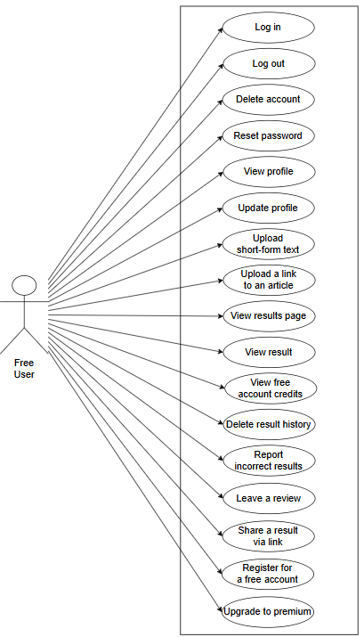
Figure 15.1. Free User use-case diagram retained from the UIABO URS.

15.2 Premium User
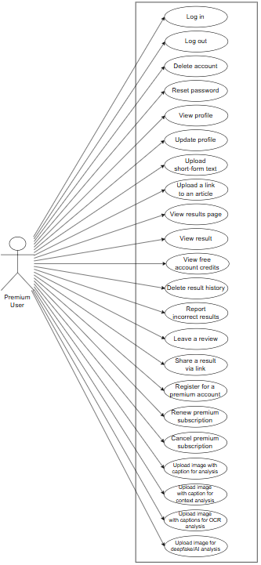
Figure 15.2. Premium User use-case diagram retained from the UIABO URS.

15.3 System Administrator
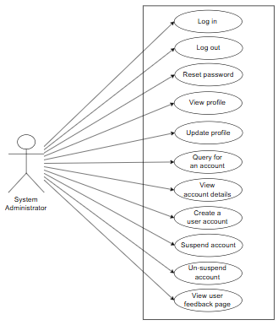
Figure 15.3. System Administrator use-case diagram retained from the UIABO URS.

15.4 Data Engineer
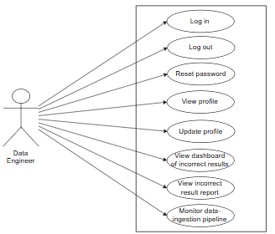
Figure 15.4. Data Engineer use-case diagram retained from the UIABO URS.

16 System Design

16.1 Architecture and Data Flow
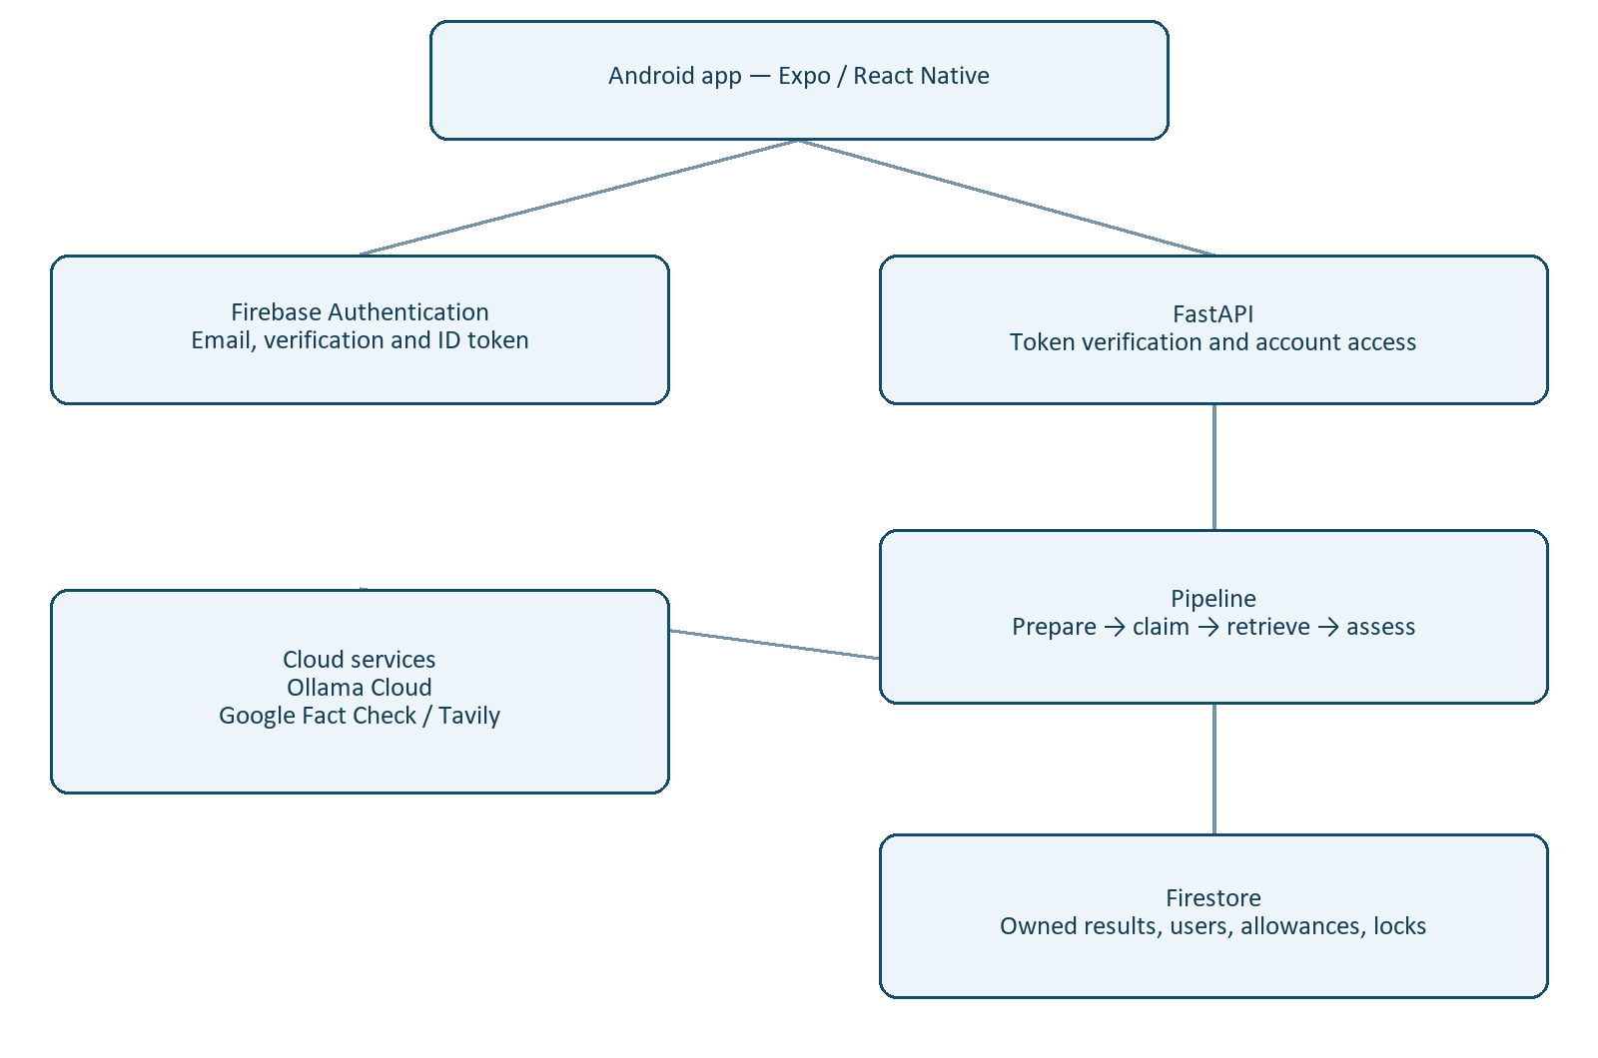
Figure 16.1. Components of the implemented text-checking architecture.
The client authenticates with Firebase and sends an identity token to FastAPI. The backend validates access and executes the pipeline using server-side provider credentials. The authoritative result and allowance update are committed to Firestore together, and the result is returned to the app. History reads go through the backend ownership checks.

16.2 Pipeline Interfaces
Stage | Contract | Implemented responsibility
Input preparation | PreparedText | Original/normalised input, language and warnings.
Claim analysis | ClaimAnalysis | Checkability, category, grounded claim and vote agreement.
Evidence retrieval | RetrievalResult | Accepted passages, citations, provenance, warnings and retrieval status.
Evidence assessment | AssessmentResult | Concern label, score or null, uncertainty, explanation and passage stances.
Orchestration | TextAnalysisResult / FailedAnalysisRecord | Combine validated stages or report a structured failure.

16.3 Claim Classification and Extraction
Three configured Ollama Cloud models classify the text into factual, opinion, joke or satire, prediction, personal experience, or unverifiable. A strict response schema rejects invalid labels and malformed output. At least two valid model responses are required. The majority result determines the category; unresolved disagreement does not establish a reliable checkable claim.
The claim-confidence field is the winning vote count divided by the three configured models. It measures model agreement, not factual accuracy. For a checkable factual input, the extraction model returns a claim that must match the submitted text after permitted normalisation. An invented or unsupported claim span is rejected.

16.4 Retrieval and Applicability Decisions
Web retrieval combines preferred sources with bounded broader discovery. Semantic relevance checks determine whether a selected passage directly concerns the claim or provides context. Applicability records whether scope is established, context is missing, the population or condition differs, or time applicability is uncertain.
The model selects numbered source sentences; the backend copies their text. User details such as nationality, visa scheme or dates are not invented to make the query answerable. A policy applying only to a particular population is not automatically decisive for an underspecified personal claim.

16.5 Evidence Assessment and Aggregation
The semantic assessor labels each passage supporting, contradicting or neutral and provides a reason and literal quote. An invalid quote or response can trigger one bounded repair using numbered source spans. Context-only or unresolved-scope evidence is forced neutral during aggregation even if a stance response initially suggests support.
Exact duplicates are removed, and each origin contributes at most once per stance. Conflicting passages remain represented. The concern score uses prototype weights; it is not a calibrated probability of misinformation. NEI uses a null score, and semantic confidence is conservatively capped at Medium.

16.6 Firestore Data Design
Collection / key | Representative stored fields | Purpose
users / UID | uid, name, email, email_verified, role, account_status, timestamps | Server-owned profile and account status.
usage_allowances / UID | tier, period_type, period_start/end, submission_limit, successful_submissions, remaining_submissions, reset_at | Calendar-based successful-check accounting.
analysis_results / result ID | user_id, original_text, claim, evidence, assessment, processing_status, pipeline_version, timestamps, request_fingerprint | Owned completed and failed analysis records.
analysis_locks / UID | token, result_id, expires_at | Exclusive in-progress reservation with a bounded lease.

A result ID is derived from the user ID and request key. The request fingerprint detects a key reused with different text. Shared Pydantic contracts validate the public result shape. New evidence provenance is optional so that existing saved records remain readable.

16.7 API Interfaces
Route | Function
PUT /account/me | Create or refresh the current profile and display name.
GET /account/me | Read the verified user’s profile and allowance.
POST /analysis/text | Run an authenticated text check with optional Idempotency-Key header.
GET /analysis/results | List owned history with limit and cursor.
GET /analysis/results/{result_id} | Read one owned saved result.

16.8 Submission Sequence and Failure Handling
- App sends text, Firebase token and request key.
- Backend verifies identity and active profile, checks allowance and obtains a leased reservation.
- Input, claim, retrieval and assessment stages run against request-local computation storage.
- For completion, a Firestore transaction writes the owned result and deducts one successful check.
- For a pipeline failure, a failure record is saved without a successful-check deduction.
- The reservation is released when possible; its lease bounds interruption recovery.
- The app shows the response. Repeated completed requests return the same saved result.

16.9 Application Screens
We captured the following Android screens on 7 September 2026. The account values are examples. These screenshots predate the assessment and retrieval changes made on 8–9 September. Inactive Home cards are outside the implemented checking functions.

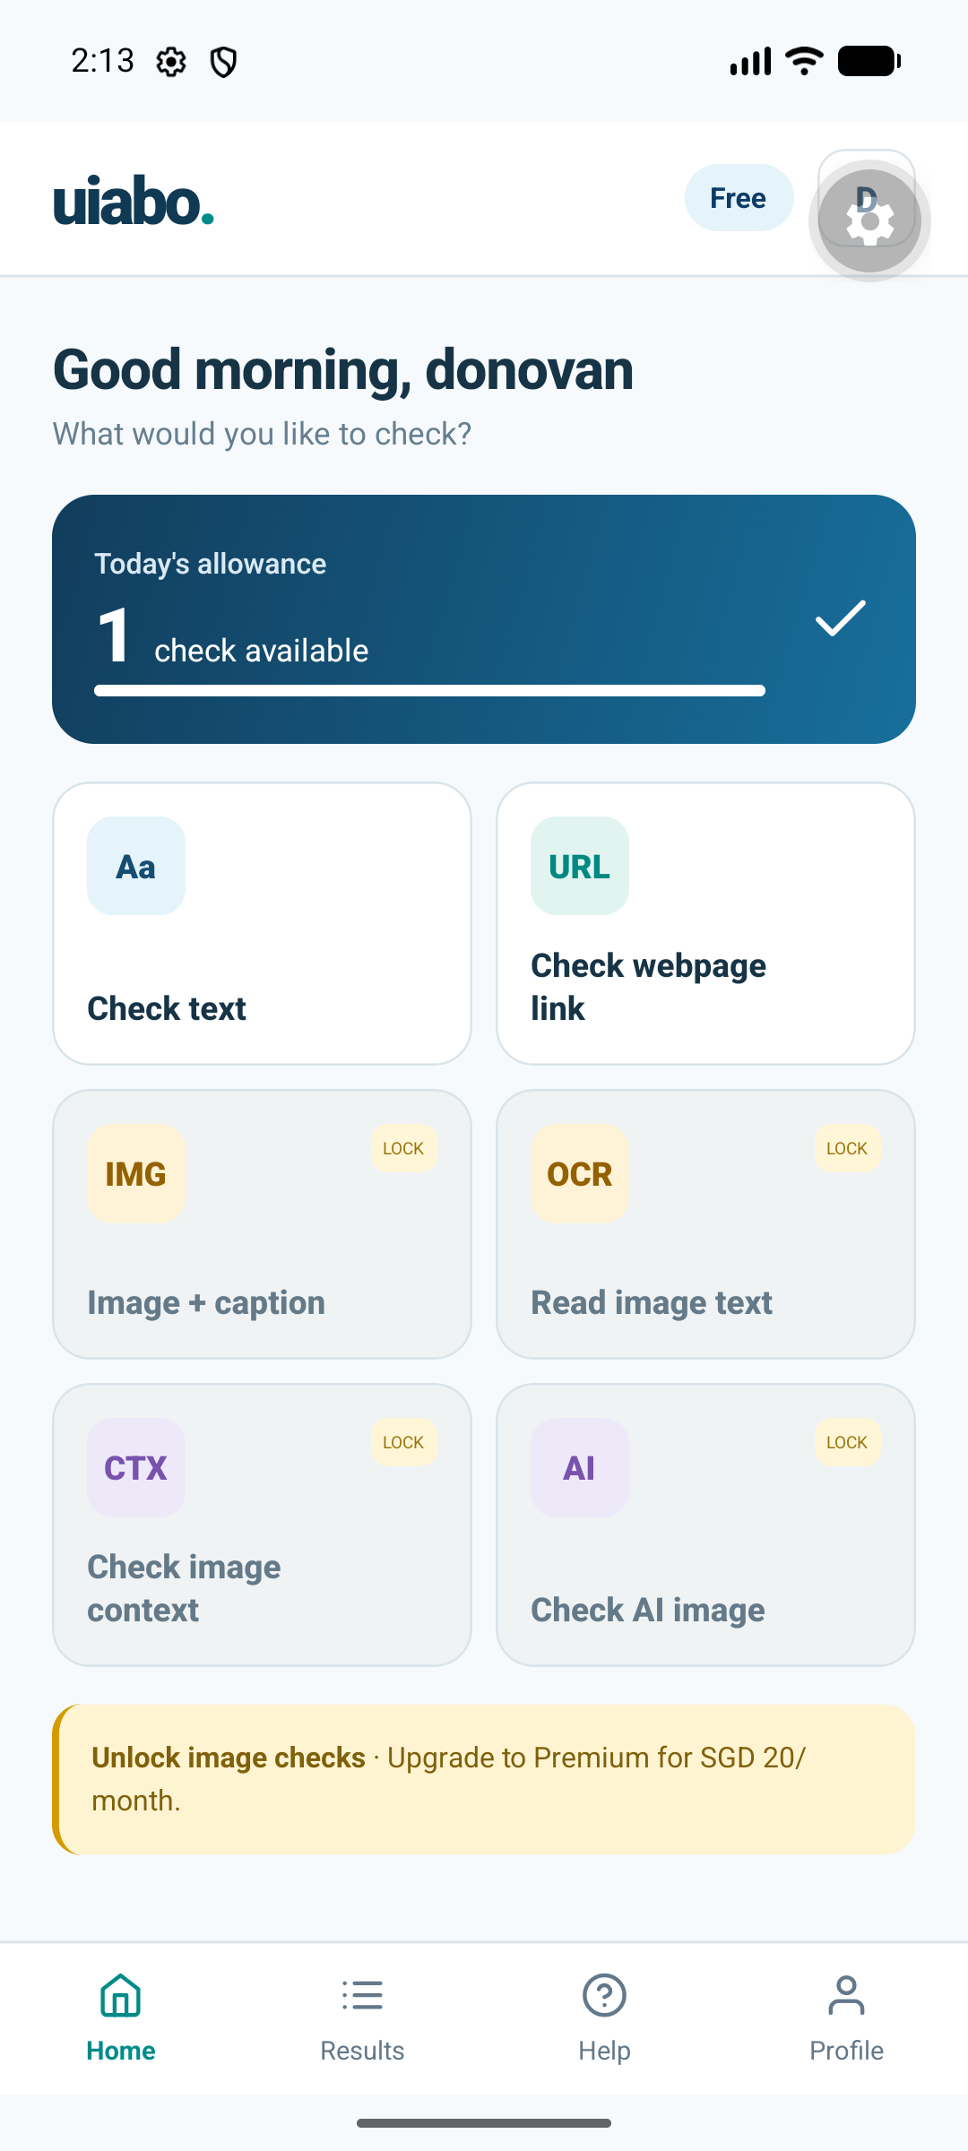
Figure 16.2. Free-account Home, captured 7 September 2026.

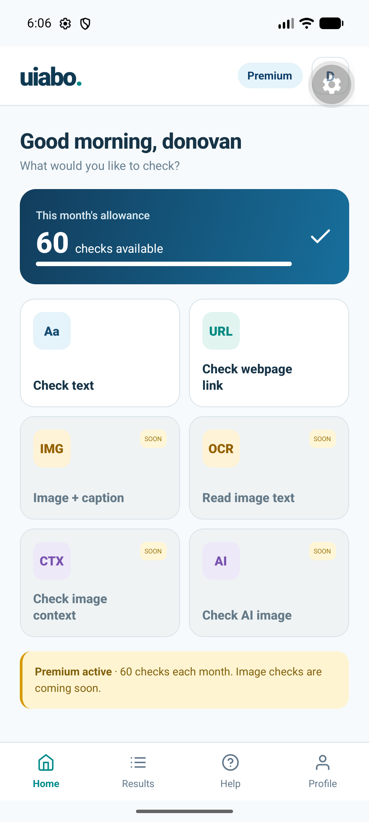
Figure 16.3. Premium-account Home, captured 7 September 2026.

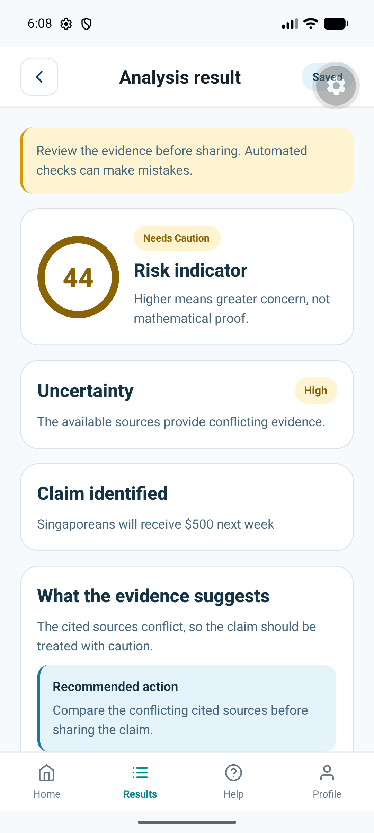
Figure 16.4. Saved text-assessment interface, captured 7 September 2026.

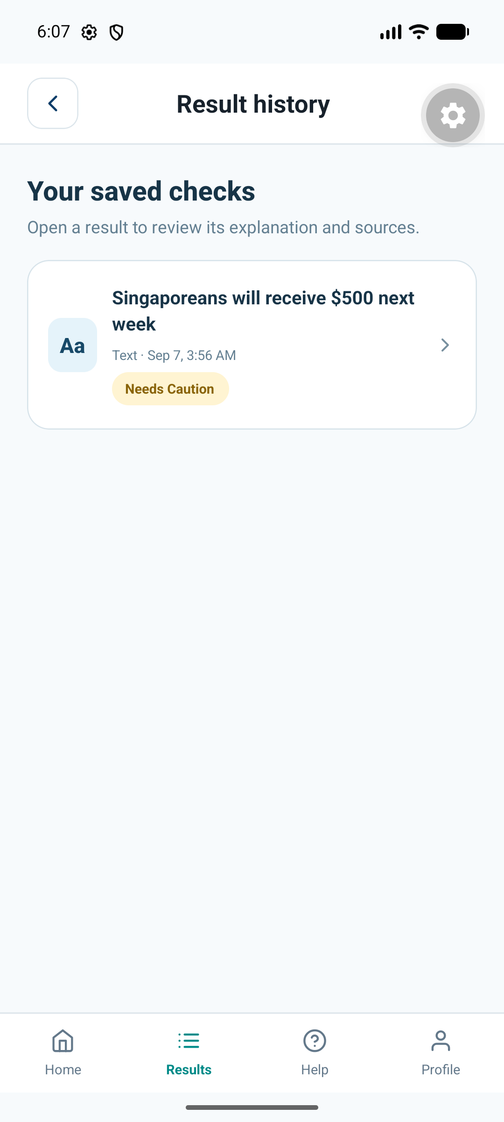
Figure 16.5. Owned result history, captured 7 September 2026.

16.10 Full Planned-System Diagrams
These TDM diagrams describe the planned complete system. The current runtime implements the Android text path and a subset of the shown Firestore collections.
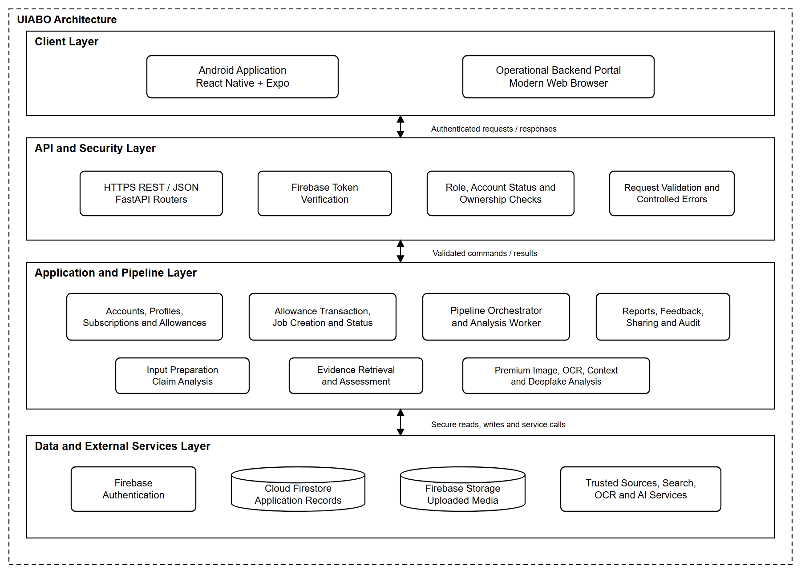
Figure 16.6. Planned UIABO system architecture.
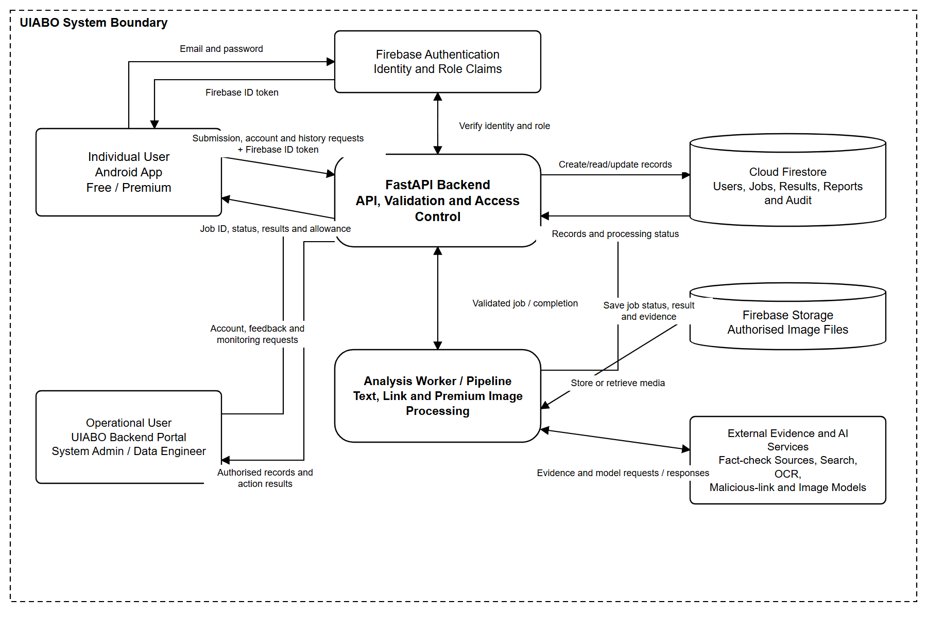
Figure 16.7. Planned UIABO data flow.
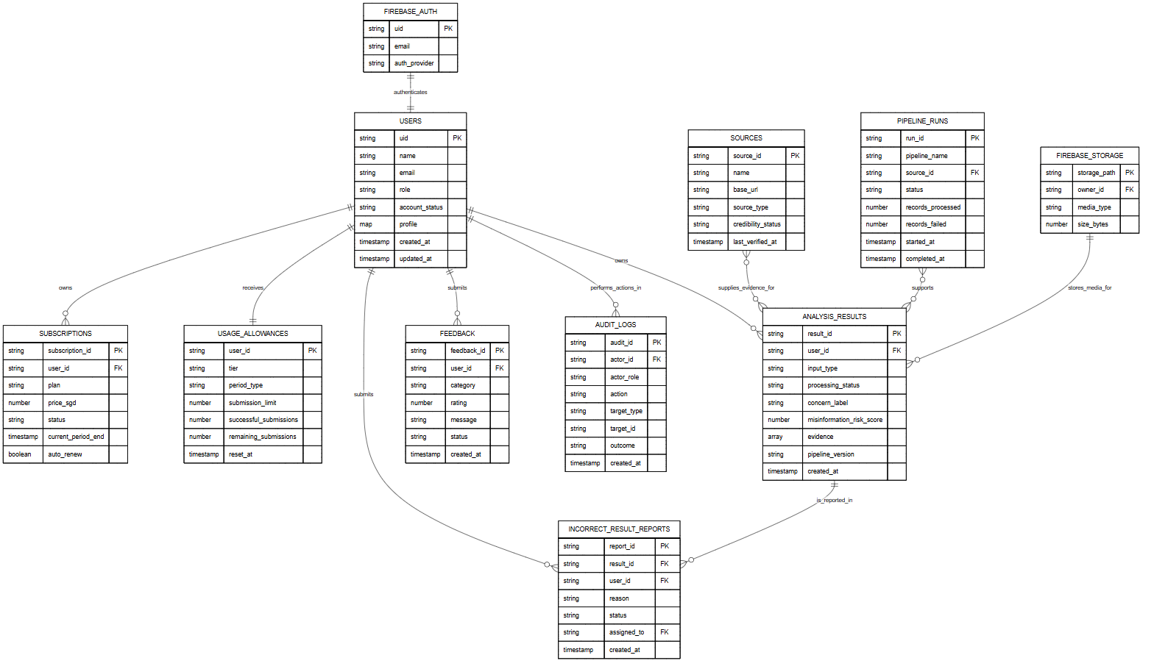
Figure 16.8. Planned Firestore database design.

16.11 Proposed Interface Samples
The following static samples were prepared during earlier interface-design work. They are proposed screens, not emulator evidence. The obsolete public landing page is intentionally excluded.

16.11.1 Pre-authentication
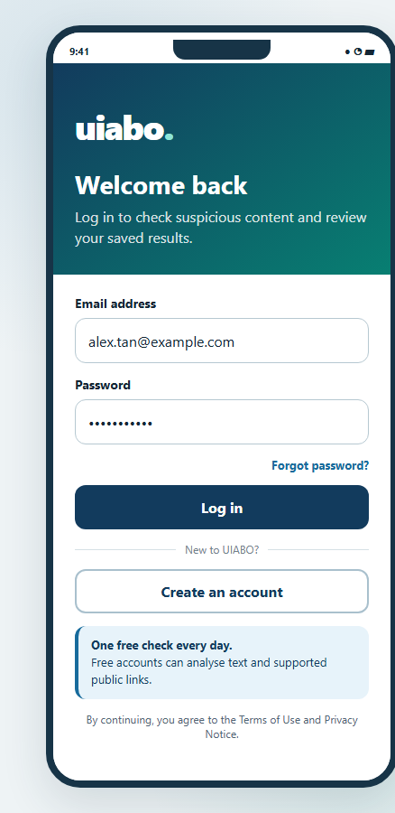  Proposed login screen | 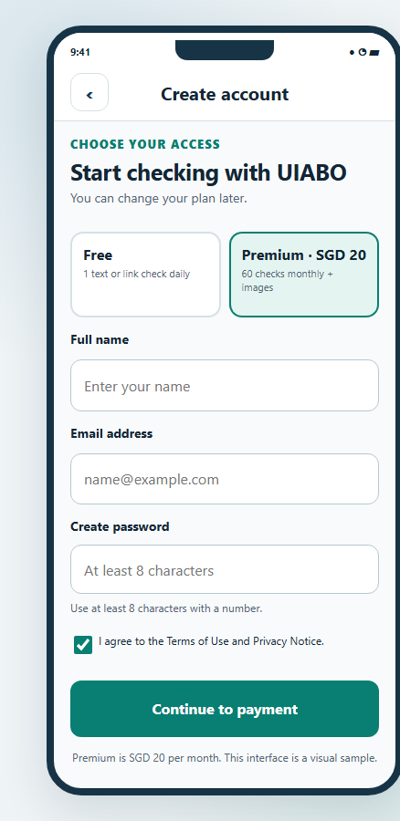  Proposed registration screen

16.11.2 Free User
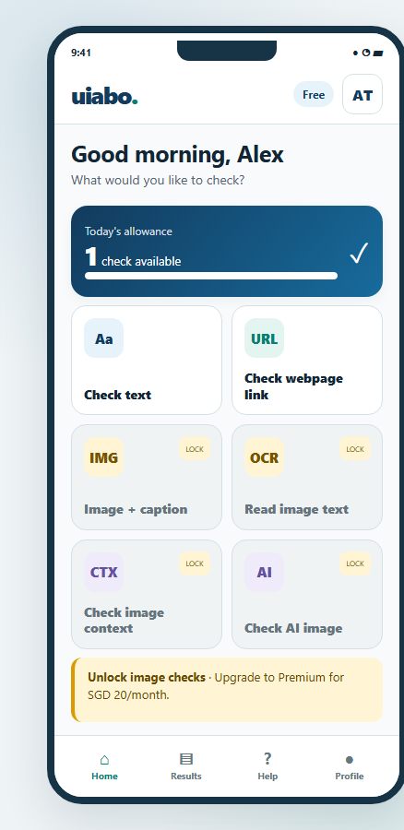  Free Home and feature menu | 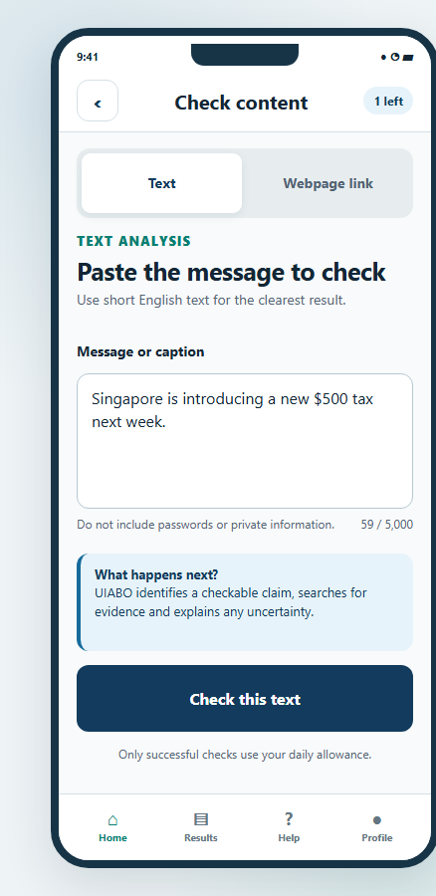  Text analysis input
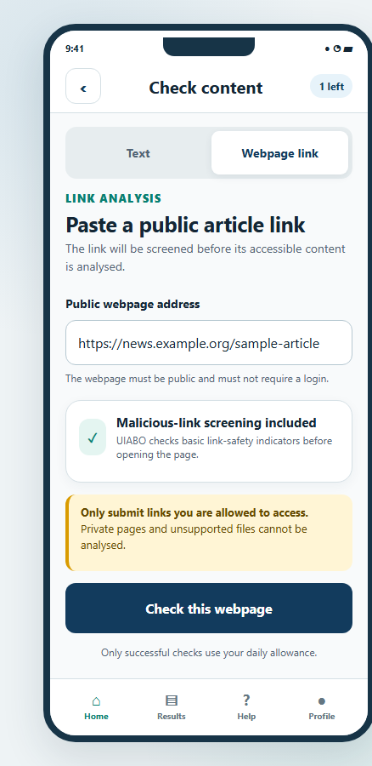  Planned public-link analysis | 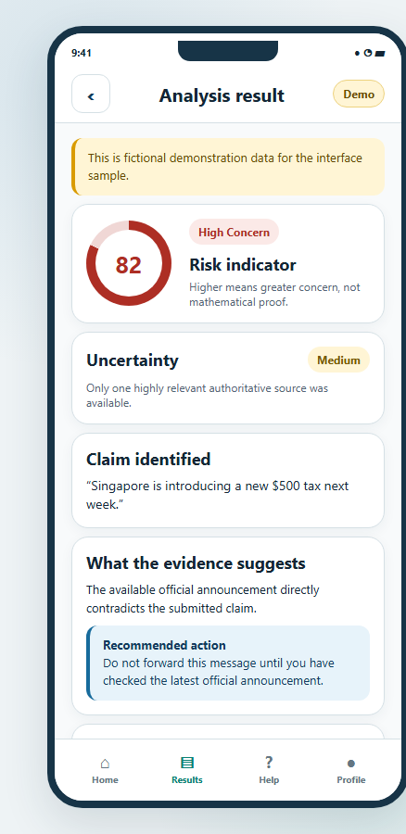  Result and evidence
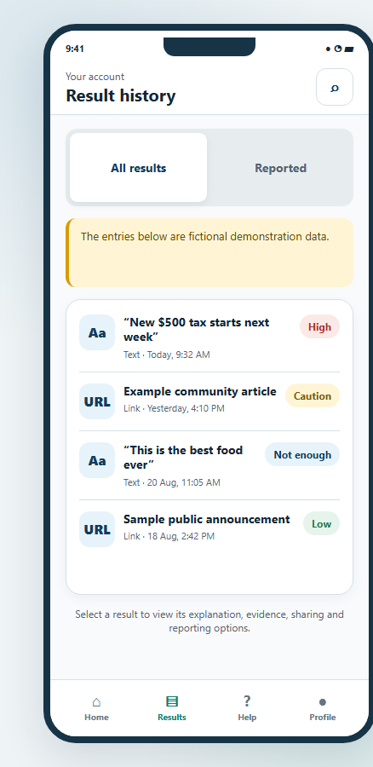  Result history | 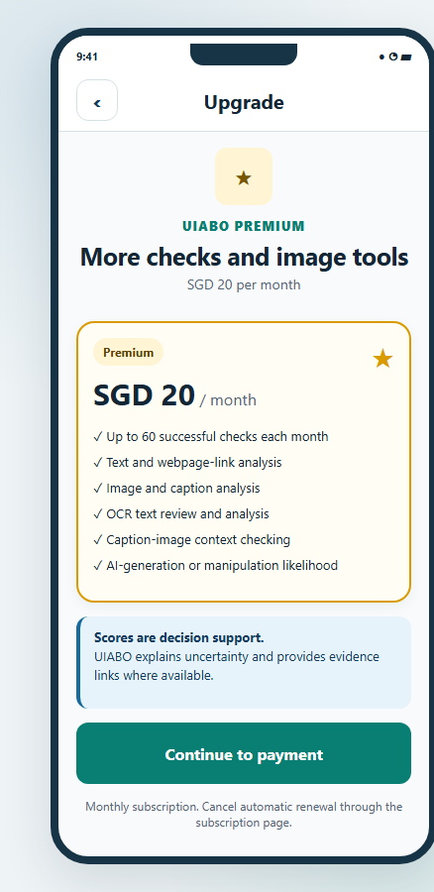  Planned Premium upgrade

16.11.3 Premium User
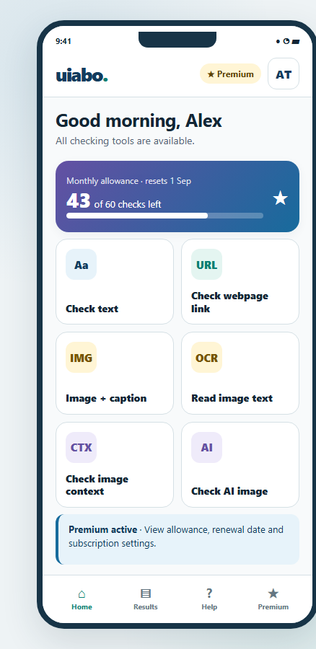  Premium Home and feature menu | 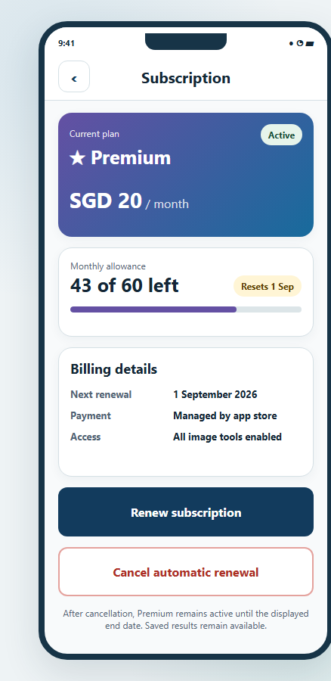  Planned subscription screen
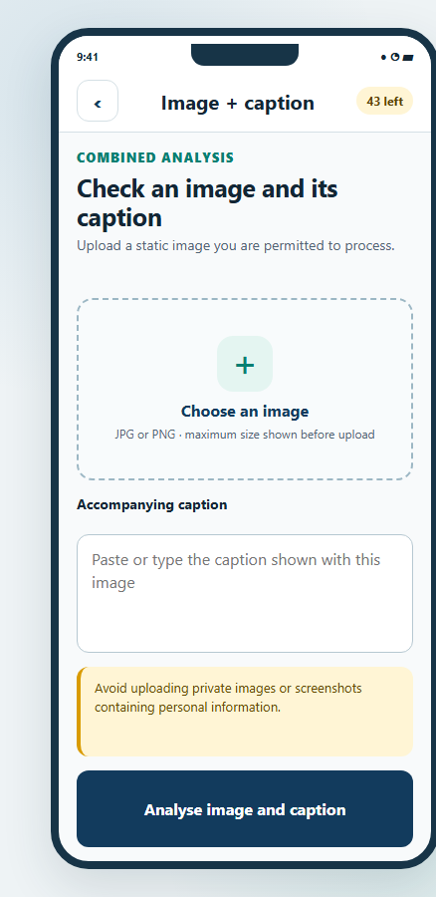  Planned image and caption input | 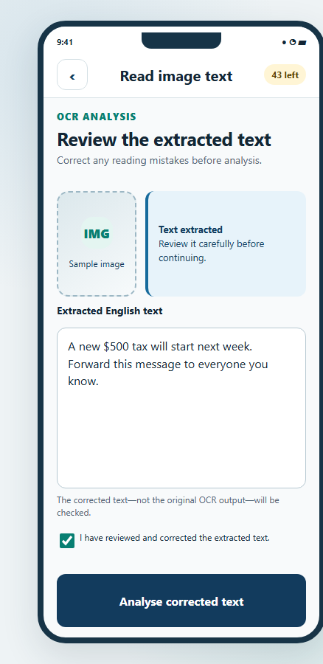  Planned OCR review
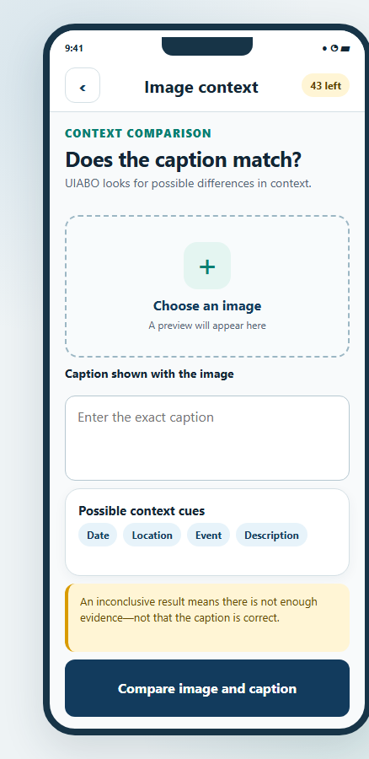  Planned caption-image context result | 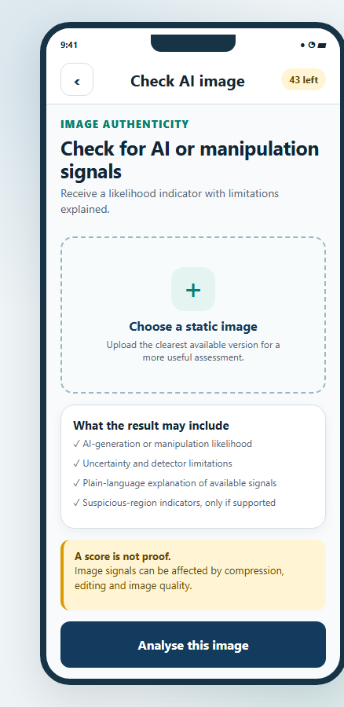  Planned image-authenticity result

16.11.4 System Administrator
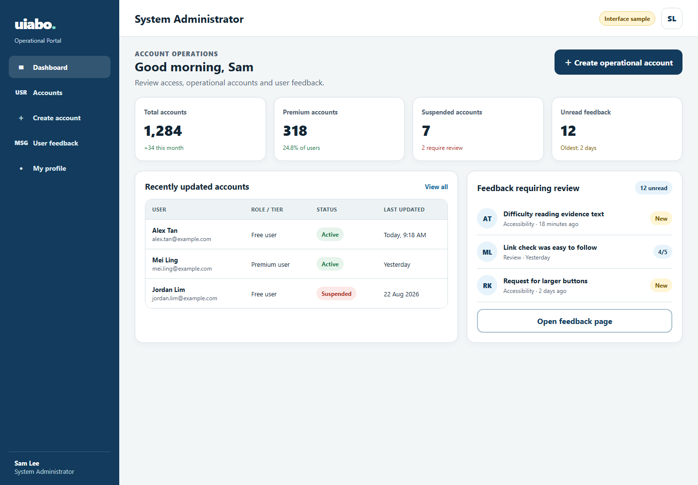  Planned administration dashboard | 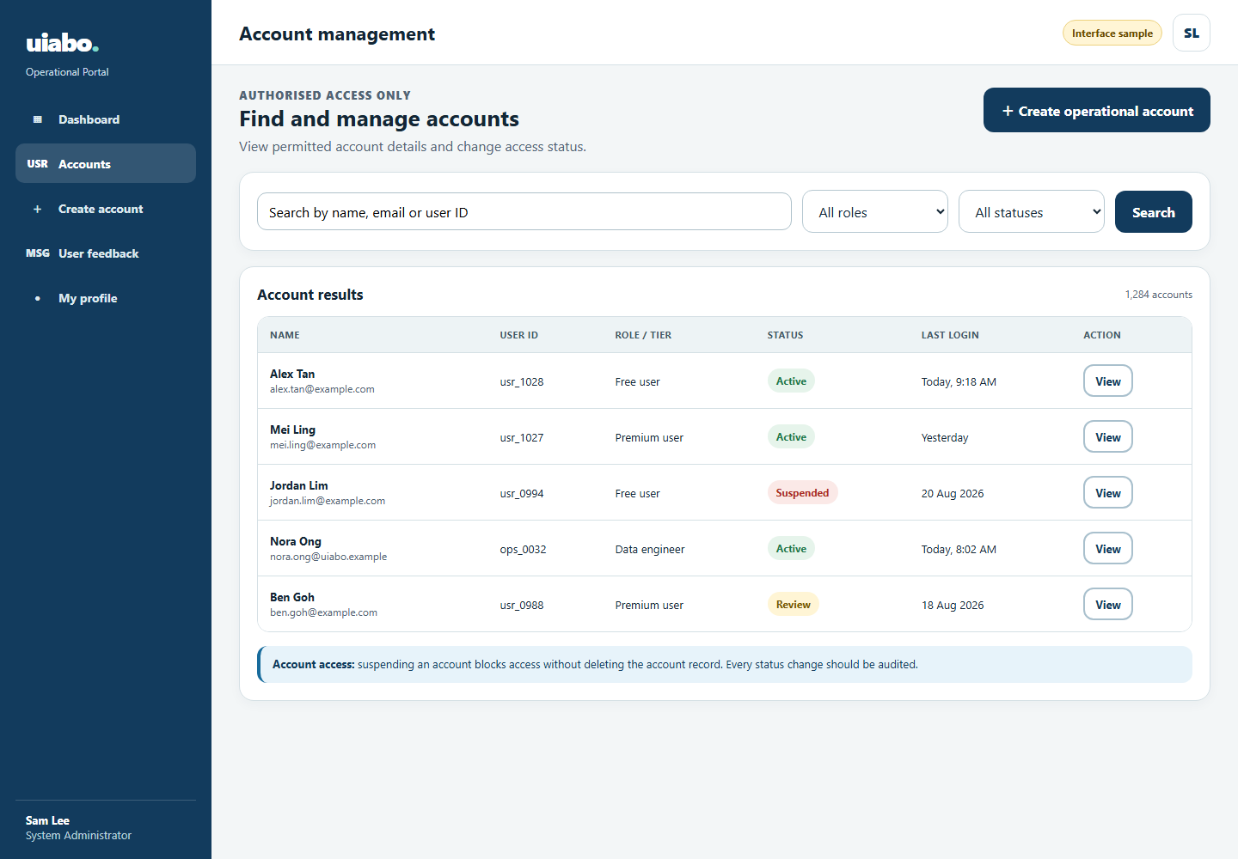  Planned account management
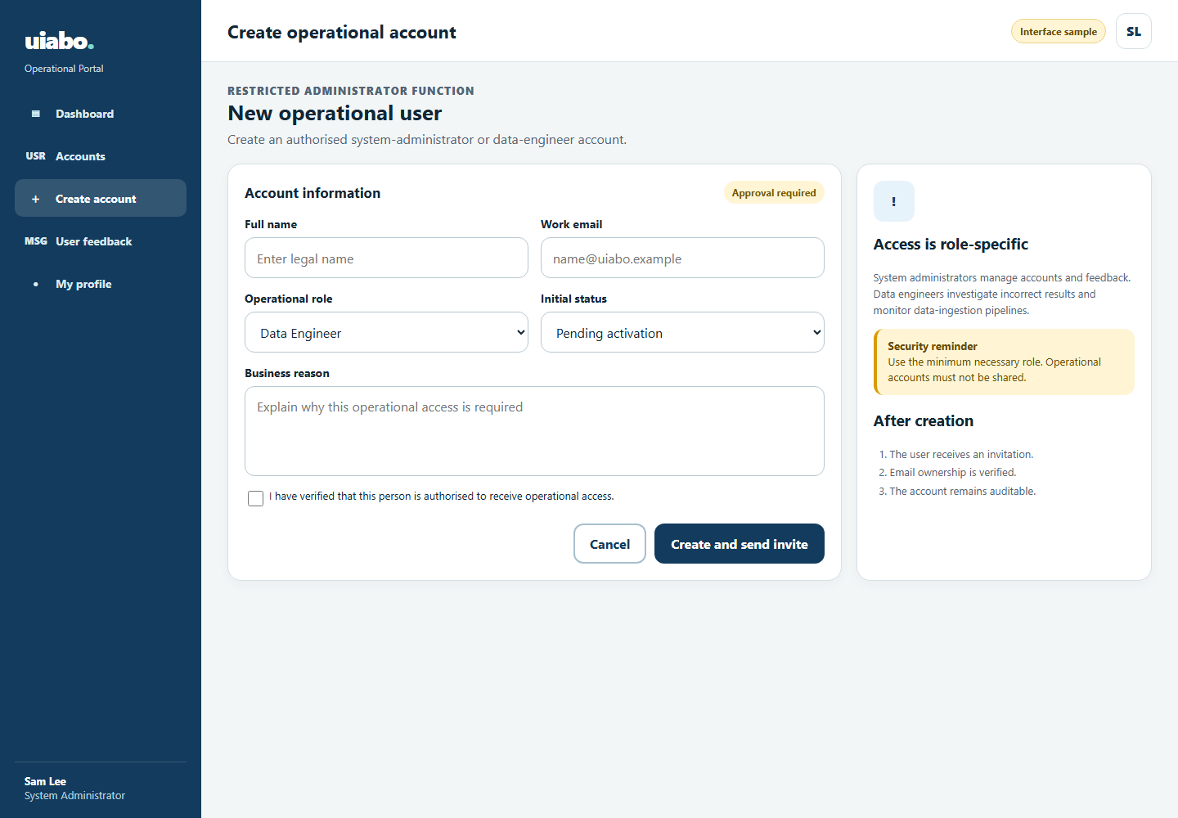  Planned operational-account creation | 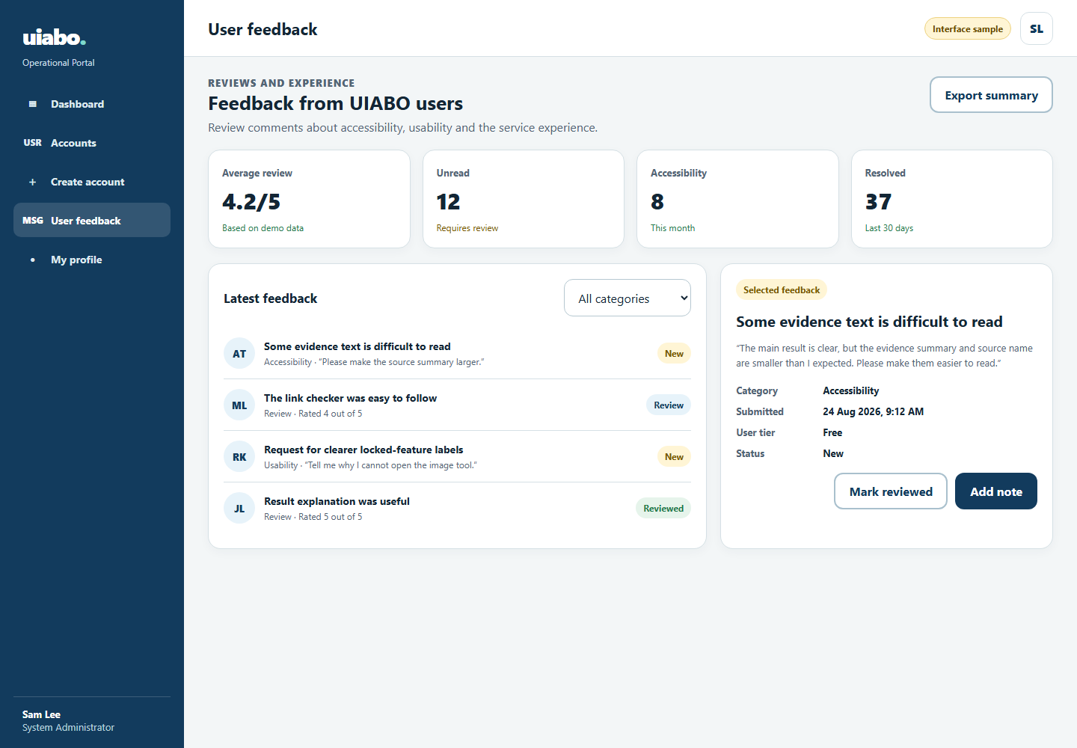  Planned feedback review

16.11.5 Data Engineer
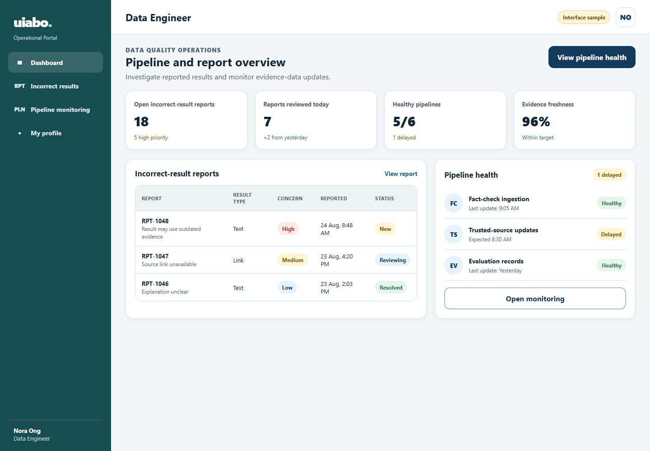  Planned incorrect-result dashboard | 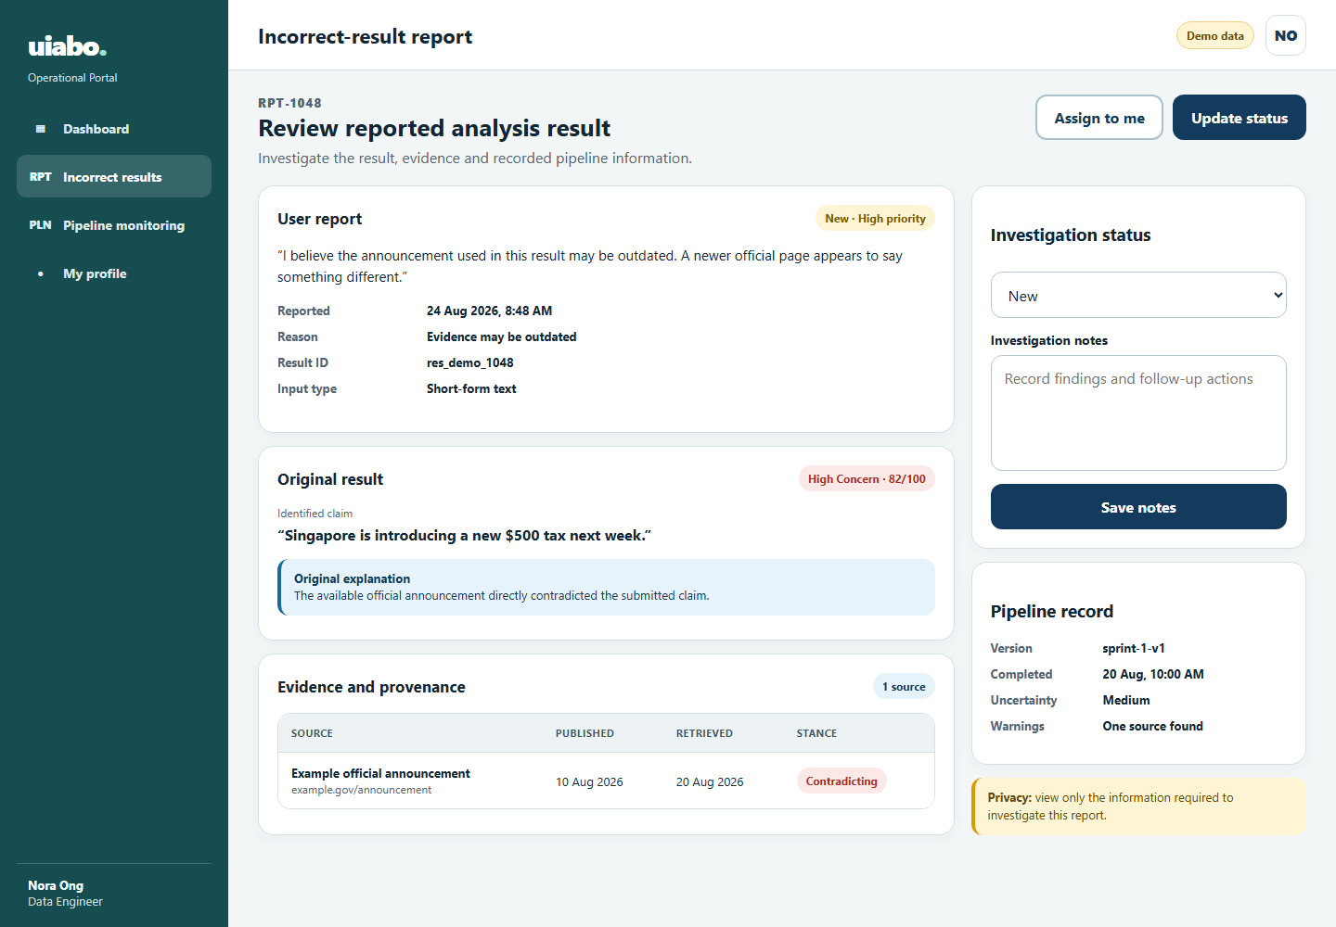  Planned report investigation
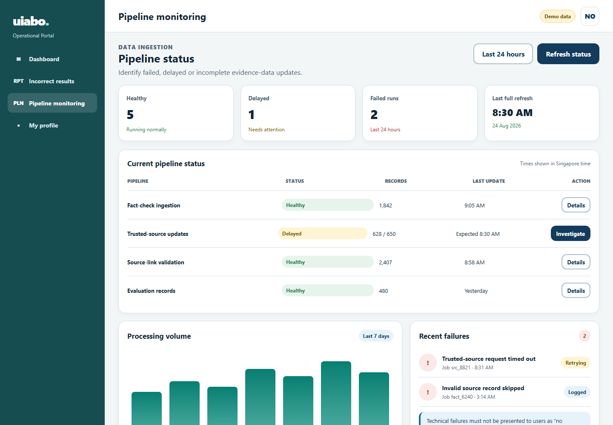
Planned ingestion monitoring

17 Conclusion
We have connected Android account access, text submission, claim analysis, evidence retrieval, passage assessment and Firestore persistence. UIABO provides a readable concern result, citations, uncertainty, private history and server-controlled allowances.
We added broader eligible-source discovery, semantic relevance checks, scope-aware neutral decisions and literal quotation validation. The tests passed for the cases we exercised. Evaluation remains limited by provisional labels, small samples, provider failures and incomplete retrieval coverage, so we cannot yet claim general detection accuracy.

18 Glossary
Term | Meaning
Assessment | The prototype’s evaluation of a claim against retrieved passages.
Claim | A statement extracted from submitted text for factual checking.
Concern label | Low Concern, Needs Caution, High Concern or Not Enough Information.
Evidence provenance | Recorded source eligibility, discovery, relevance and applicability details.
Firestore | Cloud document database used for owned account and result records.
Idempotency | A repeated completed request returns its saved result without another deduction.
NEI | Not Enough Information: the current evidence does not justify a decisive assessment.
Origin group | Source grouping used to limit repeated contributions to aggregation.
Stance | Supporting, contradicting or neutral relationship of a passage to a claim.
UID | Firebase account identifier used for ownership.
WBS | Work Breakdown Structure; the functionality hierarchy in Figure 5.1.

19 Appendix

19.1 Test Results
We tested the backend, exported the Android app and evaluated stance assessment and retrieval using the cases described below. The results are dated 7–9 September 2026. Software test passes establish behaviour on the exercised cases, rather than factual accuracy on arbitrary real-world claims.
Record | Observed outcome | Interpretation
Recorded backend baseline, 9 September | 400 tests passed; one Starlette/HTTPX deprecation warning. | Previously recorded baseline; the exact environment must remain identifiable.
Android export, 8 September | Export passed following result-screen and timeout changes. | Build/export evidence, distinct from user or device testing.
Android / Firestore integration, 7 September | Application screenshots and integrated result/history checks. | Validates the connected prototype on 7 September; retrieval v3 was not visually tested in Android.
Local runtime, 9 September | OpenAPI HTTP 200; Expo listening; no Android device connected at final check. | Local services were available at the time of the check.
PTD review rerun, 9 September | 398 passed, 2 failed; one existing deprecation warning. | Failures concerned real retrieval/API wiring under local web mode and the expected catalogue-mode default. Resolve configuration isolation before claiming a current clean suite.

19.1.1 Stance Evaluation — 8 September
Split | Semantic v2r2 label matches | Lexical baseline
Development | 70 / 72 | 24 / 72
Reserved split | 43 / 48 | 16 / 48
Historical regression | 5 / 5 | 4 / 5

The final stance run had zero literal-quote errors across 125 cases. The label matches are based on a constructed dataset with provisional labels. We have already inspected the reserved split, so it is no longer an untouched holdout. These stance-only results do not measure the end-to-end accuracy of the retrieval-v3 app.

19.1.2 Retrieval Evaluation — 9 September
Run / version | Observed label matches | Technical errors
Initial development, v1, 24 cases | Catalogue 11/24; web 11/24 | Catalogue 11; web 13
Slower paired sample, v2, 8 cases | Catalogue 6/8; web 7/8 | One in each mode
Final targeted regression, v3, 4 cases | Web 3/4 | Zero

The initial run encountered provider throttling and relevance-validation errors. We retained those failures in the totals. The slower v2 sample returned evidence for 5/8 catalogue cases and 6/8 web cases, with mean processing times of 11.56 and 17.83 seconds respectively, excluding evaluation cooldowns. Both modes had zero wrong decisive answers and zero literal-quote errors in those eight cases.
The final v3 check refuted the Great Wall/Moon claim, kept the personal Phuket requirement uncertain because context was missing, and treated a food preference as non-factual. A false Moon-rings claim remained uncertain because adequate evidence was not retrieved. The four-case run had no technical errors, wrong decisive answers or invalid quotes. It is a targeted regression check; the eight-case v2 figures are not a complete v3 evaluation.
We ran live evaluations with real providers and in-memory persistence. API tests covered owned history and idempotent replay with provenance, while Firestore serialization tests used a fake client. These runs did not write user records, consume user allowances or test the Android interface.

19.2 Evaluation Review
G15 — Independent dataset review

G16 — Complete evaluation of a frozen current version

19.3 Meeting Minutes
On 13 August 2026, we reviewed the initial FastAPI health and text endpoints, shared request and response contracts, and Firebase write/read checks. We also identified the need to connect the real pipeline stages.
G17 — Formal meeting minutes and supervisor feedback

19.4 References
Corney, D. (2025, February 11). How AI can help fact checkers. Full Fact AI. https://fullfact.ai/blog/how-ai-can-help-fact-checkers/
Digital for Life. (2025, July 8). Seniors Go Digital: Digital skills for seniors. https://www.digitalforlife.gov.sg/About/Our-Projects/Seniors-Go-Digital
Factiverse. (n.d.-a). Factiverse API. Retrieved July 31, 2026, from https://www.factiverse.ai/solutions/api
Factiverse. (n.d.-b). Factiverse Gather. Retrieved July 31, 2026, from https://www.factiverse.ai/solutions/gather
Factiverse. (n.d.-c). Factiverse Live. Retrieved July 31, 2026, from https://www.factiverse.ai/solutions/live
Full Fact AI. (n.d.). How we do it. Retrieved July 31, 2026, from https://fullfact.ai/product/
Google. (2024, August 8). Fact Check Tools API. Google for Developers. https://developers.google.com/fact-check/tools/api/reference/rest
Johnston, C. (2025, October 1). How we're using generative AI to transcribe challenging audio. Full Fact AI. https://fullfact.ai/blog/using-generative-aI-to-transcribe-challenging-audio/
National Population and Talent Division. (2026, July 8). Longevity. https://www.population.gov.sg/our-population/population-trends/longevity/
NewsGuard. (n.d.-a). False Claim Fingerprints. Retrieved July 31, 2026, from https://www.newsguardtech.com/solutions/false-claim-fingerprints/
NewsGuard. (n.d.-b). False Claim Fingerprints process. Retrieved July 31, 2026, from https://www.newsguardtech.com/ratings/false-claim-fingerprints-process/
NewsGuard. (n.d.-c). News Reliability Ratings. Retrieved July 31, 2026, from https://www.newsguardtech.com/solutions/news-reliability-ratings/
Soon, C., Bala Krishnan, N., & Goh, S. (2022, March 17). Why are some people more immune to falsehoods and what can we learn from them? Institute of Policy Studies. https://lkyspp.nus.edu.sg/ips/publications/details/commentary-why-are-some-people-more-immune-to-falsehoods-and-what-can-we-learn-from-them
WeVerify. (n.d.-a). Context aggregation and analysis. Retrieved July 31, 2026, from https://weverify.eu/tools/caa/
WeVerify. (n.d.-b). Image Verification Assistant. Retrieved July 31, 2026, from https://weverify.eu/tools/image-verification-assistant/
WeVerify. (n.d.-c). Tools. Retrieved July 31, 2026, from https://weverify.eu/tools/
WeVerify. (n.d.-d). Verification plugin. Retrieved July 31, 2026, from https://weverify.eu/verification-plugin/
World Wide Web Consortium. (2025, November 20). Older users and web accessibility: Meeting the needs of ageing web users. https://www.w3.org/WAI/older-users/
Expo. SDK 57 reference. Accessed 7 September 2026. https://docs.expo.dev/versions/v57.0.0/
Firebase. Verify ID tokens. Accessed 7 September 2026. https://firebase.google.com/docs/auth/admin/verify-id-tokens
Firebase. Transactions and batched writes. Accessed 7 September 2026. https://firebase.google.com/docs/firestore/manage-data/transactions
Ollama. Cloud. Accessed 7 September 2026. https://docs.ollama.com/cloud
Google. Fact Check Tools API: claims.search. Accessed 7 September 2026. https://developers.google.com/fact-check/tools/api/reference/rest/v1alpha1/claims/search
Tavily. Search API. Accessed 7 September 2026. https://docs.tavily.com/documentation/api-reference/endpoint/search
Tavily. Extract API. Accessed 7 September 2026. https://docs.tavily.com/documentation/api-reference/endpoint/extract

19.5 Demonstration / Release Record
G18 — Exact demonstrated build and submission record

