


CSIT-26-S3-30: AI-Based Misinformation Detection for Short-Form Content

FYP-26-S3-30: Project Requirement Documentation

Team

Student Name | UOW ID | Student E-mail
Ho Sze Wei, Donovan | 8949724 | swdho001@mymail.sim.edu.sg
Wong Yi Da | 1037274 | ydwong003@mymail.sim.edu.sg
Matthew Alexander Peeris | 1052585 | peeris001@mymail.sim.edu.sg
CHU WAI CHUNG | 8949256 | wcchu001@mymail.sim.edu.sg
POON CHUN PING | 8865747 | cppoon001@mymail.sim.edu.sg

Supervisor:
Mr Liaw Chun Huei

Table of Contents
1. Introduction 3
1.1 Overview 3
1.2 Project Scope 3
1.3 Research Finding Analysis 5
1.4 Project Description 8
1.5 Business Model 9
2. Project Motivation 13
3. Requirements 14
3.1 Functional Requirements 14
3.2 Non-Functional Requirements 17
4. Proposed Plan 19
4.1 Execution Strategy 19
4.2 Software Development Methodologies 19
4.3 Risk Analysis 23
4.4 Roles and Responsibilities 24
4.5 Gantt Chart 25
5. Development Tools 26
5.1 Front-End 26
5.2 Back-End 26
5.3 Database 26
5.4 API Communication 27
5.5 Authentication 27
6. Expected Results 28
7. Conclusion 29
References 30

1. Introduction

1.1 Overview
The increasing use of smartphones, messaging applications and social-media platforms has changed how people consume and share information. Online content is frequently circulated in short formats such as messages, captions, screenshots, memes and images. Although these formats make information easy to distribute, they can also allow inaccurate, outdated or misleading claims to spread without sufficient verification.
Evaluating suspicious content may require a user to identify the factual claim, locate the original source, search for previous fact-checks and compare information across reliable sources. This process can be difficult for users with limited fact-checking experience. Research by the Institute of Policy Studies found a misinformation-immunity gap among Singaporeans: respondents who were more susceptible tended to be older, relied more heavily on friends and social media for news, and were less familiar with external validation practices such as consulting authoritative sources (Soon et al., 2022).
Singapore also has a rapidly ageing population. The proportion of citizens aged 65 and above increased from 13.1% in 2015 to 20.7% in 2025 and is projected to reach 23.9% by 2030 (National Population and Talent Division, 2026). At the same time, initiatives such as Seniors Go Digital show that older residents actively use smart devices and online services, while some continue to benefit from guided support in exploring information and staying safe online (Digital for Life, 2025). Accordingly, the prototype will focus specifically on Singapore citizens aged 65 and above so that its target group is consistent with the population statistics used in this PRD.
uiabo will be an accessible AI-assisted misinformation-checking Android application for Singapore citizens aged 65 and above. Free users will be able to submit text or a public webpage link once per day. Premium users will receive up to 60 successful submissions per month and will also be able to upload images with captions, review OCR-extracted text and use an image deepfake-detection function.
Instead of returning only a binary true-or-false verdict, the result page will provide a misinformation risk score, an AI-generation or manipulation likelihood score where applicable, uncertainty information, a plain-language explanation and links to supporting or contradicting evidence. The system is not intended to replace professional fact-checkers or guarantee that every result is correct. It will function as a decision-support tool that encourages users to review evidence before believing or forwarding suspicious content.

1.2 Project Scope
The primary objective of uiabo is to develop an elderly-friendly Android mobile application that assists users in assessing potentially misleading short-form content. The initial prototype will support English-language text, public webpage links and static images. Access will be tiered: free users may submit text or webpage links once per day, while premium users may perform up to 60 successful analyses per month and access image, OCR and deepfake-detection functions.

Core Functions

Content Submission
- Free users and premium users may paste short-form text or captions.
- Premium users may upload images, screenshots and memes together with an accompanying caption.
- Premium users may add or edit the caption associated with an uploaded image.
- Premium users may review and correct OCR-extracted text before analysis.
- Free users and premium users may submit a supported public webpage or article link. The system will also inspect the submitted URL for malicious-link indicators.

Text and Image Processing
- Extract visible text from premium image submissions using Optical Character Recognition (OCR).
- Identify objectively checkable factual claims.
- Distinguish factual claims from opinions, jokes and other non-verifiable statements.
- Analyse the relationship between a premium user’s uploaded image and its caption.
- Identify possible contextual mismatches involving date, location, event or description, and generate an image deepfake or manipulation likelihood score where supported.
Caption-image analysis will focus on contextual inconsistency. The premium deepfake detector may identify indicators associated with AI generation or digital manipulation, but its score will be presented as probabilistic supporting evidence rather than conclusive proof. Its media-forensics explanation will translate the detector's available technical output into plain language by describing the signals that influenced the score, their limitations and, when supported by the detector, any suspicious visual regions. It will not treat a heatmap or individual artefact as proof of manipulation.

Fact-check and Evidence Retrieval
- Search for semantically similar claims that have already been reviewed by fact-checking organisations.
- Retrieve supporting or contradicting evidence from available sources.
- Prioritise authoritative and credible sources.
- Assess the credibility of the original source when sufficient information is available.
- Display links to the evidence used in the assessment.

Result Generation
- Display a clear result page with a simple concern label.
- Display a misinformation or fake-news risk score.
- Display an AI-generation or manipulation likelihood score where applicable and communicate the uncertainty of both scores.
- Show the factual claim identified by the system.
- Provide a plain-language explanation.
- Present supporting and contradicting evidence.
- Provide source links or citations.
- Allow the user to report a result that appears inaccurate and leave a review of the service.
- Provide a shareable result link and recommend an appropriate next action, such as advising the user not to forward the content yet.
The proposed concern labels are Low Concern, Needs Caution, High Concern and Not Enough Information. Numerical values will be presented as risk or likelihood indicators rather than mathematical proof that a claim is false or that an image was AI-generated.

Account and Usage Functions
- Register an account, log in, log out, reset a password, update a profile and delete an account.
- Free users may submit text or a public webpage link once per day and cannot access image upload or OCR.
- Premium users may perform up to 60 successful submissions per month and may access all supported input and analysis functions.
- Display the user’s remaining daily or monthly submission allowance.
- Allow users to view and delete result history and share a result through a link.
- Allow users to report incorrect results, leave a review and provide feedback for investigation.
- Allow free users to upgrade to premium access.

Administrative and Data-management Functions
- System administrators may log in, log out, query and view user accounts, and suspend or unsuspend accounts.
- System administrators may review user feedback and reported problems.
- Data engineers may log in, log out and update their profiles.
- Data engineers will use a dashboard to review reported incorrect results and data-quality issues.
- Data engineers will monitor data-ingestion pipelines so that failed or incomplete updates can be identified.
- Data engineers will maintain the data, source provenance and evaluation records required by the verification workflow.

Target Users
The primary target users are Singapore citizens aged 65 and above who can use Android smartphones but may have limited experience with formal fact-checking. They may regularly encounter forwarded text, webpage links, screenshots, images or captions and prefer clear explanations over professional investigation tools. Family members may recommend the application or help an older user interpret a result.

Platforms and Language
- Android mobile application for supported Android smartphones.
- Free and premium account tiers within the mobile application.
- English-language content for the initial prototype.

1.3 Research Finding Analysis

1.3.1 AI Misinformation Products on the Market
The research focused on five products that directly support misinformation verification: Full Fact AI, Factiverse, NewsGuard, Google Fact Check Explorer and InVID-WeVerify. These products were selected because they support one or more stages of the verification process, including claim monitoring, factual assessment, retrieval of previous fact-checks, source evaluation, evidence search or multimedia verification. Supporting technologies such as general-purpose AI APIs and standalone deepfake-detection services are outside the scope of this direct market comparison.
The findings were verified against official product information on 31 July 2026. A feature is classified as documented only when the vendor identifies it as a current and substantive capability. A partial classification means that the feature is indirect, optional, human-operated or dependent on another component.

1.3.2 Product Comparison
To preserve readability in portrait format, the direct comparison is divided into two tables. “Yes” means that a capability is documented, “Partial” indicates an indirect or component-dependent capability, and “No” means that no current official documentation was identified. In the uiabo column, “Planned” represents a selected FYP capability, “Future” indicates a possible later enhancement, and a blank cell means that the feature is not included in the currently selected scope.
Table 1A. Direct Verification Comparison: Full Fact AI, Factiverse and NewsGuard
Feature group | Feature | Full Fact AI | Factiverse | NewsGuard
Claim analysis | Automated factual-claim extraction | Yes | Yes | Partial
Claim analysis | AI-assisted misinformation risk assessment | Partial | Yes | Partial
Multimodal input | Image and meme analysis | No | No | No
Multimodal input | Short-form video analysis | Yes | Yes | No
Multimodal input | OCR: extract text from images | No | No | No
Multimodal input | Speech-to-text / transcription | Yes | Yes | No
Context analysis | Caption-image consistency or context analysis | No | No | No
Media authenticity | AI-generated or manipulated-media detection | No | No | No
Evidence | Match claims with previous fact-checks | Yes | Yes | Yes
Evidence | Retrieve supporting or contradicting evidence | Partial | Yes | Yes
Evidence | Assess credibility of the original source | No | Yes | Yes
Explainability | Claim-level factual explanation | Partial | Partial | Yes
Explainability | Media-forensics explanation | No | No | No
Explainability | Links or citations to supporting sources | Partial | Yes | Yes
Explainability | Confidence or uncertainty score | No | Partial | Partial
Explainability | Highlight suspicious claims or visual regions | Yes | Yes | Partial
Workflow | Human-review or user-feedback workflow | Yes | No | Yes
Integration | API or external-system integration | Partial | Yes | Yes

Table 1B. Direct Verification Comparison: Google Fact Check Explorer, InVID-WeVerify and uiabo
Feature group | Feature | Google Fact Check Explorer | InVID-WeVerify | uiabo (FYP)
Claim analysis | Automated factual-claim extraction | No | No | Planned
Claim analysis | AI-assisted misinformation risk assessment | No | Partial | Planned
Multimodal input | Image and meme analysis | Partial | Yes | Planned (Premium)
Multimodal input | Short-form video analysis | No | Yes
Multimodal input | OCR: extract text from images | No | Yes | Planned (Premium)
Multimodal input | Speech-to-text / transcription | No | No
Context analysis | Caption-image consistency or context analysis | No | Yes | Planned (Premium)
Media authenticity | AI-generated or manipulated-media detection | No | Yes | Planned (Premium)
Evidence | Match claims with previous fact-checks | Yes | Yes | Planned
Evidence | Retrieve supporting or contradicting evidence | Partial | Yes | Planned
Evidence | Assess credibility of the original source | No | Partial | Planned
Explainability | Claim-level factual explanation | Partial | Partial | Planned
Explainability | Media-forensics explanation | No | Yes | Planned (Premium)
Explainability | Links or citations to supporting sources | Yes | Yes | Planned
Explainability | Confidence or uncertainty score | No | Yes | Planned
Explainability | Highlight suspicious claims or visual regions | No | Yes
Workflow | Human-review or user-feedback workflow | No | Partial | Planned
Integration | API or external-system integration | Yes | Partial | Future

1.3.3 Research Findings and Analysis
Full Fact AI supports large-scale monitoring and human fact-checking. It monitors text, audio, video, social media, radio and broadcast content; generates transcripts; extracts and ranks check-worthy statements; and matches new statements with claims that were previously fact-checked. However, the product is intended to help professional fact-checkers identify what requires investigation rather than automatically deciding whether every new claim is true or false (Corney, 2025; Full Fact AI, n.d.; Johnston, 2025).
Factiverse is the closest direct comparison to an automated evidence-backed workflow. It analyses text, audio and video; transcribes speech; detects claims; searches multiple engines and databases; prioritises credible sources; and provides Supported or Disputed assessments with linked evidence. Current documentation does not establish image or meme forensics, and Factiverse Live describes user correction and interaction as a future feature rather than a current workflow (Factiverse, n.d.-a, n.d.-b, n.d.-c).
NewsGuard specialises in source reliability and human-vetted false claims. Its News Reliability Ratings assess publishers using journalistic criteria, while False Claim Fingerprints document known false narratives, evidence, provenance, examples and spread. The source rating and the claim record serve different purposes. A publisher's 0–100 rating must not be presented as the probability that an individual post is false (NewsGuard, n.d.-a, n.d.-b, n.d.-c).
Google Fact Check Explorer is a retrieval service rather than a new-claim verifier. Through the Fact Check Tools API, users and systems can search published ClaimReview records using text or an image. This is valuable when a rumour has already been checked, but it does not extract claims, evaluate a new statement, assess the original publisher or conduct media forensics independently (Google, 2024).
InVID-WeVerify is a human-guided multimedia verification toolkit with automated components. It provides OCR, video keyframe extraction, reverse and cross-network search, fact-check and known-fake search, context aggregation, source-credibility lookup, deepfake detection and image-forensics outputs such as probability scores and heatmaps. A journalist or analyst chooses the relevant tool and interprets the evidence; the plugin does not normally produce a single automatic truth verdict for an entire post (WeVerify, n.d.-a, n.d.-b, n.d.-c, n.d.-d).
Overall market gap. None of the official documentation reviewed for the five direct-verification products describes the exact proposed combination of tiered consumer access, elderly-friendly text and link checking, malicious-link screening, evidence-backed misinformation assessment, premium image and OCR analysis, and image deepfake-risk scoring within one mobile workflow. This conclusion is limited to the documented capabilities reviewed and does not establish that every listed product lacks all of these characteristics. Factiverse is strongest for claim assessment and evidence search, NewsGuard is strongest for source reliability and curated false-claim data, Google is strongest for retrieving existing ClaimReview records, Full Fact AI is strongest for professional monitoring and repeat-claim detection, and InVID-WeVerify provides the broadest human-guided multimedia verification toolkit.

1.3.4 Selected Scope for uiabo
Table 2. Selected Features and Access Tiers for uiabo
Feature group | Selected feature | Access tier
Claim analysis | Automated factual-claim extraction | Free and Premium
Claim analysis | AI-assisted misinformation risk assessment | Free and Premium
Link security | Public webpage/article analysis and malicious-link screening | Free and Premium
Multimodal input | Image and meme analysis | Premium
Multimodal input | OCR: extract and correct text from images | Premium
Context analysis | Caption-image consistency or context analysis | Premium
Media authenticity | AI-generated or manipulated-image likelihood detection | Premium
Evidence | Match claims with previous fact-checks | Free and Premium
Evidence | Retrieve supporting or contradicting evidence | Free and Premium
Evidence | Assess credibility of the original source | Free and Premium
Explainability | Claim-level factual explanation | Free and Premium
Explainability | Plain-language media-forensics explanation of the available detection signals, limitations and any supported suspicious-region indicators | Premium
Explainability | Links or citations to supporting sources | Free and Premium
Explainability | Confidence or uncertainty communication | Free and Premium
Workflow | Incorrect-result reporting, reviews and user feedback | Free and Premium

The planned application will provide one free text or webpage-link submission per day and up to 60 premium submissions per month. Both tiers will receive evidence-backed misinformation assessments, explanations, citations, uncertainty information, result sharing and incorrect-result reporting. Premium access will additionally support images with captions, OCR correction, caption-image context analysis, an image deepfake or manipulation likelihood score and a plain-language explanation of the detector's available forensic signals and limitations. Video and speech analysis remain outside the prototype scope.

1.4 Project Description
uiabo will provide a guided misinformation-checking Android application designed for Singapore citizens aged 65 and above who may have limited experience evaluating online information. The initial release will support English and will provide separate free-user, premium-user, system-administrator and data-engineer access.
After registering or logging in, a free user may paste text or submit a public webpage or article link. Free users receive one successful submission per day and cannot upload images or use OCR. The submitted URL will be checked for malicious-link indicators before the article content is analysed.
The system will identify the principal factual claim or claims in the submitted text or linked article. Statements consisting mainly of opinion, humour, personal experience or unverifiable predictions will not automatically be treated as misinformation. If no checkable claim is found, the result page will state that there is Not Enough Information.
For a checkable claim, the system will search for similar claims previously investigated by recognised fact-checking organisations and retrieve current supporting or contradicting evidence. Source credibility may contribute to the assessment, but it will not replace claim-specific evidence.
Premium users will receive up to 60 successful submissions per month and may use all supported functions. They may upload images with captions, review and correct OCR-extracted text, analyse caption-image context and run an image deepfake detector. The deepfake detector will provide an AI-generation or manipulation likelihood score rather than claim conclusive proof. The accompanying media-forensics explanation will describe, in plain language, the available detection signals that influenced the score, the limitations of those signals and any suspicious visual regions supplied by the detector. It will not imply that an individual signal or highlighted region conclusively proves manipulation.
After analysis, the result page will display a concern label, a fake-news or misinformation risk score, uncertainty information, a plain-language explanation and evidence links. When relevant to the input, it will also display an AI-generation or manipulation likelihood score. The two scores will remain separate because media authenticity and factual accuracy are different questions.
Free and premium users will be able to view and delete result history, share a result through a link, report a result that appears wrong and leave a review. The dashboard will display the user’s remaining daily or monthly submission allowance, and free users will be able to upgrade to premium access.
The interface will prioritise readable text, high contrast, large interaction targets, clear labels and a small number of steps. System administrators will query and manage accounts, suspend or unsuspend users and review feedback. Data engineers will monitor ingestion pipelines through a dashboard and investigate reported incorrect results and data-quality failures. World Wide Web Consortium guidance notes that declining vision, dexterity, concentration and short-term memory can affect some older users, and that established accessibility standards address many of these needs (World Wide Web Consortium, 2025).

1.5 Business Model
uiabo will adopt a social-impact freemium subscription model. Free access will provide one text or webpage-link submission per day, while premium access will provide up to 60 successful submissions per month together with image upload, OCR, caption-image analysis and image deepfake detection. A future API-licensing model may allow organisations to integrate selected verification functions into their own systems.

Key Partners
- Government and public agencies involved in digital inclusion, media literacy, public communication and online safety.
- Trusted news and fact-checking organisations that publish verified claims and evidence.
- Community centres, senior activity centres, libraries and elderly-support organisations.
- Universities and research organisations that can support evaluation and dataset development.
- Technology providers supplying AI, OCR, search, authentication, cloud hosting, database and payment services.
- Social-media and messaging platforms as possible future integration partners.
These organisations are potential partners only. The project must not imply formal endorsement or access to private platform data unless an agreement is established.

Key Activities
- Designing and testing an elderly-friendly mobile interface.
- Analysing text and webpage links, screening malicious URLs, extracting OCR text and assessing caption-image context.
- Matching claims against previous fact-checks and retrieving current evidence.
- Ranking source relevance and credibility.
- Generating misinformation risk, AI-generation or manipulation likelihood, uncertainty and claim-level explanations.
- Validating citations and maintaining trusted-source collections.
- Evaluating OCR, retrieval and misinformation-assessment performance.
- Managing free daily allowances, premium monthly allowances, accounts, subscriptions, user reports, privacy and security.
- Conducting usability testing and improving the system through feedback.

Key Resources
- A five-person development team.
- Mobile application development frameworks.
- AI and natural-language processing models.
- OCR, malicious-link screening, image deepfake detection, search and fact-check retrieval services.
- Trusted government, academic, news and fact-check sources.
- Backend, authentication, database and cloud infrastructure.
- Labelled evaluation datasets and data-engineering pipelines.
- Older adult participants for usability testing.

Value Proposition
The principal value proposition is to provide Singapore citizens aged 65 and above with a simple and transparent method of assessing suspicious short-form content before believing or forwarding it.
- A guided workflow that does not require professional fact-checking knowledge.
- Free text and webpage-link checking, with premium image, caption, OCR and deepfake-detection functions.
- Plain-language explanations rather than an unexplained verdict.
- Links to relevant evidence so users can verify the result independently.
- Visible uncertainty and a Not Enough Information outcome when evidence is weak.
- Premium caption-image context analysis and a separate AI-generation or manipulation likelihood score.
- Shareable results that support check-before-sharing behaviour.
- A no-cost daily free tier and a predictable premium monthly allowance of 60 successful submissions.

Individual Users

Free Users
Free users are registered users who receive one successful submission per day. They may submit pasted text or a public webpage/article link and use the malicious-link detector. They can view the result page, misinformation assessments, explanations, evidence links and remaining allowance. They may also delete history, report incorrect results, leave a review, share a result through a link and upgrade to premium access. Free users cannot upload images, use OCR or access the image deepfake detector and its AI-generation or manipulation likelihood score.

Premium Users
Premium users pay for monthly access and receive up to 60 successful submissions per month. They retain all free-user functions and may additionally upload images with captions, review and correct OCR-extracted text, analyse caption-image context and use the image deepfake detector. Their dashboard will display the remaining monthly submission allowance.

Operational Users
System administrators will query and view accounts, suspend or unsuspend users and review user feedback. Data engineers will access a monitoring dashboard, review reported incorrect results, maintain relevant account details and monitor data-ingestion pipelines for failed or incomplete updates.

Channels
- Google Play Store for supported Android smartphones.
- Community centres and senior activity centres.
- Public libraries and digital-literacy programmes.
- Government and community awareness campaigns.
- Family-member recommendations.
- News and social-media campaigns.
- Workshops and demonstrations for older users.
- Future developer and organisational outreach for API licensing.

Revenue Streams

Free Introductory Access
Free users will receive one successful text or webpage-link submission per day. This free access allows users to experience the core verification, explanation, sharing and feedback functions before upgrading.

Premium User Access
Premium users will pay for monthly access that includes up to 60 successful submissions per month. Premium access unlocks image uploads with captions, OCR correction, caption-image analysis and image deepfake detection. The subscription price should be validated through user research.

Future API Licensing
A future version may license selected claim-analysis, evidence-retrieval, malicious-link and image-analysis functions through an API for approved organisational or platform integrations.

Cost Structure
Table 3. Proposed Cost Structure
Cost category | Examples
Development | Mobile application development; backend and database development; UI/UX and accessibility design; AI, OCR, malicious-link, deepfake and retrieval integration; testing tools.
Operations | AI-model usage; OCR, malicious-link, image deepfake and web-search charges; cloud hosting; database and image storage; app-store accounts; monitoring and subscription payment-processing fees.
Data and evaluation | Dataset collection, cleaning and labelling; source validation; retrieval and model evaluation; accessibility and elderly-user usability testing; possible participant incentives.
Marketing and support | Community demonstrations; onboarding material; digital-literacy workshops; customer support; public-awareness campaigns.
Contingency | Unexpected API usage; changes to third-party services; additional cloud capacity; replacement technology and security improvements.

Customer Segments
- Free-user segment: Singapore citizens aged 65 and above who use Android smartphones, want to check text or webpage links and can work within one successful submission per day.
- Premium-user segment: Older Android users who require more frequent checks or image analysis and are willing to pay for up to 60 successful submissions per month.
- Future API-customer segment: Approved organisations or platforms that may license selected verification functions. Family members, community groups and libraries remain important recommendation and adoption channels rather than separate first-version account types.

2. Project Motivation
The rapid growth of messaging applications, social-media platforms and online news has made short-form content easier to create and share. Information is commonly received through short messages, article links, screenshots, memes and images. Although these formats are convenient, they can also allow misleading or inaccurate information to spread quickly, especially when users forward content without checking the original source.
uiabo focuses on elderly users in Singapore aged 60 and above. Many elderly users are able to use smartphones and messaging applications but may be unfamiliar with formal fact-checking methods. Checking suspicious information manually may require the user to identify the main claim, search for previous fact-checks, evaluate the original website and compare information from several reliable sources. This process can be time-consuming and difficult for users with limited digital-literacy experience.
The name uiabo is a stylised spelling of the Singapore Hokkien question ū-iáⁿ--bô? (有影无?), which asks whether something is true or real—similar to “legit anot?” in Singlish. The name directly reflects the application’s purpose of helping users assess whether online information is trustworthy. Using a familiar local expression also gives uiabo a distinctly Singaporean identity and may make it more relatable and memorable for elderly users, particularly those who speak or recognise Hokkien.
Existing misinformation-verification products address different parts of the verification process. Full Fact AI supports professional fact-checkers by identifying check-worthy claims, Factiverse performs evidence-backed claim assessment, NewsGuard evaluates publisher reliability, Google Fact Check Explorer retrieves previously published fact-checks, and InVID-WeVerify provides tools for investigating images and online content. However, these products are generally designed for professional users, organisations or users who already understand how to conduct online verification.
uiabo aims to simplify this process by combining selected verification functions within an elderly-friendly mobile application. Free users will be able to submit short text and webpage links for analysis, while premium users will also be able to upload images with captions and review text extracted using Optical Character Recognition.
After analysing the submitted content, the system will present a misinformation risk score, an uncertainty level, a plain-language explanation and links to supporting or contradicting sources. The application may also screen submitted links for potentially malicious websites before users open or share them. Instead of presenting the AI result as an unquestionable true-or-false judgement, the system will explain the reasons behind the assessment and communicate when there is insufficient evidence.
The project is therefore motivated by the need to:
- Simplify fact-checking for elderly users.
- Reduce the need to search and compare multiple websites manually.
- Provide clear explanations and reliable evidence.
- Communicate uncertainty and avoid overconfidence in AI results.
- Help users assess suspicious text, article links and images.
- Encourage users to check information before forwarding it.
- Allow users to report incorrect results for review and improvement.
uiabo is intended to support users rather than replace professional fact-checkers. By combining accessible design, automated analysis, evidence retrieval and explainable results, the project aims to help elderly users make more informed decisions when encountering suspicious online content.

3. Requirements

3.1 Functional Requirements
uiabo will cater to 2 types of users: Individual users and Operational users.
- Individual users: Free Users and Premium Users
- Operational users: System Administrators and Data Engineers

We have grouped our functional requirements for these users into:
- Base Requirements (Minimum requirements for a viable product)
- Additional Requirements (Nice-To-Have features)
- Stretch Goals (Ambitious/future features)

Base Requirements
For all 4 users:
- Log in
- Log out
- View and update profile
- Reset password

Login is a basic functionality that is required to differentiate/personalise what each user sees on the various pages of the app, based on the data stored in our database. E.g. different homepage UI for different user types, or individual users’ unique results page containing content submitted for misinformation detection.

The login and logout system also ensures the security of the app for the users, ensuring only the specific user has access to their account and its functions. This is especially necessary for system admin accounts, which have the ability to suspend other accounts.

View profile is needed before updating profile is possible. The update profile function is needed so important user information can be kept up-to-date. Resetting passwords is an essential function in the case of forgotten passwords, or as a preventative measure when suspicious activity is observed.

For Free & Premium users:
- Register for an account
- Delete account
- Upload short-form text into the app for misinformation detection
- Upload a link to an article/webpage into the app for misinformation detection
- View their personal results page and individual results details
- View their remaining free credits
- Report results that are incorrect

In order to login and logout, the user must first register for an account, so this is a base requirement. Users will have the option to register as a free user or as a premium user on the spot.

Deleting an account is a common function for account-based apps, as users may decide they no longer want to use the app or receive notifications from it, so it is another base requirement.

In order to achieve a viable product, the app must be able to:
- Accept at least one type of short-form content
- Analyse the content for misinformation and generate an output result

As a base requirement, we plan to implement text-based detection for short-form text as well as links to articles/webpages. The results of users’ submitted content will be saved so the user can view their results at any time on the results page. Free and premium users will be granted limited uses to the functions of the app.

Finally, users are able to report a result for providing incorrect information (e.g. misclassification of AI/deepfake images or identifying misinformation in a factually accurate article). This is a base requirement as it allows the operational team (specifically data engineers) to gather information on issues with the AI models easily.

For Free users:
- Upgrade to a premium account

For Premium users:
- Renew their premium subscription
- Cancel their premium subscription
- Upload images into the app into various functions
  - Images with captions
  - Review and correct OCR extracted text
  - Analyse caption-image context
  - Deepfake/AI generated image detector

As uiabo uses a freemium business model, an option for free users to upgrade to a premium user is a base requirement of the app. As uiabo’s premium subscription is on a monthly basis, an option for premium users to renew or cancel their subscription is also necessary.

In order to differentiate between free and premium users, premium users will be given more uses of the functions within the app. They will also be able access the full range of functions, namely these four image-related functions:

Image with captions: Refers to analysing both the image and its caption to explain the content of the image and its caption.

Review and correct OCR extracted text: Refers to extracting the text present in an image and analysing it specifically for misinformation, disregarding the actual image.

Analyse caption-image context: Refers to analysing both the image and its caption but also the using the context to detect misinformation.

Deepfake/AI generated image detector: Refers to analysing an image to determine if it is deepfaked, modified using AI or generated by AI.

For System administrators:
- Query for an account
- View account details
- Suspend and un-suspend accounts

The base requirement of the system administrators is to be able to manage the accounts of users of the app, which requires the ability to view the account details as well as suspend/unsuspend an account when necessary. In a large user base, a query function is also necessary to allow system administrators to locate a specific account quickly.

For Data engineers:
- View data dashboard of the results of the AI models in the app
- View reported incorrect results

When it comes to AI based systems, there is always room for error when it comes to the results it generates. Therefore, it is a base requirement for the data engineers to be able to access an overview of the incorrect results in the form of a dashboard, as well as view the details of the individual reports.

Additional Requirements (nice-to-haves)
For Free & Premium users:
- Delete their results history
- Leave a review
- Share a result via link

For System administrators:
- View user reviews

The above features are not strictly necessary for the app to function, however they will provide benefits to the operational team as well as the individual users.

For individual users, the ability to delete their results history grants them even more control over their account, allowing them to de-clutter their results page by removing unwanted results. This also helps them to find specific results in their collection faster. Sharing results via link is the most efficient way to allow users to share information with others, and it also serves as free advertising for the app.

The individual users’ ability to leave a review are common features that can be found in many apps. They are especially useful as they allow system administrators to detect flaws/issues with the functions of the app.

Stretch Goals
A function that could possibly be implemented in future versions is an API for the app, which allows other organisations’ to integrate their platforms with uiabo, leveraging on the various AI models within it to perform misinformation detection.

Not only does that expand the reach of the app outside of our target group (elderly Singaporeans), but it also opens up partnership/business opportunities, where we would be given access to organisation-specific data, resulting in new AI models that are extremely robust in detecting misinformation in specific areas.

3.2 Non-Functional Requirements

User capacity (scalability)
Concurrent usage: The system must be able to support at least 100 concurrent users.

Peak Traffic Load: The system must be able to function during peak traffic times, being able to handle 100 requests per minute.

Scalability: The system and database architecture must be designed to handle a 20% increase in user base per year.

Load time
Initial UI Load: The initial UI of the app (homepage/login/register) must load within 2 seconds over a stable mobile connection.

Interaction Latency: UI elements must respond to user input (clicks/taps) within 1 second.

Image/Asset Optimisation: The app should lazy-load images and compress assets to ensure they load in no longer than 2.5 seconds.

Database storage space
Limit: The system should provide a notification to the user if they exceed 80% of their allocated personal storage quota.

Result generation time
Short-form text-based content: The system should generate results in under 5 minutes.

Links: The system should generate results in under 5 minutes.

Image related functions: The system should generate results in under 10 minutes.
Timeout: The system should have a timeout mechanism in place, canceling processes that exceed 20 minutes to prevent resource exhaustion.

System security
Data in database/app: All sensitive user data stored in the database must be encrypted. All sensitive user data available to system administrators must also be encrypted.

Authentication: The system must implement username and passwords for all user accounts.

Session Management: User sessions should automatically expire after 30 minutes of inactivity.

4. Proposed Plan

4.1 Execution Strategy
The team will use Scrum because the performance of AI-text detection, claim verification, evidence retrieval and scam analysis cannot be predicted fully at the start. Work will be divided into two-week sprints so that each component can be tested early and improved before integration.
The product backlog will prioritise text submission, Singapore trusted-source retrieval, explainable results and confidence-score testing. GitHub will manage code, while a Kanban board will track tasks. Every sprint will include testing, documentation, data-quality checks and review of model limitations. Deepfake and full image-manipulation detection will remain future work.

4.2 Software Development Methodologies

Waterfall Model
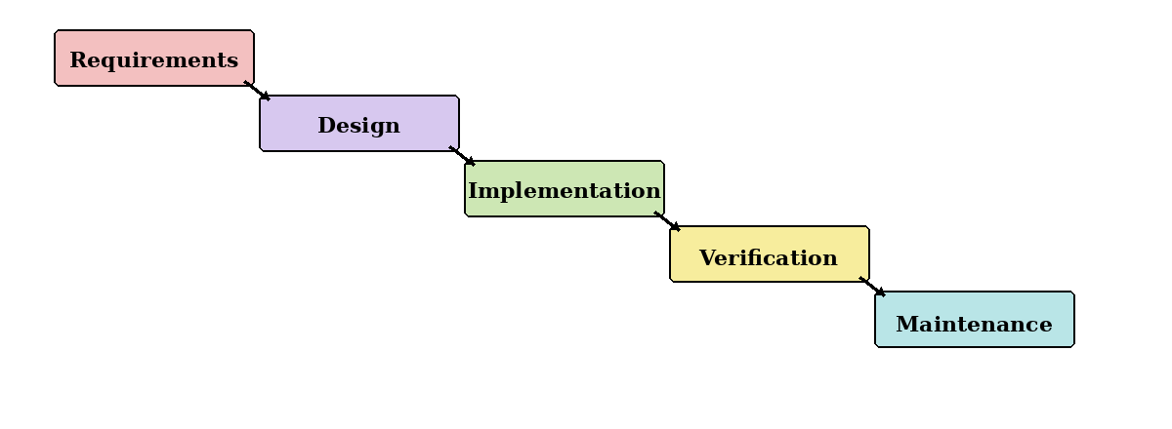
Figure 4.1: Waterfall model.
Waterfall follows a fixed sequence from requirements to maintenance. Although it offers clear stages, it is unsuitable as the main approach because AI models and data sources may require repeated changes. It will only be used for stable tasks such as final documentation and submission checks.

Prototyping Model
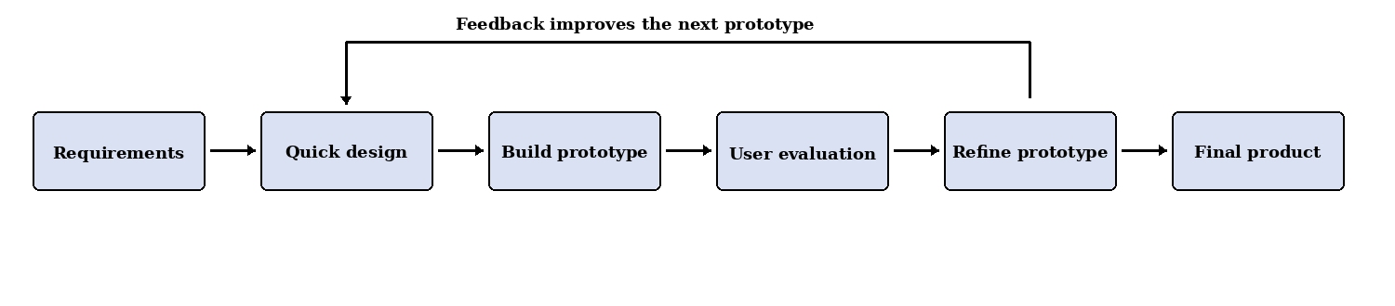
Figure 4.2: Prototyping model.
Prototyping allows the team to test claim extraction, evidence retrieval, scam detection and AI-authorship scoring before integrating them. To avoid endless changes, all prototypes will be compared using the same test dataset and only useful improvements will be retained.

Kanban Model
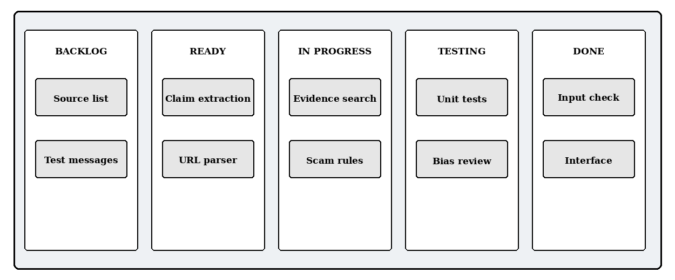
Figure 4.3: Example Kanban task board.
Kanban provides a visual view of tasks in Backlog, Ready, In Progress, Testing and Done. It supports daily coordination and limits unfinished work, but it lacks fixed review dates. Therefore, it will support Scrum rather than replace it.

Scrum
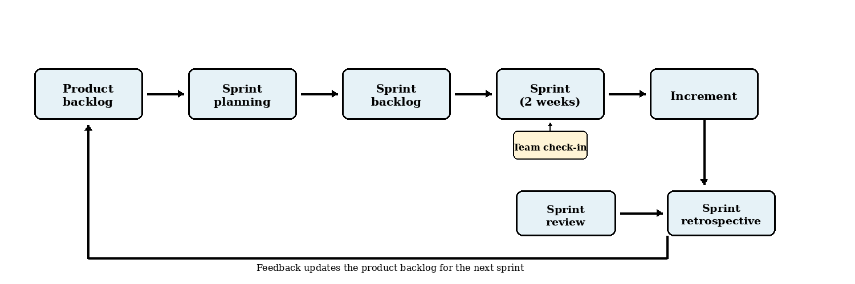
Figure 4.4: Scrum development cycle.
Scrum divides the project into short sprints that each produce a tested increment. The main practices used will be:
- Two-week sprints with planning, development, testing and documentation.
- User stories and a prioritised product backlog for project requirements and technical tasks.
- Sprint reviews to evaluate results, collect supervisor feedback and revise the backlog.
- Sprint retrospectives to identify delays and improve the next sprint.
Scrum is suitable because the team can respond when a model performs poorly, a Singapore source is unavailable or a feature exceeds the available time.

4.2.1 Development Methodology Chosen: Scrum
Scrum is selected as the main methodology because it combines structure with flexibility. This is important for an AI-based misinformation detection project, where models, datasets, trusted sources and scoring methods must be evaluated before the final approach is confirmed.

Justification for Choosing Scrum
- Adaptability: Requirements can be revised when testing or supervisor feedback reveals problems.
- Iterative progress: Short sprints provide regular working results within the six-month schedule.
- Early evaluation: AI detection, factual verification and scam analysis can be tested separately.
- Scope control: Essential functions are prioritised, while unrealistic features are moved to future work.
- Explainability and ethics: Each sprint can review false positives, data quality, robustness and user-facing explanations.

How Scrum Will Be Used
At the start of each sprint, the team will select a small number of high-priority tasks. A task is complete only when it works, has passed basic tests and has updated documentation. The sprint review and retrospective will then guide the next sprint.

Conclusion
A lightweight Scrum process, supported by prototyping and Kanban, is the most realistic approach for this six-month, zero-budget student project.

4.3 Risk Analysis
Risk Category | Identified Risk | Risk Elements
Risk Category | Identified Risk | Impact | Probability | Risk Rating
Communication | Group members are required to be proactive in terms of communicating with stakeholders | H | L | M
Communication | Inadequate user feedback to improve verdict explanations and interface | M | M | M
Resources | No project budget; reliance on free-tier APIs subject to rate limits | M | H | M
Resources | Lack of a labelled Singapore-context scam and misinformation dataset | H | H | H
Resources | Lack of access to professional fact-checkers for ground-truth labels | M | M | M
Resources | Limited team experience in machine learning and mobile development | M | L | M
Technical | Language model produces confident but incorrect explanations | H | M | H
Technical | OCR errors on uploaded screenshots corrupt the text analysed | H | M | M
Technical | Free-tier hosting cannot serve the required model size or GPU inference | M | L | M
Technical | Inference latency too high for acceptable mobile response time | M | H | M
User | Users over-trusting an incorrect verdict and acting on it | H | M | H
User | Low user engagement due to a complex or unfamiliar interface | M | M | M
User | Privacy concerns discourage users from uploading screenshots | M | L | M
Maintenance | Blacklists and trusted news sources becoming stale | H | M | H
Maintenance | Scam and misinformation tactics evolving after deployment | M | H | M
Security and Legal | Prompt injection in submitted content manipulating the model’s verdict | H | M | H
Security and Legal | Non-compliance with PDPA in storing and processing user uploads | H | M | H
Security and Legal | Third-party personal data contained in uploaded chat screenshots | M | L | H

4.4 Roles and Responsibilities
Name | Roles | Responsibilities | Contact Information
HO SZE WEI, DONOVAN | Project Leader, Back-  End Developer,  Database Engineer,  Documentation | Monitor the overall progress of the project and delegate tasks to each team member. Design, develop, and maintain the back-end functions of the system. Design and manage the project database. Ensure that project documentation is properly prepared and updated. | swdho001@mymail.sim.edu.sg
MATTHEW ALEXANDER PEERIS | Documentation,  Database Engineer,  Software Analyst,  Tester | Manage and maintain the project documentation. Design, develop, and manage the project database. Analyse the system requirements and ensure that the system meets its intended business goals. Prepare test cases and conduct testing to identify errors and verify that the system functions correctly. | peeris001@mymail.sim.edu.sg
CHU WAI CHUNG | Lead Documentation, Database Engineer, Software Tester, Software Analyst | Lead and manage the preparation of project documentation, including meeting minutes and progress records. Design, develop, and maintain the project database. Analyse the system requirements and ensure that the system meets its intended objectives. Prepare test cases and conduct software testing to verify the quality and functionality of the system. | wcchu001@mymail.sim.edu.sg
POON CHUN PING | Database Engineer, Documentation, Software Analyst | Design, develop, and maintain the project database. Assist in preparing and updating the project documentation. Analyse the system requirements and ensure that the proposed system meets its intended functions and business goals. | cppoon001@mymail.sim.edu.sg
WONG YI DA | Front-End Developer, Back-End Developer, Software Tester, Security Tester | Design and develop the front-end and back-end components of the system. Prepare and conduct software tests to ensure that the system functions correctly. Perform security testing to identify vulnerabilities and implement suitable security measures to protect the system and user data. | ydwong003@mymail.sim.edu.sg

4.5 Gantt Chart
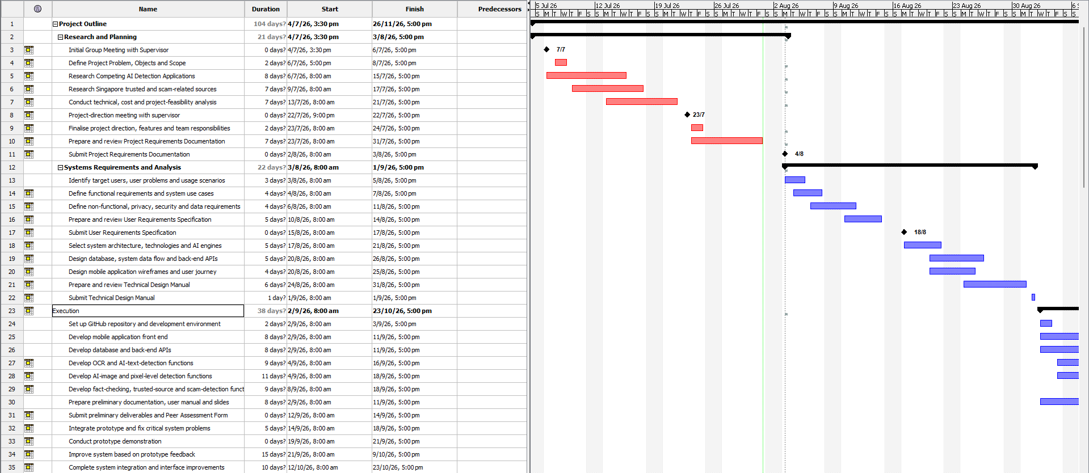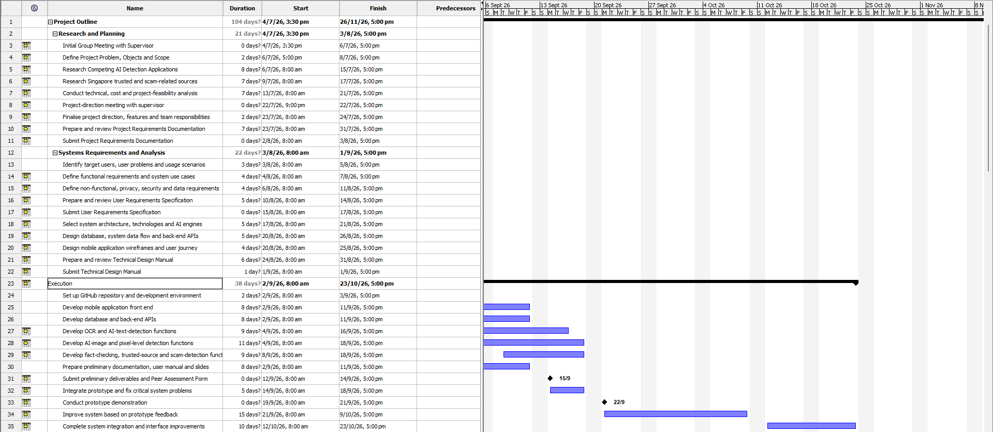

5. Development Tools
The development stack has been selected for an Android-based AI-assisted misinformation-checking prototype. The selected tools provide native Android support, straightforward integration with Python-based processing, and a manageable architecture for the FYP team.

5.1 Front-End
Front-End | Selected Technology
Language | JavaScript
Framework | React Native with Expo
Development Tool | Visual Studio Code, Expo and Android Studio Emulator
Description | JavaScript will be used to implement the Android application with React Native. React Native will provide reusable components for the interface, navigation and application state, while Expo will simplify development, testing and Android builds. Visual Studio Code will be used to write the application code, and the Android Studio Emulator will be used for device testing.
Why We Chose Them | JavaScript and React Native were selected because they allow the team to develop the Android interface using familiar web-style component concepts. Expo supports rapid prototyping and reduces the initial Android project configuration required. This combination is appropriate for the FYP because it supports faster interface development while still producing an Android application.

5.2 Back-End
Back-End | Selected Technology
Language | Python
Framework | FastAPI
Runtime Server | Uvicorn
Development Tool | Visual Studio Code
Description | Python will be used for server-side processing and integration with the application's AI and data-processing components. FastAPI will provide REST API endpoints for receiving submissions, coordinating analysis, applying usage limits and returning structured results. Uvicorn will run the FastAPI application during development and deployment.
Why We Chose Them | Python is well suited to AI, natural-language processing and image-analysis libraries. FastAPI provides request validation, clear routing and automatically generated API documentation, making it practical for a five-person FYP team. Using Python for both the back-end and AI components also avoids maintaining a separate Node.js service.

5.3 Database
Database | Selected Technology
Database | Cloud Firestore
Database Type | NoSQL document database
Development Tool | Firebase Console
Description | Cloud Firestore will store user profiles, account roles, free and premium submission allowances, analysis results, result history, evidence records, feedback and reported incorrect results. The React Native application will access the database through the Firebase JavaScript SDK. The Firebase Console will be used to inspect records, configure access rules and monitor database usage.
Why We Chose It | Cloud Firestore integrates with Firebase Authentication and can be accessed from the React Native application through the Firebase JavaScript SDK. It requires less database administration than a self-hosted database, and its document structure is suitable for user accounts, submissions and result records. Firebase Realtime Database is not required for the selected scope.

5.4 API Communication
API Communication | Selected Technology
Architecture | RESTful API
Data Format | JSON
React Native Library | Axios
Testing Tool | Postman
Description | The React Native application will communicate with the FastAPI back-end through HTTPS REST endpoints. Axios will send text, links, images and authentication headers to the back-end and convert JSON responses into JavaScript objects. Postman will be used to test the API independently from the mobile interface.
Why We Chose Them | REST and JSON provide a simple and widely supported communication method between JavaScript and Python. Axios reduces the networking code required in React Native and supports request configuration, file uploads and error handling. Separating the mobile interface from the back-end also keeps secret service credentials and analysis logic out of the Android application.

5.5 Authentication
Authentication | Selected Technology
Authentication Service | Firebase Authentication
React Native Integration | Firebase JavaScript SDK
Initial Sign-In Method | Email and password
Description | Firebase Authentication will manage account registration, login, logout, password reset and user sessions through the Firebase JavaScript SDK. The React Native application will obtain a Firebase identity token, and the FastAPI back-end will verify that token before allowing protected operations. Application roles and access tiers will be checked by the back-end using the associated account record.
Why We Chose It | Firebase Authentication works with the selected React Native and Cloud Firestore stack and removes the need to build password storage and session handling from the beginning. Email-and-password authentication is sufficient for the initial prototype and keeps registration familiar and straightforward for the target users.

6. Expected Results
What we expect from the implementation of uiabo:
- Make misinformation checking easier for elderly users
Elderly users will be able to submit text, webpage links and, for premium users, images with captions for analysis. The application is expected to reduce the difficulty of manually searching through multiple websites when checking suspicious online information.
- Provide clear and easy-to-understand results
The system will present a misinformation risk score, uncertainty level, simple explanation and supporting source links. These results are expected to help elderly users understand why the submitted content may be trustworthy, misleading or lacking sufficient evidence.
- Support safer online sharing among elderly users
By providing an accessible Android application with simple navigation and readable information, the project is expected to help elderly users make more informed decisions before believing or forwarding content to family members and friends.

7. Conclusion
The proposed project aims to provide elderly users in Singapore with a simple and accessible way to assess suspicious online information. By combining AI-assisted claim analysis, evidence retrieval and explainable results in an Android application, the system can help users make more informed decisions before trusting or sharing content.

References
Corney, D. (2025, February 11). How AI can help fact checkers. Full Fact AI. https://fullfact.ai/blog/how-ai-can-help-fact-checkers/
Digital for Life. (2025, July 8). Seniors Go Digital: Digital skills for seniors. https://www.digitalforlife.gov.sg/About/Our-Projects/Seniors-Go-Digital
Factiverse. (n.d.-a). Factiverse API. Retrieved July 31, 2026, from https://www.factiverse.ai/solutions/api
Factiverse. (n.d.-b). Factiverse Gather. Retrieved July 31, 2026, from https://www.factiverse.ai/solutions/gather
Factiverse. (n.d.-c). Factiverse Live. Retrieved July 31, 2026, from https://www.factiverse.ai/solutions/live
Full Fact AI. (n.d.). How we do it. Retrieved July 31, 2026, from https://fullfact.ai/product/
Google. (2024, August 8). Fact Check Tools API. Google for Developers. https://developers.google.com/fact-check/tools/api/reference/rest
Johnston, C. (2025, October 1). How we're using generative AI to transcribe challenging audio. Full Fact AI. https://fullfact.ai/blog/using-generative-aI-to-transcribe-challenging-audio/
National Population and Talent Division. (2026, July 8). Longevity. https://www.population.gov.sg/our-population/population-trends/longevity/
NewsGuard. (n.d.-a). False Claim Fingerprints. Retrieved July 31, 2026, from https://www.newsguardtech.com/solutions/false-claim-fingerprints/
NewsGuard. (n.d.-b). False Claim Fingerprints process. Retrieved July 31, 2026, from https://www.newsguardtech.com/ratings/false-claim-fingerprints-process/
NewsGuard. (n.d.-c). News Reliability Ratings. Retrieved July 31, 2026, from https://www.newsguardtech.com/solutions/news-reliability-ratings/
Soon, C., Bala Krishnan, N., & Goh, S. (2022, March 17). Why are some people more immune to falsehoods and what can we learn from them? Institute of Policy Studies. https://lkyspp.nus.edu.sg/ips/publications/details/commentary-why-are-some-people-more-immune-to-falsehoods-and-what-can-we-learn-from-them
WeVerify. (n.d.-a). Context aggregation and analysis. Retrieved July 31, 2026, from https://weverify.eu/tools/caa/
WeVerify. (n.d.-b). Image Verification Assistant. Retrieved July 31, 2026, from https://weverify.eu/tools/image-verification-assistant/
WeVerify. (n.d.-c). Tools. Retrieved July 31, 2026, from https://weverify.eu/tools/
WeVerify. (n.d.-d). Verification plugin. Retrieved July 31, 2026, from https://weverify.eu/verification-plugin/
World Wide Web Consortium. (2025, November 20). Older users and web accessibility: Meeting the needs of ageing web users. https://www.w3.org/WAI/older-users/

