5. Project Design

5.1 Functional Requirements
uiabo will cater to 2 types of users: Individual users and Operational users.
- Individual users: Free Users and Premium Users
- Operational users: System Administrators and Data Engineers

We have grouped our functional requirements for these users into:
- Base Requirements (Minimum requirements for a viable product)
- Additional Requirements (Nice-To-Have features)
- Stretch Goals (Ambitious/future features)

Base Requirements
For all 4 users:
- Log in
- Log out
- View and update profile
- Reset password

Login is a basic functionality that is required to differentiate/personalise what each user sees on the various pages of the app, based on the data stored in our database. E.g. different homepage UI for different user types, or individual users’ unique results page containing content submitted for misinformation detection.

The login and logout system also ensures the security of the app for the users, ensuring only the specific user has access to their account and its functions. This is especially necessary for system admin accounts, which have the ability to suspend other accounts.

View profile is needed before updating profile is possible. The update profile function is needed so important user information can be kept up-to-date. Resetting passwords is an essential function in the case of forgotten passwords, or as a preventative measure when suspicious activity is observed.

For Free & Premium users:
- Register for an account
- Delete account
- Upload short-form text into the app for misinformation detection
- Upload a link to an article/webpage into the app for misinformation detection
- View their personal results page and individual results details
- View their remaining free credits
- Report results that are incorrect

In order to login and logout, the user must first register for an account, so this is a base requirement. Users will have the option to register as a free user or as a premium user on the spot.

Deleting an account is a common function for account-based apps, as users may decide they no longer want to use the app or receive notifications from it, so it is another base requirement.

In order to achieve a viable product, the app must be able to:
- Accept at least one type of short-form content
- Analyse the content for misinformation and generate an output result

As a base requirement, we plan to implement text-based detection for short-form text as well as links to articles/webpages. The results of users’ submitted content will be saved so the user can view their results at any time on the results page. Free and premium users will be granted limited uses to the functions of the app.

Finally, users are able to report a result for providing incorrect information (e.g. misclassification of AI/deepfake images or identifying misinformation in a factually accurate article). This is a base requirement as it allows the operational team (specifically data engineers) to gather information on issues with the AI models easily.

For Free users:
- Upgrade to a premium account

For Premium users:
- Renew their premium subscription
- Cancel their premium subscription
- Upload images into the app into various functions
  - Images with captions
  - Review and correct OCR extracted text
  - Analyse caption-image context
  - Deepfake/AI generated image detector

As uiabo uses a freemium business model, an option for free users to upgrade to a premium user is a base requirement of the app. As uiabo’s premium subscription is on a monthly basis, an option for premium users to renew or cancel their subscription is also necessary.

In order to differentiate between free and premium users, premium users will be given more uses of the functions within the app. They will also be able access the full range of functions, namely these four image-related functions:

Image with captions: Refers to analysing both the image and its caption to explain the content of the image and its caption.

Review and correct OCR extracted text: Refers to extracting the text present in an image and analysing it specifically for misinformation, disregarding the actual image.

Analyse caption-image context: Refers to analysing both the image and its caption but also the using the context to detect misinformation.

Deepfake/AI generated image detector: Refers to analysing an image to determine if it is deepfaked, modified using AI or generated by AI.

For System administrators:
- Query for an account
- View account details
- Suspend and un-suspend accounts

The base requirement of the system administrators is to be able to manage the accounts of users of the app, which requires the ability to view the account details as well as suspend/unsuspend an account when necessary. In a large user base, a query function is also necessary to allow system administrators to locate a specific account quickly.

For Data engineers:
- View data dashboard of the results of the AI models in the app
- View reported incorrect results

When it comes to AI based systems, there is always room for error when it comes to the results it generates. Therefore, it is a base requirement for the data engineers to be able to access an overview of the incorrect results in the form of a dashboard, as well as view the details of the individual reports.

Additional Requirements (nice-to-haves)
For Free & Premium users:
- Delete their results history
- Leave a review
- Share a result via link

For System administrators:
- View user reviews

The above features are not strictly necessary for the app to function, however they will provide benefits to the operational team as well as the individual users.

For individual users, the ability to delete their results history grants them even more control over their account, allowing them to de-clutter their results page by removing unwanted results. This also helps them to find specific results in their collection faster. Sharing results via link is the most efficient way to allow users to share information with others, and it also serves as free advertising for the app.

The individual users’ ability to leave a review are common features that can be found in many apps. They are especially useful as they allow system administrators to detect flaws/issues with the functions of the app.

Stretch Goals
A function that could possibly be implemented in future versions is an API for the app, which allows other organisations’ to integrate their platforms with uiabo, leveraging on the various AI models within it to perform misinformation detection.

Not only does that expand the reach of the app outside of our target group (elderly Singaporeans), but it also opens up partnership/business opportunities, where we would be given access to organisation-specific data, resulting in new AI models that are extremely robust in detecting misinformation in specific areas.

5.1.1 Use Case Diagrams and Descriptions
The following use-case diagrams, user stories and descriptions are reused from Section 3 of the approved User Requirement Specification.


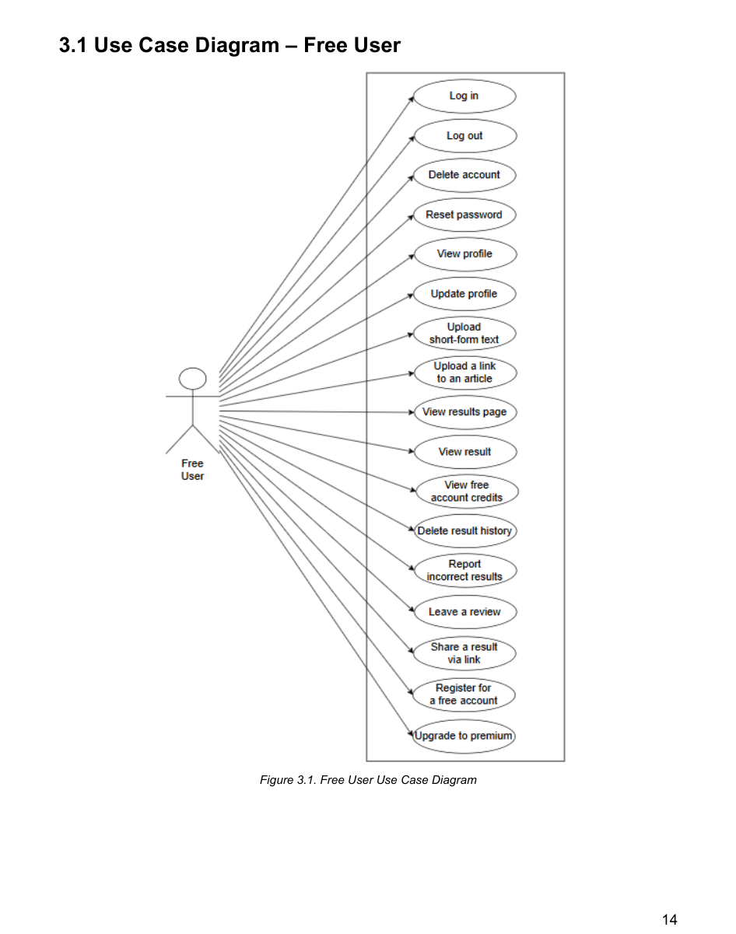

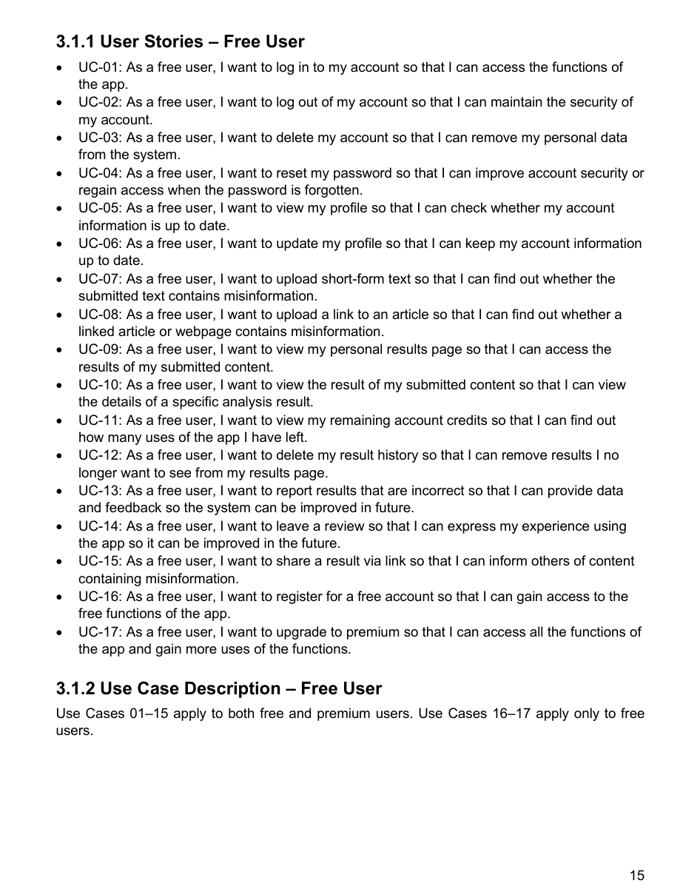

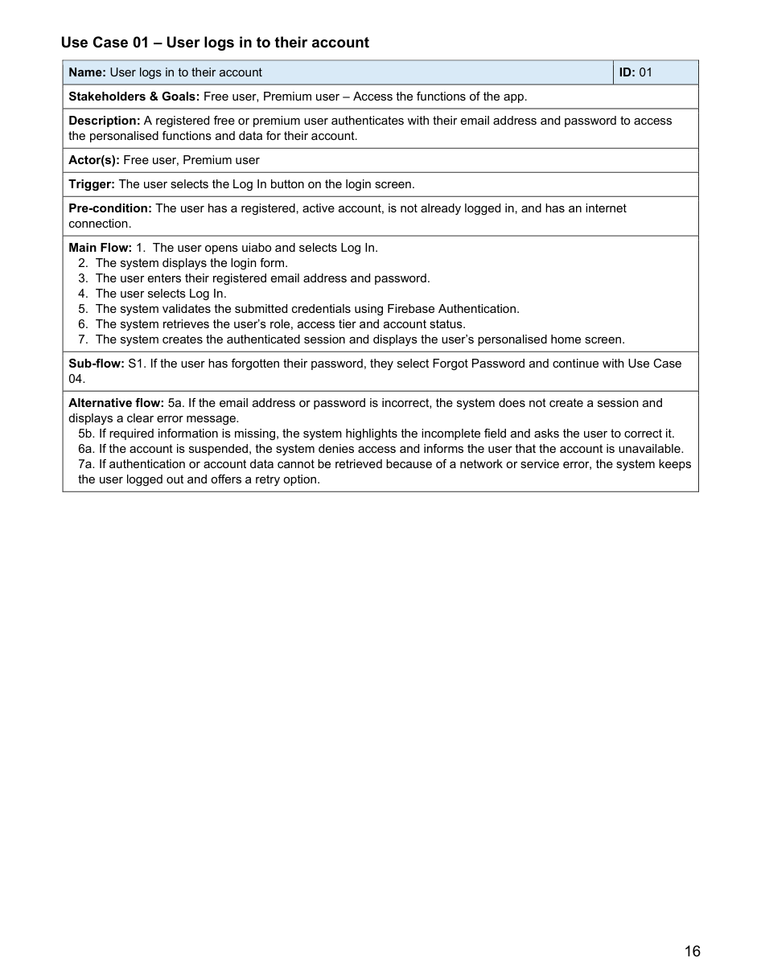

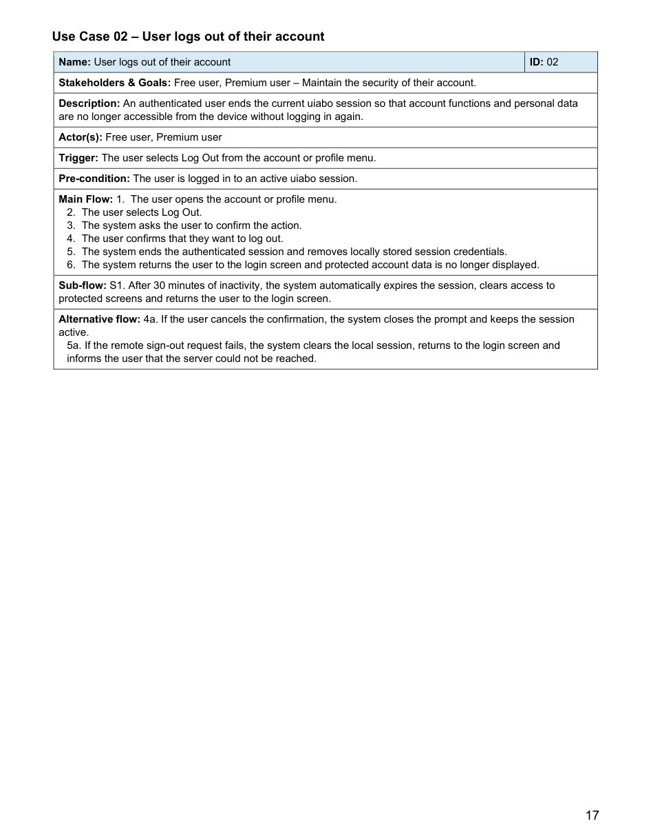

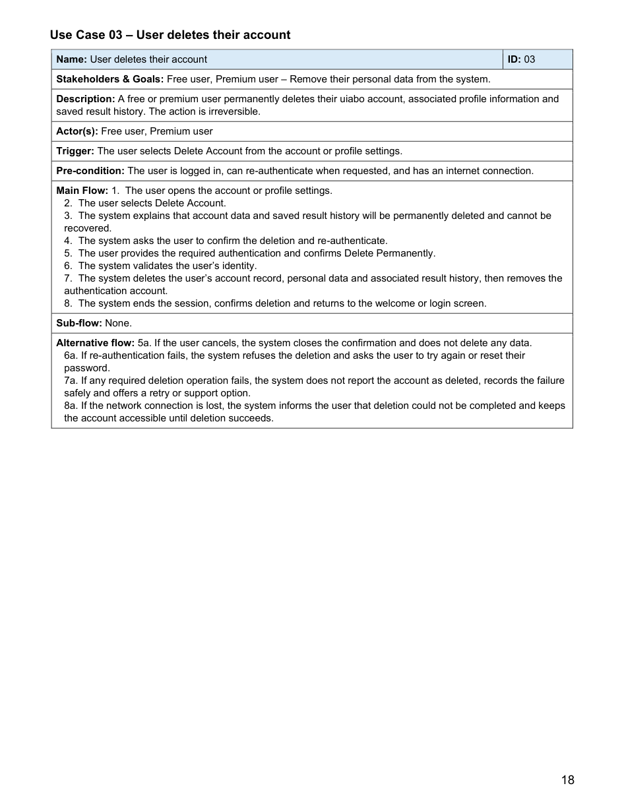

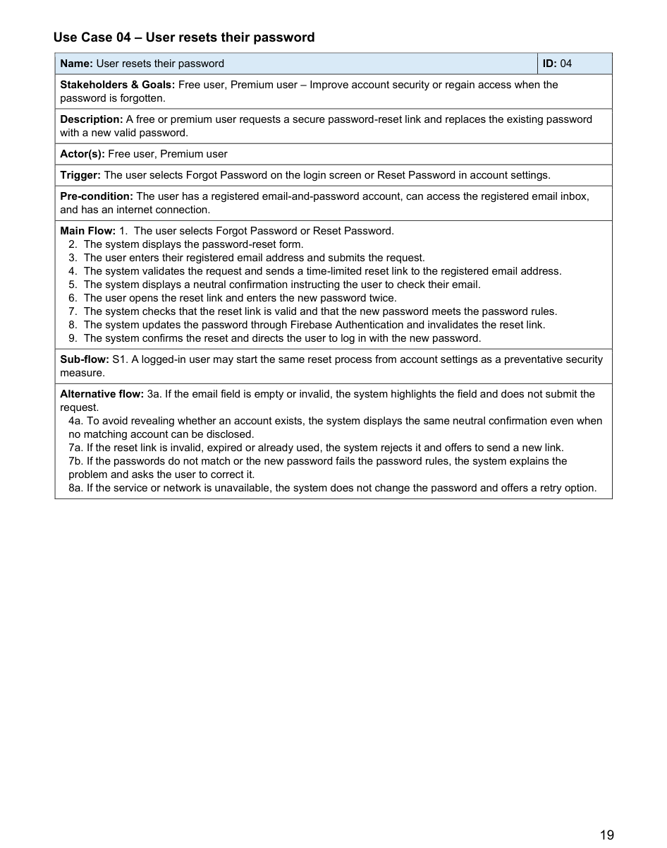

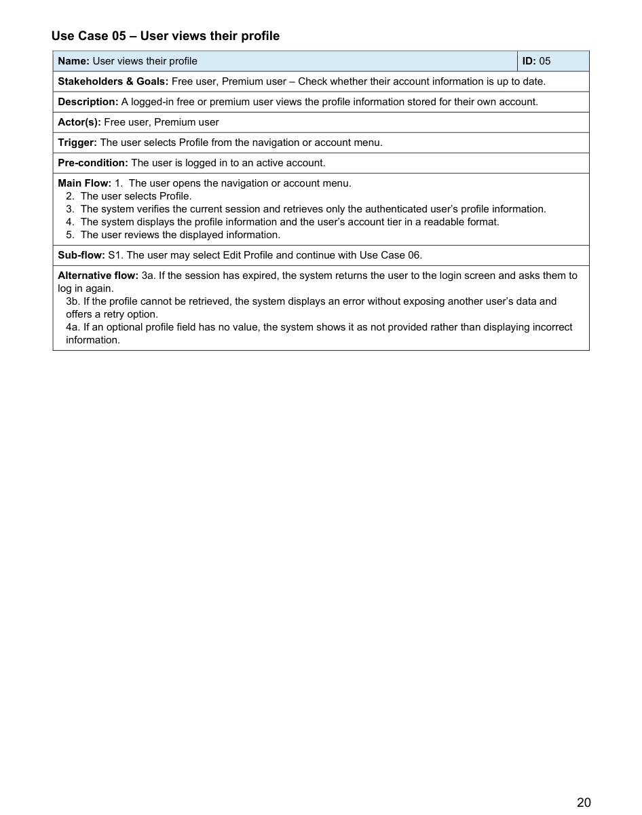

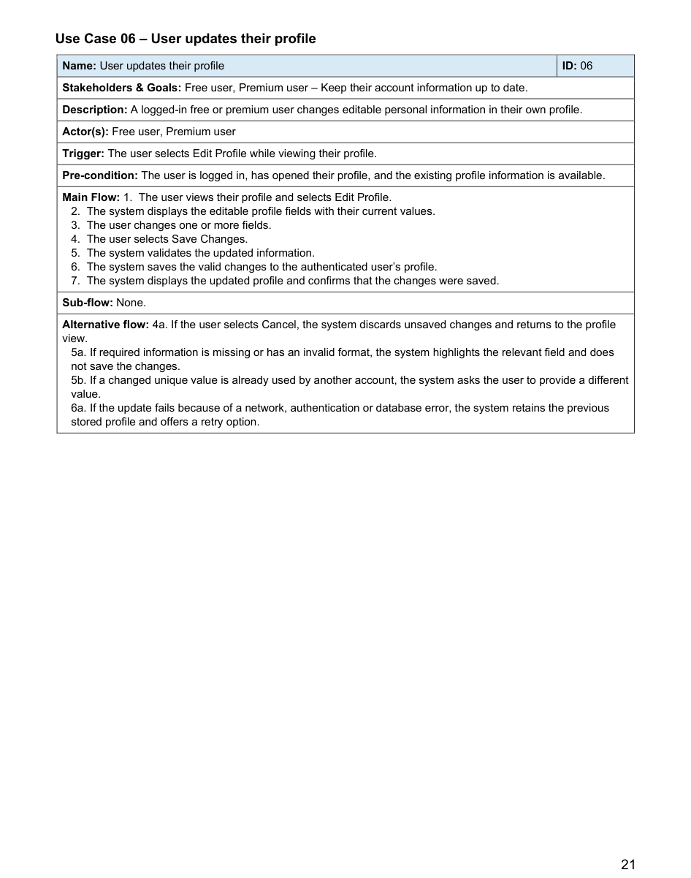

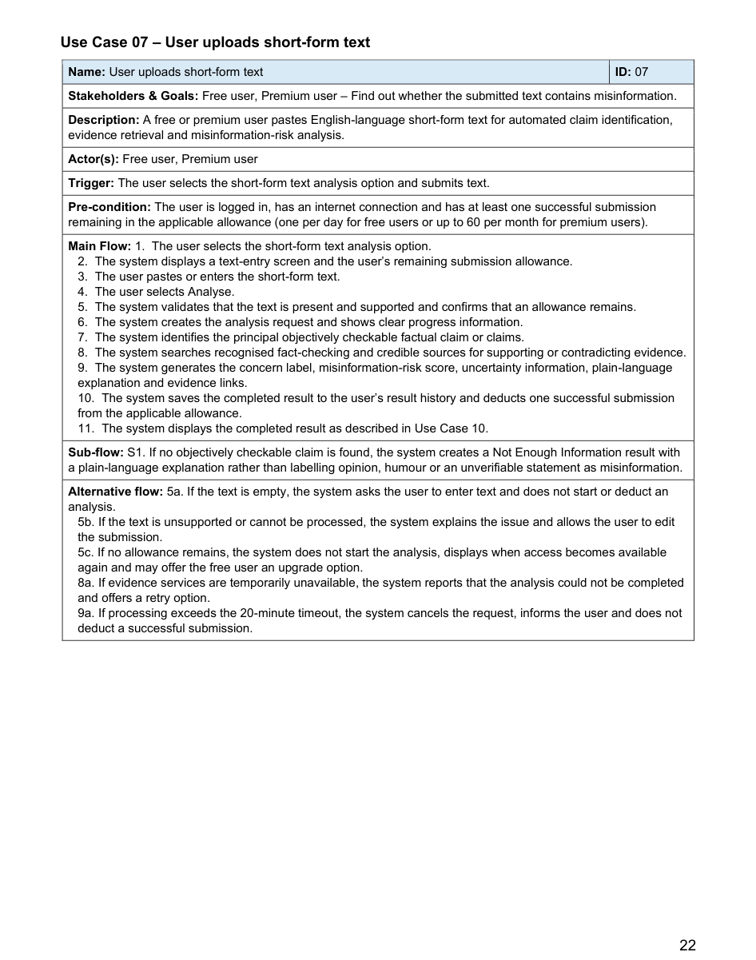

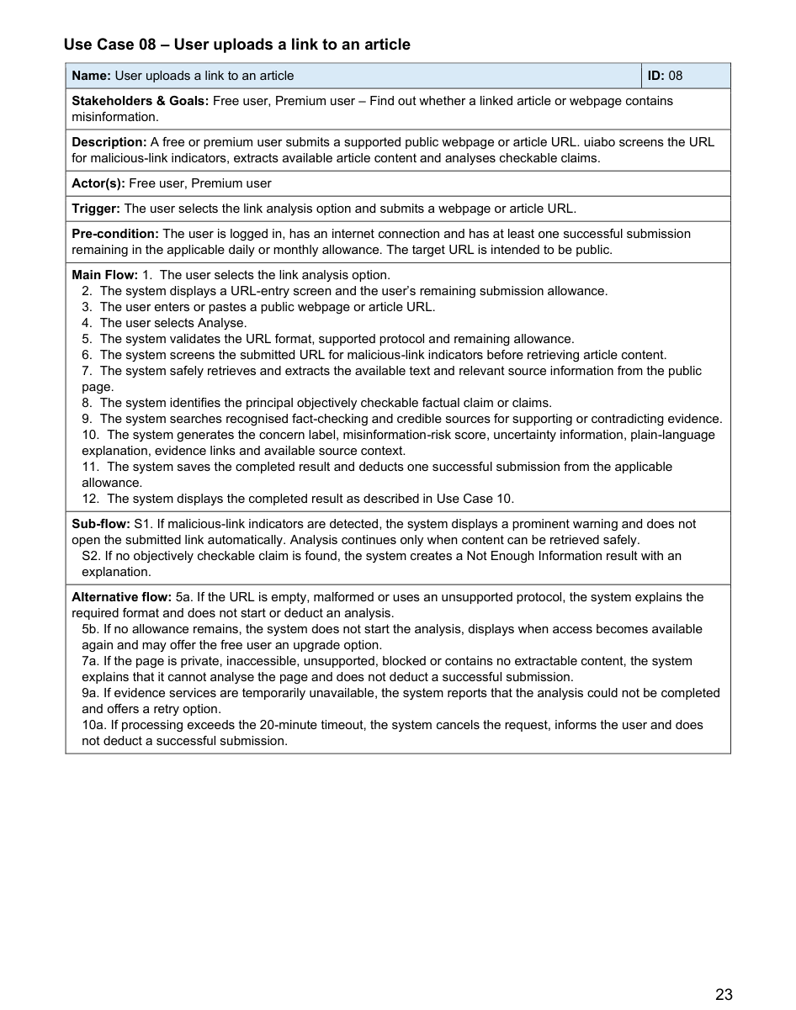

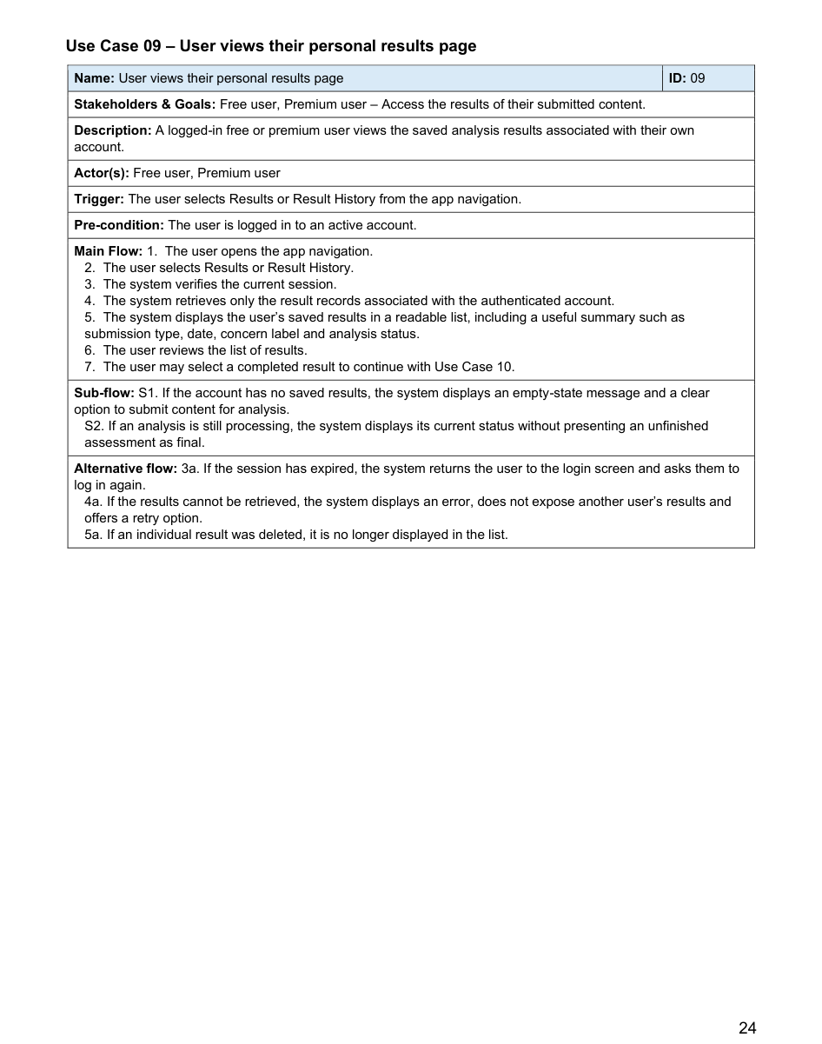

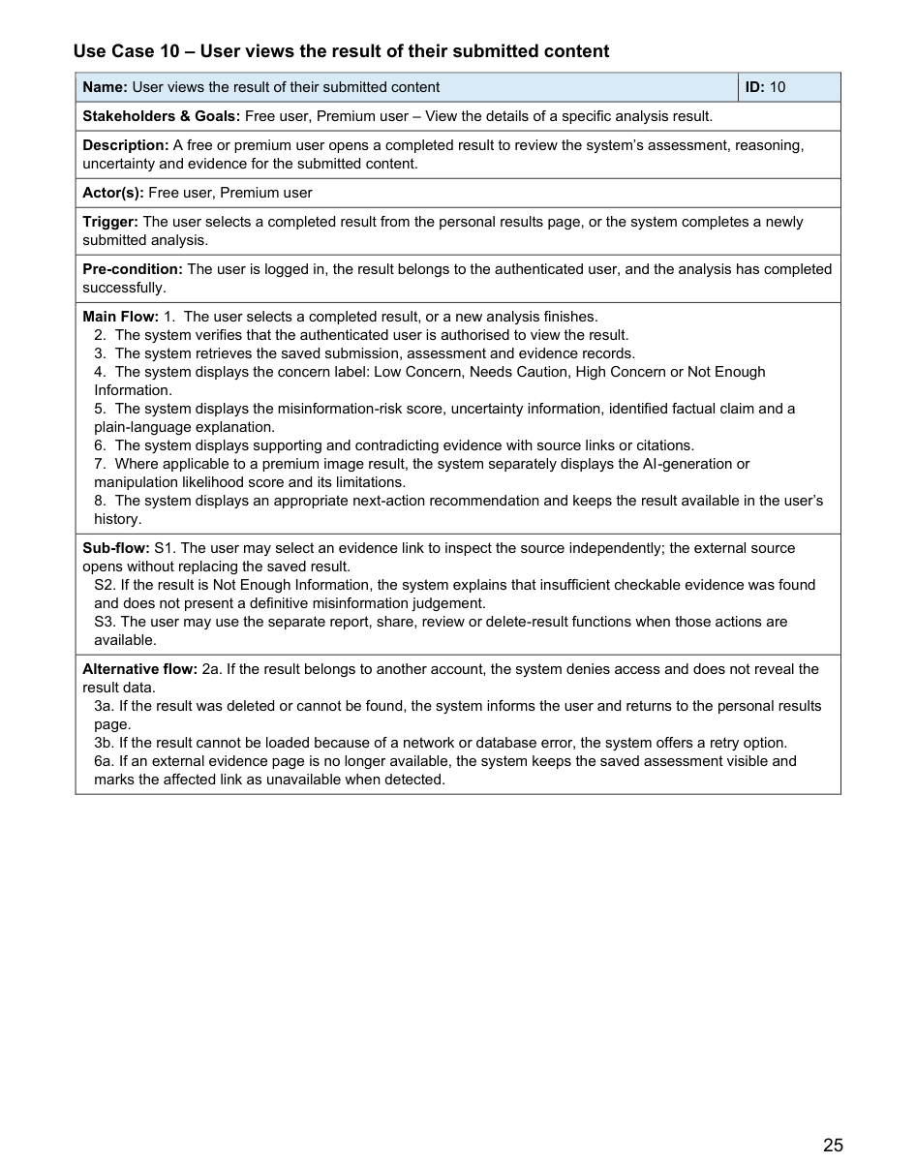

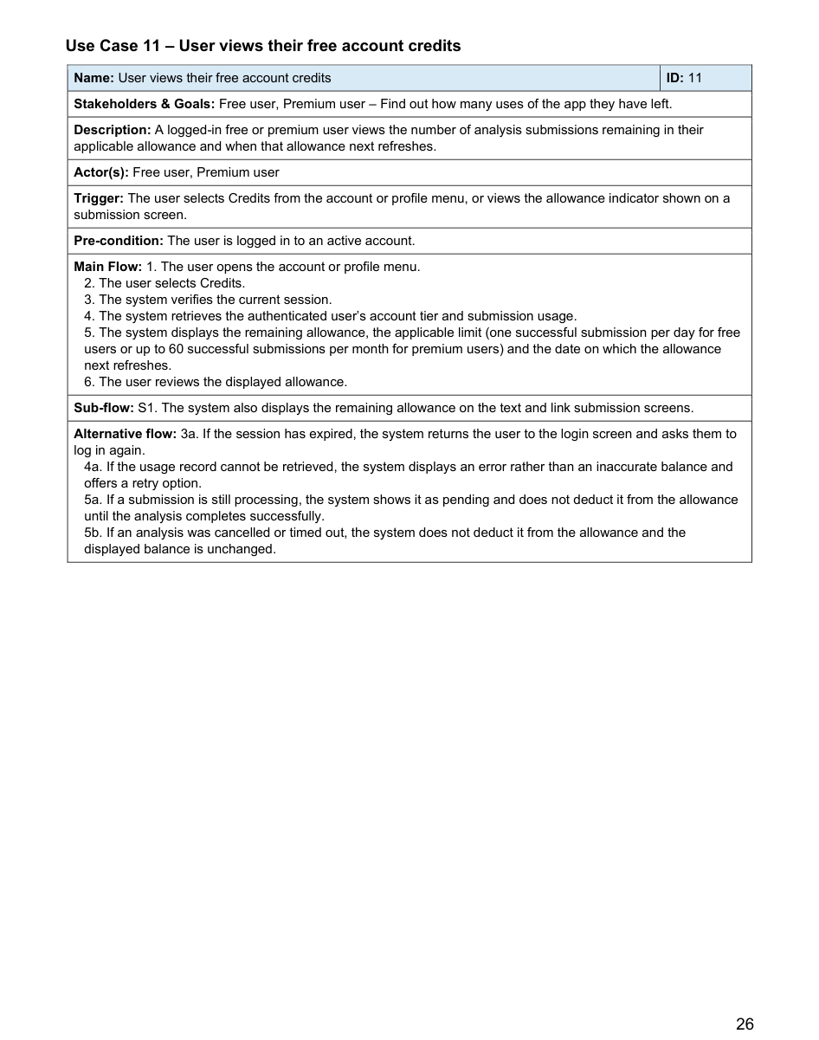

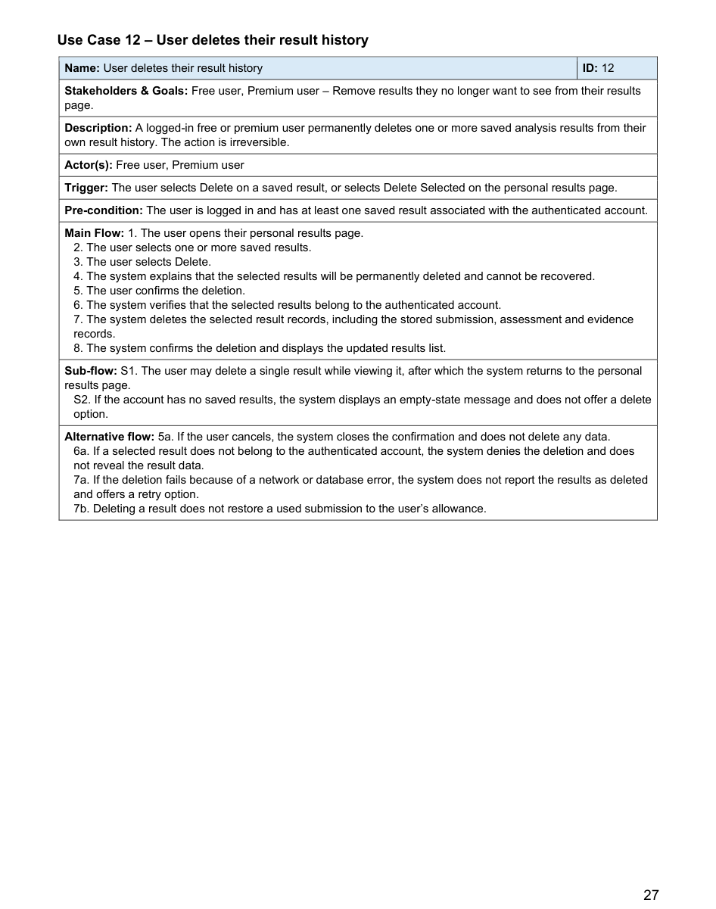

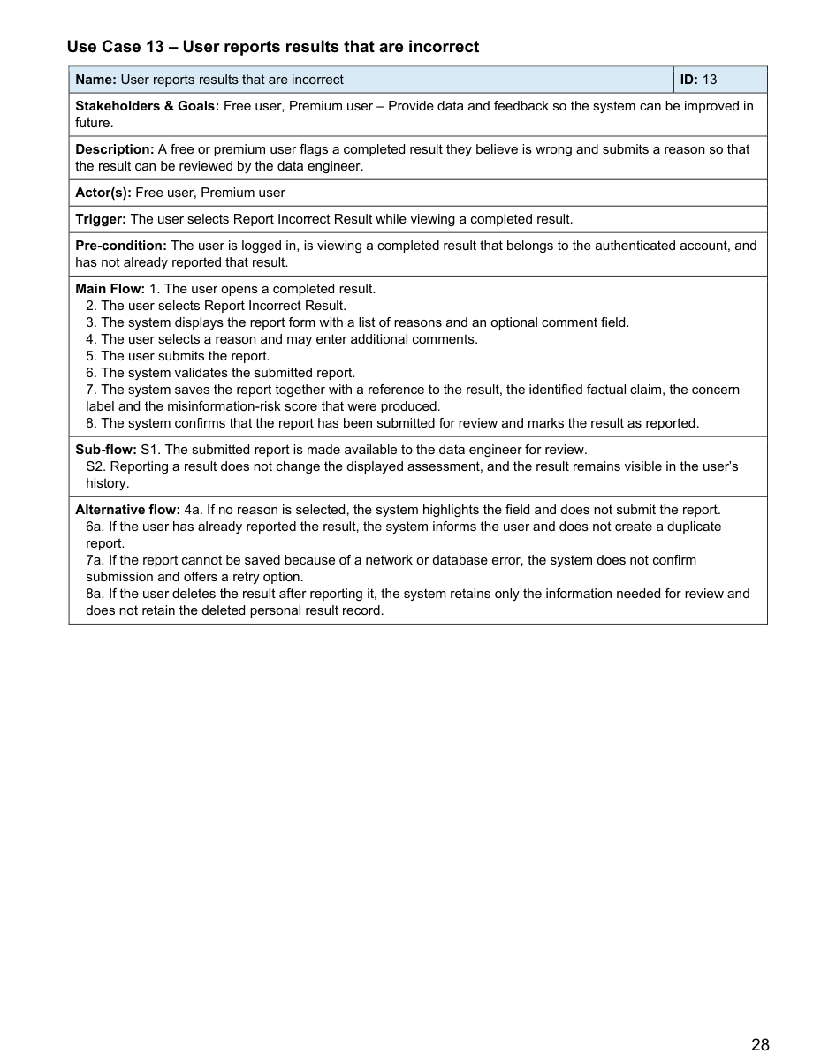

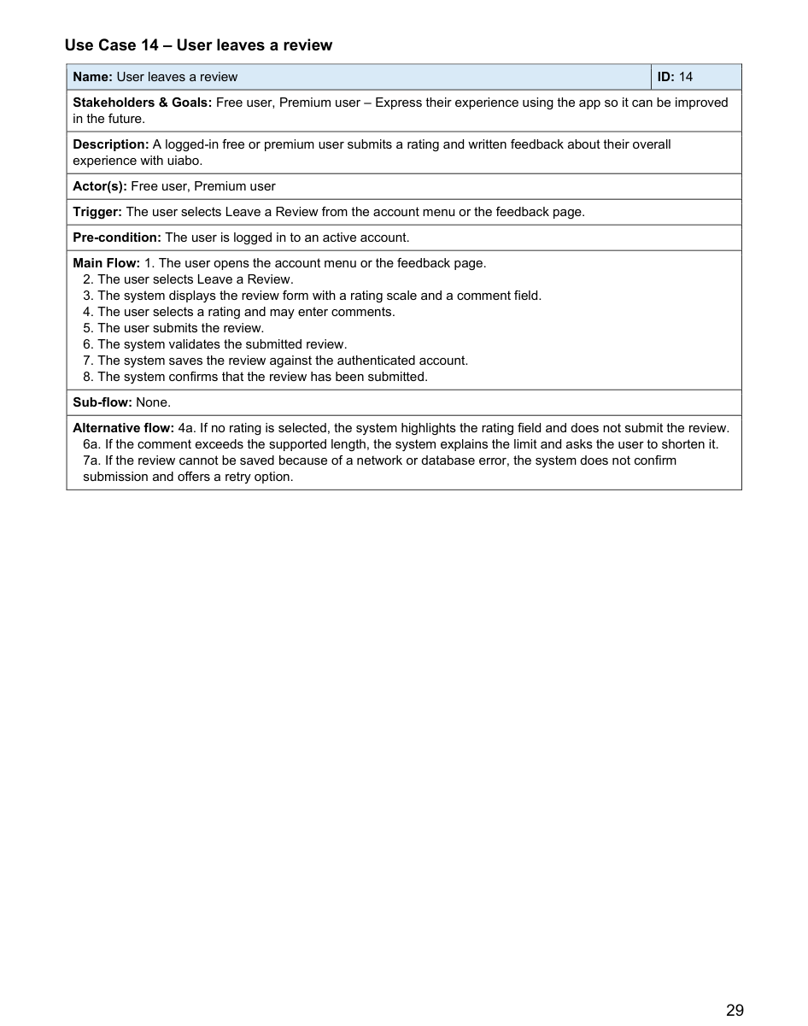

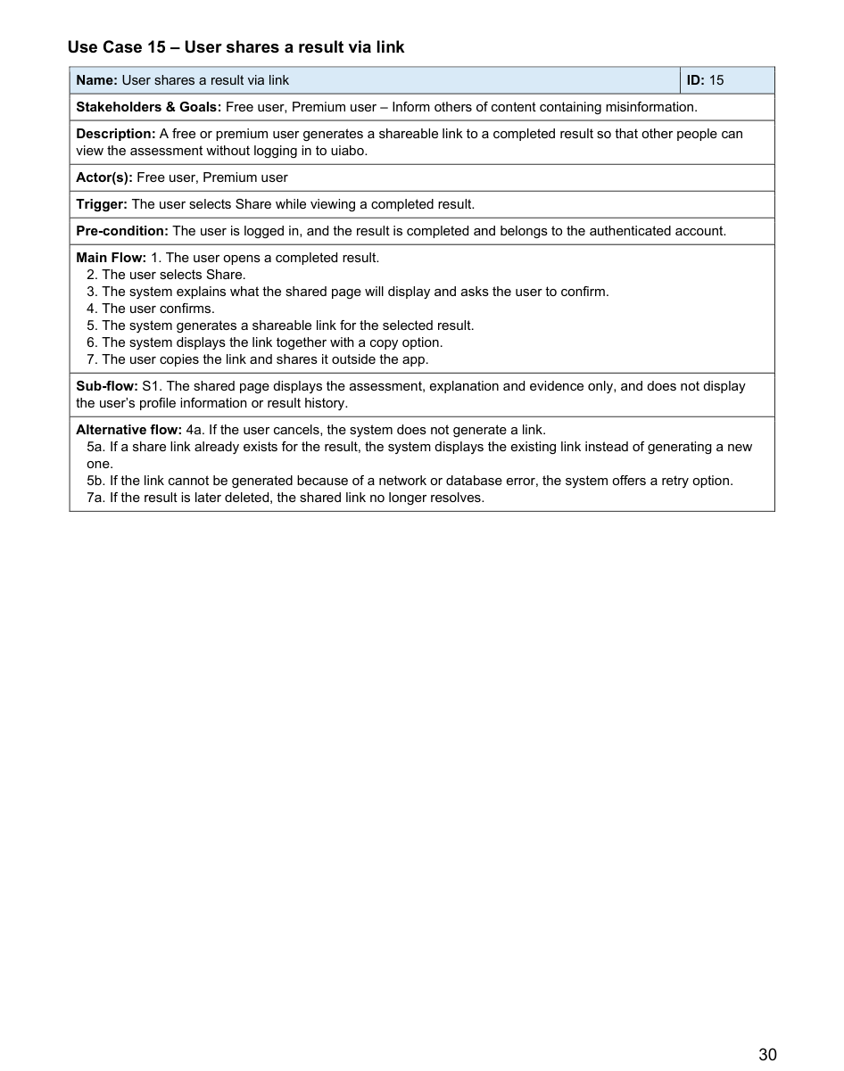

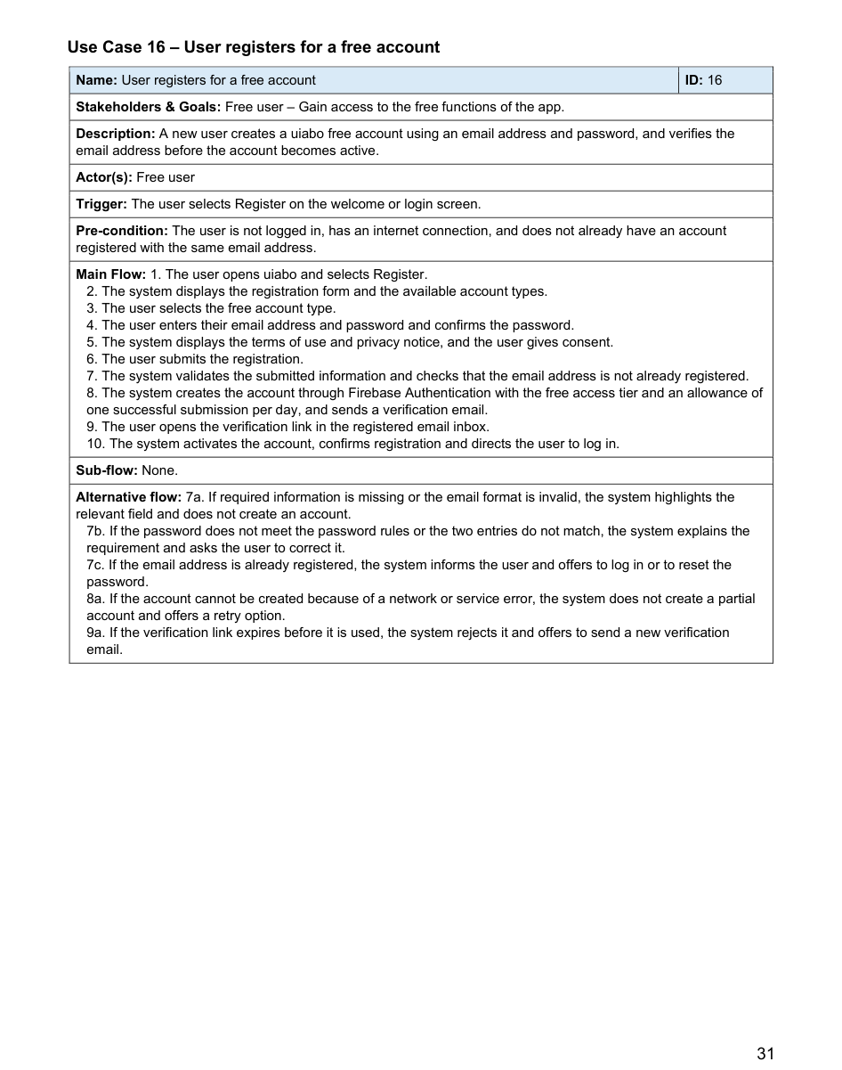

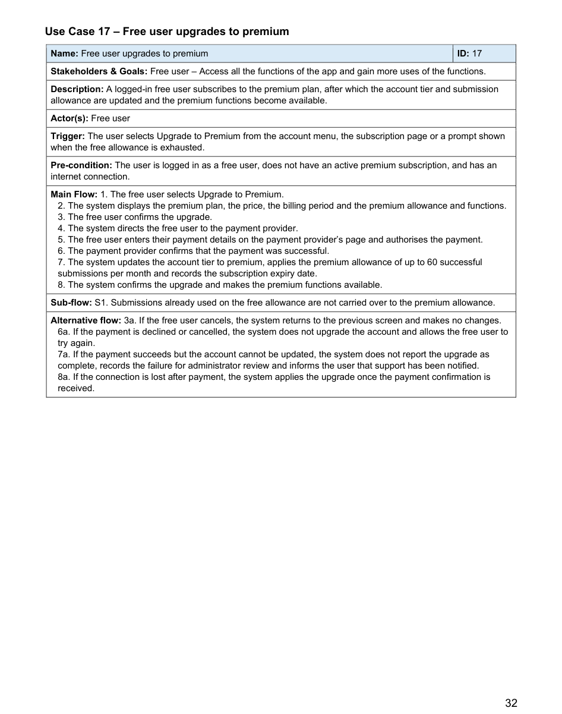

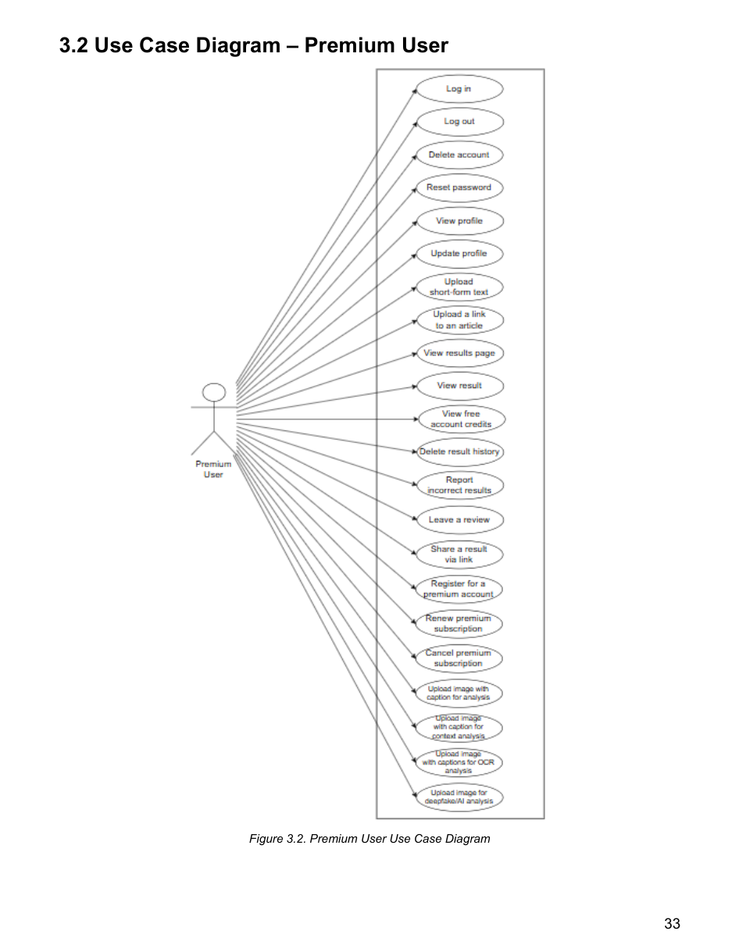

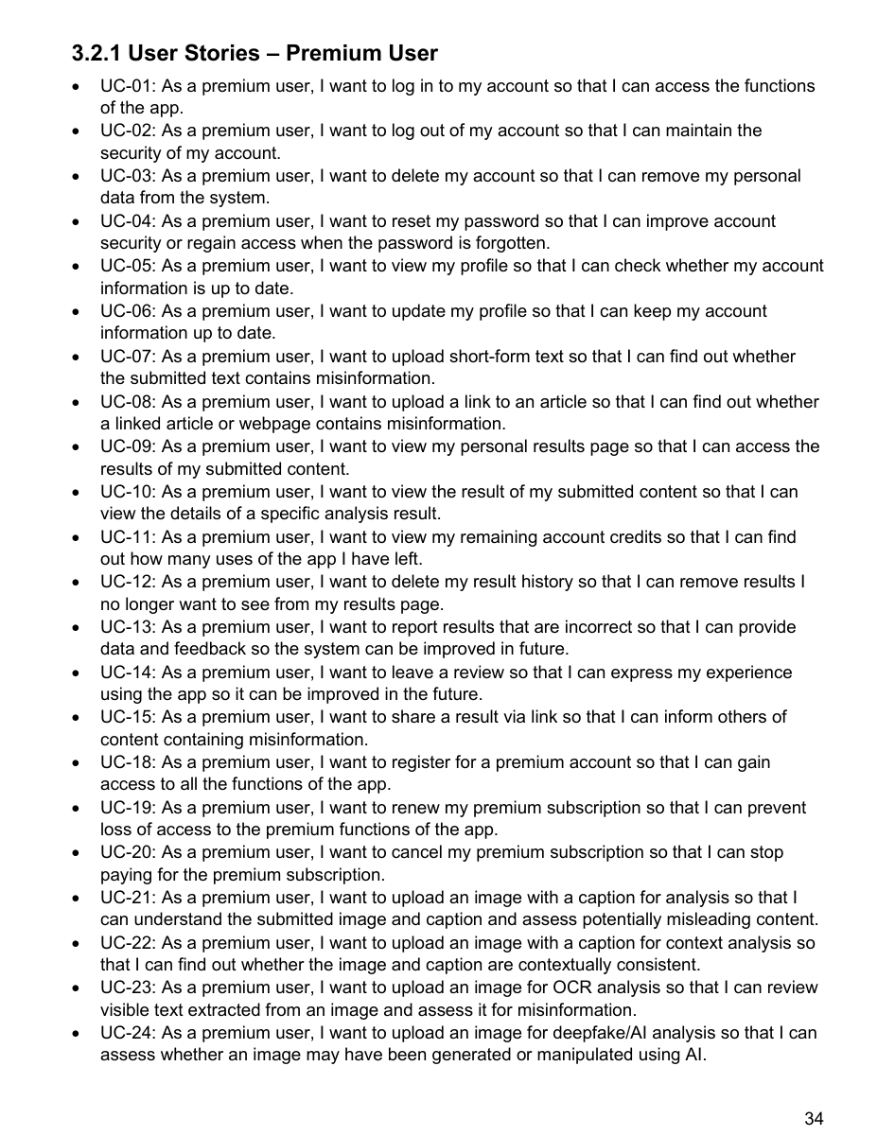



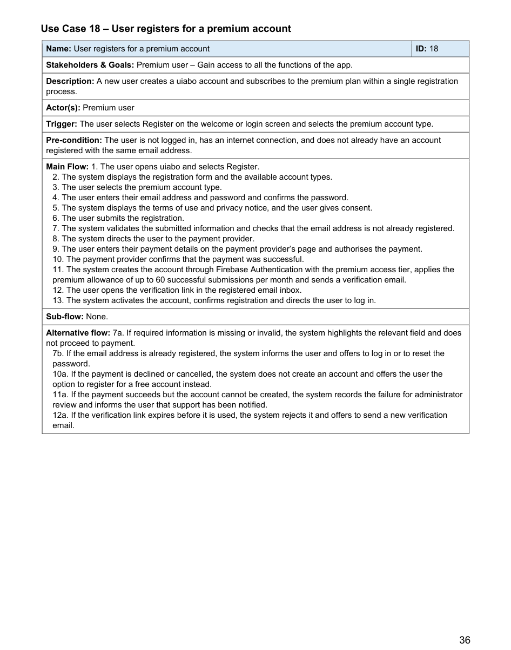

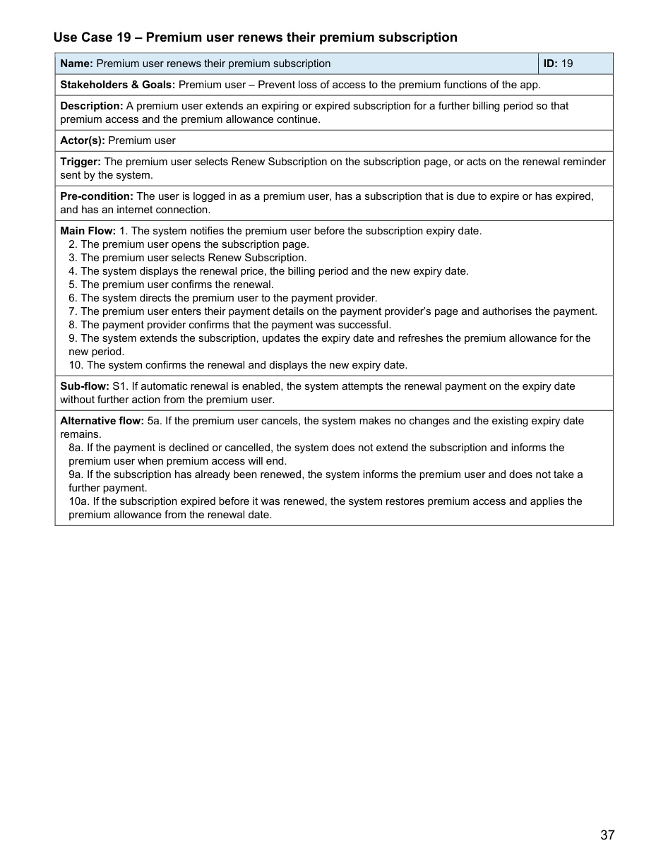

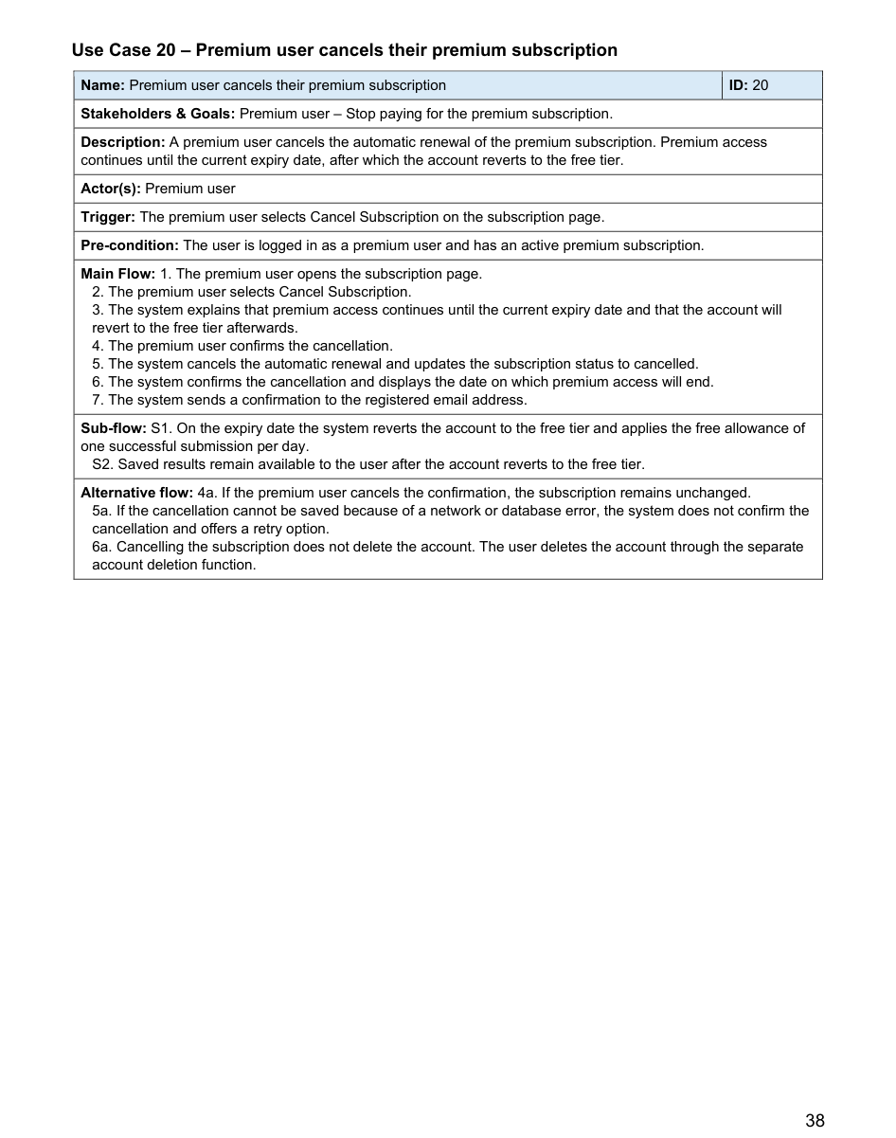

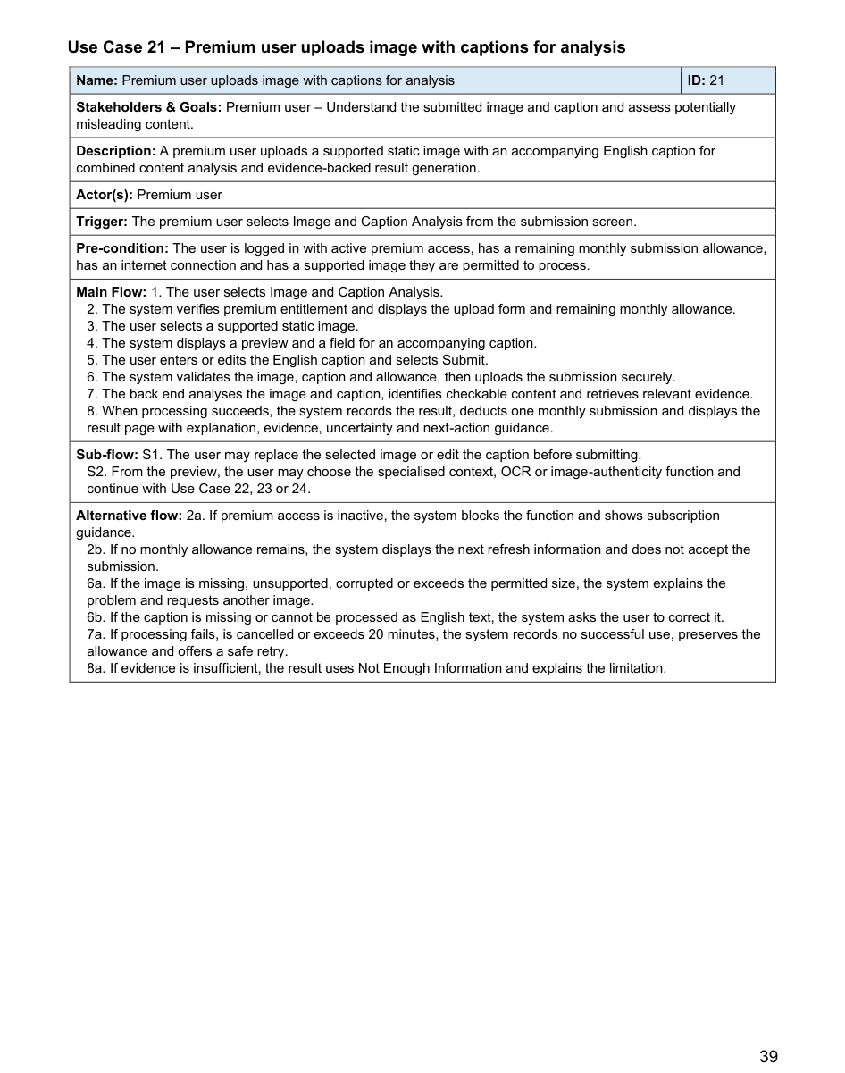

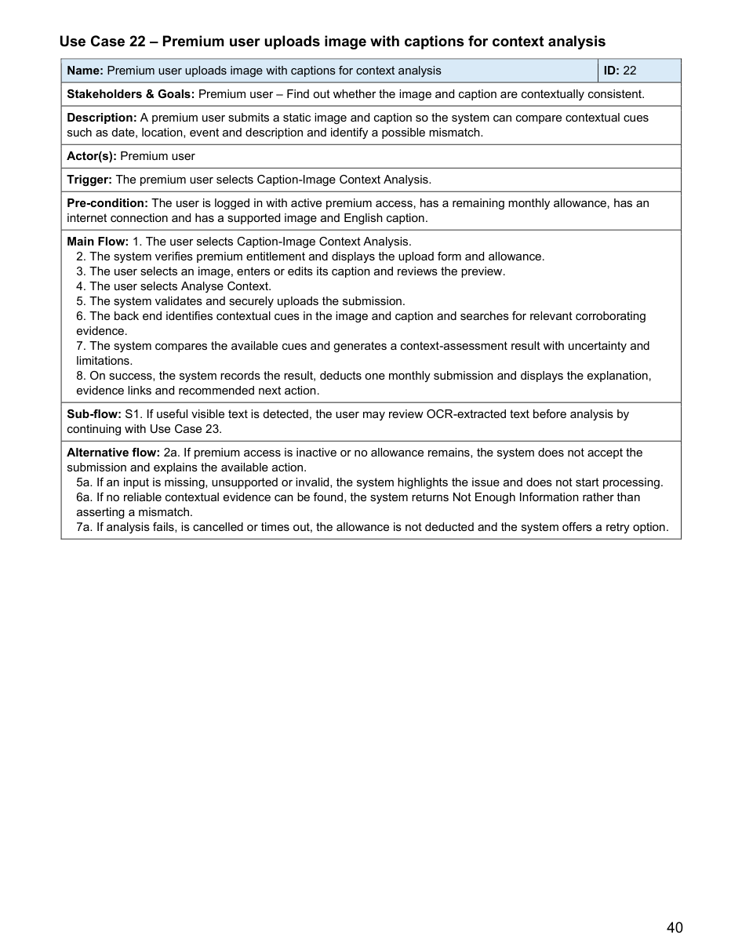

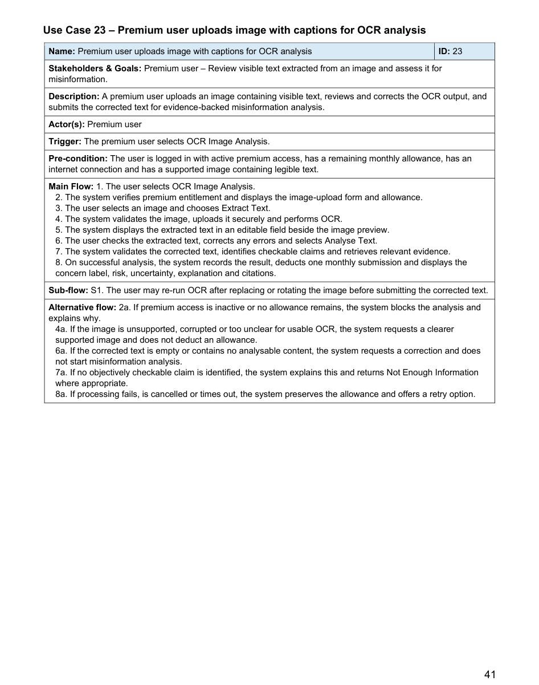

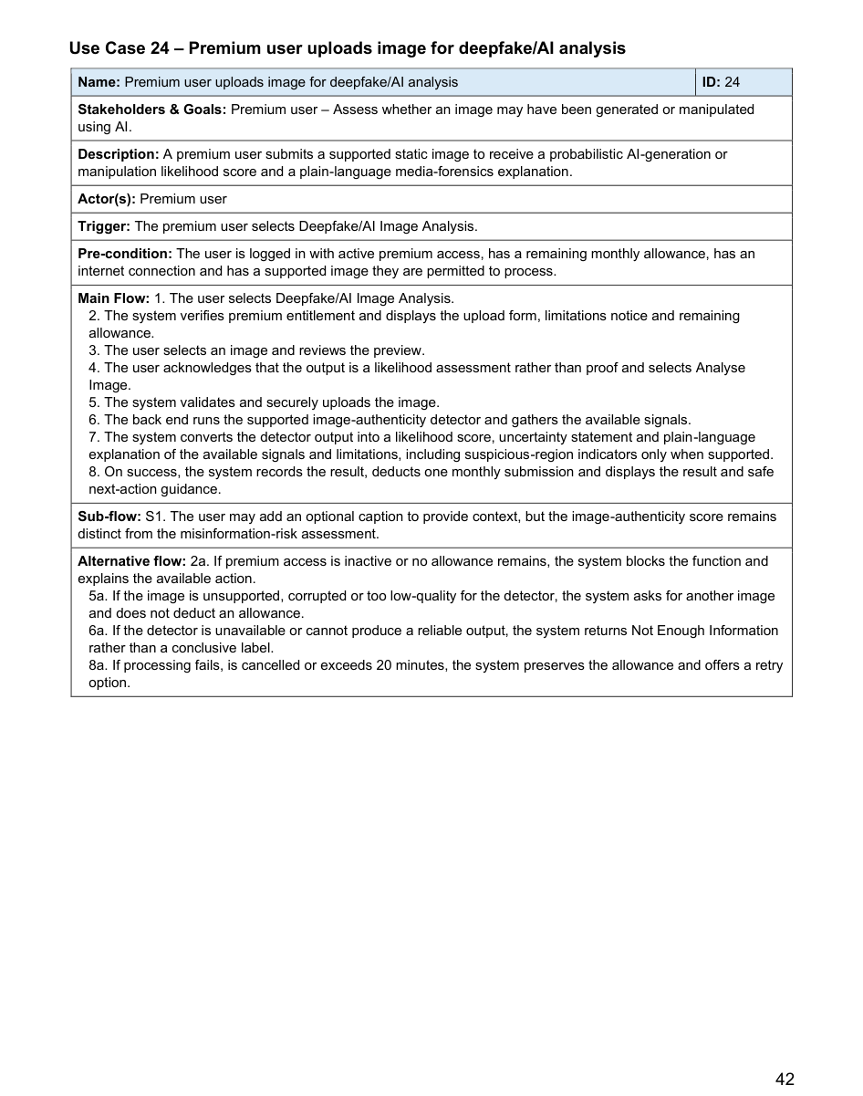

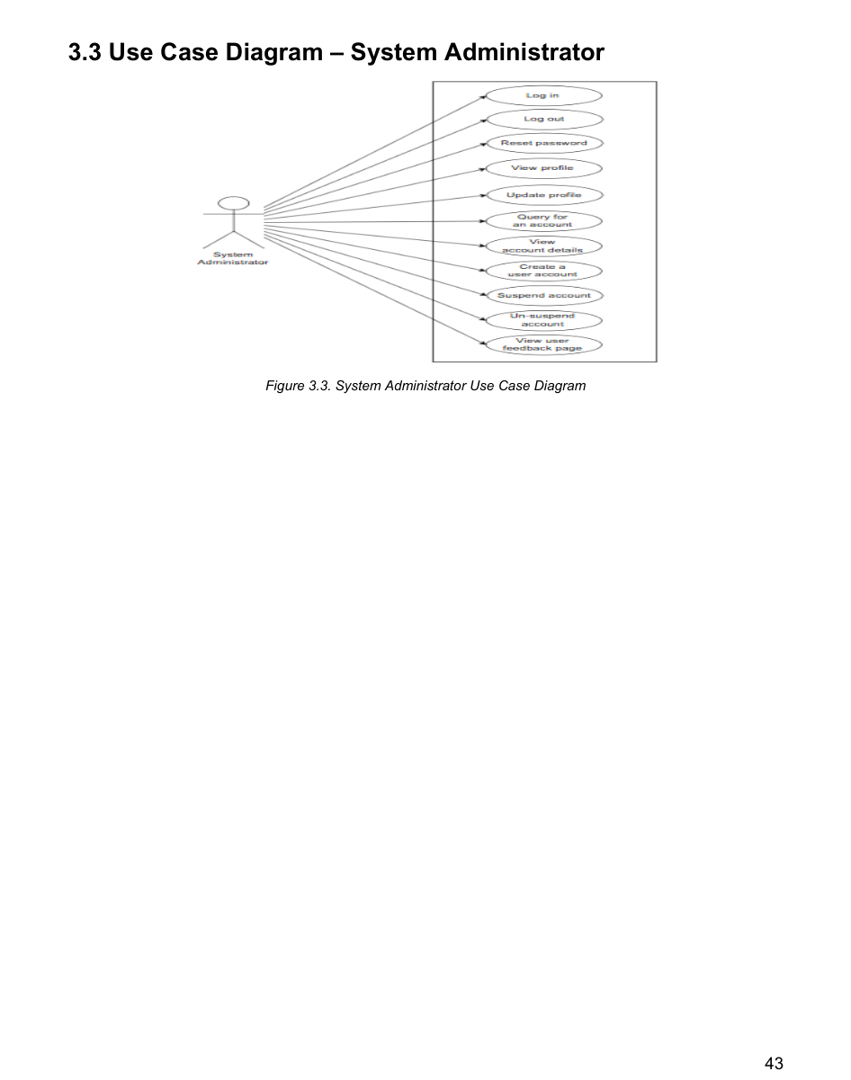

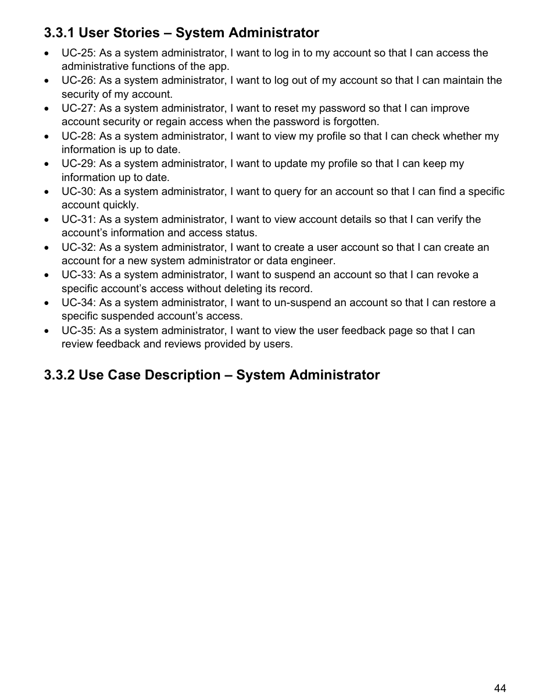

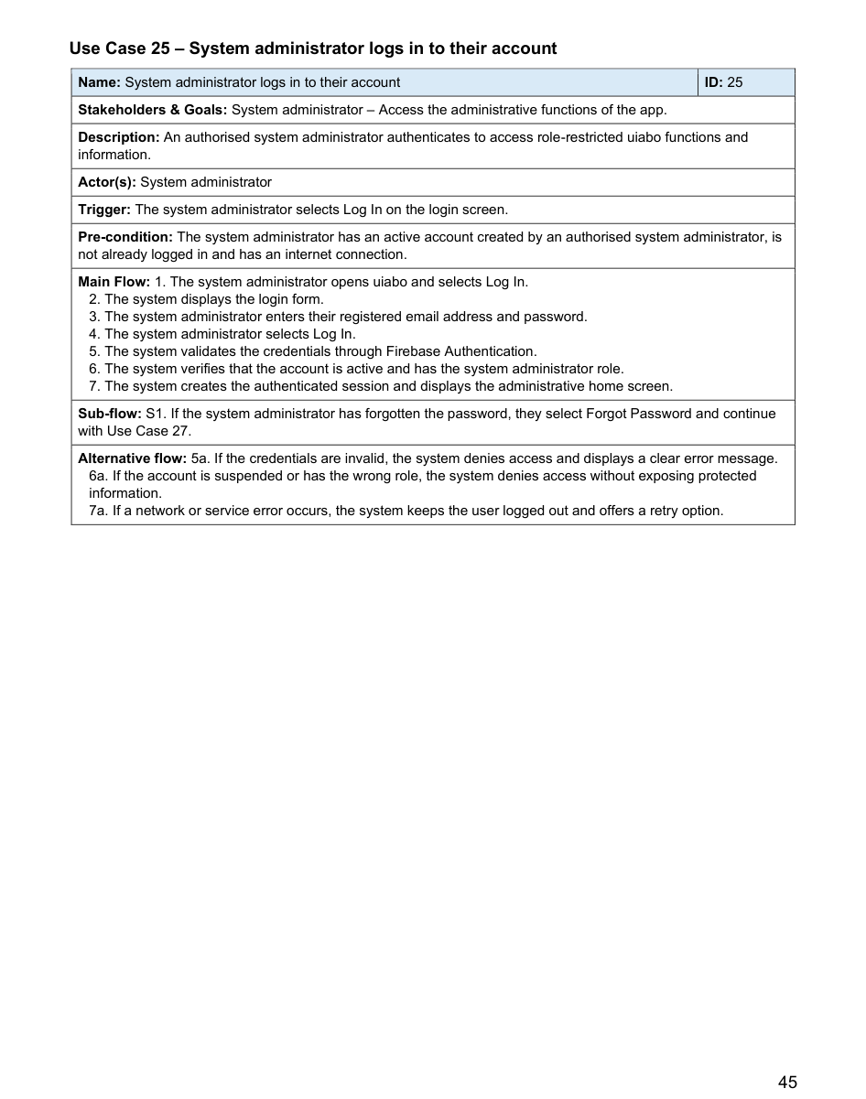

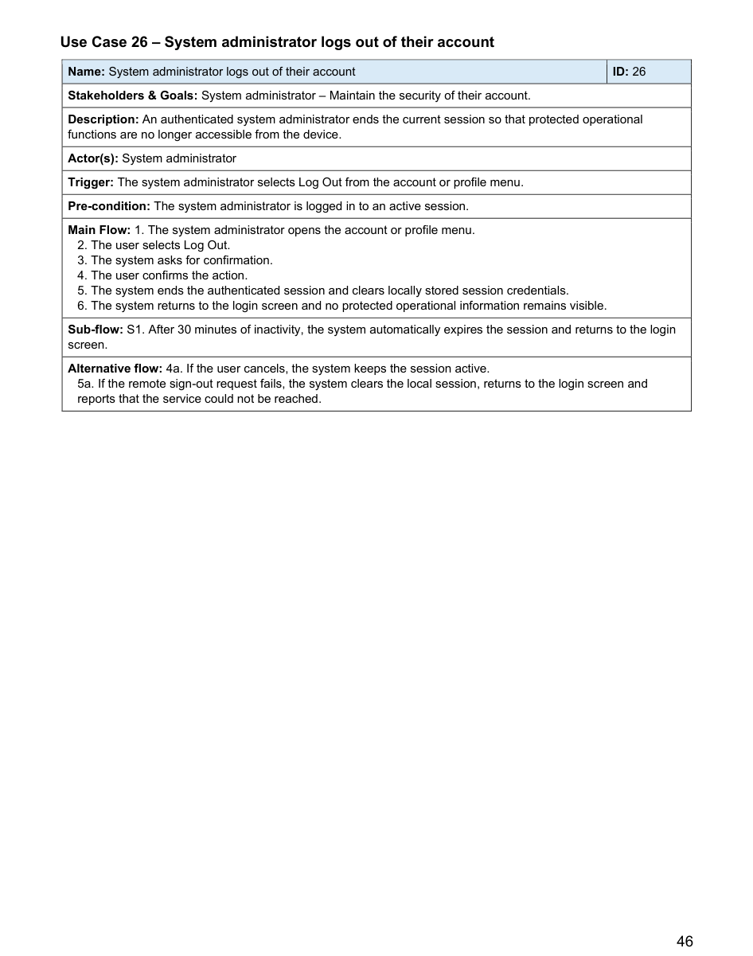

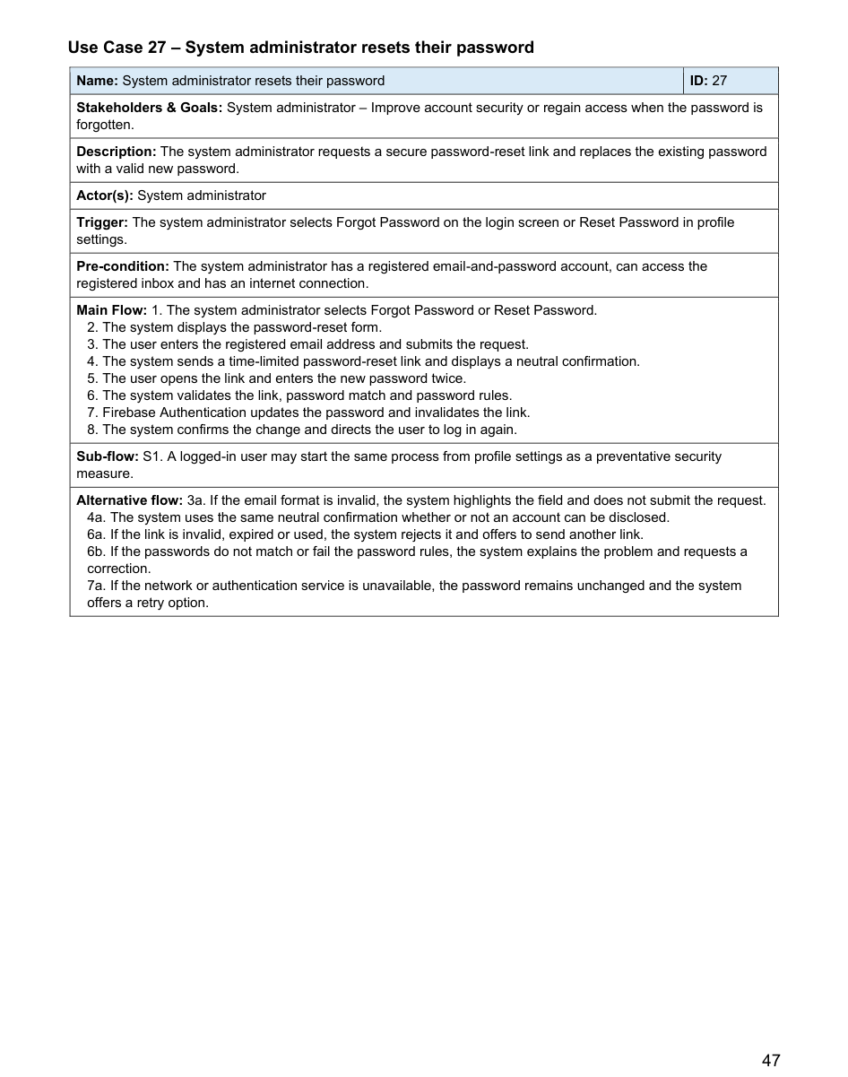

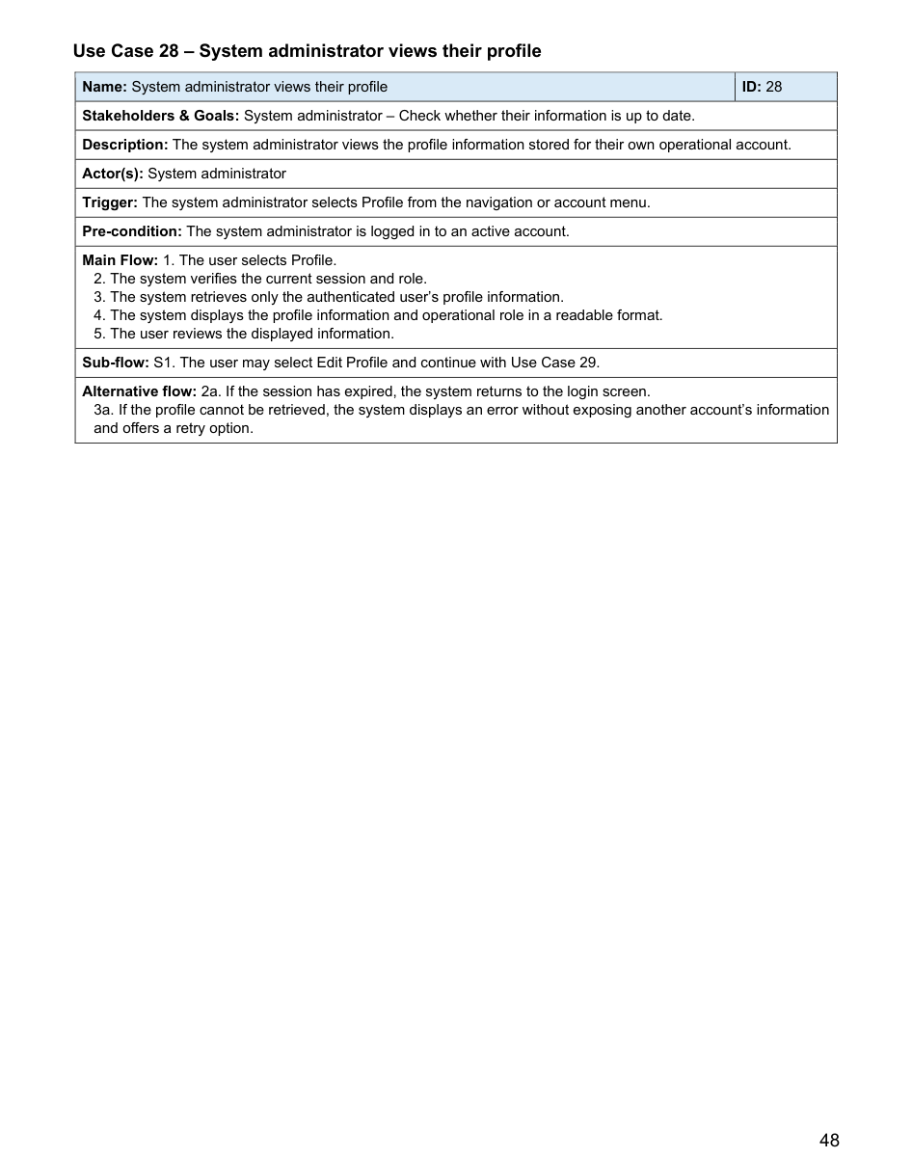

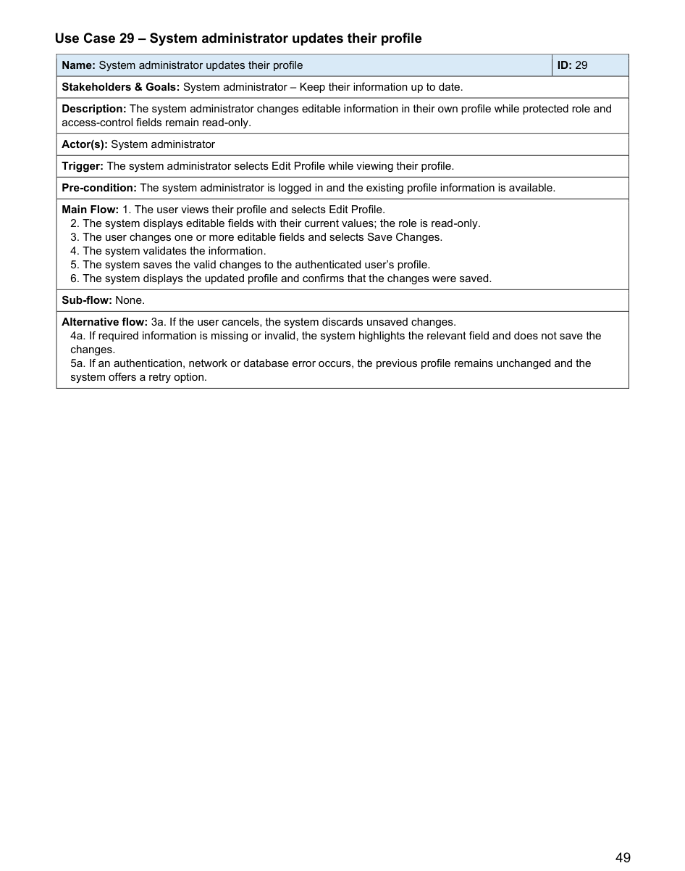

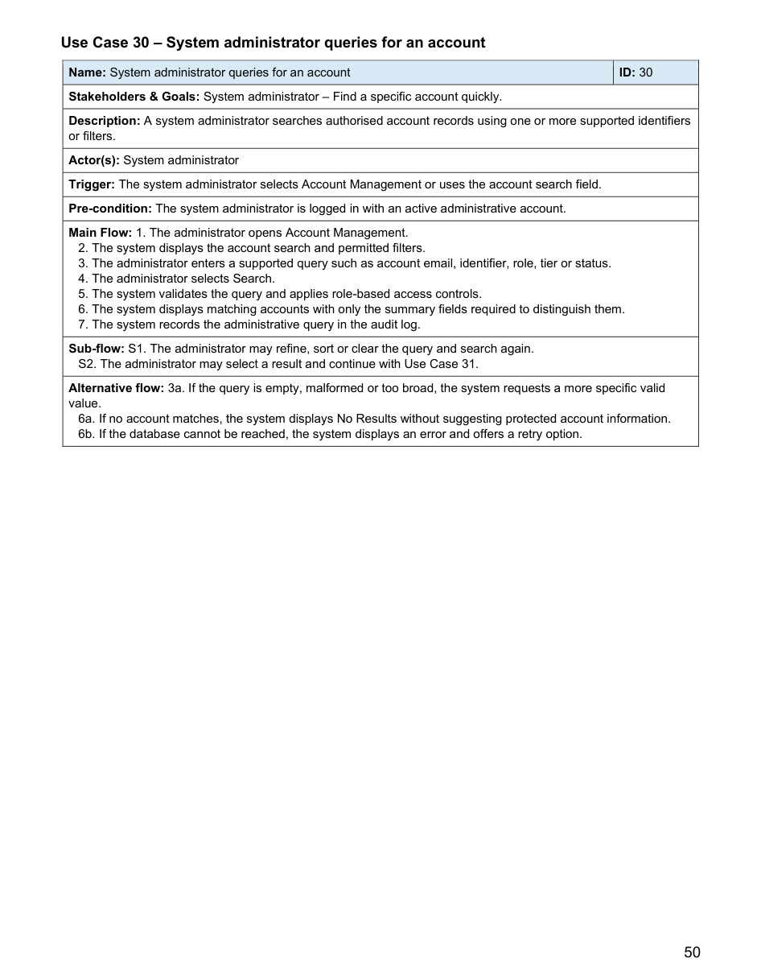

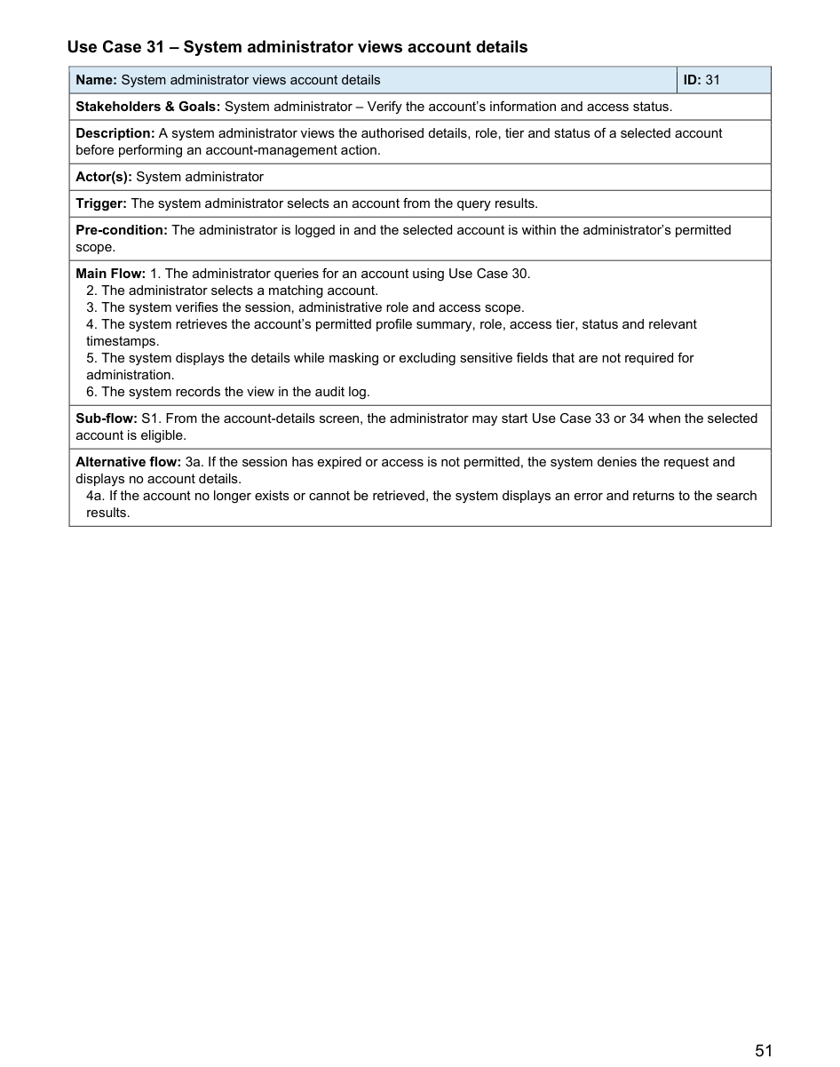

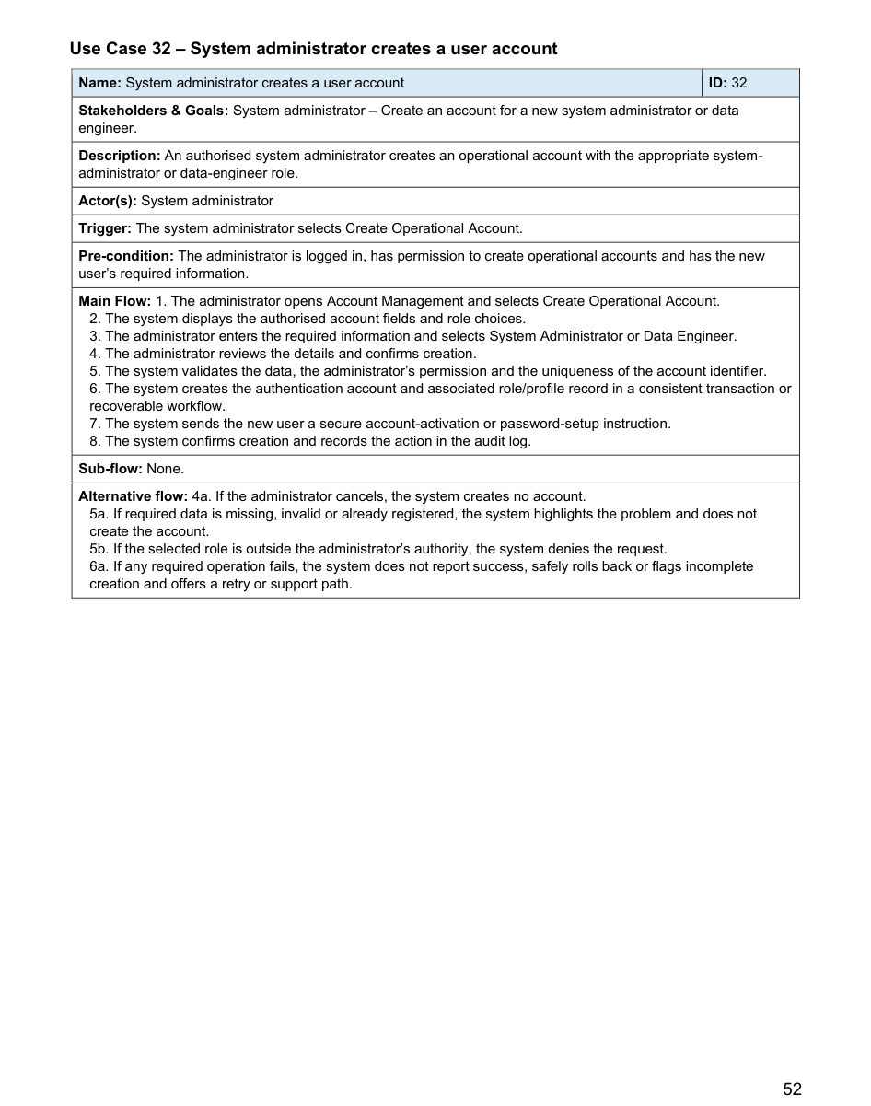

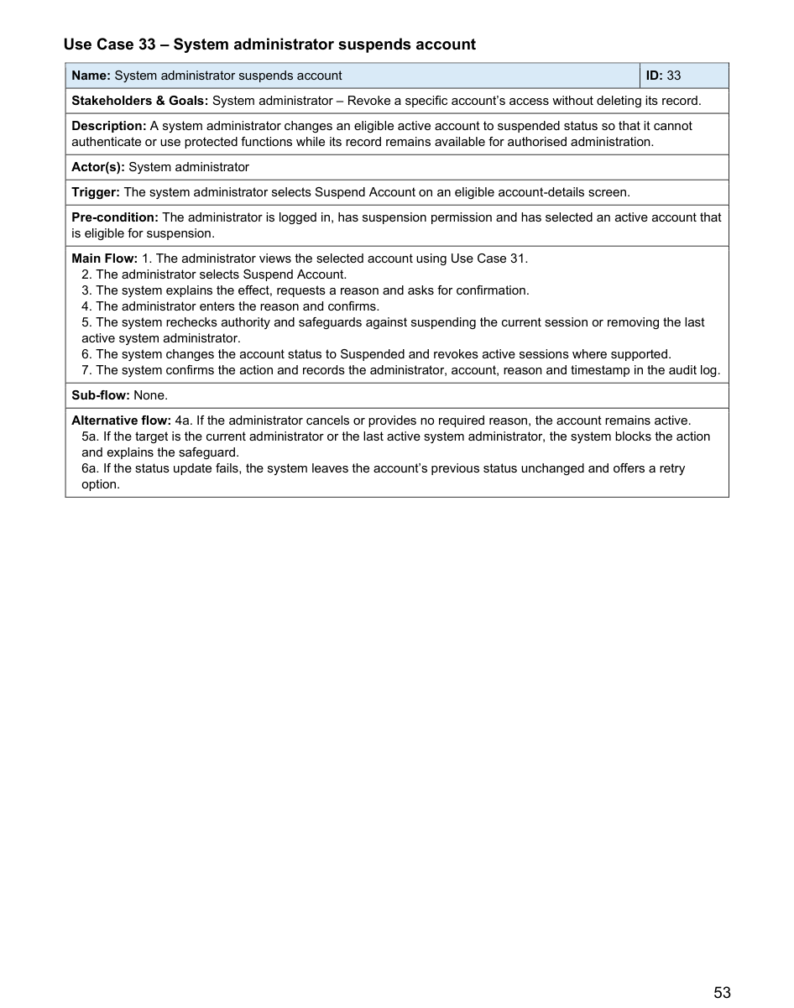

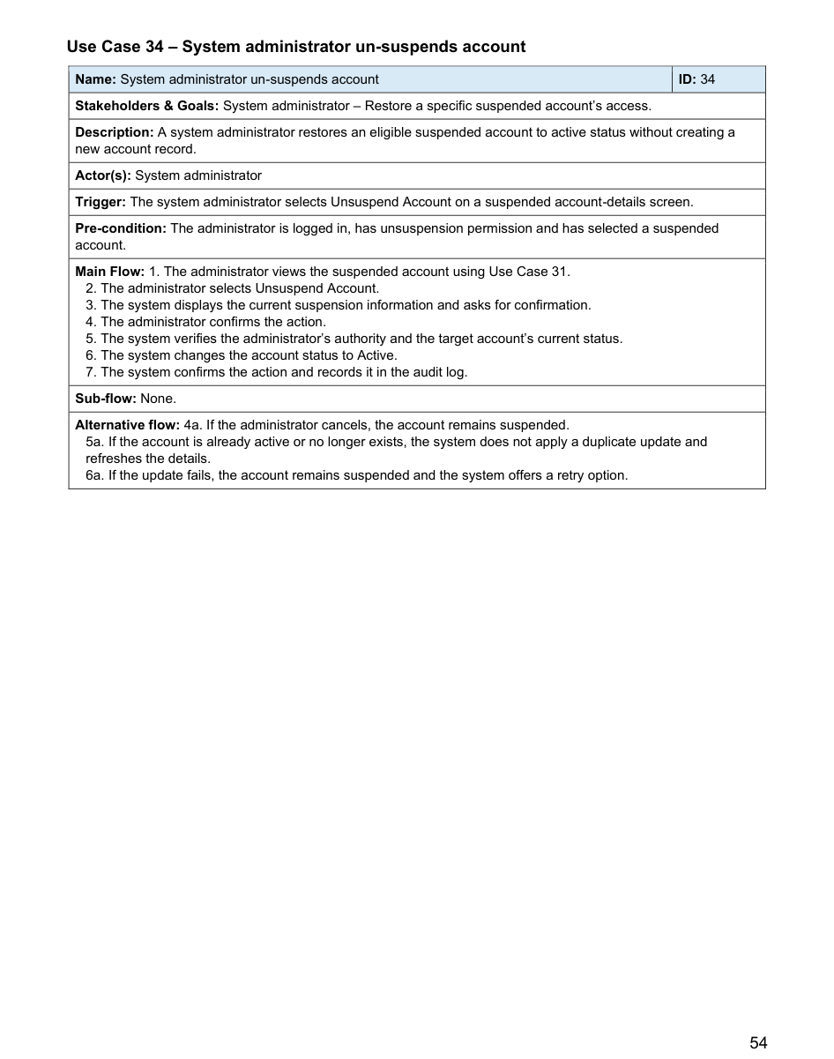

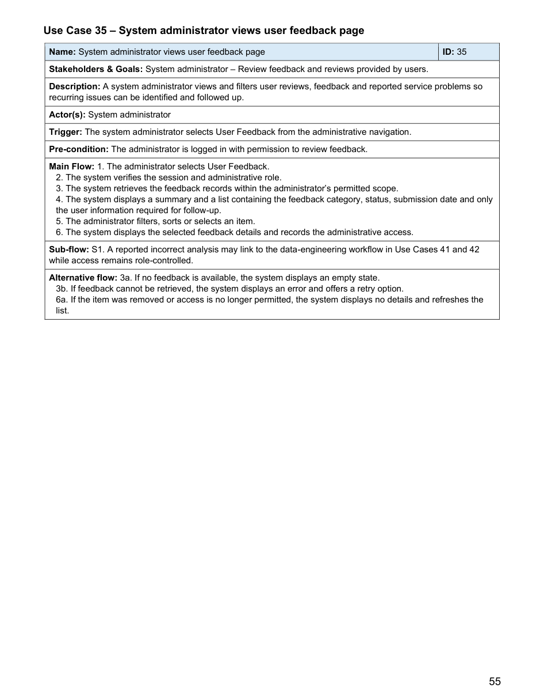

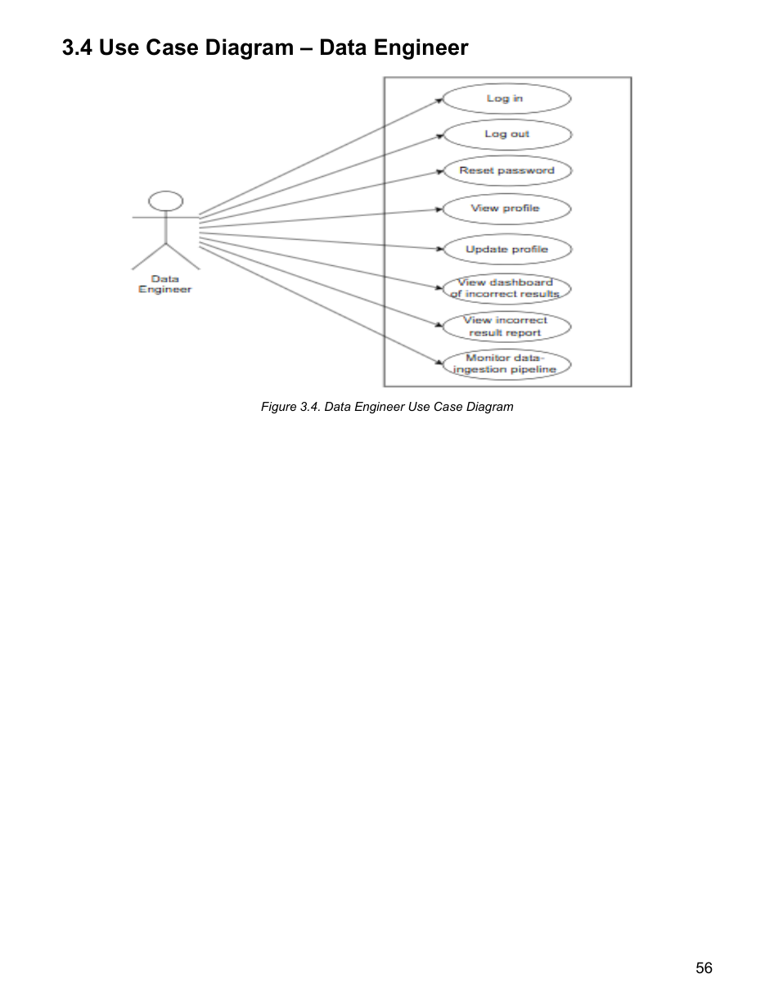

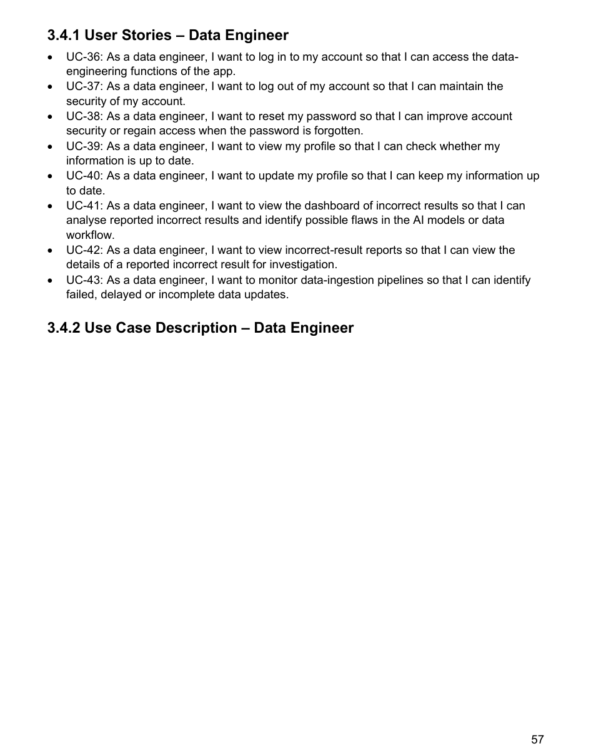

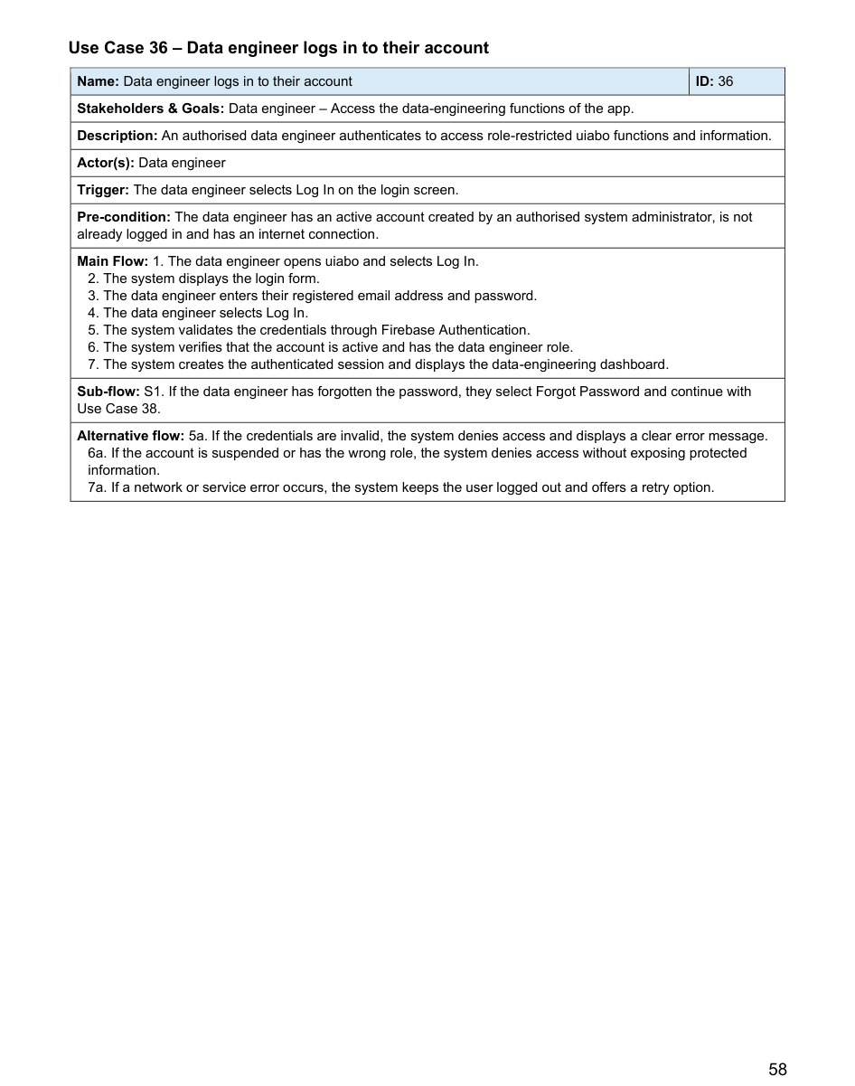

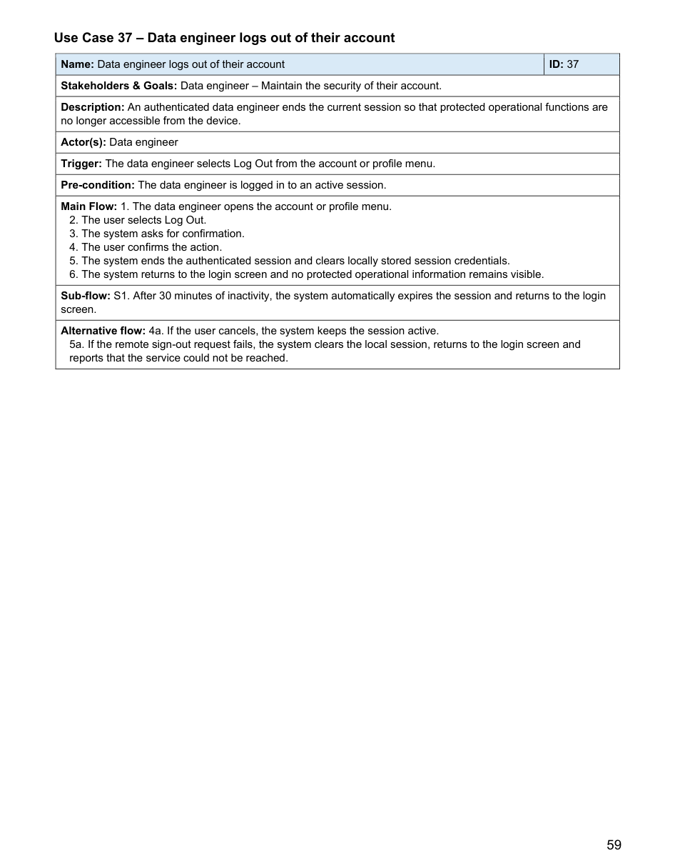

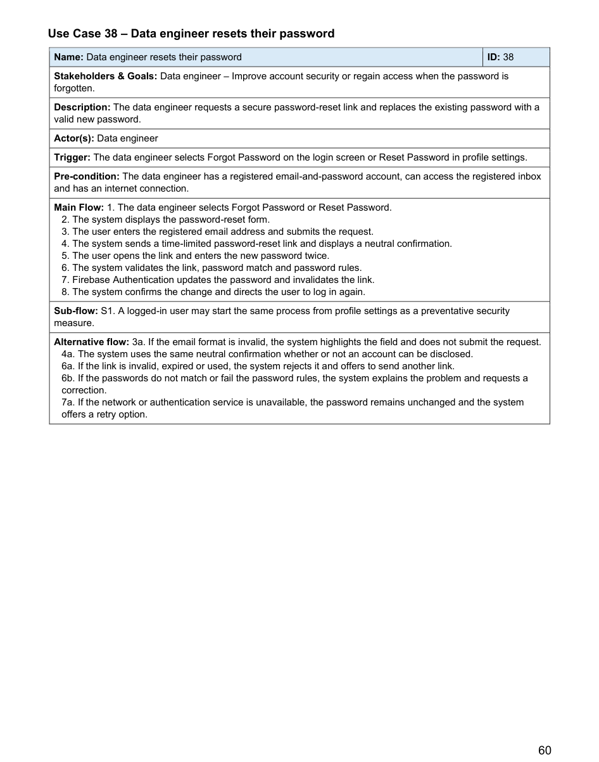

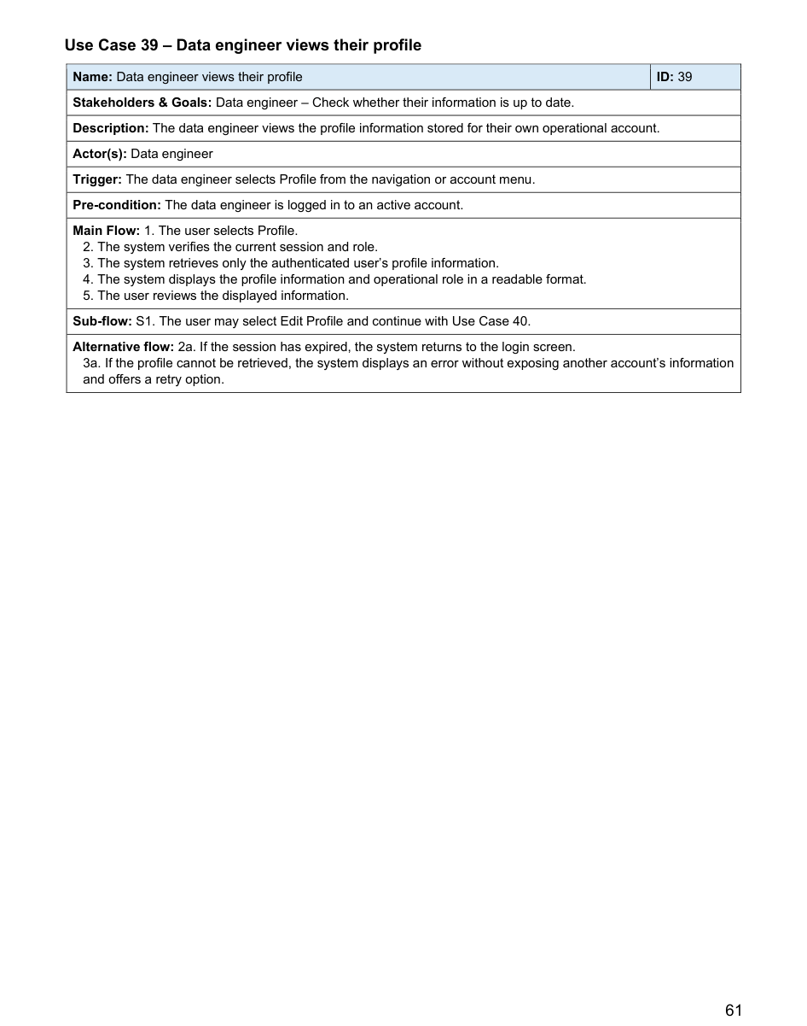

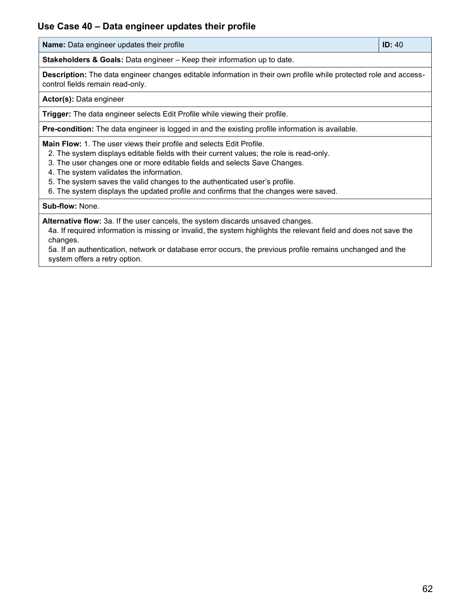

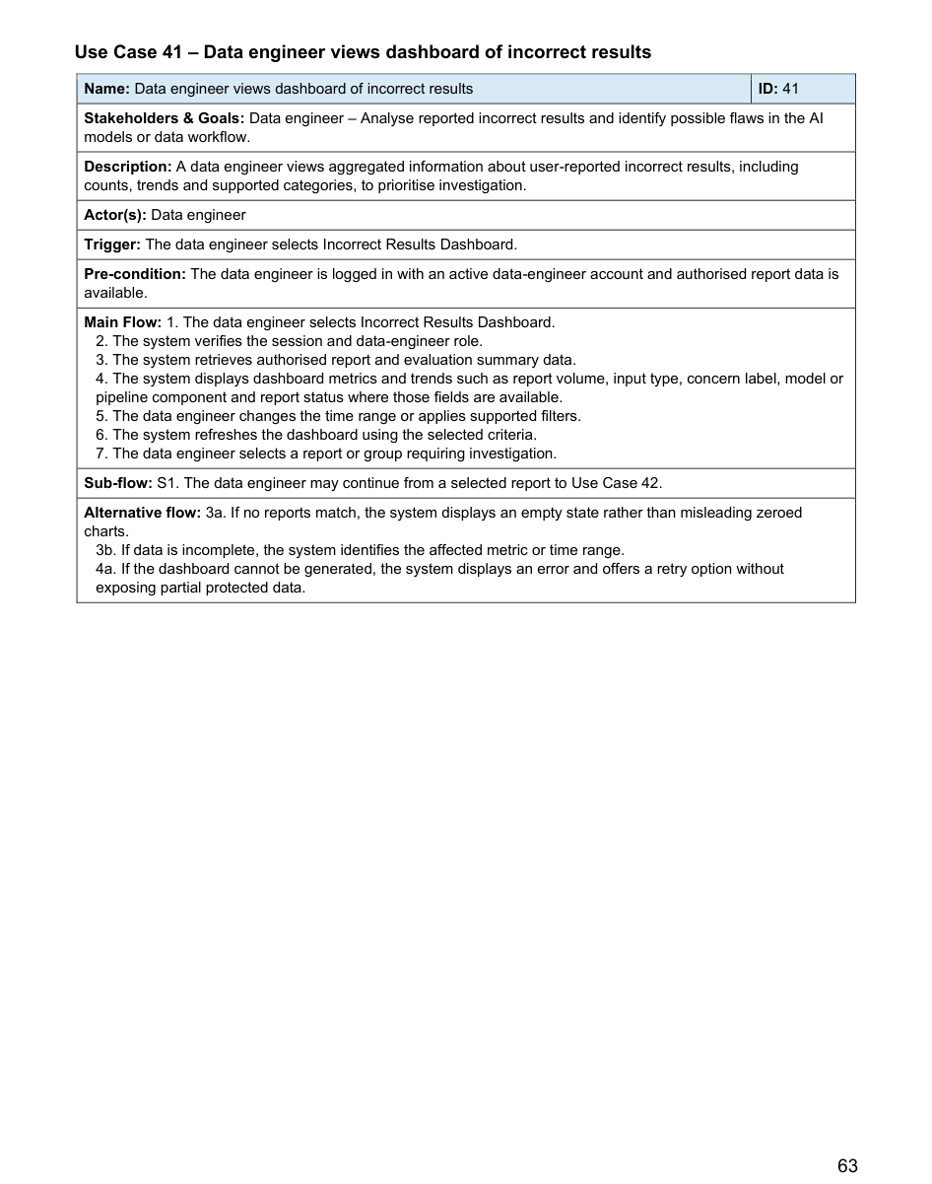

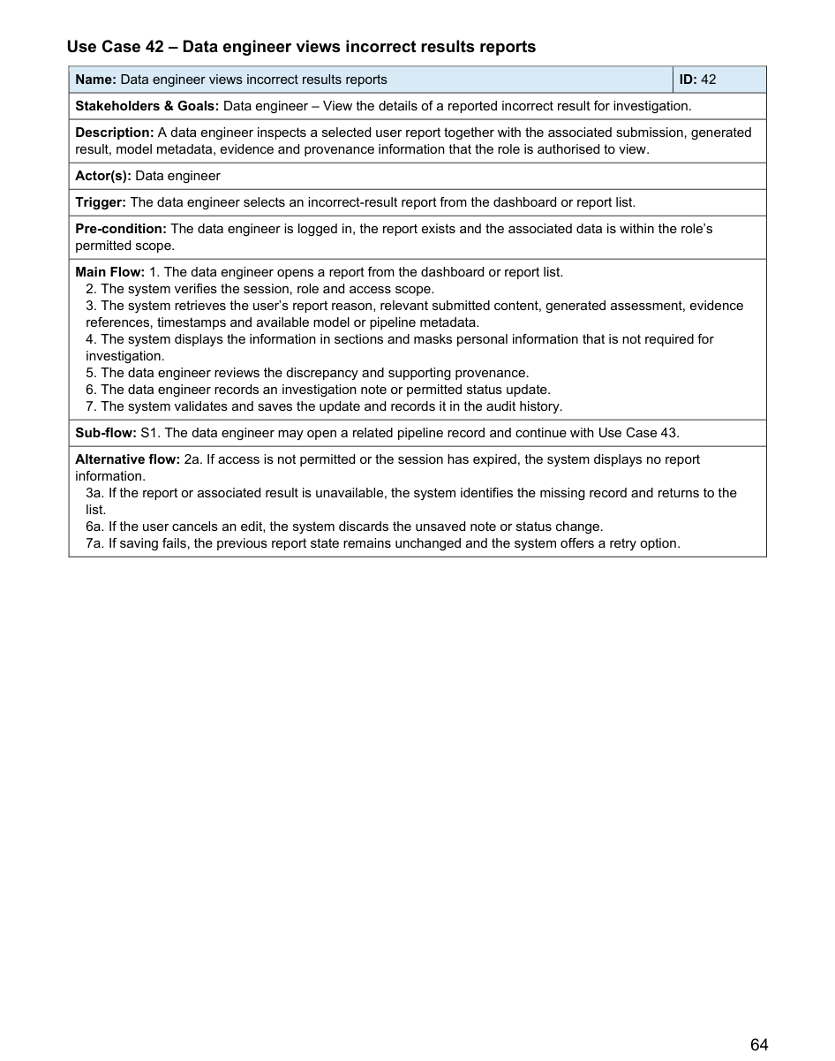

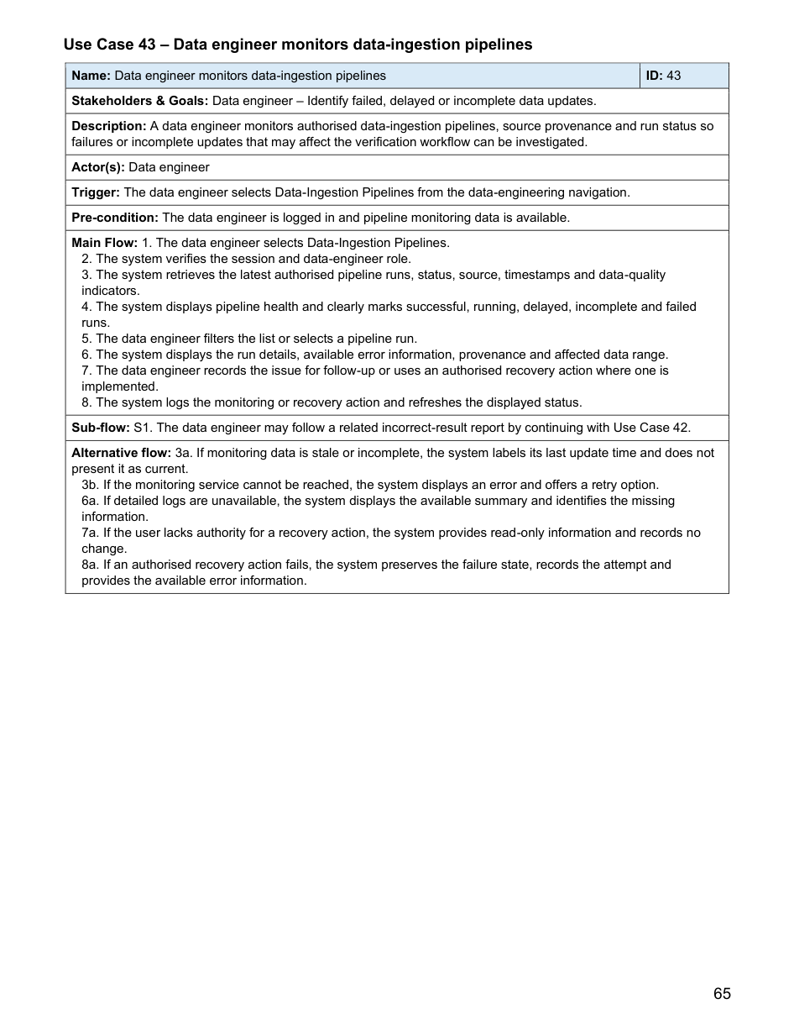

5.2 Non-Functional Requirements

5.2.1 User Capacity (Scalability)
Concurrent usage: The system must be able to support at least 100 concurrent users.

Peak Traffic Load: The system must be able to function during peak traffic times, being able to handle 100 requests per minute.

Scalability: The system and database architecture must be designed to handle a 20% increase in user base per year.

5.2.2 Load Time
Initial UI Load: The initial UI of the app (homepage/login/register) must load within 2 seconds over a stable mobile connection.

Interaction Latency: UI elements must respond to user input (clicks/taps) within 1 second.

Image/Asset Optimisation: The app should lazy-load images and compress assets to ensure they load in no longer than 2.5 seconds.

5.2.3 Database Storage Space
Limit: The system should provide a notification to the user if they exceed 80% of their allocated personal storage quota.

5.2.4 Result Generation Time
Short-form text-based content: The system should generate results in under 5 minutes.

Links: The system should generate results in under 5 minutes.

Image related functions: The system should generate results in under 10 minutes.
Timeout: The system should have a timeout mechanism in place, canceling processes that exceed 20 minutes to prevent resource exhaustion.

5.2.5 System Security
Data in database/app: All sensitive user data stored in the database must be encrypted. All sensitive user data available to system administrators must also be encrypted.

Authentication: The system must implement username and passwords for all user accounts.

Session Management: User sessions should automatically expire after 30 minutes of inactivity.

5.3 Architectural Design
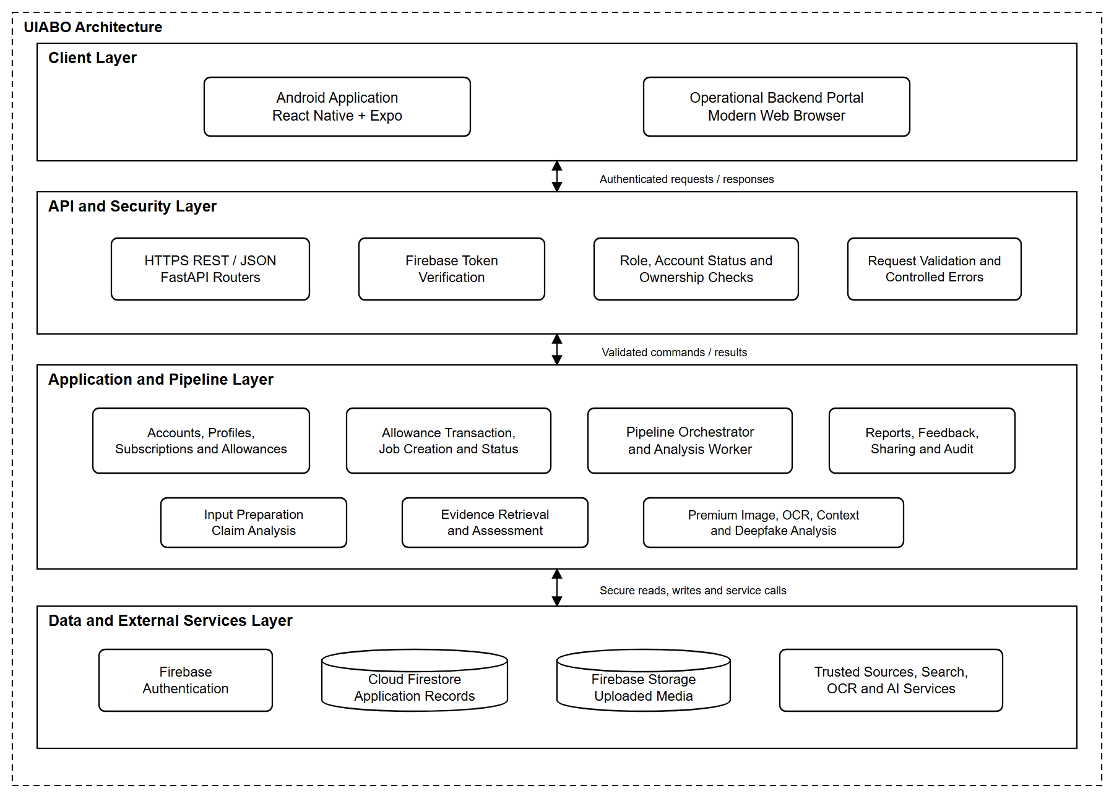

5.4 System Design

5.4.1 Sequence Diagrams

5.4.1.1 System Administrator

Login (System Administrator)
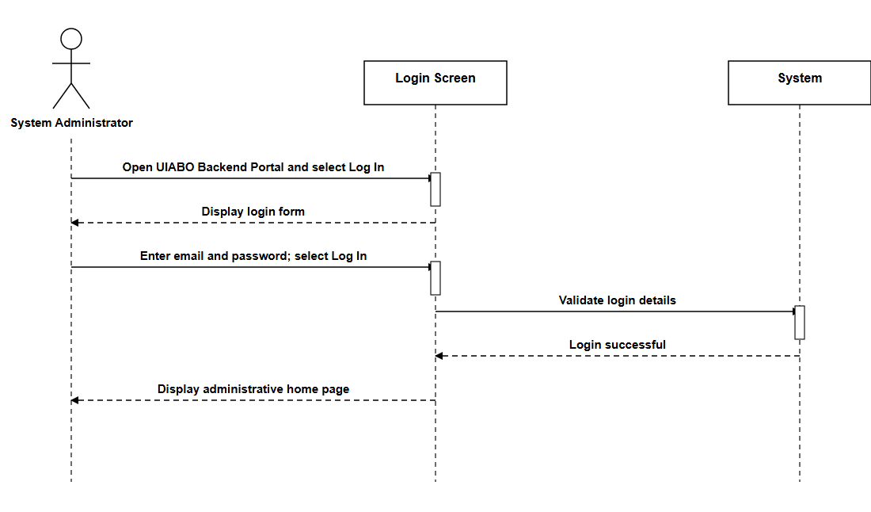

Logout (System Administrator)
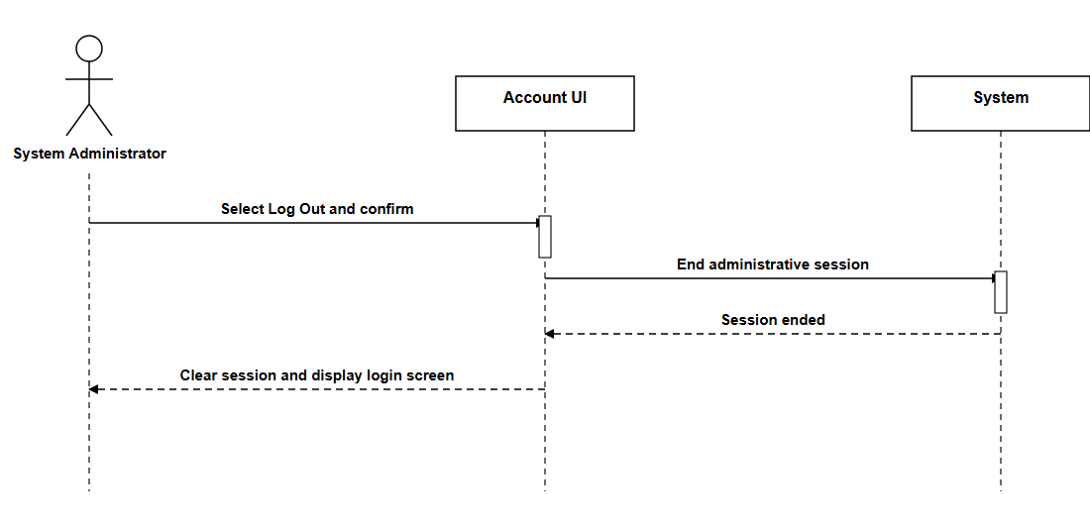

Reset Password (System Administrator)
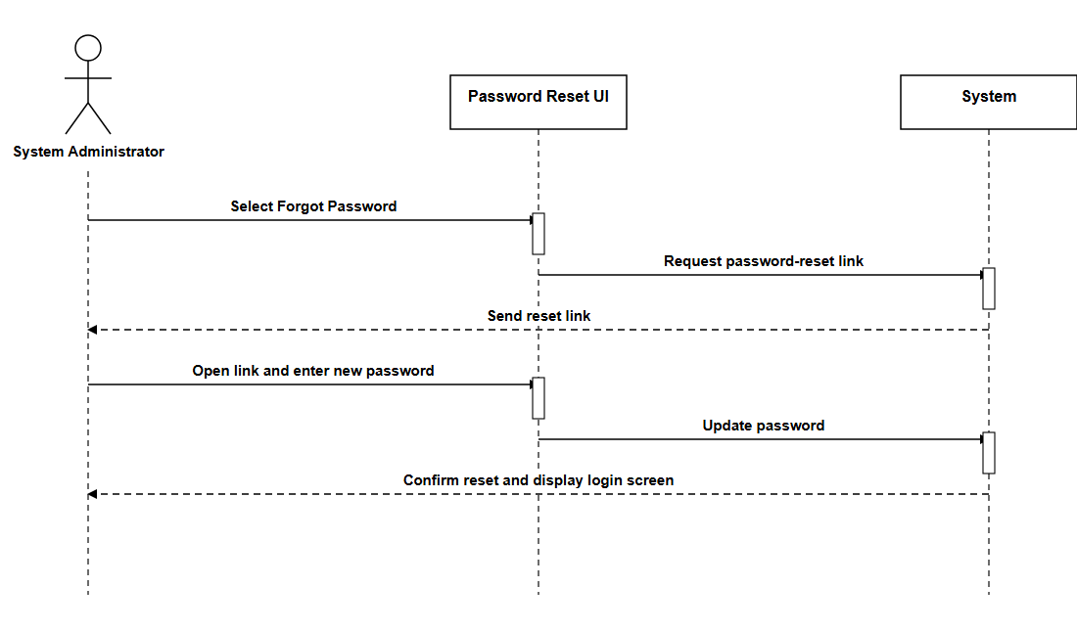

View Profile (System Administrator)
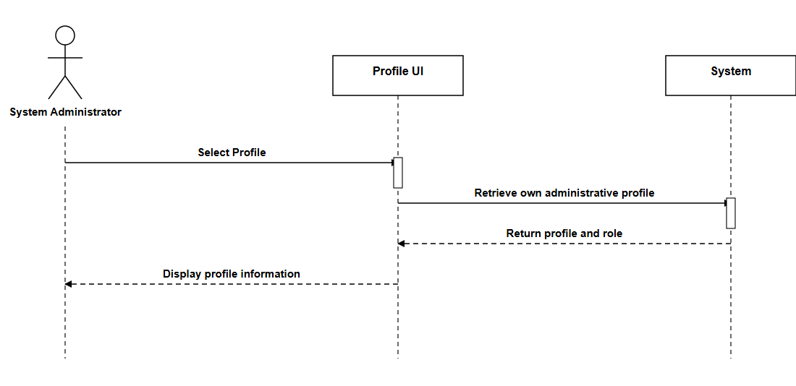

Update Profile (System Administrator)
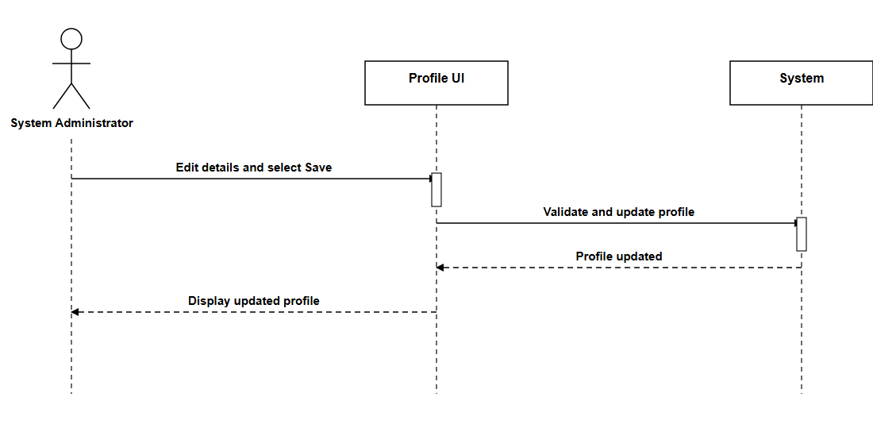

Query Account (System Administrator)
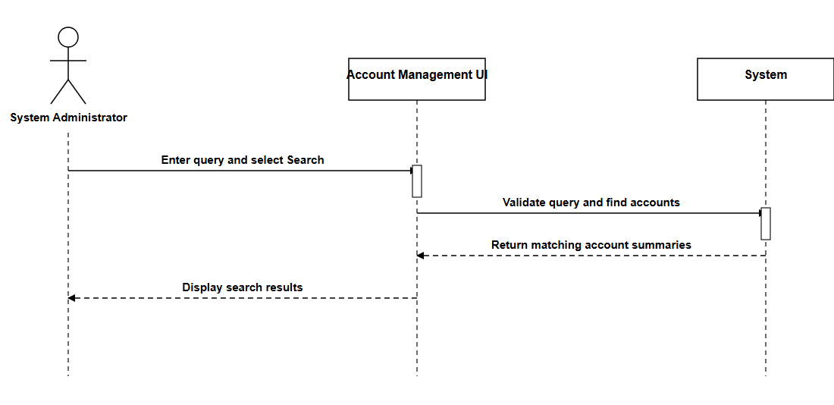

View Account Details (System Administrator)
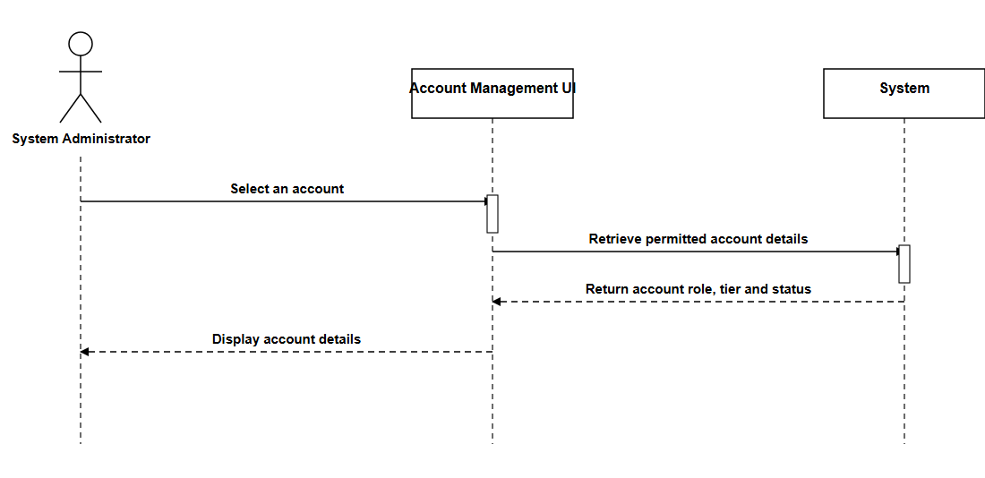

Create Operational Account (System Administrator)
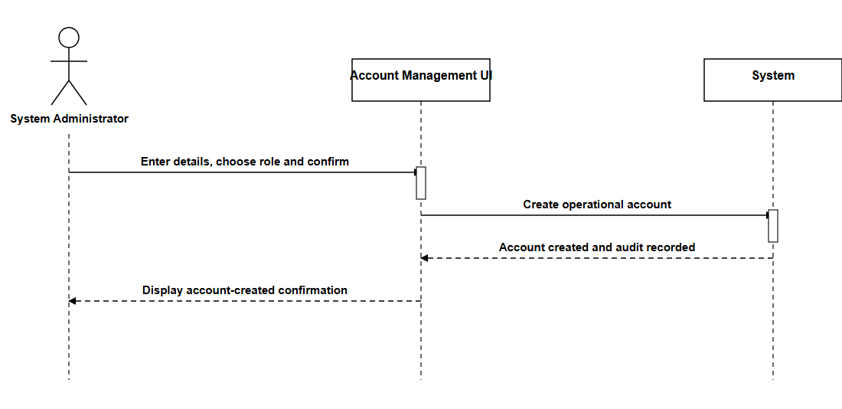

Suspend Account (System Administrator)
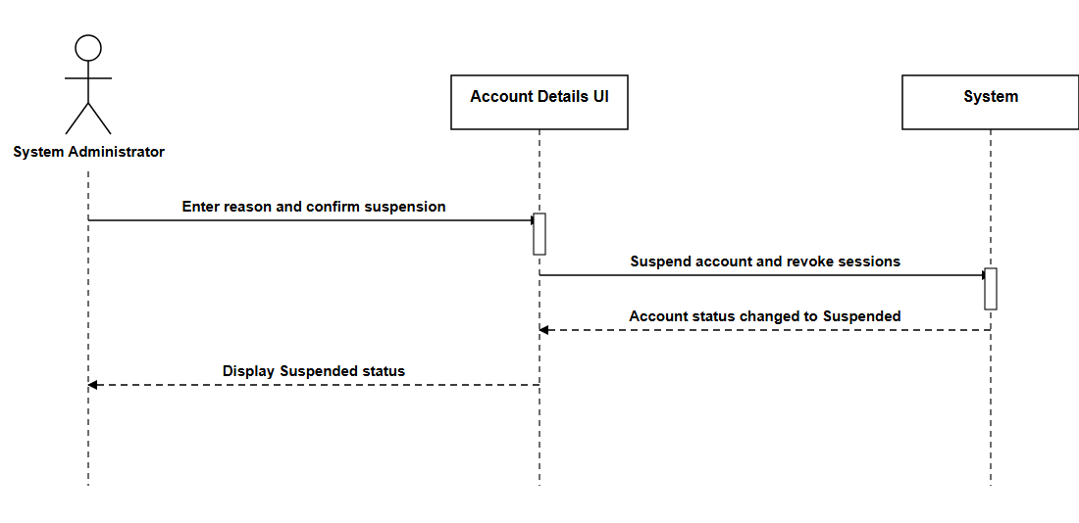

Unsuspend Account (System Administrator)
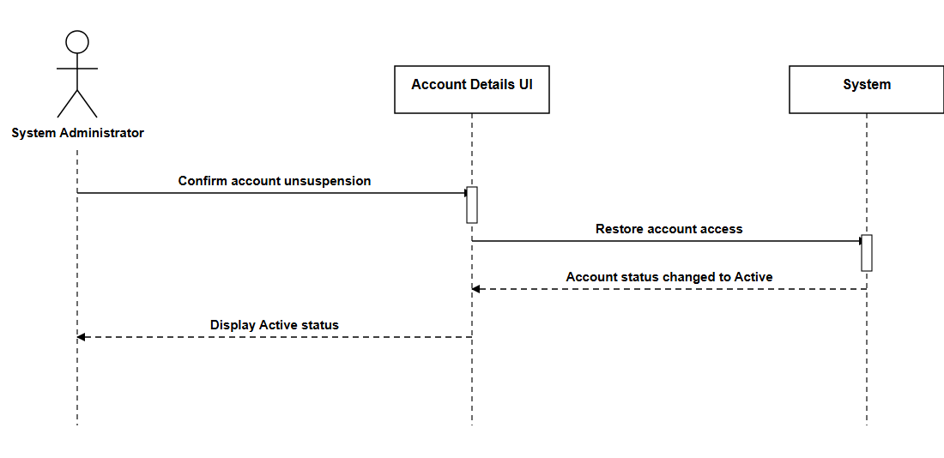

View User Feedback (System Administrator)
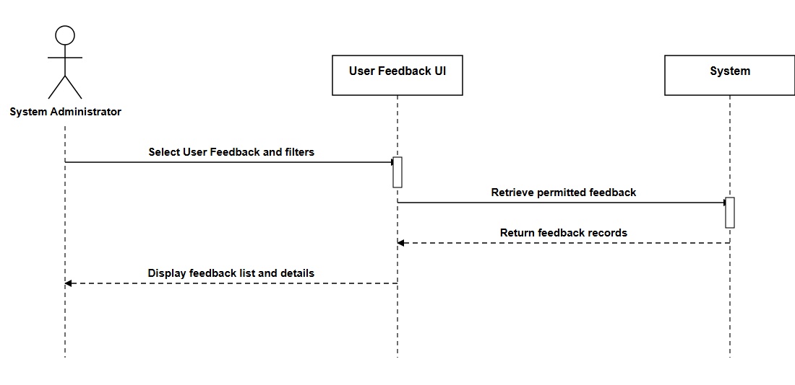

5.4.1.2 Free User

Login (Free User)
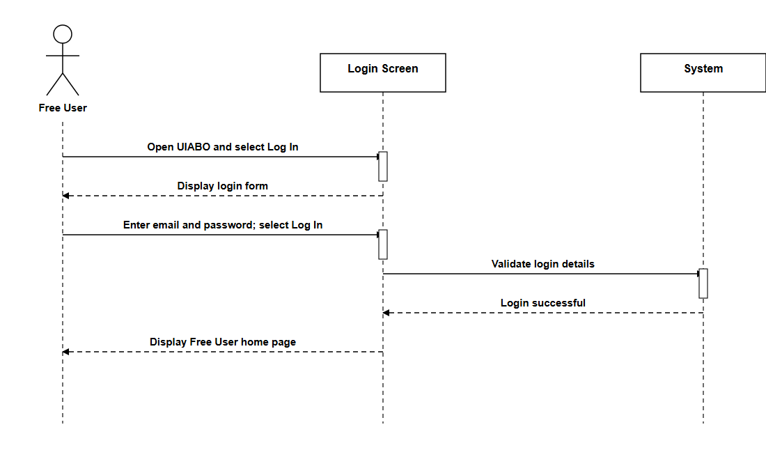

Logout (Free User)
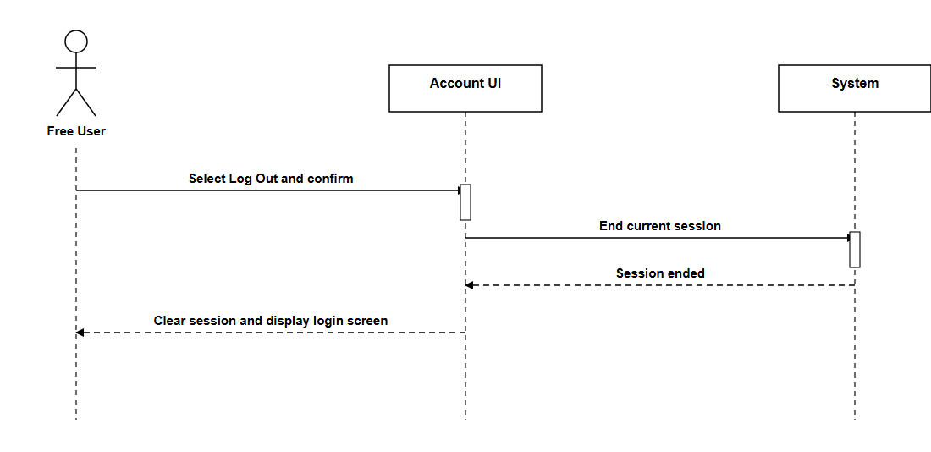

Delete Account (Free User)
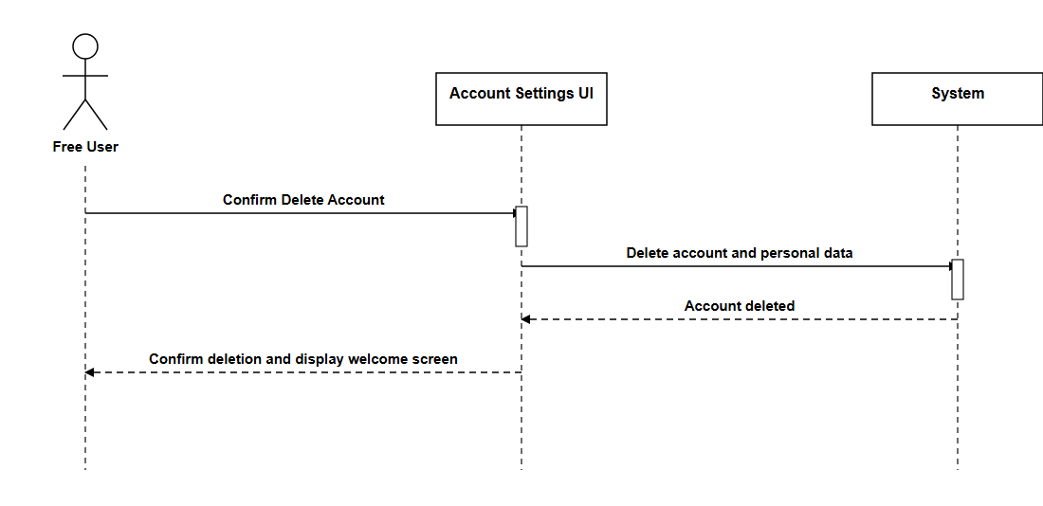

Reset Password (Free User)
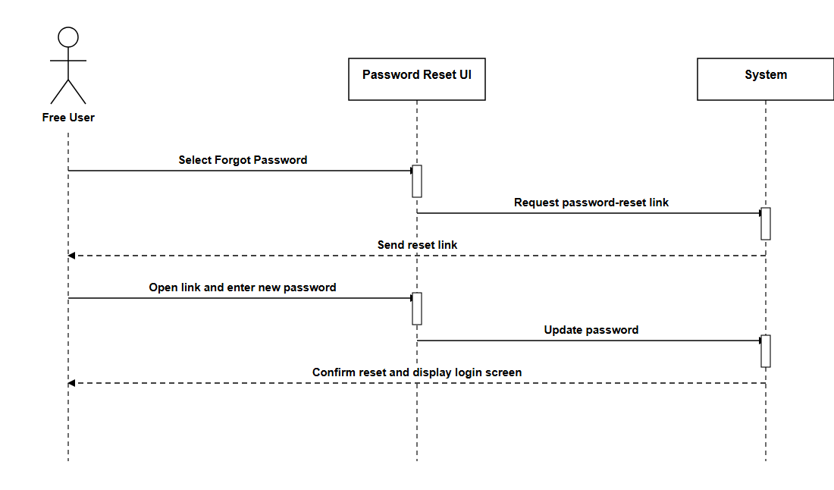

View Profile (Free User)
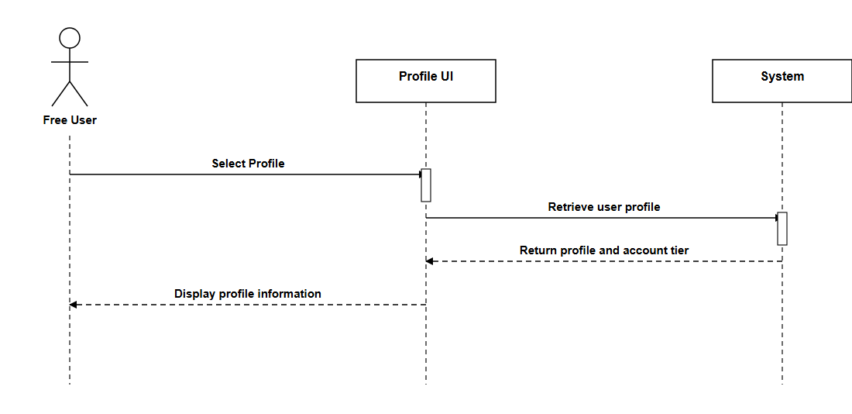

Update Profile (Free User)
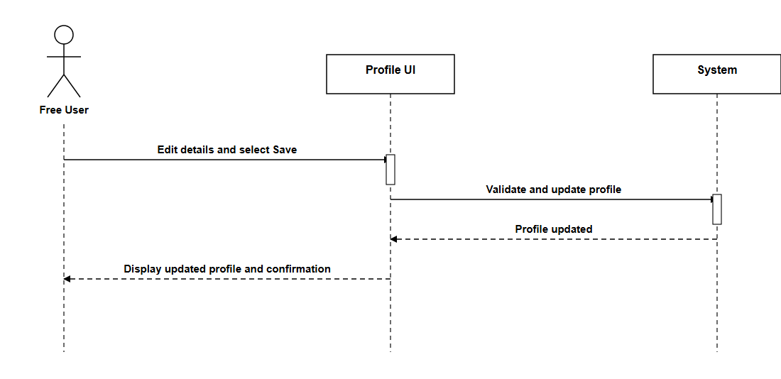

Analyse Short-form Text (Free User)
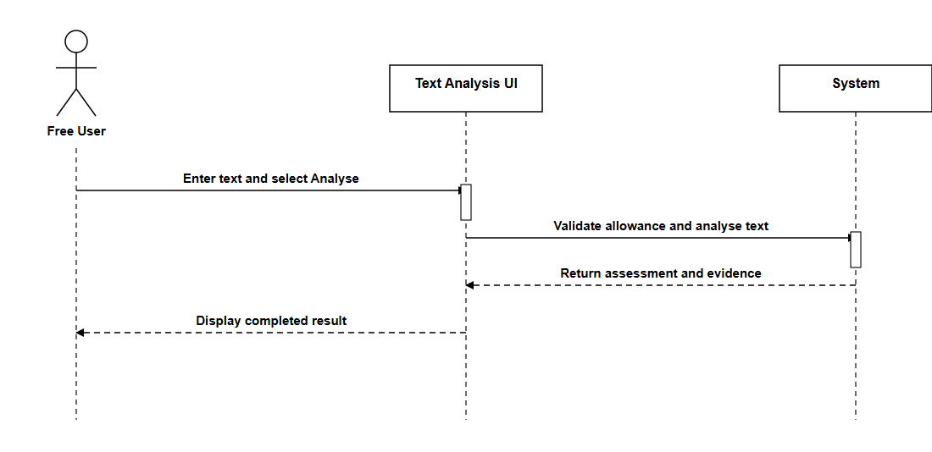

Analyse Public Webpage Link (Free User)
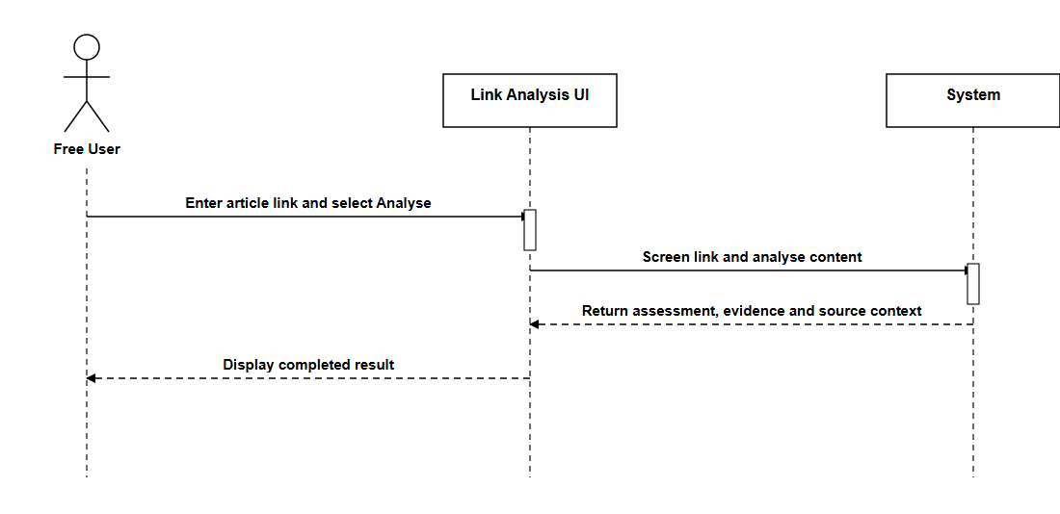

View Result History (Free User)
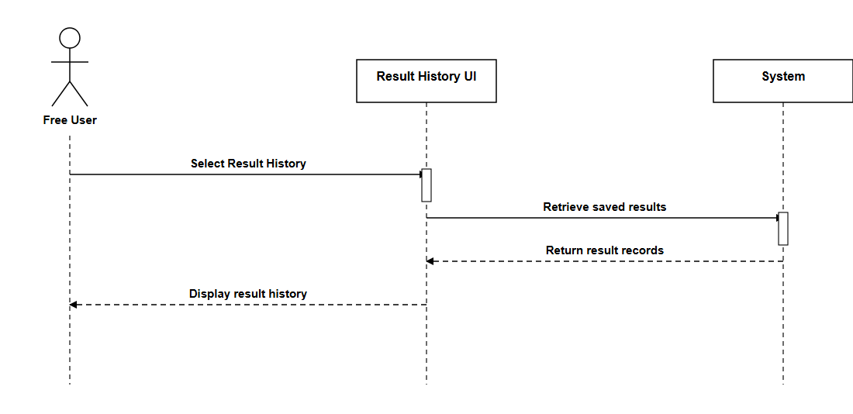

View Result Details (Free User)
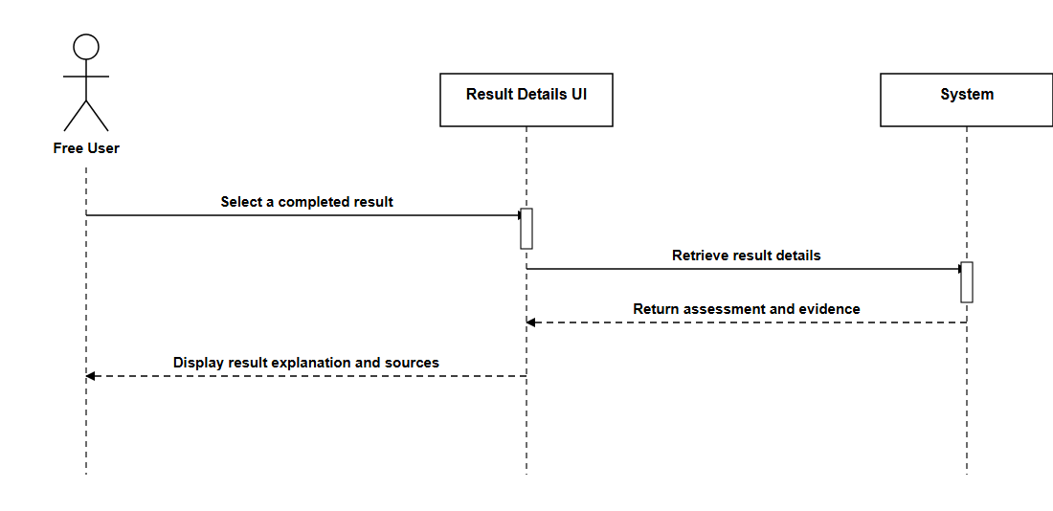

View Remaining Allowance (Free User)
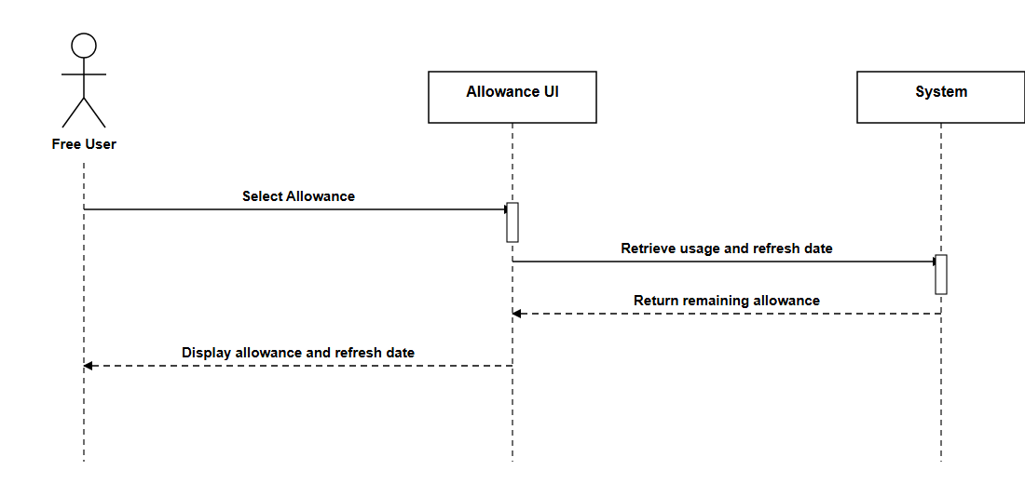

Delete Results (Free User)
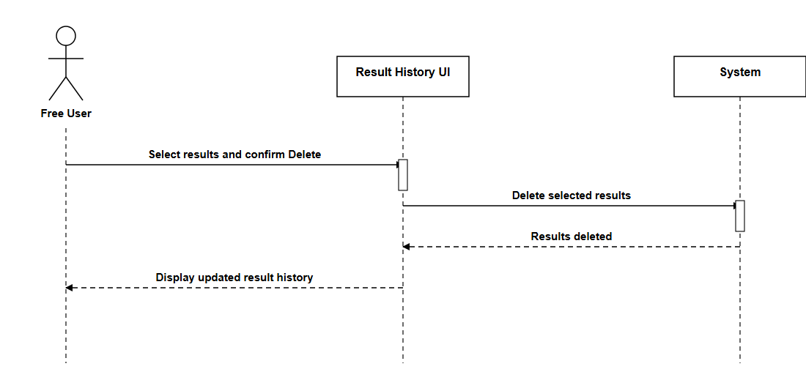

Report Incorrect Result (Free User)
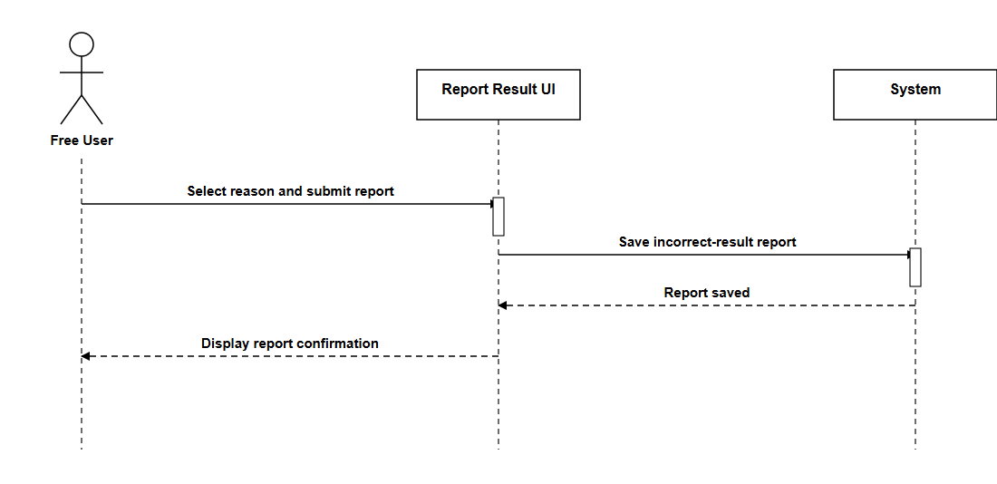

Leave a Review (Free User)
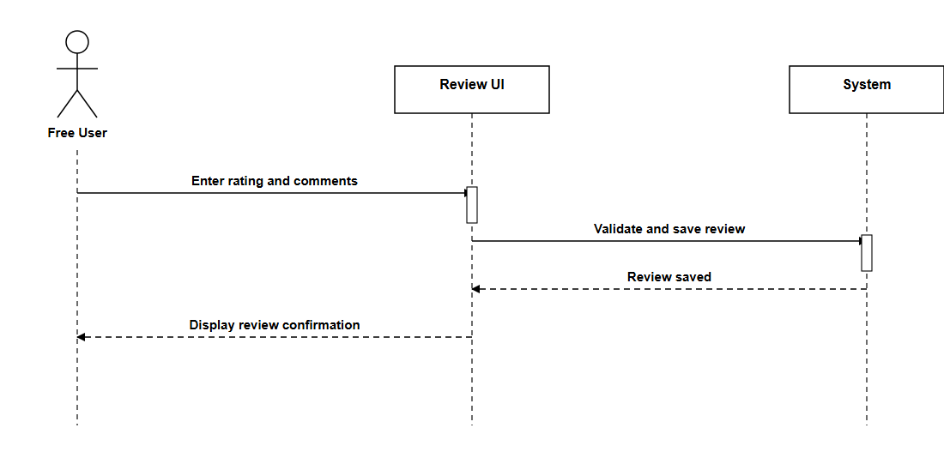

Share Result (Free User)
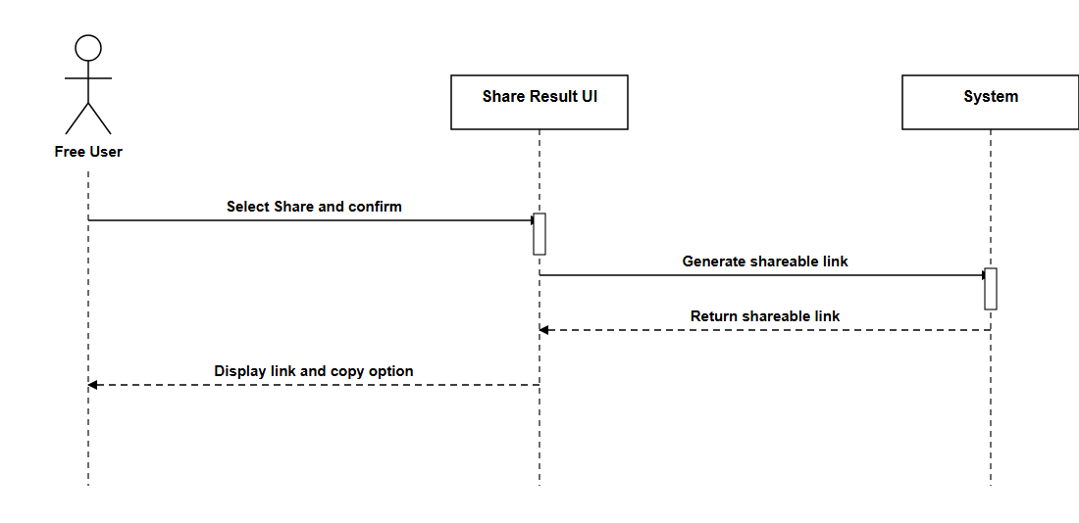

Create Account (Free User)
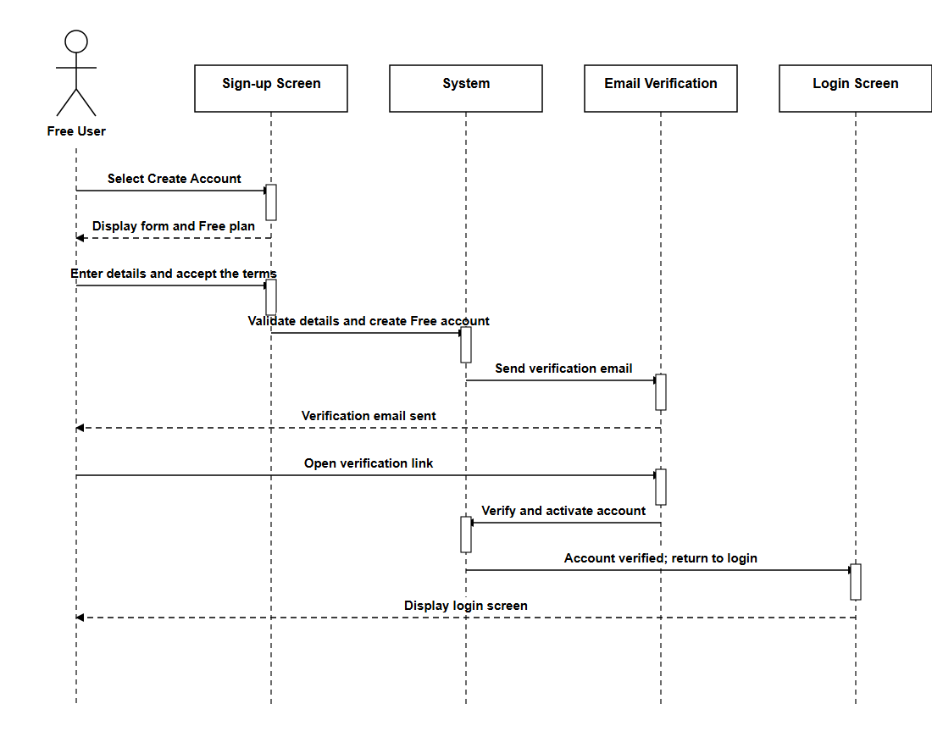

Upgrade to Premium (Free User)
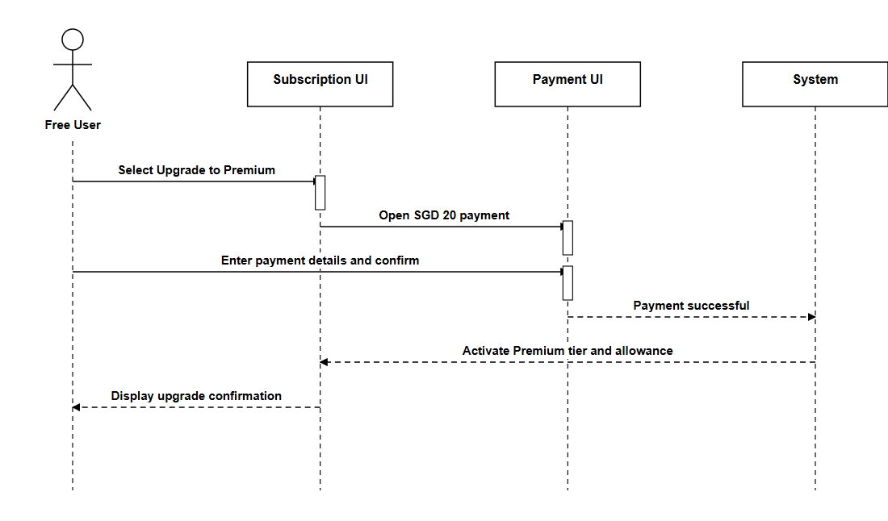

5.4.1.3 Premium User

Login (Premium User)
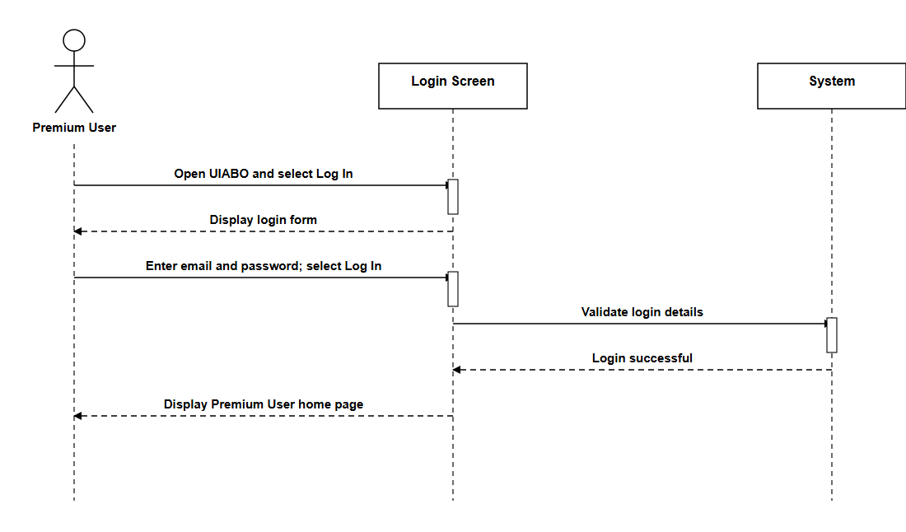

Create Account (Premium User)
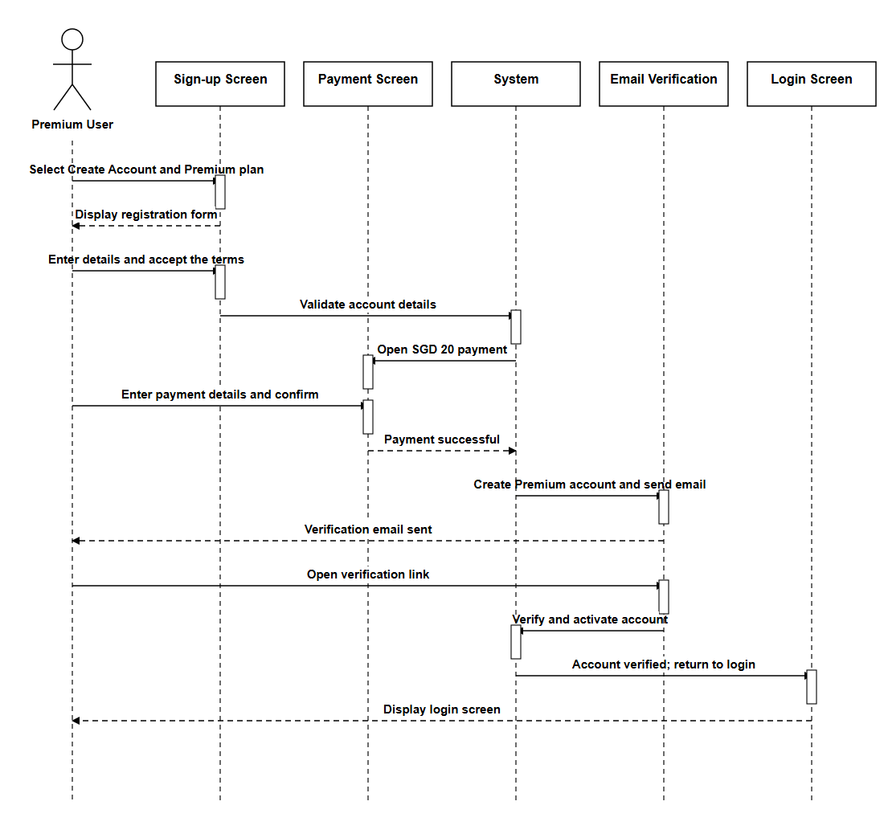

Renew Subscription (Premium User)
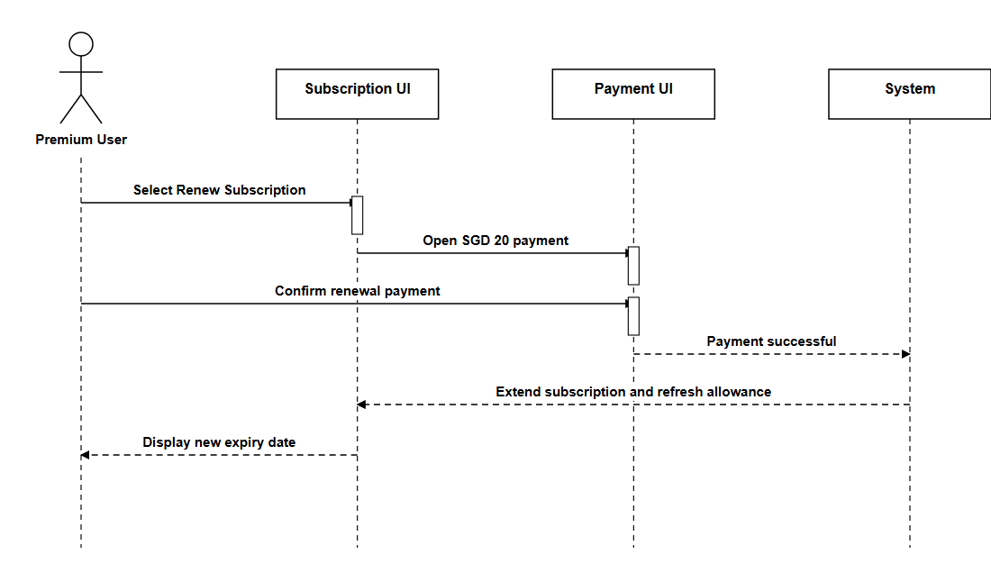

Cancel Subscription (Premium User)
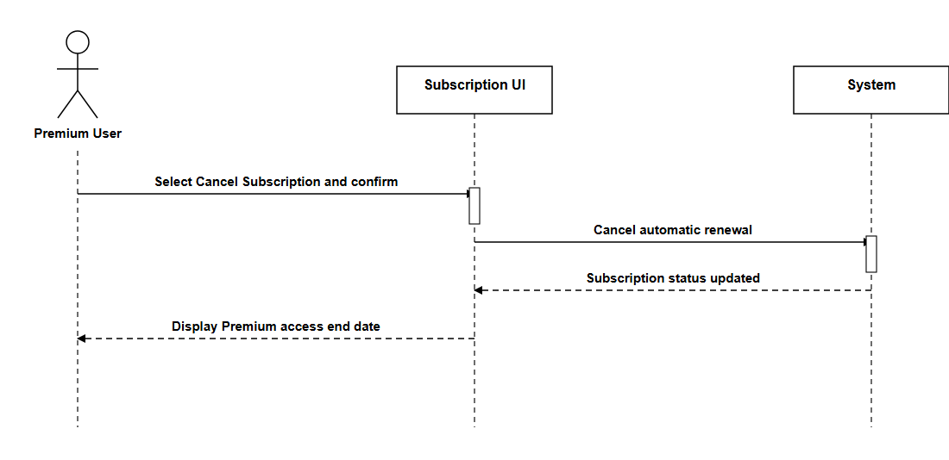

Image and Caption Analysis (Premium User)
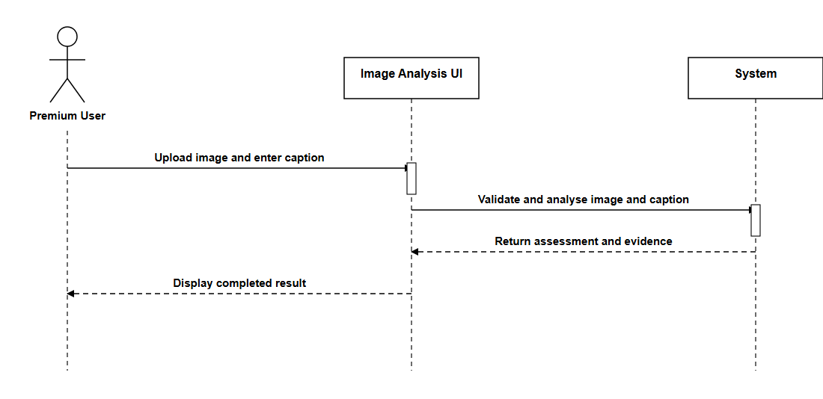

Caption-Image Context Analysis (Premium User)
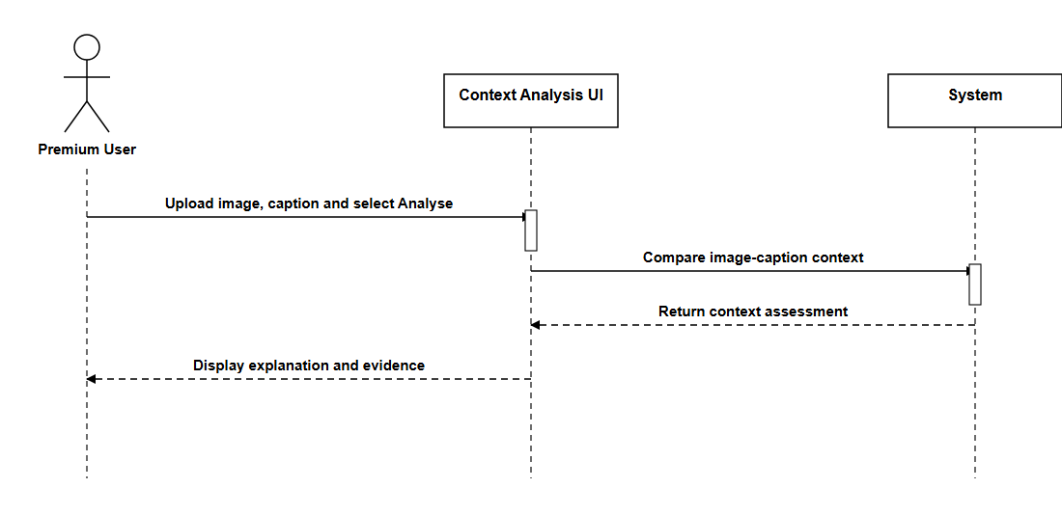

OCR Image Analysis (Premium User)
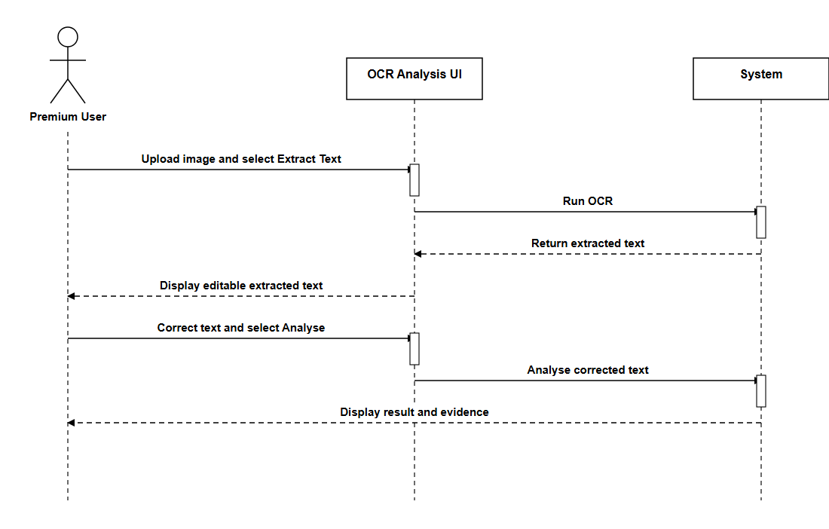

Deepfake/AI Image Analysis (Premium User)
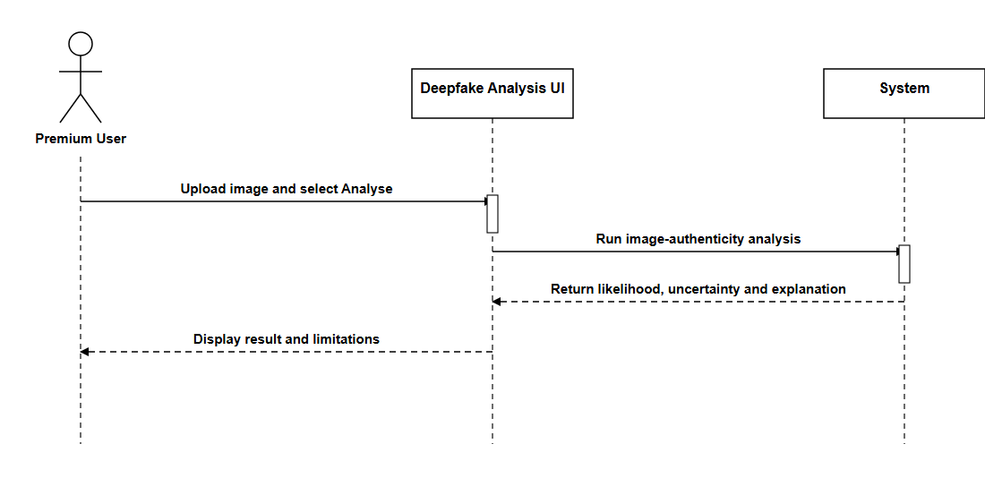

5.4.1.4 Data Engineer

Login (Data Engineer)
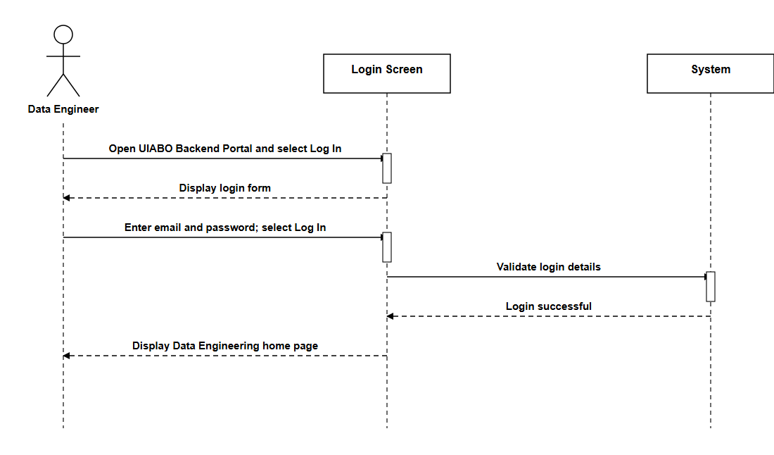

Logout (Data Engineer)
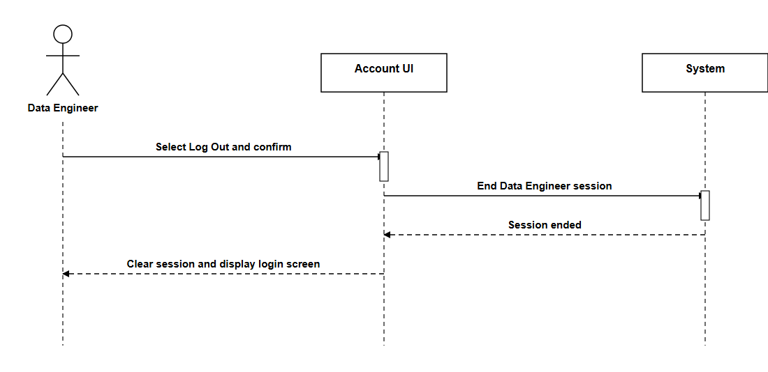

Reset Password (Data Engineer)
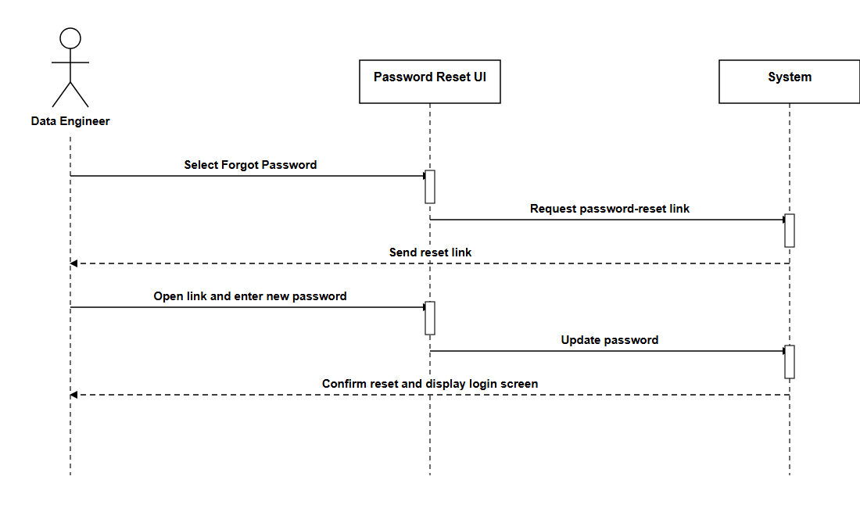

View Profile (Data Engineer)
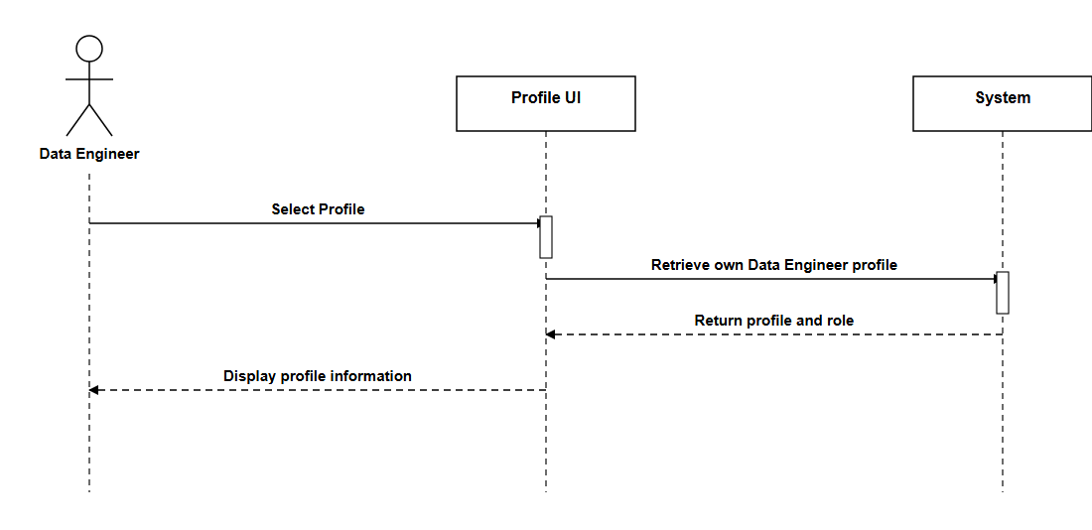

Update Profile (Data Engineer)
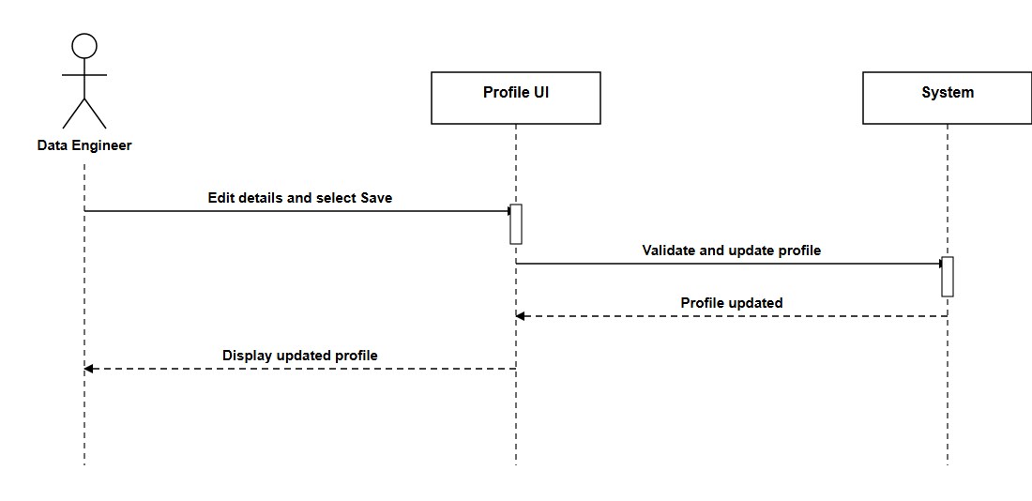

View Incorrect Results Dashboard (Data Engineer)
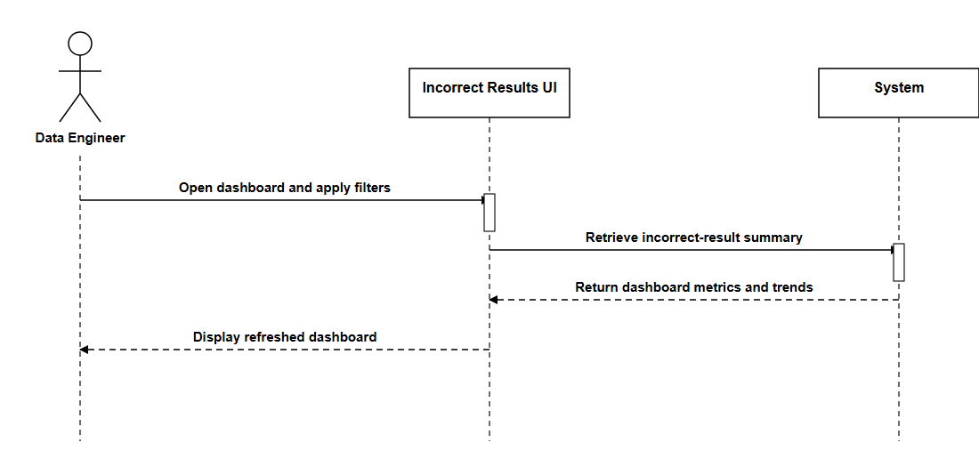

View Incorrect Result Report (Data Engineer)
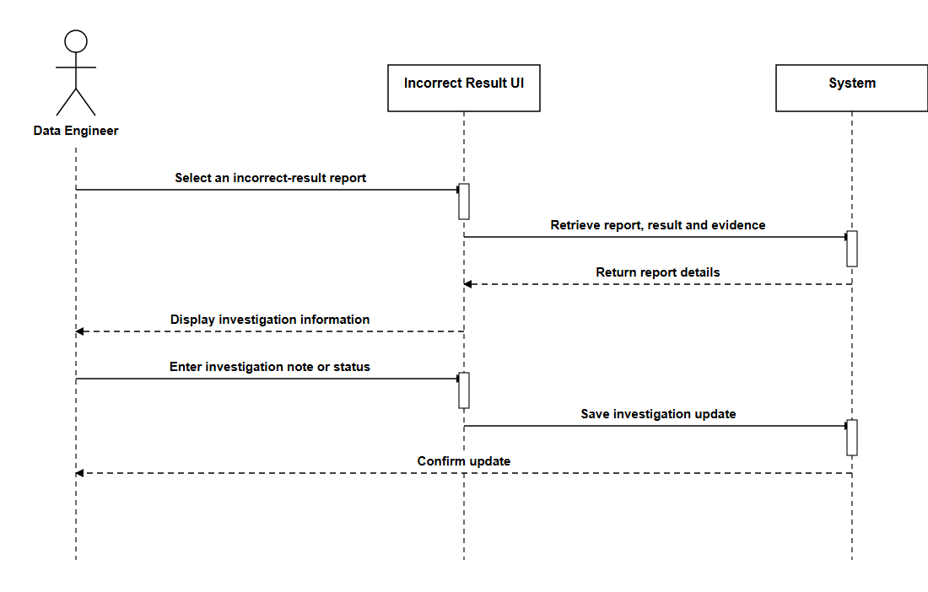

Monitor Data-Ingestion Pipelines (Data Engineer)
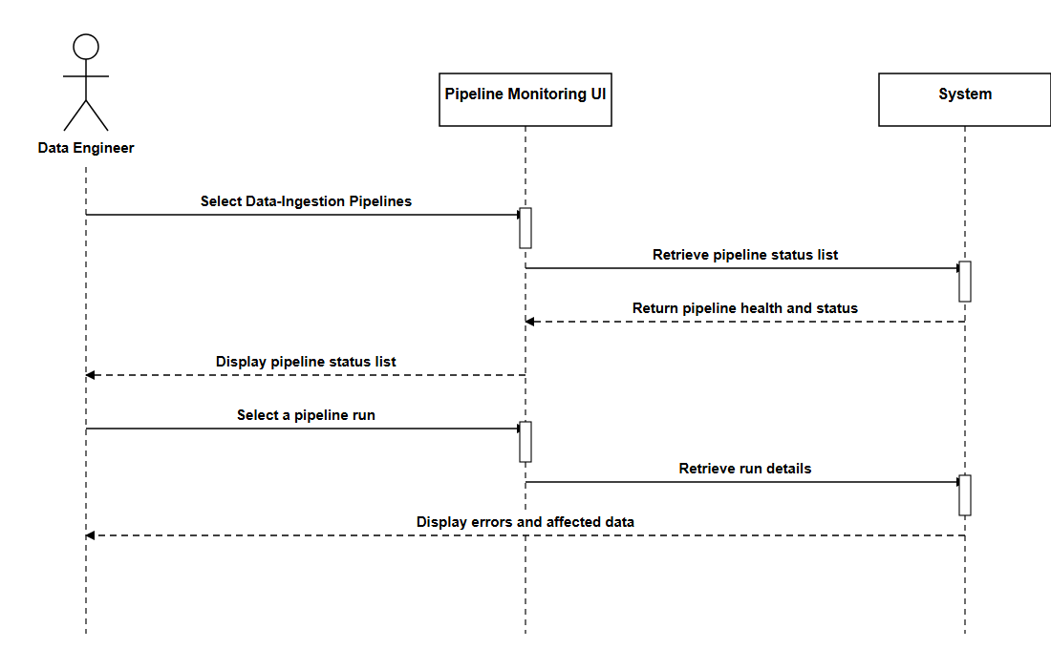

5.4.2 Activity Diagrams

5.4.2.1 System Administrator
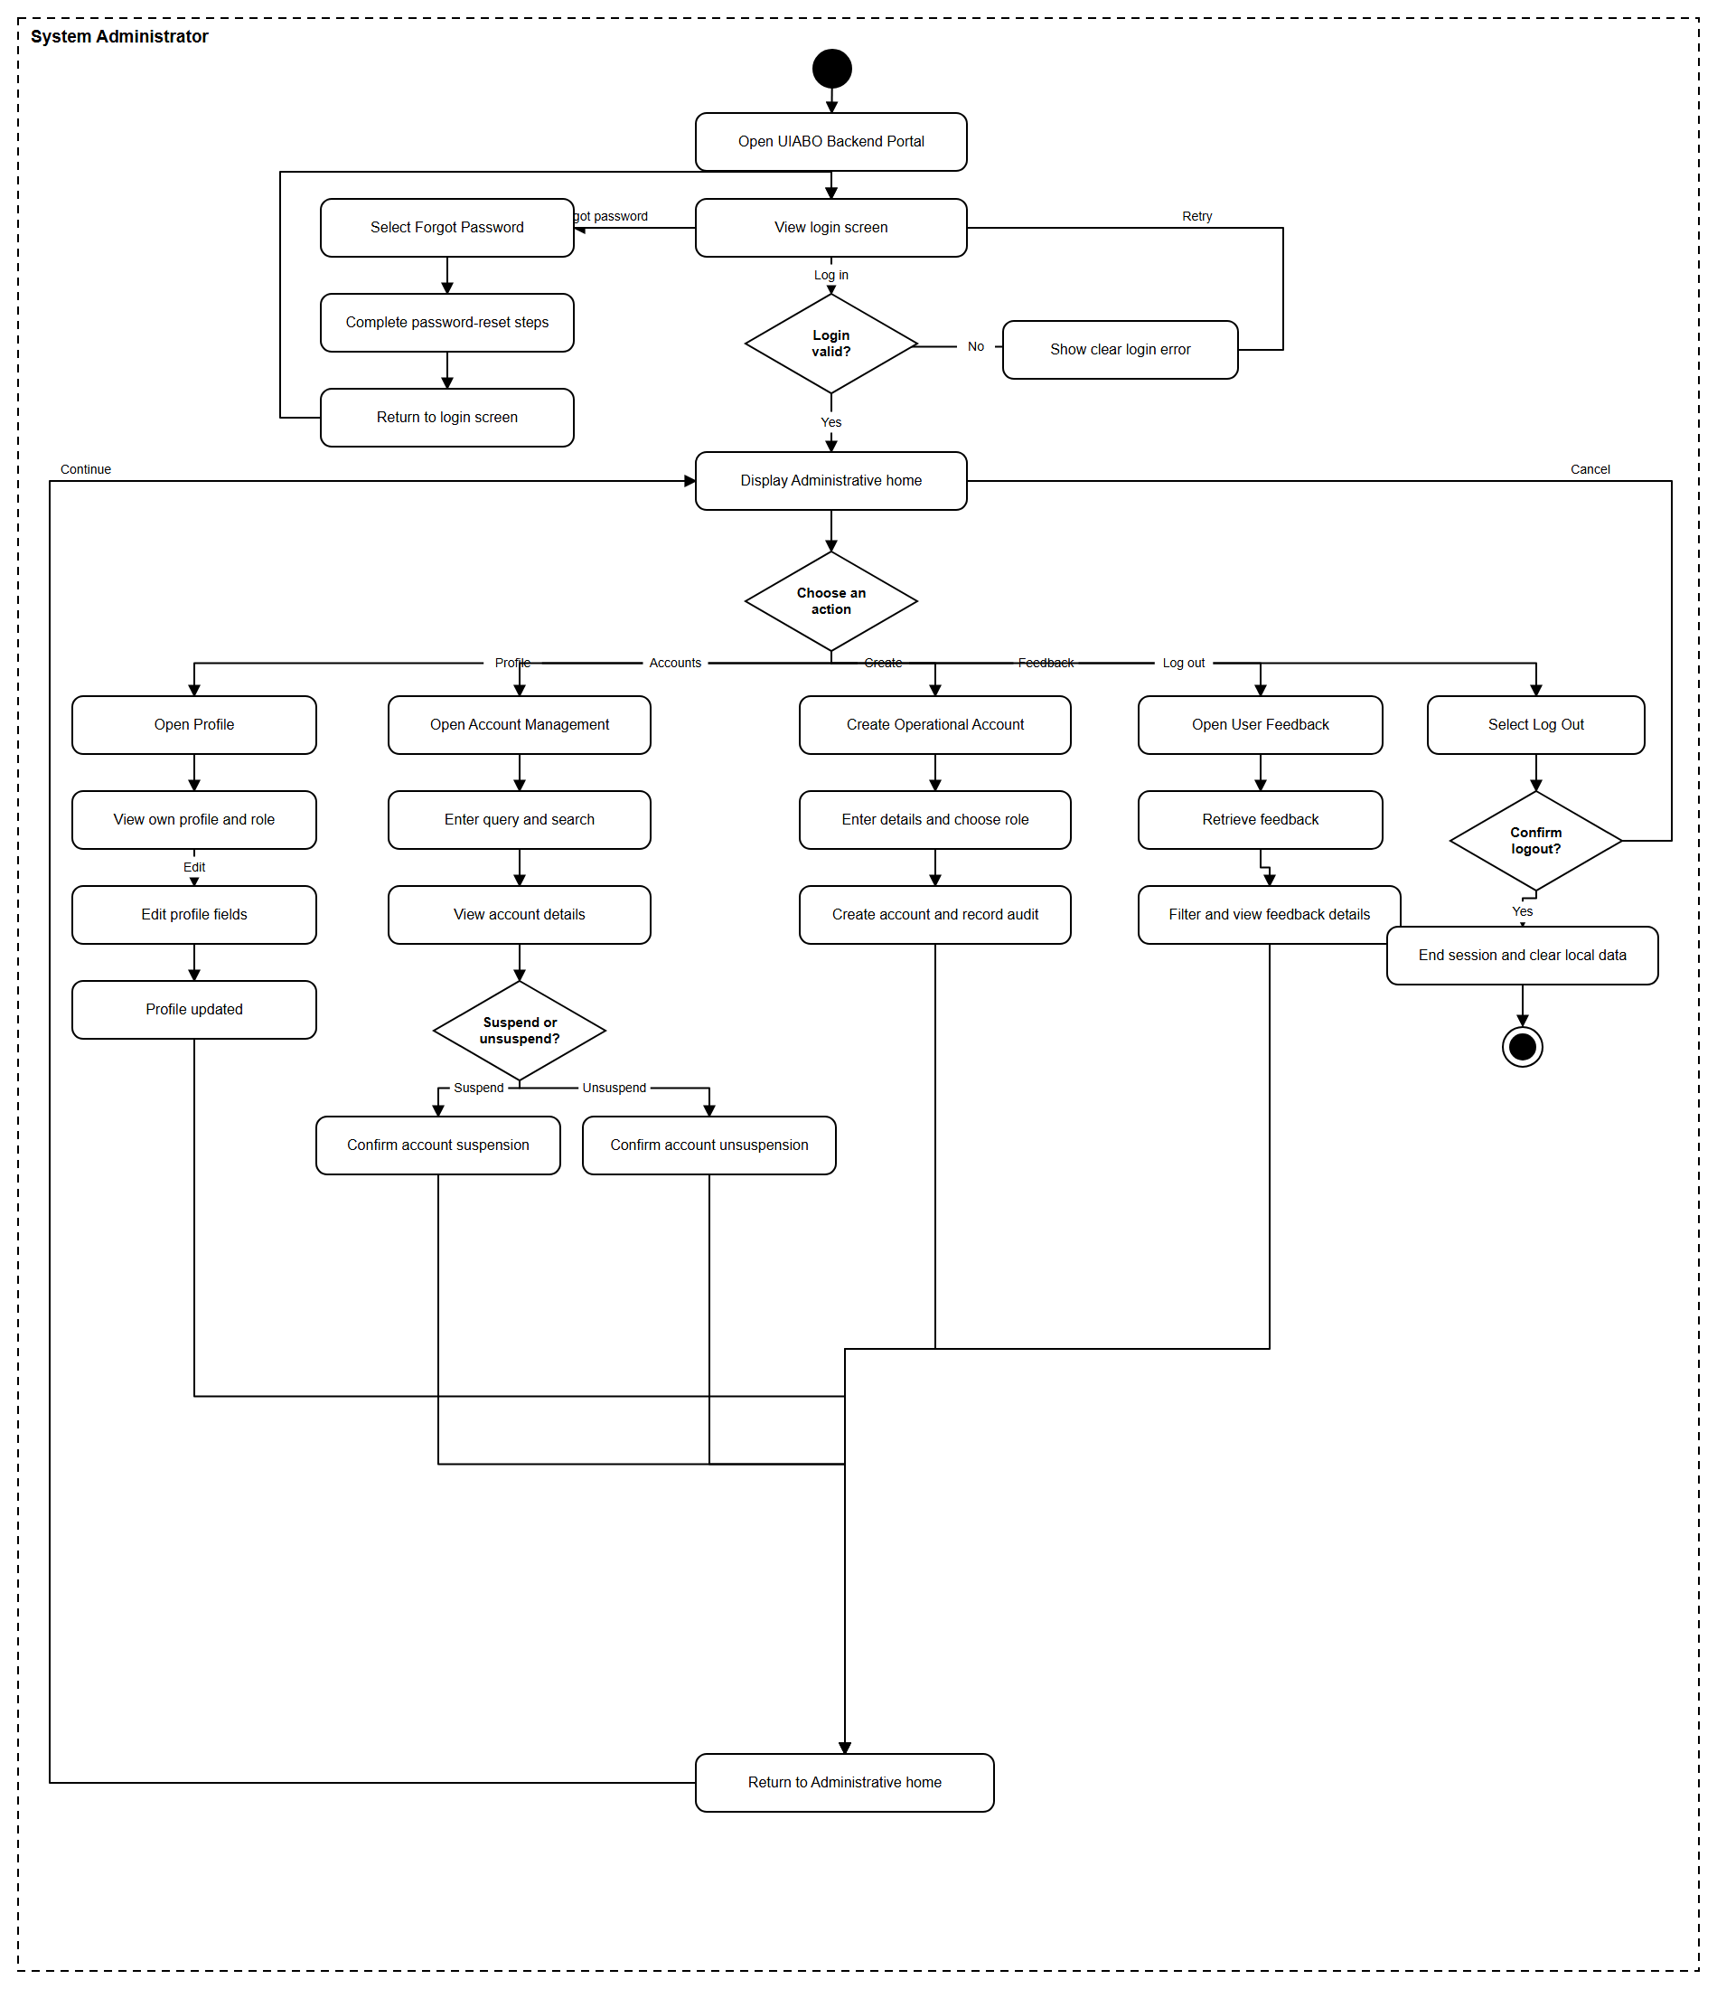

5.4.2.2 Free User
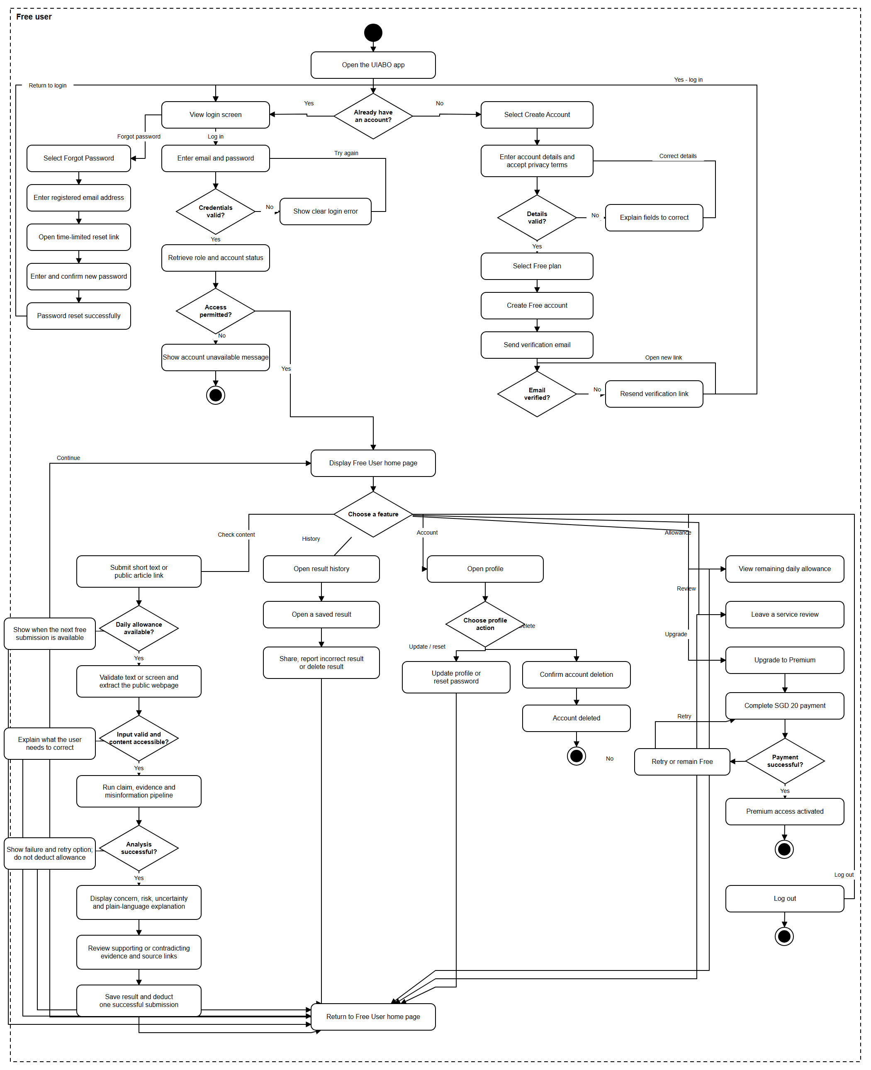

5.4.2.3 Premium User
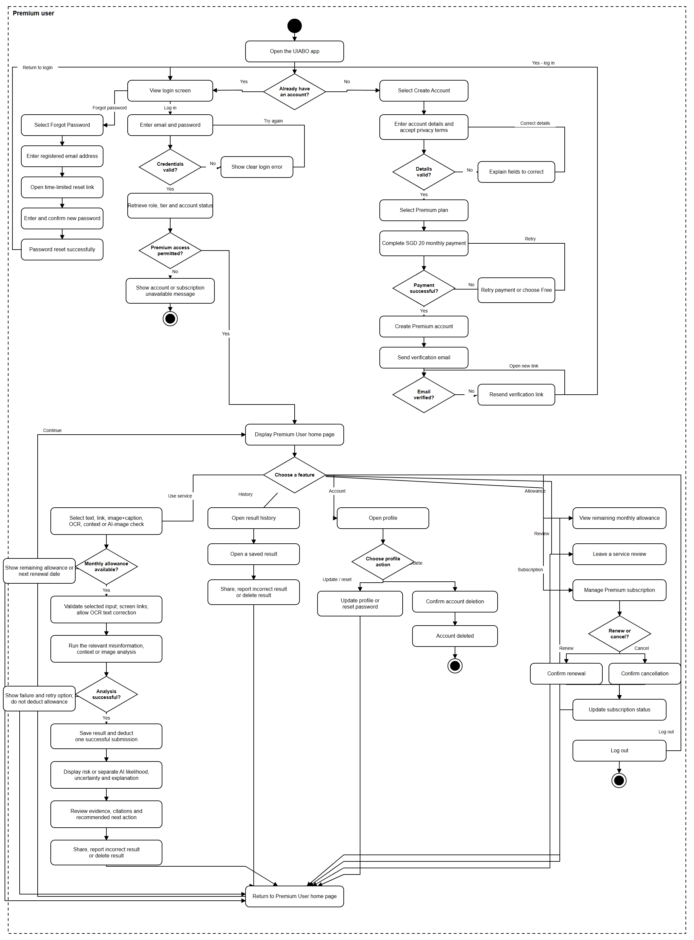

5.4.2.4 Data Engineer
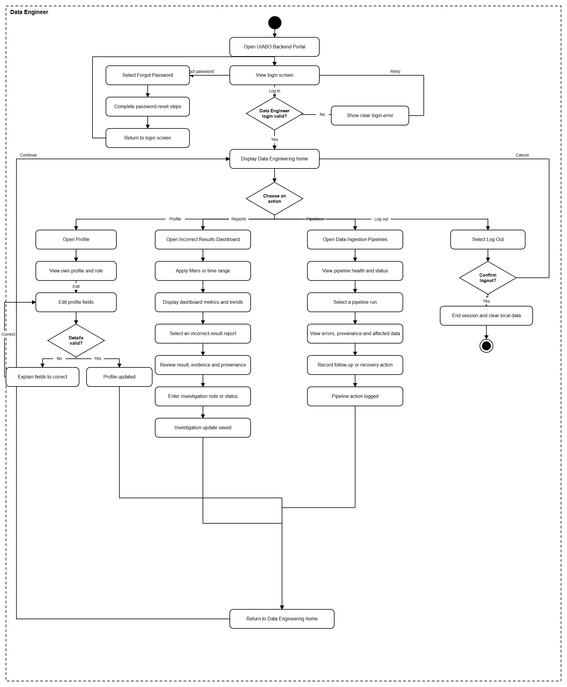

5.5 Database Design

5.5.1 Firestore Database Diagram
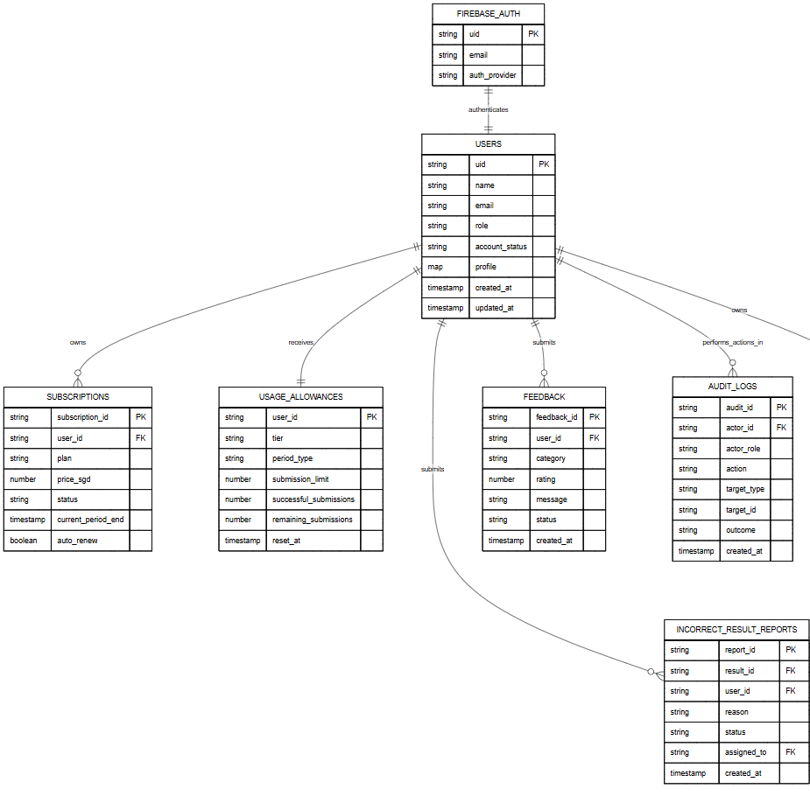

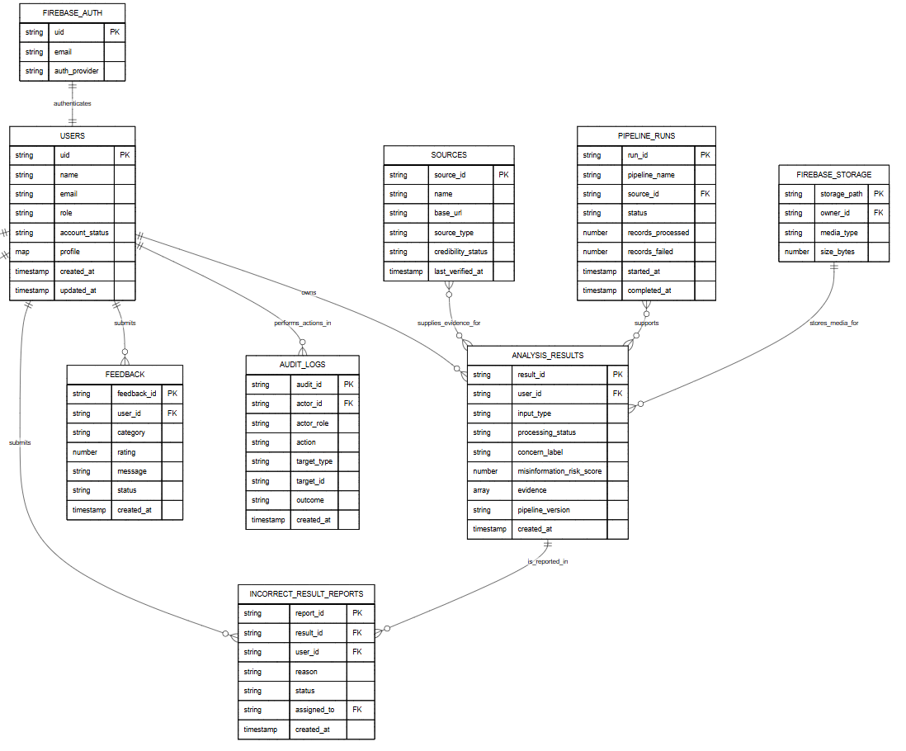
Cloud Firestore is a NoSQL document database. The lines in the diagram show document-ID references rather than SQL joins. Evidence snapshots are embedded inside analysis_results to match the current pipeline implementation and preserve the evidence used for each result.

5.5.2. Users Collection
Document path: users/{uid}
Stores the Firestore profile for every Free User, Premium User, System Administrator and Data Engineer. The document ID is the Firebase Authentication UID. Passwords are not stored here.
Field | Type | Required | Purpose
uid | String | Yes | Firebase Authentication UID and Firestore document ID.
name | String | Yes | User's display name.
email | String | Yes | Email copied from Firebase Authentication for profile display and authorised account queries.
role | String | Yes | Access role: free, premium, system_admin or data_engineer.
account_status | String | Yes | Account state: active, suspended or deactivated.
profile | Map | Yes | Editable profile information. Only data needed by the application should be stored.
storage_used_bytes | Number | Yes | Current personal storage usage used for the 80% warning.
storage_quota_bytes | Number | Yes | Maximum personal storage allocation.
last_login_at | Timestamp | No | Most recent successful login time.
created_at | Timestamp | Yes | When the profile record was created.
updated_at | Timestamp | Yes | When the profile record was last changed.

5.5.3. Subscriptions Collection
Document path: subscriptions/{subscription_id}
Stores premium subscription periods and renewal state. Payment-card details must remain with the payment provider and must not be stored in Firestore.
Field | Type | Required | Purpose
subscription_id | String | Yes | Unique subscription document ID.
user_id | String | Yes | UID of the user who owns the subscription.
plan | String | Yes | Plan identifier, such as premium_monthly.
price_sgd | Number | Yes | Recorded monthly price; SGD 20 for the prototype.
status | String | Yes | pending, active, cancelled, expired or payment_failed.
current_period_start | Timestamp | Yes | Start of the current paid period.
current_period_end | Timestamp | Yes | End of the current paid period.
auto_renew | Boolean | Yes | Whether automatic renewal remains enabled.
payment_provider | String | Yes | Provider or app-store mechanism used for payment.
provider_reference | String | No | Non-sensitive provider transaction or subscription reference.
created_at | Timestamp | Yes | When the subscription record was created.
updated_at | Timestamp | Yes | When the subscription record was last updated.

5.5.4. Usage Allowances Collection
Document path: usage_allowances/{user_id}
Stores the current free daily or premium monthly allowance. One successful Free User submission is allowed per day; Premium Users receive up to 60 successful submissions per month.
Field | Type | Required | Purpose
user_id | String | Yes | User UID and document ID.
tier | String | Yes | free or premium.
period_type | String | Yes | daily for free access or monthly for premium access.
period_start | Timestamp | Yes | Beginning of the current allowance period.
period_end | Timestamp | Yes | End of the current allowance period.
submission_limit | Number | Yes | Maximum successful submissions for this period: 1 or 60.
successful_submissions | Number | Yes | Number of completed analyses charged during the period.
remaining_submissions | Number | Yes | Remaining amount displayed in the application.
reset_at | Timestamp | Yes | When the allowance will reset.
updated_at | Timestamp | Yes | When the counter was last changed.

5.5.5. Analysis Results Collection
Document path: analysis_results/{result_id}
Stores completed and failed pipeline records. Result history is retrieved by querying user_id and created_at. Evidence is embedded as an array so the explanation preserves the evidence that was used when the result was generated.
Field | Type | Required | Purpose
result_id | String | Yes | Unique analysis result and document ID.
user_id | String | Yes | UID of the user who owns the result.
input_type | String | Yes | text, link, image_caption, ocr, context or deepfake.
original_text | String | No | Submitted text, caption or corrected OCR text.
submitted_url | String | No | Public webpage URL for a link analysis.
media_storage_path | String | No | Firebase Storage path for an authorised image submission.
processing_status | String | Yes | completed or failed.
extracted_claim | String | No | Factual claim identified by the pipeline.
claim_category | String | Yes | factual, opinion, satire, prediction, personal experience or unverifiable.
checkable | Boolean | Yes | Whether the identified claim can be fact-checked.
concern_label | String | No | Low Concern, Needs Caution, High Concern or Not Enough Information.
misinformation_risk_score | Number | No | Risk indicator from 0 to 100; null when information is insufficient.
ai_manipulation_likelihood | Number | No | Premium image AI-generation or manipulation likelihood from 0 to 100.
uncertainty | String | No | Low, Medium or High uncertainty.
uncertainty_reasons | Array | No | Plain-language reasons for uncertainty.
explanation | String | No | Plain-language result explanation.
recommended_action | String | No | Suggested next action for the user.
evidence | Array<Map> | No | Evidence snapshots containing source, URL, passage, stance and quality score.
warnings | Array | No | Non-fatal preparation, retrieval or assessment warnings.
pipeline_version | String | Yes | Version of the pipeline that generated the record.
failure | Map | No | Failure stage, error code, safe message and retryable flag for failed runs.
share_token | String | No | Random token used when result sharing is enabled.
share_enabled | Boolean | Yes | Whether a shareable result link is active.
created_at | Timestamp | Yes | When analysis processing finished or failed.
saved_at | Timestamp | Yes | Server timestamp written by Firestore.

5.5.6. Incorrect Result Reports Collection
Document path: incorrect_result_reports/{report_id}
Stores reports submitted from an analysis result and the Data Engineer's investigation state.
Field | Type | Required | Purpose
report_id | String | Yes | Unique report document ID.
result_id | String | Yes | Analysis result being reported.
user_id | String | Yes | UID of the reporting user.
reason | String | Yes | Selected reason or report category.
user_comment | String | No | Optional explanation supplied by the user.
status | String | Yes | new, investigating, resolved or rejected.
priority | String | Yes | low, medium or high investigation priority.
assigned_to | String | No | UID of the assigned Data Engineer.
investigation_notes | Array<Map> | No | Timestamped investigation notes and permitted status updates.
resolution_summary | String | No | Final investigation outcome without unnecessary personal information.
created_at | Timestamp | Yes | When the user submitted the report.
updated_at | Timestamp | Yes | When the report was last changed.
resolved_at | Timestamp | No | When the investigation was closed.

5.5.7. Feedback Collection
Document path: feedback/{feedback_id}
Stores application reviews, accessibility feedback, bug reports and general comments for System Administrator review.
Field | Type | Required | Purpose
feedback_id | String | Yes | Unique feedback document ID.
user_id | String | Yes | UID of the user who submitted the feedback.
category | String | Yes | review, accessibility, bug or general.
rating | Number | No | Optional service rating, normally from 1 to 5.
message | String | Yes | Feedback text entered by the user.
status | String | Yes | new, reviewed or resolved.
reviewed_by | String | No | UID of the reviewing System Administrator.
admin_note | String | No | Operational follow-up note.
created_at | Timestamp | Yes | When the feedback was submitted.
updated_at | Timestamp | Yes | When the feedback record was last changed.

5.5.8. Sources Collection
Document path: sources/{source_id}
Stores trusted-source and provenance metadata used by evidence retrieval and maintained by authorised Data Engineers.
Field | Type | Required | Purpose
source_id | String | Yes | Unique source document ID.
name | String | Yes | Publisher or organisation name.
base_url | String | Yes | Canonical source website URL.
source_type | String | Yes | fact_check, government, academic, news or other.
credibility_status | String | Yes | trusted, review_required or blocked.
country | String | No | Country or region associated with the source.
provenance_notes | String | No | Reason for its status and relevant validation notes.
active | Boolean | Yes | Whether the retrieval pipeline may currently use the source.
last_verified_at | Timestamp | Yes | Most recent source validation time.
created_at | Timestamp | Yes | When the source record was created.
updated_at | Timestamp | Yes | When source metadata was last changed.

5.5.9. Pipeline Runs Collection
Document path: pipeline_runs/{run_id}
Stores the monitoring data needed to identify running, delayed, incomplete and failed ingestion updates.
Field | Type | Required | Purpose
run_id | String | Yes | Unique pipeline run document ID.
pipeline_name | String | Yes | Name of the ingestion or update pipeline.
source_id | String | No | Related source record when the run imports source data.
status | String | Yes | running, completed, delayed, incomplete or failed.
records_expected | Number | No | Expected number of records, when known.
records_processed | Number | Yes | Number of successfully handled records.
records_failed | Number | Yes | Number of failed records.
data_range | Map | No | Affected dates, record range or dataset version.
error_summary | String | No | Safe summary of the run failure or delay.
triggered_by | String | Yes | system or authorised operational-user UID.
started_at | Timestamp | Yes | When the run started.
completed_at | Timestamp | No | When the run ended.
updated_at | Timestamp | Yes | Most recent monitoring update.

5.5.10. Audit Logs Collection
Document path: audit_logs/{audit_id}
Stores immutable records of sensitive operational actions such as account queries, account views, account creation, suspension, unsuspension and investigation updates.
Field | Type | Required | Purpose
audit_id | String | Yes | Unique audit record ID.
actor_id | String | Yes | UID of the operational user or system process.
actor_role | String | Yes | system_admin, data_engineer or system.
action | String | Yes | Action that was attempted.
target_type | String | Yes | Collection or resource type affected.
target_id | String | No | Identifier of the affected record.
reason | String | No | Required reason for sensitive changes where applicable.
outcome | String | Yes | success, denied or failed.
metadata | Map | No | Non-sensitive context needed for security or investigation.
created_at | Timestamp | Yes | Server timestamp. Audit records are not edited after creation.

5.5.11. Supporting Firebase Services
These services support the database but are not Firestore collections.
Service | Responsibility
Firebase Authentication | Stores email-and-password credentials, creates the UID and manages authenticated sessions. Password hashes must not be copied into Firestore.
Firebase Storage | Stores uploaded images and screenshots. Firestore keeps only authorised storage paths and media metadata.
Cloud Firestore | Stores the document collections described above. Security rules and backend role checks restrict every read and write.

5.6 Data Flow Diagram
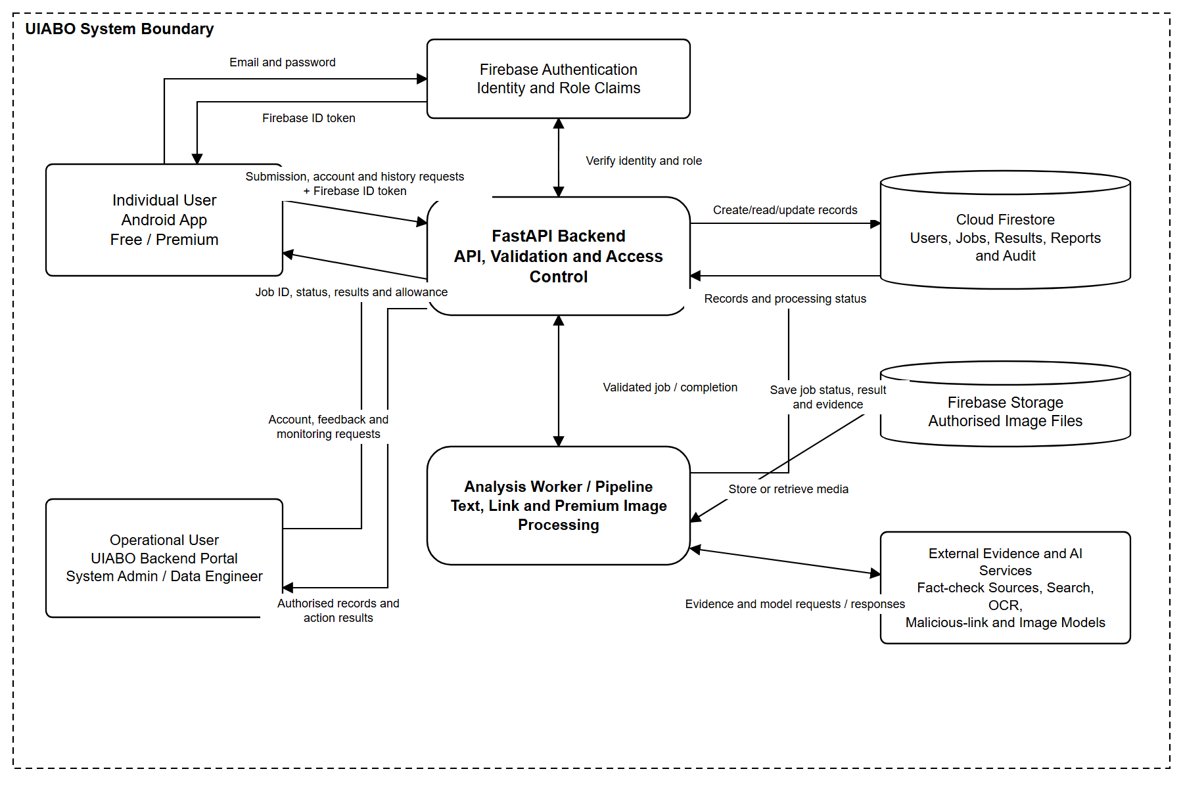

5.7 User Interface Design

5.7.1 Login and Account Creation
Login Page | Sign Up Page
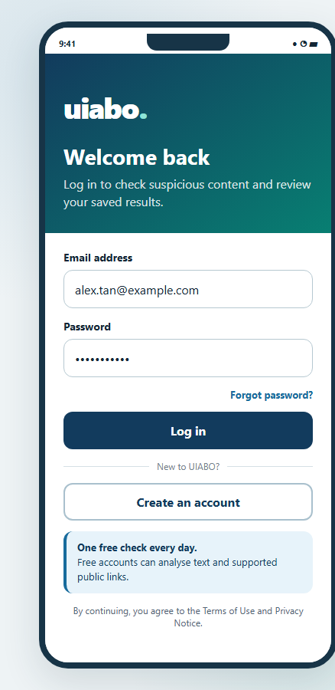 | 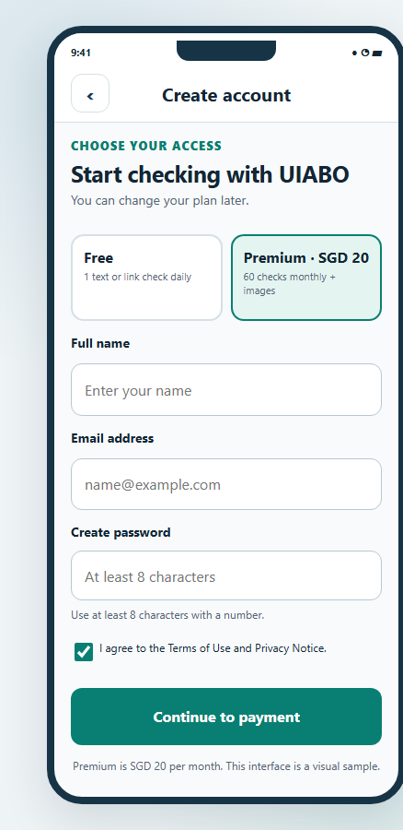

5.7.2 Free User
Home Page  (Premium features locked) | Text Analysis | Link Analysis
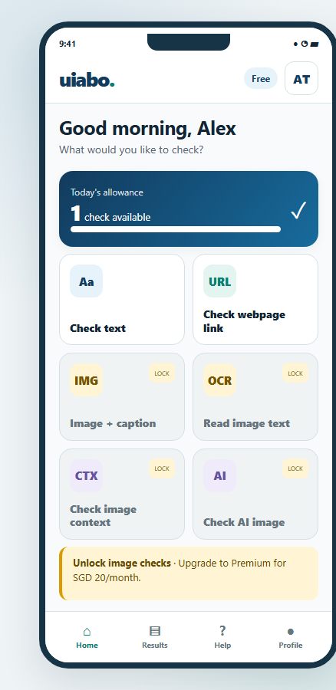 | 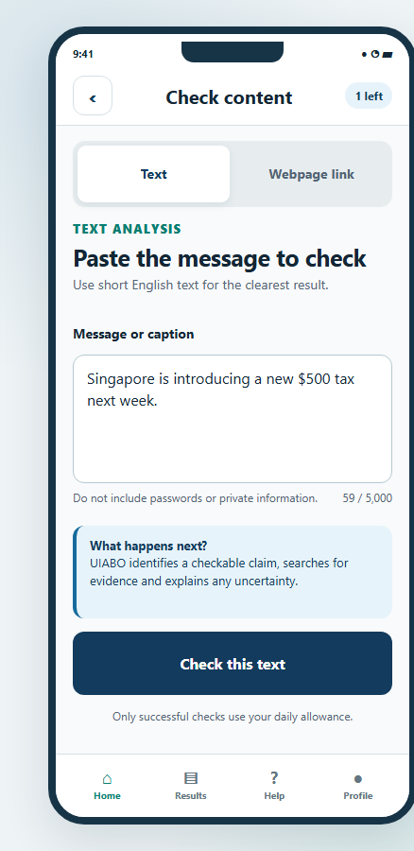 | 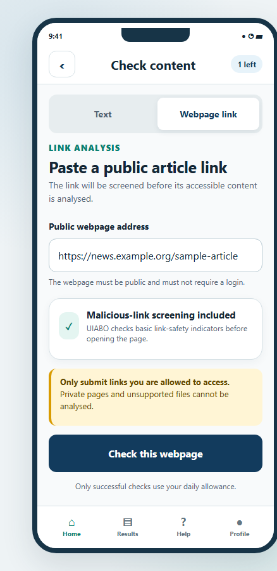

Result Page | Result History | Upgrade to Premium
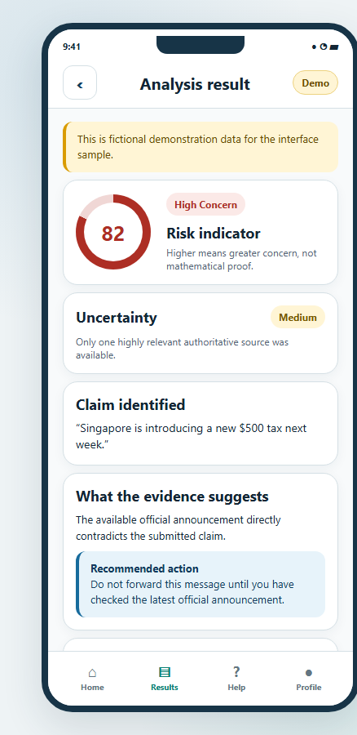 | 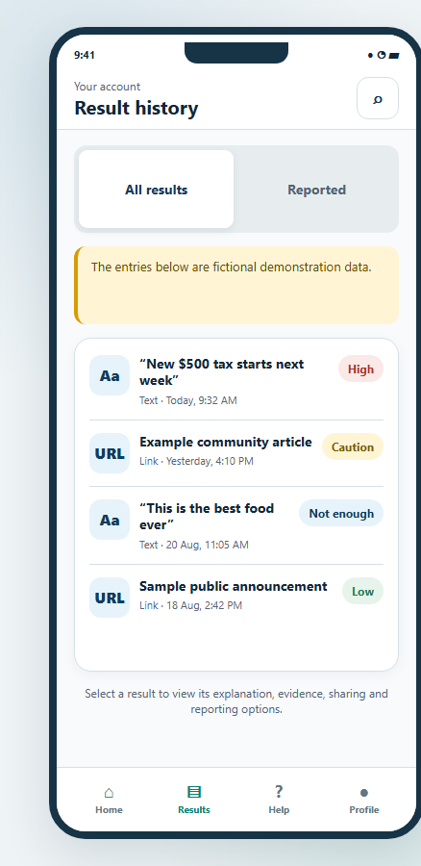 | 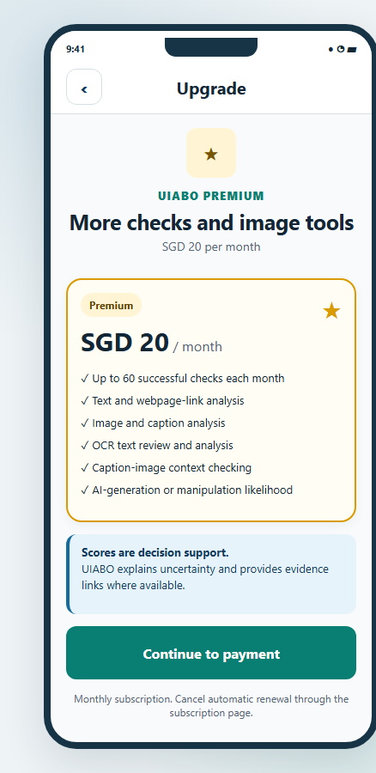

5.7.3 Premium User
Home Page | Image Caption Analysis | Context Analysis
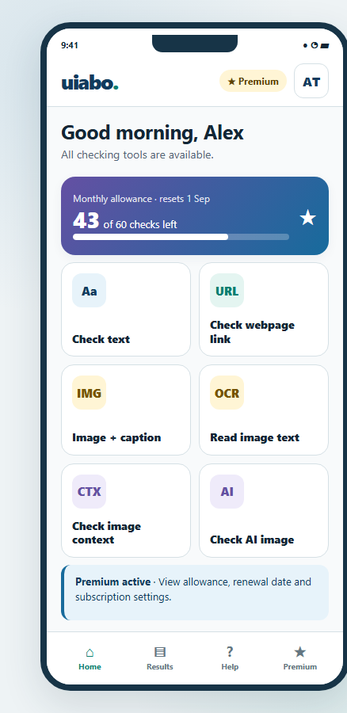 | 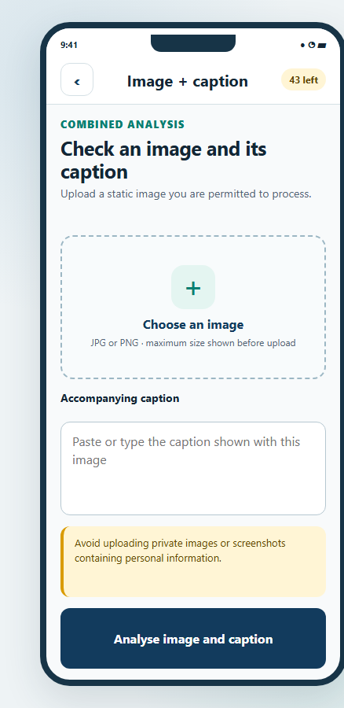 | 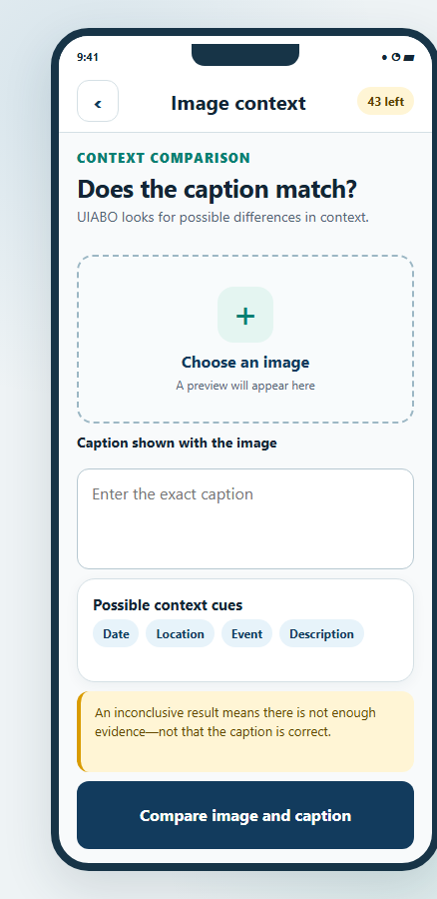

OCR Analysis | Deepfake Analysis | Subscription
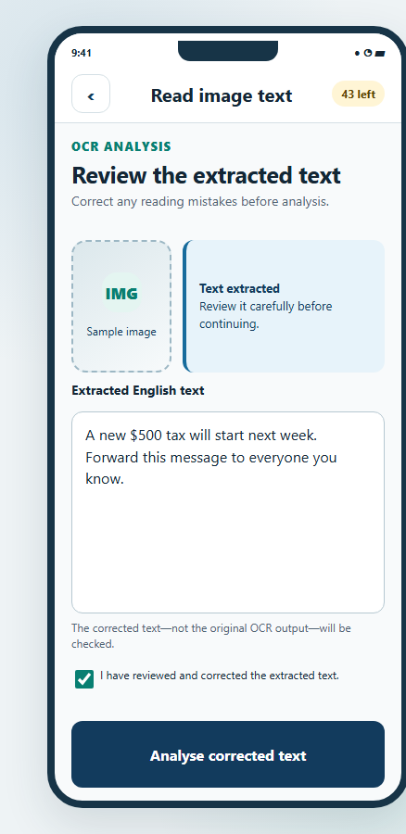 | 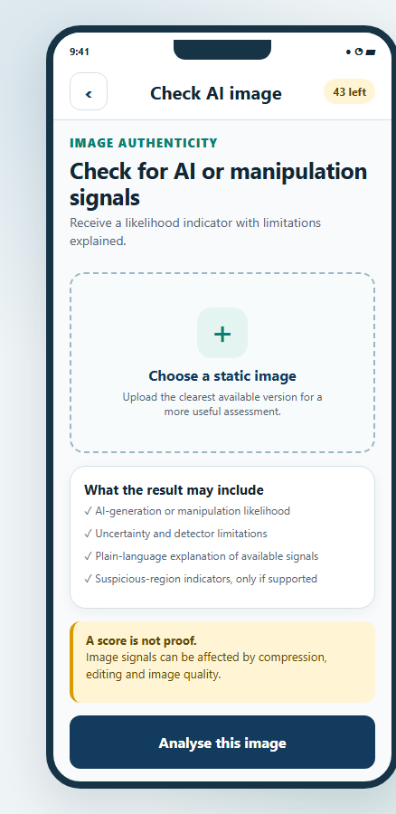 | 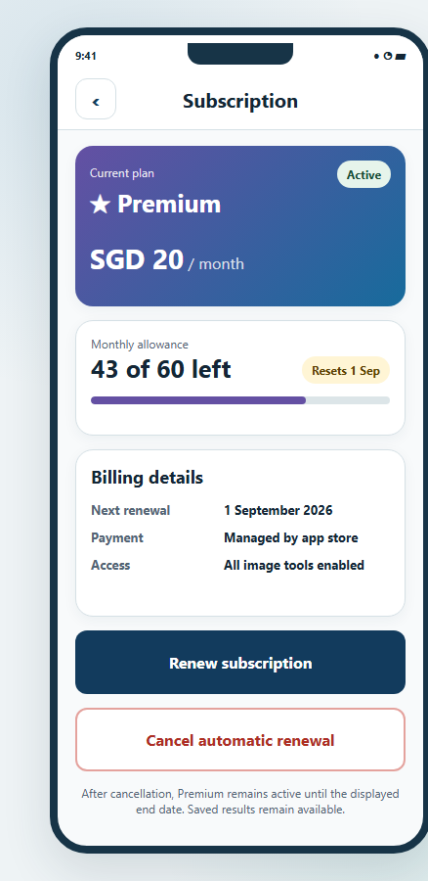

5.7.4 System Administrator
System Administrator Dashboard
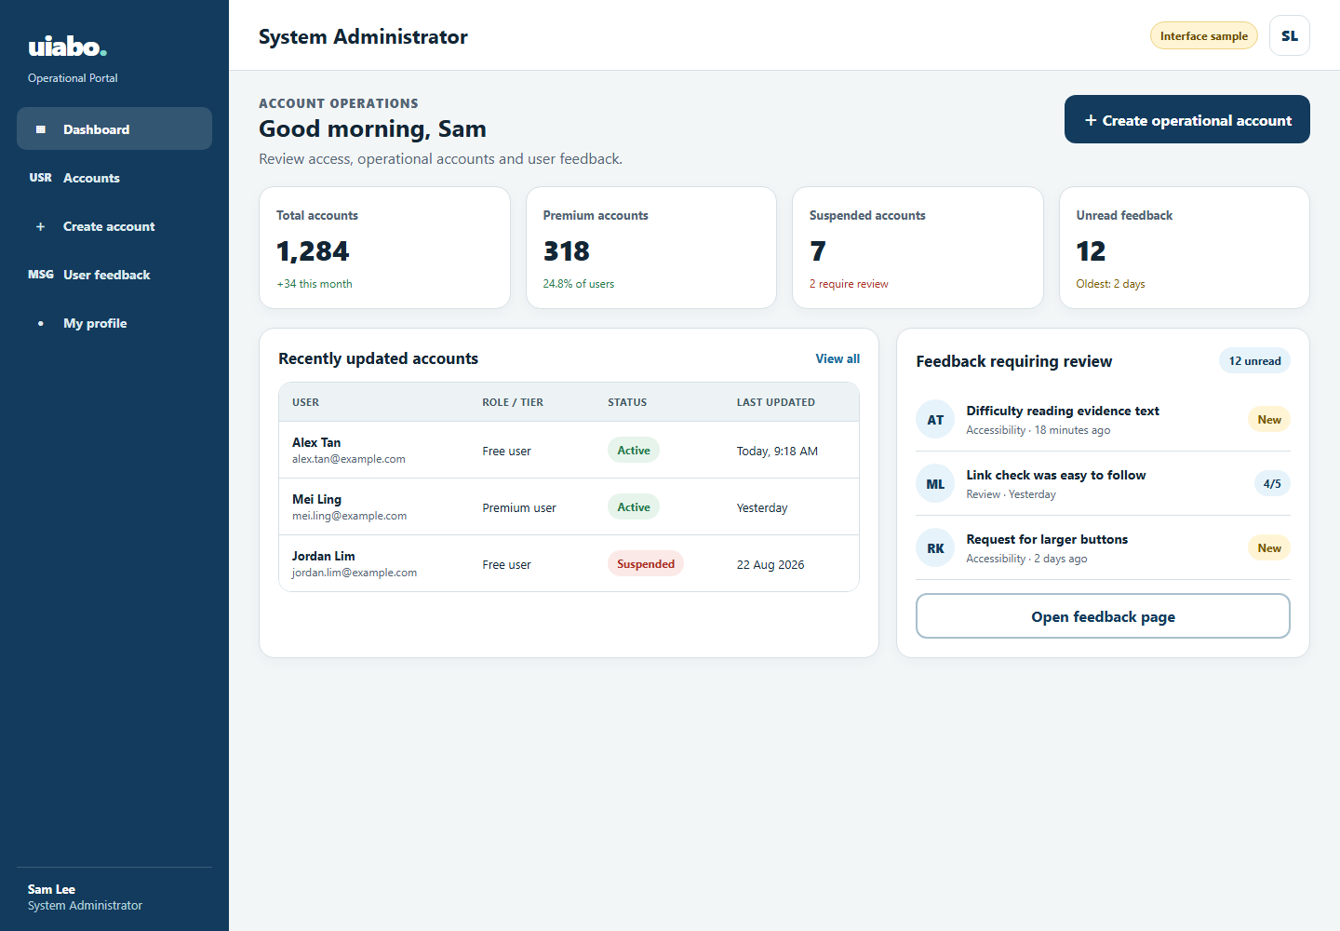
Account Management
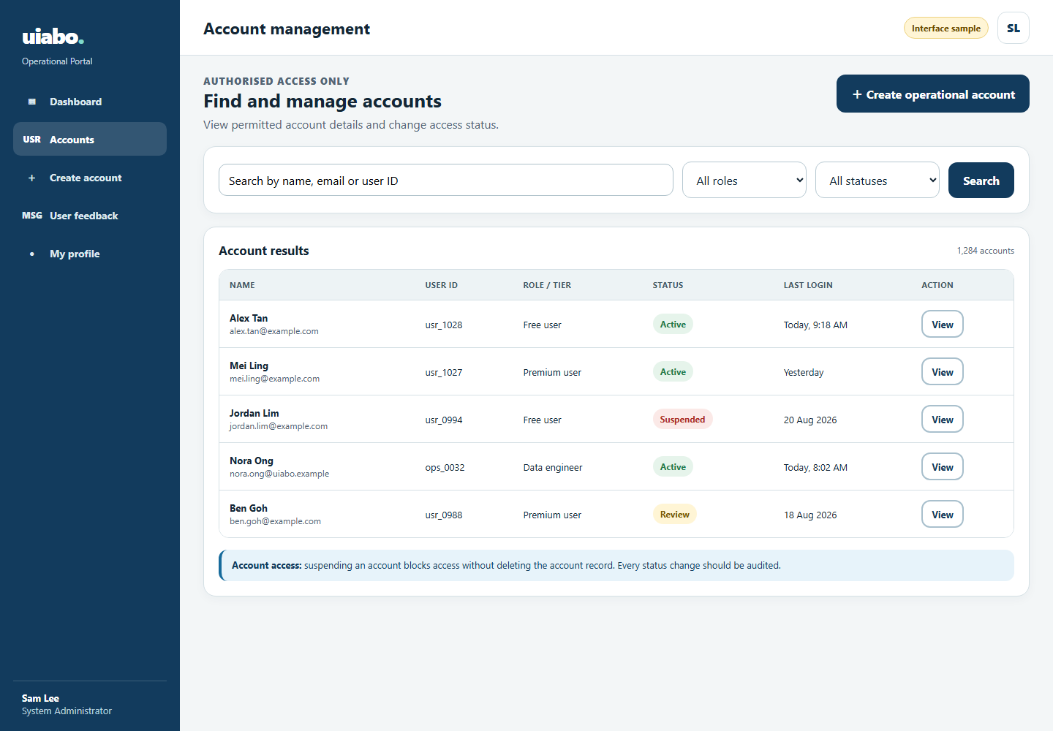

Create Operational Account
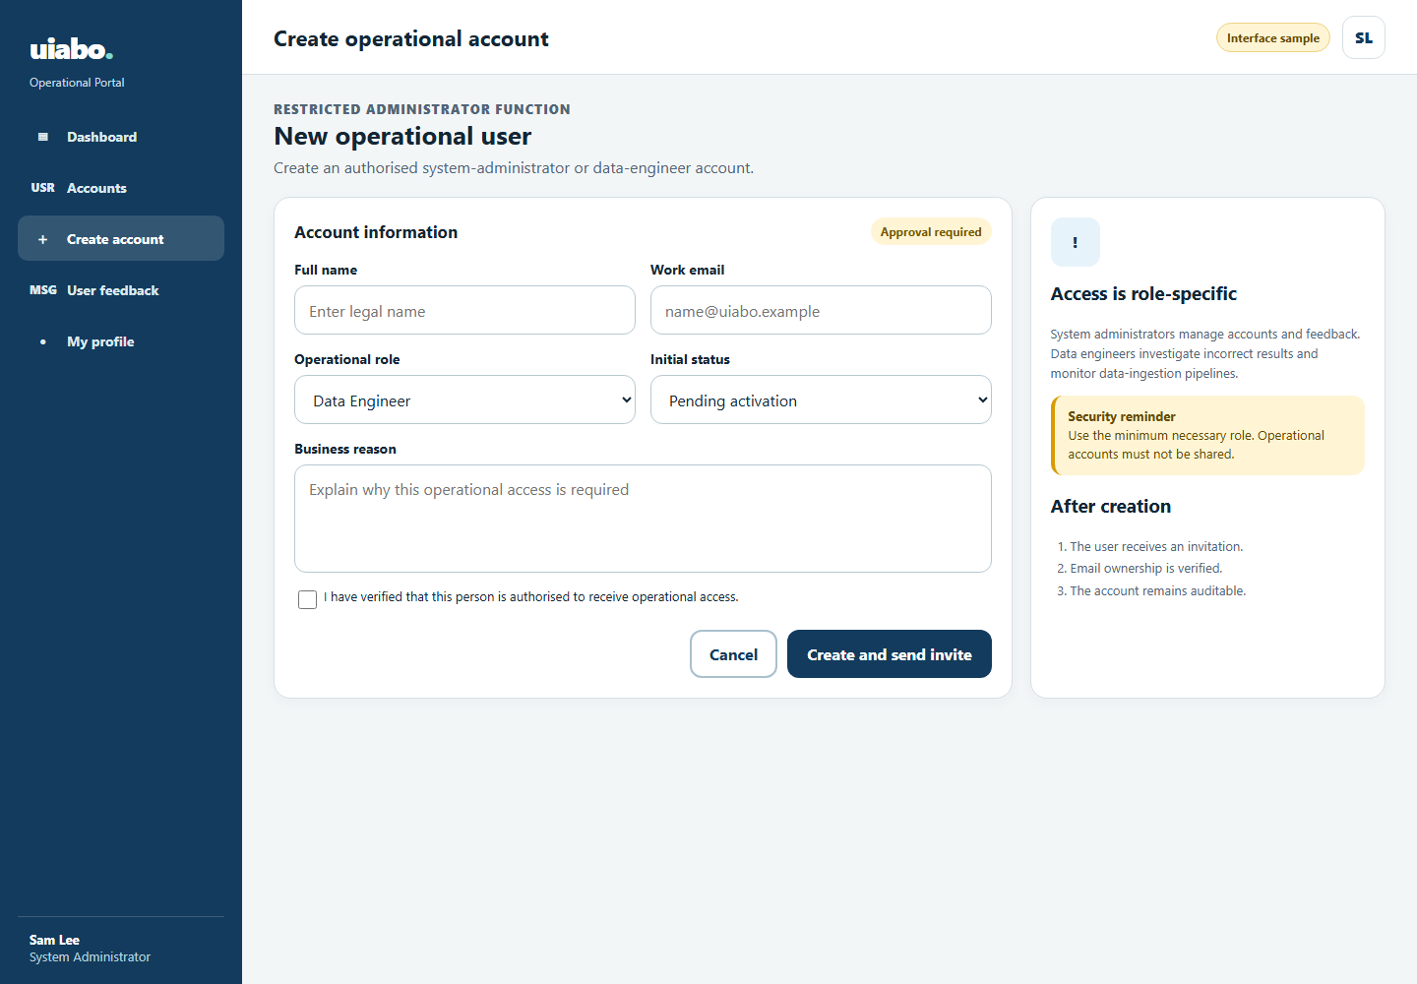
User Feedback
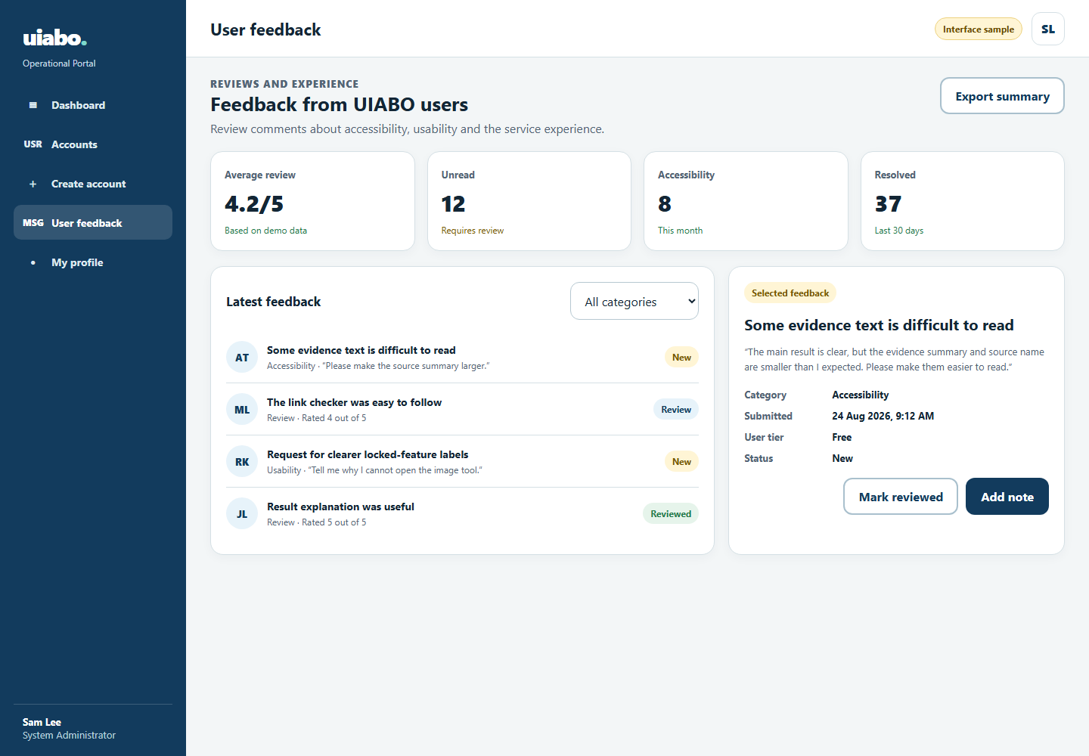

5.7.5 Data Engineer
Data Engineer Dashboard
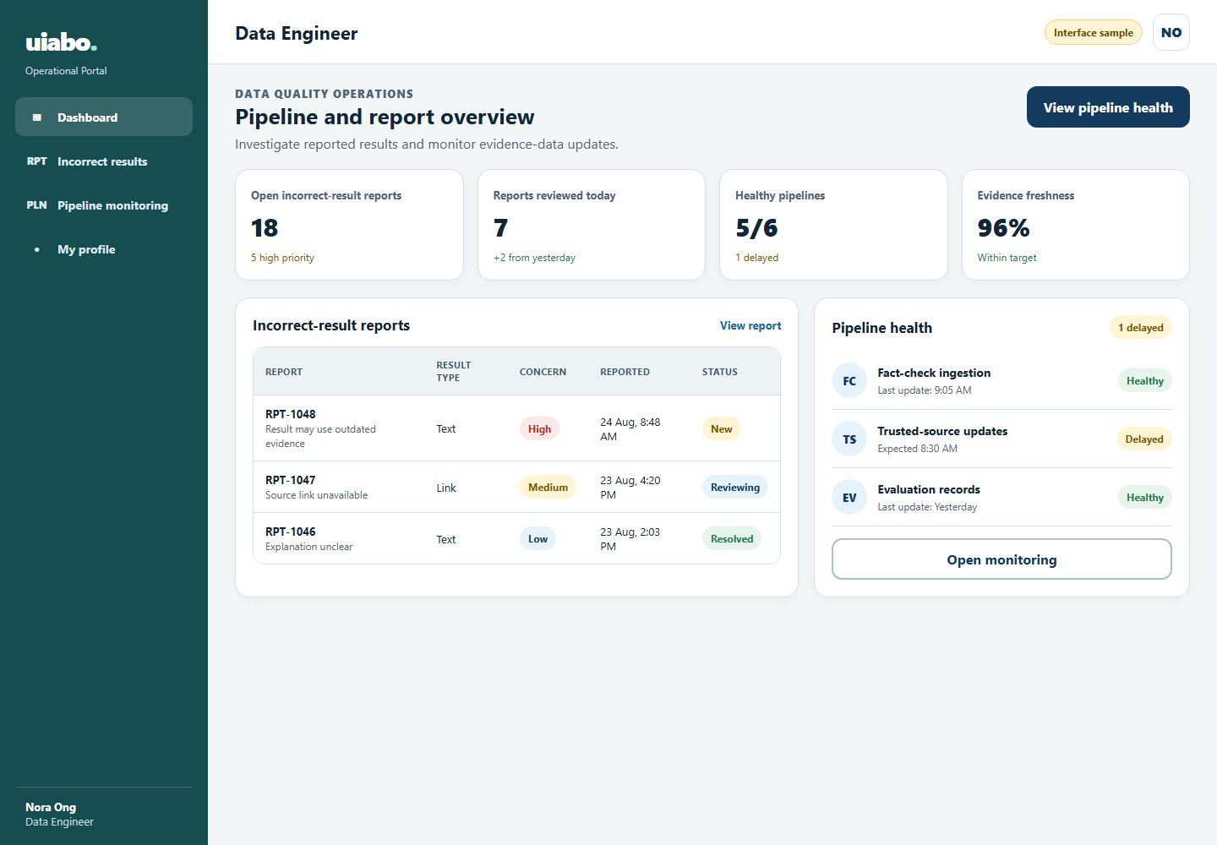
Incorrect Result Report
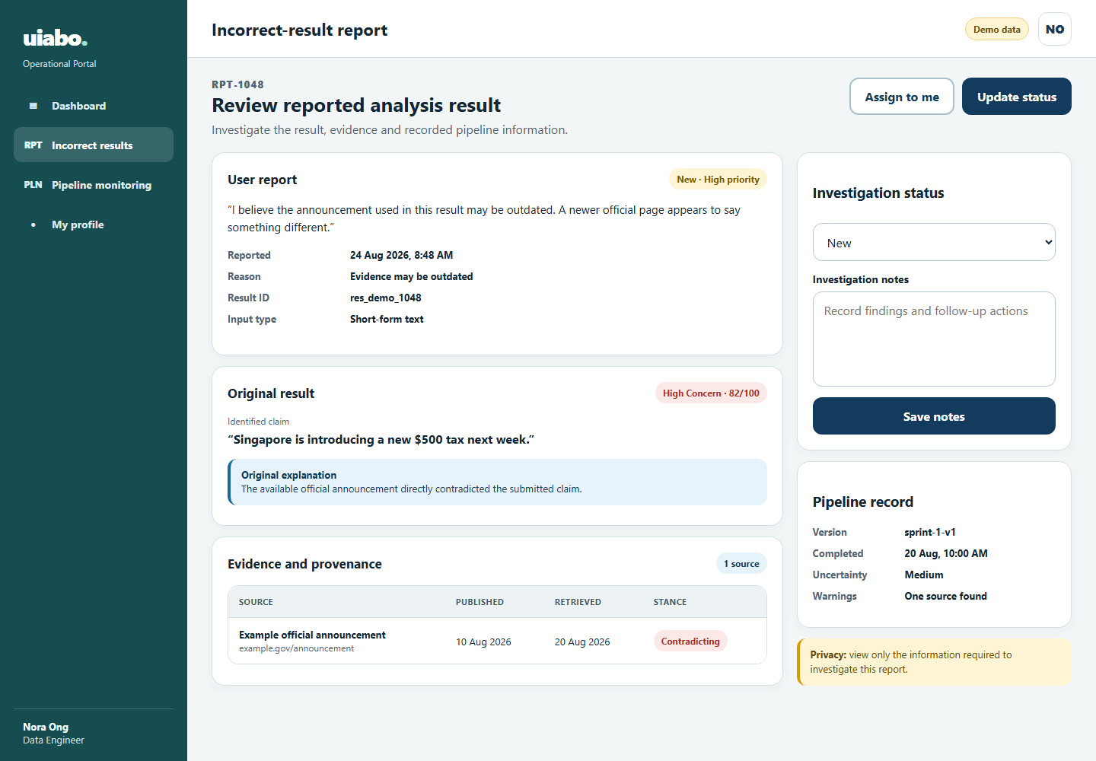

Pipeline Monitoring
