6. Project Implementation

6.1 Software Development Methodology

Waterfall Model
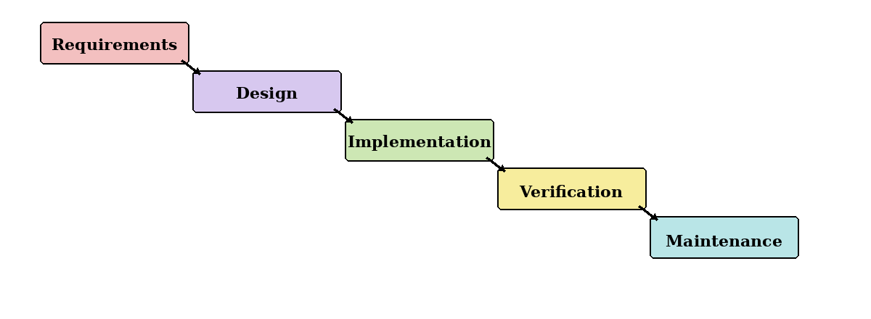
Figure 4.1: Waterfall model.
Waterfall follows a fixed sequence from requirements to maintenance. Although it offers clear stages, it is unsuitable as the main approach because AI models and data sources may require repeated changes. It will only be used for stable tasks such as final documentation and submission checks.

Prototyping Model
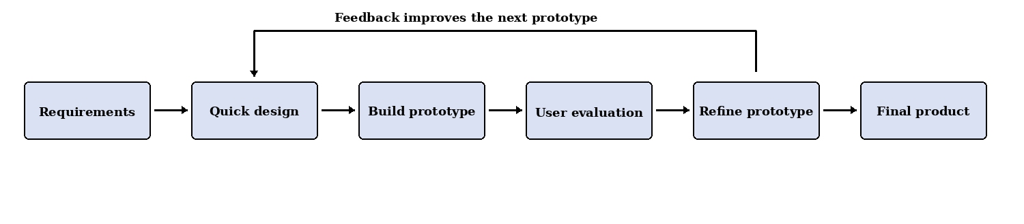
Figure 4.2: Prototyping model.
Prototyping allows the team to test claim extraction, evidence retrieval, scam detection and AI-authorship scoring before integrating them. To avoid endless changes, all prototypes will be compared using the same test dataset and only useful improvements will be retained.

Kanban Model
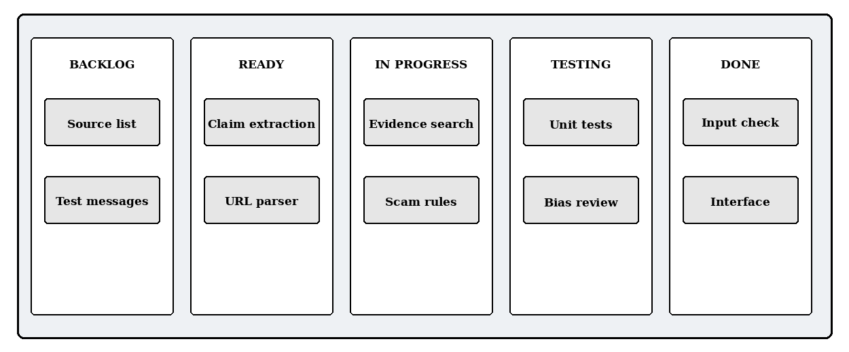
Figure 4.3: Example Kanban task board.
Kanban provides a visual view of tasks in Backlog, Ready, In Progress, Testing and Done. It supports daily coordination and limits unfinished work, but it lacks fixed review dates. Therefore, it will support Scrum rather than replace it.

Scrum
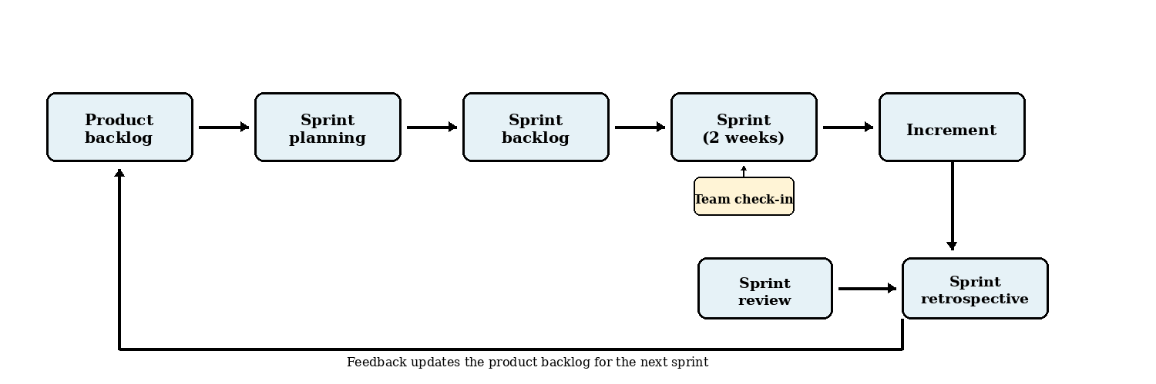
Figure 4.4: Scrum development cycle.
Scrum divides the project into short sprints that each produce a tested increment. The main practices used will be:
- Two-week sprints with planning, development, testing and documentation.
- User stories and a prioritised product backlog for project requirements and technical tasks.
- Sprint reviews to evaluate results, collect supervisor feedback and revise the backlog.
- Sprint retrospectives to identify delays and improve the next sprint.
Scrum is suitable because the team can respond when a model performs poorly, a Singapore source is unavailable or a feature exceeds the available time.

6.1.1 Development Methodology Chosen: Scrum
Scrum is selected as the main methodology because it combines structure with flexibility. This is important for an AI-based misinformation detection project, where models, datasets, trusted sources and scoring methods must be evaluated before the final approach is confirmed.

Justification for Choosing Scrum
- Adaptability: Requirements can be revised when testing or supervisor feedback reveals problems.
- Iterative progress: Short sprints provide regular working results within the six-month schedule.
- Early evaluation: AI detection, factual verification and scam analysis can be tested separately.
- Scope control: Essential functions are prioritised, while unrealistic features are moved to future work.
- Explainability and ethics: Each sprint can review false positives, data quality, robustness and user-facing explanations.

How Scrum Will Be Used
At the start of each sprint, the team will select a small number of high-priority tasks. A task is complete only when it works, has passed basic tests and has updated documentation. The sprint review and retrospective will then guide the next sprint.

Conclusion
A lightweight Scrum process, supported by prototyping and Kanban, is the most realistic approach for this six-month, zero-budget student project.

6.2 Development Tools
The development stack has been selected for an Android-based AI-assisted misinformation-checking prototype. The selected tools provide native Android support, straightforward integration with Python-based processing, and a manageable architecture for the FYP team.

6.2.1 Front-End
Front-End | Selected Technology
Language | JavaScript
Framework | React Native with Expo
Development Tool | Visual Studio Code, Expo and Android Studio Emulator
Description | JavaScript will be used to implement the Android application with React Native. React Native will provide reusable components for the interface, navigation and application state, while Expo will simplify development, testing and Android builds. Visual Studio Code will be used to write the application code, and the Android Studio Emulator will be used for device testing.
Why We Chose Them | JavaScript and React Native were selected because they allow the team to develop the Android interface using familiar web-style component concepts. Expo supports rapid prototyping and reduces the initial Android project configuration required. This combination is appropriate for the FYP because it supports faster interface development while still producing an Android application.

6.2.2 Back-End
Back-End | Selected Technology
Language | Python
Framework | FastAPI
Runtime Server | Uvicorn
Development Tool | Visual Studio Code
Description | Python will be used for server-side processing and integration with the application's AI and data-processing components. FastAPI will provide REST API endpoints for receiving submissions, coordinating analysis, applying usage limits and returning structured results. Uvicorn will run the FastAPI application during development and deployment.
Why We Chose Them | Python is well suited to AI, natural-language processing and image-analysis libraries. FastAPI provides request validation, clear routing and automatically generated API documentation, making it practical for a five-person FYP team. Using Python for both the back-end and AI components also avoids maintaining a separate Node.js service.

6.2.3 Database
Database | Selected Technology
Database | Cloud Firestore
Database Type | NoSQL document database
Development Tool | Firebase Console
Description | Cloud Firestore will store user profiles, account roles, free and premium submission allowances, analysis results, result history, evidence records, feedback and reported incorrect results. The React Native application will access the database through the Firebase JavaScript SDK. The Firebase Console will be used to inspect records, configure access rules and monitor database usage.
Why We Chose It | Cloud Firestore integrates with Firebase Authentication and can be accessed from the React Native application through the Firebase JavaScript SDK. It requires less database administration than a self-hosted database, and its document structure is suitable for user accounts, submissions and result records. Firebase Realtime Database is not required for the selected scope.

6.2.4 API Communication
API Communication | Selected Technology
Architecture | RESTful API
Data Format | JSON
React Native Library | Axios
Testing Tool | Postman
Description | The React Native application will communicate with the FastAPI back-end through HTTPS REST endpoints. Axios will send text, links, images and authentication headers to the back-end and convert JSON responses into JavaScript objects. Postman will be used to test the API independently from the mobile interface.
Why We Chose Them | REST and JSON provide a simple and widely supported communication method between JavaScript and Python. Axios reduces the networking code required in React Native and supports request configuration, file uploads and error handling. Separating the mobile interface from the back-end also keeps secret service credentials and analysis logic out of the Android application.

6.2.5 Authentication
Authentication | Selected Technology
Authentication Service | Firebase Authentication
React Native Integration | Firebase JavaScript SDK
Initial Sign-In Method | Email and password
Description | Firebase Authentication will manage account registration, login, logout, password reset and user sessions through the Firebase JavaScript SDK. The React Native application will obtain a Firebase identity token, and the FastAPI back-end will verify that token before allowing protected operations. Application roles and access tiers will be checked by the back-end using the associated account record.
Why We Chose It | Firebase Authentication works with the selected React Native and Cloud Firestore stack and removes the need to build password storage and session handling from the beginning. Email-and-password authentication is sufficient for the initial prototype and keeps registration familiar and straightforward for the target users.

