6. Project Implementation

6.1 Software Development Methodology
Waterfall Model
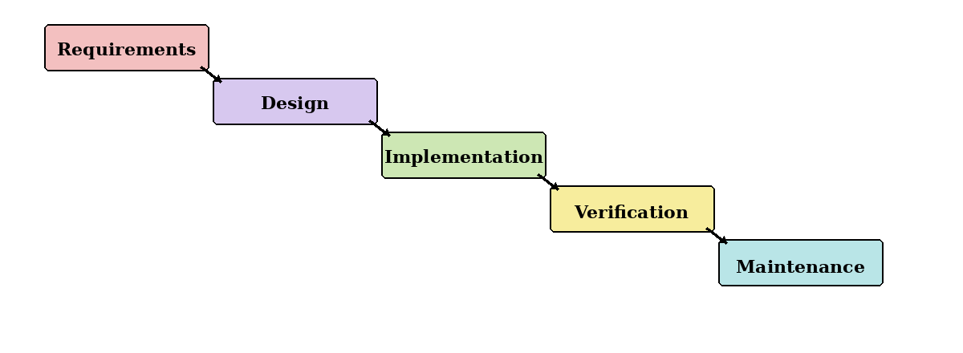
Figure 4.1: Waterfall model.
Waterfall follows a fixed sequence from requirements to maintenance. Although it offers clear stages, it is unsuitable as the main approach because AI models and data sources may require repeated changes. It will only be used for stable tasks such as final documentation and submission checks.
Prototyping Model
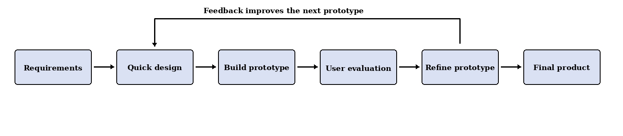
Figure 4.2: Prototyping model.
Prototyping allows the team to test claim extraction, evidence retrieval, scam detection and AI-authorship scoring before integrating them. To avoid endless changes, all prototypes will be compared using the same test dataset and only useful improvements will be retained.
Kanban Model
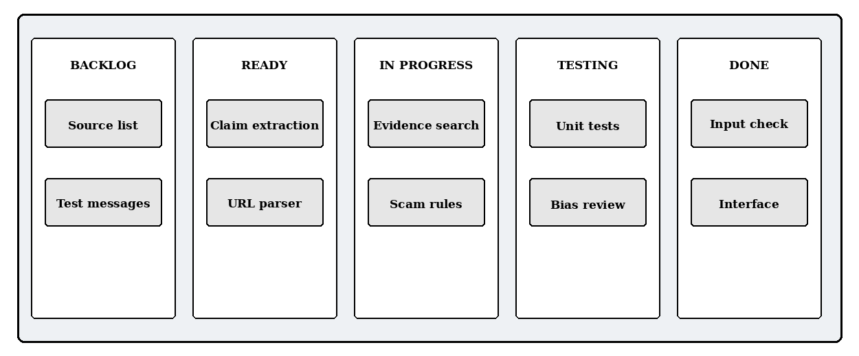
Figure 4.3: Example Kanban task board.
Kanban provides a visual view of tasks in Backlog, Ready, In Progress, Testing and Done. It supports daily coordination and limits unfinished work, but it lacks fixed review dates. Therefore, it will support Scrum rather than replace it.
Scrum
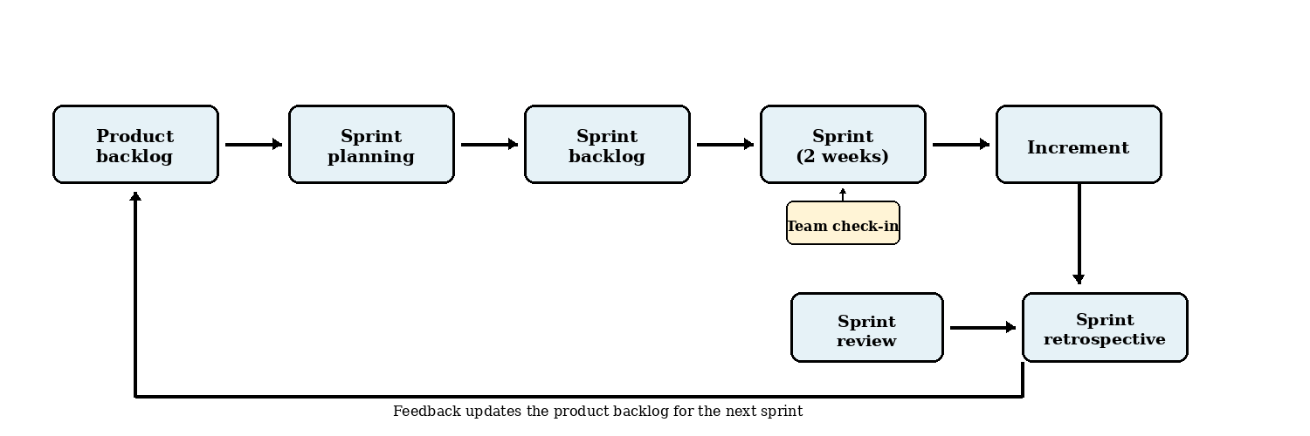
Figure 4.4: Scrum development cycle.
Scrum divides the project into short sprints that each produce a tested increment. The main practices used will be:
- Two-week sprints with planning, development, testing and documentation.
- User stories and a prioritised product backlog for project requirements and technical tasks.
- Sprint reviews to evaluate results, collect supervisor feedback and revise the backlog.
- Sprint retrospectives to identify delays and improve the next sprint.
Scrum is suitable because the team can respond when a model performs poorly, a Singapore source is unavailable or a feature exceeds the available time.

6.1.1 Development Methodology Chosen: Scrum
Scrum is selected as the main methodology because it combines structure with flexibility. This is important for an AI-based misinformation detection project, where models, datasets, trusted sources and scoring methods must be evaluated before the final approach is confirmed.
Justification for Choosing Scrum
- Adaptability: Requirements can be revised when testing or supervisor feedback reveals problems.
- Iterative progress: Short sprints provide regular working results within the six-month schedule.
- Early evaluation: AI detection, factual verification and scam analysis can be tested separately.
- Scope control: Essential functions are prioritised, while unrealistic features are moved to future work.
- Explainability and ethics: Each sprint can review false positives, data quality, robustness and user-facing explanations.
How Scrum Will Be Used
At the start of each sprint, the team will select a small number of high-priority tasks. A task is complete only when it works, has passed basic tests and has updated documentation. The sprint review and retrospective will then guide the next sprint.
Conclusion
A lightweight Scrum process, supported by prototyping and Kanban, is the most realistic approach for this six-month, zero-budget student project.

6.2 Development Tools
Current implementation clarification: JavaScript/React Native with Expo 57, Python/FastAPI/Uvicorn, Firebase Authentication and Cloud Firestore. The mobile API wrapper uses fetch rather than the Axios library originally proposed. Database descriptions below retain the wider planned storage scope; see Section 5.5 for implemented collections.
The development stack has been selected for an Android-based AI-assisted misinformation-checking prototype. The selected tools provide native Android support, straightforward integration with Python-based processing, and a manageable architecture for the FYP team.

6.2.1 Front-End
Front-End | Selected Technology
Language | JavaScript
Framework | React Native with Expo
Development Tool | Visual Studio Code, Expo and Android Studio Emulator
Description | JavaScript will be used to implement the Android application with React Native. React Native will provide reusable components for the interface, navigation and application state, while Expo will simplify development, testing and Android builds. Visual Studio Code will be used to write the application code, and the Android Studio Emulator will be used for device testing.
Why We Chose Them | JavaScript and React Native were selected because they allow the team to develop the Android interface using familiar web-style component concepts. Expo supports rapid prototyping and reduces the initial Android project configuration required. This combination is appropriate for the FYP because it supports faster interface development while still producing an Android application.

6.2.2 Back-End
Back-End | Selected Technology
Language | Python
Framework | FastAPI
Runtime Server | Uvicorn
Development Tool | Visual Studio Code
Description | Python will be used for server-side processing and integration with the application's AI and data-processing components. FastAPI will provide REST API endpoints for receiving submissions, coordinating analysis, applying usage limits and returning structured results. Uvicorn will run the FastAPI application during development and deployment.
Why We Chose Them | Python is well suited to AI, natural-language processing and image-analysis libraries. FastAPI provides request validation, clear routing and automatically generated API documentation, making it practical for a five-person FYP team. Using Python for both the back-end and AI components also avoids maintaining a separate Node.js service.

6.2.3 Database
Database | Selected Technology
Database | Cloud Firestore
Database Type | NoSQL document database
Development Tool | Firebase Console
Description | Cloud Firestore will store user profiles, account roles, free and premium submission allowances, analysis results, result history, evidence records, feedback and reported incorrect results. The current Android client accesses protected account and result data through FastAPI; the backend Firebase Admin SDK performs Firestore operations. The Firebase Console will be used to inspect records, configure access rules and monitor database usage.
Why We Chose It | Cloud Firestore integrates with Firebase Authentication and can be accessed from the React Native application through the Firebase JavaScript SDK. It requires less database administration than a self-hosted database, and its document structure is suitable for user accounts, submissions and result records. Firebase Realtime Database is not required for the selected scope.

6.2.4 API Communication
API Communication | Selected Technology
Architecture | RESTful API
Data Format | JSON
React Native Library | fetch
Testing Tool | Postman
Description | The React Native application will communicate with the FastAPI back-end through HTTPS REST endpoints. fetch will send text, links, images and authentication headers to the back-end and convert JSON responses into JavaScript objects. Postman will be used to test the API independently from the mobile interface.
Why We Chose Them | The current app uses fetch for JSON requests and Firebase bearer headers, with request timeouts and friendly error handling. Server-only credentials and analysis logic remain outside the Android client.

6.2.5 Authentication
Authentication | Selected Technology
Authentication Service | Firebase Authentication
React Native Integration | Firebase JavaScript SDK
Initial Sign-In Method | Email and password
Description | Firebase Authentication will manage account registration, login, logout, password reset and user sessions through the Firebase JavaScript SDK. The React Native application will obtain a Firebase identity token, and the FastAPI back-end will verify that token before allowing protected operations. Application roles and access tiers will be checked by the back-end using the associated account record.
Why We Chose It | Firebase Authentication works with the selected React Native and Cloud Firestore stack and removes the need to build password storage and session handling from the beginning. Email-and-password authentication is sufficient for the initial prototype and keeps registration familiar and straightforward for the target users.

6.3 Current analysis components
Component | Implemented method | Important limitation
Input preparation | Validate at most 5,000 characters; normalize Unicode/whitespace without discarding meaning; verify English; warn about instruction-like content. | A warning is not a complete prompt-injection defence.
Claim classification | Concurrent Ollama Cloud calls to gpt-oss:120b, gemma4:31b and nemotron-3-super. At least two valid replies are needed; valid votes select a majority category. | A split returns unverifiable; agreement is not a truth probability.
Claim extraction | gemma4:31b extracts a principal factual source span; validate JSON and occurrence in the submitted text. | A span match cannot prove all decisive context was retained.
Evidence retrieval | Google published-check discovery → Tavily page extraction → scoped Tavily search when needed; validate, rank and deduplicate citations. | Lexical relevance can miss paraphrases or admit related but inconclusive sources.
Evidence assessment | Supporting/contradicting/neutral stance using lexical overlap, negation, amounts and dates; heuristic quality and risk rules. | Known semantic stance errors; no calibrated probability or trained assessment model.
Orchestration | Validate handoffs, skip unnecessary stages, distinguish failures from insufficient evidence, return structured results. | One principal claim is processed; multiple-claim coverage needs evaluation.

6.3.1 Model voting, validation and prompt handling
Invalid responses and provider failures do not vote. Fewer than two valid classifiers produces a controlled failure. A winning category uses agreement divided by the three configured models, so 0.67 is agreement rather than a 67% likelihood of truth. Submitted content is placed in a separate untrusted data message; system instructions define the task. Locally enforced schemas and span checks reject malformed or fabricated extraction output.
The configured claim stage uses a 90-second overall deadline and bounded provider calls. Retrieval uses a 65-second stage deadline; the current mobile text request waits up to 180 seconds. These bounds limit waiting but do not establish a response-time service guarantee. There are no automatic provider retries in these stages.
Evidence / source: Current claim_analysis/categories.py and service.py; evidence_retrieval service/providers; mobile/src/services/api.js. Ollama Cloud reference in Section 13.

6.4 APIs, interfaces and dependencies
Endpoint / boundary | Purpose
GET / and GET /health | Basic process reachability; does not prove provider readiness.
PUT /account/me | Create/refresh the authenticated profile; verification status is enforced by subsequent protected operations.
GET /account/me | Return the verified active user’s own profile and allowance.
POST /analysis/text | Verified, active account; English text payload; optional Idempotency-Key; controlled errors and owned completed/failed persistence.
GET /analysis/results | Owned result list, default page limit 20 and maximum 50; optional result-ID cursor.
GET /analysis/results/{result_id} | Owned result detail; missing/other-user records return 404.
Pipeline models | PreparedText → ClaimAnalysis → RetrievalResult → AssessmentResult → TextAnalysisResult, plus FailedAnalysisRecord.
Dependency | Purpose / credential boundary
Firebase Authentication / Firestore | Client identity and backend-owned storage. Admin JSON stays outside the repository; no password is stored in a user-profile document.
Ollama Cloud | Claim-stage inference using a server-only API key; no local model download required.
Google Fact Check Tools API | Search existing ClaimReview records; no claim-verification conclusion is implied by a search match alone.
Tavily Search / Extract | Fetch source passages and search the scoped catalogue; provider keys remain backend-only.
External source pages | Evidence/provenance; availability, publication date and meaning must be evaluated for each claim.
The app displays controlled errors for invalid input, authentication/access failure, depleted allowance, overlapping/reused requests and unavailable services. Empty successful searches can produce Not Enough Information; technical failures are not converted into a confident assessment.
Evidence / source: backend/app/routers, pipeline/shared/models.py; provider APIs in Section 13.

6.5 Hosting, deployment and configuration
Current delivery is a local Windows/Android-emulator demonstration with a cloud Firebase project and cloud AI/search providers. There is no verified public API deployment, installed release APK, Play Store listing or operational portal. Source-control use does not establish a CI/CD pipeline.
Project-root .env supplies OLLAMA_API_KEY, GOOGLE_FACT_CHECK_API_KEY, TAVILY_API_KEY and GOOGLE_APPLICATION_CREDENTIALS. The credential path points outside Git. The mobile environment contains Firebase Web configuration and EXPO_PUBLIC_API_URL; it must not contain provider keys or the Admin JSON. Real credentials are deliberately omitted from this report.
cd C:\Dev\uiabo\backend
.\.venv\Scripts\python.exe -m uvicorn app.main:app --host 127.0.0.1 --port 8000

cd C:\Dev\uiabo\mobile
npm.cmd ci
npx.cmd expo start --lan
The existing virtual environment and private configuration must be prepared first. The standard Android emulator uses http://10.0.2.2:8000 to reach this backend. This is local development HTTP; the submitted deployment design requires HTTPS. The PUM Section 2 provides the longer setup procedure.
The current workspace uses Expo 57, React Native 0.86.3, React 19.2.3, Node v24.14.0 and Python 3.14.3. Expo’s SDK 57 reference lists Node 22.13.x and Android 7+ as framework minimums; these are not a UIABO device-compatibility certification. A clean-machine and physical-device matrix remains pending (Expo, SDK 57 reference).

6.6 Release work still required
- Choose and document deployment targets, HTTPS endpoints, environment separation and release artifact/version.
- Provide reproducible Firebase rules/IAM configuration and a tested recovery/backup procedure.
- Implement and evaluate required static-image/deepfake functions, then payments and operational workflows as agreed.
- Validate assessment accuracy, latency, capacity, accessibility and failure behavior before stronger release claims.
Evidence / source: Current READMEs, configuration templates, package files and PUM; official Expo SDK 57 reference accessed 7 September 2026.

