10. Project Schedule
The Gantt images below are the original PRD planning baseline. They do not reflect a newly approved rebaseline or establish actual completion. The dated milestones and work breakdown after the figures show the evidence available for this update.
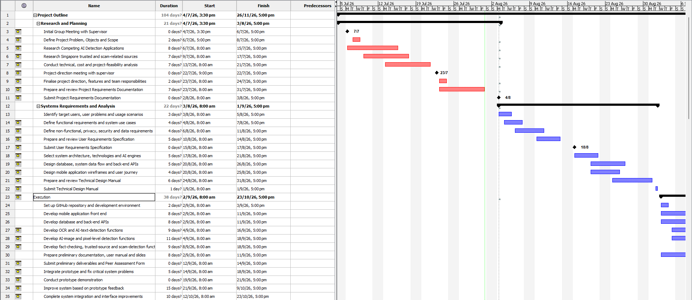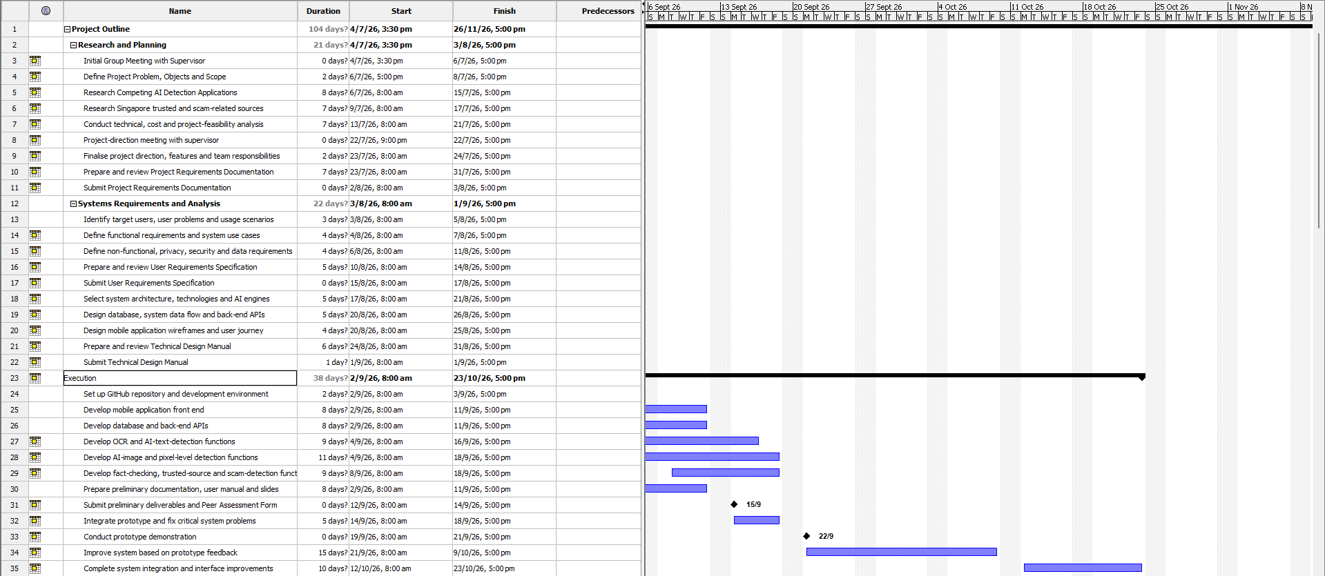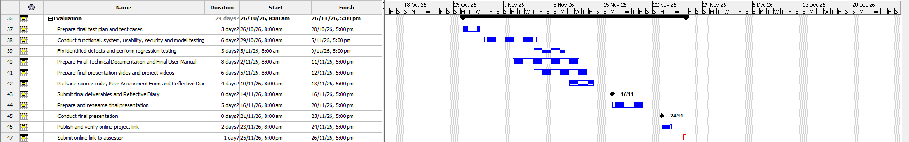

10.1 Milestones and current progress
Milestone | Date / state | Evidence or action
Initial backend/Firebase foundation | 12–13 Aug 2026, recorded | Meeting brief records basic API tests and Firestore connectivity.
Claim analysis integration | 6 Sep 2026, recorded | Ollama live report and validation changes.
Retrieval integration | 7 Sep 2026, recorded | Google/Tavily live requests and pipeline results.
Android and owned persistence | 7 Sep 2026, recorded | Emulator, Firestore history/detail and quota checks.
Preliminary documentation | 7 Sep 2026, draft | PUM section files/PDF and this updated PTD.
Prototype submission | 12 Sep 2026, user-provided deadline | Basic Sprint 1 text demonstration; scope clarity, known limits and reproducible setup needed.
Final submission | November 2026, exact date pending | Complete required image/deepfake scope and evaluation; confirm official deadline and rebaseline.

10.2 Work breakdown structure
Work package | Deliverable / responsibility area | State
W1 Requirements/design | PRD, URS, TDM; team and documentation. | Existing baseline; scope differences recorded.
W2 Input preparation | English validation and preparation; Yi Da stage. | Integrated.
W3 Claim analysis | Classification/extraction; Matthew stage. | Integrated; additional evaluation needed.
W4 Evidence retrieval | Provider discovery/search/citations; Chu stage. | Live completion exists in the current workspace; confirm contribution attribution.
W5 Assessment | Evidence stance/risk/explanation; Poon stage. | Integrated baseline; semantic accuracy improvement outstanding.
W6 App/API/persistence | Android flow, auth, results and quota; Donovan-led integration. | Basic text journey working.
W7 Required image scope | OCR, image/caption/context, deepfake. | Not implemented; confirm named owners and dates.
W8 Remaining product functions | Payments, deletion, reports, public sharing and portals. | Planned; prioritization and delivery dates needed.
W9 Evaluation/release | Dataset, usability, load/security, packaging and documentation. | Partial tests/drafts; acceptance evidence incomplete.

10.3 Proposed next work order
Before 12 September, prioritize reproducible text demonstration, clear unavailable-feature labels, meaningful accuracy examples and consistent documentation. For the remaining project, prioritize required image/deepfake implementation and assessment evaluation, then agreed operational/subscription functions and release validation. These priorities do not assign invented sprint dates or certify supervisor acceptance.
Evidence / source: PRD 4.5 Gantt; dated meeting/integration reports; user-provided September and November milestones.

