4. Initial GUIs of uiabo
The interfaces below introduce account access, content analysis, result history, premium image tools and the two operational roles defined in the submitted URS and TDM.
Every TDM image is captioned as a proposed design. For implemented functions, the instructions use the current app’s controls, which may differ from the mock-up. Proposed workflows are retained to show the agreed design, not to imply that the screens are usable in the current build.
Area | Sections
Account access | 4.1–4.4: sign-in, registration, verification, errors and password recovery
Individual user workflow | 4.5–4.11: Home, allowances, text/link checking, result/history and profile
Premium design | 4.12–4.13: subscription and the four image tools
Operational design | 4.14–4.15: system administrator and data engineer
Guidance and feedback | 4.16: help, sharing, incorrect-result reports and reviews
Use Home, Results, Help and Profile in the bottom navigation. The active tab is highlighted. An authenticated session may return directly to Home when the app is reopened.
Source: TDM Section 6, printed pages 53–61 (PDF pages 56–64); URS Section 3; current mobile App.js.

4.1 Welcome and sign-in
Current prototype — TDM design shown
A user without a saved session begins at the sign-in screen. Existing users sign in with their registered email address and password.
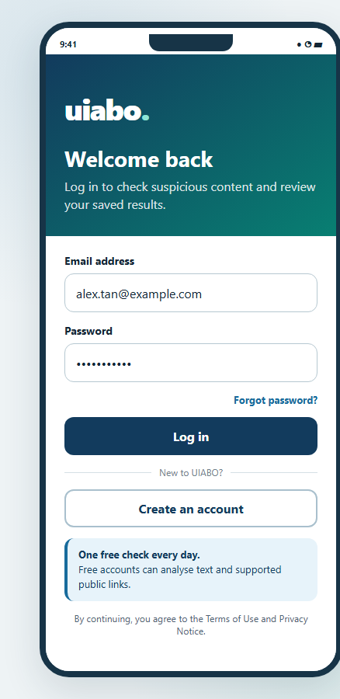 | How to use  1. Enter the registered email address.  2. Enter the password.  3. Select Sign in.  4. If prompted, complete email verification. An active, verified account opens Home.  5. Select Create a free account to register, or Forgot password? to recover access.  The sign-in form is the entry point for users without a saved session.
Figure 4.1. Proposed login design from TDM 6.1. The current button reads “Sign in”.
Source: URS UC-01 and UC-04; TDM 6.1, PDF p. 56; mobile AuthScreen and VerifyEmailScreen.

4.2 Create a free account
Current prototype — TDM design shown
Registration creates an individual free account. The TDM also illustrates premium selection during registration, but the current app does not provide paid registration.
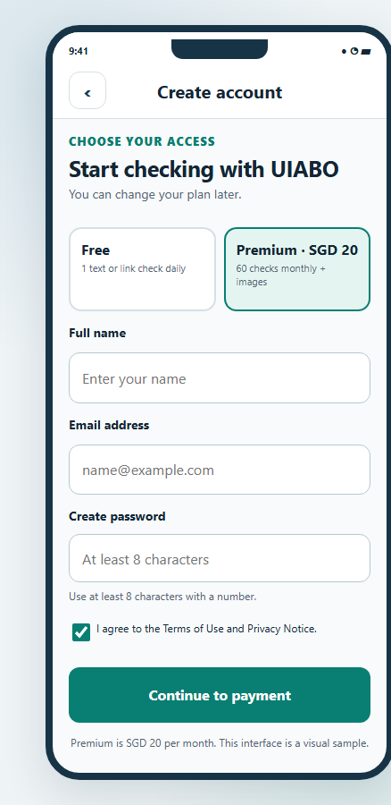 | How to use  1. Select Create a free account from Sign in.  2. Enter your name and email address.  3. Create a password with at least eight characters, then enter it again in Confirm password.  4. Read the consent wording and select the checkbox.  5. Select Create account and continue with email verification.  The current app includes password confirmation. The final linked privacy notice and terms still need to be supplied; see PUM_MISSING_INFORMATION.md.
Figure 4.2. Proposed account-creation design. Premium choice and payment in this mock-up are not implemented.
Source: URS UC-16 and UC-18; TDM 6.1, PDF p. 56; current AuthScreen.

4.2.1 Email verification
Current prototype
The account must be verified before content checking is available. Verification uses a link sent to the registered email address.
1. Open the inbox for the registered email address.
2. Open the verification message and follow its link.
3. Return to uiabo and select I have verified my email.
4. If the message is missing, check the spam folder or select Send the email again.
5. Use Use a different account to leave this verification session if the wrong email was entered.
Source: URS UC-16; mobile VerifyEmailScreen and AuthContext.

4.2.2 Password and consent checks
If the two passwords differ, correct them before submitting. A missing name, missing email address, short password or unselected consent checkbox prevents registration and produces a message explaining what to correct.
UIABO collects the required free-account details in one registration form. The team still needs to supply the final linked privacy notice and terms of use.
Source: URS UC-16; current AuthScreen. Privacy/terms document gap: PUM_MISSING_INFORMATION.md, G04.

4.3 Incorrect sign-in details
Current prototype
An unsuccessful sign-in displays an error on the account form and does not open protected results.
1. Check the spelling of the email address and enter the password again.
2. If you cannot remember the password, use Forgot password?.
3. If an account is awaiting verification, open the email link and complete the verification step.
4. If a network or service message appears, restore the connection and try again. An unavailable or suspended account requires assistance from the project team.
Source: URS UC-01 alternative flows; mobile AuthScreen, AuthContext and Firebase error mapping.

4.4 Password recovery
1. From Sign in, select Forgot password?.
2. Enter the registered email address and select Send reset email.
3. Read the neutral confirmation and check the inbox for reset instructions.
4. Open the reset link and set the new password using the Firebase page.
5. Return to uiabo and sign in with the new password.
A confirmation message does not reveal whether an account exists for a particular email address. If a link is invalid or expired, request another reset email.
Source: URS UC-04; mobile AuthScreen and AuthContext. Current recovery-screen captures are not present in the submission documents.

4.5 Free-user Home and allowance
Current prototype — TDM design shown
Home greets the signed-in user and shows the free daily allowance. The six cards follow the submitted design; there is no audio card.
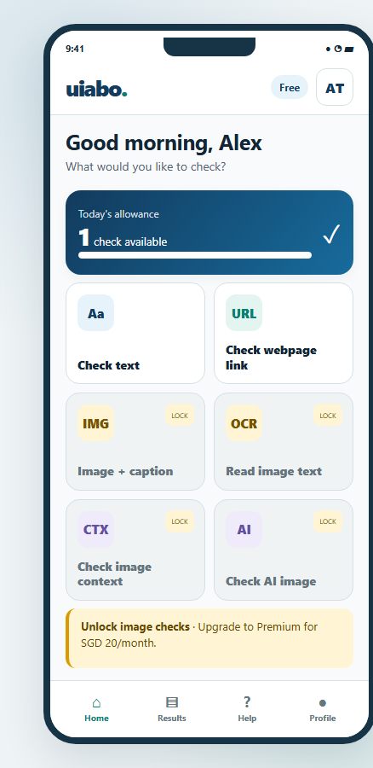 | How to use  1. Read the Free badge and remaining allowance.  2. Select Check text to paste an English message.  3. Check webpage link currently offers checking copied text.  4. Image + caption, Read image text, Check image context and Check AI image are premium tools and remain unavailable in this build.  5. Open Results for saved checks, Help for guidance or Profile for account details.  One completed check is available per Singapore calendar day. A completed Not Enough Information result uses that allowance. Existing results remain readable when no new checks remain.
Figure 4.3. Proposed free-user Home design from TDM 6.2.
Source: PTD Sections 1 and 2.4; URS UC-07/08/11; TDM 6.2, PDF p. 57; current HomeScreen.

4.6 Premium-user Home and allowance
Current prototype — current Android capture shown
A premium account displays a Premium badge and a monthly allowance. Premium status is checked by the backend and cannot be changed through an editable profile field.
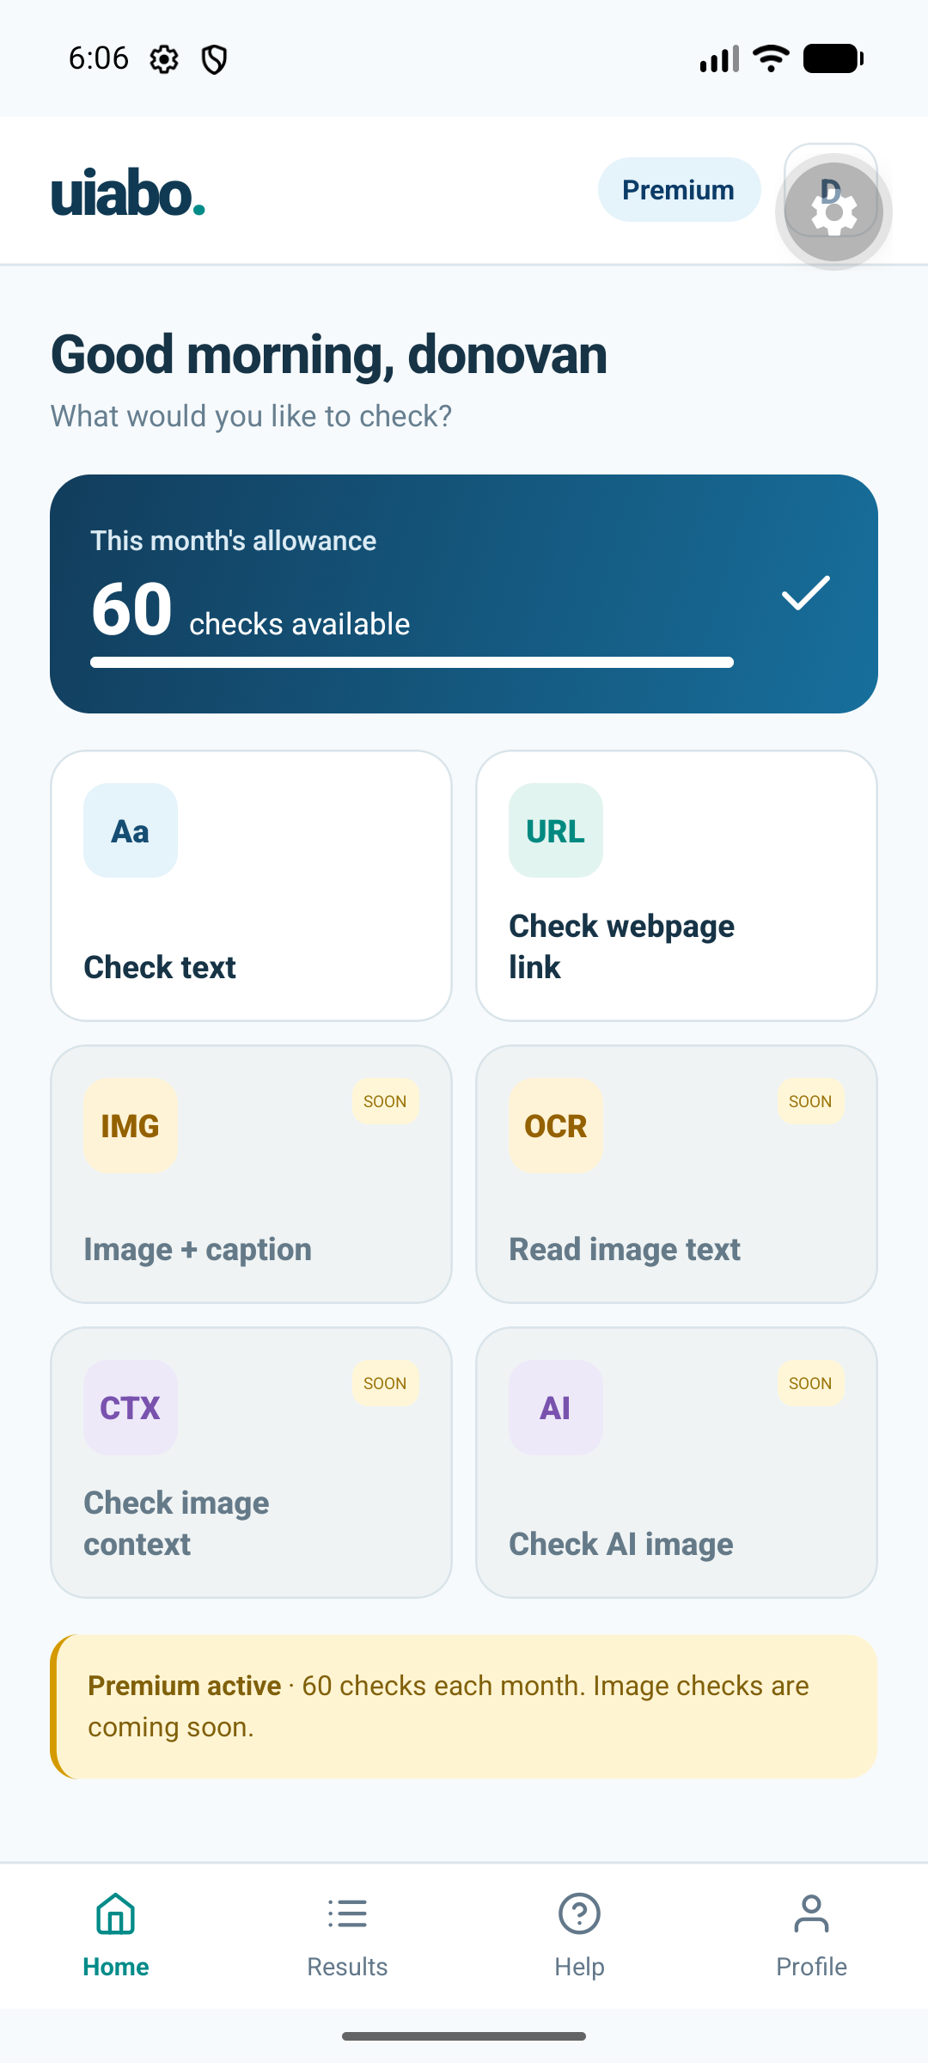 | How to use  1. Read the monthly allowance card.  2. Use Check text in the same way as a free user.  3. Recognise that the image cards marked SOON are not yet available, even with premium access.  4. Open Results to revisit saved analyses without submitting the claim again.  Current premium allowance: 60 successful checks per calendar month, resetting at midnight Singapore time on the first day of the month. A project-granted Premium account does not establish a payment subscription.
Figure 4.4. Android emulator capture, 7 September 2026. The displayed account and remaining count are a snapshot.
Source: URS Section 2.3 and UC-11; TDM 6.3; current HomeScreen and app-integration capture.

4.7 Text analysis
Current prototype — TDM design shown
Text checking accepts a short English message, claim or caption. The current form allows up to 5,000 characters.
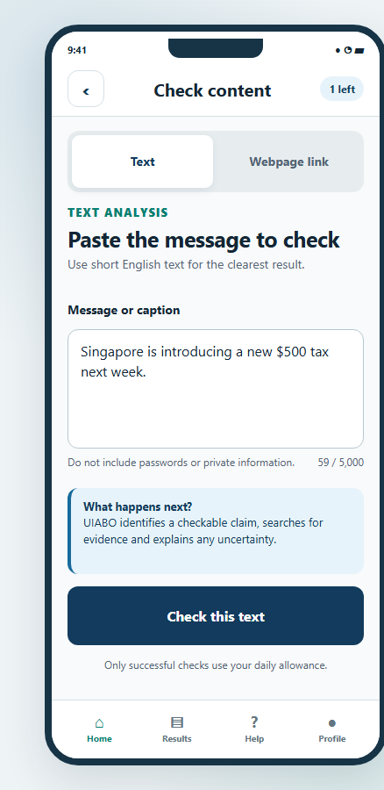 | How to use  1. Select Check text from Home.  2. Paste or type the message into Message or caption.  3. Check that the wording includes the important date, amount and context. Do not include passwords or private information.  4. Select Check this text once and keep the screen open while it processes.  5. Read the completed result, explanation, uncertainty and evidence.  6. Open Results to find the saved check again.  A technical failure does not consume an allowance. After a connection timeout, view saved results before starting a new check; the original request may have completed.
Figure 4.5. Proposed text-analysis design from TDM 6.2; the current flow retains these main controls.
Source: URS UC-07; TDM 6.2, PDF p. 57; current TextCheckScreen.

4.8 Public webpage-link analysis
Proposed design — direct webpage checking not implemented
The agreed design allows a public webpage or article URL to be checked after malicious-link screening. The image below describes that intended feature.
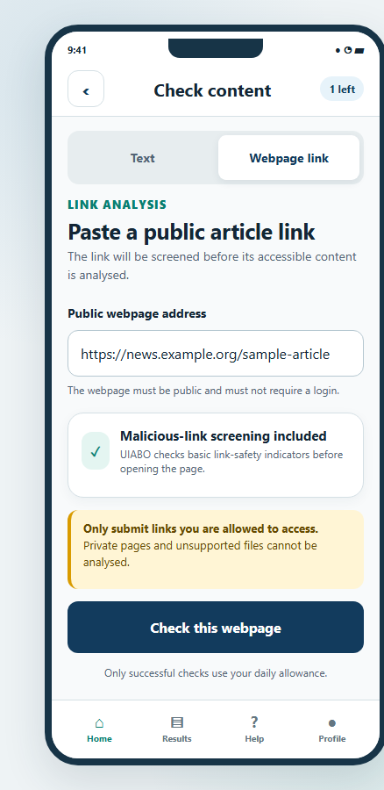 | Proposed user flow  1. Select Check webpage link.  2. Paste a supported public webpage or article address.  3. Select the webpage-check action.  4. The proposed service screens the link and extracts accessible article text before assessing the claim.  5. Read the result, source context and citations once processing succeeds.  Current alternative: the link tab offers Check copied text. It does not fetch or screen a URL. The design excludes private, paywalled and inaccessible content.
Figure 4.6. Proposed link-analysis design from TDM 6.2. Malicious-link screening shown here is not currently available.
Source: URS UC-08 and Sections 2.4–2.5; TDM 6.2, PDF p. 57; current TextCheckScreen.

4.9 Analysis result
Current prototype — current Android capture shown
A completed result presents the concern label and uncertainty alongside the identified claim. Scroll to read the evidence sources and available actions.
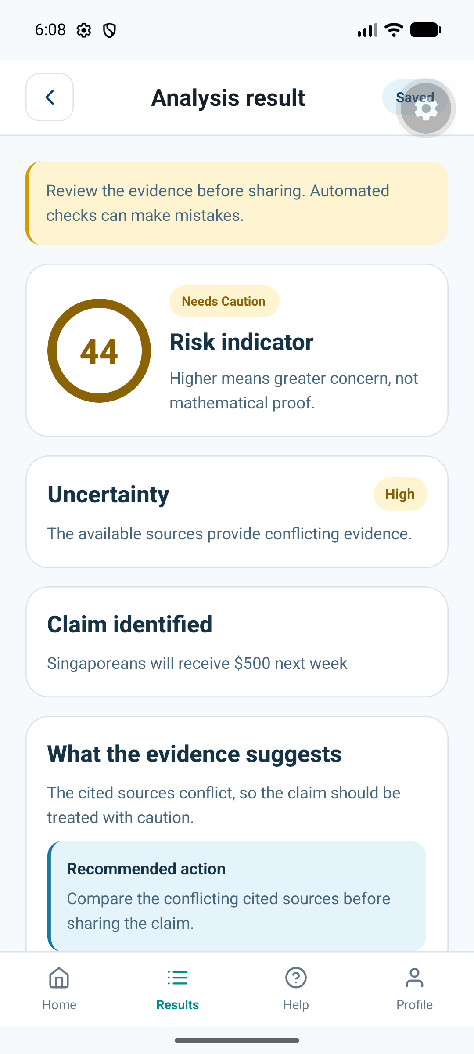 | How to use  1. Check that Claim identified represents the statement you intended to check.  2. Read the concern label together with the uncertainty explanation.  3. Read What the evidence suggests and the recommended action.  4. Scroll to Evidence sources and inspect the passages and source links.  5. Use Share only after reviewing what will be sent, or return to Results.  The current assessment uses an initial scoring approach and can misinterpret evidence. Read the sources. An image-authenticity score, when implemented, will remain separate from misinformation risk.
Figure 4.7. Saved-result screen from the Android emulator. This capture illustrates layout, not an independently verified verdict.
Source: URS UC-10; TDM 6.2, PDF p. 58; current ResultScreen and app-integration capture.

4.9.1 When no assessment can be established
Not Enough Information is used when no checkable factual claim or adequate decisive evidence is available. It has no numerical risk score. A technical processing failure is displayed as a failed check, rather than presented as a successful factual assessment.

4.10 Saved result history
Current prototype — current Android capture shown
Results lists analyses saved to the signed-in account. Reopening an item reads its saved result rather than launching another fact check.
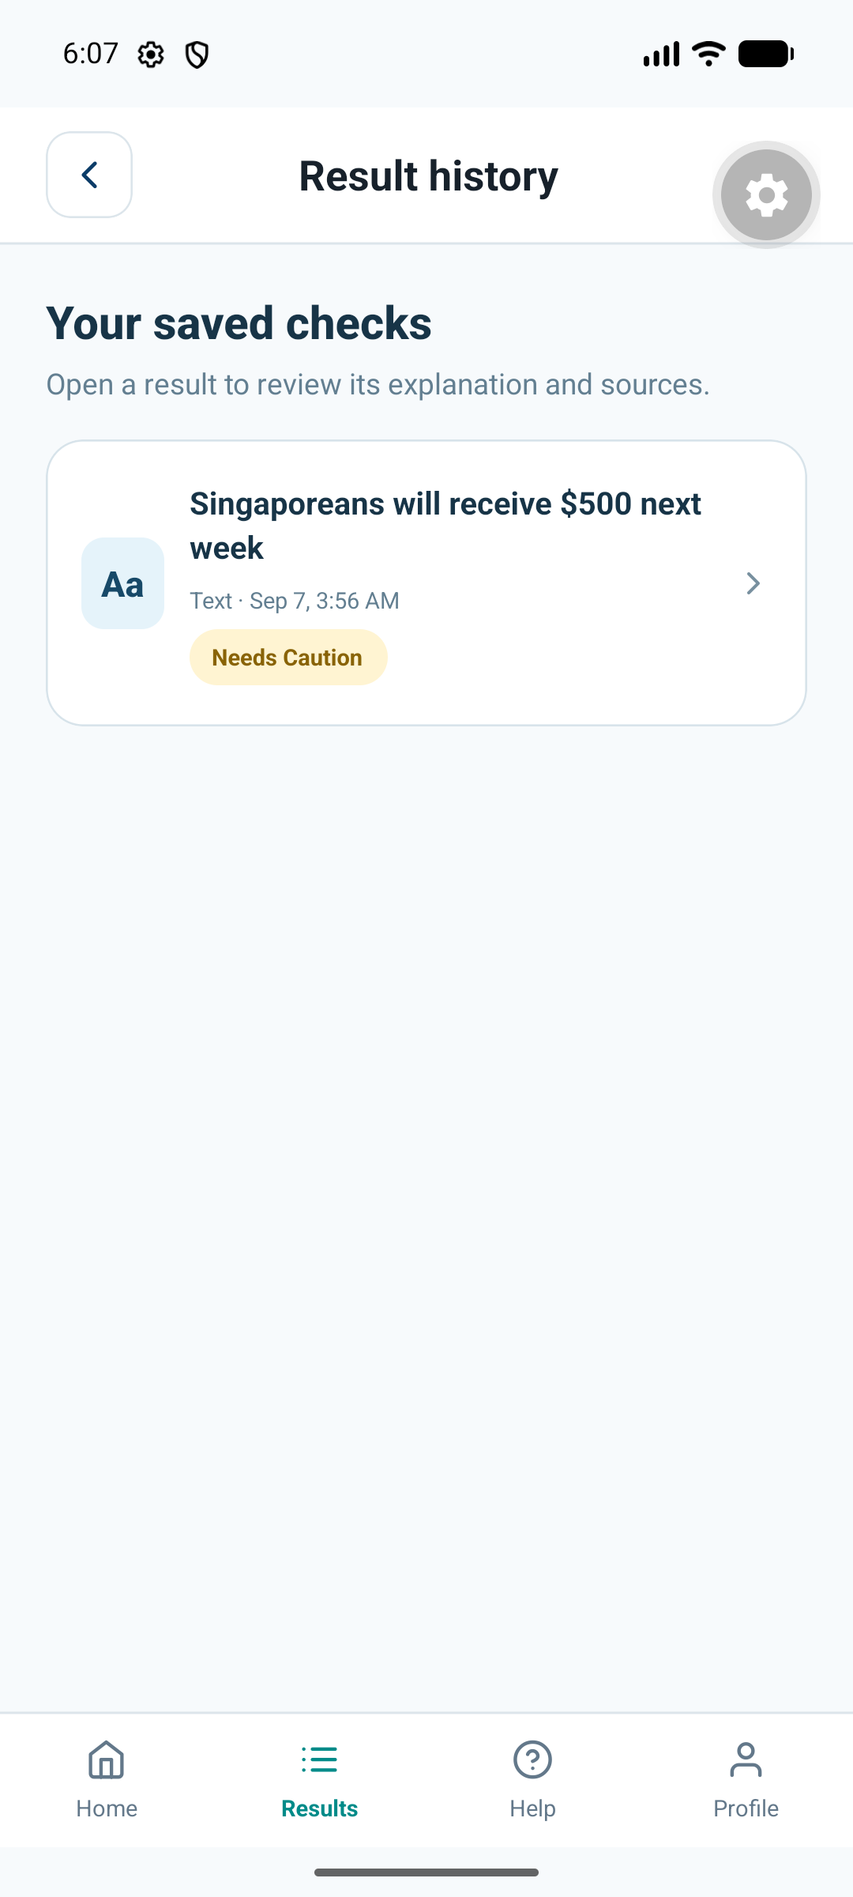 | How to use  1. Select Results in the bottom navigation.  2. Refresh the list if a newly completed item is missing.  3. Select an item to reopen its saved result and citations.  4. Load more items when that option is available.  Current history is private to the account. The TDM’s reported-result filters and deletion workflow are proposed features; they are not controls in the current list.
Figure 4.8. Android result-history capture, 7 September 2026.
Source: URS UC-09/10/12; TDM 6.2, PDF p. 58; current ResultsScreen.

4.10.1 Planned history deletion
URS UC-12 specifies selecting owned results, choosing Delete and confirming permanent removal. That workflow is not implemented in this prototype. Do not assume that the Android app currently provides a deletion button.

4.11 Profile and sign-out
Current prototype
Profile displays the name, email address and account type for the current individual user.
1. Select Profile in the bottom navigation.
2. Edit Name and select Save name.
3. Read the confirmation that the profile has been updated.
4. Select Back to home to return.
5. To leave the account, select Sign out and confirm, or Cancel to remain signed in.
Email and account type are read-only in the current app. Password recovery starts from the sign-in screen; an in-profile email/password editor is not provided.
Source: URS UC-02/05/06; current ProfileScreen.

4.11.1 Planned account deletion
URS UC-03 specifies a permanent account-deletion flow with a clear warning, confirmation and re-authentication. The account and associated history would be removed. This is a requirement for later implementation; no account-deletion control is available in the current profile.
Source: URS UC-03. Final deletion behavior and screen capture are recorded as outstanding work in the companion Markdown file.

4.12 Upgrade and subscription
Proposed design — payments not implemented
The submitted design describes a premium plan with up to 60 successful submissions per month and the supported image tools. The TDM displays SGD 20 per month as its proposed price.
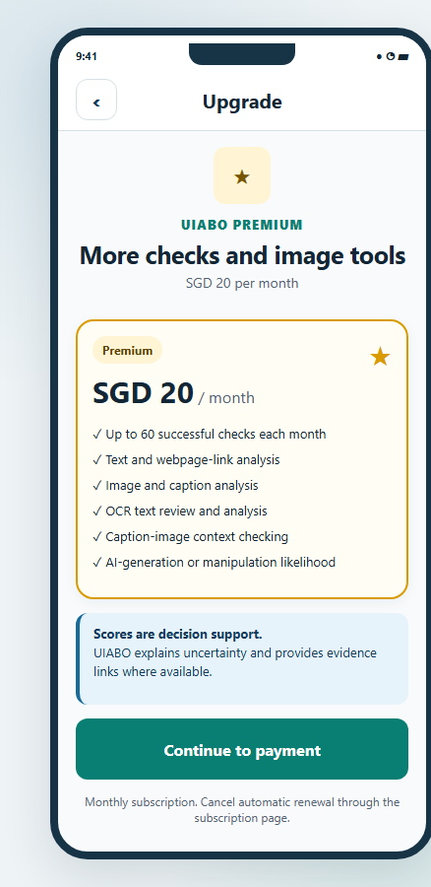 | Proposed user flow  1. Select Upgrade to Premium.  2. Review the proposed plan, price, billing period and allowance.  3. In the intended flow, confirm the upgrade and authorise payment through the selected payment provider.  4. After confirmed payment, the account would receive premium access and subscription details.  Current behavior: Premium information explains that images and payments are unavailable. The project team can grant an account Premium for demonstration. No payment is collected by this prototype.
Figure 4.9. Proposed upgrade design from TDM 6.2. SGD 20/month is a design price, not a working checkout.
Source: PTD 2.4; URS UC-17/18; TDM 6.2, PDF p. 58; current InfoScreen.

4.12.1 Renewal and cancellation
Proposed design — subscription controls not implemented
The proposed subscription page shows plan status, allowance, billing information and renewal/cancellation actions.
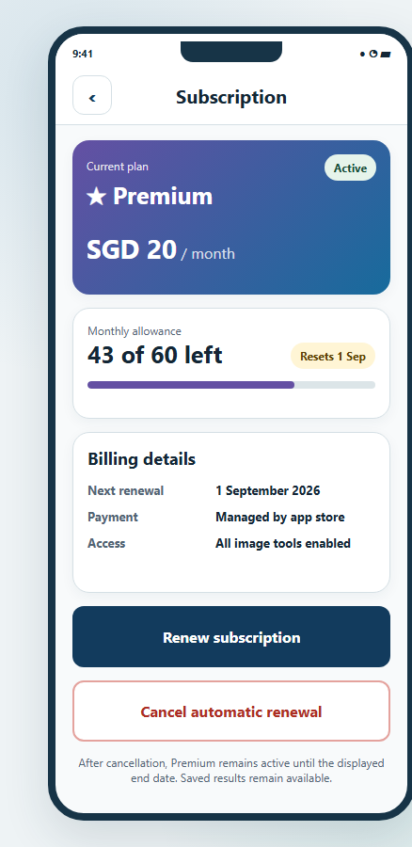 | Proposed user flow  1. Open Subscription and review the plan and end date.  2. For renewal, select Renew Subscription and review the price and new period before authorising payment.  3. For cancellation, select Cancel Subscription and read when premium access will end.  4. Confirm the intended action and review the resulting status.  The URS describes paid access through the current expiry date after cancellation. The payment provider, final billing rules and alignment with the prototype’s calendar-month allowance need confirmation.
Figure 4.10. Proposed subscription design from TDM 6.3; displayed billing details are illustrative.
Source: URS UC-19/20; TDM 6.3, PDF p. 60.

4.13 Premium image functions
Proposed design — all four image tools remain unimplemented
The required image scope includes image + caption, OCR text correction, caption-image context and deepfake/AI-image likelihood. Free users cannot use these functions. Premium users need an available monthly allowance once the functions are implemented.
Source: PTD Sections 1 and 2.1; URS UC-21–24; TDM 6.3; user-confirmed deepfake requirement.

4.13.1 Image + caption
Proposed design
This proposed workflow checks a static image together with the English caption supplied by the user.
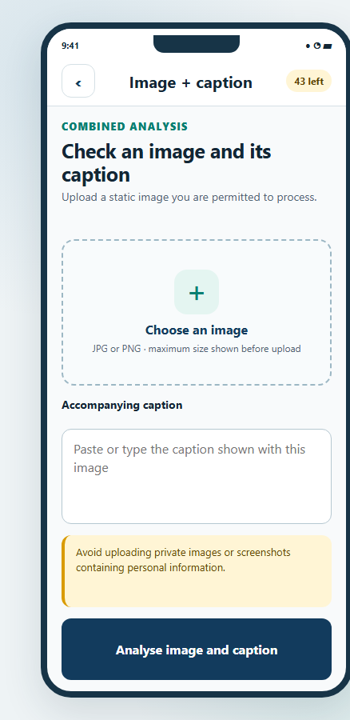 | Proposed user flow  1. Select Image + caption.  2. Choose a supported static image and review its preview.  3. Enter or correct the accompanying English caption.  4. Select Analyse image and caption.  5. Review the resulting explanation, uncertainty and evidence.  The accepted image formats, size limits and final image-processing services have not been established for this manual.
Figure 4.11. Proposed image-and-caption design from TDM 6.3.
Source: URS UC-21; TDM 6.3, PDF p. 59.

4.13.2 Caption-image context
Proposed design
This feature compares the supplied caption with contextual evidence about the image. A real photograph can still be described with an incorrect date, location or event.
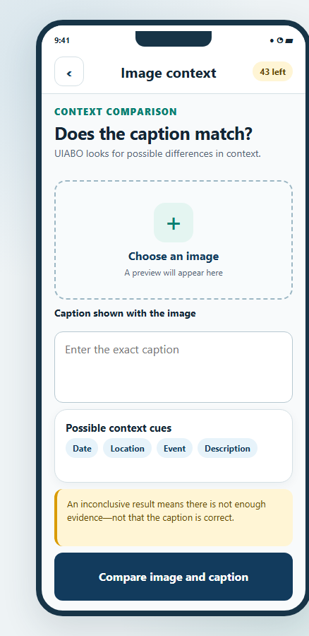 | Proposed user flow  1. Select Check image context.  2. Choose the image and enter the caption being checked.  3. Review the proposed context cues, such as date, location, event or description.  4. Select Compare image and caption.  5. Read the explanation and evidence; insufficient context should lead to an inconclusive result.
Figure 4.12. Proposed caption-image context design from TDM 6.3.
Source: URS UC-22; TDM 6.3, PDF p. 59.

4.13.3 Read image text (OCR)
Proposed design
OCR extracts visible words from an image so the user can check and correct them before submitting a text analysis.
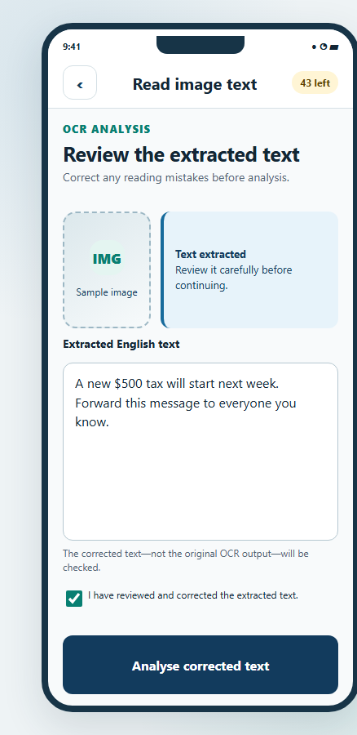 | Proposed user flow  1. Select Read image text.  2. Choose a clear image containing readable text.  3. Extract the text and compare it with the original image.  4. Correct any recognition errors and confirm that the text has been reviewed.  5. Select Analyse corrected text, then read the resulting assessment and sources.  Reviewing OCR output is important: a mistaken amount, name or date can change the claim being checked.
Figure 4.13. Proposed OCR review/correction design from TDM 6.3.
Source: URS UC-23; TDM 6.3, PDF p. 60.

4.13.4 Check AI image / deepfake analysis
Proposed design — required project feature
This function is intended to assess whether a supported static image may be AI-generated or manipulated. It does not analyse audio or video.
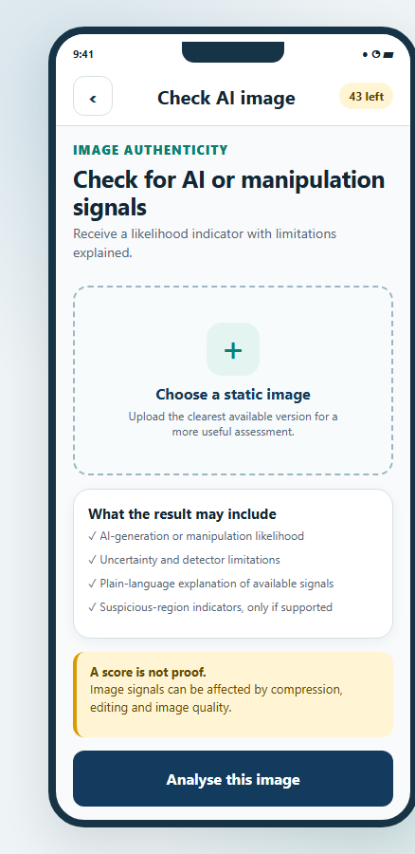 | Proposed user flow  1. Select Check AI image.  2. Choose a supported static image and review the preview.  3. Read the notice explaining that the output is a likelihood assessment.  4. Select Analyse image.  5. Review the separate image-authenticity likelihood, uncertainty and explanation of the available detector signals.  Only detector signals actually supported by the selected service may be shown. A highlighted region or visual artefact must not be presented as conclusive proof. Detector selection and final screens remain outstanding.
Figure 4.14. Proposed deepfake/AI-image design from TDM 6.3.
Source: PTD Sections 1 and 2.1; URS UC-24; TDM 6.3, PDF p. 60.

4.14 System administrator dashboard
Proposed operational portal — not implemented
The system administrator role manages permitted account access and reviews feedback through the proposed UIABO Backend Portal.
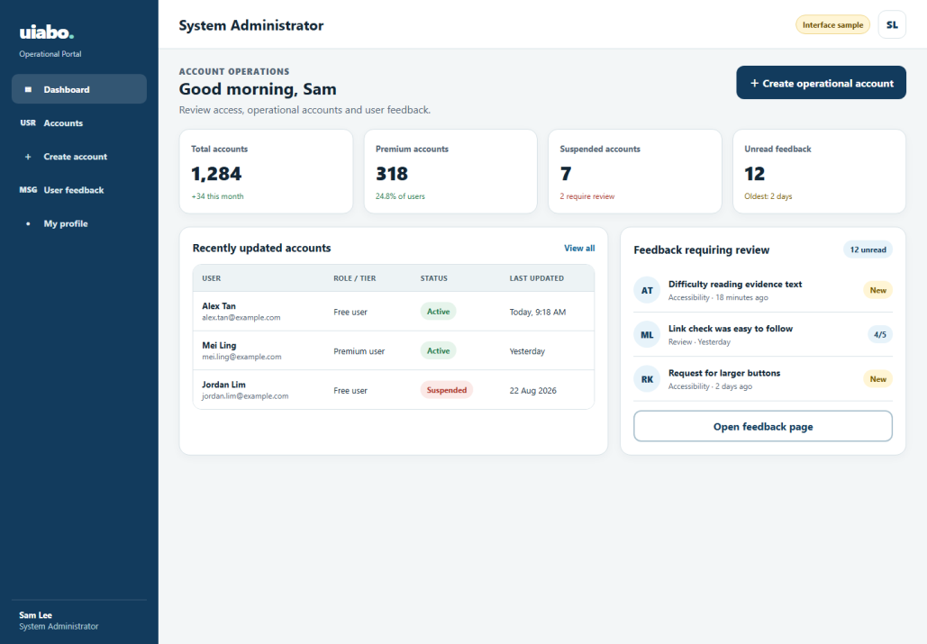
Figure 4.15. Proposed administrator dashboard from TDM 6.4. Dashboard numbers are illustrative.
1. Sign in with an authorised, active system-administrator account.
2. Review the dashboard summaries and available account/feedback areas.
3. Open Account Management or User Feedback to perform the corresponding task.
4. Use the account/profile area for the authorised user’s own profile, password-reset and sign-out workflows.
No deployed portal address or operational sign-in instructions have been supplied.
Source: URS UC-25–29; TDM 3.1 and 6.4, PDF p. 61.

4.14.1 Account management
Proposed operational portal
Account management allows an authorised administrator to locate an account and inspect the information needed for administration.
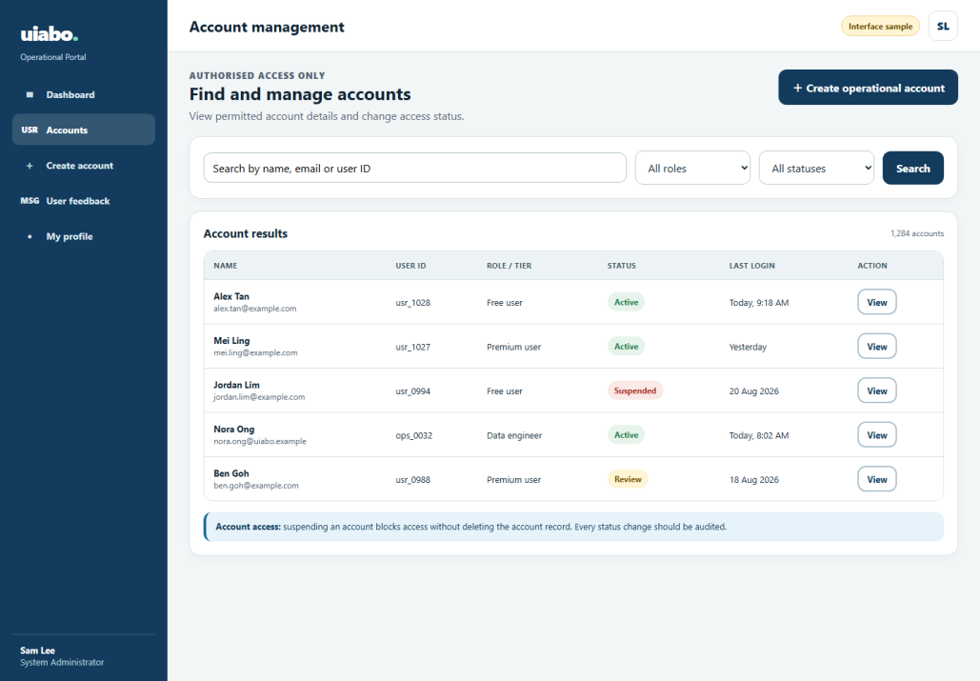
Figure 4.16. Proposed account-management design from TDM 6.4.
1. Open Account Management and enter a supported query or filter.
2. Select Search and choose a matching account.
3. Review its permitted profile summary, role, tier and status.
4. If appropriate, choose Suspend Account, supply the required reason and confirm.
5. To restore an eligible suspended account, choose Unsuspend Account and confirm.
The URS requires role checks, an audit history and safeguards for protected accounts. This manual does not provide a database-editing substitute for those controls.
Source: URS UC-30/31/33/34; TDM 6.4, PDF p. 61.

4.14.2 Create operational account
Proposed operational portal
Operational accounts are created by authorised administrators rather than by individual-user registration.
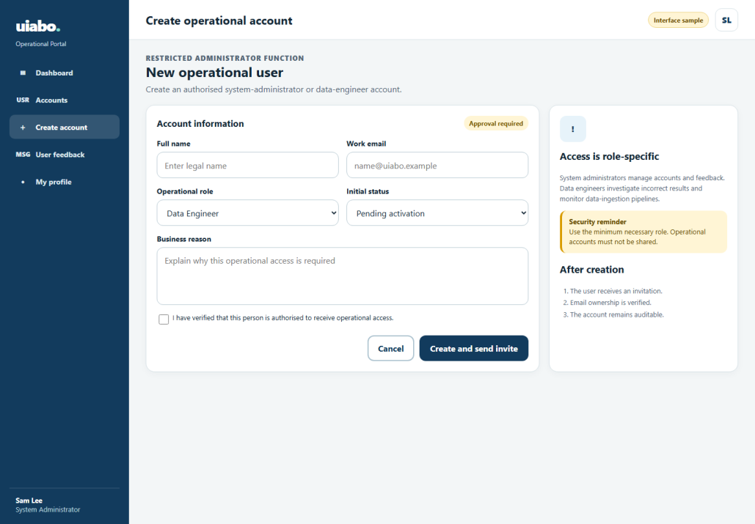
Figure 4.17. Proposed operational-account creation design from TDM 6.4.
1. Open Account Management and select Create Operational Account.
2. Enter the requested account information.
3. Choose the authorised role: System Administrator or Data Engineer.
4. Review the information and confirm creation.
5. The intended system sends secure activation/password-setup instructions and records the action.
Source: URS UC-32; TDM 6.4, PDF p. 62.

4.14.3 User feedback management
Proposed operational portal
The feedback page presents submitted reviews and feedback for authorised administrative review.
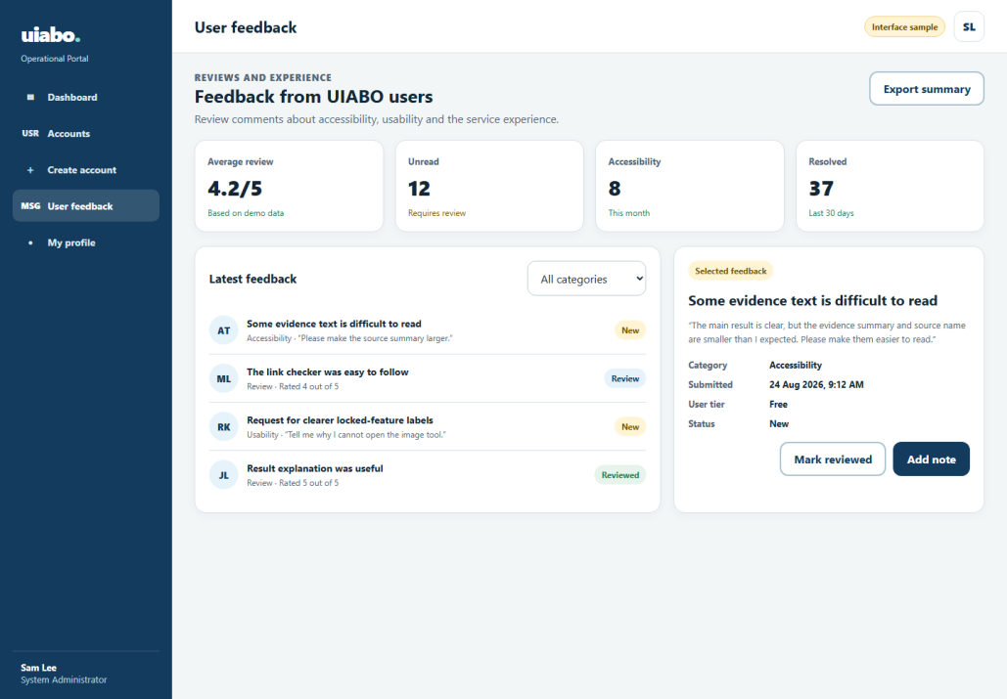
Figure 4.18. Proposed administrator feedback design from TDM 6.4.
1. Select User Feedback.
2. Review the feedback summary and permitted records.
3. Filter or select a feedback item.
4. Read its category, status, submission date and relevant comments.
5. Use only the follow-up actions supported by the completed portal.
The available feedback actions must follow the permissions and controls of the completed portal.
Source: URS UC-35; TDM 6.4, PDF p. 62.

4.15 Data engineer dashboard
Proposed operational portal — not implemented
The data engineer investigates incorrect-result reports and monitors the data workflows supporting analysis.
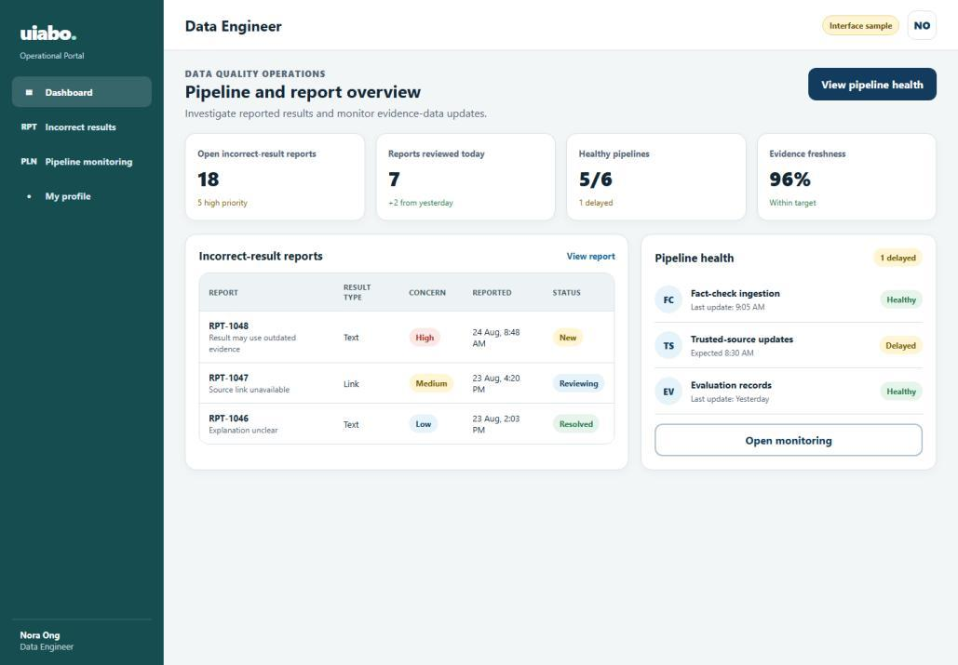
Figure 4.19. Proposed data-engineer dashboard from TDM 6.5.
1. Sign in with an authorised, active data-engineer account.
2. Review available report totals, trends and pipeline summaries.
3. Apply a relevant time range or supported filter.
4. Select a report requiring investigation, or open Pipeline Monitoring.
Operational profile, password-reset and sign-out use the corresponding role-restricted flows specified in the URS.
Source: URS UC-36–41; TDM 6.5, PDF p. 63.

4.15.1 Incorrect-result report details
Proposed operational portal
A report detail view brings together the reported problem, submitted content, generated assessment and available provenance.
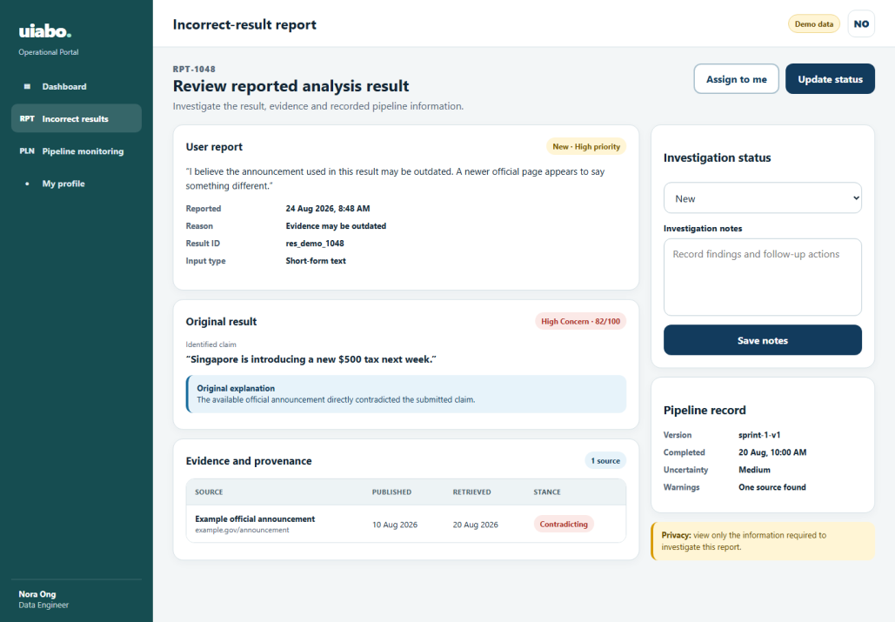
Figure 4.20. Proposed incorrect-result investigation design from TDM 6.5.
1. Open a report from the dashboard or report list.
2. Read the user’s stated reason and relevant submitted content.
3. Compare the generated claim, concern label and evidence with the report.
4. Inspect available timestamps and pipeline/model information.
5. Record an investigation note or permitted status update and save it.
The final investigation statuses and available actions must match the implemented portal; no working update action is implied by this design.
Source: URS UC-42; TDM 6.5, PDF p. 63.

4.15.2 Pipeline monitoring
Proposed operational portal
Pipeline monitoring is intended to show data-ingestion runs, source updates, errors and data-quality indicators.
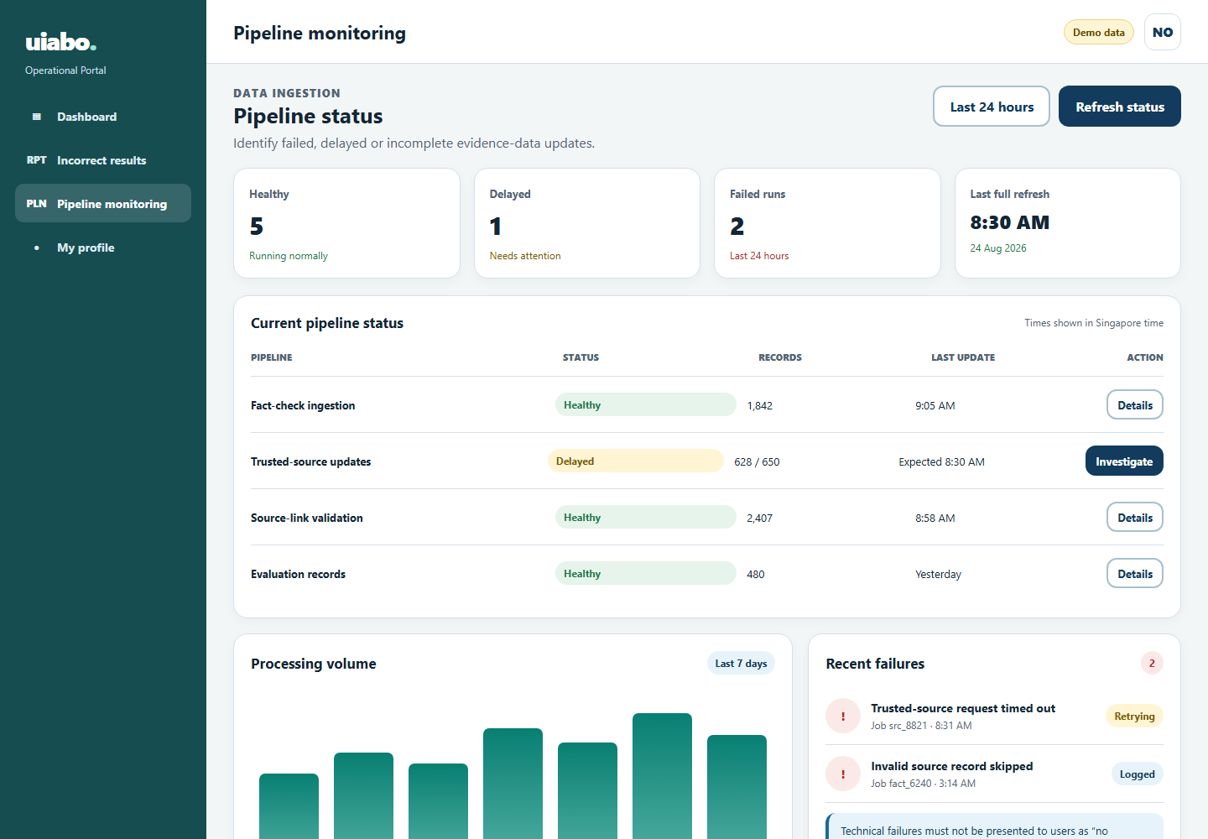
Figure 4.21. Proposed pipeline-monitoring design from TDM 6.5.
1. Open Pipeline Monitoring.
2. Review the latest run states and timestamps.
3. Filter the list or select a run.
4. Inspect available error details, source provenance and the affected data range.
5. Record an issue for follow-up; use a recovery action only when one has been implemented and authorised.
Source: URS UC-43; TDM 6.5, PDF p. 64.

4.16 Help, sharing and feedback
Current help/sharing; reporting and reviews remain proposed
Help explains how to check text, read uncertainty and understand the allowance. The URS also specifies separate incorrect-result reports and service reviews.
Source: URS Section 2.6 and UC-13–15; current InfoScreen and ResultScreen.

4.16.1 Help and troubleshooting
1. Select Help in the bottom navigation.
2. Read the text-check instructions and result limitations.
3. Read the allowance and interrupted-request guidance.
4. Select Check some text to return to the text workflow.
Situation | Suggested next action
No allowance remains | Reopen existing results or wait for the next reset shown by the account tier.
No checkable claim / insufficient evidence | Read the Not Enough Information explanation. Review the original wording and available authoritative sources.
A request times out | Check Results before trying again. The original check may already have completed.
A source will not open | Check the connection and try another citation. Source pages can become unavailable.
A result seems wrong | Review the evidence rather than relying on the score. The in-app reporting workflow is still planned.

4.16.2 Share a result
1. Open a completed result and review its explanation and citations.
2. Select Share.
3. Choose the receiving app from the Android share sheet and review the text before sending.
The current share action sends summary text and citation URLs. It does not generate a public UIABO result-page link. The shareable-link workflow in URS UC-15 remains planned.
Source: Current InfoScreen and ResultScreen; URS UC-15. Support contact and final legal/help pages are missing from the supplied project material.

4.16.3 Report an incorrect result
Proposed workflow — not implemented in the Android prototype.
1. Open the completed result and select Report Incorrect Result.
2. Choose a reason and optionally explain the problem.
3. Submit the report.
4. Read the confirmation; the intended system associates the report with the result for investigation.
Source: URS UC-13; the submitted TDM contains the operational report-detail design, but no separate consumer report-form image.

4.16.4 Leave a review
Proposed workflow — not implemented in the Android prototype.
1. Open the feedback area and select Leave a Review.
2. Choose a rating and optionally add comments.
3. Submit the review and read the confirmation.
An incorrect-result report concerns a particular assessment; a review concerns the experience of using uiabo.
Source: URS UC-14 and PF-A02. A consumer review-form design and final support/contact route are outstanding.

