


CSIT-26-S3-30: AI-Based Misinformation Detection for Short-Form Content

FYP-26-S3-30: Technical Design Manual

Team

Student Name | UOW ID | Student E-mail
Ho Sze Wei, Donovan | 8949724 | swdho001@mymail.sim.edu.sg
Wong Yi Da | 1037274 | ydwong003@mymail.sim.edu.sg
Matthew Alexander Peeris | 1052585 | peeris001@mymail.sim.edu.sg
CHU WAI CHUNG | 8949256 | wcchu001@mymail.sim.edu.sg
POON CHUN PING | 8865747 | cppoon001@mymail.sim.edu.sg

Supervisor:
Mr Liaw Chun Huei

Table of Contents
1. Introduction 1
2. Purpose 1
3. Design Approach 2
3.1 System Environment 2
3.2 Data Flow 3
3.3 Architecture Design 4
4. Activity Diagrams 5
4.1 System Administrator 5
4.2 Free User 6
4.3 Premium User 7
4.4 Data Engineer 8
5. Sequence Diagrams 9
5.1 System Administrator 9
5.2 Free User 20
5.3 Premium User 37
5.4 Data Engineer 45
6. User Interface 53
6.1 Login and Account Creation 53
6.2 Free User 54
6.3 Premium User 56
6.4 System Administrator 58
6.5 Data Engineer 60
7. Database Design 62
Mermaid Diagram 62
7.1. Users Collection 63
7.2. Subscriptions Collection 64
7.3. Usage Allowances Collection 64
7.4. Analysis Results Collection 65
7.5. Incorrect Result Reports Collection 66
7.6. Feedback Collection 66
7.7. Sources Collection 66
7.8. Pipeline Runs Collection 67
7.9. Audit Logs Collection 67
7.10. Supporting Firebase Services 68

1. Introduction
The objective of this document is to give an overview of the technical design for an AI-Based Misinformation Detection for Short-Form Content

2. Purpose
The purpose of the Technical Design Manual (TDM) is to provide a comprehensive overview of the architecture, components, and implementation details for our application. This document would serve as a reference for our team to be consistent and clear with our design and development of the system.

3. Design Approach

3.1 System Environment
UIABO uses a separated client, API, analysis-pipeline and Firebase architecture so the Android application and operational portal do not contain secret service credentials or AI processing logic.
• Consumer client: Android smartphone running the React Native application built with Expo.
• Operational client: UIABO Backend Portal accessed through a modern Chrome, Edge or Firefox browser.
• Back end: Python with FastAPI and Uvicorn for authenticated REST API services.
• Communication: HTTPS requests and JSON responses; the Android application uses Axios.
• Firebase services: Firebase Authentication, Cloud Firestore and Firebase Storage.
• Analysis environment: input preparation, claim analysis, evidence retrieval, evidence assessment and premium image-processing components.
• Development and testing: Visual Studio Code, Expo, Android Studio Emulator, Postman and Firebase Console.
• Network requirement: Internet access to the UIABO API, Firebase and approved evidence or AI services.

3.2 Data Flow
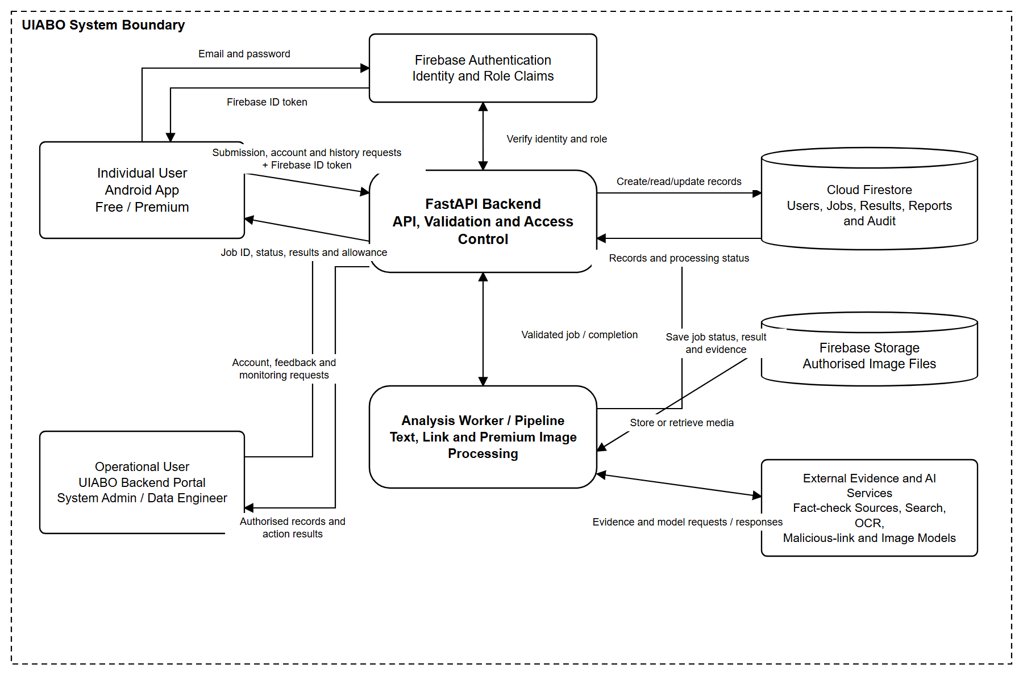

3.3 Architecture Design
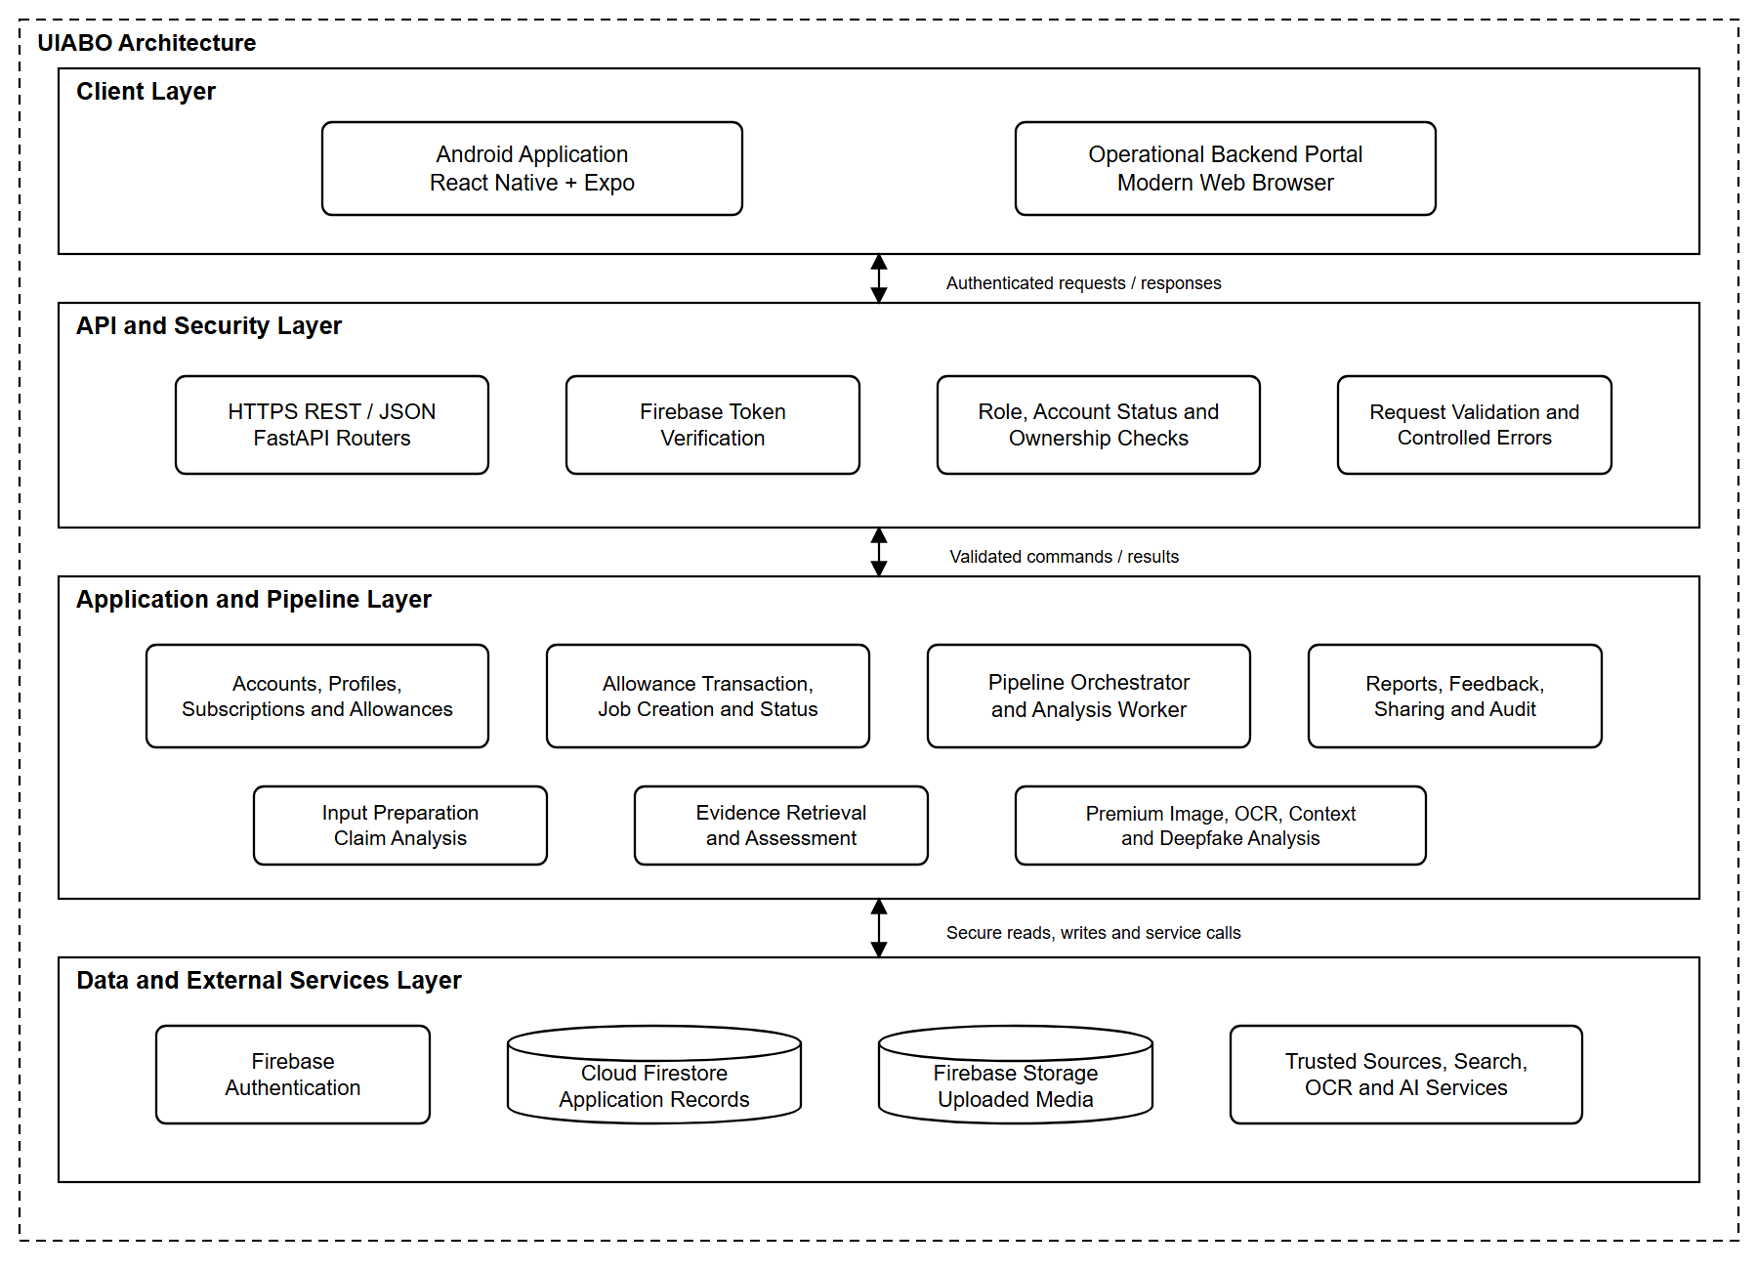

4. Activity Diagrams

4.1 System Administrator
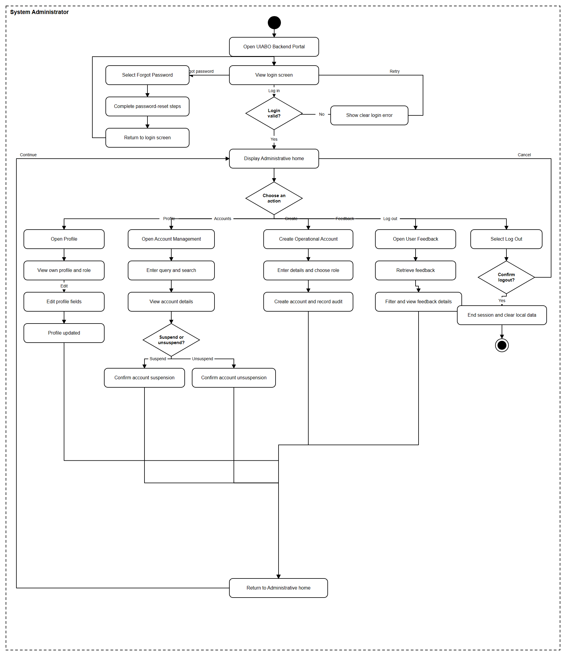

4.2 Free User
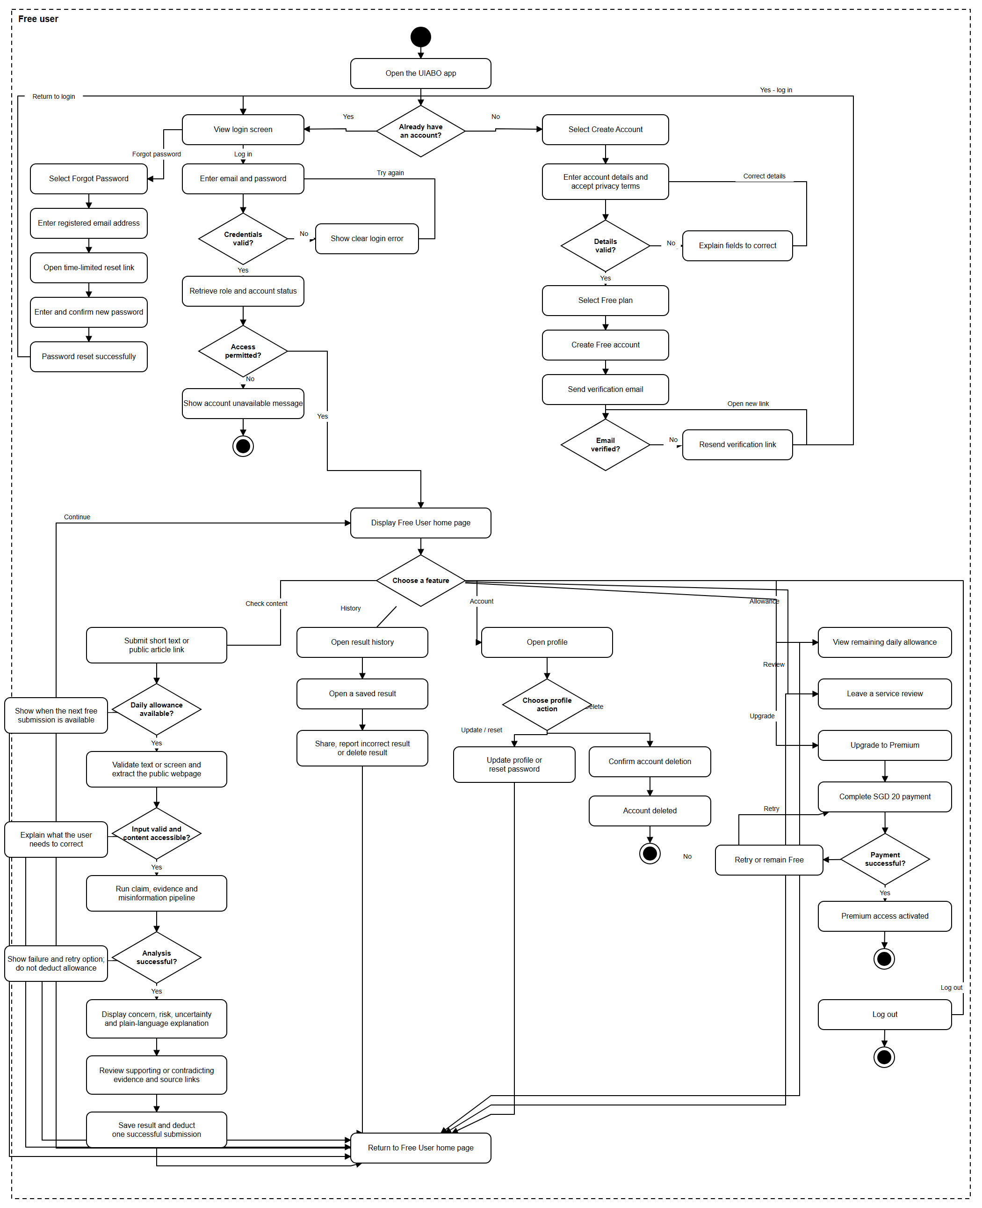

4.3 Premium User
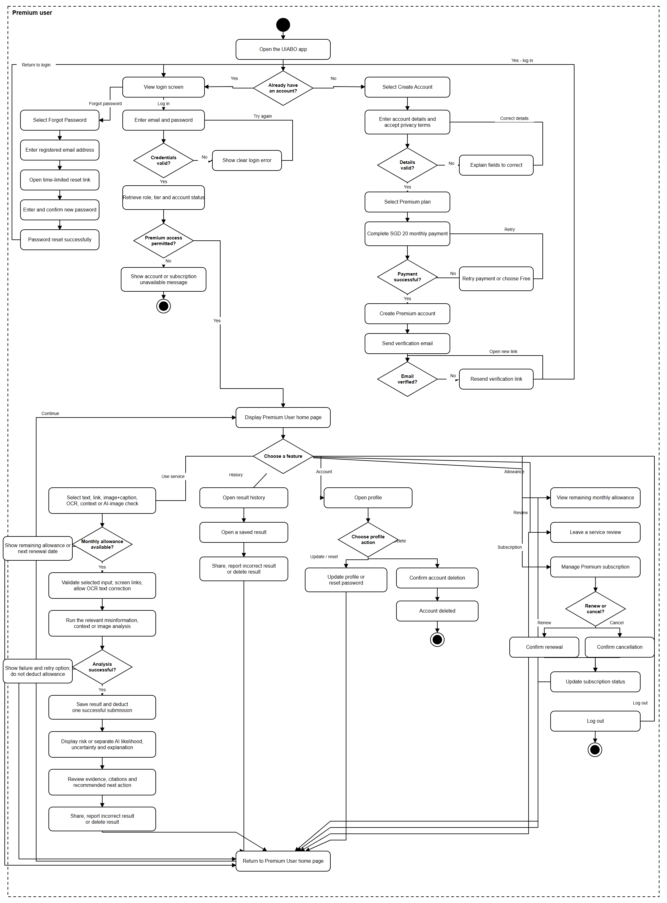

4.4 Data Engineer
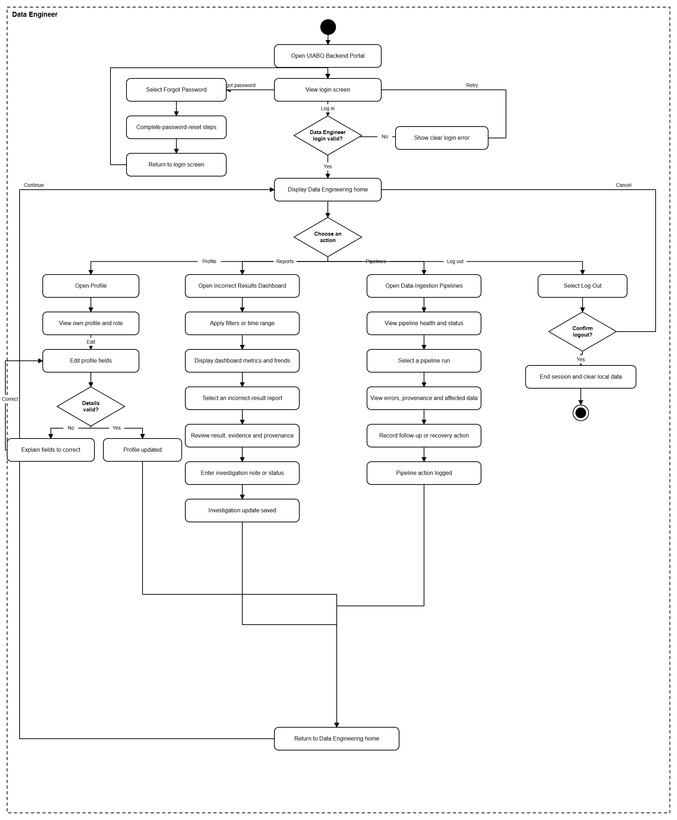

5. Sequence Diagrams

5.1 System Administrator

Login (System Administrator)
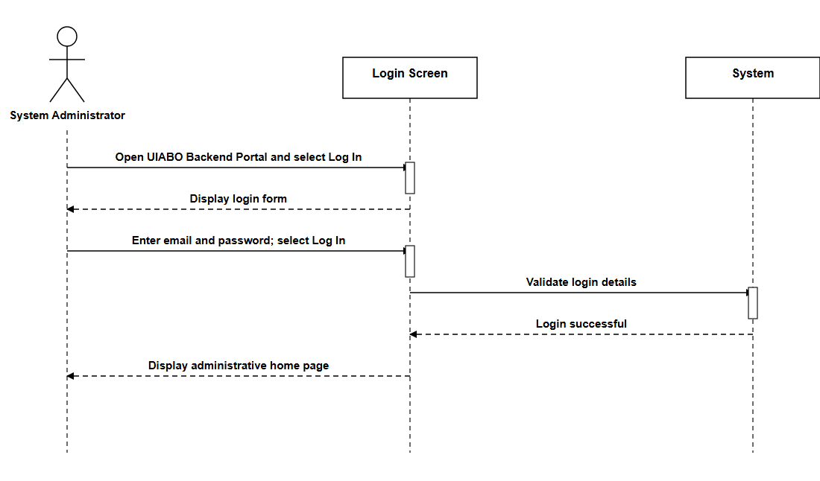

Logout (System Administrator)
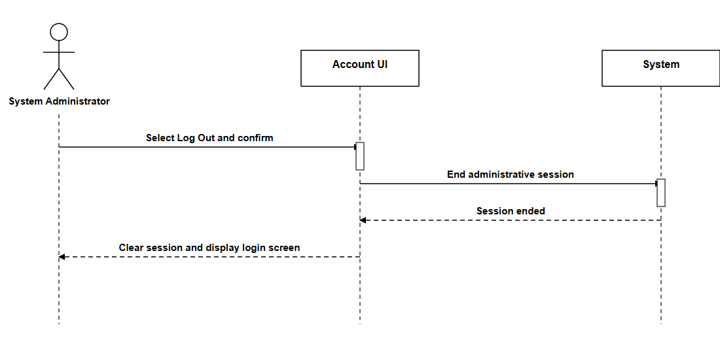

Reset Password (System Administrator)
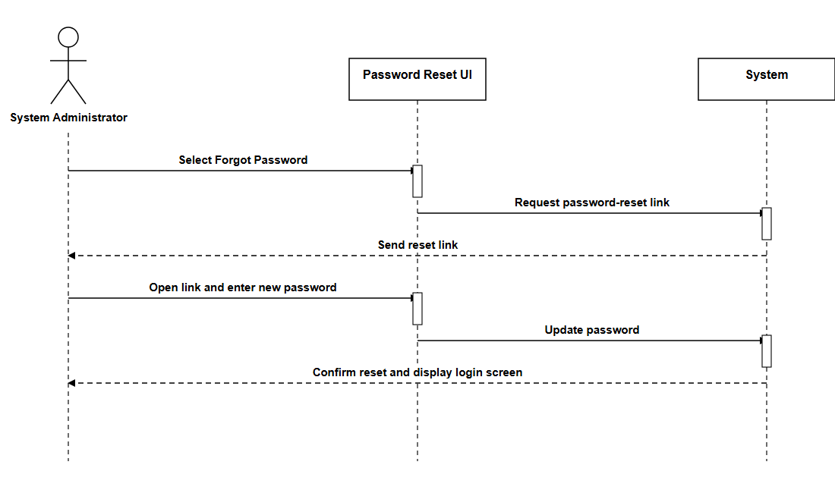

View Profile (System Administrator)
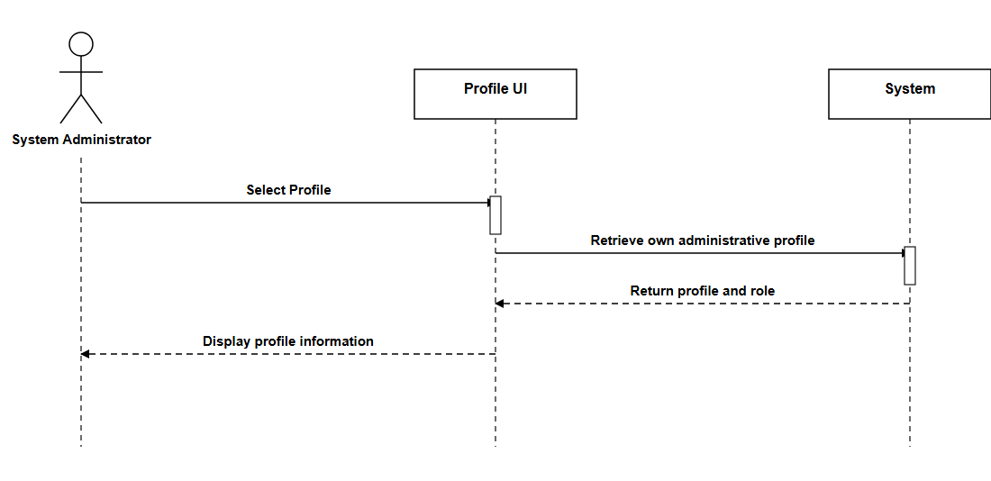

Update Profile (System Administrator)
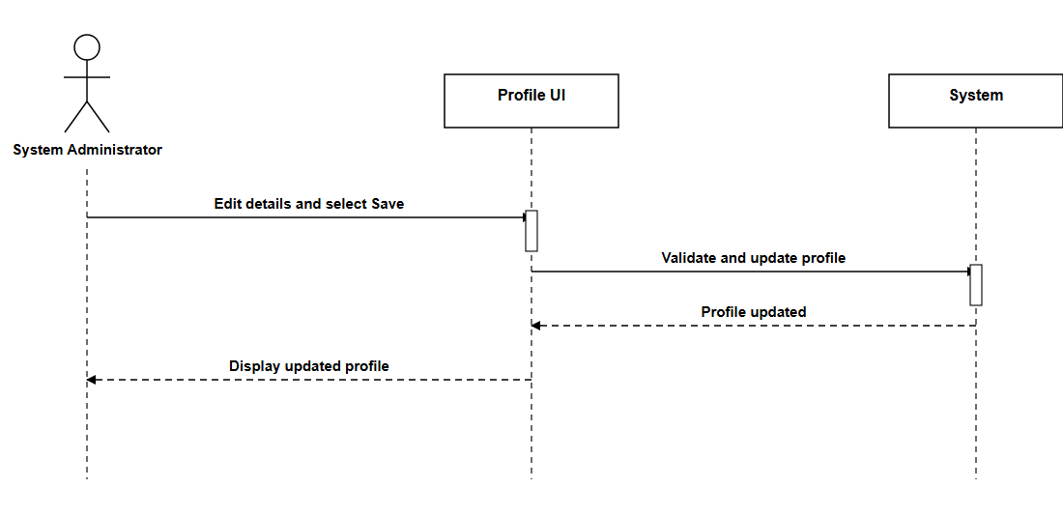

Query Account (System Administrator)
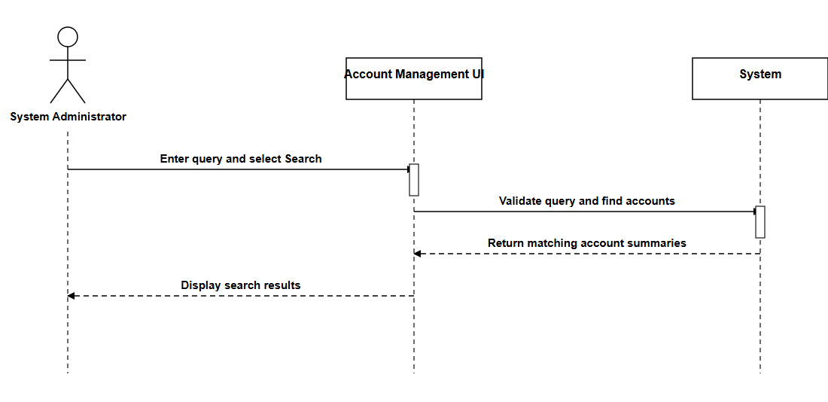

View Account Details (System Administrator)
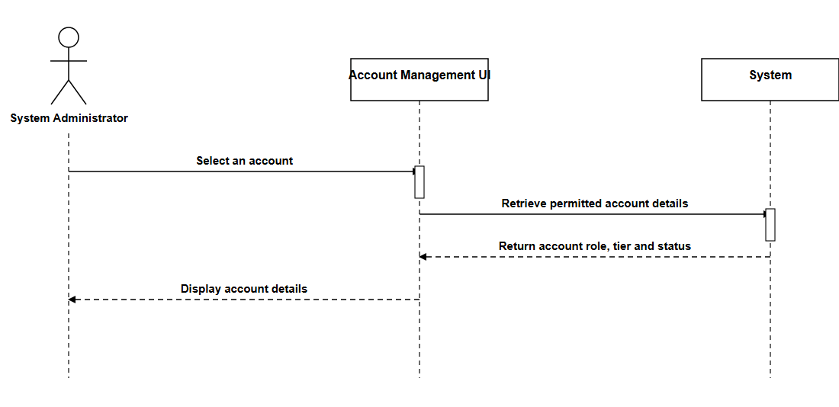

Create Operational Account (System Administrator)
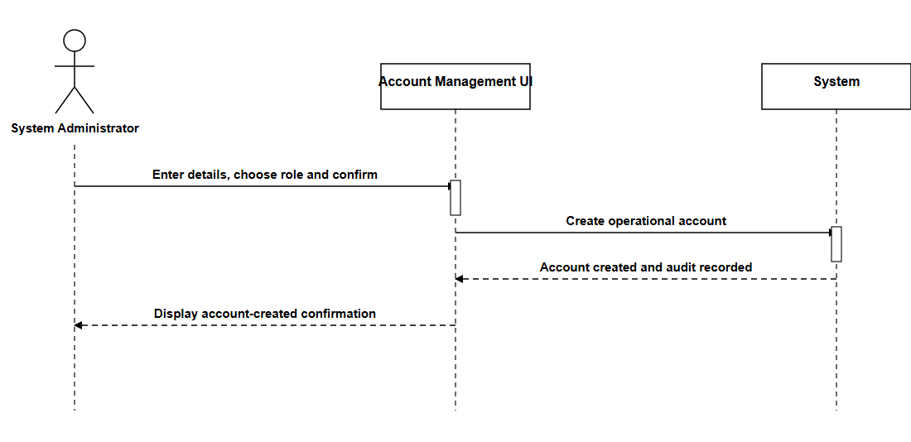

Suspend Account (System Administrator)
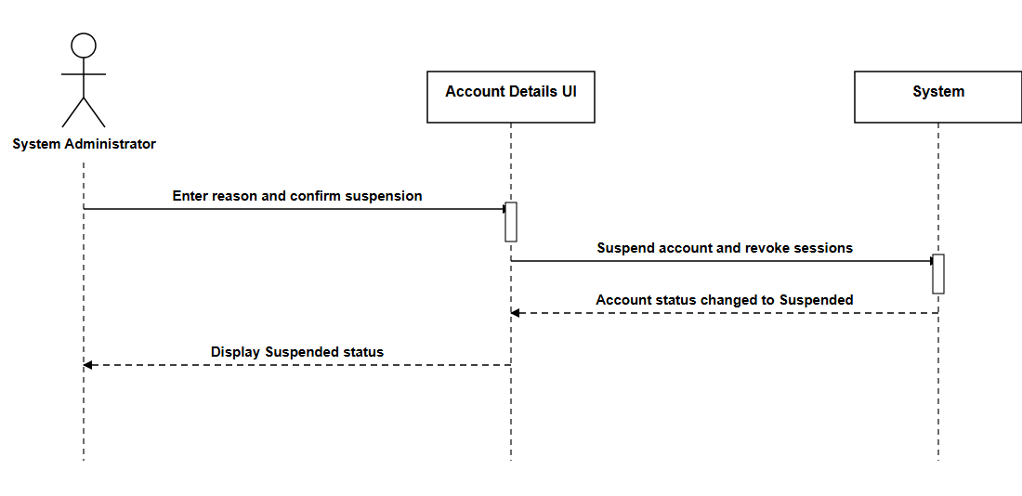

Unsuspend Account (System Administrator)
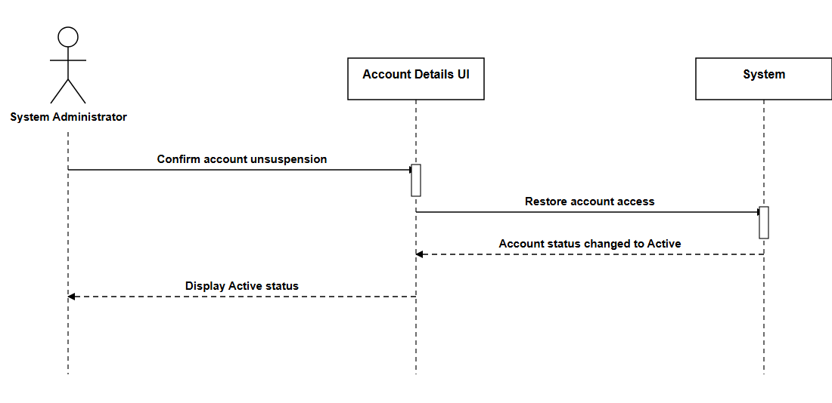

View User Feedback (System Administrator)
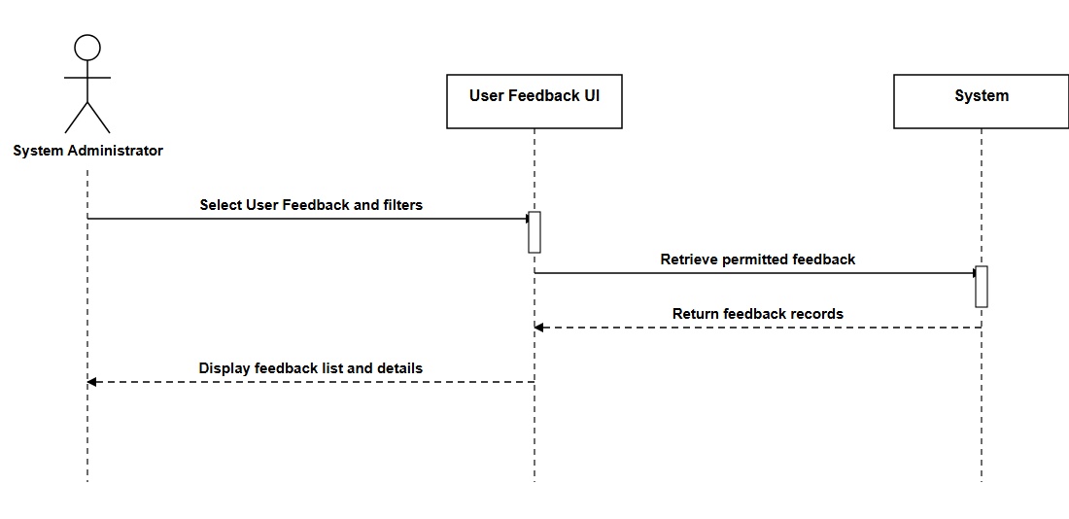

5.2 Free User

Login (Free User)
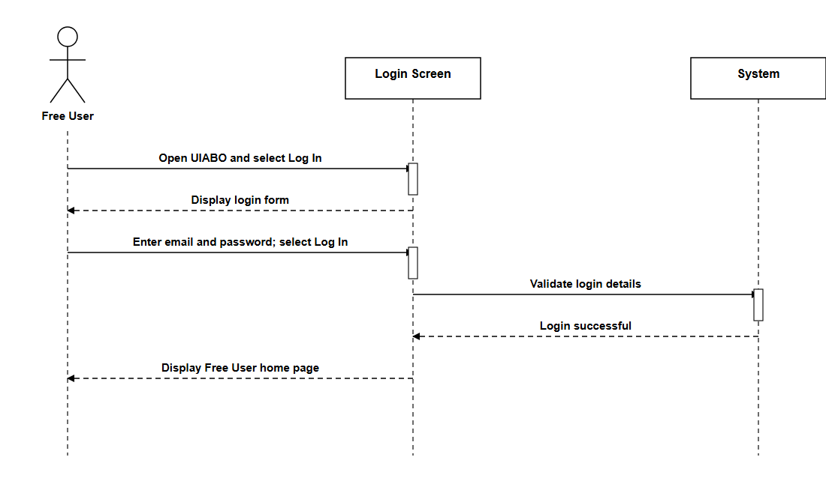

Logout (Free User)
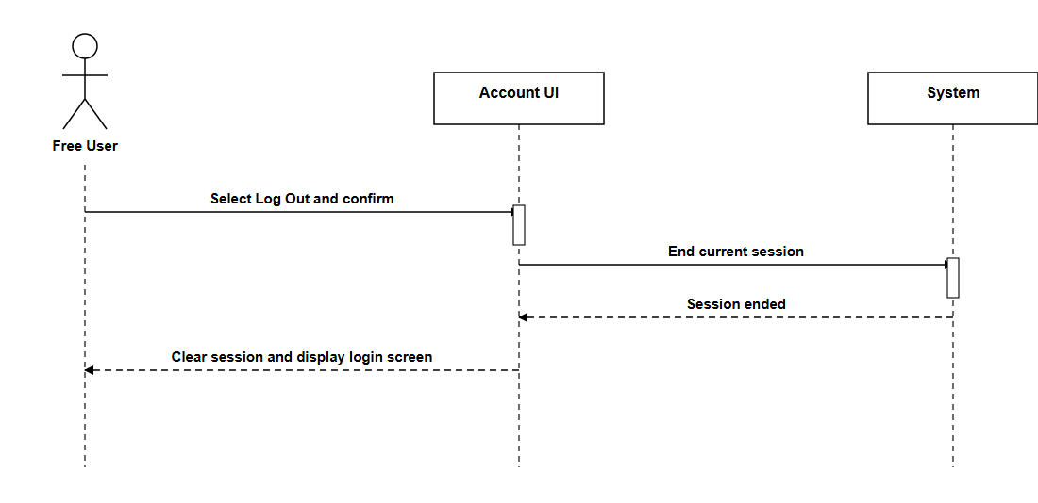

Delete Account (Free User)
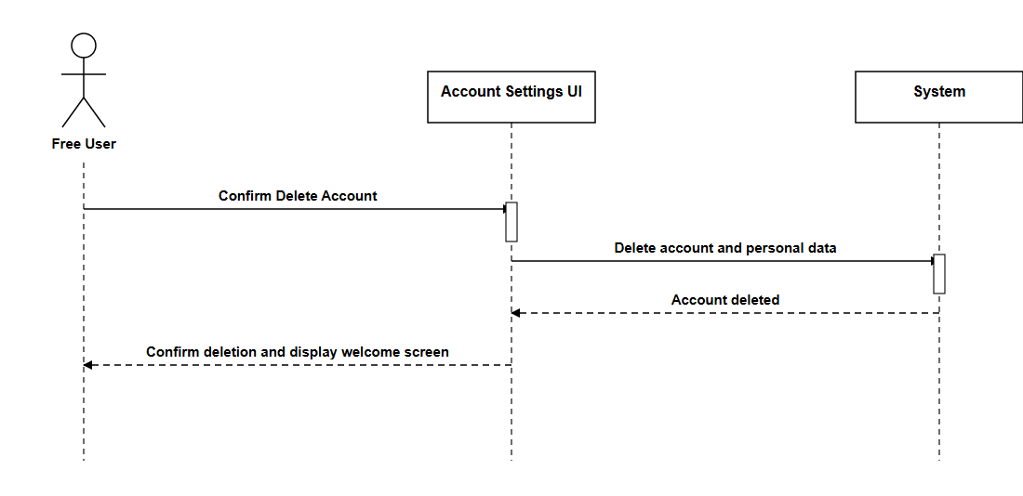

Reset Password (Free User)
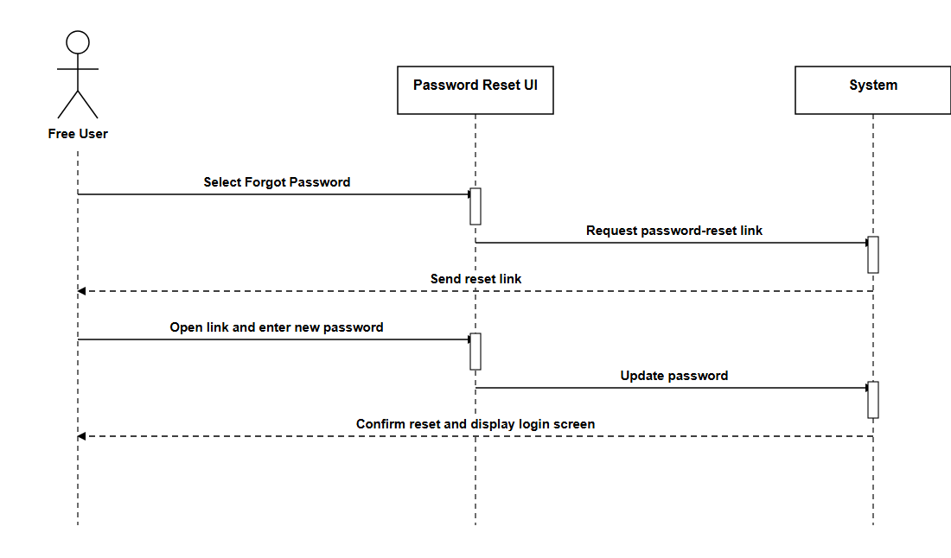

View Profile (Free User)
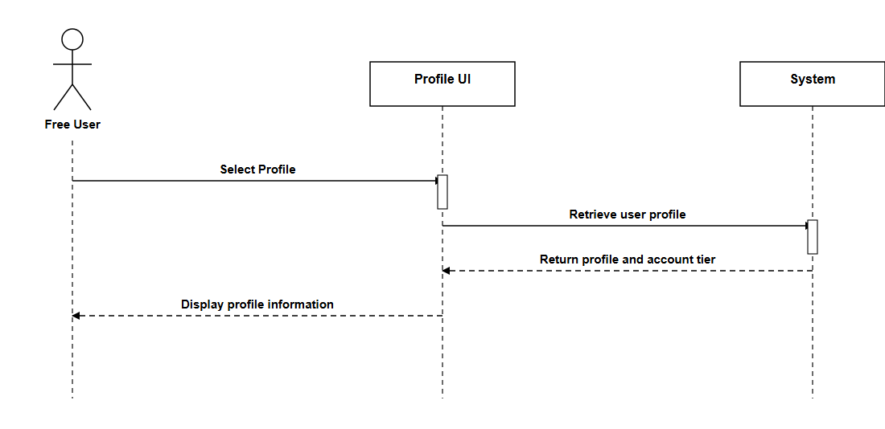

Update Profile (Free User)
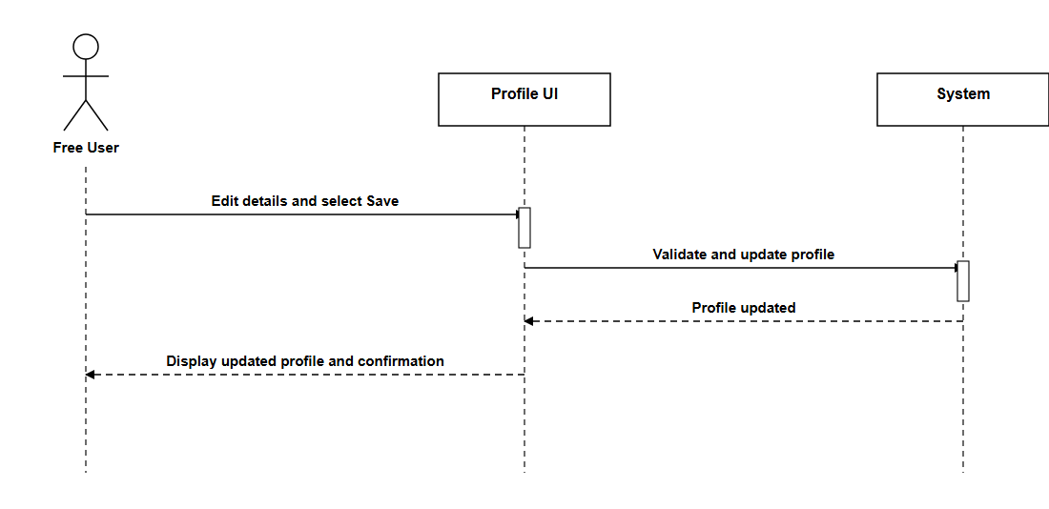

Analyse Short-form Text (Free User)
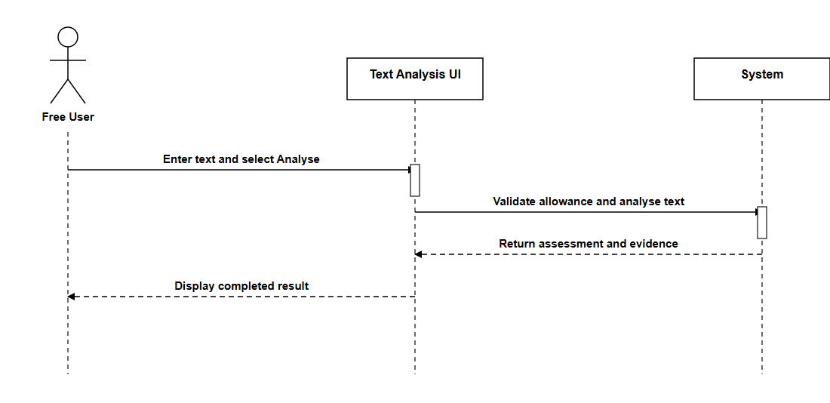

Analyse Public Webpage Link (Free User)
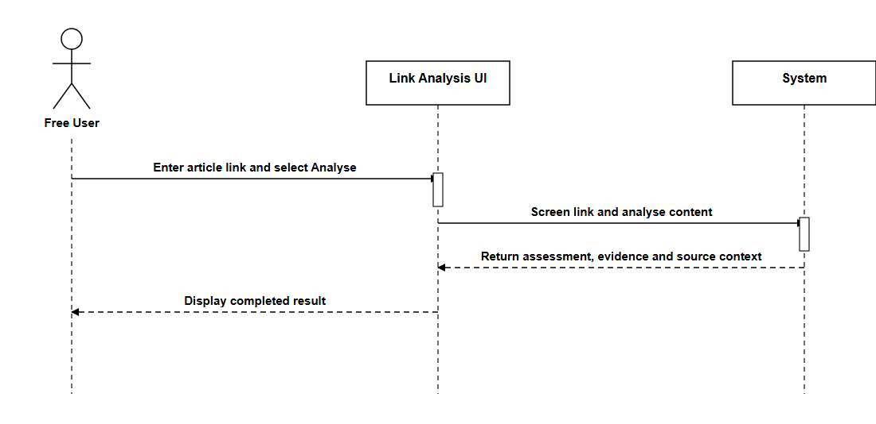

View Result History (Free User)
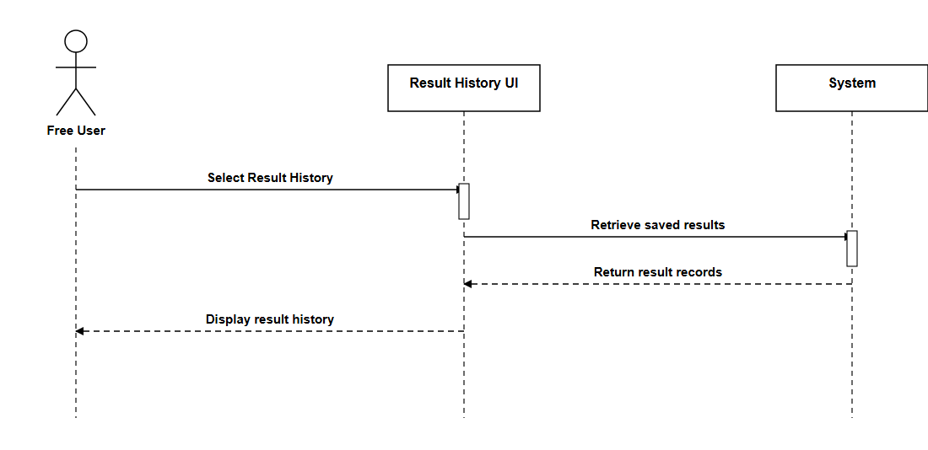

View Result Details (Free User)
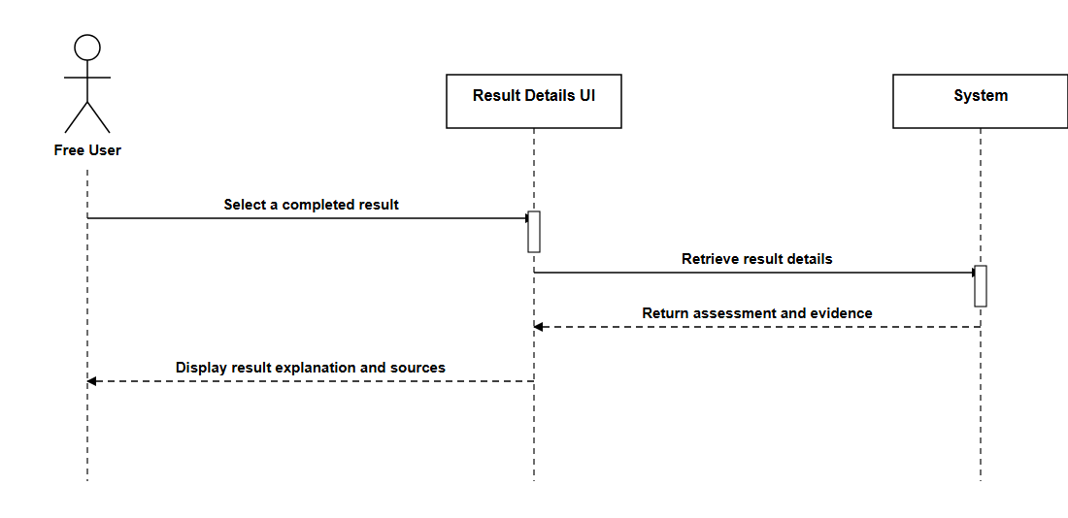

View Remaining Allowance (Free User)
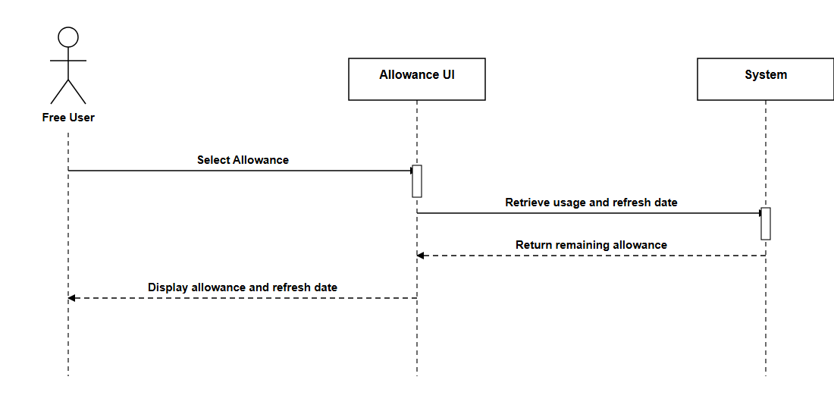

Delete Results (Free User)
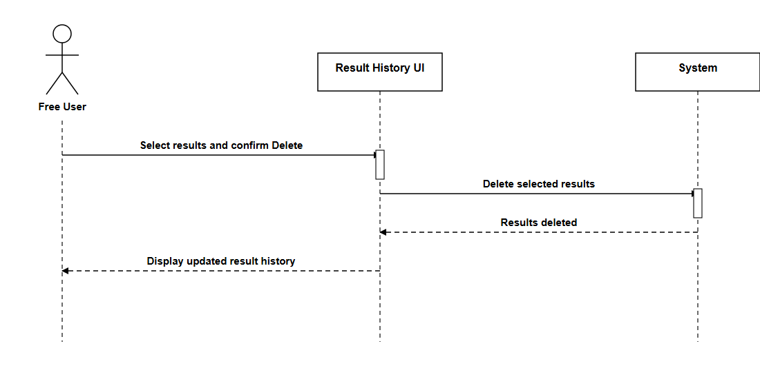

Report Incorrect Result (Free User)
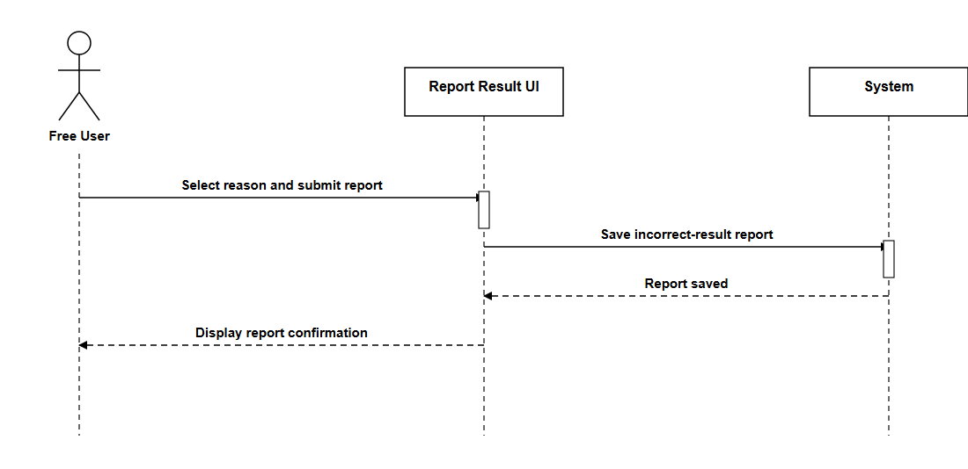

Leave a Review (Free User)
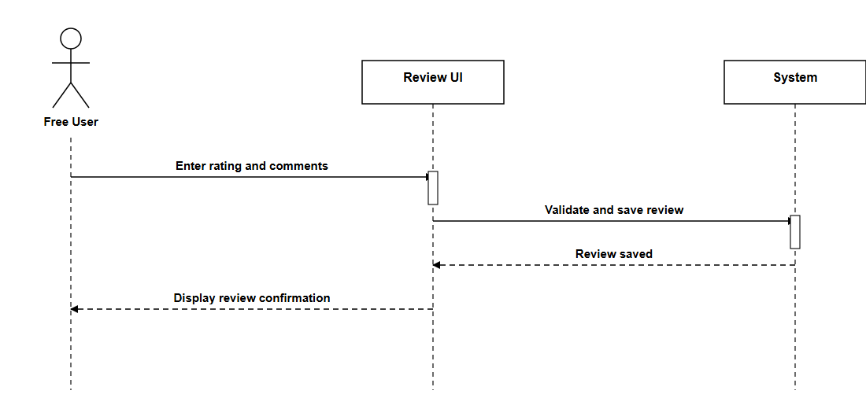

Share Result (Free User)
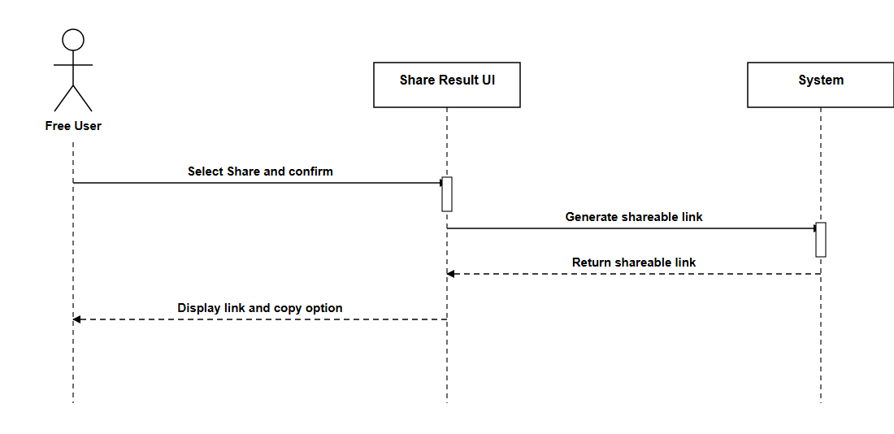

Create Account (Free User)
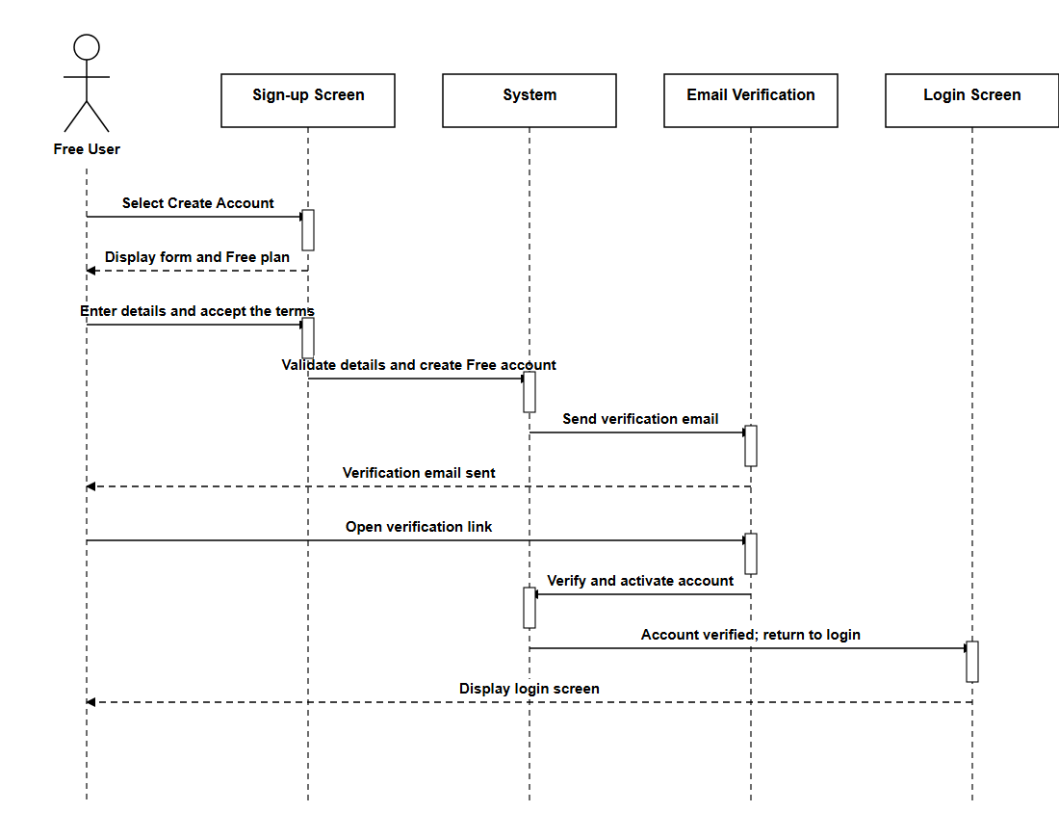

Upgrade to Premium (Free User)
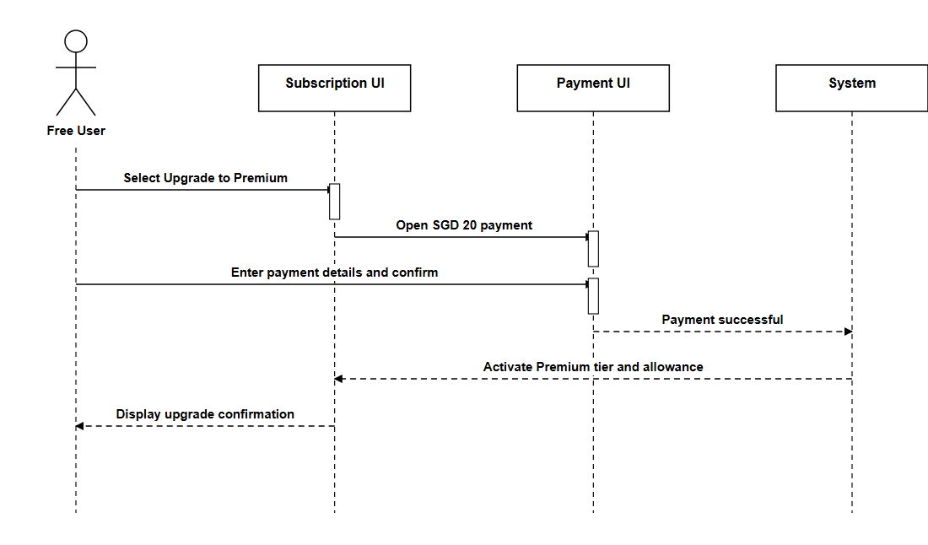

5.3 Premium User

Login (Premium User)
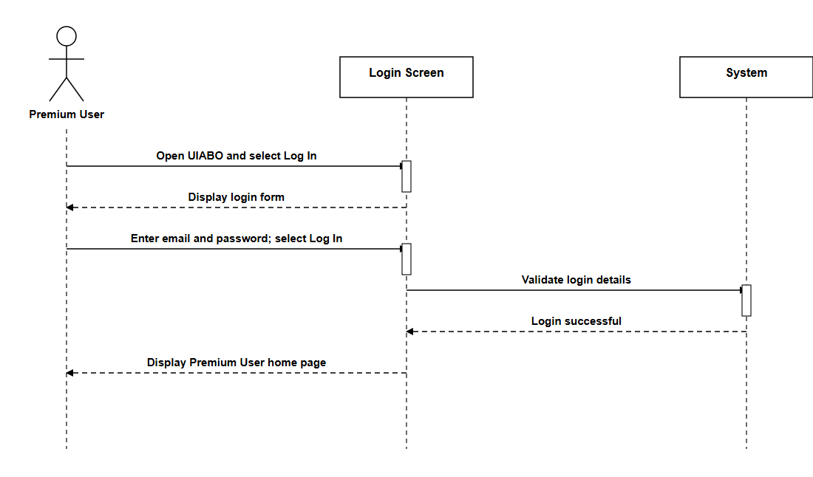

Create Account (Premium User)
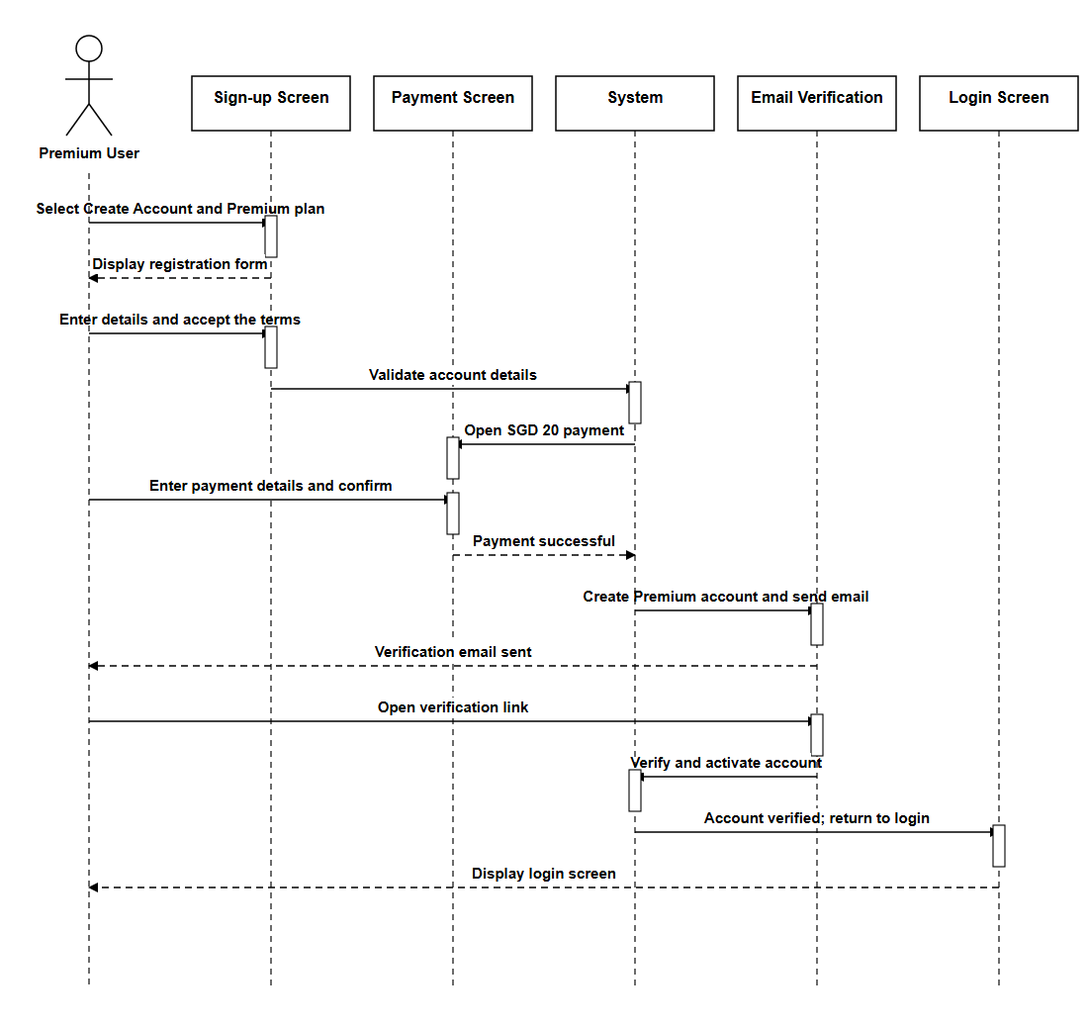

Renew Subscription (Premium User)
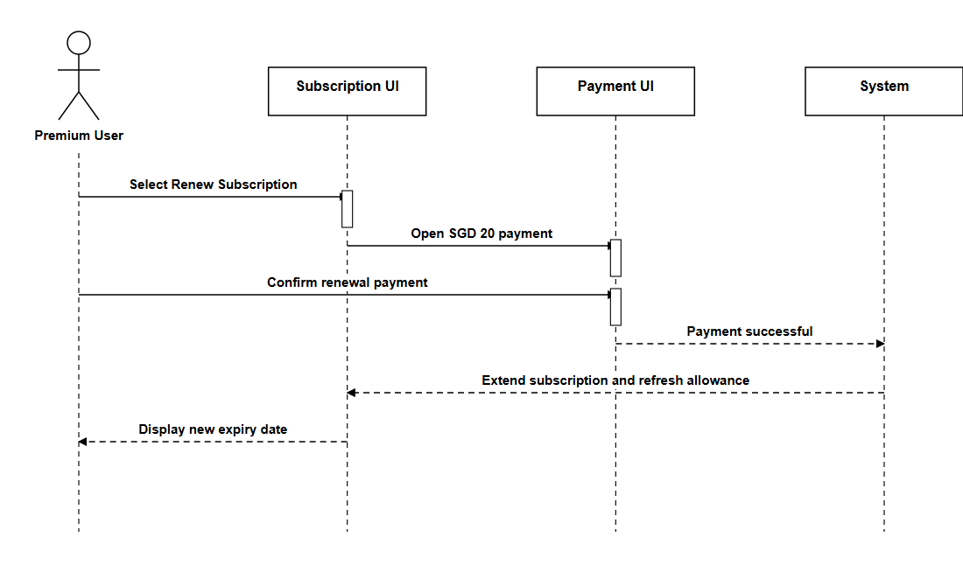

Cancel Subscription (Premium User)
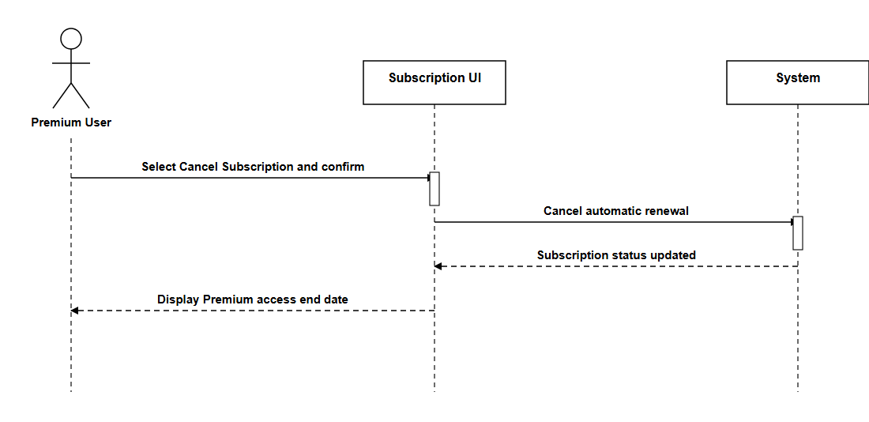

Image and Caption Analysis (Premium User)
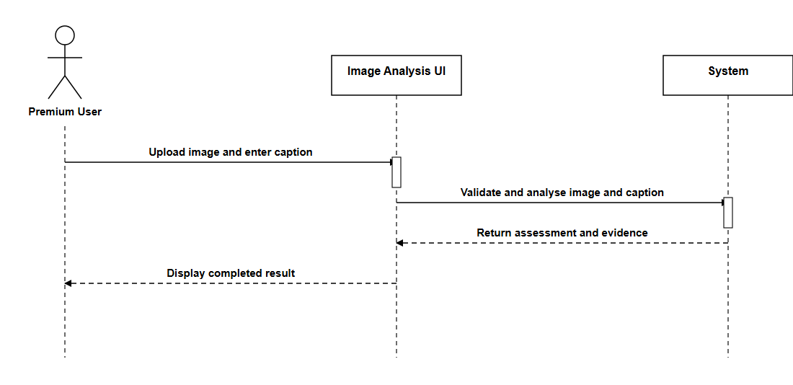

Caption-Image Context Analysis (Premium User)
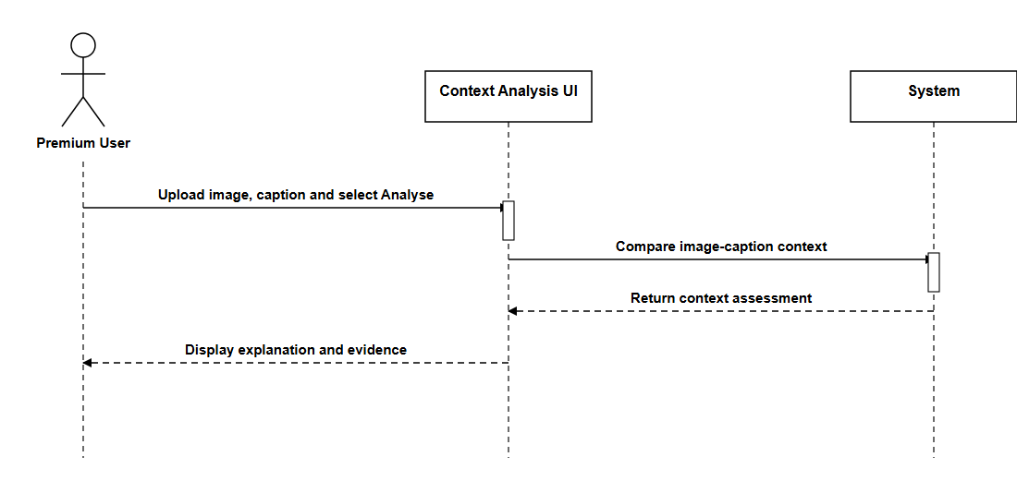

OCR Image Analysis (Premium User)
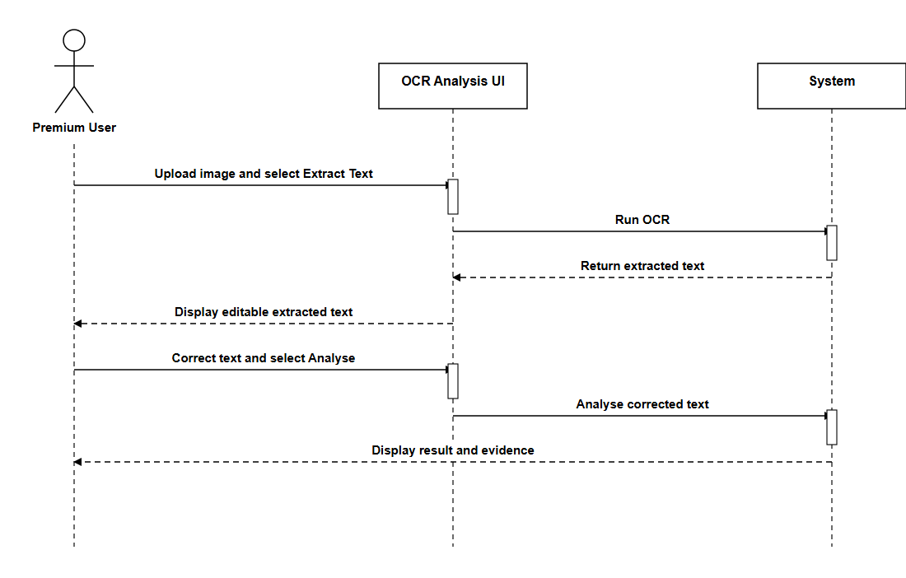

Deepfake/AI Image Analysis (Premium User)
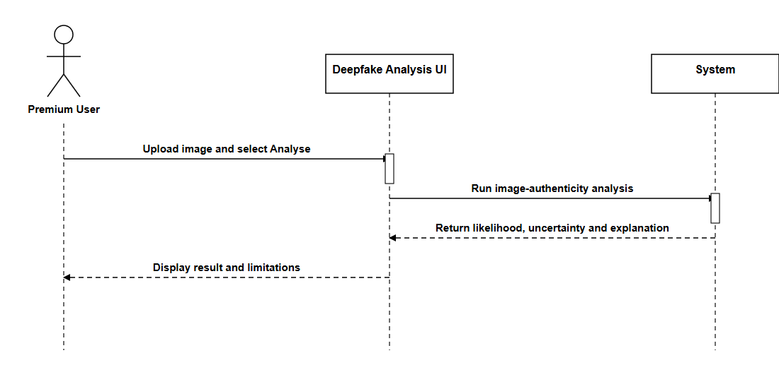

5.4 Data Engineer

Login (Data Engineer)
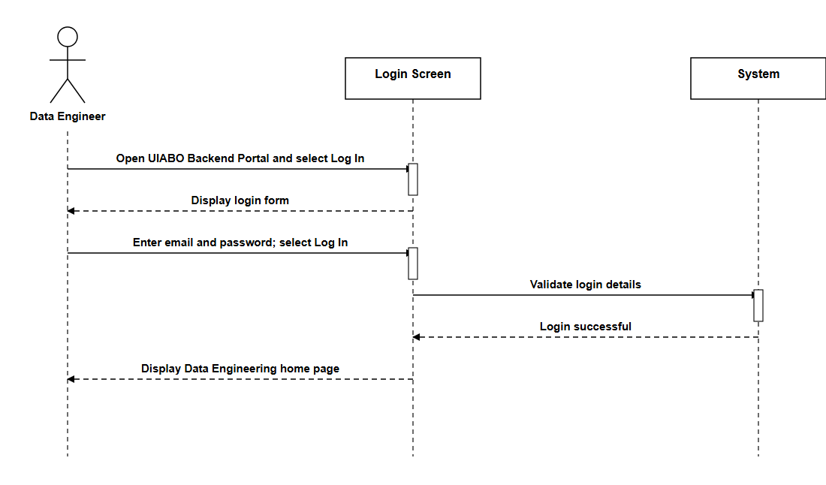

Logout (Data Engineer)
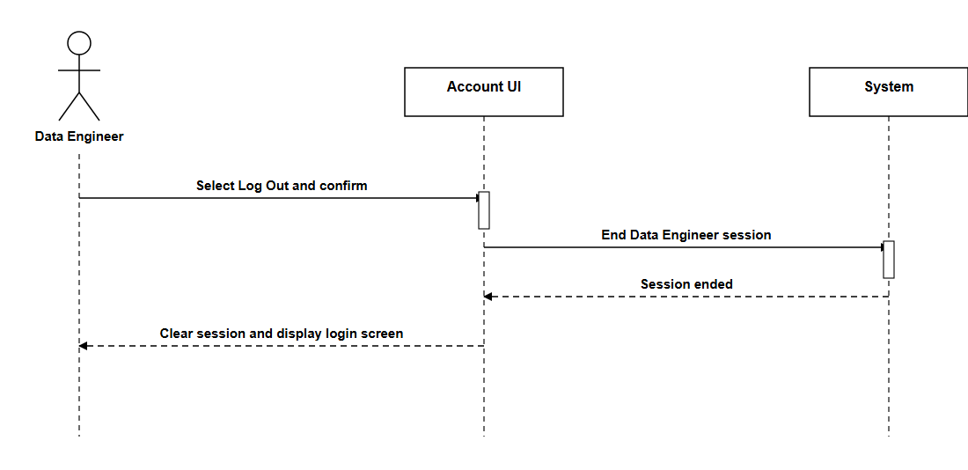

Reset Password (Data Engineer)
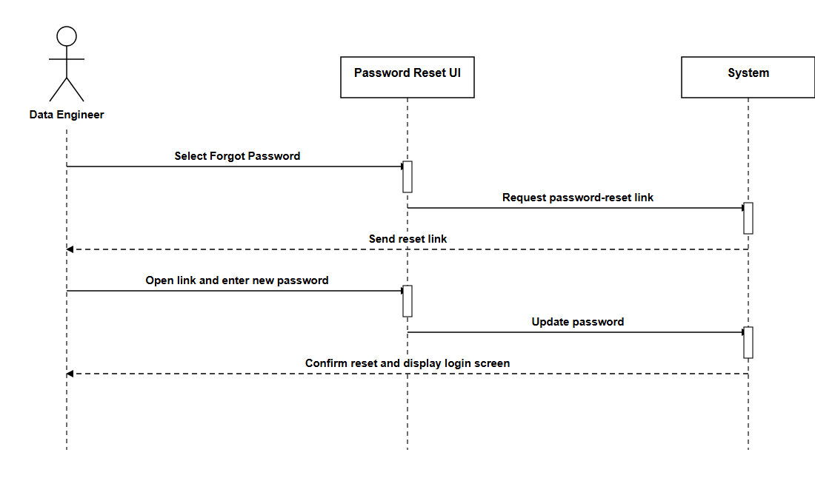

View Profile (Data Engineer)
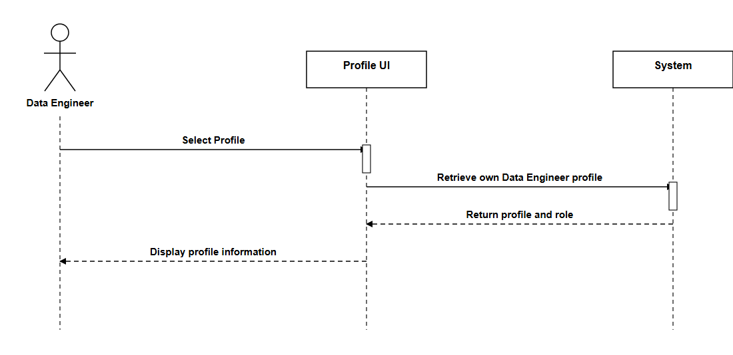

Update Profile (Data Engineer)
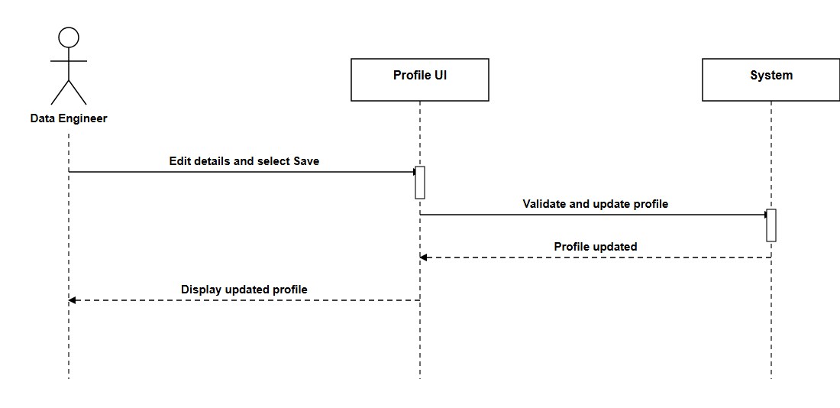

View Incorrect Results Dashboard (Data Engineer)
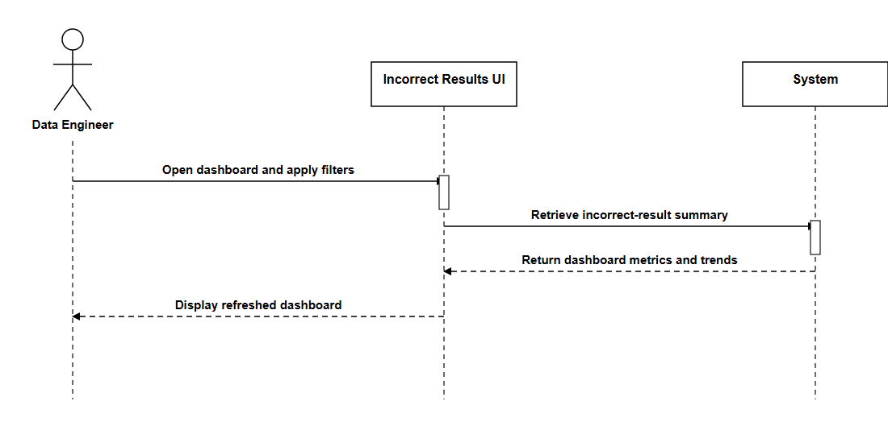

View Incorrect Result Report (Data Engineer)
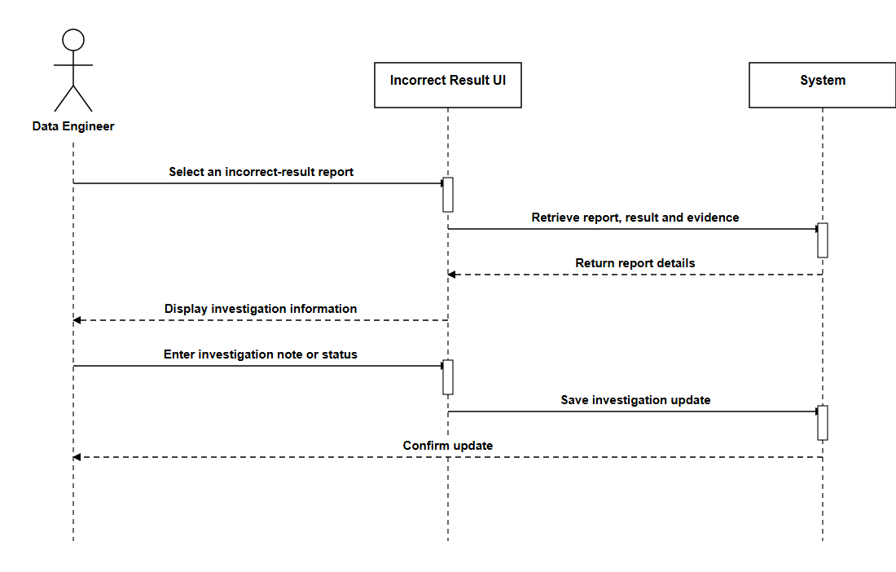

Monitor Data-Ingestion Pipelines (Data Engineer)
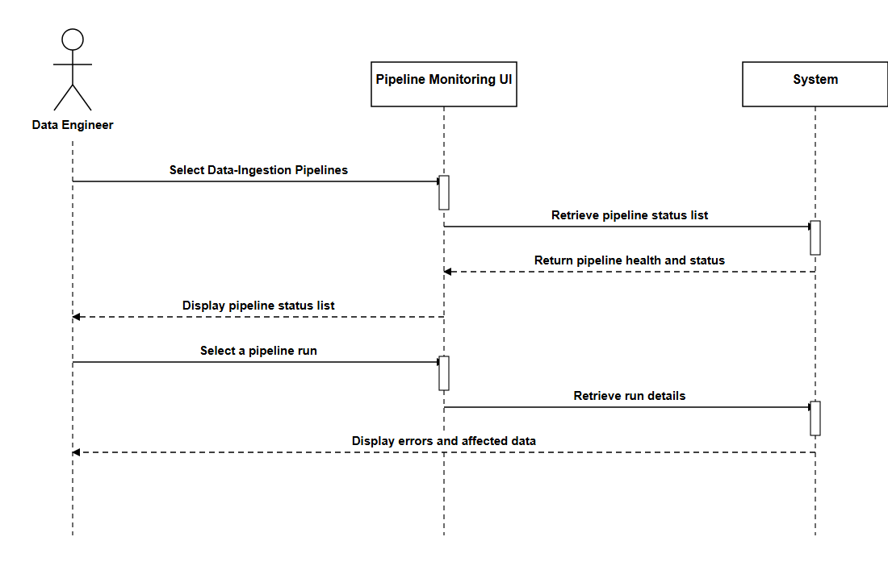

6. User Interface

6.1 Login and Account Creation
Login Page | Sign Up Page
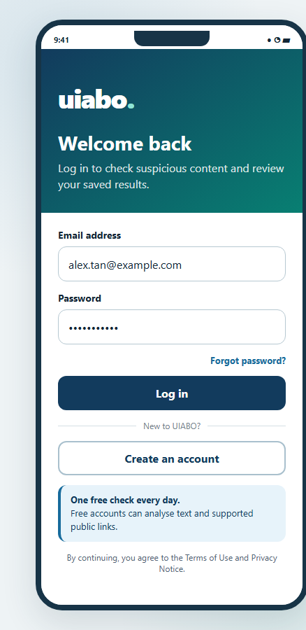 | 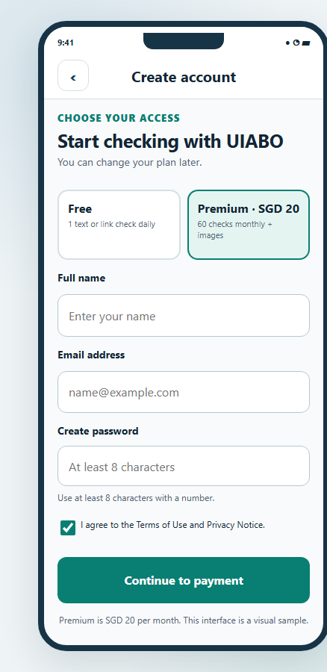

6.2 Free User
Home Page  (Premium features locked) | Text Analysis | Link Analysis
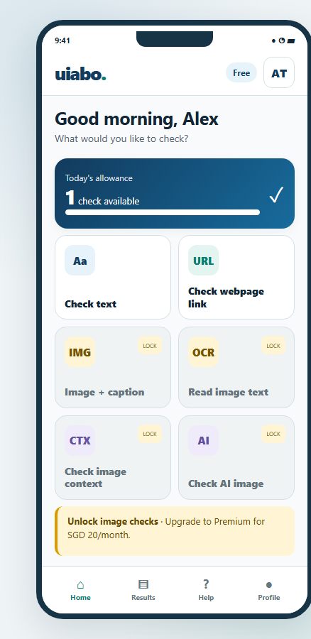 | 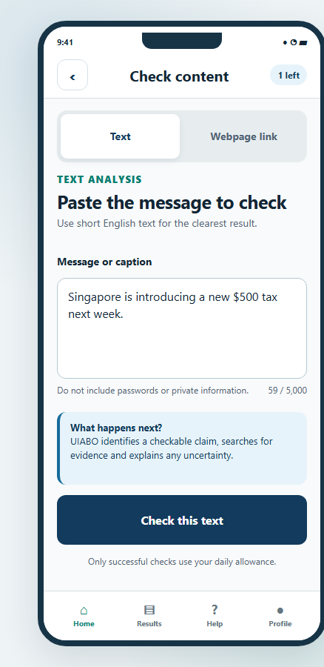 | 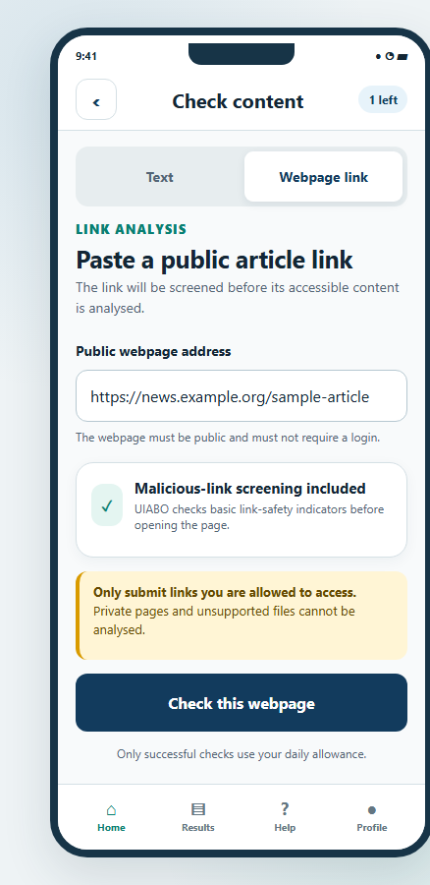

Result Page | Result History | Upgrade to Premium
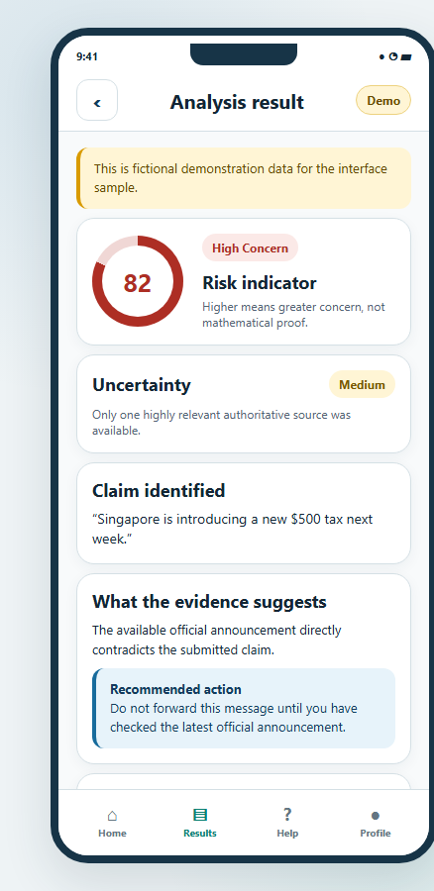 | 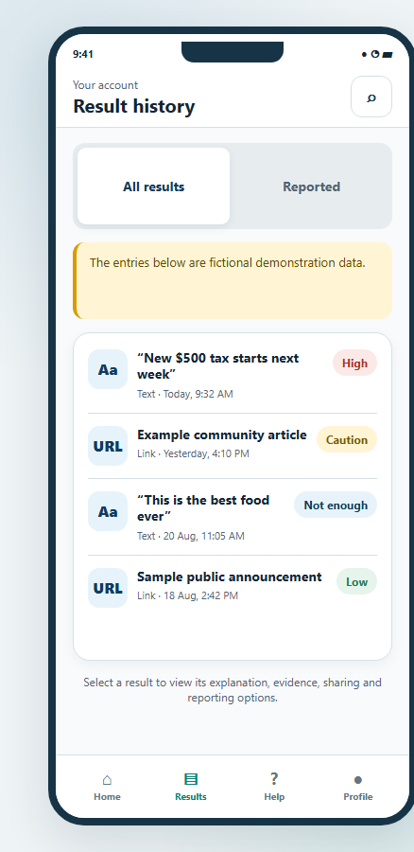 | 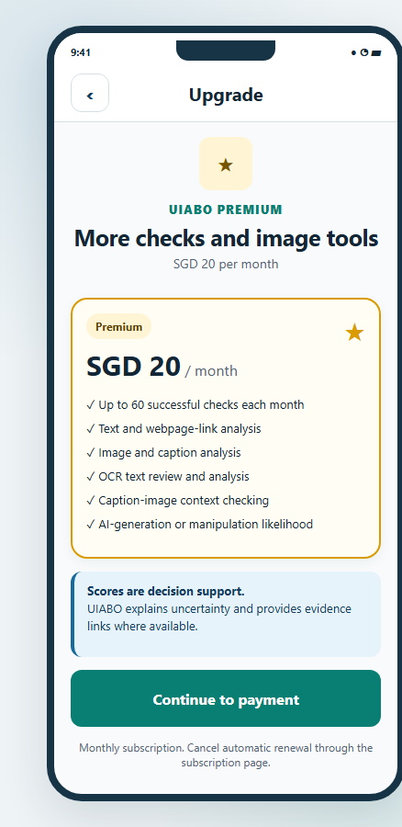

6.3 Premium User
Home Page | Image Caption Analysis | Context Analysis
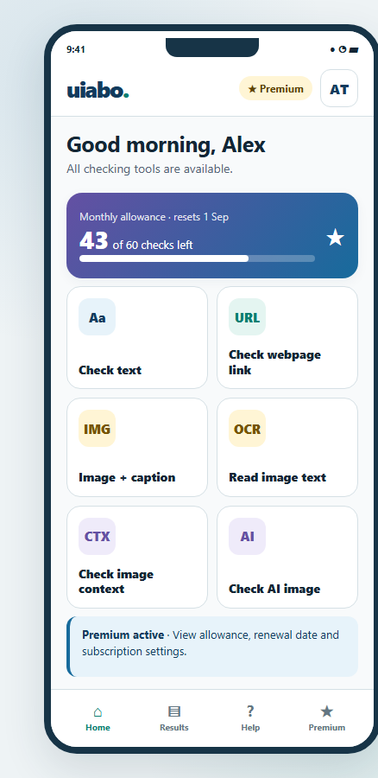 | 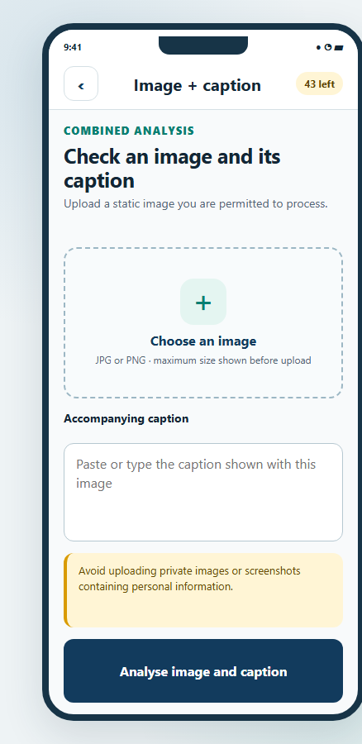 | 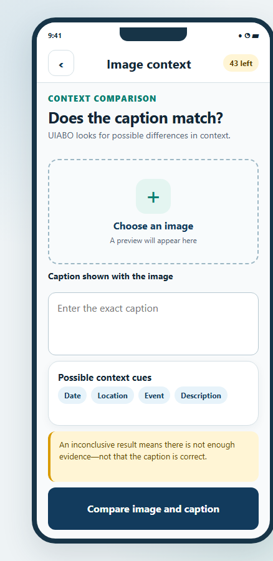

OCR Analysis | Deepfake Analysis | Subscription
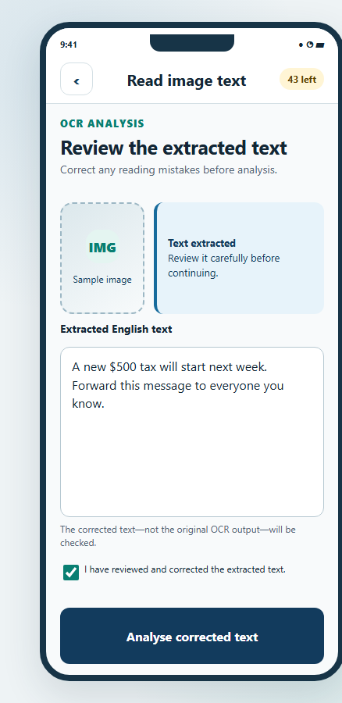 | 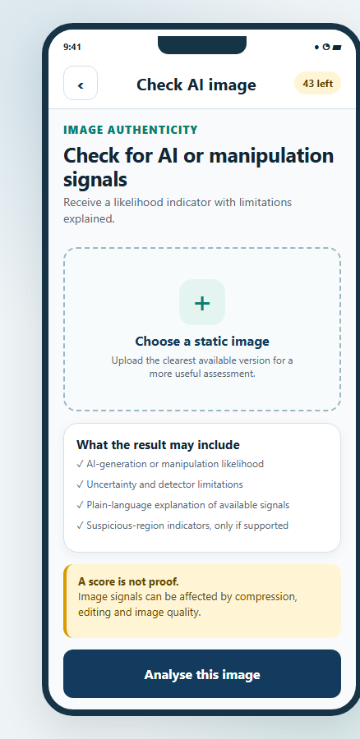 | 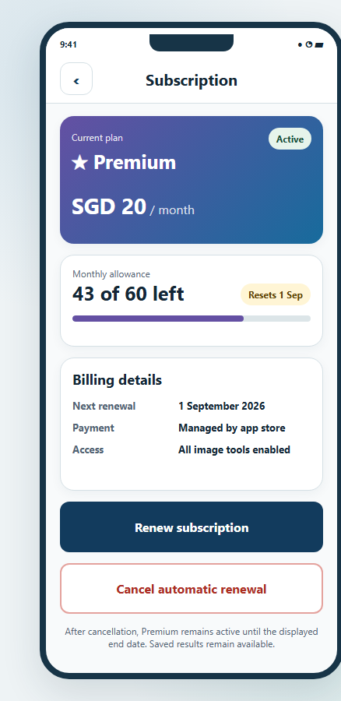

6.4 System Administrator
System Administrator Dashboard
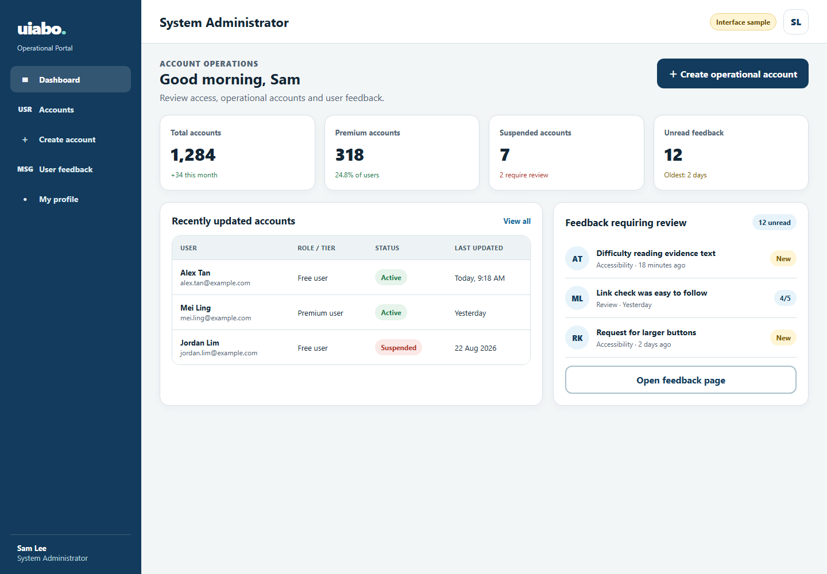
Account Management
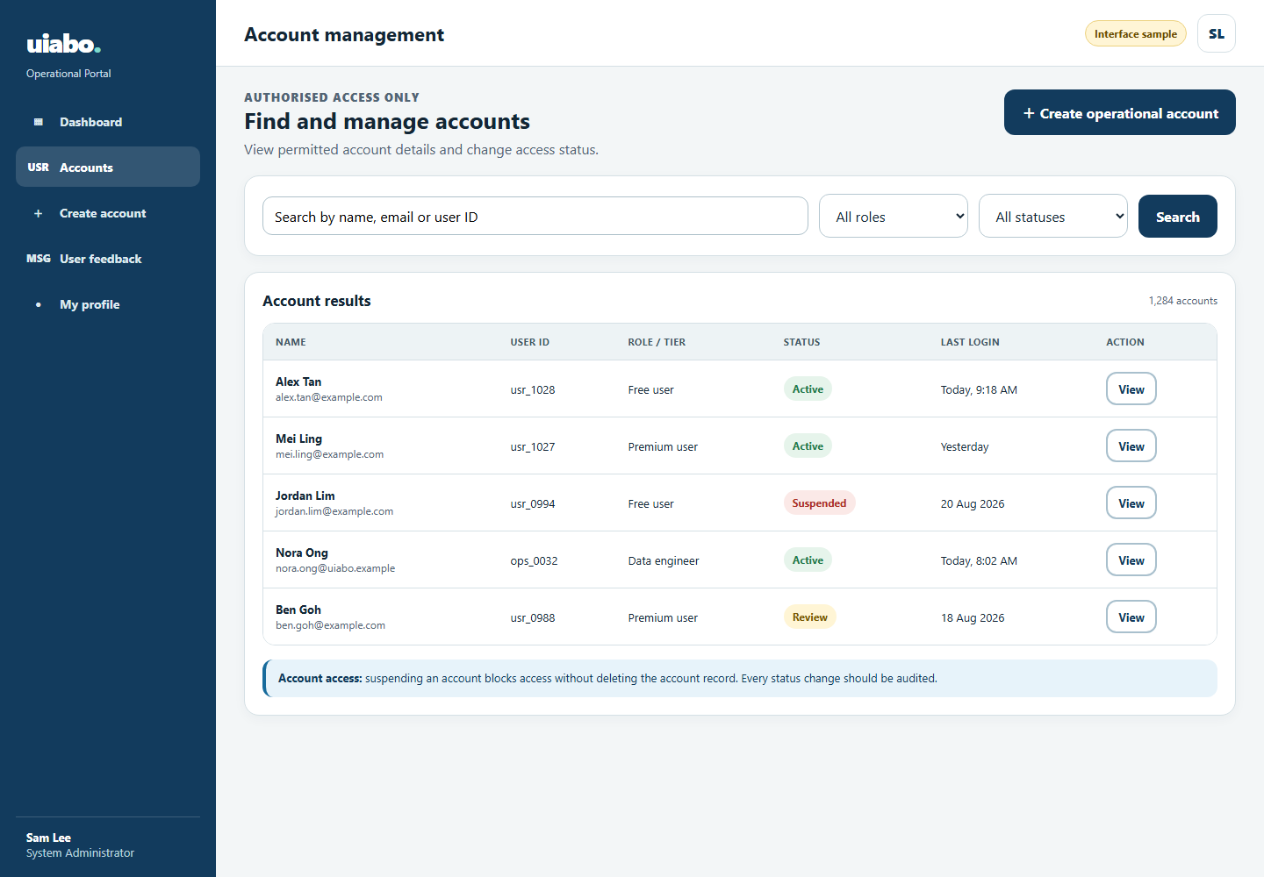

Create Operational Account
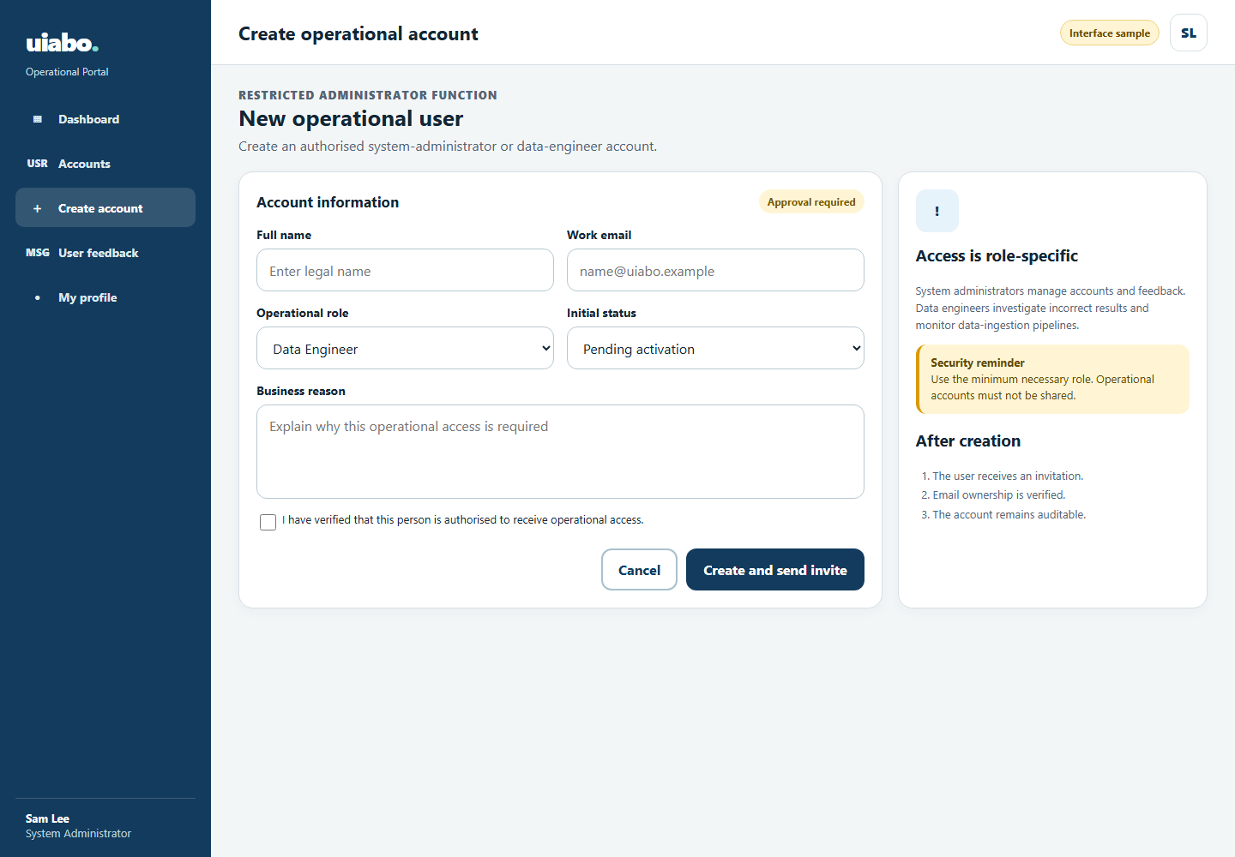
User Feedback
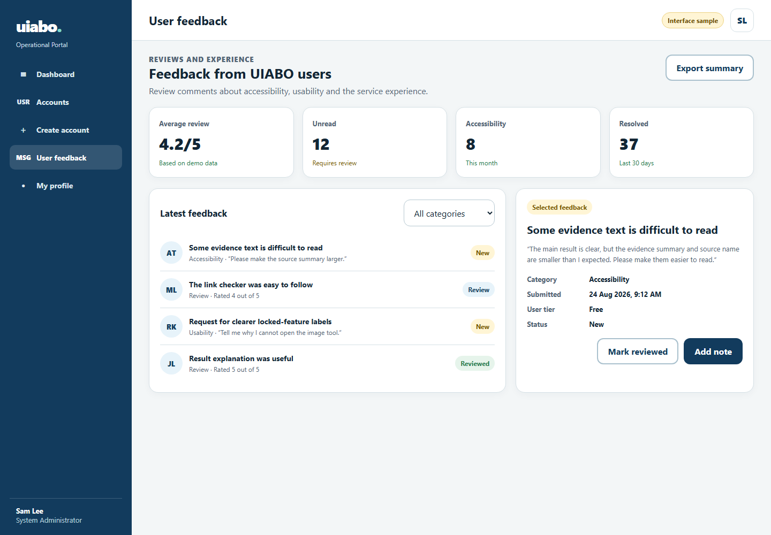

6.5 Data Engineer
Data Engineer Dashboard
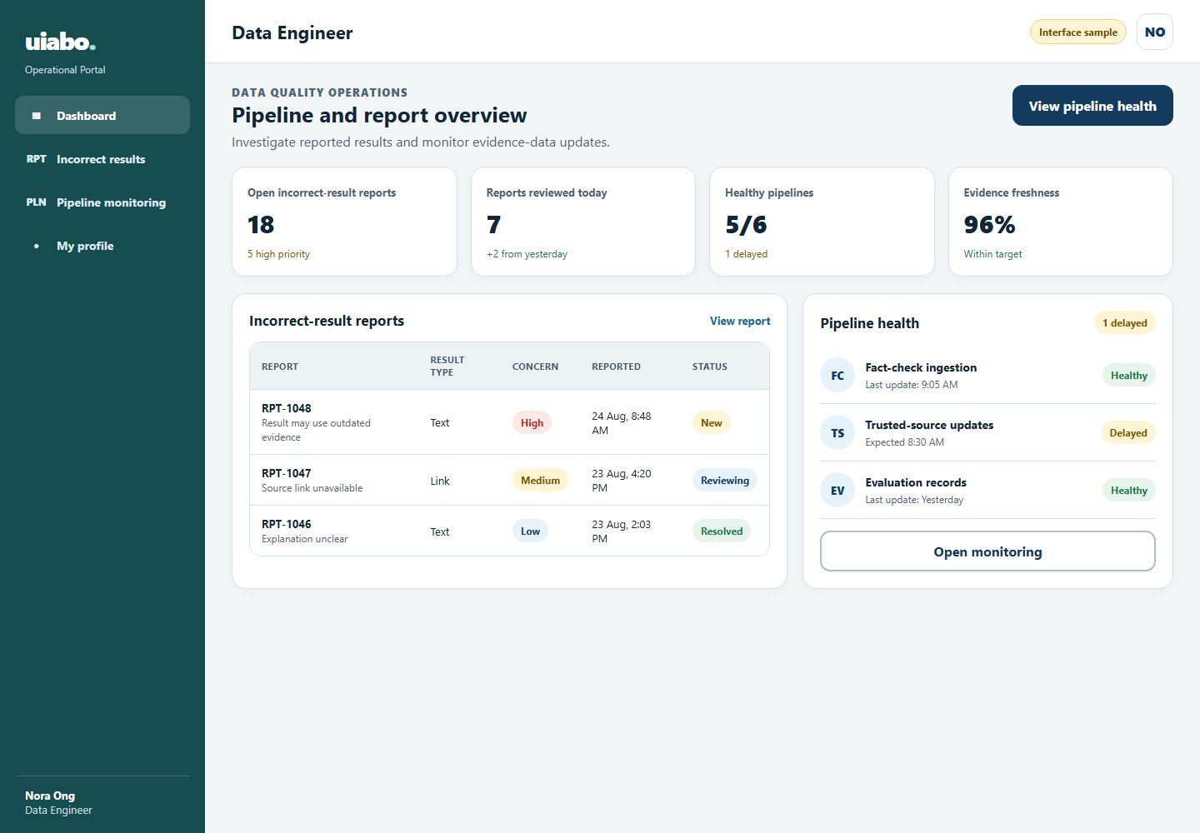
Incorrect Result Report
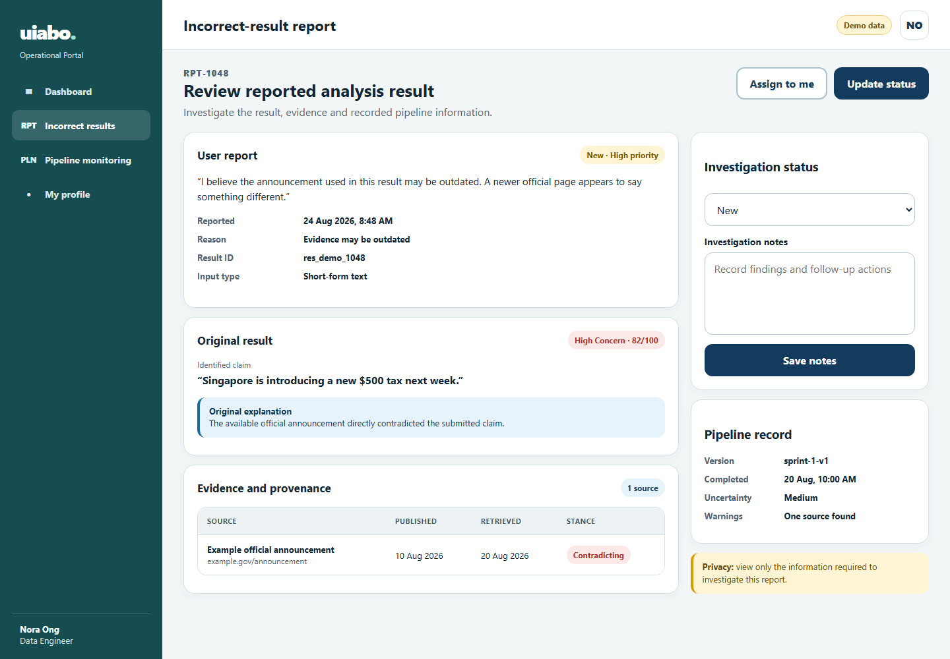

Pipeline Monitoring
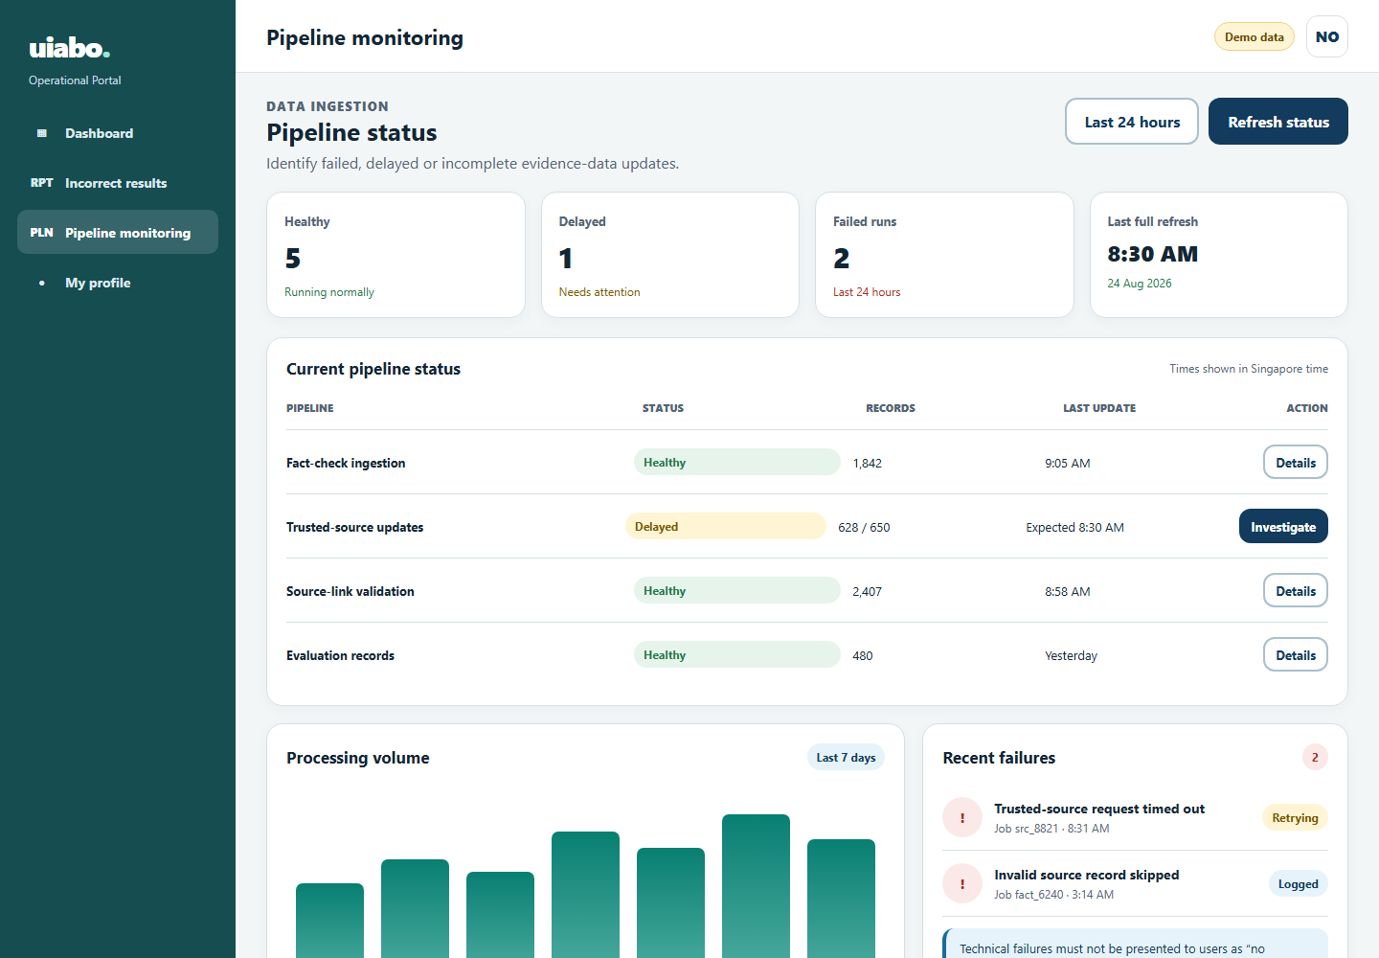

7. Database Design

Mermaid Diagram
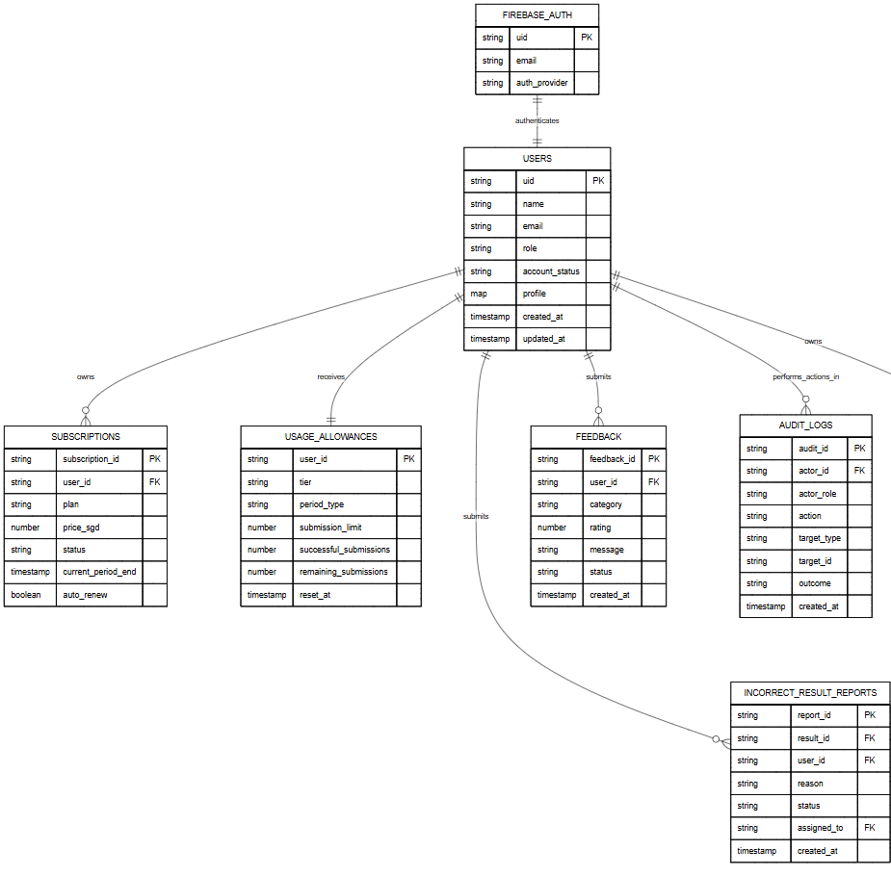

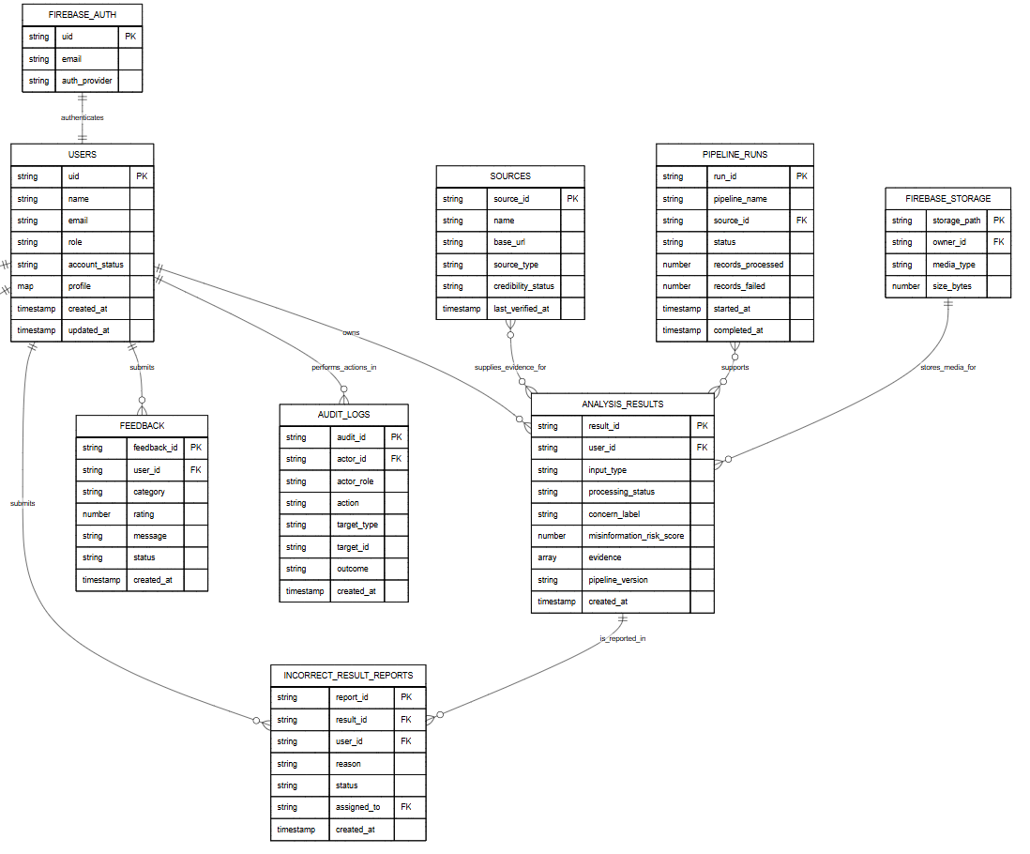
Cloud Firestore is a NoSQL document database. The lines in the diagram show document-ID references rather than SQL joins. Evidence snapshots are embedded inside analysis_results to match the current pipeline implementation and preserve the evidence used for each result.

7.1. Users Collection
Document path: users/{uid}
Stores the Firestore profile for every Free User, Premium User, System Administrator and Data Engineer. The document ID is the Firebase Authentication UID. Passwords are not stored here.
Field | Type | Required | Purpose
uid | String | Yes | Firebase Authentication UID and Firestore document ID.
name | String | Yes | User's display name.
email | String | Yes | Email copied from Firebase Authentication for profile display and authorised account queries.
role | String | Yes | Access role: free, premium, system_admin or data_engineer.
account_status | String | Yes | Account state: active, suspended or deactivated.
profile | Map | Yes | Editable profile information. Only data needed by the application should be stored.
storage_used_bytes | Number | Yes | Current personal storage usage used for the 80% warning.
storage_quota_bytes | Number | Yes | Maximum personal storage allocation.
last_login_at | Timestamp | No | Most recent successful login time.
created_at | Timestamp | Yes | When the profile record was created.
updated_at | Timestamp | Yes | When the profile record was last changed.

7.2. Subscriptions Collection
Document path: subscriptions/{subscription_id}
Stores premium subscription periods and renewal state. Payment-card details must remain with the payment provider and must not be stored in Firestore.
Field | Type | Required | Purpose
subscription_id | String | Yes | Unique subscription document ID.
user_id | String | Yes | UID of the user who owns the subscription.
plan | String | Yes | Plan identifier, such as premium_monthly.
price_sgd | Number | Yes | Recorded monthly price; SGD 20 for the prototype.
status | String | Yes | pending, active, cancelled, expired or payment_failed.
current_period_start | Timestamp | Yes | Start of the current paid period.
current_period_end | Timestamp | Yes | End of the current paid period.
auto_renew | Boolean | Yes | Whether automatic renewal remains enabled.
payment_provider | String | Yes | Provider or app-store mechanism used for payment.
provider_reference | String | No | Non-sensitive provider transaction or subscription reference.
created_at | Timestamp | Yes | When the subscription record was created.
updated_at | Timestamp | Yes | When the subscription record was last updated.

7.3. Usage Allowances Collection
Document path: usage_allowances/{user_id}
Stores the current free daily or premium monthly allowance. One successful Free User submission is allowed per day; Premium Users receive up to 60 successful submissions per month.
Field | Type | Required | Purpose
user_id | String | Yes | User UID and document ID.
tier | String | Yes | free or premium.
period_type | String | Yes | daily for free access or monthly for premium access.
period_start | Timestamp | Yes | Beginning of the current allowance period.
period_end | Timestamp | Yes | End of the current allowance period.
submission_limit | Number | Yes | Maximum successful submissions for this period: 1 or 60.
successful_submissions | Number | Yes | Number of completed analyses charged during the period.
remaining_submissions | Number | Yes | Remaining amount displayed in the application.
reset_at | Timestamp | Yes | When the allowance will reset.
updated_at | Timestamp | Yes | When the counter was last changed.

7.4. Analysis Results Collection
Document path: analysis_results/{result_id}
Stores completed and failed pipeline records. Result history is retrieved by querying user_id and created_at. Evidence is embedded as an array so the explanation preserves the evidence that was used when the result was generated.
Field | Type | Required | Purpose
result_id | String | Yes | Unique analysis result and document ID.
user_id | String | Yes | UID of the user who owns the result.
input_type | String | Yes | text, link, image_caption, ocr, context or deepfake.
original_text | String | No | Submitted text, caption or corrected OCR text.
submitted_url | String | No | Public webpage URL for a link analysis.
media_storage_path | String | No | Firebase Storage path for an authorised image submission.
processing_status | String | Yes | completed or failed.
extracted_claim | String | No | Factual claim identified by the pipeline.
claim_category | String | Yes | factual, opinion, satire, prediction, personal experience or unverifiable.
checkable | Boolean | Yes | Whether the identified claim can be fact-checked.
concern_label | String | No | Low Concern, Needs Caution, High Concern or Not Enough Information.
misinformation_risk_score | Number | No | Risk indicator from 0 to 100; null when information is insufficient.
ai_manipulation_likelihood | Number | No | Premium image AI-generation or manipulation likelihood from 0 to 100.
uncertainty | String | No | Low, Medium or High uncertainty.
uncertainty_reasons | Array | No | Plain-language reasons for uncertainty.
explanation | String | No | Plain-language result explanation.
recommended_action | String | No | Suggested next action for the user.
evidence | Array<Map> | No | Evidence snapshots containing source, URL, passage, stance and quality score.
warnings | Array | No | Non-fatal preparation, retrieval or assessment warnings.
pipeline_version | String | Yes | Version of the pipeline that generated the record.
failure | Map | No | Failure stage, error code, safe message and retryable flag for failed runs.
share_token | String | No | Random token used when result sharing is enabled.
share_enabled | Boolean | Yes | Whether a shareable result link is active.
created_at | Timestamp | Yes | When analysis processing finished or failed.
saved_at | Timestamp | Yes | Server timestamp written by Firestore.

7.5. Incorrect Result Reports Collection
Document path: incorrect_result_reports/{report_id}
Stores reports submitted from an analysis result and the Data Engineer's investigation state.
Field | Type | Required | Purpose
report_id | String | Yes | Unique report document ID.
result_id | String | Yes | Analysis result being reported.
user_id | String | Yes | UID of the reporting user.
reason | String | Yes | Selected reason or report category.
user_comment | String | No | Optional explanation supplied by the user.
status | String | Yes | new, investigating, resolved or rejected.
priority | String | Yes | low, medium or high investigation priority.
assigned_to | String | No | UID of the assigned Data Engineer.
investigation_notes | Array<Map> | No | Timestamped investigation notes and permitted status updates.
resolution_summary | String | No | Final investigation outcome without unnecessary personal information.
created_at | Timestamp | Yes | When the user submitted the report.
updated_at | Timestamp | Yes | When the report was last changed.
resolved_at | Timestamp | No | When the investigation was closed.

7.6. Feedback Collection
Document path: feedback/{feedback_id}
Stores application reviews, accessibility feedback, bug reports and general comments for System Administrator review.
Field | Type | Required | Purpose
feedback_id | String | Yes | Unique feedback document ID.
user_id | String | Yes | UID of the user who submitted the feedback.
category | String | Yes | review, accessibility, bug or general.
rating | Number | No | Optional service rating, normally from 1 to 5.
message | String | Yes | Feedback text entered by the user.
status | String | Yes | new, reviewed or resolved.
reviewed_by | String | No | UID of the reviewing System Administrator.
admin_note | String | No | Operational follow-up note.
created_at | Timestamp | Yes | When the feedback was submitted.
updated_at | Timestamp | Yes | When the feedback record was last changed.

7.7. Sources Collection
Document path: sources/{source_id}
Stores trusted-source and provenance metadata used by evidence retrieval and maintained by authorised Data Engineers.
Field | Type | Required | Purpose
source_id | String | Yes | Unique source document ID.
name | String | Yes | Publisher or organisation name.
base_url | String | Yes | Canonical source website URL.
source_type | String | Yes | fact_check, government, academic, news or other.
credibility_status | String | Yes | trusted, review_required or blocked.
country | String | No | Country or region associated with the source.
provenance_notes | String | No | Reason for its status and relevant validation notes.
active | Boolean | Yes | Whether the retrieval pipeline may currently use the source.
last_verified_at | Timestamp | Yes | Most recent source validation time.
created_at | Timestamp | Yes | When the source record was created.
updated_at | Timestamp | Yes | When source metadata was last changed.

7.8. Pipeline Runs Collection
Document path: pipeline_runs/{run_id}
Stores the monitoring data needed to identify running, delayed, incomplete and failed ingestion updates.
Field | Type | Required | Purpose
run_id | String | Yes | Unique pipeline run document ID.
pipeline_name | String | Yes | Name of the ingestion or update pipeline.
source_id | String | No | Related source record when the run imports source data.
status | String | Yes | running, completed, delayed, incomplete or failed.
records_expected | Number | No | Expected number of records, when known.
records_processed | Number | Yes | Number of successfully handled records.
records_failed | Number | Yes | Number of failed records.
data_range | Map | No | Affected dates, record range or dataset version.
error_summary | String | No | Safe summary of the run failure or delay.
triggered_by | String | Yes | system or authorised operational-user UID.
started_at | Timestamp | Yes | When the run started.
completed_at | Timestamp | No | When the run ended.
updated_at | Timestamp | Yes | Most recent monitoring update.

7.9. Audit Logs Collection
Document path: audit_logs/{audit_id}
Stores immutable records of sensitive operational actions such as account queries, account views, account creation, suspension, unsuspension and investigation updates.
Field | Type | Required | Purpose
audit_id | String | Yes | Unique audit record ID.
actor_id | String | Yes | UID of the operational user or system process.
actor_role | String | Yes | system_admin, data_engineer or system.
action | String | Yes | Action that was attempted.
target_type | String | Yes | Collection or resource type affected.
target_id | String | No | Identifier of the affected record.
reason | String | No | Required reason for sensitive changes where applicable.
outcome | String | Yes | success, denied or failed.
metadata | Map | No | Non-sensitive context needed for security or investigation.
created_at | Timestamp | Yes | Server timestamp. Audit records are not edited after creation.

7.10. Supporting Firebase Services
These services support the database but are not Firestore collections.
Service | Responsibility
Firebase Authentication | Stores email-and-password credentials, creates the UID and manages authenticated sessions. Password hashes must not be copied into Firestore.
Firebase Storage | Stores uploaded images and screenshots. Firestore keeps only authorised storage paths and media metadata.
Cloud Firestore | Stores the document collections described above. Security rules and backend role checks restrict every read and write.

