5. Project Timeline

5.1 Project Milestones
Milestone | Date / state | Evidence or action
Initial backend/Firebase foundation | 12–13 Aug 2026, recorded | Meeting brief records basic API tests and Firestore connectivity.
Claim analysis integration | 6 Sep 2026, recorded | Ollama live report and validation changes.
Retrieval integration | 7 Sep 2026, recorded | Google/Tavily live requests and pipeline results.
Android and owned persistence | 7 Sep 2026, recorded | Emulator, Firestore history/detail and quota checks.
Preliminary documentation | 7 Sep 2026, draft | PUM section files/PDF and this updated PTD.
Prototype submission | 12 Sep 2026, user-provided deadline | Basic Sprint 1 text demonstration; scope clarity, known limits and reproducible setup needed.
Final submission | November 2026, exact date pending | Complete required image/deepfake scope and evaluation; confirm official deadline and rebaseline.

5.2 Gantt Chart
The Gantt images below are the original PRD planning baseline. They do not reflect a newly approved rebaseline or establish actual completion. The dated milestones and work breakdown after the figures show the evidence available for this update.
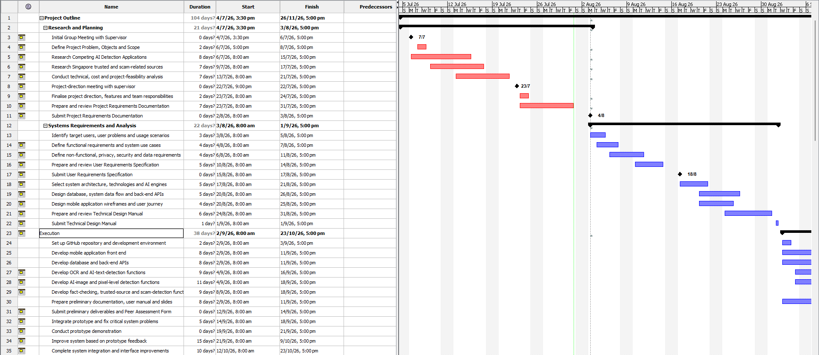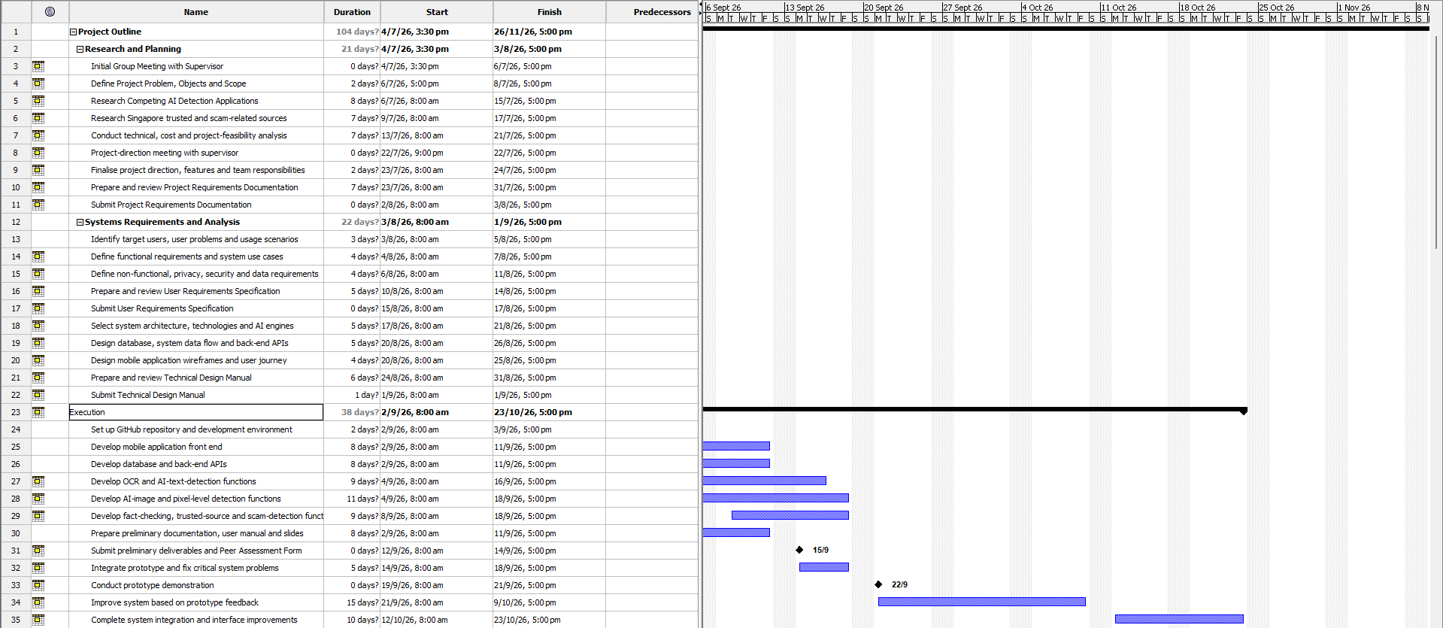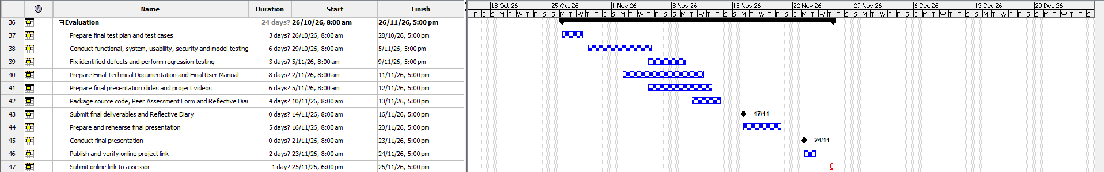

5.3 Work Breakdown Structure (WBS)
Work package | Deliverable / responsibility area | State
W1 Requirements/design | PRD, URS, TDM; team and documentation. | Existing baseline; scope differences recorded.
W2 Input preparation | English validation and preparation; Yi Da stage. | Integrated.
W3 Claim analysis | Classification/extraction; Matthew stage. | Integrated; additional evaluation needed.
W4 Evidence retrieval | Provider discovery/search/citations; Chu stage. | Live completion exists in the current workspace; confirm contribution attribution.
W5 Assessment | Evidence stance/risk/explanation; Poon stage. | Integrated baseline; semantic accuracy improvement outstanding.
W6 App/API/persistence | Android flow, auth, results and quota; Donovan-led integration. | Basic text journey working.
W7 Required image scope | OCR, image/caption/context, deepfake. | Not implemented; confirm named owners and dates.
W8 Remaining product functions | Payments, deletion, reports, public sharing and portals. | Planned; prioritization and delivery dates needed.
W9 Evaluation/release | Dataset, usability, load/security, packaging and documentation. | Partial tests/drafts; acceptance evidence incomplete.

5.3.1 Unregistered User
Registration, email verification, sign-in and password recovery; validate error handling and access before analysis.

5.3.2 Registered Free User
Complete text submission, evidence retrieval, result presentation, history and daily allowance; then implement agreed direct-link, account and feedback gaps.

5.3.3 Registered Premium User
Enforce monthly entitlement; deliver and evaluate image, OCR, context and deepfake functions; implement the agreed subscription lifecycle.

5.3.4 System Administrator
Deliver role-restricted account queries, account creation, suspension controls and feedback review with access and audit checks.

5.3.5 Data Engineer
Deliver incorrect-result investigation, source/provenance management and ingestion monitoring, supported by labelled evaluation and recovery records.
These role-based work packages elaborate the existing requirements. They do not imply that all packages are complete or that new owners or dates have been agreed.

5.4 Project Charter
This charter summary is a proposed consolidation of existing requirements and schedule information. It is not a signed authorization or newly approved scope baseline.
Charter field | Draft record
Project | uiabo — AI-Based Misinformation Detection for Short-Form Content; FYP-26-S3-30.
Purpose | Help older Singapore Android users review suspicious short-form content using evidence and clear uncertainty.
Team / oversight | Five members listed on the cover; supervisor Mr Liaw Chun Huei; assessor Mr Terrence Chew.
Immediate milestone | 12 September 2026 prototype, as stated by the user; basic Sprint 1 text demonstration.
Final milestone | November 2026; exact official deadline not supplied.
Resources | Existing development machines, Firebase project and provider accounts. No agreed funded budget or committed provider spend documented.
Constraints | English Android scope, external service access/quotas, small evaluation base and limited remaining development time.
Decision / approval | Team review and supervisor confirmation of unresolved acceptance/scope items required; no signatures inferred.

5.5 Communication Management Plan
The five-person team uses GitHub for source control and shared implementation, and maintains PRD, URS, TDM, meeting notes and Sprint 1 handoff samples in the project workspace. Team discussions are used to confirm scope, assign ownership, review interfaces and identify blockers. Shared JSON contracts allow pipeline components to be developed and tested without waiting for another member's unfinished implementation.
- GitHub repository for code review, change history and integration.
- Meeting notes and presentation material for decisions and progress reporting.
- PRD, URS and TDM for requirements and design alignment.
- Sprint 1 sample JSON files for cross-member interface coordination.

5.5.1 Stakeholder Communication Requirements
Team members need current contracts, task ownership and blockers. The supervisor and assessor need reviewable requirements, demonstrations and progress evidence. User-facing communication must explain supported functions, uncertainty and data handling in accessible language.

5.5.2 Communications Summary
Proposed additions for team review. Existing evidence supports GitHub, shared documents and meeting notes; the cadence and escalation rules below are not claimed as previously approved practices.
Audience / purpose | Channel / artifact | Proposed trigger
Team implementation coordination | Repository changes, shared contracts, task list and blocker notes. | Each handoff or blocker; include owner, next action and evidence.
Supervisor progress/scope review | Dated progress summary and demonstrable build. | Agreed review meetings and material scope changes.
Assessor delivery | Submission PDFs, user manual and reproducible demonstration instructions. | Required submission milestones.
User feedback | Planned usability notes and feedback/report workflows. | Each approved study or implemented feedback submission.

5.5.3 Communication Guidelines
Use a dated record that identifies the decision or issue, affected component, owner and next action. Keep implementation claims tied to test or demonstration evidence. Share configuration instructions without provider keys or private service-account files.

5.5.4 Conflict Escalation Procedure
- Record the disputed requirement or technical decision, alternatives and impact in a shared note.
- The affected component owners and project leader review it against the URS/TDM and prototype goal.
- Escalate unresolved scope or academic-requirement questions to the supervisor; record the decision without inventing approval.

5.5.5 Document Revision Protocol
- For interface changes, update schema, examples, tests and dependent components together.
Preserve the previous document, record the reason and source for each revision, reconcile section references and refresh the Word contents and page fields. This revision updates the Word report only; the existing PDF retains the previous structure.

5.6 Scope Statement
Category | Scope
Implemented increment | Individual authentication, English text pipeline, cited result, Android Home/text/history/detail and server-enforced allowances.
Required/planned product | Public links with screening; image+caption, OCR, context and deepfake; agreed accounts/subscriptions and operational functions.
Additional features | History deletion, reviews, public result links and operational feedback as identified by the URS.
Excluded | Audio/speech, video and non-English analysis; private/paywalled inaccessible content. No iOS release or public API licensing is part of the current working increment.

5.6.1 Deliverables and Dependencies
- Product: Android application, authenticated API, Firebase configuration, evidence pipeline, source code and reproducible setup.
- Documentation: PRD, URS, TDM, this PTD, PUM, source/evaluation records and actual meeting minutes.
- Verification: automated results, labelled evaluation, usability/performance/security records and final demonstration evidence.
- Dependencies: provider availability, appropriate credentials, source access, detector selection and approved final deadlines.

5.6.2 Acceptance and Outstanding Approval
The local text demonstration has evidence of completion, but the full planned product is incomplete. Final acceptance must explicitly address accuracy limits, required image/deepfake delivery, unfinished user/operational flows and non-functional targets. Confirm whether a public project website is an assessed deliverable. Approval dates, signatures and exact final submission dates remain pending rather than fabricated.
Evidence / source: PRD scope/business model/schedule; URS; team-task document; user-provided prototype scope and dates.

5.7 Proposed Next Work Order
Before 12 September, prioritize reproducible text demonstration, clear unavailable-feature labels, meaningful accuracy examples and consistent documentation. For the remaining project, prioritize required image/deepfake implementation and assessment evaluation, then agreed operational/subscription functions and release validation. These priorities do not assign invented sprint dates or certify supervisor acceptance.
Evidence / source: PRD 4.5 Gantt; dated meeting/integration reports; user-provided September and November milestones.

