11. Development Methodologies

11.1 Waterfall Model
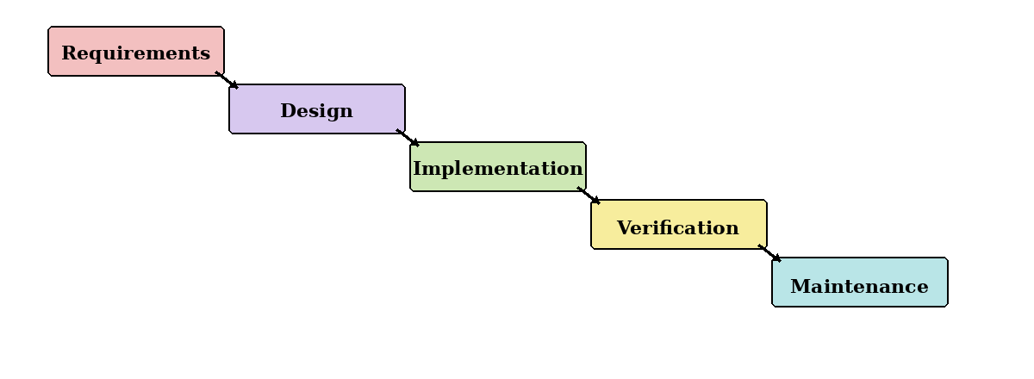
Figure 11.1: Waterfall model.
Waterfall follows a fixed sequence from requirements to maintenance. Although it offers clear stages, it is unsuitable as the main approach because AI models and data sources may require repeated changes. It will only be used for stable tasks such as final documentation and submission checks.

11.2 Prototyping Model
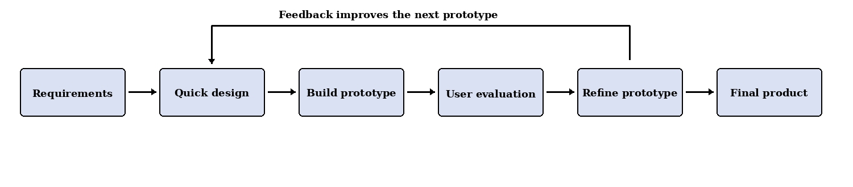
Figure 11.2: Prototyping model.
Prototyping allows the team to test claim extraction, evidence retrieval, URL screening and static-image authenticity assessment before integrating them. To avoid endless changes, all prototypes will be compared using the same test dataset and only useful improvements will be retained.

11.3 Kanban Model
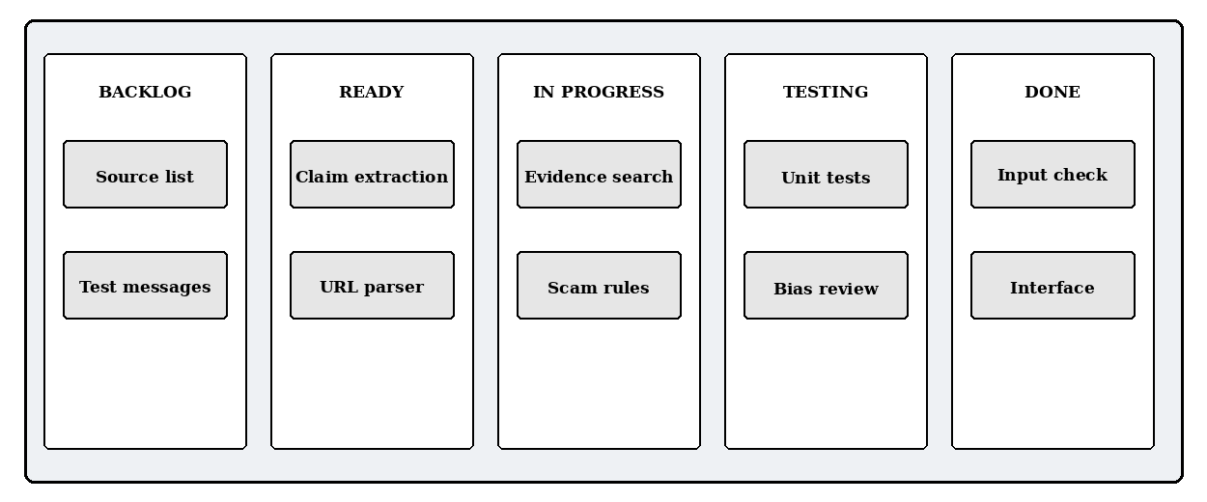
Figure 11.3: Example Kanban task board.
Kanban provides a visual view of tasks in Backlog, Ready, In Progress, Testing and Done. It supports daily coordination and limits unfinished work, but it lacks fixed review dates. Therefore, it will support Scrum rather than replace it.

11.4 Scrum
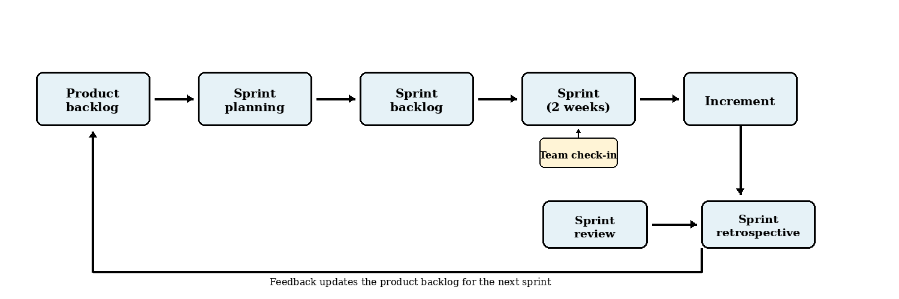
Figure 11.4: Scrum development cycle.
Scrum divides the project into short sprints that each produce a tested increment. The main practices used will be:
- Two-week sprints with planning, development, testing and documentation.
- User stories and a prioritised product backlog for project requirements and technical tasks.
- Sprint reviews to evaluate results, collect supervisor feedback and revise the backlog.
- Sprint retrospectives to identify delays and improve the next sprint.
Scrum is suitable because the team can respond when a model performs poorly, a Singapore source is unavailable or a feature exceeds the available time.

11.5 Development Methodology Chosen: Scrum
Scrum is selected as the main methodology because it combines structure with flexibility. This is important for an AI-based misinformation detection project, where models, datasets, trusted sources and scoring methods must be evaluated before the final approach is confirmed.
Justification for Choosing Scrum
- Adaptability: Requirements can be revised when testing or supervisor feedback reveals problems.
- Iterative progress: Short sprints provide regular working results within the six-month schedule.
- Early evaluation: AI detection, factual verification and scam analysis can be tested separately.
- Scope control: Essential functions are prioritised, while unrealistic features are moved to future work.
- Explainability and ethics: Each sprint can review false positives, data quality, robustness and user-facing explanations.
How Scrum Will Be Used
At the start of each sprint, the team will select a small number of high-priority tasks. A task is complete only when it works, has passed basic tests and has updated documentation. The sprint review and retrospective will then guide the next sprint.
Conclusion
A lightweight Scrum process, supported by prototyping and Kanban, is the most realistic approach for this six-month, zero-budget student project.

