15. Use Case Diagram
The four use-case diagrams are retained from the UIABO URS. Their original figure identifiers belong to that source document. They describe the planned role boundaries and complement the editable stories and descriptions in Chapters 13 and 14. Unregistered access is represented through registration and recovery, without inventing an additional role diagram.

15.1 Registered Free User
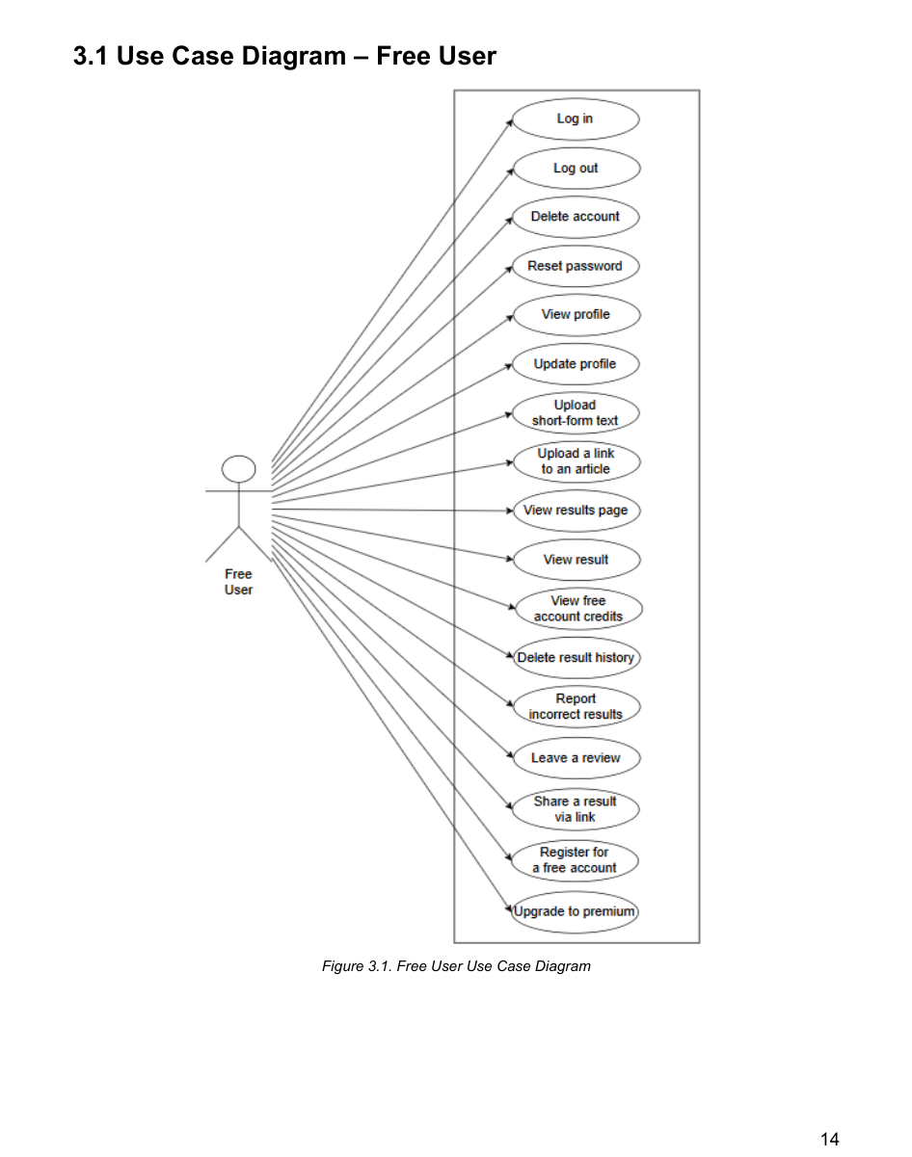
Source: URS, page 14; source diagram retained.

15.2 Registered Premium User
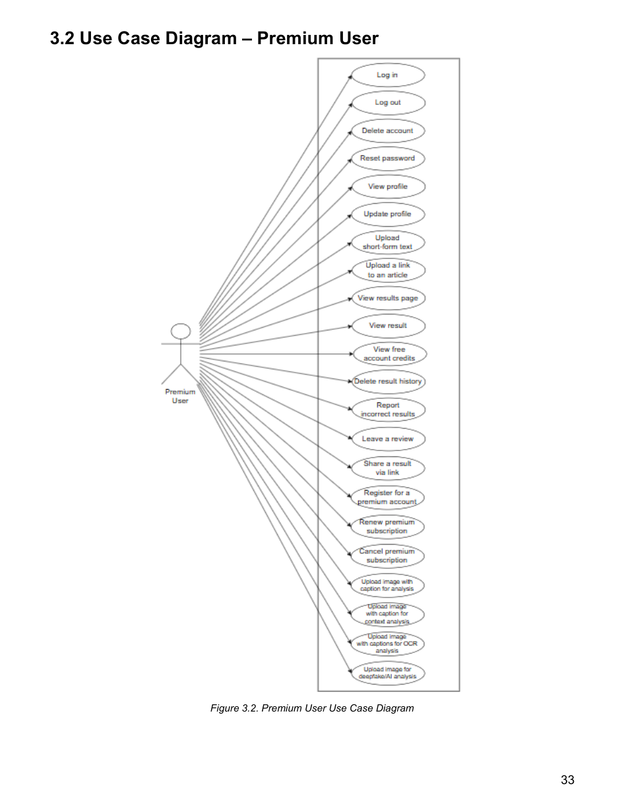
Source: URS, page 33; source diagram retained.

15.3 System Administrator
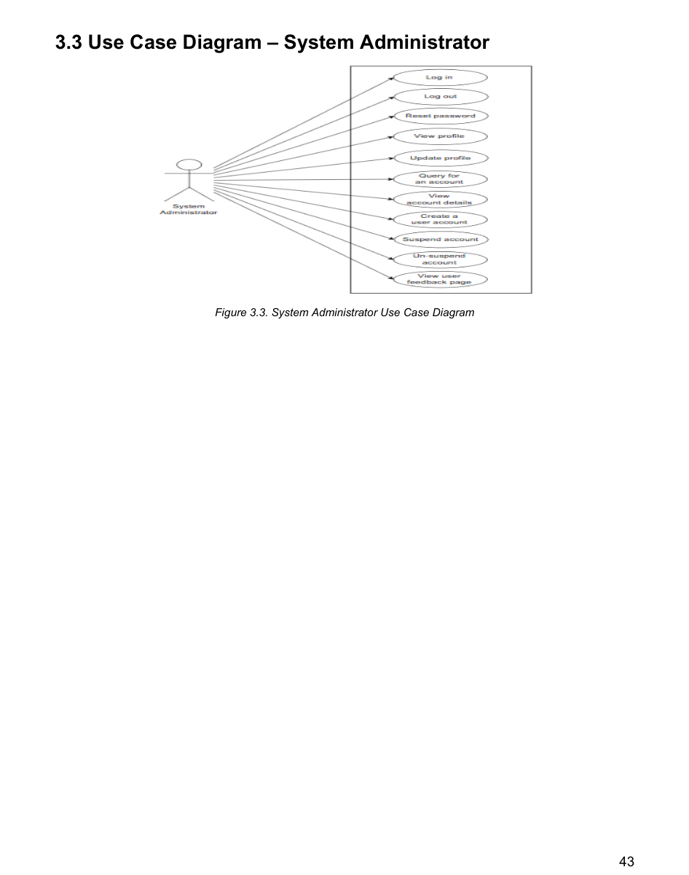
Source: URS, page 43; source diagram retained.

15.4 Data Engineer
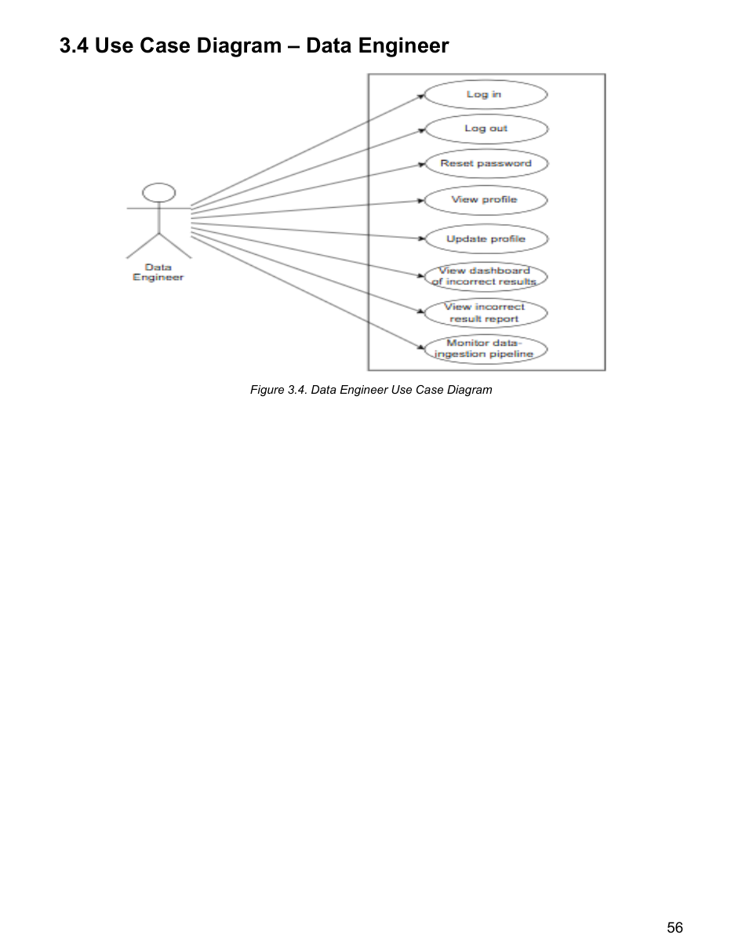
Source: URS, page 56; source diagram retained.

