4. Initial GUIs of uiabo
This chapter follows the screens used in the current application. Button names match the app. The figures are actual Android captures; only the text-checking workflow described below should be used. Cards marked LOCK or SOON in the Home captures do not perform an analysis.

4.1 Sign-in Page
When no account is signed in, UIABO opens the Sign in screen. It contains Email address, Password, Sign in, Create a free account and Forgot password?. If a verified session is already saved on the emulator, the app can open Home directly.
1. Enter the email address used for your account.
2. Enter your password.
3. Select Sign in.
4. If Verify your email appears, follow Section 4.2.1. Otherwise, wait for Home to open.

4.2 Create a Free Account
1. From Sign in, select Create a free account.
2. Enter your name and an email address you can access.
3. Enter a password with at least eight characters, then enter the same password in Confirm password.
4. Read the account/content storage statement and select its checkbox if you agree.
5. Select Create account and wait for Verify your email.
The registration screen contains a storage-consent checkbox. It does not open a separate privacy-policy page. If you need clarification about the statement, ask the person running the demonstration before registering.

4.2.1 Email Verification
1. Open the verification email in your email application or browser.
2. Follow the verification link.
3. Return to UIABO and select I have verified my email.
4. If verification is complete, Home opens. If the app says the email is not verified yet, finish the email-link step and try again.
Select Send the email again if you need another verification message. Check the inbox and spam/junk folder. Select Use a different account to leave this screen and return to account access.

4.2.2 Registration Validation
Message or situation | Action
Enter your name / email address | Complete the indicated field.
Use a password with at least 8 characters | Enter a password of at least eight characters.
The passwords do not match | Make Password and Confirm password identical.
Please agree to the privacy notice to create an account | Review the displayed statement. The checkbox is required to submit registration.
An account already uses this email address | Return to sign-in or use password recovery for your existing account.

4.3 Incorrect Sign-in Details
If UIABO displays The email or password is incorrect, check the email address and re-enter the password. Select Sign in again. If you cannot remember the password, use Forgot password?. A message about too many attempts means you should wait before retrying. An unavailable account cannot proceed until its access issue is resolved with the demonstration organiser.

4.4 Password Recovery
1. From Sign in, select Forgot password?.
2. Enter your account email address.
3. Select Send reset email.
4. Check your email and follow the password-reset link.
5. Select Back to sign in, then sign in using the new password.
The app displays a neutral confirmation: If an account uses that email, Firebase has sent reset instructions. This message does not confirm whether a particular email has an account.

4.5 Free-user Home
Home shows your greeting, Free badge and Today’s allowance. Select Check text to start a check. Use the navigation at the bottom to open Results, Help or Profile. You can also open Profile using the initials near the top of Home.
Figure 4.1. Actual free-user Home, with one check available.
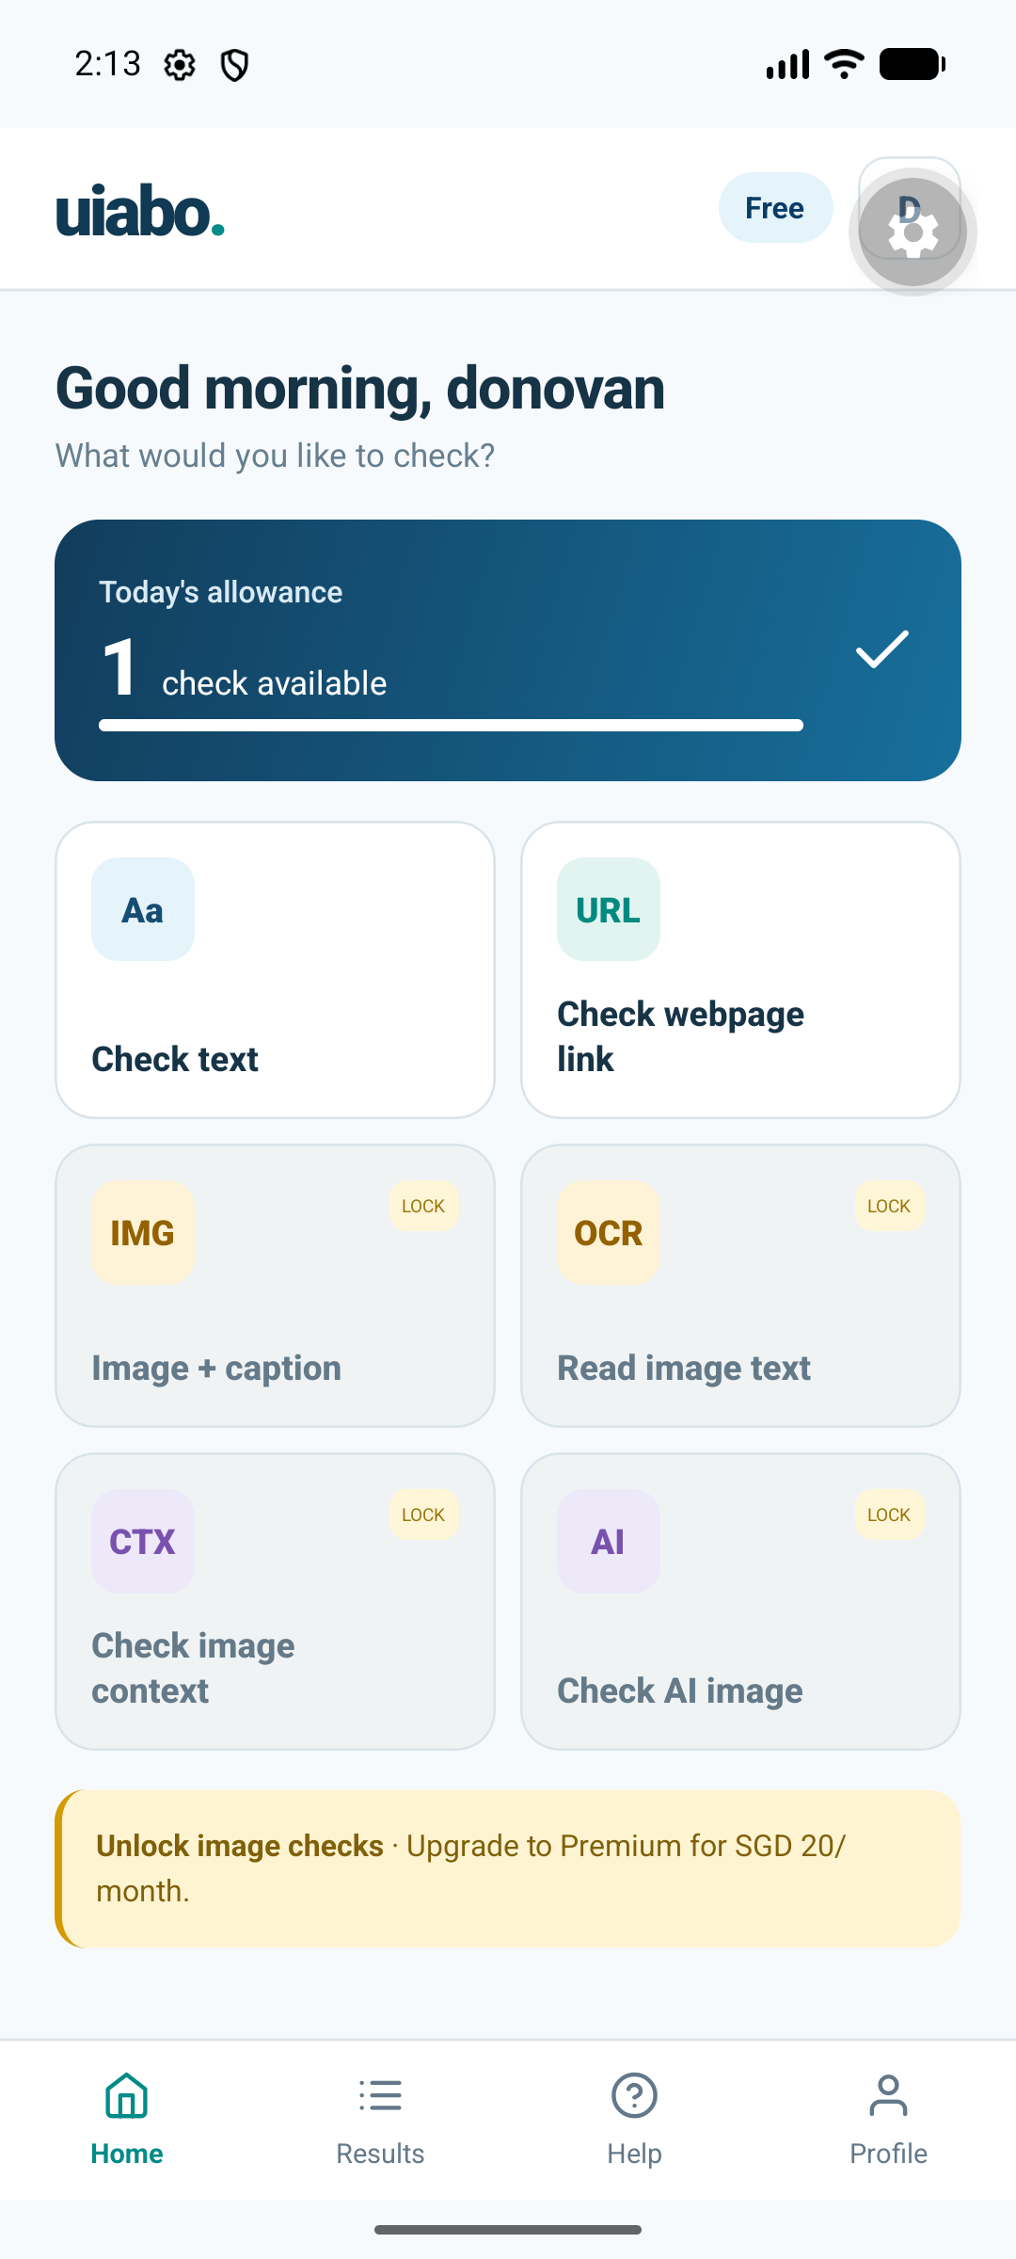
The full Home capture includes inactive cards and a promotional banner. Their presence is not an available checking or purchase workflow. For this prototype, select Check text.

4.5.1 Refreshing and Using the Allowance
1. Read the number of checks available on Home.
2. Pull down on Home to refresh account and allowance information.
3. If the allowance could not be loaded, select the retry message.
4. When no checks remain, read the reset time and use Results to review checks you have already saved.

4.6 Premium-user Home
An account already enabled as Premium shows a Premium badge and This month’s allowance. The working text-check flow is the same as for a free account, with up to 60 successful checks in a calendar month.
Figure 4.2. Actual Premium Home and monthly text-check allowance.
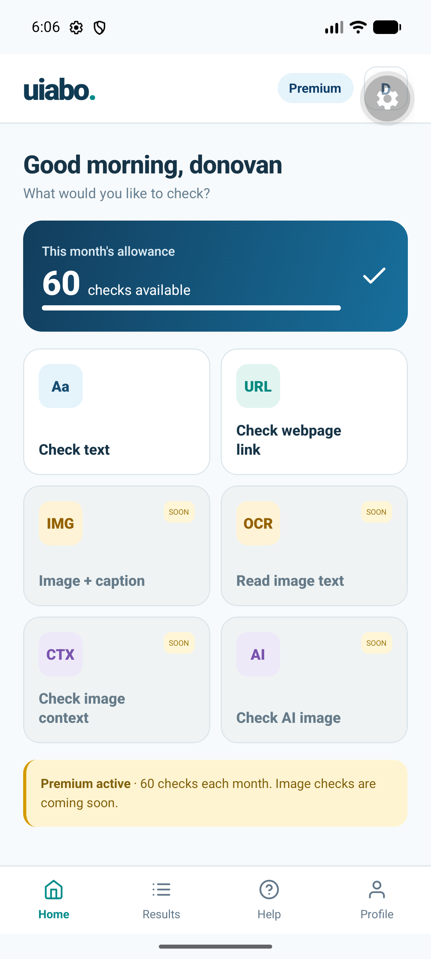
The number shown is the remaining allowance at the time of the capture. Refresh Home to see your account’s current value. The additional Home cards remain unavailable in this prototype.

4.7 Text Analysis
1. On Home, select Check text.
2. In Message or caption, paste or enter a short English message, claim or caption.
3. Keep the text within the displayed 5,000-character limit. Do not include passwords or private information.
4. Review the text, then select Check this text.
5. Keep the screen open while Checking the claim and its sources… is displayed.
6. When the check completes, read the Analysis result screen.
Example text for learning the input flow: Singapore became independent on 9 August 1965. A completed practice check uses one allowance; the result depends on the evidence returned during that check.
The Webpage link tab currently directs users to copied-text checking. If you arrive there, select Check copied text, then paste the article’s relevant wording into the text field. A URL alone is not a direct webpage analysis.

4.7.1 While a Check Is Running
UIABO shows a progress indicator and prevents navigation within the app while the check runs. Processing may take a couple of minutes. Avoid repeatedly pressing the submit button or closing the app during this period.

4.7.2 Text-check Errors and Retry
Situation | What to do
Empty field | Enter the message when Paste a message to check is shown.
No remaining checks | Read saved results or wait for the account’s next reset.
Allowance not loaded | Select Refresh allowance or return to Home and refresh.
Invalid or unsupported input | Read the error and supply usable English text within the length limit.
Connection failure or a long-running request | Select View saved results or open Results before submitting again. The first check may already have completed.
A failed check is shown | Read the error and resolve the cause before starting a new check. A failed server analysis does not use the allowance.

4.8 Analysis Result
The Analysis result screen displays the saved assessment. Scroll down to read the complete explanation and evidence; the first screen does not show every source.
Figure 4.3. Actual saved result showing a risk indicator, uncertainty and the identified claim.
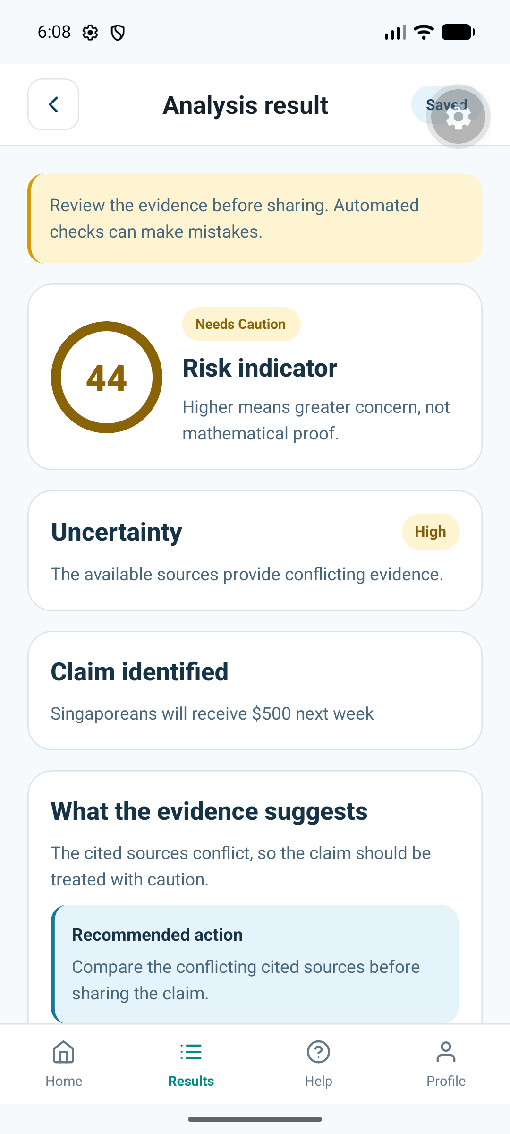
This capture illustrates the screen layout, not a verified conclusion about the example message.
1. Read the concern label and risk indicator, if present.
2. Read Uncertainty and its reasons.
3. Check Claim identified, or Submitted text if no claim was extracted.
4. Read What the evidence suggests and Recommended action.
5. Continue down to Evidence sources and review the passages and source links.

4.8.1 Opening Evidence Sources
1. Find an evidence source on the result screen.
2. Read its publisher, title, passage and stance label.
3. Select the source title or Open source to open the cited page.
4. Use Android’s Back control to return to UIABO when you have finished reading.
Publication date unavailable means the app did not establish a publication date for that item. It should not be read as an estimated date. If a link cannot open, check the connection and try another available source.

4.8.2 Not Enough Information and Failed Checks
Not Enough Information is a completed outcome when the app cannot identify a suitable checkable claim or establish sufficient evidence. Read the explanation and uncertainty. The screen can show a dash and No risk score rather than a number. This completed outcome uses one check.
A Failed result instead says This check could not finish, shows the available error message and states that the allowance was not used. Select Start a new check after addressing the cause.

4.9 Saved Result History
1. Select Results in the bottom navigation.
2. Review Your saved checks. Each row shows the claim or submitted text, saved time and concern label.
3. Select a row to open its explanation and sources.
4. Pull down to refresh the list. Select Load more results when that button appears.
5. If the list could not load, select Retry.
Figure 4.4. Actual result history for the signed-in account.
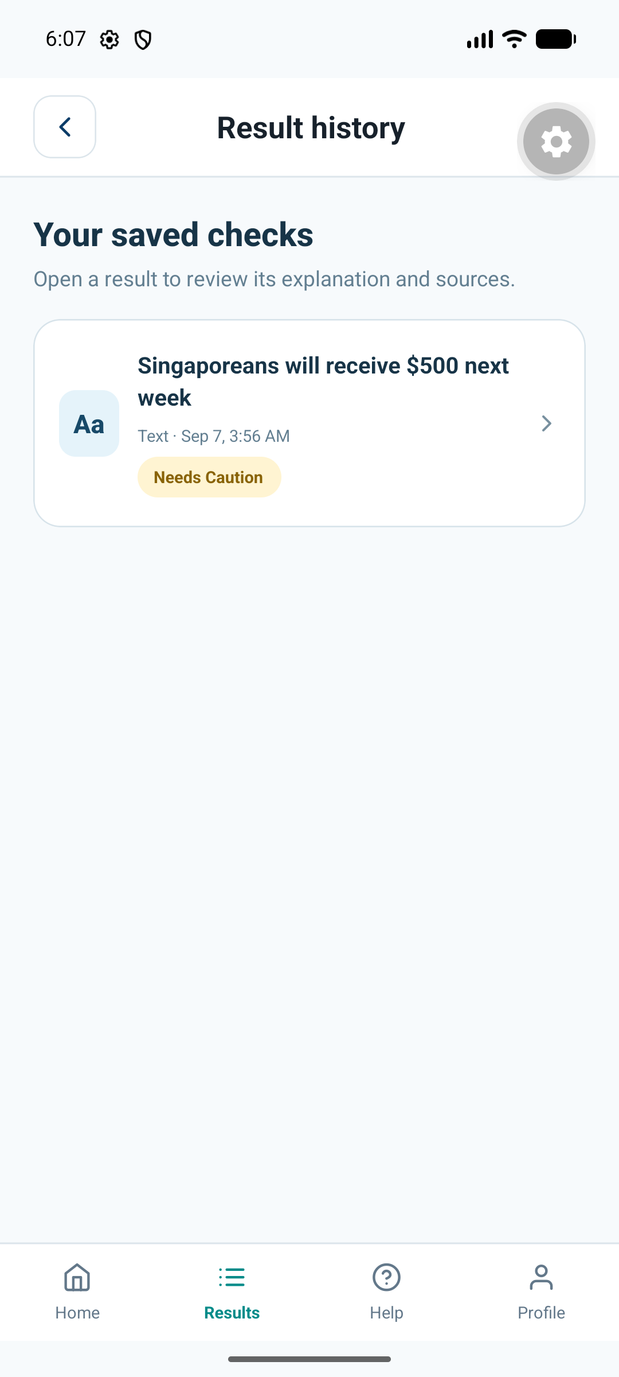
If no results are saved, the screen offers Check some text. The list belongs to the signed-in account. Reopening an existing result does not start another analysis or use another check.

4.10 Profile and Sign-out
1. Select Profile, or select the initials on Home.
2. Read My profile. The screen shows Name, Email address and Account type.
3. To change the displayed name, edit Name and select Save name.
4. Wait for Your profile has been updated.
5. Select Back to home to return.
Email address and Account type are read-only on this screen. Save name changes the name only.

4.10.1 Signing Out
1. On My profile, select Sign out.
2. Read the confirmation that you will need your email and password to sign in again.
3. Select Sign out to confirm, or Cancel to stay signed in.

4.11 Help
1. Select Help in the bottom navigation.
2. Read the guidance on checking text, interpreting concern scores, allowances and saved results.
3. Select Check some text to open the text-checking screen.
Question | Available action
The result seems wrong | Review the claim, evidence passages and source pages before relying on the result.
The app says it cannot reach UIABO | Check the connection. Ask the person running the demonstration to check the backend and Expo terminals.
The request took too long | Open Results first to see whether the original check was saved.
The app shows Finish app setup | Ask the installer to check the mobile Firebase configuration using Chapter 2.

4.12 Sharing a Result
1. Open a completed result and review the explanation and sources.
2. Select Share result.
3. Choose a receiving application from the Android share sheet.
4. Review the prepared summary and citation URLs in the receiving application before sending.
Sharing uses the Android share sheet to pass summary text and source URLs. The shared text includes the automated-assessment caveat. Cancelling the share sheet does not change the saved result.

