I. The Design Document

Cover Page –

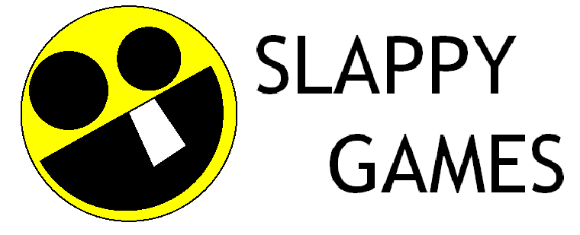
And Carbon13

Super Pillow Fighter

Design Document

Dan Manning – 407 416 8966 dmanning23@hotmail.com
Kevin Cecelski – 908 303 3155 cecelski@hotmail.com
Daron Keeler – 352 216 0311 litefyre@yahoo.com
Matt Strand – 512 663 1481 mstrand@austin.rr.com
Allan Bittan – 240 793 9422 mrallan20850@yahoo.com

Table of Contents –
I. The Design Document 1
A. Cover Page – 1
B. Table of Contents – 2
C. Executive Summary – 2
D. Game Charter – 7
E. Treatment – 11
F. Interactivity – 25
G. Interaction Component Matrix – 28
H. Art and Production Design – 29
I. Asset List – 31
J. Sample art – 47
L. Revision History -- 47

Executive Summary –

    - Mission Statement – To produce a game that is accessible to as large an audience as possible, and remains fun to play. Each person in the team wants to showcase their abilities.

    - High Concept – The first ever pillow fighting game. Ever.

    - Game Concept - Super Pillow Fighters is a light-hearted fighting game in which up to four players battle it out simultaneously. The goal of each player is to knock as many opposing pillow fighters off the board as possible. Using the simple control interface, players can choose to use their fists and abilities, or they can pick up items to use or throw at other players. While the control interface is simple and easy to learn, veteran pillow fighters can juggle their opponents in the air using multiple attacks. Based on a player’s personality, they can choose from various characters to suit their style. Will you choose the agile ninja, the powerful librarian, or the versatile girl next door?

    - Locale - Several different fighting arenas, each one being relative to a character. We are planning on doing at least two arenas. The first one will be on a pirate ship in the ocean. The second arena will be in a giant bathtub.

    - Genre – Fighting Game

    - Basic Control – Basic controls will be very simple. There will be a directional pad, an attack button, a jump button, and a block button. The players will be able to use the keyboard or joysticks, with emphasis on joystick play. The camera system will be locked on the xy plane, and will zoom in and out on the z plane to fit all the action on the screen.

    - Game Goal – To knock your opponent off the game world while avoiding the same fate.

    - Target Platform – PC

      - Minimum Specs
        - Graphics card with vertex shader support and 64 MB of memory
        - Pentium 1.2 gigahertz
        - 256 MB of system memory
      - Recommended Specs
        - Pentium 1.6 gigahertz or better
        - Joystick

    - Target Audience – The ESRB rating we are aiming for is T for Teen. This game is targeted towards teen to adult consumers who enjoy fast paced games.

    - Front End Flow Chart
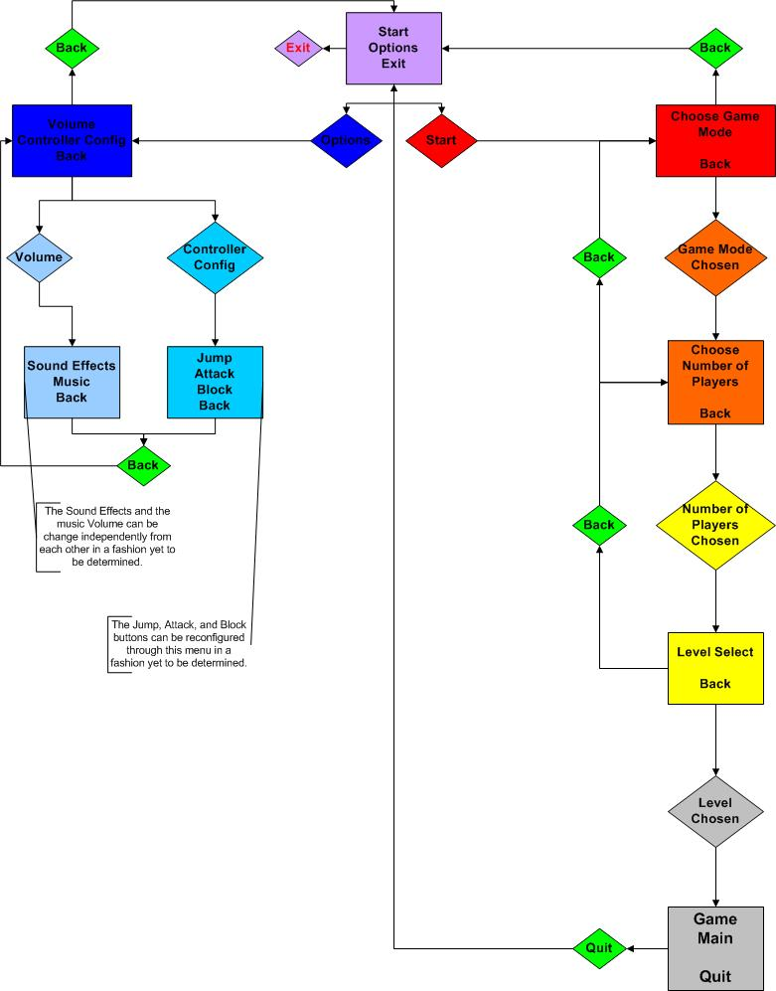

    - Game Walkthrough
The game plays the splash screen and then directs you to the main menu. You choose to start a new game, and you play survival mode. Now you choose to play as Josie against a computer opponent. Now you choose to play on Sally’s Pirate Ship. You’re standing poised with your throw pillow, starting down Miss Elizabeth, who is clenching her whip-like pillow. Miss Elizabeth jumps at you with a pillow slam, but you block and counter with a Whirlybird, sending feathers flying all over the place. Miss Elizabeth tumbles to the ground, so you jump after her with a Somersault attack, which is quickly blocked. Meanwhile, a nearby whale launches a pineapple from his blowhole into the fray. Miss Elizabeth runs after the pineapple on the ground. She picks it up and hurls it at your face. Ouch! You go flying off the ship and fall into the water, losing a life. You quickly re-spawn and the battle ensues. A few moments later, you and Miss Elizabeth are both down to your last lives, and have taken massive damage. You realize the turkey in your hand will finish the game. You hurl it at her face and she goes flying into the ocean, leaving you victorious! As you look at the final ranking, you smile with the satisfaction of beating up a librarian with a pillow. The game returns to the main menu, just as your best friend walks in…

    - Key Features –
    - General Features
      - 3D fighting game locked on the 2D xy plane.
      - Simple learning curve.
      - High Replayability

    - Multiplayer Features
      - Up to four players simultaneous.
      - Four controllers can be attached to one PC.

    - Gameplay
      - Players can choose different characters.
      - Each character will have her own attributes and attacks.

    - Comparative Products –
    - Super Smash Brothers – Nintendo 64 and Gamecube
    - Kung Fu Chaos – Xbox
    - Dead Or Alive – PS2, Xbox

    - How this product stacks up – This game is very similar to Super Smash Brothers. The character design is similar to Dead Or Alive. The game has the lighthearted feel and fast paced gameplay of Kung Fu Chaos. This game should have a shorter learning curve than any of these games.

Game Charter –

- Meeting Schedule:
      - Meet one or two times a week minimum. Meetings outside of class will be held at Dan, Kevin, or Allan’s place. Maximum meeting length will be eight hours.
      - At least one meeting every Sunday afternoon. 6:00 PM – 10:00 PM
      - Future meeting schedules will be redesigned at the end of the current month to account for code integrations and reviews. At least once a week after the first two weeks there will be a full integration and review. These sessions will be chaired by the tech lead.
      - Breaks will last no longer than 20 minutes.

- Hours Worked/week
      - Minimum hours worked per week will be 20 hours. (Outside school)
      - No team members will be expected to work more than 80 hours per week (Including classes)

- Code Review Process
      - Code Review will occur at the weekly meetings.
      - Each team member will present their code to be sure that it adheres to the team’s interface. These reviews will be lead by the tech officer. At these reviews, the code will be checked to make sure it matches the agreed upon standards.
      - Code reviews will also take place at each integration.
      - There will also be general reviews of coding practices to check for possible optimizations and errors in the code. All team members will be expected to participate to get maximum feedback.

- When things go wrong / Backup Plans
- Don’t Panic.
- For major problems, emergency meetings will be held to solve the problem at that time. The project officer will contact the group and schedule the meeting. Anyone can call for an emergency meeting. At least two hours notice is required before the meeting. If a team member cannot be contacted, they will be updated at the soonest possible time.
- If a minor problem or a design change is in order, the Project manage will be notified.

- Decision-making Process
      - A democracy will be used.
      - No major decisions will be made without the entire team present.
      - In the event the group cannot come to a decision or there is a tie, we will get impartial opinions from an outside party to help the team decide.
      - All decisions will be made by the end of each meeting, or within a four-hour time period in the event we run out of time during a meeting.

- Rules of Conduct
      - No sleeping at meetings whatsoever.
      - All members are expected to be prepared and pay attention at the meetings. This means having your laptop, notes, code, and readiness to discuss any issues.
      - No unnecessary distractions during meetings. This includes, but is not limited to, TV, web surfing, and video games.
      - No drinking during or immediately before meetings. (Alcohol)
      - Try to maintain a professional atmosphere at team meetings. Team members must show respect for other team members during meetings.
      - Members breaking rules have no say in the votes of that meeting.

- Administrative Roles
      - Project Manager: Dan Manning
          - In charge of file system (CVS)
          - Keep meetings organized
          - Schedules meetings
          - Design Document
      - Tech Lead: Kevin Cecelski
          - Integration
          - Tech Documentation
      - Outsource Manager: Daron Keeler
          - Compile list of Assets
          - Communicate with content providers

- Technical Roles
      - Dan Manning
        - Memory Manager
        - Main Game Loop
        - Profiler
        - Logger
        - Sound
        - Object Factories
        - Windows Installer
        - Particle System (Engine/Editor)
      - Kevin Cecelski
        - Renderer
        - Math Library
        - Level Editor
      - Daron Keeler
        - HUD
        - Input
        - Menus
        - AI
      - Matt Strand
        - Model Loader
        - Animation Engine
      - Alan Bittan
        - Physics
        - Collision Detection/Response
        - Player Editor

- Integration Schedule – After a module’s interface has been unit tested and deemed complete, it will be integrated into the build and system tested. The person in charge of the module will do unit tests. There will be a code review to make sure the interface of the module matches the specification. If the module passes the code review, it will be deemed completed.

Treatment –

    - Dust Jacket Story - The group of friends in this game have slumber parties at each other’s places all over the world. After the extreme makeover session, but before the ice cream binge, these slumber parties break out into a huge free-for-all pillow fight.

- Characters – All players are one meter tall.
 | Josie | Ms. Elizabeth | Captain Sally | Sumi
Attack Speed | 3/second | 3/second | 3/second | 4/second
Walk Speed | 5 m/s | 4 m/s | 5 m/s | 6 m/s
Jump Height | 3 m | 3m | 2.7 m | 3.3 m
Mass | 100 kg | 105 kg | 110 kg | 90 kg
Attack Power | 5 points damage | 7 points damage | 5 points damage | 3 points damage
Attacks
Attack | Sidearm pillow swing | Pillow Snap | Two handed overhand pillow swing | Pillow Stab
Up + Attack | Swing pillow over head | Upwards pillow snap | Two handed dig | Air Clear
Down + Attack | Whirlybird | Crazy Eights | Upsy-Downsies | Switcheroo
Forward + Attack | Overhand pillow swing | Underhand pillow snap | Baseball swing | Double handed super stab
Air Attacks
Attack | Somersault | Pillow slam | Hurricane Swing | Windmill
Up + Attack | Overhead pillow swing | Upwards pillow snap | Two handed overhand pillow swing | Air Clear
Down + Attack | Swing pillow between legs | Downwards pillow snap | Two handed between the legs pillow swing | Ground Clear
Forward + Attack | Overhand pillow swing | Pillow snap | Baseball swing | Double Handed limp wrist attack

      - Josie
- One Sentence Description – Josie is the cute girl-next-door.

- A Brief Description – Josie is the all-around balanced character in the game.

- Visual Design –
- Average build in relation to other characters
- Wears a nightgown, ends below knees, has straps similar to a sundress, light green with yellow flowers.
- Brown hair with small pigtails
- Pink bunny slippers
- Carries a normal pillow

- Back story – Josie is a student at Real College, where she majors in Volleyball. She comes from a small Ohio town. She met her friends when they were playing volleyball at Crescent Fresh Beach.

- Sample Dialogue –
- “Banana Salad!” – picked up an item
- “Bump Set Spike!” – victory chant
- "Puddin!” – taunt
- “Heehee!” – hit someone
- “Eeeeek!” – got hit

      - Ms. Elizabeth
- One Sentence Description – A librarian in a black leather outfit.

- A Brief Description – Ms. Elizabeth is slower but more powerful than other characters.

- Visual Design –
- Short red spiky hair
- Black leather outfit, very Cat-Womanesque
- Black thigh high boots
- Lots of zippers all over outfit
- Looks very angry
- Carries a really big pillow
- Uses same model geometry as Sumi

- Back story – Ms. Elizabeth is a work-study student at the Real College library. She wants to be a librarian. Her friends just gave her a makeover, which is why she is wearing the leather outfit.

- Sample Dialogue –
- “The Dewey Decimal System!” – taunt
- “Quiet, Please!” – picked up an item
- “I am Conan the Librarian!” – victory chant
- “Heehee!” – hit someone
- “Eeeeek!” – got hit

      - Captain Sally
- One Sentence Description – A sassy pirate

- A Brief Description – Can’t jump as high as other characters, but is harder to knock off.

- Visual Design –
  - Wears a black eye patch
  - Has a pirate hat
  - Wears a long sleeve puffy shirt with lots of frills
  - Brown leather Pirate boots
  - Baggy pants
  - Carries a regular pillow

- Back story – She was studying marine biology on a boat when she was kidnapped by pirates. She smacked around all the pirates and took over. She is now the pirate captain.

- Sample Dialogue –
- “Pirate Tray-sure!” – taunt
- “Yar, booty for me!” – picked up an item
- “Ar, me matey!” – victory chant
- “Yarharhar!” – hit someone
- “Aye!” – got hit

      - Sumi
- One Sentence Description – A ninja chick

- A Brief Description – Sumi is very fast and jumps high, but is easy to knock off and not as powerful.

- Visual Design –
  - Short black spiky hair
  - Wears a black bandit mask over her mouth
  - Sandals held on by leather straps
  - Skin tight black pants
  - Wears a sleeveless crop top made of Ninja chain mail
  - Wears open finger gloves and arm guards made of ninja chain mail
  - Carries two small throw pillows, one in each hand
  - Uses same model geometry as Ms. Elizabeth

- Back story – Sumi is studying at Real College to be a corporate ninja. She is working on her MBA with a focus on Tactical Corporate Espionage.

- Sample Dialogue –
- “You lack patience, grasshopper!” – taunt
- “Ahh, very good!” – picked up an item
- “You stand no chance against my double pillows of death!” – victory chant
- “Beeioo!” – hit someone
- “Aaeeii!” – got hit

    - Powerups –

    - Powerup Rules –
Powerups are spawned from “emitters” that are placed around the board. They randomly spit powerups into the air, which float down to the ground. Each type of powerup will have a “time to live” before it disappears. After a powerup is picked up the timer has no effect. Players will have to press the attack button while colliding with a powerup to collect it. Powerups are either immediately used (health items) or held onto until the player throws them. Throwing items are thrown by doing the player’s special attack. Thrown items travel in a straight on the x plane at 10 m/s. Player can only hold one powerup at a time.

- Powerups are removed from gameplay when:
- The timer runs out and it has not been picked up
- A player picked up a health powerup
- A powerup is thrown and hits another player or powerup
- A powerup is thrown and goes off the game board

- Pear
      - Visual Design – A small light green pear.

      - Attributes – The pear has a time to live of 5 seconds before it disappears from play. If a player picks up the pear before it disappears, 50 points of are removed from their damage.

- Grapes
- Visual Design – A small group of purple grapes.

- Attributes – The pear has a time to live of 3 seconds before it disappears from play. If a player picks up the pear before it disappears, all damage is removed.

- Ice Cream Cone
- Visual Design – One scoop of strawberry ice cream in a waffle cone.

- Attributes – The ice cream cone has a time to live of 5 seconds. If it hits a player after thrown, it does 20 points of damage.

- Pineapple
- Visual Design – It looks like a pineapple.

- Attributes – The ice cream cone has a time to live of 3 seconds. If it hits a player after thrown, it does 30 points of damage.

- Blueberry Pie
- Visual Design – A pie in a pie tin with the crust hanging out the top.

- Attributes – The blueberry pie has a time to live of 7 seconds. If it hits a player after thrown, it does 10 points of damage.

- Whole Turkey
- Visual Design – A brown cooked turkey, just like mom always makes.

- Attributes – The whole turkey has a time to live of 2 seconds. If it hits a player after thrown, it does 40 points of damage.

    - Worlds and Maps –

- Name – Captain Sally’s Ship: The El Nino

- One Sentence Description – A pirate boat in the middle of the ocean where the girls can battle on different parts of the boat.

- Visual Design/Description – There’s a boat floating in an ocean. The water will be rippling and reflecting light. The boat will be rocking around the “Z” axis. There will also be two whales on either side of the boat going above and under the water. The side of the boat and whales will be facing the camera.

- Audio Design/Description –
- Wave/Ocean Noise, specifically water noises
- Wood Creaking to simulate ship rocking
- Sail or flag in the wind
- Blowhole sound, similar to water shooting or geyser noise
- Cannon firing sound
- Something hitting wood, for when players land on ship
- Kerplunk noise, something falling in water

- Music –
      - Sea Chantey type song
      - Similar to Flogging Molly, but a little slower tempo
      - Instruments can include fiddle, accordion, banjo, acoustic guitar, drums, wooden blocks

- Scale – The board will be 40+ meters wide. The boat will average 25+ meters in width and 20+ tall. There are three tiers tall, and a small crow’s nest on top, that players can stand and fight on. The whale is five meters long, and 3 and a half tall.

- Rules – There will be four powerup emitters in this level. Whales will have an emitter in their blow hole, and there will be two cannons on the boat that will contain emitters. If the player touches the edges of the level, they will die. The bottom edge will be 1 meter under the bottom of the whale, the top will be 10 meters above the crow’s nest, and each side will be 6 meters past the edges of the whale.

- Environmental Interactions –
- Boat – The players can stand on the boat. The boat will rock back and forth, simulating a wave action.
- Whales – The players can stand on the whales. The whales will bob up and down in the water. The whales will shoot powerups out of their blow holes in random directions.
- World Borders – Touching the world borders will kill a player. The world borders are invisible lines in the world.

- Ambient Environmental Aspects –
- Sun – There will be a small smiley face sun in the upper right corner.
- Water – The water will ripple. Touching the water does not affect characters in any way, other than to create a particle effect.
- Pirate Flag – There will be a Jolly Roger flying from the mast above the crow’s nest.
- Clouds – There will be small clouds floating in the background.
- Sail – The sail of the ship will billow in the wind.
- Cannons – The cannons on the boat will swivel back and forth. They will emit powerups in the direction they are facing.

- Name – Josie’s Bathtub

- One Sentence Description – A pillow fight held in a giant bathtub.

- Visual Design/Description – There is a rubber duck and a bar of soap floating in the water. The faucet and handles are facing the camera. The faucet and handles will be above the duck and soap. Water will be poring out of the faucet. The camera will be positioned at the back of the tub so you can only see the front and faucet. There will be a small floating water gun next to the soap.

- Audio Design/Description –
      - Water running noise
      - Rubber Duck squeak
      - Bubble popping noise
      - Squirt gun noise
      - Quacking noise
      - Kerplunk noise, something falling in water
      - Thud noise, something landing on wood

- Song –
- Goofy Ween type song
- Techno beat
- Catchy melody
- Instruments could include whistling, drums, rhythm guitar

- Scale – The level will be about 40 meters wide and 30 tall. The faucet is 8 meters wide and 7 tall. It starts about 12 meters above the bottom of the board. The handles are 8 meters wide and tall. The left handle will be tilted at about 35-45 degrees around the z axis. The rubber duck is 11 meters tall and 11 wide. There are two levels to the duck. The soap is 14 wide and 7 tall. Both duck and soap start about a meter from the bottom of the board.

- Rules – There will be two powerup emitters in this level. One will be in the water gun, which will shoot in the direction the gun is facing. The second will be in the bill of the duck, which will spit out onto the soap. The left and right edges of the board are about 6 meters to the left of the duck and 1 meter to the right of the gun.

- Environmental Interactions –
- Duck – The player can stand on the duck. The duck will rock back and forth to simulate a wave motion. The duck will emit powerups from its bill in the direction it is facing.
- Soap – The player can stand on the soap. The soap will rock back and forth to simulate a wave motion.
- Faucet – The player can stand on the faucet.
- Handles – The players can stand on the horizontal portion of the handles.
- Shower Switch – The player can stand on the shower switch.

- Ambient Environmental Aspects –
- Tiles – The background of this level will be tiles. These tiles will have bump mapping, specular highlight, and possibly reflection.
- Faucet Water – The faucet will have water spilling out of it. There will be some sort of visual effect on the faucet water.
- Bath Water – The bath water will ripple. Touching the water will not have any effect on the player, other than to emit particles.
- Water Gun – The water gun will swivel back and forth and bob up and down. It will emit powerups in the direction it is facing. The players cannot stand on the water gun.
- Soap Bubbles – There will be soap bubbles coming out of the water. They will float upwards.

    - Combat System –
      - This game will use circle to circle collision for the combat. Each player has a “collision circle” around them. When a player attacks with their pillow, an “attack circle” is created around the pillow for the duration of the attack. When an item is thrown, an attack circle will be created around it, until the thrown item is removed from gameplay.
      - When a player gets hit, several factors will be taken into account to determine what direction and magnitude they will be thrown. These factors are the player’s weight, how much damage they have, if the damage is over 100%, and if they are being hit by a thrown item. Heavier players will not travel as far when hit. The more damage a player has, the farther they travel. If a players damage is over 100%, the distance traveled will be multiplied by X amount. If a thrown item hits the player, the distance traveled will be doubled.
      - After a player gets hit, they will be in a “falling” state and will not be able to control the character for one second.
      - The direction will be determined using perfectly elastic circle collision. If a player is hit and is flying through the air and hits the top of the ground, their vector will be reflected.
      - If two players hit each other in the air, they will be bounced using perfectly elastic collision. If two players hit each other on the ground, they will be stopped.
      - When a thrown item hits a player, the item is removed from game play. If two thrown items collide, they are removed from game play. Thrown items that collide with level borders or the ground will be destroyed.
      - If a player is blocking and is hit, they will not be thrown, but they will still take half damage. Players cannot block in the air.

    - Particle Effects
      - When a pillow hits a player, a small puff of feathers will fly out.
      - When a player jumps or lands on the ground, a small cloud puff will shoot out from under their feet.
      - When a player is knocked off the board and dies, a large sparkle effect will shoot out from the spot where they left the board.
      - When a player jumps or falls into water, there will be a small splash effect.
      - When players get hit and are tossed, there will be small cloud trails following the character until they regain control.
      - When an item hits players, a small effect of colored blobs will shoot out.
      - When players are spawned, there will be a sparkly particle effect.
      - When players pick up health powerups, there will be a sparkly particle effect as their damage is reduced.

Interactivity –

    - Goal – There will be three different game modes in this game. A player is knocked out when they hit the boundaries of the board. A player gains a knockout when they are the last person to hit them. If a player touches the ground and has control of the character, then jumps or falls off the board, it counts as a suicide.
- Survival Mode – Each player starts with ten lives. When a player gets knocked out or suicides, they lose a life. When a player runs out of lives, they are out of the game. The last player alive wins the game.
- Time Attack – There will be five minutes on the clock. When a player knocks another player off, they get a point. If a player suicides, they lose a point. After the time runs out, the player with the most points wins the game.
- Knockout Competition – When a player knocks another player off the board, they get a point. If a player suicides, they lose a point. The first player with ten points wins the game.

    - Interface –
      - The interface for this game will utilize a directional pad and three buttons. The directional pad will control movement. The buttons will be jump, attack, and block.
      - Pressing the attack button or the attack button and a direction will form attacks.
      - A player can block by holding down the block button. While a player is blocking, they cannot move, jump, or attack.
      - A player can jump by pressing the jump button. After the player jumps, they can do a double jump by pressing the jump button again. Pressing a direction on the d-pad while in the air will allow the player to control the direction of the jump.
      - The game can be paused by pressing the escape button on the keyboard.
      - Each character has two special attacks. While a character is on the ground, they execute the special move by pressing down and the attack button. While a player is in the air, pressing the attack button with the directional pad in the neutral position will execute the second special attack. If the player is holding an item and executes a special move, they will throw the item instead of doing the special move.
      - When a player gets hit and is tossed, they will have no control over the character for one second.
      - Player one has complete control of the menu selection, except during character selection.

    - HUD – The HUD will consist of a small picture of the player, the number of lives/points, and damage. The lives/points will be decided by which game mode is being played. If the game is a timed mode, the timer will be displayed at the top center of the screen. All player stats will be displayed on the bottom of the screen.

    - Menus – The game starts at a splash screen that displays the Carbon13 logo, then goes to the Slappy Games logo, then goes to the main game screen. The main game screen will have Start, Options, and Quit. The Options menu will have Volume, Controller Config, and Back. Back goes to the main game screen. In the Volume menu, the player will be able to change the sfx volume and music volume. In the Controller Config menu, the player will be able to key bind their controller.

    - Player Experience – This game is a fun to play party game. It is an exciting new way to school your buddies and relieve stress.

    - Interactive Rhythm – This whole game is designed to be fast and streamlined, requiring no thinking to play. The player can start it up and quickly navigate the menus into a game. The game is a fast paced fighting game with instant gratification. The replay value of the game rests on mastering the different characters and their fighting styles.

Interaction Component Matrix –
 | PlayerObject/Characters | PowerUps/ Items | Level Borders | Menu | HUD | Thrown Objects | Pillow/ Collision Sphere | Platforms
PlayerObject/Characters | D
Powerups/Items | E | D
Level Borders | B | B | X
Menu | X | X | X | G
HUD | X | X | X | X | H
Thrown Objects | A | X | B | X | X | X
Pillow/Collision Sphere | F | X | X | X | X | X | X
Platforms | C | C | X | X | X | B | X | X
Key
A | Collision: Player damaged.
B | Collision: Object death.
C | Collision: Object stays above platform.
D | Collision: Objects do not overlap. PlayerObjects will bounce off of each other
 | if they are in the air. Otherwise no action taken
E | Collision: Item is either consumed or carried by the player until thrown.
F | Special: Pillows are attached to player geometry. If another player is hit, damage occurs to that player.
G | Special: The menu is always available by pressing the Esc key. It pauses all gameplay.
H | Special: The HUD is always visiable along the bottom of the screen. Displays player info.
X | Objects do not interact.

Art and Production Design –

      - Style of art & animation –
- The art in this game will have a cartoon look to it.
- Level objects will be large and brightly colored.
- Characters will have large heads, hands, eyes, and feet. This is so that the collision spheres placed around them in game will appear to fit better.
- Character animation will have a fast, fluid motion.
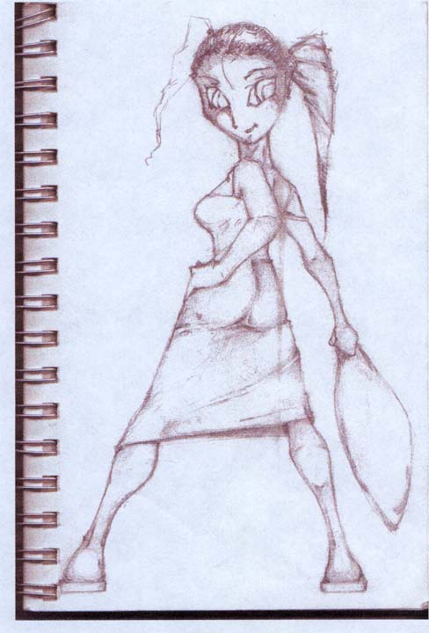

      - Style of Sound effects –
- Sounds in this game will be sharp and crisp.
- There will be almost a Loony-Toon quality to the sound effects.

      - Style of music –
- Songs in this game will have catchy rhythms and beats. Players should want to hum along to the songs.
- Examples will be presented to musicians to better help them capture the feel of the game. Each song will have one or two examples.

      - Style of Menus – (mockup of menus)

      - Style of HUD – Mockup of HUD
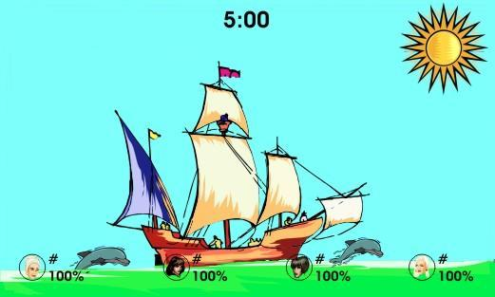

Asset List –
The game’s positive Y axis is up. The positive Z goes into the screen. Game effectively uses a left handed system.

- 3D Art
  - Animated (Dynamic) Models:
For the skin mesh, each vertex may have no more than two weights.
    - Josie
- Visual Description
- Average build in relation to other characters (1 meter tall)
- Wears a nightgown, ends below knees, has straps similar to a sundress, light green with yellow flowers.
- Brown hair with small pigtails
- Pink bunny slippers
- Fist will always be clenched such that they look like they are holding a pillow.
- Models
- 1500 polygons
- One that is Animated by the bone structure
- Textures
- Texture for this model.
- Max size 512x512.
- TGA file format (RGBA)
- Animations
- She is a really prissy character. The type of girl that wouldn’t want a broken nail. All of her movements are feminine. She holds her pillow in her right hand. All pillow attack descriptions are with her right hand
- Standing
- Defensive fighting stance, one hand up by her face, and the other down by her side.
- Breathing heavily.
- Running
- She’ll have a prissy bounce to her run.
- Jump
- After her initial push off of the ground, she put her arms behind her and her chest forward. She has one leg bent up in front of her and the other straight down. The foot of the bent leg comes to the knee of the straight one.
- Falling
- Leaned back like she is falling backwards. Arms and legs flailing.
- Throw Item
- Bring her left arm back for a sidearm throw. She has a limp wristed throw.
- Forward Attack
- Overhand swing with her pillow hand.
- Attack
- Sidearm pillow swing.
- Up Attack
- Swings pillow up over her head as if to hit an enemy above her.
- Down Attack - Whirlybird
- She has her right arm outstretched in front of her with pillow in hand, and spins in a circle around her Y axis to attack all around her.
- Air Attack - Somersault
- Holds her pillow straight in front of her and does a somersault.
- Air Forward Attack
- Overhand swing with her pillow hand.
- Air Down Attack
- Swings with her pillow hand between her legs to hit someone below her.
- Air Up Attack
- Swings pillow up over her head as if to hit an enemy above her.
    - Ms. Elizabeth
- Model
- Poly Count 1500
- One that is animated by bone structure.
- Textures
- One texture for this model.
- Animations
- Standing
- Stands with her arms slightly bent at her side.
- Running
- Jump
- Falling
- Throw Item
- Forward Attack
- Attack
- Up Attack
- Down Attack
- Air Attack
- Air Forward Attack
- Air Down Attack
- Air Up Attack
    - Captain Sally
- Visual Design –
- Wears a black eye patch
- Has a pirate hat
- Wears a long sleeve puffy shirt with lots of frills
- Brown leather Pirate boots
- Baggy, black pants
- Model
- Poly Count 1500
- One that is animated by her bone structure.
- Texture
- One texture for this model.
- Max size 512x512
- TGA format (RGBA color)
- Animations
- Sally is a very proud character and usually stands firm. She would readily fight any guy that manages to piss her off. Sally holds her pillow in her right hand, but all attacks are with both hands.
- Standing
- Sally stands with her arms slightly bent at her sides. Her legs are positioned to give her a firm stance, ready to absorb an attack.
- Running
- She has a masculine run with long strides and a proud posture.
- Jump
- After her initial push, she puts her left fist in front of her as if cursing the Gods. Her pillow hand is at her side. She brings her right knee up and keeps her left leg straight. At the height of the jump, her right foot should line up with her left knee.
- Falling
- Her legs and arms should stretch in front of her as if she was hit in the stomach with a cannonball. Arms and legs are flailing.
- Throw Item
- She has a strong underhand throw similar to a professional softball pitcher.
- Forward Attack
- A baseball bat swing.
- Attack
- An overhand swing.
- Up Attack
- She starts this attack low and swings up to attack opponents above her. It looks as if she is trying to dig a hole.
- Down Attack – Upsy-downsies
- This attack starts low as well. Sally swings up and behind her head then finishes the move by slamming the pillow into the ground.
- Air Attack – Hurricane Swing
- She holds the pillow in front of her and spins around on her y-axis.
- Air Forward Attack
- A baseball bat swing.
- Air Down Attack
- Swings the pillow from above her head down and between her legs to hit opponents below her.
- Air Up Attack
- Overhead pillow attack to hit enemies above her.
    - Sumi
      - Model
        - Use the same model as Ms. Elizabeth’s model.
        - Pillow
      - Texture
        - One for this model.
      - Animations
        - Standing
        - Running
        - Jump
        - Falling
        - Throw Item
        - Forward Attack
        - Attack
        - Up Attack
        - Down Attack
        - Air Attack
        - Air Forward Attack
        - Air Down Attack
        - Air Up Attack

  - Static 3D models:
  - Pillows
    - Josie’s Pillow
        - A regular throw pillow. Square shaped.
        - Max Poly count 100
        - Size ¼ meter
        - Texture size max 64x64
        - Texture Format is TGA (RGBA color)
    - Ms. Elizabeth’s Pillow
    - Captain Sally’s Pillow
      - A feather pillow (like one from a bed) with a skull and crossbones on it
      - Max Poly count 120
      - Size 1/5 m wide by 1/3 m long
      - Texture size max 128x64
      - Texture Format is TGA (RGBA color)
    - Sumi’s Pillows
    - Power ups (Models & Textures):
      - Pear
        - Model
          - 1/5 meter tall
          - Max 50 polygons
        - Texture
          - Max size 64x64
          - TGA format (RGBA color)
      - Pineapple
        - Model
          - 1/5 meter tall
          - Max 50 polygons
        - Texture
          - Max size 64x64
          - TGA format (RGBA color)
      - Grapes (A vine of grapes)
        - Model
          - 1/5 meter tall
          - Max 50 polygons
        - Texture
          - Max size 32x32
          - TGA format (RGBA color)
      - Ice Cream Cone
        - Model
          - 1/5 meter tall
          - Max 50 polygons
        - Texture
          - Max size 64x64
          - TGA format (RGBA color)
      - Blueberry pie
        - Model
          - 1/5 meter tall
          - Max 50 polygons
        - Texture
          - Max size 64x64
          - TGA format (RGBA color)
      - Whole turkey
        - Model
          - 1/5 meter tall
          - Max 50 polygons
        - Texture
          - Max size 64x64
          - TGA format (RGBA color)
    - Level Objects (Models & Textures):
      - Pirate Boat
        - Model
          - 25 meter in width and 20 meters in height
          - Max 5,000 polygons
        - Texture
          - We will need three to five textures.
          - The first texture will be the boat’s sails
            - Max size 128x128
            - TGA format (RGBA color)
          - The second texture will be the boat’s flag
            - Max size 64x64
            - TGA format (RGBA color)
          - The rest of the textures (1-3) will be for the actual boat.
            - Max size of each texture 512x512
            - TGA format (RGBA color)
      - Whale
        - Model
          - The whale is 5 meters wide and 3 ½ meters tall
          - Max 1500 polygons
        - Texture
          - Max size 128x128
          - TGA format (RGBA color)
      - Cannon (separate from boat)
        - Model
          - The cannon is 2 meters long and a meter wide.
          - Max 500 polygons
        - Texture
          - Max size 64x64
          - TGA format (RGBA color)
      - Rubber Ducky
        - Model
          - 11 meters tall and 11 meters wide
          - Max 5000 polygons
        - Texture
          - Max size 256x256
          - TGA format (RGBA color)
      - Bar of Soap
        - Model
          - 14 meters wide and 7 meters tall
          - Max 100 polygons
        - Texture
          - Max size 256x256
          - TGA format (RGBA color)
      - Faucet
        - Model
          - 8 meters wide and 7 meters tall
          - Max 500 polygons
        - Texture
          - Max size 128x128
          - TGA format (RGBA color)
      - Water Gun Barrel
        - Model
          - 8 meters tall and 3 meters wide
          - Max 200 polygons
        - Texture
          - Max size 128x128
          - TGA format (RGBA color)
      - Faucet handles
        - Model
          - 8 meters wide and tall
          - Max 400 polygons
        - Texture
          - Max size 128x128
          - TGA format (RGBA color)
- 2D Art:
  - HUD
    - Picture of each character.
      - A full body shot of each character holding their pillow. Faces must be clear and visible.
TGA format (RGBA color)
      - 512 tall x 256 wide
    - Fonts – alpha numeric and special chars - % and:
        - Fonts need to be made of balloons that are semi-transparent and colored pink and baby-blue.
        - Each letter must be 32x32
        - TGA format (RGBA color)
  - Front end menus
    - Mini picture of each level
      - Need a 2d picture of both levels.
      - Size must be 128x128
      - TGA format (RGBA color)
    - 2 Pictures (icon) of a Pillow - 1 indented, 1 not.
      - First picture is of a fluffed pillow.
      - The second picture is the same pillow but squished in the center like it was hit in the center.
      - Pillow sizes need to be 128x128
      - TGA Format (RGBA color)
    - 1 Picture with 2 characters pillow fighting. Title screen as well
      - The picture needs to be of Captain Sally swinging her pillow and hitting Josie in the face. This picture will be used on the title screen. The pillow should be in the upper middle of the screen and has “Super Pillow Fighter” written on it.
      - Size must be 512x512
      - TGA Format (RGBA color)
    - Back ground for level and character select screen
      - Picture needs to be of feathers floating on a pink background.
      - Size must be 512x512
      - TGA Format (RGBA color)
- Picture of Rubber ducky
  - Picture of a happy rubber duck on a baby blue background.
  - Size must be 512x512
  - TGA Format (RGBA color)
  - Particle Texture
    - Feathers
    - Cloud Puff
    - 3 Sparkles
    - Cloud Trail
    - Water Splash
    - White Glob
- Sound:
  - Sound effects
All sound effects will be encoded in .wav format. Sound effects should be kept under 5 seconds long. Environmental sounds should have a relatively low volume. Player sounds should have a relatively high volume. This will help emphasize combat in the game.
    - Wave/Ocean Noise – The sound of a small wave breaking to be looped in the boat level. This sound should not be very loud.
    - Wood creaking – The sound of wood creaking to be looped in the boat level. This sound should not be very loud.
    - Sail/flag in the wind - A piece of canvas flapping in the wind, looped in the boat level to simulate the flag. This sound should not be very loud.
    - Blow Hole sound (geyser) – A large jet of water to be used in the boat level when a whale shoots a powerup out of their blow hole. This sound should have a low volume.
    - Cannon Firing sound – A cannon firing sound to be used in the boat level when a cannon shoots out a powerup. This sound should have a low volume.
    - Body hitting wood (clunk sounding) – The sound of a large piece of meat hitting a wooden floor, used in the boat level when players are hit into the wooden deck of the ship. This sound should have a low volume.
    - A “ker-plunk” sound (body falling in water) – The sound a player makes when they fall into the water. This is not a splash sound, but more of a “kerplunk.” This sound should have a low volume.
    - Water Running – The sound of a tub filling up, which will be looped into the tub level. This should be a low sound.
    - Rubber Ducky squeak – The sound a rubber duck or squeak toy makes. This will be used in the tub level when a player lands on the rubber ducky. This should be a low volume.
    - Bubble sounds (popping) – A small “pop” noise used in the tub level when a bubble pops. This sound should be a low volume.
    - Squirt gun noise – A water spraying noise to be used in the tub level when the squirt gun shoots out a powerup. This should be a low volume.
    - Quacking noise – The sound a duck makes when it spits a powerup onto a bar of soap. This should be a low volume.
    - Soft Pillow sound (pillow impact on body) – A “thump” noise that a pillow makes when it hits a player. This sound should have a higher volume.
    - Hard Pillow Sound – A “smack” noise a pillow makes when it hits a player. This sound should have a high volume.
    - Item Pick sound (bling, clink clink) – A beep or whistle a powerup makes when it is picked up. This sound should have a medium volume.
    - Item hitting body (splat sounding) – The “splat” noise a thrown powerup makes when it hits a player. This sound should have a high volume.
    - Power up sound FX (Rev noise) – The sound that is played in the menu when the player changes the sound effects level. This sound should have a high volume.
  - Music
All music will be encoded in Og Vorbis format. Volume on music should be such that it will not drown out sound effects.
- Menu Loop
- This song will loop for roughly 30 – 45 seconds.
- This song will be similar to a 311 reggae song.
- This song will have the 311 style of drumbeat.
- This song will have a medium paced rhythm.
- There will also be maybe some guitars and a bass playing.
- Credits Loop
- This song will loop for roughly 30-45 seconds.
- This will be another reggae style song, but with a more Caribbean feel. It will be similar to a Bob Marley song.
- This song will have a slower rhythm.
- Some instruments used on this track could include steel drums, organ, bass, or maybe some horns.
- Pirate Board Loop
- This song will loop for roughly 1.5-2 minutes.
- See level description for details about this loop.
- Bathtub Board Loop
- This song will loop for roughly 1.5-2 minutes.
- See level description for details about this loop.
  - Recorded voice/Dialogue:
All voice/dialogue should have a relatively high volume.
    - Josie
- “Banana salad!”
- “Bump, set, spike!”
- “Puddin!”
- “HeeHee!”
- “Eeeeeek!”
- Ms. Elizabeth
- “The Dewey Decimal system!”
- “Quiet please!”
- “I am Conan the Librarian!”
- “HeeeeHeeee!”
- “EEeeeeek!”
- Capt. Sally
- “Pirate Tray-sure!”
- “Yar, Booty for me!”
- “Ar, me matey!”
- “Yarharhar!”
- “Aye!”
- Sumi
- “You stand no chance against many double pillows of death!”
- “You lack patience, grasshopper!”
- “Ahh, very good!”
- “Beeeiooo!”
- “Aaeeii!”

Sample art –

L. Revision History --
Version | Author | Description | Date

