Name and Degree | Headshot | Bio | Role (Panelist/Mixer)
Verena Kallhoff  PhD in Molecular and Human Genetics  MBA | 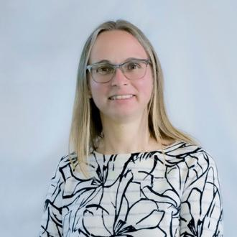 | Senior Director, Global Life Sciences, Greater Houston Partnership  Dr. Verena Kallhoff is the Senior Director of Global Life Sciences at the Greater Houston Partnership, where she leads strategic initiatives to grow and strengthen the region’s life sciences and biotechnology ecosystems. She works closely with local, state, national, and international stakeholders to support innovation, attract investment, and assist companies seeking to relocate or expand in the Greater Houston area.  Prior to joining the Partnership, Dr. Kallhoff served as Vice President of Omics and Precision Medicine at Equideum Health, a health tech startup. She also held multiple leadership roles at The University of Texas at Austin, including directing The WorkSpaces at Texas Health CoLab, the innovation hub at Dell Medical School. There, she worked with innovators and startups commercializing their technology and developed and led programs to foster regional innovation. She became a co-founder of TEXGHS—the Texas Global Health Security Consortium—in response to the COVID-19 pandemic. She continues to mentor startups.  Her earlier roles include positions at Harris Health System and Houston Methodist Research Institute, where she was the Managing Director of CyBHOR, an Industry/University Cooperative Research Center funded by the National Science Foundation.  Dr. Kallhoff earned her Ph.D. in Molecular and Human Genetics from Baylor College of Medicine and an MBA from the University of Houston–Clear Lake.  https://www.linkedin.com/company/ghpartnership/ | Panelist and Mixer
Michelle Swick  PhD in Cell and Molecular Biology  ELS | 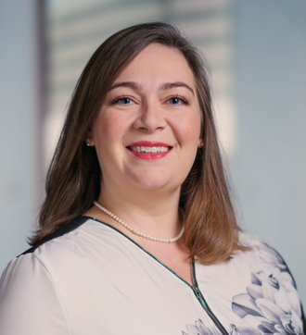 | Research Development Associate, Office of Faculty and Research Development, Houston Methodist Research Institute  Dr. Michelle C. Swick specializes in the strategic development and growth of clinical and translational research programs, from individual professors to large academic departments and centers of excellence. She earned a PhD from Baylor College of Medicine in 2011 and has 12 years of research experience in cell and molecular biology, microbiology, and molecular genetics. After completing a postdoctoral research fellowship at UTHealth, she transitioned to focus her career on scientific communication, following her passion to show scientists how to communicate their research effectively to all audiences. She has 11 years of scientific writing and editing experience, including teaching scientific writing to junior academic faculty and postdoctoral fellows in the biomedical sciences. She has an Editor of Life Sciences (ELS) certification from the Board of Editors in the Life Sciences.  https://www.linkedin.com/company/houston-methodist/ | Panelist and Mixer
Sana Shaikh  PhD in Biochemistry  CA-AM | 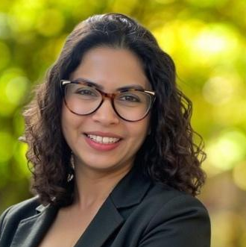 | Project Lead, Project and Alliance Leadership, Cell Therapy Manufacturing Center (CTMC)  Prior to her current appointment at CTMC, Dr. Shaikh was a Senior Manager at Immatics, where she spearheaded strategic alliances with BMS and Editas. She pursued her Ph.D. in Biochemistry at The Ohio State University, then moved to UTHealth as a Postdoctoral Fellow. Subsequently as a Senior Entrepreneurship Fellow at Fannin Innovation Studio, Sana developed a resounding interest in drug development and commercialization.  https://ctmc.com/  https://www.linkedin.com/company/immatics/ | Panelist and Mixer
Efrosini (Efi)Tsouko  PhD in Cell & Molecular Biology | 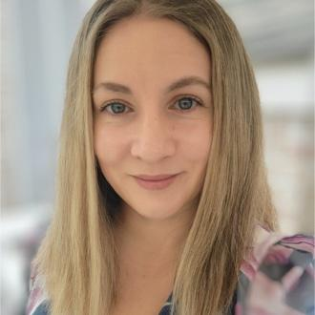 | Account Executive, 10x Genomics  Before joining 10x Genomics, Dr. Tsouko completed postdoctoral research at Baylor College of Medicine, following her Ph.D. in Cell & Molecular Biology from the University of Houston, specializing in cancer research. Bringing a unique blend of deep scientific expertise and business development experience, she is passionate about supporting career transitions and mentoring others, helping professionals navigate their paths and achieve their goals in science and beyond.  (https://www.linkedin.com/company/10xgenomics/) | Mixer
Amy Hazen  PhD in Cancer Biology/Immunology | 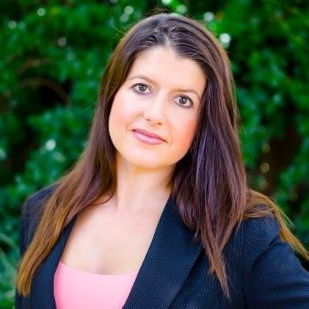 | Senior Director, Research Operations, The University of Texas Health Science Center at Houston (UTHealth Houston)  As Senior Director of Research Operations, Dr. Hazen provides high-level support to the university and school/department leadership in evaluating needs, strategic planning, and implementation of initiatives to enhance research operations and collaboration. She oversees multiple facets of research support, including managing shared facilities, coordinating grant opportunities, facilitating technology platforms, and fostering inter-institutional collaboration. This role involves guiding compliance with funding agency policies, data management, and supporting faculty in research collaboration efforts. Dr. Hazen joined UTHealth Houston in 2011 as a Research Program Manager. Previosuly, she was a Research Scientist at MD Anderson Cancer Center, following Postdoctoral training on stem cell biology.  https://www.linkedin.com/school/uthealth-houston/posts/?feedView=all | Mixer
Secondra Holmes  PhD in Pharmacology | 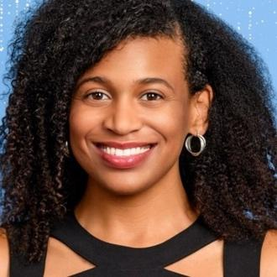 | Product Development Associate at Fannin Innovation Studio  Dr. Secondra Holmes is a translational science professional with experience in developing oncology, cardiology, radiopharmaceuticals, and precision medicine therapies. As a Product Development Associate at Fannin Innovation Studio she leads early-stage therapeutic programs and supports strategic development from discovery through Phase 1. Her work focuses on advancing innovative treatments toward patient impact  https://www.linkedin.com/company/fannin/ | Mixer
Kimberly Mankiewicz  PhD in Biochemistry and Biophysics  ELS | 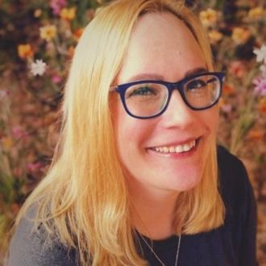 | Scientific Editor in the Center for Translational Injury Research at The University of Texas Health Science Center in Houston, Texas  Dr. Mankiewicz has over 15 years of experience working with trainees and faculty on grants, manuscripts, scientific visuals, and other projects. Kim also serves as Chapter Advisory Council Representative and Co-Communications Chair for the American Medical Writers Association Southwest Chapter and Chair of Marketing for the Board of Editors in the Life Sciences.  https://www.linkedin.com/school/uthealth-houston/posts/?feedView=all | Mixer
Yasmin  Chebaro  PhD in Biochemistry and Cell Biology | 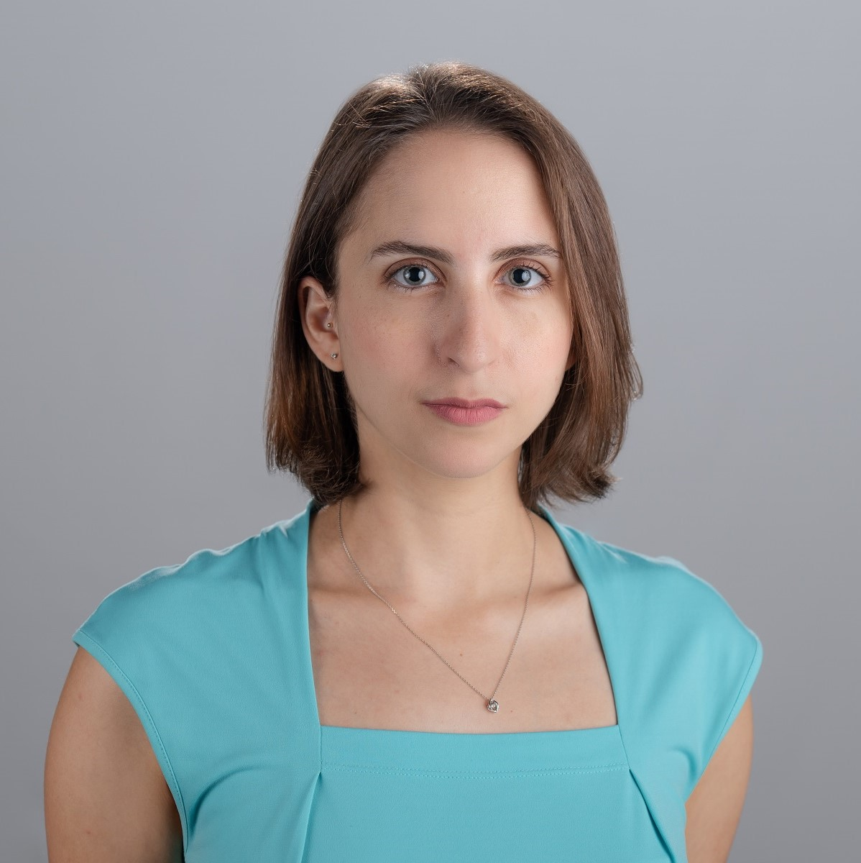 | Associate Director of Academic and Faculty Affairs, The University of Texas Health Science Center at Houston (UTHealth Houston)  From microscope to meeting room, Dr. Yasmin Chebaro has drawn on her research experience to support university-wide academic administration at UTHealth Houston. After completing her postdoctoral training in the Department of Microbiology and Molecular Genetics at McGovern Medical School, she transitioned into university administration to support the academic and professional development of researchers and faculty. She first joined the Office of Postdoctoral Affairs, where she led the Postdoctoral Certificate Training Program and advanced efforts to strengthen postdoc science communication skills. Now serving as Associate Director in the Office of Academic and Faculty Affairs, she works at the institutional level to support all seven schools within UTHealth Houston. Her work covers a wide range of faculty affairs, including promotion and tenure, institutional awards, policy implementation, and establishing centers and institutes, while also serving as a key liaison between the schools and central administration.  https://www.linkedin.com/school/uthealth-houston/posts/?feedView=all | Mixer
Enrique Armijo  PhD in Stem Cell Biology | 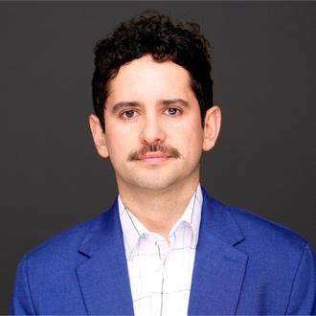 | Associate Director, Process and Analytical Development -Cell Therapy, Cellipont Bioservices  Enrique has more than 10 years of experience in Research, Quality Control, and Analytical Development in Cell and Gene Therapy, including expertise in Contract Development and Manufacturing Organizations (CDMOs). He has contributed to the growth and success of companies, including KBI Biopharma, Catalent Pharma Solutions, Kiromic Biopharma, and, most recently, as the Associate Director of Process & Analytical Development for Cellipont Bioservices. Enrique received his Bachelor of Science Degree in Biotechnology and his Master’s Degree in Neuroscience from the Universidad de Chile and his Ph.D. in Biomedicine from the Universidad de los Andes. He served as a Graduate Research Assistant and postdoctoral fellow researching stem cell therapies for neurodegenerative diseases at the University of Texas Health Science Center, Houston.  https://www.linkedin.com/company/cellipont-bioservices/ | Mixer
Karen Wozniak  PhD in Microbiology, Immunology, and Parasitology |  | Associate Professor, Microbiology and Molecular Genetics, Oklahoma State University  Dr. Karen Wozniak is Associate Professor in the Department of Microbiology & Molecular Genetics at Oklahoma State University. Her research centers on three main projects in the lab: 1) examining the roles of differentially-regulated genes in antifungal activity by macrophage and dendritic cell subsets, 2) examining the mechanism(s) involved in antfungal activity by lysosomal enzymes from DCs, and 3) examining antifungal potential of novel antifungal compounds.Her group also places strong emphasis on student training and fungal immunology outreach.  Dr. Wozniak earned her B.S. in Biological Sciences from the University of Notre Dame, and her M.S. and Ph.D. in Microbiology, Immunology & Parasitology from Louisiana State University Health Sciences Center with Paul Fidel. She completed her postdoctoral fellowship at Boston Medical Center and at University of Massachusetts Medical School under the mentorship of Suart Levitz. She is active in professional societies including the Medical Mycological Society of the Americas.  https://experts.okstate.edu/karen.wozniak | Mixer

