My Reproducible Report

A forward thinking researcher

2023-01-17

# Introduction

This file provides a quick look at how each component of an R Markdown file works together to produce an integrated report.

Remember, R Markdown allows us to: - **Combine narriative text, code, and output** into a single document - Incorporate mathematical expressions or equations - And render/export the .Rmd file to a variety of output file formats! - The YAML header specified in this .Rmd file enables us to render the output to: - A Microsoft Word document (.docx) - A pdf file - Or html file

## Load packages

In this code chunk, we are loading some relevant package libraries. By using the include = FALSE in our chunk options, we are telling the .Rmd file to exclude the code/output from the exported document.

## Create a plot in the below code chunk

Below we create a faceted figure using the gapminder dataset. We use the chunk options to specify the figure output height and width, as well as to create a figure caption. Notice that we can also use markdown syntax to format the caption text (e.g., **bold face text**)

# Create life expectancy by year figure  
ggplot(gapminder, aes(x = year, y = lifeExp, color = country)) +  
 geom_line(show.legend = FALSE) +  
 scale_x_continuous(  
 expand = c(0, 0),  
 limits = c(1950, 2010),  
 breaks = seq(1950, 2010, 10)  
 ) +  
 scale_y_continuous(  
 expand = c(0, 0),  
 limits = c(20, 90),  
 breaks = seq(20, 90, 10)  
 ) +  
 labs(x = "Year", y = "Life Expectancy at Birth (Years)") +  
 facet_wrap(~ continent) +  
 theme_bw() +  
 theme(  
 axis.text = element_text(face = "bold", color = "black"),  
 axis.text.x = element_text(angle = 45, vjust = 0.6),  
 axis.title = element_text(face = "bold"),  
 strip.text = element_text(face = "bold"),  
 panel.spacing.x = unit(1.5, "lines"),  
 panel.spacing.y = unit(1.5, "lines")  
 )

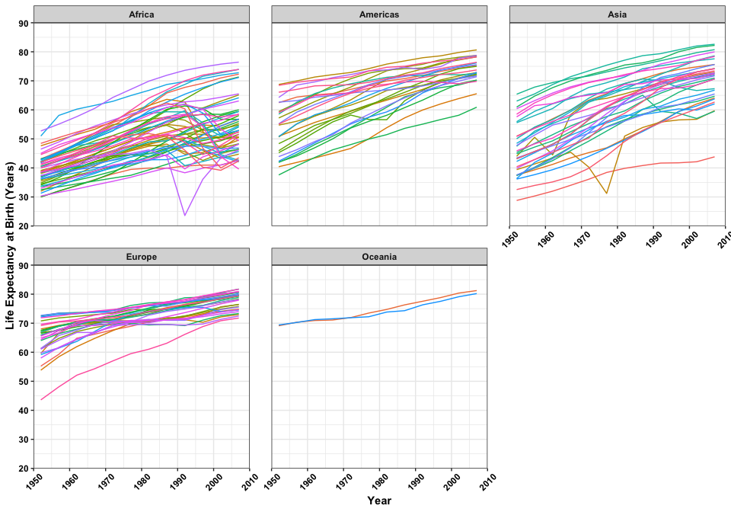

**Life expecetancy over time by country, stratified by continent.**

## Here are some quick examples of how you can use LaTeX syntax to embed quantitative statments into your file.

* Wrapping the expression in pairs of two dollar signs ($$..$$) generates a stand-alone equation.
$${\hat{Y}}_{i}={\hat{β}}_{0}+{\hat{β}}_{1}X_{i}+{\hat{ϵ}}_{i}$$

* In contrast, wrapping the expression in a pair of singe dollar signs ($..$) creates an in-line quantitative expression

This is some text with an in-line equation like ${\hat{Y}}_{i}={\hat{β}}_{0}+{\hat{β}}_{1}X_{i}+{\hat{ϵ}}_{i}$. Pretty cool, right?