David Mariani

650.483.4491

INSTRUCTIONS FOR importing finalsite CONSTITUENTS data into PDS church office

Table of Contents

Exporting Data from Finalsite 3

Step 1: Launch the Finalsite Export Utility 3

Step 2: Enter Start Date in the Exporter Tool & Click “Go” 4

Step 3: Import Family Data File into PDS Church Office 5

Step 4: Import Member Data File into PDS Church Office 12

# Exporting Data from Finalsite

First launch your **Windows VM** by clicking on the **Virtual Box** icon

## Step 1: Launch the Finalsite Export Utility

Go to the “c:\Program Files (x86)\OLA Parish\Finalsite Export Utility” folder and double-click on the **FinalSiteConstituentsExporter.exe** file.

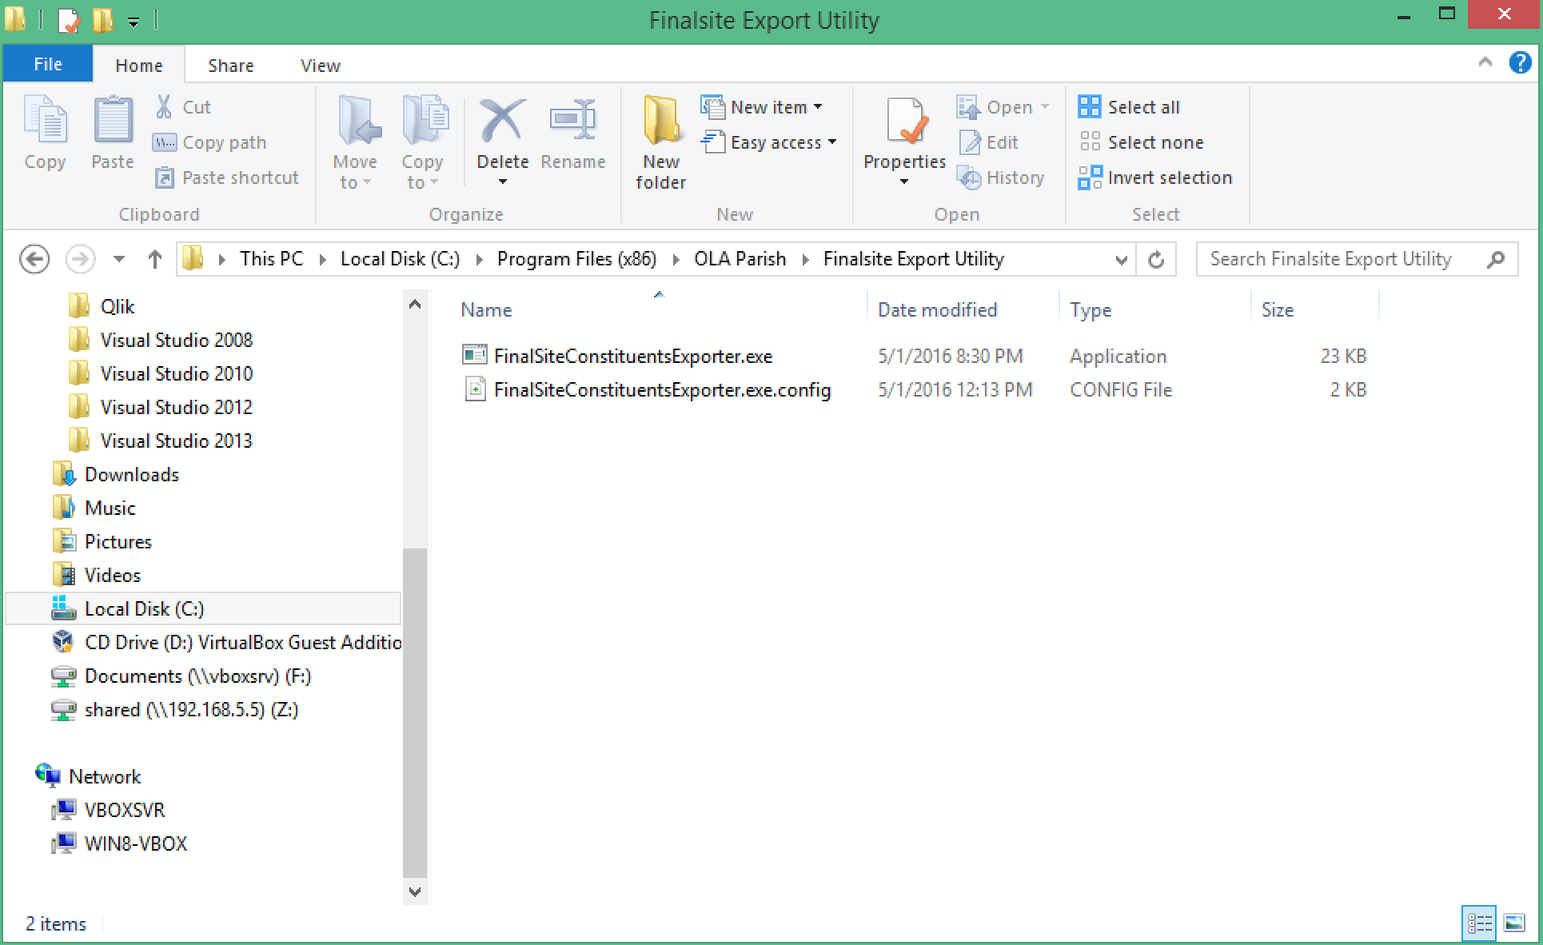

## Step 2: Enter Start Date in the Exporter Tool & Click “Go”

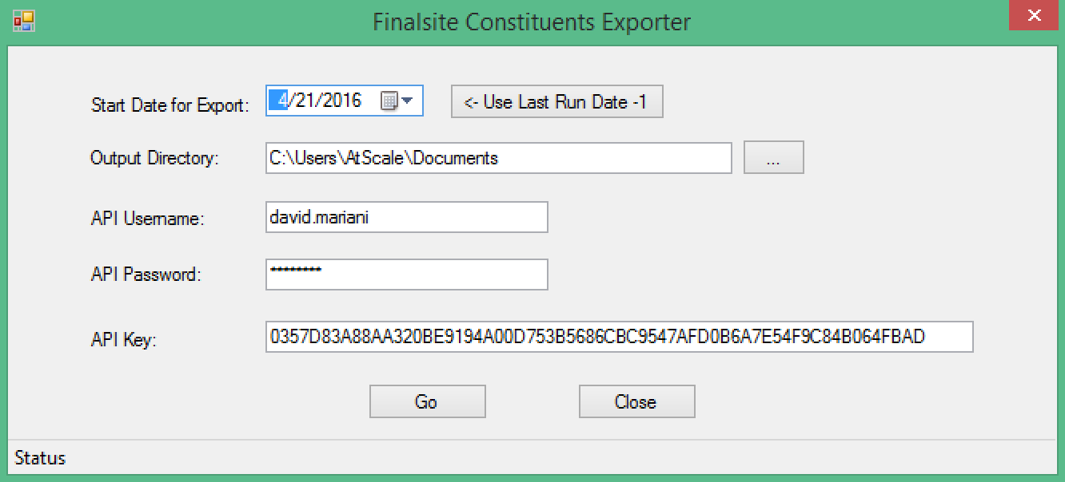

1. Choose the “Start Date for Export” date. This should be **1 day BEFORE your last export** so that you can be assured not to miss any new data. **You can click on the “Use Last Run Date -1” button to fill the control with the correct date of the last run minus 1 day**.
2. Choose the “Output Directory” location where the following files will be written:
   1. Families.csv (family data)
   2. Members.csv (individuals data)

**NOTE: You shouldn’t have to change this once it is configured.**

1. Enter the “API Username” and “API Password” fields. This should be the name ID and password that you use to log into Finalsite. You need to have API permissions to use this tool.

**NOTE: You shouldn’t have to change this once it is configured.**

1. Enter the “API Key” field. This is the API key that was sent to us from Finalsite.

**NOTE: You shouldn’t have to change this once it is configured.**

1. Click the “Go” button to start the export. If successful, you will get a message indicating the number of rows exported and you will have 2 output files (families.csv, members.csv) in the specified output directory.

**IMPORTANT: DON’T TRY AND EXPORT MORE THAN 4 WEEKS OF DATA USING THIS UTILITY. THE WEB SERVICE CALL TO FINALSITE MAY TIME OUT. FOR LARGER EXPORTS, USE THE FINALSITE CONSTITUENTS EXPORT TOOL INSTEAD.**

## Step 3: Import Family Data File into PDS Church Office

Launch the **PDS Church Office** program.

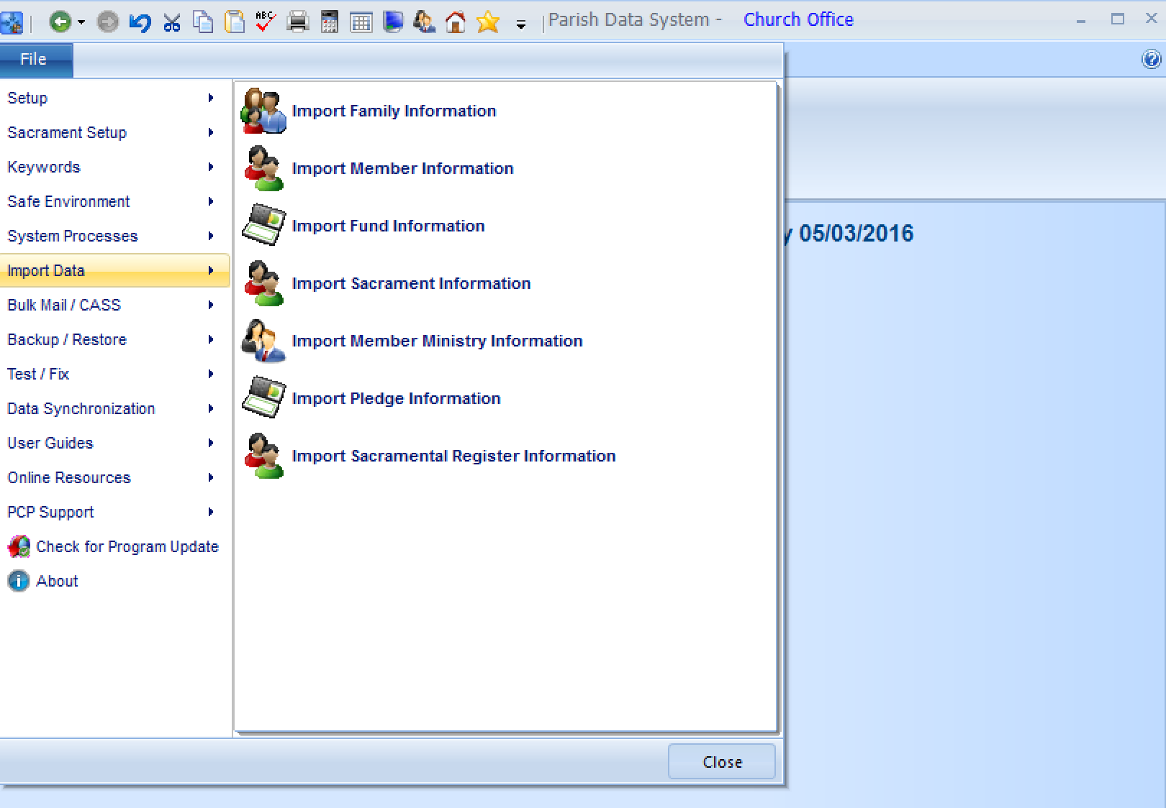

1. Under the File menu, choose the **Import Data/Import Family Information** option
2. Make sure your settings match the following screenshots **EXACTLY**
3. You can ignore (use defaults) for the “Keyword / Remarks” tab

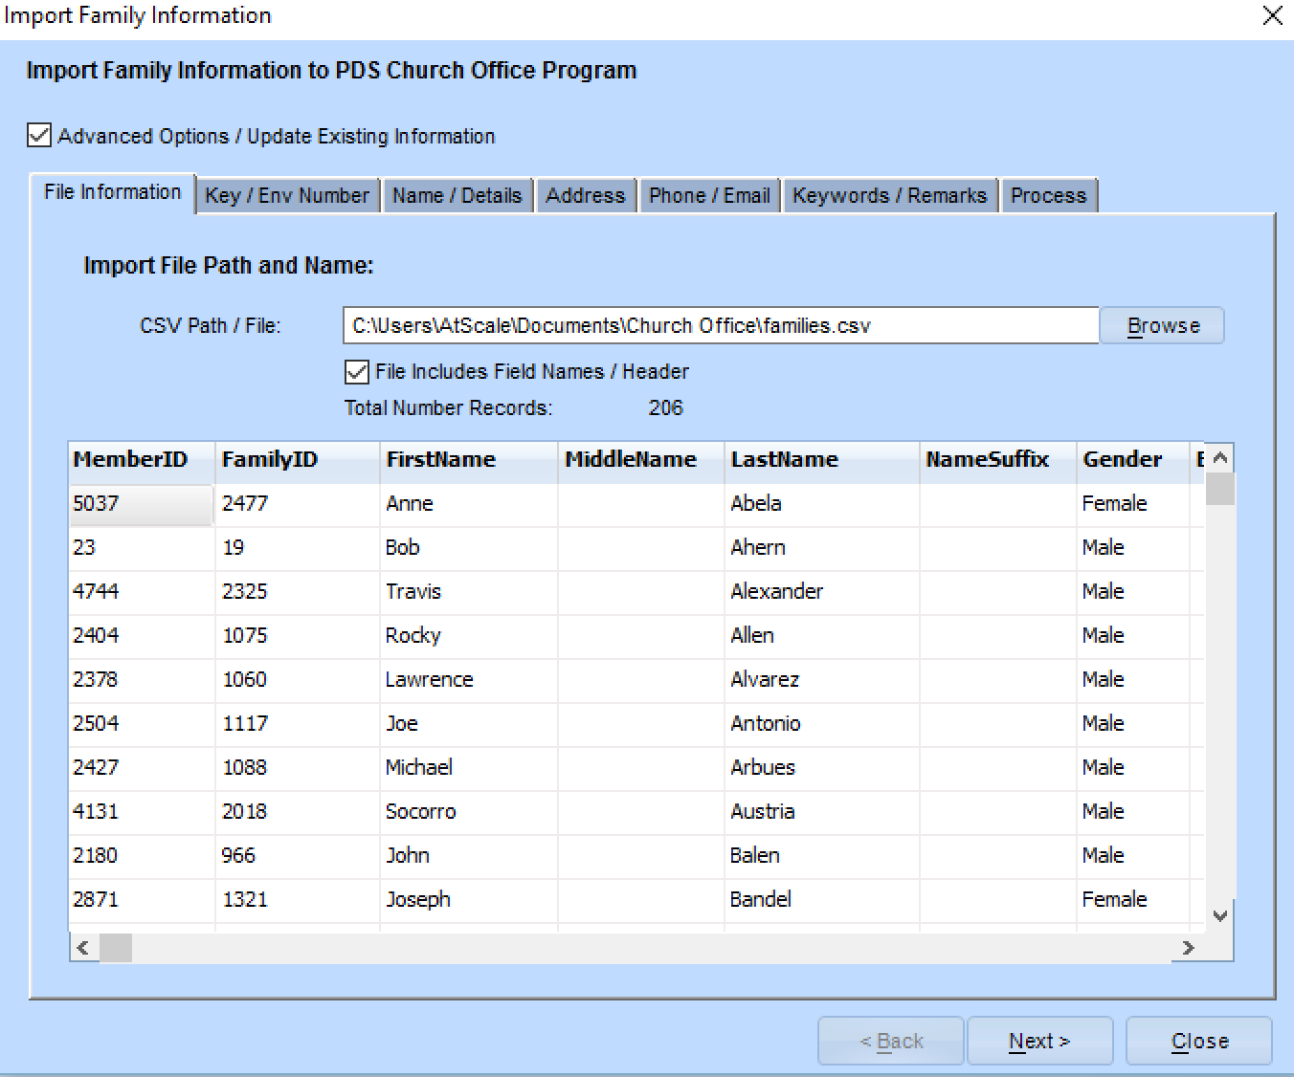

1. Find the families.csv file that was exported from Finalsite and load that file.

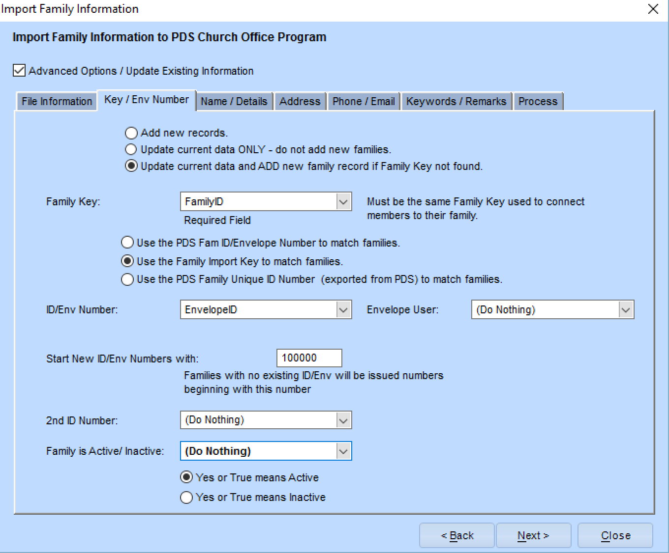

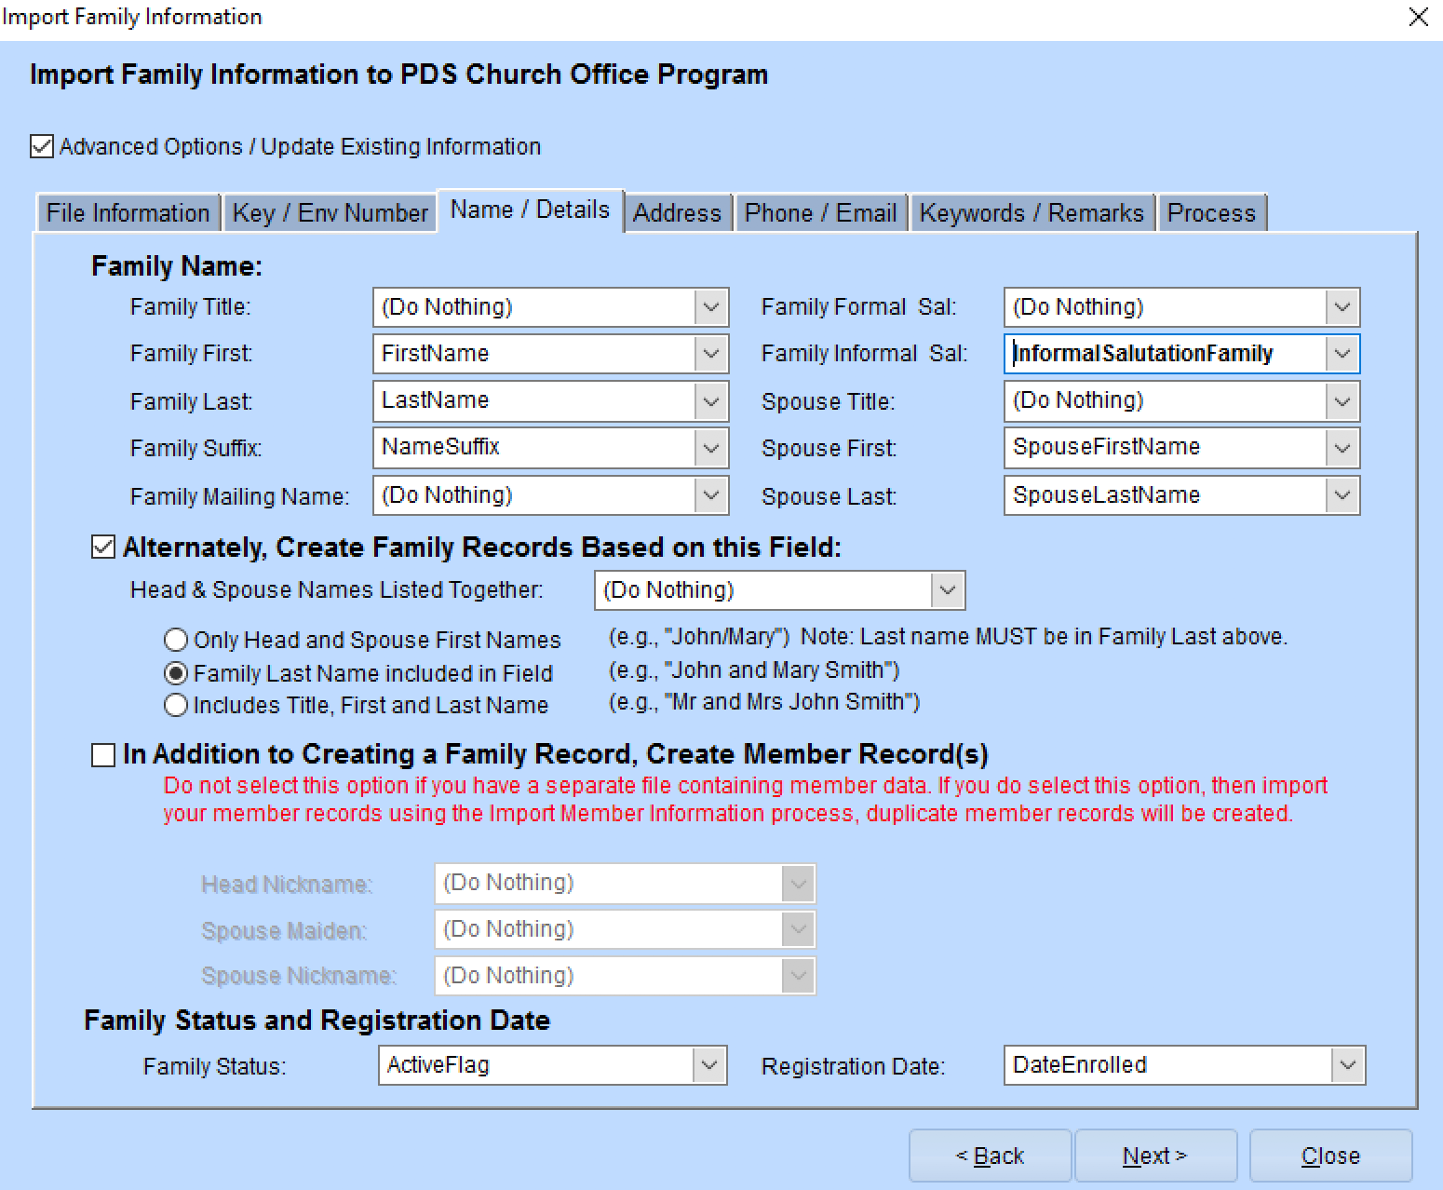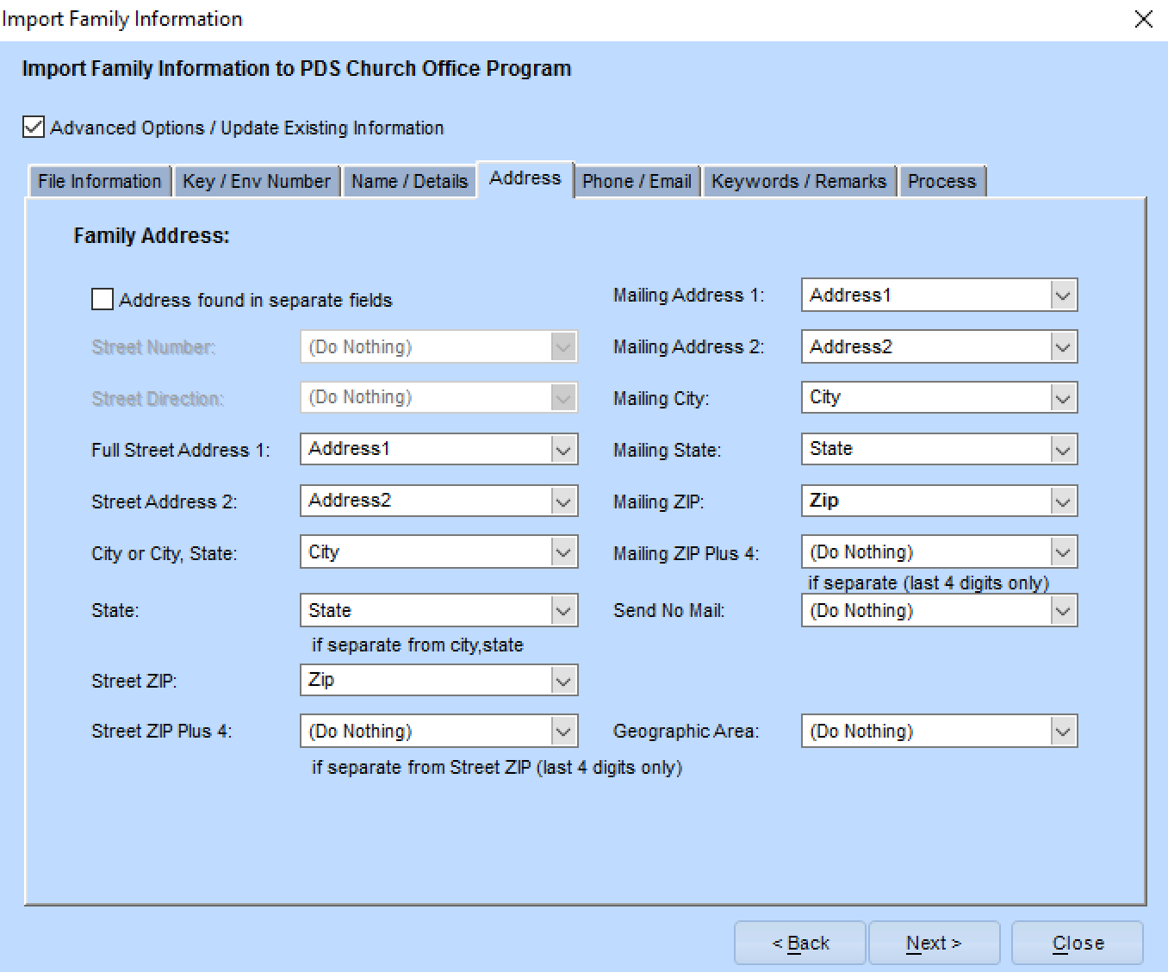

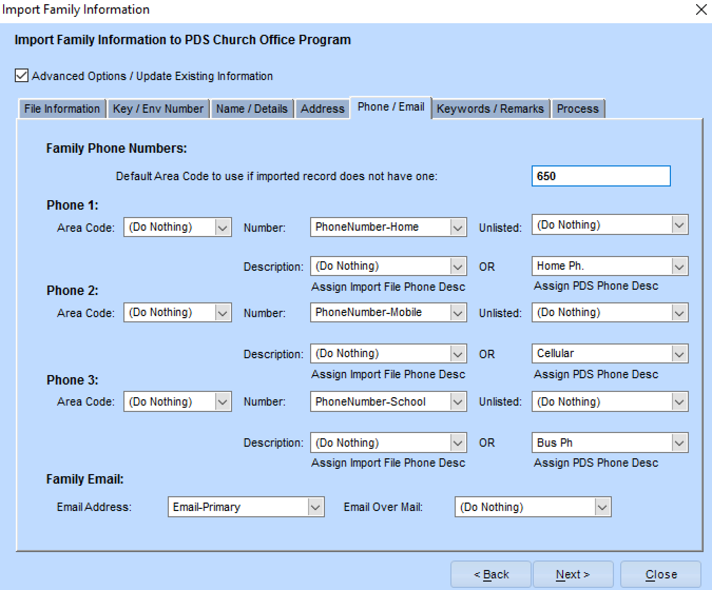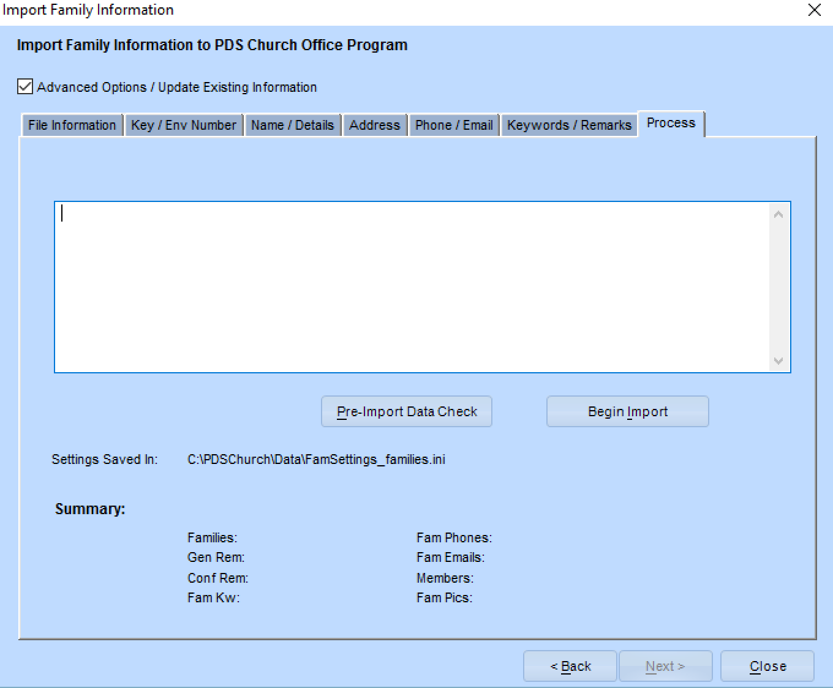

1. Click on the “Pre-Import Data Check” button to preview the import results. Verify that everything looks in order.
2. Then click on the “Begin Import” button.

## Step 4: Import Member Data File into PDS Church Office



1. Under the File menu, choose the **Import Data/Import Family Information** option
2. Make sure your settings match the following screenshots **EXACTLY**
3. You can ignore (use defaults) for the “User Keywords” and “Keyword / Remarks” tabs

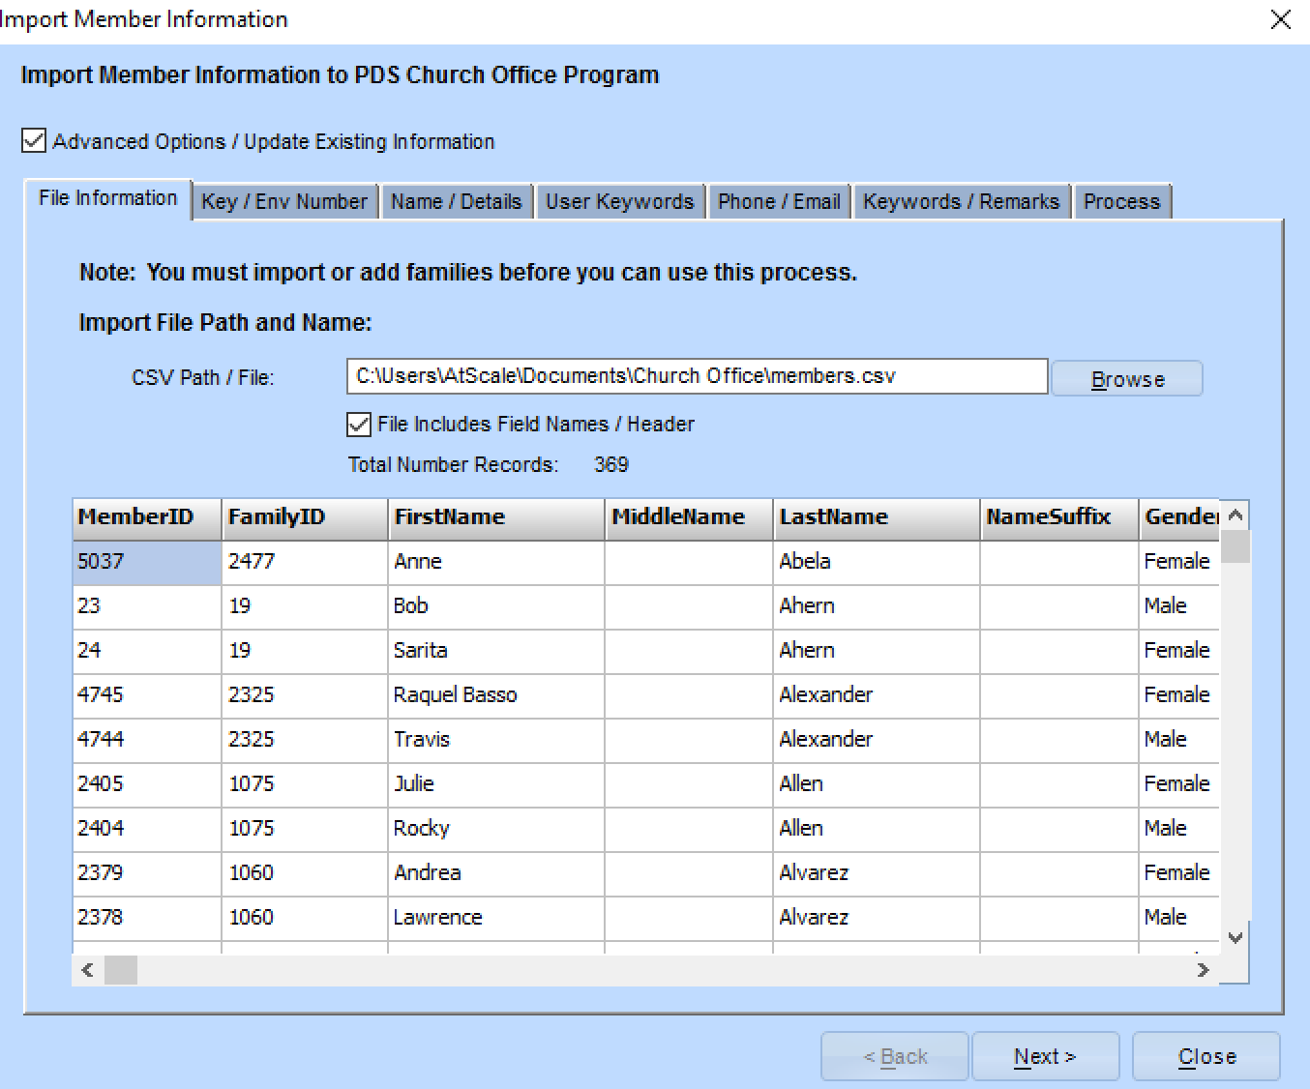

1. Find the members.csv file that was exported from Finalsite and load that file.

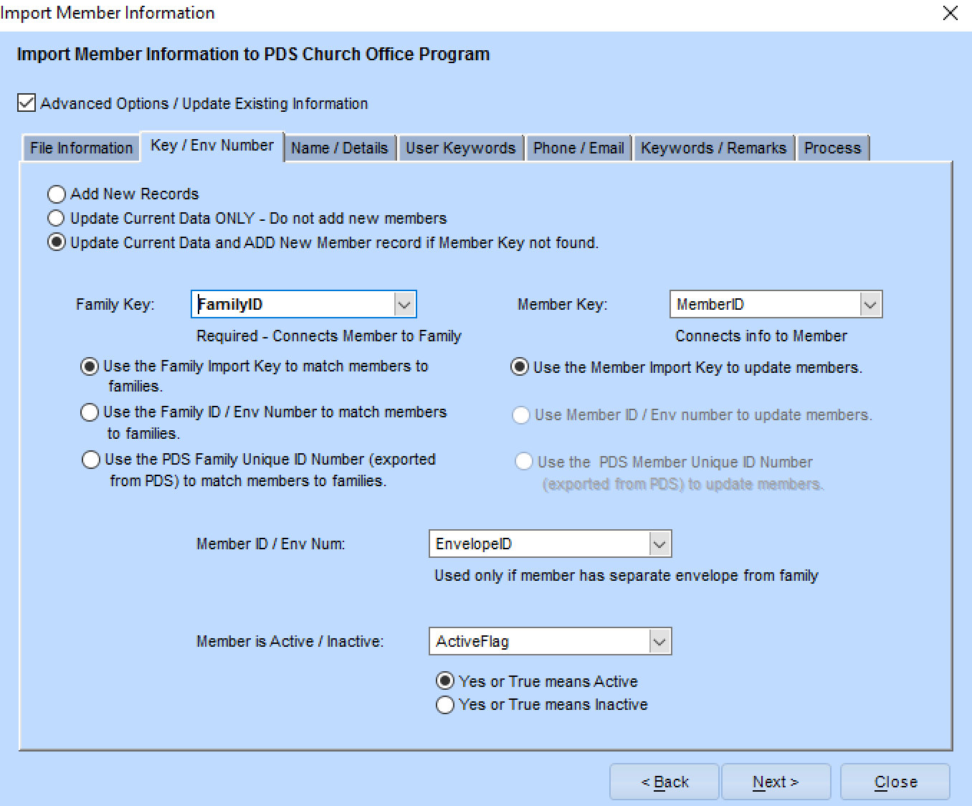

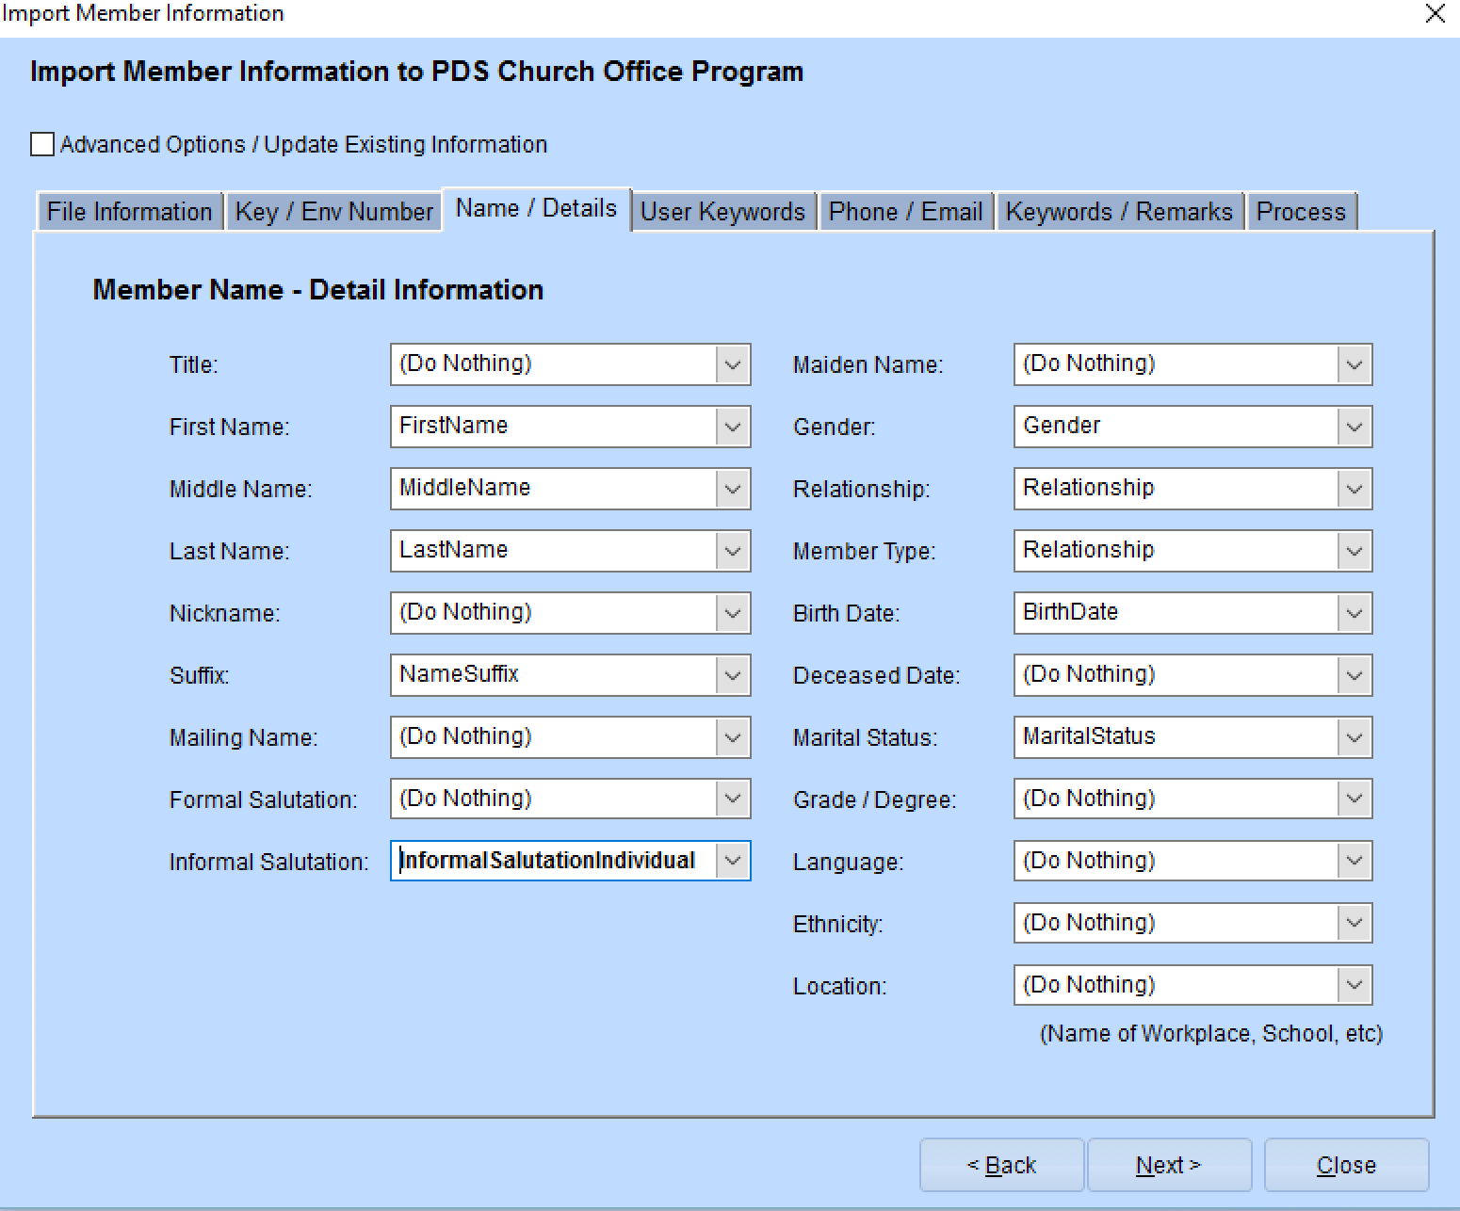

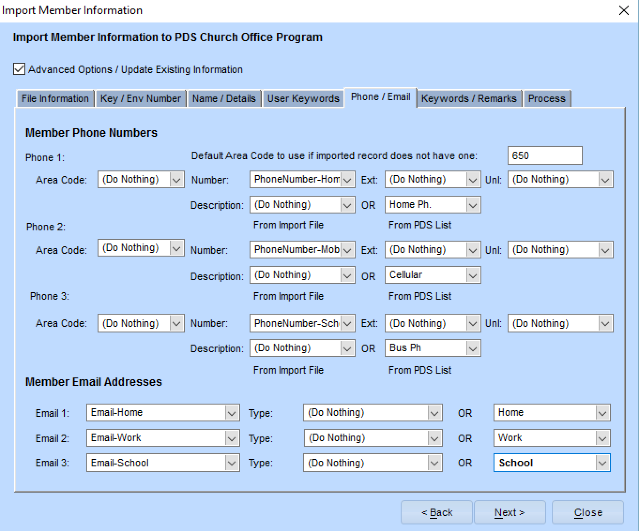

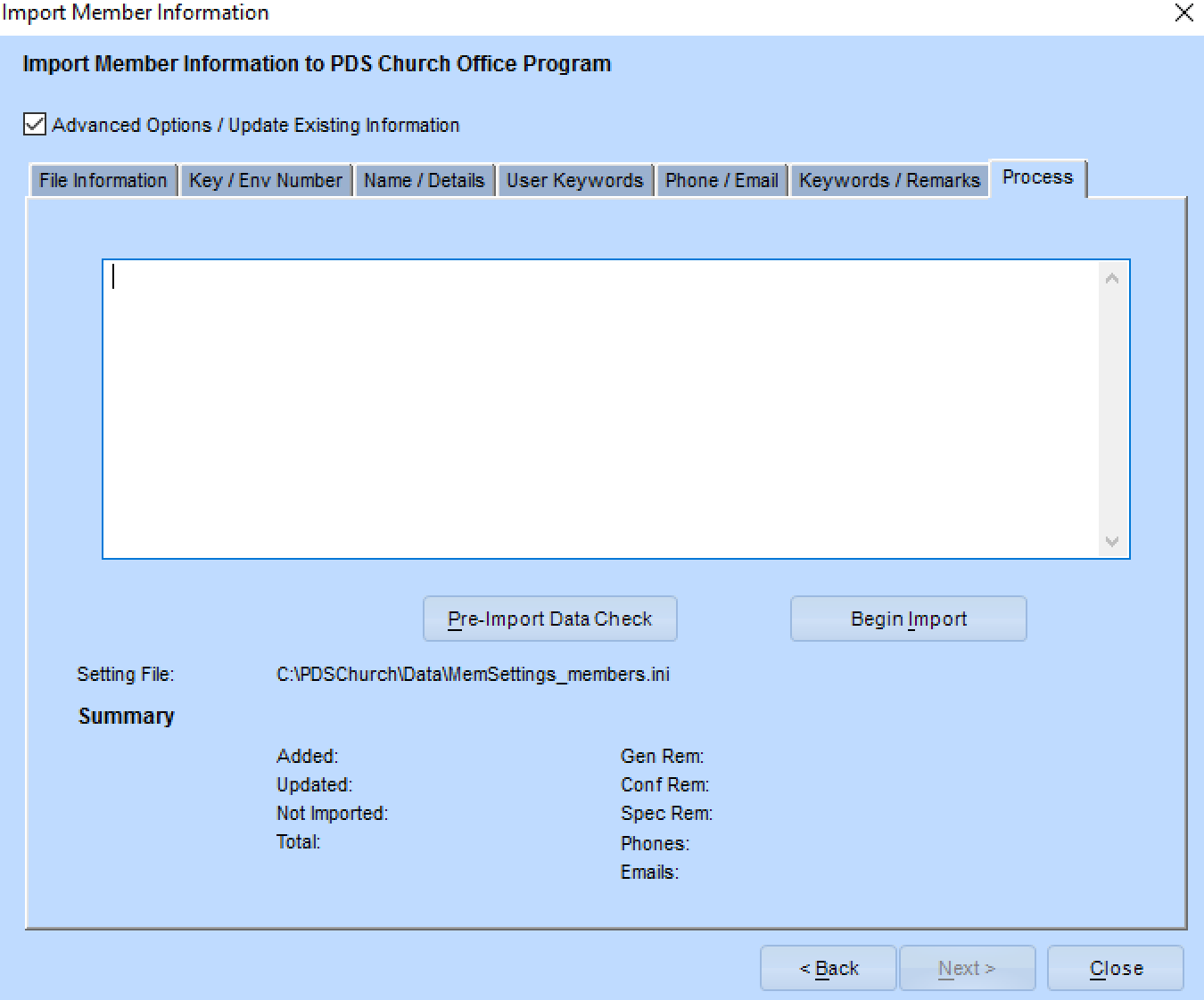

1. Click on the “Pre-Import Data Check” button to preview the import results. Verify that everything looks in order.
2. Then click on the “Begin Import” button.