Dart Frog Batesian Mimicry
Danielle Marichal
2026-11-06
library(patchwork)
library(tidyverse)
## ── Attaching core tidyverse packages ──────────────────────── tidyverse 2.0.0 ──
## ✔ dplyr 1.2.1 ✔ readr 2.2.0
## ✔ forcats 1.0.1 ✔ stringr 1.6.0
## ✔ ggplot2 4.0.3 ✔ tibble 3.3.1
## ✔ lubridate 1.9.5 ✔ tidyr 1.3.2
## ✔ purrr 1.2.2
## ── Conflicts ────────────────────────────────────────── tidyverse_conflicts() ──
## ✖ dplyr::filter() masks stats::filter()
## ✖ dplyr::lag() masks stats::lag()
## ℹ Use the conflicted package (<http://conflicted.r-lib.org/>) to force all conflicts to become errors
library(mgcv)
## Loading required package: nlme
##
## Attaching package: 'nlme'
##
## The following object is masked from 'package:dplyr':
##
## collapse
##
## This is mgcv 1.9-5. For overview type '?mgcv'.
library(ggplot2)
read_csv("McEwen-etal-2025_BehaviourData.csv")
## Rows: 351 Columns: 22
## ── Column specification ────────────────────────────────────────────────────────
## Delimiter: ","
## chr (6): FocalFrog, vids, Batch, TimeOfDay, LightTmnt, Behavior
## dbl (16): Day, Round, SVL, entry, EntryLatency, cross_square, jump, climb, T...
##
## ℹ Use `spec()` to retrieve the full column specification for this data.
## ℹ Specify the column types or set `show_col_types = FALSE` to quiet this message.
## # A tibble: 351 × 22
## FocalFrog vids Batch Day Round TimeOfDay LightTmnt SVL Behavior entry
## <chr> <chr> <chr> <dbl> <dbl> <chr> <chr> <dbl> <chr> <dbl>
## 1 ZAP_125 july8vi… A 1 1 Morning Light 17.0 entry 1
## 2 ZAP_125 july8vi… A 1 2 Afternoon Dark 17.0 entry 1
## 3 ZAP_125 july9vi… A 2 1 Morning Light 17.0 entry 1
## 4 ZAP_125 july9vi… A 2 2 Afternoon Light 17.0 entry 1
## 5 ZAP_126 july8vi… A 1 1 Morning Light 14.3 entry 1
## 6 ZAP_126 july8vi… A 1 2 Afternoon Dark 14.3 entry 1
## 7 ZAP_126 july9vi… A 2 1 Morning Light 14.3 entry 1
## 8 ZAP_126 july9vi… A 2 2 Afternoon Light 14.3 <NA> 0
## 9 ZAP_127 july8vi… A 1 1 Morning Light 17.0 entry 1
## 10 ZAP_127 july8vi… A 1 2 Afternoon Dark 17.0 entry 1
## # ℹ 341 more rows
## # ℹ 12 more variables: EntryLatency <dbl>, cross_square <dbl>, jump <dbl>,
## # climb <dbl>, TimeInArena <dbl>, TimeClimbing <dbl>, TimeTerrestrial <dbl>,
## # MinsTerrestrial <dbl>, SPMT <dbl>, JPMT <dbl>, DorsalColJND <dbl>,
## # DorsalLumJND <dbl>
dartfrog<-read_csv("McEwen-etal-2025_BehaviourData.csv")
## Rows: 351 Columns: 22
## ── Column specification ────────────────────────────────────────────────────────
## Delimiter: ","
## chr (6): FocalFrog, vids, Batch, TimeOfDay, LightTmnt, Behavior
## dbl (16): Day, Round, SVL, entry, EntryLatency, cross_square, jump, climb, T...
##
## ℹ Use `spec()` to retrieve the full column specification for this data.
## ℹ Specify the column types or set `show_col_types = FALSE` to quiet this message.
dartfrog<-dartfrog%>%select(FocalFrog,vids,SVL,DorsalColJND,DorsalLumJND)
oneSVL<-dartfrog%>%group_by(FocalFrog)%>%slice_min(order_by = vids)
oneSVL<-as.data.frame(oneSVL)
#Achromatic
ggplot(data = oneSVL)+geom_point(aes(x=SVL,y=DorsalLumJND))+ggtitle("Body Length vs. Achromatic Contrast") +theme_bw()+theme(panel.grid.major = element_blank())+theme(panel.grid.minor = element_blank())+ylab("Achromatic Contrast (Delta.L)")+xlab("Frog Length (SVL.mm)")+theme(legend.title = element_blank())+theme(legend.background = element_rect(linetype = "solid",color = "orchid"))
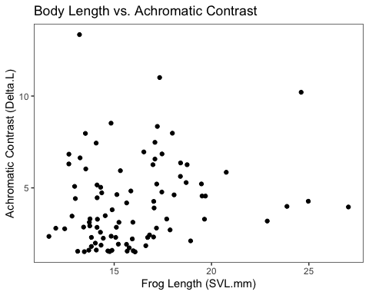
#Chromatic
ggplot(data = oneSVL)+geom_point(aes(x=SVL,y=DorsalColJND))+ggtitle("Body Length vs. Chromatic Contrast") +theme_bw()+theme(panel.grid.major = element_blank())+theme(panel.grid.minor = element_blank())+ylab("Chromatic Contrast (Delta.S)")+xlab("Frog Length (SVL.mm)")+theme(legend.title = element_blank())+theme(legend.background = element_rect(linetype = "solid",color = "navy"))
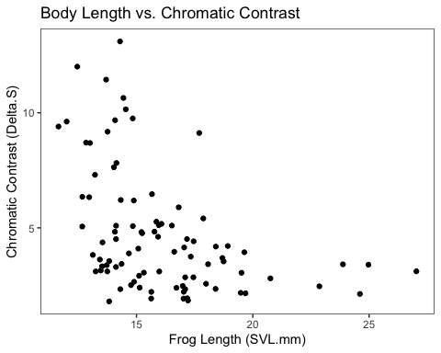
#GAMs
gamdorsalcol<-gam(DorsalColJND~s(SVL),data = oneSVL,family = gaussian(),method = "REML")
gam.check(gamdorsalcol)
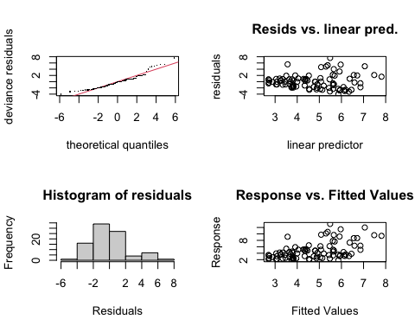
##
## Method: REML Optimizer: outer newton
## full convergence after 6 iterations.
## Gradient range [-2.540908e-09,2.041478e-11]
## (score 204.1784 & scale 5.327166).
## Hessian positive definite, eigenvalue range [0.579141,44.01168].
## Model rank = 10 / 10
##
## Basis dimension (k) checking results. Low p-value (k-index<1) may
## indicate that k is too low, especially if edf is close to k'.
##
## k' edf k-index p-value
## s(SVL) 9.00 2.42 1.03 0.57
summary(gamdorsalcol)
##
## Family: gaussian
## Link function: identity
##
## Formula:
## DorsalColJND ~ s(SVL)
##
## Parametric coefficients:
## Estimate Std. Error t value Pr(>|t|)
## (Intercept) 4.7415 0.2433 19.49 <2e-16 ***
## ---
## Signif. codes: 0 '***' 0.001 '**' 0.01 '*' 0.05 '.' 0.1 ' ' 1
##
## Approximate significance of smooth terms:
## edf Ref.df F p-value
## s(SVL) 2.424 3.033 9.247 2.14e-05 ***
## ---
## Signif. codes: 0 '***' 0.001 '**' 0.01 '*' 0.05 '.' 0.1 ' ' 1
##
## R-sq.(adj) = 0.234 Deviance explained = 25.5%
## -REML = 204.18 Scale est. = 5.3272 n = 90
gamdorsallum<-gam(DorsalLumJND~s(SVL),data = oneSVL,family = gaussian(),method = "REML")
gam.check(gamdorsallum)
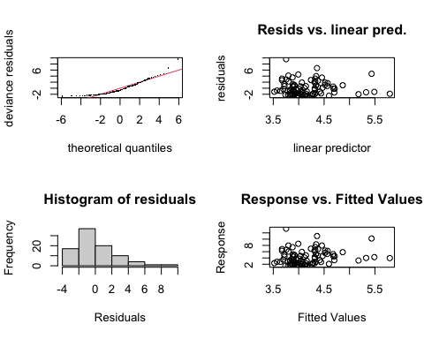
##
## Method: REML Optimizer: outer newton
## full convergence after 9 iterations.
## Gradient range [-4.569883e-05,2.865386e-05]
## (score 203.5216 & scale 5.394312).
## Hessian positive definite, eigenvalue range [4.569155e-05,43.99997].
## Model rank = 10 / 10
##
## Basis dimension (k) checking results. Low p-value (k-index<1) may
## indicate that k is too low, especially if edf is close to k'.
##
## k' edf k-index p-value
## s(SVL) 9 1 0.99 0.4
summary(gamdorsallum)
##
## Family: gaussian
## Link function: identity
##
## Formula:
## DorsalLumJND ~ s(SVL)
##
## Parametric coefficients:
## Estimate Std. Error t value Pr(>|t|)
## (Intercept) 4.1701 0.2448 17.03 <2e-16 ***
## ---
## Signif. codes: 0 '***' 0.001 '**' 0.01 '*' 0.05 '.' 0.1 ' ' 1
##
## Approximate significance of smooth terms:
## edf Ref.df F p-value
## s(SVL) 1 1 3.062 0.0836 .
## ---
## Signif. codes: 0 '***' 0.001 '**' 0.01 '*' 0.05 '.' 0.1 ' ' 1
##
## R-sq.(adj) = 0.0227 Deviance explained = 3.36%
## -REML = 203.52 Scale est. = 5.3943 n = 90
predictgamdorsalcol<-data.frame(SVL=oneSVL$SVL,DorsalColJND = predict.gam(gamdorsalcol, newdata = oneSVL))
predictgamdorsalcol
## SVL DorsalColJND
## 1 17.050 3.809311
## 2 14.305 5.479820
## 3 17.031 3.817280
## 4 13.830 5.855587
## 5 18.077 3.441144
## 6 13.125 6.452796
## 7 13.724 5.942331
## 8 14.031 5.694040
## 9 18.696 3.266293
## 10 15.213 4.820438
## 11 24.970 2.705343
## 12 14.440 5.376768
## 13 14.360 5.437637
## 14 17.335 3.695357
## 15 14.294 5.488289
## 16 17.698 3.564044
## 17 15.930 4.367294
## 18 27.031 2.739404
## 19 15.773 4.460389
## 20 17.171 3.759675
## 21 12.674 6.857515
## 22 15.666 4.525898
## 23 12.458 7.055956
## 24 18.926 3.208523
## 25 13.522 6.110654
## 26 17.093 3.791453
## 27 13.758 5.914389
## 28 13.218 6.371350
## 29 16.075 4.284589
## 30 17.217 3.741299
## 31 14.886 5.048383
## 32 18.401 3.345942
## 33 15.961 4.349347
## 34 16.816 3.910878
## 35 24.604 2.702427
## 36 13.827 5.858027
## 37 13.696 5.965426
## 38 14.081 5.654439
## 39 14.766 5.134855
## 40 14.540 5.301504
## 41 12.671 6.860254
## 42 12.000 7.482718
## 43 20.756 2.874527
## 44 13.541 6.094653
## 45 17.871 3.506288
## 46 17.184 3.754455
## 47 17.093 3.791453
## 48 14.326 5.463681
## 49 14.124 5.620566
## 50 14.897 5.040528
## 51 15.079 4.912423
## 52 18.410 3.343417
## 53 16.718 3.955686
## 54 12.968 6.591955
## 55 11.648 7.813261
## 56 16.523 4.048970
## 57 19.638 3.052695
## 58 15.980 4.338418
## 59 16.991 3.834215
## 60 14.139 5.608789
## 61 15.640 4.542063
## 62 13.466 6.158019
## 63 17.447 3.653283
## 64 13.428 6.190331
## 65 15.857 4.410127
## 66 19.515 3.077171
## 67 14.120 5.623710
## 68 15.318 4.749833
## 69 14.118 5.625282
## 70 15.138 4.871669
## 71 14.675 5.201372
## 72 23.874 2.701995
## 73 15.633 4.546431
## 74 13.248 6.345241
## 75 22.862 2.719520
## 76 13.005 6.558979
## 77 19.481 3.084115
## 78 12.835 6.711351
## 79 17.457 3.649596
## 80 15.245 4.798779
## 81 14.845 5.077765
## 82 14.074 5.659970
## 83 15.111 4.890271
## 84 16.624 3.999961
## 85 19.687 3.043224
## 86 13.746 5.924238
## 87 17.022 3.821072
## 88 18.746 3.253418
## 89 17.989 3.468510
## 90 14.839 5.082080
predictgamdorsallum<-data.frame(SVL=oneSVL$SVL,DorsalLumJND = predict.gam(gamdorsallum, newdata = oneSVL))
predictgamdorsallum
## SVL DorsalLumJND
## 1 17.050 4.318807
## 2 14.305 3.913511
## 3 17.031 4.316002
## 4 13.830 3.843382
## 5 18.077 4.470446
## 6 13.125 3.739296
## 7 13.724 3.827732
## 8 14.031 3.873057
## 9 18.696 4.561841
## 10 15.213 4.047572
## 11 24.970 5.488148
## 12 14.440 3.933443
## 13 14.360 3.921632
## 14 17.335 4.360889
## 15 14.294 3.911887
## 16 17.698 4.414486
## 17 15.930 4.153437
## 18 27.031 5.792427
## 19 15.773 4.130256
## 20 17.171 4.336673
## 21 12.674 3.672710
## 22 15.666 4.114457
## 23 12.458 3.640820
## 24 18.926 4.595800
## 25 13.522 3.797909
## 26 17.093 4.325157
## 27 13.758 3.832752
## 28 13.218 3.753026
## 29 16.075 4.174846
## 30 17.217 4.343465
## 31 14.886 3.999292
## 32 18.401 4.518285
## 33 15.961 4.158014
## 34 16.816 4.284257
## 35 24.604 5.434112
## 36 13.827 3.842939
## 37 13.696 3.823598
## 38 14.081 3.880440
## 39 14.766 3.981575
## 40 14.540 3.948207
## 41 12.671 3.672268
## 42 12.000 3.573201
## 43 20.756 4.865992
## 44 13.541 3.800714
## 45 17.871 4.440030
## 46 17.184 4.338593
## 47 17.093 4.325157
## 48 14.326 3.916612
## 49 14.124 3.886788
## 50 14.897 4.000916
## 51 15.079 4.027788
## 52 18.410 4.519614
## 53 16.718 4.269787
## 54 12.968 3.716116
## 55 11.648 3.521232
## 56 16.523 4.240994
## 57 19.638 4.700925
## 58 15.980 4.160819
## 59 16.991 4.310096
## 60 14.139 3.889003
## 61 15.640 4.110618
## 62 13.466 3.789641
## 63 17.447 4.377426
## 64 13.428 3.784031
## 65 15.857 4.142658
## 66 19.515 4.682764
## 67 14.120 3.886198
## 68 15.318 4.063075
## 69 14.118 3.885902
## 70 15.138 4.036499
## 71 14.675 3.968139
## 72 23.874 5.326336
## 73 15.633 4.109585
## 74 13.248 3.757455
## 75 22.862 5.176925
## 76 13.005 3.721579
## 77 19.481 4.677744
## 78 12.835 3.696480
## 79 17.457 4.378902
## 80 15.245 4.052297
## 81 14.845 3.993239
## 82 14.074 3.879406
## 83 15.111 4.032512
## 84 16.624 4.255907
## 85 19.687 4.708160
## 86 13.746 3.830980
## 87 17.022 4.314673
## 88 18.746 4.569224
## 89 17.989 4.457453
## 90 14.839 3.992353
library(tidygam)
#attempting graph for chromatic contrast
chromaticplot<- ggplot(data = predictgamdorsalcol, aes(x = SVL, y = DorsalColJND)) + geom_point(data = oneSVL, aes(x = SVL, y = DorsalColJND), color = "navy", alpha = 0.5, shape = 3, size = 1) + geom_smooth(data= oneSVL, aes(x=SVL,y=DorsalColJND),method = "lm", level = 0.95, fill = "cornflowerblue", alpha = 0.5,inherit.aes = FALSE) + geom_line(color = "black", linewidth = 1) + labs(title = "Body Length vs. Chromatic Contrast",x = "SVL (mm)", y = "Chromatic contrast (dS)")+ scale_x_continuous(limits = c(0, 30), breaks = seq(0, 30, 5)) + scale_y_continuous(limits = c(0, 15), breaks = seq(0, 15, 5)) + theme_bw() + theme(axis.line = element_line(colour = "black"), panel.grid.major = element_blank(), panel.grid.minor = element_blank(), panel.background = element_blank()) + theme(panel.grid = element_blank()) + theme(panel.grid = element_blank()) + theme(plot.title = element_text(size=11,face = "bold",hjust = 0.5)) + theme(axis.title.y = element_text(size = 9, face = "bold")) + theme(axis.title.x = element_text(size = 9, face = "bold")) + theme(axis.text.x = element_text(size = 8, face = "bold")) + theme(axis.text.y = element_text(size = 8, face = "bold")) + theme(axis.ticks.y = element_line(linewidth = 0.7)) + theme(axis.ticks.x = element_line(linewidth = 0.7))
#attempting graph for achromatic contrast
plot(chromaticplot)
## `geom_smooth()` using formula = 'y ~ x'
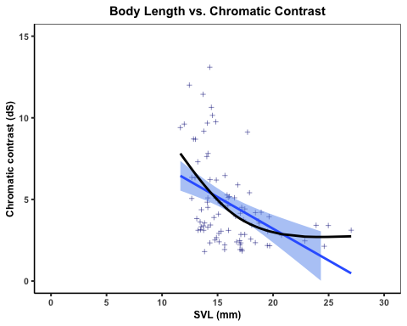
achromaticplot<- ggplot(data = predictgamdorsallum, aes(x = SVL, y = DorsalLumJND)) + geom_point(data = oneSVL, aes(x = SVL, y = DorsalLumJND), color = "darkgreen", alpha = 0.5, shape = 3, size = 1) + geom_smooth(data= oneSVL, aes(x=SVL,y=DorsalLumJND),method = "lm", level = 0.95, fill = "springgreen", alpha = 0.5,inherit.aes = FALSE) + geom_line(color = "black", linewidth = 1) + labs(title = "Body Length vs. Achromatic Contrast",x = "SVL (mm)", y = "Achromatic contrast (dL)")+ scale_x_continuous(limits = c(0, 30), breaks = seq(0, 30, 5)) + scale_y_continuous(limits = c(0, 15), breaks = seq(0, 15, 5)) + theme_bw() + theme(axis.line = element_line(colour = "black"), panel.grid.major = element_blank(), panel.grid.minor = element_blank(), panel.background = element_blank()) + theme(panel.grid = element_blank()) + theme(panel.grid = element_blank()) + theme(plot.title = element_text(size=11,face = "bold",hjust = 0.5)) + theme(axis.title.y = element_text(size = 9, face = "bold")) + theme(axis.title.x = element_text(size = 9, face = "bold")) + theme(axis.text.x = element_text(size = 8, face = "bold")) + theme(axis.text.y = element_text(size = 8, face = "bold")) + theme(axis.ticks.y = element_line(linewidth = 0.7)) + theme(axis.ticks.x = element_line(linewidth = 0.7))
plot(achromaticplot)
## `geom_smooth()` using formula = 'y ~ x'
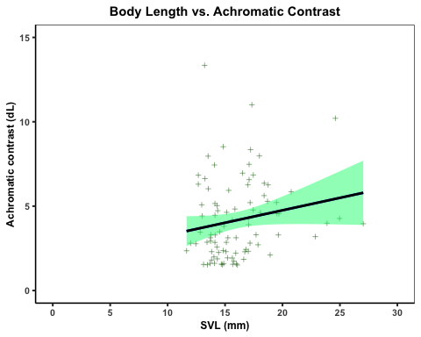
#combining chromatic and achromatic graphs
achrom.chrom.plot<-chromaticplot+achromaticplot+plot_layout(nrow=2)
plot(achrom.chrom.plot)
## `geom_smooth()` using formula = 'y ~ x'
## `geom_smooth()` using formula = 'y ~ x'


