Eclipse RCP course
Exercises script

Introduction
This document assumes the reader has already attended GMV's EclipseRCP course. It is intended to enable the reader to REPEAT the exercises from the course on his/her own.

To follow the exercises you need the course material, which includes:
- “Infrastructure” plugins the exercises are built on top of.
- Solutions to the exercises (to be used as cheatsheet).
The exercises material and solutions are located at repository:
- https://github.com/dmarina-esa/EclipseRCPTraining/

The source code for the exercises has been tested with java 11 and Eclipse IDE 2019-09 (4.13) for RCP and RAP Developers, running under Microsoft Windows 10.
- Link to Eclipse IDE 2019-09 for RCP and RAP Developers

Extra information sources:
- Eclipse RCP course slides
- Eclipse RCP book (ISBN13: 978-0321334619), available at GMV’s library.

If you notice inconsistencies, lack of information or any other issue, please report them to David Marina (dmarina@gmv-insyen.com).

Exercise 01: An empty plugin

Goals
- First glance at the elements that conforms a plugin.
- First glance at the Target Platform.

Material
- Eclipse IDE for RCP and RAP Developers 4.13 (2019-09) or higher (Java 11 compatible)
- Target Platform folder for the course.

Abstract
In this exercise, the student creates a new empty RCP Plugin to understand which the required files are. The plugin dependencies mechanisms are explored to understand the role of the Target Platform.

Steps
- Open Eclipse and create a new Workspace
- Clone the course repository:

  - Copy the project’s repository URL to your clipboard
  - Open Eclipse’s Git perspective (on the right top corner)
  - In Git Repoitories view, select “Clone a Git repository
    - The repository location is auto-completed from the clipboard
- Create a new plug-in project
  - Switch back to the Plug-in Development perspective
  - In the main menu: File -> New -> Project…
  - Select Plug-in Development -> Plug-in Project in the wizard).
  - Click next, specify a project name: com.gmv.course.exercise01
  - Click next, select “Generate an activator, […]”.
  - Click Finish.
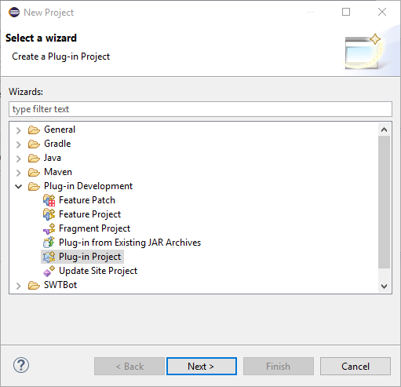
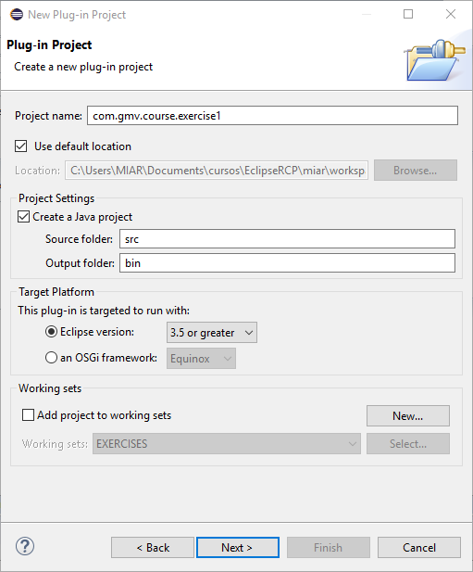
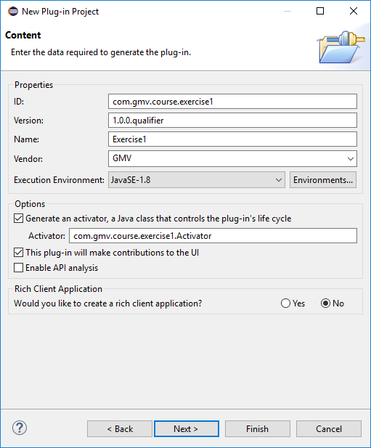

- Open the META-INF/MANIFEST.MF file (it should be open automatically)
- In the “Dependencies” tab, remove “org.eclipse.core.runtime” and save.
- Open the Activator class, check that there are errors because the imports cannot be resolved.
- In the MANIFEST.MF editor, in the “Dependencies” tab, click “Add…” and select “org.eclipse.core.runtime” again. Save.
- Check that the errors are gone from the Activator class.
- Open the Target Platform configuration
  - In the main menu: Window -> Preferences.
  - In the Preferences dialog, open Plug-in Development -> Target Platform.
- Create a new target platform
  - Click “Add…” and create a target platform from the current one “Current Target: Copy settings from the current target platform”.
  - Enter a name and click “Add…”.
  - In the wizard, select “Directory” and click “Next”.
  - Select the folder with the additional Target Platform plugins for the course and click “Finish”:
    - The folder named “target_plugins” at the master branch of the cloned repository.
    - It is recommended to copy this folder to a new location; otherwise, you will lose the Target Platform files when switching branches.
  - Click “Finish”.
  - Select (tick) the new target platform and click “OK”.
- Add a dependency to “com.gmv.exercise.utils”.

Exercise 02: Contribute a view to the IDE

GOALS
- Provide an extension for an extension point.
- Contributing a view.
- Executing a plugin with Eclipse.

Material
- Target platform folder for the course.
- Icons folder.

Abstract
In this exercise, the student creates a new plugin that provides an extension to “org.eclipse.ui.views” extension point to contribute a view to the Eclipse IDE.
In the final steps, the student launches an application containing the Eclipse IDE, but extended with the functionality from the newly created plugin.

Steps
- Add the course target platform folder to the default target platform. (skip this step if you finished Exercise 01)
- Create a new plug-in project as in Exercise 01 (optionally, the plugin created in Exercise 01 can be reused).
- Notice that initially the plugin does not have a file called “plugin.xml”. It is created automatically when you specify an extension or extension point using the manifest editor.
- Add a dependency on “com.gmv.course.exercise.utils”. (skip this step if you finished Exercise 01 and you are reusing the created plugin)
- Open the MANIFEST.MF and in the “Overview” tab click on “Extensions”.
- In the “Extensions” tab, click “Add…” and select “org.eclipse.ui.views”. Press “Finish”. (note that file plugin.xml is automatically created)
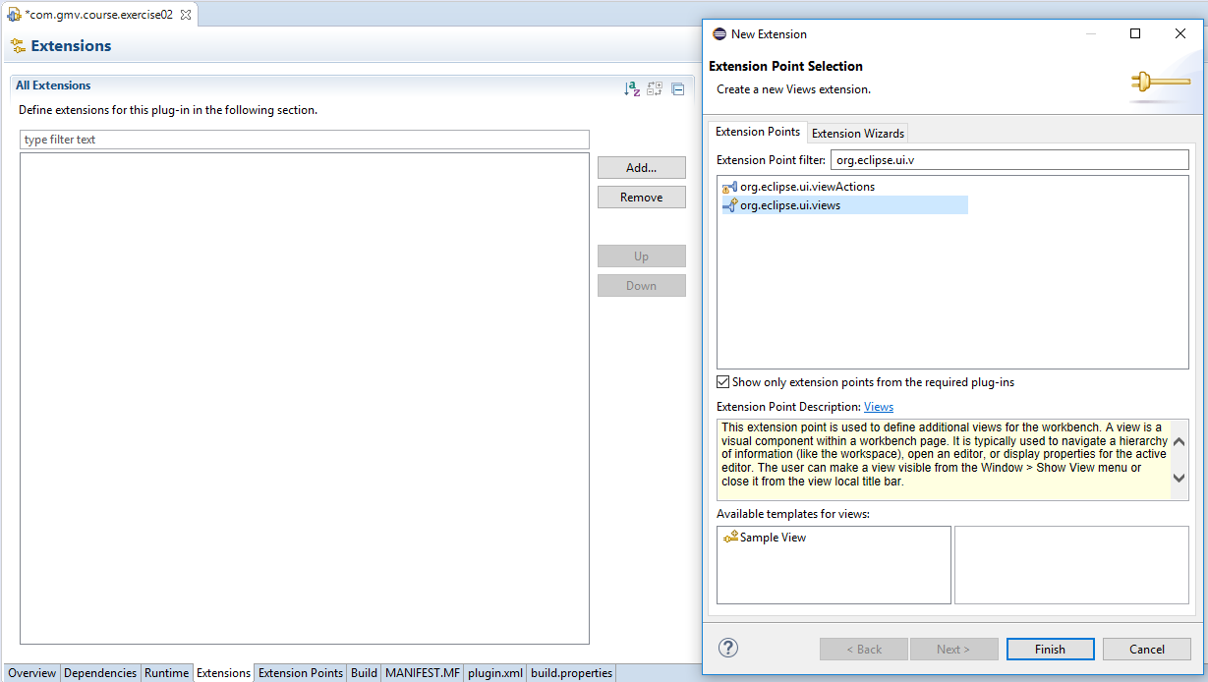
- Right-click on the just created element "org.eclipse.ui.views" and select New -> view.
- In Extension Element Details, fill the mandatory data marked with “*”.
  - Id = “com.gmv.course.exercise02.view”
  - Name = “Exercise02”
  - For the class, click on “class*:” and fill the class name and package in the wizard
    - Package = “com.gmv.course.exercise02.views”
      - It is a good practice that the plugin id is used as the root for all the package names, so you may want to call it “com.gmv.course.exercise01.views” if you reused the plugin from exercise01
    - Name = “Exercise02View”
  - Press “Finish”
- In the view editor, go to createPartControl() method and add: Exercise02Utils.createViewContents(parent);
- Save all the files.
- Double click in the Manifest file. In the “Overview” tab of the manifest editor, click “Launch an Eclipse application”.
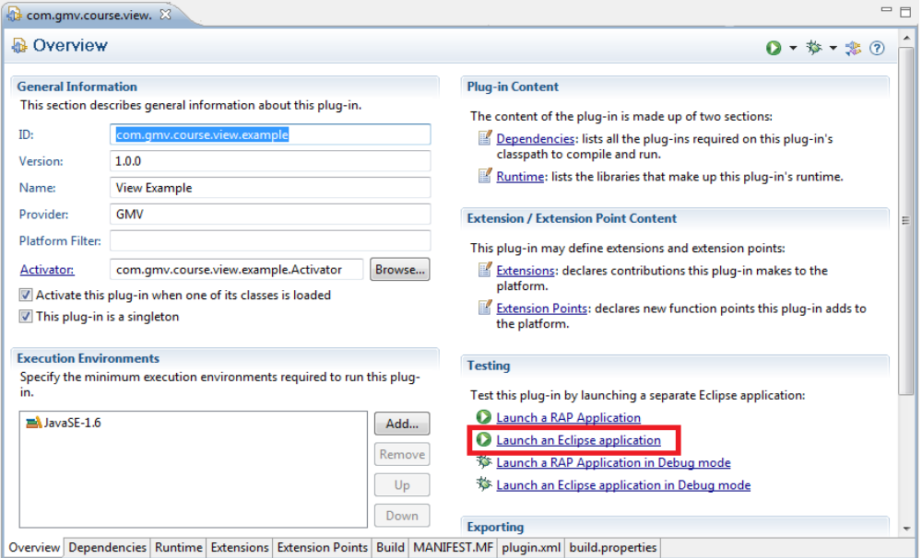
  - Some versions of Eclipse may show some errors, ignore them for the moment
- Wait for a new Eclipse application to start and close the Overview page if it is displayed.
  - Depending on the version this may take long: we are launching a full Eclipse!!
- In the new Eclipse, select Window -> Show view -> other -> other -> Exercise 02.

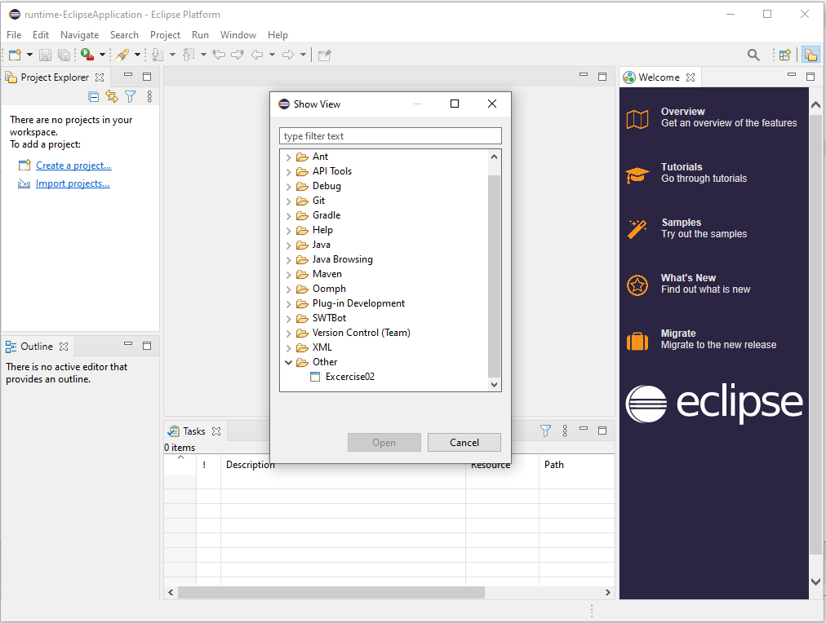

Exercise 03: Sport Simulator application

Goals
- Plugin project creation
- Extending an extension point.
- Creating a view.
- First steps with SWT and JFace viewers.
- Creating an RCP application.

Material
- Target platform folder for the course.
  - Eclipse plugin exporting sport service API (called "com.gmv.sportsimulator.api")
  - Eclipse plugin exporting tennis simulator service (called “com.gmv.sportsimulator.tennis”)
- Icons folder.

Abstract
In this exercise, the student creates a new plugin that extends org.eclipse.ui.views extension point and codes a ViewPart showing a TreeViewer displaying game/players hierarchy. For the domain model to be filled with data, the student hardcodes the creation of Teams and Games in the body of the view constructor.
The student will use the Eclipse wizard to create an empty RCP application and will modify it to display the created views as a separate application out of the Eclipse IDE.

The Sport Simulator Service
The plugins included as the addition to the Target Platform compose a sport simulator service. The following is the class diagram describing the Simulator Service:
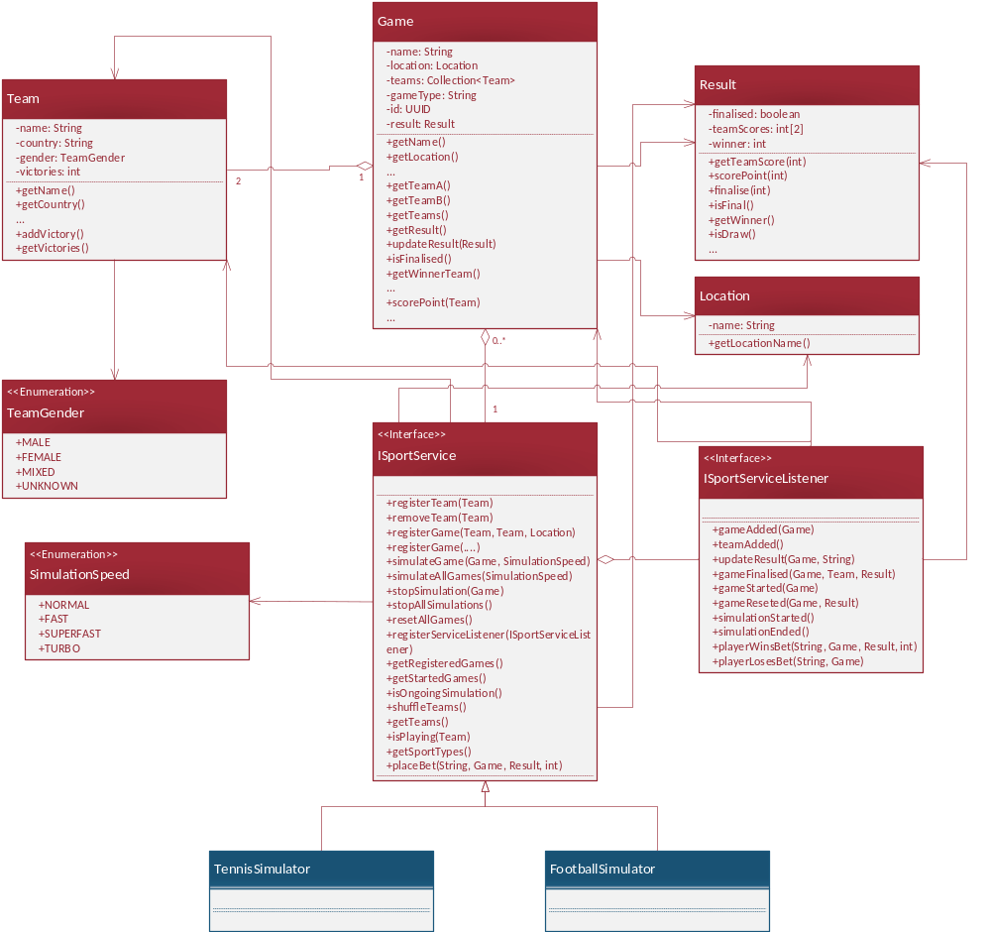

Plugin com.gmv.sportsimulator.api provides a generic service interface that shall serve as the contact point for the service clients, regardless of the type of sport that the actual implementation(s) provides. Classes provided by this plugin are displayed in red color in the diagram.
In general, a sport service is composed of Games that can be simulated to produce some game Result. A Game is played by two Teams, it takes place in a Location and it has some Result (either ongoing or final if the game is simulated). Each Team has a name, and same basic information, like the Country, the TeamGender or the number of accumulated victories.
The ISportService provides the tools to manage the set of Game that compose the simulation, as well as the Teams that are registered. Clients can register Team and Games manually, start the simulation of some Games, place a bet on a Game… It also allows to register ISportServiceListeners that will be notified about changes in the list of games, teams, simulation status, bet status…
The classes displayed in blue in the diagram represent the specific ISportService implementations. The provided target platform includes one implementation for a Tennis Simulator. Students can decide to implement other simulator types that will be exchangeable in the application by simply replacing the plugin with one or another implementation.

Steps
- Launch eclipse and specify a new workspace. (You can continue with the workspace from previous exercises)
- Include the course’s target platform folder in the configured target platform. (Omit this step if you completed the previous exercises)
- Create a new plugin project:
  - File -> New -> Project.
  - Select "Plug-in development -> Plug-in project" and press "Next".
  - Give a name to the project (i.e. com.gmv.course.sportsimulator.application) and press "Next".
  - Uncheck the option for generating an "Activator".
  - Check the option “This plug-in will make contributions to the UI”.
  - Answer "Yes" to the question on whether you would like to create a rich client application, and press "Next".
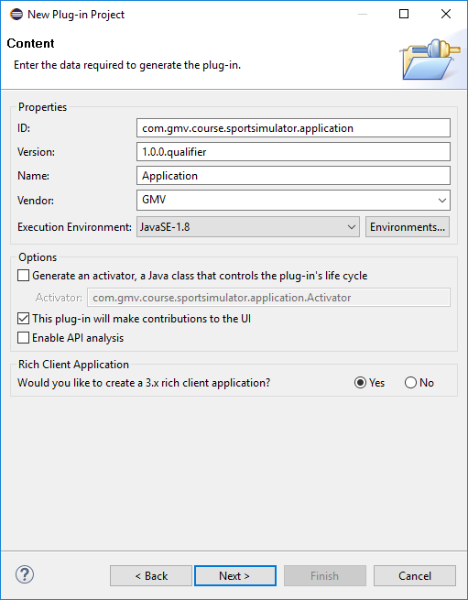
  - Create the plug-in using the template “RCP 3.x application (minimal)
    - In some versions this same template is named "Hello RCP".
  - Explore generated classes (Application, ApplicationActionBarAdvisor, ApplicationWorkbenchAdvisor, ApplicationWorkbenchWindowAdvisor and Perspective).
- Explore generated classes (Application, ApplicationActionBarAdvisor, ApplicationWorkbenchAdvisor, ApplicationWorkbenchWindowAdvisor and Perspective)
- Perform right click on the plug-in and select “Run as”-> “Eclipse Application”
  - Depending on the content of your workspace, some errors may be displayed. You can ignore them for now.
- A new empty application opens.
  - Notice that, simultaneously, a Run Configuration has been generated by Eclipse. You can check this configuration navigating to the menu: Run -> Run Configurations…
  - You can find the new run configuration on the “Eclipse Application” section on the tree on the left side. Click on it to open its settings.
- In tab “Main” mark option “Clear” and unmark “Ask for confirmation before clearing”
- Verify that section “Program to Run” option displays “Run an application” and the application id is com.gmv.sportsimulator.application.application
- Navigate to section Plug-ins. You will notice that only a “small” amount of plug-ins are selected and not all the available plugins. Close the dialog.
- Create a new plugin project that will provide a view for the application:
  - File -> New -> Project.
  - Select "Plug-in development -> Plug-in project" and press "Next".
  - Give a name to the project (i.e. com.gmv.course.sportsimulator.display) and press "Next".
  - Mark the options for generating an "Activator" and for stating the plugin will make contributions to the UI.
  - Answer "No" to the question on whether you would like to create a rich client application or not, and press "Finish".
    - This may sound confusing: we are developing a rich client application!!!... However, the option here simply means that the plugin we are creating will contain an IApplication and add it to the registry (entry point to the app). Our entry point was already created in step 3. ☺

- Copy the folder called "icons" (included with the course material) in the just created project.
- Add plugin com.gmv.sportsimulator.api as dependency of your plugin.
  - Open file "META-INF/MANIFEST.MF".
  - Select tab labeled "Dependencies".
  - Add there the dependency. Click on the “Add...” button and select the “com.gmv.sportsimulator.api” plug-in.
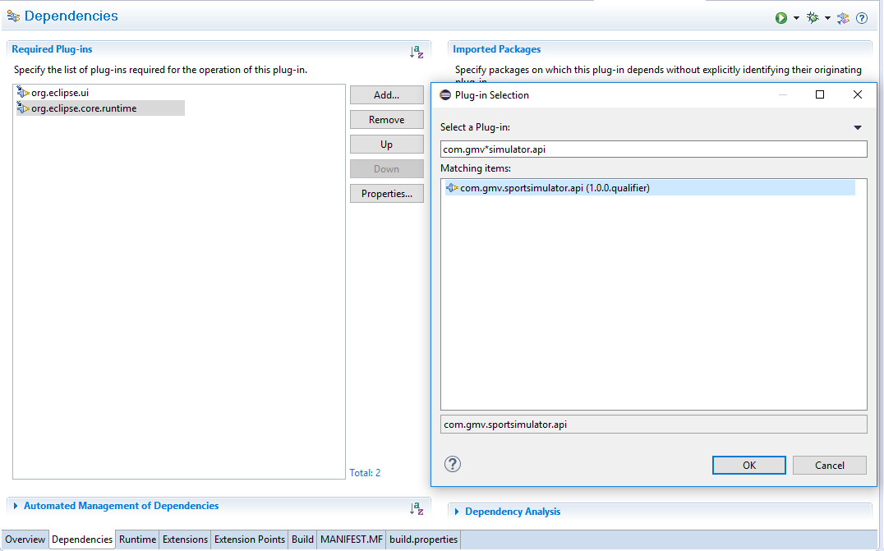 Figure 1: Add dependencies to a plug-in
- In the plugin.xml file, state your plug-in has an eclipse view:
  - Notice your project does not have a file called "plugin.xml". It is created automatically when you specify an extension or extension point when editing the manifest.
  - Open the file "META-INF/MANIFEST.MF", which is opened by default in a multi-tab editor. This editor provides a "unified view" of three files: MANIFEST.MF, plugin.xml and build.properties.
  - Select "Extensions" tab. It should look quite empty.
  - Press "Add…". The extension point selection dialog should be showed. (see Figure 2: Add the views' extension point).
  - Select the extension point "org.eclipse.ui.views" and press "Finish".
  - Check that "plugin.xml" file has been added to your project.
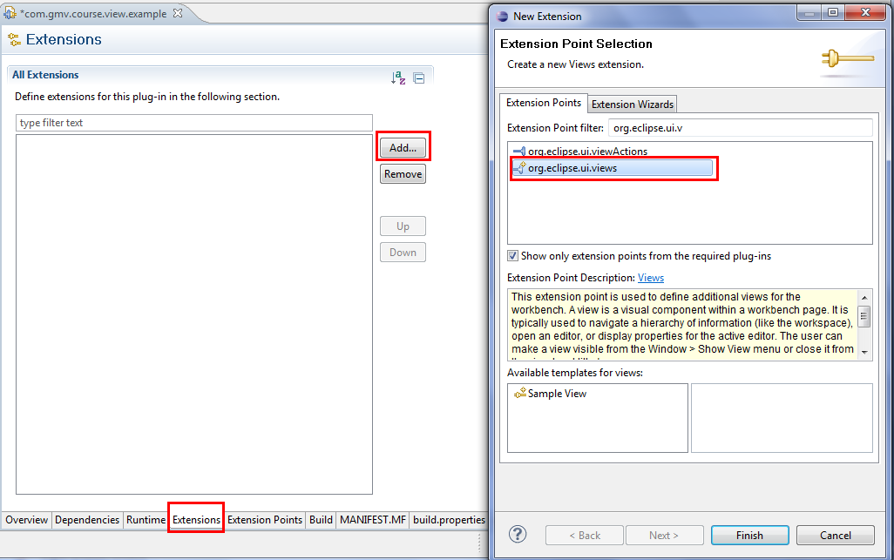
Figure 2: Add the views' extension point
- Right-click on the just created extension element "org.eclipse.ui.views" and select New -> View.
- Select the view element you just created and fill its "extension element details:"
  - id: com.gmv.course.sportsimulator.display.generalview
  - name: General Sports View
  - class: com.gmv.course.sportsimulator.display.GeneralView (this class will be the View implementation)
  - icons/sports/sports.png
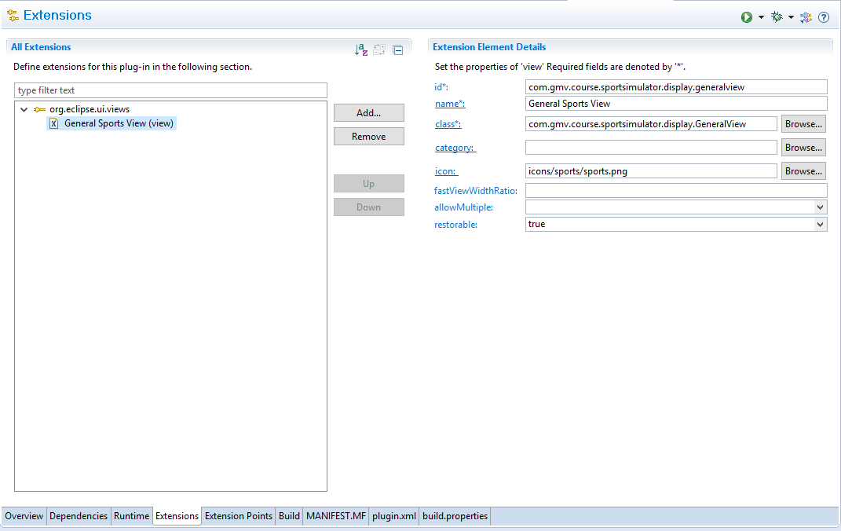Figure 3: View's properties
- Click on the hyperlink labeled "class". The class creation dialog should appear, click "Finish" button. The View class is created automatically. (If the view class exists when you click on “class”, the existing class will be opened).

- Fill method "createPartControl" with proper SWT/JFace stuff:
  - For convenience, the target platform plugin com.gmv.course.exercise.utils will help us creating the display → Add it as a dependency
  - Then, let’s give some content to GeneralView:
    - Get the service reference:
      - Exercise03Utils.getSportService()
    - Populate the service with teams and games. Remember: games are composed at least of the name, two teams, and the location.
  - Create a JFace TreeViewer to show the hierarchical structure of games/teams. Note: you need a Content Provider, and a Label Provider.
    - Use Content Provider to feed items to the Label Provider
    - Use Label Provider to select the information to display in the tree; typically text and icons
Optionally, you can use Exercise03Utils class from com.gmv.course.exercise.utils and let it create a simple tree by invoking:
    - Exercise03Utils.createViewContents(parent);
It is recommended to use it as a reference for the first implementation. Later, you should try to create your own tree with its providers. You can also look into the repository solutions to see a more advanced implementation.
- Back at plug-in com.gmv.sportsimulator.application open class ApplicationWorkbenchWindowAdvisor.java
- Override method postWindowOpen() with the following code in order to open the new view on startup:
@Override
public void postWindowOpen()
{
try
{
PlatformUI.getWorkbench().getActiveWorkbenchWindow()
.getActivePage().showView("com.gmv.course.sportsimulator.display.generalview");
}
catch (PartInitException e)
{
e.printStackTrace();
}
}
- Navigate again to Run -> Run Configurations... and select the previously created application configuration.
- Unmark option “Include optional dependencies when computing required plug-ins”
- Select your display plugin com.gmv.course.sportsimulator.display
- We will also need to have one simulator implementation. Select tennis simulator plugin: com.gmv.sportsimulator.tennis
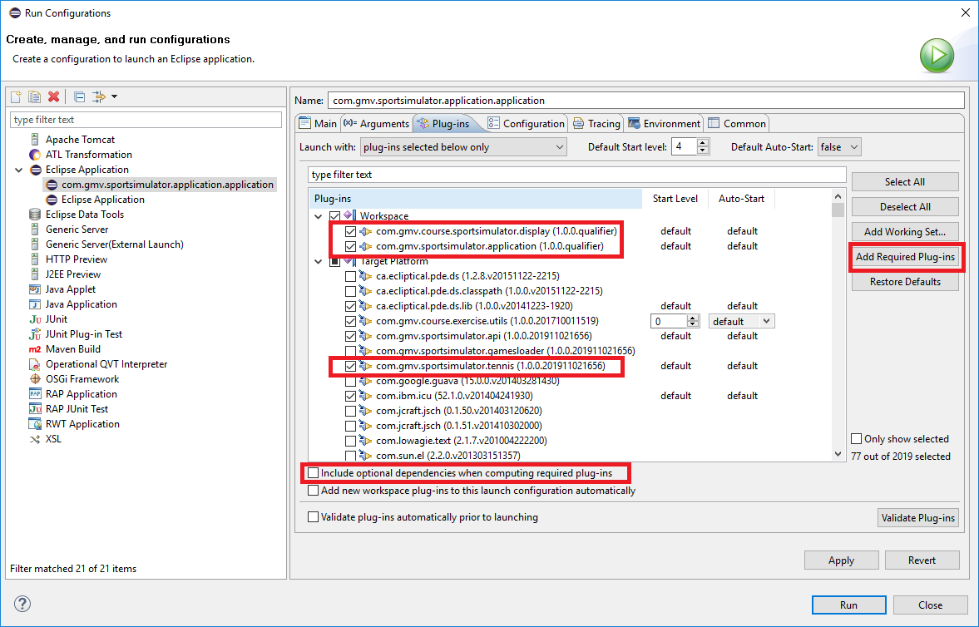
Figure 4: Run Configuration for launching an application
- Press button “Add Required Plug-ins”. Notice that the number of plug-ins selected has increased
- Press “Run” to start the application

Exercise 04: Detailed views

Goals:
- Understand the selection service mechanism and more generally, how parts collaborate.
- Gain expertise on View parts development.
- Gain expertise on SWT and SWT layout managers.

Material:
- Previous exercises.

Abstract:
In this exercise, the student creates a plugin that contributes two views, one to display the Team properties and the other to display the Game and its status. The views shall subscribe to the selection service and, upon selection of the proper object (Team/Game), show its details.

Steps:
- Run eclipse, specifying the same workspace you created in previous exercises.
- Select the display plugin created in Exercise 03 (com.gmv.course.sportsimulator.display)
- Add a new View (see previous exercises). The view name could be “Team detailed view”. Create the following content (4 Labels, 4 Texts, and GridLayout):
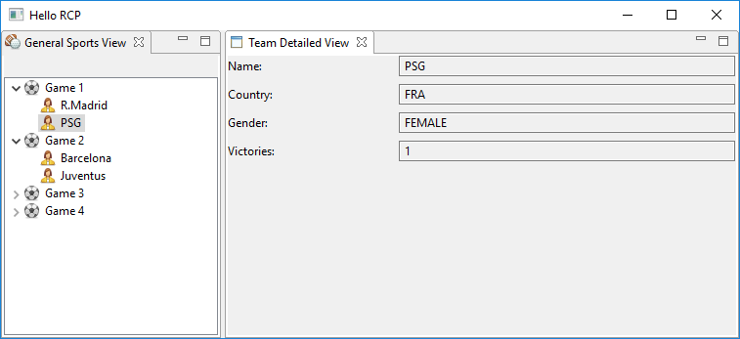
Figure 5: Detailed view content
- Modify the view you created in exercise 3 to be selection provider. Then, add the following line:
super.getSite().setSelectionProvider(viewer);
where viewer is the TreeViewer in charge of displaying the Games/Teams hierarchical structure
- Register your just created view as selection listener and make it display the details of a Team, when one is selected. Use the Selection Service to register your view:
ISelectionService selectionService = getSite().getWorkbenchWindow().getSelectionService();
Your view has to implement the listener org.eclipse.ui.ISelectionListener
Note, your view will be notified about all the selection changes. Then you have to check if the current selection is IStructuredSelection and if its first element is a Team object.
- Create another view that performs the same operation, but instead shows the details of the selected Game.
- (Optional) Register the Game details view to the sport service as a ISportServiceListener. Request the service to start all simulations. The listener will be notified about the game results. Fill the view with the updated information by creating a table with the games.

Exercise 05: Extension point

Goals:
- Understand the mechanism of extension points.

Material:
- Previous exercises.

Abstract:
In this exercise, the student adds an extension point for defining a service factory that provides the access to one sport service. Then, the student creates a new plugin that extends the just created extension point, providing a sport service factory that allows the access to the service.

Steps:
- Run eclipse, specifying the same workspace you created in previous exercises.
- Create a new plug-in com.gmv.sportsimulator.api.service. This plugin will be the intermediate that will allow the access to the specific service implementation. Other plugins will depend on it instead of depending on the specific sport service.
- Create an interface ISportServiceFactory for the service factory that declares method getSportService()
- Open manifest file of the new plugin.
- Create a new extension point to provide the information for a sport service factory. Extensions to this extension point shall provide the sport type and the name of a class implementing the interface defined by ISportServiceFactory.
- Open the plugin.xml and select tab labeled "Extension Points".
- Click on the “Add…” button to add a new extension point definition.
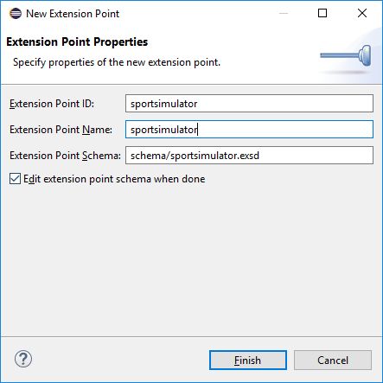
Figure 6: Extension point configuration
- The extension point is configured in a exsd file (it’s similar to a XSD file but you create it using an Eclipse editor):
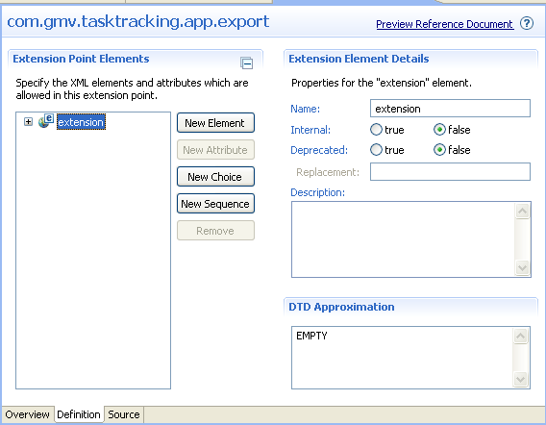
Figure 7: EXSD Editor

- Create an element that consists of three attributes, the first one of string type to give one id, the second of type string to give the sport type and the third one of type java to refer to the class implementing the factory.
- Select the “extension” node and add a sequence of your element with 1 max. occurrence.
- Create a new plugin for a soccer service (or the sport you choose) and name it com.gmv.sportsimulator.soccer
- Create SoccerService class extending BaseSportService (from com.gmv.sportsimulator.api).
- Implement method getSportTypes by returning one array with String “Soccer”.
- Implement createGameInstance creating and returning a game using the parameters.
- Implement createAndStartSimulation by creating a thread implementing ISimulationThread. It will start by invoking Game::resetGame() method. Then, it perform changes in the game results, it will call notifyResultChanged(Game) from base class, and eventually it will invoke Game::finalise() and notifyGameEnded(Game) from base class.
- Contribute to the sportsimulator extension point by registering a service factory class that creates an instance to the SoccerService.
- Implement the factory class. Implementation should also populate the sport simulator data when the service is created. You may move here the set of sports and teams that you created in exercise 3.
- In com.gmv.course.sportsimulator.display create a class that will read the extension contribution, instantiate the factory and return always the same instance of the soccer service. You can get the service factory like this:
IConfigurationElement[] configElements = Platform.getExtensionRegistry()
.getConfigurationElementsFor("com.gmv.sportsimulator.servicelocator.sportsimulator");
serviceFactory = (ISportServiceFactory) configElements[0].createExecutableExtension("class");

Exercise 06: Create Command/Handler

Goals:
- Understand what commands and handlers are.

Material:
- Previous exercises.

Abstract:
In this exercise, the student creates a new command that will start the simulation of games. All the generated items from previous exercises are necessary. The application shall implement a perspective that shows both the view created in exercise 3 and the new detailed views.

Steps:
- Run eclipse, specifying the same workspace you created in previous exercises.
- In plugin com.gmv.course.sportsimulator.display:
  - Contribute to extension point org.eclipse.ui.commands and define a new command.
  - Contribute to extension point org.eclipse.ui.menus:
    - New -> menuContribution
    - locationURI: popup:com.gmv.sportsimulator.generalviewmenu
    - Select the menuContribution -> New -> Command
    - Reference to the command ID of the command defined previously (you can use the Browse… button)
    - Provide a label and/or an icon for the menu item
  - Contribute to extension point org.eclipse.ui.handlers and define a new command handler that references to the command and create a handler class
  - Make your new handler class extend org.eclipse.core.commands.AbstractHandler and implement method execute. The execution should use the service reference and the selection service to invoke method ISportSimulator::simulateGame(Game,SimulationSpeed)
  - Add a menu to the sports view from exercise 3:
In createPartControl add the following code snippet and populate using the menu id as defined in step b:
MenuManager mm = new MenuManager("com.gmv.sportsimulator.generalviewmenu");
((IMenuService) getSite().getService(IMenuService.class)).populateContributionManager(mm, "popup:com.gmv.sportsimulator.generalviewmenu");
Menu menu = mm.createContextMenu(viewer.getTree());
viewer.getTree().setMenu(menu);

Exercise 07 (Optional): Export RCP application

Goals:
- Understand what an eclipse RCP application and a product configuration are.

Material:
- Previous exercises.

Abstract:
In this exercise, the student exports the application created in the previous exercises.

Steps:
- Create a product configuration:
  - File -> New... -> Product Configuration.
  - Fill product name, product id and application id in Overview tab.
  - Add the plugins your application is composed of in Configuration tab (hint: add the main plugin and then press "Add required plugins").
  - Add all the platform required plugins:
    - Bundle org.eclipse.equinox.ds
      - Or org.apache.felix.scr instead (depending on the platform baseline)
    - Bundle org.eclipse.equinox.event
    - Bundle org.eclipse.equinox.simpleconfigurator
- Press Export to export the product

