EUD course
Exercises script

Introduction
This document assumes the reader has already attended GMV's EclipseRCP and EUD course.

The source code for the exercises has been tested with java 1.8 + Eclipse 4.4.1 (plugin development version), running under Microsoft Windows 10.

Extra information sources:
- Eclipse EUD course slides
- Eclipse RCP course slides
- Eclipse IDE course slides

If you notice inconsistencies, lack of information or any other issue, please report them to David Marina (dmarina@gmv.com).

Exercise 01: EUD Workspace SETUP

Goals
- Configure a workspace ready to work with EUD applications.
- Learn to configure the workspace settings
- First glance at the EUD Target Platform
- Execution of the EUD Test application from the workspace

Material
- Eclipse installation, aka EUD3-IDE
- A cloned Git repository from: https://github.com/dmarina-esa/EclipseRCPTraining.git
- EUD Backend Simulator and configuration files

Abstract
In this exercise, the student creates a new empty workspace ready to work with EUD. The student will configure the necessary Eclipse settings and prepare the Target Platform. Then, the student will start the EUD Test application and will connect to the EUD Backend Simulator. Finally, the student will add the Sport simulator application source code to the repository by using the Team Project Set.

Steps
- Start Eclipse and create a new empty Workspace.
- Import Eclipse preferences from EUD3-IDE directory:
  - In the main menu: File -> Import… -> Preferences
  - Select file Eclipse-Preference-settings_for_EUD_2015-09-29.epf from EUD3-IDE directory
  - Mark “Import All” check button
  - Click “Finish”
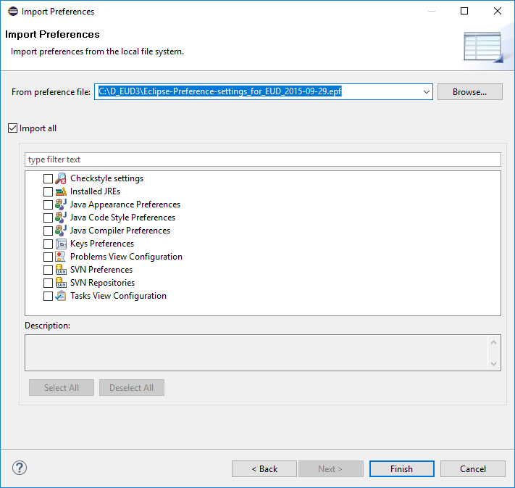
- Restart Eclipse and open the same workspace again.
Notice that Eclipse does not remember your previous workspace. Instead, it will suggest the one that was used during the creation of the preferences file (quite annoying). You will have to look for your workspace folder again.
From this point on, your Eclipse is almost ready to develop EUD applications. All the preferences have been set excepting the “Checkstyle” plug-in.
- Go to the Git perspective and add an existing Git repository. Add the EclipseRCPTraining repository as used in the previous part of the course:
https://github.com/dmarina-esa/EclipseRCPTraining.git
- In Git Repositories view, switch to branch exercise_eud1 (checkout new local branch if necessary)
- Import project “Project” into workspace
  - In the main menu: File > Import… > Projects from Git > Existing local repository > EclipseRCPTraining
  - Mark option “Import existing Eclipse projects”
  - Select project “Project_Course_EUD” and press “Next”
  - Uncheck “Search for nested projects” since we only want to import project “Project_Course_EUD”
  - Select project “Project_Course_EUD”
  - Click Finish
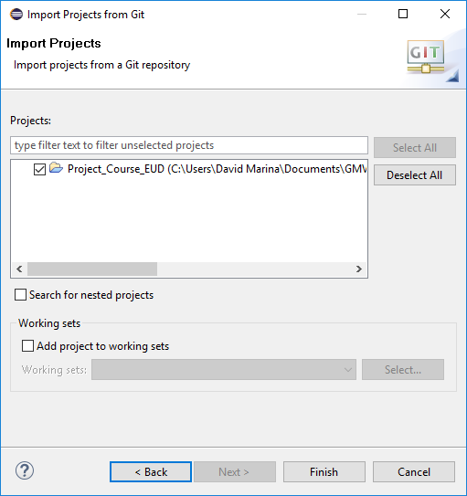

- Explore the content of Project:
  - It contains folders to keep version control of the project settings: checkstyle, compiler settings and code formatters
  - There is a folder for storing the target platform definitions so they can be shared amongst the team members
  - LaunchConfigurations folder is reserved for storing the launch configurations. It contains launch configurations for the EUD Test Application and the EUD Backend Simulator
  - Release_Management folder contains some tools used in EUD-related projects to create software releases: version updates, automatic commits…
  - Finally, EUD_Test contains some files for using with the EUD Test application
- Configure Eclipse Checkstyle:
  - Press Window > Preferences > Checkstyle > New
  - Select “Project Relative Configuration”
  - Name it ESA-Checkstyle
  - Click on “Browse…” and select Project_Course_EUD > CODE-ANALYSIS > Checkstyle > “ESA HSO-GI Checkstyle Set v1.3.xml”
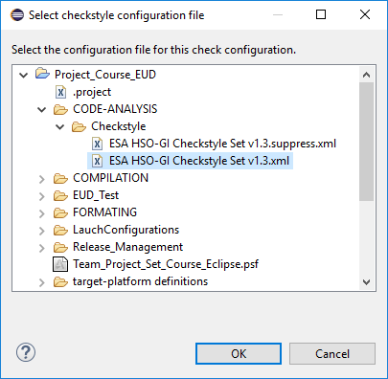
  - Mark option “Protect Checkstyle configuration file” and press OK
  - Select your new configuration file on the dialog table and press “Set as Default”
  - Press OK and confirm to rebuild the existing projects.

---From this point on your workspace is ready to use---
Regardless of the project, you will have to follow the previous steps every time you create a new workspace. In the case of EUD projects, a project named “Project_XXX” should be available to provide the checkstyle configuration file and keep track of some customized settings that may apply: formatter modifications, class header design….

- Import target platform defined in Project
  - Press Window > Preferences > Plug-in Development > Target Platform
  - Select “Eclipse-Luna-2.0.0_Development.target”
  - Press “Apply”
  - Press “OK” to close the dialog
- Open view Target Platform State and check that the Target Platform includes the EUD plug-ins
- Start EUD Backend Simulator application:
  - Select Run -> Run Configurations…
  - Select Eclipse Application named “EUD_Backend_Simulator”
- Start EUD Backend Simulator and select the database file named “Backend-Sim-2.6.0-2014-08-29.xml”
- Start EUD Test application:
  - Select Run -> Run Configurations…
  - Select Eclipse Application named “EUD_Product_Test”
- Log into the Backend Simulator:
  - User: “a”; Password: “a”
The course repository contains multiple test parameter display definition files that you can use in EUD. Also, the Backend Simulator can be configured to generate data.
- When you are done with the EUD Test application, import the Sport Simulator application from the repository by using the Team Project Set file:
  - Open project “Project_Course_EUD”
  - Right click on “Team_Project_Set_Course_Eclipse.psf” file > Import Project Set…
- Switch your package explorer to display Working Sets instead of Projects:
  - Package explorer menu > Top Level Elements > Working Sets

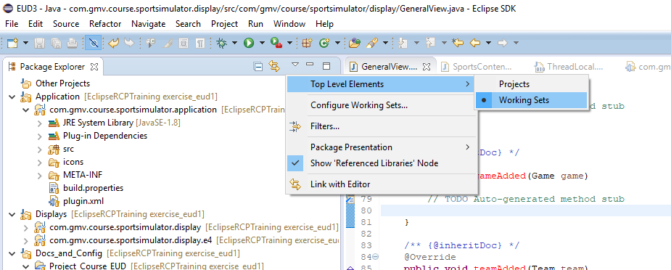

- Check the workspace organization

Exercise 02: Convert application into EUD application

Goals
- Create a EUD application

Material
- Eclipse installation, aka EUD3-IDE
- Git repository from the course or previous exercises
- Target platform folder for the course.

Abstract
In this exercise, the student converts the previous RCP application into a EUD application that will include a log-in dialog. For simplicity, the application will reuse the SessionManager service of the EUD Test application, which means that the application will need to connect to the EUD Backend Simulator. Also, the EUD workspace view is desired, so some extra EUD plugins are necessary to run the new EUD application.

Steps
- Locate and use plugin esa.egos.eud.product.test as a reference for building the initial steps of your EUD application:
  - You can go to the Target Platform State view, select the plugin > right click > Import As> Source Plugin
  - Remember to delete this plugin from your workspace later
- Starting from Exercise 01, convert the application plugin “com.gmv.course.sportsimulator.application” into a EUD application:
  - Create a SystemContext class named SportSystemContextand reuse System ID from EUD Test for simplicity (“TEST_SYSTEM”)
  - Register SystemContext extension point contribution
  - Modify your Application class:
    - Create a SystemContext instance
    - Call to CoreUiPlugin.initCorePlugin()
    - Configure login preferences (as in activator ProductTestPlugin.java)
    - Pass the SystemContext reference to the ApplicationWorkbenchAdvisor constructor
  - Modify your ApplicationWorkbenchAdvisor
    - Set the SystemContext reference into the Eclipse context (for convenience)
    - Pass the SystemContext reference to the ApplicationWorkbenchWindowAdvisor constructor
  - Modify your ApplicationWorkbenchWindowAdvisor
    - Configure CoolBar and StatusLine
    - Initialize StatusLineLogListener
    - Initialize storage area for Workspaces
  - Modify your ApplicationActionBarAdvisor
    - Populate menus and CoolBar in a similar way to the EUD Test application, but ignoring the parameter display-related commands and actions
- Register a product extension point for your application (org.eclipse.core.runtime.products) since EUD needs a proper product ID
- Modify/create a run configuration for your EUD application including:
  - Your application plugins
  - Bundle esa.egos.eud.adapters.persistentstorage.filesystem
  - Bundle esa.egos.eud.adapters.persistentstorage.manager.test
  - Bundle esa.egos.eud.adapters.sessionmanager.sim
  - Bundle esa.egos.eud.common.platformpatcher
  - Bundle esa.egos.eud.displays.login
  - Bundle esa.egos.eud.displays.parameters.workspace
  - Bundle esa.egos.eud.errorreport
  - Bundle esa.egos.eud.service.alarm
  - Bundle org.apache.batik.css ver. 1.6.0
  - Bundle org.apache.batik.util ver. 1.6.0
  - Bundle org.apache.batik.util.gui ver. 1.6.0
  - Bundle org.eclipse.equinox.simpleconfigurator
- Run your first EUD application
- Run also the EUD Backend Simulator application in order to log-in

Exercise 03: Create a EUD Service Adapter

GOALS
- Learn to create and service adapter
- Understand how EUD uses extension points to instantiate services.

Material
- Eclipse installation, aka EUD3-IDE
- Git repository from the course or previous exercises
- Target platform folder for the course.
- The results of Exercise 02

Abstract
In this exercise, starting with the workspace from Exercise 02, the student will create a EUD service interface to the bet system of the sport simulator (observe that ISportService has a method name placeBet) and create a service adapter to the service, which will delegate the actions to the sport simulator. Then, the student will register the service adapter with a factory to the Bet service.

Steps
- In plugin com.gmv.sportsimulator.servicelocator create a new interface IEudBetService extending IEgosService that provides method:
void placeBet(String userName, int euros, String gameName, String result);
- Create a new EUDBetService class implementing IEudBetService
- Finally, register the factory as a serviceAdapter for the service type “Bet_Service” (esa.egos.eud.core.serviceAdapter) and specify the system ID associated to the service adapter (it can be either your SystemContext ID or just “generic”)
- In your General View in plugin com.gmv.course.sportsimulator.display use service registry to locate a service of type “Bet_Service” matching your system context (if you registered the service adapter as “generic” you will have to invoke method getGenericServiceAdapterFor)
CorePlugin.getDefault().getServiceManager().getServiceAdapterFor(…)

But in order to access the service you will need a SystemContext instance. You have several options:
- Your view extends AbstractEUDView → You have direct access to SystemContext
- As it was registered in previous exercise 02, get the reference from the Eclipse context (maybe injection?)
- Use CorePlugin.getDefault().getDefaultSystemContext() … assuming that your application uses only one SystemContext!!
- Others: e.g. you carry on one object with a reference to the SystemContext

Exercise 04: Convert your views into EUD Views

Goals
- Creating a EUD View
- Accessing services in EUD

Material
- Eclipse installation, aka EUD3-IDE
- Git repository from the course or previous exercises
- Target platform folder for the course.
- The plugins created in Exercise 03
- A running instance of the EUD Backend Simulator
- Icons folder.

Abstract
In this exercise, the student will convert the views into EUD views and the Bet service created in Exercise 03 will be requested to the service registry using the EUD service manager.

Steps
- Starting from Exercise 03, make your views extend AbstractEUDView.
- Implement the necessary changes, including implementing missing methods
- Populate the view in method doCreatePartControl
- Use also doCreatePartControl to request the service references: the ISportSimulator reference and the recently created Bet_Service in Exercise 03. Now you can complete last step of Exercise 03 since EUD Views have a direct reference to the SystemContext (getSystemContext())
- Fill method getServices() by returning a list of IEgosService that includes your Bet Service
- Run the application and verify that your views now require a proper user login to be displayed (do not forget to start the EUD Backend Simulator in order to log in)
- Log out to verify that your views get greyed-out and re-enabled after a new log-in
- Check that the connection status icon in the CoolBar is monitoring the Bet Service status for your EUD views.

Optional - Exercise 05: Create a GenericDataTable

Goals
- Creating a EUD GenericDataTable

Material
- Eclipse installation, aka EUD3-IDE
- Git repository from the course or previous exercises
- Target platform folder for the course.
- The plugins created in Exercise 04
- A running instance of the EUD Backend Simulator

Abstract
In this exercise, the student will use a GenericDataTable to display the game simulation results.

Steps
- Create a new View for the Game results
- Register to the ISportService to get result modification notifications
- Create a GenericDataTable and keep it updated with the game results.
- Create a privileged action, requiring CONTROL privilege, that will try to place a bet in one of the games.

