Eclipse RCP course
Exercises script

Introduction
This document assumes the reader has already attended GMV's EclipseRCP course. It is intended to enable the reader to REPEAT the exercises from the course on his/her own.

To follow the exercises you need the course material, which includes:
- “Infrastructure” plugins the exercises are built on top of.
- Solutions to the exercises (to be used as cheatsheet).

The source code for the exercises has been tested with java 1.8 + Eclipse 4.6 (plugin development version), running under Microsoft Windows 10.

Extra information sources:
- Eclipse RCP course slides
- Eclipse RCP book (ISBN13: 978-0321334619), available at GMV’s library.

If you notice inconsistencies, lack of information or any other issue, please report them to David Marina (dmarina@gmv-insyen.com).

Exercise 01: An empty plugin

Goals
- First glance at the elements that conforms a plugin.
- First glance at the Target Platform.

Material
- Target Platform folder for the course.

Abstract
In this exercise, the student creates a new empty RCP Plugin to understand which the required files are. The plugin dependencies mechanisms are explored to understand the role of the Target Platform.

Steps
- Create a new plug-in project
  - In the main menu: File -> New -> Project…
  - Select Plug-in Development -> Plug-in Project in the wizard).
  - Click next, specify a project name: com.gmv.course.exercise01
  - Click next, select “Generate an activator, […]”.
  - Click Finish.
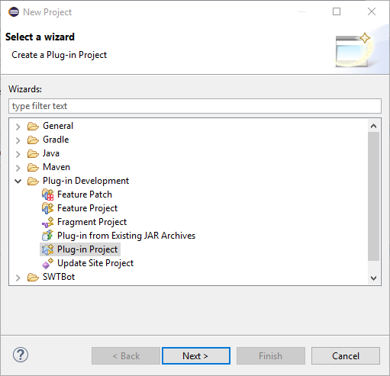
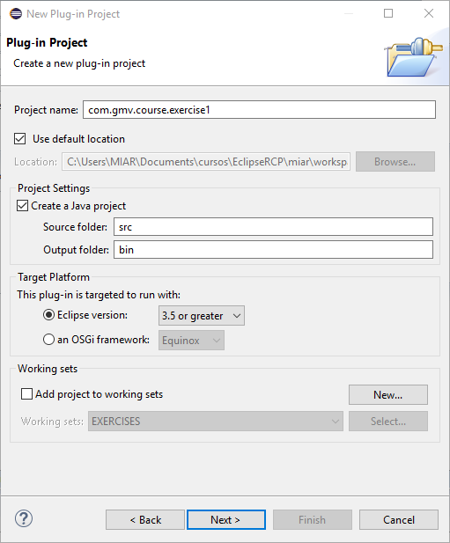
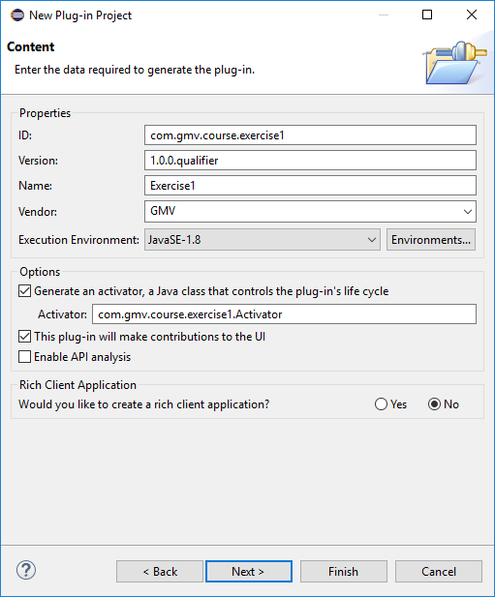

- Open the META-INF/MANIFEST.MF file (it should be open automatically)
- In the “Dependencies” tab, remove “org.eclipse.core.runtime” and save.
- Open the Activator class, check that there are errors because the imports cannot be resolved.
- In the MANIFEST.MF editor, in the “Dependencies” tab, click “Add…” and select “org.eclipse.core.runtime” again. Save.
- Check that the errors are gone from the Activator class.
- Open the Target Platform configuration
  - In the main menu: Window -> Preferences.
  - In the Preferences dialog, open Plug-in Development -> Target Platform.
- Create a new target platform
  - Click “Add…” and create a target platform from the current one “Current Target: Copy settings from the current target platform”.
  - Enter a name and click “Add…”.
  - In the wizard, select “Directory” and click “Next”.
  - Select the folder with the course materials and click “Finish”.
  - Click “Finish”.
  - Select the new target platform and click “OK”.
- Add a dependency to “com.gmv.exercise.utils”.

Exercise 02: Contribute a view to the IDE

GOALS
- Provide an extension for an extension point.
- Contributing a view.
- Executing a plugin with Eclipse.

Material
- Target platform folder for the course.
- Icons folder.

Abstract
In this exercise, the student creates a new plugin that provides an extension to “org.eclipse.ui.views” extension point to contribute a view to the Eclipse IDE.

Steps
- Include the course target platform folder in the configured target platform. (skip this step if you finished Exercise 01)
- Create a new plug-in project as in Exercise 01 (optionally, the plugin created in Exercise 01 can be reused).
- Note that initially the plugin does not have a file called “plugin.xml”. It is usually created on-demand when you specify an extension or extension point using the manifest editor.
- Add a dependency on “com.gmv.course.exercise.utils”.
- Open the MANIFEST.MF and in the “Overview” tab click on “Extensions”.
- In the “Extensions” tab, click “Add…” and select “org.eclipse.ui.views”. Press “Finish”.
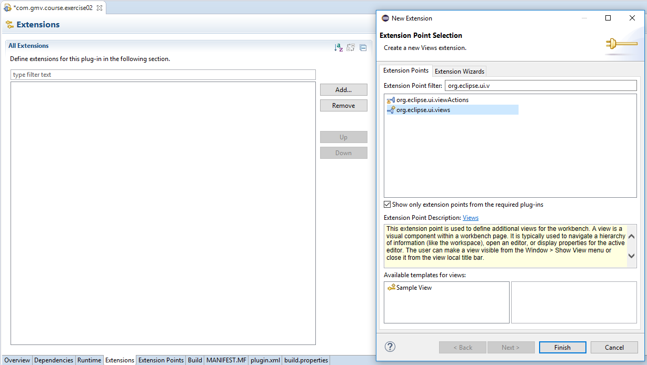
- Right-click on the just created element "org.eclipse.ui.views" and select New -> view.
- In Extension Element Details, fill the mandatory data marked with “*”.
  - Id = “com.gmv.course.exercise02.view”
  - Name = “Exercise02”
  - For the class, click on “class*:” and fill the class name and package in the wizard
    - Package = “com.gmv.course.exercise02.views”
    - Name = “Exercise02View”
- In the view editor, go to createPartControl() method and add: Exercise02Utils.createViewContents(parent);
- Double click in the Manifest file. In the “Overview” tab of the manifest editor, click “Launch an Eclipse application”. 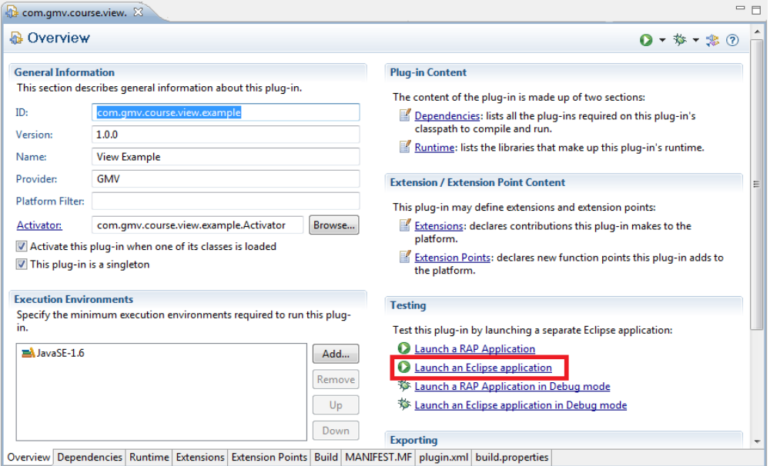
- Wait for a new Eclipse application to start and close the Overview page.
- In the new Eclipse, select Window -> Show view -> other -> other -> Exercise 02.

Exercise 03: Sport Simulator application

Goals
- Plugin project creation
- Extending an extension point.
- Creating a view.
- First steps with SWT and JFace viewers.
- Creating an RCP application.

Material
- Target platform folder for the course.
  - Eclipse plugin exporting sport service API (called "com.gmv.sportsimulator.api")
  - Eclipse plugin exporting tennis simulator service (called “com.gmv.sportsimulator.tennis”)
- Icons folder.

Abstract
In this exercise, the student creates a new plugin that extends org.eclipse.ui.views extension point and code a ViewPart showing a TreeViewer displaying game/players hierarchy. For the domain model to be filled with data, the student hardcodes the creation of Teams and Games in the body of the view constructor.
The student will use the Eclipse wizard to create an empty RCP application and will modify it to display the created views as a separate application out of the Eclipse IDE.

Steps
- Include the course target platform folder in the configured target platform.
- Run eclipse. Specify a new workspace.
- Create a new plugin project:
  - File -> New -> Project.
  - Select "Plug-in development -> Plug-in project" and press "Next".
  - Give a name to the project (i.e. com.gmv.course.sportsimulator.application) and press "Next".
  - Uncheck the option for generating an "Activator". Check the options for stating the plugin will make contributions to the UI.
  - Answer "Yes" to the question on whether you would like to create a rich client application, and press "Next".
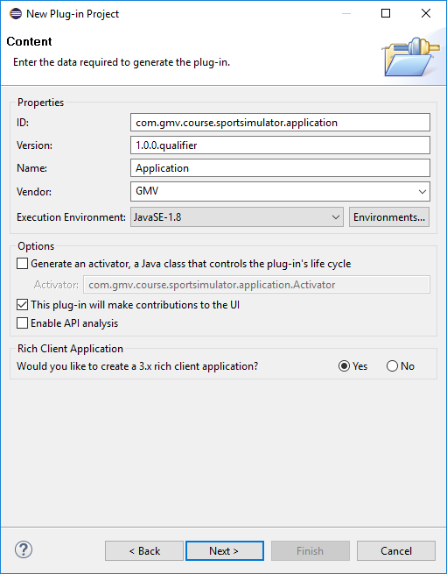
  - Create the plug-in using the template "Hello RCP".
  - Explore generated classes (Application, ApplicationActionBarAdvisor, ApplicationWorkbenchAdvisor, ApplicationWorkbenchWindowAdvisor and Perspective).
- Explore generated classes (Application, ApplicationActionBarAdvisor, ApplicationWorkbenchAdvisor, ApplicationWorkbenchWindowAdvisor and Perspective)
- Perform right click on the plug-in and select “Run as”-> “Eclipse Application”
- A new empty application opens. Notice that, simultaneously, a Run Configuration has been generated by Eclipse. You can check this configuration navigating to the menu: Run -> Run Configurations… You can find the new run configuration on the “Eclipse Application” section on the tree. Click on it to open its settings.
- In tab “Main” mark option “Clear” and unmark “Ask for confirmation before clearing”
- Verify that section “Program to Run” option displays “Run an application” and the application id is com.gmv.sportsimulator.application.application
- Navigate to section Plug-ins. You will notice that only a “small” amount of plug-ins are selected and not all the available plugins. Close the dialog.
- Create a new plugin project:
  - File -> New -> Project.
  - Select "Plug-in development -> Plug-in project" and press "Next".
  - Give a name to the project (i.e. com.gmv.course.sportsimulator.display) and press "Next".
  - Mark the options for generating an "Activator" and for stating the plugin will make contributions to the UI.
  - Answer "No" to the question on whether you would like to create a rich client application or not, and press "Finish".

- Copy the folder called "icons" (part of the course material) in the just created project.
- Mark plugin com.gmv.sportsimulator.api as dependency of your plugin.
  - Open file "META-INF/MANIFEST.MF".
  - Select tab labeled "Dependencies".
  - Add there the dependency. Click on the “Add...” button and select the “com.gmv.sportsimulator.api” plug-in.
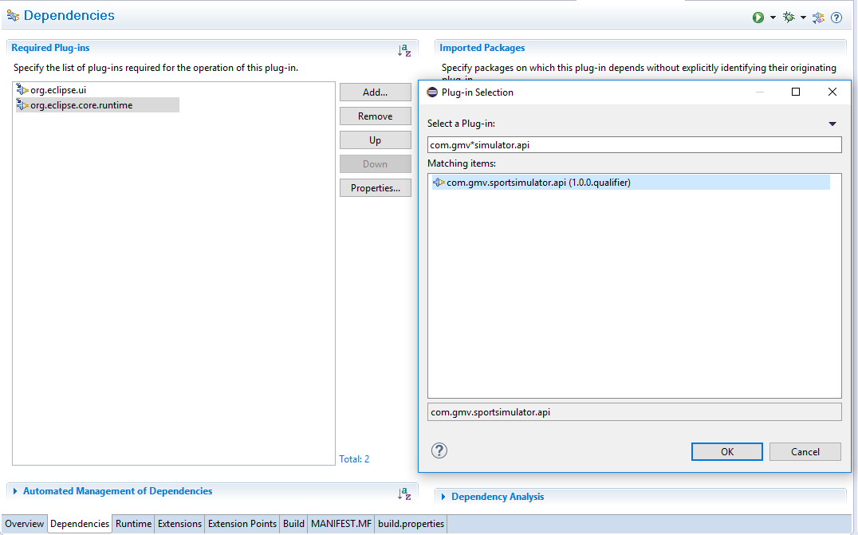 Figure 1: Add dependencies to a plug-in
- In the plugin.xml file, state your plug-in has an eclipse view:
  - Notice your project does not have a file called "plugin.xml". It is usually created on-demand when you specify an extension or extension point when editing the manifest.
  - Open the file "META-INF/MANIFEST.MF", which is opened by default in a multi-tab editor. This editor provides a "unified view" of three files: MANIFEST.MF, plugin.xml and build.properties.
  - Select "Extensions" tab. It should look quite empty.
  - Press "Add…". The extension point selection dialog should be showed. (see Figure 2: Add the views' extension point).
  - Select the extension point "org.eclipse.ui.views" and press "Finish".
  - Notice now you have a "plugin.xml" in your project.
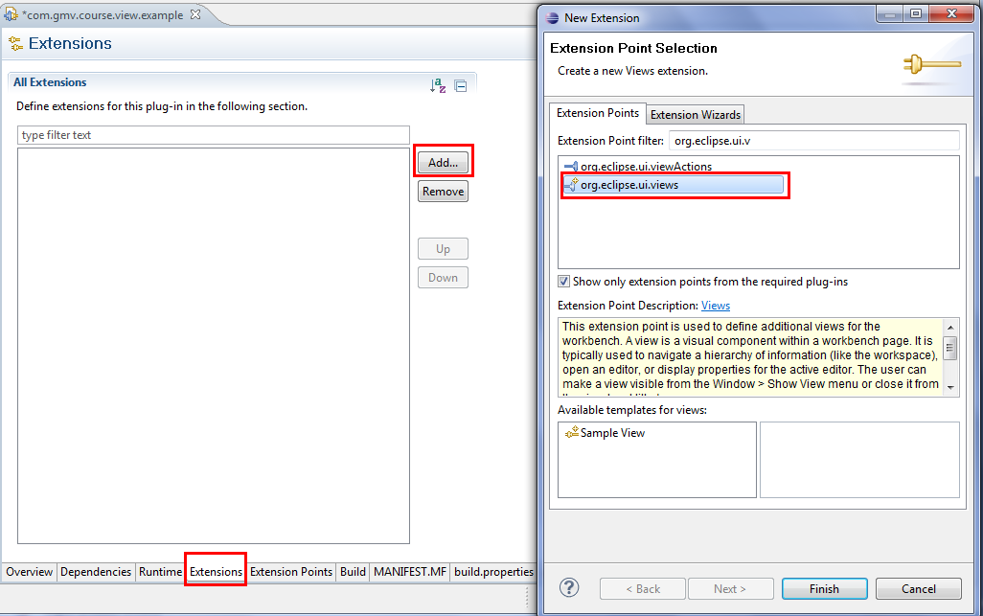
Figure 2: Add the views' extension point
- Right-click on the just created element "org.eclipse.ui.views" and select New -> View.
- Select the view element you just created and fill its "extension element details:"
  - id: com.gmv.course.sportsimulator.display.generalview
  - name: General Sports View
  - class: com.gmv.course.sportsimulator.display.GeneralView (this class will be the View implementation)
  - icons/sports/sports.png
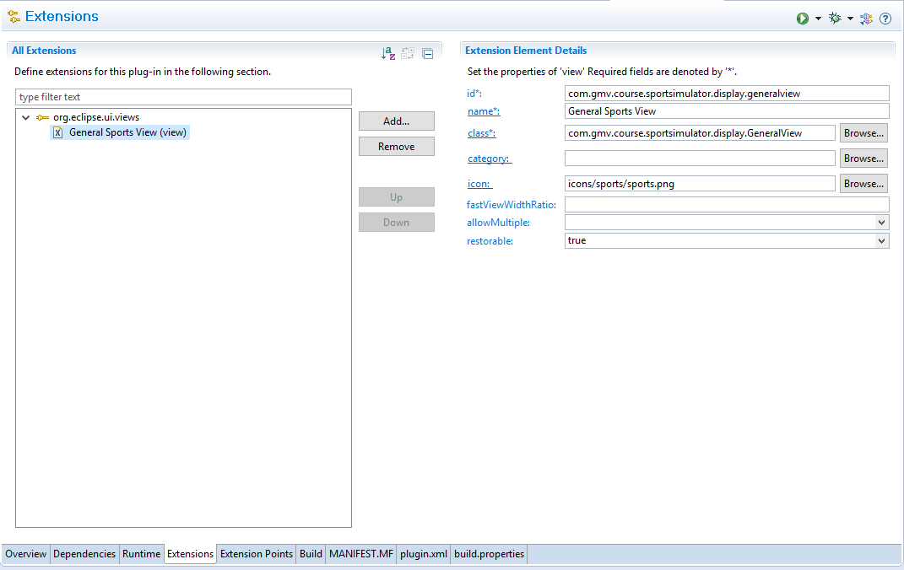Figure 3: View's properties
- Click on the hyperlink labeled "class". The class creation dialog should be showed, click "Finish" button. The View class is created automatically. (If the view class exists when you click on “class”, the existing class will be opened).

- Fill method "createPartControl" with proper SWT/JFace stuff:
  - First, get the service reference:
    - Exercise03Utils.getSportService()
    - Populate the service with teams and games. Games are composed of two teams, a location and optionally some metadata.
  - Create a JFace TreeViewer to show the hierarchical structure of games/teams. Note: you need a Content Provider, and a Label Provider.
    - Use Content Provider to feed items to the Label Provider
    - Use Label Provider to select the information to display in the tree; typically text and icons
Optionally, you can use Exercise03Utils class from com.gmv.course.exercise.utils and let it create a simple tree. It is recommended to use it as a reference for the implementation.
- Back at plug-in com.gmv.sportsimulator.application open class ApplicationWorkbenchWindowAdvisor.java
- Override method postWindowOpen() with the following code:
@Override
public void postWindowOpen()
{
try
{
PlatformUI.getWorkbench().getActiveWorkbenchWindow()
.getActivePage().showView("com.gmv.course.sportsimulator.display.generalview");
}
catch (PartInitException e)
{
e.printStackTrace();
}
}
- Navigate again to Run -> Run Configurations... and select the previously created application configuration.
- Unmark option “Include optional dependencies when computing required plug-ins”
- Select your display plugin com.gmv.course.sportsimulator.display
- Select tennis simulator plugin: com.gmv.sportsimulator.tennis
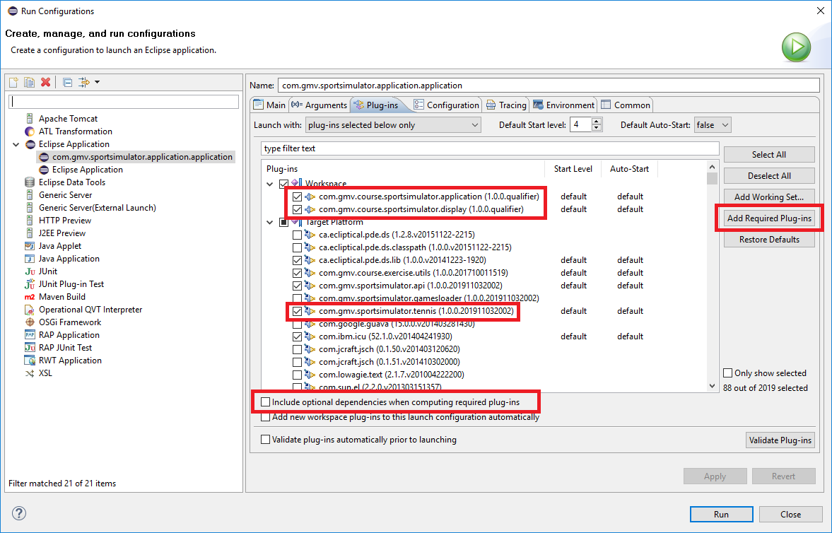
Figure 4: Run Configuration for launching an application
- Press button “Add Required Plug-ins”. Notice that the number of plug-ins selected has increased
- Press “Run” to start the application

