**CHAPTER 2 ANALYSIS**

**Overview**

I was tasked with evaluating the data for MV Houses, LLC. I used R Studio to create a histogram, polygon, and ogive to create a visual representation of houses sold in different price ranges in the area, and derived out conclusions from that information. Below is the code I used in R, as well as a description of the results of that code.

The histogram shows how many houses were sold at what price in each category (frequency). Below is the histogram and an enlargement of the R code, respectively.

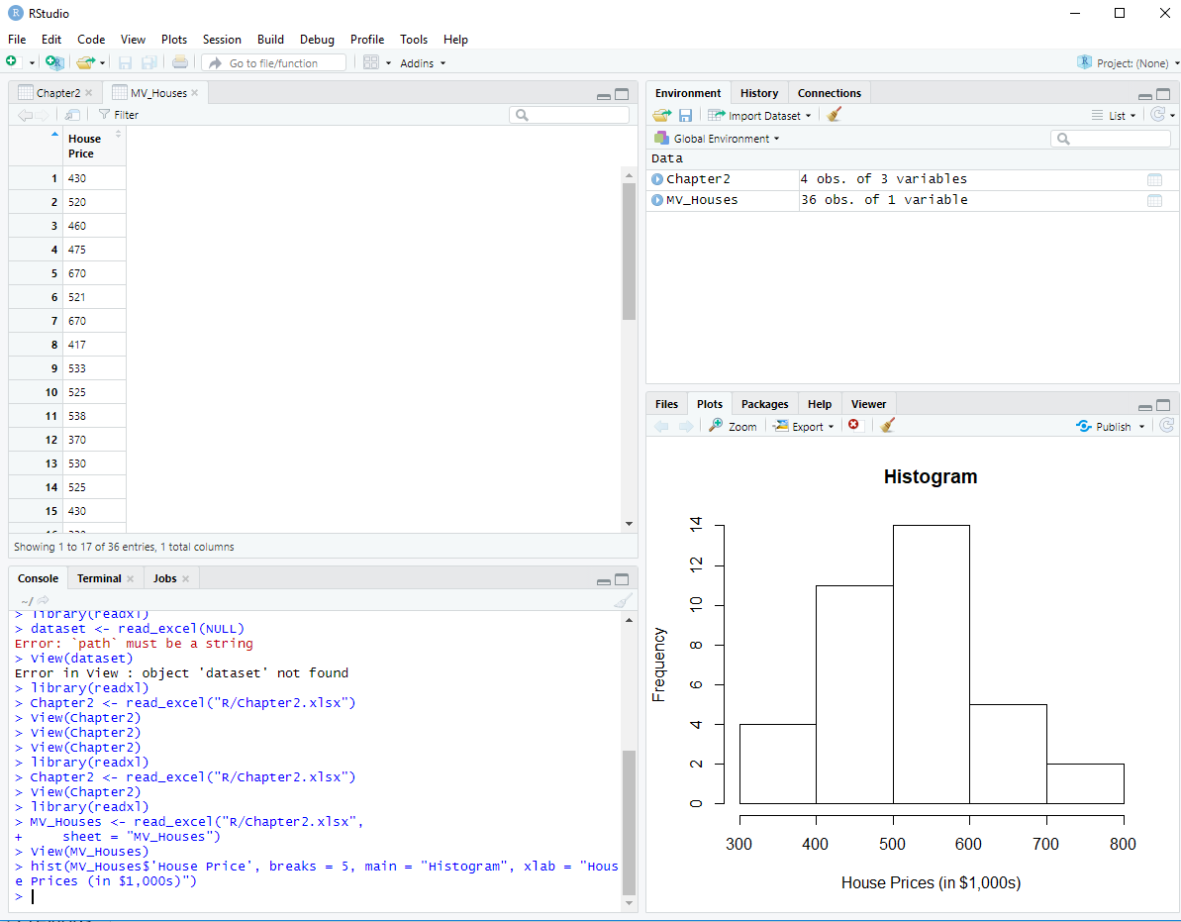

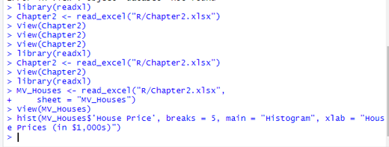

The polygon shows the percentage of houses sold at what price in each category (relative frequency, aka percentage). Below is the polygon and an enlargement of the code, respectively.

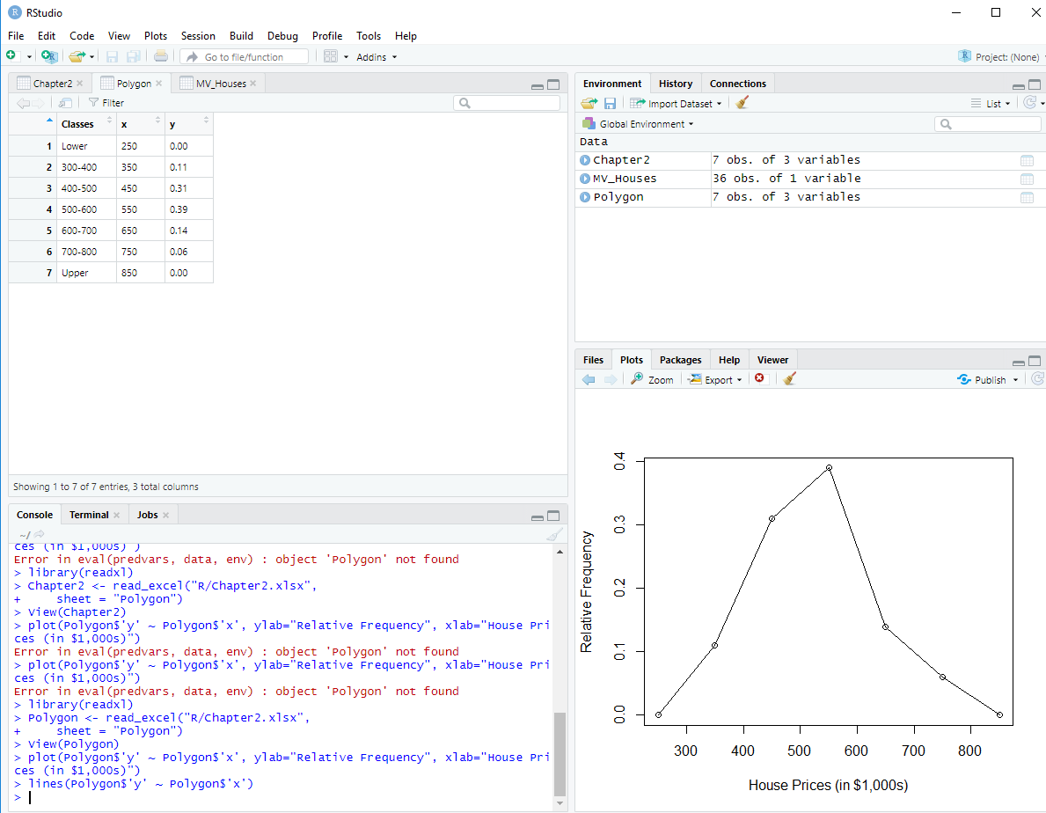

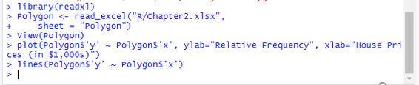

The ogive shows the percentage of houses sold in each category, including the category below it, thus measuring cumulative frequency (even though in R the Y axis only says relative frequency):

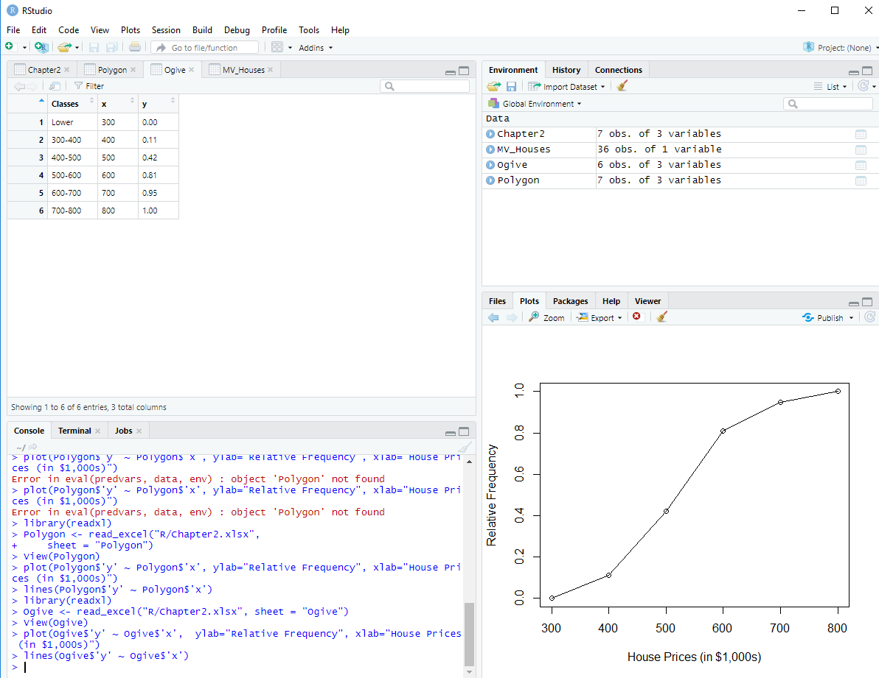

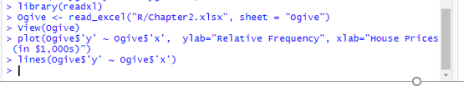

**Descriptive Analysis**

The histogram and the polygon show that the data is positively skewed, meaning that more houses are priced on the lower half of the spectrum, down to $300,000.00, than houses that are priced on the higher half of the spectrum, up to $800,000.00. The histogram and the polygon also show that the majority of houses are priced between $500,000.00 and $600,000.00. In addition, the 2nd highest category includes the houses priced at $400,000.00 to $500,000.00. You can clearly see that the histogram tells you the number of houses priced in each category, and the polygon tells you the percentage of houses priced in each category. The ogive tells you that the biggest percentage of houses are priced up to $600,000.00 and that it tapers off abruptly from there. 80% of houses are priced up to $600,000.00, and only 20% are priced from $600,000.00 to $800,000.00.